A Molecular Approach to Solanum Dulcamara GLRs: Sequence Alignment, Structure Prediction, and Docking.

- Introduction.
Glutamate is the most important amino acid that is formed as the product of different mechanisms in the cells and it is mainly formed by the usage of synthase enzymes like Glutamate synthase. Its work is to do metabolism of nitrogen in plants (Forde & Lea, 2007). The GLR of Arabidopsis thaliana AtGLR3.3 worked in the regulation of calcium flux by the attachment microbe associated molecular patterns is recognized in the plant body(Kang et al., 2006) (Kwaaitaal et al., 2011).We use A. thaliana as model organism because the genome of this plant is completely sequenced and is published all over the world and its genome sequence is present on its genome databank. 24 OsGLRs in Oryza sativa (Singh et al., 2014). 16 ZmGLRs in Zea mays (Zhou et al., 2021). Zea mays is subjected as a model organism because it is useful in study for genome evolution, plant domestication, epigenetics, pest resistance, quantitative inheritance(Strable & Scanlon, 2009). 36 GhGLRs in Gossypium hirsutum. We study it as a model organism because it is mainly use in the context of research in polyploidy, cell wall elongation and cell wall biogenesis(Lu et al., 2018). 13 SlGLRs in Solanum lycopersicum (Ahmed et al., 2023). Mainly we look on A. thaliana as a model plant. As well as for this research we also consider Z. mays, O. sativa and S. lycopersicum as a model organism because for Glutamate Receptors (GluRs) research is also done in these organisms. S. lycopersicum is mainly used for the study of Abiotic biotic stress and fruit ripening (Liu et al., 2022).
As we take A. thaliana as model organism it contains three clades which identified by the usage of phylogenetic analysis and this case is also same as some other plants that are used in the research such as S. lycopersicum. Some has 4 clades such as O. sativa and G. hirsutum (Liu et al., 2021; Singh et al., 2014). But some plants that are important such as Z. mays has less than three clades, only two clades in sense of GLRs in the whole genome(Zhou et al., 2021). Full length sequence of AtGLR3.4 is completely done in 2021 for the first time (Green et al., 2021). Glutamate Receptor plays an important role in the defense mechanism in plants and it is much likely in work as those work in mammalian genome(Forde & Roberts, 2014). Mostly AtGLR3.5 works by modulating the Ca²⁺ present in the cytosol and it is specially work in the germination of seeds and root formation and during sexual reproduction it helps in the formation of pollen tube(Kong et al., 2015). AtGLR3.5 lowers the sensitivity of seed to Abscisic Acid (inhibit the formation of ABIA, a transcription factor) and reduce the time of germination of seeds (Qiu et al., 2020).In S. lycopersicum GLR3.3 and GLR3.5 regulates the cold stress in plants. Studies suggests that if plant is subjected to acclimated cold (like 12°C) the value of transcript of GLR3.5and 3.3 is increased to 2-8 fold than in plant at 25°C(H. Li et al., 2019). The functional research of A. thaliana is very wide and is divided into four parts. First, clades are overlapped in such manner that they regulate each other and make pattern of organs e.g. leaf, flower, root etc. (Chiu et al., 2002). Second, the role of GLRs in nitrogen-carbon Balance(Kang & Turano, 2003). Third, abiotic and Abscisic acid stressing sense(Kang et al., 2004). Fourth it is least but not last, their contribution on ionic relations(Kim et al., 2001). In Zea Mays, the treatment of glutamate increase the heat tolerance of seedling by ZmGLRs Ca²⁺ mediated signaling(Z.-G. Li et al., 2019). An organism called Fusarium oxysporum f. sp. vasinfectum race 7 that cause vascular Wilt, In G. Hirsutum GhGLR4.8 do resistance against this organism(Liu et al., 2021).
There is different quantity of Glutamate receptor genes is present in different organism and it is varied from organism to organism. A. thaliana has 20 genes of Glutamate receptor in the whole genome that is well identified. O. Sativa (rice) has 24 genes of Glutamate Receptor in the whole genome. G. hirsutum (Cotton) have 36 genes of Glutamate Receptor in the Whole Genome. Z. mays (Corn) have 16 genes of Glutamate Receptor in the Whole Genome. S. lycopersicum (Tomato) has 13 genes of Glutamate Receptor in the whole genome that is identified. Saccharum spontaneum (Wild sugarcane) has 34 genes of glutamate Receptor in the whole genome that is identified until now.
Organism name Solanum dulcamara is native plant of Europe and Asia and it is naturally present in some parts of the North America. I chose this research because in the world it has less research compares to its Family member Solanum tuberosum (potato) and S. lycopersicum (tomato). This research will bring understanding in the structure of protein of glutamate receptors in S. dulcamara. This plant has much medicinal use. Its stem is some time used for the treatment of skin diseases. The stem is some time used as treatment for bronchitis, asthma, pneumonia. It is written in official papers as the native people of North America use its roots for the relief in Fever and nausea. This plant has less or no GLR structure analysis present in research area. This research will helpful in understanding the future of GLR mediated pathways that are involved in plant defense mechanism, long distance signaling, plant growth and development. It has the ability to tolerate abiotic stress and they survive in harsh environment.
- Material and Methods.
2.1 Sequence Retrieval
The retrieval of Glutamate Receptor(GLR) sequences of A. thaliana (AtGLRs) is done from its main website TAIR(Reiser et al., 2024)( https://www.arabidopsis.org/), Z. Mays (ZmGLRs) from its website Maize GDB(Andorf et al., 2024)( https://www.maizegdb.org/), the retrieval of sequences of Organism of interest S. dulcamara(SdGLRs) is done by the usage of blastp in NCBI(Sayers et al., 2022)( https://www.ncbi.nlm.nih.gov/)
2.2 Phylogenetic Analysis.
By the usage of Blastp the phylogenetic analysis of GLR of organism of interest is done (Camacho et al., 2023). Then the alignment of the sequences is done by the usage of MEGA software and the tool that is used for alignment is ClustalW( gap opening penalty = 10 and gap extension penalty = 0.10(for Pairwise) 0.20(for Multiple)) and by using the same software the phylogenetic tree is designed(Both maximum likelihood and Neighbor Joining) (Kumar et al., 2004)( https://www.megasoftware.net/).
2.3 Execution of secondary and tertiary structure.
The execution of Secondary structure is done by the usage of Gor4(Deléage, 2017) (https://npsa-prabi.ibcp.fr/cgi-bin/npsa_automat.pl?page=/NPSA/npsa_gor4.html) and the execution of tertiary structure is made by the usage of Alpha fold 2(Mirdita, Schütze et al. 2022)( https://colab.research.google.com/github/sokrypton/ColabFold/blob/v1.2.0/AlphaFold2.ipynb). For the visualization of tertiary structure the help of Software Chimera X is taken (Meng et al., 2023)( https://www.cgl.ucsf.edu/chimerax/). After visualization for the betterment of the tertiary structure the refinement of the structure is done by usage of Galaxy web (Ko et al., 2012)( https://galaxy.seoklab.org/)
2.4 Structure Validation.
The validation of structure is done by the usage of Molprobity and by using this software these values are found all atom contacts, Protein geometry, Molprobity scores, peptide omegas, low resolution criteria (Williams et al., 2018) (http://molprobity.biochem.duke.edu/). The biophysical parameters like Molecular weight, Theoretical PI, Gravy, Aliphatic index, instability index of GLR proteins is found by the usage of software EXPASY (Gasteiger, 2005) (https://web.expasy.org/protparam/).

2.5 Protein validation and Docking.
The validation and the analysis for the checking of common ligand protein for the protein of interest is done by the usage of String (Szklarczyk et al., 2023)( https://string-db.org/). For the purpose of docking the file used in docking is prepared by the usage of Chimerax (Meng et al., 2023)(https://www.cgl.ucsf.edu/chimerax/). After this process the most crucial point is done by doing the docking of proteins by the usage of Cluspro(Jones et al., 2022)( https://cluspro.bu.edu/). After doing docking from Cluspro its Attachment with ligand protein is check and seen by using software PYMOL(Schrodinger, 2015) (https://www.pymol.org/).
- Results
3.1 Identification of GLR family in S. dulcamara.
For the identification of the GLR Genes in S. dulcamara some organisms such as one of the common organisms in plant study Model organism A. thaliana (AtGLRs), Z. Mays (ZmGLRs), O. sativa (OsGLRs), S. lycopersicum (SlGLRs), G. hirsutum (GhGLRs) is used for the running of Blastp in NCBI. Different alleles of same gene are described as naming then as a, b, c, d and so on.
Common Name | Scientific Name | Gene Name | Accession No. | Location of Gene
Bittersweet nightshade | Solanum dulcamara | SdGLR2.8a | XP_055829386.1 | NC_077244.1(68003379..68007141, complement)
Bittersweet nightshade | Solanum dulcamara | SdGLR2.8b | XP_055832305.1 | NC_077244.1(68043728..68047706, complement)
Bittersweet nightshade | Solanum dulcamara | SdGLR2.8c | XP_055831965.1 | NC_077244.1(68015956..68019792, complement)
Bittersweet nightshade | Solanum dulcamara | SdGLR2.8d | XP_055829320.1 | NC_077244.1(68063695..68068977, complement)
Bittersweet nightshade | Solanum dulcamara | SdGLR2.8e | XP_055832100.1
  NC_077244.1(68034908..68038980, complement)
Bittersweet nightshade | Solanum dulcamara | SdGLR2.8f | XP_055829319.1 | NC_077244.1(68063695..68068977, complement)
Bittersweet nightshade | Solanum dulcamara | SdGLR2.3a | XP_055819940.1
  NC_077241.1 (5890326..5898935)
Bittersweet nightshade | Solanum dulcamara | SdGLR2.8g | XP_055829321.1
  NC_077244.1(68063695..68068977,complement)
Bittersweet nightshade | Solanum dulcamara | SdGLR2.8h | XP_055829322.1 | NC_077244.1(68063695..68068977, complement)
Bittersweet nightshade | Solanum dulcamara | SdGLR2.9a | XP_055829388.1
  NC_077244.1(67975289..67978949, complement)
Bittersweet nightshade | Solanum dulcamara | SdGLR2.9b | XP_055805951.1 | NC_077247.1 (46953120..46957777)
Bittersweet nightshade | Solanum dulcamara | SdGLR2.9c | XP_055836107.1
  NC_077245.1 (4132097..4140077, complement)
Bittersweet nightshade | Solanum dulcamara | SdGLR3.4a | XP_055823215.1
  NC_077242.1 (8782657..8789262, complement)
Bittersweet nightshade | Solanum dulcamara | SdGLR3.4b | XP_055810829.1
  NC_077238.1(72466161..72471770, complement)
Bittersweet nightshade | Solanum dulcamara | SdGLR3.2a | XP_055815428.1
  NC_077240.1 (282217..286388, complement)
Bittersweet nightshade | Solanum dulcamara | SdGLR3.7a | XP_055823220.1
  NC_077242.1 (8828404..8833497, complement)
Bittersweet nightshade | Solanum dulcamara | SdGLR3.3a | XP_055833256.1
  NC_077245.1 (566695..573424, complement)
Bittersweet nightshade | Solanum dulcamara | SdGLR3.7b | XP_055823221.1 | NC_077242.1 (8828404..8833497, complement)
Bittersweet nightshade | Solanum dulcamara | SdGLR3.6a | XP_055803218.1
  NC_077247.1(52015665..52020413, complement)
Bittersweet nightshade | Solanum dulcamara | SdGLR3.6b | XP_055803219.1
  NC_077247.1(52015665..52020413, complement)
Bittersweet nightshade | Solanum dulcamara | SdGLR3.6c | XP_055803217.1 | NC_077247.1(52015665..52020413, complement)
Bittersweet nightshade | Solanum dulcamara | SdGLR2.9d | XP_055835599.1
  NC_077245.1 (4103822..4112296, complement)
Bittersweet nightshade | Solanum dulcamara | SdGLR2.9e | XP_055836108.1 | NC_077245.1 (4132097..4140077, complement)
Bittersweet nightshade | Solanum dulcamara | SdGLR3.6d | XP_055803219.1
  NC_077247.1(52015665..52020413, complement)
Bittersweet nightshade | Solanum dulcamara | SdGLR3.2b | XP_055815429.1
  NC_077240.1 (282217..286388, complement)
Bittersweet nightshade | Solanum dulcamara | SdGLR2.9f | XP_055836108.1
  NC_077245.1 (4132097..4140077, complement)
Bittersweet nightshade | Solanum dulcamara | SdGLR2.2a | XP_055827347.1
  NC_077243.1 (395665..400257)
Table 1: This table contains the information about the organism its common name, scientific name, Accession no. of gene, Location of gene in the genome. This data is retrieved by NCBI (https://www.ncbi.nlm.nih.gov/)

3.2 Phylogenetic analysis of GLR Gene Family.
For the purpose of studying the evolutionary relationship among the GLRs in S. dulcamara, a phylogenetic tree is constructed by using 70 sequences of three monocotyledon and three dicotyledons. By doing phylogenetic analysis there is some interesting fact that come in sight that both Monocotyledons and Dicotyledons did not form separate clusters in tree it refers that the GLR genes of both Monocotyledons and Dicotyledons is conserved but different plants have different no. of genes such as A. thaliana has 20 genes and Z. Mays has 16 genes of GLR in whole genome. This organism has only two clades of GLR genes clade two or clade three clade one is missing it does not mean that the function of clade one gene is missing is absent in this organism but the function of clade one is done by different genes.
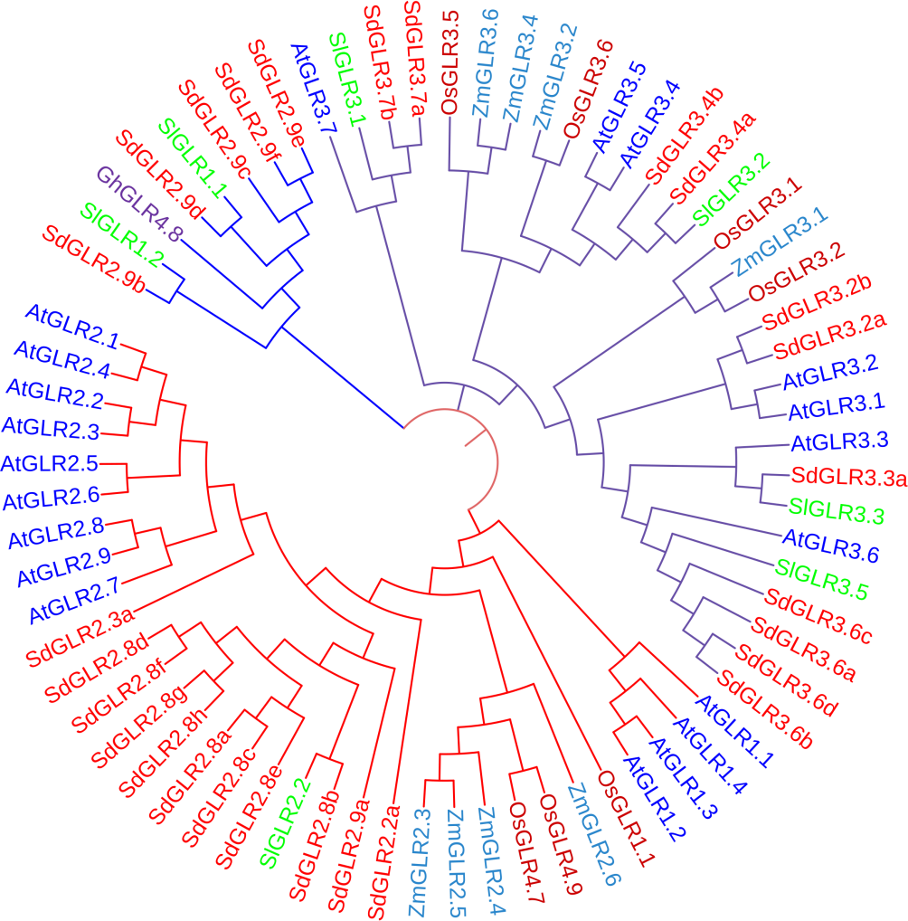
Figure 1. This shows the phylogenetic connection among the model organism and organism of interest. Tree designed by MEGA and Color modification is done by the usage of ITOL.
In this the Model that is used in the default Jones-Taylor-Thornton (JTT) Model.

3.3 Characteristics of GLR family genes in S. dulcamara.
The basic characteristics of GLR genes in S. dulcamara is described in the following table. The amount of amino acid that is lowest among SdGLRs is 343aa (SdGLR2.2) and highest is 1004aa (SdGLR2.8b) with the average of 674aa. The theoretical PI that is Lowest among SdGLRs is 5.7 (SdGLR2.8d) and the highest is 8.97 (SdGLR3.2b) with the average of 7.335. The Molecular weight is measured in Dalton that is highest is 111884.72Kd (SdGLR2.8b) and the lowest is 38044.83Kd (SdGLR2.2) with the average of 74964.775Kd. The instability index among all genes is highest is 42.49(Unstable) (SdGLR2.8a) and the lowest is 31.00(Stable) (SdGLR2.2). The highest aliphatic index is 98.94(SdGLR2.9c) and the lowest is 89.8 (SdGLR2.9b). The next is most important point that is Grand average of hydropathicity (GRAVY) that is highest is 0.122 (SdGLR3.2b) and lowest is -0.122 (SdGLR2.2). The Next Property is Error Rate of Tertiary Structure Analysis (ERRAT) the highest is 94.6237 (SdGLR3.4b) and the lowest is 90.0277 (SdGLR2.8h).
Name of Protein | No. of amino acid | Theoretical PI | Molecular weight (Dalton) | Instability Index | Aliphatic index | GRAVY | ERRAT
SdGLR2.8a | 967 | 6.55 | 107829.92 | 42.49(unstable) | 95.73 | -0.071 | 93.7274
SdGLR2.8b | 1004 | 5.99 | 111884.72 | 36.82(stable) | 98.12 | 0.009 | 94.1943
SdGLR2.8c | 967 | 7.22 | 107856.11 | 40.79(unstable) | 95.63 | -0.062 | 92.4005
SdGLR2.8d | 965 | 5.7 | 107421.26 | 36.98(Stable) | 96.45 | -0.021 | 93.4446
SdGLR2.8e | 974 | 6.24 | 108447.75 | 39.57(Stable) | 95.94 | -0.03 | 93.3014
SdGLR2.8f | 999 | 5.88 | 111460.99 | 37.43(stable) | 96.67 | -0.01 | 91.9512
SdGLR2.3a | 966 | 6.01 | 108153.53 | 36.13(Stable) | 91.16 | 0.038 | 93.6989
SdGLR2.8g | 918 | 5.89 | 102703.86 | 39.71(Stable) | 94.14 | -0.032 | 91.6446
SdGLR2.8h | 887 | 5.8 | 99132.73 | 39.79(Stable) | 94.46 | -0.037 | 90.0277
SdGLR2.9a | 817 | 8.79 | 91675.99 | 36.45(Stable) | 96.6 | 0.005 | 92.7178
SdGLR2.9b | 932 | 8.37 | 105323.58 | 33.89(Stable) | 89.8 | -0.119 | 93.5287
SdGLR2.9c | 906 | 8.34 | 100521.29 | 31.76(Stable) | 98.94 | 0.118 | 94.2683
SdGLR3.4a | 961 | 6.34 | 107196.39 | 38.72(Stable) | 92.46 | -0.029 | 92.381
SdGLR3.4b | 931 | 7.88 | 103599.62 | 37.17(Stable) | 94.91 | 0.002 | 94.6237
SdGLR3.2a | 899 | 8.54 | 99744.14 | 35.8(Stable) | 96.48 | 0.104 | 93.8169
SdGLR3.7a | 904 | 8.55 | 101084.47 | 39.48(Stable) | 98.75 | 0.071 | 91.9471
SdGLR3.3a | 947 | 7.03 | 104657.92 | 38.98(Stable) | 95.58 | 0.054 | 93.19
SdGLR3.7b | 814 | 8.75 | 91498.25 | 41.24(Unstable) | 96.99 | 0.021 | 92.6764
SdGLR3.6a | 937 | 6.25 | 104331.48 | 39.02(stable) | 92.98 | 0.013 | 93.2322
SdGLR3.6b | 962 | 6.61 | 107148.88 | 39.16(Stable) | 93.7 | 0.034 | 94.5915
SdGLR3.6c | 951 | 6.8 | 106069.6 | 39.92(Stable) | 92.73 | 0.016 | 93.0556
SdGLR2.9d | 907 | 7.19 | 101476.47 | 37.80(Stable) | 97.46 | 0.084 | 93.8979
SdGLR2.9e | 803 | 8.44 | 89190.04 | 32.27(Stable) | 95.99 | 0.05 | 92.1852
SdGLR3.6d | 926 | 6.44 | 103171.2 | 39.72(stable) | 91.14 | -0.01 | 93.6663
SdGLR3.2b | 827 | 8.97 | 91766.2 | 35.40(Stable) | 98.05 | 0.122 | 92.2025
SdGLR2.9f | 803 | 8.44 | 89190.04 | 32.27(Stable) | 95.99 | 0.05 | 92.5072
SdGLR2.2a | 343 | 8.87 | 38044.83 | 31.00(Stable) | 90.9 | -0.122 | 93.3071
Table 2: This table gives the information about different parameters obtained from Protparam (https://web.expasy.org/protparam/). Gives you information about No. of amino acid, PI, AI, MW, GRAVY, ERRAT.

3.4 Secondary structure of Proteins of GLR in S. dulcamara.
The secondary structure is maintained by using the hydrogen bond that made among the amino acids and that hydrogen bonds are divides into Alpha Helix (Hh), Extended Strand (Ee) and Random Coil (Cc). Taking SdGLR2.8b as an example with the total no. of amino acid of 1004, the factors like Hh, Ee, and Cc is 25.30%, 24.20%, 50.50% accounted for the total no. of amino acids.
Name of Protein | Alpha helix(Hh) | Extended Strand(Ee) | Random coil (Cc)
SdGLR2.8a | 27.92% | 23.68% | 48.40%
SdGLR2.8b | 25.30% | 24.20% | 50.50%
SdGLR2.8c | 28.13% | 23.78% | 48.09%
SdGLR2.8d | 29.84% | 21.87% | 48.29%
SdGLR2.8e | 30.18% | 22.79% | 47.02%
SdGLR2.8f | 28.83% | 22.32% | 48.85%
SdGLR2.3a | 25.36% | 26.60% | 48.03%
SdGLR2.8g | 28.87% | 21.35% | 49.78%
SdGLR2.8h | 28.30% | 22.21% | 49.49%
SdGLR2.9a | 25.46% | 26.68% | 47.86%
SdGLR2.9b | 27.47% | 24.57% | 47.96%
SdGLR2.9c | 26.49% | 25.94% | 47.57%
SdGLR3.4a | 26.53% | 24.45% | 49.01%
SdGLR3.4b | 24.17% | 25.67% | 50.16%
SdGLR3.2a | 28.14% | 23.47% | 48.39%
SdGLR3.7a | 31.08% | 20.02% | 48.89%
SdGLR3.3a | 20.38% | 24.92% | 54.70%
SdGLR3.7b | 31.45% | 18.92% | 49.63%
SdGLR3.6a | 25.93% | 24.87% | 49.20%
SdGLR3.6b | 25.68% | 25.05% | 49.27%
SdGLR3.6c | 25.55% | 25.13% | 49.32%
SdGLR2.9d | 30.76% | 20.84% | 48.40%
SdGLR2.9e | 28.77% | 24.41% | 46.82%
SdGLR3.6d | 27.54% | 24.08% | 48.38%
SdGLR3.2b | 26.96% | 24.43% | 48.61%
SdGLR2.9f | 28.77% | 24.41% | 46.82%
SdGLR2.2a | 20.41% | 25.66% | 53.94%
Table3: gives the information about Alpha helix, extended strand and Random coil. The information got from GOR4 (https://npsa-prabi.ibcp.fr/cgi-bin/npsa_automat.pl?page=/NPSA/npsa_gor4.html)

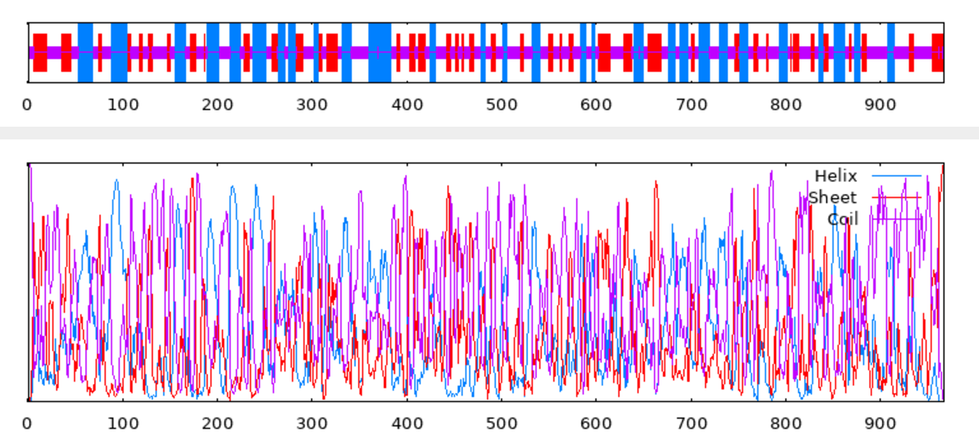
Figure2: This the 2D structure of SdGLR2.8a formed by the usage of GOR4.

3.5 Evaluation of structure of GLR protein structure.
The evaluation is done by the usage of Molprobity. The resulting tables for each SdGLRs were taken, but here only one resulting table is shown:
All-Atom  Contacts | Clashscore, all atoms: | 3.99 |  | 96th percentile* (N=1784, all resolutions)
All-Atom  Contacts | Clashscore is the number of serious steric overlaps (> 0.4 Å) per 1000 atoms.
Protein  Geometry | Poor rotamers | 3 | 0.35% | Goal: <0.3%
Protein  Geometry | Favored rotamers | 837 | 98.24% | Goal: >98%
Protein  Geometry | Ramachandran outliers | 3 | 0.31% | Goal: <0.05%
Protein  Geometry | Ramachandran favored | 955 | 98.96% | Goal: >98%
Protein  Geometry | Rama distribution Z-score | 0.79 ± 0.23 |  | Goal: abs(Z score) < 2
Protein  Geometry | MolProbity score^ | 1.18 |  | 99th percentile* (N=27675, 0Å - 99Å)
Protein  Geometry | Cβ deviations >0.25Å | 13 | 1.43% | Goal: 0
Protein  Geometry | Bad bonds: | 26 / 7773 | 0.33% | Goal: 0%
Protein  Geometry | Bad angles: | 66 / 10553 | 0.63% | Goal: <0.1%
Peptide Omegas | Cis Prolines: | 0 / 49 | 0.00% | Expected: ≤1 per chain, or ≤5%
Peptide Omegas | Twisted Peptides: | 2 / 966 | 0.21% | Goal: 0
Low-resolution Criteria | CaBLAM outliers | 10 | 1.0% | Goal: <1.0%
Low-resolution Criteria | CA Geometry outliers | 7 | 0.73% | Goal: <0.5%
Additional validations | Tetrahedral geometry outliers | 1
Additional validations | Waters with clashes | 0/0 | 0.00% | See UnDowser table for details
Table 4: The table is formed by the usage of Molprobity to understand different values like all atom contacts, Protein geometry, Molprobity scores, peptide omegas, low resolution criteria

Next the Ramachandran plots were also downloaded from PROCHECK. Following is the Ramachandran plot of SdGLR3.3
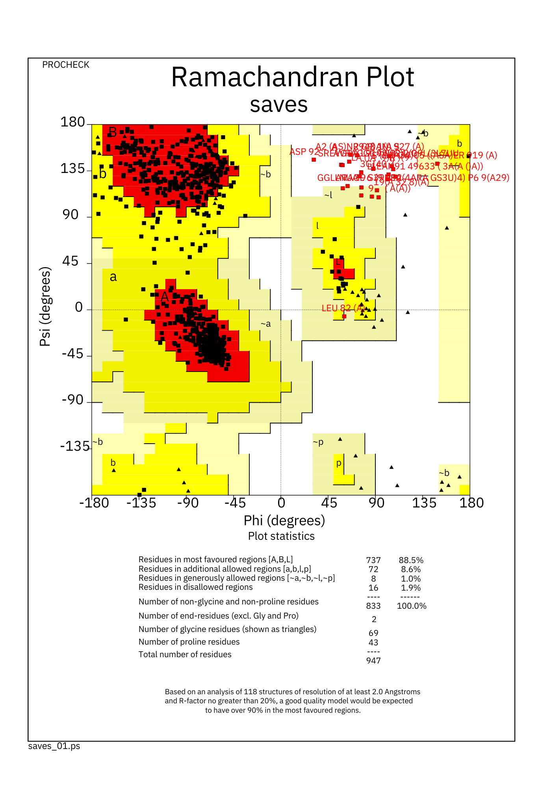
Figure 3: The picture of Ramachandran plot of SdGLR2.8a.
3.6 Tertiary structure of protein GLR in S. dulcamara.
The tertiary structure predicted is done by using of alpha fold 2 but its visualization is done by the usage of Chimerax to check the simple 3D structure of protein.

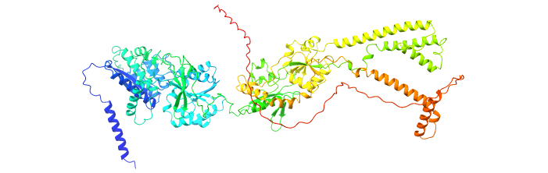
Figure 4: This structure is done by the usage of Alpha fold 2 and its visualization is done by the usage of ChimeraX

3.7 Common Protein analysis.
For the purpose of Docking and the analysis of checking the common ligand among the proteins string analysis is done by the usage of String (https://string-db.org/). And the common proteins are also come out.
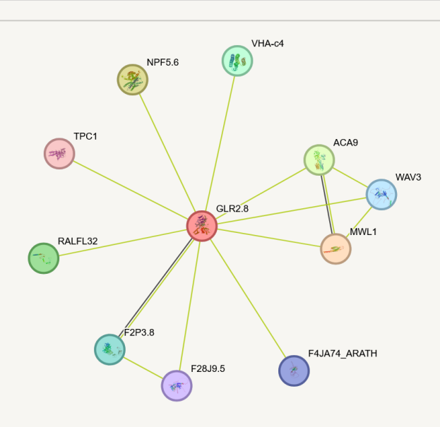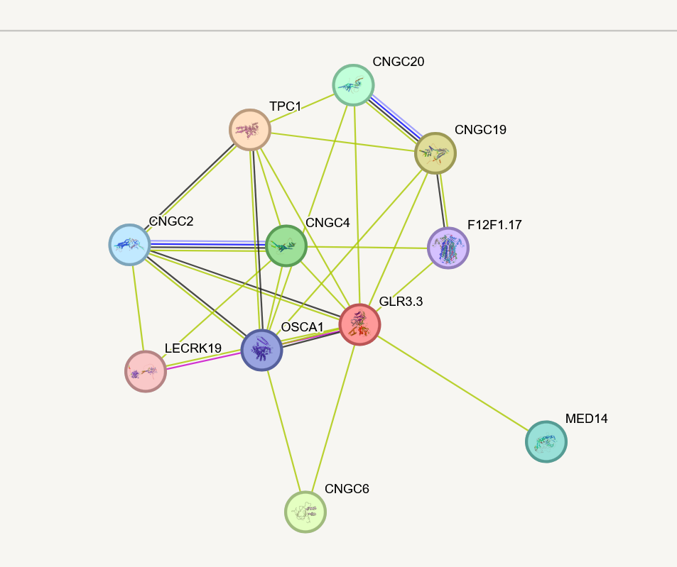
Figure6: Prediction of protein interaction of SdGLR3.3 by STRING Database.
Figure5. Prediction of protein interaction of SdGLR2.8a by STRING Database

3.8 Docking Results Analysis.
The docking is done by using Cluspro and its results is not correctly visualized by the usage of Chimerax so another software is used PYMOL and the results that are given is very satisfying and detailed.
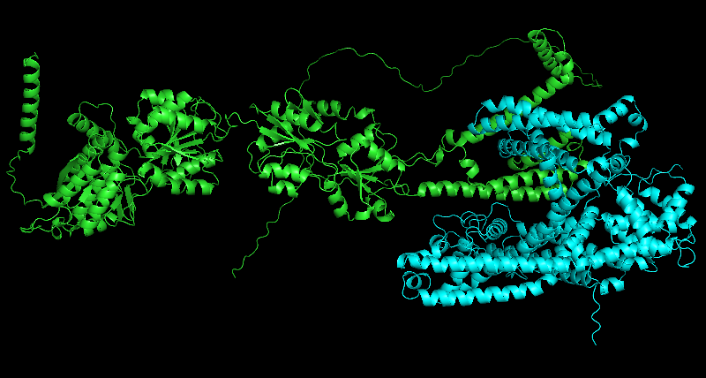
Figure 7: Formed from PYMOL of structure of SdGLR2.8a

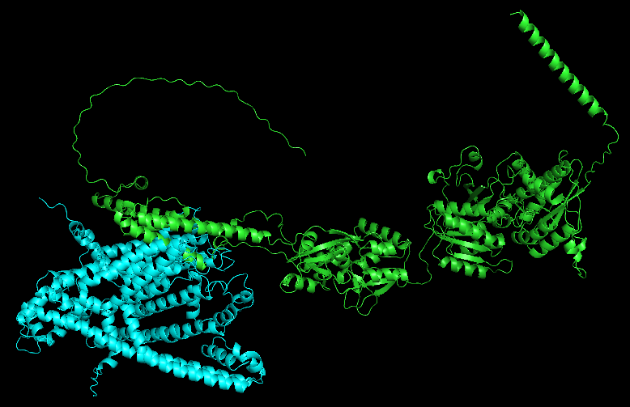
Figure 8: Formed from PYMOL of structure of SdGLR3.3

4. Discussion.
Animal ionotropic glutamate receptor (iGluRs) is the part of the human body nervous system that work as the neurotransmitter and it is the ligand gated channels that work in the form of developing connections and transmission of message in the body (Wudick et al., 2018). Glutamate receptors are useful in different function that are very useful for the survival of plan like fungal attack resistance, root growth, response to pathogen (De Bortoli et al., 2016). Mainly the GLRs is involved in the mechanism that is stimulated by the usage of the Ca²⁺ but it involves in many other functions like the response of light (Lam et al., 1998), the production and enlargement of the pollen tube (Wudick, Portes, et al., 2018), The effect of microtubule on the sensitivity of aluminium (Sivaguru et al., 2003) and to the response which is caused by the wound (Mousavi et al., 2013).
The sequence is retrieved from the NCBI database by doing the process of BLAST P that is run against the GLR sequence of A. thaliana, O. sativa, S. lycopersicum as per done in this article (D’Agostino et al., 2013). There is a large study gap is present in S. dulcamara. This study will provide a large information about the structure and function of GLR genes and phylogenetic analysis is done. In this study Genome wise identification, Phylogenetic analysis, structural analysis, study of GLR structural dynamics, docking results that is done in between SdGLRs and TPC, Protein-protein interaction was performed. This process and the analysis series are very important in the understanding the role of GLRs in S. dulcamara. There are 27 variants of SdGLRs are found in the screening on NCBI. This screening is done by the usage of process that runs on the basis of similar structural domains that have theoretically same biological functions. So, for this purpose the Blastp is run with the sequences of AtGLRs, OsGLRs, SlGLRs against the Protein sequences of S. dulcamara and it helps in the finding of the GLR sequences of the GLRs present in this plant genome. There are 27 sequences is found and these are classified into clade Ⅱ and Ⅲ. The members of clade Ⅰ and Ⅳ is missing it indicates the necessity of detailed study of genome so that it is a chance that clade Ⅰ or Ⅳ might be discovered. This research might be proof in the stepping stone in the development of that type of research.
The phylogenetic analysis is done to achieve the milestone of gathering the information about the relationship of S. dulcamara with the model organism that have the whole genome sequenced in past. So, the maximum likelihood tree and Neighbor joining tree is made by the usage of MEGA 11 with the help of 20 AtGLRs, 8 ZmGLRs, 7 SlGLRs, 7 OsGLRs and 1 GhGLRs. Among them 27 SdGLRs are also added that are discovered by the usage of Blastp. These 70 GLRs then subjected to the Multiple sequence alignment that is done by the usage of MEGA 11 and ClustalW. The 2D and 3D structure of SdGLRs give the accessibility to enhance the knowledge about the structure of SdGLRs in the plant. The prediction of 2D structure is done by the usage of GOR4. The prediction of 3D structure is done by the usage of ALPHAFOLD2. The ALPHA FOLD 2 is used because it uses AI to predict the structure of the protein with high computational ability. The tools used in the evaluation analysis are Molprobity, ERRAT, Protparam etc. These biophysical properties describe the versatility of the structure of GLRs in the plant. This evaluation analysis describes the importance of predicted proteins of GLRs. This evaluation analysis of PI and instability index shows the versatility of protein structures. The stability of values like GRAVY and aliphatic indices gives the prediction of the structure of GLRs. These predictions give the proof by giving the protein-protein interaction with the SdGLRs and TPC1, where it is demonstrated that TPC1 is also works in the manipulation of stress response (Pottosin & Dobrovinskaya, 2022). It also provides the basis the future of GLR study
5. Conclusion.
In this research the genome wide identification is done of GLR genes in Solanum dulcamara. The major is done in its family member S. tuberosum and S. Lycopersicum but the research on this plant is very limited and is very little. In this Research in the secondary and tertiary structure is done. The secondary and tertiary structure is not found or builds by any other person. The Phylogenetic relationship is created among the plants species and their relationship is build. The sequence is present in databases but the location on gene is un-identified so due to this the location and naming is done. The bio-physical properties are also found and tertiary is also produced and their interaction is produced.
6. Abstract.
The article presents a comprehensive study on the structural and functional aspects of Glutamate Receptor-Like (GLR) proteins in Solanum dulcamara, a plant species with significant medicinal value but limited research compared to its relatives like Solanum tuberosum (potato) and Solanum lycopersicum (tomato). The research focuses on sequence alignment, phylogenetic analysis, structural modeling, and ligand docking to understand the role of GLRs in plant defense mechanisms, stress responses, and growth regulation. The study identifies 27 GLR genes in S. dulcamara and classifies them into clades II and III, with clades I and IV missing, suggesting a need for further genomic exploration. Phylogenetic analysis reveals conserved GLR genes across monocotyledons and dicotyledons, indicating evolutionary relationships. Secondary and tertiary structures of GLR proteins are predicted using tools like GOR4 and AlphaFold2, and their biophysical properties are analyzed. Protein-protein interactions and docking studies are conducted to explore the functional roles of GLRs, particularly in stress responses and calcium signaling. The research provides novel insights into the structural dynamics of GLRs in S. dulcamara, contributing to the understanding of their role in plant physiology and defense mechanisms. This study lays the groundwork for future research on GLR-mediated pathways in plants, particularly in stress tolerance and signaling.
This study investigates the structural and functional properties of glutamate receptor-like genes (GLRs) in Solanum dulcamara, a plant with limited prior research compared to its relatives, Solanum tuberosum and Solanum lycopersicum. Using computational approaches, including sequence alignment, structural modeling, and molecular docking, this research identifies 27 variants of GLRs classified into clades II and III. The study employs phylogenetic analysis to compare S. dulcamara GLRs with those from model organisms such as Arabidopsis thaliana, Zea mays, and Oryza sativa, revealing conserved evolutionary patterns across monocots and dicots. Secondary and tertiary protein structures were predicted using GOR4 and AlphaFold2, respectively, and validated through MolProbity analysis. Protein-protein interaction networks and docking studies revealed potential functional roles in stress responses, particularly through calcium signaling pathways. This research fills a significant gap by providing the first comprehensive structural characterization of GLRs in S. dulcamara, laying a foundation for future studies on plant defense mechanisms, stress responses, and developmental processes.
5. References.
- Forde, B. G., & Lea, P. J. (2007). Glutamate in plants: metabolism, regulation, and signalling. Journal of experimental botany, 58(9), 2339-2358
- Kang, S., Kim, H. B., Lee, H., Choi, J. Y., Heu, S., Oh, C. J., Kwon, S. I., & An, C. S. (2006). Overexpression in Arabidopsis of a plasma membrane-targeting glutamate receptor from small radish increases glutamate-mediated Ca2+ influx and delays fungal infection. Molecules and Cells, 21(3), 418-427.
- Strable, J., & Scanlon, M. J. (2009). Maize (Zea mays): a model organism for basic and applied research in plant biology. Cold spring harbor protocols, 2009(10), pdb. emo132.
- Lu, H., Cui, X., Liu, Z., Liu, Y., Wang, X., Zhou, Z., Cai, X., Zhang, Z., Guo, X., & Hua, J. (2018). Discovery and annotation of a novel transposable element family in Gossypium. BMC plant biology, 18, 1-10.
- Ahmed, I., Kumar, A., Bheri, M., Srivastava, A. K., & Pandey, G. K. (2023). Glutamate receptor like channels: Emerging players in calcium mediated signaling in plants. International Journal of Biological Macromolecules, 234, 123522.
- Liu, K., Chen, D., Zhang, Z., Li, B., El-Mogy, M. M., Tian, S., & Chen, T. (2022). Solanum lycopersicum, a model plant for the studies in developmental biology, stress biology and food science. Foods, 11(16), 2402.
- Liu, S., Zhang, X., Xiao, S., Ma, J., Shi, W., Qin, T., Xi, H., Nie, X., You, C., & Xu, Z. (2021). A single‐nucleotide mutation in a GLUTAMATE RECEPTOR‐LIKE gene confers resistance to Fusarium Wilt in Gossypium hirsutum. Advanced Science, 8(7), 2002723.
- Singh, A., Kanwar, P., Yadav, A. K., Mishra, M., Jha, S. K., Baranwal, V., Pandey, A., Kapoor, S., Tyagi, A. K., & Pandey, G. K. (2014). Genome‐wide expressional and functional analysis of calcium transport elements during abiotic stress and development in rice. The FEBS journal, 281(3), 894-915.
- Zhou, S., Zhang, L., Lv, Q., & Huang, J. (2021). Identification and analysis of GLR family genes in maize. J. Maize Sci, 29, 35-42.
- Green, M. N., Gangwar, S. P., Michard, E., Simon, A. A., Portes, M. T., Barbosa-Caro, J., Wudick, M. M., Lizzio, M. A., Klykov, O., Yelshanskaya, M. V., Feijó, J. A., & Sobolevsky, A. I. (2021). Structure of the <em>Arabidopsis thaliana</em> glutamate receptor-like channel GLR3.4. Molecular Cell, 81(15), 3216-3226.e3218. https://doi.org/10.1016/j.molcel.2021.05.025
- Forde, B. G., & Roberts, M. R. (2014). Glutamate receptor-like channels in plants: a role as amino acid sensors in plant defence? F1000prime reports, 6.
- Kong, D., Ju, C., Parihar, A., Kim, S., Cho, D., & Kwak, J. M. (2015). Arabidopsis glutamate receptor homolog3. 5 modulates cytosolic Ca2+ level to counteract effect of abscisic acid in seed germination. Plant physiology, 167(4), 1630-1642
- Qiu, X.-M., Sun, Y.-Y., Ye, X.-Y., & Li, Z.-G. (2020). Signaling Role of Glutamate in Plants [Review]. Frontiers in Plant Science, 10. https://doi.org/10.3389/fpls.2019.01743
- Li, H., Jiang, X., Lv, X., Ahammed, G. J., Guo, Z., Qi, Z., Yu, J., & Zhou, Y. (2019). Tomato GLR3. 3 and GLR3. 5 mediate cold acclimation‐induced chilling tolerance by regulating apoplastic H2O2 production and redox homeostasis. Plant, cell & environment, 42(12), 3326-3339.
- Reiser, L., Bakker, E., Subramaniam, S., Chen, X., Sawant, S., Khosa, K., Prithvi, T., & Berardini, T. Z. (2024). The Arabidopsis Information Resource in 2024. Genetics, 227(1), iyae027.
- Andorf, C. M., Haley, O. C., Hayford, R. K., Portwood, J. L., Harding, S., Sen, S., Cannon, E. K., Gardiner, J. M., Kim, H.-S., & Woodhouse, M. R. (2024). PanEffect: a pan-genome visualization tool for variant effects in maize. Bioinformatics, 40(2), btae073.
- Sayers, E. W., Bolton, E. E., Brister, J. R., Canese, K., Chan, J., Comeau, D. C., Connor, R., Funk, K., Kelly, C., & Kim, S. (2022). Database resources of the national center for biotechnology information. Nucleic acids research, 50(D1), D20-D26.
- Camacho, C., Boratyn, G. M., Joukov, V., Vera Alvarez, R., & Madden, T. L. (2023). ElasticBLAST: accelerating sequence search via cloud computing. BMC bioinformatics, 24(1), 117.
- Kumar, R., Tamura, K., & Nei, M. (2004). Phylogenetic and molecular evolutionary analyses were conducted using MEGA. The Pennsylvania State University, University Park, Pa, version, 3.
- Mirdita, M., et al. (2022). "ColabFold: making protein folding accessible to all." Nature methods 19(6): 679-682.
- Williams, C. J., Headd, J. J., Moriarty, N. W., Prisant, M. G., Videau, L. L., Deis, L. N., Verma, V., Keedy, D. A., Hintze, B. J., & Chen, V. B. (2018). MolProbity: more and better reference data for improved all‐atom structure validation. Protein Science, 27(1), 293-315.
- Gasteiger, E. (2005). Protein identification and analysis tools on the ExPASy server. The proteomics protocols handbook/Human Press Inc.
- Meng, E. C., Goddard, T. D., Pettersen, E. F., Couch, G. S., Pearson, Z. J., Morris, J. H., & Ferrin, T. E. (2023). UCSF ChimeraX: Tools for structure building and analysis. Protein Sci, 32(11), e4792. https://doi.org/10.1002/pro.4792
- Ko, J., Park, H., Heo, L., & Seok, C. (2012). GalaxyWEB server for protein structure prediction and refinement. Nucleic acids research, 40(W1), W294-W297.
- Szklarczyk, D., Kirsch, R., Koutrouli, M., Nastou, K., Mehryary, F., Hachilif, R., Gable, A. L., Fang, T., Doncheva, N. T., & Pyysalo, S. (2023). The STRING database in 2023: protein–protein association networks and functional enrichment analyses for any sequenced genome of interest. Nucleic acids research, 51(D1), D638-D646.
- Jones, G., Jindal, A., Ghani, U., Kotelnikov, S., Egbert, M., Hashemi, N., Vajda, S., Padhorny, D., & Kozakov, D. (2022). Elucidation of protein function using computational docking and hotspot analysis by ClusPro and FTMap. Acta Crystallographica Section D: Structural Biology, 78(6), 690-697.
- Schrodinger, L. (2015). The PyMOL molecular graphics system. Version, 1, 8.
- Chiu, J. C., Brenner, E. D., DeSalle, R., Nitabach, M. N., Holmes, T. C., & Coruzzi, G. M. (2002). Phylogenetic and expression analysis of the glutamate-receptor–like gene family in Arabidopsis thaliana. Molecular biology and evolution, 19(7), 1066-1082.
- Kang, J., & Turano, F. J. (2003). The putative glutamate receptor 1.1 (AtGLR1. 1) functions as a regulator of carbon and nitrogen metabolism in Arabidopsis thaliana. Proceedings of the National Academy of Sciences, 100(11), 6872-6877.
- Kang, J., Mehta, S., & Turano, F. J. (2004). The putative glutamate receptor 1.1 (AtGLR1. 1) in Arabidopsis thaliana regulates abscisic acid biosynthesis and signaling to control development and water loss. Plant and Cell Physiology, 45(10), 1380-1389.
- Kim, S. A., Kwak, J., Jae, S.-K., Wang, M.-H., & Nam, H. (2001). Overexpression of the AtGluR2 Gene Encoding anArabidopsis Homolog of Mammalian Glutamate Receptors Impairs CalciumUtilization and Sensitivity to Ionic Stress in TransgenicPlants. Plant and Cell Physiology, 42(1), 74-84.
- Li, Z.-G., Ye, X.-Y., & Qiu, X.-M. (2019). Glutamate signaling enhances the heat tolerance of maize seedlings by plant glutamate receptor-like channels-mediated calcium signaling. Protoplasma, 256, 1165-1169.
- Liu, S., Zhang, X., Xiao, S., Ma, J., Shi, W., Qin, T., Xi, H., Nie, X., You, C., & Xu, Z. (2021). A single‐nucleotide mutation in a GLUTAMATE RECEPTOR‐LIKE gene confers resistance to Fusarium Wilt in Gossypium hirsutum. Advanced Science, 8(7), 2002723.
- Deléage, G. (2017). "ALIGNSEC: viewing protein secondary structure predictions within large multiple sequence alignments." Bioinformatics 33(24): 3991-3992.
- Kwaaitaal, M., Huisman, R., Maintz, J., Reinstädler, A., & Panstruga, R. (2011). Ionotropic glutamate receptor (iGluR)-like channels mediate MAMP-induced calcium influx in Arabidopsis thaliana. Biochemical Journal, 440(3), 355-373.
- Lam, H.-M., Chiu, J., Hsieh, M.-H., Meisel, L., Oliveira, I. C., Shin, M., & Coruzzi, G. (1998). Glutamate-receptor genes in plants. Nature, 396(6707), 125-126.
- Wudick, M. M., Portes, M. T., Michard, E., Rosas-Santiago, P., Lizzio, M. A., Nunes, C. O., Campos, C., Santa Cruz Damineli, D., Carvalho, J. C., & Lima, P. T. (2018). CORNICHON sorting and regulation of GLR channels underlie pollen tube Ca2+ homeostasis. Science, 360(6388), 533-536.
- Sivaguru, M., Pike, S., Gassmann, W., & Baskin, T. I. (2003). Aluminum rapidly depolymerizes cortical microtubules and depolarizes the plasma membrane: evidence that these responses are mediated by a glutamate receptor. Plant and Cell Physiology, 44(7), 667-675.
- Mousavi, S. A., Chauvin, A., Pascaud, F., Kellenberger, S., & Farmer, E. E. (2013). GLUTAMATE RECEPTOR-LIKE genes mediate leaf-to-leaf wound signalling. Nature, 500(7463), 422-426.
- D’Agostino, N., Golas, T., Van de Geest, H., Bombarely, A., Dawood, T., Zethof, J., Driedonks, N., Wijnker, E., Bargsten, J., & Nap, J.-P. (2013). Genomic analysis of the native European Solanum species, S. dulcamara. BMC Genomics, 14, 1–14.
- Pottosin, I., & Dobrovinskaya, O. (2022). Major vacuolar TPC1 channel in stress signaling: What matters, K+, Ca2+ conductance or an ion-flux independent mechanism? Stress Biology, 2(1), 31.

