“Clinical Evaluation of Ayurvedic Management in Asthenopia Associated with Digital Screen Use: A Prospective Case Series”’
Chandni Dav¹*, Manjiri Keskar²
¹PG Scholar, Department of Shalakya Tantra, Parul Institute of Ayurveda, Parul University, Vadodara, India
²Professor & HOD, Department of Shalakya Tantra, Parul Institute of Ayurveda, Parul University, Vadodara, India
*Corresponding author:
Chandni Dav
Email: chandnidav000@gmail.com

Abstract:
Background:
Asthenopia (eye strain) is a common functional visual disorder associated with prolonged near work and excessive digital screen exposure. Conventional management mainly includes refractive correction, artificial tears, and ergonomic measures, which may provide only temporary relief in many patients. Ayurveda describes similar functional visual disturbances under early stages of Timira, where management focuses on ocular nourishment and restoration of visual function.
Objective:
To evaluate the clinical effectiveness and safety of an Ayurvedic treatment protocol in patients presenting with asthenopic symptoms related to extensive electronic device use.
Methods:
A prospective observational case series was conducted on 10 patients diagnosed with asthenopia attending the Shalakya Tantra outpatient department of an Ayurvedic teaching hospital. Patients received standardized Ayurvedic local ocular therapies along with internal medications for six weeks. Clinical outcomes were assessed using symptom score, visual comfort, and functional improvement.
Results:
All patients showed marked reduction in asthenopic symptoms including eye strain, headache, visual fatigue, and dryness. Mean symptom score reduced from 10.8 ± 2.1 at baseline to 2.1 ± 1.3 after treatment. Improvement in work tolerance and visual comfort was observed in all cases. No adverse events were reported.
Conclusion:
Ayurvedic management showed promising clinical improvement in asthenopic symptoms and may be considered as a supportive therapeutic approach; however, larger controlled studies are required.
Keywords:
Asthenopia, Digital eye strain, Timira, Netra Tarpana, Triphala, Ayurveda, Case series
Introduction
Asthenopia is a functional visual disorder characterized by eye strain, headache, blurred vision, dryness, and visual fatigue, commonly associated with prolonged near work and extensive digital screen use. With increasing dependence on computers, smartphones, and electronic devices, asthenopia has become a frequent occupational and lifestyle-related ocular complaint.¹, ² Conventional management includes refractive correction, artificial tears, ergonomic modification, and visual hygiene measures; however, many patients continue to experience persistent symptoms despite treatment.³,⁴ In Ayurveda, functional disturbances of vision without structural pathology resemble early stages of Timira, where impairment of visual function occurs due to imbalance of Doshas affecting ocular tissues. Management is aimed at Chakshushya, Rasayana, and Tridosha-shamaka therapy, including local ocular procedures and internal medications that nourish ocular structures. ⁵,⁶ the present study was conducted to evaluate the clinical outcome of Ayurvedic management in patients presenting with asthenopia symptoms related to excessive electronic device use.
Materials and Methods
Study Design
Prospective, single-arm observational case series.
Study Setting
Outpatient Department of Shalakya Tantra, Ayurvedic Teaching Hospital, Vadodara, Gujarat, India.
Sample Size
Ten patients were included considering feasibility and exploratory nature of the study.
Inclusion Criteria
- Age 18–40 years
- Clinical diagnosis of asthenopia
- Screen exposure ≥4 hours/day
- Normal ocular examination or mild refractive error

Exclusion Criteria
- Pathological refractive errors
- Ocular surface disease, glaucoma, or retinal pathology
- History of ocular surgery

Clinical Presentation
Common symptoms observed:
- Eye strain and heaviness
- Frontal or peri-orbital headache
- Blurred vision after prolonged work
- Burning or dryness of eyes
- Reduced work efficiency

Table 1 Details of Ayurvedic Intervention Protocol Used in Patients with Asthenopia (n = 10)
Category | Therapy / Drug | Dose & Form | Route | Frequency | Duration
Local ocular therapy | Netra Tarpana | Medicated ghee (Triphala Ghrita) | Topical ocular | Once daily | 5 Consecutive days
Local ocular therapy | Netra Prakshalana | Medicated decoction (Triphala Kwatha) | Ocular wash | Once daily | 14 days
Internal medication | Saptamrita Lauha | 250 mg tablet | Oral | Twice daily | 6 weeks
Internal medication | Triphala Churna | 3 gm powder with warm water | Oral | Once daily (bedtime) | 6 weeks
Internal medication | Yashtimadhu Churna | 2 gm powder | Oral | Twice daily | 6 weeks
Internal medication | Eyebright capsules | 2 capsules | Oral | Twice daily | 6 weeks
Lifestyle Advice
- Limitation of continuous screen exposure
- Regular visual breaks (20-20-20 rule)
- Adequate sleep
- Proper illumination
Outcome Measures
- Symptom severity score
- Visual comfort duration
- Functional improvement
- Safety and tolerability
Statistical Analysis
Descriptive statistics were used to summarize the data. Mean and standard deviation were calculated for symptom scores. Pre- and post-treatment scores were compared using paired t-test. A p-value < 0.05 was considered statistically significant.

The present study was conducted as an observational clinical case series in outpatient patients. Written informed consent was obtained from all participants before starting treatment.

Results
Table 2 Baseline Demographic and Clinical Characteristics of Patients with Asthenopia (n = 10)
Parameter | Observation
Total patients (n) | 10
Age (years) Mean ± SD | 26.4 ± 5.2 years
Gender | 6 Male, 4 Female
Screen exposure(hrs/day) | 6–10
Emmetropia | 4
Mild refractive error | 6
A total of 10 patients were included in the study. The mean age of the participants was 26.4 ± 5.2 years. Among them, 6 were males and 4 were females. All patients had history of prolonged digital screen exposure ranging from 6 to 10 hours per day. Ocular examination revealed emmetropia in 4 patients and mild refractive error in 6 patients.
Table 3 Frequency of Asthenopic Symptoms at Baseline and After Ayurvedic Treatment (n = 10)
Symptom | Baseline (n) | Post-treatment (n)
Eye strain | 10 | 1
Headache | 8 | 1
Blurred vision after work | 7 | 1
Burning / dryness | 6 | 0
Early fatigue | 10 | 1
All major symptoms of asthenopia showed marked reduction after treatment. Maximum improvement was observed in eye strain and early visual fatigue, which were present in all patients at baseline.
Table 4 Change in Total Asthenopia Symptom Score Following Ayurvedic Treatment (Mean ± SD, n = 10)
Parameter | Mean Score ± SD
Baseline total score | 10.8 ± 2.1
Post-treatment score | 2.1 ± 1.3
Mean reduction | 8.7 points
T value | 11.4
P value | < 0.001

The mean total asthenopia score significantly decreased after Ayurvedic treatment (10.8 ± 2.1 vs 2.1 ± 1.3). Paired t-test revealed highly significant improvement (t = 11.14, p < 0.001).
A clinically meaningful reduction in total asthenopia symptom score was observed in all patients.

Improvement in Visual Comfort
Marked improvement was observed in 7 patients, while 3 patients showed moderate improvement. No patient showed worsening of symptoms. The average duration of comfortable near work increased from 30–40 minutes at baseline to 90–120 minutes after treatment.

Objective Findings
No deterioration in visual acuity or refractive status was observed in any patient. Slit-lamp examination remained normal in all cases. Patients reporting dryness showed subjective improvement in tear film stability. No signs of ocular surface irritation or inflammation were noted.

Safety and Tolerability
No adverse drug reactions were reported during the study period. Local ocular procedures were well tolerated by all patients, and complete compliance to treatment was observed.

Follow-Up Findings
During 8-week follow-up after completion of therapy, sustained symptom relief was observed in 9 patients. Mild recurrence of eye strain was reported in one patient, associated with excessive screen exposure. No serious ocular complaints were noted

Summary of Results
- Significant reduction in asthenopic symptoms
- Improved tolerance to near and screen work
- Good safety profile
- High patient compliance and satisfaction
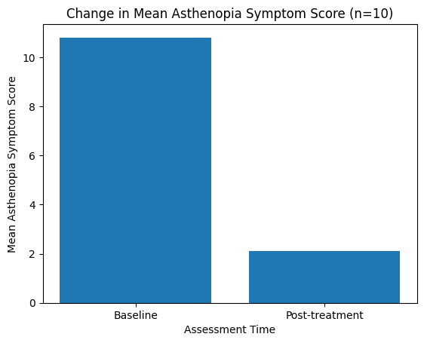
Figure 1 Reduction in mean asthenopia symptom score after treatment

Figure shows the comparison of mean asthenopia symptom scores at baseline and after 6 weeks of Ayurvedic treatment. The mean total symptom score reduced from 10.8 ± 2.1 at baseline to 2.1 ± 1.3 post-treatment, indicating a marked improvement in asthenopic symptoms.

Mean reduction in symptom score: 8.7 points
Improvement observed in all 10 patients

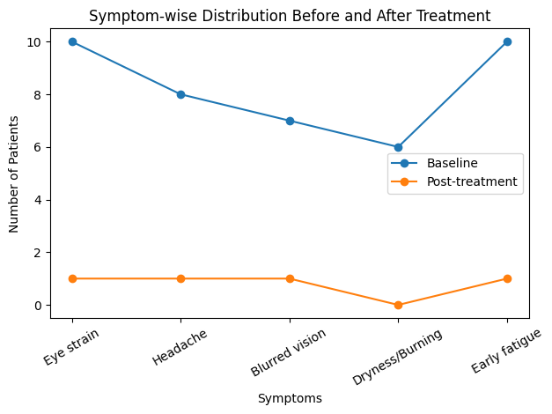
Figure 2 Symptom-wise Distribution of Asthenopia Before and After Ayurvedic Treatment (n = 10)
Figure illustrates the symptom-wise distribution of asthenopia before and after treatment. A substantial reduction was observed across all major symptoms including eye strain, headache, blurred vision, dryness/burning sensation, and early visual fatigue.

Discussion
The present case series demonstrates that Ayurvedic management comprising local ocular therapies and internal medications produced substantial improvement in asthenopic symptoms. The observed benefits may be attributed to the Chakshushya, Rasayana, and Tridosha-shamaka properties of Triphala, Yashtimadhu, and Saptamrita Lauha described in Ayurvedic literature. Netra Tarpana provides ocular nourishment and improves tear film stability, which may explain the improvement in dryness and visual fatigue. Similar benefits of Triphala in ocular disorders have been reported previously.⁷ The sustained symptom relief during follow-up suggests that Ayurvedic therapy may offer long-term functional benefits in digital eye strain. However, the absence of a control group and small sample size limit generalizability of findings, necessitating larger randomized controlled trials.

The present study has certain limitations including small sample size, absence of control group, and short follow-up duration. The findings should therefore be interpreted as preliminary clinical observations. Larger randomized controlled trials with objective parameters are required to establish definitive efficacy of Ayurvedic management in asthenopia associated with digital eye strain.

Conclusion
The present prospective case series suggests that Ayurvedic management
including Netra Tarpana, Triphala-based therapy, and internal medications
may provide significant symptomatic relief in patients with asthenopia
associated with excessive digital screen use.
The treatment was safe, well tolerated, and showed improvement in visual comfort and work tolerance. However, the findings are preliminary due to small sample size and lack of control group. Larger randomized controlled trials are required to establish definitive clinical efficacy.

Author Contributions
CD conducted the clinical study, collected the data, and prepared the manuscript.
MK supervised the study, verified the results, and critically reviewed the manuscript.
Both authors read and approved the final version of the manuscript.

Funding
No funding was received for this study.

Conflict of Interest
The authors declare no conflict of interest.

Acknowledgement
The authors are thankful to the Patients and Department of Shalakya Tantra, Parul Institute of Ayurveda, Parul University, Vadodara, Gujarat, India, for providing necessary facilities to conduct this study.

References
1. Sheedy JE. Vision problems at video display terminals. Optom Vis Sci. 1992;69(3):184-9.
2. Rosenfield M. Computer vision syndrome: a review of ocular causes and potential treatments. Ophthalmic Physiol Opt. 2011;31(5):502-15.
3. Blehm C, Vishnu S, Khattak A, Mitra S, Yee RW. Computer vision syndrome: a review. Surv Ophthalmol. 2005;50(3):253-62.
4. Hayes JR, Sheedy JE, Stelmack JA, Heaney CA. Computer use, symptoms, and quality of life. Optom Vis Sci. 2007;84(8):738-44.
5. Sushruta Samhita, Uttara Tantra. Varanasi: Chaukhambha Orientalia; Reprint edition.
6. Sharangadhara Samhita. Varanasi: Chaukhambha Surbharati; 2013.
7. Peterson CT, Denniston K, Chopra D. Therapeutic uses of Triphala. J Altern Complement Med. 2017;23:607–14.
8. Sharma PV. Dravyaguna Vijnana. Chaukhambha Bharati.
9. Ayurvedic Pharmacopoeia of India. Government of India.
10. Murthy KR. Ayurvedic Ophthalmology. Chaukhambha.

