DEEP LEARNING BASED MALWARE DETECTION IN NETWORK PACKETS





Abstract
In the age of rapidly evolving cybersecurity threats, detecting malware through network traffic analysis has become a critical task for securing digital infrastructures. This project focuses on leveraging Bidirectional Long Short-Term Memory (BiLSTM) networks for advanced threat detection in network traffic through In-Depth Packet Inspection. Network traffic data, typically comprising packet headers and payloads, can provide critical insights into potential threats such as malware, DDoS attacks, and data exfiltration. BiLSTM, a type of recurrent neural network (RNN), is used to capture both past and future contextual information by processing the data in both forward and backward directions.
This approach enhances the model’s ability to identify subtle attack patterns that evolve over time, a typical characteristic of modern malware behaviors. The model is trained on labeled network traffic datasets and tested on various attack scenarios, enabling it to distinguish between benign and malicious packets effectively. The primary objective of this project is to demonstrate the applicability of BiLSTM in detecting malware, analyzing both the sequential and temporal relationships within network packets.
The proposed system shows significant potential in classifying malicious network traffic with high accuracy, providing a reliable solution for real-time intrusion detection systems. Through this approach, the model adapts to and identifies previously unseen malware, offering a robust defense against ever-changing cyber threats.

TABLE OF CONTENTS

S. NO | TITLE | PAGE NO
 | ABSTRACT | IV
 | List Of Figures | VII
 | List Of Abbreviations | VIII
1 | INTRODUCTION | 1
 | 1.1. Objective | 1
 | 1.2. Problem Statement | 1
 | 1.3. Project Overview | 2
2 | SYSTEM ANALYSIS | 4
 | 2.1. Literature Review | 4
 | 2.2. Existing System | 6
 | 2.3. Proposed System | 7
 | 2.4. Hardware Specification | 8
 | 2.5. Software Specification | 8
 | 2.6. Modules Description | 8
3 | SYSTEM DESIGN | 11
 | 3.1. Introduction | 11
 | 3.2. Input Design | 11
 | 3.3. Output Design | 12
 | 3.4. System Architecture | 13
 | 3.5. UML Diagrams | 14

4 | SYSTEM IMPLEMENTATION AND MAINTENANCE | 19
 | 4.1. Implementation | 19
 | 4.2. System Maintenance | 20
 | 4.3. System Development | 22
5 | SYSTEM TESTING | 24
 | 5.1. Software Testing | 24
 | 5.2. Test Case | 25
 | 5.3. Test Report | 28
6 | CONCLUSION AND FUTURE ENHANCEMENT | 30
 | 6.1. Conclusion | 30
 | 6.2. Future Enhancement | 31
 | REFERENCES | 32
 | APPENDIX | 34
 | Screenshots | 34
 | Source Code | 38

LIST OF FIGURES

FIGURE NO. | FIGURE NAME | PAGE NO.
3.4 | System Architecture | 13
3.5.1 | Class Diagram | 14
3.5.2 | Data Flow Diagram | 15
3.5.3 | Use Case Diagram | 16
3.5.4 | Activity Diagram | 16
3.5.5 | Collaboration Diagram | 17
3.5.6 | Component Diagram | 17
3.5.7 | Deployment Diagram | 18

LIST OF ABBREVIATIONS

1 | NLP | Natural Language Processing
2 | API | Application Programming Interface
3 | ML | Machine Learning
4 | DL | Deep Learning
5 | RNN | Recurrent Neural Network
6 | BILSTM | Bidirectional Long Short-Term Memory
7 | DDOS | Distributed Denial of Service
8 | APT | Advanced Persistent Threats
9 | PCA | Principal Component Analysis
10 | PI | Packet Inspection

  - OBJECTIVE
CHAPTER 1

INTRODUCTION

The Objective of the Project to develop an advanced malware detection system using Bidirectional Long Short-Term Memory (BiLSTM) for in-depth packet inspection of network traffic, enabling real-time detection of sophisticated and evolving threats.

    - To analyze network traffic and extract relevant features for malware detection.
    - To implement BiLSTM for capturing temporal dependencies in packet data.

    - To develop a real-time malware detection system.

    - To evaluate the system's accuracy and efficiency in detecting threats.
    - To enhance network security by detecting both known and unknown malware.

PROBLEM STATEMENT
Traditional malware detection methods struggle to keep up with the increasing sophistication of cyber threats. Signature-based detection techniques are no longer sufficient to identify evolving malware that exhibits complex, time-dependent behaviors in network traffic. Additionally, the exponential growth of network data presents challenges in efficiently analyzing packets for malicious activity, as manual inspection and conventional detection methods are slow and error-prone. Real-time threat detection is crucial to prevent data breaches, yet many existing systems fail to provide timely alerts, leaving organizations exposed to prolonged attacks. Modern threats, such as zero-day exploits and advanced persistent threats (APTs), are

specifically designed to evade traditional detection by altering their behavior or using non-signature-based techniques.
Furthermore, malware often executes multi-stage attacks over time, making it difficult for conventional approaches to capture the temporal and sequential dependencies necessary for effective detection. This project addresses these challenges by utilizing Bidirectional Long Short-Term Memory (BiLSTM) networks to analyze network traffic, leveraging deep learning to model both spatial and temporal dependencies, thereby enhancing the accuracy and efficiency of malware detection.

PROJECT OVERVIEW
Malware, short for malicious software, refers to any intrusive software developed by cybercriminals (often called hackers) to steal data and damage or destroy computers and computer systems. Examples of common malware include viruses, worms, Trojan viruses, spyware, adware, and ransomware. Recent malware attacks have exfiltrated data in mass amounts. Malware is developed as harmful software that invades or corrupts your computer network. The goal of malware is to cause havoc and steal information or resources for monetary gain or sheer sabotage intent.

Intelligence and intrusion
Exfiltrated data such as emails, plans, and especially sensitive information like passwords.

Disruption and extortion
Locks up networks and PCs, making them unusable. If it holds your computer hostage for financial gain, it's called ransomware.

Destruction or vandalism
Destroys computer systems to damage your network infrastructure.

Steal computer resources
Use your computing power to run botnets, crypto mining programs (cryptojacking), or send spam emails.

Monetary gain
Sells your organization's intellectual property on the dark web. Typically, businesses focus on preventative tools to stop breaches. By securing the perimeter, businesses assume they are safe. However, some advanced malware will eventually make their way into your network. As a result, it is crucial to deploy technologies that continually monitor and detect malware that has evaded perimeter defenses. Sufficient advanced malware protection requires multiple layers of safeguards along with high-level network visibility and intelligence.

CHAPTER 2

SYSTEM ANALYSIS

LITERATURE REVIEW

A Scalable SIMD-Based Multi-Literal Pattern Matching Engine for Deep Packet Inspection
Traditional Deep Packet Inspection (DPI) systems often face limitations in efficiently processing high-speed network traffic due to sequential pattern matching bottlenecks. The study by Xu et al. (2023) introduces "Harry", a scalable pattern matching engine that leverages SIMD (Single Instruction Multiple Data) parallelism to accelerate multi-literal pattern matching. This architecture significantly improves throughput and enables efficient deep packet inspection on commodity CPUs. By employing a column-vector-based matching algorithm and leveraging SIMD shuffle instructions, the system maximizes data-level parallelism and minimizes processing latency. Harry outperforms traditional engines such as Aho-Corasick and FDR, achieving up to 70 Gbps throughput and integrating successfully into Hyperscan, a widely used regex engine. This innovative method provides a high-performance and scalable solution to meet modern network security demands.
Keywords—Deep Packet Inspection (DPI), SIMD, pattern matching, network security, Hyperscan.

Deep Learning for Network Traffic Monitoring and Analysis
A Survey Traditional network traffic monitoring techniques struggle to keep up with the increasing volume, variety, and velocity of network data. The survey by Abbasi, Shahraki, and Taherkordi (2021) explores the integration of deep learning into network traffic monitoring and analysis (NTMA) to address these limitations. The study categorizes various deep learning models used in NTMA, including

CNNs, RNNs, and autoencoders, highlighting their ability to learn complex patterns from raw traffic data. It discusses their effectiveness in tasks such as anomaly detection, traffic classification, and intrusion detection. This comprehensive review provides insights into the advantages, limitations, and research challenges of using deep learning for intelligent traffic analysis. The work emphasizes the potential of deep learning to significantly enhance the automation, accuracy, and scalability of NTMA systems.
Keywords—Network Traffic Monitoring and Analysis (NTMA), Deep Learning, CNN, RNN, Anomaly Detection.
    - Classifying Tor Traffic Encrypted Payload Using Machine Learning Identifying encrypted traffic, especially from anonymity networks like Tor, remains a significant challenge for network security systems. The study by Choorod, Weir, and Fernando (2024) proposes a machine learning-based approach to classify encrypted payloads in Tor traffic. This method extracts statistical and time-based features from encrypted flows without needing to decrypt the data, ensuring privacy compliance. Using classifiers such as Random Forest and Gradient Boosting, the system achieves high accuracy in differentiating Tor traffic from other encrypted or normal traffic. The study demonstrates that even heavily encrypted payloads can reveal behavioral patterns detectable through machine learning, offering a powerful tool for network traffic classification and anomaly detection. This research contributes to strengthening network visibility and threat detection in the context of
privacy-preserving technologies.
Keywords—Tor Traffic, Encrypted Payload, Machine Learning, Network Security, Traffic Classification.

EXISTING SYSTEM
Traditional cybersecurity systems often rely on manual inspection, where human analysts review network logs, traffic patterns, and packet data to identify suspicious activity. They examine attributes like unusual traffic spikes or irregular packet flows to detect threats. However, this approach is slow, labor-intensive, and prone to human error, making it inefficient for large-scale network traffic and increasing operational costs due to the need for skilled professionals. Signature-based detection is another common method, where predefined malware signatures are stored in a database and incoming packets are scanned against it. While effective against known threats, it cannot detect new, evolving, or obfuscated malware, making it vulnerable to zero-day attacks and advanced persistent threats (APTs). Additionally, some systems use rule-based heuristic analysis, which applies predefined rules to identify anomalies in traffic, such as unusual connections or excessive data transfers. Although this can help detect unknown threats, it often leads to false positives and can be bypassed by sophisticated malware mimicking normal behavior.

DISADVANTAGES
- Limited to known malware, unable to detect zero-day threats.
- High false positives, often misclassified benign activities.
- Struggles with advanced and evolving attack patterns.
- Slow detection, making real-time protection difficult.
- Static approach, lacks adaptability to new malware techniques.

PROPOSED SYSTEM
The proposed system is developed to enhance malware detection by employing real-time, in-depth packet inspection powered by deep learning. Unlike traditional approaches that rely on static signatures or predefined heuristic rules, this system dynamically analyzes network traffic using a Bidirectional Long Short-Term Memory (BiLSTM) model. The BiLSTM network processes traffic data by considering both past and future packet sequences, which enables it to identify complex malware patterns with higher accuracy. By capturing temporal dependencies within network traffic, the model is capable of detecting sophisticated and previously unseen threats that conventional systems might overlook. Furthermore, the system goes beyond simple metadata scanning or signature matching by performing a comprehensive inspection of both packet headers and payloads. This allows it to extract crucial features such as protocol behaviors, irregular data flows, and hidden malicious code, thereby strengthening its ability to uncover concealed threats and prevent malware from evading detection mechanisms.

ADVANTAGES
- Identifies malware instantly as it enters the network.
- Minimizes false positives and enhances detection precision.
- Adaptable to New Threats: Detects evolving and previously unknown malware.
- Inspects both packet headers and payloads for deeper insights.
- Efficiently processes large volumes of network traffic.
- Strengthens network defense against diverse cyber threats.

HARDWARE SPECIFICATION
- Processor : Intel Core i5 (or equivalent) or higher
- RAM : 8 GB or more
- Storage : 50 GB free disk space
- Network : Stable internet connection for real-time data processing.

SOFTWARE SPECIFICATION
- Operating System: Windows 10 or Linux (Ubuntu)
- Programming : Python 3.6 or higher
- Libraries/Tools : TensorFlow, Keras, NumPy, Pandas, Scikit-learn, Matplotlib
- Development Tool: Jupyter Notebook, Google Colab (online tool)
- Web Framework : Flask (for deployment)
- Database : MySQL (for data storage)
- IDE : Visual Studio Code, PyCharm, or Jupyter Notebook.

MODULES DESCRIPTION

PI Online Tool
A cloud-based platform (using Google Colab or Jupyter Notebook) for developing, testing, and deploying the malware detection system. It supports real- time network traffic analysis, data preprocessing, model training, and collaborative development without the need for powerful local hardware.

BiLSTM: Build and Find
This module builds a BiLSTM model to classify network packets as malicious or benign.

Import Dataset
The network traffic dataset, containing packets labeled as benign or malicious, is imported to provide the data needed for model training

Preprocessing
The data is preprocessed by cleaning noise, handling missing values, normalizing features, and formatting it properly for the BiLSTM model.

Feature Extraction (using PCA)
Principal Component Analysis (PCA) is applied to reduce the dataset’s dimensionality by selecting key features, improving training efficiency and model accuracy.

Build and Train (using BiLSTM)

The BiLSTM model is trained on the processed data to learn patterns from past and future packet sequences, making it effective for detecting anomalies in time-series network traffic.

Deploy Model (Deploy into PI Online Tool)
After training, the BiLSTM model is deployed in the PI Online Tool for real- time packet inspection, enabling it to classify incoming packets as benign or malicious.

Malware Prediction
This module is responsible for classifying incoming network packets as benign or malicious using the trained BiLSTM model.

Input Packet
This step involves capturing incoming network packets that need to be analyzed. The packets are preprocessed to extract features, which are then input to the trained BiLSTM model for classification.

Malware Prediction
The preprocessed packet is passed to the BiLSTM model, which predicts whether the packet is malicious or benign. The prediction result is provided to the system for further processing (e.g., generating alerts or logging the results).

Alert Generator
Once the malware prediction is made, the Alert Generator module creates a notification or alert. If the packet is classified as malicious, an alert is triggered, notifying the system admin or relevant users about the potential threat. The alert may include details like the packet's source, type, and threat level.

System User
This module manages access and roles within the system, defining user permissions and capabilities.

Admin
        - The Admin has full system control, including configuring settings, managing datasets, monitoring model performance, training or updating the model, reviewing alerts, and accessing logs and statistics.

User
        - The User interacts with the system to submit network packets for malware prediction. Users can view prediction results and receive alerts.

  - INTRODUCTION
CHAPTER 3

SYSTEM DESIGN

The malware detection system is designed for real-time analysis of network traffic using deep learning techniques, specifically BiLSTM. It inspects packet headers and payloads to identify malicious activity by capturing temporal dependencies. The system consists of key modules, including data preprocessing, feature extraction using PCA, model training with BiLSTM, and real-time malware prediction. A web-based interface allows users to monitor detections, while an alert generator provides instant notifications upon identifying threats. The architecture ensures scalability, secure authentication, and efficient processing.

INPUT DESIGN
The Input Design focuses on collecting and preparing network traffic data for analysis. This stage ensures that incoming data is structured and formatted correctly for processing by the malware detection system.
- Source of Input: The system captures real-time network traffic using packet sniffers or network monitoring tools, such as Wireshark or tcpdump. It also supports uploading pre-recorded network logs in PCAP or CSV formats.
- Data Preprocessing: Raw network traffic data undergoes preprocessing, including packet segmentation, noise removal, feature normalization, and missing value handling.
- Feature Extraction: The system extracts key features from both packet headers and payloads, such as source/destination IP, protocol type, payload size, and behavioral patterns. These extracted features serve as input for the deep learning model.

OUTPUT DESIGN
The Output Design focuses on presenting malware detection results in an understandable and actionable format. The system ensures that security analysts receive detailed insights into potential threats.
- Malware Classification Results: Each analyzed packet is categorized as benign or malicious based on the trained BiLSTM model's predictions.
- Threat Reports: If malware is detected, the system generates a report containing relevant details such as threat type, timestamp, packet information, and confidence score.
- Real-Time Alerts: In case of high-risk malware activity, the system immediately triggers alerts via email notifications, UI-based alerts, or SMS to inform users for swift action.

System Architecture

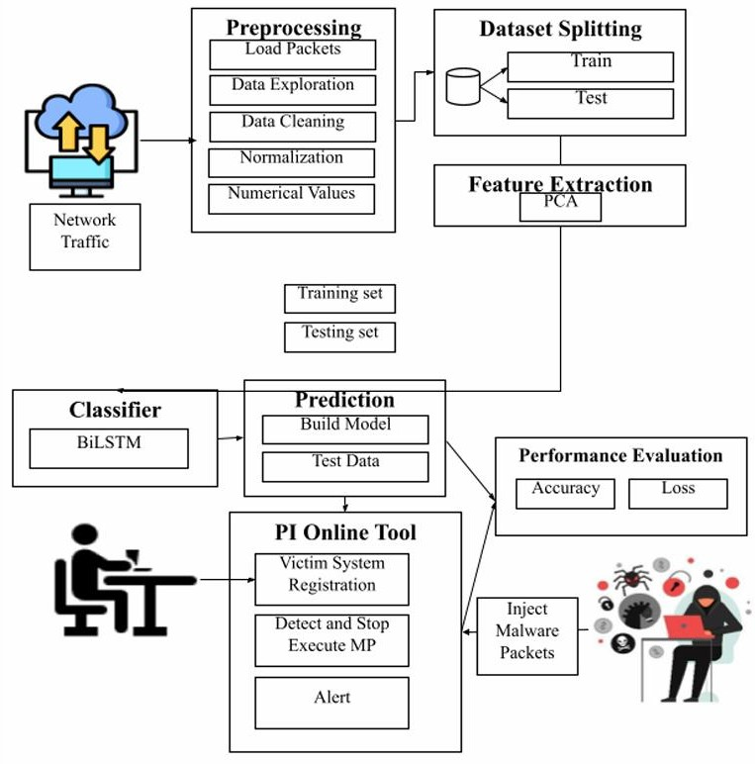

Figure. 3.4 System Architecture

UML DIAGRAMS

Class Diagram
Class diagram is used to describe the static structure of the system by showing key classes like Packet, FeatureExtractor, BiLSTMModel, and their relationships.
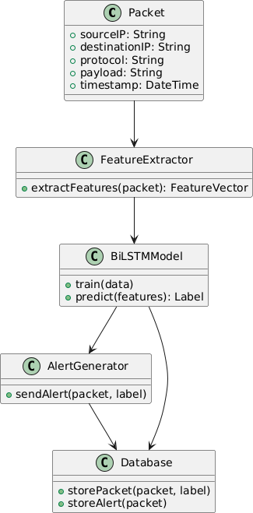

Figure. 3.5.1 Class Diagram

Data Flow Diagram
Data flow diagram is used to illustrate how network packet data flows through the system from capture to malware prediction and alert generation.
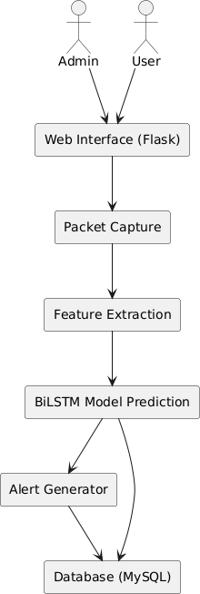

Figure. 3.5.2 Data Flow Diagram

3.5.3. USE CASE DIAGRAM
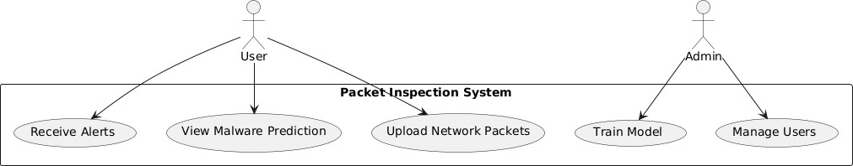
Use case diagram is used to depict the interactions between users (Admin and User) and the system functionalities like uploading packets, receiving alerts, and managing users.

Figure. 3.5.3 Use Case Diagram

3.5.4. Activity Diagram
Activity diagram is used to show the dynamic flow of actions involved in capturing, analyzing, and classifying network packets as benign or malicious.
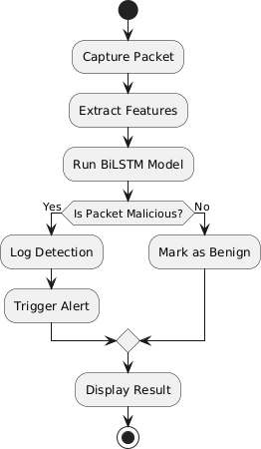

Figure. 3.5.4 Activity Diagram

Collaboration Diagram
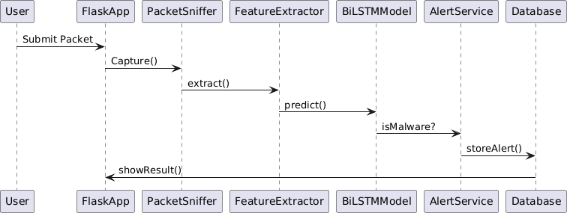
Collaboration diagram is used to demonstrate how system components like the Flask app, BiLSTM model, and alert service interact to process packet data.

Figure. 3.5.5 Collaboration Diagram

Component Diagram
Component diagram is used to represent the high-level software components of the system and their dependencies within the client-server architecture.
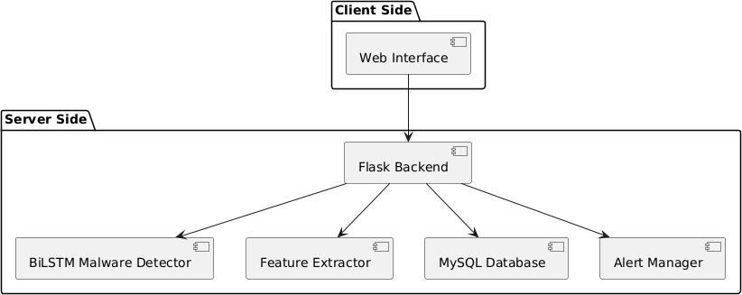

Figure. 3.5.6 Collaboration Diagram

Deployment Diagram
Deployment diagram is used to visualize the physical deployment of system components across client machines, web servers, and database servers.
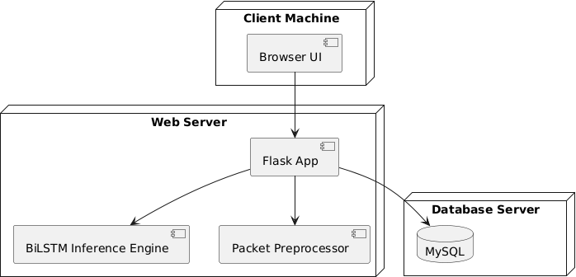

Figure. 3.5.7 Deployment Diagram

CHAPTER 4

SYSTEM IMPLEMENTATION AND MAINTENANCE

IMPLEMENTATION
The implementation of the Real-Time Malware Detection Using BiLSTM system involves several key phases, including data preprocessing, model training, system integration, and deployment. The system is designed to efficiently analyze network traffic and detect malware threats in real time.

Data Preprocessing
The first step involves collecting network traffic data, extracting relevant features from packet headers and payloads, and cleaning the data by removing redundant or missing values. The dataset is then transformed into a structured format suitable for deep learning.

Model Training and Optimization
A Bidirectional Long Short-Term Memory (BiLSTM) network is trained using the preprocessed network traffic data. The model is fine-tuned using hyperparameter optimization techniques to enhance its accuracy in detecting malware patterns. The training process includes evaluating the model's performance based on precision, recall, and F1-score to ensure effective classification.

System Integration
The trained BiLSTM model is integrated into a Flask-based web application, which serves as the front-end interface for users. The system is connected to a MySQL database that stores detected malware logs, historical data, and system alerts. The integration also includes APIs for real-time packet inspection.

Real-Time Packet Analysis
The system continuously monitors network traffic, extracting key features from incoming packets and analyzing them using the trained BiLSTM model. If a malicious activity is detected, the system generates an alert and logs the details for further investigation.

Deployment and User Access
The system is deployed on a server for real-time operation, enabling users (administrators and cybersecurity analysts) to access the dashboard, view detection reports, and manage security responses. The web interface ensures ease of use and provides visualization tools for analyzing detected threats.

Testing and Performance Evaluation
After deployment, rigorous testing is conducted to validate the system’s performance in different network environments. Test cases include evaluating detection accuracy, response time, and false positive rates to ensure the system’s reliability in real-world scenarios.
By implementing this system, organizations can enhance their cybersecurity posture, detect threats proactively, and respond to malware attacks efficiently.

SYSTEM MAINTENANCE
The maintenance of the Real-Time Malware Detection Using BiLSTM system is crucial for ensuring its continuous effectiveness and reliability in detecting evolving cyber threats. The system maintenance process involves regular updates, performance monitoring, security enhancements, and troubleshooting.

Regular Model Updates
Since malware evolves constantly, the BiLSTM model requires periodic retraining with updated datasets. New network traffic data containing the latest malware patterns are collected and used to improve detection accuracy. Retraining helps in adapting the system to emerging threats.

Performance Monitoring
Continuous monitoring of system performance ensures that the malware detection model operates efficiently. Key performance indicators such as detection accuracy, false positive rates, and response times are analyzed to identify any decline in effectiveness. Logs and reports are reviewed periodically to track system behavior.

Security Enhancements
Regular security updates are applied to address vulnerabilities in the system. Patching software dependencies, updating the Flask framework, and strengthening database security help prevent potential exploitation by attackers. Encryption mechanisms and authentication protocols are periodically reviewed and enhanced.

Database Maintenance
The MySQL database storing malware logs and detection reports undergoes regular maintenance. Unnecessary data is archived or removed to optimize storage and improve query performance. Backup procedures are implemented to prevent data loss in case of system failure.

Bug Fixes and Troubleshooting
System bugs and performance issues are identified through user feedback and error logs. Any anomalies or unexpected crashes are investigated, and necessary fixes are deployed promptly.

User Support
Administrators and cybersecurity teams receive ongoing support, including system usage guidance and troubleshooting assistance. Documentation, including user manuals and system architecture details, is regularly updated to reflect changes in functionality and security protocols.

SYSTEM DEVELOPMENT
The Real-Time Malware Detection Using BiLSTM project aims to enhance cybersecurity by utilizing deep learning techniques to identify and mitigate evolving malware threats. Traditional detection methods, such as signature-based and heuristic approaches, struggle to detect zero-day attacks and advanced persistent threats (APTs). Additionally, manual network traffic analysis is inefficient and error- prone. To overcome these limitations, this project leverages Bidirectional Long Short-Term Memory (BiLSTM) networks to analyze network traffic in real time, capturing both temporal and sequential dependencies to improve malware detection accuracy. The system processes incoming network packets by extracting essential features from both headers and payloads. These features are then fed into a BiLSTM model that identifies malicious patterns based on learned behaviors. If a threat is detected, an alert is generated, and appropriate mitigation measures are triggered. The system provides a user-friendly interface for administrators and cybersecurity professionals to monitor traffic, review detection reports, and respond to threats efficiently.

Developed using Python, the project incorporates frameworks such as TensorFlow and Keras for deep learning, Flask for web-based deployment, and MySQL for storing network logs and detection results.The system’s real-time capability ensures quick response to potential attacks, minimizing the risk of security breaches. By implementing this solution, organizations can improve their ability to detect and prevent malware threats more effectively. The use of BiLSTM enhances accuracy while reducing false positives, making the system highly reliable and scalable for various cybersecurity applications. This project ultimately contributes to strengthening network security by providing a proactive approach to threat detection and mitigation.

CHAPTER 5

SYSTEM TESTING

SOFTWARE TESTING
Software testing ensures the reliability and accuracy of the malware detection system. Various testing methodologies are applied to validate the system's performance and security.

Unit Testing
Each module, including data preprocessing, feature extraction, BiLSTM model training, and malware prediction, is tested individually to verify its functionality.

Integration Testing
The interaction between different modules, such as dataset import, model deployment, and alert generation, is tested to ensure seamless data flow.

Performance Testing
The system is tested under different network traffic loads to evaluate its efficiency, response time, and scalability.

Security Testing
Ensures that the system is resistant to unauthorized access and cyber threats, safeguarding sensitive data and preventing false malware detections.

Accuracy Testing
The model's malware detection accuracy is assessed using performance metrics like precision, recall, F1-score, and confusion matrix.
By performing these tests, the system is validated for real-time malware detection, ensuring high performance and reliability in identifying network threats.

TEST CASE
Test Case ID: TC_001
Input: Upload dataset (CSV file)
Expected Result: Dataset successfully imported Actual Result: Dataset imported without errors Status: Pass

Test Case ID: TC_002
Input: Missing or corrupted dataset Expected Result: Error message displayed
Actual Result: Error message displayed. Status: Pass

Test Case ID: TC_003 Input: Preprocess dataset
Expected Result: Data cleaned and normalized
Actual Result: Data processed successfully. Status: Pass

Test Case ID: TC_004
Input: Extract features using PCA
Expected Result: Dimensionality reduced successfully Actual Result: Features extracted correctly. Status: Pass

Test Case ID: TC_005
Input: Train BiLSTM model with dataset Expected Result: Model trains without interruption
Actual Result: Model training completed successfully Status: Pass

Test Case ID: TC_006
Input: Input network packet for prediction
Expected Result: System classifies packet as malware or benign.Actual Result: Correct classification given. Status: Pass

Test Case ID: TC_007
Input: Input known malware packet Expected Result: System detects as malware
Actual Result: Malware detected successfully. Status: Pass

Test Case ID: TC_008 Input: Input benign packet
Expected Result: System detects as normal. Actual Result: Correct classification as benign. Status: Pass

Test Case ID: TC_009
Input: Generate real-time alert for malware detection Expected Result: Alert sent to the admin
Actual Result: Alert received successfully. Status: Pass

Test Case ID: TC_010
Input: Unauthorized access attempt
Expected Result: System blocks access and logs activity Actual Result: Unauthorized attempt detected and logged Status: Pass

Test Case ID: TC_011

Input: Deploy trained model
Expected Result: Model successfully deployed in the PI Online Tool Actual Result: Model runs without errors. Status: Pass

Test Case ID: TC_012
Input: Load large network traffic dataset Expected Result: System processes without crash
Actual Result: Dataset processed without performance issues. Status: Pass

Test Case ID: TC_013
Input: User login authentication with valid credentials Expected Result: Access granted
Actual Result: Successful login Status: Pass

Test Case ID: TC_014
Input: User login authentication with invalid credentials
Expected Result: Access denied Actual Result: Unauthorized attempt blocked Status: Pass

TEST REPORT

Introduction
The purpose of this test report is to evaluate the performance, accuracy, and reliability of the proposed malware detection system. The system utilizes Bidirectional Long Short-Term Memory (BiLSTM) networks for analyzing network traffic and detecting malware in real time. Various test cases have been executed to validate its functionality, efficiency, and robustness.

Test Objective

The primary objective of the testing process is to verify that the malware detection system correctly identifies malicious network packets, generates real-time alerts, and maintains accuracy under different conditions. The key focus areas include:
      - Ensuring the system correctly classifies malware and benign traffic.
      - Evaluating system performance under high traffic conditions.
      - Validating the real-time alerting mechanism and Ensuring security features function as expected.

Test Scope
The test scope of the proposed system encompasses several critical components to ensure its effectiveness and reliability. It includes evaluating the accuracy of data preprocessing and feature extraction, assessing the efficiency of model training and validation processes, and measuring the performance of malware classification. Additionally, the system is tested for its stability and responsiveness under heavy network traffic loads to verify its robustness in real-world scenarios. User authentication and access control mechanisms are also examined to ensure secure and authorized usage of the system.User authentication and access control mechanisms.

Test Environment
      - Hardware: Intel Core i5 processor (or equivalent), 8 GB RAM, 50 GB free disk space.
      - Operating System: Windows 10 / Linux (Ubuntu).
      - Software & Tools: Python 3.6+, TensorFlow, Keras, Flask, MySQL, Jupyter Notebook, Google Colab.

      - Network: Stable internet connection for real-time data processing.

Test Result
The system successfully passed all the test cases, including:
      - Dataset Import and Preprocessing: The system accurately handled missing values and feature extraction.
      - Model Training & Prediction: The BiLSTM model performed well with high accuracy in detecting malware.
      - Real-Time Packet Analysis: Successfully classified both benign and malicious packets.
      - System Performance: Handled large network traffic without crashes or slowdowns.
      - Security & Access Control: Unauthorized login attempts were detected and blocked.

Test Conclusion
Based on the results of the conducted test cases, the malware detection system is found to be reliable, efficient, and capable of detecting real-time network threats. The BiLSTM-based approach significantly improves malware classification accuracy compared to traditional methods. The system meets the expected requirements and is ready for deployment with minor optimizations for further performance enhancements.

CHAPTER 6

CONCLUSION AND FUTURE ENHANCEMENT

CONCLUSION
In conclusion, the Real-Time Malware Detection System Using BiLSTM is a cutting-edge cybersecurity solution designed to combat evolving malware threats by leveraging deep learning. The system integrates Bidirectional LSTM (BiLSTM) networks to analyze network traffic, capturing both temporal and sequential dependencies for enhanced threat detection. By employing in-depth packet inspection, the system identifies malicious activities in real time, surpassing the limitations of traditional signature-based methods.
Key components such as real-time data processing, deep learning-based anomaly detection, and automated threat alerts contribute to an efficient and proactive cybersecurity framework. The system architecture, built using Python, Flask, MySQL, and TensorFlow, ensures high performance, scalability, and adaptability to emerging threats. Additionally, the integration of a user-friendly web interface allows administrators to monitor network activity seamlessly.
With its advanced detection mechanisms, automated learning capabilities, and real- time response system, this project presents a significant advancement in network security. It not only enhances the accuracy of malware detection but also reduces manual effort, making cybersecurity more efficient and effective. The system is poised to be a valuable tool for organizations, ensuring stronger defense against sophisticated cyber threats while continuously evolving to address future security challenges.

FUTURE ENHANCEMENT

Cross-Platform Compatibility: Expanding the system to support various platforms, including mobile and IoT devices, for broader malware detection coverage.
Multilingual Support: Expanding the system's ability to analyze network traffic across different regions and languages, increasing its global applicability.
Integration with Blockchain for Security: Utilizing blockchain technology to provide tamper-proof logs for network traffic analysis and malware detection results.
Improved Data Privacy: Introducing advanced encryption techniques for data transmission to ensure the protection of sensitive network traffic information.

REFERENCES
    - Xu, H., Zhang, Y., Liu, Z., Li, Y., Xu, C., & Li, B. (2023). Harry: A scalable SIMD-based multi-literal pattern matching engine for deep packet inspection. In Proceedings of the IEEE Conference on Computer Communications (INFOCOM) (pp. 1–10). IEEE. https://doi.org/10.1109/INFOCOM53939.2023.10229022
    - Abbasi, M., Shahraki, A., & Taherkordi, A. (2021). Deep learning for network traffic monitoring and analysis (NTMA): A survey. Computer Communications, 170, 19–41. https://doi.org/10.1016/j.comcom.2021.01.012
    - Choorod, P., Weir, G., & Fernando, A. (2024). Classifying Tor traffic encrypted payload using machine learning. IEEE Access, 12, 19418–19431. https://doi.org/10.1109/ACCESS.2024.3356073
    - Hypolite, J., Dong, Y., Feamster, N., Basu, S., & Vahdat, A. (2020). Deepmatch: Practical deep packet inspection in the data plane using network processors. In Proceedings of the ACM International Conference on Emerging Networking Experiments and Technologies (CoNEXT). https://doi.org/10.1145/3386367.3431304
    - Ning, J., Poh, G. S., Loh, J.-C., Chia, J., & Chang, E.-C. (2019, November). PrivDPI: Privacy-preserving encrypted traffic inspection with reusable obfuscated rules. In Proceedings of the ACM SIGSAC Conference on Computer and Communications Security (CCS) (pp. 1657–1670). https://doi.org/10.1145/3319535.3354223
    - Arshad, S., Zanib, R., Akram, A., & Saeed, T. (2023, January). A short review on faster and more reliable TCP reassembly for high-speed networks in deep packet inspection. In Proceedings of the 1st International Conference on

Advanced Innovations in Smart Cities (ICAISC) (pp. 1–6). IEEE. https://doi.org/10.1109/ICAISC56366.2023.10085644
    - Ponomarev, S., & Atkison, T. (n.d.). Industrial control system network intrusion detection by telemetry analysis. IEEE Transactions on Dependable and Secure Computing, 1–1. https://doi.org/10.1109/TDSC.2016.2602339
    - Zamfir, S., Balan, T., Sandu, F., & Costache, C. (2016, June). Solutions for deep packet inspection in industrial communications. In Proceedings of the 2016 International Conference on Communications (COMM) (pp. 153–158). IEEE. https://doi.org/10.1109/ICComm.2016.7528300
    - Xue, M., Ni, K., Zeng, Y., Yin, Y., & Zhao, B. (2024). A novel deep packet inspection method for polymorphic network. In Proceedings of the 6th International Conference on Next Generation Data-driven Networks (NGDN) (pp. 268–271). IEEE. https://doi.org/10.1109/NGDN.2024.10085644
    - Layas, A., Asbali, A., & Benmusa, T. (2022). Classification of the Libyan international internet traffic using deep packet inspection tools. 2022 International Conference on Microelectronics, Signals and Technology Applications (Mi-STA), 1–6.
https://doi.org/10.1109/MI-STA54861.2022.9837479

APPENDIX

SCREENSHOTS


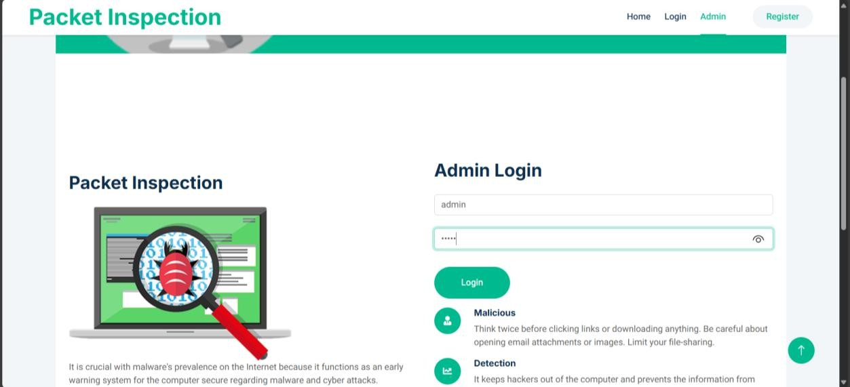

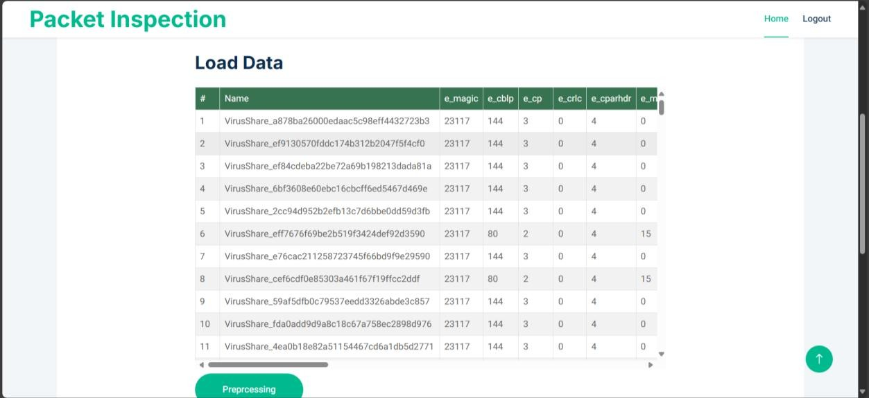

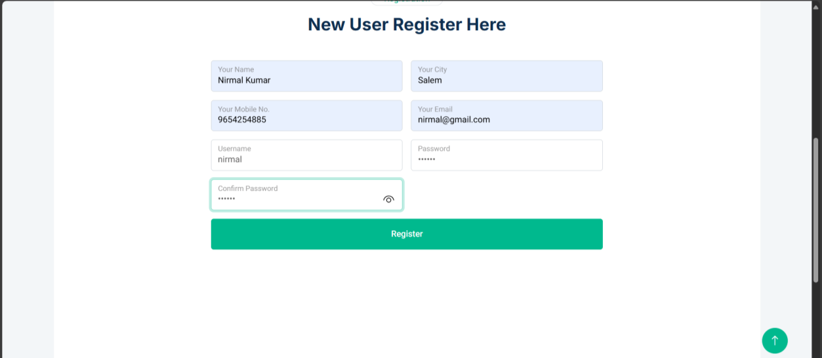

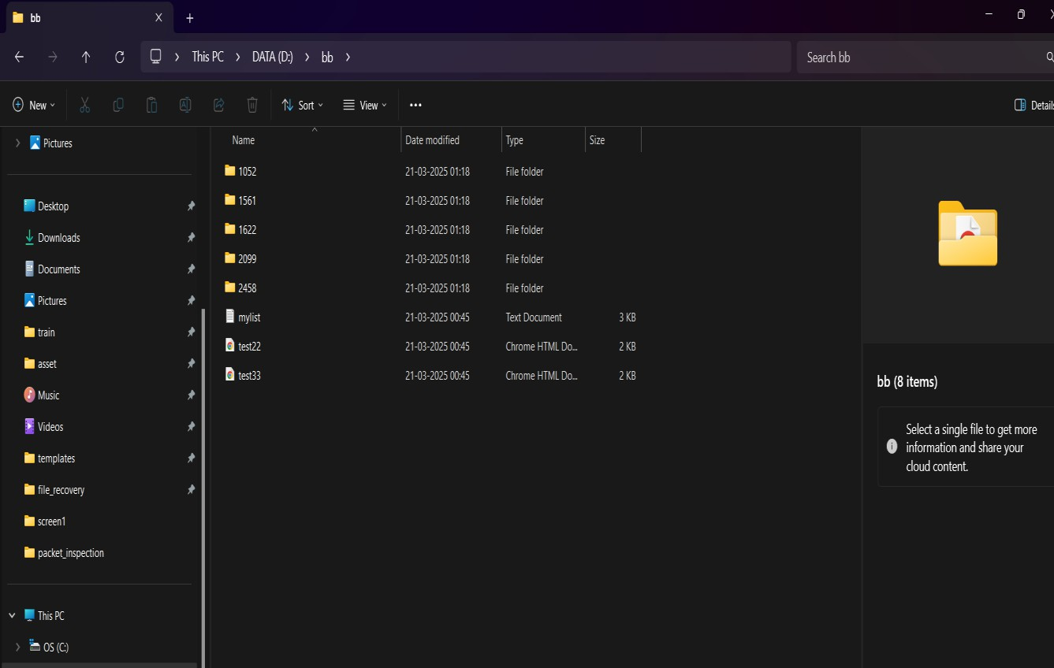




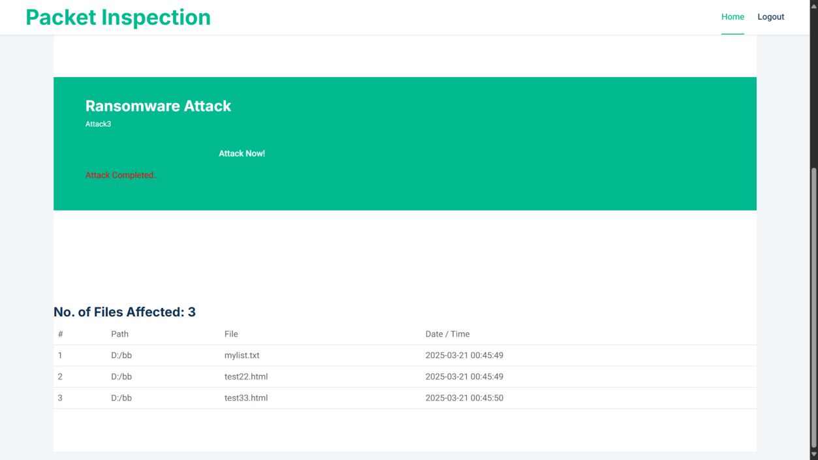

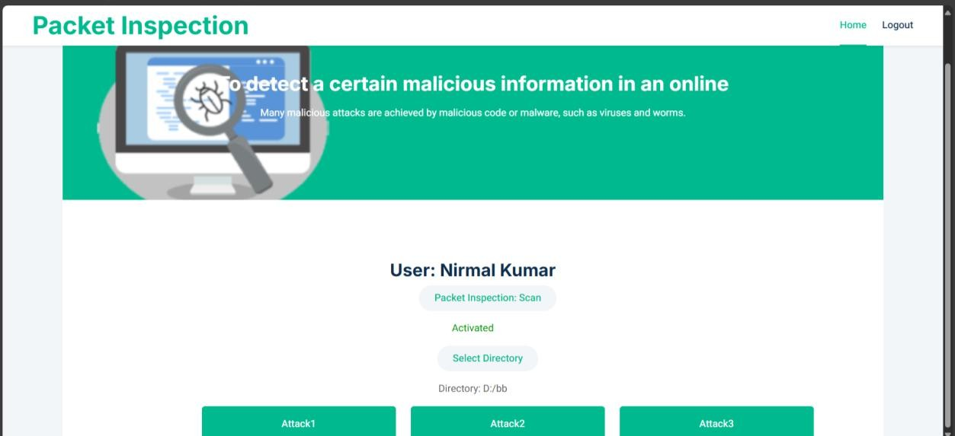

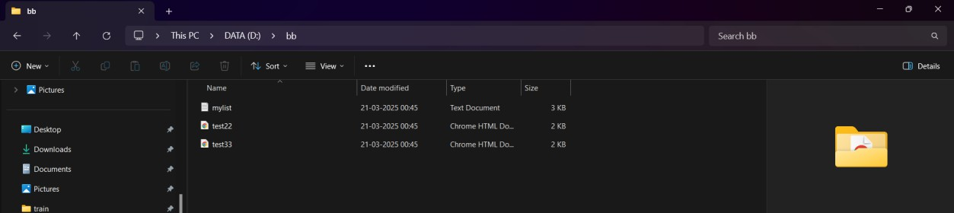

SOURCE CODE

Packages
from flask import Flask, render_template, Response, redirect, request, session, abort, url_for
import os import base64
from cryptography.hazmat.backends import default_backend from cryptography.hazmat.primitives import hashes
from cryptography.hazmat.primitives.kdf.pbkdf2 import PBKDF2HMAC from cryptography.fernet import Fernet

from PIL import Image
from datetime import datetime from random import randint
from werkzeug.utils import secure_filename from flask import send_file
import matplotlib.pyplot as plt import pandas as pd
import numpy as np import csv
import threading import shutil import hashlib import webbrowser import pickle
import seaborn as sns
from sklearn.model_selection import train_test_split
from sklearn.metrics import classification_report, confusion_matrix import tensorflow as tf
from tensorflow.keras.models import Sequential
from tensorflow.keras.layers import Embedding, Bidirectional, LSTM, Dense,
Dropout
from sklearn.model_selection import train_test_split from sklearn.preprocessing import LabelEncoder import mysql.connector
User Registration def register(): msg=""

act=request.args.get("act") mycursor = mydb.cursor() f request.method=='POST':
name=request.form['name'] city=request.form['city'] mobile=request.form['mobile'] email=request.form['email'] uname=request.form['uname'] pass1=request.form['pass']
mycursor.execute("SELECT count(*) FROM register where uname=%s",(uname,)) myresult = mycursor.fetchone()[0]
if myresult==0:
mycursor.execute("SELECT max(id)+1 FROM register") maxid = mycursor.fetchone()[0]
if maxid is None:
maxid=1
now = date.today() #datetime.datetime.now() rdate=now.strftime("%d-%m-%Y")
sql = "INSERT INTO register(id,name,city,mobile,email,uname,pass,create_date) VALUES (%s,%s,%s,%s,%s,%s,%s,%s)"
val = (maxid,name,city,mobile,email,uname,pass1,rdate) mycursor.execute(sql, val)
mydb.commit()
<form name="form1" method="post" class="php-email-form">
<div class="row g-3">
<div class="col-md-6">
<div class="form-floating">

<div class="col-md-6">
<div class="form-floating">
<input type="text" class="form-control" name="city" placeholder="Your City">
<label>Your City</label>
</div>
</div>
<div class="col-md-6">
<div class="form-floating">
<input type="text" class="form-control" name="email" placeholder="Your Email">
<label>Your Email</label>
</div>
</div>
<div class="col-6">
<div class="form-floating">
<input type="text" class="form-control" name="uname" placeholder="Username">
<label>Username</label>
</div>
</div>
<div class="col-6">
<div class="form-floating">
<input type="password" class="form-control" name="pass" placeholder="Password">
<label>Password</label>
</div>
</div>

</form>

Training
def preprocess():
msg="" uname=""
if 'username' in session:
uname = session['username'] mycursor = mydb.cursor()
dat1 = pd.read_csv('static/dataset/dataset_malwares.csv') data3=[]
dat=dat1.head(200) rows=len(dat1.values) for ss3 in dat.values:
cnt=len(ss3) data3.append(ss3) cols=cnt mem=float(rows)*0.75 list_of_column_names=[]
with open("static/dataset/dataset_malwares.csv") as csv_file: csv_reader = csv.reader(csv_file, delimiter = ',') list_of_column_names = []
for row in csv_reader: list_of_column_names.append(row) break
#Feature Extraction def feature(): msg=""

uname=""
if 'username' in session:
uname = session['username'] mycursor = mydb.cursor()
data = pd.read_csv('static/dataset/dataset_malwares.csv')
used_data = data.drop(['Name', 'Machine', 'TimeDateStamp', 'Malware'], axis=1) '''plt.figure(figsize=(8, 6))
ax=sns.countplot(data['Malware']) ax.set_xticklabels(['Benign', 'Malware']) plt.savefig("static/graph/graph1.png")'''
features = ['MajorSubsystemVersion', 'MajorLinkerVersion', 'SizeOfCode', 'SizeOfImage', 'SizeOfHeaders', 'SizeOfInitializedData', 'SizeOfUninitializedData', 'SizeOfStackReserve', 'SizeOfHeapReserve', 'NumberOfSymbols', 'SectionMaxChar']
for feature in features:
plt.figure(figsize=(10, 15))
ax1 = plt.subplot(len(features), 2, i) sns.distplot(data[data['Malware']==1][feature], ax=ax1, kde_kws={'bw': 0.1}) ax1.set_title(f'Malware', fontsize=10)
ax2 = plt.subplot(len(features), 2, i+1) sns.distplot(data[data['Malware']==0][feature], ax=ax2, kde_kws={'bw': 0.1}) ax2.set_title(f'Benign', fontsize=10) #plt.savefig("static/graph/g"+str(j)+".png")
i= i+2 j+=1 #BiLSTM
def bestThresshold(y_train,train_preds):

tmp = [0,0,0] # idx, cur, max delta = 0
for tmp[0] in tqdm(np.arange(0.1, 0.501, 0.01)):
tmp[1] = f1_score(y_train, np.array(train_preds)>tmp[0]) if tmp[1] > tmp[2]:
delta = tmp[0] tmp[2] = tmp[1]
print('best threshold is {:.4f} with F1 score: {:.4f}'.format(delta, tmp[2])) return delta , tmp[2]
def model_train_cv(x_train,y_train,nfold,model_obj): splits = list(StratifiedKFold(n_splits=nfold, shuffle=True, random_state=SEED).split(x_train, y_train))
x_train = x_train
y_train = np.array(y_train)
# matrix for the out-of-fold predictions train_oof_preds = np.zeros((x_train.shape[0])) for i, (train_idx, valid_idx) in enumerate(splits): print(f'Fold {i + 1}')
x_train_fold = x_train[train_idx.astype(int)] y_train_fold = y_train[train_idx.astype(int)] x_val_fold = x_train[valid_idx.astype(int)] y_val_fold = y_train[valid_idx.astype(int)] clf = copy.deepcopy(model_obj)
clf.fit(x_train_fold, y_train_fold, batch_size=512, epochs=5, validation_data=(x_val_fold, y_val_fold))
valid_preds_fold = clf.predict(x_val_fold)[:,0] # storing OOF predictions

train_oof_preds[valid_idx] = valid_preds_fold return train_oof_preds
data = pd.read_csv('static/dataset/dataset_malwares.csv')
used_data = data.drop(['Name', 'Machine', 'TimeDateStamp', 'Malware'], axis=1) features = ['MajorSubsystemVersion', 'MajorLinkerVersion', 'SizeOfCode', 'SizeOfImage', 'SizeOfHeaders', 'SizeOfInitializedData', 'SizeOfUninitializedData', 'SizeOfStackReserve', 'SizeOfHeapReserve', 'NumberOfSymbols', 'SectionMaxChar']
X_train, X_test, y_train, y_test = train_test_split(used_data, data['Malware'], test_size=0.2, random_state=0)
print(f'Number of used features is {X_train.shape[1]}')
rfc = RandomForestClassifier(n_estimators=100, random_state=0, oob_score True, max_depth = 16)
rfc.fit(X_train, y_train) y_pred = rfc.predict(X_test)
print(classification_report(y_test, y_pred, target_names=['Benign', 'Malware'])) #ax=sns.heatmap(confusion_matrix(y_pred, y_test), annot=True, fmt="d", cmap=plt.cm.Blues, cbar=False)
ax.set_xlabel('Predicted labels') ax.set_ylabel('True labels') plt.savefig("static/graph/graph2.png") plt.close() importance = rfc.feature_importances_
importance_dict = {used_data.columns.values[i]: importance[i] for i in range (len(importance))}
sorted_dict = {k: v for k, v in sorted(importance_dict.items(), key=lambda item: item[1])}

CERTIFICATE












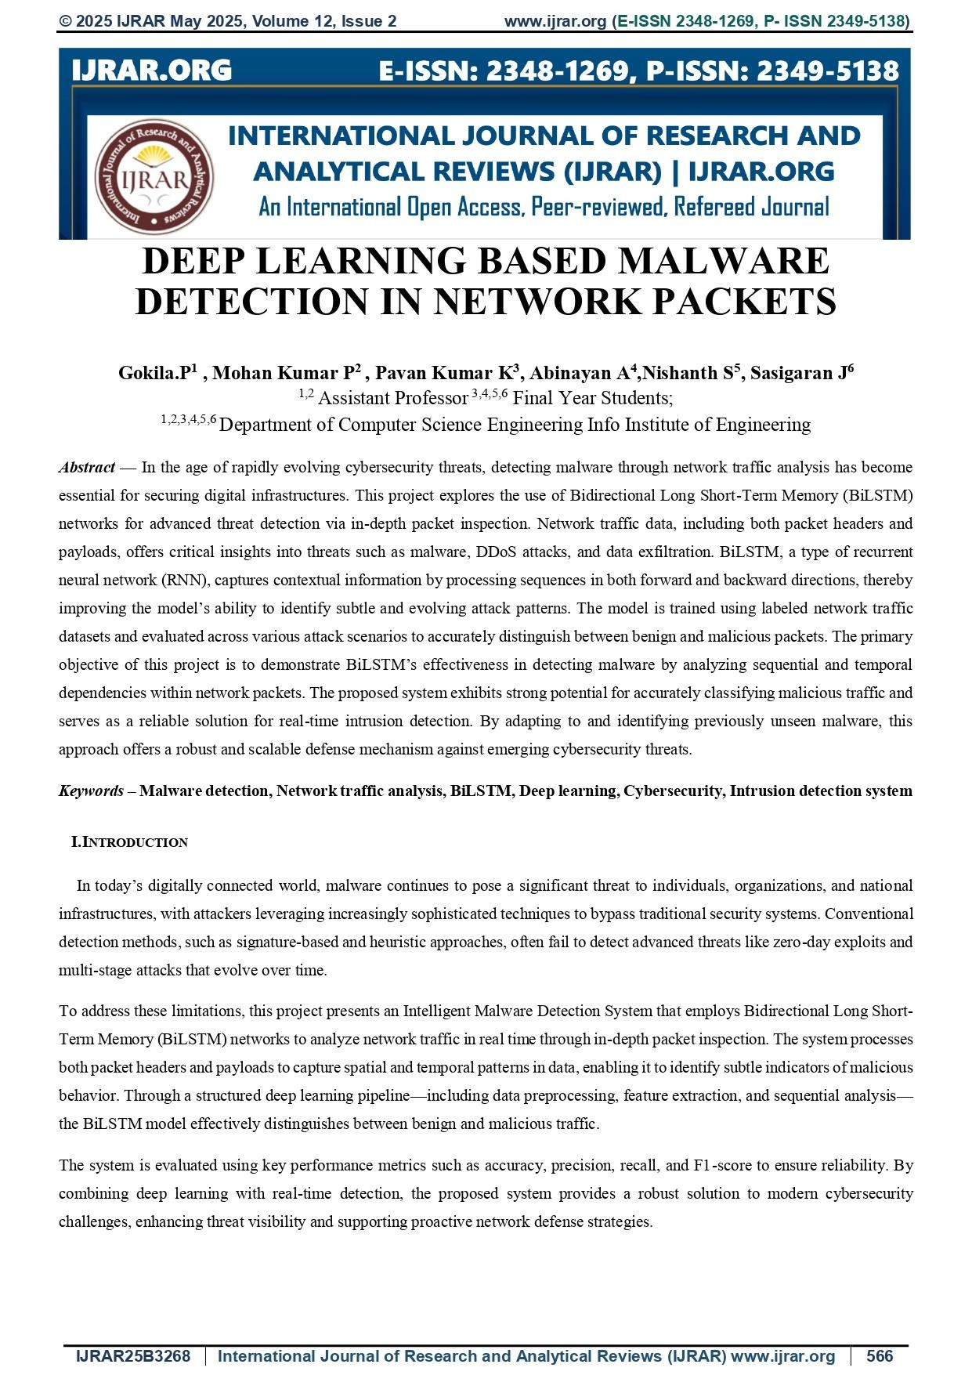
52

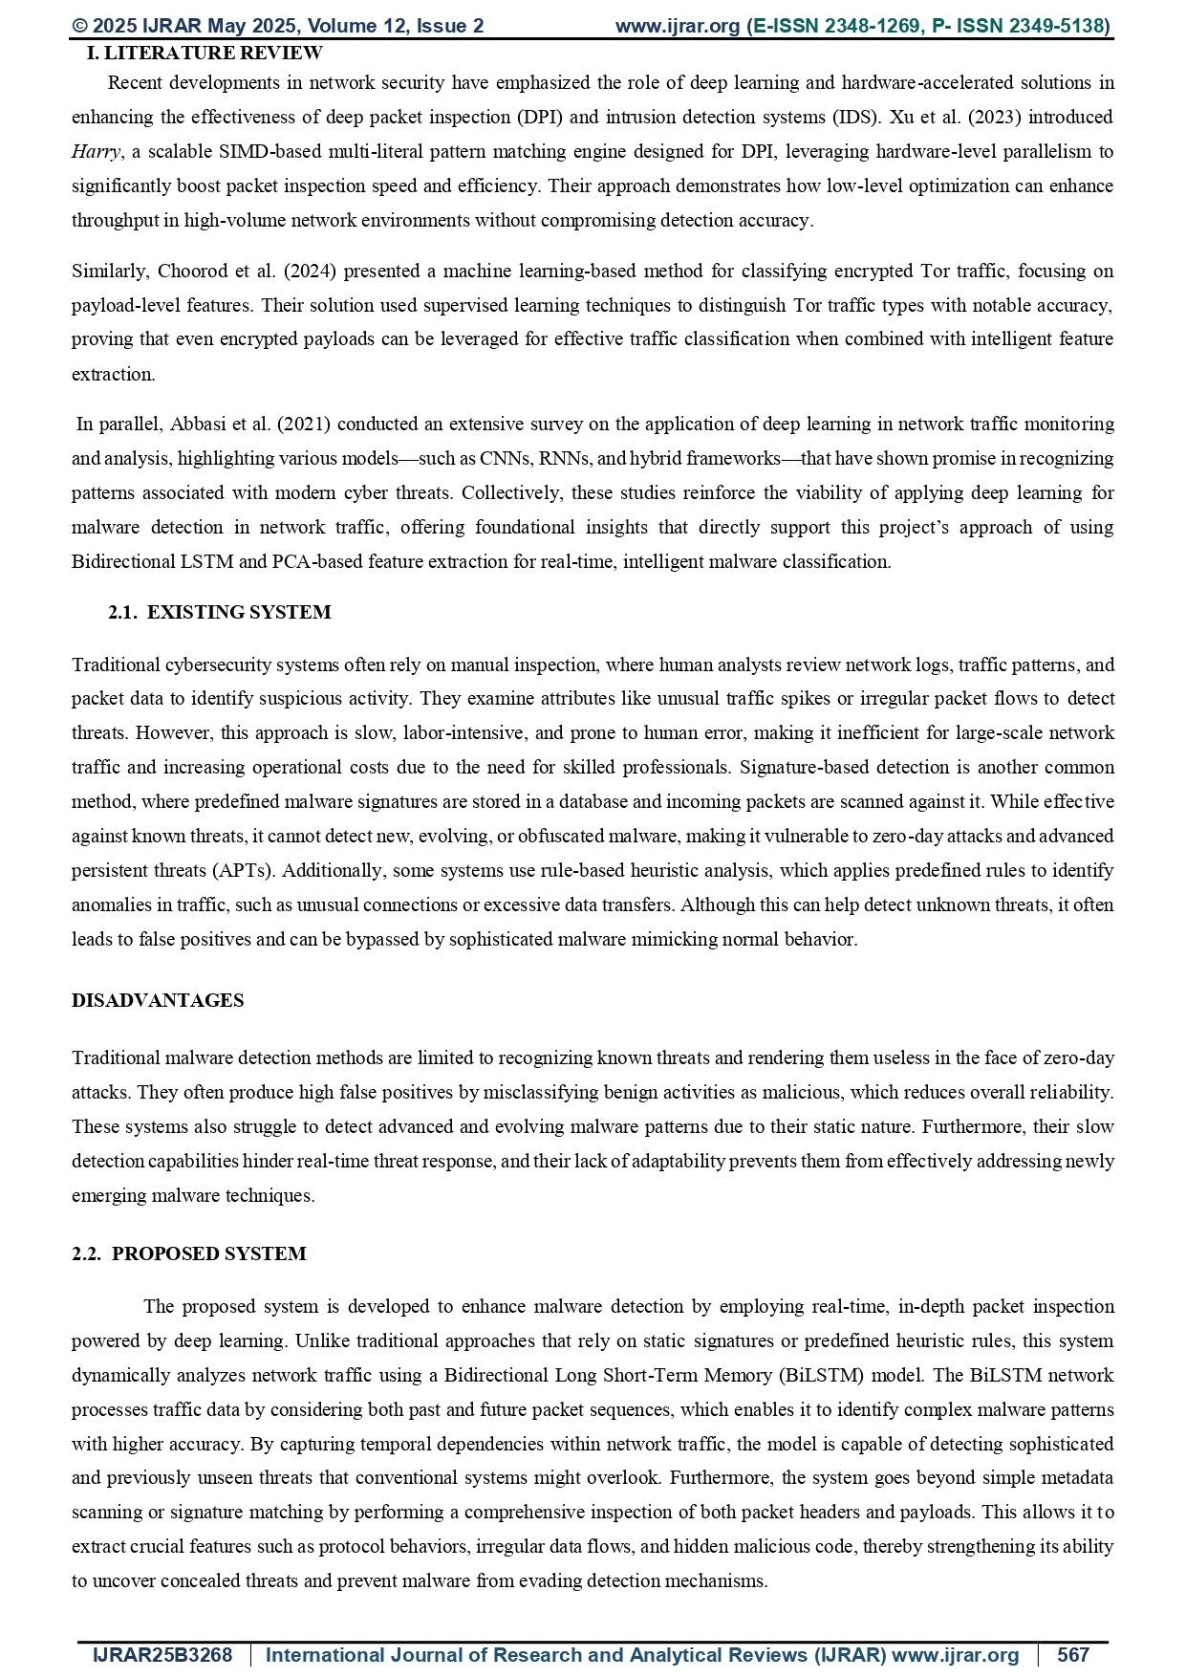
53

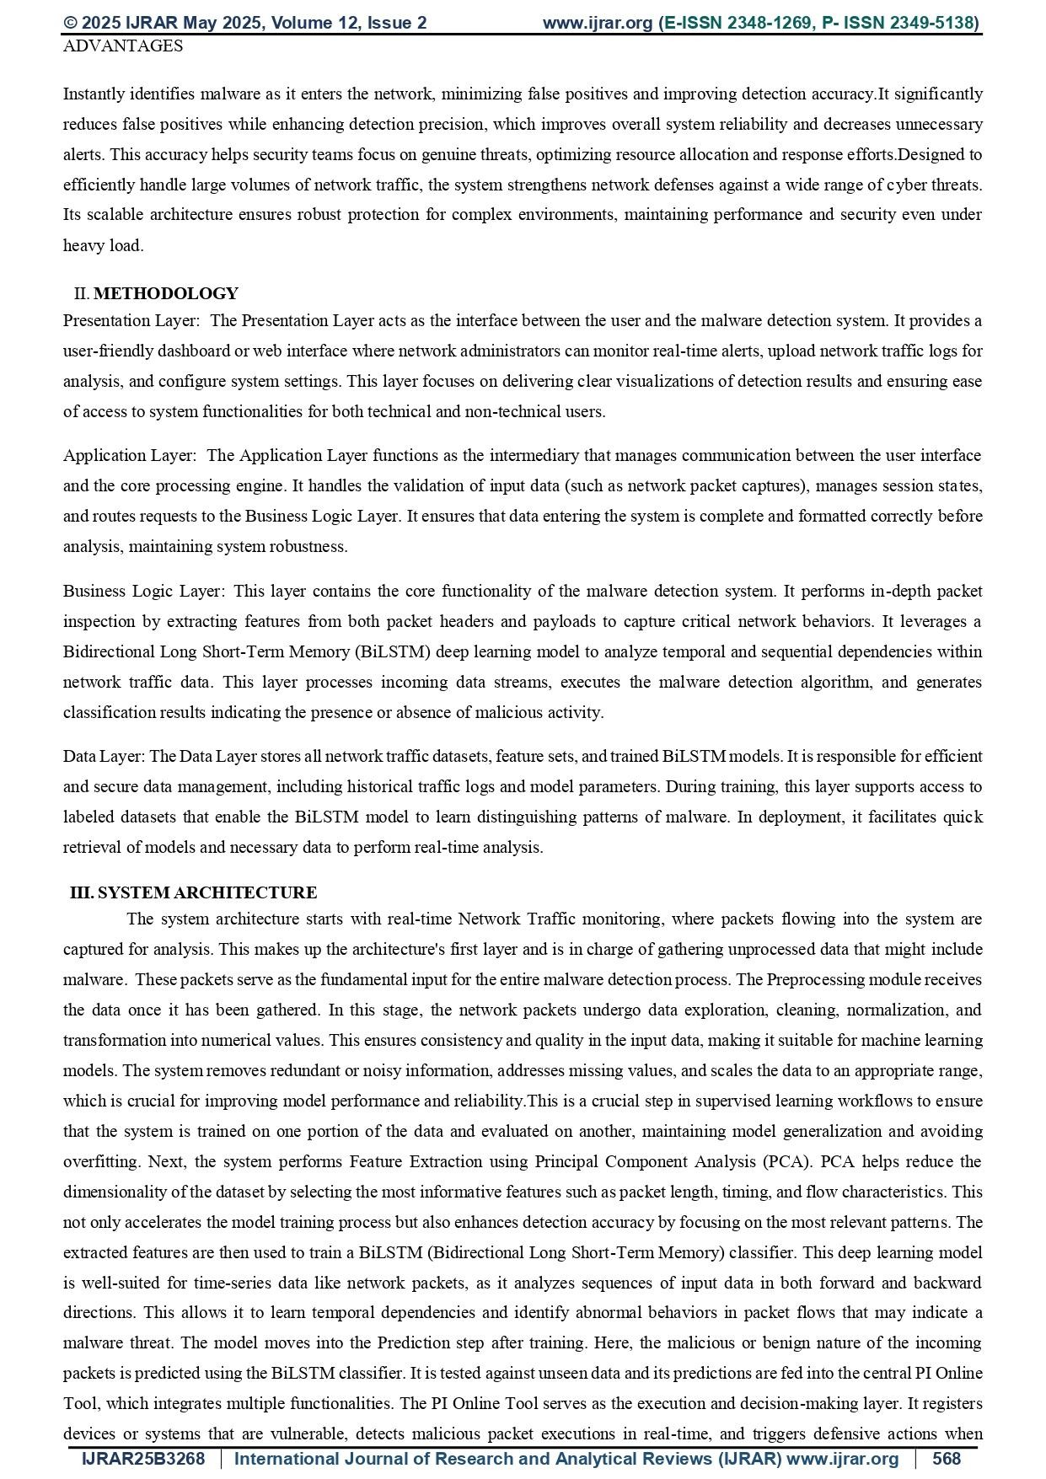
54

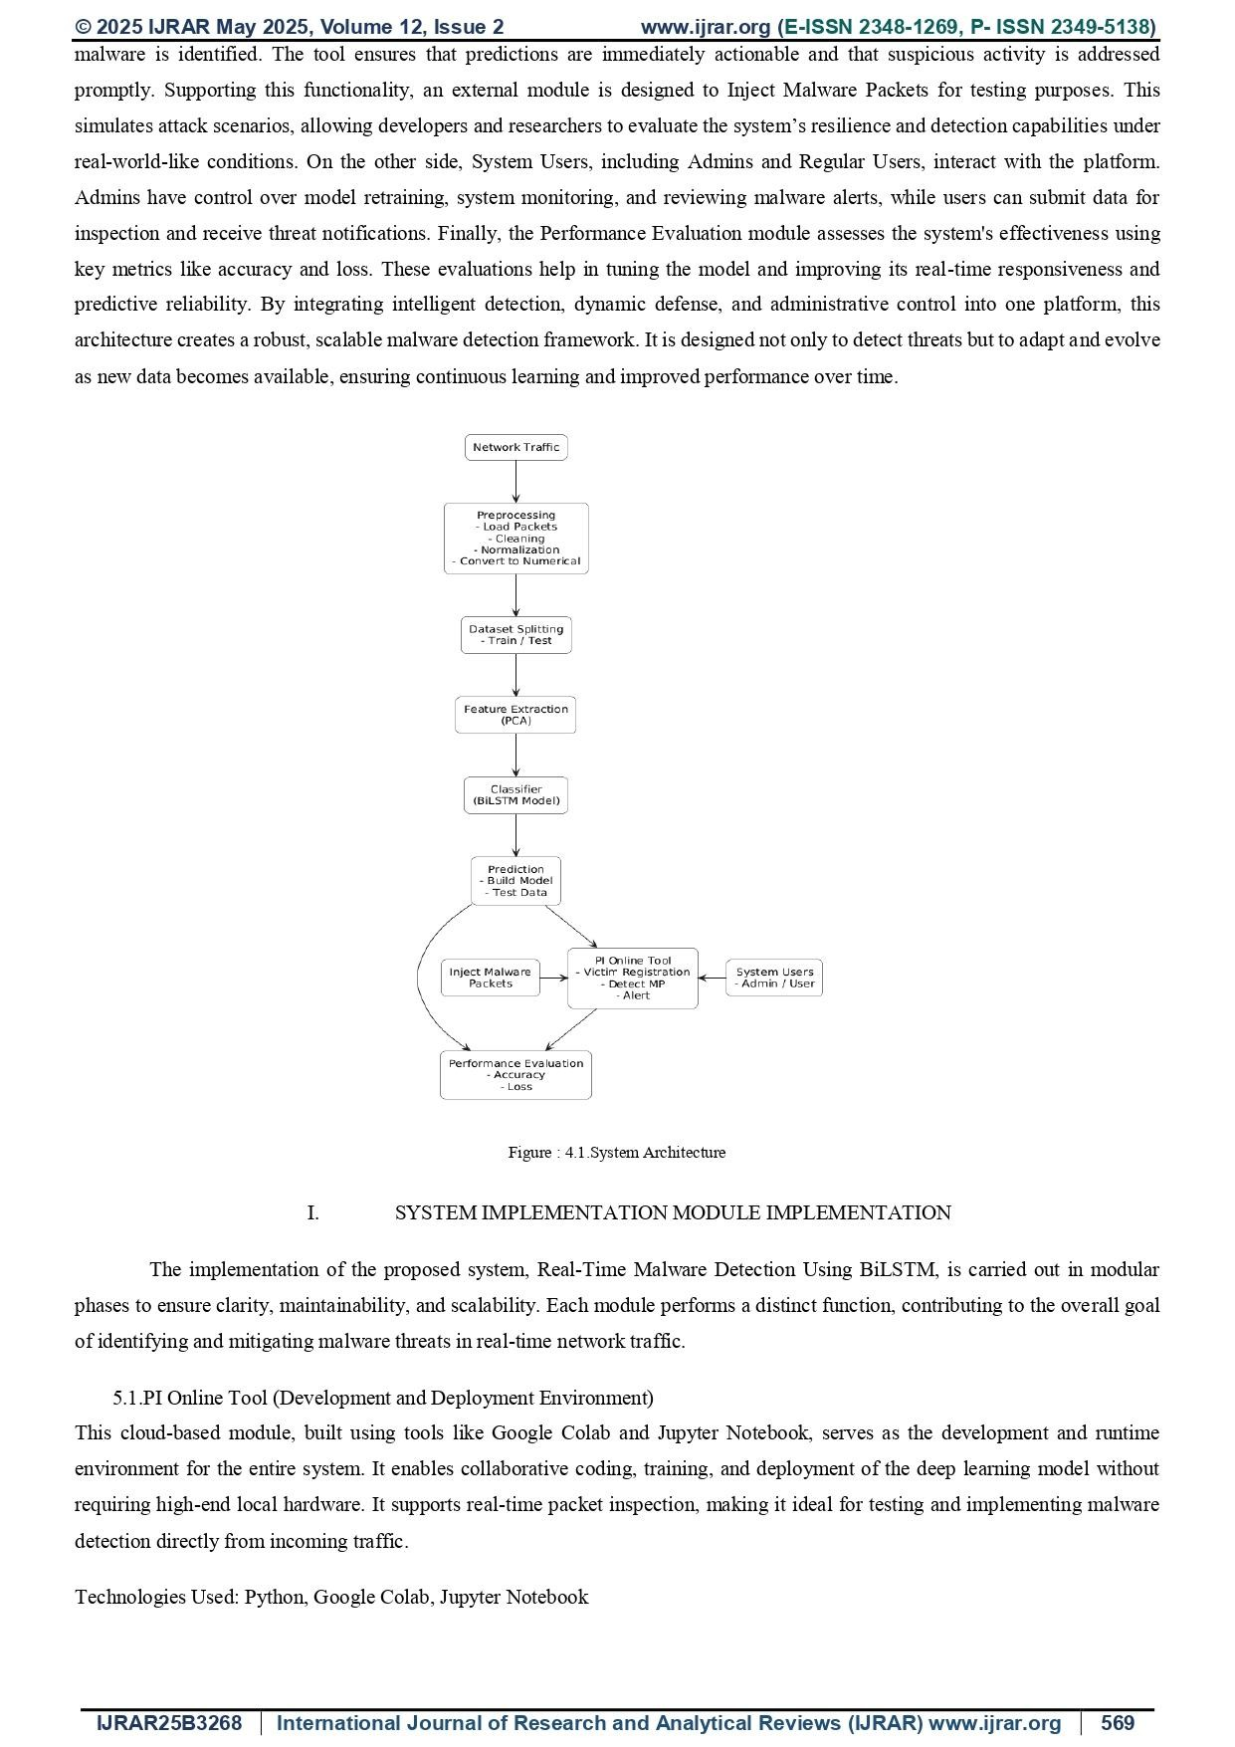
55

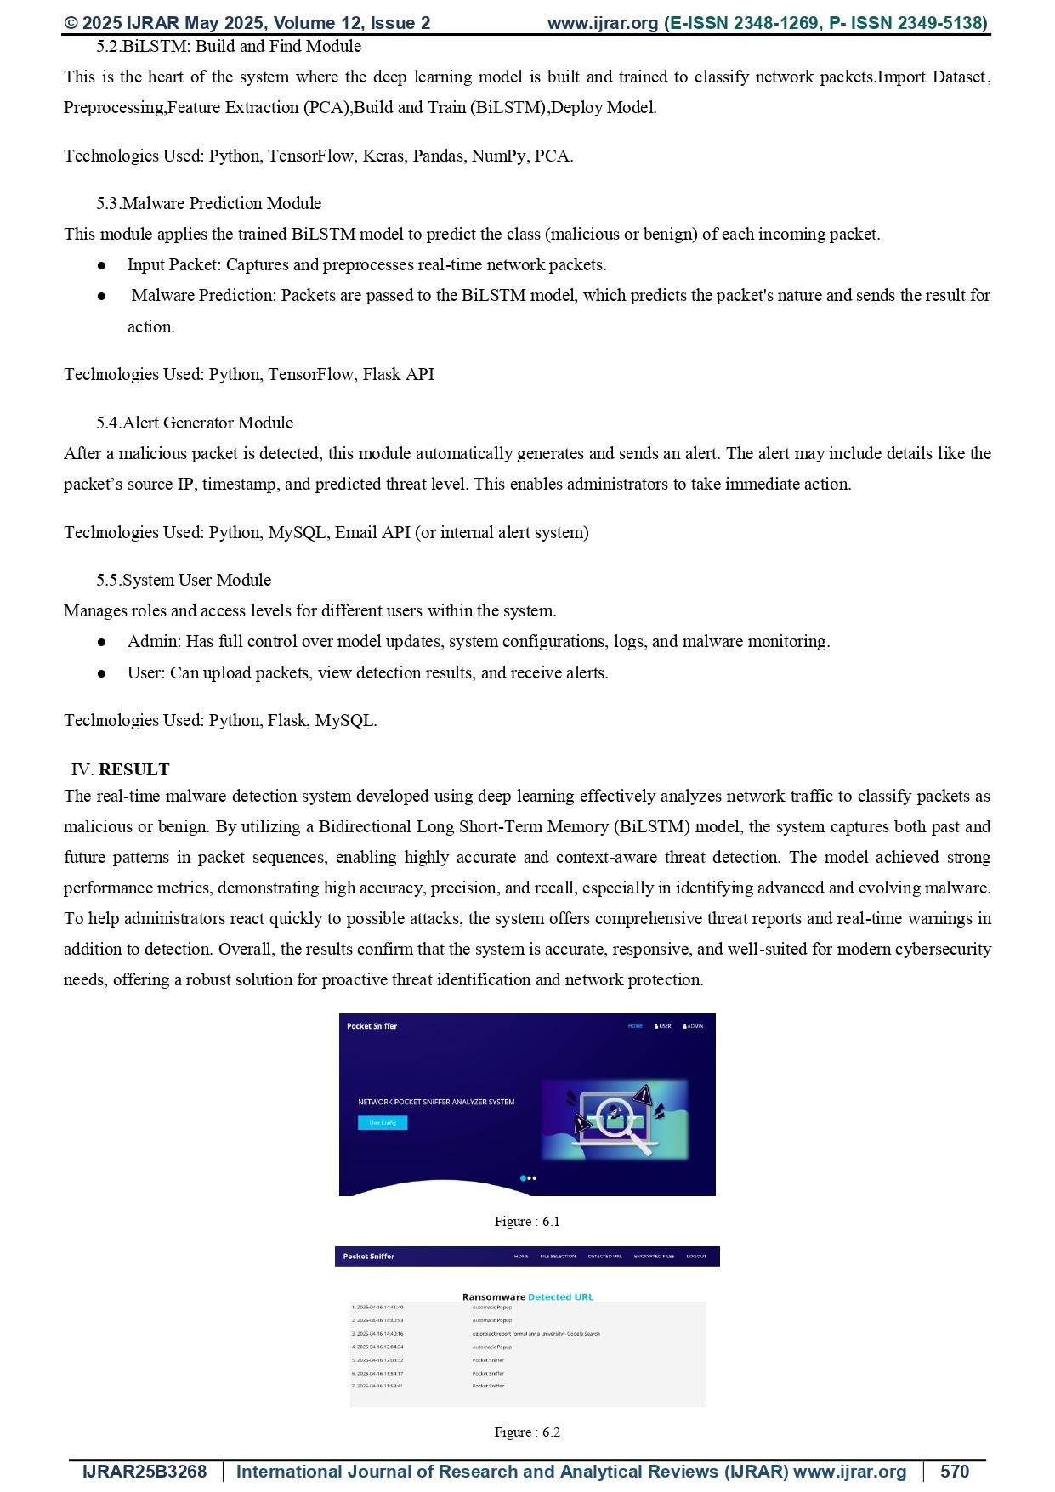
56

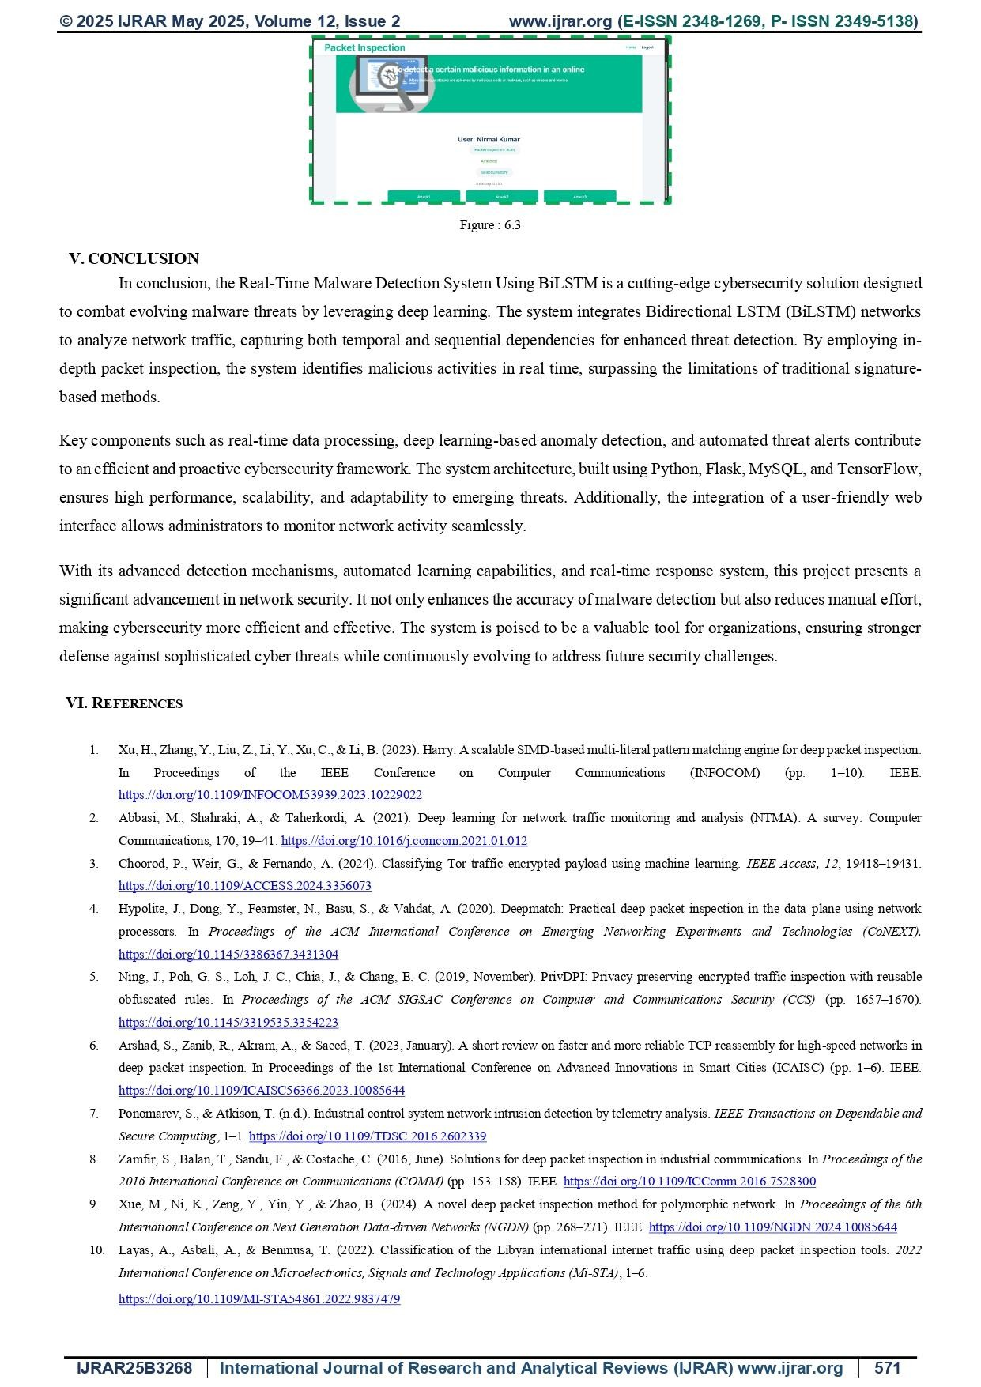
57

