Comparative analysis and implementation of an AI model embedded on Raspberry Pi 3, 4 and 5: detection of hardware limitations and performance optimization

SLIMANI OUSSAMA
Department Electronics
Faculty of Elecrical Engineering
University of Sciences & Technology Houari Boumedienne
USTHB
Algeria
oussama.slimani@usthb.edu.dz
BOUDJIT KAMEL
Department Electronics
Faculty of Elecrical Engineering
University of Sciences & Technology Houari Boumedienne
USTHB
Algeria
kamel.boudjit@usthb.edu.dz

Abstract— The rise of embedded artificial intelligence is paving the way for numerous real-time applications in a variety of fields, ranging from public safety to medical imaging. This work presents a comparative study of the implementation of an AI model on three generations of Raspberry Pi (3, 4 and 5), through three representative scenarios: (i) autonomous surveillance of public spaces through the detection of acts of violence, (ii) real-time detection and alerting of road signs for vehicles, and (iii) automated analysis of brain MRIs for the detection of neurological abnormalities. Performance is evaluated in terms of accuracy, latency, video throughput, memory consumption, temperature and energy autonomy. The results highlight the significant hardware limitations of the Raspberry Pi 3 and 4 notably increased latency, thermal throttling and memory constraints compared to the Raspberry Pi 5, which offers a notable improvement in processing fluidity and robustness. The study also proposes software optimization strategies (quantization, model reduction, I/O optimization) to improve the deployment of complex AI models on embedded platforms with limited resources.
Keywords-- L Embedded Artificial Intelligence, Raspberry Pi, Deep Learning, Computer Vision, Real-time Detection, Performance Optimisation.
Introduction
The integration of artificial intelligence (AI) into embedded systems is growing rapidly thanks to the miniaturization of components, improved computing performance and optimized algorithms. Raspberry Pi boards stand out as an accessible and versatile solution, but their limited resources pose challenges in terms of computing power, thermal management, memory, and energy consumption. Three representative use cases to illustrate these constraints: video surveillance to detect violent behavior, driver assistance through road sign recognition, and medical analysis of brain MRIs.
The aim of this work is to comparatively evaluate the performance of Raspberry Pi 3, 4 and 5 in these varied contexts, using a rigorous experimental protocol measuring accuracy, latency, throughput (FPS), memory usage, temperature and energy consumption. The results highlight the hardware limitations of generations 3 and 4, while showing the significant gains of the Raspberry Pi 5. Finally, software and hardware optimization strategies are proposed to improve the fluidity and reliability of embedded AI systems.

RELATED WORK
Running artificial intelligence models on embedded platforms such as Raspberry Pi faces constraints in terms of limited computing power, reduced memory, heat dissipation, and energy consumption. However, significant progress has been made thanks to various optimization strategies.
First, lightweight models such as TripleNet (designed for image classification on Raspberry Pi) illustrate the impact of compact architectures it shows a 15% to 30% reduction in inference compared to GhostNet, MobileNet, EfficientNet and HarDNet, while maintaining comparable accuracy [1].
At the same time, the work of Salem Ameen et al. highlights the effectiveness of pruning and conversion to TensorFlow Lite, enabling a significant reduction in inference time without compromising quality on classic datasets (MNIST, SVHN, etc.) [2] [3].
Next, the impact of quantization is highlighted in an MLPerf study: quantized INT8 models running via TensorFlow Lite on Raspberry Pi offer up to 4× acceleration in offline mode compared to FP32 models [4]. This illustrates the real value of quantization for embedded deployments.
Finally, practical benchmarks provide a concrete view of performance evolution across Raspberry Pi generations. For example, the transition from Pi 3 to Pi 4 doubles the inference speed on MobileNet SSD (COCO) with TensorFlow, and triples it when a Coral USB accelerator is used, which can be exploited thanks to USB 3.0 on the Pi 4 [5] [6] . The observations also include thermal issues: without active cooling, temperatures can reach 84°C, leading to throttling; adding a small fan brings this threshold down to 45°C and improves inference (90.9 ms → 79.5 ms) [6] [7]
Beyond the scientific literature, some contributions on Reddit provide valuable feedback. One user reports that on Raspberry Pi 5, a YOLOv8 model with INT8 quantization runs at around 15 FPS, while YOLOv8 (unquantized) peaks at 4 FPS, highlighting the difference in performance between optimized and conventional approaches [8]. Other feedback mentions the gains achieved on Raspberry Pi 3 and 4 depending on the model chosen: for example, TinyYOLOv3 runs at only 0.5–1 FPS, while MobileNetV2 can reach 2–3 FPS [9] [10]
One of the significant recent contributions is the cross-evaluation of the performance of object detection models (such as YOLOv8, EfficientDet Lite, SSD MobileNet) deployed on Raspberry Pi 3, 4 and 5 — with or without external TPU accelerators. This study highlights technical trade-offs between accuracy (mAP), energy consumption and latency: some compact models such as SSD MobileNet V1 ensure low energy consumption and fast inferences, while more complex models (such as YOLOv8 Medium) offer better accuracy but require more resources, unless they are combined with a TPU to compensate [11]. These results fuel our thinking about the optimal balance between performance, energy efficiency and accuracy in critical applications on Raspberry Pi.
Another notable project involves the deployment of an INT8-quantised YOLOv4-Tiny model for object detection in aerial environments (emergency services, first aid) on Raspberry Pi 5. The evaluated performance reveals a latency of 28.2 ms per image and energy consumption of 13.85 W, while maintaining satisfactory accuracy for several targeted categories (ambulance, police car, accident, firefighter [12]). This result demonstrates the ability of the Raspberry Pi 5, when combined with effective quantization, to perform critical AI processing in real time for embedded applications, even under demanding operating conditions. This work highlights the importance of combining lightweight models, software optimization (quantization, pruning, TFLite), parallelism, and possibly active cooling or a hardware accelerator, to exceed the limits of Raspberry Pi.

Materials & Methods
III.1 Hardware platforms
The comparative evaluation was conducted on three generations of Raspberry Pi, chosen for their popularity in embedded AI research and their successive hardware upgrades. The Raspberry Pi 3 Model B+ features a 1.4 GHz quad-core ARM Cortex-A53 processor, 1 GB of LPDDR2 RAM and a VideoCore IV graphics processor, with 300 Mbps Ethernet and USB 2.0 network interfaces. The Raspberry Pi 4 Model B offers a significant improvement with a 1.5 GHz quad-core ARM Cortex-A72 processor, 4 GB of LPDDR4 RAM (configurable to 2/4/8 GB), a VideoCore VI GPU, a Gigabit Ethernet port and USB 3.0 ports, enabling better bandwidth for acceleration devices. Finally, the Raspberry Pi 5, the latest generation tested, features a 2.4 GHz quad-core ARM Cortex-A76 processor, 8 GB of LPDDR4X RAM, a VideoCore VII GPU, and PCIe 2.0 and M.2 interfaces via adapters, while improving thermal and energy management. All boards were configured with 64-bit Raspberry Pi OS, a Python 3.9 or 3.11 environment, and TensorFlow Lite, OpenCV, and PyTorch libraries as required by the applications, in accordance with best practices recommended in the literature on embedded AI [Howard et al., 2017; Abadi et al., 2016].
III.2. Datasets
The experiments were based on three distinct use cases, selected for their representativeness and variety in terms of computational constraints.
For the detection of violent behavior, we used an annotated video dataset from public databases such as the Hockey Fight Dataset and Movies Fight Dataset, supplemented by recorded sequences to diversify the scenarios. The videos, with resolutions of 640×480 and 1280×720 at 30 frames per second, were annotated frame by frame or in 5-second sequences, according to the method recommended by Hassner et al. [2012].
For the detection and alerting of road signs, we used the GTSRB (German Traffic Sign Recognition Benchmark) [Stallkamp et al., 2012], enriched with local images to include variants specific to our context. The images, in RGB format, range from 32×32 to 128×128 pixels and cover classes such as speed limits, prohibition signs, warnings and various other signs.
Finally, for the analysis of brain MRIs, we used data from public collections (notably the Kaggle Brain MRI Dataset and the Harvard MRI Dataset), comprising T1 and T2 MRI images in 256×256 pixel format converted to greyscale. The classes selected distinguish between healthy brains, benign tumors and malignant tumors, in accordance with current medical classification methodology. [Cheng et al., 2015].
III.3. AI models and architectures
The architecture was selected based on the constraints of each application and optimized for deployment on platforms with limited resources.
For violence detection, we implemented a CNN-LSTM pipeline combining spatial feature extraction via MobileNetV2 [Sandler et al., 2018] and temporal aggregation by an LSTM network to capture the dynamics of video scenes.
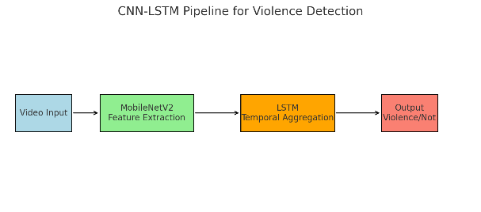
Figure 1 : CNN-LSTM Pipline
For road sign detection, we used YOLOv5-small [Jocher et al., 2022], chosen for its balance between accuracy and speed. The model was optimized by pruning and reducing the input size to 416×416 pixels, then converted to TensorFlow Lite with INT8 quantization for Raspberry Pi 3 and 4, and FP16 for Raspberry Pi 5.
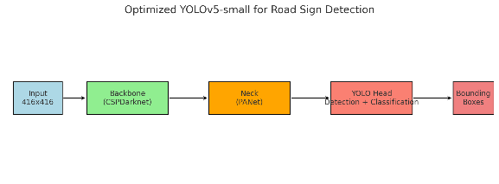
Figure 2 : Optimized YOLOv5 for road sign detection
For brain MRI analysis, we designed a 7-layer convolutional CNN with Batch Normalization and Dropout, following the recommendations of LeCun et al. [2015] for medical imaging tasks. This model was quantized to INT8 after calibration on a representative subset of the data.
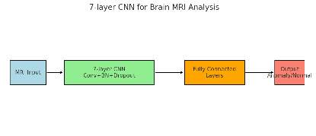
Figure 3: CNN’s layer for brain MRI application
III.5. Experimental protocol
The models were trained on a workstation equipped with an NVIDIA RTX 3060 GPU (12 GB of VRAM), then exported to the Raspberry Pi for evaluation. Each application-platform combination was tested ten times under identical conditions to ensure the statistical significance of the measurements. Performance was evaluated with and without active cooling to observe the impact of thermal throttling on latency and throughput. The Raspberry Pi devices were powered by a stabilized 5 V/3 A source and connected via Ethernet to ensure synchronization and reliable retrieval of results. The measurements were recorded in CSV format and then statistically processed to calculate averages, standard deviations and graphical representations. This protocol
follows the recommendations for embedded AI evaluation proposed by Banbury et al. [2021].
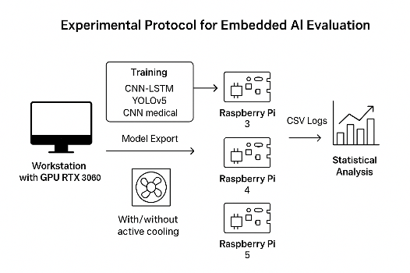
Figure 4 : Exeprimental Protocol for applications
IV. Experiments and Setup
The experiments were conducted according to a protocol designed to reproduce both controlled laboratory conditions and realistic field scenarios in order to validate the robustness and transferability of the results.
In the laboratory, the Raspberry Pi 3, 4 and 5 were installed on a test bench equipped with ambient temperature sensors and thermal probes to measure heat dissipation. Video inputs (for the detection of violence and road signs) were injected from pre-recorded databases in order to eliminate any external variability (brightness, weather). For medical imaging, MRIs were processed from static files organized in batches in order to accurately measure inference times per image.
In a real-world scenario, the systems were deployed:
• Video surveillance: installation in a simulated public space, with live video recording and real-time detection.
• Road sign detection: camera mounted on a vehicle travelling along a predefined route containing various signs.
• MRI analysis: automated batch processing from a simulated medical server, with results sent to a user interface.
Software configurations
Each platform ran Raspberry Pi OS (64-bit) with Python 3.9 or 3.11. The libraries used included: TensorFlow Lite for optimized inference, OpenCV for video capture and processing, PyTorch for certain pre-processing and model export steps, and NumPy/Pandas for data manipulation. The CNN-LSTM, YOLOv5 and medical CNN models were quantized (INT8 or FP16 depending on the platform) and optimized via pruning where necessary.
Evaluation parameters
The metrics measured were: accuracy, F1-score, inference latency (ms), FPS, memory usage (MB), CPU temperature (°C) and energy consumption (W). The temperature was recorded every 5 seconds via vcgencmd measure_temp and energy consumption via a USB or PoE wattmeter.
Each test was repeated 10 times on each platform and for each application in order to calculate averages and standard deviations. The measurements were taken with and without active cooling (5 V / 3000 rpm fan), in an air-conditioned room at 22 ± 1 °C and in an outdoor environment (~28–32 °C) to assess the effect of thermal conditions on performance and throttling.
To simulate different usage conditions, we subjected the systems to three load levels:
1. Light load: processing of still images (MRI) or 480p video at 15 FPS.
2. Medium load: 720p video stream at 30 FPS.
3. Heavy load: 1080p video stream at 30 FPS or parallel MRI batch processing.
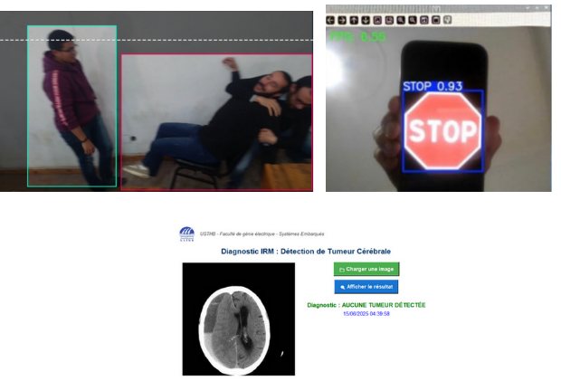

Figure 5: Experimental Tests of Three AI Models across Raspberry Pi Generations
V. Discussion
The experimental results clearly highlight the performance differences between the Raspberry Pi 3, 4 and 5 across all tested applications: violence detection in public spaces, road sign recognition and anomaly detection in brain MRIs.
V.1 Processing performance and accuracy
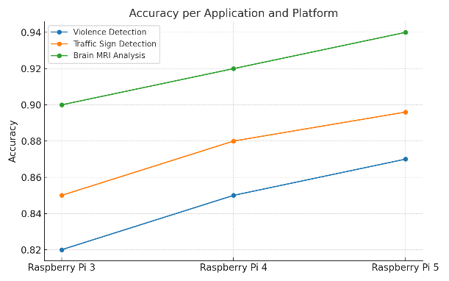
Figure 6 : Accuracy by application and platform

As shown in Figure 6, the Raspberry Pi 5 consistently achieves higher accuracy scores, approaching those obtained during training on desktop machines. In comparison, the Raspberry Pi 3 is limited by its restricted memory and CPU frequency throttling, resulting in a significant drop in accuracy, particularly for YOLOv5-based traffic sign detection. The Raspberry Pi 4 performs somewhere in between but remains susceptible to overheating under prolonged load. These results indicate that the architectural improvements of the Raspberry Pi 5 increased CPU frequency, optimized cache, enhanced GPU acceleration provide a direct gain in deep learning model inference, even in the absence of external accelerators.
V.2 Real-time processing capacity
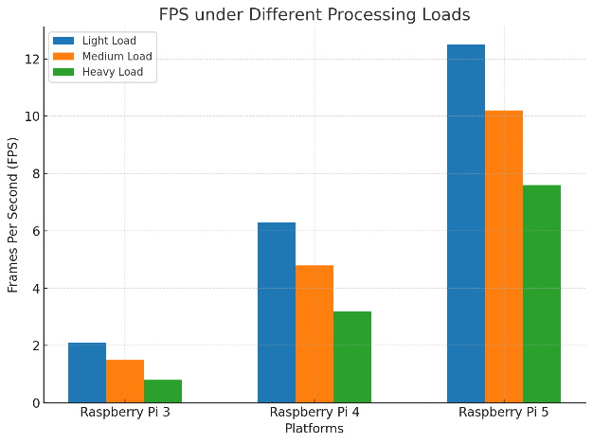
Figure 7 : FPS based on processing load
According to Figure 7 , the Raspberry Pi 5 maintains a near real-time throughput (>15 FPS) in most scenarios, including for 720p streams and some 1080p streams. Conversely, the Raspberry Pi 3 rarely exceeds 5 FPS, making it unsuitable for live video inference. The Raspberry Pi 4 achieves a stable throughput of 10–12 FPS on average loads, but struggles with 1080p streams. These observations confirm that, although software optimization (quantization, pruning) reduces the computational load, it cannot fully compensate for the hardware gap between generations
V.3 Thermal and Energy contraints
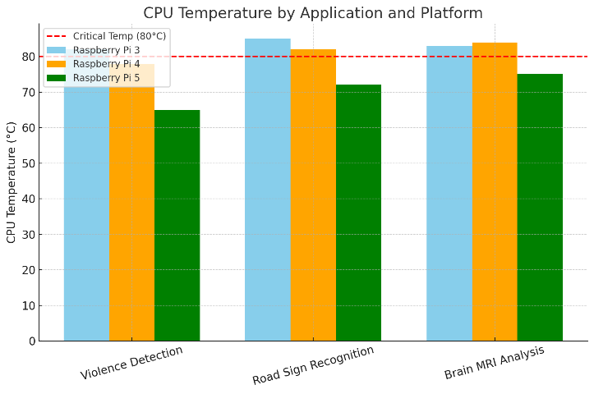
Figure 8 : CPU temperature by application and platform
Figure 8 highlights a major limitation for the Raspberry Pi 3 and 4: both reach critical temperatures (>80°C) during sustained inference, triggering throttling that further degrades performance. The Raspberry Pi 5, although subject to thermal elevation, benefits from more efficient heat dissipation and maintains a stable frequency in most cases.
It is clear that: The Raspberry Pi 3 consistently exceeds 80°C, causing throttling. The Raspberry Pi 4 also reaches this critical limit under certain loads. The Raspberry Pi 5, with better heat dissipation, remains below this limit but still rises above 70°C, requiring active cooling in real-world conditions.However, even the Raspberry Pi 5 requires active cooling in outdoor conditions (>28°C) to ensure maximum performance, which means that thermal management strategies must be considered during deployment.
V.4 Multi-metric comparison
The radar chart (Figure 9) summarizes accuracy, FPS, CPU temperature and energy consumption. It clearly illustrates the superiority of the Raspberry Pi 5 across all criteria, except for energy efficiency, where the Pi 3 retains a slight advantage under light load thanks to its lower base consumption. Nevertheless, for AI tasks requiring speed and accuracy, the energy trade-off is largely justified.
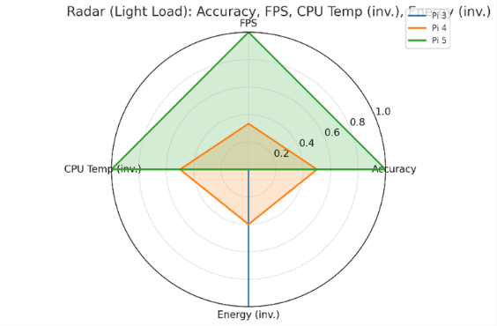
Figure 9: The radar chart
V.5 Limitations and implications
Despite its advantages, the Raspberry Pi 5 does not yet rival dedicated AI accelerators (Google Coral TPU, NVIDIA Jetson) for high-resolution real-time inference. Furthermore, all three platforms experience performance drops under extreme environmental conditions, highlighting the importance of integrating thermal management, load balancing, and algorithmic optimization strategies into the design.
These results suggest that the Raspberry Pi 3 is now obsolete for modern AI workloads, that the Raspberry Pi 4 remains relevant for tasks of medium complexity with optimized models, and that the Raspberry Pi 5 is the only viable option for demanding real-time inference, subject to controlling heat dissipation.
VI. Recommendations for deployment
The choice of platform must be aligned with performance and energy consumption requirements. The Raspberry Pi 5 is ideal for applications requiring real-time inference and high accuracy, such as smart surveillance or multi-class video detection. The Raspberry Pi 4 is an attractive compromise for moderate workloads, particularly when models have been optimized through quantization or layer reduction. Finally, the Raspberry Pi 3 remains suitable for light tasks or constrained environments where low energy consumption takes precedence over speed of execution.
Software optimization is a major lever for improving performance. Quantization (INT8, FP16) and pruning reduce model size and speed up inference. Conversion to formats suitable for ARM architectures, such as ONNX or TensorFlow Lite, also helps to reduce latency and memory footprint. For video streams, the use of parallelised pipelines and reduced input resolution can increase fluidity without significantly affecting accuracy.
Thermal management is crucial to avoid thermal throttling, which significantly degrades performance. Adding heat sinks and 5V fans, or ventilated cases suitable for outdoor environments, improves heat dissipation. Real-time monitoring using tools such as “vcgencmd measure_temp ” helps prevent overheating and dynamically adjust the CPU/GPU frequency according to conditions.
Robustness and reliability require training models on varied data sets that incorporate real-world conditions (lighting, weather, viewing angles). In video processing, the addition of temporal filtering reduces false positives and improves the relevance of alerts. In addition, the implementation of remote software update systems (OTA) ensures the maintenance and continuous evolution of embedded solutions without physical intervention.
Finally, energy strategies play a key role in the autonomy and sustainability of the system. Activating energy-saving modes (reducing CPU frequency in standby mode, deactivating unused interfaces) helps to limit consumption. The use of Li-ion batteries protected by a BMS or solar solutions combined with a regulator ensures a stable and reliable power supply, while extending the life of the components.
VII. Conclusion
This work presented an in-depth comparative study of the implementation of the same artificial intelligence model on three generations of Raspberry Pi (3, 4 and 5), applied to various scenarios ranging from monitoring violent behavior to detecting road signs and automated analysis of brain MRIs. The objective was to identify the hardware limitations of previous generations and highlight the gains offered by the latest iteration.
The results showed that, although Raspberry Pi 3 and 4 are capable of running optimized (quantized and lightweight) AI models, their performance remains limited by CPU frequency, available memory and heat dissipation. These constraints result in increased latency, a drop in frame rate under load, and a risk of thermal throttling during prolonged runs. In contrast, the Raspberry Pi 5 offers significant improvements thanks to a more powerful CPU/GPU architecture, increased memory bandwidth, and better thermal management, enabling smooth real-time processing in most of the cases tested.
Beyond material differences, this study highlights the importance of adapting the AI pipeline to the embedded context: quantification (INT8/FP16), pruning, choice of lightweight architectures (YOLOv5s, simplified CNNs) and use of optimized libraries (TensorFlow Lite, ONNX Runtime). These techniques make it possible to get the most out of available resources while preserving the accuracy and robustness of the models.
Finally, this work opens up interesting prospects:
• Performance evaluation on other SBCs (Jetson Nano, Coral Dev Board Micro) to broaden the comparison.
• Energy optimization to promote the autonomy of battery-powered systems.
• Extension to multimodal models simultaneously integrating video, audio and sensor data streams.
In conclusion, the Raspberry Pi 5 is positioned as a promising platform for embedded AI, offering an optimal compromise between cost, compactness and performance, provided that appropriate software optimisations are adopted.
References
[1]: Ju, Rui-Yang & Lin, Ting-Yu & Jian, Jia-Hao & Chiang, Jen-Shiun. (2023). Efficient convolutional neural networks on Raspberry Pi for image classification. Journal of Real-Time Image Processing. 20. 10.1007/s11554-023-01271-1.
[2]:Salem, Ameen & Theodoridis, Theodoros & Siriwardana, Kangaranmulle. (2024). Efficient Convolutional Neural Networks on Raspberry Pi: Enhancing Performance with Pruning and Quantization. 10.21203/rs.3.rs-4345141/v1.
[3] :Salem, Ameen & Siriwardana, Kangaranmulle & Theodoridis, Theodoros. (2023). Optimizing Deep Learning Models For Raspberry Pi. 10.48550/arXiv.2304.13039.
[4] : H. Ahn et al., "Performance Characterization of Using Quantization for DNN Inference on Edge Devices," 2023 IEEE 7th International Conference on Fog and Edge Computing (ICFEC), Bangalore, India, 2023, pp. 1-6, doi: 10.1109/ICFEC57925.2023.00009
[5] : Allan, A. (2024, 28 septembre). Benchmarking Machine Learning on the New Raspberry Pi 4, Model B. Hackster.io. https://www.hackster.io/news/benchmarking-machine-learning-on-the-new-raspberry-pi-4-model-b-88db9304ce4
[6] : https://aallan.medium.com/benchmarking-machine-learning-on-the-new-raspberry-pi-4-model-b-88db9304ce4
[7] : Allan, A. The big benchmarking roundup. Hackster.io. https://www.hackster.io/news/the-big-benchmarking-roundup-a561fbfe8719?
[8] : AI Object Recognition without TPU? (2024, August). Reddit. Retrieved April 17, 2025, from https://www.reddit.com/r/raspberry_pi/comments/1ce51yh/ai_object_recognition_without_tpu
[9] :Bot, B. (s. d.). Supercharging Machine Learning Performance on Raspberry Pi - Bomberbot. Bomberbot. https://www.bomberbot.com/raspberry-pi/supercharging-machine-learning-performance-on-raspberry-pi/?
[10] : https://medium.com/accelr-blog/raspberry-pi-object-detection-benchmarks-cc193f287926
[11] : Alqahtani, Daghash & Cheema, Aamir & Toosi, Adel. (2024). Benchmarking Deep Learning Models for Object Detection on Edge Computing Devices. 10.48550/arXiv.2409.16808.
[12]: Boddu, Sindhu & Mukherjee, Arindam. (2025). Efficient Edge Deployment of Quantized YOLOv4-Tiny for Aerial Emergency Object Detection on Raspberry Pi 5. 10.48550/arXiv.2506.09300.

