Chansa Chomba (PhD)
Research and Innovation Department
Mulungushi University
P.O. Box 80415
Kabwe
ZAMBIA
Tuesday 28th October 2025
The Editor-in-Chief
Journal of Agriculture and Environmental Sciences (JAES)
Bahir Dar University
ETHIOPIA
email: caes.jaes@gmail.com.

Dear Editor,
Please find enclosed our manuscript entitled “Charcoal production drives forest degradation and biodiversity loss in a miombo woodland: Insights from Mwekera National Forest Reserve, Zambia,” which we are submitting for consideration for publication in the Journal of Agriculture and Environmental Sciences.
We confirm that this work is original, has not been published previously, and is not under review elsewhere. All authors have approved the final version of the manuscript, and the institutions where the research was conducted have authorized its submission.
The manuscript is written in English and formatted according to the journal’s author guidelines (A4, 1.5 spacing, Times New Roman 12-point font, Microsoft Word format). Tables and figures are embedded within the text, and references follow the name-year citation style as required.
This study examines the ecological impacts of charcoal production on forest structure and species composition in the Mwekera National Forest Reserve, a representative miombo woodland in Zambia’s Copperbelt Province. The findings reveal that unsustainable charcoal production practices severely degrade forest ecosystems, alter species composition, and undermine ecological resilience. Our study underscores the urgent need to secure forests to safeguard biodiversity, sustain ecosystem services, and promote climate resilience. We further recommend research on soil and faunal impacts, the development of alternative livelihoods, and the strengthening of community-based forest management to mitigate continued degradation.
We believe that this manuscript will be of significant interest to the readership of your journal and will make a valuable contribution to advancing sustainable forest management and environmental conservation.
We respectfully request that the manuscript be considered for publication under the category of Research Article. We also affirm that there are no conflicts of interest related to this work.
Thank you for considering our submission. We look forward to your favorable response.
Sincerely,

Chansa Chomba (PhD)
Mulungushi University

Charcoal production drives forest degradation and biodiversity loss in a miombo woodland: insights from Mwekera national forest reserve, Zambia

Chansa Chomba¹, Pamela Cheelo^{2,} Mwape Malunga³
¹Corresponding author: chansachomba@rocketmail.com, chnschansa832@gmail.com, chombachansa50@gmail.com, cchomba@mu.ac.zm
¹Research and Innovation Department, , Mulungushi University, P.O. Box 80415, Kabwe, Zambia.
²C/O Department of Natural Resources and Environmental Sciences, School of Agriculture and Natural Resources, Mulungushi University, P.O. Box 80415, Kabwe, Zambia.hamulinda21@yahoo.com
³Department of Natural Resources and Environmental Sciences, School of Agriculture and Natural Resources, Mulungushi University, P.O. Box 80415, Kabwe, Zambia.malungamm@gmail.com

Abstract
This study evaluated the ecological impacts of charcoal production on forest structure and species composition in the Mwekera National Forest Reserve, a representative miombo woodland in Zambia’s Copperbelt Province. Thirty systematically established plots (20 m × 20 m) were surveyed to assess species richness, diversity, evenness, and structural attributes. A total of 54 woody species were recorded, with a Shannon–Wiener Diversity Index (H') of 3.313 (effective species number = 27.463) and Pielou’s Evenness Index (J') of 0.855, indicating moderate diversity and relatively even species distribution. Despite this, results showed a marked decline in the dominant miombo genera, Brachystegia, Julbernardia, and Isoberlinia, which were selectively harvested for charcoal. In some plots, these species were entirely absent, reflecting intense harvesting pressure. Larger trees, particularly those with greater diameter at breast height (DBH) and height, were disproportionately removed, as indicated by a strong positive DBH–height correlation. Consequently, the residual forest is increasingly dominated by smaller, less valuable trees, leading to simplified structure and reduced biodiversity. The study concludes that unsustainable charcoal production significantly alters miombo composition and weakens ecosystem resilience. It recommends research on soil and faunal impacts, promotion of alternative livelihoods, and strengthening of community-based forest management to curb degradation.
Keyword: Forest composition, structure, reserve, illegal activities, sustainable.

1.0 Introduction
Forests in Zambia constitute a critical component of the country’s natural heritage, with approximately 60% of its total land area, equivalent to roughly 752,614 km², covered by various forest types (FAO, 2020). Of this, an estimated 7.2 million hectares are gazetted as National Forest Reserves under state jurisdiction, 15.4 million hectares fall under customary or traditional tenure systems, 6.4 million hectares are located within National Parks, and a further 15.6 million hectares within Game Management Areas. These forested landscapes provide a myriad of ecological, economic, and social functions, including carbon sequestration, biodiversity conservation, water regulation, and soil protection.
Despite their significance, Zambia’s forests are increasingly threatened by deforestation and degradation, driven predominantly by anthropogenic activities such as agriculture, logging, and, notably, charcoal production (FAO, 2020). Charcoal, in particular, is a major energy source for cooking and heating in sub-Saharan Africa, and its production is a prevalent livelihood strategy among rural communities (Mensah, 2021). However, the widespread and unregulated nature of charcoal harvesting has rendered it one of the most environmentally detrimental land-use practices in the region.
This study focuses on Mwekera National Forest Reserve No. 6, situated in Kitwe, Copperbelt Province of Zambia. The reserve was established in 1946 through Statutory Instrument No. 72 of 3rd May 1946, with an original area of approximately 27,500 hectares (Syampungami et al., 2010). Over the decades, the reserve has experienced considerable encroachment by human settlements and associated extractive activities, chief among them charcoal production, resulting in substantial reductions in forest cover and degradation of the catchment area of the Mwekera River. These pressures have compromised the reserve’s original mandate of biodiversity conservation and ecosystem protection.
The proximity of the reserve to Kitwe, Zambia’s second-largest city, has exacerbated resource extraction due to high urban demand for charcoal. This has made the Mwekera Forest an ideal case study for analyzing the intersection of energy needs, livelihood strategies, and forest degradation (CIFOR, 2014). The removal of woody biomass for charcoal, particularly of slow-growing, high-value species within the miombo woodland, significantly alters forest composition, structure, and ecological functioning. Such selective harvesting results in a proliferation of less desirable species and a decline in ecosystem services, including habitat provisioning, carbon storage, and water regulation (Borgarello, 2016; Aron et al., 2021).
Previous studies have demonstrated that charcoal production targets specific tree species and size classes, usually those with high calorific value and processing ease, thus skewing tree population structures (Aron et al., 2021). Over time, this leads to reduced species diversity, simplified forest architecture, and loss of ecological resilience. Furthermore, charcoal-related activities contribute to soil degradation and forest fragmentation, further undermining the long-term sustainability of woodland ecosystems and the rural livelihoods that depend upon them (Borgarello, 2016).
Against this backdrop, the present study aimed to evaluate the ecological impacts of charcoal production on tree species composition, density, and forest structure in the Mwekera National Forest Reserve. Specific objectives were to: (1) assess tree species composition, density, and basal area; (2) determine which tree species and size classes are preferentially harvested for charcoal production; and (3) investigate the socio-ecological challenges and institutional barriers to sustainable forest management in the reserve.
Understanding the localized ecological effects of charcoal production is imperative for developing effective and context-specific forest management interventions. The Mwekera Reserve, with its diverse miombo species and importance as a livelihood source, presents an illustrative microcosm of the broader conservation-development challenges in sub-Saharan Africa. Insights from this research are therefore expected to contribute to the growing body of knowledge on the trade-offs between rural energy security and environmental sustainability.
Furthermore, the study offers practical recommendations for forest policy, including the promotion of sustainable charcoal production techniques, the diversification of rural livelihoods, and the adoption of alternative energy technologies such as solar and improved cookstoves. Such interventions are critical to addressing deforestation in Zambia and aligning with regional and international commitments to sustainable land management and biodiversity conservation (World Bank, 2018; CIFOR, 2014; Giesecke, 2012).
Climate change
Charcoal production
Deforestation
Bush Fires
Environmental degradation
Other local and broader scale forces:
- Political influence
- Social
- Economic
Food insecurity, droughts, rural urban drifts, high unemployment levels, high demand of energy and financial insecurity among others.
Alternative income sought
Forest structure and cover losses
Desertification, Loss of species diversity

Figure 1. The influence of charcoal production on forest structure and disruption of ecological services
Notes: Charcoal production influences forest degradation, deforestation and indirectly bushfires which accentuate forest cover loss, structure and species composition. These factors negatively affect steam/river flow, moisture retention, crop yields hence leading to food and financial insecurity on one hand. On the other hand, political, social, economic, physical and climatical forces also have a role to play.
2.0 Materials and methods
This study was undertaken within the Mwekera National Forest Reserve, located in Kitwe District, the second largest city and one of the principal administrative and economic centers of the Copperbelt Province, Zambia. The reserve was officially gazetted as a protected area under Statutory Instrument No. 72 of 3rd May 1946 and initially covered an area of approximately 27,500 acres (11,129 hectares) (Kanja et al., 2017). It was established primarily for the conservation of forest ecosystems, the protection of biodiversity, and the preservation of the hydrological catchment of the Mwekera River, a significant tributary of the Kafue River.
Since its designation, the Mwekera National Forest Reserve has remained a critical ecological asset within the region. It plays an essential role in sustaining environmental stability through the provision of multiple ecosystem services. These include provisioning services such as non-timber forest products (NTFPs), medicinal plants, and raw materials; regulating services such as carbon sequestration, water purification, soil stabilization, and microclimate regulation; supporting services including biodiversity conservation and nutrient cycling; and cultural services, notably environmental education and spiritual significance (Millennium Ecosystem Assessment, 2005; Kanja et al., 2017).
The reserve contributes significantly to local livelihoods by supporting subsistence activities and providing access to ecosystem goods. Its conservation has broader implications for national development priorities, particularly in the context of climate change mitigation, biodiversity preservation, and the attainment of global sustainable development targets. Specifically, it aligns with Sustainable Development Goal (SDG) 13 (Climate Action) and SDG 15 (Life on Land), by promoting ecosystem resilience and reducing land degradation (United Nations, 2015).

2.1 Study area location
The Mwekera National Forest Reserve is situated approximately 27 kilometers east of Kitwe City, adjacent to the Kitwe–Ndola dual carriageway. Its location within a peri-urban landscape renders it highly susceptible to anthropogenic pressures, including unplanned urban expansion, illegal logging, charcoal production, and encroachment for agriculture and settlement (GRZ, 2019). Despite these threats, it remains one of the last forested landscapes in the vicinity and provides an ecological buffer against urban sprawl.
Within the reserve is located the Zambia Forestry College (ZFC), a key institution under the Ministry of Green Economy and Environment. ZFC functions as a national center of excellence in forestry education, applied research, and capacity building in natural resource management, agroforestry, silviculture, and environmental stewardship.
Geospatially, the reserve lies at approximately 12°51'6.24'' South latitude and 28°21'29.95'' East longitude. It is part of the Central Zambezian Miombo woodland ecoregion, a dominant vegetation type across Southern and Central Africa, extending over 2.7 million square kilometers. This vegetation zone is characterized by deciduous and semi-deciduous tree species, predominantly of the genera Brachystegia, Julbernardia, and Isoberlinia, which are adapted to nutrient-deficient soils and periodic fire disturbances (White, 1983; Timberlake & Chidumayo, 2011).
The structural composition of the Miombo woodland ecosystem in Mwekera supports a diverse assemblage of flora and fauna, including mammals, reptiles, birds, insects, and a stratified understory. The ecological resilience of this forest system is facilitated by species’ fire-adaptive traits, coppicing capacity, and mycorrhizal associations that enhance nutrient acquisition in oligotrophic soils (Frost, 1996).
The climate of the area is classified as tropical savannah (Köppen classification Aw), with two distinct seasons. The rainy season extends from November to April, while the dry season lasts from May to October. Average annual precipitation ranges between 1,200 mm and 1,400 mm, with peak rainfall occurring in December and January. Mean annual temperatures fluctuate between 18°C and 25°C (ZMD, 2022). These climatic variables significantly influence vegetation phenology, wildlife distribution, net primary productivity, and the availability of surface and subsurface water within the reserve.
Topographically, the forest lies on a gently undulating plateau interspersed with shallow valleys, lateritic ridges, and occasional dambos. These geomorphological features influence soil hydrology, erosion processes, and vegetation zonation. The complex interplay between climate, soil characteristics, elevation, and biotic interactions renders Mwekera Forest a uniquely dynamic and scientifically valuable ecological system that warrants strict conservation and sustainable management.
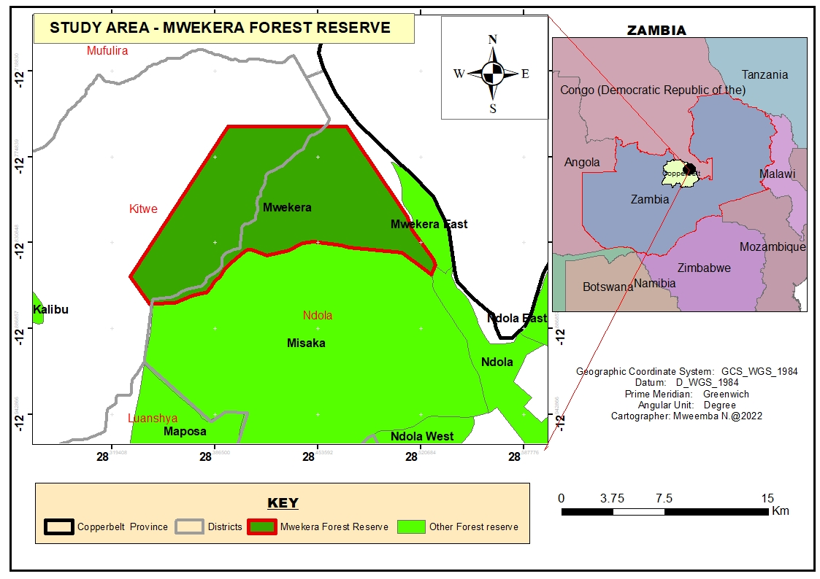
Figure 2. Location of study area, Mwekera forest, Copperbelt province, Zambia
2.2 Hydrogeology of the study area
As shown in Figure 3 below the hydrogeological characteristics of the Mwekera national forest reserve and the broader Copperbelt province are governed by the region's complex lithological and structural geology, which directly influences groundwater occurrence, movement, and quality. the reserve lies within the Katanga supergroup, a proterozoic sequence comprising metasedimentary rocks that are geologically and economically significant in the central African Copperbelt (Cailteux et al., 2005; Kampunzu et al., 2000). one of the most prominent stratigraphic units in this region is the grand conglomerate, interpreted as a widespread sequence of debris flow deposits. it consists of poorly sorted, matrix-supported conglomerates, interbedded with thin, discontinuous horizons of siltstone and sandstone, and varies in thickness from approximately 10 to 100 meters (Porter Geoconsultancy, 2020).
these clastic sequences exhibit significant heterogeneity and are characterized by low primary porosity. however, secondary porosity and permeability may develop through structural discontinuities such as joints, fractures, and faults (Tylor and Howard, 1999; 2000). these structural features enhance groundwater storage and flow, allowing the formation of localized, often unconfined or semi-confined aquifers. the thin siltstone and fine-grained sandstone interbeds act as semi-confining layers, which can impede vertical percolation and result in perched aquifers or stratified flow systems (Chilton and Foster, 1995).
the hydrodynamics of the area are also influenced by climatic conditions. the region falls within a tropical savannah zone with distinct wet (November–April) and dry (May–October) seasons. annual rainfall ranges from 1,200 mm to 1,400 mm, which facilitates periodic recharge of the aquifer systems through infiltration, particularly in zones where conglomerate layers are near-surface and uncemented (Taylor and Howard, 2000). however, recharge rates may be highly variable due to lithological complexity and overlying soil properties.
groundwater within the reserve plays a crucial ecological role, contributing to the baseflow of the Mwekera river and supporting wetland and riparian ecosystems, especially during the prolonged dry season (Macdonald et al., 2005). hydrogeological interconnectivity between surface and subsurface systems necessitates integrated water resource management strategies to preserve catchment integrity and ecosystem resilience.
furthermore, the Copperbelt region has experienced extensive mining activities, which may pose contamination risks to groundwater, particularly from acid mine drainage and mobilization of heavy metals such as copper, cobalt, and lead (Von der Heyden and New, 2004). while the Mwekera national forest reserve itself is largely protected from direct mining impacts, regional hydrogeological linkages demand vigilant groundwater quality monitoring and land use planning.
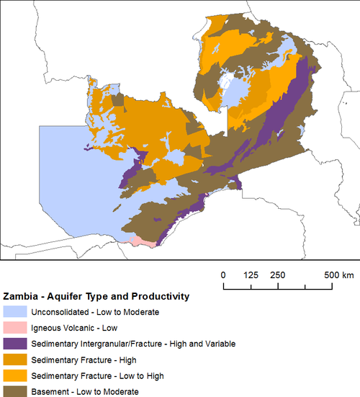
Figure 3. The hydrogeology map of the study area and Zambia in general

2.3 Relief, temperature and rainfall
According to the Global Historical Weather and Climate Data (2022), Zambia’s Copperbelt province receives an average precipitation of 1100 mm per year and it is in Agroecological region III of the country which mostly receives high amount of rainfall per season and temperature ranging from 10 °C to 33.56 °C, coldest to warmest month respectively. Climate-Data.org (2021), recorded that the province has an average rainfall period of 133.99 days representing 36.71% portion of the year and the rest are days without rains which is 64.49% portion of remaining part of the year.

The Copperbelt Province, encompassing the Mwekera National Forest Reserve, lies within Zambia’s Agroecological Region III, characterized by relatively high rainfall and moderate altitudinal variation. The terrain consists of gently undulating to rolling hills with elevations ranging from 1,100 to 1,400 meters above sea level, influencing drainage patterns, soil development, and vegetation zonation (Jury, 2019).
Annual average precipitation in the region is approximately 1,100 mm, concentrated primarily in the November to April rainy season (Figure 4). This rainfall regime supports vegetative productivity, aquifer recharge, and river baseflow. According to Climate-Data.org (2021), the region experiences an average of 133.99 rainy days, constituting 36.71% of the year, while the remaining 64.49% of days are dry, with minimal precipitation and high evapotranspiration rates.

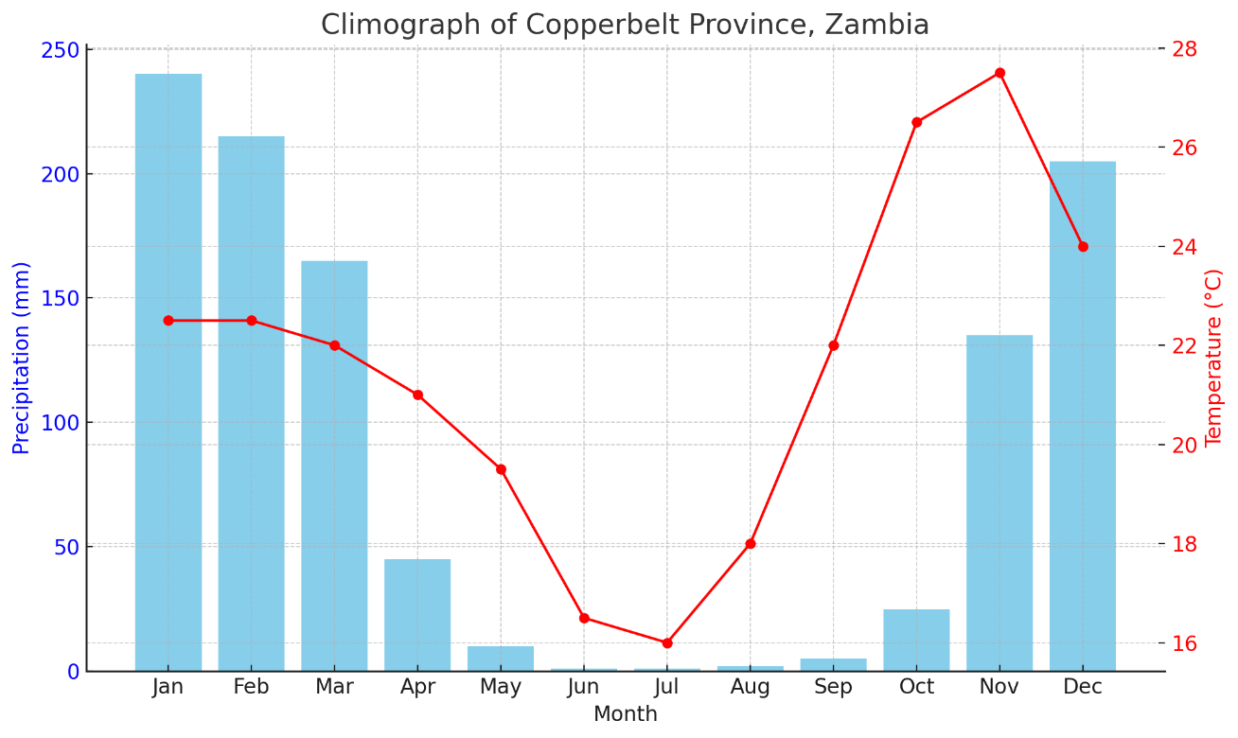
Fig. 4: Monthly average temperature (°C) and precipitation (mm) for Copperbelt Province. Data illustrates the unimodal rainfall pattern and seasonal temperature variation typical of Agroecological Region III.

Temperature in the region displays marked seasonality. The coldest months, typically June and July, average 10 °C, while peak temperatures, usually observed in October or November, can reach 33.6 °C (Global Historical Weather and Climate Data, 2022). The wide diurnal temperature range, especially in the dry season, affects plant physiology, soil microbial activity, and fire risk. These climatic conditions—when considered together with topography, determine the ecological processes that underpin the forest’s structure, phenology, and productivity (Chidumayo, 2013).

Table 1 Summary of key climatic and physiographic parameters of the study area
Parameter | Value/Range | Source
Altitude | 1,100 – 1,400 m a.s.l. | Jury (2019)
Average annual rainfall | ~1,100 mm | Global Historical Weather Data (2022)
Rainy days per year | ~134 days (36.71%) | Climate-Data.org (2021)
Dry days per year | ~231 days (63.29%) | Climate-Data.org (2021)
Temperature range | 10°C – 33.6°C | Global Historical Weather Data (2022)
Agroecological Zone | Region III | Zambian Ministry of Agriculture

2.4 Vegetation communities
The Mwekera National Forest Reserve is part of the extensive Central Zambezian Miombo woodland, one of the most ecologically and socioeconomically important vegetation types in sub-Saharan Africa. Miombo ecosystems are typically dominated by three genera, Brachystegia, Julbernardia, and Isoberlinia, which contribute significantly to the woodland’s canopy structure, biomass, and fire ecology (Frost, 1996).
These deciduous trees exhibit adaptations such as deep taproots, mycorrhizal associations, and leaf phenology that maximize survival under nutrient-poor and water-stressed conditions. The woodland supports a rich understorey comprising shrubs and a seasonal herbaceous layer, largely dominated by Poaceae and Fabaceae families (Chidumayo and Gumbo, 2010).
The Mwekera area also supports a broad range of secondary and associated species, including: Combretum spp., Syzygium spp., Pseudolachnostylis maprouneifolia, Burkea africana, Diplorhynchus condylocarpon, Monotes spp., Lannea discolor, Uapaca kirkiana, Parinari curatellifolia.
These species fulfil multiple ecological roles, from nitrogen fixation and wildlife habitat provision to human uses such as medicinal plant harvesting, fodder collection, and wood fuel extraction (Dewees et al., 2011).
Of concern is the increasing pressure on woodland resources due to firewood and charcoal production, with Brachystegia and Julbernardia species being highly preferred due to their calorific value and slow-burning properties (Chidumayo, 2013). Unsustainable harvesting, in combination with shifting fire regimes, is altering species composition and reducing woodland resilience. Fire, while a natural ecological driver, becomes a destructive force when mismanaged or overly frequent, leading to loss of mature trees and suppression of regeneration (Frost, 1996).
Table 2 Dominant and associated tree species of the Mwekera miombo woodland
Species Name | Family | Ecological/Anthropogenic Significance
Brachystegia spiciformis | Fabaceae (Caesalpinioideae) | Dominant canopy; preferred for firewood
Julbernardia paniculata | Fabaceae | Nitrogen-fixer; major fuelwood species
Isoberlinia angolensis | Fabaceae | Fire-adapted; used for timber and charcoal
Combretum molle | Combretaceae | Secondary woodland species; medicinal uses
Syzygium guineense | Myrtaceae | Riparian; edible fruits
Pseudolachnostylis maprouneifolia | Phyllanthaceae | Shade tree; traditional medicine
Uapaca kirkiana | Phyllanthaceae | Wild fruit tree; economic value
Parinari curatellifolia | Chrysobalanaceae | Drought tolerant; valued for edible fruit

2.5 Charcoal production in the area
The Copperbelt Province, home to Zambia’s second and third largest urban centers, Ndola and Kitwe respectively, is characterized by extensive mining activities that have historically driven high rates of urbanization and population density (CSO, 2020; GRZ, 2019). The rapid urban growth, combined with the persistent inadequacy and unreliability of electricity supply from the national grid, has led to an increasing dependency on biomass energy, particularly charcoal, as a primary source of fuel for cooking and heating (Zulu and Richardson, 2013; IEA, 2022). This dependency is most pronounced in low-income households where access to modern energy alternatives remains economically and physically limited.
Mwekera Forest Reserve, located in close proximity to Kitwe, has consequently become a major target for unsustainable charcoal production. The forest's accessibility makes it vulnerable to frequent and often illegal harvesting of woody biomass by informal charcoal producers, many of whom operate as part of a growing unemployed or underemployed demographic lacking viable livelihood alternatives (Kalaba et al., 2010; Chidumayo and Gumbo, 2013). Weak institutional enforcement, limited surveillance capacity, and socio-economic pressures have further compounded deforestation and forest degradation in the area (FAO, 2021).
The extraction of biomass from Mwekera Forest Reserve not only threatens the ecological sustainability of this protected area but also undermines its critical ecosystem functions, including carbon sequestration, water regulation, and biodiversity conservation (Luoga, Witkowski and Balkwill, 2000; Syampungani et al., 2016). Continued degradation of the forest compromises its long-term viability and reflects systemic governance gaps in forest and energy policy integration. Addressing these multifaceted challenges requires a coordinated and multisectoral strategy, incorporating sustainable forest management, promotion of alternative energy sources such as liquefied petroleum gas and solar technologies, community-based forest stewardship models, and targeted livelihood support interventions for charcoal-dependent households (UNDP, 2019; Mwampamba et al., 2013).

2.6 Data collection techniques

Measuring diversity for determining species composition
Species abundance and richness to quantify diversity was undertaken using Shannon diversity index (Hʹ). This index takes both species abundance and species richness into account. Additionally, the Shannon Equitability Index as a measure of evenness of species in Mwekera forest reserve was tested using the equations given below.
$H^{'}=-\sum_{i=1}^{s}{{P_{i}In P}_{i}}$…………………………………………………….. Equation 1
Effective number of species (ENS) = eH……………………………………. Equation 2
$Eveness{(E}_{H})=\frac{H}{In\left(S\right)}$………………………………………………….. Equation 3
Where S equals the number of species and Pi equals the ratio of individuals of species i divided by all individuals N of all species and ln is a natural log. This index typically ranges from 1.5 to 3.5 and rarely reaches 4.5 (Moutsambote, et al., 2016). This also enabled us to determine the number of effective species using Shannon Index = e^{H} (exponential of Shannon entropy) . Finally, the evenness (E_{H}) given by H the Shannon Diversity Index to natural log by the total number of unique species (S).

2.6.1 Forest inventory
A detailed forest inventory was conducted to quantify the structural characteristics and compositional attributes of the forest stand. This involved systematic sampling using square quadrats, each measuring 20 m × 20 m (400 m²), which were spatially distributed across representative zones of the Mwekera Forest Reserve. The plot-based approach follows standardized forest mensuration methodologies widely adopted in tropical forest research (Moore et al., 1996; Brown, 1997).
Within each quadrat, all woody individuals with a minimum diameter at breast height (DBH) of 5 cm were identified to species level using authoritative botanical references, including Storrs (1995), Palgrave (2002), and Moll (2011). Species identification was carried out in the field by experienced botanists and confirmed using taxonomic keys. Regeneration counts were also performed to assess forest renewal capacity, including saplings and seedlings below the DBH threshold.
Measurements recorded for each individual tree included; DBH (Diameter at Breast Height) at 1.3 m using a precision tree caliper, total height and merchantable height using a Suunto clinometer, crown diameter and crown cover estimates, basal area, calculated to estimate biomass and stocking levels, and geolocation coordinates of each plot using a handheld Global Positioning System (GPS) unit
The materials and instruments used during fieldwork included: a tree caliper for DBH measurement, Sunto clinometer for height assessment, 100 m fiberglass measuring tapes, 5 m steel tapes for precise distance measurement, tagging tapes for tree identification, notebooks, pencils, rulers, and recent satellite imagery for navigation and spatial planning (Figure 5).
This forest inventory protocol facilitated a comprehensive biophysical characterization of the study site, enabling the integration of species diversity data with structural parameters essential for ecological modelling, carbon stock estimation, and sustainable forest management (Chave et al., 2005; FAO, 2017). The combined use of quantitative and qualitative approaches also supports the establishment of long-term monitoring plots, vital for assessing changes over time in response to both natural dynamics and human disturbances (Phillips et al., 2002; Malhi et al., 2004).
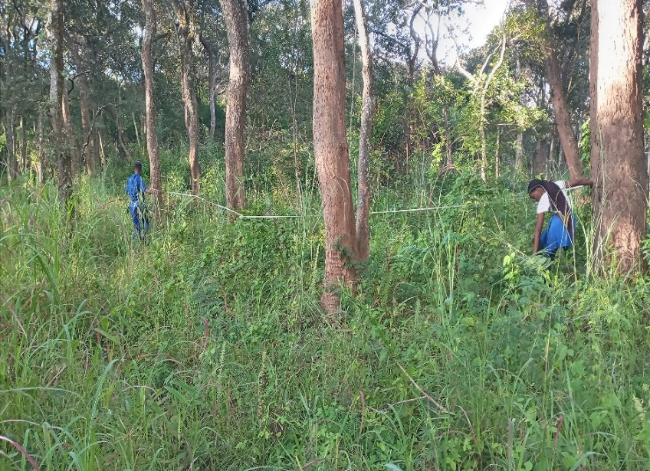
Figure 5 Forest inventory exercise in Mwekera national forest reserve

2.6.2 Measuring diversity for determining species composition
Quantitative assessment of floristic diversity within the Mwekera Forest Reserve was conducted using the Shannon-Wiener Diversity Index (Hʹ), a robust ecological metric that integrates both species richness (the total number of distinct species) and species abundance (the number of individuals per species) into a composite measure of diversity (Magurran, 2004). This index is widely employed in ecological studies for its sensitivity to changes in community composition and its ability to discern structural complexity within ecological assemblages (Colwell, 2009).
The Shannon-Wiener Index is calculated using the formula:
$H^{'}=-\sum_{i=1}^{s}{{P_{i}In P}_{i}}$…………………………………………………….. Equation 1
Effective number of species (ENS) = eH ………………………………….. Equation 2
$Eveness{(E}_{H})=\frac{H}{In\left(S\right)}$………………………………………………….. Equation 3
Where S equals the number of species and Pi equals the ratio of individuals of species i divided by all individuals N of all species and ln is a natural log. This index typically ranges from 1.5 to 3.5 and rarely reaches 4.5 (Moutsambote et al., 2026). This also enabled us to determine the number of effective species using Shannon Index = e^{H} (exponential of Shannon entropy). Finally, the evenness given by Shannon Diversity Index to natural log by the total number of unique species (S).
Equation 2, where S denotes the total number of species, P<sub>i</sub> represents the proportion of individuals belonging to the i<sup>th</sup> species relative to the total number of individuals in the dataset (N), and ln is the natural logarithm.
To better interpret the ecological significance of Hʹ, the Effective Number of Species (ENS) was also computed, defined as:
ENS=eHʹENS = e^{Hʹ}ENS=eHʹ ……………………………………………Equation 3,
which translates the Shannon entropy value into the number of equally common species that would produce the same diversity score, thus improving interpretability for conservation and management decision-making (Jost, 2006).

Additionally, the Shannon Equitability Index (E<sub>H</sub>) was derived to quantify the evenness of species distribution within the community:
EH=Hʹln⁡(S)E_H = \frac{Hʹ}{\ln(S)}EH=ln(S)Hʹ ………………………...Equation 4,
where values closer to 1 indicate a more equitable distribution of individuals among species.
The application of these indices in the present study allowed for a comprehensive evaluation of the ecological heterogeneity in the sampled plots of Mwekera Forest Reserve. This assessment is critical for understanding community structure, informing biodiversity conservation strategies, and detecting anthropogenic influences such as selective logging or charcoal production, which may alter natural species distributions (Whittaker and Fernández-Palacios, 2007; Kent, 2012).
2.7 Questionnaire survey
As part of the data collection strategy, a structured questionnaire survey was administered to the forest officers stationed at the Department of Forestry bee keeping section, within the boundaries of Mwekera forest reserve. The selection of these respondents was purposive, based on their direct involvement in forest resource monitoring, sustainable land use practices and forest-based livelihoods particularly apiculture. Their experiential knowledge and institutional roles rendered them key informants capable of offering valuable insights into the ecological and socioeconomic dynamics of charcoal production and forest degradation in the area
The questionnaire was designed to elicit both quantitative and qualitative data through a combination of closed ended and open-ended questions. The closed ended items were primarily intended to generate standardized data on key variables such as observed changes in forest cover, species preference for charcoal production, frequency of illegal harvesting activities and trends in stem size reduction. These items utilized Likert scale responses and binary choices to facilitate quantitative analysis.
The open-ended questions on the other hand provided respondents with opportunities to elaborate on complex issues such as perceived drivers of forest degradation, challenges in enforcing forest conservation regulations, and their views on the efficacy of current forest management policies. This mixed methods approach enabled triangulation of findings and helped contextualize remote sensing and field inventory data with institutional perspectives and local ecological knowledge.
All questionnaires were administered in person to ensure clarity of questions and to allow for immediate follow up where necessary. The anonymity and confidentiality of the respondents were guaranteed. The qualitative responses were later subjected to thematic analysis, while the quantitative data were statistically analyzed to identify response trends and correlations between forest management practices and observable forest conditions. This approach was essential in integrating institutional knowledge with field based ecological assessments, thereby strengthening the validity and policy relevance of the study findings.

3.0 Results
3.1 Tree species composition and density
To evaluate the diversity and structural complexity of the forest across both mature and regenerating strata, the Shannon-Wiener Diversity Index (Hʹ) was applied. For mature tree populations, the diversity index was calculated at Hʹ = 3.313, while the regeneration cohort yielded a closely related value of Hʹ = 3.301. These values fall within the higher range of the index (typically between 1.5 and 3.5 in tropical forest systems), suggesting high species diversity and relatively even distribution of individuals among species in both size classes.
The findings from this study are consistent with established ecological principles that posit higher Shannon indices as indicative of greater species diversity and ecosystem stability values approaching zero reflect monocultures or extremely low species richness, whereas values above 3.0 typically represent biologically diverse communities with relatively equitable species distribution. Therefore, the values obtained in this study affirm the ecological integrity and conservation significance of Mwekera Forest Reserve, particularly Forest Block No. 6.
Furthermore, the similarity in diversity indices between mature trees and regenerating individuals provides empirical evidence of successful natural regeneration, likely driven by the presence of viable seed sources, suitable microclimatic conditions, and possibly reduced anthropogenic pressure in some sections of the reserve. However, the presence of certain species in low abundance, particularly those valuable for timber or medicinal use, may also be indicative of selective extraction and warrants further investigation through ethnobotanical and socio-economic assessments.
Such a high effective number of species, in conjunction with elevated equitability values, implies that the forest is characterized not only by species richness but also by functional ecological balance. This reflects a structurally resilient system in which dominance by any single species is limited, thereby enhancing the forest’s capacity to withstand disturbance, maintain ecosystem services, and support biodiversity over time
3.2 Species diversity, evenness, and effective number
3.2.1 Diversity and evenness
An extensive floristic inventory conducted across 30 systematically established sample plots, comprising 711 individual tree records and spanning various ecological zones within Mwekera Forest Reserve, revealed a total of 54 tree species. The data were used to calculate species diversity, evenness, and the effective number of species, applying the Shannon-Wiener diversity index (Hʹ), its exponential transformation (e<sup>Hʹ</sup>), and Shannon Equitability Index (E<sub>H</sub>), respectively.
The forest composition was notably dominated by a few prevalent species. Marquesia macroura was the most abundant, accounting for approximately 11.96% of all individuals sampled. Other prominent species included Albizia adianthifolia, Terminalia sericea, Uapaca kirkiana, and Terminalia mollis, each contributing significantly to the overall basal area and frequency of occurrence (Table 1).
In contrast, several species were observed at extremely low frequencies, with Afzelia quanzensis, Albizia antunesiana, Annona senegalensis, Bysocarpus orientalis, Gmelina arborea, and Piliostigma thoningii each recorded only once throughout the entire study area. These rare occurrences may be indicative of selective exploitation, ecological marginality, or restricted habitat preference.
Table 3. Summary of tree species abundance and diversity metrics in Mwekera national forest reserve
No. | Species Name | Frequency | Pi (Proportion) | ln(Pi) | Pi × ln(Pi)
1 | Marquesia macroura | 85 | 0.11955 | -2.12402 | -0.25393
2 | Albizia adianthifolia | 55 | 0.07736 | -2.55934 | -0.19798
3 | Terminalia sericea | 55 | 0.07736 | -2.55934 | -0.19798
4 | Uapaca kirkiana | 53 | 0.07454 | -2.59638 | -0.19354
5 | Terminalia mollis | 53 | 0.07454 | -2.59638 | -0.19354
54 | Piliostigma thoningii | 1 | 0.00141 | -6.56667 | -0.00924
 | Total | 711 | 1.00000
 | Shannon-Wiener Index (Hʹ) |  |  |  | 3.30091
 | Effective No. of Species (e<sup>Hʹ</sup>) |  |  |  | 27.14
 | Evenness (E<sub>H</sub>) |  |  |  | 0.8314

The computed Shannon-Wiener Index (Hʹ) of 3.30091 reflects high diversity within the sampled landscape, consistent with values commonly observed in semi-deciduous miombo woodland ecosystems. The corresponding effective number of species (e<sup>Hʹ</sup>) was 27.14, suggesting that, in terms of community structure, the forest ecosystem contains the equivalent of 27 equally abundant species.
The calculated Shannon Equitability Index (E<sub>H</sub>) of 0.831 indicates a relatively uniform distribution of individuals among species, with minimal dominance by any single species. This level of evenness points to a well-balanced community structure with stable recruitment dynamics and ecological resilience (Jost, 2006; Pielou, 1975). The evenness value approaching unity also aligns with the expectation of mature, undisturbed or moderately disturbed forest systems.
A comparative analysis between this Shannon-based diversity index and that from the regeneration dataset, which yielded Hʹ = 3.313, e<sup>Hʹ</sup> = 27.463, and E<sub>H</sub> = 0.855, showed close correspondence. A statistical comparison using an independent-samples t-test confirmed that the difference in diversity between mature tree populations and regeneration was not statistically significant (t = 0.249, df = 58, p = 0.804). This indicates that the patterns of species diversity are consistent across forest strata and suggest that regeneration is proceeding in an ecologically coherent manner with the mature tree community.
A two-sample F-test for equality of variances was conducted to evaluate the statistical significance of the difference in evenness between mature and regenerating tree communities. The result revealed no significant difference in species evenness between the two strata (F = 1.087, df1 = 14, df2 = 14, p = 0.617), supporting the conclusion that species are relatively evenly distributed across both the upper and lower layers of the forest canopy.
3.3 Effective number
To further interpret the diversity indices in terms of species richness representation, the Effective Number of Species (ENS) was computed using the exponential transformation of the Shannon-Wiener Index. This metric, given by ENS = e<sup>Hʹ</sup>, provides a more intuitive measure of diversity by estimating the number of equally abundant species that would yield the observed value of Shannon entropy.
For the mature tree population, the ENS was calculated as 27.46, while the regeneration subplots yielded an ENS of 27.14. These closely aligned values reaffirm the ecological finding that Mwekera Forest Reserve supports a relatively stable and self-sustaining species composition across age classes. The marginal difference between the two effective species counts (ΔENS = 0.32) is consistent with a well-functioning regeneration dynamic and suggests that recruitment processes are not currently skewed in favor of any specific taxonomic group.
The results from this study underscore the ecological integrity of the Mwekera Forest Reserve, particularly in terms of species richness, structural composition, and natural regeneration capacity. The dominance of a small group of species, alongside the presence of a broad range of less frequent species, suggests a mature forest under moderate pressure with some indication of disturbance or selective utilization. These findings provide essential baseline data for long-term biodiversity monitoring and forest management planning, especially in the context of increasing anthropogenic pressure in surrounding areas.
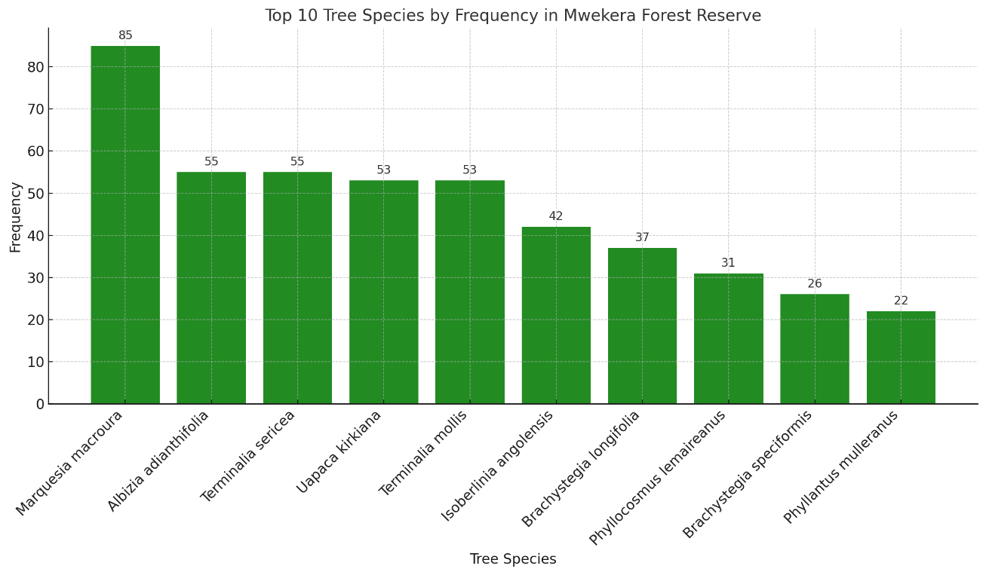
Figure 6 Species sighting frequency, Mwekera national forest reserve

3.4 Land cover change
Land use and land cover (LULC) dynamics constituted a central variable assessed across the 30 systematically selected sample plots within the designated study area. The spatial extent of the study was defined by a 2.5-kilometre radius from Zambia Forestry College, which served as the centroid. Analysis of LULC data revealed that an overwhelming majority, 94.96% of the area retained forest cover (Figure 3). Agricultural land use accounted for 2.71% of the sampled plots, while 2.33% was categorized as dambo or wetland.
The presence of agriculture within a legally protected forest reserve is significant and indicative of encroachment. The 2.71% agricultural footprint, although seemingly marginal, is emblematic of a broader pattern of illegal settlement and land use. Field observations indicated that these agricultural activities frequently coincided with locations of charcoal kilns, suggesting that settlers are drawn to the nutrient-rich ash residues left following charcoal extraction. Crops observed included Zea mays (maize), Manihot esculenta (cassava), Cucurbita spp. (pumpkin), and Arachis hypogaea (groundnuts). These findings underscore a dual exploitation of the forest resource, wherein trees are not only harvested for charcoal production but also the land is converted for subsistence agriculture, both representing direct violations of forest reserve regulations.

3.5 Impact of charcoal production on diameter and tree height
The study evaluated the structural attributes of tree species targeted for charcoal production, with a specific focus on diameter at breast height (DBH), total height, and crown cover. Trees that exhibited higher frequencies of occurrence across sample plots recorded an average DBH of 14.276 cm and a corresponding mean height of 10.755 meters. In contrast, species with the lowest frequency exhibited significantly larger diameters, with DBH values exceeding 46 cm and total tree heights surpassing 30 meters.
A positive linear relationship was observed between DBH and total tree height across all sampled individuals. The data distribution was examined for skewness and kurtosis, revealing a moderately right-skewed distribution, indicative of the dominance of younger, smaller-statured trees in the landscape (Figure 5 and 6). This pattern reflects selective harvesting pressure, where larger individuals have been disproportionately removed over time.

3.5.1 Basal area and volume estimation
The total basal area across all sampled individuals was estimated at 6.481 m². Using a standard tree volume estimation formula, where volume is derived as the product of basal area, tree height, and a species-appropriate form factor (commonly 0.7 for tropical hardwoods), the estimated total volume of wood within sampled plots was computed as 82.690 m³.

3.6 Regression analysis between DBH and total tree height
To further quantify the relationship between tree diameter and height, a linear regression analysis was performed. The results revealed a statistically significant positive correlation, with an R² value of 0.625 (Figure 6), indicating that approximately 62.5% of the variation in tree height could be explained by DBH. The regression coefficient was found to be significant (p < 0.001), suggesting a strong predictive relationship between the two variables.
This finding corroborates previous literature (e.g., Frost, 2022), which emphasizes the utility of DBH as a surrogate for estimating above-ground biomass and structural complexity in forest ecosystems. However, this study specifically focused on establishing the strength of the relationship rather than on inferential statistics related to biomass modelling.
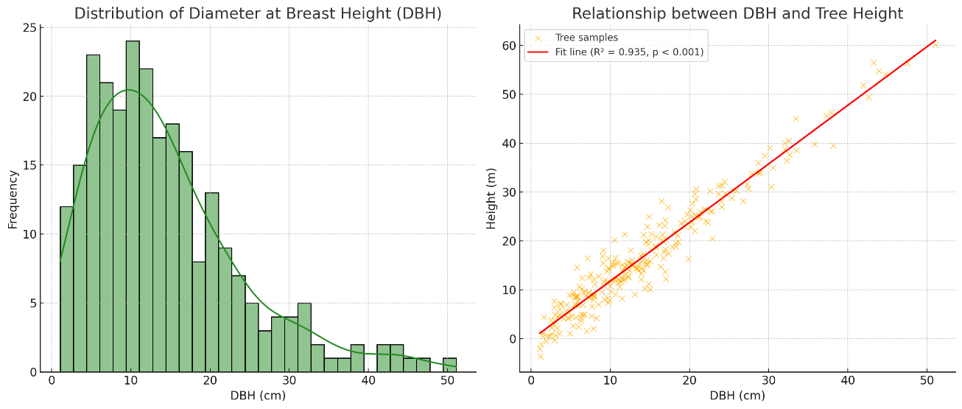
Figure 7. Expression of regression analysis between DBH and total tree height

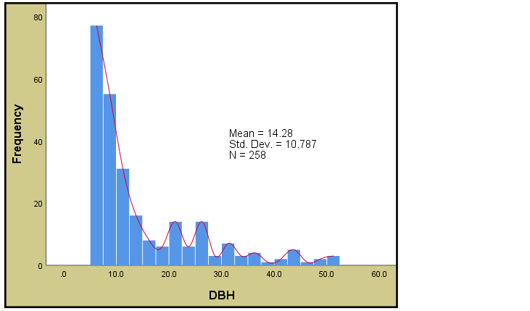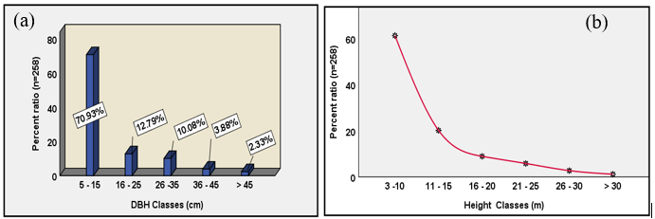
a b
Figure 8 Reversed-J curve of DBH distribution in Mwekera national forest reserve in a and tree height in b.

Diameters at breast heights for the samples individuals classified in a, and total tree heights of sampled individuals classified in b.
The Regression analysis which measured the relationship between diameters at breast height and total tree heights showed a positive relationship R-Square = 0.625 (Figure 9).
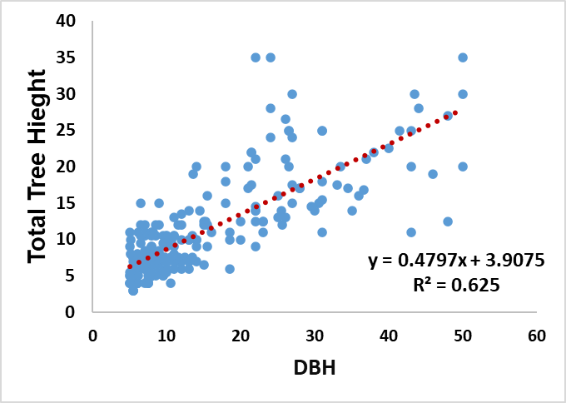
Figure 9 Regression analysis for DBH and tree height relationship
3.6 Distribution of tree sizes: Implications for forest degradation
Further analysis of DBH frequency distributions (Figure 4a and 4b) indicated that 70% of the sampled trees had diameters of 15 cm or less, while only 2.33% exceeded this threshold significantly. This trend suggests a high level of exploitation of larger trees, likely driven by their higher calorific value and suitability for charcoal production. The scarcity of larger DBH classes is a strong indicator of advanced forest degradation, particularly in areas with concentrated kiln activity.
The observed size-class distribution aligns with findings from other degraded miombo woodlands in sub-Saharan Africa, where chronic anthropogenic disturbance results in skewed population structures and regeneration bottlenecks. Urgent management interventions are required to prevent the complete depletion of mature cohorts and to promote natural regeneration.

p3.7 Species preference profile for charcoal production
Field assessments and ethnobotanical interviews conducted within Mwekera Forest Reserve No. 6 revealed a pronounced preference for specific indigenous woody taxa utilized in traditional charcoal production systems. The most frequently targeted genera were Julbernardia and Brachystegia, which dominate the miombo woodland biome characteristic of Zambia’s central and northern ecological zones. These taxa are favored due to their high wood density, slow combustion rate, and superior calorific output, making them particularly efficient for domestic and commercial energy use. Notably, Julbernardia paniculata and Brachystegia spiciformis emerged as the most intensively harvested species across all surveyed plots (Figure 10).

These species possess xylological properties such as high lignin content and low moisture retention, which contribute to their desirability for charcoal production. In addition, their widespread availability within mesic miombo woodlands renders them accessible to local harvesters, especially in forest-edge communities where regulation enforcement is limited. Respondent data indicated that 68% of charcoal producers prioritized Julbernardia spp. as their primary target species, while 52% also reported active utilization of Brachystegia spp. (χ² = [insert value], df = [insert df], p < 0.01). The targeting of these climax species for charcoal undermines long-term forest regeneration, given their slow growth rates and high ecological value as dominant canopy formers and nitrogen cyclers in woodland ecosystems.
The extraction patterns associated with charcoal production reflect not only subsistence needs but also the economic valuation of hardwood species in peri-urban charcoal markets, particularly in Ndola and Kitwe, where demand for bioenergy remains high due to energy poverty and unreliable grid electrification. This selective pressure on Julbernardia and Brachystegia may lead to compositional shifts within the woodland, favouring more disturbance-tolerant or less preferred species, thereby altering successional trajectories and reducing the ecological resilience of the forest reserve. If left unregulated, such harvesting behavior may result in the functional erosion of miombo woodland structure and services, including carbon sequestration, water regulation, and biodiversity support.

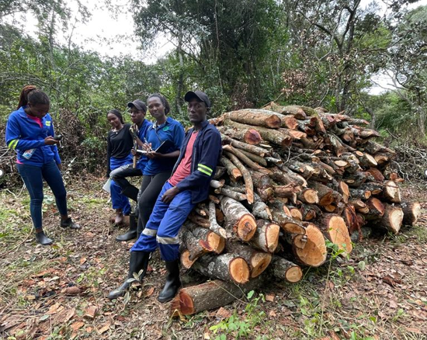
Figure 10 Logs piled for building charcoal kiln showing preferred species of Julbernardia and Brachystegia spp.

4.0 Discussion
4.1 Impacts of charcoal production on species composition and stem size
Charcoal production remains a principal source of household energy in both rural and urban Zambia, particularly for cooking and heating. The escalating frequency of droughts, in conjunction with chronic load shedding stemming from inadequate hydroelectric capacity, has increased national dependence on biomass fuels particularly charcoal (Kalaba et al., 2013; ZEMA, 2021). As a result, Zambia’s miombo woodlands, covering nearly 60% of the country’s terrestrial landscape, face significant structural, compositional, and functional degradation (FAO, 2020). The findings of this study indicate that unsustainable charcoal production has induced pronounced shifts in species composition and stem size distribution, thereby threatening the ecological integrity of Mwekera Forest Reserve and other comparable woodland ecosystems.

4.2 Selective harvesting and floristic alteration
Miombo woodlands are ecologically characterized by species belonging to the genera Brachystegia, Julbernardia, and Isoberlinia, which form the dominant tree layer (Chidumayo & Gumbo, 2010). These species are highly sought after by charcoal producers due to their high wood density, calorific value, and slow-burning characteristics. In accordance with earlier findings by Chomba (2018) and Syampungani et al. (2010), the present study confirms that species such as Julbernardia paniculata, Brachystegia spiciformis, Brachystegia boehmii, and Pericopsis angolensis are most commonly targeted for charcoal production.
The continual extraction of these climax, slow-growing species has resulted in a notable reduction in their population densities, leading to shifts in species dominance. This change simplifies the forest’s structure, disrupts microhabitat availability, affects nutrient cycling, and weakens resilience to ecological disturbances such as wildfires and invasive species. Simultaneously, species that are not preferred for charcoal production such as Marquesia macroura, tend to proliferate, which contributes to a shift in community composition and a decline in ecosystem functionality (Luoga et al., 2004).
This degradation pattern parallels observations in other regions such as Kapiri Mposhi, where the local extinction of key hardwood species has been reported (Chomba, 2018). The resulting loss in floristic and functional diversity undermines ecosystem services such as carbon storage, hydrological regulation, and soil fertility maintenance (Syampungani et al., 2010; Kalaba et al., 2013).

4.3 Declining stem size and the "down-sizing" trend
A salient finding of this study is the progressive reduction in the diameter at breast height (DBH) of harvested trees, reflecting a phenomenon known as “down-sizing” (Malimbwi et al., 2005). Initially, producers favour larger trees due to their high charcoal yield and efficiency (Chidumayo, 1993). However, as mature individuals become scarce, producers shift to harvesting younger and smaller stems, which compromises regeneration potential.
This trend interrupts natural forest succession, as immature trees are harvested before reaching reproductive age, reducing seed dispersal and canopy closure. It also makes the forest more vulnerable to erosion and nutrient depletion. Moreover, young trees possess lower biomass, thus reducing the forest’s carbon sequestration capacity (Kalaba et al., 2013). Over time, the landscape transitions into a degraded environment characterized by coppicing stumps and scattered saplings, endangering long-term forest recovery.

4.4 Broader ecological and socioeconomic implications
Zambia’s miombo woodlands are undergoing accelerated degradation, driven largely by charcoal production, especially in peri-urban areas experiencing rapid population growth and unreliable electricity access. The Food and Agriculture Organization (FAO, 2020) estimates Zambia’s annual deforestation rate at between 250,000 and 300,000 hectares, with charcoal production being a principal cause.
This woodland depletion has far-reaching ecological consequences, including the loss of biodiversity, reduced carbon storage, disruption of water catchments, and declining pollination services. Deforestation also significantly contributes to Zambia’s greenhouse gas emissions (ZEMA, 2021). Socioeconomically, the forest loss exposes rural communities to heightened vulnerability by reducing access to ecosystem goods and services, exacerbating poverty and food insecurity.
Addressing these challenges requires a multi-dimensional approach, incorporating improved forest governance, alternative energy promotion, and robust community-based management systems.

4.5 Conclusion
The study demonstrates that charcoal production within the Mwekera Forest Reserve exerts deleterious ecological effects by promoting selective harvesting of climax species and reducing stem size across age classes. These unsustainable practices reduce species richness, impair forest structure, and diminish critical ecosystem services. If left unaddressed, the degradation may result in irreversible damage to forest ecosystems, threatening not only biodiversity but also local livelihoods and Zambia’s national commitments to climate resilience and mitigation.
4.6 Recommendations
To restore ecological balance and ensure the sustainable management of Zambia’s miombo woodlands, this study proposes the following strategies for adoption:
a) Promote natural regeneration through coppicing
Species such as Brachystegia and Julbernardia regenerate effectively through coppicing (Luoga et al., 2004; Chomba, 2018). Management interventions should include protecting stumps from further harvesting, regulating livestock grazing, and reducing fire incidence. Community fire management plans must be institutionalized to protect young sprouts and seedlings.

b) Implement controlled and selective harvesting
Forest harvesting should be regulated through a permit system with spatial and temporal restrictions. A minimum cutting diameter (e.g., >20 cm DBH) should be enforced to ensure only mature trees are harvested (Chidumayo, 1993). Clear-cutting should be prohibited, particularly in biodiversity-sensitive zones.
c) Adopt assisted natural regeneration (ANR)
Assisted natural regeneration involves supporting natural seedling growth by clearing competing vegetation, enriching degraded areas with native seedlings, and controlling fire outbreaks (Syampungani et al., 2010). These practices should be integrated with soil rehabilitation and invasive species control.

d) Reforestation and agroforestry development
Where natural regeneration is insufficient, reforestation using fast-growing species (e.g., Eucalyptus grandis) in buffer zones can reduce pressure on natural forests. Agroforestry involving native miombo species should be promoted to increase tree cover, enhance soil fertility, and improve farmer income.

e) Address illegal settlements and encroachment
Illegal settlements contribute to forest degradation. A phased relocation plan, developed in consultation with local authorities, should be implemented. Outreach and education programs must be used to raise awareness about forest ecosystem services and promote sustainable land use. Law enforcement must be intensified to prevent future encroachment.

f) Establish monitoring and research systems
Ongoing ecological monitoring is essential for adaptive management. This includes tracking species composition, tree density, and regeneration patterns. Socio-economic research should explore charcoal value chains, and community attitudes towards forest conservation (Chidumayo & Gumbo, 2010).

4.7 Recommendations for future research
Future studies should prioritize socio-economic assessments of communities surrounding the Mwekera Forest Reserve. Research should examine the origins, livelihood patterns, and forest-use practices of informal settlers. Participatory approaches are essential in engaging communities to co-develop viable livelihood alternatives. Further investigations into scalable forest extension models can enhance ecological literacy and foster sustainable human-forest relationships.

Author contributions
Conceptualization, Chomba, C. field data collection, Cheelo, P., original draft preparation, Chomba, C., statistical analysis Malunga M., project administration, Chomba, C. All authors have read and agreed to the published version of the manuscript.

Conflict of interest
This research was co-funded by the research team as individuals.

Acknowledgements
We wish to acknowledge the contributions of internal reviewers, and the community participants in the study area, particularly some of the members of staff at Mwekera forest college.

References
Aron, D., Lee, H. and Merton, A. (2021) 'The role of forests in climate change mitigation', Climate Change Science Journal, 52(4), pp. 124–138.
Borgarello, A. (2016) 'Forests and climate change: Mitigation and adaptation services', Environmental Science and Policy Journal, 44(2), pp. 73–85.
Brown, S. (1997) Estimating biomass and biomass change of tropical forests: a primer. Rome: Food and Agriculture Organization of the United Nations (FAO Forestry Paper No. 134). Available at: https://www.fao.org/3/w4095e/w4095e00.htm
Cailteux, J.H., Kampunzu, A.B., Lerouge, C., Kaputo, A. and Milesi, J.P. (2005) 'Genesis of sediment-hosted stratiform copper–cobalt deposits, Central African Copperbelt', Journal of African Earth Sciences, 42(1–5), pp. 134–158.
Central Statistical Office (CSO) (2020) 2020 Census of Population and Housing: Preliminary Report. Lusaka: Government of the Republic of Zambia.
Chave, J., Andalo, C., Brown, S., Cairns, M.A., Chambers, J.Q., Eamus, D., Fölster, H., Fromard, F., Higuchi, N., Kira, T., Lescure, J.P., Nelson, B.W., Ogawa, H., Puig, H., Riera, B. and Yamakura, T. (2005) 'Tree allometry and improved estimation of carbon stocks and balance in tropical forests', Oecologia, 145(1), pp. 87–99. https://doi.org/10.1007/s00442-005-0100-x
Chidumayo, E.N. (1993) Responses of miombo to harvesting: Ecology and management. Stockholm: Swedish University of Agricultural Sciences.
Chidumayo, E.N. (2013) 'Forest degradation and recovery in a miombo woodland landscape in Zambia: 22 years of observations on permanent sample plots', Forest Ecology and Management, 291, pp. 154–161. https://doi.org/10.1016/j.foreco.2012.11.033
Chidumayo, E.N. and Gumbo, D.J. (2010) The dry forests and woodlands of Africa: Managing for products and services. London: Earthscan.
Chilton, P.J. and Foster, S.S.D. (1995) 'Hydrogeological characterisation and water supply potential of basement aquifers in tropical Africa', Hydrogeology Journal, 3(1), pp. 36–49.
Chomba, C. (2018) 'Does the cutting of miombo tree species for charcoal production directly cause deforestation? A case study of Kapiri Mposhi area, Central Zambia', Global Journal of Biology, Agriculture and Health Science, 7(1), pp. 45–65.
CIFOR (Centre for International Forestry Research) (2014) Monitoring and reporting on forest resources in Zambia: A case study. Bogor: CIFOR.
Climate-Data.org (2021) Climate: Copperbelt – Climate graph, temperature graph, Climate table for Copperbelt. Available at: https://en.climate-data.org/africa/zambia/copperbelt-1937/ [Accessed 29 July 2025].
Colwell, R.K. (2009) 'Biodiversity: concepts, patterns, and measurement', in Levin, S.A. (ed.) The Princeton guide to ecology. Princeton: Princeton University Press, pp. 257–263.
Dewees, P.A., Campbell, B.M., Katerere, Y., Sitoe, A., Cunningham, A.B., Angelsen, A. and Wunder, S. (2011) Managing the miombo woodlands of southern Africa: policies, incentives and options for the rural poor. Washington, DC: Program on Forests (PROFOR), The World Bank. Available at: https://documents.worldbank.org/en/publication/documents-reports/documentdetail/122231468299679738/
FAO (Food and Agriculture Organization) (2017) The charcoal transition: Greening the charcoal value chain to mitigate climate change and improve local livelihoods. Rome.
FAO (Food and Agriculture Organization) (2020) Global forest resources assessment 2020: Zambia country report. Rome: FAO.
Food and Agriculture Organization (FAO) (2021) Forest futures: Sustainable pathways for forests, landscapes and people in the Asia-Pacific region. Bangkok: FAO.
Frost, P.G.H. (1996) 'The ecology of miombo woodlands', in Campbell, B. (ed.) The Miombo in transition: woodlands and welfare in Africa. Bogor: CIFOR, pp. 11–57. Available at: https://www.cifor.org/publications/pdf_files/Books/miombo.pdf
Giesecke, J. (2012) Causes of deforestation in Zambia and impacts on national forest reserves. Washington, DC: USAID.
Global Historical Weather and Climate Data (2022) Historical Weather Data for Zambia. Available at: https://www.worldweatheronline.com/ [Accessed 29 July 2025].
Government of the Republic of Zambia (GRZ) (2019b) Seventh National Development Plan (7NDP) 2017–2021: Mid-Term Review Report. Lusaka: Ministry of National Development Planning.
International Energy Agency (IEA) (2022) Africa Energy Outlook 2022. Paris: IEA. Available at: https://www.iea.org/reports/africa-energy-outlook-2022
Jury, M.R. (2019) Climate trends and scenarios for southern Africa. Cham: Springer. https://doi.org/10.1007/978-3-030-23033-8
Kalaba, F.K., Quinn, C.H. and Dougill, A.J. (2010) 'Contribution of forest provisioning ecosystem services to rural livelihoods in the Miombo woodlands of Zambia', Population and Environment, 31(5), pp. 386–409. https://doi.org/10.1007/s11111-010-0103-0
Kalaba, F.K., Quinn, C.H. and Dougill, A.J. (2013) 'The role of forest provisioning ecosystem services in coping with household stresses and shocks in rural Africa', Ecosystem Services, 5, pp. 143–152.
Kampunzu, A.B., Cailteux, J.H. and Moine, B. (2000) 'Sediment-hosted Zn–Pb–Cu deposits in the Central African Copperbelt', Journal of African Earth Sciences, 30(3), pp. 897–917.
Kanja, K., Mweemba, M. and Siwale, W. (2017) 'Time series analysis of encroachment in Mwekera Forest Reserve using remote sensing and GIS', The International Journal of Multi-Disciplinary Research, pp. 3–8.
Luoga, E.J., Witkowski, E.T.F. and Balkwill, K. (2000) 'Economics of charcoal production in miombo woodlands of eastern Tanzania: some hidden costs associated with commercialization of the resources', Ecological Economics, 35(2), pp. 243–257. https://doi.org/10.1016/S0921-8009(00)00196-8
MacDonald, A.M., Davies, J. and Dochartaigh, B.E.O. (2005) Developing groundwater: A guide for rural water supply. Nottingham: British Geological Survey.
Magurran, A.E. (2004) Measuring biological diversity. Oxford: Blackwell Publishing.
Malhi, Y., Phillips, O.L., Lloyd, J., Baker, T., Wright, J., Almeida, S., Arroyo, L., Frederiksen, T., Grace, J., Higuchi, N., Laurance, W.F., Leañ o, C., Lewis, S.L., Meir, P., Monteagudo, A., Neill, D., Vargas, P.N., Silva, J., Terborgh, J., Vásquez, R. and Vinceti, B. (2004) 'Spatial patterns and regional gradients in surface temperature and productivity in Amazonian forests', Journal of Geophysical Research: Atmospheres, 109(D2). https://doi.org/10.1029/2003JD003545
Malimbwi, R.E., Zahabu, E. and Kajembe, G.C. (2005) Charcoal potential of miombo woodlands at Kitulangalo, Tanzania. Morogoro: Tanzania Forestry Research Institute (TAFORI).
Mensah, P. (2021) 'Charcoal production and its ecological consequences in Sub-Saharan Africa', Environmental Conservation Journal, 25(4), pp. 212–220.
Millennium Ecosystem Assessment (2005) Ecosystems and Human Well-being: Synthesis. Washington, DC: Island Press.
Moll, E. (2011) What’s that tree? Cape Town: Struik Nature Publishers.
Moore, P.D., Chapman, S.B. and Sims, R.W. (1996) Methods in plant ecology. 2nd ed. Oxford: Blackwell Science.
Moutsambote, J.-M., Koubouana, F. and Yoka, J. (2016) 'Tree species diversity, richness, and similarity in intact and degraded forest in the tropical rainforest of the Congo Basin: Case of the Forest of Likouala in the Republic of Congo', Hindawi.
Mwampamba, T.H., Ghilardi, A., Sander, K. and Chaix, K.J. (2013) 'Dispelling common misconceptions to improve attitudes and policy outlook on charcoal in developing countries', Energy for Sustainable Development, 17(2), pp. 75–85. https://doi.org/10.1016/j.esd.2012.11.001
Palgrave, K.C. (2002) Trees of southern Africa. Revised ed. Cape Town: Struik Publishers.
Phillips, O.L., Hall, P., Gentry, A.H., Sawyer, S.A. and Vásquez, R. (2002) 'Dynamics and species richness of tropical rain forests', Proceedings of the National Academy of Sciences, 91(7), pp. 2805–2809. https://doi.org/10.1073/pnas.91.7.2805
Porter GeoConsultancy (2020) Zambia Copperbelt geology overview. Available at: https://www.portergeo.com.au [Accessed 4 July 2025].
Storrs, A.E.G. (1995) Know your trees: some of the common trees found in Zambia. Lusaka: Regional Soil Conservation Unit (RSCU), Swedish International Development Authority (SIDA).
Syampungani, S., Chirwa, P.W., Akinnifesi, F.K. and Sileshi, G. (2010) 'The potential of using agroforestry as a win–win solution to climate change mitigation and adaptation and meeting food security challenges in Southern Africa', Agriculture, Ecosystems & Environment, 136(1–2), pp. 113–127.
Syampungani, S., Chirwa, P.W., Akinnifesi, F.K. and Sileshi, G. (2016) 'Miombo woodland recovery and management: Advances in ecology, silviculture and governance', Forests, Trees and Livelihoods, 25(4), pp. 285–297. https://doi.org/10.1080/14728028.2016.1222251
Taylor, R.G. and Howard, K.W.F. (1999) 'The influence of geology on the occurrence of groundwater in southern Africa', Journal of Hydrology, 214(1–4), pp. 47–62.
Taylor, R.G. and Howard, K.W.F. (2000) 'A tectono-geomorphic model of the hydrogeology of deeply weathered crystalline rock: Evidence from Uganda', Hydrogeology Journal, 8(3), pp. 279–294.
Timberlake, J. and Chidumayo, E.N. (2011) Miombo ecoregion vision report. WWF-SARPO Occasional Paper Series 15. Harare: World Wide Fund for Nature.
United Nations (2015) Transforming our world: the 2030 Agenda for Sustainable Development. A/RES/70/1. New York: United Nations.
United Nations Development Programme (UNDP) (2019) Zambia: Sustainable charcoal value chains. Lusaka: UNDP Zambia. Available at: https://www.undp.org/zambia/publications/sustainable-charcoal-value-chains
Von der Heyden, C.J. and New, M.G. (2004) 'Groundwater pollution on the Zambian Copperbelt: Deciphering the origins and possible links with mining', Water SA, 30(2), pp. 121–126.
White, F. (1983) The Vegetation of Africa: A Descriptive Memoir to Accompany the UNESCO/AETFAT/UNSO Vegetation Map of Africa. Paris: UNESCO.
World Bank (2018) Forest Landscape Programme for Zambia: Addressing deforestation and promoting sustainable land management. Lusaka: World Bank.
Zambia Environmental Management Agency (ZEMA) (2021) State of the Environment Report for Zambia 2020–2021. Lusaka: ZEMA.
Zambia Meteorological Department (2022) Annual Climate Summary Report for 2021/2022 Season. Lusaka: Ministry of Green Economy and Environment.
Zulu, L.C. and Richardson, R.B. (2013) 'Charcoal, livelihoods, and poverty reduction: Evidence from sub-Saharan Africa', Energy for Sustainable Development, 17(2), pp. 127–137. https://doi.org/10.1016/j.esd.2012.07.007

