Prevalence of Hypertension and Associated Risk Factors Among Adults in Rural Lucknow, Uttar Pradesh, India: A Community-Based Cross-Sectional Study

ABSTRACT
Background: Hypertension is one of the foremost cardiovascular risk factors with increasing prevalence in lower and middle-income countries. In India, the overall prevalence of hypertension is around 27 %, while awareness, treatment, and control data at the community level, in rural communities, are still lacking.
Objectives: This study aimed to determine the prevalence of hypertension and its associated risk factors among adults ≥18 years of age in the rural field practice area of the Integral Institute of Medical Sciences & Research (IIMSR), Lucknow, India.
Methodology: This study is a community-based cross-sectional survey of 320 individuals, selected through multistage sampling and through a door-to-door approach. The survey included a questionnaire, anthropometry, and blood pressure measurements. Chi-square test (p < 0.05) was used for statistical analysis.
Key results: Hypertension was prevalent in 24.7 % of the study population. There was poor awareness in 75.6% of the study population; 31.9 % of the study population had never been screened for high blood pressure. The majority of them were not taking any particular medication (77.5%), and only 1.6 % of them adhered to medication. There was a statistical relationship between age categories and hypertension (p< 0.001). However, there was no statistical relationship between gender, smoking, alcohol consumption, marital status, and body mass index.
Conclusion: Community-based health education interventions are needed to improve hypertension awareness and control, poor awareness, and poor adherence to medications among the study population. It is critical to educate the population in rural areas about hypertension.
Keywords: Hypertension; Rural population; Cardiovascular risk factors; Awareness; Uttar Pradesh; India

INTRODUCTION
In fact, it is not only high blood pressure per se that is regarded as a key indicator in the field of public health, but also indicates the problems with prevention, screening, and follow-up care.
Internationally, it can be stated that hypertension has long been regarded as one of the most prominent non-communicable disorders owing to the correlation between the condition and the mentioned health hazards, such as cardiovascular diseases, strokes, kidney problems, and premature death. According to recent global estimates, approximately 1.4 billion people aged 30-79 suffer from the problem but remain unaware of the diagnosis and are not treated accordingly. At the same time, the highest prevalence of the condition can be noted in low- and middle-income countries where there are numerous other priorities, as well as a shortage of chronic disease surveillance systems (Boateng & Ampofo, 2023) (Hossain, 2023) (O'Connell et al., 2026). In this respect, it can be argued that hypertension becomes a silent killer that often develops asymptomatically. Moreover, prevention and treatment remain inadequate. As far as the awareness rate, treatment rate, and control rate are concerned, none of these indicators show any improvement (Farrar & Frieden, 2025).
However, in India, this global challenge becomes an even greater one due to India’s large population, epidemiological transition, and increasing vulnerability among its rural inhabitants. The national and pooled data demonstrate that almost a quarter of all Indian adults suffer from high blood pressure, with great disparities across regions and a marked age-related gradient (Prabha et al., 2025; Mohammad & Bansod, 2024). Even though previously, hypertension was prevalent in urban areas, at present, the rural population carries a considerable burden of lifestyle-related disease, aging, nutrition habits, and lack of opportunities to receive preventive services (Uthakalla et al., 2024; Chaubey et al., 2025) (Anjana et al., 2023). This leads to increased morbidity rates associated with hypertension without addressing the problem in health policy.
It is particularly important to stress the importance of rural areas because it is difficult to identify and track patients after leaving urban health facilities. Rural individuals may have fewer opportunities for regular examinations, counseling sessions, and coordination of screening and starting the treatment process. There are several studies conducted on the rural population in India, which show that the prevalence rate of hypertension among residents of the aforementioned territories is not regarded as low any longer, hypertension being related in most cases to low awareness and treatment coverage (Uthakalla et al., 2024; Daniyala et al., 2024) (Ranjan et al., 2025). It was found out by national surveys and implementation studies that the screening program had the potential to reveal new cases of hypertension; however, the problem in communication between screening, diagnosing, and providing care proved to be the central barrier (Soundappan et al., 2024) (J, 2024). Actually, this tendency correlates with the phenomenon known as "the rule of halves," when most patients are not aware of their hypertensive disease, and many people diagnosed with it are not able to control it.
Locally available evidence is still crucial in Uttar Pradesh since there are considerable differences in the prevalence and care-seeking patterns in different districts and among different segments of the population. The few studies conducted in the state reveal high hypertension prevalence rates as well as significant gaps in awareness and screening in the community and at the primary care facility level (Prajapati et al., 2024; Chaubey et al., 2025). However, there are still insufficient data from rural districts of Lucknow in spite of the region's strategic role in the training and services delivery in the community health field. The use of the general data on the state or even national levels is inappropriate, given the fact that the specific needs of the local community can be lost in these statistics, especially for the adult population, especially those who are relatively old or poorly educated and thus do not use preventive health care.
Against this backdrop, the current study was conceived to generate empirical data from the rural field practice area of IIMSR, Lucknow. The objective of the current research is to estimate the prevalence of hypertension in adults ≥18 years of age, identify associated risk factors, determine the level of awareness about hypertension, and find out the socio-demographic correlates of hypertension amongst the study subjects. Generating such empirical data from a rural setup of Lucknow would help in formulating prevention strategies for such a population.

METHODOLOGY
To address the gap identified in the preceding literature, this study used a community-based cross-sectional design to estimate the prevalence of hypertension and its associated factors among adults in the rural field practice area of Integral Institute of Medical Sciences & Research (IIMSR), Lucknow, India.

Study design and setting
The study was conducted as a community-based cross-sectional survey in rural communities under the field practice area of IIMSR, Lucknow. This setting was selected because it provides a representative rural training and service environment and permits direct household-level assessment of blood pressure, anthropometric status, and hypertension-related awareness and practices. The study population comprised adults aged ≥ 18 years residing in the selected rural area.

Study population, eligibility, and sample size
Eligible participants were adults aged ≥ 18 years or older who had been residents of the area for at least 6 months and who were willing to participate. Seriously ill individuals, pregnant women, and those who did not provide consent were excluded. The final sample size was 320 respondents, consistent with the dissertation-based study plan and evidence registry. This sample size was derived using the standard formula:
n = $\frac{4pq }{d^{2}}$
Where:
p = 24% (0.24, a combined pooled estimate of hypertension prevalence).
q = 1-0.24 = 0.76
d = 0.05 (5% absolute precision or allowable error)
n = $\frac{4 x 0.24 x 0.76 }{{(0.05)}^{2}}$
After allowing for 10% non-response, the adjusted target was approximately 320 participants.

Sampling and recruitment
A multistage cluster sampling technique was employed. Eleven villages were randomly selected from the rural field practice area of IIMSR. Within each selected village, eligible adults were recruited through house-to-house visits until the required sample size was achieved.

Data collection procedures
Data were collected using a structured questionnaire and anthropometric measurements. The questionnaire captured socio-demographic characteristics, behavioral risk factors, medical history, awareness regarding hypertension, and treatment status. The source instrument included sections on age, sex, marital status, education, occupation, monthly family income, smoking, alcohol use, physical activity, salt intake, prior blood pressure checking, antihypertensive treatment, and knowledge about hypertension. Anthropometric data were recorded alongside blood pressure measurements.
Blood pressure was measured using a calibrated Omron digital sphygmomanometer after participants rested for at least 5 minutes in a seated position. Two measurements were taken 2 minutes apart, and the average was used for analysis. Hypertension classification followed the threshold specified in the questionnaire, namely, ≥ 140/90 mmHg. Height and weight were also measured for the calculation of body mass index (BMI), which was analyzed as an additional clinical indicator.

Variables
The dependent variable was hypertension status. Independent variables included age, gender, education, occupation, monthly income, marital status, smoking status, daily alcohol consumption, physical activity, salt intake, blood pressure screening behavior, BMI, awareness level, and treatment status. For analysis, categorical variables were summarized as frequencies and percentages, while continuous variables such as systolic blood pressure, diastolic blood pressure, and BMI were expressed as means and standard deviations.

Data management and statistical analysis
Data were analyzed using SPSS version 27. Descriptive statistics, including frequencies, percentages, means, and standard deviations, were used to summarize participant characteristics. Associations between categorical variables and hypertension were assessed using the Chi-square test. Variables considered relevant based on epidemiological importance were subsequently entered into a multivariable binary logistic regression model to identify factors independently associated with hypertension. Adjusted odds ratios (AORs) with 95% confidence intervals (CIs) were reported. Statistical significance was set at p < 0.05.

Ethical considerations
The study was reviewed and approved by the Institutional Ethics Committee of Integral Institute of Medical Sciences & Research under ethical clearance number IEC/IIMSR/2026/35, dated 24/01/2026. It was conducted in accordance with ethical principles and guidelines for biomedical and public health research involving human participants. Written informed consent was obtained from all respondents before participation. Confidentiality was maintained throughout data collection and analysis, and participants identified with elevated blood pressure were referred for appropriate medical care. The study involved minimal risk, limited primarily to transient discomfort during blood pressure measurement.

Tables

Table 1. Socio-demographic Characteristics of Respondents (n = 320)
Variable | Category | Frequency (n=320) | Percentage (100%)
Gender: | Male | 141 | 44.1
 | Female | 179 | 55.9
Age group: | 25 years and below | 35 | 10.9
 | 26-39 years | 106 | 33.1
 | above 40 years | 179 | 55.9
Education Level: | No formal education | 124 | 38.8
 | Primary | 77 | 24.1
 | Secondary | 69 | 21.6
 | Higher secondary | 28 | 8.8
 | Graduate or above | 22 | 6.9
Occupation: | Student | 14 | 4.4
 | Self-employed | 133 | 41.6
 | Homemaker | 154 | 48.1
 | Employed | 19 | 5.9
Marital Status: | Single | 13 | 4.1
 | Married | 305 | 95.3
 | Widow/Widower | 2 | .6
Monthly income: | Low income | 129 | 40.3
 | Lower-middle income | 27 | 8.4
 | Middle income | 101 | 31.6
 | Upper-middle income | 56 | 17.5
 | High income | 7 | 2.2

Table 2. Behavioral Risk Factors of Respondents (n = 320)
Variable | Category | Frequency (n=320) | Percentage  (%100)
smoking status: | smokers | 103 | 32.2
 | nonsmokers | 217 | 67.8
Daily alcohol consumption status | Yes | 17 | 5.3
 | No | 303 | 94.7
Daily physical activity: | Yes | 241 | 75.3
 | No | 79 | 24.7
BP checking location: | Government hospital | 111 | 34.7
 | Private clinic | 105 | 32.8
 | Health camp | 2 | .6
 | Never check | 102 | 31.9
Daily salt intake: | Yes | 45 | 14.1
 | No | 275 | 85.9
Treatment status | Not diagnosed | 28 | 8.8
 | Not on treatment | 248 | 77.5
 | Irregular treatment | 39 | 12.2
 | Regular treatment | 5 | 1.6

Table 3. Clinical Characteristics of Respondents (n = 320)
Variable | Mean ± SD
Systolic Blood Pressure (mmHg) | 123.48 ± 16.91
Diastolic Blood Pressure (mmHg) | 81.09 ± 11.94
Body Mass Index (kg/m²) | 22.09 ± 3.61

Table 4: Prevalence of hypertension among respondents (n = 320)
Hypertension status | Frequency (n) | Percentage (%)
Non-hypertensive | 241 | 75.3
Hypertensive | 79 | 24.7
Total | 320 | 100.0

Figure 1: Prevalence of hypertension among respondents

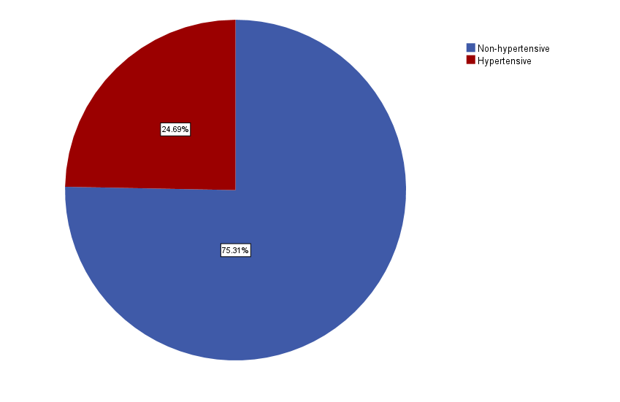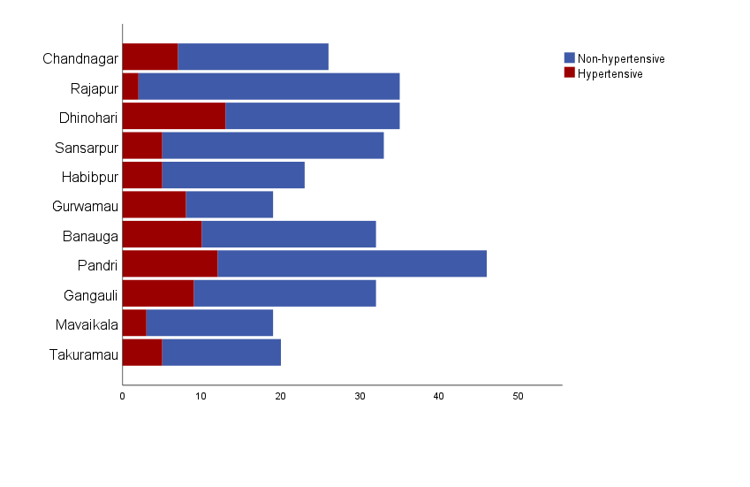
Figure 2 Hypertension status by Village
Figure 1: Prevalence of hypertension among respondents

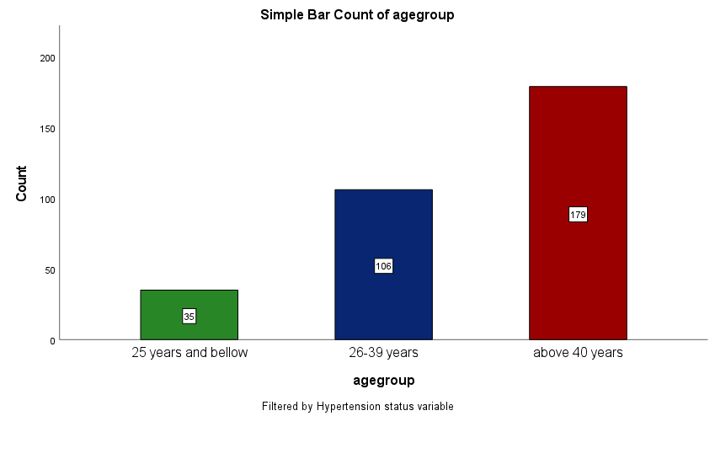
Figure 3: Relationship between age group and blood pressure status

RESULTS
The analyzed sample is summarized below, with the key outcome patterns presented in the accompanying tables and figures.

Results
Table 4 and Figure 1 show the prevalence of hypertension in the study population. Of the 320 respondents, 241 were non-hypertensive (75.31%), and 79 were hypertensive (24.69%). This indicates that approximately one in four adults in the rural field practice area of IIMSR, Lucknow, had hypertension at the time of assessment.
Figure 2 further illustrates the village-wise distribution of hypertension status, while Figure 3 presents the relationship between age group and blood pressure status. The visual pattern is consistent with the tabulated findings that hypertension clustered more strongly in older adults.
Awareness of hypertension was low across the sample. As shown in Figure 4, 242 respondents had poor awareness (75.6%), 63 had moderate awareness (19.7%), and only 15 demonstrated good awareness (4.7%). Awareness was assessed using 10 questions related to hypertension risk factors, symptoms, complications, and prevention. Correct responses scored one point. Scores were categorized as poor (<50%), moderate (50–74%), and good (≥75%).
Table 5: Awareness of hypertension among respondents (n=320)
Awareness status | Frequency (n) | Percentage (%)
Poor awareness | 242 | 75.6
Moderate awareness | 63 | 19.7
Good awareness | 15 | 4.7
Total | 320 | 100.0
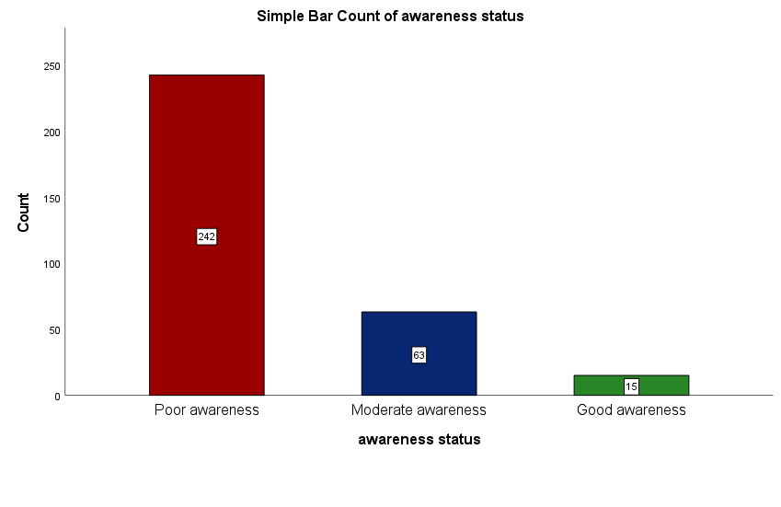
Figure 4: Awareness of hypertension among respondents

Behavioral risk factor profiling showed that 217 respondents were non-smokers (67.8%), while 103 were smokers (32.2%). Most respondents did not consume alcohol daily: 303 (94.7%) reported no daily alcohol use, compared with 17 (5.3%) who did. Physical activity was relatively common, with 241 respondents (75.3%) reporting daily activity and 79 (24.7%) reporting no daily physical activity. In addition, 275 respondents (85.9%) did not report daily excess salt intake, whereas 45 (14.1%) did. These descriptive findings indicate that although some health-promoting behaviors were common, a substantive minority of participants remained exposed to modifiable risk factors relevant to hypertension prevention.
Treatment status was similarly suboptimal. As shown in Table 6 and Figure 5, 28 respondents (8.8%) were not diagnosed, 248 (77.5%) were not on treatment, 39 (12.2%) were on irregular treatment, and Only 1.6% reported regular treatment. This means that among all respondents, a very small proportion had ongoing regular treatment, while most were either untreated, inconsistently treated, or undiagnosed.

Table 6: Treatment Status of Respondents
Treatment status | Frequency (n) | Percentage (%)
Not diagnosed | 28 | 8.8
Not on treatment | 248 | 77.5
Irregular treatment | 39 | 12.2
Regular treatment | 5 | 1.6
Total | 320 | 100.0
The clinical profile of respondents showed a mean systolic blood pressure of 123.48 ± 16.91 mmHg, a mean diastolic blood pressure of 81.09 ± 11.94 mmHg, and a mean body mass index of 22.09 ± 3.61 kg/m². Although the mean values were not in the hypertensive range, the spread around the means indicates heterogeneity in cardiovascular risk within the sample. This variability is reflected in the overall hypertension prevalence and the age-related pattern observed in the analysis.
Association testing identified age group as the only variable with a statistically significant relationship to hypertension. As shown in Table 4: 7, hypertension increased progressively with age: 1 respondent aged ≤ 25 years was hypertensive (2.9%), compared with 13 respondents aged 26-39 years (12.3%) and 65 respondents aged ≥40 years (36.3%). The chi-square test confirmed a significant association between age group and hypertension (χ² = 30.782, df = 2, p < 0.001). Figure 1 visually reinforces this age gradient, showing a higher concentration of hypertension among older adults.
Table 7: Association Between Selected Variables and Hypertension
Variable | Category | Non-Hypertensive n (%) | Hypertensive n (%) | χ² | df | p-value
Age group | ≤ 25 years | 34 (97.1) | 1 (2.9) | 30.782 | 2 | p < 0.001
 | 26-39 years | 93 (87.7) | 13.(12.3)
 | ≥40 years | 114 (63.7) | 65 (36.3)
Gender | Male | 100 (70.9) | 41 (29.1) | 2.613 | 1 | p = 0.106
 | Female | 141 (78.8) | 38 (21.2)
Marital status | Single | 13 (100.0) | 0 (0.0) | 5.079 | 2 | p = 0.079
 | Married | 227 (74.4) | 78 (25.6)
 | Widow/Widower | 1 (50.0) | 1 (50.0)
Smoking | Non-smoker | 163 (75.1) | 54 (24.9) | 0.014 | 1 | p = 0.905
 | Smoker | 78 (75.7) | 25 (24.3)
Alcohol | Yes | 11 (64.7) | 6 (35.3) | 1.086 | 1 | p = 0.297
 | No | 230 (75.9) | 73 (24.1)
BMI | Underweight | 34 (70.8) | 14 (29.2) | 1.316 | 3 | p = 0.725
 | Normal weight | 154 (74.8) | 52 (25.2)
 | Overweight | 48 (80.0) | 12 (20.0)
 | Obese | 4 (80.0) | 1 (20.0)
No statistically significant associations were observed between hypertension and gender (χ² = 2.613, df = 1, p = 0.106), marital status (χ² = 5.079, df = 2, p = 0.079), smoking status (χ² = 0.014, df = 1, p = 0.905), alcohol consumption (χ² = 1.086, df = 1, p = 0.297), or BMI (χ² = 1.316, df = 3, p = 0.725). Although some category-specific differences were present descriptively, they did not reach statistical significance in this sample.
Overall, the results indicate a community burden of hypertension that is substantial but not uniformly distributed. The prevalence was accompanied by very poor awareness, limited blood pressure screening, and weak treatment continuity. Together, these findings point to a pattern in which hypertension is both present and insufficiently detected or managed in the rural study setting, with older age emerging as the clearest associated factor.
Figure 3: Age Group and Hypertension Status.
Table 8: Univariate Logistic Regression Analysis of Factors Associated with Hypertension (N = 320)
Variable | Category | Crude OR (95% CI) | p-value
Age group | ≤25 years vs ≥40 years | 0.052 (0.007–0.386) | 0.004
 | 26–39 years vs ≥40 years | 0.245 (0.127–0.472) | <0.001
Gender | Male vs Female | 1.521 (0.913–2.534) | 0.107
Education level | No formal education vs Graduate+ | 2.906 (0.812–10.402) | 0.101
 | Primary vs Graduate+ | 2.375 (0.636–8.863) | 0.198
 | Secondary vs Graduate+ | 1.073 (0.267–4.309) | 0.920
 | Higher secondary vs Graduate+ | 1.727 (0.379–7.864) | 0.480
Occupation | Student vs Employed | Not stable† | 0.999
 | Self-employed vs Employed | 3.923 (0.867–17.760) | 0.076
 | Homemaker vs Employed | 2.500 (0.551–11.349) | 0.235
Physical activity | Yes vs No | 0.451 (0.260–0.785) | 0.005
BMI category | Underweight vs Obese | 1.600 (0.164–15.600) | 0.686
 | Normal weight vs Obese | 1.351 (0.148–12.358) | 0.790
 | Overweight vs Obese | 1.000 (0.102–9.784) | 1.000
Alcohol consumption | No vs Yes | 0.582 (0.208–1.628) | 0.302
Statistically significant at p < 0.05.
The occupation model failed to converge because of sparse observations in the student category; therefore, the OR estimate should be interpreted with caution.
Univariate logistic regression was performed to identify factors associated with hypertension among the study participants. Age group and physical activity were significantly associated with hypertension.
Participants aged ≤25 years had significantly lower odds of hypertension compared with those aged ≥40 years (OR = 0.052, 95% CI: 0.007–0.386, p = 0.004). Similarly, participants aged 26–39 years were significantly less likely to be hypertensive than those aged ≥40 years (OR = 0.245, 95% CI: 0.127–0.472, p < 0.001).
Participants who reported engaging in at least 30 minutes of physical activity daily had significantly lower odds of hypertension compared with those who did not (OR = 0.451, 95% CI: 0.260–0.785, p = 0.005).
Gender, educational status, occupation, BMI category, and alcohol consumption were not significantly associated with hypertension in the univariate analysis (p > 0.05).

Table 9. Multivariable Logistic Regression Analysis of Factors Associated with Hypertension (N = 320)
Variable | AOR | 95% CI | p-value
Age Group | 3.733 | 2.034–6.852 | <0.001
Gender | 0.917 | 0.358–2.346 | 0.856
Education Level | 0.954 | 0.729–1.248 | 0.732
Occupation | 0.877 | 0.420–1.831 | 0.726
BMI Category | 0.971 | 0.614–1.536 | 0.900
Alcohol Consumption | 1.733 | 0.543–5.528 | 0.353
Physical Activity (≥30 min/day) | 1.330 | 0.721–2.453 | 0.361

Logistic Regression Analysis of Factors Associated with Hypertension
Binary logistic regression analysis was performed to identify factors independently associated with hypertension among the study participants. Hypertension status was entered as the dependent variable (1 = hypertensive, 0 = non-hypertensive), while age group, gender, educational level, occupation, body mass index (BMI) category, alcohol consumption status, and engagement in at least 30 minutes of daily physical activity were included as independent variables.

The omnibus test of model coefficients demonstrated that the overall model was statistically significant (χ² = 38.321, df = 7, p < 0.001), indicating that the included predictors significantly improved the prediction of hypertension compared with the null model. The model explained between 11.3% (Cox and Snell R² = 0.113) and 16.8% (Nagelkerke R² = 0.168) of the variance in hypertension status.
Multivariable logistic regression revealed that age group was the only significant predictor of hypertension. Participants in higher age groups had significantly greater odds of hypertension compared with those in the reference age group (AOR = 3.733, 95% CI: 2.034–6.852, p < 0.001).

No statistically significant associations were observed between hypertension and gender (AOR = 0.917, 95% CI: 0.358–2.346, p = 0.856), educational level (AOR = 0.954, 95% CI: 0.729–1.248, p = 0.732), occupation (AOR = 0.877, 95% CI: 0.420–1.831, p = 0.726), BMI category (AOR = 0.971, 95% CI: 0.614–1.536, p = 0.900), alcohol consumption status (AOR = 1.733, 95% CI: 0.543–5.528, p = 0.353), or engagement in at least 30 minutes of daily physical activity (AOR = 1.330, 95% CI: 0.721–2.453, p = 0.361).Although physical activity demonstrated a significant protective association in univariate analysis, the association was attenuated after adjustment for age and other covariates, suggesting potential confounding effects

These findings suggest that increasing age is an important determinant of hypertension among the study population, whereas the socio-demographic and lifestyle characteristics examined did not demonstrate independent associations with hypertension.

DISCUSSION
This pattern reveals that, while hypertension is prevalent in the field practice area setting in a rural location, it is also undetected and undertreated, indicating a large disparity between the burden of the condition and its management.
This finding is reflective of the trend that has been reported in the country and the world at large, wherein the burden of hypertension has gone from being one that is primarily concentrated in urban areas to a burden that is now common across communities (Prabha et al., 2025) (Uthakalla et al., 2024). In this case, the prevalence rate recorded in the rural population is similar to that seen in other rural samples, as well as some recent district-level samples from the northern parts of India, confirming that the rural population is no longer insulated against the epidemiologic transition of cardiometabolic diseases (Chaubey et al., 2025) (Hebballi & Aurupa, 2024).
Undoubtedly, the greatest advantage of the study can be defined in relation to the difference in the prevalence rates and awareness level related to high blood pressure. It is possible to state that the low level of awareness became the main trend in the conducted study, which coincides with the data provided by other scholars based on the rising awareness and prevalence rates of hypertension across the world and in India in particular (O'Connell et al., 2026; Mohanty et al., 2021). It should be stated that such information becomes important as hypertension is considered to be usually asymptomatic, which means that individuals do not think about checking their blood pressure. This fact can also serve as proof of the low rate of screening, which becomes one of the factors influencing the low awareness among the population concerning this condition.
The other area of vulnerability that came out from the study as a significant one among the participants is that of treatment. The findings indicate that most of the participants were not on any medication, and even where some were on medication, continuation of medication was rarely experienced. The findings reflect gaps in the hypertension care cascade in India (Basu et al., 2015) (Jain et al., 2026). From the results of this study, however, it is important to note that this is not just an individual problem since it is based largely on institutional factors such as diagnosis, counselling, follow-up, availability of drugs and treatment among others. In this case, as far as the bigger picture is concerned, it becomes particularly worrying since the condition, if not properly handled, will lead to heart and kidney diseases.
From an epidemiological perspective, it is quite natural for age to become a significant association in the current research. Hypertension risk rises with age, as there is arteriosclerosis, a growing possibility of involvement in activities potentially leading to the development of this disease, along with the ongoing progression of body metabolism and physiology. At the same time, the absence of other associations and their lack of statistical significance is in agreement with many studies performed in India, proving a high prevalence rate among individuals suffering from age-related blood pressure diseases (Mohammad & Bansod, 2024; Daniyala et al., 2024; Sushma et al., 2025). In the present study, the significant influence of age on high blood pressure is explained by higher exposure of respondents to uncontrolled hypertension, along with fewer opportunities to take preventive measures. Absence of significant associations about gender, smoking, drinking, marital status, and BMI cannot be interpreted as a lack of impact of these factors on blood pressure level, as it can occur due to specific sample size, low exposure to some factors, self-reporting, and low power of results. Studies performed in India proved the influence of these factors on blood pressure prevalence, although not always (Sushma et al., 2025; Agrawal & Kumari, 2025).
It should be noted that the general clinical characteristics of the respondents are also of great interest. Even though the mean blood pressure levels and body mass index of the respondents were at comparatively normal levels, the percentage of cases with hypertension was quite high. These figures confirm that there is a subgroup of individuals that cannot be detected based on statistical population measures only. Moreover, the results indicate that in rural settings, hypertension is possible in individuals with good lifestyle habits. Recent findings in rural and semi-urban India show that cardiometabolic risk is more widespread than stereotypes assume, and hypertension can occur in individuals with normal body weight or who are physically active (Bidhu et al., 2025).
From a programming point of view, a number of issues arise from the findings. First, the screening process needs to go past measuring the disease among the community into something repetitive and organized, including confirmation, counseling, and referral. Second, the health education process needs to include not only modifying lifestyles but also knowing the concept of asymptomatic diseases and routine BP measurements. Finally, the primary care team, as well as CHWs, needs to ensure that cases identified follow through the process properly. These measures align with how India has been combating the disease and its packages, which are supported by the WHO; however, the current research shows that these practices are inconsistently implemented in villages (Kaur et al., 2020)(Sharma et al., 2023).
Among other things, this also implies that the approach towards managing hypertension in rural areas should have a continuity focus, as opposed to a mere concern about prevalence. While locating the cases is one thing, the aspect of maintaining continuity after locating the patient also needs to be tackled. Given that there is very low awareness, screening, and treatment in the area, it means that the care cascade has several shortcomings. The process of strengthening the cascade will probably involve actions such as community mobilization, making referrals easy, accessing medicine, and risk communication. In such a situation, it might even make sense to use routine home visits, outreach camps, and maternal and chronic disease visits to identify hypertension (Prajapati et al., 2024) (Jain et al., 2026).

Lastly, the study provides local evidence concerning rural areas of Lucknow, since specific community evidence was previously lacking. It is important for researchers to collect local evidence because it would assist them in determining the intensity of the need for screening as well as appropriate staff allocations and health education priorities in the community. In this case, however, this study provides much more than statistics; it demonstrates the existence of a pattern that needs to be addressed when dealing with rural populations and their hypertension problems.

The prevalence observed in the present study (24.7%) closely resembles findings reported by Daniyala et al. (2024) in rural Andhra Pradesh and Prajapati et al. (2024) in Uttar Pradesh, where prevalence estimates ranged between 22% and 28%

Strengths

The study employed direct blood pressure measurement using standardized procedures and household-based recruitment, improving the validity of prevalence estimates.
Limitations
As discussed above, the results must be taken into consideration along with certain methodological limitations.
Firstly, the cross-sectional research design allows for a snapshot observation of hypertension and its predictors at a particular moment of time. This means that the direction of associations found, such as those between age and hypertension, or behavioral and BP status factors, should not be taken as evidence for causation.
Secondly, the research was carried out among a population from one rural practice field area affiliated with IIMSR in Lucknow, with the use of a sample of 320 participants. The obtained data may prove helpful in gaining insights into the issues related to hypertension management within this specific community but cannot be applied to generalization of rural areas elsewhere in Uttar Pradesh or India that differ from this community demographically, access-wise, or in terms of health-system exposure.
Finally, the self-report nature of smoking, drinking, physical activity, blood pressure check, and treatment variables used is associated with recall bias and social desirability bias. This may have caused an underestimate of risky behaviors and an overestimate of healthy habits. In addition, awareness and treatment status were assessed through rather short questions in the survey.

Fourth, while the information about BP measurement and anthropometric data were collected using standardized procedures, the analysis focused on just a select few from the thesis database. Variables that might have been significant enough to influence the occurrence of the disease, such as salt intake, other than one variable concerning food intake, family history, duration of the disease, kind of drugs being taken, and other complications, were not investigated further.

Lastly, due to the small number of samples involved in taking regular medicines for the condition, it is difficult to gain insights into their medication habits. Nevertheless, regardless of these constraints, the results yielded by the study offer a good starting point on understanding the prevalence and poor treatment behavior in this group of patients.
CONCLUSION
Based on the above, the study offers an important community-specific message that hypertension is a health problem in Lucknow, and there is a need to intensify efforts in the diagnosis and management of cases.
Generally, the findings of the study indicate that almost a quarter of all the participants suffered from hypertension, yet knowledge, regular screening, and treatment were insufficient. With such a pattern associated with an aging population, the implication of the problem is not only the occurrence but the fact that most cases do not get screened and treated in time.
The current results will affect the approach to public health care delivery. First of all, regular screening should be intensified by conducting outreach in villages and other areas and making screening part of other non-communicable diseases. In addition, community health education should focus on informing people about the silent nature of hypertension and the fact that they need regular checks and long-term therapy despite the lack of signs. Lastly, it will be important to improve compliance with medical instructions regarding medication through follow-up consultations and ensuring affordable treatment.
applicable in cases like in rural areas where there are fewer people aware about certain issues, having a large number of individuals who have never been screened for their blood pressure before.
As far as this research study goes, it is also emphasized that a more targeted prevention strategy should be implemented among those over the age of fifty, owing to the fact that they have the strongest links with this issue. Thus, the determination of the patterns linked to age in these two aspects will enable more efficient utilization of preventative measures. However, one should also keep in mind that the absence of statistical significance of a certain variable doesn’t make it insignificant at all.
More studies need therefore to be conducted that go much deeper than mere calculations of prevalence rates. There needs to be longitudinal research to facilitate better understanding about causation and also to establish how the presence of high blood pressure eventually turns into diagnosable hypertension. Research involving larger sample sizes and deeper investigation on issues related to dietary behavior, salt intake, exercising, access to medication, and health care could help in finding the factors that predict hypertension in rural areas of Uttar Pradesh. The testing of any model used for the diagnosis and follow-up of patients can be very helpful.
In summary, this study has shown the magnitude of hypertension cases in rural communities in India near Lucknow. Hypertension is common but not diagnosed or controlled. Awareness creation and screening of the disease in rural areas should be regarded as highly necessary.
Conflict of Interest: The authors declare no conflict of interest.
Data Availability: Data available on reasonable request from the corresponding author.

ACKNOWLEDGEMENTS
The author would like to acknowledge the Department of Basic Medical Sciences, Integral Institute of Medical Sciences and Research (IIMSR), Integral University, Lucknow, India, for providing the academic environment and institutional support necessary for conducting this study.
The author is sincerely grateful to the dissertation supervisor and co-supervisor for their expert guidance, valuable recommendations, and continuous encouragement throughout the research process.
The author also extends appreciation to all study participants for their time, cooperation, and willingness to contribute to this research. Their participation was essential to the successful completion of the study.
No external funding was received for this study.

REFERENCES
- Author (2025). Hypertension -World Health Organization (WHO) [Internet].
- Farrar, J. and Frieden, T. (2025) ‘Who global report on hypertension 2025’, The Lancet, 406(10517), pp. 2318–2319. doi:10.1016/s0140-6736(25)02208-1.
- Boateng EB and Ampofo AG (2023) A glimpse into the future: modelling global prevalence of hypertension. BMC Public Health 23(1). Springer Nature: 1906. DOI: 10.1186/s12889-023-16662-z.
- Hossain (2023). Global burden of hypertension and strategies to overcome it. Bangladesh J Med. https://doi.org/10.3329/bjm
- O’Connell SS, Whelton PK and Mills KT (2026) Global trends in hypertension prevalence, awareness, treatment, and control. Current opinion in nephrology and hypertension 35(2). Wolters Kluwer Health: 174–180. DOI: 10.1097/mnh.0000000000001151.
- Prabha C, Bera OP, Mantri N, et al. (2025) National prevalence and regional variation in the burden of hypertension in India: a systematic review and meta-analysis. BMC Public Health 25(4). Springer Nature: 3768. DOI: 10.1186/s12889-025-24766-x.
- Mohammad R and Bansod DW (2024) Hypertension in India: a gender-based study of prevalence and associated risk factors. BMC Public Health 24(1). Springer Nature: 2681. DOI: 10.1186/s12889-024-20097-5.
- Uthakalla VK, Naidana PS, Yendapu RS, et al. (2024) Prevalence of Hypertension Among the Rural Adult Population in India: A Systematic Review and Meta-Analysis. Cureus 16(9). Springernature: e69942. DOI: 10.7759/cureus.69942.
- Chaubey J, Kumar S, Singh M, et al. (2025) Hypertension and associated risk factor among individuals attending tertiary care center in Sitapur district – A cross-sectional study. Asian Journal of Medical Sciences 16(8). Manipal College of Medical Sciences, Pokhara: 54–60. DOI: 10.71152/ajms.v16i8.4656.
- Anjana R, Unnikrishnan R, Tripathy S, et al. (2023) Metabolic non-communicable disease health report of India: the ICMR-INDIAB national cross-sectional study (ICMR-INDIAB-17). The lancet. Diabetes & endocrinology 11(7). Elsevier: 474–489. DOI: 10.1016/s2213-8587(23)00119-5.
- Mohanty SK, Pedgaonkar SP, Upadhyay AK, et al. (2021) Awareness, treatment, and control of hypertension in adults aged 45 years and over and their spouses in India: A nationally representative cross-sectional study. PLOS Medicine 18(8). Public Library of Science: e1003740. DOI: 10.1371/journal.pmed.1003740.
- Basu S, Malik M, Anand T, et al. (2023) Hypertension Control Cascade and Regional Performance in India: A Repeated Cross-Sectional Analysis (2015-2021). Cureus 15(2). Springernature: e35449. DOI: 10.7759/cureus.35449.
- Jain, Jethwani, Gupta, Bhardwaj, Goel, Srinivasan (2026). From numbers to care: the increasing burden of hypertension and diabetes mellitus at primary health centers in rural Indiainsights from NFHS-5. Indian J Community Med. https://doi.org/10.4103/ijcm.ijcm_314_24
- Daniyala B, Myla A and Kotinadham S (2024) Prevalence of hypertension and its associated risk factors in the rural field practice area of a tertiary care hospital in Andhra Pradesh, India: A cross-sectional study. National Journal of Physiology, Pharmacy and Pharmacology (0). Scopemed: 1. DOI: 10.5455/njppp.2023.13.11550202329122023.
- Ranjan A, Pandey S, Kumar Nirala S, et al. (2025) Prevalence and factors associated with hypertension in rural areas of Naubatpur block of Patna District in Bihar, India: a population−based cluster cross−sectional study. BMC Public Health 25(1). Springer Nature: 2023. DOI: 10.1186/s12889-025-23198-x.
- Soundappan, Periyasamy, Rana, Rajavel, Murugan, Regmi (2024). Expanded and intensified population-based screening and diagnosis of hypertension and diabetes mellitus among rural adults in Northern India: implementation research in a routine programmatic setting. Int J Noncommun Dis. https://doi.org/10.4103/jncd.jncd_8_24
- J (2024). Assessment, prevalence, awareness, risk factors, and control of hypertension in urban and rural India: a review. World J Pharm Res. https://doi.org/10.20959/wjpr202411-32094
- Shivani S, Chawla PS and Kalra K (2024) Is the Rule of Halves Still Relevant today? A Study from a Tertiary Care Hospital in India. Preventive Medicine: Research & Reviews 1(3). Medknow: 134–136. DOI: 10.4103/pmrr.pmrr_66_23.
- Prajapati AK, Jain S, Kumar S, et al. (2024) Prevalence of hypertension, screening, awareness, and associated risk factors in teaching institution of Etawah District, Uttar Pradesh: A cross-section study. Journal of family medicine and primary care 13(5). Wolters Kluwer Medknow Publications: 2037–2043. DOI: 10.4103/jfmpc.jfmpc_1835_23.
- Hebballi PB, Aurupa M and Nitin S (2024) IJCM_185A: Prevalence and Predictors of hypertension among adult population of rural health training center of a medical college in central karnataka- A Cross Sectional study. Indian Journal of Community Medicine 49(Suppl 1). Wolters Kluwer Health: S54. DOI: 10.4103/ijcm.ijcm_abstract185.
- Peters R, Xu Y, Fitzgerald O, et al. (2022) Blood pressure lowering and prevention of dementia: an individual patient data meta-analysis. European Heart Journal 43(48). Oxford University Press: 4980–4990. DOI: 10.1093/eurheartj/ehac584.
- Sai Sushma K, Kumar S, Gujjarlapudi C, et al. (2025) Unhealthy behaviours associated with uncontrolled hypertension among adults in India- Insights from a national survey. PloS one 20(1). Public Library of Science: e0310099. DOI: 10.1371/journal.pone.0310099.
- Agrawal A and Kumari R (2025) Association of lifestyle factors and non-communicable diseases among patients attending the NCD clinic of a Government Health Facility in Rural Uttar Pradesh, India. International Journal Of Community Medicine And Public Health 12(7). Medip Academy: 3173–3179. DOI: 10.18203/2394-6040.ijcmph20252113.
- Prasad Bidhu R, Muraleedharan A, Daniel RA, et al. (2025) Prevalence and Determinants of Metabolic Syndrome Among Adults (18–60 Years) in Urban and Rural South India: A Community-Based Cross-Sectional Study. Cureus 17(5). Springernature: e84384. DOI: 10.7759/cureus.84384.
- Kaur P, Kunwar A, Sharma M, et al. (2020) India Hypertension Control Initiative—Hypertension treatment and blood pressure control in a cohort in 24 sentinel site clinics. The Journal of Clinical Hypertension 23(4). Wiley: 720–729. DOI: 10.1111/jch.14141.
- Sharma N, Singh M, Bahurupi Y, et al. (2023) “75/25” Initiative for Hypertension: Setting Priority for Action. Indian Journal of Clinical Cardiology 4(3). Sage Publishing: 175–178. DOI: 10.1177/26324636231202922.

