A Study on the Innovative Indian Applique Work

1. Introduction
Applique work is a decorative textile technique in which pieces of fabric are cut into shapes and stitched onto a larger base fabric to create patterns, designs, or images. Applique is a sophisticated textile ornamentation technique characterized by the layering of fabric motifs onto a primary base to create multidimensional, tactile patterns. The term finds its roots in the French verb appliquer, meaning to put on or to apply, which describes the mechanical process of attaching smaller pieces of cloth to a larger surface. While often categorized as a decorative art, applique historically served a dual purpose: it began as a practical solution for patching worn-out garments and domestic linens, eventually evolving into a refined medium for storytelling, religious iconography, and social status. Unlike embroidery, which creates designs through thread alone, applique relies on the interplay of fabric weight, grain, and color contrast, offering a structural depth that gives the textile a sculptural quality.
In the Indian subcontinent, the culture of applique is deeply intertwined with regional identity and sacred traditions. It is not merely a surface embellishment but a craft that defines the visual landscape of entire communities. In Odisha, specifically within the Pipli cluster, the craft reached its zenith through its association with the Jagannath Temple, where artisans created massive, vibrant canopies and ceremonial umbrellas for the deities. Similarly, in the arid regions of Gujarat and Rajasthan, applique emerged as a vibrant response to the desert landscape, using bold geometries and mirror-work to decorate everything from wedding trousseaus to animal trappings. These regional styles demonstrate how local ecosystems influence material choice, from the heavy-duty cottons used for outdoor tents to the delicate silks and metallic Gota used in courtly attire.
This craft has been practiced for centuries across different cultures and regions. In India, applique work is especially famous in states like Odisha (Pipili work), Gujarat, and Rajasthan, where it is used to decorate garments, wall hangings, umbrellas, quilts, and ceremonial textiles. The designs often include floral motifs, animals, geometric patterns, and traditional symbols. Applique can be done by hand stitching or using a sewing machine. Various stitches such as running stitch, chain stitch, and satin stitch are used to attach the fabric pieces securely while also enhancing the design. The technique allows great creativity, as different colors, textures, and fabrics can be combined to produce visually rich and vibrant compositions. Today, applique work is widely used in fashion, home decor, and craft industries. It blends traditional craftsmanship with modern design, making it an important and versatile textile art form.
In the contemporary context, the relevance of applique has shifted from traditional rituals to the global stage of sustainable fashion and interior design. As the modern consumer moves away from mass produced fast fashion, the artisanal nature of applique offers a unique value proposition: slow production that is inherently eco-friendly. Because the technique often utilizes fabric remnants or chindi, it aligns perfectly with modern upcycling and circular economy principles. However, the craft now stands at a critical crossroads. While it continues to provide a vital source of income for thousands of rural artisans particularly women it faces intense competition from digital printing and machine automated embroidery. This research, therefore, explores the delicate balance between preserving the authentic hand stitching techniques of the past and integrating modern design interventions to ensure applique remains a viable, high value art form in the 21st century.
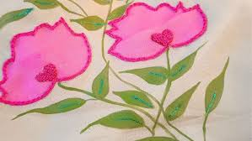
Image no 1: Applique with Hand Needle Work
2. Review of The literature
Applique work has been extensively documented as both a foundational heritage craft and a dynamic contemporary textile technique. Researchers have increasingly focused on its historical trajectory, cultural semiotics, and its shifting role within the global socio-economic landscape. Early literature characterizes applique as a decorative needlework method where secondary fabric fragments are layered and stitched onto a primary foundation to construct complex patterns or figurative imagery York, 2019. As a global textile tradition, it is found in diverse forms from the quilts of the American South to the ceremonial banners of West Africa serving as a medium for social, political, and cultural narratives Gonsalves, 2012.
The evolution of needle embroidery reflects a broader shift in the textile market, where the integration of traditional craftsmanship with modern technological quality is becoming a prerequisite for global competitiveness Agarwal,2018. When designing for high-performance or aesthetic apparel, the researcher must account for the functional impact of heavy thread work on the base fabric's drape and comfort Agarwal & Mehta, 2024
In the Indian context, the regional diversity of applique is a primary area of scholarly interest. Research identifies major craft clusters in Odisha, Gujarat, and Rajasthan, where the technique has historically transitioned from domestic utility to a specialized trade. For instance, the Pipli cluster in Odisha was originally sustained by temple patronage for religious processions, but has since evolved into a vital source of livelihood for rural artisan communities Mohanty,2018. Studies indicate that these clusters have successfully maintained market relevance by adapting traditional motifs to modern materials and contemporary aesthetics, thereby ensuring the craft's survival in a competitive industrial climate Development Commissioner Handicrafts 2016.
From a design and innovation perspective, scholars view applique as a versatile surface ornamentation technique that bridges the gap between traditional folk art and high fashion. It is frequently synthesized with other methods such as embroidery, patchwork, and mixed media collage to create tactile, high relief textures Pittman, 2018. Furthermore, research into the adaptation of indigenous art such as the integration of Aipan motifs from Uttarakhand into applique demonstrates how cultural heritage can be preserved through contemporary fashion applications National Institute of Fashion Technology NIFT, 2021. This evolution allows for the reconceptualization of traditional symbols to meet the demands of the modern global consumer.
The socio-economic dimensions of the craft are equally significant in the literature. Studies focusing on artisan clusters, particularly in Odisha, highlight applique as a powerful instrument for women’s empowerment and rural income generation Das & Mishra, 2021. Despite its economic potential, scholars note persistent challenges, including fragmented market access, a lack of institutional resources, and direct competition from low-cost, machine made imitations. Comparative research on global traditions, such as the Asafo flags of Ghana, further emphasizes that applique motifs often carry deep ancestral meanings and serve as essential markers of collective identity Textile Learner, 2022.
Mohanty 2018 explores the deep-rooted connection between the Pipli applique craft and the religious rituals of the Jagannath Temple in Puri. The study highlights that applique was not originally a commercial endeavor but a sacred service (Seva) performed by the Mahapatra community. The research details how specific color palettes predominantly red, black, yellow, and white were dictated by religious iconography to create the Chandua (canopies) and Trirath (umbrellas) used during the Ratha Yatra. This review establishes that the survival of the craft for centuries was due to its institutionalization within temple traditions before it transitioned into the secular market.
Shah & Gupta 2020 examine the semiotics of applique motifs among the nomadic and semi nomadic tribes of the Kutch region. Their research identifies a distinct design language where geometric shapes represent the landscape, and floral motifs signify fertility and prosperity. The authors argue that Gujarat's applique is unique because it is frequently integrated with Abhla -mirror work and Heer -silk embroidery. The review highlights a shift from heavy, functional household items like Dharaniyo -quilt covers to lightweight contemporary apparel, noting that while the motifs remain traditional, the scale and placement have evolved to suit modern silhouettes.
Overall, the existing body of literature confirms that applique is a resilient and evolving art form. While its traditional roots remain firm, it continues to adapt through technical experimentation and integration into the luxury and craft sectors. However, a critical analysis of current research reveals a significant Research Gap regarding the intersection of digital design tools, sustainable upcycling of textile waste, and the long term environmental performance of applique on bio based sustainable fabrics.
3. Research Gap
Student has extensively documented the historical, cultural, and decorative dimensions of Indian applique, several critical analysis after the find same missing or lack area of research as mention below.
3.1Contemporary Market Integration & Digital Transition: Current studies predominantly focus on traditional motifs and regional clusters in Odisha, Gujarat, and Rajasthan. However, there is a significant lack of research on the methodological transition required to adapt these ethnic techniques for the global luxury pret-a-porter and high street markets. The intersection of traditional hand-craftsmanship with digital design tools (CAD/CAM) and 3D visualization remains largely unexplored.
3.2Technological & Material Innovation: There is a noticeable absence of technical documentation regarding the performance of applique on non-traditional, sustainable substrates. While designers are increasingly experimenting with mixed media and fusion styles, academic research has failed to establish empirical data on how these new material combinations e.g., blending applique with technical textiles or bio-fibers affect the structural integrity and durability of the garment.
3.3The Sustainability & Circularity Paradox: Despite the global shift toward ethical fashion, the role of applique in circular economy frameworks is under researched. There is a lack of focused studies on the use of eco-friendly adhesives, biodegradable threads, and the quantifiable impact of applique as a tool for industrial waste upcycling and Slow Fashion advocacy.
3.4Socio Technical Challenges for Artisans: While the socio-economic status of artisans is broadly discussed, there is a lack of data driven research on the digital divide. The impact of e-commerce, block chain based traceability and digital marketing platforms on the traditional artisan’s livelihood versus the threat of machine-made mass production remains a critical research deficit.
3.5Comparative Technical Performance: There is a dearth of comparative analysis between traditional hand stitched applique and modern machine based techniques. Current literature lacks rigorous testing regarding the consumer perception of value, the mechanical longevity of different stitch types, and the cost-to-benefit ratio of maintaining artisanal authenticity in a high speed fashion cycle.
In essence, the existing body of knowledge lacks a comprehensive, multidisciplinary framework that connects heritage preservation with industrial innovation, ecological sustainability, and digital market relevance. This study intends to bridge these disparities by investigating the dual identity of applique as both an ancient craft and a future ready design solution.
4. Problem Statement
Despite its profound cultural heritage and versatility, applique work faces a critical struggle for relevance within the highly mechanized global fashion industry. Traditional hand-stitched techniques are in a state of gradual decline, primarily due to shifting consumer preferences toward fast fashion and the overwhelming influx of low cost, machine made imitations that lack the tactile soul of artisanal work. Artisans within traditional clusters such as those in Odisha, Gujarat, and Rajasthan operate with restricted market access and significant exposure deficits regarding contemporary design aesthetics. This creates a detrimental disconnect between ancestral craftsmanship and modern consumer demand, leading to stagnant income levels and a lack of interest among younger generations to carry the craft forward.
Furthermore, there is a distinct lack of academic documentation and empirical research regarding the integration of innovative techniques, sustainable materials such as organic fibers and natural dyes, and digital design tools that could modernize the craft's functionality. Without a strategic framework for design intervention, the traditional essence of applique remains isolated from the lucrative home decor and luxury fashion sectors. Consequently, the central problem lies in developing a methodology that preserves the authentic hand crafted identity of applique while re-engineering it for contemporary sustainability and commercial viability.
5. Objectives of the Study
To encapsulate all aspects of history, regional variation, craftsmanship, artisan challenges, and contemporary innovation into a single, comprehensive research objective, use the following: To evaluate the socio-technical evolution of Indian applique work by documenting its regional heritage and technical variations, while developing a strategic design framework to integrate sustainable materials and innovative practices into the contemporary global fashion market
6. Methodology
The methodology is structured as a Qualitative Experimental Research Design. This approach combines theoretical documentation with practical material exploration, aligning with the research frameworks. In this study utilizes a multi-dimensional research strategy to bridge the gap between traditional craftsmanship and modern design application. The methodology is divided into the following key phases:
  - Phase I: Secondary Research and Literature Synthesis: Relevant information was collected from books, research papers, journals, government reports, and online sources related to textile design and traditional crafts. This helped in understanding the history, cultural background, techniques, and evolution of applique work. Archival Review A comprehensive analysis of existing literature, including government reports from the Development Commissioner (Handicrafts), NIFT research papers, and academic journals focusing on textile heritage. Thematic Mapping Categorizing the history, origin, and cultural symbolism of applique motifs across Indian states, with a focus on Odisha, Gujarat, and Rajasthan. Framework Selection Utilizing the Sustainable Design and Circular Economy paradigms to evaluate the current status of the craft.

Phase II: Empirical Field Study and Documentation: Visits to local craft markets, exhibitions, or artisan clusters were conducted to observe applique work directly. Interaction with artisans provided insights into their techniques, tools, materials, and working conditions Site Visits Conducting field observations at major craft hubs and exhibitions, such as Gauhar Mahal (Bhopal) and state-level handloom expos, to document real-world artisan workflows. Artisan Interaction Engaging in semi-structured interviews with master craftsmen to identify socio-economic challenges, such as market access and the impact of machine-made competition. Visual Documentation Photographing and cataloguing traditional tools, materials (base fabrics, threads, needles), and specific stitch types like the chain, satin, and blanket stitch.

Phase III: Experimental Design and Material Exploration: Different types of applique products such as garments, wall hangings, and home decor items were studied to analyze design elements, color combinations, and stitching methods. Substrate Testing Following the research precedents of SA (2021), the study will test the behavior of applique motifs on sustainable bases, including organic cotton and bamboo. Natural Dye Application Experimenting with plant-based dyes, such as pomegranate peel and indigo, for motif coloration to ensure a zero-carbon footprint production process. Thread Work Integration Exploring the synergy between manual thread work and traditional embroidery (e.g., Phulkari) to enhance the structural relief of the applique.

Phase IV: Comparative Analysis: The collected data was analyzed to identify trends, challenges, and opportunities in applique work, with a focus on sustainability, market relevance, and future scope. A comparison was made between traditional hand applique and modern machine applique to understand differences in quality, cost, durability, and visual appeal. Technical Evaluation Comparing traditional hand-applique against machine-based methods in terms of stitch density, durability, and aesthetic finish. Market Perception Study Analyzing consumer preferences between Heritage Applique and Modernized Fusion Applique to determine the viability of new design interventions.

3.5 Phase V: Synthesis and Design Intervention: Experimental designs were developed by applying applique techniques using different fabrics, colors, and patterns to explore creative possibilities and innovation. Framework Development: Developing a set of design guidelines for the integration of traditional applique into contemporary luxury and lifestyle products. Final Documentation: Compiling findings into a comprehensive research report that offers actionable solutions for artisan empowerment and craft sustainability.
3.6Research Tools & Materials Summary: Primary Tools Professional tailoring shears, specialized embroidery needles (various gauges), and traditional wooden blocks. Base Media Digital design software (CAD) for initial motif mapping, followed by manual execution. Materials Organic textiles, natural dyes, and a variety of thread counts for intricate needlework.
4. Field Study and Documentation
4.1 Visit to State Museum : The field study of applique work was conducted to gain practical knowledge about the craft, its techniques, and the working conditions of artisans. This helped bridge the gap between theoretical understanding and real-world practice. Field Visit Visits were made to local markets, craft exhibitions, and artisan workplaces where applique products such as garments, wall hangings, cushion covers and decorative textiles were available. The study focused on observing the making process, tools, and materials used in applique work. Interaction with Artisans Direct interaction with artisans provided valuable insights into their skills, traditional knowledge, and design practices. Discussions included topics such as fabric selection, cutting techniques, stitching methods, color combinations, and the time required to complete different products. Artisans also shared the challenges they face, including low wages, limited market reach, and competition from machine made items.

Image no2: State Handloom export Gauhar Mahal

  - Applique Work Technique and Materials
    - Hand Applique: This is the traditional method where fabric pieces are stitched onto a base fabric using hand stitches. Common stitches include running stitch, blanket stitch, chain stitch, and satin stitch. It gives a detailed and artistic finish.

Image no3: Hand Applique
    - Machine Applique
In this method, a sewing machine is used to attach the fabric pieces. It is faster and more suitable for mass production. Zigzag and straight stitches are commonly used.
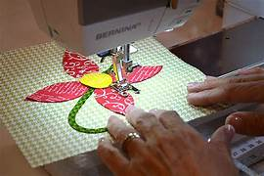
Image no4: Machin Applique
5. Materials Used in Applique Work
5.1 Base Fabric
Base fabric is the primary material on which the applique design is developed and serves as the foundation of the entire artwork. The selection of base fabric plays a crucial role in determining the durability, texture, and overall appearance of the final product. Commonly used base fabrics include Cotton, Silk, Linen, and Canvas, each chosen according to the intended application and desired aesthetic effect. Cotton is widely preferred for its versatility and ease of handling, while silk offers a luxurious finish. Linen provides strength and a natural texture, whereas canvas is ideal for heavier and more durable products such as bags and wall hangings.
5.2 Applique Fabric
Applique fabric refers to the additional pieces of fabric that are cut and layered onto the base fabric to create decorative motifs and patterns. These fabrics are selected based on their color, texture, pattern, and compatibility with the base material. Various fabrics such as Cotton, Silk, Velvet, and synthetic blends are commonly used to enhance visual appeal and create contrast. The use of different fabrics allows designers to experiment with texture, depth, and dimension, making the applique work more attractive and unique.
5.3 Threads
Threads are an essential component in applique work, as they are used for attaching applique pieces to the base fabric and for outlining designs to add definition and detail. The choice of thread depends on the fabric type, required strength, and desired finish. Common thread materials include Cotton Thread, Silk Thread, and Polyester Thread. Cotton threads are suitable for natural fabrics, silk threads provide a fine decorative finish, and polyester threads are valued for their durability and resistance to wear, making them ideal for long-lasting products.
5.4 Needles
Needles are fundamental tools in applique work, used to sew fabric pieces accurately onto the base material. Different types and sizes of needles are selected depending on the thickness and texture of the fabric as well as the stitching technique employed. Fine needles are used for delicate fabrics like silk, while stronger and thicker needles are necessary for heavier materials such as canvas or denim. Proper needle selection ensures smooth stitching, prevents fabric damage, and improves overall workmanship quality.
5.5 Scissors and Cutting Tools
Sharp scissors and specialized cutting tools are essential for achieving precision in applique work. They are used to cut intricate shapes, patterns, and motifs from applique fabrics with accuracy and neatness. Fabric scissors, embroidery scissors, and rotary cutters are commonly used tools in this process. High-quality cutting tools help maintain clean edges, reduce fabric fraying, and ensure professional finishing, which significantly contributes to the aesthetic quality of the final design.
5.6 Adhesives (Fusible Web)
Adhesives such as Fusible Web are widely used in modern applique techniques, especially in fused applique. Fusible web is a heat-activated adhesive placed between the applique fabric and the base fabric to temporarily bond the layers before stitching. This method simplifies the applique process by holding fabric pieces securely in place, reducing movement during sewing, and allowing for more precise placement. It also saves time and makes the technique more accessible for beginners.
5.7 Embellishments (Optional)
Optional embellishments are decorative materials added to applique designs to enhance their visual appeal and artistic value. These may include Beads, Sequins, Mirrors, lace, ribbons, and decorative embroidery threads. Such embellishments add texture, sparkle, and cultural richness to the finished product, making it more attractive and suitable for fashion garments, home décor items, and handcrafted accessories.

6. Indian Culture of Applique Work
Applique work is one of India’s most vibrant and traditional textile art forms, deeply rooted in the country’s cultural heritage. The craft involves stitching small pieces of fabric onto a larger base fabric to create decorative motifs and patterns. In India, applique work reflects regional identities, local traditions, and cultural narratives, making it an important part of traditional clothing, home décor, and ceremonial textiles. Different states have developed unique styles of applique work, each distinguished by specific motifs, colors, and techniques.

6.1 Rajasthan Applique Work
Rajasthan is renowned for its rich textile traditions and vibrant use of colors. Applique work in Rajasthan is prominently seen in traditional sarees, lehengas, wall hangings, and decorative household items. The designs often feature motifs inspired by desert life, animals such as camels and elephants, floral patterns, and geometric forms. Bright colors like red, yellow, orange, and green dominate Rajasthani applique, symbolizing the lively culture and festive spirit of the region. Mirror work is often combined with applique to enhance visual appeal and reflect the traditional craftsmanship of Rajasthan.
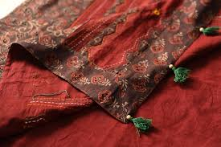
Image no5: Hand Applique traditional craftsmanship of Rajasthan

6.2 Gujarat Applique Work
Gujarat is famous for its intricate embroidery and applique traditions, particularly in regions such as Kutch and Saurashtra. Gujarati applique work is known for bold colors, symmetrical patterns, and detailed hand stitching. Traditional garments such as sarees, chaniya cholis, and dupattas frequently showcase applique work combined with mirror embroidery, beadwork, and patchwork. Common motifs include peacocks, flowers, folk symbols, and religious designs, representing the cultural diversity and artistic richness of Gujarat.
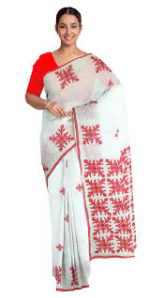
Image no 6: Hand Applique

6.3 Odisha Applique Work
Odisha holds a distinguished place in Indian applique traditions, especially through the famous Pipili applique craft. The town of Pipili is globally recognized for its unique applique artistry. Traditionally associated with temple rituals and decorations for Lord Jagannath’s chariot festival, Odishan applique uses bright fabrics stitched into motifs such as flowers, birds, animals, and mythological symbols. Products include canopies, umbrellas, wall hangings, handbags, and sarees. The craft reflects Odisha’s spiritual heritage and strong connection between art and religion.
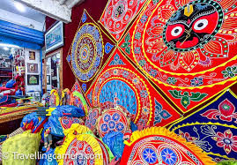
Image no 7: Hand Applique Odisha

7. Conclusion and Design Intervention
Applique work represents a significant element of India’s textile heritage, preserving century’s old craftsmanship while reflecting regional identity and cultural values. From the vibrant mirror-adorned textiles of Rajasthan and Gujarat to the spiritually inspired applique traditions of Odisha, this art form demonstrates India’s rich diversity in design and handcraft techniques. However, with changing lifestyles and industrialization, traditional applique faces challenges such as reduced artisan participation, declining market demand, and competition from machine-made products.
To preserve and modernize applique work, thoughtful design intervention is essential. Contemporary designers can integrate traditional applique techniques into modern fashion, interior products, and lifestyle accessories to expand market relevance. Digital design tools can help artisans develop innovative patterns while maintaining traditional authenticity. Sustainable materials, improved product diversification, and better branding can increase commercial value. Workshops, design education, and collaboration between artisans and professional designers can further empower local craftspeople. Through innovation and preservation, applique work can continue to thrive as both a cultural symbol and a sustainable creative industry.
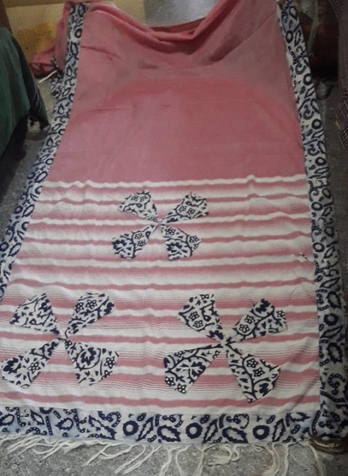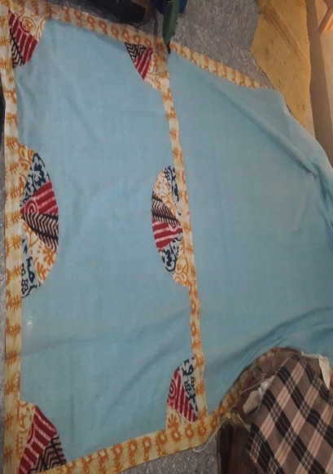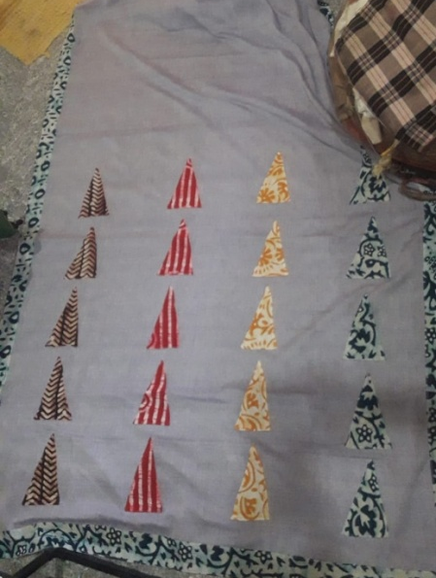
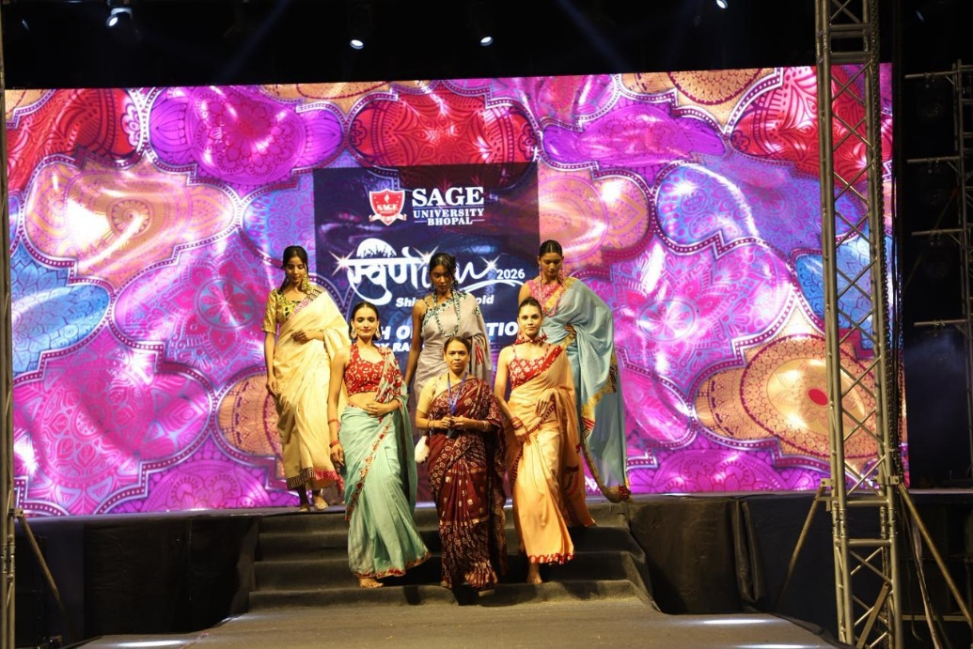
Image no 8.9.10&11: Examples of Design Intervention

References
[1] Crafts Council of India. (2020). Documentation of Indian craft clusters. CCI Publications.
[2] Development Commissioner (Handicrafts). (2016). Applique work of India: A sectoral report. Ministry of Textiles, Government of India.
[3] Pittman, J. (2018). Applique: The basics & beyond. C&T Publishing.
[4] York, C. (2019). The art of applique: Design and technique. Stash Books.
[5] Agarwal, S. (2024). Technology innovation is the key to triumph for the glaring future of the fashion industry. International Research Journal on Advanced Engineering and Management, 2(8), 2649–2657
[6] Agarwal, S. (Supervisor). (2014). Renascence of embroidery through newer: Advanced scientific and contemporary expertise for novel and creative enterprise [Doctoral dissertation].

