Formulation Development and Performance Assessment of Banana Powder Floating Tablet
Md. Hasheem Khan, Aamir Imam, Ijlal Husain, Khushi Mishra, Mohd. Mohsin, Badruddeen, Mohammad Irfan Khan*, Juber Akhtar, Mohammad Ahmad
Faculty of Pharmacy, Integral University, Lucknow-226026, Uttar Pradesh, India.
Corresponding author: Mohammad Irfan Khan
Associate Professor, Faculty of Pharmacy, Integral University, Lucknow-226026, Uttar Pradesh, India
E-mail: irfan9896@gmail.com
ABSTRACT
The present investigation focuses on the formulation and comprehensive evaluation of a novel gastroretentive floating tablet based on banana powder, designed to increase the gastric residence time of the drug and prolong the therapeutic action. Floating drug delivery systems (FDDS) offer a promising strategy to improve the bioavailability of drugs or nutrients that exhibit preferential absorption in the upper gastrointestinal tract or show instability under intestinal conditions. Banana (Musa acuminata), a rich source of flavonoids, phenolic compounds, resistant starch, and fructooligosaccharides, was selected for its documented gastroprotective, prebiotic, and antioxidant properties.
Floating tablets were prepared by the wet granulation technique using xanthan gum and acacia gum as hydrophilic matrix forming polymers, sodium bicarbonate as gas generating agent, and starch and talc as pharmaceutical excipients. The developed formulations were systematically evaluated for physicochemical parameters including hardness, friability, thickness, weight variation, in vitro buoyancy and swelling behavior. The tablets exhibited satisfactory mechanical strength (hardness: 5.68 ± 0.15 kg/cm²; friability: 0.62%), uniform thickness (4.12 ± 0.02 mm), and acceptable weight variation within pharmacopoeial limits. Effective buoyancy and gastric retention were confirmed for both short term (52 seconds) and longer term (>12 hours) durations. The swelling index (78% at 6 hours) demonstrated controlled hydration and matrix integrity, supporting sustained release behavior.
The findings highlight the potential of a banana-based natural polymer system as a safe, cost-effective, and gastroprotective floating drug delivery platform. This study provides a scientific basis for the development of plant-based gastroretentive formulations with advanced therapeutic and nutraceutical applications.
Keywords: Floating drug delivery system (FDDS), Banana powder, Fructooligosaccharides (FOS), Gastric retention, In vitro buoyancy.
INTRODUCTION
Floating or dynamically controlled systems are low-density drug delivery systems that can float on the gastric contents for an extended period of time without interfering with normal gastric emptying. Various methods such as mucoadhesion, flotation, sedimentation, swelling, and shape modification are used to increase the residence time of solid dosage forms in the stomach. Among these methods, floating drug delivery systems are considered the most effective way to control drug release in the stomach^{1,2}.
Floating drug delivery systems (FDDS) are low-density systems that can float on gastric contents for long periods of time without affecting the normal gastric emptying rate. These systems are particularly useful for drugs that are poorly absorbed or unstable in intestinal fluids. While floating in the stomach, the drug is released in a controlled manner, and only after the drug has been completely released does it exit the stomach in the form of a dose. This increases the drug's residence time in the stomach, reduces fluctuations in plasma drug concentrations, and improves therapeutic efficacy. FDDS (Fig. 1) are particularly beneficial for drugs that are absorbed in the upper part of the digestive tract or that break down in the alkaline environment of the intestine³.
Drug delivery systems are designed to increase the therapeutic effectiveness of drugs and reduce side effects by delivering the drug to a specific location. The recent advances in pharmaceutical technology, drugs that require frequent dosing are formulated into single-unit dosage forms, helping to reduce the number of doses required by patients. The main challenge in developing controlled drug delivery systems is not only maintaining sustained drug release, but also it aims to increase the duration of the drug's retention in the stomach, so that the drug is completely eliminated from the body within the prescribed time⁴.
Figure 1: Floating drug delivery system
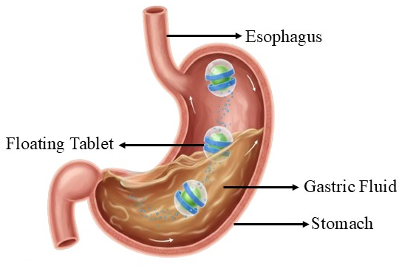
Studies have shown that bananas contain several important bioactive components such as phenolic compounds, carotenoids and biogenic amines, with the highest concentrations found in the peel. The composition of these compounds varies with the stage of ripening, unripe bananas have higher concentrations of phenolic compounds and biogenic amines, while ripe bananas have higher concentrations of carotenoids. Experimental in vivo studies have further demonstrated that the flavonoids found in bananas, especially leucocyanin, provide protection to the digestive system. These compounds increase the thickness of the gastric mucosal layer and enhance the expression of epidermal growth factor receptors, thereby supporting angiogenesis and mucosal re-epithelialization, which together helps in preventing the development of gastric ulcers⁵.
Historically, bananas have been used therapeutically to manage a number of diseases (Fig. 2) and reduce the risk of long-term degenerative conditions. Bananas contain numerous bioactive compounds, many of which have antioxidant properties that help protect the body from various types of oxidative stress⁶. Bananas of different varieties are rich in nutrients such as carbohydrates, dietary fiber, protein, polyunsaturated fatty acids, potassium and a variety of bioactive components. It contains carotenoids, flavonoids, vitamins C and E, phytosterols, gallocatechins, catechins and other polyphenols. Many of these components contribute significantly to biological functions by acting as antioxidants and providing protection against atherosclerosis and cardiovascular diseases⁷.
Figure 2: How banana helps in managing common digestive symptoms
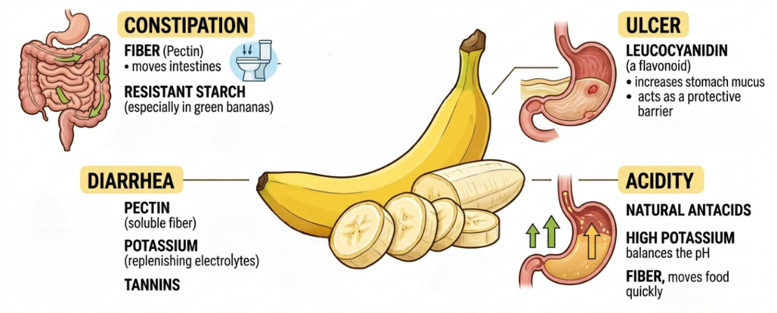
A study conducted in 2014 examined the combined effects of Lactobacillus plantarum and green banana starch in the proximal colon. The study findings showed that the resistant starch in green bananas improved the probiotic activity of Lactobacillus plantarum, promoting intestinal health and helping to inhibit pathogenic bacteria like Salmonella Typhimurium. These results highlight the role of green bananas in enhancing immune function and supporting a balanced gut microbiota⁸.
Bananas are a rich source of fructooligosaccharides (FOS) and resistant starch, especially in the green and ripe stages, and these components play an important role in boosting immunity and regulating gut microflora. These prebiotics support the growth and function of healthy gut flora⁹. The resistant starch present in bananas is not digested in the small intestine and hence passes into the large intestine. In the colon, this resistant starch is fermented by gut microorganisms, producing short-chain fatty acids, especially butyrate. Butyrate plays an important role in reducing inflammation, promoting intestinal motility, and maintaining the structural integrity of the gut¹⁰.
Fructooligosaccharides (FOS), a prebiotic fiber present in bananas, selectively stimulates the growth of beneficial gut bacteria, especially bifidobacteria. These microorganisms play a crucial role in immune regulation by strengthening mucosal immunity and producing short-chain fatty acids. It was observed that fructooligosaccharides extracted from bananas significantly enhanced the survival and growth of beneficial probiotic yeasts and bacteria. Thus, promoting intestinal health and contributing to the regulation of immune system functions¹¹.
Advantages of Floating Drug Delivery System
- Improves the absorption of medications that are primarily absorbed in the stomach.
- Useful for medications with a short half-life.
- Provides controlled and sustained drug release.
- When there are frequent bowel movements and food passes quickly through the intestines, as happens in some types of diarrhoea, the medication is not absorbed properly. In such cases, keeping the medication floating in the stomach can be helpful to achieve a better therapeutic effect¹².
- Improves Bioavailability of drug.
- Helps with local action in the stomach (e.g., antacids, antibiotics for H. pylori).
- Reduces drug degradation in the intestines.
- Improves patient compliance.
- By preventing sudden fluctuations in drug levels in the plasma, bioavailability is improved and the first-pass effect is reduced. The drug is released slowly and continuously to maintain the necessary plasma concentration¹³.
Limitations of FDDS¹⁴⁻¹⁶
- Drugs that exhibit poor solubility or stability in the digestive tract are not suitable for floating drug delivery systems.
- Drugs such as nifedipine and propranolol, which are absorbed throughout the GIT and undergo extensive first-pass metabolism, are not ideal candidates for FDDS.
- Those drugs that irritate the gastric mucosa are also not suitable for these systems.
- Drugs that are unstable in the acidic environment of the stomach should not be prepared using a floating system.
- Adequate gastric fluid is needed to keep the body afloat and the system functioning properly.
The following ingredients were used in the preparation of floating tablet of banana powder:
Banana Powder
Bananas (Fig. 3) belong to the Musaceae family and are one of the most important tropical fruits in the global market. They are enjoyed by people of all age groups and are consumed both fresh and processed. Bananas are inexpensive, highly nutritious, and a rich source of energy. Compared to fruits like apples, bananas are digested more quickly (about 105 minutes versus 210 minutes). Bananas are widely popular due to their soft texture, pleasant aroma, and ease of peeling and eating. Banana plants typically grow to about 6-8 meters tall, with large, spirally arranged leaves¹⁷.
Taxonomical Classification:
- Kingdom: Plantae
- Phylum: Magnoliophyta
- Class: Liliopsida
- Order: Zingiberales
- Family: Musaceae
- Genus: Musa
- Species: acuminata
- Uses: There are so many health benefits of banana like:
- Acts as a prebiotic due to fructooligosaccharides (FOS) and resistant starch.
- Promotes the growth of beneficial gut bacteria (e.g., Bifidobacterium, Lactobacillus).
- Improves digestion and maintains a healthy gut microbiome.
- It produces short-chain fatty acids (especially butyrate) that protect the intestinal lining.
- Due to the presence of fibre, it helps in providing relief from constipation and diarrhoea.
Figure 3: Raw banana and its powder
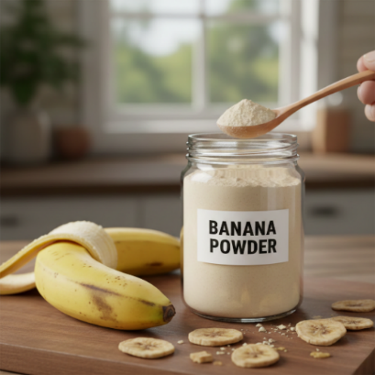
Amla powder
Phyllanthus emblica L., commonly known as amla (Fig. 4) or Indian gooseberry, is a deciduous tree. Its edible fruit is widely distributed in India, Southeast Asia, China, Iran, and Pakistan. In traditional Indian medicine, amla is widely used for its therapeutic properties, which include reducing anxiety, improving digestion, enhancing liver function and exert overall tonic effect on the cardiovascular system¹⁸.
Taxonomical Classification:
- Kingdom: Plantae
- Phylum: Magnoliophyta
- Class: Magnoliopsida
- Order: Malpighiales
- Family: Phyllanthaceae
- Genus: phyllanthus
- Species: emblica
- Uses: It acts as:
- Natural polymer: Amla powder or extract can be used as a natural matrix-forming agent.
- Floating agent: The presence of pectin, mucilage, and dietary fiber causes the tablets to swell and float in the stomach fluid.
- Sustained drug release: It forms a gel layer that aids in controlled or prolonged drug release.

Figure 4: Raw amla and its powder
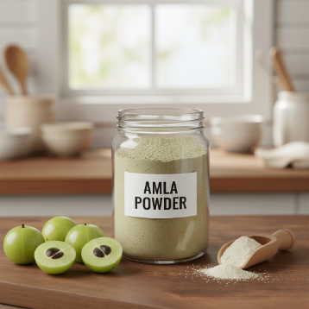
Xanthan gum powder
Xanthan gum (Fig. 5) is a high molecular weight extracellular polysaccharide produced commercially through fermentation of the Gram-negative bacterium Xanthomonas campestris. It is a hydrophilic polymer that was previously used primarily as a thickening, suspending, and emulsifying agent in aqueous systems. In recent years, xanthan gum has gained importance as a matrix-forming material in gum-based sustained-release tablet formulations¹⁹.
Taxonomical Classification:
- Kingdom: Bacteria
- Phylum: Proteobacteria
- Class: Gammaproteobacteria
- Order: Xanthomonadales
- Family: Xanthomonadaceae
- Genus: Xanthomonas
- Species: campestris
- Uses: Xanthan gum acts as a hydrophilic matrix polymer, providing buoyancy, gastric retention, and sustained drug release in floating tablet formulations.
Figure 5: Guar gum and its powder
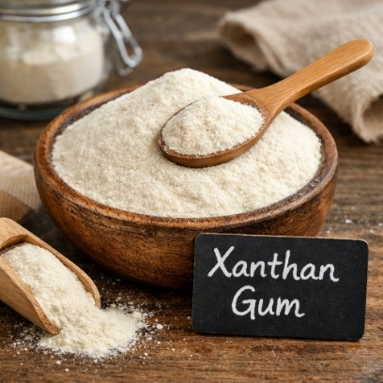
Acacia gum powder
Acacia gum (Fig. 6) is a natural heteropolysaccharide obtained from various types of acacia trees. Due to its arabinogalactan structure, it exhibits low viscosity and effective emulsifying properties. Recent studies have highlighted its growing applications in nanotechnology, drug delivery systems and sustainable biomaterials development. Moreover, its biodegradability and biocompatibility make acacia gum a promising natural alternative to synthetic surfactants and stabilizing agents such as Polyethylene glycol (PEG), polyvinyl pyrrolidone (PVP), polylactic acid (PLA), and cetyltrimethylammonium bromide (CTAB) are used in biomedical, therapeutic, and industrial fields²⁰.

Taxonomical Classification:
- Kingdom: Plantae
- Phylum: Magnoliophyta
- Class: Magnoliopsida
- Order: Fabales
- Family: Fabaceae
- Genus: Acacia
- Species: Senegal
- Uses: Acacia gum is used primarily as a natural binder, matrix forming agent, and swellable polymer in floating (gastroretentive) tablet formulations.
Figure 6: Acacia gum and its powder
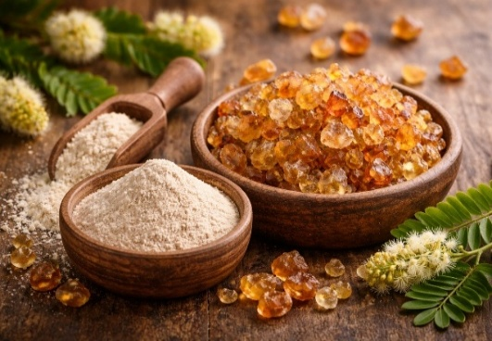
Sodium bicarbonate
Sodium bicarbonate (Fig. 7) acts as a gas-forming agent in floating tablets, releasing carbon dioxide into the gastric fluid, which reduces the density of the tablet and helps it float in the gastric fluid for a longer period of time.
Chemical formula: NaHCO₃
IUPAC name: Sodium hydrogen carbonate
Other names: Baking soda, sodium hydrogen carbonate.
Figure 7: Sodium bicarbonate powder
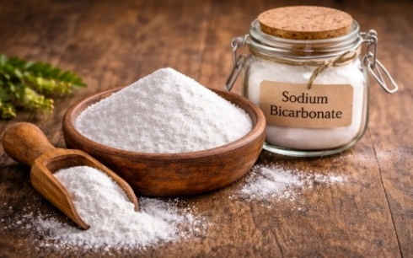
Starch
Starch (Fig. 8) in floating tablets acts as a diluent, binding agent, and disintegrant. It improves the flow properties of the powder, increases tablet hardness, and aids in controlled swelling, which maintains the structure of the tablet during floating and ensures uniform drug release.
Chemical formula: (C₆H₁₀O₅)ₙ
Other name: Amylum, Corn starch, Potato starch, Rice starch.
Figure 8: Starch
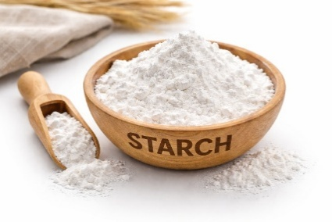
Talc
The talc (Fig. 9) in floating tablets acts as a glidant and anti-adherent, improving powder flow and preventing the tablet from sticking to the punch and die when compressing.
Chemical formula: Mg₃Si₄O₁₀(OH)₂
Other Names: Magnesium hydroxide silicate, Steatite, Soapstone.
Figure 9: Talc Powder
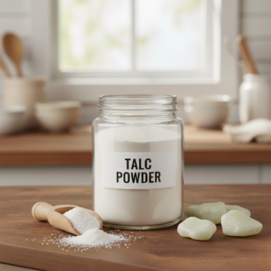
MATERIALS AND METHODS
All the ingredients were purchased from the local market of Aminabad, Lucknow, Uttar Pradesh. Listed crude drugs (Table 1) were authenticated with the reference no. IU/PHAR/HRB/01 by Dr. Mohd. Arif (Associate Professor, Department of Pharmacy, Integral University Lucknow).
Table 1: List of ingredients used in floating tablet
S. No. | Ingredients | Quantity/tablet (mg) | Quantity for 50 Tablet (g)
1. | Banana powder | 288 mg | 14.4 g
2. | Xanthan gum | 90 mg | 4.5 g
3. | Sodium bicarbonate | 60 mg | 3.0 g
4. | Amla powder | 30 mg | 1.5 g
5. | Starch | 30 mg | 1.5 g
6. | Acacia gum | 72 mg | 3.6 g
7. | Talc | 30 mg | 1.5 g

Method for preparation of floating tablet (Wet granulation)
Step 1: Weighing
All the ingredients were accurately weighed (Fig. 10) using a digital scale according to the prescribed formula for 50 tablets.
Figure 10: Weighing of Ingredients
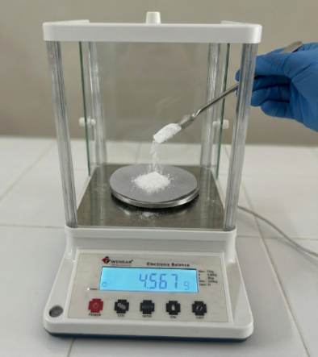
Step 2: Sieving
All the ingredients except talc were sieved (Fig. 11) through a #60 sieve to ensure uniform particle size and proper mixing.
Figure 11: Sieving of Ingredients
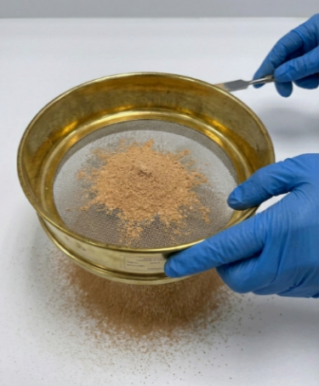
Step 3: Dry Mixing
Raw banana powder, xanthan gum, sodium bicarbonate, amla powder and starch were mixed (Fig. 12) thoroughly in a mortar for 10 minutes to obtain a uniform and homogenous mixture.
Figure 12: Mixing of Ingredients
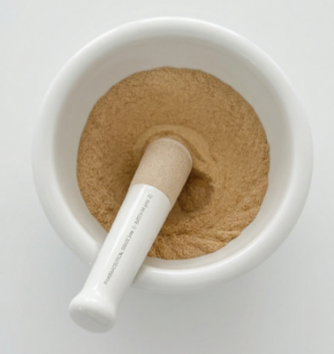
Step 4: Binder solution preparation
Preparation of Binder Solution (12% Binder Solution)
Binder: Acacia gum = 3.6 g (for 50 tablets)
Method of preparation of Binder Solution (Fig. 13):
- Distilled water was heated to lukewarm temperature (not boiling).
- About 15 ml of hot distilled water was taken into a beaker.
- Then, 3.6 g of acacia gum was added slowly and with constant stirring.
- The mixture was thoroughly stirred until a smooth, lump-free, thick solution was formed.
- It was allowed to stand for 5 minutes to ensure complete hydration.
Figure 13: Binder solution
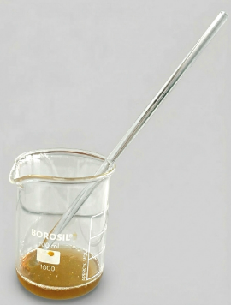
Step 5: Wet Granulation
- The binder solution was slowly added to the dry powder mixture.
- The mixture was stirred continuously.
- Mixing was continued until a suitable, properly wet mixture was produced for granulation.
Step 6: Screening of wet mass
The wet mixture was sieved through a #16 sieve to obtain uniform wet granules.
Step 7: Drying & sizing
The granules were dried in a hot air oven (Fig. 14) at 60°C for 20 minutes. The dried granules were passed through a #20 sieve to obtain a uniform granule size.
Figure 14: Drying the granules in hot air oven
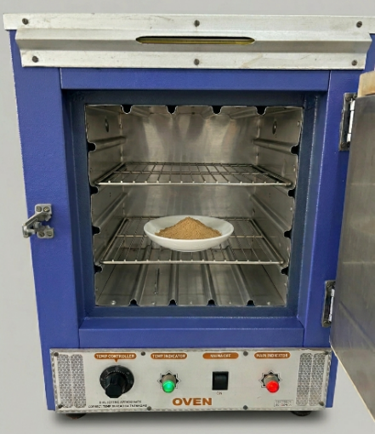
Step 8: Lubrication
Talc was added to the dried granules and mixed gently for 2 minutes.
Step 9: Compression
The lubricated granules were compressed using a tablet compression machine.
EVALUATION OF FLOATING TABLET
Organoleptic properties
The organoleptic properties of floating tablets made from banana powder are important for their overall acceptability (Table 2). The appearance of tablets significantly influences patient compliance and acceptance. Therefore, the prepared floating tablets were evaluated based on colour, odor, size and overall appearance.
Friability Test
The friability was measured using a Roche Friabilator (Fig. 15) and the result was expressed as a percentage. First, 20 tablets were selected and weighed to obtain the initial weight (W₁). The tablets were then placed in the friabilator and rotated at a speed of 25 rpm for 4 min, completing 100 revolutions. After testing, the tablets were removed and weighed again to record the final weight (W₂). The percentage friability was calculated using the following formula^{21,22}:
F = [(W₁ − W₂) / W₁] × 100
Figure 15: Roche Friabilator
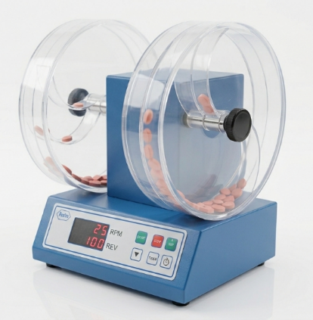
Thickness test
Six tablets were randomly selected from the formulation. The thickness of each tablet was measured using a vernier caliper (Fig. 16) and then the average thickness was calculated²³.
Figure 16: Vernier Caliper
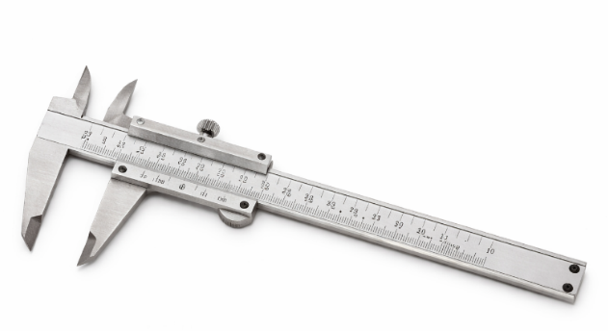
Floating Test
An in vitro buoyancy test was conducted using randomly selected tablets. The tablets were placed in a 100 ml beaker containing a 0.1 N hydrochloric acid solution (Fig. 17) with a pH of 1.2. The time taken for the tablet to reach the surface and begin floating was recorded as the floating lag time. Total floating time (TFT) was recorded as the time period during which the tablet continuously floated on the surface of the medium^{24,25,26}.
Figure 17: In Vitro Buoyancy Study: Measuring Floating Lag Time (FLT) and Total Floating Time (TFT) in a simulated gastric medium (0.1 N HCl, pH 1.2)
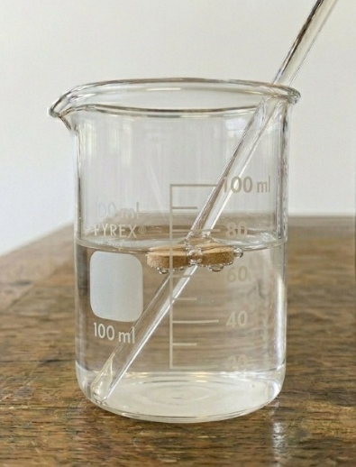
Hardness Test
Tablet hardness refers to the ability of tablet to resist mechanical stress and breakage. It reflects the strength of the tablet when subjected to pressure. Six tablets were randomly selected for this test²⁷. The hardness of the tablets was measured using a Monsanto hardness tester (Fig. 18) and the results were expressed in kg/cm².
Figure 18: Monsanto Hardness Tester
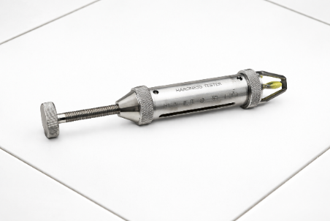
Weight variation Test
Twenty tablets were randomly selected and weighed individually. The average weight of the tablets was then calculated. The percentage deviation from the average weight for each tablet was then determined using the following formula:
Percentage Deviation = [(Average weight – Individual weight) / Average weight] × 100.
Swelling study
To study the swelling behavior, a tablet was first weighed and its initial weight (W₁) was recorded. The tablet was then placed in a glass beaker filled with 200 ml of 0.1 N HCl maintained at 37 ± 0.5°C. After that, on an hourly basis, the tablet was removed, gently wiped with filter paper to remove excess surface liquid, and weighed again to obtain the final weight (W₂)^{28,29,30,31}.
The swelling index was calculated using the following formula: SI = [(W₂ − W₁) / W₁] × 100
RESULT AND DISCUSSION
Organoleptic properties
Table 2: Observation of organoleptic parameters of Floating Tablet
Parameters | Result
Color | Light brown
Odor | Characteristic
Shape | Round
Texture | Smooth and uniform
Friability test
The friability of the prepared floating tablets was found to be 0.62%.
Since the friability value was less than 1%, the tablets exhibited good mechanical strength and resistance to abrasion. Therefore, this formulation passed the friability test according to the pharmacopeial limits.
Thickness test
The thickness of six tablets was measured using a vernier caliper and the results are shown in (Table 3).
Table 3: Thickness (mm) of six tablets
S. No. | Thickness (mm)
1 | 4.12
2 | 4.15
3 | 4.10
4 | 4.14
5 | 4.13
6 | 4.11

Average Thickness = 4.12 ± 0.02 mm
The results revealed uniform thickness, indicating proper compression during tablet punching.
Floating time
Floating time was evaluated in 0.1N HCl (pH 1.2).
Floating Lag Time (FLT): 52 seconds
Total Floating Time (TFT): More than 12 hours
The tablets exhibited strong buoyancy and remained floating for a long time, confirming the successful formulation of gastro-retentive floating tablets.
Hardness
The hardness of the six tablets was measured using a Monsanto hardness tester and results are shown in (Table 4).
Table 4: Hardness of six tablets
S. No. | Hardness (kg/cm²)
1 | 5.6
2 | 5.8
3 | 5.7
4 | 5.5
5 | 5.9
6 | 5.6

Average Hardness = 5.68 ± 0.15 kg/cm².
The hardness was within acceptable limits, indicating sufficient mechanical strength.
Weight variation
Twenty tablets were weighed individually.
Average weight = 500 mg
Maximum percentage deviation = ±1.8%
Since the percentage deviation was within pharmacopoeial limits.
Swelling Study
Initial weight (W₁) = 500 mg
After 6 hours (W₂) = 890 mg
Swelling Index (after 6 hrs): SI = [(890 − 500) / 500] × 100
SI = 78%
These tablets swell slowly and in a controlled manner, which supports sustained drug release and prolonged floating behavior.
The floating tablets prepared from banana powder exhibited satisfactory physicochemical properties, including uniform size, smooth surface, and light brown colour. Hardness and brittleness values ​​were within acceptable limits according to pharmaceutical standards, confirming adequate mechanical strength and abrasion resistance. The tablets showed uniform thickness and minimal weight variation, indicating uniform compression and good flow properties. The Floating Lag Time was 52 seconds, and the tablets remained buoyant for more than 12 hours, demonstrating effective gastric retention. The swelling index (78% after 6 hours) confirmed controlled hydration and proper gel layer formation. The combined effect of xanthan gum, acacia gum, and sodium bicarbonate resulted in sustained release behavior and prolonged buoyancy. Overall, the formulation was found to be stable, mechanically strong, and suitable for gastroretentive floating drug delivery applications.
CONCLUSION
In the present study, gastroretentive floating tablets based on banana powder were successfully developed and evaluated using the wet granulation method. The prepared tablets exhibited satisfactory physicochemical properties, including acceptable hardness, low friability, uniform thickness, and weight variation within pharmacopoeial limits, confirming the good mechanical stability and uniformity of the formulation.
This optimized formulation demonstrated a short Floating Lag Time (52 seconds) and a long Total Floating Time of over 12 hours, indicating effective buoyancy and prolonged gastric retention. The swelling index (78% after 6 hours) confirmed controlled hydration and matrix integrity, supporting sustained release behavior.
The incorporation of banana powder, rich in resistant starch and fructooligosaccharides, provides additional gastroprotective and prebiotic benefits. Overall, this study highlights the potential of banana-based natural polymers as a safe, cost-effective, and promising alternative for developing gastroretentive floating drug delivery systems.
CONFLICT OF INTEREST
The authors declare no conflicts of interest and agree to the publication of this work.
AUTHOR’S CONTRIBUTION
All the authors are equally contributed in this research work
FUNDING
None

REFERENCES
- Patil, H., Tiwari, R. V., & Repka, M. A. (2016). Recent advancements in mucoadhesive floating drug delivery systems: A mini-review. Journal of Drug Delivery Science and Technology, 31, 65-71.
- Ghadge, A. V., Gharat, S. A., Phalak, S. D., & Sharad, V. (2024). Formulation and evaluation of floating tablet of esomeprazole by using natural gums. World J of Adv Res and Rev, 22(2), 1895-907.
- Agale, K. A., & Shinde, S. P. (2025). A Review on Floating Tablet. Journal of Drug Delivery & Therapeutics, 15(2).
- Manjula, B., Ishaq, B. M., Kumar, C. H., & Usha Rani, G. (2010). Formulation and Evaluation of Gastro retentive Floating Drug Delivery System of Ketoprofen. Scholars Research Library, Der Pharmacia Lettre, 2(3), 197-208.
- Muñoz, R. L. P., Mora, C. P., Parra-Perdomo, L. V., & Rojas, G. (2025). Healing from the Peel: Exploring the Bioactive Potential of Bananas for Gastric Ulcer Management. Journal of Agricultural and Food Chemistry, 73(24), 14689-14706.
- Singh, B., Singh, J. P., Kaur, A., & Singh, N. (2016). Bioactive compounds in banana and their associated health benefits–A review. Food chemistry, 206, 1-11.
- Bucalen, F. C. K. (2023). Antioxidant and anti-atherosclerotic potential of Banana (Musa spp): A review of biological mechanisms for prevention and protection against atherosclerosis. Avicenna Journal of Phytomedicine, 13(3), 240.
- Uraipan, S., Brigidi, P., & Hongpattarakere, T. (2014). Antagonistic mechanisms of synbiosis between Lactobacillus plantarum CIF17AN2 and green banana starch in the proximal colon model challenged with Salmonella Typhimurium. Anaerobe, 28, 44-53.
- Chong, C. W., Liew, M. S., Ooi, W., Jamil, H., Lim, A., Hooi, S. L., ... & Tan, G. (2024). Effect of green banana and pineapple fibre powder consumption on host gut microbiome. Frontiers in Nutrition, 11, 1437645.
- de Andrade, L. S., Sarda, F. A. H., Pereira, N. B. F., Teixeira, R. R., Rodrigues, S. D., de Lima, J. D., ... & Cuppari, L. (2021). Effect of unripe banana flour on gut-derived uremic toxins in individuals undergoing peritoneal dialysis: a randomized, double-blind, placebo-controlled, crossover trial. Nutrients, 13(2), 646.
- Maqsood, S., Arshad, M. T., Ikram, A., & Gnedeka, K. T. (2025). Fruit‐Based Diet and Gut Health: A Review. Food science & nutrition, 13(5), e70159.
- Suvarna, C., & Ashok, B. (2022, December). Design and Optimization of Novel Floating Agent Saccharomyces boulardii Probiotic Formulation Based Floating Tablet of Valsartan. In Techno-Societal 2016, International Conference on Advanced Technologies for Societal Applications (pp. 529-540). Cham: Springer International Publishing.
- Samala, M. L., & Janga, R. B. (2021). Design, statistical optimization of Nizatidine floating tablets using natural polymer. Future Journal of Pharmaceutical Sciences, 7(1), 2.
- Singh, L. P., Rajesh, K. S., Umalkar, D. G., Chauhan, V. K., Rana, V., & Vasava, K. S. (2011). Floating effervescent tablet: A review. J Pharm Biomed Sci, 5(11), 1-6.
- Pawar, V. K., Kansal, S., Garg, G., Awasthi, R., Singodia, D., & Kulkarni, G. T. (2011). Gastroretentive dosage forms: A review with special emphasis on floating drug delivery systems. Drug delivery, 18(2), 97-110.
- Padhan, A., Nanda, B. K., & Behera, B. C. (2019). Floating oral in-situ gel, a comprehensive approach of gastro-retentive drug delivery system: a review. Int. J. Pharm. Sci. Res, 10, 4026-4039.‬‬‬‬‬‬‬‬‬‬‬‬‬‬‬‬‬‬‬‬‬‬‬‬‬‬‬‬‬‬‬‬
- Al-Dairi, M., Pathare, P. B., Al-Yahyai, R., Jayasuriya, H., & Al-Attabi, Z. (2023). Postharvest quality, technologies, and strategies to reduce losses along the supply chain of banana: A review. Trends in Food Science & Technology, 134, 177-191.
- Gul, M., Liu, Z. W., Rabail, R., Faheem, F., Walayat, N., Nawaz, A., ... & Aadil, R. M. (2022). Functional and nutraceutical significance of Amla (Phyllanthus emblica L.): a review. Antioxidants, 11(5), 816.
- Kar, R., Mohapatra, S., Bhanja, S., Das, D., & Barik, B. (2010). Formulation and in vitro characterization of xanthan gum-based sustained release matrix tables of isosorbide-5-mononitrate. Iranian journal of pharmaceutical research: IJPR, 9(1), 13.
- Zahid, M. U., Jatoi, N. R., Gul, S. N., Malik, S., Kayani, W. K., & Rasheed, F. (2025). Molecular perspectives on Acacia Gum as a functional polysaccharide for biomedical and industrial applications: A review. International Journal of Biological Macromolecules, 145412.
- Liang, Y. K., Cheng, W. T., Chen, L. C., Sheu, M. T., & Lin, H. L. (2023). Development of a swellable and floating gastroretentive drug delivery system (sf GRDDS) of ciprofloxacin hydrochloride. Pharmaceutics, 15(5), 1428.
- Israr, M., Pugliese, N., Farid, A., Ghazanfar, S., Di Cerbo, A., Muzammal, M., ... & Khan, K. A. (2022). Preparation and characterization of controlled-release floating bilayer tablets of esomeprazole and clarithromycin. Molecules, 27(10), 3242.
- Alqahtani, A. A., Mohammed, A. A., Fatima, F., & Ahmed, M. M. (2023). Fused deposition modelling 3D-printed gastro-retentive floating device for propranolol hcl tablets. Polymers, 15(17), 3554.
- Singh, B., Sharma, V., Mohan, M., Sharma, P., & Ram, K. (2023). Design of ciprofloxacin impregnated dietary fiber psyllium-moringa gum-alginate network hydrogels via green approach for use in gastro-retentive drug delivery system. Bioactive Carbohydrates and Dietary Fibre, 29, 100345.
- Kaushik, A. Y., Tiwari, A. K., & Gaur, A. (2015). Role of excipients and polymeric advancements in preparation of floating drug delivery systems. International journal of pharmaceutical investigation, 5(1), 1.
- Srivastava, A. K., Rajput, D. S., & Sharma, N. K. (2023). Formulation and evaluation of nicorandil floating tablets using natural polymers. Asian Journal of Pharmaceutical Research and Development, 11(2), 74-82.
- Shimmula RR, Atla VP, Nimmagada S, Balusu H, Chinthala SP. Formulation and evaluation of esomeprazole magnesium trihydrate controlled release floating tablets. Annals of Phytomedicine. 2023 Dec 1;12(2).
- Rao GK, Mandapalli PK, Manthri R, Reddy VP. Development and evaluation of gastroretentive delivery systems for cefuroxime axetil. Saudi Pharm J. 2013; 21(1): p. 1-7.
- Prajapati, S., Patel, L., & Patel, D. (2008). Gastric floating matrix tablets: design and optimization using combination of polymers. Acta pharmaceutica, 58(2), 221-229.
- Dash, S., Murthy P. N., Nath L., Chowdhury P. Kinetic modeling on drug release from controlled drug delivery systems. Acta polonaiae pharmaceutica. 2010; 67 (3): p. 217 -223.
- Ahirrao, S., Bhambere, D., Todkar, K., Patil, M., Khairnar, P., & Udavant, P. (2022). Formulation Development and Evaluation of Floating Tablets of Zolmitriptan. Biosciences Biotechnology Research Asia, 19(2), 395-405.

