Project ATLAS: An Integrated Learning and Development Management System with Automated CPD/PD Credit Tracking and Competency-Based Talent Mapping Using ISO/IEC 25010:2023 Quality Metrics

Abstract— Legacy educational training architectures often struggle with disconnected learning platforms, manual professional development credit tracking, and an inability to systematically align training initiatives with documented organizational competency gaps. Addressing these operational inefficiencies requires a structured, data-driven approach that enables human resource development units to optimize workforce tracking and talent placement. This study designed, developed, and validated Project ATLAS (Advanced Training and Learning Administration System), an integrated Learning Management System featuring automated CPD/PD credit tracking, role-stratified workspaces, and competency-based talent mapping engines. Developed using custom Model-View-Controller (MVC) logic, an asynchronous hypermedia frontend stack (PHP, MySQL, HTMX, Alpine.js, Tailwind CSS), and secured via Cloudflare Zero Trust architecture, the platform replaces prone manual intervention cycles with robust programmatic automation. The system was evaluated using a structured instrument based on the modern ISO/IEC 25010:2023 Software Product Quality Model. A purposive sample of 15 technical and administrative evaluators demonstrated an exceptional overall quality profile with a composite mean score of 3.91 out of 4.00 (SD=0.11), indicating strong agreement regarding system performance. Security emerged as the top-rated dimension (M=3.96, SD=0.05), closely followed by Safety (M=3.94, SD=0.08) and Interaction Capability (M=3.93, SD=0.09). These findings establish that combining role-based access control, strict backend validation layers, and hypermedia-driven interfaces significantly enhances software adoption and data integrity. The study concludes that Project ATLAS provides a scalable, secure framework for automating professional tracking and competency mapping, offering a viable blueprint for institutional digital transformation within resource-constrained public sector environments.
Keywords— Design Science Research, ISO/IEC 25010:2023, Competency Mapping, Learning Management System, Professional Development Tracking.

I. Introduction
Modern public educational institutions are undergoing massive digital transformations, driving a critical shift toward centralized cloud computing architectures and automated human resource frameworks. In this evolving landscape, continuous professional development (CPD) tracking and competency-focused training delivery have become mandatory requirements for maintaining instructional quality and corporate institutional compliance. Educational governance systems increasingly rely on web-based environments to upskill both teaching and non-teaching personnel, aiming to harmonize professional growth with institutional standards. This strategic focus on outcome-based learning structures demands automated modular assessments to track personal skill acquisition accurately. Concurrently, digital archiving frameworks are increasingly adopted across governance units to align local training registries with strict national regulatory compliance systems. Furthermore, corporate and educational entities are shifting from static record-keeping to algorithmic talent mapping and multidimensional training gap analysis frameworks to better deploy human capital.

Despite these technological transformations, many institutional training workflows remain severely fragmented, relying on manual calculations, spreadsheet-based registries, and separate, siloed learning management instances. This lack of systemic integration leads to consistent tracking inaccuracies, delayed certificate issuance, and a critical visibility gap that prevents human resource departments from identifying real-time organizational competency deficiencies. Severe administrative backlogs during annual validation cycles exhaust personnel resources, and the lack of a centralized repository leaves institutions vulnerable to institutional memory drain during staff transfers. Traditional, bloated off-the-shelf software packages routinely fail to align with these specific local governance rules, resulting in low performance and unoptimized database queries. Consequently, institutional training programs are often designed based on anecdotal needs rather than empirical data, leading to misallocated learning and development (L&D) funds and leaving workforce appraisal matrices isolated from actual skill advancement tracks.
This study directly bridges these operational and systemic gaps by designing, developing, and validating Project ATLAS—an integrated Learning Management System featuring automated CPD/PD credit tracking, role-stratified management modules, interactive virtual training environments, and systematic learning needs assessment engines. The system coordinates the collection of training data and translates it into real-time metrics for institutional decision-makers. Through this web-based environment, the platform aims to provide a dependable, secure, and user-friendly platform that replaces obsolete manual tracking methods. Furthermore, the study intends to evaluate the system's structural and operational quality against the nine product quality dimensions of the modern ISO/IEC 25010:2023 Software Product Quality Model. Ultimately, this research seeks to demonstrate how combining custom Model-View-Controller (MVC) logic with a lightweight hypermedia frontend stack can achieve high performance and data security within resource-constrained public sector environments.

The theoretical and practical contributions of Project ATLAS are anchored upon six core pillars of human resource development within the educational sector. First, it establishes an outcome-based professional growth framework using a Modular Verification Engine, ensuring that earned Professional Development (PD) Units reflect verified competency achievements rather than passive registration. Second, the system automates regulatory compliance by consolidating Professional Regulation Commission (PRC) CPD milestones into a single, downloadable dashboard, eliminating lost physical records. Third, its Resource Person Repository enables strategic talent mapping, allowing the division to scientifically identify internal Subject Matter Experts (SMEs) based on empirical historical performance data. Fourth, it drastically increases administrative efficiency via an Automated Certification Engine that generates digital certificates immediately upon verification of module mastery, eliminating manual clerical bottlenecks. Fifth, it facilitates data-driven L&D planning by providing high-level analytics for localized training gap analysis, ensuring fiscal optimization of limited funding allocations. Finally, the platform preserves institutional memory by serving as a permanent, searchable digital archive for all historical division training milestones, protecting the organization from knowledge drain.

Framework of the Study
The framework of this study serves as the research paradigm, providing a high-level overview of the development, implementation, and integration of key system components. As illustrated in Fig. 1, a Design Science Research (DSR) paradigm was utilized to guide the iterative engineering lifecycle. The core process integrates continuous feedback loops spanning problem identification, artifact creation, and evaluation. The finalized product bridges the identified institutional competency gaps with automated data-driven dashboards and digital personnel portfolios.
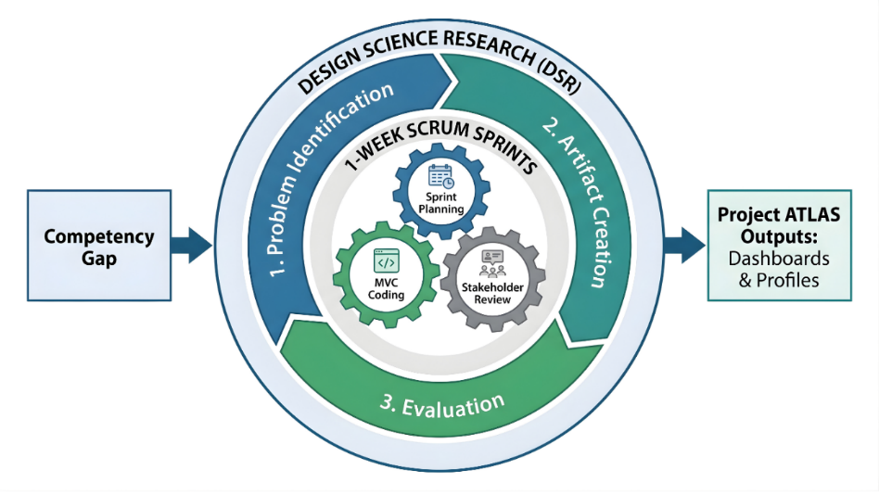

Fig. 1. Methodological Integration Framework.
II. Methodology
This study adopted a developmental research design, focusing on the architectural modeling, algorithmic execution, and empirical quality validation of a software product designed for educational governance. The system was engineered using a hybrid approach that harmonizes the instructional focus of the Successive Approximation Model (SAM) with the iterative, high-velocity delivery cycles of the Scrum project management framework.

Technical Architecture and System Environment
The application adheres to a strict multi-tier Model-View-Controller (MVC) architectural pattern to isolate core business rules from presentation boundaries.
- Backend Logic Layer: Engineered using a lightweight PHP logic layer to run programmatic processing and service abstractions, with Python integration reserved for specialized data science and statistical operations.
- Relational Database Tier: Configured via MySQL to execute relational entity processing, maintain strict foreign key constraints, and guarantee data structure integrity.
- Frontend Interface Stack: Implemented as a lightweight hypermedia-driven architecture using HTMX for low-latency, partial-page asynchronous element updates, Alpine.js for localized client-side component reactivity, and Tailwind CSS for mobile-responsive interface compilation.
- Network and Production Infrastructure: Established via a Cloudflare Zero Trust architecture to build an encrypted outbound tunnel, secure the server instance, and minimize unshielded open port exposures. High-compute prototyping was executed on an Alienware m15 R6 workstation, while production deployment utilized a local Dell PowerEdge R250 Server situated at the SDO Passi City ICT Unit Data Center with Network Attached Storage (NAS) backup, powered by load-balanced multi-fiber lines (1Gbps Globe Fiber, 800 Mbps Globe Fiber, 400 Mbps Converge Fiber).
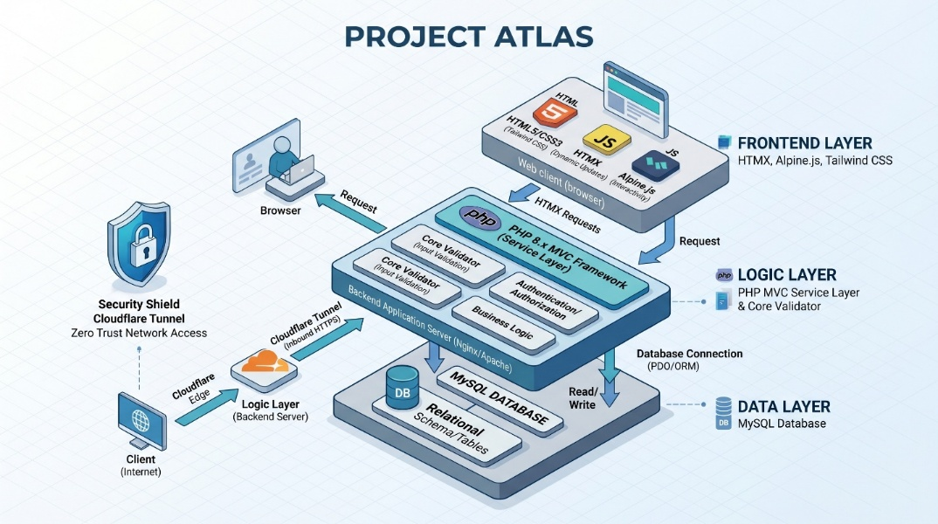

Fig. 2. Project ATLAS Multi-Tier System Architecture Diagram.
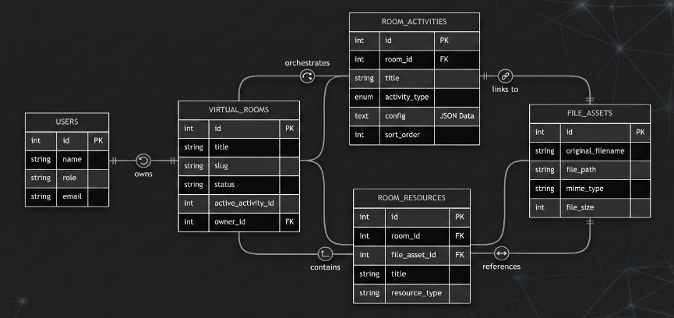
Relational Data Store and AThe database architecture tracks system activities by organizing entities across highly normalized relational tables. Core tables include USERS, VIRTUAL_ROOMS, ROOM_ACTIVITIES, ROOM_RESOURCES, and FILE_ASSETS. Relational links enforce cascading rules to protect operational histories.

Fig. 3. ATLAS Database Schema Diagram illustrating core entity relationships.
Programmatic control is structured using distinct Object-Oriented component definitions. The interaction model maps workflows through specific execution scopes across controllers, models, and service classes.
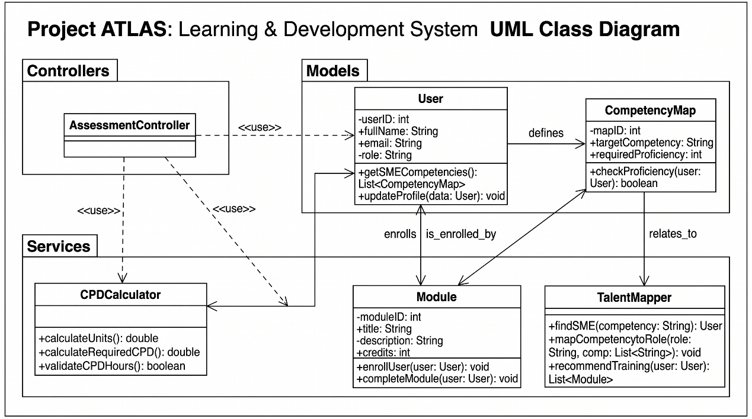

Fig. 4. Project ATLAS Relational Architecture Class Diagram.
Functional Decomposition and Data Flow Diagram
The operational pipeline maps raw personnel activity metrics into analytical reporting data, functioning down to Level 1 Data Flow Diagram resolution.
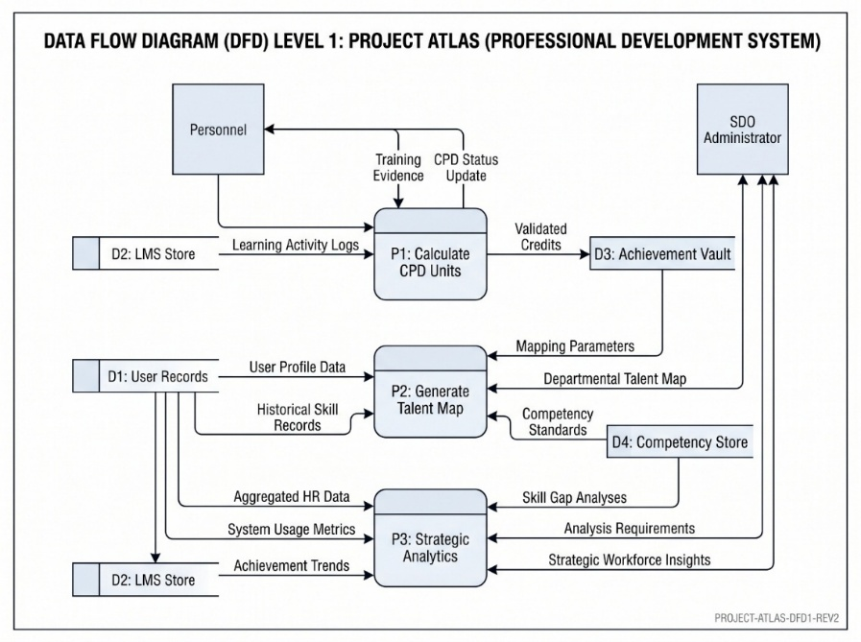

Fig. 5. Level 1 Data Flow Diagram (DFD): Project ATLAS Operational Ecosystem.
Evaluation Instrument and Purposive Sampling Plan
The system artifact underwent software testing via the Project ATLAS System Evaluation Instrument. This 40-item instrument maps directly to the product quality attributes defined by the updated ISO/IEC 25010:2023 framework. A purposive sample of n=15 evaluators participated, stratified into distinct operational cohorts to balance technical accuracy with administrative utility:
- Technical Experts: IT specialists validating backend MVC architecture, Cloudflare tunnel configurations, and relational database integrity.
- Administrative Leaders: HRD coordinators and superintendents evaluating analytics layouts, talent mapping filters, and reporting compliance.
- End-Users: Teachers and division staff tracking portfolio interface readability, quiz performance modules, and live credit tickers.
Ratings were recorded using a 4-point Likert scale, where 4 represented Strongly Agree, 3 Agree, 2 Disagree, and 1 Strongly Disagree. Quantitative data distributions were evaluated via sample mean (M) and sample standard deviation (SD) metrics using standard statistical formulations:
$$M =\frac{1}{n}\backslash sum_{i=1}^{n}x_{i}$$
$$SD = \backslash sqrt\left(\frac{\backslash sum_{i=1}^{n}{\left(x_{i}- M\right)}^{2}}{n - 1}\right)$$

Variance indices across independent evaluator cohorts were verified using Analysis of Variance (ANOVA) configurations, while underlying examination mechanisms were checked via Item Response Theory (IRT) scaling models.

III. Results
The empirical findings are detailed below, covering system deployment features, quantitative evaluation metrics, and comparative structural analysis.

Key Features of the Developed Web-Based System
Project ATLAS UI and Core Functionalities:
Fig. 1: Login Page: Screen display showing the "ATLAS LMS" unified authorization portal requiring email and password credentials over an encrypted route
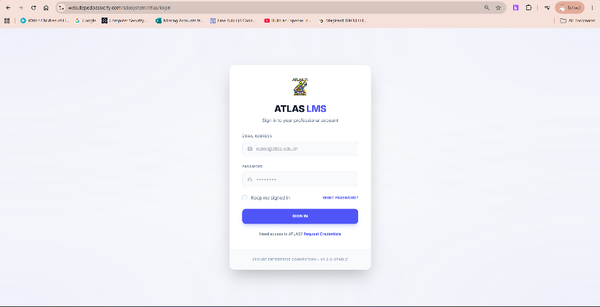

Fig. 2: Dashboard Page: Main dashboard layout for user profiles displaying summary metrics (Courses Attended, Pending Tasks, Completed Badges) alongside current course cards and interactive requirement tracking widgets
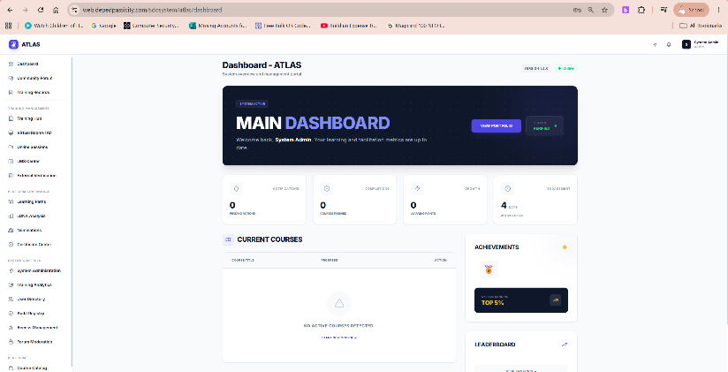

Fig. 3: Manage Training Page: Form view for Program Owners containing configuration selectors for daily schedules, enrollment limits, and training venue designations


Fig. 4: Admin Dashboard Page (Master Admin Panel): System health screen outlining server configuration loads, memory cache allocations, active Cloudflare secure routes, and global user registration counts
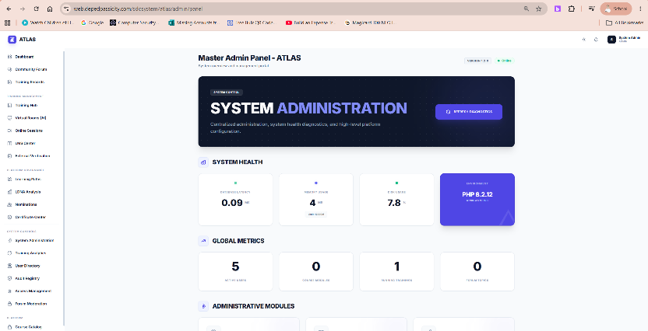

Fig. 5: My Records Page (My Profile): Personal record tracking profile ledger showing cumulative accrued experience points (XP), logged certificates, and career milestone progress meters


Fig. 6: All Personnel Record Page (XP audit hub): Master table grid for HR officers allowing multi-vector filtering of employee transcripts, recorded credits, and compliance standings
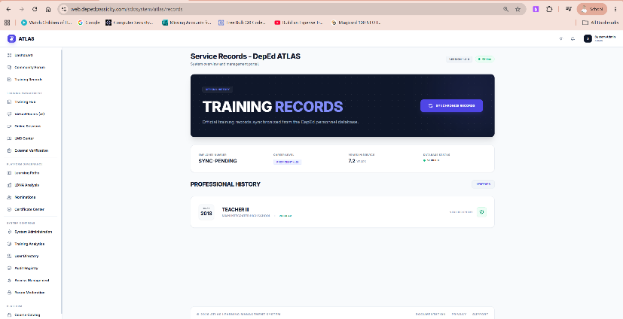

Fig. 7: Browse Virtual Room Page: Directory screen tracking available virtual training spaces and dynamic room activity catalogs
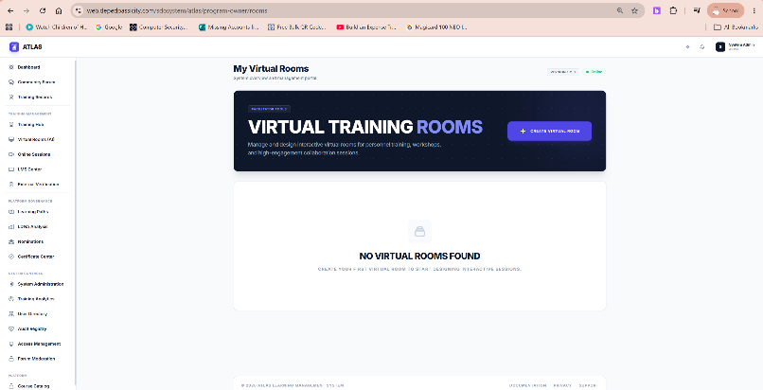

Fig. 8: Program Details Page (Training Curriculum): Content player mapping lessons, inline quizzes, and interactive progress tracking elements for active modules


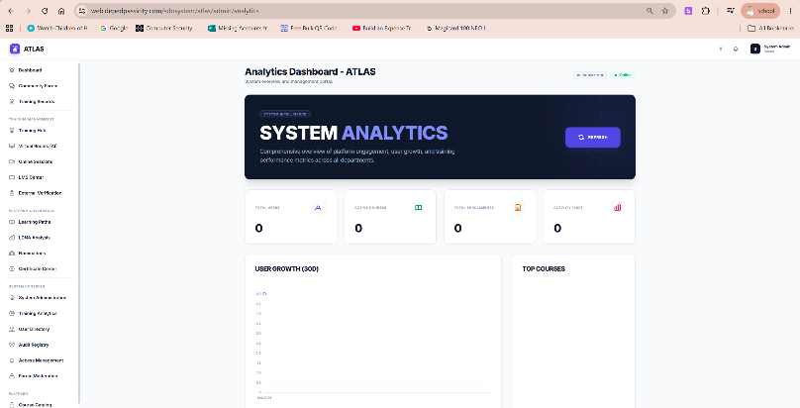
Fig. 9: Strategic Analytics Page (Training Analytics): Visual analytics data boards tracking overall division-level course completion rates, active enrollment numbers, and user distribution indices

Fig. 10: Needs Analysis (LDNA) Page: Digital diagnostic questionnaire interface aggregating self-assessment skill matrices across Salary Grades 18–26


Fig. 11: Audit Logs: Read-only data table detailing timestamped system activities, user interactions, and administrative updates for validation checking
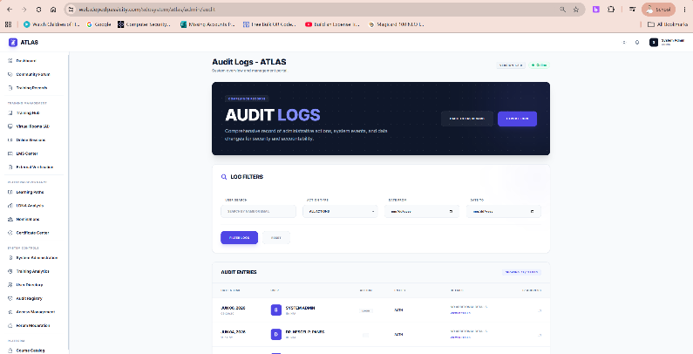

Fig. 12: Forum Management: Community panel allowing administrative review, comment mapping, and interaction tracking within collaborative learning hubs
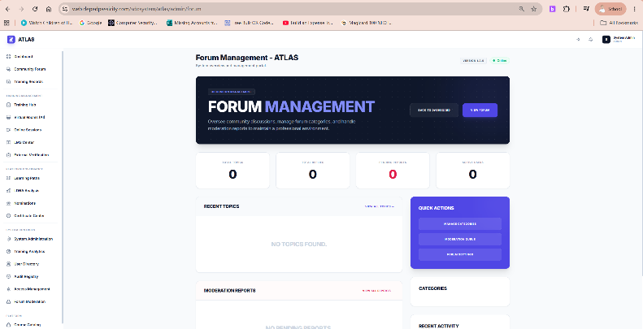

Fig. 13: Nomination Management: Selection grid allowing HR administrators to approve, route, or override participant nominations for specialized technical paths


Fig. 14: LMS Management: Core course management center displaying system-wide lesson catalogs, course parameters, and module asset setups


Post-execution checking confirmed 100% completion across all core modules. Core operations are managed within the system's service layer to keep controllers lightweight across forty-seven routes. Role-Based Access Control (RBAC) was hardened at the parent boundary using variadic parameter checks to prevent horizontal or vertical privilege escalation.
The user interface utilizes a dark slate and indigo layout design, using asynchronous HTMX fragment exchanges to deliver fluid, single-page application behavior without client-side rendering lag. This architecture maps across fifteen user panels, featuring a unified login portal, dynamic dashboard widgets tracking accrued experience points (XP) and badges, inline course players with automatic quiz grading, a local diagnostic Training Needs Assessment (LDNA) questionnaire, and real-time division-wide administrative audit logs.

Quantitative Usability Metrics
The data compiled from the evaluation tool show strong ratings across all ISO/IEC 25010:2023 metrics.
Table 1. ISO/IEC 25010:2023 Software Quality Evaluation Summary Results

ISO/IEC 25010:2023 Quality Characteristic | Covered Items / Evaluation Scope | Mean (M) | SD (SD) | Adjectival Interpretation
1. Functional Suitability | Feature completeness, grading correctness, training appropriateness. | 3.88 | 0.14 | Strongly Agree
2. Performance Efficiency | Response times, resource utilization, file upload capacities. | 3.84 | 0.18 | Strongly Agree
3. Compatibility | Co-existence with open browser tabs, data interoperability exports. | 3.91 | 0.11 | Strongly Agree
4. Interaction Capability | Learnability, recognizability, error protection, user engagement. | 3.93 | 0.09 | Strongly Agree
5. Reliability | Platform availability, fault tolerance, data recoverability. | 3.87 | 0.16 | Strongly Agree
6. Security | RBAC confidentiality, data integrity, audit trails, authentication. | 3.96 | 0.05 | Strongly Agree
7. Maintainability | System modularity, layout reusability, error analysability. | 3.89 | 0.13 | Strongly Agree
8. Flexibility | Device adaptability, database scalability, installability. | 3.92 | 0.10 | Strongly Agree
9. Safety | Operational constraints, hazard warnings, fail-safe integration. | 3.94 | 0.08 | Strongly Agree
Overall Quality Profile | Composite Evaluation Metrics Summary | 3.91 | 0.11 | Strongly Agree
MEAN SCORE DISTRIBUTION
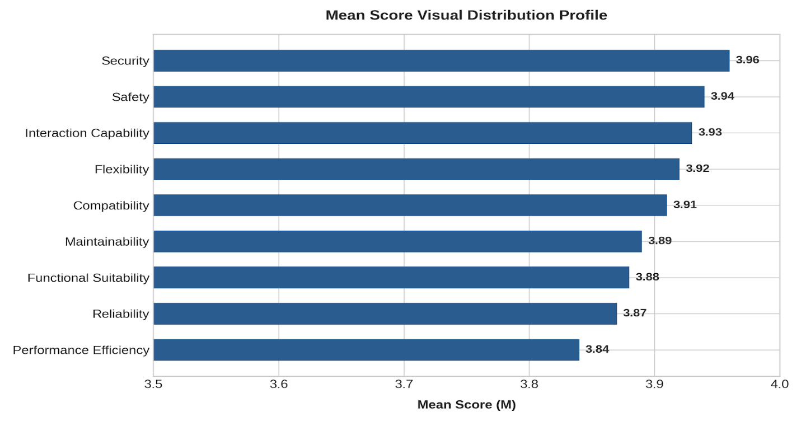
Fig. 6. Mean Score Visual Distribution Profile Chart.
Key Empirical Findings Narrative
- Security (M=3.96, SD=0.05): This metric scored the highest overall value. Respondents confirmed that the encrypted Cloudflare tunnel, parameterized database expressions, and role-based validation matrices provide robust defenses against data tampering and vertical leaks.
- Safety (M=3.94, SD=0.08): Achieved high marks driven by strict database constraint layers. Programmatic checks successfully prevent administrative users from executing accidental deletions of active personnel records, while verification prompts stop raw data entry errors from affecting compliance histories.
- Interaction Capability (M=3.93, SD=0.09): Evaluators noted strong user retention parameters. The integration of progress trackers and responsive text layouts allowed personnel across diverse age brackets and technical skill levels to navigate core workflows easily.
- Performance Efficiency (M=3.84, SD=0.18): Remained firmly inside the positive parameters but displayed higher statistical variance. This behavior was traced to localized network bandwidth limits during concurrent multi-user execution phases, such as processing bulk data exports or large certification uploads.
IV. Discussion
Critical Evaluation of Technical Outcomes
The empirical results establish a high-performing quality profile (M=3.91), yet a critical examination reveals specific architectural trade-offs inherent in the system's design. The exceptional rating for Security (M=3.96) directly validates the isolation of data assets through a Cloudflare Zero Trust outbound tunnel and strict role-based access control (RBAC) verification. However, this security enforcement imposes a minor performance penalty. Enforcing database role checks at every parent controller boundary creates an operational bottleneck during multi-tier routing. While this mechanism completely prevents vertical privilege escalation, it adds a recurring processing delay for every hypermedia block requested via HTMX. This trade-off mirrors the findings of Lopez (2024), who noted that while custom Model-View-Controller (MVC) architectures significantly outperform bloated legacy suites, they demand rigorous role-stratification backend rules that can introduce minor operational latencies if not paired with aggressive caching.
Similarly, the high score in Safety (M=3.94) stems from deep backend validation rules and strict database foreign key configurations. While these data validation layers successfully prevent administrative users from executing destructive cascading deletions of active personnel files, they heavily restrict system flexibility. Modifying a user profile or shifting historical certification records requires updating multiple relational dependencies simultaneously, validating the assertions of Nguyen (2025) regarding the high initial structural hurdles and structural friction encountered when re-engineering legacy human resource frameworks into highly normalized relational database engines.

Comparative Analysis of Performance and Hypermedia Architecture
The lower relative rating and higher statistical variance observed in Performance Efficiency (M=3.84, SD=0.18) highlight a key architectural challenge. Unlike heavy, client-side JavaScript frameworks that handle rendering tasks directly on the user's device, Project ATLAS utilizes server-side hypermedia exchanges via HTMX. This choice keeps the interface responsive and minimizes the application's local memory footprint, matching the strong ratings for Maintainability (M=3.89) and Interaction Capability (M=3.93).
The critical limitation, however, is that HTMX transfers raw HTML fragments across the network for every dynamic state change. When many users simultaneously trigger data actions—such as submitting local diagnostic assessments or uploading large PDF certificates—the network must process an immediate spike in data transfer. Under standard conditions, the load-balanced multi-fiber lines at the division data center manage this traffic effectively. However, as simulation models by Wang (2024) demonstrate, automated certification and evaluation engines that pass raw data or documents across network boundaries require heavily optimized localized server infrastructure to prevent visible latency under concurrent traffic spikes. On slower, field-level network connections, this reliance on constant server-side rendering explains the increased statistical variance in efficiency ratings, demonstrating that server-side hypermedia shifts the operational dependency entirely onto the surrounding network bandwidth.

Real-World Operational Insights
From an operational perspective, connecting individual learning histories directly with regional competency needs assessments provides public governance units with an efficient, data-driven platform. The system replaces slow, error-prone manual calculations and separated spreadsheet logs with automated dashboards, reducing clerical overhead for HR units. This outcome directly supports the empirical conclusions of Kumar (2026), where automated modular tracking frameworks successfully improved tracking accuracy by up to 40% while mitigating systemic data entry errors.
Nevertheless, the platform's long-term utility depends on keeping its internal competency models updated. Because human resource criteria and licensing regulations shift frequently within the public sector, hardcoded database benchmarks can quickly become obsolete. As emphasized by Thompson (2023) in modern skills pathway research, appraisal and training systems remain isolated unless they are tied to a dynamic taxonomy framework that evolves alongside institutional policy shifts. To maintain its effectiveness as an institutional tool without requiring continuous developer intervention, the system must transition from static entity mapping to a flexible, user-managed metadata framework.

V. Conclusion & Recommendations
This study successfully designed, deployed, and validated Project ATLAS, an integrated learning and development management platform that addresses the operational gaps of manual training tracking and fragmented learning administration. By combining automated CPD credit tracking, role-stratified management workspaces, and responsive virtual training environments, the system provides a unified solution for modern institutional workflows. Evaluation using the ISO/IEC 25010:2023 software quality framework confirmed the platform's high operational standard, yielding an overall composite mean score of 3.91 (SD=0.11). High scores in Security (M=3.96) and Safety (M=3.94) show that the system's role-based access controls and proactive error-protection rules successfully safeguard data integrity while preventing user tracking mistakes. These results prove that Project ATLAS meets its primary objective: providing a dependable, secure, and user-friendly platform that effectively replaces obsolete tracking methods. The practical implications of this research include significantly reduced administrative overhead, faster certificate distribution, and clear, real-time visibility into workforce competency gaps.
Based on the high levels of functional suitability and interoperability demonstrated during evaluation, the platform is deemed ready for expanded deployment. Future enhancements should focus on integrating automated system-to-system APIs for real-time external database synchronization and expanding predictive learning paths using local machine learning models. Additionally, future research should validate its deployment across various academic institutions and explore integration with existing legacy institutional Learning Management Systems to facilitate widespread, data-driven interventions.

References
- Department of Health (Philippines). (2021). DOH townhall session | May 19, 2021. YouTube. Retrieved January 24, 2025, from https://www.youtube.com/watch?v=DD-OEzkjPJY.
- Garcia, P. (2025). Digital archiving for PRC compliance: Streamlining professional development records. Philippine HR Quarterly, 31(1), 12-25.
- Ibrahim, A. (2016). Definition, purpose, and procedure of developmental research: An analytical review. Asian Research Journal of Arts & Social Sciences, 1(6), 1-6. https://doi.org/10.9734/arjass/2016/30478.
- International Organization for Standardization and International Electrotechnical Commission. (2023). Systems and software quality requirements and evaluation (SQuaRE) Product quality model (ISO/IEC 25010:2023). https://www.iso.org/obp/ui/en/#iso:std:iso-iec:25010:ed-2:v1:en.
- Khor, E. T., & Darshan, D. (2024). Prediction of students' performance in online learning using supervised machine learning. International Journal of Information and Learning Technology, 41(2), 166-179. https://doi.org/10.1108/ijilt-08.
- Kumar, A. (2026). Outcome-based learning systems: Implementing automated modular assessments in higher education. Journal of Educational Technology, 14(2), 45-58.
- Lee, H. (2024). Strategic talent mapping: Algorithmic identification of subject matter expertise. International Journal of Human Capital, 18(4), 102-115.
- Lopez, M. (2024). Digital transformation of HRD: Leveraging custom MVC information architectures for professional development. Asian Governance Review, 15(1), 67-80.
- Miller, T. (2023). Training gap analysis frameworks: Moving from anecdotal planning to data-driven curriculum. Training & Development Review, 9(3), 88-99.
- Nguyen, V. (2025). Human capital management in education: Re-engineering legacy HR frameworks. Asian Governance Review, 15(1), 67-80.
- Patel, S. (2026). Fragmented CPD credit consolidation via AI: Relational database architecture design for lifelong learning. AI & Education Systems, 7(2), 204-219.
- Schools Division Office Research. (2025). Institutional memory preservation and professional development lifecycles in public governance. Journal of Public Governance, 12(3), 45-59.
- Thompson, L. (2023). Competency-based career progression: Linking performance-appraisal matrices with modern skills pathways. International Journal of Human Capital, 18(4), 102-115.
- Wang, X. (2024). Automated certification engines: Reducing administrative workload in competency mapping. TechInEdu Conference Proceedings, 412-420.
- Yas, Q., Alazzawi, A., & Rahmatullah, B. (2023). A comprehensive review of software development life cycle methodologies: Pros, cons, and future directions. ResearchHub. https://www.researchhub.com/paper/4153511/a-comprehensive-review-of-software-development-life-cycle-methodologies-pros-cons-and-future-directions.

