An Experimental and Modelling Approach of Paraffin Wax Deposition on Flow Rate for Crude Oil Pipeline Corrosion

Abstract: -This paper aims to experiment and model paraffin wax deposition on flow Rate for crude oil pipeline corrosion. Heavy paraffin deposits are unfavorable because they reduce the effective size of flow conduits and reduce the well's rate of production. When large amounts of paraffin are deposited, they must be removed mechanically, thermally, or otherwise, resulting in costly downtime and greater operating costs. Corrosion rate against time was conducted, to determine the effect of the paraffin wax deposit on corrosion of crude oil pipeline, the results of the corrosion rate were recorded and analyzed, the experiment was terminated by stopping the pump. The procedure is performed to experiment and model paraffin wax deposition on flow rate for crude oil pipeline corrosion. The experiment was conducted by varying the time 3, 6, 9, 12, 15 and 18 minutes at different temperature of 15, 20, 25, 30 and 35 ºC and flow rate kept constant at 40.28 L/min. At time 12 and 18 minutes, the experimental and model results predicted a significant reduction of corrosion rates while others gave only moderate or negligible protection to the crude oil pipeline. From the profile plot, the values of the corrosion rate (mpy) against time (min) of the experimental and model results are 3 (0.96 mpy, 0.9058 mpy), 6 (0.68 mpy, 0.7876 mpy), 9 (0.87 mpy, 0.6694 mpy), 12 (0.32 mpy, 0.5512 mpy), 15 (0.45 mpy, 0.433 mpy), 18 (0.38 mpy, 0.3148 mpy). But the variation of the experimental and model results in terms of deviation is (0.05%) indicating that both results are insignificant in variation, showing positive agreement between the experimental and model results. However, it can be deduced that the long chain paraffin layer was physically removed from the surface during periods of elevated flow rate or temperature, resulting in the loss of the majority of the corrosion protection.
Keywords – Experimental, modelling, waxy, crude oil, deposition, flow rate, corrosion

- INTRODUCTION
Paraffin wax deposition is a major problem in oil and gas industry. It is an unsolved difficulty in flow assurance in pipelines and manufacturing equipment. Though paraffin wax restricts the flow in the pipeline, it acts as a corrosion inhibitor by covering the inner wall of pipeline (Shein and Denisova, 2016). The rate of wax deposition is significantly influenced by this removal mechanism. Wax applied at high flow rates has a different texture than wax applied at low flow rates. (Tronov, 2017; Hag, 2014). These problems mainly caused in the transportation and utilities where the pipelines are severely corroded. The paraffin wax on the surface provides excellent corrosion protection, while others provided only moderate or negligible protection in the crude oil pipeline, but most of the corrosion protection has been lost due to the long chain paraffin layer being physically removed from the surface during the periods of increased temperature or increased flow rates (Hsu et al., 2019). The protection of paraffins can be assumed to be due to physisorption caused by relatively weak intermolecular forces such as van der Waals forces (Gjermundsen, 2016). The rate of wax deposition is affected by the flow rate in the pipe line, which is caused by shear removal of the deposited wax due to shear stress on the wax's surface. The resident duration of crude oil in the pipeline is affected by flow rates, as a longer residence time results in more wax deposits on the pipe wall. When it comes to shear removal, however, larger flow rates result in less wax deposits. The flow rates' final effect is determined by which of these two opposing effects is more powerful. The most essential component in the laminar flow regime is residence time, whereas shear removal is more critical in the pseudo-turbulent and turbulent flow regimes. As the flow rate increases from laminar to pseudo-turbulent to turbulent, the maximum deposition rate decreases, while the temperature at which the maximum deposition rate occurs decreases (Hsu et al., 2005). The wax coating is pushed or sloughed away from the pipe wall by the viscous force caused by the turbulent stream. When the viscous drag overcomes the deposit's resistance to shear, the wax sloughs and returns to the liquid. At high flow rates, the deposited paraffin wax seems tougher, more compacted, and firmly bonded to the deposition surface, with good cohesion among the molecules. Another issue that the oil and gas industry is grappling with is corrosion in steel pipes (Villamizar etal., 2017). Corrosion can cause damage in the pipeline material by deteriorating the pipelines material. There is not much research work that studies the relationship between paraffin wax deposition and corrosion behavior (Rodriquez et al., 2019) Despite the lack of surface chemical activity, at low temperatures-below the so-called wax appearance temperature (WAT), paraffins can precipitate and deposit on the pipe surface. When the wax layer covers the steel surface, it can slow down corrosion processes by hindering the diffusion of corrosive species to the surface (Alsabagh et al., 2015; Bentiss et al., 2018). However, if the temperature stays below the WAT for extended period of time, the wax layer becomes thicker with time, and can, in the long run, cause partial or total blockage of the pipe. It was found that crude oils can generate corrosion inhibition, but the extent of inhibition varied from one crude oil to another. Corrosion inhibitors have become more widely employed and improved throughout time. Individual tests have been carried out to determine the elements that produce corrosion and wax deposition (Lebrini et al., 2017). Wax deposits, on the other hand, can help to prevent corrosion by forming wax layers on the interior pipeline surface, which prevent corrosive water from reaching the surface and thereby minimizing metal loss due to corrosion (Morad et al., 2016). Waxy crudes have different properties depending on where they're found.

2. MATERIALS AND METHODS

  - MATERIALS
The materials and equipment used in the experiment were used in this study.: Samples of waxy crude oil, experimental flow loop system, 0.5hp pump for recirculating the waxy crude oil. A flow meter with a temperature probe, ball valves for regulating the flow of the fluid and handheld infrared thermometer for temperature measurement, MS1000 Corrosion Meter and a straight stainless-steel pipe with (0.0266m x 0.0133m (internal diameter and inside radius) x 0.0334m x 0.0167m (outer diameter and outside radius) x 2.007m x 0.0034m (pipe length and thickness).

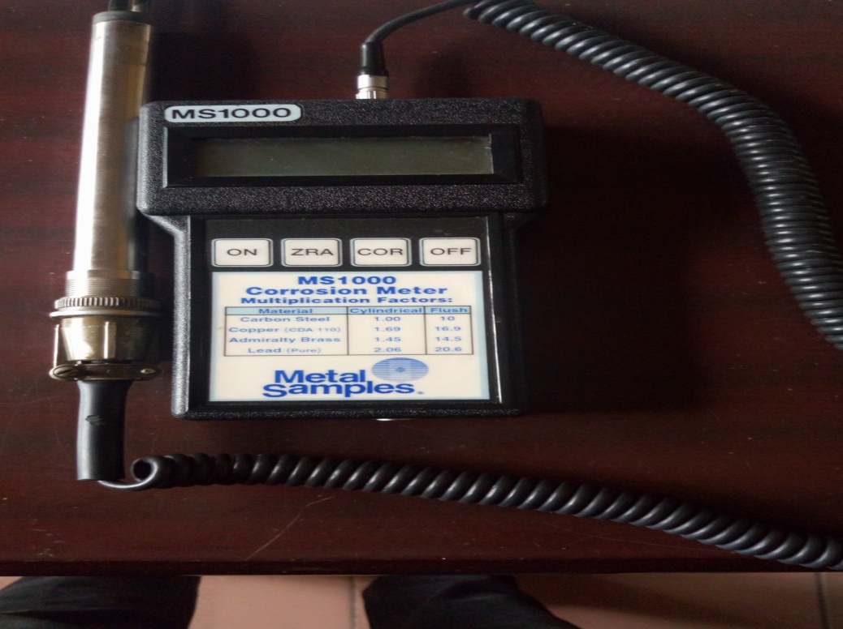

Plate 1: MS1000 LPR corrosion meter with the probe

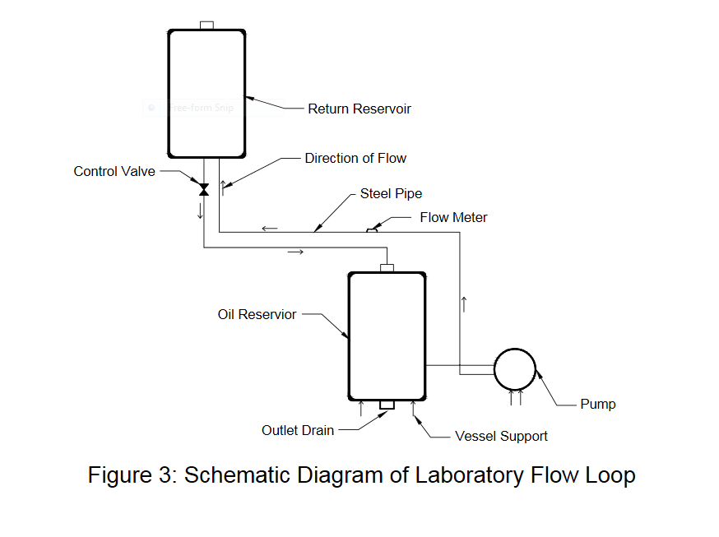

Plate 2: Schematic Diagram of the Experimental Laboratory Flow Loop

- METHODS
Laboratory flow loop was developed and constructed for the experiment. The flow loop gave a good representation of crude oil pipeline transportation process and to carry out experiment and model paraffin wax deposition on flow Rate for crude oil pipeline corrosion. The flow loop was used to determine the corrosion inhibition rate in mils per year (mpy) against time in minutes on pipeline. Waxy crude used in this study is one of the oilfields pipelines with waxing problems of Shell Petroleum Development Company in Niger Delta and was procured from Agbada 1 flow station in Ikwerre Local Government Area Rivers State. The waxy crude was characterized to examine the physical properties of the wax and conditions of operation. The waxy crude characterizations were performed in consonance with the requirement of ASTM D5442-17 (2021). The ASTM is a standard testing method for petroleum waxes. The variables studied experimentally and modeled were flow rate between crude oil mixture and inner pipe wall. The rate of corrosion rate in mil per year verse time in minutes of the wax deposit on crude oil pipeline corrosion were tested using MS1000 Corrosion Meter. The experimental and model results were recorded and analyzed.

Figure 2.1: Schematic Diagram of the Experimental Laboratory Flow Loop

- EXPERIMENTAL STUDY

The experiment was setup and performed in the Materials Laboratory of the Department of Mechanical Engineering at University of Port Harcourt, Choba. The experimental studies were conducted to investigate the paraffin wax deposition on flow rate between the waxy crude oil and inner pipe wall at different time, flow rate and temperature. The laboratory flow loop was assembled and 6L waxy crude was poured into the receiving reservoir and the pump was turned on to circulate it. The deposition process was commenced by circulating the waxy crude oil in the flow loop system and the valve was adjusted which was connected to the return pipe to achieve the desired flow rate. The waxy crude was pumped into the steel pipe at constant flow rate of 40.28 L/min. The experiment was conducted using flow meter with a temperature probe which were used to regulate the temperature and the flow meter measures flow rate The inlet temperature of the waxy crude oil were varied between (10-40ºC). The waxy crude flow from oil reservoir connected to the pump through the section pipe, and discharge pipe connected to the pump transfer the fluid to the fountain pipe connected under to the receiving reservoir, and the fountain pipe discharges the fluid which passes through the return pipe back to oil reservoir.
The waxy crude oil forms an impingement in the bottom of the oil reservoir which effect lead to precipitation and deposition of wax samples at the bottom of the oil reservoir and the corrosion rate with time were tested using MS1000 Corrosion Meter as the waxy crude oil flow into the oil reservoir by inserting the Linear Polarization Resistance (LPR) meter probe into the waxy oil reservoir, making sure that the probe touched the steel pipe and waxy crude oil in order to test for the corrosion rate in mils per year (mpy) against time in minutes. The corrosion testing started by pressing the LPR button “ ON” to turn it on. Next, the “COR” button was then pressed to measure instantaneous corrosion rate. After approximately 60 seconds, a short beep sounds to indicate that the measurement is complete, the measured corrosion rate is shifted to the screen and the value is saved. Corrosion rate against time was conducted; the experiment was terminated by stopping the pump. The experiment was conducted by varying temperature of (15, 20, 25, 30 and 35 ºC), time (3, 6, 9, 12, 15 and 18 minutes) and at constant flow rate of 40.28 L/min. The results were recorded, the graph of corrosion rate (mpy) against time (min) was plotted and the result analyzed.
- Computer Simulation of the Model
The developed models were solved using computer program designed to solve numerically the governing equations of using the input parameter from the wax physical properties and Operating Conditions and the experimental data from the flow rate on corrosion against time on pipeline corrosion. The model was implemented using MATLAB software, solved analytically. From the developed model, equation (3.130) is the flow rate model used for simulation. The results from computer simulation of the model were recorded, graph plotted and analyzed to compare the experimental and model data of the flow rate on deposition of wax on pipeline corrosion against time in minutes.

4. RESULTS AND DISCUSSION
Table 1: Experimental Results of Flow Rate at 40.28 L/min on Corrosion Rate (mpy) against Time (min) on Wax Deposition
Time (min) | Corrosion Rate (mpy) @15ºC | Corrosion Rate (mpy) @ 20ºC | Corrosion Rate (mpy) @ 25ºC | Corrosion Rate (mpy) @ 30ºC | Corrosion Rate (mpy) @ 35ºC
3 | 0.96 | 0.78 | 0.67 | 0.82 | 0.94
6 | 0.68 | 0.91 | 0.72 | 0.69 | 0.88
9 | 0.87 | 0.65 | 0.48 | 0.59 | 0.92
12 | 0.32 | 0.42 | 0.51 | 0.62 | 0.72
15 | 0.45 | 0.38 | 0.25 | 0.41 | 0.65
18 | 0.38 | 0.17 | 0.42 | 0.35 | 0.48

Figure 1: Graph of Experimental Results of Flow Rate at 40.28 L/min on Corrosion Rate (mpy) against Time (min) on Wax Deposition
Figure 1 shows the graph of experimental of flow rate on corrosion against time at different temperature of wax deposition during the corrosion inhibition. A significant reduction in corrosion rates and excellent corrosion protection was achieved at temperature of 20ºC for 18 minutes at a constant flow rate of 40.28 L/min, while others gave only moderate or negligible protection to the crude oil pipeline. It was observed that at time 3 min and at temperature of 15ºC, the corrosion rate is 0.96mpy and 0.78 mpy at 20ºC at the same time, 0.67 mpy at the same time and temperature of 25ºC, 0.82 mpy at temperature of 30 ºC, and 0.94 mpy at temperature of 35 ºC. At time 6 min and temperature of 15 ºC, 20 ºC, 25 ºC, 30 ºC, and 35 ºC, the corrosion rate was 0.68 mpy, 0.91 mpy, 0.72 mpy, 0.69 mpy, and 0.88 mpy respectively. At time 9 min corrosion rate were 0.87 mpy, 0.65 mpy, 0.48 mpy, 0.59 mpy, and 0.92 mpy in the order of the temperature respectively. At time 12 min in the order of the temperature were 0.32 mpy, 0.42 mpy, 0.51 mpy, 0.62 mpy, and 0.72 mpy respectively. At time 15 min corrosion rate were 0.45 mpy, 0.38 mpy, 0.25 mpy, 0.41 mpy, and 0.65 mpy in the order of the temperature respectively and at 18 min the corrosion rate were 0.38 mpy, 0.17 mpy, 0.42 mpy, 0.35 mpy, and 0.48 mpy respectively.
Morales et al. (2000) discovered that the presence of a paraffin wax film on the surface reduces general corrosion rates significantly, however localized corrosion was observed due to the paraffin layer's loss of integrity.
Table 2: Experimental and Model Results of Flow Rate on Wax Deposit on Corrosion Rate (mpy) against Time (min) at constant Flow Rate of 40.28 L/min and Temperature at 15ºC
Time  (min) | CR Exp  (mpy) | CR Model  (mpy) | Error
3 | 0.96 | 0.9058 | 0.0542
6 | 0.68 | 0.7876 | -0.1076
9 | 0.87 | 0.6694 | 0.2006
12 | 0.32 | 0.5512 | -0.2312
15 | 0.45 | 0.433 | 0.017
18 | 0.38 | 0.3148 | 0.0652

Figure 2: Experimental and Model Results of Flow Rate on Wax Deposit on Corrosion Rate (mpy) against Time (min) at Flow Rate of 40.28 L/min and Temperature at 15ºC
Figure 2: illustrate the variation profile plot of experimental and model results of the effect of flow rate on wax deposit on corrosion rate (mpy) against time (min) at flow rate of 40.28 L/min and temperature at 15ºC L/min during the corrosion inhibition.
At time 12 and 18 minutes, the experimental and model results predicted a significant reduction of corrosion rates while others gave only moderate or negligible protection to the crude oil pipeline. From the profile plot, the values of the corrosion rate (mpy) against time (min) of the experimental and model results are 3 (0.96 mpy, 0.9058 mpy), 6 (0.68 mpy, 0.7876 mpy), 9 (0.87 mpy, 0.6694 mpy), 12 (0.32 mpy, 0.5512 mpy), 15 (0.45 mpy, 0.433 mpy), 18 (0.38 mpy, 0.3148 mpy). But the variation of the experimental and model results in terms of deviation is (0.05%) indicating that both results are insignificant in variation, showing positive agreement between the experimental and model results.
Table 3: Experimental and Model Results of Flow Rate on Wax Deposit on Corrosion Rate (mpy) against Time (min) at Flow Rate of 40.28 L/min and Temperature at 20ºC
Time  (min) | CR Exp  (mpy) | CR Model  (mpy) | Error
3 | 0.78 | 0.8995 | -0.1195
6 | 0.91 | 0.7603 | 0.1497
9 | 0.65 | 0.6211 | 0.0289
12 | 0.42 | 0.4819 | -0.0619
15 | 0.38 | 0.3427 | 0.0373
18 | 0.17 | 0.2035 | -0.0335

Figure 3: Experimental and Model Results of Flow Rate on Wax Deposit on Corrosion Rate (mpy) against Time (min) at Flow Rate of 40.28 L/min and Temperature at 20ºC.
Figure 3: illustrate the variation profile plot of experimental and model results of the effect of flow rate on wax deposit on corrosion rate (mpy) against time (min) at flow rate of 40.28 L/min and temperature at 20ºC L/min during the corrosion inhibition.
At time 18 minutes, the experimental and the model results predicted a significant reduction of corrosion rates and excellent corrosion protection while others gave only moderate or negligible protection to the crude oil pipeline.
From the profile plot, the values of the corrosion rate (mpy) against time (min) of the experimental and model results are 3 (0.78 mpy, 0.8995 mpy), 6 (0.91 mpy, 0.7603 mpy), 9 (0.65 mpy, 0.6211 mpy), 12 (0.42 mpy, 0.4819 mpy), 15 (0.38 mpy, 0.3427 mpy), 18 (0.17 mpy, 0.2035 mpy). But the variation of the experimental and model results in terms of deviation is (0.03%) indicating that both results are insignificant in variation, showing positive agreement between the experimental and model results.
Table 4: Comparison of Experimental and Model Results of the Effect of Flow Rate on Wax Deposit on Corrosion Rate (mpy) against Time (min) at Flow Rate of 40.28 L/min and Temperature at 25ºC
Time  (min) | CR Exp  (mpy) | CR Model  (mpy) | Error
3 | 0.67 | 0.6963 | -0.0263
6 | 0.72 | 0.6213 | 0.0987
9 | 0.48 | 0.5463 | -0.0663
12 | 0.51 | 0.4713 | 0.0387
15 | 0.25 | 0.3963 | -0.1463
18 | 0.42 | 0.3213 | 0.0987

Figure 4: Comparison of Experimental and Model Results of the Effect of Flow Rate on Wax Deposit on Corrosion Rate (mpy) against Time (min) at Flow Rate of 40.28 L/min and Temperature at 25ºC.
Figure 4: illustrate the variation profile plot of experimental and model results of the effect of flow rate on wax deposit on corrosion rate (mpy) against time (min) at flow rate of 40.28 L/min and temperature at 25ºC L/min during the corrosion inhibition. At time 15 and 18 minutes, the experimental and model results predicted a significant reduction of corrosion rates while others gave only moderate or negligible protection to the crude oil pipeline. From the profile plot, the values of the corrosion rate (mpy) against time (min) of the experimental and model results are 3 (0.67 mpy, 0.6963 mpy), 6 (0.72 mpy, 0.6213 mpy), 9 (0.48 mpy, 0.5463 mpy), 12 (0.51 mpy, 0.4713 mpy), 15 (0.25 mpy, 0.3963 mpy), 18 (0.42 mpy, 0.3213 mpy). But the variation of the experimental and model results in terms of deviation is (0.09%) indicating that both results are insignificant in variation, showing positive agreement between the experimental and model results.
Table 5: Comparison of Experimental and Model Results of the Effect of Flow Rate on Wax Deposit on Corrosion Rate (mpy) against Time (min) at Flow Rate of 40.28 L/min and Temperature at 30ºC
Time  (min) | CR Exp  (mpy) | CR Model  (mpy) | Error
3 | 0.82 | 0.8057 | 0.0143
6 | 0.69 | 0.7154 | -0.0254
9 | 0.59 | 0.6251 | -0.0351
12 | 0.62 | 0.5348 | 0.0852
15 | 0.41 | 0.4445 | -0.0345
18 | 0.35 | 0.3542 | -0.0042

Figure 5: Comparison of Experimental and Model Results of the Effect of Flow Rate on Wax Deposit on Corrosion Rate (mpy) against Time (min) at Flow Rate of 40.28 L/min and Temperature at 30ºC.
Figure 5: shows the variation profile plot of experimental and model results of the effect of flow rate on wax deposit on corrosion rate (mpy) against time (min) at flow rate of 40.28 L/min and temperature at 30ºC L/min during the corrosion inhibition. At time 18 minutes, the experimental and the model results predicted a significant reduction of corrosion rates while others gave only moderate or negligible protection to the crude oil pipeline. From the profile plot, the values of the corrosion rate (mpy) against time (min) of the experimental and model results are 3 (0.82 mpy, 0.8057 mpy), 6 (0.69 mpy, 0.7154 mpy), 9 (0.59 mpy, 0.6251 mpy), 12 (0.62 mpy, 0.5348 mpy), 15 (0.41 mpy, 0.4445 mpy), 18 (0.35 mpy, 0.3542 mpy). But the variation of the experimental and model results in terms of deviation is (0.09%) indicating that both results are insignificant in variation, showing positive agreement between the experimental and model results.
Table 6: Comparison of Experimental and Model Results of the Effect of Flow Rate on Wax Deposit on Corrosion Rate (mpy) against Time (min) at Flow Rate of 40.28 L/min and Temperature at 35ºC
Time  (min) | CR Exp  (mpy) | CR Model  (mpy) | Error
3 | 0.94 | 0.9928 | -0.0528
6 | 0.88 | 0.9016 | -0.0216
9 | 0.92 | 0.8104 | 0.1096
12 | 0.72 | 0.7192 | 0.0008
15 | 0.65 | 0.628 | 0.022
18 | 0.48 | 0.5368 | -0.0568

Figure 6: Comparison of Experimental and Model Results of the Effect of Flow Rate on Wax Deposit on Corrosion Rate (mpy) against Time (min) at Flow Rate of 40.28 L/min and Temperature at 35ºC
Figure 6: illustrate the variation profile plot of experimental and model results of the effect of flow rate on wax deposit on corrosion rate (mpy) against time (min) at flow rate of 40.28 L/min and temperature at 35ºC L/min during the corrosion inhibition.
At time 18 minutes, the experimental and the model results predicted a significant reduction of corrosion rates while others gave only moderate or negligible protection to the crude oil pipeline
From the profile plot, the values of the corrosion rate (mpy) against time (min) of the experimental and model results are 3 (0.94 mpy, 0.9928 mpy), 6 (0.88 mpy, 0.9016 mpy), 9 (0.92 mpy, 0.8104 mpy), 12 (0.72 mpy, 0.7192 mpy), 15 (0.65 mpy, 0.628 mpy), 18 (0.48 mpy, 0.5368 mpy). But the variation of the experimental and model results in terms of deviation is (0.03%) indicating that both results are insignificant in variation, showing positive agreement between the experimental and model results.

V. CONCLUSION
Corrosion inhibition can be produced by crude oils, the degree of inhibition varies from one crude oil to the next. Paraffin wax is one of the most common components in crude oil. By depositing or forming wax on the inside surface of the pipeline, paraffin wax can limit corrosion and reduce corrosion. Wax deposition is caused by a variety of factors, including flow rate. Paraffin wax coatings can provide significant corrosion protection at temperatures below the Wax Appearance Temperature. However, they should not be relied upon for corrosion protection because van der Waals interactions weaken their contacts with the metal surface, and they can be eliminated with heat and/or shear, potentially resulting in a localized attack on the steel surface. In the paraffin industry, heavy paraffin deposits are undesirable because they reduce the effective size of flow conduits and limit the well's output rate. When a wax layer is applied to a steel surface, it slows corrosion by preventing corrosive species from diffusing to the surface. By coating the inner wall of the pipeline with paraffin wax, it works as a corrosion inhibitor while also restricting flow. The paraffin wax on the surface provides excellent corrosion protection, while others provided only moderate or negligible protection in the crude oil pipeline, but most of the corrosion protection has been lost due to the long chain paraffin layer being physically removed from the surface during the periods of increased increased flow rates. The protection provided by paraffin is assumed to be due to physisorption, which is caused by weak intermolecular interactions such as van der Waals forces. Wax applied at high flow rates has a different texture than wax applied at low flow rates. These problems mainly caused in the transportation and utilities where the pipelines are severely corroded. The protection of paraffins can be assumed to be due to physisorption caused by relatively weak intermolecular forces such as van der Waals forces. The rate of wax deposition is affected by the flow rate in the pipe line, which is caused by shear removal of the deposited wax due to shear stress on the wax's surface. The resident duration of crude oil in the pipeline is affected by flow rates, as a longer residence time results in more wax deposits on the pipe wall. When it comes to shear removal, however, larger flow rates result in less wax deposits. When the wax layer covers the steel surface, it can slow down corrosion by preventing corrosive species from diffusing to the surface. If the temperature remains below the WAT for an extended length of time, the wax layer thickens, potentially obstructing part or all of the pipe.

References
[1] Alsabagh, A. M., Migahed, M. A., and HayamAwad, S. (2015). Reactivity of polyester aliphatic amine surfactants as corrosion inhibitors for carbon steel in formation water (deep well water), Corrosion Science, 48, 813.

[2] Bentiss, F., Lagrenée, M., Traisnel, M. (2018). 5-Bis(n-Pyridyl)-1,3,4-Oxadiazoles as Corrosion Inhibitors for Mild Steel in Acidic Media, Corrosion, 56, 733. Journal of Corrosion Science, 42, 127.

[3] Gjermundsen, I. (2016). State of the art: Wax precipitation deposition and aging in flowing hydrocarbon systems, Internal Hydro report, October, Porsgrunn. International Journal of Petroleum Engineering.

[4] Lebrini, M, Traisnel, M., Lagrene, M., Mernari, B., Bentiss, F. (2017). Inhibitive properties, adsorption and a theoretical study of 3,5-bis(n-pyridyl)-4-amino-1,2,4-triazoles as corrosion inhibitors for mild steel in perchloric acid, Journal of Corrosion Science, 50, 473.

[5] Morad, M.S., Kamal, El-Dean, A. M. (2016). 2,2'-Dithiobis(3-cyano-4,6-dimethylpyridine): A new class of acid corrosion inhibitors for mild steel, Journal Corrosion of Science, 48, 3398.

[6] Rodrıguez-Valdez, L. M., Villamisar, W., Casales, M., Gonzalez-Rodriguez, J. G., Martınez-Villafane A., Martinez, L., Glossman-Mitnik, D. (2019). Computational simulations of the molecular structure and corrosion properties of amidoethyl, aminoethyl and hydroxyethylimidazolines inhibitors, Corrosion Science, 48, 4053.

[7] Shein, A. B., Denisova, A. V. (2016). Choice of Effective Corrosion Inhibitors for Acid Treatment of Wells, Protection of Metals, 42, 34.

[8] Villamizar, W., Casales, M. J., and Gonzalez-Rodriguez, G., Martinez, L. (2017). CO₂ corrosion inhibition by hydroxyethyl, aminoethyl, and amidoethylimidazolines in water–oil mixtures, Journal of Solid-State Electrochemistry, 11, 619.

[9] Hsu, J. J., Santamaria, M. M., Brubaker, J. P. (2019). Wax Deposition of Waxy Live Crudes under Turbulent Flow Conditions, Society of Petroluem Engineers Paper No. 28480, Presented at the Society of Petroluem Engineers 69th Annual Technical Conference and Exhibition held in New Orleans, LA, USA

[10] Tronov, J. P. (2017). Effect of Flow Rate and Other factors on the Formation of Paraffin Deposits’ Tr. Tatar Neft.Nauch-Issled, Inst. 13, 207.

[11] Haq, M. A. (2014). Deposition of Paraffin Wax from Its Solution with Hydrocarbon, Society of Petroluem Engineers Paper No. 10541, SPE e-library.

