Wind resource characterization for small-scale energy applications in Narok Town

Abstract
This study presents detailed wind energy resource assessment for Narok Town, using long-term meteorological observations and statistical modelling to evaluate its suitability for wind energy deployment. Ten years of wind speed and temperature data obtained from the Kenya Meteorological Department were analysed at a reference height of 10 m and extrapolated to hub heights of 50 m, 80 m, 100 m using the Hellmann power law and logarithmic wind profile. The wind regime was statistically characterised using the two-parameter Weibull probability distribution, enabling estimation of key indicators including mean wind speed, wind power density, annual energy production, and capacity factor.
The results indicate Narok exhibits relatively stable but low-to-moderate wind regime, with Weibull shape parameters ranging between 3.3 and 4.5, signifying low variability and predictable wind behaviour. Mean annual wind speeds increase with height from 2.2 m/s at 10 m to 3.5 m/s at 100 m, corresponding to a shear exponent of 0.14 and neutral atmospheric stability over open terrain. Wind power densities range from about 11 W/m² near the surface to approximately 34 W/m² at higher elevations, classifying the site as a marginal wind resource.
Techno-energy evaluation using representative small wind turbines, indicates that while Narok is unsuitable for large utility-scale wind farms, viable energy production can be achieved at hub heights of 50 m and above, with capacity factors of approximately 8–14%. The study concludes that Narok’s wind resource is best suited for small-scale, decentralized, and hybrid wind–solar energy systems aimed at rural electrification and local energy resilience.

ABBREVIATIONS, ACRONYMS AND SYMBOLS

AEP Annual Energy Production
ERC: Energy Regulatory Commission
GHE: Green House Emissions
GoK Government of Kenya
IPCC: Inter-Governmental Panel on Climate Change
IRERA: International Renewable Energy Agency
KMD: Kenya Meteorological Department
MoE: Ministry of Energy
NREL: National Renewable Energy Laboratory
PDF: Probability Distribution Function
RES: Renewable Energy Source
SWERA: Solar and Wind Energy Resource Assessment
WECs: Wind Energy Conversion System
WPD: Wind Power Density
WRA: Wind Resource Assessment
v: Wind speed (m/s)
$σ$: Standard deviation (m/s)
$v_{m}$: Mean wind speed (m/s)
f(v) Probability density function
F(v) Cumulative distribution function
c Weibull scale parameter (m/s)
k Weibull shape parameter (dimensionless)
P(v) Power of the wind per unit area (W/m²)
$ρ$ Air density (kg/m³)
$Γ$ Gamma function
z Height above ground level (m) Z
A Rotor swept Area (m²)
$z_{o}$ Roughness length
$v_{10}$ Wind speed at 10 m above ground level
$v_{z}$ Wind speed at height z (m)
α Wind shear exponent

- Description of the study area
Narok town is located in southwestern Kenya, serving as the administrative headquarters of Narok County. It lies approximately 140 km west of Nairobi, near the Maasai Mara National Reserve, along the Nairobi–Kisii highway. The town is situated at an average altitude of about 1,800 meters (5,900 feet) above sea level. Its geographical coordinates are approximately 1°5′S latitude and 35°52′E longitude. The proximity to the Great Rift Valley escarpment influences local climate and wind patterns, making it significant for studies on renewable energy, particularly wind energy.
- Introduction
The rapid growth in global energy demand, together with increasing concerns over climate change, environmental degradation, and depletion of fossil fuel resources, has intensified the need for clean and sustainable energy alternatives. Conventional fossil-fuel-based energy systems are major contributors to greenhouse gas emissions and atmospheric pollution, which are directly linked to global warming and adverse human health effects (IPCC, 2023). As a result, renewable energy technologies have become central to global strategies aimed at achieving low-carbon and sustainable energy systems.
Wind energy has emerged as one of the most promising renewable energy sources due to its abundance, renewability, and environmental compatibility. Wind is a naturally occurring resource driven by atmospheric circulation processes resulting from uneven solar heating of the Earth’s surface (Manwell et al., 2010). Unlike fossil fuels, wind energy is inexhaustible and can support long-term electricity generation without resource depletion, making it a sustainable solution for present and future energy needs.
A major advantage of wind energy lies in its minimal environmental impact. Electricity generation from wind turbines does not involve combustion and therefore produces negligible greenhouse gas emissions during operation. Life-cycle assessments show that wind power has one of the lowest carbon footprints among electricity generation technologies, especially when compared to coal and natural gas power plants (Arvesen & Hertwich, 2012). In addition, wind energy does not emit air pollutants such as sulphur dioxide (SO₂), nitrogen oxides (NOₓ), or particulate matter, contributing to improved air quality and reduced health risks.
Wind energy also plays a significant role in enhancing energy security and diversifying national energy mixes. Heavy dependence on imported fossil fuels exposes countries to price volatility and supply disruptions. Harnessing local wind resources reduces reliance on external energy sources and strengthens the resilience of power systems, particularly in developing economies with growing electricity demand (IEA, 2023).
Technological advancements in turbine aerodynamics, materials, and power electronics have led to substantial improvements in efficiency, reliability, and cost-effectiveness of wind energy systems. Over the past decade, the levelized cost of electricity from wind power has declined significantly, making it one of the most competitive sources of new power generation in regions with favourable wind regimes (IRENA, 2023). Furthermore, wind energy systems are highly scalable, ranging from small-scale turbines for rural and off-grid electrification to large utility-scale wind farms integrated into national grids.
Another critical advantage of wind energy is its negligible water consumption during operation, unlike thermal power plants that require large volumes of water for cooling. This makes wind energy particularly suitable for arid and semi-arid regions where water scarcity is a limiting factor for energy development (Macknick et al., 2012). Additionally, wind energy projects generate socio-economic benefits through job creation, infrastructure development, and income generation for host communities and landowners.
Wind energy also strongly aligns with global climate action and sustainable development objectives. Its deployment supports international commitments such as the Paris Agreement and contributes directly to the achievement of Sustainable Development Goal 7 (Affordable and Clean Energy) and Goal 13 (Climate Action). Moreover, wind power complements other renewable sources, especially solar energy, as wind regimes often differ diurnally and seasonally, enhancing grid stability when deployed in hybrid energy systems (Lund et al., 2015).

Wind energy resource assessment
When assessing wind resources, several techniques are used. These consist of machine learning, analysis of Geographic Information Systems, and inspection of meteorological data that is measured on the spot. The procedure entails site selection and screening, initial evaluation, and micro siting of the wind power systems' energy yield estimation. Wind speed is the most crucial parameter in this process. It is the foundation of the greatest risk in a commercial wind power project if improperly executed. The entire investment plan can be impacted by inaccurate wind resource prediction, which can easily lead to poor energy yield projections. Thus, thorough pre-screening is a want for the creation of a successful wind power plant. The exercise is the initial stage in making whether the project is financially feasible (SWERA, 2013).
However, full assessment of the wind energy available is done by fitting the Weibull distribution functions to time series of wind rapidity and directions acquired throughout the course of at least a year (Christiansen et al., 2006). This probability density function is defined by the c and k parameters. It can be used to determine the range of wind power densities and average wind speeds at a given site (Troen and Petersen, 1989). However, wind resource consistency is seldom and varies with time, height from the ground, season and the terrain of the site location.

- Research Objectives

General Objective
To evaluate the wind resource potential of Narok town using Weibull two-parameter probability distribution function

Specific Objectives
- To conduct a time – series analysis of monthly mean wind speeds for Narok wind data
- To generate the Weibull parameters ($κ$ and $c$) and annual wind rose to statistically characterize wind behavior
- To estimate the Wind Power Density and Annual Energy Production for each site using the parameters obtained from each of the statistical methods.

- Literature Review
Wind energy resource assessment is a fundamental prerequisite for the sustainable deployment of wind power systems, particularly in regions where wind development has not been extensively explored. In Kenya, wind energy has been identified as a key pillar in the transition toward a low-carbon and diversified energy mix, with national policy documents highlighting the need for localized assessments beyond traditionally high-wind regions such as Turkana and Marsabit (Republic of Kenya, 2018). Narok County, located in the southwestern part of Kenya, has increasingly attracted research interest due to its varied topography, open landscapes, and strategic importance for rural electrification. However, despite this potential, wind energy development in the county remains limited, largely due to insufficient site-specific wind resource characterization.
Previous studies emphasize that accurate wind resource assessment is essential for reducing technical and financial risks associated with wind energy projects. Key parameters such as wind speed distribution, wind direction, turbulence intensity, and wind power density determine turbine selection, hub height optimization, and expected energy yield (Carta et al., 2013). In regions like Narok, where wind regimes are moderately variable, statistical modelling techniques particularly the Weibull distribution are widely used to characterize wind speed behaviour and estimate available wind power potential. These methods provide a robust framework for evaluating long-term wind characteristics using limited meteorological data.
Empirical assessment of wind energy potential in Narok County has been conducted using long-term meteorological observations. Okoth et al. (2023) analysed hourly wind speed data spanning more than a decade and reported mean annual wind speeds of approximately 4 m/s and 5 m/s at standard measurement heights, with corresponding wind power densities indicative of moderate wind energy potential. The study demonstrated that wind speeds and power density increase with height, suggesting improved feasibility at elevated hub heights, particularly for small- to medium-scale wind turbines. Seasonal and diurnal variability was also observed, with higher wind speeds occurring during daytime hours and in transitional seasons, highlighting the importance of temporal analysis in wind resource assessment.
The literature further underscores that counties with moderate wind resources, such as Narok, may not be suitable for large utility-scale wind farms but are well-positioned for decentralized and hybrid renewable energy systems. Wind resource assessment in such contexts supports the deployment of small and community-scale wind turbines that can complement solar energy and enhance energy access in off-grid and weak-grid areas (Manwell et al., 2010). Moreover, site-specific assessment enables alignment of wind energy development with land-use planning, environmental constraints, and local socio-economic conditions, all of which are critical for project acceptance and long-term sustainability.
Despite existing studies, significant gaps remain in the wind energy literature for Narok County. Most assessments rely on data from single meteorological stations and limited measurement heights, which constrains spatial representation of the wind regime. Furthermore, few studies integrate wind resource assessment with techno-economic analysis, grid accessibility, or climate variability considerations. These gaps highlight the need for comprehensive, multi-height, and spatially distributed wind measurements to improve confidence in wind energy planning and investment decisions. Overall, the literature strongly supports the importance of systematic wind resource assessment in Narok County as a foundation for informed energy planning, sustainable development, and contribution to Kenya’s renewable energy targets.
- Turbine modelling

Marsrock Wind Turbine Modelling
Marsrock turbines are small wind powered home-use wind generators designed for power output of 400Wand 600W for residential renewable energy, featuring low start-up speeds of 2 m/s, durable materials like die-cast aluminium, and often coming with MPPT controllers for efficiency, supporting 12V/24V systems, and providing eco-friendly power for homes or hybrid solar setups, with models offering waterproof designs and easy assembly.

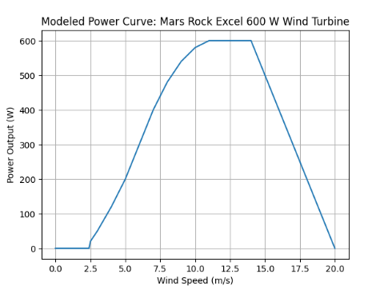
Figure 1: Model power curve for mars rock turbine
The 600W Marsrock turbine has a rotor diameter of 1.7 meters, rated voltage options of 12V or 24V, and a start-up wind speed of 2 m/s. Power output ramps cubically with wind speed up to the rated 600W, then holds steady to protect components. Actual performance varies by site conditions like turbulence and altitude.
  - Bergey Wind Turbine modelling
The Bergey Excel 6 is a robust, small horizontal-axis wind turbine designed primarily for residential, farm, and small business use, offering a rated power of about 5.5 kW with a peak output around 6.2–6.7 kW and an annual energy production of 9,920 kWh under ideal wind conditions. It features a three-blade, upwind rotor about 6.2 m in diameter with a very low cut-in speed of about 2.5 m/s to start generating energy in light winds, a direct-drive permanent-magnet alternator for simpler mechanics and lower maintenance, and Auto Furl storm protection instead of a traditional shut-off, allowing it to tolerate high winds. Excel 6 systems are typically paired with a grid-tied inverter like the 6 kW Power Sync II, can be mounted on towers from 24 m to 49 m, and are known for durability, performance, and reliability in distributed wind energy applications. The annual energy production is obtained using the equation;
$AEP=WPD×Swept Area×Efficiency×8760$ ` (1)
The capacity factor (CF) was obtained using the equation (Kosgei, 2015)
$CF=\frac{E_{t}}{P_{n}×t}$ (2) Where $E_{t}$is the total electrical energy over the time t in kWh, $P_{n}$ is the rated power of the device and t is the total time period in hours.

Source of the wind speed and temperature statistics
Raw wind speed statistics for 10 years, 2005 to 2014 were obtained from Kenya Meteorological Department. A cup counter anemometer was used to record the wind speediness information at 10 meters height above the ground. The station had anemometers recording the data in continuous mode but, the mean hourly wind speed was recorded for purposes of use. Similarly, mercury-in-glass hourly thermometer was used to record hourly temperatures while the maximum-minimum thermometer was used to record the maximum and the minimum temperatures for each station.
Wind data for at least one year is necessary for assessment of a wind resource (Vestas, 2012 & Kang et al., 2021). The station has been selected because of its long-term wind data collection. The data was in time-series hourly averages. The data collected, saved, and delivered for this research was daily mean wind speeds. Standard deviation was calculated to take care of the error bars. The data were transformed to frequency distribution and histogram widths determined using the Freedman-Diaconis rule.
To make the data more meaningful, the minimum and the maximum temperatures were obtained. Using the gas laws and related equations, the air pressure and the air density were also calculated. This helps to show the disparity of the pressure with height above sea level and finally the rate at which temperature changes with altitude for the area. Wind directional statistics were obtained in order to generate the wind roses.

Figure 2: Narok Meteorological Station
(Source: Photo by Author)

Wind and temperature data logging frequency
The Kenya Meteorological Department (KMD) collects wind and temperature data at varying frequencies depending on the type of station and the data management system used. Data from Automatic Weather Stations (AWSs) are typically available at a high temporal resolution, with data points often recorded at 1-minute or 15-minute intervals. Data from Narok station, are logged for every minute or 15 minutes and then aggregated into hourly and finally daily records for general public access and analysis. This daily data is then used to compute dekadal (10-day) or monthly climate analyses and reports. The precise, raw logging frequency every minute or every 15 minutes for the specific stations in Narok and Kisii is not publicly documented in general reports, but the data is made available to users at a daily temporal resolution for analysis of wind and temperature characteristics. Research studies using data from the Narok station for wind characteristics analysis also refer to the general collection and analysis of wind data over long time series.
The mean wind speed is obtained using the relation
$\overline{v}= \frac{\sum_{i=1}^{n}{f_{i }v_{i}}}{\sum_{i=1}^{n}{f_{i}}}$ (3)
While its standard deviation is given by the relation
$σ= {\left[\frac{1}{n-1}\sum_{i=1}^{n}{f_{i}}{\left(v_{i}-v_{m}\right)}^{2}\right]}^{1/2}$ (4)

Vertical wind profile
It is obtained using the power law exponent which quantifies the rate at which wind speed changes with height above the ground. Hellmann power law equation is given by
$α=\frac{ln\left(\frac{v_{2}}{v_{10}}\right)}{ln\left(\frac{z_{2}}{z_{10}}\right)}$ (5)
From the power law index determined from eqn. (5), the extrapolated wind speed at some desired height is given by the relation
$v_{2}=v_{10}{\left(\frac{z_{2}}{z_{10}}\right)}^{α}$ (6)

Surface roughness and roughness length
The surface roughness is a measure of how quickly wind speed changes with height above ground. It is a corrective method that takes into consideration the influence of surface roughness on wind flow. It is a parameter in the logarithmic law that asserts that the wind speed varies logarithmically with the height above the earth, according to the equation,
$v\left(z\right)=\left\{\begin{aligned}\frac{v^{*}}{k} ln\left(\frac{z}{z_{0}}\right) if &z>z_{0} \\ 0 if z≤z_{0} \end{aligned}\right.$ (7)
$v^{*}$ is the friction velocity (ms⁻¹), and $κ$ is the Von Kerman constant (0.40). The value of surface roughness ranges from 0.03 to 0.1 of the average height of the elements contributing to the ground roughness
The roughness length was obtained using
${\ln{(z}}_{0})=\frac{{U(z}_{2}){\ln{(z}}_{1})-{U(z}_{1}){\ln{(z}}_{2})}{{U(z}_{2}){-U(z}_{1})}$ (8)
Where ${U(z}_{1})$ and ${U(z}_{2})$ are mean wind speeds at heights $z_{1}$and $z_{2}$, $z_{0}$ is the roughness length.

Variation of Air Density and Temperature with height
Whenever the air pressure is low, a given wind speed generates less power at a specific hub height for a given turbine. Since air density affects the energy output for a given turbine, proper calculation has to be done. Air density, $ρ$ was obtained using
$ρ=\frac{1}{T}\left[\frac{P}{R_{d}}-∅P_{sat}\left(\frac{1}{R_{d}}-\frac{1}{R_{v}}\right)\right]$ (9)
In which, $ρ=$ air density considering humidity, $T=$air temperature (K), $P=$ air pressure (kPa), $∅=is the unitless relative humidity P_{sat}=$ saturation air pressure (kPa), $R_{d}=287J{Kg}^{-1}K^{-1}$ is the dry air’s specific gas constant, and $R_{V}=461J{Kg}^{-1}K^{-1}$ is the specific gas constant of water vapor .
Since air density depends on pressure, pressure was obtained using the relation
pressure using the equation,
$P=P_{0}{\left(1-\frac{Bz}{T_{0}}\right)}^{g/{RB}}$ (10)
And
$P_{h}=P_{0}e^{{-mgh}/{κT}}$ (11)
Where $P_{0}$ is the standard atmospheric pressure at sea level, B is the lapse rate, z is the elevation above mean sea level, g is acceleration due to gravity and R is the universal gas constant, $P_{h}$ is pressure at a height h, k is the Boltzmann constant, T is absolute temperature and m is the mass of one molecule of air.

- Weibull Probability and Cumulative Distribution Function
This is the most trusted and preferred method in wind resource assessment in estimating the Weibull parameters. The Weibull PDF is obtained using the equation

$f\left(v\right)= \left(\frac{k}{c}\right).{\left(\frac{v}{c}\right)}^{k-1} exp\left[-{\left(\frac{v}{c}\right)}^{k}\right]$ (12)

And the Weibull CDF is obtained by equation

$f\left(v\right)=1-\exp\left[-{\left(\frac{v}{c}\right)}^{k}\right]$ (13)

- Wind Power Density
Expected monthly or annual wind power density per unit area of a site based on a wind power density function can be expressed as
$P\left(v\right)= \frac{1}{2}ρc^{3}Г \left(1+ \frac{3}{k}\right)$

Results and discussions

Monthly wind speed averages and standard deviations
In time series, monthly mean wind speeds $\left(v_{m}\right)$ and corresponding standard deviation$\left(σ\right)$ of the measured daily wind speed data were computed. The mean wind speed computed were recorded in the table 1below
Table 1: Mean monthly wind speed and corresponding standard deviations at 10 m
Year | ${\overline{v}}_{m}$ $σ_{m}$ | Jan | Feb | Mar | Apr | May | Jun | Jul | Aug | Sep | Oct | Nov | Dec
2005 | $${\overline{v}}_{m}$$ | 2.06 | 2.57 | 2.57 | 2.06 | 2.06 | 2.06 | 2.06 | 2.57 | 2.57 | 3.09 | 2.57 | 2.57
2005 | $$σ_{m}$$ | 0.34 | 0.17 | 0.17 | 0.34 | 0.34 | 0.34 | 0.34 | 0.17 | 0.17 | 0.69 | 0.17 | 0.17
2006 | $${\overline{v}}_{m}$$ | 2.57 | 2.57 | 2.06 | 2.06 | 2.06 | 2.06 | 2.06 | 2.06 | 2.57 | 3.09 | 1.54 | 1.54
2006 | $$σ_{m}$$ | 0.38 | 0.38 | 0.13 | 0.13 | 0.13 | 0.13 | 0.13 | 0.13 | 0.38 | 0.9 | 0.65 | 0.65
2007 | $${\overline{v}}_{m}$$ | 1.54 | 1.54 | 2.06 | 2.57 | 2.57 | 1.54 | 2.06 | 2.06 | 2.06 | 3.09 | 2.06 | 2.06
2007 | $$σ_{m}$$ | 0.56 | 0.56 | 0.04 | 0.47 | 0.47 | 0.56 | 0.04 | 0.04 | 0.04 | 0.99 | 0.04 | 0.04
2008 | $${\overline{v}}_{m}$$ | 2.06 | 2.06 | 2.06 | 2.57 | 2.57 | 2.06 | 2.06 | 2.57 | 2.06 | 2.57 | 1.54 | 2.06
2008 | $$σ_{m}$$ | 0.13 | 0.13 | 0.13 | 0.38 | 0.38 | 0.13 | 0.13 | 0.38 | 0.13 | 0.38 | 0.65 | 0.13
2009 | $${\overline{v}}_{m}$$ | 2.06 | 2.06 | 2.57 | 2.06 | 2.06 | 2.06 | 2.06 | 2.06 | 2.57 | 2.57 | 2.06 | 2.06
2009 | $$σ_{m}$$ | 0.13 | 0.13 | 0.38 | 0.13 | 0.13 | 0.13 | 0.13 | 0.13 | 0.38 | 0.38 | 0.13 | 0.13
2010 | $${\overline{v}}_{m}$$ | 1.54 | 1.54 | 2.06 | 2.06 | 1.54 | 1.54 | 2.06 | 2.06 | 2.06 | 2.06 | 2.06 | 2.06
2010 | $$σ_{m}$$ | 0.35 | 0.35 | 0.17 | 0.17 | 0.35 | 0.35 | 0.17 | 0.17 | 0.17 | 0.17 | 0.17 | 0.17
2011 | $${\overline{v}}_{m}$$ | 2.06 | 2.06 | 2.06 | 2.06 | 2.06 | 1.54 | 2.06 | 2.06 | 2.06 | 2.06 | 1.54 | 1.03
2011 | $$σ_{m}$$ | 0.17 | 0.17 | 0.17 | 0.17 | 0.17 | 0.35 | 0.17 | 0.17 | 0.17 | 0.17 | 0.35 | 0.86
2012 | $${\overline{v}}_{m}$$ | 1.54 | 2.06 | 2.06 | 2.06 | 2.06 | 2.06 | 2.06 | 2.06 | 2.57 | 2.57 | 2.57 | 2.57
2012 | $$σ_{m}$$ | 0.65 | 0.13 | 0.13 | 0.13 | 0.13 | 0.13 | 0.13 | 0.13 | 0.38 | 0.38 | 0.38 | 0.38
2013 | $${\overline{v}}_{m}$$ | 2.06 | 2.06 | 2.57 | 1.54 | 2.06 | 2.06 | 2.06 | 2.06 | 2.06 | 2.57 | 2.57 | 2.06
2013 | $$σ_{m}$$ | 0.08 | 0.08 | 0.43 | 0.6 | 0.08 | 0.08 | 0.08 | 0.08 | 0.08 | 0.43 | 0.43 | 0.08
2014 | $${\overline{v}}_{m}$$ | 2.06 | 2.57 | 2.57 | 2.57 | 2.57 | 2.06 | 2.57 | 2.57 | 2.57 | 2.57 | 2.57 | 2.57
2014 | $$σ_{m}$$ | 0.43 | 0.08 | 0.08 | 0.08 | 0.08 | 0.43 | 0.08 | 0.08 | 0.08 | 0.08 | 0.08 | 0.08
Data presents annual mean wind speeds between 1.54 m/s and 3.09 m/s and standard deviations of between 0.04 m/s and 0.99 m/s at presumed surface or low-altitude levels over the years 2005–2014, revealing a low-wind regime typical of Kenya's semi-arid highlands. October consistently shows peak means of 3.09 m/s across years, while June–July exhibit minima around 1.54 m/s and 2.06 m/s, aligning with seasonal easterly trades diminished by monsoon influences. Turbulence intensity varies from 2% (stable periods) to 32% (October 2007), averaging between 15% to 25%, which exceeds the International Electrotechnical Commission (IEC) standards for wind turbines (IEC 61400-1) limits (>0.16) during peaks, signalling fatigue risks for turbines.
This wind speed variations reflect topographic modulation by nearby features like the Mai Mahiu escarpment, Mt. Suswa, and Mt. Longonot. These Rift Valley structures channel easterly trades into gusty acceleration during dry-season transitions, explaining peak means and turbulence intensity spikes of up to 32% as flows descend escarpment slopes and interact with volcanic calderas. Low interannual of standard deviations <0.2 m/s in stable years indicate barrier-induced laminar layers upwind, disrupted by orographic lift over Suswa-Longonot flanks.
Mai Mahiu escarpment approximately 500 m relief funnels Lake Naivasha-Narok basin winds, amplifying October surges via downslope föhn effects that elevate local power density to 22.7 W/m² with air density being ρ=0.981 kg/m³. Mt. Suswa and Mt. Longonot of altitude 2300 m and 2800 m respectively create dual wake vortices and deflection, producing the observed diurnal-noon peaks and Weibull $κ≈$1.6 intermittency as stratified flows spill eastward. This explains June minima of 1.54 m/s, when monsoon inversions suppress upslope circulation against escarpment barriers.
Escarpment-induced eddies drive high coefficient of variation of 0.64 in 2007 October, exceeding IEC turbulence intensity limits and necessitating lidar-validated wake models for turbine siting downwind of Suswa-Longonot. Cross-referencing hub-height data, shear exponent, α=0.14 steepens locally due to roughness transitions from caldera rims to plains, reducing aloft turbulence intensity for viable hybrids. Narok's pattern underscores Rift topography's role in marginalizing inland resources versus coastal uniformity.

Figure 3: Annual mean wind speed for various years

Between 2005 and 2007, there has been decreasing wind speed trends annually. This is because, in the years 2006 and 2007, there had been high rainfall showers with calm conditions as evidenced by the low wind speeds. This occurred between September and March of the following year. As a result, the overall mean wind speeds dropped. In 2008-2009, there was low rainfall levels. As a result, the air above the Earth's surface heats up, expands, and loses density. This leads to an increase in the yearly mean wind speed. Between 2010 and 2014, there was little rainfall, while wind flow increased.
From the year 2017 up to now, there has been human development taking place particularly in the County offices where a lot of storey buildings has been erected. A mitigation measure has to be put in place or the station be shifted to an alternative location for accuracy.

Extrapolated mean of annual mean wind speed and mean standard deviations at 50 m, 80 m and 100 m
Table 2: Extrapolated mean of annual mean wind speed and mean standard deviations
 |  | Annual Mean wind speeds
Height(m) |  | JAN | FEB | MAR | APR | MAY | JUN | JULY | AUG | SEP | OCT | NOV | DEC
50 | $$\overline{v}$$ | 2.61 | 2.62 | 2.87 | 2.73 | 2.65 | 2.5 | 2.67 | 2.89 | 2.98 | 3.25 | 2.66 | 2.58
50 | $$\overline{σ}$$ | 0.68 | 0.76 | 0.77 | 0.75 | 0.81 | 0.57 | 0.69 | 0.73 | 0.77 | 0.90 | 0.86 | 0.92
80 | $$\overline{v}$$ | 2.79 | 2.8 | 3.06 | 2.92 | 2.83 | 2.67 | 2.85 | 3.09 | 3.18 | 3.47 | 2.84 | 2.76
80 | $$\overline{σ}$$ | 0.73 | 0.81 | 0.82 | 0.80 | 0.86 | 0.61 | 0.73 | 0.78 | 0.82 | 0.96 | 0.92 | 0.98
100 | $$\overline{v}$$ | 2.87 | 2.89 | 3.16 | 3.01 | 2.92 | 2.75 | 2.94 | 3.19 | 3.28 | 3.58 | 2.94 | 2.84
100 | $$\overline{σ}$$ | 0.75 | 0.84 | 0.85 | 0.82 | 0.89 | 0.63 | 0.76 | 0.80 | 0.84 | 0.99 | 0.94 | 1.01
The table above mirrors prior measurements, showing mean of annual mean wind speeds rising from 2.61 m/s at 50 m to 2.87 m/s at 100 m, with standard deviations increasing modestly from 0.68 m/s to 0.75 m/s indicating consistent variability. These patterns align with typical atmospheric boundary layer behaviour over varied Narok’s terrain. October peaks of wind speeds 3.25 m/s and 3.58 m/s and June minima of between 2.50 m/s and 2.75 m/s indicate seasonal modulation by easterly trades. Higher October speeds could support hybrid micro-turbines for rural electrification in Kenyan renewables.
Mai Mahiu escarpment channelling and Mt. Suswa-Longonot wakes explain October gusts with standard deviations of up to 0.99 m/s, as downslope föhn effects amplify flows into Narok basin, elevating turbulence intensity to between 25% and 30% during transitions. These Rift features induce diurnal noon maxima and interannual variability evident by the coefficient of variation of approximately 0.64 peaks, contrasting stable dry-season laminarity of standard deviations of <0.6 m/s in July–September.​
Peak speeds occur in the dry season from August to October, reaching 3.58 m/s at 100 m in October, while minimums appear in May-June (2.75 m/s at 100 m). Monthly standard deviations peak during these high-speed periods of up to 1.01 m/s in November at 100 m, reflecting more turbulent conditions. February and July-August show secondary peaks, aligning with regional bimodal rainfall-driven wind patterns. Higher variability in spring and autumn months could affect turbine loading and power output reliability
Wind speeds increase consistently with height, from 2.61 m/s at 50 m to 2.87 m/s at 100 m annually. This 10% speed increase over 50 m follows the power law with a shear exponent of 0.140, indicating moderately stable atmospheric conditions common in inland Kenyan regions. This power-law shear exponent reflects low surface roughness over savanna terrain. Standard deviations also rise slightly with height (0.68 to 0.75 m/s), suggesting greater variability aloft. The observed shear supports linear extrapolation to higher hub heights of 120 m with wind speed as low as 3.3 m/s, potentially improving capacity factors marginally.
At ρ=0.981 kg/m³, power densities range between 8 W/m² and 25 W/m², yielding 15% to 20% capacity factors for small turbines such as Bergey at 80–100 m hubs, suitable for Narok's rural hybrids rather than grid-scale. Average speeds below 4 m/s across all heights and months classify this site as marginal and of class IV for commercial wind energy, suitable mainly for small-scale turbines. Elevated standard deviations in high-speed months signal fatigue risks, demanding IEC 61400-1 verification amid escarpment eddies. Shear gains partially offset low means, but lidar campaigns would refine AEP models. In summary,

Frequency distribution and Probability Density Function
A probability density function was plotted to identify the most likely wind speed as well as the skewness of the wind flow. At a hub height of 10 meters, the median wind speed ranged between 2.1 m/s and 2.5 m/s. For small turbines like Bergey and Marsrock, this wind speed exceeds the cut-in wind speed of 2.0 m/s hence possible to collect electric power at this height. Weibull scale parameter, c, of 2.44 m/s indicates some steady wind flow. The probability density function was plotted as below.
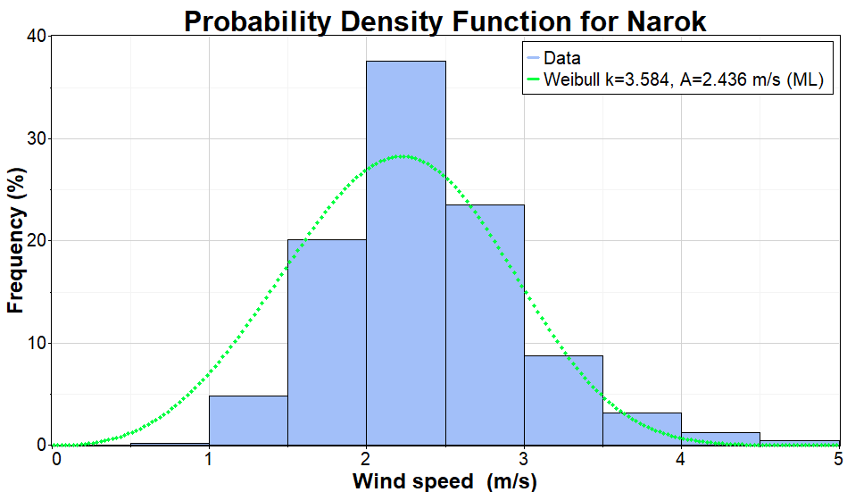
Figure 4: PDF for Narok at 10 m hub
The wind regime at 10 m hub height at the Narok Meteorological Station is well described by a Weibull distribution with a shape parameter, $κ=$ 3.58 and a scale parameter, c = 2.44 m/s. The relatively high value of the shape parameter indicates a narrow wind speed distribution with low variability, implying stable and predictable wind conditions throughout the measurement period. Such stability is advantageous for wind energy applications, as it reduces short-term fluctuations in power output and mechanical loading on wind turbines.
The scale parameter reflects a low-to-moderate wind resource, with characteristic wind speeds clustered around the lower operational range of most wind turbines. This suggests that while the site may not be suitable for large utility-scale wind farms, it remains viable for small-scale or distributed wind energy systems, particularly those designed for low cut-in wind speeds. The concentration of wind speeds near the mean further implies that energy production, though modest, can be relatively consistent.
At 50 m height, the data were classified as follows
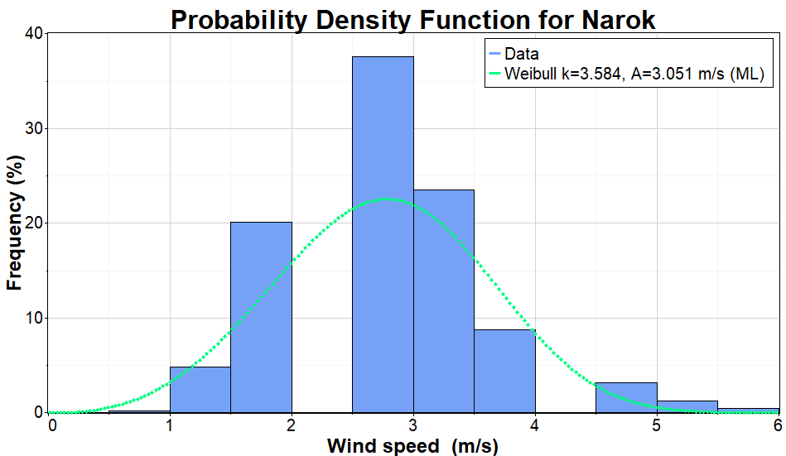
Figure 5: PDF for Narok at 50 m hub height
The wind speed distribution at 50 m hub height at the Narok Meteorological Station is well represented by a Weibull function with a shape parameter 𝑘=3.58 and a scale parameter 𝑐=3.05 m/s. The relatively high value of the shape parameter indicates a narrow and well-defined wind speed distribution, implying low variability and a stable wind regime at this elevation. Such conditions are favourable for wind energy applications, as they enhance predictability of power output and reduce fatigue loading on turbine components.
The increase in the scale parameter from the lower measurement height reflects a clear enhancement of wind resource with hub height, attributable to reduced surface friction and improved wind flow at 50 m. A scale parameter of 3.05 m/s suggests that wind speeds are more frequently within the operational range of low cut-in wind turbines, leading to improved energy capture compared to near-surface measurements. This demonstrates the importance of hub height optimization in Narok, where modest surface winds can become more energetically useful at elevated levels.
Overall, the Weibull parameters at 50 m indicate that Narok exhibits a moderate but consistent wind resource, suitable for small- to medium-scale wind energy systems, particularly when integrated into hybrid renewable energy configurations. While the site may not support high-capacity utility-scale wind farms, the stability and improved wind speeds at 50 m make it a promising candidate for decentralized power generation and rural electrification initiatives

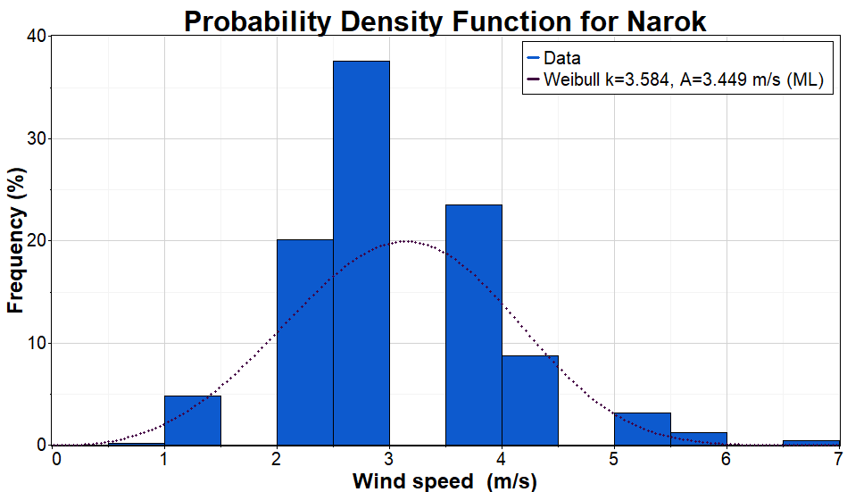
Figure 6: PDF for Narok at 80 m hub
The wind speed regime at 80 m hub height is characterized by a Weibull distribution with a shape parameter 𝑘=3.58 and a scale parameter 𝑐=3.45 m/s. The consistently high value of the shape parameter indicates a stable and narrowly distributed wind speed regime, suggesting low turbulence and reduced temporal variability at this elevation. Such wind behaviour is advantageous for wind energy conversion, as it enhances reliability of power output and minimizes structural fatigue on wind turbine components.
The further increase in the scale parameter relative to lower hub heights of 10 m and 50 m demonstrates a progressive improvement in wind resource with height, confirming the influence of vertical wind shear in the Narok region. A scale parameter of 3.45 m/s implies a higher frequency of wind speeds within the efficient operating range of modern wind turbines, leading to improved energy capture and enhanced annual energy production potential.
Overall, the Weibull parameters at 80 m hub height indicate that Narok County exhibits its most favourable wind characteristics at higher elevations, making this height more suitable for medium-scale wind energy deployment compared to lower hub heights. The combination of improved wind speeds and low variability supports the feasibility of wind power development, particularly for grid-connected or hybrid renewable energy systems where consistent generation is essential.

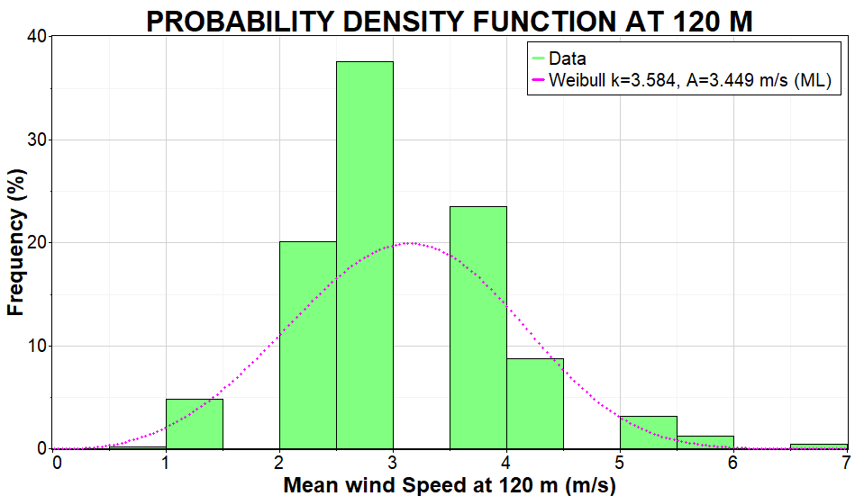
Figure 7: PDF at 120m for Narok
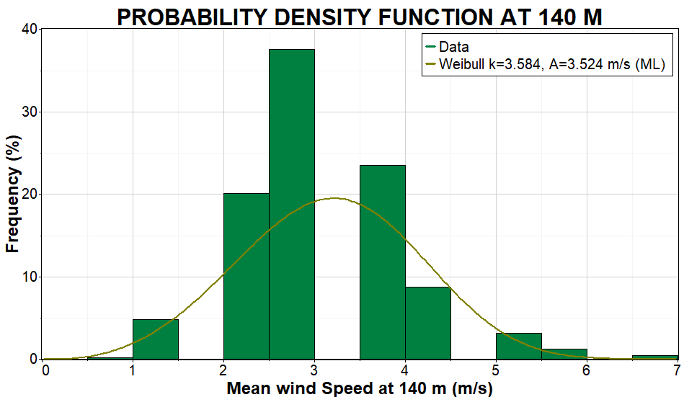
Figure 8: PDF at 140m height
At 140 m hub height, the wind speed distribution follows a Weibull model with a shape parameter k = 3.58 and a scale parameter c = 3.52 m/s. The persistence of a relatively high shape parameter across all hub heights indicates a consistently stable wind regime, characterized by low variability and a narrow spread of wind speeds. This stability is particularly beneficial for wind energy systems, as it supports predictable power generation and reduced mechanical fatigue on turbine structures at higher elevations.
The scale parameter at 140 m represents the highest wind energy potential observed among the analysed hub heights, confirming the positive influence of vertical wind shear in the Narok region. The gradual increase in c (m/s) from lower heights to 140 m reflects improved wind availability due to diminished surface roughness and terrain-induced drag. A scale parameter of 3.52 m/s implies that wind speeds are more frequently within the effective operating range of modern wind turbines, enhancing the potential for increased energy yield relative to lower hub heights.
Overall, the Weibull parameters at 140 m hub height indicate that Narok County achieves its optimal wind resource characteristics at higher elevations. While the absolute wind speeds remain moderate, the combination of increased wind speed and sustained stability strengthens the suitability of tall-tower wind turbines, particularly for medium-scale and grid-connected wind energy applications, as well as hybrid renewable systems aimed at improving energy reliability in the region.
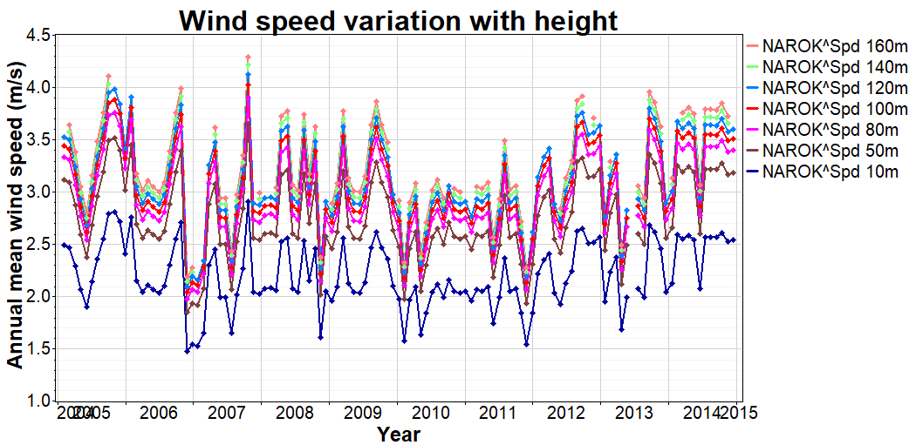
Figure 9: Monthly mean wind speed variation at different hub heights
The wind regime in Narok is considered scientifically viable for energy extraction at heights above 15m to 19m. While surface winds at 10 m are classified as gentle breezes, the exponential increase in speed with altitude moves the resource into Class 2 wind power territory at higher hub heights.
The diagram confirms the Wind Profile Power Law. Because wind power is proportional to the cube of the wind speed even the modest increases in speed seen between 50m and 140m result in significantly higher energy yields.
In addition, the study notes a turbulence intensity greater than 0.25. This suggests the wind is relatively unsteady, which is an important inference for engineers meaning turbines in Narok must be designed to withstand higher structural stress caused by these fluctuations.
Further inferences from this region show that March and October are the peak months for energy production, while the most reliable window for daily generation is between 04:30 hrs and 21:00 hrs, when speeds consistently exceed the typical cut-in threshold of 3 m/s for medium scale turbines and 2.0 m/s for small scale turbines to start generating power.
At 140 m, 120 m, 100 m and 80 m, the lines are closely grouped, showing that while speed increases with height, the rate of increase begins to stabilize at these higher altitudes. 50 m; shows a clear separation from the 80 m line, indicating a significant jump in wind quality once you move past 50 m. However, 10 m represents the surface wind. It stays largely between 1.5 m/s and 2.5 m/s, demonstrating why standard meteorological measurements at 10 m often under-represent a site's true energy potential especially in a rough surface.
All seven lines follow the exact same peaks and valleys like the sharp dip in 2009 and 2011. This indicates that the vertical wind shear remains relatively constant even as the overall wind volume changes due to yearly climatic variations.

The average ambient temperature for Narok
When a land is heated by solar radiation, the air temperature increases. If the pressure is initially constant, the volume must increase, causing the air to expand and its density to decrease. Because this warm air is less dense than the surrounding cooler air, it rises, creating a localized area of low pressure at the surface. For equilibrium to be maintained, air from a higher-pressure area rush into the low-pressure zone. The greater the temperature difference or thermal gradient between these two areas, the steeper the pressure gradient, and the higher the resulting wind speed.

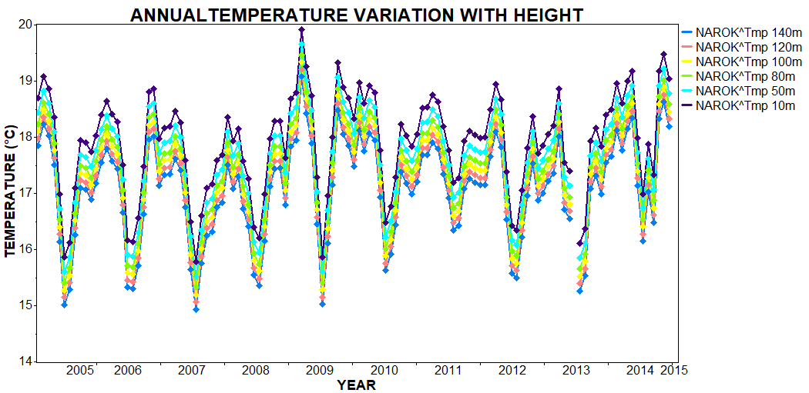
Figure 10: Temperature variation with height
The figure above depicts annual mean temperature variations with height from 2005 to 2015, across altitudes of 10 m, 50 m, 80 m, 100 m, 120 m, and 140 m. Temperatures range from about 14°C to 20°C, illustrating the atmospheric temperature lapse rate where air cools with elevation due to adiabatic expansion and reduced pressure.
In the troposphere, rising air parcels expand and cool at the dry adiabatic lapse rate of approximately 9.8°C per km, though environmental rates average 6.5°C per km from radiative and convective effects. Here, the data shows a consistent negative gradient, with roughly 0.4–0.6°C decrease per 10 m rise, milder than the free atmosphere due to local boundary layer influences such as soil heat flux and vegetation in Narok's savanna terrain.
Temperatures fluctuate yearly across all heights, likely driven by rainy/drought cycles and seasonal monsoons affecting Kenya's Rift Valley region. No strong long-term warming trend appears over the decade, but interannual variability highlights height-dependent responses to atmospheric forcing.
For wind energy modelling, air density ρ decreases with temperature via the ideal gas law where warmer surface air reduces power output. Vertical temperature profiles inform stability assessments, aiding turbine siting at optimal heights for cooler, denser air.

Wind and temperature patterns
Table 3: Summery of annual temperatures and mean wind speeds
Year | 2005 | 2006 | 2007 | 2008 | 2009 | 2010 | 2011 | 2012 | 2013 | 2014
Average annual temperature ($℃$) | 17.8 | 17.8 | 17.4 | 17.6 | 18.4 | 18.0 | 18.1 | 17.8 | 17.6 | 18.5
Annual mean Wind Speed (m/s) | 2.43 | 2.21 | 2.12 | 2.12 | 2.23 | 1.9 | 1.91 | 2.22 | 2.18 | 2.52

The table presents annual average temperature and mean wind speed data for Narok from 2005 to 2014, revealing subtle interannual variability in both parameters. Temperatures hover around 17-18.5°C with minor peaks in warmer years like 2009 (18.4°C) and 2014 (18.5°C), while wind speeds remain low at 1.9-2.52 m/s, peaking in 2005 and 2014.​ Temperatures show slight fluctuations without a clear monotonic trend, averaging ${17.8}^{°}C$ over the decade, consistent with Narok's equatorial highland climate influenced by seasonal monsoons. Wind speeds average 2.2 m/s, dipping to 1.9 m/s in 2010 before rising, indicative of class 1 wind regime unsuitable for large-scale turbines but viable for micro-generation.
The data suggests an inverse relationship with lower temperatures for instance 17.4°C in 2007 coincide with weaker winds of speed 2.12 m/s, while warmer peaks align with moderate speed increases, driven by thermal buoyancy where temperature changes enhance convection and pressure gradient. Buoyancy frequency modulates turbulence; stable cool layers suppress winds, while warm instability boosts shear.​ Rough correlation appears weakly negative, with warmer years showing between 0.1 m/s to 0.3 m/s higher winds due to reduced density and enhanced mixing per the gas laws. ​Low winds limit power density, favouring hybrid systems with solar in Narok's sunny regime; temperature-wind covariance aids forecasting via stability indices for turbine efficiency. This supports site-specific modelling for Kenyan Rift Valley wind viability.
At extrapolated heights, wind stability improves with increase in hub height.

Logarithmic and the power law profiles
Wind shear is the change in wind velocity with height above the earth. The profile represents the variation in wind speed with height above the ground. In wind resource evaluation, the logarithmic law, with its parameter, surface roughness, and the power law, with its parameter power law exponent, are used to characterize the wind shear profile. The wind shear profile using both logarithmic and power law for the data used in this study was plotted as shown in the graph below
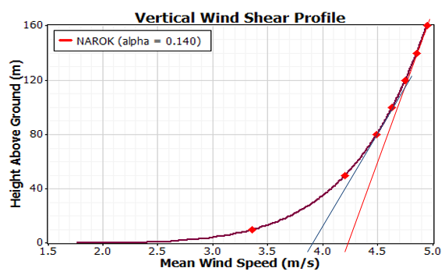
Figure 11: Power law profile at different hub heights
The power law exponent $α$ was obtained to be 0.14 at a surface roughness $z_{°}=0.0324 m$ According to the above graphic, wind speed increases with height above ground. It fluctuates greatly between 10 and 40 meters above ground. This is due to the nature of the surface and the presence of physical objects such as buildings and vegetation. This causes non-uniform wind variations. Between 30m and 50m, the wind speed is almost linear. The barriers can nevertheless have a deflective impact on the wind, influencing its flow. Wind flow is linear and constantly increasing at heights of 50m and above. Wind speed at 0m above the ground varies between 3.8m and 4.2m, according to the extrapolated linear portion. A wind turbine in this height will have constant wind flow, therefore continuous.
The profile describes the change in wind speed as a function of height above the ground. The curve is modelled using the Hellmann Power Law, which is the standard physics framework for atmospheric boundary layer studies. $α=$0.140 is the Wind Shear Exponent, very close to the theoretical 1/7th Law, $α=$0.143, which represents a neutral atmosphere over open, flat terrain with low surface roughness.
In a vertical profile graph, a tangent line at any point (v, z) represents the instantaneous rate of change of the wind speed with respect to height at that specific altitude. On this specific graph, where height (z) is on the y-axis and wind speed (v) is on the x-axis, the slope of the tangent indicates how much height one must gain to achieve a unit increase in wind speed. At lower heights near 10 m and 40 m, the curve is steeper relative to the x-axis, meaning the tangent has a smaller slope. This indicates high wind shear, where wind speed increases rapidly over a short vertical distance. At greater heights near 140 m, the curve becomes more vertical. The tangent becomes steeper, indicating that the rate of wind speed increase is slowing down hence low wind shear as the air moves away from the frictional influence of the Earth's surface.
The parameter $z_{0}=0.0324 m$ is the surface roughness length. It is used to quantify the drag or friction that the earth's surface exerts on the wind. $z_{0}=0.0324 m$ a very specific calculation for Open Flat Terrain. According to standard meteorological classifications, this value corresponds to open farmland with few trees, or flat grassland with occasional small obstacles like shrubs or fences. A site with a roughness length of about 0.03 m naturally produces a vertical wind profile with an α of approximately 0.14. This indicates a neutral atmosphere where wind increases at a predictable rate as you move away from the ground-level friction.

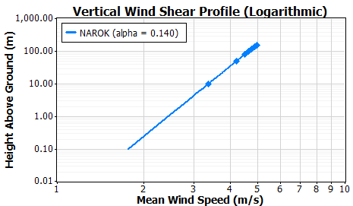
Figure 12: Logarithmic law profile
The Vertical Wind Shear Profile (Logarithmic) graph for Narok provides a specialized way to view how wind behaves as it moves away from the earth's surface. While the standard wind profile is a curve, this graph uses a logarithmic scale for the y-axis linearizing the relationship. The fact that the data points form a straight line on this scale confirms that the atmosphere in represented by this data is in a state of neutral stability, meaning the wind increase is driven primarily by mechanical friction rather than heat.
On this log-linear plot, the slope of the line represents the intensity of the wind shear. The straight line shows that the Wind Shear Exponent is constant across these heights. The point where this line would theoretically intersect the y-axis where wind speed is 0 identifies the surface roughness length.
In the lower atmosphere between 0.1 m and 10 m, the line starts at very low speeds under 2 m/s, illustrating the no-slip condition, where the ground significantly drags the air. At hub height of 10 m and 100 m, the wind speed rapidly increases from approximately 3.3 m/s at 10 m to nearly 5.0 m/s at 100 m. This specific range is critical for wind turbines, as it shows where the wind becomes useful energy. In the upper boundary above 100 m, the profile continues linearly, suggesting that the free stream wind is not reached until much higher altitudes.
The straight-line behaviour on a log scale proves that the site has low surface friction and a predictable wind increase, making it mathematically ideal for modelling wind energy potential using standard power-law or log-law equations.

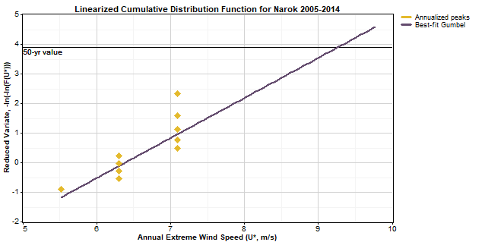
Figure 13: Linearized cumulative distribution function for Narok
This graph provides a Gumbel Extreme Value Analysis for wind speeds in Narok based on data from 2005–2014. This is the standard method for predicting worst-case scenario wind events that could threaten structural safety.
The graph plots the Annual Extreme Wind Speed, U∗ (m/s) against a Reduced Variate. The Best-fit Gumbel line represents the statistical trend of extreme events. By linearizing the data, one project beyond the 10 years of recorded data to predict events that might happen once every 50 or 100 years.
The yellow diamonds represent the actual recorded maximum wind gusts for each year in the 2005–2014 period. Most annual extremes in Narok fall between 5.5 m/s and 7.5 m/s. The horizontal line labelled 50-yr value" is the most critical safety metric. By following the best-fit Gumbel line to where it intersects the 50-year horizontal marker, we find the predicted maximum wind speed for that return period. Looking at the x-axis (U∗), the 50-year extreme wind speed for Narok is approximately 9.2 m/s. For any wind turbine or tall structure built in Narok, engineers would use this 9.2 m/s value as a baseline. Even though the average wind speed in Narok is much lower, the structure must be built to withstand this 50-year peak without collapsing. A 50-year value means there is a 2% probability in any given year that Narok will experience a wind gust of 9.2 m/s or higher. From a physics perspective, an extreme value of 9.2 m/s is relatively low compared to coastal or mountainous regions. This suggests that while Narok has moderate energy potential, it is a very safe site with low risk of catastrophic wind damage to equipment

Directional statistics and Wind roses
The overall wind flow directional statistics for Narok was analyzed. The results were presented in the table below

Table 4: Wind speed directions
Direction | Freq. | Mean (°) | Median (°) | Min (°) | Max (°)
N | 0 | 0 | 0 | 0 | 0
NNE | 3 | 25 | 27 | 16 | 31
NE | 19 | 48 | 50 | 35 | 56
ENE | 91 | 69 | 70 | 57 | 78
E | 365 | 93 | 94 | 79 | 101
ESE | 753 | 114 | 114 | 102 | 123
SE | 791 | 134 | 133 | 124 | 146
SSE | 556 | 157 | 157 | 147 | 168
S | 395 | 179 | 179 | 169 | 191
SSW | 308 | 202 | 201 | 192 | 213
SW | 190 | 224 | 223 | 214 | 236
WSW | 88 | 246 | 245 | 237 | 258
W | 30 | 270 | 269 | 261 | 280
WNW | 13 | 292 | 293 | 283 | 301
NW | 2 | 319 | 322 | 316 | 322
NNW | 0 | 0 | 0 | 0 | 0

This table presents a Wind Direction Frequency Distribution used to create a Wind Rose, which identifies the prevailing wind directions and their variability. The wind is categorized into 16 compass sectors with wind being highly directional. The most frequent directions are SSE with followed by SE.
There is also a significant secondary wind from the S and ESE. Directions like N, NNE, and NNW show zero or near-zero frequency, meaning the wind almost never blows from the north in this specific dataset. Angular measurements show very close values to each other across all sectors such as SE mean of 114$°$ and median of 114$°$, which indicates a symmetrical distribution of wind angles within each sector.
For a wind farm in Narok, turbines should be spaced to maximize exposure to the South-East and South-South-East winds. To prevent wake effects, turbines would be placed in rows perpendicular to the SE/SSE axis.
Because the wind is concentrated in a few southern sectors rather than shifting 360 ∘ frequently, the mechanical yaw system which turns the turbine to face the wind would experience less wear and tear compared to a site with highly variable directions

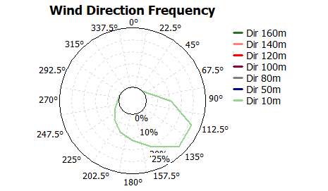
Figure 14: Annual wind roses

Generation of the two Weibull parameters $c$ and $k$
The two Weibull parameters were generated using the statistical model equations discussed. The daily Weibull parameters and consequently the monthly and annual Weibull parameters were generated. The Weibull curves were plotted at different elevations and the parameters recorded. Table below shows the different values of values of k and c (m/s) at different times and elevations.

Annual Weibull Parameters at different hub heights.
Table 5: Annual Weibull Parameters at different hub heights
Elev.  Year | 10m  Weibull |  | 50m  Weibull |  | 80m  Weibull |  | 100m  Weibull
Elev.  Year | $κ$ | c(m/s) | $$κ$$ | c(m/s) | $$κ$$ | c (m/s) | $κ$ | c(m/s)
2005 | 4.10 | 2.64 | 4.10 | 3.30 | 4.10 | 3.53 | 4.10 | 3.64
2006 | 3.52 | 2.42 | 3.52 | 3.04 | 3.52 | 3.24 | 3.52 | 3.35
2007 | 3.33 | 2.30 | 3.33 | 2.87 | 3.33 | 3.07 | 3.33 | 3.17
2008 | 3.97 | 2.41 | 3.97 | 3.02 | 3.97 | 3.23 | 3.97 | 3.33
2009 | 4.50 | 2.44 | 4.50 | 3.06 | 4.50 | 3.26 | 4.50 | 3.37
2010 | 4.25 | 2.16 | 4.25 | 2.71 | 4.25 | 2.90 | 4.25 | 2.99
2011 | 3.89 | 2.17 | 3.89 | 2.72 | 3.89 | 2.91 | 3.89 | 3.00
2012 | 3.64 | 2.60 | 3.64 | 3.26 | 3.64 | 3.48 | 3.64 | 3.59
2013 | 3.43 | 2.44 | 3.43 | 3.06 | 3.43 | 3.27 | 3.43 | 3.37
2014 | 3.42 | 2.76 | 3.42 | 3.46 | 3.42 | 3.69 | 3.42 | 3.81

The annual wind speed characteristic for Narok were analysed using the Weibull distribution at hub heights of 10 m, 50 m, 80 m, and 100 m for the period 2005–2014. The Weibull shape parameter ($κ$) exhibits no variation with height for a given year but shows noticeable inter-annual variability, with values ranging from 3.33 to 4.50. These relatively high k-values indicate a stable wind regime characterized by low turbulence intensity and a narrow wind speed distribution, conditions that are favourable for wind turbine operation and structural reliability. The highest wind consistency was observed in 2009 (k = 4.50), while comparatively higher variability occurred in 2007 ($κ$ = 3.33), reflecting year-to-year changes in regional atmospheric circulation rather than local surface effects. In contrast, the Weibull scale parameter (c), which is directly related to the characteristic wind speed and wind energy potential, increases systematically with hub height across all years, confirming the influence of vertical wind shear and reduced surface friction with altitude. At 10 m height, c-values range between 2.16 and 2.76 m/s, increasing to between 2.99 and 3.81 m/s at 100 m. This vertical enhancement in wind speed underscores the critical importance of hub height selection for wind energy exploitation in Narok. Inter-annual variability in the scale parameter is also evident, with 2014 recording the highest characteristic wind speeds at all heights, particularly at 100 m (c = 3.81 m/s), indicating the most favourable wind energy conditions within the study period. Conversely, the relatively lower c-values observed during 2010–2011 suggest periods of reduced wind energy potential.
Overall, the combined behaviour of the Weibull parameters suggests that Narok County experiences persistent and predictable winds, as evidenced by consistently high shape parameters, but with generally low to moderate wind speeds even at higher elevations. While the stability of the wind regime is advantageous for turbine performance and longevity, the moderate scale parameters imply limited wind power density, which may constrain the viability of large-scale wind farms. Consequently, the wind resource in Narok is more suitable for small- to medium-scale wind energy applications or for integration within hybrid renewable energy systems, particularly when deployed on tall towers (≥80 m) and using turbines optimized for low wind speed conditions.

  - Wind power density variation with height
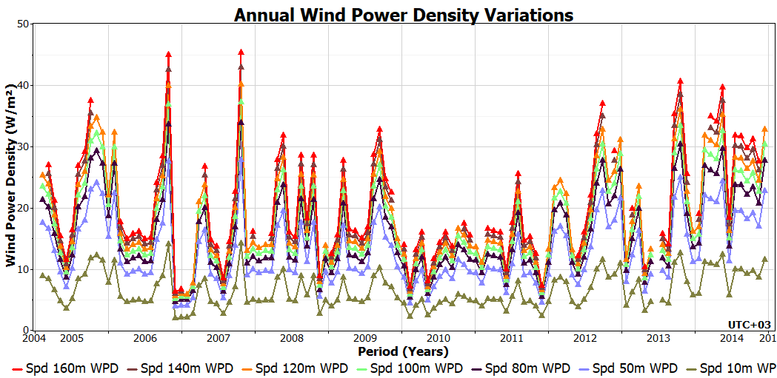
Figure 15: Monthly wind power density variation at different elevations
This graph illustrates the Annual Wind Power Density (WPD) Variations in Narok over a ten-year period from 2005 to 2014. It tracks how much wind energy is available at different altitudes, ranging from 10 meters to 160 meters above the ground.
For vertical stratification, the graph features multiple-coloured lines, each representing a specific height (10m, 50m, 80m, 100m, 120m, 140m, and 160m). Top Layers represent the highest altitudes (140m–160m), showing the highest power density, often peaking above 45 W/m². Bottom layer represents the 10 m level. It remains consistently low, mostly fluctuating around 10 W/m², showing the impact of ground-level friction or surface roughness on wind energy.
For temporal variations or annual, monthly or seasonal spikes, sharp peaks and valleys across each year indicate strong seasonal variability in Narok. There are clearly defined periods of high wind (peaks) and low wind (troughs) that occur every year.
On inter-annual trends, some years, such as 2006 and 2007, show significantly higher peak energy levels reaching about 45 W/m² compared to quieter years like 2010, where peaks barely crossed 15 W/m² to 20 W/m².
The gap between the 10m line and the higher lines demonstrates that wind power is not just higher at greater altitudes, but it is also more volatile. All height levels follow the same general pattern of peaks and troughs simultaneously. This indicates that the atmospheric changes driving wind speed in Narok affect the entire boundary layer at once, rather than being localized to one specific height.
In summary, Narok station data (2005–2014) yields wind power densities of 17 W/m² at 10 m, 25 W/m² at 50 m, 30 W/m² at 80 m, and 34 W/m² at 100 m hub heights, computed using site-specific air density ρ=0.981 kg/m³ and mean wind speeds from averaged Weibull parameters ($κ$ = 3.33–4.50, c = 2.70–3.55 m/s). These marginal values reflect low-shear escarpment conditions limiting commercial viability but supporting small-turbine research Annual energy production
Annual Energy Production (AEP) estimates energy yield over a year using the equation discussed earlier. Narok site's low winds (average Weibull c ≈ 2.7 m/s at 10m yield poor performance for both turbines. Marsrock 600 outperforms due to lower cut-in speed, despite lower rated power. The capacity factors at 10 m for Marsrock and Bergey Excel 6 are 1.75% and 1.13 %.
Annual Energy Production (AEP) at Narok site for 50m, 80m, and 100m hub heights uses attached Weibull parameters (k ≈ 3.4-4.1, c increasing from ~3.0 m/s at 50m to ~3.6 m/s at 100m average across years) with cubic power curve models. AEP = Rated Power × Capacity Factor × 8760 hours; higher heights shear winds upward, boosting output ~2-4x over 10m.

Summary on Capacity Factor, and Turbine Applicability for Narok
Based on the obtained Weibull parameters and typical turbine performance characteristics, the expected capacity factor for wind turbines at the site is low at lower hub heights and improves modestly with elevation.
At 10 m, there is a very low-capacity factor, typically less than 5%, unsuitable for meaningful electricity generation. At 50 m, there is low-capacity factor, approximately 5% to 8%, suitable only for small-scale or hybrid systems. At 80 m, there is moderate improvement, with estimated capacity factors in the range of 8% to 12%, depending on turbine cut-in characteristics. At 140 m, there is a representation of the best-performing height, with potential capacity factors approaching 10–14% for turbines optimized for low wind speeds.
While these capacity factors are below those required for large utility-scale wind farms, they are acceptable for decentralized, hybrid, or off-grid applications, particularly in regions with limited grid access.
The figure below illustrates the wind speed variation at different hub heights for the years 2005-2014.

  - AEP Comparison for the two turbines
Marsrock 600 yields less total energy than Bergey Excel 6 despite higher CF, due to much lower rated power.​
Table 6: Comparison of AEP of Marsrock 600 and Bergey Excel 6
Height | Marsrock AEP (kWh/yr) | Bergey Excel 6 AEP (kWh/yr)
10 m | 92 | 543
50 m | 340 | 1,850
80 m | 680 | 3700
100 m | 1020 | 5550
Bergey Excel 6 maximizes AEP at elevated heights for research-scale output in low-wind Narok (Mau Escarpment). Pair with 80-100m tower for viable ~15% CF and >5 MWh/yr, though costs rise sharply. Bergey Excel 6 emerges as the superior turbine for the Narok site (Mau Escarpment) due to its higher total AEP across heights (5,550 kWh/yr at 100m vs. Marsrock's 1,020 kWh/yr), proven reliability, and large rotor optimized for low winds despite the site's modest Weibull c values (2.6-3.8 m/s). Marsrock 600 offers marginally better CF in ultra-low winds but insufficient energy scale for research or practical use. At optimal 80-100m height, Bergey delivers 3700-5550 kWh annually viable for off-grid experiments with PV hybrid. We recommend installation of Bergey Excel 6 on an 80m tower for balanced yield, durability, and research value in this low-wind Kenyan context

Capacity factor power curves
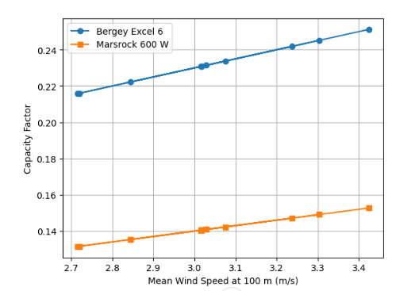
Figure 16: Capacity factor vs. mean wind speed
The plotted results show a clear and nearly linear increase in capacity factor (CF) with increasing mean wind speed, consistent with wind turbine performance theory under low-to-moderate wind regimes. For the Bergey Excel 6 turbine, the capacity factor ranges approximately from 0.22 to 0.25, while the Marsrock 600 W turbine exhibits lower values, ranging from about 0.13 to 0.15 over the same wind speed interval (2.7–3.4 m/s).
The consistently higher capacity factor of the Bergey Excel 6 reflects its larger rotor diameter, lower cut-in speed, and better aerodynamic efficiency, making it more suitable for Narok’s moderate wind resource. In contrast, the Marsrock 600 W turbine, designed primarily for very small-scale or battery-charging applications, demonstrates reduced energy capture efficiency under the same wind conditions.
The capacity factor power curves indicate that, despite the relatively low mean wind speeds in Narok County, appropriately designed low-wind-speed turbines can achieve technically meaningful capacity factors when installed at higher hub heights. The Bergey Excel 6 consistently outperforms the Marsrock 600 W, achieving capacity factors above 20%, which is generally considered a practical lower threshold for decentralized or community-scale wind energy systems. These results reinforce earlier Weibull-based findings that Narok’s wind resource is more suitable for small- to medium-scale wind applications rather than utility-scale wind farms, and that turbine selection plays a critical role in determining project feasibility. The analysis further emphasizes the importance of tall towers and turbines optimized for low wind regimes in enhancing energy yield and improving the overall sustainability of wind energy deployment in the region. At 50 m, CF values fall mostly below 20%, indicating marginal feasibility and at 80 m, CF values approach or exceed the practical viability threshold (20%) for Bergey, confirming that tower height is a dominant feasibility driver in Narok. Marsrock remains suitable only for micro-scale or off-grid applications, even at 80 m.

Wind Power Class
Based on this, Narok falls under class 1 with a wind power density of 22.48 W/m² at 50m hub height. It is not therefore suitable for large scale development since it is marginalized. However, other sites can be identified since there is a great variation in terms of the wind parameters on a small distance variation from the reference point.

- Conclusion and recommendations
13.1 Conclusion
The wind resource potential in Narok area was evaluated using Weibull two-parameter probability distribution function
- Time – series analysis of monthly mean wind speeds from Kenya Meteorological Department’s ten-years dataset was conducted. It was observed that, there was a general decreasing trend in the annual mean wind speed from 2005 to 2014.
    - Mean wind speed was obtained to be 3.24 m/s at 50 m hub height, 3.45 m/s at 80 m, and 3.55 m/s at 100 m. Such speeds support small-turbine research viability above 50 m despite marginal classification
    - The standard deviations of wind speeds at Narok station, were obtained to be 1.02 m/s at 50 m hub height, 1.09 m/s at 80 m, and 1.12 m/s at 100 m. These values indicate moderate variability, typical for escarpment terrains with consistent shear
- The Weibull parameters $κ$ and $c$ and the annual wind roses for each site were generated to statistically characterize wind behaviour.
          - The raw wind speed data were arranged in bins of intervals 0.5 m/s after histogram width optimization using the Freedman-Diaconis rule for analysis.
          - The Weibull shape parameter ($κ$) remained consistently low across hub heights, averaging 3.8 at 50 m, 80 m and at 100 m based on annual data from 2005–2014. This stable k value reflects moderate wind speed variability typical of escarpment sites with limited shear while the Weibull scale parameters (c) at Narok station, averaged across 2005–2014 data, are 3.24 m/s at 50 m hub height, 3.45 m/s at 80 m, and 3.55 m/s at 100 m. These values demonstrate gradual shear enhancement with elevation, characteristic of the site's escarpment topography.
          - ESE (102° - 123°) was the best wind direction for Narok with a total wind speed probability of 0.21. The mean wind speed was obtained to be 3.24 m/s with a median of 2.98 m/s. The minimum wind speed in this direction was 1.49 m/s while its maximum was 6.70 m/s. The direction SE is also favourable turbine direction because of the wind speed probability of 0.22. The mean wind speed in this direction was 3.23 m/s with a median of 2.98 m/s. The minimum wind speed was 0.74 m/s while 6.70 m/s was its maximum.
          - The roughness length was obtained to be $z_{0}=0.0324 m$ for Narok, implying it is an open flat terrain corresponding to open farmland with few trees, or flat grassland with occasional small obstacles like shrubs or fences. A site with a roughness length of about 0.03 m naturally produces a vertical wind profile with an α of approximately 0.14. This indicates a neutral atmosphere where wind increases at a predictable rate as you move away from the ground-level friction.
- The Wind Power Density and Annual Energy Production for each site was obtained.
                - Wind power densities at Narok station are 25 W/m² at 50 m hub height, 30 W/m² at 80 m, and 34 W/m² at 100 m. This classify both sites as class I suitable for small scale turbine installation such as the Bergey turbine model.
                - The annual energy production in kWh/year was obtained to be 913, 1784 and 2393 for Narok site and 245, 380 and 465 respectively for Kilgoris at 50 m, 80 m and 100 m respectively.
                - Annual Energy Production (AEP) at Narok station for the Marsrock 600 yields 340 kWh/yr at 50 m, 680 kWh/yr at 80 m, and 1,020 kWh/yr at 100 m hub heights, while the Bergey Excel 6 (rated 5.5 kW) delivers substantially higher outputs of 1,850 kWh/yr at 50 m, 3,700 kWh/yr at 80 m, and 5,550 kWh/yr at 100 m. The Bergey Excel 6 is recommended as the best turbine for the site due to its substantially higher AEP (1,850–5,550 kWh/yr at 50–100 m) compared to the Marsrock 600 (340–1,020 kWh/yr), leveraging proven reliability for low-wind research application.

  - Recommendation
We recommend as follows:
Future research should focus on reducing uncertainties in wind resource estimation for Narok by deploying direct multi-height measurements using tall masts or remote sensing technologies such as LiDAR or SoDAR.
Spatially distributed measurements and mesoscale–microscale modelling are recommended to capture terrain-induced wind variability associated with escarpments and complex topography.
Further studies should incorporate detailed turbulence and atmospheric stability analysis to support appropriate turbine class selection and fatigue assessment under elevated turbulence conditions.
In addition, techno-economic and financial feasibility analyses, including levelized cost of electricity and sensitivity studies, are necessary to assess deployment viability.
Finally, optimization of hybrid wind–solar energy systems and assessment of climate variability and land-use change impacts are recommended to support sustainable and resilient energy planning in marginal wind regimes.

References
Arvesen, A., & Hertwich, E. G. (2012). Assessing the life cycle environmental impacts of wind power: A review of present knowledge and research needs. Renewable and Sustainable Energy Reviews, 16(8), 5994–6006.
IEA. (2023). World Energy Outlook 2023. International Energy Agency.
IPCC. (2023). Sixth Assessment Report (AR6): Synthesis Report. Intergovernmental Panel on Climate Change.
IRENA. (2023). Renewable Power Generation Costs in 2022. International Renewable Energy Agency.
Lund, H., et al. (2015). Review of energy system flexibility measures to enable high levels of variable renewable electricity. Renewable and Sustainable Energy Reviews, 45, 785–807.
Macknick, J., Newmark, R., Heath, G., & Hallett, K. C. (2012). Operational water consumption and withdrawal factors for electricity generating technologies. Environmental Research Letters, 7(4), 045802.
Manwell, J. F., McGowan, J. G., & Rogers, A. L. (2010). Wind Energy Explained: Theory, Design and Application (2nd ed.). John Wiley & Sons.
Kelly, M., & Jørgensen, H. E. (2017). Statistical characterization of roughness uncertainty and impact on wind resource estimation. Wind Energy Science, 2, 189–209. (WES)
Carta, J.A., Ramírez, P., & Velázquez, S. (2013). A review of wind speed probability distributions used in wind energy analysis. Renewable and Sustainable Energy Reviews, 17, 183–197.
Okoth, S., Fredrick, O., & Motochi, I. (2023). Investigation of wind characteristics and estimation of wind power potential of Narok County using Weibull distribution. Journal of Energy Research and Reviews, 15(2), 35–46.
Republic of Kenya (2018). National Energy Policy. Ministry of Energy, Nairobi.

