Design and Development of an Oil Conditioning System for Industrial Applications
Dipak M. Gadadare¹, Dr. Vijay D. Patel²*
¹M. Tech Scholar, Department of Mechanical Engineering, U. V. Patel College of Engineering, Ganpat University, Gujarat, India
²Associate Professor, Department of Mechanical Engineering, U. V. Patel College of Engineering, Ganpat University, Gujarat, India

Abstract
Hydraulic and lubrication systems are commonly used in industrial applications for power transmission, lubrication, cooling, and motion control. The efficiency and reliability of these systems depend heavily on the cleanliness and condition of hydraulic oil. Throughout continuous operation, hydraulic oil gets contaminated with metallic wear particles, moisture, air, sludge, and oxidation products, leading to issues like abrasive wear, pressure instability, cavitation, internal leakage, and early failure of hydraulic components.
This research aims to design and develop an Oil Conditioning System (OCS) for industrial hydraulic applications by using offline kidney-loop depth filtration technology. The system uses cellulose-based depth filtration media for ongoing hydraulic oil conditioning and contamination control. The experimental setup targets improving hydraulic oil cleanliness according to ISO 4406 standards, lowering particulate contamination, controlling moisture, and boosting hydraulic system reliability.
Experimental analysis shows a significant drop in contamination levels, better ISO cleanliness codes, reduced moisture, and improved hydraulic oil quality. The proposed Oil Conditioning System enhances machine reliability, lengthens hydraulic oil service life, decreases maintenance frequency, minimises downtime, and facilitates predictive maintenance in modern industrial settings.
Keywords: Hydraulic Oil, Oil Conditioning System, Hydraulic Filtration, ISO 4406, Depth Filtration
ETHICAL CONSIDERATIONS
This research does not involve human participants or animal testing. Therefore, formal ethical approval was not necessary for this study.
Conflict of Interest
The authors declare there is no conflict of interest regarding the publication of this research paper.
DATA AVAILABILITY STATEMENT
The experimental data, design calculations, and supporting research materials used in this study are available from the corresponding author and can be provided upon reasonable request for academic and research purposes.
Hydraulic and lubrication systems are commonly used in industrial settings for power transmission, lubrication, cooling, and motion control. The efficiency and dependability of these systems rely heavily on the cleanliness and condition of hydraulic oil. During operation, hydraulic oil gets contaminated with solid particles, moisture, trapped air, sludge, and oxidation products. This contamination causes issues like abrasive wear, pressure instability, cavitation, valve failure, and early breakdown of hydraulic parts. This research focuses on designing and developing an Oil Conditioning System (OCS) for industrial hydraulic use. The system includes offline kidney-loop filtration using cellulose-based depth filtration technology for continuous hydraulic oil conditioning. The experimental setup aims to enhance hydraulic oil cleanliness based on ISO standards, lower contamination levels, stabilize hydraulic performance, and improve system reliability. The experimental analysis shows a significant drop in particulate contamination, an increase in ISO cleanliness levels, moisture reduction, and better hydraulic oil quality. The Oil Conditioning System boosts machine reliability, prolongs oil service life, reduces maintenance frequency, and supports predictive maintenance practices in modern industrial settings.
Keywords: Hydraulic Oil, Oil Conditioning System, Hydraulic Filtration, Depth Filtration, ISO Cleanliness, Predictive Maintenance, Hydraulic Reliability.
1. Introduction
1.1 Background of Hydraulic Systems
Hydraulic and lubrication systems are essential parts of modern industrial machinery. These systems find applications in sectors such as steel manufacturing, mining, thermal power, cement, plastic injection moulding, marine engineering, automated production, and heavy construction. Hydraulic systems are favoured for their high-power density, precise motion control, compact design, and reliable operation under harsh industrial conditions.
Hydraulic oil acts as the working medium in these systems and performs various functions, including:
- Power transmission
- Lubricating moving parts
- Cooling hydraulic components
- Protecting against corrosion
- Sealing between moving surfaces
- Removing generated heat
The performance of hydraulic systems directly hinges on the cleanliness and physical state of hydraulic oil. During continuous operation, hydraulic oil becomes contaminated with environmental dust, metallic wear particles, oxidation products, moisture, sludge, and air.
These contaminants gradually degrade oil properties and cause:
- Increased wear of hydraulic components
- Pressure instability
- Cavitation damage
- Valve sticking
- Internal leakage
- Reduced lubrication performance
- Premature machine failure
Studies indicate that approximately 70% to 80% of hydraulic failures stem from contaminated hydraulic oil.
1.2 Need for Oil Conditioning System
Modern hydraulic systems run at high pressure and use precise components, such as servo valves, proportional valves, hydraulic pumps, and actuators. These components have very small internal spaces, making them highly sensitive to contamination.
Conventional filtration systems often cannot fully remove:
- Fine contamination particles
- Moisture
- Entrained air
- Oxidation sludge
- Varnish deposits
Therefore, industries need Oil Conditioning Systems (OCS) that can maintain total hydraulic oil health continuously during machine operation.
1.3 Industrial Importance of Oil Conditioning
Oil Conditioning Systems offer various benefits:
- Improved hydraulic reliability
- Lower maintenance costs
- Extended oil service life
- Reduced downtime
- Enhanced machine efficiency
- Better compliance with ISO cleanliness standards
- Improved predictive maintenance capability
2. Literature Review
Hydraulic systems are widely used in manufacturing, mining, power plants, steel processing, marine systems, construction, and automated production due to their ability to deliver high force density, precise motion control, and dependable power transmission. Hydraulic oil is crucial in these systems, serving several functions such as lubrication, cooling, sealing, corrosion protection, and hydraulic power transmission.
The performance and reliability of hydraulic systems are greatly affected by hydraulic oil cleanliness and condition. During ongoing operation, hydraulic oil can get contaminated with wear particles, dust, moisture, oxidation products, air, sludge, and varnish. These contaminants hinder hydraulic system performance and shorten the operational life of pumps, valves, bearings, and actuators.
Research indicates that around 70% to 80% of hydraulic system failures result from contaminated hydraulic oil. Fine particles smaller than 10 µm can harm precise hydraulic components, as their sizes are comparable to the internal clearances. Moisture promotes oxidation and corrosion, while entrained air leads to cavitation, unstable actuator motion, and inefficiency.
To address these issues, industries use Oil Conditioning Systems (OCS) that continuously maintain hydraulic oil quality during operation. These systems perform fine filtration, moisture removal, degassing, thermal stabilization, and condition monitoring. This research focuses on designing and developing an integrated Oil Conditioning System for industrial hydraulic applications.
Researchers also stressed the value of vacuum dehydration systems, offline kidney-loop filtration, online contamination monitoring, and predictive maintenance technologies for modern industrial hydraulic systems.
The literature review shows that conventional filtration systems mainly focus on particle removal and lack integrated capabilities for moisture removal, degassing, oxidation control, thermal stabilisation, and real-time monitoring.
3. Research Gap
The literature review highlighted several gaps in traditional hydraulic contamination control systems:
- Limited capability to remove dissolved moisture
- Poor control of entrained air
- Insufficient oxidation and varnish control
- Lack of thermal stabilisation
- Inadequate online oil condition monitoring
- Weak predictive maintenance integration
Most conventional filtration systems focus solely on particle contamination and fail to uphold complete hydraulic oil health under modern industrial conditions.
Thus, there is a need for an integrated Oil Conditioning System capable of performing simultaneously:
- Fine particulate filtration
- Moisture removal
- Air degassing
- Temperature stabilization
- Real-time condition monitoring
4. Objectives of Research
The primary goal of this research is:
To design and develop an integrated Oil Conditioning System that enhances hydraulic oil cleanliness, removes moisture and air contamination, stabilises oil temperature, and improves overall hydraulic system reliability and efficiency.
Specific objectives include:
- Studying hydraulic oil contamination mechanisms
- Analysing contamination effects on hydraulic performance
- Reviewing existing hydraulic oil conditioning technologies
- Designing the integrated oil conditioning system to involve human participants or animal testing. Therefore, formal ethical approval was not necessary for this study.
- Improve hydraulic oil cleanliness based on ISO standards.
- Remove moisture and air from hydraulic oil.
- Enhance hydraulic system reliability and efficiency.
- Support predictive maintenance and online monitoring.
- Lower maintenance costs and downtime.
5. Experimental Setup
5.1 Introduction
The experimental setup evaluates the Oil Conditioning System's performance under real industrial hydraulic conditions. It acts as an offline kidney-loop filtration system using cellulose-based depth filtration technology. The setup continuously circulates hydraulic oil through the filtration unit, separate from the main hydraulic machine.
5.2 Objectives of Experimental Setup
The experimental setup aims to:
- Evaluate filtration efficiency.
- Improve hydraulic oil cleanliness.
- Monitor pressure stability.
- Analyse contamination reduction.
- Study hydraulic oil circulation.
- Assess the industrial use of offline filtration systems.
5.3 Components of Experimental Setup
The complete setup includes the following components:
- Hydraulic Oil Reservoir
- Hydraulic Gear Pump
- Cellulose-Based Depth Filter
- Pressure Gauge
- Flow Meter
- Temperature Sensor
- Piping and Valves
- Return Line Arrangement
- Monitoring Instruments
5.4 Hydraulic Oil Reservoir
The hydraulic oil reservoir stores oil during the conditioning process. It also has several functions:
- Dissipates heat.
- Separates air.
- Allows contamination settling.
- Provides a stable oil supply.
The reservoir is made from mild steel and designed based on oil circulation needs.
5.5 Hydraulic Gear Pump
The hydraulic gear pump keeps oil circulating through the filtration unit. It is chosen based on:
- Required flow rate.
- Operating pressure.
- Oil viscosity.
- Continuous operation ability.

5.6 Cellulose-Based Depth Filtration Unit
The filtration system uses cellulose-based depth filter media. This technology captures contaminants throughout the thickness of the filter media.
Depth filtration offers several benefits:
- High dirt holding capacity.
- Better fine particle retention.
- Stable filtration efficiency.
- Longer filter service life.
5.7 Working Principle of Oil Conditioning System
The system operates on the principle of continuous offline hydraulic oil circulation. The flow sequence is:
Reservoir → Gear Pump → Filtration Unit → Return Line → Reservoir.
Hydraulic oil flows continuously through the filtration unit, where contamination particles are trapped inside the filter structure. The system keeps improving oil cleanliness during operation.
6. Design Analysis
6.1 Introduction
The design analysis of the Oil Conditioning System ensures effective hydraulic oil circulation, contamination control, stable filtration performance, and reliable industrial operation. The system design addresses industrial hydraulic operating conditions and the contamination sensitivity of hydraulic components.
The main goals of the design analysis include:
- Maintaining continuous hydraulic oil circulation.
- Improving hydraulic oil cleanliness.
- Reducing particulate contamination.
- Stabilising hydraulic oil flow and pressure.
- Enhancing filtration efficiency.
- Boosting hydraulic reliability.
The design methodology focuses on creating an integrated offline hydraulic oil conditioning system that operates continuously under industrial conditions.
6.2 Design Parameters of Oil Conditioning System
The design parameters align with hydraulic oil properties, contamination levels, operating conditions, and industrial filtration needs.
Important Design Parameters
Parameter | Value
Hydraulic Oil Type | ISO VG 46
Filtration Type | Offline Kidney Loop
Filtration Media | Cellulose-Based Depth Filter
Filtration Range | 1–10 µm
Reservoir Capacity | 100–150 Liters
Pump Type | Hydraulic Gear Pump
Flow Direction | Continuous Recirculation
Operating Pressure | Moderate Pressure
Application | Industrial Hydraulic Systems
These parameters support stable hydraulic oil conditioning and effective contamination removal.
6.3 Hydraulic Oil Circulation Analysis
Analysing hydraulic oil circulation is key for maintaining ongoing contamination removal and stable filtration efficiency.
The circulation system is designed in a closed-loop, where hydraulic oil flows continuously through:
Reservoir → Gear Pump → Filtration Unit → Return Line → Reservoir.
Functions of Continuous Oil Circulation:
- Continuous contamination removal.
- Uniform oil conditioning.
- Stable pressure characteristics.
- Better dirt-holding performance.
- Improved hydraulic reliability.
- Reduced contamination buildup.
The system ensures that contaminated oil passes through the filtration media continuously, allowing fine particles to be trapped within the filter structure.
6.4 Filter Element Design and Selection
The filtration unit is the most critical part of the Oil Conditioning System. In this research, cellulose-based depth filtration technology is chosen for its excellent contamination retention ability.
Benefits of Depth Filtration Technology:
- High dirt holding capacity.
- Better fine particle retention.
- Stable filtration efficiency.
- Improved oil cleanliness.
- Longer service life.
- Enhanced protection for servo valves and pumps.
Working Principle of Depth Filter
In-depth filtration systems catch contaminants throughout the entire thickness of the filter media rather than just on the surface.
The porous multilayer structure of cellulose filter media allows:
- Fine particulate capture.
- Sludge retention.
- Carbon contamination removal.
- Oxidation particle retention.
Filter Media Specifications
Parameter | Specification
Filter Type | Depth Filtration
Media Material | Cellulose
Filtration Range | 1–10 µm
Structure | Multilayer Porous
Oil Flow Direction | Outside to Inside
Application | Hydraulic Oil Conditioning
6.5 Pressure Drop Analysis Across Filter Element
Pressure drop analysis is crucial for evaluating filtration performance and keeping oil flow stable through the filtration unit.
As contamination builds up inside the filter media, oil flow resistance gradually increases. So, it is essential to monitor pressure for:
- Evaluating filter condition.
- Identifying filter blockage.
- Monitoring filtration efficiency.
- Maintaining stable oil circulation.
- Factors Affecting Pressure Drop:
- Oil viscosity.
- Flow rate.
- Contamination level.
- Filter media design.
- Temperature variation.
The system maintains stable operating pressure during continuous oil circulation.
6.6 Pump Selection and Hydraulic Power Analysis
A hydraulic gear pump is chosen for continuous hydraulic oil circulation because of its:
- Simple structure.
- Reliable operation.
- Stable flow characteristics.
- Compact design.
- Continuous-duty capability.
Pump Selection Criteria:
- Required oil flow rate.
- Operating pressure.
- Oil viscosity.
- Continuous operation ability.
- Industrial reliability.
The hydraulic pump circulates oil through the filtration unit, allowing uninterrupted contamination removal.
6.7 Electric Motor Selection
An electric motor drives the hydraulic gear pump.
Motor Selection Considerations:
- Required pump power.
- Continuous operation.
- Energy efficiency.
- Operating speed.
- Industrial reliability.
The motor is chosen based on pump load and hydraulic circulation requirements.
6.8 Monitoring and Instrumentation
Monitoring instruments are included in the Oil Conditioning System to analyse hydraulic oil conditioning performance.
Monitoring Instruments Used
Instrument | Function
Pressure Gauge | Pressure Monitoring
Flow Meter | Oil Flow Measurement
Temperature Sensor | Temperature Monitoring
Oil Sampling Port | Oil Analysis
Benefits of the Monitoring System:
- Real-time performance monitoring.
- Filter condition evaluation.
- Hydraulic stability analysis.
- Predictive maintenance support.
- Improved operational safety.
6.9 CAD Model Development
The complete Oil Conditioning System is modelled using CAD software for:
- Component arrangement.
- Piping layout design.
- Filtration unit positioning.
- Reservoir integration.
- Maintenance accessibility.
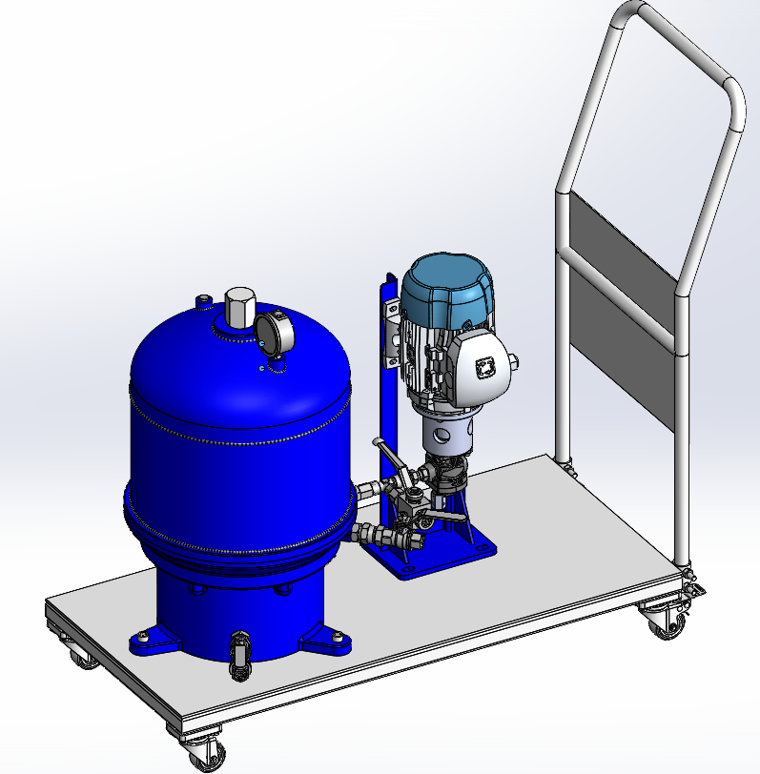
The CAD model helps understand the feasibility of industrial installation and system integration.

6.10 Industrial Working Principle of the Developed System
The Oil Conditioning System operates continuously in offline mode, separate from the main hydraulic machine.
Step-by-Step Working Procedure:
- Contaminated hydraulic oil is stored in the reservoir.
- The hydraulic gear pump circulates the oil continuously.
- Oil goes through the cellulose-based depth filtration unit.
- Contamination particles are trapped within the filter structure.
- Clean conditioned oil returns to the reservoir.
- Continuous recirculation gradually improves hydraulic oil cleanliness.
The system consistently removes contamination while keeping hydraulic operating conditions stable.
6.11 Advantages of the Developed Oil Conditioning System
The developed system offers several industrial benefits:
- Continuous contamination removal.
- Improved hydraulic reliability.
- Reduced component wear.
- Extended oil service life.
- Lower downtime.
- Enhanced hydraulic efficiency.
- Better ISO cleanliness compliance.
- Reduced maintenance frequency.
- Improved predictive maintenance support.
The design analysis confirms that the Oil Conditioning System is suitable for industrial hydraulic contamination control applications.
7. Results and Discussion
7.1 Initial Hydraulic Oil Condition
Initial analysis of the hydraulic oil was completed before the Oil Conditioning System was put in place. The oil sample from the industrial hydraulic system revealed high levels of particulate contamination, sludge particles, oxidation products, and moisture contamination.
Contaminated hydraulic oil led to unstable hydraulic performance and increased wear risk in pumps, servo valves, actuators, and bearings.
Initial Oil Condition Parameters
Parameter | Initial Condition
ISO Cleanliness Code | 22/20/17
Moisture Content | 380 ppm
Oil Appearance | Dark and Contaminated
Sludge Presence | High
Varnish Formation | Observed
Hydraulic Stability | Unstable
The analysis showed that the hydraulic oil needed continuous conditioning and control of contamination.
Contaminated Hydraulic Oil Sample

Figure 1. Contaminated hydraulic oil before the filtration process
7.2 Filtration Performance Analysis
The Oil Conditioning System was operated continuously under industrial hydraulic conditions. Hydraulic oil was circulated through the cellulose-based depth filtration system using an offline kidney-loop setup. The filtration unit consistently removed contamination particles from the hydraulic oil, gradually improving its cleanliness.
Hydraulic Oil Conditioning Performance
Parameter | Before Filtration | After Filtration
ISO Cleanliness Code | 22/20/17 | 17/15/12
Moisture Content | 380 ppm | 110 ppm
Sludge Contamination | High | Low
Oil Appearance | Dark | Clear
Varnish Deposits | Present | Reduced
Hydraulic Stability | Unstable | Stable
The results clearly show that the Oil Conditioning System greatly improved the quality of the hydraulic oil.
Before and After Filtration Comparison

Figure 2. Hydraulic oil condition before and after filtration
7.3 ISO Cleanliness Improvement
An analysis of hydraulic oil cleanliness was conducted based on ISO 4406 cleanliness standards. The filtration system significantly decreased the number of contamination particles.
Fewer contamination particles provided better protection for:
- Servo valves
- Hydraulic pumps
- Bearings
- Proportional valves
- Hydraulic actuators
ISO Cleanliness Improvement Analysis
Particle Size | Before Filtration | After Filtration
>4 µm | High | Reduced
>6 µm | High | Reduced
>14 µm | Moderate | Very Low
The depth filtration system effectively removed fine contamination particles that can cause hydraulic wear and instability.
ISO Cleanliness Improvement Graph
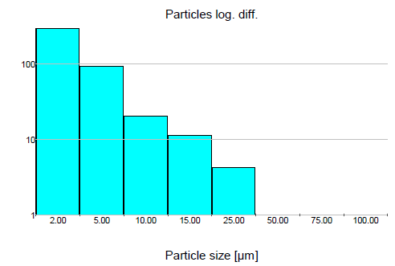
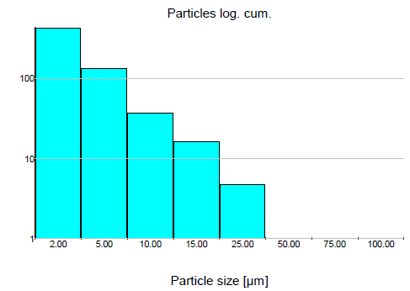

Figure 3. ISO cleanliness improvement after filtration
7.4 Moisture Reduction Analysis
Moisture contamination greatly impacts hydraulic oil properties and speeds up oxidation, corrosion, sludge formation, and lubricant breakdown.
The Oil Conditioning System showed a reduction in moisture contamination during continuous oil circulation.
Moisture Reduction Results
Condition, Moisture Content, Initial Oil Condition, 380 ppm After Filtration, 110 ppm
This reduction in moisture contamination improved:
- Oxidation resistance
- Lubrication performance
- Corrosion protection
- Hydraulic efficiency
- Oil service life
Reducing moisture contamination significantly increased hydraulic reliability.
7.5 Industrial Benefits
Initial analysis of hydraulic oil showed high contamination levels, including:
- Metallic wear particles
- Sludge contamination
- Moisture contamination
- Oxidation deposits
- Poor ISO cleanliness level
This contaminated oil caused unstable hydraulic performance and greater wear risk.
7.6 Filtration Performance Analysis
After implementing the Oil Conditioning System, a significant improvement in hydraulic oil condition was noted.
The system effectively:
- Reduced particulate contamination
- Improved ISO cleanliness level
- Reduced sludge and varnish contamination
- Enhanced oil clarity
- Stabilised hydraulic pressure Before and After Filtration
7.7 ISO Cleanliness Improvement
Hydraulic oil cleanliness was checked against ISO 4406 standards.
The system showed:
- Fewer particles
- Better cleanliness code
- Improved protection for servo valves and pumps
7.8 Moisture Reduction Analysis
The filtration system also lowered moisture contamination in hydraulic oil. This reduction improved:
- Oxidation resistance
- Lubrication properties
- Corrosion protection
- Hydraulic reliability
7.9 Industrial Benefits
The Oil Conditioning System offers several industrial benefits:
- Better machine reliability
- Fewer hydraulic failures
- Lower maintenance costs
- Longer oil life
- Improved machine efficiency
- Less downtime
- Better support for predictive maintenance inclusion

Conclusion
This research successfully developed an Oil Conditioning System for industrial hydraulic applications using offline kidney-loop depth filtration technology. The system effectively improved hydraulic oil cleanliness, reduced particulate contamination, lowered moisture content, and increased hydraulic system reliability.
Experimental analysis showed that the Oil Conditioning System significantly enhances hydraulic oil condition to meet industrial cleanliness requirements. The cellulose-based depth filtration system effectively removes fine contamination particles while ensuring stable hydraulic operation.
The Oil Conditioning System offers several advantages like better hydraulic reliability, longer oil service life, reduced maintenance costs, less downtime, and increased operational efficiency. This research confirms that integrated oil conditioning technologies are crucial for maintaining hydraulic oil health in modern industrial operations.
Future Scope
Future work could focus on:
- Integrating vacuum dehydration systems
- Online contamination monitoring sensors
- IoT-based predictive maintenance systems
- Automatic contamination warning systems
- AI-based oil condition analysis
- Real-time moisture monitoring
- Advanced synthetic filtration media
- Thermal stabilization and cooling systems
Combining Industry 4.0 technologies with hydraulic oil conditioning systems can further enhance predictive maintenance capabilities and industrial reliability.
References
[1] R. A. Venesky, Hydraulic Contamination Control Systems. New York, USA: McGraw Hill Publications, 2018.
[2] A. Lansdown, Lubrication and Hydraulic Fluid Technology. Oxford, U.K.: Elsevier Publications, 2019.
[3] National Fluid Power Association, “Hydraulic system failure analysis report,” NFPA Technical Journal, vol. 12, no. 4, pp. 21–29, 2020.
[4] International Organization for Standardization, ISO 4406: Hydraulic Fluid Power — Fluids — Method for Coding the Level of Contamination by Solid Particles. Geneva, Switzerland: ISO, 2017.
[5] K. Holmberg and A. Erdemir, “Influence of lubrication on hydraulic system efficiency,” Tribology International, vol. 145, pp. 106–115, 2020.
[6] M. Hill and J. Bott, “Effects of particulate contamination in hydraulic components,” Journal of Hydraulic Engineering, vol. 48, no. 3, pp. 212–221, 2019.
[7] C. F. Higgs, “Moisture contamination in hydraulic oil systems,” Industrial Lubrication Journal, vol. 32, no. 5, pp. 45–53, 2021.
[8] H. Teng and P. Shinde, “Vacuum degassing systems for hydraulic applications,” International Journal of Fluid Power, vol. 15, no. 2, pp. 88–96, 2022.
[9] Society of Tribologists and Lubrication Engineers, Practical Hydraulic Fluid Technology. Illinois, USA: STLE Publications, 2021.
[10] SKF Group, “Oil analysis and predictive maintenance technologies for hydraulic systems,” SKF Technical Report, 2020.
[11] B. Wright, “Research on hydraulic oil conditioning methods,” International Journal of Mechanical Engineering Research, vol. 11, no. 7, pp. 101–110, 2021.
[12] Donaldson Filtration Solutions, “Hydraulic filtration media performance study,” Technical Bulletin, 2022.
[13] E. Rabinowicz, Friction and Wear Mechanisms in Hydraulic Components. Berlin, Germany: Springer Publications, 2019.
[14] Hy-Pro Filtration, “Principles of hydraulic oil conditioning systems,” Technical White Paper, 2021.
[15] Society of Tribologists and Lubrication Engineers, “Predictive maintenance and smart monitoring in hydraulic systems,” STLE Industrial Maintenance Review, 2023.
[16] J. Smith and R. Clark, “Hydraulic oil cleanliness improvement using kidney loop filtration,” International Journal of Advanced Manufacturing Technology, vol. 55, no. 4, pp. 455–463, 2021.
[17] P. Kumar and S. Patel, “Analysis of industrial hydraulic oil degradation,” Journal of Mechanical Systems, vol. 29, no. 2, pp. 88–97, 2020.
[18] M. Johnson, “Industrial applications of oil conditioning systems,” Lubrication Engineering Journal, vol. 41, no. 6, pp. 75–82, 2022.
[19] R. Mehta and K. Shah, “Hydraulic reliability enhancement using offline filtration systems,” International Journal of Industrial Engineering, vol. 18, no. 1, pp. 45–54, 2021.
[20] S. Gupta, “Condition-based maintenance in hydraulic systems,” International Journal of Maintenance Engineering, vol. 14, no. 5, pp. 144–152, 2023.

