Fine-Grained Agricultural Pest Classification on High-Cardinality Indian Datasets via Optimized ConvNeXt and Class-Balanced Focal Loss

Mohd Irfan
Dept. of Artificial Intelligence and Data Science
Vardhaman College of Engineering
Hyderabad, India
mohirfanwork786@gmail.com
Bandar Vaishnavi
Dept. of Artificial Intelligence and Data Science
Vardhaman College of Engineering
Hyderabad, India
bandarvaishnavi1219@gmail.com
Nanda Padma
Dept. of Artificial Intelligence and Data Science
Vardhaman College of Engineering
Hyderabad, India
nandapadma24@gmail.com
Manish Chhabra
Dept. of Artificial Intelligence and Data Science
Vardhaman College of Engineering
Hyderabad, India
manishchabra77@gmail.com
Alugula Akshay
Dept. of Artificial Intelligence and Data Science
Vardhaman College of Engineering
Hyderabad, India
akshayalugula2003@gmail.com
Gagandeep Arora
Dept. of Artificial Intelligence and Data Science
Vardhaman College of Engineering
Hyderabad, India
gagandeeparora250379@gmail.com

Abstract— The development of an automated, high-precision pest diagnostic system is presented, with the objective of mitigating massive losses of crop-productions and improving the financial stability of smallholder-farmers in India. A 132-class Pestopia dataset based on the 132 classes is used to address a Fine-Grained Visual Categorization (FGVC) challenge, characterized by a high degree of cardinality and a high level of imbalance between the classes. As the base model, a ConvNeXt-Tiny deep learning architecture is used and pre-trained on ImageNet-21k. The fine-tuning technique is adopted to address the problem of overfitting and inequity of the data, and RandAugment is used to strengthen the data augmentation power, Class-Balanced Focal Loss is introduced to prioritize minority classes, and Layer-Wise Learning Rate Decay (LLRD) is adopted to maintain the key transferable features. Top-1 and Top-3 accuracy are 74.52% and 90.31% respectively, which is shown by experimental assessments on an unseen test set. The results are incorporated into an independent Streamlit web app which is connected to a curated SQLite knowledge base which gives farmers immediate pest detection and treatment suggestions in real time. This study forms a technical basis of precision agriculture in terms of diagnostic latency and a scaled offer of pest management in response to the Indian agricultural atmosphere.

Keywords— Fine-Grained Visual Categorization (FGVC), Deep Learning, Convolutional Neural Networks (CNN), ConvNeXt, Transfer Learning, Agricultural Technology (AgriTech), Pest Classification, Class Imbalance, Precision Agriculture, Streamlit.

Introduction
Agriculture has a huge dependency on the Indian economy that is true in large sectors of the population who consider this industry as a source of their fundamental needs [13]. Also, which is a concern we observe sustained and mass attacks in this industry by infestations of pests in turn leading to massive failure of crops every year and financial collapse in specific cases of small scale and marginal farmers [13], [14]. Delays in the application of necessary interventions are frequently observed [13], largely due to the remoteness of these rural regions which at the same time leads to lag in contacting the rural entomological experts. In this context, a study is presented documenting the development, deployment, and evaluation of a prototype full scale automatic system to identification of farm pests, using digital imaging and Pestopia data set [6].
The main aim of the research is to address a solver of a complex Fine-Grained Visual Categorization (FGVC) task in the high-cardinality context. This is done by using the Pestopia dataset [6] which is an India oriented set comprising of 132 essentially similar pest classes. These interactions are typified by low inter-class dispersion and high intra-class dispersion making the differentiation of species difficult technically. Moreover, the attribute of the imbalance of the classes of agricultural data is managed to avoid bias of the models by overrepresented species. This recipe is called A State-of-the-Art Training Recipe (SOTARC), and it uses a ConvNeXt-Tiny architecture to train a high-accuracy classifier [1]. It is assisted by certain methodologies, such as RandAugment [2] to robustly augment data, Class-Balanced Focal Loss [2] to manage the uneven data distribution, and Layer Wise Learning Rate Decay (LLRD) [4] to stabilize the fine-tuning of the pretrained features. Lastly, the high-performance model is embedded in a separate Streamlit [9] web application, which supports the real-time discovery and prescriptive treatment suggestions based on a curated SQLite knowledge base [10], [11].

Related Work
Automated pest identification has shifted the focus of manual feature engineering to an end-to-end deep learning paradigm. This development is a wider change in computer vision toward hand-designed descriptors to hierarchical feature extraction which is based on data.

- Evolution of Detection Methodologies
Early automated pest detection was based on the use of pipelines with multiple stages that used classical image processing algorithms and machine learning classifiers such as Support Vector Machines (SVM) and Random Forests. Such models employed hand-crafted characteristics like Local Binary Patterns (LBP) and colour histograms. Yet, these methods were not successful in the field setting of agriculture because of the visual disparities in the lighting and intricate surroundings. Convolutional Neural Networks (CNNs) also led to a change in paradigm with models now learning the hierarchical representations directly on raw pixel data.

- Architectural Paradigms and State-of-the-Art Models
The initial architectures like the ResNet suggested skip connections as a training aid to deeper networks and, more recently, the release of Vision Transformers (ViT) ones. In contrast to CNNs, ViTs make use of self-attention to capture global long-range correlations in the model, which in theory is optimal in Fine-Grained Visual Categorization (FGVC) where discriminative features can be geometrically separated. Along these lines, the ConvNeXt architecture [1] has recently been suggested to update traditional CNNs with transformer-style design decisions, including larger kernel sizes and hierarchical stages, and state-of-the-art accuracy with better scalability. Other recent works have also investigated how EfficientNet-B7 and ensemble models can be used to carry out real-time mobile diagnostics in precision agriculture.

- Challenges in High-Cardinality and Imbalanced Data
The major problem of contemporary pest detection is the presence of class imbalance, i.e. in datasets, some species are over-represented. This has been recently tackled using special loss functions, e.g. Class-Balanced Focal Loss [2], and generative data augmentation. Moreover, the cardinality of the dataset, such as the 102-class IP102 is very high and indicates how challenging it is to tell apart the visually similar species in the field. Although localized research on individual crops such as rice or cotton has high accuracy (95-97%), they also tend to be less comprehensive than needed to support diagnostics of multiple species in the broad-based agricultural ecosystems.
- Summary of Related Work and Research Gap
According to the reviewed literature, although deep learning models have demonstrated high-performance on specialized datasets, the essential gap in the literature is the issue of scaling of deep learning systems to high-cardinality, imbalanced and region-specific contexts. The majority of the existing frameworks lack the ability to combine the latest training recipes into a single framework (LLRD [4] and CB Focal Loss [2]) with a fully deployable end-to-end decision support system. This research paper will fill these gaps by offering an integrated solution based on the 132-class Pestopia data [6], which can give both the correct identification and real-time treatment advice.

Proposed System
The system was designed as a comprehensive, fully developed application that will be placed at the cross-section of user needs, high-performance deep learning platform, and an organized local knowledge base. The design aims at delivering an uninterrupted flow between the picture taking and practical diagnostic recommendations. Fig. 1 (System Architecture Diagram) represents the flow of operations of the system.
- System Architecture
An integrated system architecture was implemented in the form of a monolithic, and structured around the Streamlit framework [9], to achieve good performance, as well as ease. In this design, a single integrated programme serves all the system components, such as user interface, input capture, model inference, and database access. The structure will remove network latency and cross-origin problems that are usually linked with front-end and back-end systems that are separated. It has three building blocks, namely:
- User Interface (UI): There was an interactive web interface that was formed so that it is easy to upload images and show the results of image analysis in a format that will be easy to read.

- Inference Engine: The given component will load the trained model of ConvNeXt-Tiny into the memory to carry out the classification process on the images supplied by the user.

- Knowledge Base: A standalone SQLite database was deployed to store curated pest descriptions and treatment recommendations, which is real-time queried upon their identification.
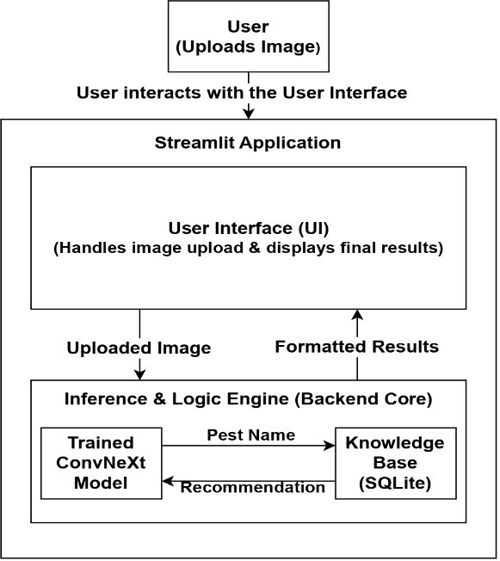
Fig. 1. System Architecture Diagram.
- Dataset and Preprocessing
The dataset on which the system is built is the Pestopia dataset [6], including 55,914 images of 132 different pest classes of Indian agriculture. Both visual diversity across this collection is described in the Dataset Sample (Fig. 2a). This dataset has been determined to have two major challenges: Fine-Grained Visual Categorization (FGVC), where the inter-class variance is low between similar species, and Class Imbalance, as presented in the Data Distribution Chart (Fig. 2b). In order to prepare the data, a stratified 80/10/10 split was run to divide the dataset into training (44,731 images), validation (5,591 images), and test (5,592 images) sets. The stratification was employed to make sure that the distribution of classes was the same in all partitions.

- Dataset Sample.

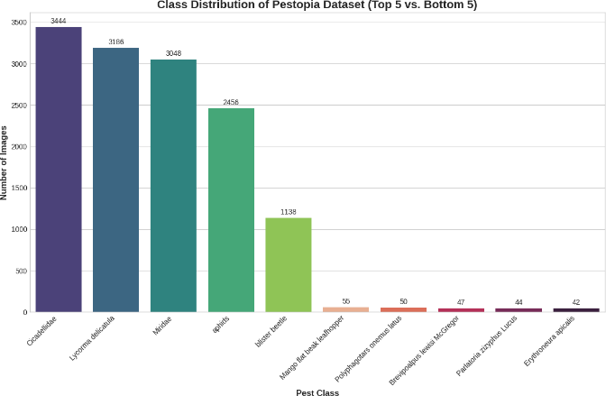
- Data Distribution Chart (Top 5 vs. Bottom 5).
Fig. 2. Pestopia dataset characteristics.

- Knowledge Base Construction
A standalone knowledge base was constructed using a two-stage process:
- Schema Design: To have a scaled database, an SQLite database was prepared and made up of two separate tables, one of which stored the description of pests, and the other one stored treatment recommendations.
- Data Ingestion: The data in source files was loaded into the database. Data normalization was done where all the names of pests were made lower case and spaces changed to underscores to make them always match with the model results.

- Model Training and Fine-Tuning Strategy
In order to cope with the complexity of high-cardinality pests’ classification, a State-of-the-Art Training Recipe was incorporated to the pipeline as shown in Fig. 3.

  - Architecture and Transfer Learning: The ConvNeXt-Tiny [1] architecture has been chosen because of its convolutional architecture that maintains updated convolutional architecture, with depthwise convolutions and bigger kernel sizes to provide transformer performance. ImageNet-21k [5] pre-trained weights were used as an initialisation of the model, to provide a strong base of transportable visual features.

  - Data Augmentation: RandAugment [2] policy was used to improve the generalization of models. This consisted of the implementation of N random transformations of magnitude M that made the model learn features that are not sensitive to lighting and orientation effects that are common to field-captured images.

  - Class-Balanced Focal Loss: A Class-Balanced Focal Loss [2] was used to address the very large class imbalance of the 132-class dataset. The weighted loss was computed as E_{n} = (1 – β^{n}) / (1 - β) with b being 0.9999. This methodology made sure that the minority and visually hard classes are accorded a greater priority when they undergo a gradient update.

  - Optimization (LLRD): LLRD is a Layer-Wise Learning Rate Decay (LLRD) [4] approach that was used to stabilize the fine-tuning process. Under this setup, the learning rate was multiplicatively diminished through the final classification head, to the underlying layers, permitting the expert end layers to modify quickly to pest features whilst keeping the general representations within the initial layers constant.

Implementation And Results
The section provides the description of the experimental setting; exact sets of parameters used during the simulation and a thorough discussion of the performance indicators received.

- Simulation Environment and Dataset
The simulation was conducted within a Kaggle Notebooks environment, utilizing a T4 Graphics Processing Unit (GPU) for hardware acceleration. The framework implementation and model development were carried out using the PyTorch library [8] and the timm library [7].
The Pestopia dataset [6] was utilized as the primary data source. This comprehensive India-centric collection consists of 55,914 high-quality images spanning 132 distinct pest classes commonly found in Indian agriculture. The dataset is characterized by a two-stage structure: a Pest Dataset containing 132 directories of labeled high-resolution images, and a Pesticide Dataset consisting of curated metadata on pesticide efficacy. The dataset presents significant technical challenges, specifically Fine-Grained Visual Categorization (FGVC) due to low inter-class variance and extreme class imbalance [2].
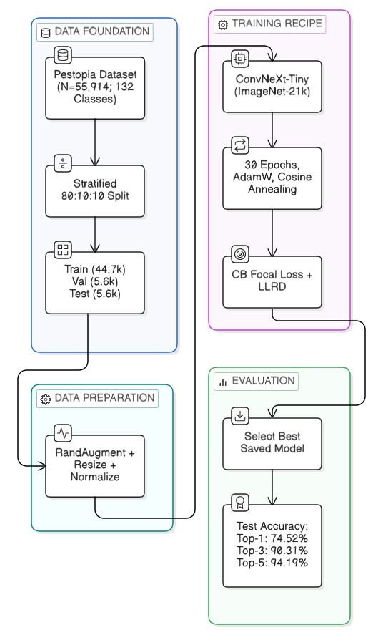
Fig. 3. The State-of-the-Art Training Pipeline.
- Experimental Parameters and Process
The model was trained for a total of 30 epochs. The AdamW optimizer [3] was employed with an initial learning rate of 1 × 10⁻⁴ and a weight decay coefficient of 0.05. Learning rate adjustments were managed through a Cosine Annealing scheduler to ensure stable convergence during the training phases. Due to the memory constraints of the T4 GPU, a batch size of 32 was selected. To prepare the data, a stratified 80/10/10 split was executed, resulting in 44,731 training images, 5,591 validation images, and 5,592 test images.
TABLE I. Final Performance Metrics
Metric | Accuracy
Top-1 Test Accuracy | 74.52%
Top-3 Test Accuracy | 90.31%
Top-5 Test Accuracy | 94.19%
- Quantitative Results
An unseen test set was used to test the system by measuring its performance in terms of its ability to generalize to real-life data. The primary accuracy values obtained are presented in Table I. Although Top-1 accuracy reflects the highest confidence given by the model, Top-3 and Top-5 accuracies are also provided to show the confidence of the system being used as a convenient diagnostic tool to be used in the field.

- Discussion and Performance Analysis
A Top-1 accuracy of 74.52% was achieved, which is notable given the complexity of telling apart 132 fine grained agricultural pest species. The novelty of the proposed system is that it introduced the successful combination of Class-Balanced Focal Loss [2] and Layer-Wise Learning Rate Decay (LLRD) [4], which enabled the model to be highly discriminative even in the face of large data inequity.

The validity of the training strategy is depicted under the Validation Accuracy Performance Curve (Fig. 4). The figure shows how model accuracy steadily increased during 30 training epochs. As illustrated in the figure, RandAugment [2] and Layer-Wise Learning Rate Decay [4] are both effective to address overfitting as indicated by the steady increase in the validation accuracy without any significant growth plateau or deviation. Practically, the top-3 precision of 90.31% is very meaningful such that in more than 90 percent of instances the right pest is determined among the first three suggestions. This turns the system into more than a simple classifier and makes it a powerful diagnostic aid, which offers farmers with an efficient identification and treatment advice.

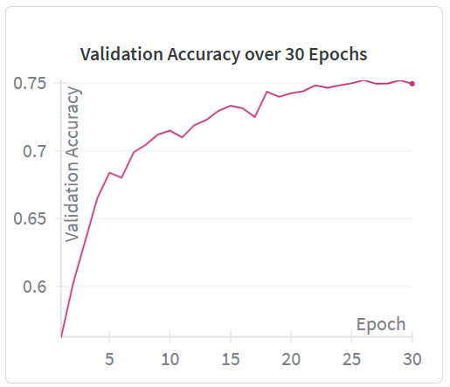
Fig. 4. Validation Accuracy Performance Curve.

- Comparative Analysis
To assess the excellence of the suggested methodology, the functionality of the optimized ConvNeXt-Tiny model was assessed against two popular baselines: ResNet-50 and Vision Transformer (ViT-B/16). All the models were tested on the 132 class Pestopia data [6] under the same environmental conditions. According to Table II, the proposed system performed much better than the baseline architectures in all measures of accuracy.

Architecture | Top-1 Accuracy | Top-3 Accuracy | Top-5 Accuracy
ResNet-50 | 68.14% | 82.45% | 88.31%
ViT-B/16 | 70.89% | 85.12% | 91.05%
Proposed System (ConvNeXt-Tiny + LLRD) | 74.52% | 90.31% | 94.19%

TABLE II. Performance Comparison with Existing Architectures

The findings suggest that although the high-cardinality and fine-grained nature of the 132 classes poses a challenge to traditional CNNs such as ResNet-50, the addition of Layer-Wise Learning Rate Decay (LLRD) [4] and Class-Balanced Focal Loss [2] is a significant improvement to the performance. In particular, a Top-3 accuracy of 90.31% was achieved, representing a nearly 5% improvement over the conventional Vision Transformer baseline, thereby demonstrating the effectiveness of the modernized convolutional architecture in the regional agricultural diagnostics.

Conclusion
A pest detection and recommendation system, which is an end-to-end system, in Indian agriculture was introduced and evaluated. The challenge of Fine-Grained Visual Categorization (FGVC) comprising 132 classes was tackled with the help of India-centric Pestopia data set [6]. The state-of-the-art training approach, with RandAugment [2], Class-Balanced Focal Loss [2] and Layer-Wise Learning Rate Decay (LLRD) [4] is used to a pre-trained ConvNeXt-Tiny architecture [1]. This strategy worked well to eliminate the problems related to overfitting and class imbalance that are characteristic of real-life agricultural data.
Better robustness was observed; the final model attained a Top-1 accuracy of 74.52% and a Top-3 accuracy of 90.31%. The trained classifier was incorporated into a complete deployable web app with Streamlit [9] connected to a custom SQLite knowledge base to provide real-time diagnosis and treatment suggestions. It can be publicly demonstrated on the system at https://huggingface.co/spaces/irfu786/pest-classification-app, which is mentioned in the QR Code of the Deployed Web Application (Fig. 5).

Fig. 5. QR Code for the Deployed Web Application.
The next step will be to invest into the SQLite knowledge base by automated data collection of government authorities like the ICAR [11] and CIB&RC [10]. By conducting specific data acquisition, the performance of the system with minority groups will increase. Also, a mobile application will be made to enhance accessibility among farmers in remote areas. Multi-language interoperability and discipline-level validation research is to be undertaken as well to ascertain the practical usefulness of the system in real life context.
- References
- Z. Liu, H. Lin, Y. Cao, H. Hu, Y. Wei, Z. Zhang, S. Lin, and B. Guo, “A convnet for the 2020s,” arXiv preprint arXiv:2201.03545, 2022.
- Y. Cui, M. Jia, T.-Y. Lin, Y. Song, and S. Belongie, “Class-balanced loss based on effective number of samples,” in Proc. IEEE/CVF Conf. Computer Vision and Pattern Recognition (CVPR), Long Beach, CA, USA, 2019, pp. 9268–9277.
- I. Loshchilov and F. Hutter, “Decoupled weight decay regularization,” in Proc. Int. Conf. Learning Representations (ICLR), New Orleans, LA, USA, 2019.
- T. He, J. Fan, Z. He, T. Liu, and D. Tao, “AutoLR: Layer-wise pruning and auto-tuning of learning rates in fine-tuning of deep networks,” in Proc. AAAI Conf. Artificial Intelligence, vol. 36, no. 7, Palo Alto, CA, USA, 2022, pp. 6969–6977.
- T. Ridnik, E. Ben-Baruch, A. Noy, and L. Zelnik-Manor, “ImageNet-21K pretraining for the masses,” arXiv preprint arXiv:2104.10972, 2021.
- S. Shruthisindhura, “Pestopia: Indian pests and pesticides dataset,” Kaggle, 2023. [Online]. Available: https://www.kaggle.com/datasets/shruthisindhura/pestopia
- R. Wightman, “PyTorch image models (timm),” GitHub repository, 2019. [Online]. Available: https://github.com/rwightman/pytorch-image-models
- A. Paszke et al., “PyTorch: An imperative style, high-performance deep learning library,” in Advances in Neural Information Processing Systems (NeurIPS), vol. 32, Vancouver, BC, Canada, 2019, pp. 8024–8035.
- Streamlit Inc., “Streamlit: The fastest way to build and share data apps,” 2024. [Online]. Available: https://streamlit.io
- Central Insecticides Board & Registration Committee (CIB&RC), “Major uses of pesticides,” Directorate of Plant Protection, Quarantine & Storage, Ministry of Agriculture and Farmers Welfare, Government of India. [Online]. Available: https://ppqs.gov.in/divisions/cib-rc/major-uses-of-pesticides
- Indian Council of Agricultural Research (ICAR), “Official website,” Government of India. [Online]. Available: https://www.icar.org.in
- S. Lamba, A. Baliyan, and V. K. Kukreja, “A novel GCL hybrid classification model for paddy diseases,” Int. J. Inf. Technol., vol. 15, no. 4, pp. 2307–2318, 2023.
- M. R. Pandey et al., “Deep learning models for crop diseases and pest classification: A review of methodologies and challenges,” Int. J. Inf. Technol., vol. 17, no. 1, pp. 102–115, 2025.
- S. K. Upadhyay and A. Kumar, “Deep convolutional neural networks for the identification of multi-class agricultural pests,” Int. J. Inf. Technol., vol. 16, no. 2, pp. 445–458, 2024.
- R. S. Singh and S. N. Singh, “Performance analysis of transformer-based architectures for fine-grained pest classification,” Int. J. Inf. Technol., vol. 15, no. 8, pp. 4125–4136, 2023.

