Impact of AI Dependency on Faculty Research Creativity and Critical Thinking in Higher Education Institutions

Abstract
Artificial Intelligence has rapidly become an integral component of academic research and higher education practices. Faculty members increasingly rely on AI-assisted technologies for scholarly writing, literature exploration, data analysis, and idea development. Although these digital tools improve efficiency and accessibility in research activities, excessive dependence on AI-generated assistance may influence originality, reflective thinking, and independent academic judgment. The present study explores the relationship between AI dependency, research creativity, and critical thinking among faculty members in higher education institutions. A descriptive quantitative approach was adopted, and primary data were collected from 50 respondents through a bilingual Likert-scale questionnaire. Statistical techniques including correlation, regression, mean score analysis, and ANOVA were used to interpret the findings. The results indicate that AI technologies positively support research productivity and creative idea generation; however, overreliance on automated outputs may reduce deep analytical engagement and originality. The study highlights the need for ethical, balanced, and responsible integration of AI technologies in academic research environments.
Keywords: Artificial Intelligence, Faculty Research, Creativity, Critical Thinking, Higher Education, AI Dependency, Academic Research, Innovation

Introduction
Artificial Intelligence is increasingly reshaping the structure and functioning of higher education and academic research systems. In recent years, AI-enabled platforms and automated digital tools have become widely integrated into scholarly activities such as manuscript preparation, literature review, citation management, data interpretation, and academic communication. Researchers and faculty members now depend on AI-supported systems to simplify complex academic tasks and improve research efficiency. While these technologies provide substantial benefits in terms of productivity and accessibility, concerns are emerging regarding their influence on originality, independent reasoning, and intellectual engagement within research practices.
The modern academic ecosystem is witnessing substantial adoption of AI-assisted tools such as ChatGPT, Grammarly, QuillBot, Elicit, Scite, Research Rabbit, Turnitin AI, and numerous data analysis platforms. Faculty members use these technologies for literature reviews, manuscript drafting, citation management, proposal writing, statistical analysis, language correction, idea generation, and research collaboration. AI systems have simplified complex research activities and reduced the time required for data processing and academic writing.
Although AI technologies offer numerous advantages in research productivity and efficiency, concerns are emerging regarding excessive dependency on AI systems. Researchers and academicians have started questioning whether continuous reliance on AI-generated outputs may weaken faculty members’ independent thinking abilities, analytical reasoning, creativity, and originality. Critical thinking, which is considered the foundation of scientific inquiry and innovation, may gradually decline when researchers excessively depend on AI-generated summaries, suggestions, and interpretations.
Creativity in academic research involves generating novel ideas, identifying research gaps, developing innovative methodologies, and producing original scholarly contributions. Excessive dependence on AI systems may encourage standardized and repetitive outputs rather than authentic intellectual exploration. Faculty members may increasingly accept AI-generated information without deep critical evaluation, thereby reducing cognitive engagement in the research process.
In the Indian higher education context, especially in developing and rural universities, the adoption of AI in research practices is rapidly increasing. However, limited empirical studies have examined the relationship between AI dependency and faculty research creativity and critical thinking. Most existing studies focus on students, digital learning, or general AI adoption, while faculty-centered investigations remain comparatively underexplored.
The present study seeks to address this research gap by exploring the influence of AI dependency on the creative and critical thinking abilities of faculty members engaged in academic research. The study also aims to contribute to ongoing discussions regarding the responsible, ethical, and balanced integration of Artificial Intelligence within higher education research practices.

Review of Literature
Recent studies indicate that Artificial Intelligence has significantly influenced academic research and higher education systems. Researchers have highlighted both positive and negative dimensions of AI integration in faculty research activities.
Dwivedi et al. (2023) Recent scholarly discussions suggest that AI technologies significantly improve the speed and accessibility of academic research processes. Several researchers have observed that AI-assisted systems reduce repetitive academic workload and support data organization. At the same time, scholars have expressed concern that excessive dependence on AI-generated outputs may weaken originality, ethical judgment, and deep cognitive engagement among researchers. Existing literature largely concentrates on students and digital learning systems, whereas comparatively fewer empirical studies examine faculty creativity and critical thinking in relation to AI dependency, particularly within Indian higher education institutions.
Kasneci et al. (2023) examined the role of generative AI systems in education and argued that AI technologies support idea generation and academic writing but also pose risks related to academic integrity and cognitive dependency.
Zawacki-Richter et al. (2019) identified that AI applications in higher education are predominantly associated with teaching, administration, and adaptive learning systems. However, the authors observed limited empirical research on faculty creativity and independent intellectual engagement.
Holmes, Bialik, and Fadel (2019) discussed the transformative role of AI in educational innovation and highlighted concerns regarding ethical governance, originality, and overdependence on automated systems.
Cotton et al. (2024) explored faculty perceptions toward AI-assisted research and found that excessive dependence on AI-generated content may reduce originality and critical analysis in academic writing. The study emphasized the importance of human-centered AI usage.
Baidoo-Anu and Owusu Ansah (2023) investigated the influence of ChatGPT in academic research and reported that while AI improves accessibility and idea generation, unchecked dependency may negatively affect problem-solving skills and critical reasoning.
The review of literature indicates that AI technologies positively influence research productivity and efficiency; however, the relationship between AI dependency and faculty research creativity remains insufficiently explored. Existing studies largely focus on student learning, AI adoption, and educational technologies, while faculty-centered empirical investigations remain limited, particularly in the Indian higher education context.

Research Objectives
- To examine the extent of AI usage among faculty members in higher education institutions.
- To analyze the impact of AI dependency on faculty research creativity.
- To study the influence of AI dependency on faculty critical thinking abilities.
- To identify faculty perceptions regarding the advantages and limitations of AI-assisted research.
- To suggest strategies for balanced and ethical use of AI in academic research.

Research Framework
Research methodology is an important component of any research study as it provides a systematic framework for data collection, analysis, interpretation, and presentation of findings. The present study aimed to investigate the impact of Artificial Intelligence (AI) dependency on faculty research creativity and critical thinking abilities in higher education institutions. The methodology was designed to examine faculty perceptions, AI usage patterns, and the relationship between AI dependency and intellectual abilities related to academic research.

Research Design
The quantitative approach enabled the researcher to statistically analyze faculty responses related to:
- AI usage patterns
- Research creativity
- Critical thinking abilities
- Faculty perception regarding AI-assisted research

Research Approach and Nature
The investigation was carried out using a descriptive quantitative framework to explore the relationship between AI dependency, research creativity, and critical thinking abilities among faculty members in higher education institutions. The study adopted a cross-sectional survey method in which responses were collected from participants during a specific period. Data collection was conducted through a structured online questionnaire prepared using Google Forms. The research primarily focused on examining faculty perceptions regarding AI-assisted research practices, patterns of AI usage, and their influence on creativity and analytical thinking. The collected responses were interpreted using appropriate statistical techniques to understand the association between AI dependency and intellectual research capabilities.

Population of the Study
The population of the present study consisted of faculty members working in higher education institutions. The respondents included academicians from various academic disciplines and departments to ensure diverse perspectives regarding AI dependency in research activities. Faculty members from departments such as Education, Agriculture, Pharmacy, Management, Science, Arts and Humanities, Computer Science, Commerce, and other interdisciplinary fields participated in the study. The inclusion of respondents from different academic backgrounds helped in obtaining comprehensive insights into the usage of Artificial Intelligence tools, research creativity, and critical thinking practices among higher education faculty members.

Sample of the Study
For the purpose of the study, faculty members from the university were selected using the convenience sampling method. The sampling technique was adopted due to the accessibility and availability of respondents for online participation. A total of 50 faculty members participated in the study through responses collected using an online Google Form questionnaire. The sample represented faculty members from diverse backgrounds, including different age groups, teaching experiences, academic designations, and departments. The inclusion of participants with varied academic and professional profiles helped in obtaining comprehensive and balanced responses regarding AI dependency, research creativity, and critical thinking in higher education research practices.

Data Collection Tool
Primary data were collected through a structured questionnaire developed by the researcher. The questionnaire was based on a five-point Likert scale ranging from Strongly Agree to Strongly Disagree.
The questionnaire included the following dimensions:
- AI usage frequency
- AI dependency level
- Research creativity
- Critical thinking ability
- Faculty perception regarding AI-assisted research

Sources of Data
- Primary Data – Structured questionnaire responses from faculty members.
- Secondary Data – Research papers, journals, books, reports, conference proceedings, and online academic databases.

Statistical Techniques Used

Descriptive Statistics
Variable | Mean Score
AI Usage | 4.01
Research Creativity | 3.55
Critical Thinking | 3.36

Correlation Analysis

Findings from the correlation analysis suggest that increased use of AI tools moderately supports research creativity among faculty members (r = 0.29). However, the association between AI usage and critical thinking was found to be relatively low (r = 0.15).

Regression Analysis
Regression coefficient for AI Usage predicting Research Creativity: 0.26
Regression coefficient for AI Usage predicting Critical Thinking: 0.18

ANOVA Analysis
ANOVA test across age groups resulted in F = 0.56, p = 0.6410.

Interpretation of Results
The analysis indicates that faculty members moderately depend on AI tools for research-related activities. Positive correlations suggest that AI usage supports research productivity and creativity. However, the findings also indicate concerns regarding reduction in deep analytical reasoning and independent thinking due to excessive dependency on AI-generated outputs.

Graphical Representation
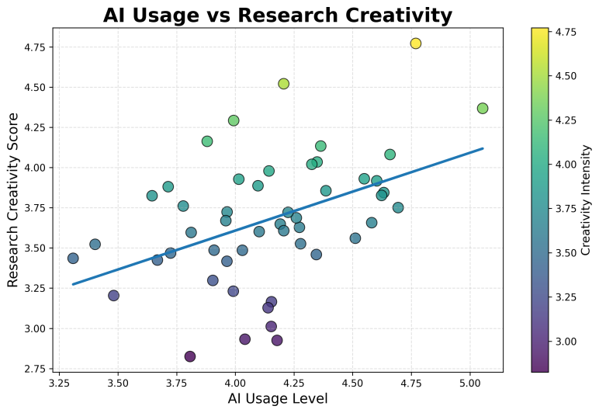
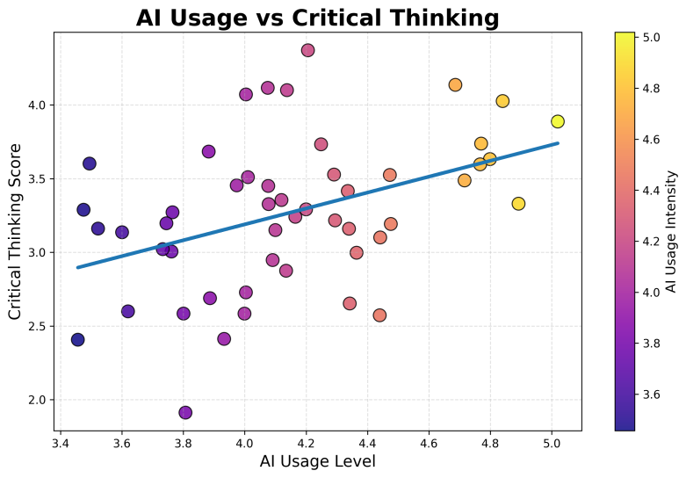

Results and Discussion
The graphical representation titled “Mean Scores of Major Variables” presents the comparative mean scores of AI Usage, Research Creativity, and Critical Thinking among faculty members in higher education institutions. The analysis indicates that faculty members demonstrate a high level of engagement with Artificial Intelligence tools in academic and research-related activities.
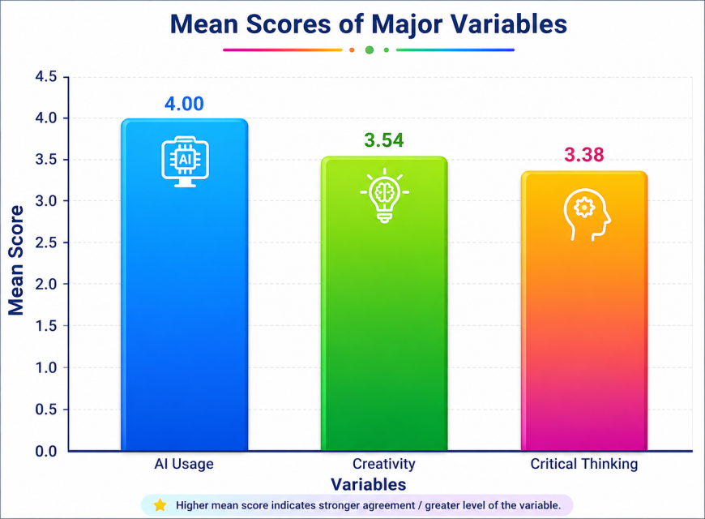
The mean score for AI Usage was found to be 4.00, which is the highest among all variables. This result indicates that faculty members frequently utilize AI-based tools for literature review, academic writing, idea generation, data interpretation, and research support activities. The high mean score reflects the growing acceptance and integration of AI technologies in higher education research practices. Faculty members perceive AI as an effective tool for improving research efficiency, reducing workload, and enhancing productivity.
The mean score for Research Creativity was recorded as 3.54, indicating a moderately positive impact of AI on creativity in research activities. The findings suggest that AI tools support brainstorming, idea generation, and innovative thinking to a certain extent. Faculty members reported that AI-assisted technologies help them explore new concepts and improve the organization of research content. However, the comparatively lower score than AI usage also reflects concerns that excessive dependence on AI-generated suggestions may reduce originality, independent idea generation, and authentic intellectual exploration in research work.
Similarly, the mean score for Critical Thinking was found to be 3.38, which is the lowest among the three variables. This finding indicates that while AI technologies simplify research processes and information access, they may also reduce deep analytical reasoning and independent critical evaluation among faculty members. Some respondents acknowledged that they occasionally rely on AI-generated outputs without thorough verification or reflection. The result highlights the possibility that excessive dependency on AI tools may weaken critical thinking abilities if users become overly dependent on automated responses and generated content.
Overall, the findings reveal that AI technologies positively contribute to faculty research productivity and creativity; however, balanced and ethical usage is necessary to preserve originality, independent thinking, and critical analytical abilities. The study emphasizes that AI should function as a supportive academic tool rather than a substitute for human intellectual engagement. Higher education institutions should therefore promote AI literacy, ethical research practices, and critical-thinking-oriented training programs to ensure responsible integration of AI in academic research ecosystems.

Impact on Research Creativity
The analysis suggests that Artificial Intelligence positively influences creative research practices among academicians to a moderate extent. The obtained mean score for research creativity (3.55) indicates that faculty respondents perceive AI-assisted technologies as supportive tools for brainstorming, innovative thinking, and idea development during research activities. Statistical findings further demonstrated a moderate positive association between AI usage and creativity (r = 0.29), implying that increased engagement with AI systems may contribute to enhanced innovative research practices. In addition, regression results (β = 0.26) indicate that AI usage acts as a positive predictor of creative academic performance.
Despite these advantages, the study also highlights certain concerns related to excessive dependence on AI-generated outputs. Overreliance on automated suggestions may gradually reduce originality, independent intellectual effort, and authentic scholarly exploration among researchers. Therefore, the study emphasizes the importance of responsible and balanced utilization of AI technologies to preserve innovation, originality, and human creativity within higher education research environments.

Impact on Critical Thinking
The analysis indicates that Artificial Intelligence exerts a moderate influence on the critical thinking abilities of faculty members engaged in academic research. The mean score obtained for critical thinking (3.36) reflects a moderate level of analytical reasoning and independent evaluation while using AI-assisted technologies. Correlation results revealed a low yet positive relationship between AI usage and critical thinking (r = 0.15), suggesting that AI tools may contribute to certain aspects of intellectual engagement. Furthermore, regression analysis demonstrated that AI usage positively predicts critical thinking ability with a coefficient value of 0.18. Although AI technologies improve information accessibility and research efficiency, excessive dependence on AI-generated content may weaken reflective analysis, independent judgment, and deep critical evaluation among researchers. Therefore, AI systems should be utilized as supportive academic resources while preserving human intellectual involvement, analytical reasoning, and critical inquiry within research practices.

Faculty Perception toward AI-assisted Research
The findings of the study reveal that faculty members generally hold a positive perception toward AI-assisted research in higher education institutions. The high mean score of AI Usage (4.01) indicates that faculty members widely utilize AI tools for academic writing, literature review, data analysis, idea generation, and research support activities. Most respondents perceived AI technologies as useful tools that enhance research productivity, save time, and improve access to academic information. The positive correlation between AI usage and research creativity further suggests that faculty members believe AI contributes to innovation and efficient research practices. However, respondents also expressed concerns regarding excessive dependency on AI-generated content, particularly related to originality, independent thinking, and critical analysis. Overall, faculty members viewed AI as a supportive and beneficial academic tool, but emphasized the need for balanced, ethical, and responsible use of AI in research activities.

Discussion
The findings of the present study indicate that Artificial Intelligence has become an important component of academic research practices in higher education institutions. Faculty members extensively use AI-assisted technologies for literature review, academic writing, data analysis, research summarization, and idea generation. The high mean score of AI usage (4.01) reflects the growing acceptance and integration of AI tools in faculty research activities.
The findings of the study demonstrate that AI usage has a moderately positive effect on the creative research abilities of faculty members. The observed correlation between AI usage and research creativity (r = 0.29) suggests that AI-assisted technologies contribute to idea development, innovative thinking, and improved research performance. Respondents indicated that AI tools support them in generating new research concepts and enhancing the efficiency of academic tasks. These results align with contemporary studies that recognize the contribution of Artificial Intelligence in improving academic productivity and streamlining various research-related activities.
However, the study also identified concerns regarding excessive dependency on AI-generated outputs. The comparatively moderate mean score of research creativity (3.55) suggests that while AI supports innovation, overdependence may reduce originality and independent intellectual engagement. Faculty members expressed concern that continuous use of AI-generated content may result in repetitive writing patterns and reduced authentic scholarly exploration.
Similarly, the findings related to critical thinking indicate a comparatively lower mean score (3.36), suggesting that excessive dependency on AI tools may weaken deep analytical reasoning and reflective thinking. Although AI tools provide quick access to information and simplify research tasks, some faculty members admitted that they occasionally rely on AI-generated responses without sufficient critical verification. The weak positive correlation between AI usage and critical thinking (r = 0.15) suggests that although AI may offer supportive benefits, its use should be approached cautiously to prevent potential declines in independent judgment and analytical thinking abilities.
The ANOVA analysis revealed no statistically significant differences among various age groups in terms of AI usage and perceptions, suggesting that faculty members across all age categories are progressively adopting AI technologies in their research practices. Overall, the study highlights that AI technologies positively contribute to academic productivity and creativity; however, balanced, ethical, and responsible usage is necessary to preserve originality, critical inquiry, and intellectual autonomy in higher education research ecosystems.

Conclusion
The present investigation explored the influence of AI dependency on research creativity and critical thinking abilities among faculty members working in higher education institutions.
The findings revealed that faculty members widely use AI tools for research-related activities such as literature review, academic writing, idea generation, and data interpretation. Artificial Intelligence has significantly improved research productivity, efficiency, and accessibility of academic information.
The study found that moderate use of AI tools positively supports research creativity by helping faculty members generate ideas, improve brainstorming, and simplify complex academic tasks. However, excessive dependency on AI-generated outputs may negatively affect originality, independent thinking, and deep analytical reasoning. The comparatively lower critical thinking scores indicate that overreliance on AI technologies may reduce reflective and analytical engagement among researchers.
The study emphasizes that Artificial Intelligence should be utilized as an assisting resource in academic research rather than serving as a substitute for human intellect, creativity, and critical inquiry. Accordingly, higher education institutions must promote the ethical, balanced, and responsible integration of AI technologies to preserve originality, innovation, and analytical thinking within scholarly research practices.

Recommendations
- Higher education institutions should organize AI literacy and ethical research training programs for faculty members.
- Universities should develop institutional guidelines and policies for responsible and balanced use of AI in academic research.
- Faculty members should critically verify AI-generated information before incorporating it into research work.
- Institutions should encourage originality, independent thinking, and innovative research practices alongside AI-assisted technologies.
- Faculty development programs should focus on strengthening critical thinking, analytical reasoning, and ethical AI usage.
- AI tools should be used as supportive research assistants rather than substitutes for human intellectual engagement.
- Researchers should maintain transparency and academic integrity while using AI-assisted writing and analytical tools.
- Future research may be conducted on larger samples and across multiple universities to obtain broader insights regarding AI dependency in higher education research.

References
- Baidoo-Anu, D., & Owusu Ansah, L. (2023). Education in the Era of Generative Artificial Intelligence: Understanding the Potential Benefits of ChatGPT in Promoting Teaching and Learning. Journal of AI in Education, 7(1), 52–62.
- Cotton, D. R. E., Cotton, P. A., & Shipway, J. R. (2024). Chatting and Cheating: Ensuring Academic Integrity in the Era of ChatGPT. Innovations in Education and Teaching International, 61(2), 228–239.
- Dwivedi, Y. K., et al. (2023). So What if ChatGPT Wrote It? Multidisciplinary Perspectives on Opportunities, Challenges and Implications of Generative Conversational AI for Research, Practice and Policy. International Journal of Information Management, 71, 102642.
- Holmes, W., Bialik, M., & Fadel, C. (2019). Artificial Intelligence in Education: Promises and Implications for Teaching and Learning. Boston: Center for Curriculum Redesign.
- Kasneci, E., et al. (2023). ChatGPT for Good? On Opportunities and Challenges of Large Language Models for Education. Learning and Individual Differences, 103, 102274.
- Luckin, R. (2018). Machine Learning and Human Intelligence: The Future of Education for the 21st Century. London: UCL Institute of Education Press.
- Russell, S., & Norvig, P. (2021). Artificial Intelligence: A Modern Approach (4th ed.). Pearson Education.
- Selwyn, N. (2019). Should Robots Replace Teachers? AI and the Future of Education. Cambridge: Polity Press.
- UNESCO. (2021). AI and Education: Guidance for Policy-makers. Paris: UNESCO Publishing.
- Zawacki-Richter, O., Marín, V. I., Bond, M., & Gouverneur, F. (2019). Systematic Review of Research on Artificial Intelligence Applications in Higher Education. International Journal of Educational Technology in Higher Education, 16(39), 1–27.
- Crawford, K. (2021). Atlas of AI: Power, Politics, and the Planetary Costs of Artificial Intelligence. Yale University Press.
- Floridi, L., & Cowls, J. (2019). A Unified Framework of Five Principles for AI in Society. Harvard Data Science Review, 1(1), 1–15.
- Bender, E. M., Gebru, T., McMillan-Major, A., & Shmitchell, S. (2021). On the Dangers of Stochastic Parrots: Can Language Models Be Too Big? Proceedings of the 2021 ACM Conference on Fairness, Accountability, and Transparency, 610–623.
- Akgun, S., & Greenhow, C. (2022). Artificial Intelligence in Education: Addressing Ethical Challenges in K-12 Settings. AI and Ethics, 2(3), 431–440.
- Williamson, B., & Eynon, R. (2020). Historical Threads, Missing Links, and Future Directions in AI in Education. Learning, Media and Technology, 45(3), 223–235.

