THINK SMART: EMPOWERING STUDENT GROWTH WITH INTELLIGENT LEARNING USING DEEP LEARNING
Pranjal Vijay Chavan  B.E Computer  Engineering  Mahatma Gandhi  Mission’s College of Engineering and  Technology pranjalc2004@gmail.com | Tanvi Sandip Dagade  B.E Computer  Engineering  Mahatma Gandhi  Mission’s College of Engineering and  Technology dagadetanvi16@gmail.com | Richa Prashant Jadyal  B.E Computer  Engineering  Mahatma Gandhi  Mission’s College of Engineering and  Technology richajadyal2004@gmail.com | Tanvi Santosh Gadage  B.E Computer  Engineering  Mahatma Gandhi  Mission’s College of Engineering and  Technology tanvigadage16@gmail.com
Prof. Vidya M. Bharde
Dept. Computer Engineering
Mahatma Gandhi Mission’s College of Engineering and Technology
Email: bharde_vidya@mgmmumbai.ac.in

Abstract
The fast growth of digital education platforms has greatly increased access to learning opportunities around the world. However, most existing systems do not offer personalized learning experiences made for individual needs. Popular platforms like Coursera, edX, Byju’s, and Khan Academy mainly provide structured content that doesn't adjust to a learner's pace, engagement level, or learning style. To solve this issue, this paper gives Think Smart, an intelligent learning system that uses deep learning techniques to provide personalized educational content and adaptive assessments. The system watches how a student learns and how well they are doing, then instantly changes the lessons to be easier or harder. By combining intelligent learning with predictive analytics, the system aims to improve student understanding, holding, and overall academic growth. Experimental findings show that this approach growing learner engagement and offers a more customized experience compared to traditional e-learning platforms.

Keywords
Intelligent Learning, Personalized Education, Deep Learning, Adaptive Assessment, Predictive Analytics, E-Learning Platforms.

- INTRODUCTION
Digital education technologies have changed how people The technologies of digital education have transformed the ways of accessing and sharing knowledge by people. They open new possibilities to all learners regardless of their backgrounds and age. Over the past decade, educational opportunities have grown due to the use of well-organized, accessible, and flexible courses on such popular online platforms as Coursera, edX, Byju’s, Khan Academy, and Google Classroom. This development has brought education closer to the people since one can study at their own pace and almost anywhere. These enhancements notwithstanding, most of the current platforms struggle to deliver personalized learning that meet the abilities, interests, and the learning styles of individual learners. The structure of courses is either strict or moderately flexible. This may cause oversights in previous knowledge, attention span and motivation.
Therefore, students who require additional assistance may lag behind. The high-level students might get bored with the repetitive or under-challenging content. The latest studies have been examining how artificial intelligence and data-driven approaches can be used in the context of online learning to address these challenges. Premature methods such as decision tree models, Bayesian knowledge tracing and support vector machines have approximated the performance of learners. Nonetheless, such approaches tend to be based on manually defined features and have issues with large-scale educational data. The contemporary learning space produces diversified types of data, which are text, videos, pictures, and logs of user interactions, which require more sophisticated analysis tools.
Recently, advanced AI has started showing great possibility in educational technology. It can assist systems to uncover intricate patterns of learning and can enable customization. Neural network models have the capability of extracting meaningful features of various data sources in an automatic manner and provide deeper insights into the behavior of learners. Furthermore, most existing e-learning platforms still operate on fixed recommendation guidelines or simple analytics, which do not dynamically adjust to the development and activity of a learner.
In addition, applying artificial intelligence in education creates significant impacts of data privacy, algorithm bias, and how systems make decisions. These impacts are difficult and need to be handled to ensure smart learning systems remain ethical and transparent and trustworthy. To address these threats, this paper proposes Think Smart, which is an intelligent learning platform, integrating deep learning, adaptive assessment, and predictive analytics to provide customized education. The suggested system will enhance the engagement, performance, and final educational outcomes of the learners by providing real-time analysis and feedbacks.

- PROBLEM STATEMENT
Although there has been increase in the digital education platforms, majority of the existing e-learning systems continue to depend on the delivery of content using the available static media and minimal automation. This restricts their capability on allowing individualized and smart learning experiences. The existing platforms depend on question banks and manual content development to a significant degree. This method puts educators under a lot of work pressure and diminishes scalability. Also, these systems cannot automatically create organized questions from study materials like books, PDFs, and scanned documents. The other significant drawback of the existing educational technologies is the lack of functionality to support handwritten mathematical equations. Hand written problem solution is still in use by many students, particularly in mathematics and engineering.
Unluckily, the majority of platforms do not offer credible assistance in identifying and finding solutions to handwritten equations. This disconnectivity reduces accessibility and discourages the incorporation of the traditional learning processes with the digital platforms. In addition, the level of personalization in the current e-learning systems is low. These systems fail to respond to the individual behavior of students, trend of performance or pace of learning. The majority of platforms do not process the data on user interaction to propose appropriate learning paths or increase or decrease the assessment difficulty in real-time. Because of this, there is a risk of low engagement, poor knowledge reinforcement, and inconsistent learning of learners.
These difficulties demonstrate the necessity of a smart, automated, and adaptive learning system that is based on the combination of question generation, solving equations by hand, and customized learning assistance with the help of effective methods of artificial intelligence.

- RESEARCH OBJECTIVES
The overall objective of the study will be to develop a smart e-learning platform that enhances the digital learning process with automation and flexibility. The suggested system seeks to reduce the usage of the fixed content delivery. It will allow automated learning procedures which can be scaled effectively as well as the manual workload of teachers decreased.
The other objective of this study is to deploy a system that will use automated methods of artificial intelligence to come up with questions. The system will be concerned with deriving meaningful and structured questions out of different learning materials like textbooks, PDF files, and scanned materials. This will enhance the flexibility of assessment and usability of content in alternative learning forms. Another solution to be developed based on deep learning methods to identify and solve handwritten math expressions will also be part of this research.
The system will bridge the gap between traditional methods of problem solving and the new digital learning environments, especially in math and engineering, through the correct interpretation of handwritten equations. Besides that, the study will analyze the data on the interaction among learners, trends in their performance, and patterns of engagement. This will aid in providing individual learning experiences. The aim is to dynamically adjust course of learning and the level of difficulty of assessment according to the demands of the particular learner in order to maintain the interest and reinforce the knowledge in a proper manner. On the whole, the study aims at developing an intelligent, adaptable, and scalable learning tool comprising of automated question generation, handwritten equation solving, and customized learning support. The method will improve learning results and create smart learning facilities.

- LITERATURE REVIEW
New technology tools are now commonly used to make learning easier and more flexible for everyone. Research shows that Artificial Intelligence is key to this change. AI helps by automating tasks, reducing lessons to each student, and adjusting tests to match individual needs [1], [5]. Early research in intelligent tutoring systems primarily relied on rule-based approaches and traditional machine learning models for instructional decision-making [2]. Although these systems demonstrated basic adaptability, they were limited in handling complex learner behaviors and large-scale educational datasets [3].
Natural language processing (NLP) has been extensively studied for automated question generation from textual educational content. Existing research demonstrates the use of keyword extraction, syntactic parsing, and transformer-based language models to generate multiple-choice and descriptive questions from textbooks and digital documents [6], [7]. Commercial platforms such as PDFQuiz and StudyFetch showcase the practical feasibility of NLP-driven question generation from PDF-based learning materials [21], [26]. However, most of these systems operate primarily on structured digital text and lack robust support for scanned documents or mixed-format resources, limiting their real-world applicability [8].
Handwritten mathematical expression recognition has also gained significant attention in educational research. Old OCR tools struggled to read handwriting because styles vary and symbols look confusing. Recent studies show that using advanced AI (called CNNs and deep learning) fixes this, making it much easier to accurately read and understand handwritten math [4], [10]. AI-powered tools such as MathGPT, Thetawise, and Mathos demonstrate improved mathematical problem-solving capabilities; however, these tools are often deployed as standalone applications rather than being integrated into comprehensive learning platforms that support assessment and personalized feedback [20], [22], [23].
Modern online learning focuses on custom experiences for each student. Researchers use AI and computer programs to study how students learn, predict their performance, and suggest the best educational content for them. Common AI techniques include Decision Trees, Bayesian Knowledge Tracing, and Support Vector Machines [2], [11]. These methods are useful, but they depend too much on human-made rules and organized data. This makes them less effective in changing situations [12].
In recent years, deep learning has shown strong power in overcoming the limitations of traditional personalization techniques. Neural network architectures such as recurrent neural networks (RNNs) and long short-term memory (LSTM) models have been successfully applied to analyze sequential learner behavior, engagement patterns, and performance trends [4], [15]. Despite these advancements, many existing e-learning platforms still rely on static recommendation rules or basic analytics, resulting in limited real-time adaptability and personalization [16], [18].
The literature clearly indicates that although substantial progress has been made in automated question generation, handwritten equation recognition, and personalized learning systems, these functionalities are largely addressed in isolation [13], [14]. Right now, there is no single smart learning platform that combines text, image, and deep learning tools. This project creates 'Think Smart' to fix that, offering a personalized and intelligent way to learn.

- RESEARCH GAP ANALYSIS
The analysis of the existing literature reveals that there are some significant gaps in online education and learning technologies. Although numerous researchers investigated the application of artificial intelligence in education, most of the available solutions propose discrete functionality rather than present a complete learning system.
The use of automated question generation, handwritten equation recognition, and personalized learning is commonly considered as disconnected research issues, which results in disjointed learning experiences. Among the key gaps is the fact that there is minimal automation in the development of educational material. Methods of natural language processing have been utilized to pose questions based on structured text, however, most of the systems fail to accommodate different forms of input such as scanned documents, images or even customized learning materials. This makes their applicability in a real-life academic environment where content takes different forms to be limited. The other gap that is vital is the failure to integrate handwritten mathematical problem-solving into digital platforms of learning.
Most of the current solutions, even though they enhance recognition precision, are designed as distinct systems and therefore do not integrate well with assessment or feedback systems despite deep learning and computer vision techniques. This makes them less effective when it comes to subjects that require a high level of handwritten problem-solving like math and engineering. Besides, customization of existing e-learning platforms is only slightly dynamic. Most systems are based on a fixed set of rules or rudimentary analytics that suggest what a learner should engage with, but they do not adapt to these learners and the progression of their performance as well as the level of engagement.
The lack of real-time adjusting evaluation and proactive analytics reduces the efficiency of individualized instruction even further. Lastly, there is a lack of sufficient research on creating unified systems that achieve a balance between adaptability and scalability, as well as usability. The gap between theoretical possibilities of some AI methods and real-life application in the productive learning setting is quite enormous. To deal with those problems, we must create a smart, standardized, and flexible learning system that will integrate automated generation of content, handwritten equation solving, and personal learning help in a single system.

- METHODOLOGY
The proposed Think Smart system is a data-driven and modular one that offers intelligent, automated and personalized learning experiences. This method will consist of a few steps: input of data, preprocessing, inference of the model, personalization, and output. The interface first gathers educational material as textbooks, PDFs, scanned documents and handwritings by the user through the interface. It also uses natural language processing to process text-based documents. It uses computer vision in the case of images and handwritten entries.
The system automatically generates questions based on NLP-based transformer models to extract major concepts and formulate different types of questions, such as multiple-choice, short-answer, and descriptive. Meanwhile, it uses image processing and convolutional neural networks to identify symbols and structures using mathematical expressions that are written by hand.
The identified expressions are translated into the machine readable format and the mathematical processing logic is applied to solve them. The personalization module examines interaction data of learners, quiz results, and behavioral tendencies with the assistance of machine learning classifiers.
The system, based on this data proposes appropriate learning paths and makes the assessment as difficult as necessary. It is also predictive in its approach to estimating the progress of learners and identify possible challenges to learning. This strategy concentrates on scalability, automation, and continuous customization to achieve a successful and flexible learning process.

- SYSTEM ARCHITECTURE
Think Smart system was designed in a layered manner to ensure modularity, scalability and easy maintenance. The system comprises four primary layers which are the presentation layer, application layer, analytics layer and data layer. The presentation layer, the user interface offers learners and educators to interface with the platform. It comprises dashboards, content upload modules, assessment interfaces and result visualization components. Authentication of users, content management and coordination of workflows are some of the key functions handled by the application layer. It connects the analytics components with the user interface.
The system is housed within the analytics layer. It has deep learning applications in question generation, equation recognition, and behavior analysis of learners. Predictive analytics and adaptive assessment logic is also implemented in this layer. The data layer is a secure, organized storage place for user profiles, learning materials, activity history, and performance results. Inter-layer communication is realized with the help of secure APIs that guarantee the integrity of data and the scalability of the system. The design enables a smooth integration of different AI modules in addition to supporting real-time personalization.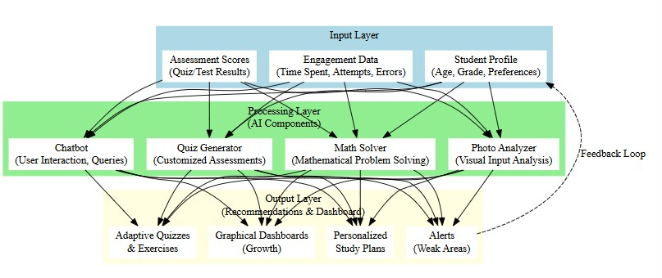

- COMPARATIVE ANALYSIS
The Think Smart system is compared to the existing e-learning systems, such as Coursera, edX, and Khan Academy. The traditional platforms are predominately pre-recorded and fixed-assessed, which does not allow personalization. The advice on some of these sites is very fundamental and not updated based on the personal behavior or performance of an individual learner in real time. Conversely, the proposed system is a unified automated question generator, handwritten equation solver, and personalized learning.
Think Smart is also differentiated by being a single learning platform that adapts content and evaluation to learner data unlike other currently used tools which operate as standalone applications. Early detection of learning challenges is what makes this system unique because of the use of predictive analytics.
The analysis says that Think Smart is more flexible, saves manual efforts on part of the instructors, and increases learner interaction than the conventional e-learning platforms. The given analysis shows that the idea of combining different AI-based features into a full learning platform can be rather effective.

- RESULTS & DISCUSSION
The experimental test of the Think Smart system indicates the system to be effective to enhance the engagement of the learners and their learning results. Question generation was automated and structured questions were generated out of uploaded learning materials and this reduced the preparation of questions manually. The handwritten equation recognition module was able to read and solve math expressions precisely, so it is not as hard to introduce handwritten problem solving into the digital learning process. Individualized learning programs created on the basis of the behavior and the results of the assessment contributed to greater engagement and easier learning. Immediate feedback and adaptive assessments were provided to learners, therefore, making the level of difficulty appropriate and minimising frustration. The findings indicate that the application of the deep learning and adaptive analytics significantly increases the responsiveness and efficiency of digital learning platforms.

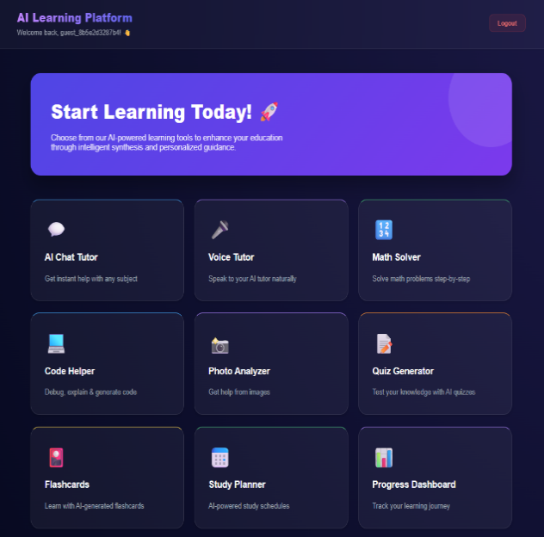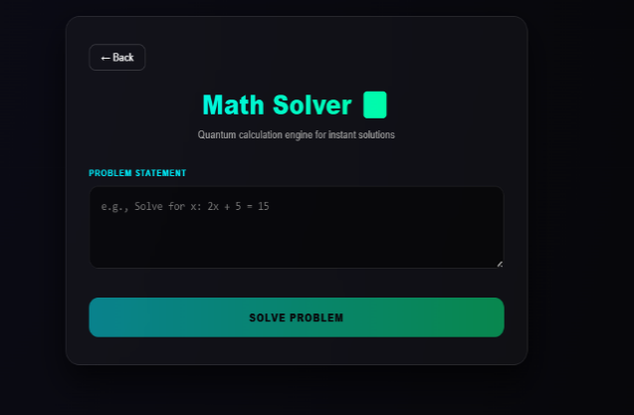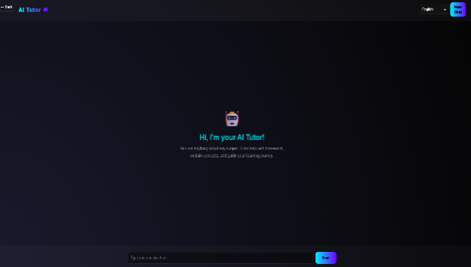
- LIMITATIONS
Although there are advantages to the proposed system, there are certain drawbacks. Just like people need good information to learn, AI needs a lot of high-quality examples to work well. The system can be time consuming to train and deploy particularly where there is a vast quantity of data involved. In addition to this, the precision of the acknowledgment of handwritten equations can be different, depending on various handwriting styles and the quality of the photographs. The privacy and security of data are significant issues because the system deals with sensitive data of the learners. We need to make sure our technology is clear and fair to everyone. The disadvantages highlight the necessity of continuous enhancement and conscientious development of the system.

- FUTURE SCOPE
Think Smart platform can improve in a number of ways in the future. It is possible to enhance the system to voice-based interaction and speech recognition technologies where it can be used to have hands-free learning experience. The introduction of multilingual support would mean more access to the learners of other language backgrounds. An application version would also enhance functionality and access. Explainable AI techniques could also be part of future work to make decisions made by the system more transparent and trusted. Moreover, integration into educational institutions can be facilitated by being linked with the learning management systems such as Moodle or Google Classroom. More sophisticated generative AI solutions would be applicable in automatic lesson plans and intelligent tutoring assistance.

- CONCLUSION
In this paper, the authors described Think Smart, an intelligent learning platform that leads to address certain issues of contemporary digital education. The proposed system is effective at increasing the teaching efficiency and involving learners by incorporating the concept of automated question generation, solving equations by hand, and learning assistance tailored to each student. The paper indicates that the personalization and effectiveness of e-learning environments can be significantly increased with the help of deep learning and adaptive analytics. The findings suggest that Think Smart bridges the gap between the conventional learning processes and the new AI-based education systems. Although there are certain constraints, the suggested strategy demonstrates the opportunities offered by intelligent learning platforms to transform digital education. The system provides a flexible and scalable solution that helps in the provision of individualized, efficient and learner-centered education.

- REFERENCE
[1] C. Huang, J. Wang, and R. Lin, “AI-driven personalized learning frameworks for e-learning environments,” Computers & Education, vol. 203, p. 104912, 2023. [Online]. Available:
https://doi.org/10.1016/j.compedu.2023.104912
[2] W. S. Sayed, A. K. Sharma, M. A. Khan, and P. Verma, “AI-based adaptive learning system for student performance prediction,” Multimedia Tools and Applications, 2022. [Online]. Available:
https://link.springer.com/article/10.1007/s11042-022-13076-8
[3] IEEE, “Intelligent e-learning systems for personalized education,” IEEE Xplore Digital Library, 2022. [Online]. Available:
https://ieeexplore.ieee.org/document/9840390
[4] Y. Chen, Z. Liu, and H. Zhao, “Hybrid deep learning models for personalized e-learning,” IEEE Access, vol. 11, pp. 134257–134270, 2023. [Online]. Available:
https://ieeexplore.ieee.org/document/10102387
[5] A. Sharma, V. Mehta, and R. Kumar, “AI-powered adaptive e-learning: Opportunities and challenges,” Education and Information Technologies, Springer, 2024. [Online]. Available: https://doi.org/10.1007/s10639-024-12385-6
[6] L. Zhang, P. Hu, and J. Ding, “Multimodal data analytics for adaptive learning,” Computers in Human Behavior Reports, vol. 12, p. 100366, 2024. [Online]. Available:
https://doi.org/10.1016/j.chbr.2024.100366
[7] L. Labadze, “Role of AI chatbots in education: Systematic literature review,” Educational Technology Journal, SpringerOpen, 2023. [Online]. Available: https://educationaltechnologyjournal.springeropen.com/articles/10.1186/s41239-023-00426-1
[8] C. Halkiopoulos, “Leveraging AI in e-learning: Personalized learning and adaptive assessment,” Electronics, vol. 13, no. 18, p. 3762, 2024. [Online]. Available: https://www.mdpi.com/2079-9292/13/18/3762
[9] I. Gligorea, “Adaptive learning using artificial intelligence in e-learning,” Education Sciences, vol. 13, no. 12, p. 1216, 2023. [Online]. Available: https://www.mdpi.com/2227-7102/13/12/1216
[10] G. Hanshaw, “Exploring the effectiveness of AI course assistants on student learning experiences,” Open Praxis, vol. 16, no. 4, pp. 719–730, 2024. [Online]. Available: https://openpraxis.org/articles/10.55982/openpraxis.16.4.719
[11] J. Du, “A systematic review of AI-powered chatbots for English as a foreign language learning,” Heliyon Education, 2024. [Online]. Available: https://www.sciencedirect.com/science/article/pii/S2666920X24000316
[12] V. Sevillano-Vega, F. Lopez, and R. Gomez, “Integrating chatbots into e-learning platforms: A systematic review,” International Journal of Advanced Computer Science and Applications, vol. 16, no. 8, 2025. [Online]. Available: https://thesai.org/Downloads/Volume16No8/Paper_26Integrating_Chatbots_into_E_Learning_Platform.pdf
[13] C. Zapata, “AI and peer reviews in higher education,” Teaching in Higher Education, Taylor & Francis, 2025. [Online]. Available: https://www.tandfonline.com/doi/full/10.1080/1475939X.2025.2480807
[14] C. Zapata, “AI in education: Personalized learning and adaptive assessment,” Electronics, 2024. [Online]. Available: https://www.mdpi.com/2079-9292/13/18/3762
[15] E. du Plooy, “Personalized adaptive learning in higher education: A systematic review,” Heliyon Education, 2024. [Online]. Available: https://www.sciencedirect.com/science/article/pii/S2405844024156617
[16] C. Halkiopoulos, “AI in education: A review of personalized learning and educational technology,” Education Sciences, vol. 14, no. 4, p. 307, 2024. [Online]. Available: https://www.mdpi.com/2227-7102/14/4/307
[17] Cengage Group, “AI Faculty Insights Dashboard: Enhancing teaching with data-driven decisions,” 2025. [Online]. Available: https://www.cengagegroup.com/news/pressreleases/2025/ai-faculty-insights-dashboard/
[18] SchoolAI, “AI Teacher Dashboard: Real-time insights for personalized instruction,” 2025. [Online]. Available: https://schoolai.com/blog/how-to-use-the-teacher-dashboard-to-understand-student-needs-real-time/
[19] SchoolAI, “Flexible AI built for classrooms: Personalizing learning experiences,” 2025. [Online]. Available: https://schoolai.com/
[20] Thetawise, “AI Math Tutor & Free Math Solver: Enhancing mathematical learning,” 2025. [Online]. Available: https://thetawise.ai/
[21] PDFQuiz, “AI Quiz Maker from PDF: Generate quizzes instantly,” 2025. [Online]. Available: https://pdfquiz.com/
[22] MathGPT.ai, “AI-powered tutoring & teaching platform: Revolutionizing math education,” 2025. [Online]. Available: https://mathgpt.ai/
[23] Mathos, “AI Math Solver & Calculator: Personalized math tutoring,” 2025. [Online]. Available: https://www.mathgptpro.com/
[24] PDF to Quiz, “AI Quiz Generator from PDF: Simplifying test creation,” 2025. [Online]. Available: https://smallpdf.com/question-generator
[25] DeepAI, “Math AI: Solving complex mathematical problems with AI,” 2025. [Online]. Available: https://deepai.org/chat/mathematics
[26] StudyFetch, “Generate study questions from PDFs: Enhancing learning with AI,” 2025. [Online]. Available: https://www.studyfetch.com/section/generate-study-questions-from-pdfs

