Impact of Climate Change on Food Quality, Safety, and Sustainability: Challenges and Technological Solutions

Abstract
Climate change, driven by anthropogenic emissions, presents a critical threat to global agricultural systems. This article examines the bidirectional relationship between food systems and the environment, noting that while food systems contribute 20%–30% of global greenhouse gas emissions, they are increasingly vulnerable to rising temperatures and extreme weather.
The study details how climatic shifts compromise food quality through the "carbon nutrient penalty"—where elevated Carbon Dioxide levels reduce essential proteins and micronutrients—and threaten food safety by promoting the growth of pathogens and mycotoxins. Furthermore, food security and sustainability are jeopardized by declining productivity and biodiversity loss, disproportionately impacting vulnerable smallholder farmers.
To mitigate these risks, the article emphasizes technological solutions, including climate-smart agriculture and AI-driven predictive modelling. As explored in this article, these innovations are vital for maintaining systemic resilience. A case study of Pakistan's Punjab region illustrates these challenges, highlighting over $30 billion in climate-related losses while showcasing the success of AI in predicting mycotoxin outbreaks with 83.3% accuracy. The article concludes that a comprehensive approach—integrating technological innovation, policy frameworks, and behavioural changes—is essential to ensuring food safety and sustainability for a growing global population.

Introduction
Climate change is primarily driven by greenhouse gas emissions from anthropogenic activities such as fossil fuel combustion, deforestation, and intensive agriculture. It represents one of the most pressing global challenges faced in the 21st century. Rising temperatures, extreme weather events, and ocean acidification are greatly disrupting ecological and agricultural systems. Food systems, which contribute approximately 20%-30% of global greenhouse gas emissions, are both a driver and victim of climate change, creating a complex bidirectional relationship that threatens global food security, safety, and sustainability.

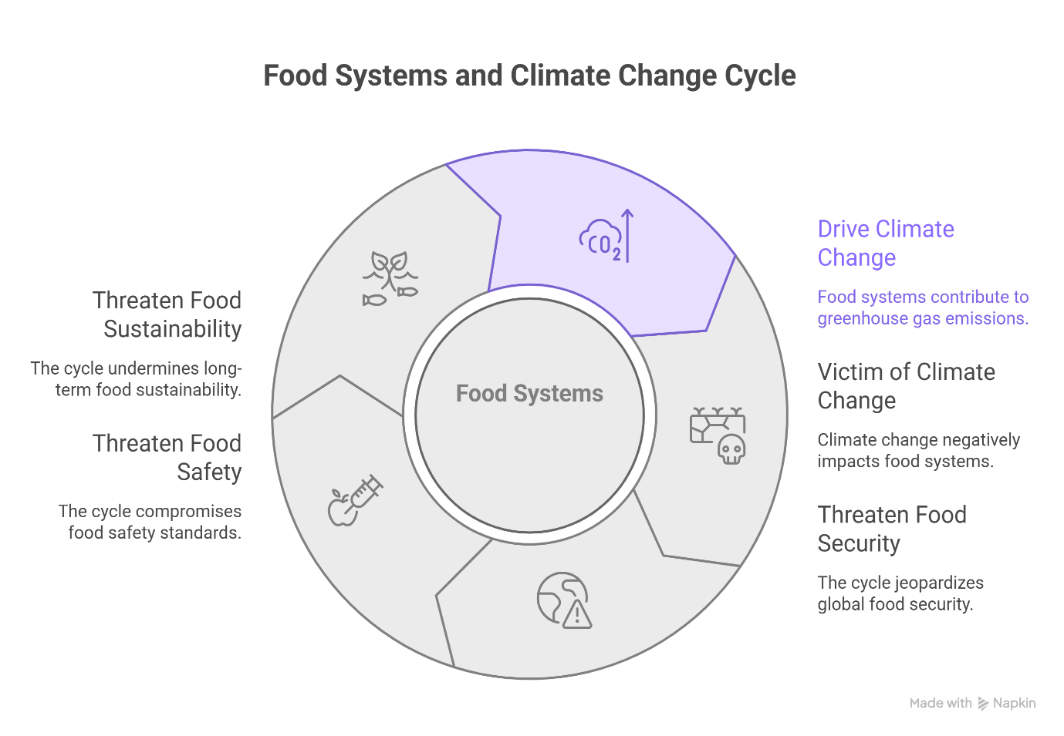

Keywords
Climate change, food security, food sustainability, nutritional quality, agricultural technology, precision agriculture, global health, environmental impact.
Food Systems Overview
Food systems comprise of a wide range of interconnected processes, including food production, processing, storage, distribution, and consumption, all of which are influenced by environmental, socio-economic, and policy related factors (Owino et al., 2022). These systems are highly sensitive to climatic variations, making them vulnerable to disruptions caused by climate change.
Impact on Food Quality
Climate change greatly affects food quality by alterations in crop physiology, nutrient composition, and environmental conditions. Elevated atmospheric CO₂ concentrations, while enhancing plant growth, reduce the nutritional quality of crops by lowering protein content and essential micronutrients such as iron, zinc and calcium (Owino et al., 2022). This phenomenon, known as the “carbon nutrient penalty,” contributes to global nutrient deficiencies. Additionally, soil degradation and heat stress further reduce crop quality, while declining biodiversity limits dietary diversity, exacerbating nutritional challenges.
Impact on Food Safety
Food safety is increasingly compromised due to climate-induced changes in environmental conditions that favor the growth of pathogens and contaminants. Rising temperatures and humidity promote the proliferation of foodborne pathogens and mycotoxin-producing fungi (Binns et al., 2021). Furthermore, increased pesticide usage and environmental pollution contribute to chemical contamination in food systems. Climate-related disruptions in water quality and sanitation exacerbate the spread of foodborne diseases, particularly in vulnerable populations (Owino et al., 2022).
Impact on Food Security & Sustainability
Climate change poses a significant threat to food security by reducing agricultural productivity, disrupting supply chains, and increasing food price volatility. Changes in temperature and precipitation patterns negatively impact crop yields and livestock productivity, while extreme weather events such as floods and droughts cause widespread damage to agricultural infrastructure (Toromade et al., 2024). Additionally, ocean acidification and changing marine conditions reduce fisheries productivity, further threatening global food availability.
Biodiversity & Sustainability
Biodiversity loss is a critical issue linked to climate change and modern agricultural practices. The global food system relies heavily on a limited number of crop species, increasing vulnerability to environmental stressors (Owino et al., 2022). The decline in genetic and species diversity reduces the resilience of food systems and limits the availability of nutrient-rich foods, emphasizing the need for biodiversity conservation.
Human Health Implications
The impacts of climate change on food systems have profound consequences for human health. Reduced food quality and availability contribute to malnutrition, including both undernutrition and obesity (Owino et al., 2022). Climate change also increases the prevalence of infectious diseases, including waterborne and zoonotic diseases, due to changes in environmental conditions and ecosystem dynamics.

Socioeconomic Impacts
The effects of climate change on food systems are disproportionately experienced by vulnerable populations, particularly smallholder farmers and low-income communities (Toromade et al., 2024). These groups often lack the resources and adaptive capacity to respond to climate-related challenges, leading to increased inequality and food insecurity.
Technological Solutions
Technological innovations play a crucial role in mitigating the impacts of climate change on food systems. Climate-smart agricultural practices, including crop diversification, agroforestry, and efficient water management, enhance resilience and sustainability (Toromade et al., 2024). Emerging technologies such as artificial intelligence (e.g., using AI-driven weather modeling to predict mycotoxin outbreaks in corn) and precision agriculture offer opportunities to optimize resource use and improve productivity.
Policy and Global Strategies
Effective policy frameworks and international cooperation are essential for addressing the challenges posed by climate change. Integrating climate adaptation and mitigation strategies into agricultural policies, promoting sustainable dietary patterns, and enhancing global collaboration can contribute to more resilient food systems.
Case Study: Climate Resilience in Pakistan
The Punjab region, including Faisalabad, exemplifies the dual role of food systems as both drivers and victims of climate change.
- Economic & Yield Impact: Catastrophic floods and unseasonal rainfall have caused over $30 billion in losses, severely threatening staple wheat production.
- Nutritional Crisis: With nearly 40% of children stunted and $CO_2$-driven nutrient penalties, over 80% of the population struggles to afford a balanced diet.
- Safety & Livestock: Heat stress reduces milk yields and increases livestock disease, while rising humidity favors mycotoxin growth in stored grains.
- Technological Response: Local adoption of AI-driven modelling now predicts mycotoxin outbreaks with 83.3% accuracy, while precision water management addresses critical scarcity.
Metric | Data Point
Security | 11M+ people facing acute food insecurity
Safety | 83.3% AI accuracy for mycotoxin prediction
Hydrology | Per capita water availability below 1,000 m³
This real-world application proves that the technological solutions discussed are vital for maintaining food quality and safety in vulnerable regions.

Conclusion & Future Directions
Addressing the impacts of climate change on food systems requires a comprehensive and integrated approach that combines technological innovation, policy interventions, and behavioral changes. While significant progress has been made, challenges such as trade-offs between productivity and sustainability, lack of standardized measurement tools, and regional disparities remain (Owino et al., 2022). Future efforts should focus on developing climate-resilient food systems that ensure food quality, safety, and sustainability for a growing global population.

References
- Binns, C. W., Lee, M. K., Maycock, B., Torheim, L. E., Nanishi, K., & Duong, D. T. T. (2021). Climate change, food supply, and dietary guidelines. Annual Review of Public Health, 42, 233–255. https://doi.org/10.1146/annurev-publhealth-012420-105044
- Owino, V., Kumwenda, C., Ekesa, B., Parker, M. E., Ewoldt, L., Roos, N., Lee, W. T., & Tome, D. (2022). The impact of climate change on food systems, diet quality, nutrition, and health outcomes: A narrative review. Frontiers in Climate, 4, Article 941842. https://doi.org/10.3389/fclim.2022.941842
- Qu, S., et al. (2026). Impacts of climate adaptation on food production and environmental sustainability across metacoupling systems. Journal of Agricultural and Environmental Studies
- Saleem, A., Anwar, S., Nawaz, T., Fahad, S., Saud, S., Rahman, T. U., Khan, M. N. R., & Nawaz, T. (2025). Securing a sustainable future: the climate change threat to agriculture, food security, and sustainable development goals. Journal of Umm Al-Qura University for Applied Sciences, 11, 595–611. https://doi.org/10.1007/s43994-024-00177-3
- Mengi Çelik, Ö., Akçakaya, S. D., & Ekici, E. M. (2025). Relationship between sustainable food literacy, organic food consumption and climate change awareness and worry in Türkiye. BMC Public Health, 25(1), Article 2491. https://doi.org/10.1186/s12889-025-22482-0
- Toromade, A. S., Soyombo, D. A., Kupa, E., & Ijomah, T. I. (2024). Reviewing the impact of climate change on global food security: Challenges and solutions. International Journal of Applied Research in Social Sciences, 6(7), 1403–1416. https://doi.org/10.51594/ijarss.v6i7.1300

