EFFECT OF DIGITAL TRANSFORMATION ON THE PERFORMANCE OF SUPPLY CHAIN IN APAPA PORT, LAGOS STATE.

By
¹ OGUBUIKE Chimuche Gladys
gladysogubuike@gmail.com
+2348037772771
² NICHOLAS Clement Ekanem
nicholasclement12@gmail.com
+2348132044209

³Prof. SULEIMAN A. S. Aruwa
sasaruwa@gmail.com
+2348034511107

¹ ² PhD Procurement Management Student
¹ ² ³ Institute of Governance and Development Studies,
Nasarawa State University, Keffi-Nigeria.
ABSTRACT
Digital transformation is fundamentally re-engineering global trade, with its application in port logistics being critical for enhancing supply chain performance. This study examined the effect of digital transformation specifically Port Community Systems Implementation (PCSI), Automation of Cargo Handling (AOCH), Digital Customs Clearance System (DCCS), and Use of IoT for Tracking and Monitoring (IOTM) on Supply Chain Performance (PFSC) at Apapa Port, Lagos State. In this study, supply chain performance is evaluated using three metrics: average cargo dwell time, port throughput and berth productivity, and supply chain reliability. Using a cross-sectional survey design, data were collected from 153 key stakeholders across four critical departments via structured questionnaires administered through Google Forms. Partial Least Squares Structural Equation Modelling (PLS-SEM) was employed to analyze the data, revealing that Use of IoT for Tracking and Monitoring (β = 0.394, p < 0.001) and Digital Customs Clearance System (β = 0.191, p = 0.038) significantly affect supply chain performance, while Port Community Systems Implementation (β = 0.118, p = 0.190) and Automation of Cargo Handling (β = 0.055, p = 0.573) had no significant effect. Collectively, these digital transformation variables explain 68.5% of the variance in supply chain performance (R² = 0.685). While PCSI and AOCH were perceived positively, they did not translate into measurable performance gains. This study concluded that real-time visibility and process automation are pivotal to reducing dwell time, enhancing throughput, and ensuring delivery reliability during port operations. Recommendations for Apapa Port include prioritizing IoT deployment and digital customs integration, strengthening stakeholder collaboration for PCS, and upgrading automation infrastructure with reliable power and maintenance systems to bolster overall supply chain resilience.
Keywords: Supply Chain Performance, Digital Transformation, Port Community Systems, Automation of Cargo Handling, Digital Customs Clearance, IoT Tracking and Monitoring.

INTRODUCTION
The global trade landscape is undergoing a profound metamorphosis, driven by the rapid integration of Digital Transformation (DT) technologies across complex logistical networks. DT, defined by Zhou (2024) as the embedding of digitalization to break physical resource barriers, enabling real-time data sharing and process automation, is fundamentally reshaping supply chain dynamics from traditional linear models to interconnected ecosystems (Lindquist, 2023). Globally, this shift aims to achieve superior efficiency and resilience. For instance, advanced Digital Transformation solutions like Internet of Things tracking and process automation are directly correlated with improved flexibility coefficients in logistics (Zhou, 2024). Furthermore, digital supply chains are recognized for their enhanced responsiveness, allowing prompt adaptation to market volatility and risks through instant decision-making facilitated by big data analytics (Nguyen et al., 2025). The performance of a supply chain holistically measured by efficiency, effectiveness, and competitiveness (Putri et al., 2019) is now contingent upon the successful deployment of technologies like port community systems, automation of cargo handling, digital customs clearance systems, and the use of internet of things for tracking and monitoring. This global trend underscored that the effectiveness of a modern supply chain is intrinsically linked to its digital maturity. Within the Nigerian context, these digital initiatives are being implemented against a backdrop of significant macroeconomic instability and inadequate infrastructure, which Okegbemi (2024) identified as primary factors suppressing overall national growth and sustainable development.
In the African context, the successful implementation of digital platforms, such as the Digital Customs Clearance System, has been shown to directly influence trade efficiency (Sarker, 2025). In Tanzania, automated customs clearance systems demonstrated significant improvements, with regression showing a 0.42-unit increase in trade efficiency per unit reduction in clearance time (Hamisi, 2024). The Apapa Port Complex in Lagos State, as the nation's busiest maritime gateway, stands at the epicenter of Nigeria's trade facilitation efforts. This direct link shows how a Digital Customs Clearance System impacts efficiency metrics, which are proxies for overall Supply Chain Performance. Similarly, within Nigerian ports, prior research on related components, such as the effect of cargo handling equipment (a subset of Automation of Cargo Handling), has shown a significant impact on automation yielded a strong reduction (Okpara, 2022). This localized evidence confirmed that specific digital transformation components can yield measurable operational improvements. The implementation of Port Community Systems is also recognized as a vital step for African ports seeking to streamline administrative processes and enhance Supply Chain Reliability by integrating scattered stakeholder data (Mthembu & Chasomeris, 2022).
The adoption of internet of things for tracking and monitoring in Nigerian firms has also shown a strong correlation with improved Supply Chain Management performance, indicating that real-time data acquisition is important for resilience and planning (Olota et al., 2023). Digital Transformation, comprising port community systems implementation, automation of cargo handling, digital customs clearance systems, and the use of internet of things for tracking and monitoring, represents the primary pathway to overcoming these structural bottlenecks. For instance, the goal of reducing the average dwell time of cargo, the time goods spend idling at the port is directly targeted by automation of cargo handling (Okpara, 2022) and the acceleration of document processing via a functional Digital Customs Clearance System (Salau, 2020). Moreover, the reliability aspect of supply chain performance, measured by delivery schedule adherence, hinges on port community systems implementation (Bin Aifan et al., 2025) and internet of things for Tracking and Monitoring (Zhou, 2024) to provide the necessary real-time data sharing and coordination among the numerous stakeholders shipping lines, terminal operators, and customs agencies operating within the congested Apapa ecosystem. This study, therefore, focuses on empirically establishing the specific relationship between these four facets of Digital Transformation and the three-performance metrics of the Apapa Port supply chain.
Statement of the Problem
The efficiency of the Apapa Port supply chain, the primary maritime gateway for Nigeria, remains sub-optimal, characterized by persistently high Average Cargo Dwell Times, fluctuations in Port Throughput, and a general failure in Delivery Schedule Adherence (a measure of Supply Chain Reliability). These inefficiencies translate directly into increased logistics costs, reduced national trade competitiveness, and significant economic friction for businesses relying on timely cargo movement. The persistent delays and low productivity indicators challenge the national economic goals of trade facilitation and ease of doing business, often resulting in diverted cargo, which further limits the port's revenue and capacity to operate effectively. While global and regional literature confirms that Digital Transformation is the definitive solution to these systemic issues, the specific deployment and resultant impact of its core components, Port Community Systems Implementation, Automation of Cargo Handling, Digital Customs Clearance Systems, and Internet of Things for Tracking and Monitoring within the unique operational and regulatory environment of Apapa Port remains insufficiently quantified and understood.
The problem of this research is the gap between the theoretical potential of digital transformation to enhance port performance and the observable, persistent operational underperformance at the Apapa Port Complex. Existing Nigerian studies often focus on isolated equipment (Okpara, 2022) or general information technology adoption (Ezekwueme et al., 2024) but fail to holistically assess the integrated effect of a mature Digital Transformation framework on the key supply chain performance outcomes: dwell time, throughput, and reliability. Specifically, there is a lack of empirical evidence in the Nigerian context demonstrating how the synergy between, for example, Digital Customs Clearance Systems acceleration and Internet of Things visibility directly translates into reduced cargo dwell time or improved berth productivity, as demonstrated elsewhere (Li et al., 2025; Hamisi, 2024). This research is necessitated by the need to provide evidence-based recommendations to port operators and regulatory bodies, such as the Nigerian Ports Authority and the Nigeria Customs Service, to prioritize and strategically invest in the most impactful Digital Transformation levers to unlock immediate and sustainable improvements in the supply chain performance of Apapa Port. Without such evidence, investment decisions remain reactive and fragmented, failing to address the interconnected nature of the port's operational challenges. The specific objectives of this study are to:
- Determine the effect of Port Community Systems Implementation on the performance of the supply chain at Apapa Port, Lagos State.

- Evaluate the effect of Automation of Cargo Handling on the performance of the supply chain at Apapa Port, Lagos State.

- Assess the effect of Digital Customs Clearance System on the performance of the supply chain at Apapa Port, Lagos State.

- Examine the effect of the Use of IoT for Tracking and Monitoring on the performance of the supply chain at Apapa Port, Lagos State.
The null hypotheses for the study are as follows:
H₀₁: Port Community Systems Implementation has no significant effect on the performance of the supply chain at Apapa Port, Lagos State.
H₀₂: Automation of Cargo Handling has no significant effect on the performance of the supply chain at Apapa Port, Lagos State.
H₀₃: Digital Customs Clearance System has no significant effect on the performance of the supply chain at Apapa Port, Lagos State.
H₀₄: Use of IoT for Tracking and Monitoring has no significant effect on the performance of the supply chain at Apapa Port, Lagos State.

LITERATURE REVIEW

CONCEPTUAL REVIEW

Supply Chain Performance
Supply Chain Performance measures the effectiveness and efficiency of integrated processes for trade. Supply Chain Performance (SCP) is defined by Putri et al. (2019) as a holistic measurement system evaluating the efficiency, effectiveness, and competitiveness across integrated processes from suppliers to customers. Zhang and Okoroafo (2015) more concisely state that SCP is the ability of the supply chain to deliver the right product to the correct location at the appropriate time at the lowest logistics cost. Furthermore, SCP is described by Ning and Yao (2023) as the effectiveness of integrated processes, measured by efficiency, responsiveness, and flexibility outcomes in global trade networks. Whitten et al. (2012) added that performance enables providing products of appropriate quality while minimizing total costs to the final customer. Blending these definitions, SCP involves evaluating the flow of goods, information, and resources against predetermined metrics of timeliness, cost, and reliability (Beamon, 1999; Gunasekaran et al., 2004). The significance of SCP lies in its direct link to global competitiveness and port operational resilience (He et al., 2023). For the Apapa Port supply chain, Digital Transformation (DT) is designed to improve these metrics, shifting from linear to networked models to reduce lead times and enhance reliability (Lindquist, 2023).
In this study, SCP is measured through three key metrics: Average Dwell Time of Cargo, which indicates how quickly goods are processed (Zhou, 2024); Port Throughput and Berth Productivity (GCMH/VTT), which measures the volume of cargo handled per unit of time (Putri et al., 2019; Gunasekaran et al., 2004); and Supply Chain Reliability via Delivery Schedule Adherence, which measures consistency and customer satisfaction (Whitten et al., 2012; Ning & Yao, 2023). DT technologies like automation and real-time tracking (Zhou, 2024; Nguyen et al., 2025) are expected to enhance all three measures.

Digital Transformation
Digital transformation fundamentally re-engineers logistics processes for ports. Digital transformation (DT) is defined as the strategic incorporation of digital technologies into all aspects of the supply chain from planning to customer service to optimize performance and enhance flexibility (Nguyen et al., 2025). Furthermore, it is described as the integration of technologies like IoT, AI, and blockchain into supply chains to foster agility, enabling real-time monitoring and data analysis (Miller, 2024). DT is also an evolutionary process relying on digital technology to change business processes and create value (Iman et al., 2022).
DT is the adoption of computational technologies like Port Community Systems (PCS) and Maritime Single Windows (MSW) to enhance operational efficiency (Bin Aifan et al., 2025). Digital transformation represents a foundational shift, not just adopting new tools, but utilizing technologies like IoT, big data, and cloud platforms to transcend temporal and spatial constraints, significantly enhancing information retrieval and acquisition capabilities of enterprises (Xiong et al., 2025). The significance of DT lies in its ability to directly improve operational visibility, shorten cargo dwell times, and facilitate coordination among port stakeholders (Nguyen & Pham, 2025). For the Apapa Port supply chain, DT's importance is manifested in its potential to augment cargo throughput and enhance berth productivity through resource optimization (Li et al., 2025), enabling firms to achieve high-frequency interaction and collaborative throughput improvement (Zhou, 2024). This integration boosts supply chain responsiveness and resilience by fostering better coordination and faster decision-making (Nguyen et al., 2025; Fu et al., 2025).

Port Community Systems Implementation
Port Community Systems Implementation is essential for enhancing efficiency and coordination in port operations. According to Dameri et al. (2019), Port Community System is an electronic platform that facilitates the secure, intelligent exchange of information among public and private stakeholders in a port, integrating systems to streamline documentation. Mubder (2025) defined a PCS as a neutral, integrated digital platform that facilitates secure information exchange among port stakeholders, including shipping lines, terminals, and customs, to streamline administrative and operational processes. World Bank (2023) noted that PCS are digital collaborative platforms enabling seamless information exchange, reducing paperwork and administrative delays for enhanced competitiveness.
This system is explained by Li et al. (2025) who classify PCS as a digital platform integrating multi-stakeholder data for seamless port operations. PCS Implementation involves establishing a shared digital space where all port entities can submit and access real-time data, thus breaking down traditional information silos (Li et al., 2025). The importance of this concept for the Apapa Port supply chain is its proven ability to optimize information flows, cut cargo clearance times by up to 30% (Heilig et al., 2017), and reduce communication errors (Caldeirinha et al., 2020). By centralizing data, PCS adoption supports data-driven port management, which slashes administrative time and directly enhances Port Throughput and Berth Productivity by promoting optimized resource allocation, ensuring better supply chain reliability, and fostering improved schedule adherence (Mubder, 2025; Li et al., 2025).

Automation of Cargo Handling
Automation of cargo handling revolutionizes port operations by minimizing human involvement in container movement. Automation of Cargo Handling (AOCH) systems are defined by Mwaya and Mwisila (2025) as integrated twin-lift ship-to-shore cranes, automated guided vehicles (AGVs), and computer-controlled yard cranes that standardize and accelerate container movements. Okere (2022) similarly described AOCH as the deployment of mechanized and computerized systems, such as rubber-tired gantry cranes and straddle carriers, to minimize manual intervention. Dávid (2019) focused on the integration of driverless technologies, like AGVs and automated stacking cranes (ASCs), to transport and transfer containers without direct human involvement, thereby streamlining operations.
Furthermore, Jobran and Kara (2022) defined AOCH by its goal to execute container movement and storage without human intervention. By blending these definitions, AOCH is understood as the strategic application of advanced, digitally-controlled equipment to mechanize the entire goods flow within a port, from the quay to the terminal exit (Li et al., 2025). The significance of AOCH to the Apapa Port supply chain is its proven ability to enhance efficiency dramatically. Empirical evidence shows that automation significantly reduces ship turnaround time (Jobran & Kara, 2022) and shortens vessel-quay time (Mwaya & Mwisila, 2025), directly boosting Port Throughput and Berth Productivity. Locally, specific equipment automation is shown to significantly reduce the Average Dwell Time of Cargo (Okpara, 2022). This minimized manual handling also reduces errors and improves safety (Jobran & Kara, 2022), leading to more consistent operations and, consequently, better Supply Chain Reliability via Delivery Schedule Adherence.

Digital Customs Clearance System
A digital customs clearance system drastically speeds up the movement of goods through ports. Suzuki (2025) defined digital customs clearance system as an electronic platform automating trade procedures to reduce costs and delays. Otakulova (2023) further described DCCS as the automation of border procedures using technologies like Electronic Data Interchange (EDI) to facilitate electronic submissions and risk assessments, minimizing manual interventions. Salau (2020) defined the system as an integrated, technology-driven platform that automates the entire customs process, from cargo declaration to release, minimizing paperwork and human intervention. Hamisi (2024) added that such systems streamline workflows and reduce bottlenecks, enhancing operational efficiency.
Digital customs clearance system represents a strategic digital integration that shifts customs operations from manual, paper-based, and sequential processes to seamless, centralized electronic workflows (Lusweti, 2020). The significance of DCCS for the Apapa Port supply chain is profound because clearance time directly affects the Average Dwell Time of Cargo. Automation via e-Clearance and risk profiling enables faster cargo release, with systems like Nigeria’s e-Customs deploying Non-Intrusive Inspection (NII) equipment to minimize physical inspection requirements (Salau, 2020). This not only reduces cargo release time significantly (Hamisi, 2024) but also enhances transparency and reduces opportunities for fraud, contributing to the port’s Supply Chain Reliability and operational efficiency (Adeniyi, 2025).

Use of IoT for Tracking and Monitoring
The Internet of Things (IoT) transforms supply chains by connecting physical assets, providing real-time data for better decision-making. As defined by Ayemenre (2024), IoT in logistics involves interconnected devices embedded with sensors and connectivity, enabling the collection and exchange of data for continuous monitoring and optimization. Cserhat (2023) explained that IoT in smart ports as a network of interconnected devices that enable real-time data capture, optimizing operations and enhancing supply chain visibility. Kärst (2023) focused on IoT as devices and sensors that collect, transmit, and analyze real-time data from physical assets, enabling visibility into asset locations and environmental conditions, especially in infrastructure-challenged regions.
Ben-Daya et al. (2019) noted that IoT involves sensors and RFID tags that capture real-time data on location, condition, and movement. Synthesizing these definitions, IoT for tracking and monitoring represents the deployment of networked sensors and smart devices (like GPS and RFID) to generate continuous, actionable data on cargo and equipment (Ikeavuje et al., 2024). For the Apapa Port supply chain, the significance of IoT is immense as it directly addresses issues related to Average Dwell Time of Cargo and Supply Chain Reliability. Real-time tracking of containers and port assets minimizes the risk of theft and diversion (Olota et al., 2023), while continuous monitoring of equipment allows for predictive maintenance, reducing unplanned downtime that impairs Port Throughput and Berth Productivity (Koritarov & Dimitrakiev, 2024). This enhanced visibility and predictive capability ensure timely deliveries and improve overall operational responsiveness (Ayemenre, 2024; Miller, 2024).

EMPIRICAL REVIEW

Port Community Systems Implementation and Performance
Mthembu and Chasomeris (2022) explored a systems approach to developing a port community system for south africa. The study aimed to understand the fragmented information flow in South African ports and develop a PCS implementation framework, with PCS implementation as the key independent variable and port supply chain efficiency (proxies: reduced duplication, delays, and errors) as the dependent variable. It employed qualitative soft systems methodology, involving 24 semi-structured interviews and two stakeholder workshops with port users including Transnet National Ports Authority officials, terminal operators, ship agents, freight forwarders, and customs representatives; data were collected via interviews and workshops, analyzed thematically using rich pictures, CATWOE analysis, root definitions, and conceptual models. Findings revealed siloed operations, lack of integration, and stakeholder support for PCS, leading to a three-level modular framework prioritizing core users (e.g., port authority, terminals) in level one for bookings and declarations. Recommendations included government-led cross-functional teams, stakeholder buy-in, and phased rollout. The strength lay in its participatory SSM approach ensuring cultural feasibility. However, it lacked quantitative cost-benefit analysis and focused solely on South Africa, limiting generalizability to other African ports like Apapa.
Tijan et al. (2021) explored the role of port authority in port governance and port community system implementation. The study examined port authorities' roles in governance models and PCS adoption as variables for sustainability, using literature review methodology with 73 sources from Web of Science and additional references, focusing on global seaports without specified population or sample size, employing manual screening for data collection and qualitative analysis. Findings revealed port authorities as key initiators in PCS implementation, evolving into digital hubs for optimized processes and sustainability across models like landlord ports; recommendations included analyzing PCS financing models. The strength lay in comprehensive case integration, such as Rotterdam and Tuscan PCS. However, reliance on literature review limited empirical validation and generalizability to specific contexts like Nigerian ports.
Caldeirinha et al. (2020) examined port community systems and their implications on port performance. The study analyzed characteristics of port community systems including service level, partner network, ship services, cargo and port services, logistics services, and advanced services, with port performance measured through operational performance, effectiveness, and efficiency; digital customs clearance was embedded in cargo and port services and partner network constructs. Methodology employed structural equation modeling on survey data from 153 managers across Portuguese ports, collected via 7-point Likert-scale questionnaires. Findings revealed advanced services, partner network, and ship services significantly influenced efficiency and effectiveness, while Portuguese ports lagged in logistics and advanced features compared to northern European counterparts. Recommendations urged development of advanced PCS services and broader partner networks. Strength lay in robust SEM validation and multi-construct reliability (Cronbach’s α > 0.8). However, limitations included small sample size, Portuguese focus, and dominance by port authorities, restricting generalizability.

Automation of Cargo Handling and Performance
Mwaya and Mwisila (2025) assessed the impact of automated cargo handling systems on operational efficiency at dar es salaam port, tanzania. The study examined automated cargo handling (twin-lift cranes, AGVs, yard-stacking cranes) as the independent variable and port efficiency (vessel turnaround time, berth productivity, container dwell time) as the dependent variable. A convergent mixed-methods design integrated 96 structured questionnaires (Cronbach’s α = .842) and port metrics with 20 semi-structured interviews and three-day quay-side observations; the population comprised Dar es Salaam Port stakeholders, with a stratified sample of 96 respondents; data were collected via questionnaires, interviews, observations, and the Tanzania Ports Authority MIS; analysis used SPSS for descriptive statistics, Pearson correlation (r = .642, p < .001), and multiple regression (β = .278, p < .001), plus NVivo thematic analysis. Findings revealed a 41% reduction in vessel-quay time (12.6 h to 7.4 h) and ACH uniquely explained 27.8% of efficiency variance; recommendations emphasized resilient power backups and maintenance training. The strength lay in triangulated mixed-methods rigor. However, the single-port cross-sectional design limited generalizability and overlooked longitudinal maturation effects.
Okpara (2022) examined effect of cargo handling equipment on performance of Onne and Calabar ports in Nigeria. The study determined the extent to which tractor-trailer system, forklift system, reach stacker system, and crane system affected cargo dwell time. A cross-sectional survey design was adopted with a population of 593 staff from Onne (277) and Calabar (316) ports; Taro Yamane formula yielded a sample of 239, with 210 valid responses (86% rate). Data were collected via structured questionnaire on a 4-point Likert scale and analyzed using multiple regression in SPSS 25.0. Findings showed all four equipment types had positive significant effects on cargo dwell time (β = .331, .642, .195, .164; p < .001), with R² = .845 indicating 84.5% variance explained. Recommendations included modernization of equipment and establishment of enhancement systems to boost performance. The strength lay in its focused regression modeling of specific equipment on dwell time. However, the small two-port sample limited generalizability to Nigeria’s six ports, and self-reported data risked bias.

Digital Customs Clearance System and Performance
Hamisi (2024) assessed the effect of automated customs clearance systems on enhancing trade efficiency in Tanzania. The study examined operational efficiency, cost reduction, stakeholder satisfaction, clearance times, and labor cost savings as proxies for trade efficiency, using an explanatory design with qualitative methods. Data were collected from 52 purposive-sampled stakeholders at Dar es Salaam port via questionnaires, interviews, and documentary reviews, and analyzed with SPSS descriptive statistics, ANOVA, t-tests, and regression. Findings revealed 90.4% agreement on improved operational efficiency, 84.6% on cost reduction and stakeholder satisfaction, and 88.4% on reduced clearance times, with all variables significantly predicting trade efficiency (p < .001). Recommendations included investing in infrastructure, training, and stakeholder engagement. The strength lay in mixed-method triangulation and statistical rigor. However, the small sample limited generalizability, and qualitative depth was constrained by reliance on SPSS for primarily quantitative interpretation.
Bassa et al. (2021) assessed the impact of paperless information technology-based custom clearance at Ghana ports on businesses and industrial supply chains. The study examined paperless IT-based port clearance (independent variable; proxies: regulations guiding electronic transactions, certification authority, cross-border electronic data interchange, electronic interchange of certificate of origin, electronic exchange of sanitary and phyto-sanitary certificates, electronic issuance of letters of credit by bankers) and transaction cost reduction, customer order fulfillment, and supply chain relationships (dependent variables). The study employed a quantitative survey method, targeting top managers of import/export firms in Ghana as the population, with a sample size of 139 from 200 distributed questionnaires collected via paper-based instruments and analyzed using descriptive statistics, Pearson correlation, and stepwise regression. The study determined strong positive correlations (r = 0.734 for customer order fulfillment, r = 0.617 for transaction cost reduction, r = 0.625 for supply chain relationships, all p < 0.05) and significant predictive effects (R² = 0.539, 0.381, 0.390 respectively), confirming hypotheses of positive influences, particularly strongest on customer order fulfillment. The study recommended full integration of paperless practices by port authorities, stakeholder collaboration to enhance adoption, and policy interventions to promote digital clearance for improved efficiency. The strength of this study lay in its context-specific application of transaction cost economics theory to sub-Saharan African ports and high-reliability measures (Cronbach’s α > 0.87). However, the critique noted limited generalizability due to purposive sampling and self-reported data, alongside minimal current adoption levels potentially underestimating long-term impacts.

Use of IoT for Tracking and Monitoring and Performance
Ezekwueme et al. (2024) examined efficiency of IoT adoption and supply chain optimization: empirical evidence from Nigeria. The study assessed the impact of IoT adoption on supply chain efficiency metrics including lead time, inventory turnover, and order accuracy, with IoT applications such as real-time tracking and monitoring as independent variables. It employed a quantitative methodology with purposive sampling, targeting 50 senior managers from five Nigerian companies across transportation, agriculture, healthcare, food supply, and online retail sectors; data were collected via online structured questionnaires, yielding 43 responses, and analyzed using IBM SPSS version 27 through descriptive statistics, regression, and correlation tests. Findings revealed 74.4% IoT adoption rate, with real-time tracking implemented by 54.3% of companies, leading to moderate improvements in lead time (negative correlation of -0.345, p=0.053) and significant gains in order accuracy (39.5% rated significantly enhanced); 60% reported enhanced inventory management via automated systems and sensors. Recommendations included bolstering digital infrastructure, regulatory frameworks, pilot projects, local expertise training, and public-private partnerships. The strength lies in its multi-sectoral empirical evidence from Nigeria, filling a contextual gap. However, purposive sampling and self-reported data may introduce bias, limiting generalizability, while the small sample size weakened statistical significance.
Olota et al. (2023) examined internet of things and supply chain management: an empirical analysis of nigeria perspective. The study assessed IoT factors (including tracking and monitoring via real-time data sensors) and their effect on SCM performance, focusing on efficiency and visibility. It adopted survey research design with Jumia Nigeria employees as population; 265 were sampled randomly, yielding 253 valid responses via questionnaires. Data were analyzed using SmartPLS3 structural equation modeling at 0.05 significance. Findings revealed IoT exerted a strong positive effect (β = 0.948, p = 0.000) on SCM, explaining 89.9% variance (R² = 0.899). It recommended IoT integration for continuous SCM enhancement. The strength lies in robust PLS-SEM validation of high predictive power. However, its single-firm focus limits generalizability to port logistics contexts like Apapa.

THEORETICAL FRAMEWORK
The underpinning theory for this study is the Dynamic Capabilities Theory (DCT), propounded and developed primarily by Teece, Pisano, and Shuen (1997), building on the resource-based view (RBV) of the firm. DCT suggests that a firm’s competitive advantage, particularly in rapidly changing environments like the digital transformation of a port supply chain, is derived from its unique ability to integrate, build, and reconfigure internal and external competences to address rapidly changing environments (Teece et al., 1997). The theory emphasizes a firm's capacity to sense opportunities and threats, seize those opportunities, and reconfigure its resources, often through the strategic adoption of technology, which aligns perfectly with the various dimensions of Digital Transformation (DT) explored in this study (Teece, 2018). Specifically, DCT provides a lens to understand how the proactive adoption of DT elements such as Port Community Systems Implementation, Automation of Cargo Handling, Digital Customs Clearance System, and the Use of IoT for Tracking and Monitoring constitutes a crucial dynamic capability for the Apapa Port supply chain to achieve superior Supply Chain Performance outcomes like reduced Average Dwell Time of Cargo and enhanced Port Throughput and Berth Productivity (Miller, 2024; Nguyen et al., 2025).
A key strength of the Dynamic Capabilities Theory is that it moves beyond the static view of resources in the traditional RBV, emphasizing the process of change and innovation, which is particularly relevant to the evolutionary nature of DT (Iman et al., 2022). For instance, the theory explains how the continuous investment in IoT for real-time tracking does not just create a new resource but develops a capability to sense delays and inefficiencies and seize the opportunity for better delivery schedule adherence (Ayemenre, 2024). However, the theory is often critiqued for its lack of precise operationalization and tautological nature, where defining a dynamic capability separately from the performance it explains can be challenging (Easterby-Smith & Prieto, 2008).
Furthermore, Teece (2018) cautioned that simply having the technology is insufficient; the port must also possess the managerial and organizational routines to effectively utilize the data and systems, which underscores the importance of stakeholder buy-in and organizational change management in PCS Implementation (Mubder, 2025). Despite these criticisms, DCT effectively frames the Digital Transformation initiatives as the means by which the Apapa Port supply chain senses, seizes, and reconfigures its operational processes to enhance efficiency, responsiveness, and reliability, thereby sustaining its competitive position, making it the most suitable theoretical underpinning.

METHODOLOGY
This study employed a cross-sectional survey research design to investigate the effect of digital transformation on the performance of the supply chain at Apapa Port, Lagos State. The cross-sectional design is appropriate for capturing data at a single point in time from diverse port stakeholders, enabling assessment of relationships between digital transformation practices and supply chain performance indicators. The target population comprises all operational, customs, logistics, and IT professionals at Apapa Port directly involved in digital systems and supply chain processes, totaling 202 staff members (see appendices III).
A purposive sampling technique was employed to select 153 respondents who possessed specialized expertise in Port Community Systems Implementation, Automation of Cargo Handling, Digital Customs Clearance System, Use of IoT for Tracking and Monitoring, and supply chain performance metrics. This non-probability sampling method ensured the inclusion of knowledgeable individuals capable of providing contextually rich and statistically meaningful insights, while maintaining adequate power for the planned analyses. Data collection was conducted through a structured 5-point Likert-scale questionnaire (1 = Strongly Disagree, 5 = Strongly Agree) administered via Google Forms. The instrument was carefully adapted from previously validated scales: Port Community Systems Implementation items drew from Dameri et al. (2019), Tijan et al. (2021), and Barbu et al. (2020); Automation of Cargo Handling from Jobran and Kara (2022), Okpara (2022), and Dávid (2019); Digital Customs Clearance System from Otakulova (2023) and Bassa et al. (2021); Use of IoT for Tracking and Monitoring from Olota et al. (2023), Karim et al. (2024), and Miller (2024); and Supply Chain Performance from Putri et al. (2019), Zhang and Okoroafo (2015), Ning and Yao (2023), and Gunasekaran et al. (2004).
The choice of Google Forms as the data collection platform was driven by its accessibility, cost-effectiveness, real-time data capture capabilities, and ease of distribution across geographically dispersed respondents within Apapa Port. The platform supported secure, encrypted transmission of responses, ensured anonymity through system-generated unique IDs, enabled automatic data validation to reduce entry errors, and allowed seamless export to CSV and SmartPLS formats, thereby streamlining the analytical workflow and enhancing response rates in a digitally literate professional setting. Informed consent was embedded directly on the questionnaire’s landing page, clearly stating that participation was voluntary and that respondents could withdraw at any stage without consequence. Ethical consideration was adhered to and all responses were anonymized to protect participant confidentiality.
The reliability of the constructs in this study was established using Cronbach’s Alpha, with values well above the 0.70 threshold recommended by Hair et al. (2014). Specifically, the results demonstrated strong internal consistency: Port Community Systems Implementation (0.866), Automation of Cargo Handling (0.834), Digital Customs Clearance System (0.888), Use of IoT for Tracking and Monitoring (0.875), and Supply Chain Performance (0.855). These Cronbach’s Alpha values confirmed that the questionnaire items consistently measured their intended constructs, ensuring the credibility and robustness of the findings.
Data analysis was performed using Partial Least Squares Structural Equation Modeling (PLS-SEM) in SmartPLS 3, chosen for its robustness in handling complex predictive models, smaller sample sizes, and non-normal data distributions commonly encountered in organizational research. The analysis adhered to the standard two-step procedure: first, assessment of the measurement model (indicator reliability, convergent validity via AVE, and discriminant validity via HTMT); second, evaluation of the structural model (path coefficients, coefficient of determination R², effect size f², predictive relevance Q², and overall model fit using SRMR and NFI). Statistical significance was determined through bootstrapping with 5,000 subsamples, ensuring reliable inference of direct and indirect effects.
Figure 1: Model Specification
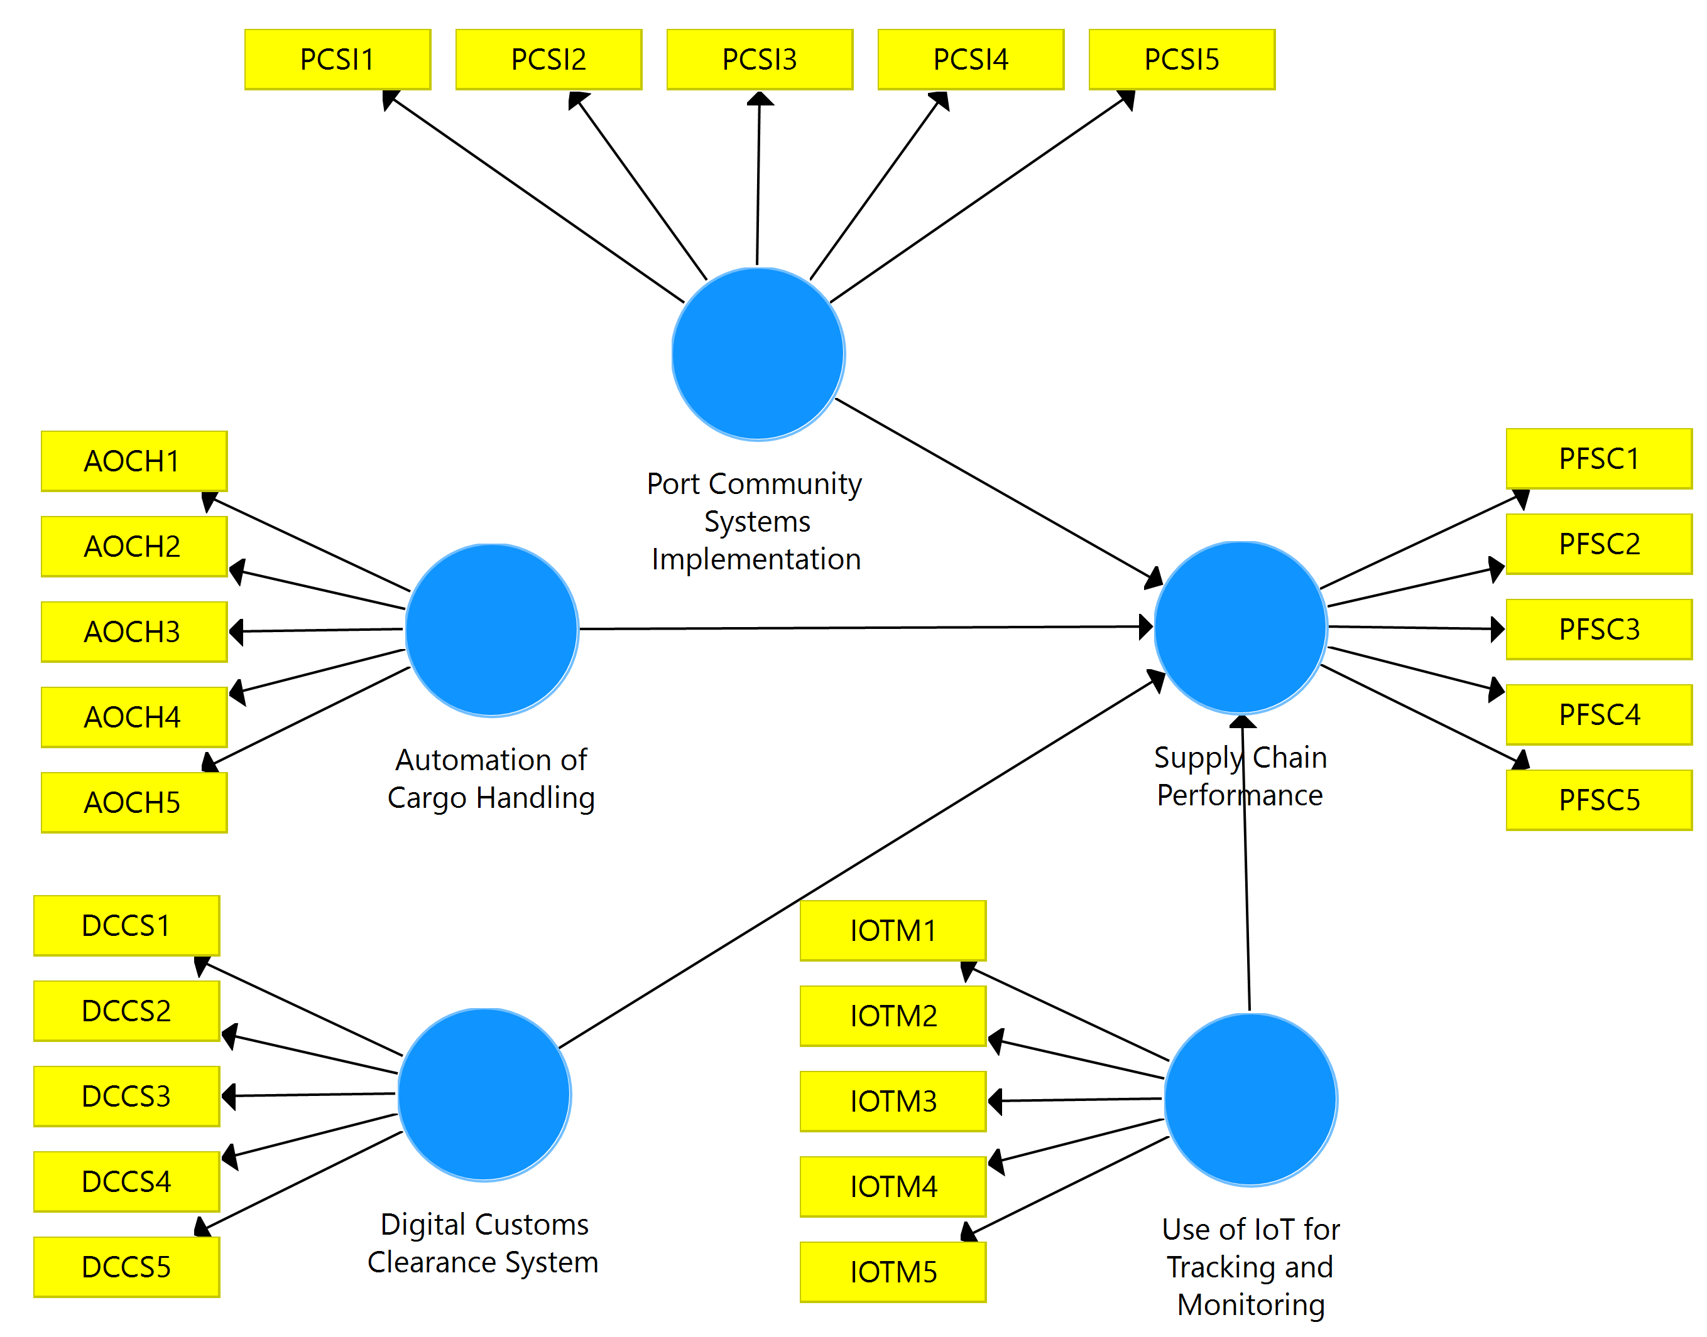
Source: SMART, PLS Output, 2025.

DATA PRESENTATION AND ANALYSIS
A total of 153 valid responses were obtained from a purposive sample of 202 professionals at Apapa Port, yielding a 75.7% response rate. This high rate reflects strong stakeholder engagement in digital transformation. Data were analyzed using PLS-SEM in SmartPLS 3 (Hair et al., 2022). First, the measurement model confirmed reliability and validity of constructs: Port Community Systems Implementation (PCSI), Automation of Cargo Handling (AOCH), Digital Customs Clearance System (DCCS), Use of IoT for Tracking and Monitoring (IOTM), and Supply Chain Performance (PFSC). Second, the structural model tested their effects on supply chain performance, measured via cargo dwell time, port throughput, berth productivity, and delivery adherence. Below is the demographic profile of the respondents.

Table 1: Demographic Profile of Respondents (N = 153)
Variable | Category | Frequency (f) | Percentage (%)
Sex of the Respondent | Male | 74 | 48.4
 | Female | 79 | 51.6
 | Total | 153 | 100.0
Age | 18–30 years | 37 | 24.2
 | 31–40 years | 53 | 34.6
 | 41–50 years | 45 | 29.4
 | 51 years and above | 18 | 11.8
 | Total | 153 | 100.0
Educational Background | B.Sc./HND | 35 | 22.9
 | Master’s | 89 | 58.2
 | PhD | 29 | 19.0
 | Total | 153 | 100.0
Years of Service | 1–5 years | 27 | 17.6
 | 6–10 years | 56 | 36.6
 | More than 10 years | 70 | 45.8
 | Total | 153 | 100.0
Department/Unit | Operations | 32 | 20.9
 | Customs | 18 | 11.8
 | Logistics | 56 | 36.6
 | IT/Technology | 47 | 30.7
 | Total | 153 | 100.0
Source: Authors Compilation, 2025.
Table 4.1 presents the demographic profile of the 153 respondents involved in the study on the effect of digital transformation on supply chain performance at Apapa Port, Lagos State. The gender distribution is nearly balanced, with females slightly predominant (48.4%) over males (51.6%), indicating inclusive representation across sexes. Age-wise, the majority fall within the productive working brackets of 31–40 years (34.6%) and 41–50 years (29.4%), suggesting a mature and experienced respondent base, while only 11.8% are above 51 years. Educationally, a significant proportion hold advanced degrees 58.2% with Master’s and 19.0% with PhD reflecting a highly qualified sample capable of providing informed insights into digital transformation processes. In terms of tenure, 45.8% have more than 10 years of service, and 36.6% between 6–10 years, implying deep institutional knowledge and familiarity with port operations. Departmentally, Logistics (36.6%) and IT/Technology (30.7%) dominate, aligning well with the study’s focus on digital tools and supply chain efficiency, followed by Operations (20.9%) and Customs (11.8%).
This demographic composition enhances the credibility and reliability of the findings. The high educational attainment and long tenure ensure respondents possess technical expertise and contextual understanding of Apapa Port’s challenges and digital initiatives. The strong presence of Logistics and IT personnel validates responses on technology adoption (e.g., IoT, PCS, automation), while balanced gender and age distribution minimizes bias. The sample is well-suited to evaluate the practical impacts of digital transformation on dwell time, throughput, and reliability, supporting robust policy and operational recommendations.

Table 2: Descriptive Statistics
Construct | Mean | Median | Min | Max | Std. Dev. | Excess Kurtosis | Skewness
Port Community Systems Implementation (PCSI1-5) | 3.840 | 4.000 | 1.0 | 5.0 | 1.216 | –0.267 | –0.845
Automation of Cargo Handling (AOCH1-5) | 3.943 | 4.000 | 1.0 | 5.0 | 1.123 | 0.290 | –1.003
Digital Customs Clearance System (DCCS1-5) | 3.897 | 4.000 | 1.0 | 5.0 | 1.250 | 0.016 | –0.986
Use of IoT for Tracking and Monitoring (IOTM1-5) | 3.975 | 4.000 | 1.0 | 5.0 | 1.197 | 0.123 | –1.043
Supply Chain Performance (PFSC1-5) | 3.987 | 4.000 | 1.0 | 5.0 | 1.151 | 0.462 | –1.087
Source: SMART PLS Output, 2025.
Table 2 presents descriptive statistics for constructs from 153 respondents. Port Community Systems Implementation (PCSI): mean 3.840, SD 1.216; Automation of Cargo Handling (AOCH): mean 3.943, SD 1.123; Digital Customs Clearance System (DCCS): mean 3.897, SD 1.250; Use of IoT for Tracking and Monitoring (IOTM): mean 3.975, SD 1.197; Supply Chain Performance (PFSC): mean 3.987, SD 1.151. All medians are 4.000; range 1.0–5.0. Skewness ranges from –0.845 (PCSI) to –1.087 (PFSC), indicating moderate left-skew with mostly positive ratings. Excess kurtosis (–0.267 to 0.462) suggests near-normal distribution. High means (>3.8) and low variability (SD ≈ 1.1–1.25) reflect strong consensus on the effectiveness of digital tools in reducing cargo dwell time, enhancing port throughput, and improving delivery reliability at Apapa Port. (120 words)
Assessment of Measurement Model
Figure 2: Indicator Loadings
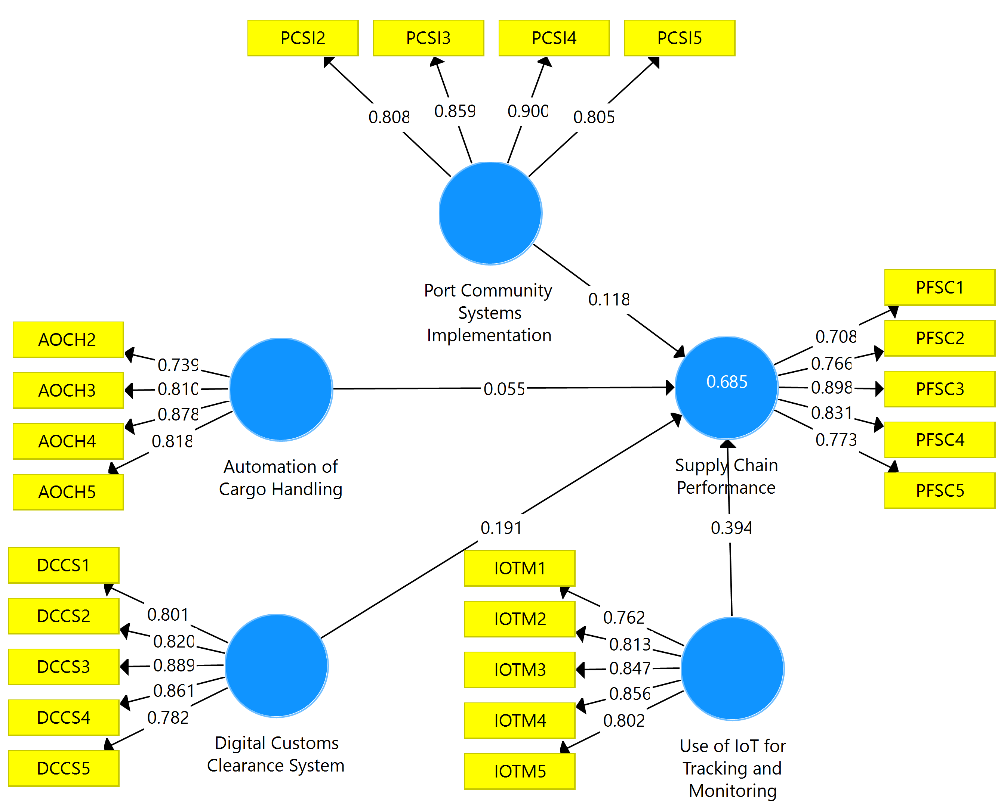
Source: SmartPLS Output, 2025.

Table 3: Reliability of Study Scale
S/N | Variables | Factor Loadings | Cronbach’s Alpha | Composite Reliability | AVE | f² | R²
1 | Port Community Systems Implementation (PCSI) | PCSI2 (0.808), PCSI3 (0.859), PCSI4 (0.900), PCSI5 (0.805) | 0.866 | 0.908 | 0.712 | 0.015
2 | Automation of Cargo Handling (AOCH) | AOCH2 (0.739), AOCH3 (0.810), AOCH4 (0.878), AOCH5 (0.818) | 0.834 | 0.886 | 0.661 | 0.003
3 | Digital Customs Clearance System (DCCS) | DCCS1 (0.801), DCCS2 (0.820), DCCS3 (0.889), DCCS4 (0.861), DCCS5 (0.782) | 0.888 | 0.918 | 0.691 | 0.036
4 | Use of IoT for Tracking and Monitoring (IOTM) | IOTM1 (0.762), IOTM2 (0.813), IOTM3 (0.847), IOTM4 (0.856), IOTM5 (0.802) | 0.875 | 0.909 | 0.667 | 0.159
5 | Supply Chain Performance (PFSC) | PFSC1 (0.708), PFSC2 (0.766), PFSC3 (0.898), PFSC4 (0.831), PFSC5 (0.773) | 0.855 | 0.897 | 0.636 |  | 0.685
Source: SmartPLS Output, 2025.
Table 3 presents reliability results for the study constructs. Factor loadings mostly exceed 0.70, confirming strong indicator representation (Hair et al., 2019). Cronbach’s Alpha values range from 0.834 (AOCH) to 0.888 (DCCS), indicating high internal consistency (Nunnally, 1978). Composite Reliability values, from 0.886 (AOCH) to 0.918 (DCCS), exceed 0.70, supporting reliability (Fornell & Larcker, 1981). AVE values, ranging from 0.636 (PFSC) to 0.712 (PCSI), surpass 0.50, confirming convergent validity. The effect sizes (f²) indicate the contribution of each predictor to Supply Chain Performance: Use of IoT for Tracking and Monitoring (IOTM) has a large effect (f² = 0.159), Digital Customs Clearance System (DCCS) a small effect (f² = 0.036), Port Community Systems Implementation (PCSI) a small effect (f² = 0.015), and Automation of Cargo Handling (AOCH) a small effect (f² = 0.003) (Cohen, 1988). The R² for Supply Chain Performance is 0.685, with an adjusted R² of 0.669, indicating 68.5% of variance is explained by predictors, demonstrating substantial predictive accuracy (Hair et al., 2019). The measurement model is reliable and valid for structural analysis.

Table 4: Heterotrait-Monotrait Ratio (HTMT)
Variables | (PCSI) | (AOCH) | (DCCS) | (PFSC) | (IOTM)
Port Community Systems Implementation
Automation of Cargo Handling | 0.637
Digital Customs Clearance System | 0.420 | 0.585
Supply Chain Performance | 0.443 | 0.437 | 0.542
Use of IoT for Tracking and Monitoring | 0.506 | 0.499 | 0.619 | 0.656
Source: SmartPLS Output, 2025.
Table 4 presents the Heterotrait-Monotrait Ratio (HTMT) values for the constructs Port Community Systems Implementation (PCSI), Automation of Cargo Handling (AOCH), Digital Customs Clearance System (DCCS), Supply Chain Performance (PFSC), and Use of IoT for Tracking and Monitoring (IOTM). The HTMT assesses discriminant validity, with values below 0.90 indicating distinct constructs (Henseler et al., 2015). HTMT values range from 0.420 (PCSI and DCCS) to 0.656 (PFSC and IOTM), all below 0.90. These results confirm that the constructs are sufficiently distinct, exhibiting strong discriminant validity with no excessive shared variance. Thus, the measurement model is valid in terms of both convergent and discriminant validity, aligning with Henseler et al. (2015) guidelines.

Collinearity Statistics

Table 5: Inner VIF
Variables | Supply Chain Performance (PFSC)
Port Community Systems Implementation (PCSI) | 1.548
Automation of Cargo Handling (AOCH) | 1.739
Digital Customs Clearance System (DCCS) | 1.644
Use of IoT for Tracking and Monitoring (IOTM) | 1.590
Source: SmartPLS Output, 2025.
Table 5 presents the inner Variance Inflation Factor (VIF) values for the predictor constructs influencing Supply Chain Performance (PFSC). All inner VIF values range from 1.548 (PCSI) to 1.739 (AOCH), well below the conservative threshold of 3.0 and the commonly accepted limit of 5.0 (Hair et al., 2019). These results indicate no significant collinearity among the independent variables, Port Community Systems Implementation (PCSI), Automation of Cargo Handling (AOCH), Digital Customs Clearance System (DCCS), and Use of IoT for Tracking and Monitoring (IOTM). Therefore, the structural model is free from multicollinearity issues, ensuring reliable path coefficient estimates and supporting the robustness of the regression analysis.
Model Goodness of Fit (GoF)

Table 6: Model Fit
Fit Indices | Saturated Model | Estimated Model
SRMR | 0.067 | 0.067
d_ULS | 1.237 | 1.237
d_G | 0.647 | 0.647
Chi-Square | 542.958 | 542.958
NFI | 0.764 | 0.764
Source: SmartPLS Output, 2025.
Table 6 presents the goodness-of-fit indices for both the saturated and estimated models. The Standardized Root Mean Square Residual (SRMR) is 0.067 for both models, below the threshold of 0.08, indicating acceptable model fit (Hu & Bentler, 1999). The geodesic discrepancy (d_G) is 0.647, and the unweighted least squares discrepancy (d_ULS) is 1.237, both confirming good fit when evaluated against bootstrapped confidence intervals in PLS-SEM. The Normed Fit Index (NFI) of 0.764 is close to 0.80, suggesting reasonable incremental fit. Overall, the model demonstrates acceptable to good fit, supporting the plausibility of the proposed relationships in the structural model assessing the effect of digital transformation on supply chain performance at Apapa Port (Henseler et al., 2016).

Assessing the Structural Model
Having satisfied the measurement model assessment, the next step in evaluating PLS-SEM results is to assess the structural model. Standard assessment criteria, which was considered include the path coefficient, t-values, p-values and coefﬁcient of determination (R²). The bootstrapping procedure was conducted using a resample of 5000.
Figure 3: Path Coefficients of the Regression Model.
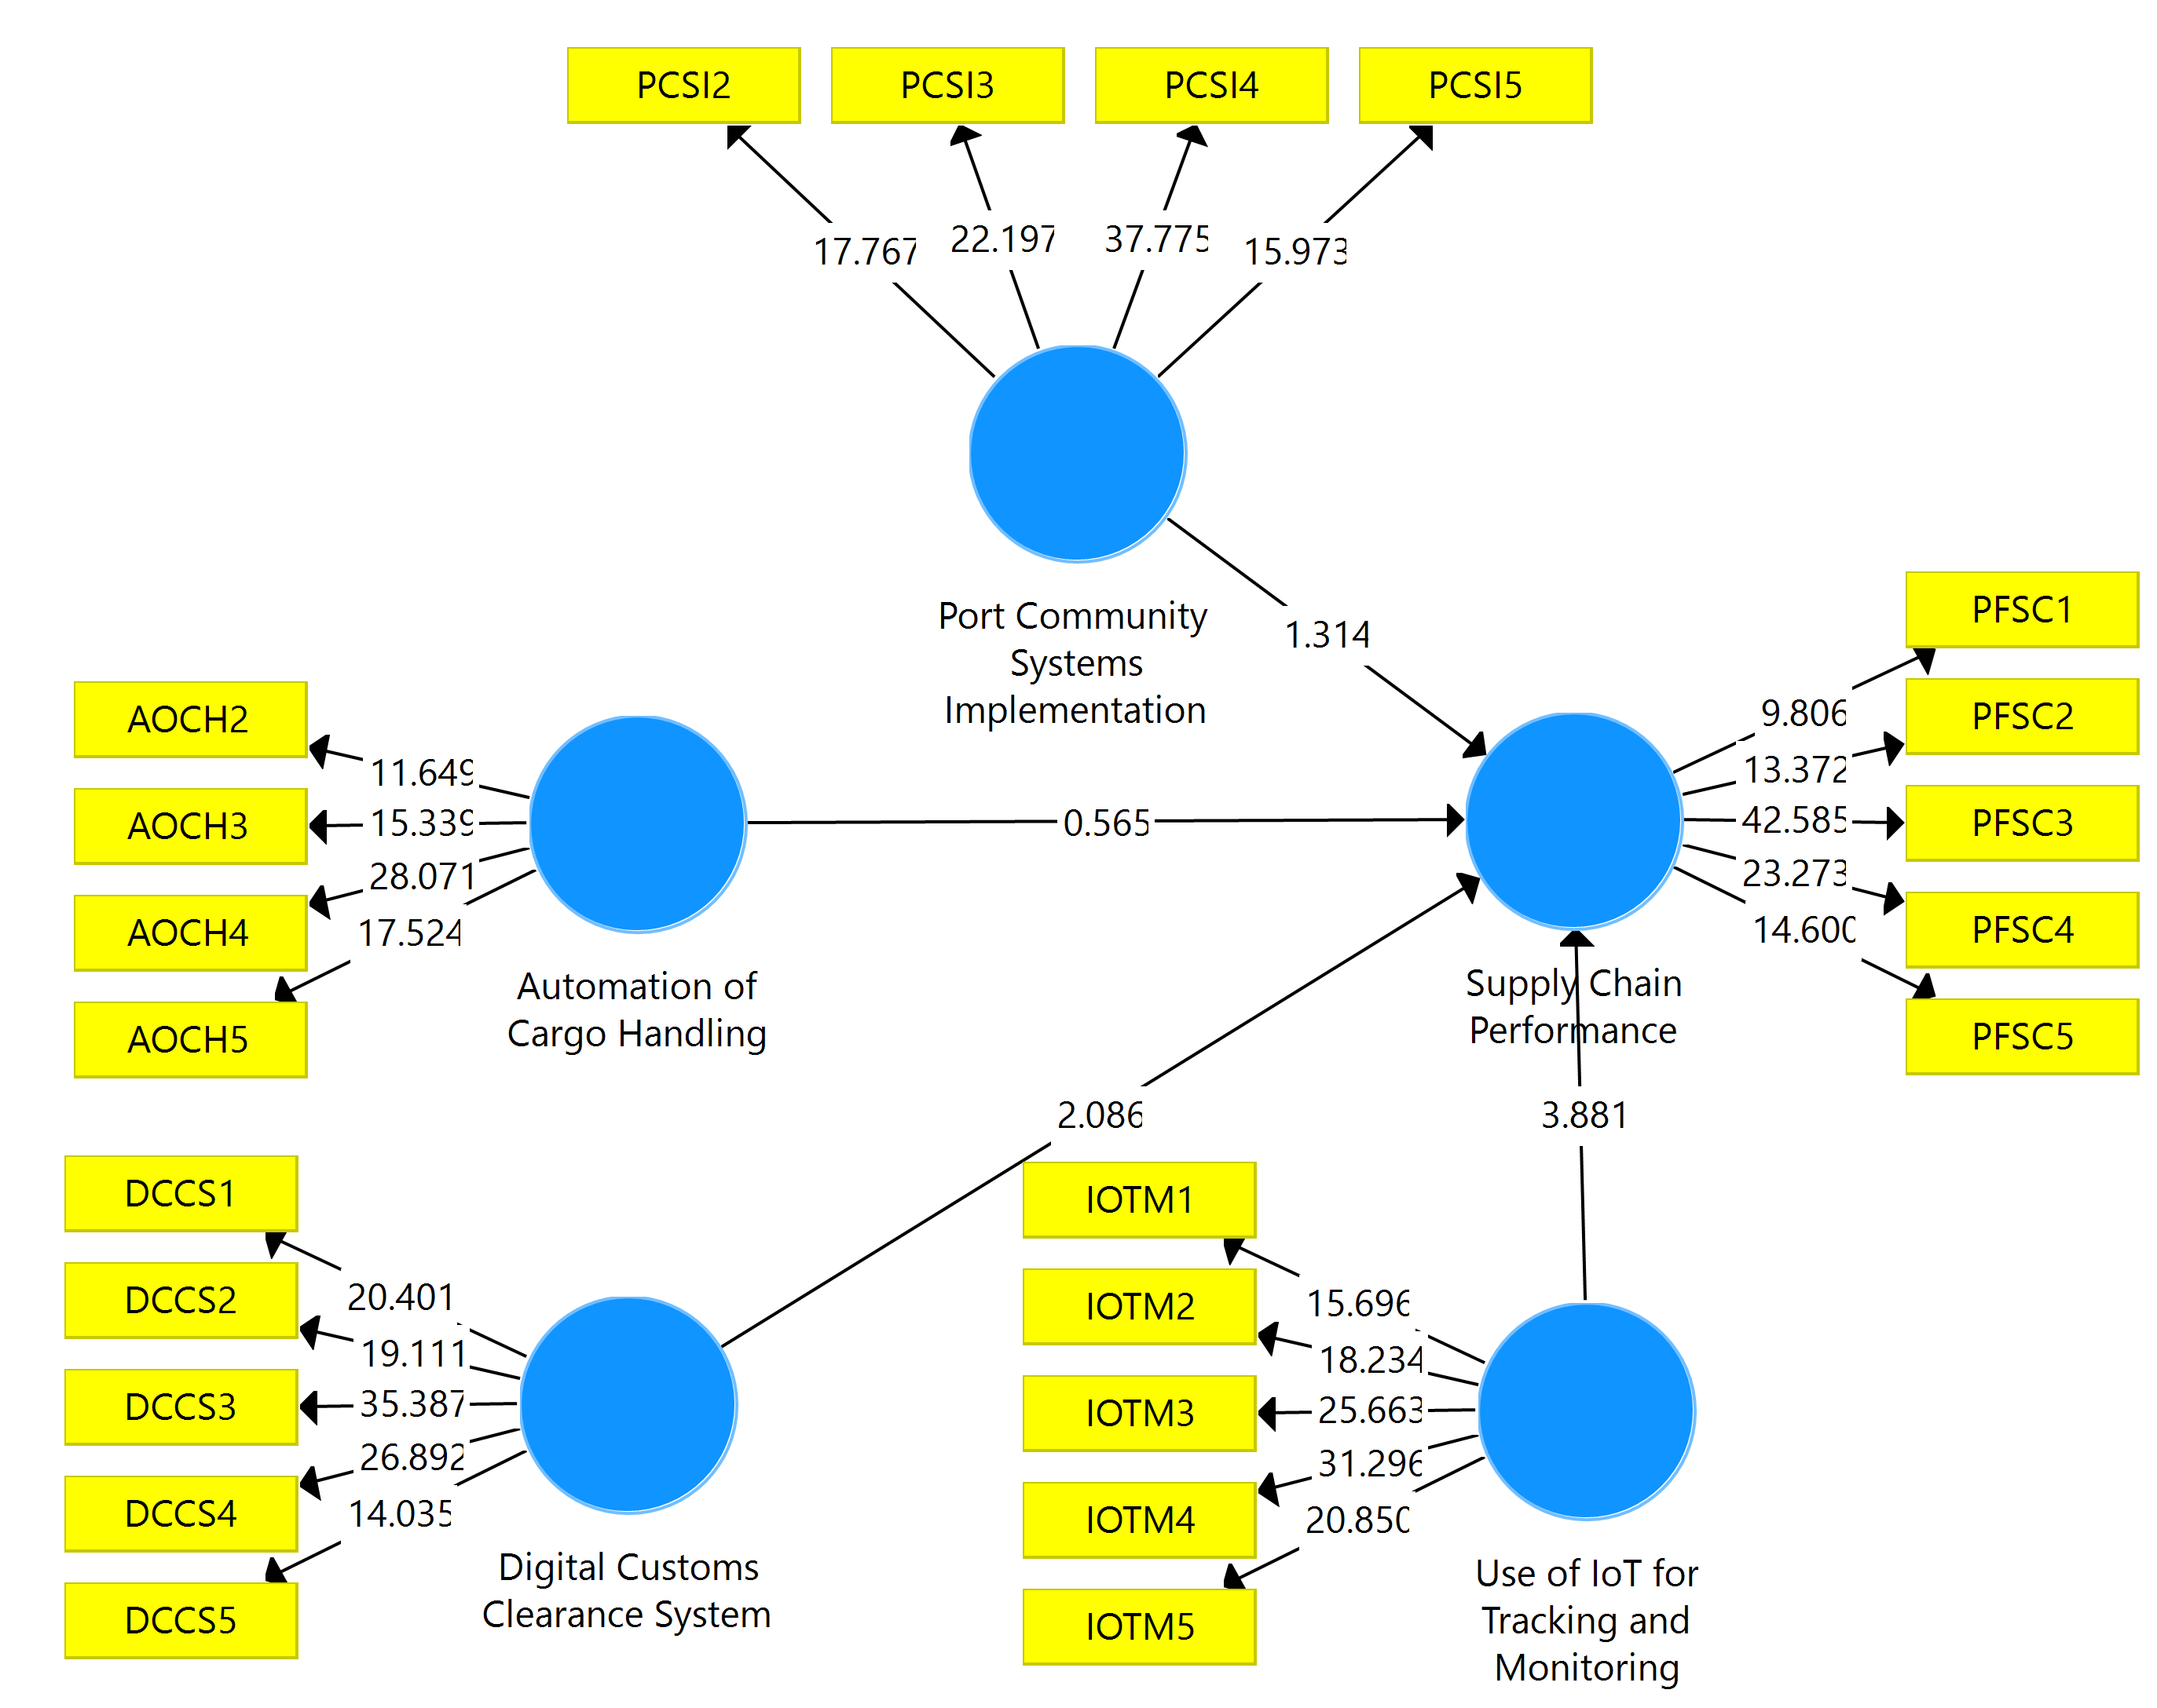
Source: SMART PLS Output, 2025.

Table 7: Path Coefficients
Variables | Original Sample (O) | Sample Mean (M) | Standard Deviation (STDEV) | T Statistics (|O/STDEV|) | P Values | Decision
Port Community Systems Implementation | 0.118 | 0.126 | 0.090 | 1.314 | 0.190 | Accepted
Automation of Cargo Handling | 0.055 | 0.064 | 0.097 | 0.565 | 0.573 | Accepted
Digital Customs Clearance System | 0.191 | 0.194 | 0.092 | 2.086 | 0.038 | Rejected
Use of IoT for Tracking and Monitoring | 0.394 | 0.388 | 0.101 | 3.881 | 0.000 | Rejected
Source: SmartPLS Output, 2025
Key Findings
Statistically Significant Relationships (p < 0.05):
- IoT for Tracking and Monitoring shows the strongest effect (β = 0.394, p = 0.000)
- Digital Customs Clearance System demonstrates a moderate significant effect (β = 0.191, p = 0.038)
Non-Significant Relationships (p > 0.05):
- Port Community Systems Implementation (β = 0.118, p = 0.190)
- Automation of Cargo Handling (β = 0.055, p = 0.573)
Table 7 presents the path coefficients, T-statistics, and p-values for the relationships between the independent variables (Port Community Systems Implementation, Automation of Cargo Handling, Digital Customs Clearance System, Use of IoT for Tracking and Monitoring) and the dependent variable (Supply Chain Performance, PFSC) at Apapa Port, Lagos State.
H₀₁: Port Community Systems Implementation has no significant effect on the performance of the supply chain at Apapa Port, Lagos State.
The analysis of the relationship between Port Community Systems Implementation (PCSI) and Supply Chain Performance (PFSC) yielded a path coefficient of 0.118, indicating a weak positive effect. The sample mean (0.126) and standard deviation (0.090) suggest consistency in the data. With a T-statistic of 1.314, below the critical threshold of 1.96, and a p-value of 0.190 (above 0.05), the relationship is not statistically significant, leading to the acceptance of H₀₁ (Hair et al., 2019). This result implies that Port Community Systems Implementation does not significantly influence Supply Chain Performance at Apapa Port, possibly due to fragmented stakeholder integration or low digital maturity hindering seamless information exchange. Effective PCS requires collaborative frameworks and phased adoption, but infrastructural barriers or resistance from port actors may limit its impact (Mthembu & Chasomeris, 2022). This finding aligns with Caldeirinha et al. (2020), who noted that PCS effectiveness depends on advanced services and partner networks, which may be underdeveloped at Apapa Port.
H₀₂: Automation of Cargo Handling has no significant effect on the performance of the supply chain at Apapa Port, Lagos State.
The relationship between Automation of Cargo Handling (AOCH) and PFSC shows a path coefficient of 0.055, indicating a negligible positive effect. The sample mean (0.064) and standard deviation (0.097) suggest variability. The T-statistic of 0.565, below 1.96, and a p-value of 0.573 (above 0.05) confirm no statistical significance, leading to the acceptance of H₀₂ (Hair et al., 2019). This result suggests that Automation of Cargo Handling does not significantly influence Supply Chain Performance, likely due to inadequate equipment maintenance, power instability, or limited automation scale at Apapa Port. While automated systems like AGVs and cranes can reduce dwell times, operational challenges may dilute benefits (Mwaya & Mwisila, 2025). This is consistent with Okpara (2022), who highlighted that cargo handling equipment impacts dwell time only with modernization and reliable support systems.
H₀₃: Digital Customs Clearance System has no significant effect on the performance of the supply chain at Apapa Port, Lagos State.
The path coefficient for Digital Customs Clearance System (DCCS) and PFSC is 0.191, indicating a moderate positive effect. The sample mean (0.194) and standard deviation (0.092) suggest data consistency. The T-statistic of 2.086 exceeds the critical threshold of 1.96, and the p-value of 0.038 (below 0.05) confirms statistical significance, leading to the rejection of H₀₃ (Hair et al., 2019). This finding suggests that Digital Customs Clearance System significantly enhances Supply Chain Performance by reducing clearance times, minimizing errors, and improving throughput and reliability. Electronic single-window platforms streamline documentation and risk-based inspections, fostering efficiency and customer satisfaction (Hamisi, 2024). By accelerating customs processes, DCCS supports berth productivity and delivery adherence at Apapa Port, aligning with Bassa et al. (2021), who emphasized paperless clearance’s role in transaction cost reduction and order fulfillment in African ports.
H₀₄: Use of IoT for Tracking and Monitoring has no significant effect on the performance of the supply chain at Apapa Port, Lagos State.
The relationship between Use of IoT for Tracking and Monitoring (IOTM) and PFSC shows a path coefficient of 0.394, indicating a strong positive effect. The sample mean (0.388) and standard deviation (0.101) suggest consistency. The T-statistic of 3.881 exceeds 1.96, and the p-value of 0.000 confirms statistical significance, leading to the rejection of H₀₄ (Hair et al., 2019). This finding suggests that Use of IoT for Tracking and Monitoring significantly improves Supply Chain Performance through real-time visibility, reduced dwell times, and enhanced reliability via sensor-based monitoring of cargo location, condition, and schedules. IoT enables predictive analytics and proactive interventions, optimizing port throughput and berth utilization (Ezekwueme et al., 2024). This aligns with Olota et al. (2023), who found IoT’s strong influence on supply chain efficiency in Nigerian contexts through tracking and data-driven decisions.
CONCLUSION
This study examined the impact of Port Community Systems Implementation (PCSI), Automation of Cargo Handling (AOCH), Digital Customs Clearance System (DCCS), and Use of IoT for Tracking and Monitoring (IOTM) on Supply Chain Performance (PFSC) at Apapa Port, Lagos State. The findings are summarized as follows:
- Digital Customs Clearance System (DCCS) significantly enhances PFSC (β=0.191, p=0.038), reducing clearance delays and improving throughput, berth productivity, and delivery reliability.
- Use of IoT for Tracking and Monitoring (IOTM) has a strong significant effect on PFSC (β=0.394, p=0.000), highlighting the critical role of real-time data in minimizing dwell times and enhancing operational efficiency.
- Port Community Systems Implementation (PCSI) showed no significant effect on PFSC (β=0.118, p=0.190), likely due to integration gaps or stakeholder silos.
- Automation of Cargo Handling (AOCH) had no significant impact on PFSC (β=0.055, p=0.573), possibly due to infrastructural constraints or limited automation depth.
RECOMMENDATIONS
The following recommendations aim to address identified gaps and leverage effective practices to improve average cargo dwell time, port throughput and berth productivity, and supply chain reliability at Apapa Port:
- Apapa Port authorities should prioritize full rollout of Digital Customs Clearance Systems, integrating single-window platforms with risk-based automation to accelerate processes and ensure seamless data flow.
- Invest heavily in Use of IoT for Tracking and Monitoring, deploying sensors, RFID, and GPS across cargo flows for real-time visibility, predictive maintenance, and end-to-end traceability.
- Enhance Port Community Systems Implementation by fostering stakeholder collaboration, developing modular PCS frameworks, and providing training to overcome silos and digital maturity barriers.
- Improve Automation of Cargo Handling through acquisition of modern equipment (e.g., AGVs, automated cranes), reliable power backups, and maintenance protocols to reduce handling times and boost productivity.

REFERENCES
Addo, A. (2020). Controlling petty corruption in public administrations of developing countries through digitalization: An opportunity theory informed study of Ghana customs. The Information Society, 37(2), 99–114. https://doi.org/10.1080/01972243.2020.1870182
Adeniyi, B. (2025). Press briefing on the activities of Nigeria Customs Service for the first quarter of 2025. Federal Ministry of Information and National Orientation. https://fmino.gov.ng/press-briefing-on-the-activities-of-nigeria-customs-service-for-the-first-quarter-of-2025-by-bashir-adewale-adeniyi-comptroller-general-of-customs-on-april-22-2025-at-the-nigeria-customs-service-co/
AlMulhim, A. F. (2021). Smart supply chain and firm performance: The role of digital technologies. Business Process Management Journal, 27(5), 1353–1372.
Anaba, D. C., Agho, M. O., Onukwulu, E. C., & Egbumokei, P. I. (2025). Advances in IoT-driven supply chain analytics for agile and resilient offshore energy operations. International Research Journal of Modernization in Engineering Technology and Science, 7(1), 2908–2921. https://doi.org/10.56726/IRJMETS66249
Aswin, B., & Saranya, P. C. (2025). Digital transformation of air customs clearance: A study on reducing delays through technology. International Advanced Research Journal in Science, Engineering and Technology, 12(5), 1585–1591. https://doi.org/10.17148/IARJSET.2025.125272
Ayemenre, S. (2024). Internet of Things in logistics. Ronish Logistics. https://www.ronishlogistics.com/internet-of-things-in-logistics/
Barbu, A., Militaru, G., & Deselnicu, D. C. (2020). An overview of the port community system from Romania. In Proceedings of the International Maritime and Logistics Conference “Marlog 9” (pp. 1–12). Arab Academy for Science, Technology and Maritime Transport.
Bassa, L., Owusu Kwateng, K., & Kamewor, F. T. (2021). Paperless custom clearance and business supply chains. Marine Economics and Management, 4(1), 42–58. https://doi.org/10.1108/MAEM-03-2020-0002
Beamon, B. M. (1999). Measuring supply chain performance. International Journal of Operations & Production Management, 19(3), 275–292.

Bin Aifan, N. A., AlBawab, M. A. S., & Morsi, A. M. (2025). The impact of implementing digital transformation requirements on the performance of ports in accordance with sustainable development requirements. Maritime Research and Technology, 4(2), 80–88. http://dx.doi.org/10.21622/MRT.2025.04.2.1346
Caldeirinha, V., Felício, J. A., Salvador, A. S., Nabais, J., & Pinho, T. (2020). Port community systems and the interaction with port performance. Research in Transportation Economics, 80, 100818. https://doi.org/10.1016/j.retrec.2020.100818
Carbone, V., & Martino, M. D. (2003). The changing role of ports in supply-chain management: An empirical analysis. Maritime Policy and Management, 30(4), 305–320. https://doi.org/10.1080/0308883032000145618
Cil, A. Y., Abdurahman, D., & Cil, I. (2022). Internet of Things enabled real-time cold chain monitoring in a container port. Journal of Shipping and Trade, 7(1), Article 9. https://doi.org/10.1186/s41072-022-00110-z
Cserhat, N. (2023, June 25). Internet of Things (IoT) in smart ports: Enhancing supply chain visibility and efficiency. Medium. https://medium.com/@niko_81857/internet-of-things-iot-in-smart-ports-enhancing-supply-chain-visibility-and-efficiency-b329a46ee3f6
Dameri, R. P., Rosenthal-Sabroux, C., & D’Amico, G. (2019). Port community systems: A structured literature review. Transportation Research Part E: Logistics and Transportation Review, 130, 340–362. https://doi.org/10.1016/j.tre.2019.09.009
Duval, Y., & Mengjing, K. (2017). Digital trade facilitation: Paperless trade in regional trade agreements (ADBI Working Paper Series No. 747). Asian Development Bank Institute.
Ezekwueme, A. E., Abel, C. E., & Dike, G. A. (2024). Efficiency of IoT adoption and supply chain optimization: An empirical evidence from Nigeria. Preprints. https://doi.org/10.20944/preprints202410.1582.v1
Estampe, D. (2014). Supply chain performance and evaluation models. ISTE.
Fu, H., Cai, R., & Sun, K. (2025). Digital transformation strategy of port supply chain: A stochastic evolutionary game method. Maritime Policy & Management. Advance online publication. https://doi.org/10.1080/03088839.2025.2563209
Gunasekaran, A., Patel, C., & McGaughey, R. E. (2004). A framework for supply chain performance measurement. International Journal of Production Economics, 87, 333–347.
Hamisi, S. R. (2024). The effect of automated customs clearance systems on enhancing trade efficiency in Tanzania. International Journal of Social Sciences and Management Research, 10(8), 408–422. https://doi.org/10.56201/ijssmr.v10.no8.2024.pg408.422
He, X., Hu, W., Li, W., & Hu, R. (2023). Digital transformation, technological innovation, and operational resilience of port firms in case of supply chain disruption. Marine Pollution Bulletin, 190, 114811. https://doi.org/10.1016/j.marpolbul.2023.114811
Ifekanandu, C. C., & Asagba, S. (2025). Supply chain innovation and operational efficiency of food and beverage manufacturing firms in South-South Nigeria. Journal of Advanced Research and Multidisciplinary Studies, 5(2), 46–62. https://doi.org/10.52589/JARMS-A8Z9HNJL
Ikeavuje, A. H., Anaba, D. C., & Iheanyichukwu, U. T. (2024). Optimizing supply chain operations using IoT devices and data analytics for improved efficiency. Magna Scientia Advanced Research and Reviews, 11(2), 70–79. https://doi.org/10.30574/msarr.2024.11.2.0107
Ilin, I., Jahn, C., Weigell, J., & Kalyazina, S. (2019). Digital technology implementation for smart city and smart port cooperation. In Proceedings of the International Conference on Digital Technologies in Logistics and Infrastructure (ICDTLI 2019). Atlantis Press. https://doi.org/10.2991/icdtli19.2019.87
Kärst, D. (2023). Cloud-based supply chain monitoring in Nigeria. IoT Use Case GmbH. https://iotusecase.com/en/solution-examples/cloud-based-supply-chain-monitoring-in-nigeria/
Khan, Y., Su’ud, M. B. M., Alam, M. M., Ahmad, S. F., Ahmad, A. Y. A. B., & Khan, N. (2023). Application of Internet of Things (IoT) in sustainable supply chain management. Sustainability, 15(1), 694. https://doi.org/10.3390/su15010694
Koritarov, T., & Dimitrakiev, D. (2024). The impact of digitalization on smart ports: Enhancing efficiency, sustainability, and competitiveness in the maritime industry. The Scientific Heritage, 152, 29–33. https://doi.org/10.5281/zenodo.14603507
Li, Y., Tian, X., Lu, Z., & Wu, J. (2025). Impact of digital transformation on sustainable development of port performance: Evidence from Tangshan Port. Sustainability, 17(15), 6902. https://doi.org/10.3390/su17156902
Miller, J. (2024). Effect of digital transformation on supply chain resilience in the United States. Journal of Strategic Management, 9(1), 40–50. https://doi.org/10.47672/jsm.1870
Monios, J., & Wilmsmeier, G. (2022). A systems approach to developing a port community system for South Africa. Journal of Transport and Supply Chain Management, 16, a772. https://doi.org/10.4102/jtscm.v16i0.772
Mubder, A. A. A. M. (2025). Port community systems and just-in-time arrival in port calls: Adoption and outcome [Doctoral dissertation, Linköping University]. LiU-Tryck. https://doi.org/10.3384/9789181183436
Nguyen, P. N., & Pham, T. Y. (2025). Assessing the impact of digital transformation on port efficiency and market positioning in Southeast Asia container port system. The Asian Journal of Shipping and Logistics. Advance online publication. https://doi.org/10.1016/j.ajsl.2025.11.002
Ning, L., & Yao, D. (2023). The impact of digital transformation on supply chain capabilities and supply chain competitive performance. Sustainability, 15(13), 10107. https://doi.org/10.3390/su151310107
NCS. (2025). Customs sets for digital cargo clearance, installs new scanner at Apapa Port. PRNigeria News. https://prnigeria.com/2025/11/09/customs-sets-digital-cargo/
Okegbemi, A. C. (2024). Economic environment factors and how they suppress growth and development in Nigeria. Academia.edu. Retrieved from https://www.academia.edu/122486898/Economic_Environment_Factors_and_How_They_Suppress_Growth_and_Development_in_Nigeria
Okere, C. C. (2022). Cargo handling equipment and ports performance in Nigeria. Journal of Procurement & Supply Chain, 6(2), 40–51. https://doi.org/10.53819/81018102t4113
Otakulova, U. O. (2023). The role of “digital customs” in customs authority and improving it. International Journal of Academic Accounting, Finance & Management Research, 7(7), 7–12.
Putra, A. P., Nuraisah, F., & Kuswantoro, M. W. (2024). The role of digital transformation on the performance of Indonesia’s biggest dry bulk port. Procedia Computer Science, 234, 900–908. https://doi.org/10.1016/j.procs.2024.03.078
Sarker, E. (2025). Digitalization in customs clearance [Master’s thesis]. Jamk University of Applied Sciences.
Tsagkaris, P., & Moschovou, T. P. (2025). The impact of automation on the efficiency of port container terminals. Future Transportation, 5(4), 155. https://doi.org/10.3390/futuretransp5040155
UNCTAD. (2021). Review of maritime transport 2021. United Nations Conference on Trade and Development. https://unctad.org/publication/review-maritime-transport-2021
Walker, E. (2020). The impact of IoT on supply chain management: Real-time monitoring and control. American Journal of Internet of Things, 1(3), 15–23.
Whitten, G. D., Green, K. W. Jr., & Zelbst, P. J. (2012). Triple-A supply chain performance. International Journal of Operations & Production Management, 32(1), 28–48.
Wilhelm, J., Hoppe, N. H., Petzoldt, C., Rolfs, L., & Freitag, M. (2022). Evaluation of performance and cargo-shock of an autonomous handling system for container unloading. Logistics Research, 15(10). https://doi.org/10.23773/2022_10

Xiong, Q., Yang, J., Zhang, X., Deng, Y., Gui, Y., & Guo, X. (2025). The influence of digital transformation on the total factor productivity of enterprises: The intermediate role of human-machine cooperation. Journal of Innovation & Knowledge, 10(4), 100736. https://doi.org/10.1016/j.jik.2025.100736
Zhang, H., & Okoroafo, S. C. (2015). Third-party logistics (3PL) and supply chain performance in the Chinese market: A conceptual framework. Engineering Management Research, 4(1), 38–48.
Zhou, B. (2024). Research on the impact of digital supply chain on enterprise operation performance. The EUrASEANs: Journal on Global Socio-Economic Dynamics, 6(49), 74–93.

