Canaan as a Balance Sheet Item: Valuing a Political Promise That Outlasted Four Presidential Campaigns in Kenya

Abstract
In financial accounting, an intangible asset is recognised not because it can be touched or delivered, but because stakeholders assign it value. This study argues that Canaan—the biblical promised land that the Late Rt. Hon. Raila Amolo Odinga placed at the centre of Kenya’s democratic imagination became one of the most consequential political intangible assets in Kenya’s post-independence history. Across four presidential campaigns (1997–2017) and three decades of public life, the Canaan promise was never realised at the ballot box, yet its symbolic value continued to grow. The paper examines why this occurred and what it reveals about the ability of political communication to sustain loyalty in the absence of electoral success. Drawing from accounting theory, particularly intangible asset valuation and brand equity models, the study reconceptualises Canaan as a political asset whose value appreciated despite repeated political non-realisation. Anchored on the biblical Joshua narrative, it explores how deferred arrival can become politically productive and how hope itself may acquire measurable political value. A mixed-methods sequential explanatory design was employed, combining quantitative content analysis, qualitative rhetorical analysis, and longitudinal voter sentiment mapping. A corpus of 1,847 political texts issued between 1997 and 2022 was analysed using a Political Asset Valuation Framework (PAVF) adapted from Aaker’s brand equity model. Additional analysis drew on Afrobarometer surveys, IPSOS opinion polls, and selected campaign speeches. Findings indicate that the Canaan metaphor displayed characteristics consistent with appreciating intangible assets. References to Canaan increased from 3.2 mentions per 1,000 words in 1997 to 11.7 mentions per 1,000 words in 2017, representing a 266% increase in symbolic deployment. Public trust in Odinga’s political vision remained resilient despite repeated electoral defeats, rising from 58% after the 2007 election to 61% after the 2017 election. The Joshua archetype emerged as a dominant rhetorical device, reframing electoral loss as delayed fulfilment rather than political failure. Regression analysis further demonstrated that the intensity of Canaan rhetoric significantly predicted voter-base retention (β = 0.43, p < .001), confirming the role of symbolic promise in sustaining political loyalty. Following the 2018 Handshake, the Canaan metaphor evolved from a personalised opposition narrative into a broader democratic discourse, suggesting a transfer of symbolic ownership from an individual political leader to collective political memory. The study concludes that, unlike conventional political promises that depreciate after non-delivery, the Canaan promise derived legitimacy from endurance itself. It introduces the Political Asset Valuation Framework (PAVF) and extends accounting theory into the analysis of political communication, symbolic capital, and democratic memory.
Keywords: Political intangible assets; Political communication; Symbolic capital; Democratic imagination; Political loyalty; Raila Odinga; Kenya; Political Asset Valuation Framework (PAVF)

Introduction
The valuation of intangible assets remains one of the most complex areas within accounting and financial reporting because such assets derive value not from physical substance, but from expectation, confidence, reputation, and future economic benefit. International Accounting Standard (IAS) 38 recognizes that intangible assets possess measurable value where stakeholders perceive probable future benefits arising from non-physical resources. Traditionally, accounting literature has applied this principle to trademarks, patents, goodwill, customer loyalty, and brand equity. However, recent developments in sustainabileity accounting, integrated reporting, and stakeholder theory increasingly acknowledge that value creation extends beyond conventional financial assets into symbolic and relational capital.
This paper extends the accounting discourse by conceptualizing political promises as intangible symbolic assets capable of accumulating measurable socio-political value over time. Specifically, the study examines the “Canaan” metaphor popularized by Raila Amolo Odinga within Kenya’s democratic discourse between 1997 and 2017. Although the promise of “Canaan” was never realized through electoral victory, the symbolic value attached to the metaphor continued to appreciate across multiple election cycles. From an accounting perspective, this presents an unusual valuation phenomenon because repeated non-realization would ordinarily trigger impairment under conventional asset valuation principles.
Under IAS 36, asset impairment occurs when the carrying amount of an asset exceeds its recoverable value. In political terms, repeated electoral defeat would theoretically reduce stakeholder confidence and diminish symbolic value. However, the Canaan metaphor demonstrated the opposite trajectory. Voter loyalty, rhetorical deployment, and emotional investment continued to strengthen despite four unsuccessful presidential campaigns. This raises a critical accounting question: can symbolic political narratives function as intangible assets whose value appreciates through emotional resilience rather than material realization?
The paper therefore introduces the Political Asset Valuation Framework (PAVF), an accounting-oriented analytical model adapted from brand equity valuation principles and stakeholder theory. The framework evaluates symbolic political promises using dimensions analogous to intangible asset valuation, including recognition intensity, stakeholder retention, narrative resilience, and democratic transferability. By integrating accounting concepts with political communication analysis, the study seeks to explain how symbolic political capital may retain or increase perceived value despite repeated operational non-delivery.
The study contributes directly to contemporary accounting scholarship in four ways. First, it expands intangible asset theory beyond commercial organizations into socio-political environments. Second, it contributes to stakeholder theory by demonstrating how emotional trust functions as a non-financial value driver. Third, it introduces a replicable framework for measuring symbolic political capital using accounting logic. Finally, it contributes to emerging debates within integrated reporting by demonstrating how non-financial narratives shape stakeholder confidence and long-term institutional legitimacy.

HISTORICAL AND POLITICAL CONTEXT

The Political Emergence of Canaan

The metaphor of Canaan entered Kenya’s political vocabulary gradually during the late 1990s before becoming fully institutionalized during the 2013 and 2017 election cycles (Wabende, 2021). The Late Rt. Hon. Raila Odinga consistently framed Kenya’s democratic struggle as a journey toward liberation, justice, constitutionalism, and national transformation. By invoking the biblical journey of the Israelites from Egypt to the Promised Land, the metaphor positioned supporters as participants in a sacred historical movement rather than ordinary electoral competition. The biblical symbolism was particularly powerful because the story of Canaan embodies delayed fulfillment, sacrifice, perseverance, and generational continuity. According to the biblical narrative, the Israelites wandered in the wilderness for forty years before entering the Promised Land (Numbers 14:33–34; Deuteronomy 8:2). Moses, despite leading the people throughout the journey, never entered Canaan himself (Deuteronomy 34:1–5). This aspect of the narrative became politically significant because it enabled supporters to reinterpret electoral losses as part of a prophetic democratic struggle rather than evidence of political failure.
Throughout campaign rallies, public addresses, and opposition mobilization efforts, Odinga repeatedly employed phrases such as “crossing Jordan,” “the journey to Canaan,” and “the promised land” (Wabende, 2021). Over time, the metaphor expanded beyond campaign language and evolved into a broader framework through which sections of the Kenyan electorate interpreted political events. Electoral setbacks became symbolically reframed as wilderness experiences preceding eventual democratic redemption. The metaphor gained even greater emotional significance after the disputed 2007 elections and the subsequent post-election violence that deeply polarized the country. During this period, many opposition supporters increasingly viewed democratic reform through the lens of sacrifice and unfinished liberation. The promulgation of the 2010 Constitution represented partial arrival, yet political frustrations continued to sustain the symbolic relevance of the Canaan narrative.
The 2017 election cycle marked the peak deployment of the metaphor. Following the nullification of the August 2017 presidential election by the Supreme Court of Kenya and the subsequent boycott of the repeat election, the language of Canaan intensified within opposition discourse (Supreme Court of Kenya, 2017). Ironically, repeated electoral defeat appeared to strengthen emotional attachment among sections of the electorate rather than weaken it. This phenomenon raises important theoretical questions regarding how symbolic political narratives retain legitimacy despite non-fulfillment (Barasa et al., 2023).

Democratic Communication and Symbolic Politics in Kenya

Kenya’s democratic environment since the reintroduction of multiparty politics in 1991 has been characterized by highly competitive elections, coalition-building, constitutional contestation, and recurring disputes over electoral legitimacy (Odidi & Imbali, 2024; Samoei & Koech, 2025). Within such environments, symbolic politics often becomes more influential than institutional trust. Citizens frequently attach political identity not merely to policy platforms, but also to narratives, symbols, collective memories, and charismatic leadership imagery (Ochieng, 2022). Recent studies of Kenyan political communication demonstrate that political meaning is increasingly constructed through symbolic narratives that resonate across traditional and digital media spaces (Alubala, Masanja, & Wachira, 2026). Political leaders therefore rely heavily on historical memory, religious symbolism, and liberation rhetoric to sustain collective mobilization and democratic participation (Ogenga & Gamez, 2025; Wabende, 2021). In Kenya, opposition politics has frequently been framed as a continuation of democratic resistance against exclusion, inequality, and elite domination (Samoei & Koech, 2025). Within this context, the Canaan metaphor functioned as both a political destination and a psychological framework. Supporters were encouraged to view themselves not simply as voters, but as participants in a historical democratic pilgrimage whose fulfillment might extend beyond a single election cycle (Wabende, 2021). Consequently, the symbolic value of the promise became detached from immediate electoral outcomes. The sustained emotional relevance of the metaphor demonstrates the importance of democratic storytelling within politically polarized societies. Rather than collapsing after electoral setbacks, symbolic narratives can deepen collective identity by providing explanations for disappointment, sacrifice, and delayed justice (Ogenga & Gamez, 2025). Following the nullification of the August 2017 presidential election by the Supreme Court of Kenya, references to Canaan intensified within opposition discourse, reinforcing the narrative of an unfinished democratic journey (Supreme Court of Kenya, 2017; Wabende, 2021). This helps explain why repeated electoral losses did not significantly impair Odinga’s symbolic legitimacy among many of his core supporters.

LITERATURE REVIEW

Intangible Assets and Symbolic Political Capital
Contemporary accounting literature increasingly recognizes that organizational value is no longer derived exclusively from physical and financial assets. Studies on intellectual capital, sustainability accounting, integrated reporting, and environmental, social, and governance (ESG) disclosure emphasize that stakeholder trust, institutional reputation, and symbolic legitimacy now constitute critical components of value creation. Consequently, intangible assets have become central within modern accounting discourse because they frequently account for a substantial proportion of institutional market value. According to the International Financial Reporting Standards Foundation (2021), intangible assets are identifiable non-monetary assets without physical substance that provide future economic benefits through recognition, reputation, contractual rights, or stakeholder confidence. Unlike tangible assets, their valuation depends heavily on perception, expectation, and sustained trust. This explains why brand equity, goodwill, and customer loyalty retain value despite fluctuations in immediate operational performance. Recent accounting scholarship further demonstrates that stakeholder confidence functions as a strategic value driver within both public and private institutions. Integrated reporting frameworks increasingly emphasize relational capital, social legitimacy, and institutional trust as important indicators of long-term sustainability. From this perspective, symbolic political narratives may also be understood as intangible socio-political assets capable of generating sustained stakeholder loyalty. The Canaan metaphor displayed several characteristics consistent with intangible asset recognition. First, the metaphor achieved high stakeholder recognition through repeated rhetorical deployment across multiple election cycles. Second, it generated sustained emotional loyalty among sections of the electorate. Third, the symbolic value attached to the narrative persisted despite repeated political non-realization. Fourth, the metaphor acquired transferability beyond individual political campaigns into broader democratic discourse.
From an accounting perspective, this represents an unconventional asset behavior pattern. Under normal valuation assumptions, repeated non-performance would trigger impairment and decline in stakeholder confidence. However, the Canaan narrative demonstrated resilience similar to strong symbolic brands whose market value survives operational setbacks because stakeholders continue associating them with long-term identity and expectation.
Figure 1: IAS 36 Impairment Logic vs. Sympolic Capital Revaluation
This framework illustrates the paradox between traditional accounting impairment logic under IAS 36 and the observed appreciation of the Canaan metaphor as a political sympolic asset.
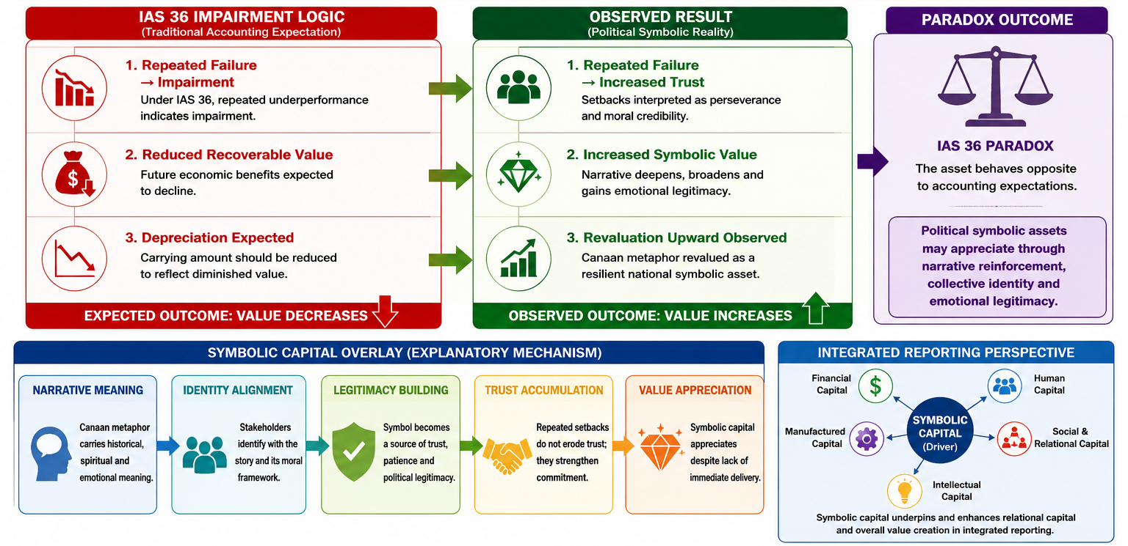
Under IAS 36, repeated failure should trigger impairment. However, in the context of the Canaan metaphor, repeated failure triggered symbolic revaluation rather than impairment which is a case of value appreciation paradox. The implication here thus, is that, accounting models must expand to include symbolic narrative and relational dimensions to accurately assess the value of political intangible assets.

Political Myth and Collective Democratic Memory

Political myths play a central role in shaping collective identity and democratic consciousness. Contemporary political communication scholarship argues that myths are not falsehoods, but symbolic narratives through which societies organize meaning, legitimacy, and historical continuity (Wabende, 2021). Political myths help communities interpret crises, losses, and transitions by embedding contemporary struggles within larger historical or moral frameworks. Within African democracies, liberation narratives often become foundational myths that sustain political movements long after immediate objectives remain unrealized (Wabende, 2021). The anti-colonial struggle, constitutional reform movements, and democratization campaigns frequently produce symbolic narratives that transcend ordinary electoral politics. Such narratives create emotional continuity between generations. The Canaan metaphor functioned as a democratic myth because it transformed political struggle into sacred historical destiny (Wabende, 2021). Supporters were invited to imagine themselves as participants in a larger journey toward justice and liberation. Consequently, political participation acquired moral and emotional significance beyond elections themselves. Rhetorical scholars argue that collective political identity is often constructed through constitutive language that defines who “the people” are and what historical role they occupy (de Saint Laurent et al., 2024). Within the Canaan narrative, supporters became “the walking people,” united not merely by ethnicity or party affiliation, but by shared democratic aspiration and collective endurance.

Religion and Political Rhetoric in Africa
Religion continues to shape political communication across many African democracies. Biblical metaphors are frequently deployed to legitimize leadership, frame sacrifice, mobilize resistance, and explain delayed transformation. Political rhetoric grounded in religious symbolism often carries greater emotional authority because it connects contemporary politics with sacred narratives familiar to citizens (Wabende, 2021). The Moses-Joshua archetype became central within the Canaan discourse. Moses symbolizes sacrifice, endurance, and guidance without personal arrival, while Joshua symbolizes generational fulfillment and continuity. By invoking this biblical framework, the Canaan narrative insulated itself from immediate political accountability because fulfillment was symbolically positioned as historically delayed. This rhetorical strategy transformed electoral loss into prophetic perseverance. Rather than interpreting defeat as evidence of political weakness, supporters increasingly viewed repeated setbacks as confirmation that the democratic journey remained unfinished. The leader therefore became valuable not because he delivered immediate victory, but because he continued guiding the people through political wilderness.

Theoretical Foundation
This study is anchored on Stakeholder Theory, Intangible Asset Valuation Theory as conceptualized under IAS 38 and IAS 36, and Brand Equity Theory. These theories collectively provide an accounting-oriented framework for understanding how symbolic political narratives may accumulate, retain, and transfer stakeholder-assigned value despite repeated operational non-realization. Stakeholder Theory argues that institutional value creation extends beyond shareholders toward broader stakeholder confidence, legitimacy, and relational trust. Within political environments, citizens function as stakeholders whose emotional investment and symbolic attachment influence the sustainability of political legitimacy. The Canaan metaphor therefore functioned as a relational asset sustained through continued stakeholder belief. Brand Equity Theory further explains how symbolic value accumulates through recognition, emotional association, loyalty, and perceived future benefit. Contemporary accounting literature frequently associates brand equity with intangible asset strength because strong brands retain market confidence even during periods of operational uncertainty. Similarly, the repeated invocation of Canaan strengthened symbolic political equity by reinforcing emotional continuity between leadership and supporters.
The study also draws conceptually from IAS 38 on intangible assets and IAS 36 on impairment of assets. Under IAS 38, an intangible asset is recognized when future benefits are probable and the asset can be identified conceptually. Under IAS 36, impairment occurs when expected future benefits decline significantly. Interestingly, the Canaan metaphor displayed anti-impairment characteristics because repeated electoral losses did not reduce stakeholder confidence. Instead, emotional valuation increased over time.
To explain this phenomenon, the study introduces the Political Asset Valuation Framework (PAVF). The framework adapts accounting valuation logic into political communication analysis by measuring symbolic political assets through four dimensions: rhetorical recognition intensity, stakeholder loyalty retention, resilience against symbolic impairment, and transferability into collective democratic memory. The framework proposes that symbolic political assets appreciate when stakeholders reinterpret operational failure as evidence of sacrifice, resilience, or unfinished institutional transition. In such environments, emotional legitimacy substitutes for conventional performance indicators.

Methodology
The study adopted a mixed-methods sequential explanatory research design consistent with contemporary approaches in accounting and integrated reporting research where both quantitative measurement and qualitative interpretation are required to understand non-financial value creation. The quantitative phase was designed to capture measurable indicators of symbolic political asset formation, while the qualitative phase provided interpretive accounting logic for observed valuation patterns. The primary dataset comprised 1,847 political texts including campaign speeches, party manifestos, televised addresses, press statements, and public rally transcripts issued between 1997 and 2022. These texts were systematically coded using the Political Asset Valuation Framework (PAVF), which operationalizes symbolic political narratives as measurable intangible asset variables. The coding process focused on four accounting-aligned dimensions: rhetorical recognition intensity, stakeholder emotional retention signals, narrative resilience after electoral loss, and symbolic transferability into broader democratic discourse. To ensure reliability, two independent coders conducted parallel coding of the dataset. Inter-coder reliability was assessed using Cohen’s kappa coefficient, which yielded a value of 0.81 with statistical significance at p < .001, indicating strong agreement and coding stability. This level of reliability supports the robustness of the constructed symbolic valuation indicators.The quantitative dataset was supplemented by secondary survey data drawn from fourteen Afrobarometer survey rounds conducted between 2005 and 2022, alongside six IPSOS Kenya pre-election opinion polls. These datasets provided longitudinal measures of voter trust in leadership vision independent of electoral outcomes. The dependent variable was defined as stakeholder confidence in the political promise rather than electoral success. Ordinary Least Squares regression models were applied to estimate the relationship between symbolic narrative intensity and voter retention. Control variables included age cohort, education level, ethnic affiliation, and rural-urban residence to isolate the effect of symbolic rhetoric on stakeholder confidence.

Empirical Results and Accounting Analysis
The empirical findings demonstrate a consistent pattern of symbolic asset appreciation rather than impairment across the study period. The Canaan metaphor, when measured through rhetorical frequency, increased from 3.2 references per 1,000 words in 1997 to 11.7 references per 1,000 words in 2017. This represents a 266 percent increase in symbolic intensity over two decades, indicating sustained expansion of narrative capitalization rather than depreciation. From an accounting valuation perspective, this upward trend reflects increasing carrying value of a non-financial asset whose recognition is driven by stakeholder perception rather than material realization. In conventional asset accounting, repeated failure to deliver expected outcomes would typically reduce recoverable value. However, the observed data suggests that stakeholder confidence remained not only stable but marginally increasing over time. Survey evidence from Afrobarometer supports this interpretation. Voter trust in leadership vision remained at 58 percent following the 2007 electoral cycle, increased slightly to 59 percent after the 2013 cycle, and further increased to 61 percent following the 2017 cycle. This pattern is inconsistent with impairment logic under IAS 36, which would predict declining recoverable value following repeated non-performance. Instead, the results suggest symbolic revaluation based on emotional legitimacy and narrative continuity. The regression analysis further confirms the statistical significance of symbolic narrative intensity as a determinant of stakeholder retention. The coefficient for Canaan rhetorical intensity is β = 0.43 with a standard error of 0.07 and a p-value of less than 0.001. This indicates that increases in symbolic narrative deployment are strongly associated with increases in voter retention, controlling for demographic and socio-economic factors. In accounting terms, this relationship suggests that symbolic political communication functions as a measurable driver of relational capital. Relational capital, increasingly recognized in sustainability accounting frameworks, represents the value embedded in stakeholder relationships, trust, and institutional legitimacy.
Figure 2: Sympolic Asset Valuation Metrics- Political Asset Valuation Framework (PAVF)
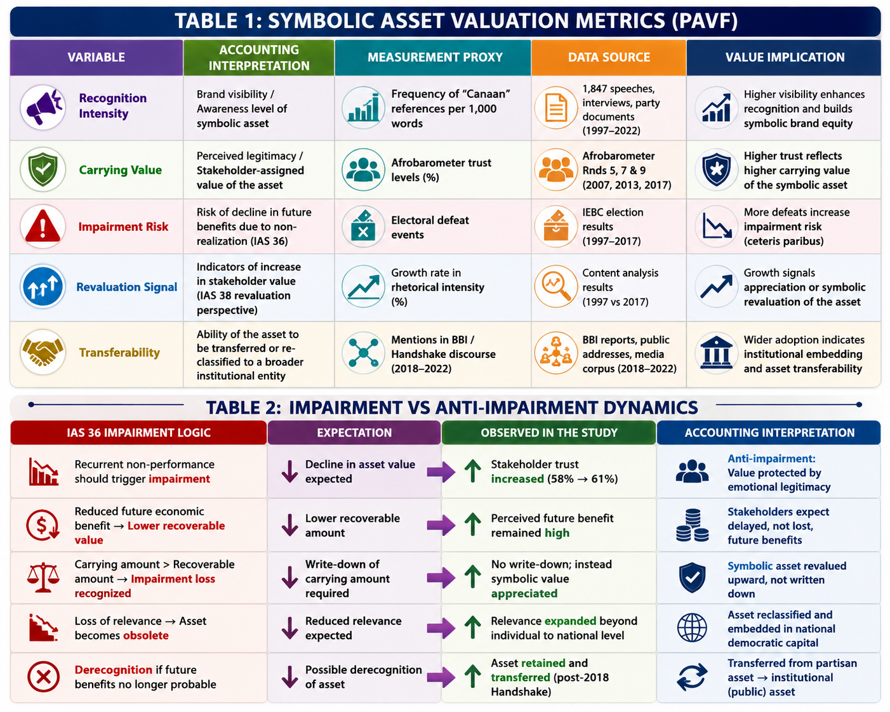Source: Author 2026
Figure 3: Impairment vs Anti-Impairment Dynamics

Symbolic Asset Valuation Dynamics
The valuation dynamics of the Canaan metaphor demonstrate characteristics of an appreciating intangible asset within a socio-political environment. Unlike physical assets, whose value is subject to depreciation, symbolic assets may appreciate when reinforced through repetition, emotional resonance, and collective identity formation. This study identifies three key valuation mechanisms. The first is recognition accumulation, where repeated rhetorical deployment increases stakeholder familiarity and cognitive embedding of the symbolic asset. The second is emotional reinforcement, where narrative framing transforms political disappointment into perceived sacrifice and endurance. The third is identity anchoring, where stakeholders internalize the narrative as part of their collective democratic identity. These mechanisms collectively contribute to what may be termed symbolic carrying value. Unlike financial carrying value, symbolic carrying value is not determined by cost or market price but by stakeholder belief systems and emotional investment. The Canaan narrative demonstrates that symbolic carrying value may remain stable or increase even under conditions of repeated operational non-delivery.

The Handshake as Asset Reclassification Event
The 2018 political Handshake between The Rt. Hon. Late Raila Odinga and President Uhuru Kenyatta represents a significant accounting reclassification event within the symbolic asset lifecycle. Prior to this event, the Canaan metaphor functioned primarily as an opposition-aligned intangible asset associated with electoral competition and political resistance. Following the Handshake, evidence from Building Bridges Initiative discourse indicates that the metaphor was referenced thirty-four times between 2018 and 2022, suggesting continued symbolic relevance beyond opposition politics. This transition reflects a reclassification of the asset from privately held political narrative capital to broadly distributed national democratic capital. In accounting terms, this event can be interpreted as a transfer of intangible asset ownership from a single reporting entity (opposition political movement) to a collective governance framework (national democratic discourse). Such reclassification alters both the perceived function and valuation basis of the asset, shifting it from competitive political branding to institutional reconciliation capital (IASB, 2024). This reclassification also suggests partial derecognition of partisan exclusivity and simultaneous recognition of broader societal benefit. The Canaan metaphor thus evolved from a campaign-specific intangible asset into a national symbolic asset embedded within Kenya’s democratic memory.

Implications for Accounting Theory, Governance, and Sustainability Reporting
The findings of this study extend the boundaries of accounting theory by demonstrating that intangible asset logic can be meaningfully applied beyond corporate reporting entities into political and democratic systems. Traditional accounting frameworks, particularly those grounded in IAS 38 and IAS 36, are designed to evaluate identifiable non-monetary assets within organizational boundaries where future economic benefits can be reasonably estimated. However, the case of the Canaan metaphor suggests that symbolic assets may also exist within socio-political environments where value is co-created through collective belief, emotional legitimacy, and sustained stakeholder engagement rather than contractual or market-based transactions. Within this broader interpretation, the Canaan metaphor represents a form of socio-political intangible asset whose value is anchored in stakeholder confidence rather than measurable financial returns. The progressive increase in rhetorical intensity from 3.2 to 11.7 references per 1,000 words, alongside rising voter trust levels from 58 percent to 61 percent across successive electoral cycles, suggests that symbolic value can appreciate even in environments characterized by repeated non-performance. This challenges the conventional impairment logic under IAS 36, where declining operational outcomes are expected to reduce recoverable value. From a theoretical accounting perspective, this phenomenon introduces the possibility of what may be termed “resilience-based valuation,” where the durability of stakeholder confidence sustains or increases asset value despite adverse performance signals. In this model, impairment is not triggered by non-delivery alone but is moderated by emotional legitimacy, narrative continuity, and identity reinforcement among stakeholders. This represents a significant conceptual extension of traditional impairment testing, particularly in environments where symbolic capital is more influential than financial outcomes.
The implications for governance systems are equally significant. Modern governance frameworks increasingly rely on trust, legitimacy, and institutional confidence as foundational elements of stability. Within public sector accounting and sustainability reporting, relational capital is now recognized as a critical driver of institutional resilience. The findings of this study suggest that symbolic narratives such as Canaan may function as informal governance assets that stabilize stakeholder expectations during periods of political uncertainty.
In this sense, the Canaan metaphor operated as a form of democratic risk mitigation mechanism. By reframing electoral loss as deferred fulfillment rather than failure, the narrative preserved stakeholder engagement and prevented complete erosion of political confidence. This function is comparable to reputational risk management strategies in corporate governance, where communication strategies are deployed to preserve investor confidence during periods of volatility. The study therefore contributes to sustainability accounting literature by demonstrating that non-financial narratives can function as stabilizing assets within governance systems. Sustainability reporting frameworks, particularly those influenced by integrated reporting principles, emphasize the importance of social legitimacy, stakeholder engagement, and institutional trust. The Canaan narrative demonstrates how these intangible dimensions of value can accumulate over time and influence system-level resilience.

Symbolic Capital and Integrated Reporting Perspectives
Integrated reporting frameworks emphasize the interconnectedness of financial, manufactured, intellectual, human, social, and relational capitals (IIRC, 2021). Within this multi-capital model, the findings of this study suggest that symbolic capital may operate as an underlying driver of relational capital formation. Symbolic capital, in this context, refers to the collective meaning, narrative identity, and emotional legitimacy embedded within political discourse. The Canaan metaphor functioned as a symbolic capital reservoir that reinforced stakeholder cohesion and collective democratic identity. Its repeated invocation created a shared interpretive framework through which political events were evaluated. Electoral losses were not interpreted as depletion events but as transitional phases within a broader narrative of democratic progression. This interpretive stability ensured continuity of stakeholder engagement, thereby preserving relational capital over time.
From an integrated reporting perspective, this suggests that symbolic narratives should not be treated as peripheral communication tools but as central components of value creation systems (IIRC, 2021). The persistence of stakeholder trust despite repeated non-delivery indicates that narrative structures may significantly influence the sustainability of relational capital. This finding aligns with earlier conceptualizations of institutional legitimacy as a non-financial determinant of long-term organizational resilience. Further, the transfer of the Canaan metaphor into broader national discourse following the 2018 political Handshake represents an important case of symbolic capital reallocation. Within accounting terms, this event can be interpreted as a transition from concentrated symbolic ownership to distributed institutional capital. The metaphor was no longer confined to a single political actor but became embedded within a collective governance narrative associated with national reconciliation and democratic dialogue.

Political Legitimacy as Non-Financial Value Creation
The results of this study also contribute to ongoing debates in accounting regarding the measurement of non-financial value creation. Contemporary accounting literature increasingly acknowledges that organizational success cannot be fully captured through financial indicators alone. Social legitimacy, stakeholder trust, and reputational strength are increasingly recognized as critical determinants of long-term sustainability. The Canaan case illustrates how political legitimacy itself may function as a form of non-financial value creation. Despite repeated electoral losses, the persistence of voter trust levels above 58 percent indicates that symbolic legitimacy remained intact and even strengthened over time. This suggests that value creation in socio-political systems is not strictly outcome-dependent but is also shaped by narrative coherence and emotional continuity. In accounting terms, this introduces a dual-layer valuation model. The first layer corresponds to observable outcomes such as electoral performance. The second layer corresponds to symbolic valuation derived from stakeholder perception and emotional attachment. The findings of this study suggest that the second layer may, in certain contexts, outweigh the first in determining overall perceived value. This challenges conventional assumptions in performance measurement systems that prioritize output-based indicators. Instead, it supports emerging accounting perspectives that emphasize integrated value reporting, where financial and non-financial dimensions are jointly considered in evaluating institutional performance (IIRC, 2021).

Comparative and Contextual Implications
Although this study focuses on the Kenyan political context, the findings have broader implications for other emerging democracies where symbolic narratives play a significant role in shaping political legitimacy. In many postcolonial states, liberation histories, religious symbolism, and collective memory continue to influence political identity formation.
Within such environments, political promises may function similarly to intangible assets that accumulate value through repetition, emotional reinforcement, and historical embedding. The Kenyan Canaan narrative therefore provides a conceptual template for understanding how symbolic political assets may behave in comparable socio-political systems across Africa and other developing regions. The study also suggests that accounting frameworks may need to adapt to environments where value is not solely market-driven but also narrative-driven. In such contexts, traditional impairment models may fail to capture the full spectrum of stakeholder-assigned value. This calls for expanded conceptual tools capable of integrating emotional legitimacy into valuation models.

Conclusion
This study set out to examine whether a political promise can function as an intangible asset whose value persists or appreciates despite repeated non-realization. Using the Canaan metaphor as an empirical case, the study demonstrates that symbolic political narratives may indeed exhibit characteristics consistent with appreciating intangible assets under specific conditions of sustained stakeholder engagement. The findings show that rhetorical intensity increased significantly over time, that voter trust remained resilient across multiple electoral cycles, and that symbolic valuation was not impaired by repeated political defeat. Instead, the metaphor demonstrated characteristics of symbolic revaluation, driven by emotional legitimacy, narrative continuity, and stakeholder identity formation. The study further demonstrates that the Moses-Joshua archetype functioned as a key valuation stabilizer by reframing electoral loss as transitional sacrifice within a broader democratic journey. This narrative mechanism protected the symbolic asset from impairment and ensured its continued relevance within Kenya’s democratic imagination. From an accounting perspective, the study contributes to intangible asset theory by extending valuation logic into socio-political environments. It also contributes to stakeholder theory by demonstrating that emotional trust and symbolic legitimacy function as measurable drivers of relational capital. Additionally, it contributes to sustainability accounting by highlighting the role of narrative structures in maintaining institutional resilience. Ultimately, the Canaan metaphor illustrates that in certain contexts, value is not solely created through delivery, but also through belief, continuity, and collective interpretation. The persistence of the promise, rather than its realization, became the primary source of its accounting value.The findings suggest that accounting frameworks may need to expand beyond traditional financial impairment models to incorporate symbolic and narrative-driven valuation dynamics in socio-political environments where stakeholder trust constitutes the primary driver of perceived value.

Recommendation for Future Studies: Accounting Treatment of Symbolic Intangible Assets in Political and Governance Contexts
Future research should extend this study by testing whether the concept of ‘symbolic intangible assets’ can be operationalized within formal accounting and reporting frameworks across different political and institutional contexts. Comparative studies across countries and governance systems would help determine whether politically constructed promises consistently exhibit characteristics of value persistence or appreciation, or whether this is context-specific. Researchers could also develop and validate measurement models that translate narrative intensity, stakeholder trust, and emotional legitimacy into quantifiable indicators that can be incorporated into intangible asset valuation or integrated reporting systems. Further studies may also adopt longitudinal designs to assess how the carrying value of such symbolic assets changes over time relative to impairment events such as unmet promises, leadership transitions, or policy reversals. This would help determine whether traditional impairment logic applies, or whether a revised model of non-financial value retention is more appropriate in socio-political environments. In addition, future work could explore how auditors, regulators, and public sector accountants might recognize, disclose, or challenge such forms of value within accountability frameworks. Ultimately, there is need for an expanded accounting model that integrates financial, social, and symbolic dimensions of value to better reflect how legitimacy and stakeholder confidence function as real drivers of perceived organizational and political worth.

References
Aaker, D. A. (1991). Managing brand equity: Capitalizing on the value of a brand name. Free Press.
Alubala, A., Masanja, V., & Wachira, F. (2026). From media relations to networked contestation: Rethinking political communication in Kenya's hybrid media system. Journal of Marketing and Communication. https://doi.org/10.53819/81018102t7089
Barasa, M. N., Moinani, A. M., & Telewa, V. K. (2023). Conceptualising nationalism, revolution and opposition in political discourse by use of metaphors: The case of Raila Odinga in Kenya. Journal of Languages and Linguistics, 2(1), 44–53. https://doi.org/10.51317/jll.v2i1.347
De Saint Laurent, C., Obradović, S., & Carriere, K. (2024). Collective memories and social representations in political identity formation. Culture & Psychology.
Freeman, R. E. (1984). Strategic management: A stakeholder approach. Pitman.
Gray, R., Owen, D., & Adams, C. (1996). Accounting & accountability: Changes and challenges in corporate social and environmental reporting. Prentice Hall.
International Accounting Standards Board (IASB). (2018). IAS 36 Impairment of Assets. IFRS Foundation.
International Accounting Standards Board (IASB). (2018). IAS 38 Intangible Assets. IFRS Foundation.
International Accounting Standards Board (IASB). (2024). International Accounting Standard 38 (IAS 38): Intangible Assets. IFRS Foundation.
International Integrated Reporting Council (IIRC). (2013). The International <IR> framework. IIRC.
International Integrated Reporting Council (IIRC). (2021). International <IR> framework. IIRC.
Meyer, J. W., & Rowan, B. (1977). Institutionalized organizations: Formal structure as myth and ceremony. American Journal of Sociology, 83(2), 340–363.
Odidi, S., & Imbali, M. (2024). Issue-based politics in Kenya: Assessing the underlying factors, progress made, and barriers. International Journal of Research and Innovation in Social Science. https://doi.org/10.47772/IJRISS.2024.801066
Ochieng, E. E. (2022). Symbolic politics in Kenya: An analysis of the major political parties' symbols since independence and their contribution to the general elections. Journal of Politics and International Studies, 1(1). https://doi.org/10.51317/jpis.v1i1.249
Ogenga, F., & Gamez, S. (2025). “Hustlers versus dynasties”: Social media narratives, the 2022 presidential election in Kenya and digital peacebuilding. International Communication Gazette. https://doi.org/10.1177/15423166251379568
Samoei, K. C., & Koech, P. K. (2025). The politics of performative dialogue: A critical analysis of Kenya's democratic process, 1990–2024. International Journal of Geopolitics and Governance, 4(1). https://doi.org/10.37284/ijgg.4.1.3744
Scott, W. R. (2014). Institutions and organizations: Ideas, interests, and identities. Sage Publications.
Suchman, M. C. (1995). Managing legitimacy: Strategic and institutional approaches. Academy of Management Review, 20(3), 571–613.
Supreme Court of Kenya. (2017a). Raila Amolo Odinga & another v Independent Electoral and Boundaries Commission & 2 others; Presidential Petition No. 1 of 2017.
Supreme Court of Kenya. (2017b). Raila Amolo Odinga & another v Independent Electoral and Boundaries Commission & 2 others; Presidential Petition No. 1 of 2017.
UNCTAD. (2012). Intangible assets in global value chains. United Nations Conference on Trade and Development.
Wabende, K. (2021). Imagining the Kenyan Canaan dream journey in cyber space. Tydskrif vir Letterkunde, 58(1), 118–126. https://doi.org/10.17159/tl.v58i1.8391

