“Investigating the Influence of Financial Literacy on Savings Behaviour Within College Students of Ernakulam District”

Ms. Namitha N A
Research Scholar, P G Department of Commerce
Bharata Mata College (Autonomous), Thrikkakara, Kochi – 21
Kerala, India

Dr. Presteena Jesna M Jose
Assistant Professor, P G Department of Commerce
Bharata Mata College (Autonomous), Thrikkakara, Kochi – 21
Kerala, India

ABSTRACT

In today’s fast-paced world, young individuals often engage in excessive spending without fully understanding their financial limits. Financial literacy has become a crucial subject, particularly for the Gen Z population, as it directly impacts their financial decision-making. This research examines the level of financial literacy among college students in the Ernakulam district and its influence on their savings behavior. Financial literacy is assessed through three key components: financial knowledge, financial attitude, and financial management skills. The study explores how these independent variables collectively affect savings behavior, which serves as the dependent variable. Data was collected from 161 college students using a structured questionnaire distributed via Google Forms, and the results were analyzed using the Statistical Package for Social Sciences (SPSS). The findings highlight the significance of financial literacy programs in equipping young adults with essential financial skills, ultimately fostering better financial habits for their future.
Keywords: Financial literacy, Saving behavior, Financial knowledge, Financial attitude, Financial management skills.
INTRODUCTION

Financial literacy has become an essential competence in today’s rapidly evolving economic environment, equipping individuals with the ability to make sound financial decisions and ensure long-term financial well-being. According to the Organization for Economic Co-operation and Development (OECD, 2009), financial literacy is ―a combination of awareness, knowledge, skills, attitude and behaviors necessary to make sound financial decisions and ultimately achieving individual financial wellbeing. Central to this definition are three key components: financial knowledge (FK), financial attitude (FA), and financial management skills (FMS), which form the foundation of this study. Among the many aspects influenced by financial literacy, savings behavior (SB) plays a crucial role in determining an individual's economic stability. In India, financial literacy levels remain alarmingly low. Business Standard (2023) reports that only 27% of Indians are financially literate and a mere 16.7% of students possess basic money management abilities. Moreover, the Asian Development Bank highlights that just 24% of Indian women and 27% of adults meet the minimum threshold for financial literacy. These figures underscore the urgency of understanding and improving financial literacy, especially among young adults. While earlier studies have focused on macro-level determinants of savings behavior—such as income levels, inflation, and demographic shifts (Xu et al., 2020; Ling, 2021)—there remains a gap in research exploring micro-level factors, particularly in the youth demographic. College students, who are transitioning into financial independence, often face complex financial decisions but are frequently overlooked in such studies (Otto, 2009).This study aims to address this gap by examining the influence of financial literacy on the savings behavior of college-going students. It specifically investigates whether financial knowledge, financial attitude, and financial management skills significantly impact students’ saving habits. The research hypothesizes that there is no significant relationship between each of these financial literacy components and savings behavior. By testing these assumptions, the study seeks to uncover whether greater financial understanding leads to more responsible saving practices. The findings are expected to offer valuable insights for educators, policymakers, and financial institutions in designing targeted financial education initiatives that empower youth to make informed financial decisions and build a secure financial future.

RESEARCH OBJECTIVES

- To examine the financial literacy levels among college-going students based on three components: Financial knowledge, financial attitude and financial management skills.

- To study the influence of financial literacy on savings behavior of college-going students.

METHODOLOGY

The study adopts a quantitative research design to examine the influence of financial literacy levels on the savings behavior of college-going students in the Ernakulam district. Financial literacy in this context is assessed through three core components—financial knowledge, financial attitude, and financial management skills—which serve as the independent variables, while savings behavior is treated as the dependent variable. The study area is limited to Ernakulam district, and a sample of 161 college students was selected using the convenience sampling method. Data collection was primarily done through a structured questionnaire developed and distributed digitally using Google Forms, with responses recorded via Google Sheets. Primary data were gathered directly from the respondents through this questionnaire, while secondary data were obtained from relevant journals, books, online articles, newspapers, and websites. The data collected were analyzed using the Statistical Package for Social Sciences (SPSS), which facilitated the generation of tables and statistical outputs essential for interpreting the results.

RESULTS AND DISCUSSION
DESCRIPTIVE FINDINGS

A reliability test confirmed internal consistency, with all four factors showing Cronbach’s Alpha values above 0.7, indicating reliable measurement of the intended constructs.

FINANCIAL KNOWLEDGE
Respondents generally demonstrate a high level of financial knowledge. Mean and mode scores are high (around 4–5), reflecting strong familiarity with financial concepts.

FINANCIAL ATTITUDE
Most respondents show a positive attitude toward saving and investing, with many prepared to save for future emergencies. This suggests a tendency toward responsible financial behavior.

FINANCIAL MANAGEMENT SKILLS
Respondents exhibit strong financial management skills, focusing on essential habits like budgeting, tracking expenses, and saving. They prioritize needs over wants, indicating a solid foundation for financial stability and planning.

CORRELATION ANALYSIS
All variables (Financial Knowledge, Financial Attitude, Financial Management Skills, and Savings Behavior) are significantly and positively correlated at the 0.01 level, indicating strong relationships among them.

REGRESSION ANALYSIS
Regression was conducted with Savings Behavior (SB) as the dependent variable and FK, FA, and FMS as predictors. Key findings include:
- Positive correlation exists between predictors and SB.
- The model explains 56.6% of the variance in SB (R² = 0.566).
- Durbin-Watson statistic = 2.149, indicating no autocorrelation.
- The model is moderately strong and reliable.
- Financial Management Skills have the strongest influence on SB (β = 0.48), followed by FK and FA.

These results suggest that enhancing financial knowledge, attitudes, and management skills can significantly improve savings behavior.

VALIDATED MODEL
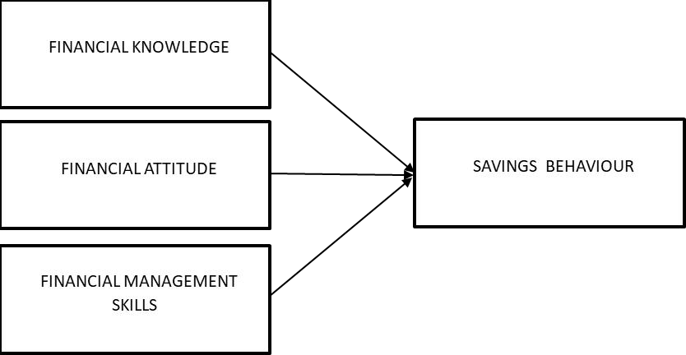
0.48
0.33
0.40

CONCLUSION

This study investigates the influence of financial literacy on the savings behavior of college- going students in Ernakulam district, focusing on three key components of financial literacy: financial knowledge, financial attitude, and financial management skills. The findings reveal that financial literacy significantly impacts students' savings behavior, with financial knowledge and financial management skills being the strongest predictors, while financial attitude plays a comparatively lesser role. These results highlight the importance of enhancing financial literacy among college students to foster better savings habits, which can contribute to long-term financial security. Future research could expand the geographical scope to include students from diverse regions, allowing for comparisons of financial literacy's influence on savings behavior across different socio-economic and cultural contexts. Additionally, longitudinal studies could provide deeper insights into how financial literacy impacts savings behavior over time, especially as students enter the workforce. Exploring the role of digital financial tools and online resources in shaping financial literacy and savings habits among young adults, as well as conducting comparative studies between college students and working professionals, could further enrich our understanding of how financial literacy influences savings behavior at different life stages.

REFERENCES

Alshebami, A. S., & Aldhyani, T. H. H. (2022). The interplay of social influence, financial literacy, and saving behaviour among Saudi youth and the moderating effect of self-control. Sustainability, 14(14), Article 8780. https://doi.org/10.3390/su14148780
Chakravorty, P., & Sharma, S. (2022). Financial literacy among college students: A study in some selected area of Guwahati. Specialusis Ugdymas, 1(43), 4988–4994.
Chawla, D., Bhatia, S., & Singh, S. (2022). Parental influence, financial literacy and investment behaviour of young adults. Journal of Indian Business Research, 14(4), 520–539. https://doi.org/10.1108/JIBR-10-2021-0357
Elnadi, M., & Gheith, M. (2021). Entrepreneurial ecosystem, entrepreneurial self-efficacy, and entrepreneurial intention in higher education: Evidence from Saudi Arabia. International Journal of Management Education, 19, Article 100458. https://doi.org/10.1016/j.ijme.2021.100458
Godwin, A., Rihan, A., Wilson, A., & P. J., A. (2023). A study on personal finance management system among youngsters with special reference to Ernakulam district. Journal of Finance and Management, 5(2), 120–135.
Mpaata, E., Koske, N., & Saina, E. (2021). Does self-control moderate financial literacy and savings behavior relationship? A case of micro and small enterprise owners. Current Psychology. Advance online publication. https://doi.org/10.1007/s12144-021-01911-y
Owusu, G. M. Y., Ossei Kwakye, T., & Duah, H. (2024). The propensity towards indebtedness and savings behaviour of undergraduate students: The moderating role of financial literacy. Journal of Applied Research in Higher Education, 16(2), 583–596. https://doi.org/10.1108/JARHE-11-2022-0340
Pandey, A., Ashta, A., Spiegelman, E., & Sutan, A. (2020). Catch them young: Impact of financial socialization, financial literacy and attitude towards money on financial well-being of young adults. International Journal of Consumer Studies, 44(6), 531–544. https://doi.org/10.1111/ijcs.12583
Pahlevan Sharif, S., Ahadzadeh, A. S., & Turner, J. J. (2020). Gender differences in financial literacy and financial behaviour among young adults: The role of parents and information seeking. Journal of Family and Economic Issues, 41(4), 672–690. https://doi.org/10.1007/s10834-020-09664-2

ETHICAL APPROVAL

This is to certify that the research study titled “Investigating the Influence of Financial Literacy on Savings Behaviour Within College Students of Ernakulam District” has obtained ethical approval from the concerned authority/institution. The study was conducted in accordance with standard research ethical guidelines. The research did not involve any harm to human participants or animals, and informed consent was obtained wherever applicable.


Name: Namitha N A_________________________
Designation: Research Scholar________________________
P G Department of Commerce
Bharata Mata College (Autonomous) Ernakulam


Name: Presteena Jesna M Jose
Designation: Assistant Professor
P G Department of Commerce
Bharata Mata College (Autonomous) Ernakulam

