Smart Chatbots for Human Resources
A Literature Review–Based Study
Parth Mahendra Deorukhkar  Dept. of Electronics and  Telecommunications Engineering  Thakur College of Engineering  and Technology  Mumbai, India  1032221464@tcetmumbai.in | Gaurav Ajit Desai  Dept. of Electronics and  Telecommunications Engineering  Thakur College of Engineering  and Technology  Mumbai, India  1032221466@tcetmumbai.in | Soham Dhanaji Dhumal  Dept. of Electronics and  Telecommunications Engineering  Thakur College of Engineering  and Technology  Mumbai, India  1032221468@tcetmumbai.in

Abstract—The integration of Artificial Intelligence (AI)-powered chatbots into Human Resource Management (HRM) is progressively reshaping how organizations handle routine operations, candidate engagement, and staff support. Early HR chatbot systems were constrained to scripted responses for common policy inquiries, but the rapid advancement of Natural Language Processing (NLP) and Large Language Models (LLMs) has given rise to sophisticated conversational systems capable of dynamic interaction, tailored guidance, and seamless enterprise integration. While the advantages are substantial, deployment of HR chatbots also brings considerable challenges, including the potential for algorithmic bias, limited interpretability, data privacy vulnerabilities, and the risk of over-delegating sensitive personnel decisions to automated systems. Significantly, the EU AI Act classifies employment-related AI tools as high-risk applications, imposing strict compliance and oversight obligations.
Keywords—Human Resources, Chatbots, Generative AI, Recruitment, NLP, Large Language Models, Responsible AI.
I. Introduction
The accelerating digitalization of Human Resource Management (HRM) has been significantly shaped by the adoption of Artificial Intelligence (AI)-based tools. Among these, chatbots—software systems engineered to replicate human conversational behavior—have emerged as an increasingly influential instrument for both talent acquisition and employee support services. Modern HR chatbots are capable of screening applicants, organizing interview schedules, responding to policy-related questions, and guiding staff through onboarding activities. Unlike conventional HR web portals, these systems offer continuous availability, natural conversational interfaces, and a degree of personalization that measurably improves the experience of both candidates and employees [1], [3], [4].
The global HR technology sector is forecasted to surpass USD 35 billion by 2030, with conversational AI identified as one of its principal growth drivers [1]. Enterprises of varying scale—from large multinationals to smaller firms—are deploying chatbots to manage high-volume interactions, such as processing thousands of job applications during active recruitment cycles or handling routine HR inquiries in geographically dispersed organizations [5].
Empirical research has documented meaningful performance improvements, including shorter recruitment timelines, greater recruiter efficiency, and faster resolution of employee queries [3], [5], [6]. Nevertheless, enthusiasm for these technologies must be weighed against documented concerns, which include:
• Algorithmic discrimination, where evaluation outcomes may be skewed due to imbalanced training data or language and accent-related disparities [2], [14].
• Interpretability deficits, as many chatbot systems are unable to explain their reasoning, creating regulatory compliance difficulties [7].
• Data protection risks, given that HR systems store some of the most sensitive categories of personal information [11].
• Over-reliance on automation in high-stakes decisions such as promotions or disciplinary procedures, where contextual nuance is critical [15].
Regulatory developments reflect these concerns. Under the EU AI Act (2024/2025), AI tools applied in employment and workforce management are formally categorized as high-risk, requiring comprehensive risk management, documentation, transparency, and human supervision [7], [8]. Complementary guidance is provided by the NIST AI Risk Management Framework [9], [10] and ISO/IEC 23894:2023 [11].
II. Background & Technical Foundations
A. The Development of HR Chatbots Over Time
HR chatbots have progressed through three distinct technological phases:
1) Rule-Based Systems (pre-2015): The earliest HR chatbots functioned as structured FAQ systems, guiding users through fixed menus and keyword-matching rules. Their functionality depended on predefined decision trees rather than genuine linguistic understanding. Though limited in adaptability, these systems reliably served repetitive use cases such as answering questions about leave policies [4].
2) ML-Based NLP Systems (2015–2020): Advances in Natural Language Understanding (NLU) enabled classification of user intents and extraction of relevant parameters like dates or employee identifiers. Platforms including Dialogflow, Microsoft Bot Framework, and Rasa [18] enabled dynamic multi-turn dialogues and HRIS integration.
3) Transformer-Based and LLM-Powered Systems (2020–present): The introduction of transformer architectures [17] and models such as BERT and GPT has fundamentally transformed chatbot capabilities. Contemporary HR chatbots built on LLMs can handle previously unseen queries, produce contextually nuanced responses, and leverage retrieval-augmented generation (RAG) pipelines to anchor outputs in verified HR documentation [16].
B. Natural Language Understanding (NLU) Pipeline
A standard NLU pipeline for HR applications encompasses:
1) Input Processing: Tokenization, stemming, and vector representation of HR queries.
2) Intent Classification: Categorizing queries into domains such as leave, payroll, or benefits using fine-tuned classifiers achieving over 90% accuracy on enterprise HR datasets [17].
3) Entity Detection: Identifying specific parameters such as dates, employee IDs, or job titles using Named Entity Recognition (NER).
4) Dialogue Management: Maintaining conversational state to support multi-turn interactions, often using reinforcement learning-based dialogue managers [18].
5) Response Synthesis: Generating templated or dynamically composed responses, increasingly via RAG pipelines drawing on verified HR knowledge bases.
C. Technical Architectures for HR Chatbots
1) Rule-Based Dialogue Flow: Effective for structured workflows such as onboarding checklists, but inflexible.
2) NLU + Intent/Entity Model: Suited for HR helpdesks with predictable query categories; integrates with HRIS through APIs.
3) LLM + RAG Hybrid (State of the Art): Balances generative fluency with factual grounding through retrieval from HR policy databases and compliance libraries.
4) Multimodal Systems: Emerging platforms supporting voice and text input, incorporating automatic speech recognition (ASR) and sentiment detection [16].
D. Integration with HR Systems
Modern HR chatbots operate in conjunction with a range of organizational platforms:
• HRIS platforms for payroll, leave records, and employee data.
• Applicant Tracking Systems (ATS) for candidate pipelines and resume screening.
• Collaboration platforms such as Microsoft Teams or Slack for omnichannel support.
• Identity management systems using single sign-on (SSO) for secure data access.
E. Security and Privacy Considerations
Because HR chatbots process highly sensitive personal data, security must be an integral design consideration:
• Data minimization: Restricting queries to only operationally necessary fields.
• Encryption: TLS 1.3 for data in transit; AES-256 for stored data.
• Anonymization: Removing PII prior to using interaction logs for model training.
• Adversarial defense: Protecting against prompt injection, model inversion, and data poisoning.
F. HR-Specific NLP Challenges
HR chatbots encounter unique linguistic and contextual challenges including:
• Industry-specific terminology such as provident fund contributions, gratuity, and leave travel allowances.
• Multilingual requirements, particularly in India where queries may span English and regional languages.
• Accent variation in voice-enabled interview systems requiring fair processing of diverse speech patterns [14].
• Legal precision in sensitive domains such as leave entitlements and grievance handling.
III. Literature Review (2019–2025)
Scholarly work on HR chatbots has grown substantially in recent years, encompassing adoption behavior, performance outcomes, user perception, and ethical and compliance risks. The following subsections synthesize key findings from global and context-specific research.
A. Patterns of Global Adoption
The deployment of AI chatbots in HR reflects broader enterprise digitalization strategies. Research by Nawaz et al. [1] indicates that organizations are increasingly deploying conversational agents to manage high-volume, repetitive HR functions including candidate outreach, scheduling, and routine employee inquiries. In North American and European contexts, large organizations treat chatbots as essential infrastructure for managing distributed teams [4]. In emerging economies such as India, adoption is driven by the need to handle exceptionally high applicant volumes during mass hiring campaigns [6].
Small and mid-sized enterprises (SMEs) have historically approached chatbot adoption more cautiously, primarily due to concerns about deployment costs and system integration complexity [3]. However, cloud-hosted chatbot-as-a-service solutions have substantially lowered these barriers, enabling SMEs to implement pre-configured systems through platforms such as Microsoft Teams and Slack [18].
B. Chatbots in Recruitment Processes
Recruitment automation represents one of the most extensively studied HR chatbot applications. Nahid et al. [5] report that chatbots measurably reduce recruitment timelines by automating resume screening, candidate FAQ responses, and interview coordination. Candidate satisfaction is generally higher when chatbots provide real-time responses compared to asynchronous email-based communications.
Bittner et al. [2] document algorithm aversion—a tendency among candidates and recruiters to distrust chatbot recommendations in screening contexts. This reluctance decreases when systems are transparent about limitations and human oversight is retained. A qualitative study from India [6] found that while recruiters acknowledge efficiency benefits, chatbots are perceived as inadequate for senior or specialized roles demanding nuanced, relationship-oriented engagement.
Bias in recruitment chatbots has received significant scholarly attention. Reports indicate that AI-driven interview tools may unfairly disadvantage candidates with non-native accents or atypical speech patterns [14]. The research consensus is that fairness depends on training data representativeness and the capacity to audit model behavior [2], [13].
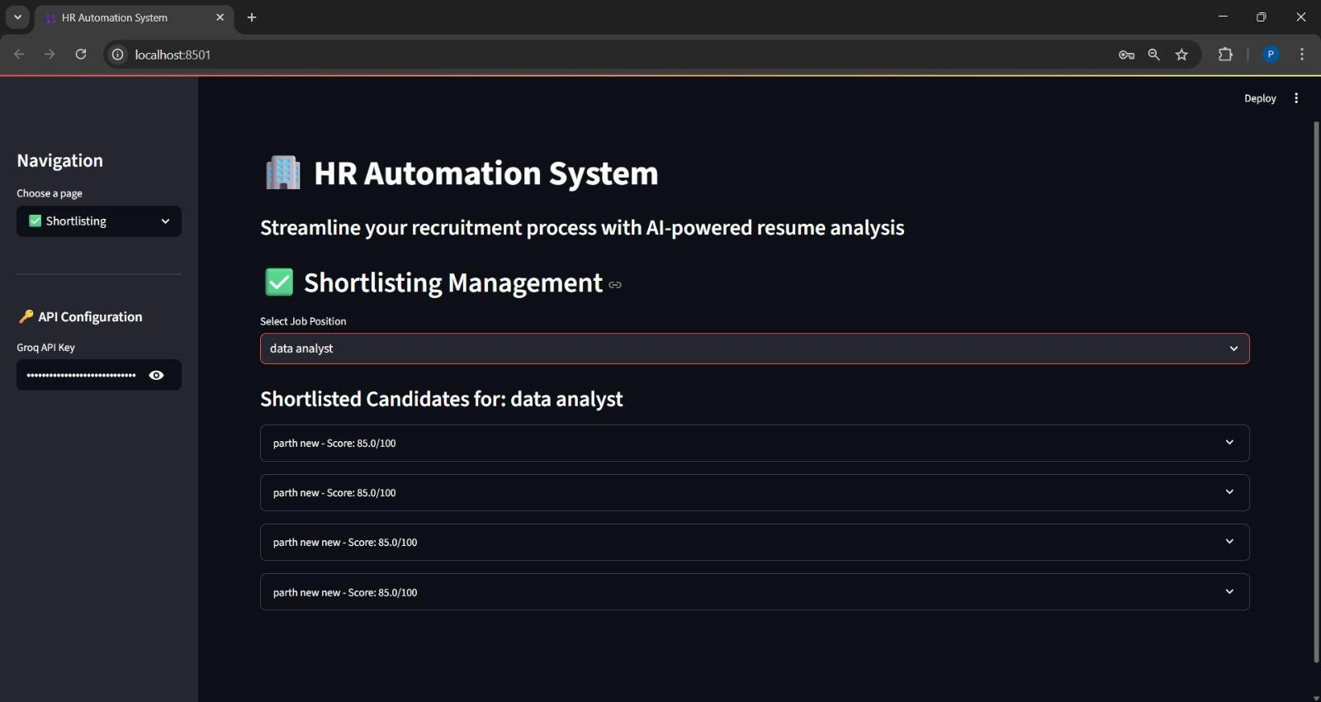
Fig. 1. HR Automation System – AI-powered Shortlisting Management interface.
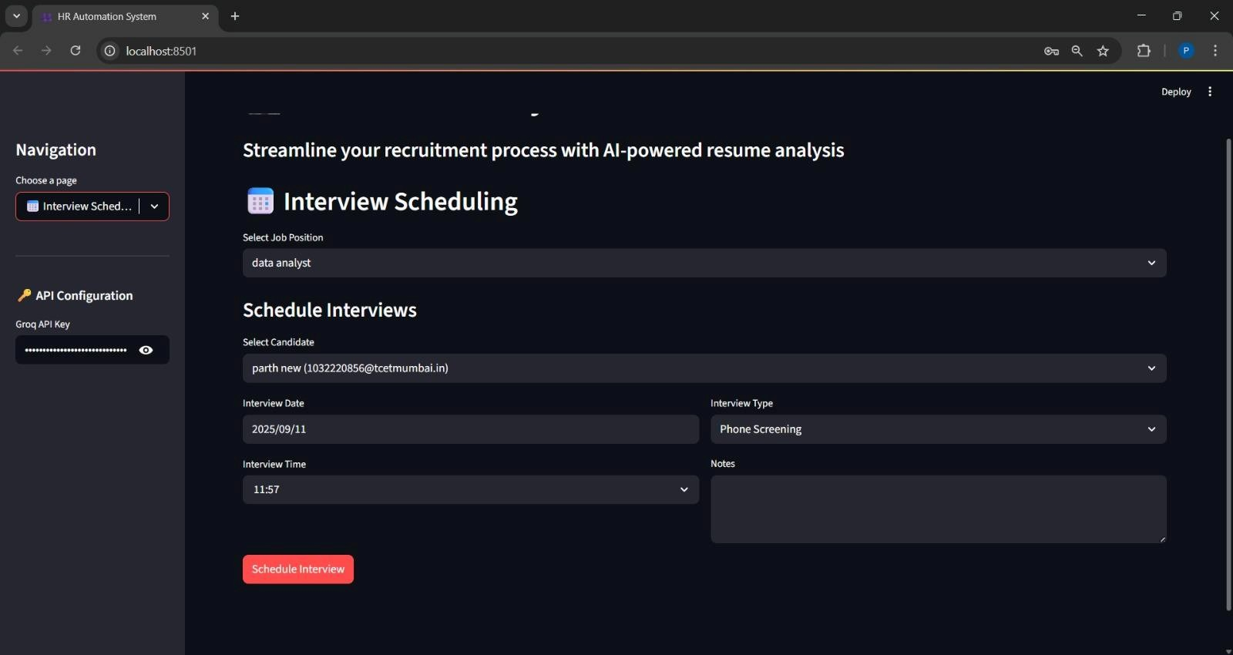
Fig. 2. HR Automation System – Interview Scheduling module.
C. Candidate Experiences and Perceptions
Candidates generally perceive chatbots favorably for handling routine inquiries such as checking application status or eligibility criteria [5]. Among digitally native applicants, interacting with chatbots is considered natural, and many prefer the speed of chatbot responses over waiting for recruiter availability [3].
Perceptions shift negatively when candidates learn that chatbots are involved in evaluative decisions such as resume ranking or shortlisting. Bittner et al. [2] report that candidates frequently express frustration with opacity—the inability to understand why a decision was made or to request a review. Cultural context also plays a role: in collectivist societies, candidates may prefer human interaction as a signal of organizational commitment [6].
D. Employee Self-Service and Internal Support
Beyond recruitment, chatbots have shown utility in internal HR functions. Septiani et al. [4] report that chatbot deployment reduces HR helpdesk workloads by resolving repetitive queries related to leave management, benefits, and policy clarification. Employees in large organizations value round-the-clock access, especially across different time zones.
A recurring concern is employee frustration when chatbots fail to escalate complex or emotionally sensitive queries to human representatives. This supports the conclusion that optimal HR chatbot deployment involves a hybrid service model, where automated systems manage routine tasks while human agents remain available for nuanced situations [11].
E. Organizational Outcomes and ROI
Sharma et al. [3] identify measurable reductions in recruitment cycle times and onboarding duration, with certain case studies reporting time-to-hire reductions of up to 30%. HR teams are additionally able to redirect capacity from administrative work toward strategic workforce planning.
However, return on investment is not guaranteed. Septiani et al. [4] caution that chatbot effectiveness is heavily dependent on content quality, HRIS integration depth, and commitment to ongoing maintenance. Outdated knowledge bases erode employee trust and drive reversion to traditional HR channels. The computational costs of maintaining LLM-powered systems can also offset efficiency gains in the absence of sufficient scale.
F. Risks Highlighted in Literature
Three categories of risk receive consistent emphasis across the literature: algorithmic bias [2], [14], limited explainability [8], and data security vulnerabilities [11]. HR chatbots, by virtue of accessing employee and candidate records, become targets for cyberattacks and adversarial inputs. Qualitative research additionally highlights the risk of employee alienation when sensitive HR interactions—such as performance reviews or grievance processes—are managed exclusively by automated systems [15].
G. Regional Perspectives
In the United States and Europe, chatbot deployment is shaped by regulatory compliance, particularly GDPR alignment [8]. In Asia-Pacific markets, adoption is driven by the need to manage large applicant volumes efficiently [6]. In Australia, public discourse has been marked by concerns about discriminatory outcomes and regulatory gaps [14]. This diversity underscores that HR chatbot strategies must be tailored to regional environments, cultural norms, and labor market conditions.
H. Cross-Sector Comparisons
Insights from healthcare [9], [13] and education [17] offer valuable comparative learnings for HR chatbot research. In both sectors, conversational agents prove most effective when narrowly scoped, regularly updated, and rigorously evaluated for usability. These parallels support the conclusion that domain-specific model fine-tuning and content governance are universal prerequisites for effective deployment.
IV. Result Discussion and Analysis
The findings synthesized from the literature collectively affirm the transformative potential of AI-powered HR chatbots across recruitment, onboarding, employee self-service, and performance management. Studies consistently document improvements in operational efficiency, cost reduction, and user satisfaction [6], [9], [11]. Recruitment-focused research demonstrates marked reductions in time-to-hire, while onboarding studies report better knowledge retention among newly hired staff [10], [13]. A unifying theme is that automation of routine HR tasks frees professionals to concentrate on higher-order responsibilities—consistent with the broader trajectory of digital HRM transformation [2].
Comparative analysis across use cases reveals persistent constraints. While employee self-service chatbots resolve approximately 70% of incoming queries [7], they consistently struggle with context-sensitive or emotionally complex requests, leading to user frustration [5]. Performance management chatbots, while effective at increasing feedback interaction frequency [14], are limited in processing qualitative data—a shortcoming attributable to current constraints in natural language understanding. This suggests chatbot value is most pronounced in transactional HR domains, while strategic and relational HR functions continue to require significant human involvement [4].
Trust and data privacy constitute another critical dimension. Research consistently indicates that employees are reluctant to share sensitive matters—such as personal grievances or health-related leave—through chatbot interfaces [15]. This caution stems from insufficient transparency regarding how interaction data is stored, processed, and potentially used in performance evaluations. While technical advances such as RAG pipelines [16] and multilingual embeddings [18] have improved response accuracy, they do not inherently address the psychological and ethical dimensions of user trust.
From a technical standpoint, transformer-based NLP architectures—particularly BERT and GPT variants—have materially advanced intent classification and contextual understanding [17]. However, the substantial data requirements of these models introduce cost and bias risks, particularly when training datasets are unrepresentative of the intended user population [12]. Despite growing interest in bias mitigation techniques and explainable AI (XAI), their practical integration into deployed HR chatbot systems remains nascent [12], [17].
Regional patterns further illustrate the importance of context-sensitive design. Organizations in North America and Europe prioritize candidate experience and workforce engagement [2], whereas multilingual functionality is the primary concern in Asia-Pacific deployments [18]. Middle Eastern and Latin American organizations tend to adopt chatbots primarily for cost reduction in HR service operations [19], [20].
A significant gap in the literature concerns longitudinal outcomes. The overwhelming majority of existing studies focus on short-term performance metrics without examining sustained organizational impact. It remains unclear whether chatbot-facilitated onboarding translates into lasting employee engagement or whether recruitment chatbots improve long-term workforce quality. Addressing this gap will require multi-year case studies and integration of chatbot performance into broader HR analytics frameworks [14], [16].
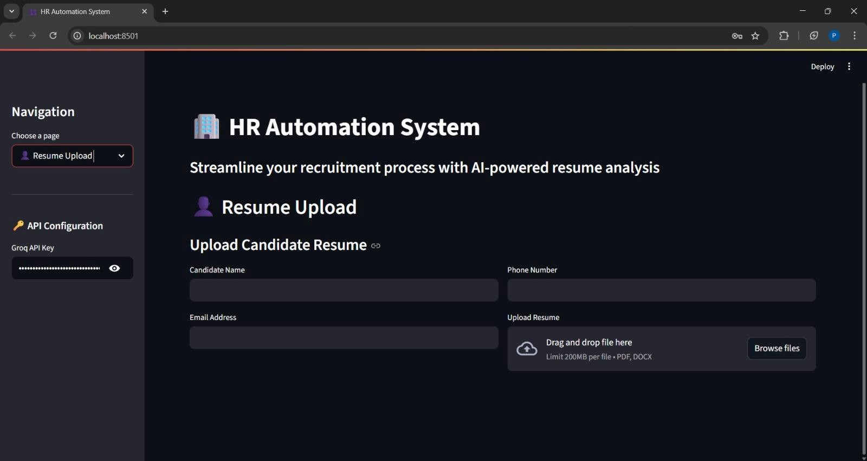
Fig. 3. HR Automation System – Resume Upload and candidate registration interface.
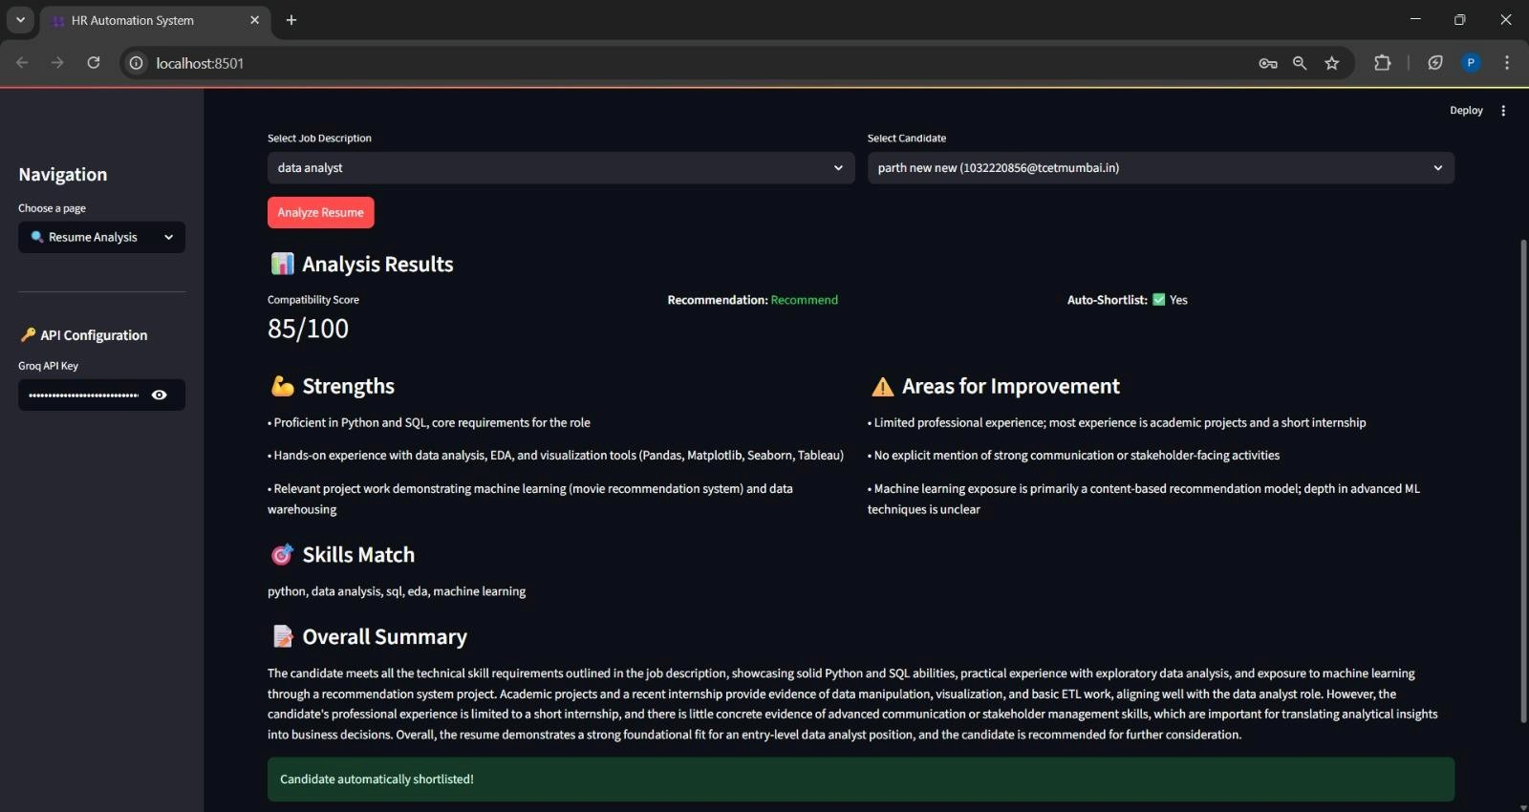
Fig. 4. HR Automation System – AI-driven candidate evaluation and scoring interface.
V. Future Research Directions
The existing body of research on HR chatbots reflects meaningful progress in task automation and service delivery, but numerous substantive questions warrant further investigation. Future inquiry must address both the technical advancement of AI systems and the organizational and ethical conditions necessary for responsible HR chatbot deployment.
On the technical side, there is a pressing need for domain-adapted NLP models specifically trained on anonymized HR datasets. Although transformer architectures such as BERT, RoBERTa, and GPT have significantly advanced intent recognition and contextual comprehension [16], [17], they continue to struggle with specialized HR vocabulary and nuanced employee queries. The development of HR-specific language models, combined with RAG and knowledge graph-based reasoning [16], could produce systems that offer both conversational fluency and grounded factual accuracy.
Addressing algorithmic bias and improving fairness in recruitment and performance evaluation systems also represent urgent research priorities. Studies demonstrate that biased training data can systematically disadvantage certain demographic groups [12], creating both legal risk and ethical harm. Future research should advance bias detection algorithms, auditing methodologies, and practical application of explainable AI (XAI) in HR contexts [17]. The application of federated learning techniques offers a promising avenue for training more representative models without compromising employee data privacy [18].
Scalability and multilingual adaptability also require further attention. Studies of deployment patterns across Asia-Pacific, the Middle East, and Latin America [18], [19] indicate that organizations in these regions require chatbot interfaces capable of functioning effectively across multiple languages and cultural contexts. Research into cross-lingual embeddings and low-resource NLP methods could substantially expand the accessibility and reliability of HR chatbots in diverse global settings.
From an organizational and behavioral perspective, longitudinal research is needed to understand how employee trust evolves through sustained chatbot interactions [15]. Designing hybrid HR service models—where chatbots handle initial contact and escalate complex matters to human staff—may represent the most viable approach for balancing automation with empathetic service [6], [14].
Future work should also examine the integration of HR chatbots into broader workforce analytics ecosystems. Systems capable of aggregating interaction data across the employee lifecycle could support predictive insights for strategic decisions such as workforce planning, retention, and diversity initiatives [20]. Finally, cross-industry, multi-year studies are essential for evaluating the sustained impact of chatbot adoption across diverse sectors [14], [19].
VI. Conclusion
The growing integration of AI-powered conversational agents into organizational HR functions marks a meaningful inflection point in the digital transformation of people management. This literature review has demonstrated that HR chatbots have progressed well beyond their origins as basic FAQ tools, evolving into multifunctional platforms capable of supporting recruitment, onboarding, training coordination, and performance facilitation [4], [6]. These systems provide organizations with a scalable mechanism to reduce administrative burden, enhance stakeholder experience, and realize operational efficiencies.
The synthesis of current literature reveals that one of the most significant contributions of HR chatbots lies in their capacity to strengthen employee engagement and organizational responsiveness. Systems that offer continuous availability and immediate response times reduce employee frustration and signal organizational investment in service quality [5], [7]. Recruitment-oriented chatbots have shown measurable promise in streamlining application workflows, improving candidate experience, and reducing cognitive demands on HR professionals [9].
At the same time, this review has consistently surfaced limitations and risks that cannot be minimized. Concerns around bias, fairness, and transparency appear repeatedly across the literature [12], [17]. The dependence of chatbot systems on historical training data creates tangible risks of entrenching systemic inequities, particularly in recruitment and promotion contexts. Issues of trust, data privacy, and cultural responsiveness remain significant barriers to broader adoption [14], [15], [18].
Technologically, the integration of advanced NLP architectures, explainable AI, and federated learning presents clear opportunities for enhancement [16], [17]. On the organizational side, hybrid HR service models—where automation and human judgment operate in complementarity rather than competition—are likely to represent the most productive deployment paradigm [6], [14].
In conclusion, HR chatbots represent a transformative yet transitional technology. They currently perform effectively as operational assistants capable of automating routine HR functions and improving user experiences. Their future trajectory may extend significantly further—toward shaping organizational strategy and culture. Achieving that vision will require coordinated contributions from technologists, HR practitioners, behavioral scientists, and policymakers. HR chatbots therefore embody both the promise and the complexity of AI-driven transformation—offering organizations an unprecedented opportunity to reimagine human resource management for the age of artificial intelligence [6], [14], [16], [20].
References
[1] S. Koivunen et al., "The march of Chatbots into recruitment: recruiters’ experiences, expectations, and design opportunities," Computer Supported Cooperative Work (CSCW), 2022.
[2] J. Devlin et al., "BERT: Pre-training of Deep Bidirectional Transformers for Language Understanding," arXiv, 2018.
[3] M. Honnibal et al., "spaCy: Industrial-strength Natural Language Processing in Python," 2020.
[4] W. X. Zhao et al., "A survey of large language models," arXiv, 2023.
[5] Q. Chen, Z. Zhu, and W. Wang, "BERT for joint intent classification and slot filling," arXiv, 2019.
[6] H. Shelar et al., "Named entity recognition approaches and their comparison for custom NER model," Science & Technology Libraries, 2020.
[7] I. Paparrizos, B. B. Cambazoglu, and A. Gionis, "Machine learned job recommendation," Proc. 5th ACM Conf. Recommender Systems, 2011.
[8] L. Zhou, J. Gao, D. Li, and H. Y. Shum, "The design and implementation of XiaoIce, an empathetic social chatbot," Computational Linguistics, 2020.
[9] S. A. Sheikh, V. Tiwari, and S. Singhal, "Generative model chatbot for Human Resource using Deep Learning," Proc. ICDSE, 2019.
[10] T. Taule, A. Følstad, and K. I. Fostervold, "How can a chatbot support human resource management? Exploring the operational interplay," Chatbot Research and Design Workshop, 2021/2022.
[11] K. Venusamy, N. K. Rajagopal, and M. Yousoof, "A study of human resources development through chatbots using artificial intelligence," Proc. ICISS, 2020.
[12] B. Shneiderman, "The dangers of faulty, biased, or malicious algorithms requires independent oversight," Proc. National Academy of Sciences, 2016.
[13] F. D. Davis, "Perceived usefulness, perceived ease of use, and user acceptance of information technology," MIS Quarterly, 1989.
[14] J. Whittlestone, R. Nyrup, A. Alexandrova, and S. Cave, "The role and limits of principles in AI ethics: Towards a focus on tensions," AAAI/ACM Conf. AI, Ethics, and Society, 2019.
[15] W. Rodgers et al., "An artificial intelligence algorithmic approach to ethical decision-making in human resource management processes," Human Resource Management Review, 2023.
[16] S. Strohmeier and F. Piazza, "Artificial intelligence techniques in human resource management—a conceptual exploration," Intelligent Techniques in Engineering Management, 2015.

