An Integrated Community Empowerment Model for the Minang Saiyo Padang Pariaman Entrepreneurial Diaspora in Malaysia

Abstract
This community service initiative aims to design and implement an integrated empowerment model for the Minang Saiyo Padang Pariaman community in Malaysia as part of strengthening diaspora capacity through a multidisciplinary approach. The program integrates expertise in food processing, digital literacy, management, mental health, and geography education within a comprehensive intervention framework. The methods employed include a participatory approach through needs assessment, technical training in food processing based on local potential, assistance in community-based business management, mental health education to enhance psychosocial well-being, and the strengthening of geographical literacy to support a better understanding of the living environment and mobility of the diaspora. The results indicate significant improvements in participants’ competencies across all domains: enhanced food processing skills and product diversification, increased digital marketing capabilities, improved business management practices, greater psychological resilience, and enriched spatial awareness and environmental understanding. This integrated model demonstrates that multidisciplinary community service, when tailored to the specific context of diaspora communities, can effectively strengthen collective identity, entrepreneurial capacity, and sustainable livelihoods.
Keywords: community empowerment; diaspora; Minang Saiyo; multidisciplinary approach; Malaysia

1. INTRODUCTION
Diaspora communities represent a unique and underexplored asset in the global development landscape. These communities, often characterized by strong cultural bonds, shared histories, and entrepreneurial drive, have the potential to contribute significantly to both their host countries and their countries of origin. The Minang Saiyo Padang Pariaman community in Malaysia is one such diaspora group whose members have migrated from West Sumatra, Indonesia, bringing with them rich cultural traditions, culinary heritage, and a deeply rooted spirit of merantau — a Minangkabau cultural practice of voluntary migration to gain experience and prosperity.
Despite their entrepreneurial spirit and cultural cohesion, diaspora communities frequently encounter complex challenges in navigating the socioeconomic landscape of their host countries. These challenges include limited access to formal business development support, barriers in digital technology adoption, gaps in business management knowledge, psychosocial stressors related to cultural displacement, and insufficient understanding of their geographical and social environment in Malaysia. Addressing these multifaceted challenges requires an intervention model that goes beyond single-sector approaches and instead embraces an integrated, multidisciplinary framework.
Community empowerment has emerged as a central paradigm in participatory development, emphasizing the agency, capabilities, and collective strength of communities as drivers of their own development. Empowerment approaches that integrate capacity building across multiple domains — technical, managerial, psychological, and spatial — have shown greater effectiveness in sustaining long-term outcomes compared to fragmented interventions. However, the application of such integrated models to diaspora entrepreneurial communities remains limited in the literature, particularly for Southeast Asian diaspora groups.
This community service initiative responds to this gap by designing and implementing an integrated empowerment model for the Minang Saiyo Padang Pariaman community in Malaysia. The program brings together expertise from five interconnected disciplines: fisheries and food processing technology, English and digital communication, digital business management, geography education, and guidance and counseling. Through this collaboration, the initiative addresses the diverse needs of the community in a holistic and contextually sensitive manner.
The significance of this initiative lies not only in its practical outcomes for the target community but also in its contribution to the broader field of community service scholarship. By documenting and analyzing an integrated, multidisciplinary empowerment model applied to a diaspora context, this article aims to offer a replicable framework for similar communities in Malaysia and beyond. The following sections present the theoretical foundations, methodological framework, program implementation, results, and reflections on the lessons learned through this initiative.
2. LITERATURE REVIEW
2.1 Diaspora Communities and Entrepreneurship
The concept of diaspora entrepreneurship has gained increasing scholarly attention over the past two decades, particularly in the context of developing transnational economic linkages and leveraging migrant social capital. Portes et al. (2002) highlighted that diaspora entrepreneurs often occupy a unique position between their origin and host societies, utilizing dual social networks and cultural knowledge as competitive advantages. In the Southeast Asian context, Minangkabau migrants have historically demonstrated strong entrepreneurial tendencies, driven by the merantau tradition that encourages migration as a rite of passage and economic strategy (Naim, 1979).
Research on Indonesian diaspora communities in Malaysia underscores both the opportunities and vulnerabilities associated with migrant entrepreneurship. While many migrants establish small-scale food and trade businesses, they frequently lack access to formal business development services, capital, and professional networks (Hugo, 2007). Consequently, diaspora entrepreneurship often remains confined to informal economic activities with limited growth potential. Capacity-building interventions that enhance technical skills, business acumen, and digital competency are therefore critical for enabling diaspora entrepreneurs to formalize and scale their enterprises.
2.2 Community Empowerment Frameworks
Community empowerment theory, as articulated by Rappaport (1987) and subsequently elaborated by scholars such as Zimmerman (2000), posits that empowerment is a multilevel construct encompassing individual, organizational, and community dimensions. At the individual level, empowerment involves the development of knowledge, skills, and self-efficacy; at the organizational level, it refers to the strengthening of collective structures and resources; and at the community level, it entails the mobilization of social capital and advocacy capacity.
Participatory approaches to community empowerment, rooted in the tradition of Freire’s (1970) critical pedagogy, emphasize the importance of engaging community members as active co-creators of the development process rather than passive recipients of assistance. This epistemological stance has profound implications for program design, necessitating thorough needs assessments, collaborative planning, and ongoing reflection cycles. The integrated model implemented in this initiative draws explicitly on these principles, situating the community’s existing strengths and locally identified needs as the foundation for all program components.
2.3 Multidisciplinary Approaches to Community Service
The limitations of single-sector approaches to community development have been well documented. Townsend and Townsend (2004) argued that sustainable development outcomes require the simultaneous addressing of technical, social, economic, and environmental dimensions, as these are deeply interconnected in the lived realities of communities. Multidisciplinary community service models, which integrate expertise from diverse academic and professional domains, are better positioned to capture this complexity and deliver comprehensive support.
In the Indonesian academic context, community service (pengabdian kepada masyarakat) is a mandated dimension of higher education institutional responsibility, reflecting the Tri Dharma Perguruan Tinggi framework that integrates education, research, and community service. Recent scholarship has increasingly called for such community service initiatives to adopt interdisciplinary frameworks that maximize their developmental impact and scholarly contribution (Huda et al., 2020). This article responds to this call by presenting a model that systematically integrates five disciplinary perspectives into a coherent community service program.
2.4 Food Processing, Digital Literacy, and Business Management for Diaspora Communities
Food-based entrepreneurship occupies a central place in the livelihood strategies of many diaspora communities, as culinary traditions serve simultaneously as cultural expression and economic resource (Ray, 2016). For Minangkabau diaspora members, the preparation and commercialization of traditional foods such as rendang, lemang, and various fermented fish products (pekasam) represent both cultural continuity and entrepreneurial opportunity. Technical training in food processing, preservation, and product diversification can therefore unlock significant value for these communities.
Concurrently, the digital transformation of commerce has created both opportunities and challenges for small-scale diaspora entrepreneurs. Digital marketing platforms, e-commerce ecosystems, and digital payment systems offer unprecedented reach to potential customers, but require specific competencies that many diaspora entrepreneurs currently lack (Rahayu and Day, 2015). Bridging this digital divide through targeted training in digital literacy and online business management is thus an essential component of contemporary diaspora empowerment programs.
2.5 Psychosocial Well-being and Geographical Literacy in the Diaspora Context
Migration inherently involves psychosocial stressors including cultural adjustment, language barriers, social isolation, and identity negotiation. Scholarly work on diaspora mental health has consistently identified elevated rates of anxiety, depression, and acculturative stress among migrant populations (Berry et al., 2006). Addressing these psychosocial dimensions is not merely a welfare concern but is also directly relevant to entrepreneurial performance, as psychological resilience and emotional well-being are well-established predictors of entrepreneurial persistence and success (Shepherd, 2003).
Geographical literacy — the understanding of spatial relationships, environmental systems, and place-based knowledge — is increasingly recognized as a fundamental competency for navigating complex social and economic environments (National Geographic Society, 2012). For diaspora communities, geographical literacy encompasses not only knowledge of the physical environment of their host country but also an understanding of transnational spatial dynamics, supply chain geographies, and the mobility patterns that connect diaspora members with their communities of origin. Strengthening geographical literacy thus supports both practical orientation in the host country and the development of informed transnational business strategies.
3. METHODS
3.1 Research Design and Participatory Framework
This community service initiative employed a participatory action research (PAR) framework, integrating cyclical processes of needs assessment, collaborative planning, action, and critical reflection. PAR was chosen as the overarching methodological orientation because it aligns with the empowerment philosophy underpinning the program and ensures that community members’ perspectives and priorities directly shape the design and implementation of interventions. The initiative was conducted over six months, spanning from preliminary needs assessment through program implementation and evaluation.
The target community consisted of members of the Minang Saiyo Padang Pariaman association in Malaysia, comprising approximately 85 registered households residing primarily in the Klang Valley region. Purposive sampling was used to recruit participants for different program components, resulting in a total of 63 active participants across all program activities. Participants included both entrepreneurs and non-entrepreneurs, enabling the program to build foundational competencies alongside more advanced business development skills.
3.2 Needs Assessment
A comprehensive needs assessment was conducted at the outset of the program using a mixed-methods approach. Quantitative data were gathered through a structured questionnaire administered to 63 community members, covering dimensions of food processing knowledge, digital literacy, business management practices, psychological well-being (assessed using the Kessler Psychological Distress Scale, K-10), and geographical knowledge. Qualitative data were gathered through focus group discussions (FGDs) with three homogeneous groups: established entrepreneurs, emerging entrepreneurs, and community members not yet engaged in entrepreneurial activities.
The needs assessment findings revealed that 74% of participants had limited knowledge of systematic food processing and preservation techniques despite most being engaged in food-related businesses. Digital literacy levels were low, with 68% reporting minimal experience with social media marketing and e-commerce platforms. In business management, only 31% had any formal record-keeping practices. Psychological distress indicators suggested moderate levels of acculturative stress among a significant proportion of participants. Geographical knowledge of the host country’s administrative, economic, and environmental geography was generally limited.
3.3 Program Components and Implementation
Based on the needs assessment, the program was structured around five integrated components, each led by a disciplinary expert from the collaborative team, but implemented in an interconnected manner that reinforced cross-domain learning.
Table 1. Program Components and Implementation Overview
Component | Key Activities | Duration | Lead Expert
Food Processing | Hands-on training in preservation, diversification, and halal product standards | 8 sessions (16 hours) | Wila Rumina Nento
Digital Literacy & Marketing | Social media management, e-commerce platforms, content creation in English and Malay | 6 sessions (12 hours) | Nurrahma Restia Fatkhiyati
Business Management | Record keeping, financial literacy, cooperative business models, digital business strategy | 6 sessions (12 hours) | Linofal Fakhrin
Mental Health & Counseling | Psychosocial support, stress management, identity and resilience workshops | 5 sessions (10 hours) | Utami Nurhafsari Putri
Geography Education | Spatial literacy, host country geography, transnational mobility mapping | 4 sessions (8 hours) | Fitriani Yulianti & Novia Zalmita

3.4 Data Collection and Evaluation
Program evaluation employed a pre-test/post-test design, enabling the measurement of changes in participants’ knowledge, skills, and attitudes across each program component. Quantitative instruments were adapted from validated scales and contextualized to the diaspora setting. Qualitative data were gathered through participant observation, reflective journals maintained by program facilitators, and exit interviews with a purposive sample of 15 participants at program completion.
Data analysis combined descriptive statistics (means, standard deviations, and percentage change scores) for quantitative data with thematic analysis for qualitative data. Triangulation across methods and sources was employed to enhance the credibility of findings. Ethical approval was obtained from the institutional ethics committee, and all participants provided written informed consent prior to program participation.
4. RESULTS AND DISCUSSION
4.1 Food Processing Competency Enhancement
Prior to the program, the majority of participants engaged in food-based entrepreneurship relied on traditional preparation methods with limited understanding of food safety protocols, preservation techniques, or product innovation. Post-program assessments demonstrated a mean increase of 62.4% in participants’ food processing knowledge scores (pre-test mean: 42.3; post-test mean: 68.7 out of 100). Qualitative data from participant reflections highlighted the practical value of the training, particularly modules on vacuum packaging, modified atmosphere storage, and low-cost diversification of existing product lines.
Participants reported developing new product variants of traditional Minangkabau foods adapted to Malaysian consumer preferences and halal certification requirements. Three participating business owners reported submitting applications for halal certification following the program, representing a concrete step toward formalizing their enterprises and accessing larger market segments. These findings align with Ray’s (2016) observation that diaspora food entrepreneurs benefit significantly from technical training that bridges cultural food knowledge with formal industry standards.

4.2 Digital Literacy and Online Marketing Capabilities
Digital literacy assessments revealed dramatic improvements following the training component led by the digital communication expert. Pre-program, only 23% of participants reported confidence in using social media platforms for business promotion. Post-program, this figure rose to 79%, representing a 56-percentage-point increase. Participants developed and launched Instagram and Facebook business pages during the training, receiving real-time feedback from facilitators on content quality, audience targeting, and customer engagement strategies.
The integration of English language communication skills into digital marketing training proved particularly valuable, enabling participants to reach both the Malay-speaking Malaysian market and the broader international diaspora network. Several participants reported receiving product inquiries from Indonesian communities in other Malaysian states and in Singapore following the launch of their social media business pages during the program period. This outcome underscores the multiplier effect of combining digital marketing skills with language competency in diaspora entrepreneurship contexts.
4.3 Business Management Practices
Business management training addressed foundational competencies in financial record-keeping, inventory management, pricing strategy, and cooperative enterprise models. Pre-program assessments indicated that only 31% of participants maintained any form of financial records. Following the six-session management training, this proportion increased to 71%, with participants demonstrating competency in using simple spreadsheet tools and mobile accounting applications for business tracking.
The introduction of cooperative business models generated particular enthusiasm among participants, several of whom initiated discussions regarding the formation of a community-based cooperative for collective purchasing and joint marketing of their products. While the formal establishment of such a cooperative falls beyond the scope of the current program, the facilitation team provided initial guidance on regulatory requirements and governance structures. This outcome reflects the capacity of community service initiatives to catalyze community-driven organizational development beyond the direct scope of program activities.
4.4 Psychosocial Well-being and Mental Health
Mental health education and psychosocial support sessions, facilitated by a guidance and counseling expert, addressed themes of acculturative stress, identity affirmation, interpersonal communication, and resilience-building. Pre-program K-10 scores indicated that 38% of participants fell within the moderate to high psychological distress category. Post-program assessments showed a reduction, with only 19% remaining in this category, representing a meaningful improvement in the psychological well-being of the community.

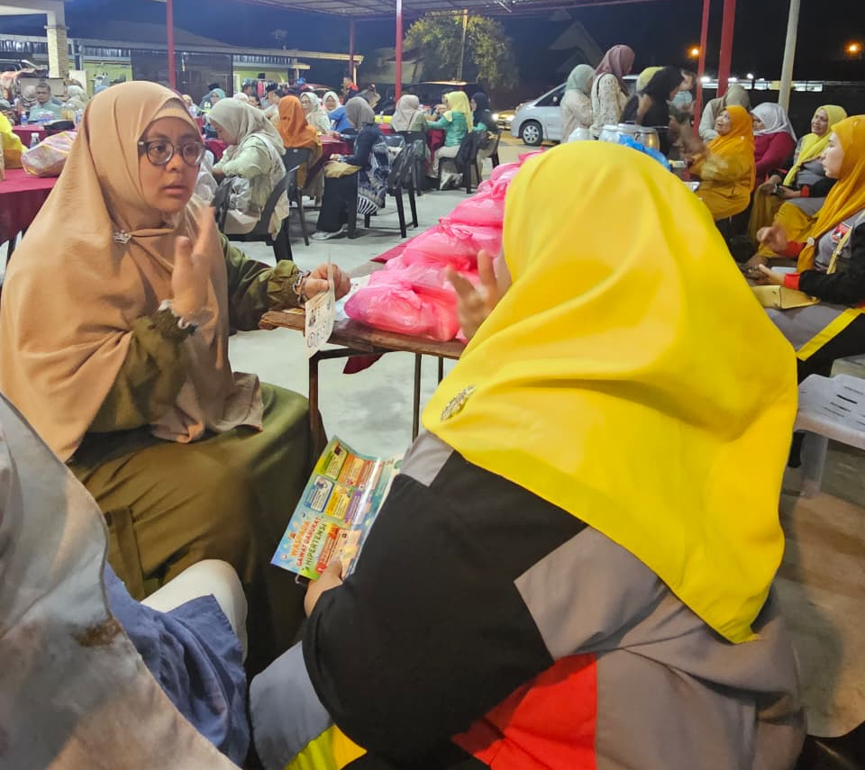

Figure 1. Providing mental health counseling services
Qualitative data revealed that many participants had not previously had access to any form of psychosocial support and expressed significant relief at having a structured space to discuss the emotional dimensions of their migration experience. Group sessions facilitated the formation of peer support relationships among participants, with several participants establishing informal mutual support groups that continued to meet after the program concluded. These findings reinforce Berry et al.’s (2006) argument that proactive psychosocial interventions for diaspora communities can reduce distress and strengthen community cohesion simultaneously.
4.5 Geographical Literacy and Spatial Understanding
Geographical literacy workshops, jointly facilitated by two geography education specialists, enhanced participants’ understanding of Malaysia’s administrative structure, economic geography, environmental features, and transportation networks. Pre-program assessments showed limited knowledge of geographic factors relevant to business decision-making, such as supply chain routes, regional market characteristics, and environmental regulations governing food businesses.
Post-program assessments indicated a mean increase of 54.7% in geographical knowledge scores. Notably, the spatial mapping exercises, in which participants collaboratively mapped their own mobility patterns, business supply chains, and social networks across Malaysia and back to Padang Pariaman, generated rich discussions about the strategic potential of diaspora networks as transnational assets. Participants reported that developing a more explicit and informed understanding of their spatial situation in Malaysia enhanced their confidence in making business location and logistics decisions.
4.6 Integrated Outcomes and Community Cohesion
Beyond the domain-specific competency improvements documented above, the integrated design of the program generated outcomes at the level of community cohesion and collective identity that exceed the sum of its individual components. Qualitative data from exit interviews and facilitator observation journals consistently highlighted that the convergence of diverse learning activities within a unified community program created a renewed sense of shared purpose and collective pride among participants.
The multidisciplinary team’s visible commitment to the community, evidenced through sustained engagement over six months, was frequently cited by participants as a source of motivation and a signal of the community’s inherent value and potential. Several community leaders expressed interest in formalizing a longer-term partnership with the academic institutions involved, suggesting that the program has established a foundation for sustained community-university collaboration. This outcome aligns with the empowerment literature’s emphasis on the importance of relational dimensions in development interventions (Zimmerman, 2000).
5. DISCUSSION
The findings of this initiative offer several important implications for the theory and practice of diaspora community empowerment. First, the participatory approach centered on thorough needs assessment proved essential for tailoring program content to the specific realities of the Minang Saiyo community in Malaysia. Generic capacity-building programs applied without contextual sensitivity risk misaligning with community needs and priorities, reducing both engagement and impact. The needs assessment data that revealed the particular salience of psychosocial dimensions alongside technical skill gaps, for instance, directly shaped the weighting given to mental health programming — a component that might otherwise have been considered peripheral in an entrepreneurship-focused initiative.
Second, the integration of five disciplinary perspectives within a coherent framework, rather than sequential or parallel provision of discipline-specific inputs, appears to have generated synergistic learning effects. Participants’ feedback consistently indicated that connections between program components — such as the relationship between geographical literacy and supply chain decision-making, or between mental health resilience and entrepreneurial persistence — enhanced the practical applicability of learning across domains. This suggests that integrated community service models can achieve outcomes not accessible through the additive combination of separate discipline-specific programs.
Third, the experience of implementing this program highlights both the opportunities and challenges of multidisciplinary collaboration in community service contexts. Coordinating six academic professionals from different institutions and disciplines required sustained communication, shared conceptual frameworks, and flexible responsiveness to emerging community dynamics. Future initiatives adopting similar integrated models should invest explicitly in team-building and shared planning processes as foundational elements of program development.
Fourth, the program’s outcomes suggest that entrepreneurial empowerment of diaspora communities must address psychosocial dimensions as a prerequisite for, rather than an addendum to, technical and business skill development. The reduction in psychological distress observed among participants may have facilitated their engagement with and retention of technical learning across other program components. Research on the relationship between psychological well-being and learning efficacy supports this interpretation (Eccles and Wigfield, 2002), and future program designs for diaspora contexts should position mental health support as a core rather than peripheral element.
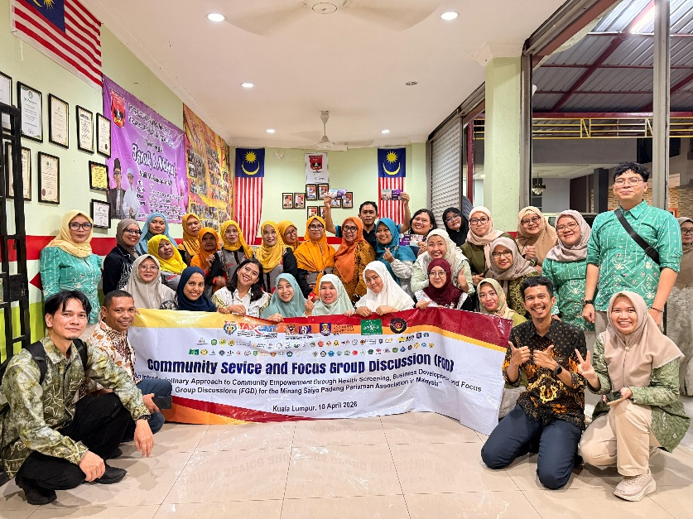
Figure 2. Group photo session with community service participants
Finally, the emergence of spontaneous community-driven initiatives — including the cooperative formation discussions and peer support group formation — beyond the direct scope of the program speaks to the catalytic potential of integrated empowerment interventions. When community members gain confidence, knowledge, and a stronger collective identity through a program, they are likely to apply these assets in ways that extend beyond the program’s original design. This emergent dimension of empowerment is difficult to predict or control but represents some of the most meaningful evidence of genuine capacity building.
6. CONCLUSION
This article has presented and analyzed an integrated community empowerment model designed and implemented for the Minang Saiyo Padang Pariaman diaspora community in Malaysia. By bringing together expertise in food processing technology, digital literacy and English communication, digital business management, guidance and counseling, and geography education within a participatory program framework, the initiative achieved meaningful improvements in participants’ competencies across all targeted domains while also fostering enhanced community cohesion and collective identity.
The program demonstrates that integrated, multidisciplinary community service models, when grounded in thorough needs assessment and participatory principles, can effectively address the complex and interconnected challenges facing diaspora entrepreneurial communities. The model’s emphasis on psychosocial well-being alongside technical and business skill development proved particularly important for the diaspora context, where acculturative stress and identity challenges are significant but often overlooked factors affecting economic participation and entrepreneurial resilience.
The findings contribute to a growing body of scholarship advocating for holistic, community-centered approaches to diaspora development and suggest several directions for future research and practice. Longitudinal follow-up studies are needed to assess the sustainability of competency gains and the realized business development outcomes of program participants. Comparative research across different diaspora communities in Malaysia and the broader Southeast Asian region would help to identify context-specific factors that mediate the effectiveness of integrated empowerment models. Additionally, the development of formal community-university partnership structures — as indicated by community leaders’ expressed interest following this program — represents a promising institutional mechanism for sustaining diaspora empowerment beyond discrete program cycles.
The Minang Saiyo community’s engagement, resilience, and entrepreneurial aspirations served as the foundation and inspiration for this initiative. It is our hope that the model presented here will contribute to the strengthening of not only this community but also the broader ecosystem of support for diaspora communities whose contributions to Malaysian society and to their communities of origin merit greater recognition and investment.
ACKNOWLEDGMENTS
The authors extend sincere gratitude to the leadership and members of the Minang Saiyo Padang Pariaman association in Malaysia for their trust, participation, and invaluable contributions throughout this program. We also acknowledge the institutional support of Universitas Negeri Gorontalo, Universitas Negeri Jakarta, Institut Teknologi Bisnis Riau, Universitas Syiah Kuala, and Universitas Negeri Medan in enabling this cross-institutional community service collaboration. Special thanks to the Indonesian Multidisciplinary Lecturer Community for facilitating the implementation of this international community service program.
REFERENCES
Berry, J. W., Phinney, J. S., Sam, D. L., & Vedder, P. (Eds.). (2006). Immigrant youth in cultural transition: Acculturation, identity, and adaptation across national contexts. Lawrence Erlbaum Associates.
Eccles, J. S., & Wigfield, A. (2002). Motivational beliefs, values, and goals. Annual Review of Psychology, 53(1), 109–132. https://doi.org/10.1146/annurev.psych.53.100901.135153
Freire, P. (1970). Pedagogy of the oppressed. Herder and Herder.
Hugo, G. (2007). Population geography. Progress in Human Geography, 31(1), 77–88. https://doi.org/10.1177/0309132507073944
Huda, M., Alyani, N., & Sabani, N. (2020). Community empowerment through multidisciplinary collaboration: Reflections on Indonesian higher education service. International Journal of Community Development and Management Studies, 4(1), 25–39.
Naim, M. (1979). Merantau: Minangkabau voluntary migration. Gadjah Mada University Press.
National Geographic Society. (2012). Road map for 21st century geography education. National Geographic Society.
Portes, A., Haller, W., & Guarnizo, L. E. (2002). Transnational entrepreneurs: An alternative form of immigrant economic adaptation. American Sociological Review, 67(2), 278–298. https://doi.org/10.2307/3088896
Rahayu, R., & Day, J. (2015). Determinant factors of e-commerce adoption by SMEs in developing countries: Evidence from Indonesia. Procedia – Social and Behavioral Sciences, 195, 142–150. https://doi.org/10.1016/j.sbspro.2015.06.423
Rappaport, J. (1987). Terms of empowerment/exemplars of prevention: Toward a theory for community psychology. American Journal of Community Psychology, 15(2), 121–148. https://doi.org/10.1007/BF00919275
Ray, K. (2016). The migrant’s table: Meals and memories in Bengali-American households. Temple University Press.
Shepherd, D. A. (2003). Learning from business failure: Propositions of grief recovery for the self-employed. Academy of Management Review, 28(2), 318–328. https://doi.org/10.2307/30040715
Townsend, R. F., & Townsend, J. (2004). Towards participatory research. In Participatory rural appraisal: Principles and methods (pp. 1–22). Intermediate Technology Publications.
Zimmerman, M. A. (2000). Empowerment theory: Psychological, organizational and community levels of analysis. In J. Rappaport & E. Seidman (Eds.), Handbook of community psychology (pp. 43–63). Kluwer Academic/Plenum Publishers.

