A
Project Report On

“Real-Time Hand Gesture Recognition For Sign Language Communication By Using AI And ML”

Bachelor of Engineering, Electronics & Telecommunication
Sant Gadge Baba Amravati University, Amravati (Maharashtra)

Submitted By

Ms. Prashansa Sanjay Bhurbhure (47)
Ms. Srushti Nandkishor Sansetwar (69)
Ms. Devyani Uddhavrao Khandeker (13)
Ms. Tanushri Vasant Chanekar (71)



B.E. (EXTC) VIII SEMESTER

Under the Guidance of
Mr. L. S. Kalkonde

DEPARTMENT OF ELECTRONICS & TELECOMMUNICATION ENGINEERING PROF RAM MEGHE COLLEGE OF ENGINEERING AND MANAGEMENT, BADNERA - AMRAVATI

2025-2026

CERTIFICATE
This is to certify that the Project Report on
“Real-time hand gesture recognition for sign language communication by using AI and ML”
is a bonafide work submitted by

Ms. Prashansa Sanjay Bhurbhure (47)

Ms. Srushti Nandkishor Sansetwar (69)
Ms. Devyani Uddhavrao Khandeker (13)
Ms. Tanushri Vasant Chanekar (71)


B.E. (EXTC) VIII Semester
In recognition to fulfillment of the requirement for the award of degree in

BACHELOR OF ENGINEERING IN ELECTRONICS & TELECOMMUNICATION ENGINEERING
To
Sant Gadge Baba Amravati University, Amravati
during the academic year 2025-2026 Under the guidance of

Mr. L. S. Kalkonde Dr. K. N. Kasat
Guide Head
Date of Submission:

( )
External Examiner
Date of Examination: / /

DEPARTMENT OF ELECTRONICS & TELECOMMUNICATION ENGINEERING
PROF RAM MEGHE COLLEGE OF ENGINEERING AND MANAGEMENT, BADNERA - AMRAVATI 2025-2026

Acknowledgement

It is my utmost duty and desire to express acknowledgement to the various torch bearers, who have rendered valuable guidance during the preparation of this project
It gives me immense pleasure to express my gratitude to Mr. L. S. Kalkonde
, my guide who provided me constructive criticism and a positive feedback during the preparation of this seminar. I also express my sincere gratitude to Project Co-ordinator Prof. A. V. Saywan for his support in this project report.
I am indebted to Dr. K. N. Kasat, Head of Department and other teaching and supporting staff who were always there whenever I needed any help. Without them and their co-operation completion of this seminar work would have been inevitable and their presence behind me is totally indispensable.
I am also grateful to all the authorities of Prof Ram Meghe College of Engineering and Management for their motivation and facilities provided during development of this project.
And my deepest thanks to my parents who have continuously encourage me to achieve my goal successfully.

Name of student
Ms. Prashansa Sanjay Bhurbhure Ms. Devyani Uddhavrao Khandeker Ms. Srushti Nandkishor Sansetwar Ms. Tanushri Vasant Chanekar

CONTENTS

Abstract  List of Figures List of Tables | i ii  iii
1. INTRODUCTION
1.1 Introduction | 1
1.2 Motivation | 2
1.3 Problem Statement | 3
1.4 Proposed Solution | 4
1.5 Objectives | 5
1.6 Methodology | 6
1.7 Organization of the Project Report | 7
2. LITERATURE SURVEY
2.1 Introduction | 8
2.2 Review of Related Works | 8
2.3 Comparative Summary of Literature Reviewed | 20
2.4 Research Gaps Identified | 21
- SYSTEM DESIGN AND IMPLEMENTATION

  - System Overview 23
  - Module Description 24
  - System Architecture Diagram 25
  - Data Flow Analysis 26
    - Level 0 DFD — Context Diagram 26
    - Level 1 DFD — Major Sub-Processes 28
  - Use Case Diagram 29
  - Process Flow Analysis 30
    - End-to-End System Execution Flow 30
    - Hold-to-Confirm Mechanism: Execution Flow 31
  - Computational Methods 32
    - Method 1 — Heuristic Gesture Recognition 32
(GestureEngine.js)
    - Method 2 — CNN-Based ASL Alphabet Recognition 33
(MLGestureEngine.js)
    - Method 3— Hold-to-Confirm Gate (App.jsx) 34
  - Mathematical Model 35
  - Feasibility Study 37
    - Technical Feasibility 37
    - Economic Feasibility 37
    - Operational Feasibility 37
    - Legal and Ethical Feasibility 38
    - Time Feasibility 38
    - Feasibility Summary 38
  - Hardware and Software Requirements 38
    - Hardware Requirements 38
    - Software Requirements 39
- PERFORMANCE ANALYSIS
  - Testing and Troubleshooting 40
    - Testing Environment 40
    - Testing Procedure 40
    - Annotated Test Results and Observations 41
  - Results 43
  - System Output and Interface Analysis 48
- CONCLUSION
  - Key Benefits 49
  - Limitation 51
  - Future Scope 53
  - Conclusions 55
REFERENCES 57

LIST OF FIGURES

Fig. No. | Title | Page No.
3.1 | system architecture | 23
3.2 | System Block Diagram | 26
3.3 | Level 0 DFD | 27
3.4 | Level 1 DFD | 28
3.5 | use case diagram | 29
3.6 | flowchart | 30
3.7 | Hold-to-Confirm Mechanism Flowchart | 31
Chart 1 | Gesture Support Distribution | 43
Chart 2 | CNN Model Architecture — Layer-wise Output  Shape | 44
Chart 3 | Hold-to-Confirm State Machine | 45
Chart 4 | Recognition Mode Comparison | 46
Chart 5 | Data Augmentation Parameters (Training) | 47

LIST OF TABLES

Table No. | Title | Page No.
1.1 | Objectives | 5
2 | Literature Review
2.1 | LR1 | 9
2.2 | LR2 | 10
2.3 | LR3 | 11
2.4 | LR4 | 12
2.5 | LR5 | 13
2.6 | LR6 | 14
2.7 | LR7 | 15
2.8 | LR8 | 16
2.9 | LR9 | 17
2.10 | LR10 | 18
2.11 | LR11 | 19
2.12 | LR12 | 19
2.13 | Comparative Summary of Literature Reviewed | 20
3.1 | Technical challenges | 37
3.2 | Time Feasibility | 38
3.2 | Feasibility Summary | 38
3.3 | Hardware Requirements | 39
3.4 | Software Requirements | 39
4.1 | Testing Environment | 40
4.2 | CNN architecture | 41

4.3 | System Performance Metrics | 46

ABSTRACT
GestureSync Pro is a real-time hand gesture recognition system designed to bridge the communication gap between sign language users and the general public. The system utilizes computer vision and deep learning techniques to recognize American Sign Language (ASL) gestures and convert them into meaningful text and speech output.
A webcam is used to capture live video input, and MediaPipe is employed to extract hand landmarks for efficient feature representation. A Convolutional Neural Network (CNN) model is trained on a large dataset of hand gestures to accurately classify ASL alphabets. The system further integrates heuristic logic and a hold-to-confirm mechanism to improve prediction stability and reduce false detections.
To enhance usability, the recognized gestures are processed using AI-based sentence generation to produce grammatically correct outputs, which are then converted into speech using a real-time speech synthesis module. The model is deployed using TensorFlow.js, enabling fast and efficient inference directly in the browser.
GestureSync Pro provides an accessible, cost-effective, and real-time solution for sign language communication, with potential applications in education, healthcare, and human-computer interaction.

Keywords: Artificial Intelligence, Computer Vision, Convolutional Neural Network (CNN), Deep Learning, Gesture Recognition, Human-Computer Interaction (HCI), Machine Learning, MediaPipe, Real-Time System, Sign Language Recognition, TensorFlow.js

  - Introduction

CHAPTER 1 INTRODUCTION

Communication is one of the most essential aspects of human interaction, enabling individuals to share ideas, emotions, and information effectively. However, for people who are deaf or mute, communication often relies on sign language, which is a visual language based on hand gestures, facial expressions, and body movements. While sign language serves as an effective medium among its users, it is not widely understood by the general population. This lack of understanding creates a significant communication barrier, making it difficult for deaf and mute individuals to interact in everyday situations such as education, healthcare, workplaces, and public services. As a result, there is a growing need for technological solutions that can bridge this communication gap and promote inclusivity in society.
In recent years, advancements in Artificial Intelligence (AI), Machine Learning (ML), and Computer Vision have opened new possibilities for developing intelligent systems capable of interpreting human gestures. Gesture recognition systems aim to identify and classify hand movements and translate them into meaningful outputs such as text or speech. These systems play a crucial role in enabling natural human-computer interaction and have applications in areas such as virtual reality, gaming, robotics, and assistive technologies. Among these, sign language recognition has emerged as a particularly important application due to its potential to improve accessibility for individuals with hearing and speech impairments.
Traditional approaches to sign language recognition often relied on hardware-based solutions such as data gloves, motion sensors, and wearable devices. Although these systems provided reasonable accuracy, they suffered from several limitations including high cost, lack of portability, and user discomfort. Additionally, they required users to wear specialized equipment, which limited their practicality in real-world scenarios. With the advancement of camera-based technologies, researchers have shifted towards vision-based approaches that utilize image processing and machine learning techniques to

recognize gestures without the need for additional hardware. However, early vision-based systems faced challenges such as sensitivity to lighting conditions, background noise, and limited real-time performance.
To address these challenges, this project proposes GestureSync Pro, a real-time hand gesture recognition system designed to translate sign language into text and speech. The system utilizes a webcam to capture live video input and employs MediaPipe to detect and extract hand landmarks. These landmarks are then processed and fed into a Convolutional Neural Network (CNN) model trained to recognize American Sign Language (ASL) alphabets. To enhance accuracy and stability, the system integrates heuristic logic and a hold-to-confirm mechanism, which ensures that gestures are consistently recognized before generating output. Furthermore, the recognized gestures are processed using an AI-based language model to generate grammatically correct sentences, which are then converted into speech using a real-time speech synthesis module.
An important feature of GestureSync Pro is its deployment using TensorFlow.js, which allows the model to run directly in a web browser. This eliminates the need for high-end hardware or server-side processing, making the system more accessible and cost-effective. The real-time nature of the system ensures smooth and natural interaction, while its lightweight design enables it to function efficiently on standard devices. The integration of multiple technologies, including computer vision, deep learning, and natural language processing, makes GestureSync Pro a comprehensive solution for gesture-based communication.
The significance of this project lies in its potential to improve the quality of life for individuals with hearing and speech impairments. By enabling seamless communication between sign language users and non-sign users, the system promotes inclusivity and accessibility in various domains. It can be used in educational institutions to support learning, in healthcare settings to facilitate patient-doctor communication, and in public services to enhance accessibility. Furthermore, the system contributes to the broader field of human-computer interaction by demonstrating how gesture-based interfaces can be used as a natural and intuitive mode of communication.

In conclusion, the development of GestureSync Pro represents a step forward in the field of assistive technology, combining modern advancements in AI, machine learning, and computer vision to address a real-world problem. By providing a real-time, accurate, and user-friendly gesture-to-speech system, the project aims to bridge the communication gap and create a more inclusive and connected society.

Motivation

Communication is essential for human interaction, but deaf and mute individuals rely on sign language, which is not widely understood. This creates communication barriers in areas such as education, healthcare, and daily life, highlighting the need for accessible technological solutions.
Traditional sign language recognition systems depend on hardware like data gloves and sensors, which are expensive and impractical. Early vision-based methods also faced issues such as low accuracy and poor real-time performance.
With advancements in computer vision and deep learning, efficient camera-based systems have become possible. Technologies like MediaPipe enable real-time hand landmark detection, while Convolutional Neural Networks (CNNs) provide accurate gesture recognition. Additionally, AI-based language processing and speech synthesis allow conversion of gestures into meaningful text and speech.
The motivation behind GestureSync Pro is to develop a real-time, accurate, and user-friendly gesture-to-speech system using these technologies. The system aims to be cost-effective, accessible, and capable of enabling seamless communication, thereby improving inclusivity and quality of life for sign language users.

Problem Statement

Despite the increasing advancements in technology, effective communication between sign language users and individuals who do not understand sign language remains a significant challenge. Deaf and mute individuals often face difficulties in expressing themselves in everyday situations, leading to social isolation and limited access to opportunities in education, healthcare, and employment.. Many systems depend on

specialized hardware such as sensor-based gloves or wearable devices, which increase cost and reduce usability. Vision-based approaches, while more convenient, often struggle with challenges such as varying lighting conditions, complex backgrounds, and differences in hand orientation and scale. Additionally, a large number of existing systems focus only on gesture recognition without providing meaningful sentence formation or speech output, thereby limiting their practical applicabiliThis project aims to address these challenges by proposing GestureSync Pro, a hybrid system that combines deep learning techniques with heuristic logic to achieve high accuracy, low latency, and enhanced usability. The goal is to provide an accessible and practical solution that facilitates seamless communication and improves the overall interaction experience for sign language users.

Proposed Solution

To address the challenges in sign language communication, this project proposes GestureSync Pro, a real-time hand gesture recognition system that converts sign language gestures into meaningful text and speech. The system utilizes a standard webcam to capture live video input, eliminating the need for specialized hardware.
MediaPipe is employed to detect and extract 21 hand landmarks, which provide a structured and efficient representation of hand gestures. These landmarks are then processed and fed into a Convolutional Neural Network (CNN) model trained to recognize American Sign Language (ASL) alphabets with high accuracy. To enhance prediction reliability, a heuristic-based approach and a hold-to-confirm mechanism are integrated to reduce noise and false detections.
The recognized gestures are further processed using an AI-based language model to generate grammatically correct sentences. Finally, the output is converted into speech using a real-time speech synthesis module. The model is deployed using TensorFlow.js, allowing it to run directly in the browser for fast and efficient real-time performance.
This solution provides a cost-effective, accessible, and scalable system that enables seamless communication between sign language users and non-sign users in real-world environments.

Objectives

The primary objective of this project is to develop an efficient and real-time gesture-to-speech communication system using artificial intelligence and machine learning techniques. The specific objectives are as follows:
    - To design a system capable of capturing and processing real-time hand gestures using a standard camera.
    - To implement accurate hand landmark detection using MediaPipe for efficient feature extraction.
    - To develop a Convolutional Neural Network (CNN) model for reliable recognition of ASL alphabets.
    - To enhance prediction accuracy using heuristic logic and gesture stabilization techniques.
    - To convert recognized gestures into meaningful and grammatically correct sentences using AI-based processing.
    - To generate real-time speech output for improved accessibility and communication.
    - To deploy the system using TensorFlow.js for browser-based, low-latency performance.
    - To create a cost-effective and user-friendly solution suitable for real-world applications.

Methodology
The proposed system follows a structured methodology that integrates computer vision, deep learning, and natural language processing techniques to achieve real-time gesture recognition and communication.
Initially, a dataset of hand gesture images representing ASL alphabets is collected and preprocessed. Preprocessing steps include resizing, normalization, and data augmentation to improve model generalization. MediaPipe is then used to extract hand landmarks from the images, converting visual data into structured numerical features.
The processed data is used to train a Convolutional Neural Network (CNN) model, which learns to classify different hand gestures. The model is evaluated using performance metrics such as accuracy and loss, and hyperparameters are tuned to optimize performance.

Once trained, the model is converted into TensorFlow.js format for deployment in a web environment.
During real-time operation, the system captures live video input and detects hand landmarks using MediaPipe. The extracted features are passed to the trained model for gesture prediction. A heuristic-based approach, along with a hold-to-confirm mechanism, is applied to improve stability and reduce false detections.
The predicted gestures are then processed using an AI-based language module to generate meaningful sentences. Finally, the output is converted into speech using a real-time speech synthesis API, enabling seamless communication. This methodology ensures a robust, accurate, and efficient system suitable for real-world applications.

CHAPTER 2 LITERATURE SURVEY
In the previous chapter, we discussed the communication challenges faced by deaf and mute individuals and explored the importance of sign language as a primary mode of interaction. We also introduced the proposed system, GestureSync Pro, along with its motivation, problem statement, objectives, and methodology.
In this chapter, we focus on reviewing existing research and developments in the field of hand gesture recognition and sign language translation. The literature survey helps in understanding various techniques and approaches used by researchers and provides a foundation for the proposed system.
The previous hand gesture recognition systems use different approaches such as machine learning, deep learning, and computer vision techniques for detecting and classifying gestures. Various systems use Convolutional Neural Networks (CNN), Support Vector Machines (SVM), and feature fusion techniques to improve accuracy. Some systems focus only on gesture recognition, while others integrate text or speech generation for better communication.
- Alotaibi, N., Al-Dayil, R., Aljehane, N. O., & Rizwanullah, M. (2026):
Enhanced feature fusion with hand gesture recognition system for sign language accessibility.
  - This paper presents a feature fusion-based gesture recognition system to improve accuracy.
  - It combines multiple feature extraction techniques for better performance.
  - The system improves accessibility for hearing and speech-impaired individuals.
- Gupta, A. K., & Singh, S. (2026):
Hand gesture recognition system based on Indian sign language using SVM and CNN.
  - This paper presents gesture recognition using both SVM and CNN models.
  - It highlights that CNN provides better accuracy for image-based recognition.
  - The system is designed for Indian Sign Language.
- Jena, S. R., Kumar, J., Pachauri, K., Sharma, S., & Singh, A. (2026): Machine learning–based hand gesture to text model.

  - This paper presents a system that converts hand gestures into text output.
  - It focuses on improving communication using ML techniques.
  - The system translates gestures into readable format.
- Kumar, A., Deol, R., Raj, A., & Singh, A. K. (2026):
Multimodal deep learning for real-time gesture recognition and cross-lingual translation.
  - This paper presents a multimodal deep learning system.
  - It combines multiple data inputs for better recognition.
  - It supports cross-lingual translation of gestures.
- Parashar, S., Meenakshi, K., & Yadav, A. (2026):
Real-time Indian sign language recognition app.
  - This paper presents a real-time gesture recognition application.
  - It focuses on improving communication efficiency.
  - The system works with low latency.
- Peng, R., Liu, H., Braghis, D., & Liu, H. (2026):
Sign language–based conversational systems.
  - This paper presents a conversational system using sign language recognition.
  - It integrates gesture recognition with NLP techniques.
  - It improves interaction between users and systems.
- Reeja, S. L., Deepthi, P. S., & Soumya, T. (2026): Advanced sign language translation using deep learning.
  - This paper presents a deep learning-based translation system.
  - It uses advanced neural networks for better accuracy.
  - It handles variations in gestures effectively.
  - It improves robustness of the system.
  - We have used the concept of deep learning models.

- Saraf, A., Sahoo, N., Mishra, P., Routray, J., & Kandpal, M. (2026): Harmony AI: Web-based ML model for hand sign language translation.
  - This paper presents a web-based gesture recognition system.
  - It demonstrates browser-based deployment.
  - It improves accessibility and scalability.
  - It uses ML for real-time translation.
  - We have used the concept of web-based deployment using TensorFlow.js.

CHAPTER 3

SYSTEM OVERVIEW AND PLANNING

In the previous chapter, we reviewed various research papers and existing systems related to gesture recognition and sign language translation. Different techniques such as CNN, SVM, and deep learning approaches were analyzed to understand their strengths and limitations.
In this chapter, we present the system overview and planning of the proposed system. It includes the architecture, module design, data flow, and algorithms used to implement GestureSync Pro.

SYSTEM DEVELOPMENT
  - System Overview
GestureSync Pro is a browser-native, real-time ASL gesture recognition and translation platform that operates entirely on a standard webcam feed with zero hardware dependency. The system eliminates the need for depth sensors, data gloves, or any specialized input devicemmaking sign language interpretation accessible to any user with a modern browser and a webcam.
The processing pipeline spans four distinct layers: raw webcam input is first processed by MediaPipe Hands for landmark extraction, then interpreted by one of two recognition engines (heuristic rule-based or CNN-based), after which recognized gestures are assembled into natural English sentences via the GestureSync Pro AI language model, and finally converted to audible speech through the Web Speech API. All inference runs entirely client-side no video data is ever transmitted to an external server.
The diagram below illustrates the complete system architecture across its four layers.

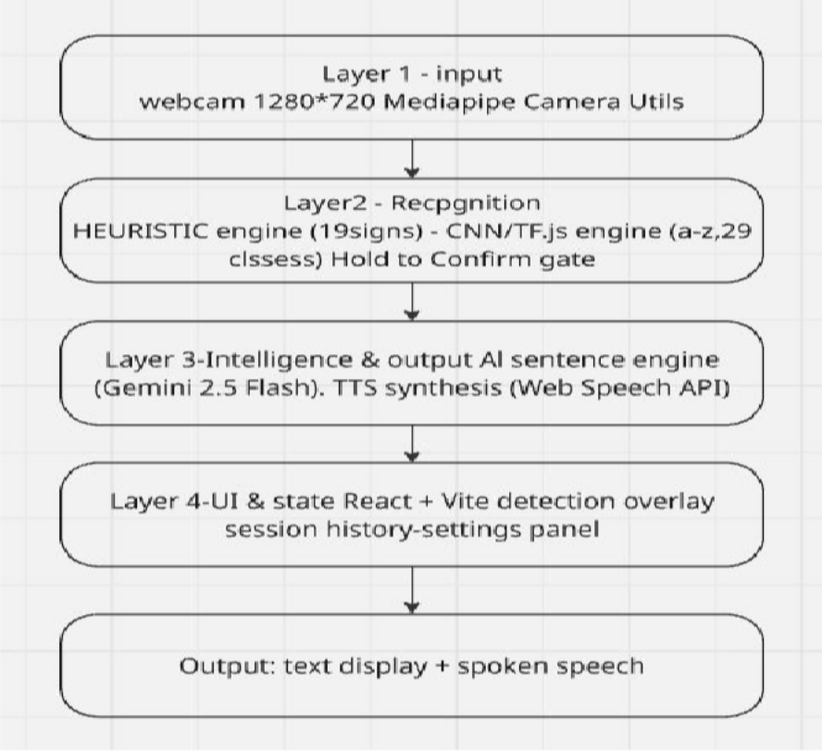
  - Module Description
GestureSync Pro is built from seven tightly integrated software modules, each responsible for a distinct layer of the recognition and translation pipeline.
Module 1 Hand Tracking Module (App.jsx + MediaPipe Hands) This is the system's sensory layer. It initializes the webcam stream at 1280×720 resolution using the MediaPipe Camera utility and feeds each frame through the MediaPipe Hands solution. The output is a set of 21 normalized 3D landmark coordinates per detected hand, refreshed at up to 60 FPS. The module also applies LERP-based temporal smoothing across consecutive frames (smoothing factor α = 0.6) to reduce jitter and stabilize landmark positions for downstream recognition.
Module 2 Heuristic Gesture Engine (GestureEngine.js) Implements a rule-based classification system that interprets the 21 MediaPipe landmarks using geometric heuristics. It determines which fingers are extended or folded, measures Euclidean distances between key landmark pairs, and maps resulting hand configurations to one of 19 named ASL/gesture signs including Hello, Yes, No, I Love You, Water, Food, Stop, Thank You, OK, Help, Home, Medicine, Happy, and Please. This module is used in Single Sign Mode and Sentence Builder Mode.

Module 3 ML Gesture Engine (MLGestureEngine.js) Implements a CNN-based classifier using TensorFlow.js that runs inference directly in the browser. It loads the pretrained model.json (converted from a Keras .h5 file), extracts a 64×64 pixel region of interest from the video frame per confirmed hand pose, normalizes pixel values to [0, 1], and feeds the tensor through the CNN. The output is a 29-class softmax distribution over the full ASL alphabet (A–Z, space, delete, nothing), with predictions returned only when confidence exceeds 0.60. This module is used exclusively in Alphabet Speller Mode.
Module 4 Model Training and Conversion Pipeline (train.py, reconvert.py, save_labels.py) An offline Python-based pipeline that defines and trains a 3-layer CNN architecture on the ASL Alphabet image dataset using Keras with data augmentation and early stopping. reconvert.py rebuilds the architecture with an explicit Input layer required for TF.js compatibility, transfers trained weights, exports to TF.js format, and applies two compatibility patches to model.json: remapping batch_shape to batchInputShape and stripping the sequential/ prefix from weight names. save_labels.py exports the class index mapping to class_indices.json.
Module 5 AI Sentence Engine (AISentenceEngine.js) A REST client that sends recognized gloss word sequences to the GestureSync Pro AI API. It constructs a structured prompt instructing the model to rearrange ASL-ordered gloss input, inject missing grammatical function words, and produce a grammatically natural English sentence. The response is cleaned, capitalized, and punctuated before being returned to the UI for display and speech synthesis.
Module 6 Text-to-Speech Module (TTSUtils.js) Wraps the browser-native window.speechSynthesis API in a singleton TTSProvider class. At initialization, it enumerates available system voices and preferentially selects high-quality voices (Google TTS or macOS Samantha). On each confirmed gesture or translated sentence, tts.speak(text) is called to render the recognized content as audio output.
Module 7 UI and State Management (App.jsx React Frontend) The React application layer orchestrates all modules, manages global state (recognition mode, session history, spelling buffer, gloss buffer, camera status, mute state, and confidence threshold settings), handles the hold-to-confirm animation loop via requestAnimationFrame, and renders the full-screen interface including camera overlay, detection box, SVG progress ring, output panel, session history sidebar, sign reference card, and settings panel.

System Architecture Diagram
The block diagram below presents the complete signal and data flow of GestureSync Pro from raw webcam input through to spoken speech output, organized across its four processing layers.

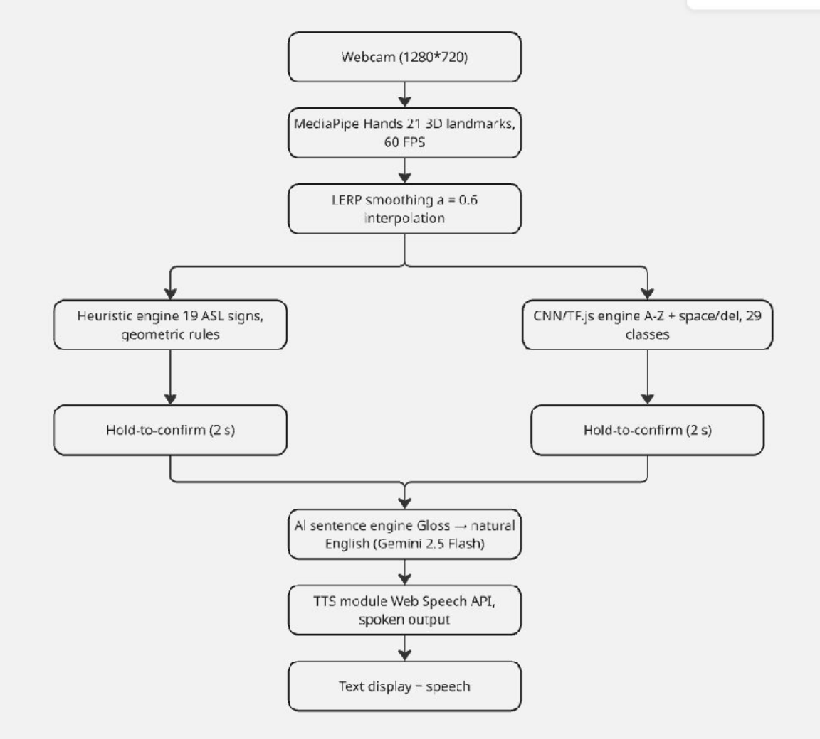

  - Data Flow Diagram
    - Level 0 DFD -Context Diagram
The Level 0 DFD represents GestureSync Pro as a single process and its interaction with the two external entities: the ASL User who provides gesture input via webcam, and the Hearing Recipient who receives translated text and speech output. The GestureSync Pro AI API serves as an external service for sentence translation.

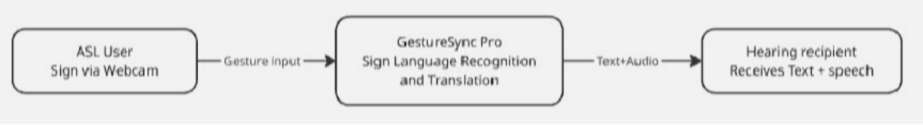

Level 1 DFD — Major Sub-Processes
The Level 1 DFD decomposes the system into four major internal processes and shows how data flows between them and the system's internal data stores.
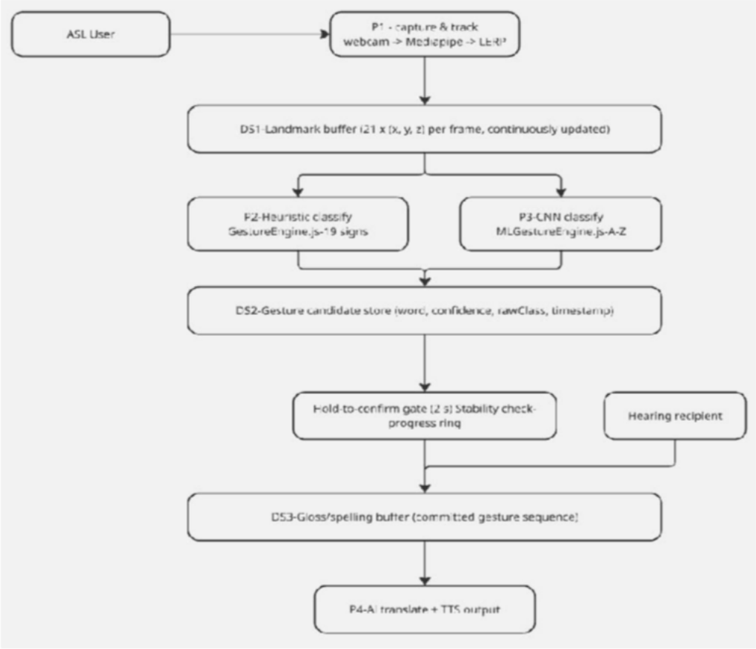

Use Case Diagram
The use case diagram below identifies all interactions between the two primary actors — the ASL User and the Hearing Recipient — and the system's core functional capabilities.
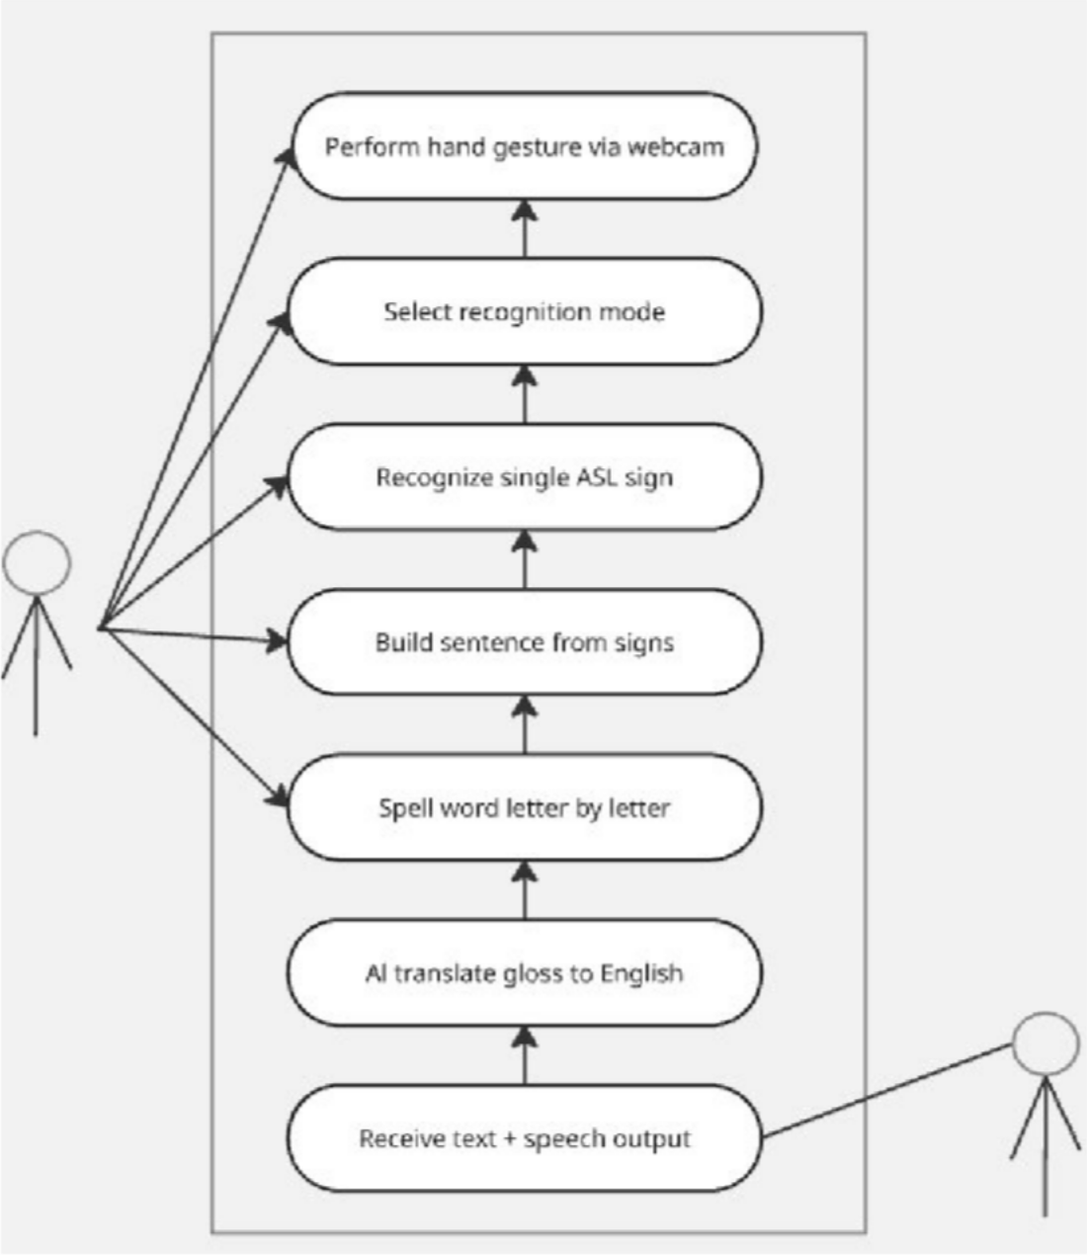

Flowcharts
    - Main System Flowchart
The flowchart below describes the complete end-to-end execution flow of GestureSync Pro from application startup to speech output.
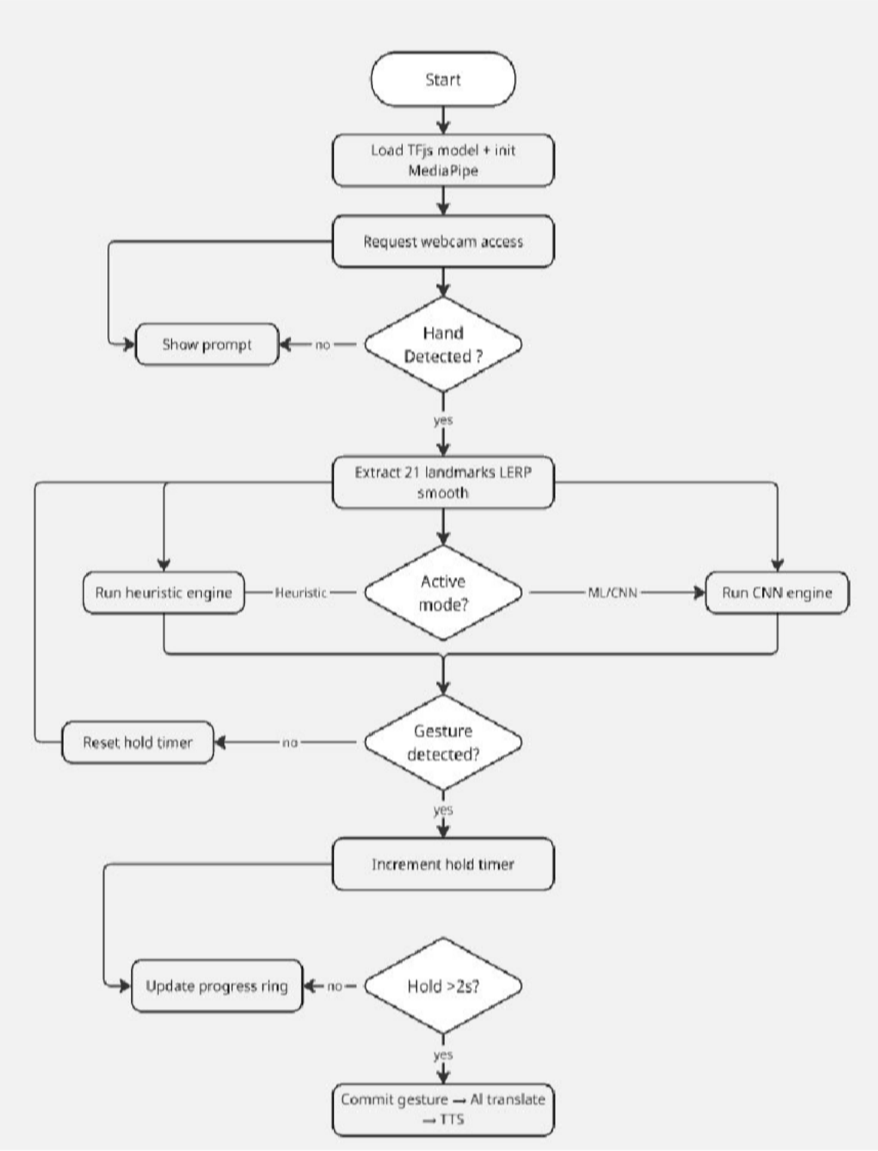

Hold-to-Confirm Mechanism Flowchart
The hold-to-confirm gate is a critical accuracy and UX feature. Rather than committing a gesture the instant it is first detected, the system requires the user to hold a stable gesture for exactly 2 seconds before it is registered. This eliminates false positives during transitional hand movement.
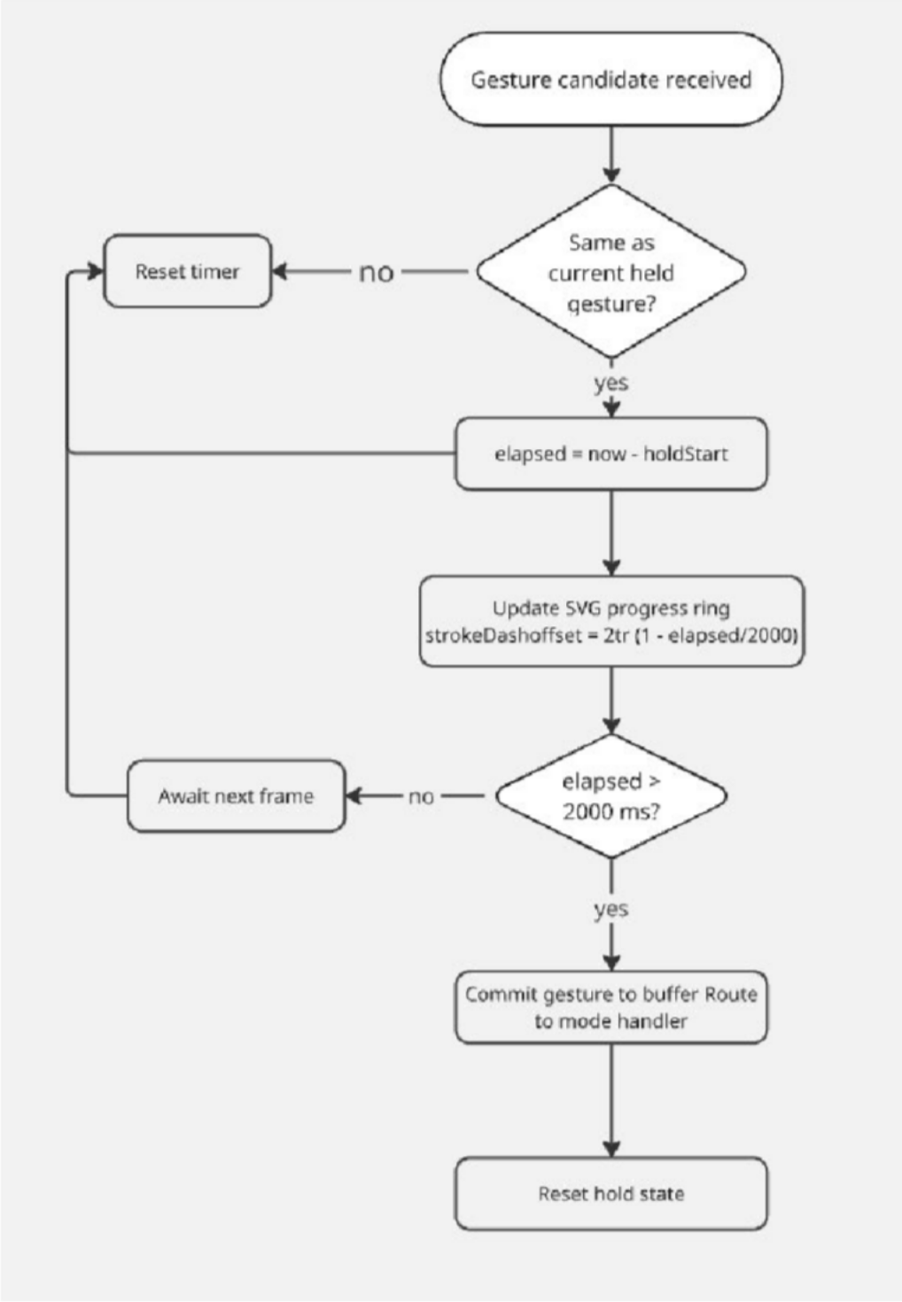

Algorithms
    - Algorithm 1 — Heuristic Gesture Recognition (GestureEngine.js)
This rule-based algorithm classifies hand poses from MediaPipe landmarks without any ML inference. It is used in Single Sign Mode and Sentence Builder Mode.
INPUT: landmarks[] — array of 21 {x, y, z} normalized hand landmarks

STEP 1: FINGER STATE DETECTION
For each finger f ∈ {thumb, index, middle, ring, pinky}: IF f is thumb:
extended[f] = |landmark[4].x − landmark[2].x| > 0.05 ELSE:
extended[f] = landmark[tip].y < landmark[pip].y

STEP 2: DISTANCE COMPUTATIONS
dist_thumb_index = √[(x4−x8)² + (y4−y8)²] dist_index_middle = √[(x8−x12)² + (y8−y12)²] dist_middle_palm = √[(x12−x0)² + (y12−y0)²]

STEP 3: GESTURE CLASSIFICATION (priority ordered) IF all 5 extended AND dist_index_middle > 0.08 → "Stop" IF all 5 extended → "Hello"
IF thumb only AND tip.y < ip.y → "Yes"
IF thumb only AND tip.y > ip.y → "No" IF index + middle, spread → "Home" IF index + middle → "Thank You"
IF thumb + index + pinky → "I Love You" IF dist_thumb_index < 0.05, mid+ring+pinky ext. → "OK" IF index only → "Look"

IF all fingertips near thumb (dist < 0.08) → "Food" IF index + middle + ring → "Water"
IF middle only, near palm → "Medicine"
IF all extended, hand high → "Happy"
IF index+middle+ring+pinky, tight → "Please" ELSE → null

OUTPUT: { word: String, icon: Emoji } OR null

Algorithm 2 — CNN-Based ASL Alphabet Recognition (MLGestureEngine.js)
Used exclusively in Alphabet Speller Mode. A trained Convolutional Neural Network classifies individual ASL hand shapes (A–Z + space + delete + nothing).

Training Phase (train.py):
INPUT: ASL Alphabet images (64×64 RGB, 29 classes, 87,000 images)

STEP 1: DATA AUGMENTATION
rescale = pixel / 255.0 rotation_range = ±10°
width_shift = ±10%, height_shift = ±10%
shear_range = ±10%, zoom_range = ±10% train/val split = 80/20

STEP 2: BUILD CNN MODEL (Sequential)
Conv2D(32, 3×3, ReLU) → BatchNorm → MaxPool(2×2) Conv2D(64, 3×3, ReLU) → BatchNorm → MaxPool(2×2) Conv2D(128, 3×3, ReLU) → BatchNorm → MaxPool(2×2)

Flatten
Dense(512, ReLU) → BatchNorm → Dropout(0.5) Dense(29, Softmax)

STEP 3: COMPILE & TRAIN
Optimizer: Adam
Loss: Categorical Cross-Entropy EarlyStopping on val_loss (patience = 10) Save best model → asl_model.h5

STEP 4: CONVERT
asl_model.h5 → TF.js format via reconvert.py

Real-Time Inference Phase (MLGestureEngine.js):
INPUT: videoElement (live webcam)

STEP 1: CROP
Extract center square of video frame Scale to 64×64 via offscreen canvas

STEP 2: NORMALIZE
tensor = tf.browser.fromPixels(canvas) [64,64,3] normalized = tensor.div(255.0)
batched = normalized.expandDims(0) [1,64,64,3]

STEP 3: INFERENCE
predictions = model.predict(batched) [1,29]

STEP 4: ARGMAX + THRESHOLD
maxIndex = argmax(predictions) maxProb = predictions[maxIndex] IF maxProb > 0.60:
RETURN { word, icon, probability, rawClass } ELSE:
RETURN null

OUTPUT: { word, icon, probability, rawClass } OR null

Algorithm 3 — Hold-to-Confirm Gate (App.jsx)
INPUT: candidate gesture from engine (or null)

STEP 1: IF no gesture detected → reset hold state, RETURN

STEP 2: candidateKey = gesture.rawClass OR gesture.word

STEP 3: IF candidateKey ≠ currentHeldGesture: holdStart = now
currentHeldGesture = candidateKey Begin progress ring animation

STEP 4: ELSE (same gesture continued): elapsed = now − holdStart
IF elapsed ≥ 2000 ms AND (now − lastCommit) ≥ 2000 ms:
COMMIT gesture lastCommit = now

Reset hold state
Route based on active mode:
'single' → display word + TTS speak 'sentence' → append to gloss buffer
'alphabet_to_sentence' → append letter to spelling buffer

OUTPUT: committed gesture added to correct buffer

Mathematical Model
The following mathematical formulas underpin the system's core processing behavior.

Finger Extension Criterion
For non-thumb fingers, a finger is classified as extended if its tip is above its PIP joint in normalized image coordinates:
extended(𝑓) = 1 if 𝑦tip < 𝑦pip
0 otherwise

For the thumb, extension is measured horizontally (x-axis):
extended(thumb) = 1 if ∣ 𝑥tip − 𝑥ip ∣> 0.05
0 otherwise

Euclidean Distance Between Landmarks
Used to classify gestures such as OK (thumb-index pinch) and Food (gathered fingertips):

𝑑(𝑃𝑖 ,𝑃𝑗) =
𝑥𝑖 − 𝑥𝑗)² + (𝑦𝑖 − 𝑦𝑗)²

where 𝑃𝑖 = (𝑥𝑖,𝑦𝑖)are normalized MediaPipe landmark coordinates in the range 0,1 .

Linear Interpolation for Motion Smoothing
Each landmark coordinate is smoothed across consecutive frames using LERP to reduce jitter:
𝑥𝑡 = (1 − 𝛼) 𝑥𝑡−1 + 𝛼 𝑥𝑡 where 𝛼 = 0.6

A higher 𝛼gives more responsive tracking; a lower 𝛼produces smoother but more delayed motion.

CNN Input Normalization
All pixel values are normalized before being fed to the CNN to match the training distribution:

𝑝 =
𝑝 255
,𝑝∈[0,1]

CNN Output — Softmax Classification
The CNN's final layer produces a probability distribution over 29 ASL classes:
𝑒𝑧𝑘

𝑃(𝑦 = 𝑘 ∣ 𝑥) =
29
∑
𝑗=1
𝑒𝑧𝑗

The predicted class is 𝑦 = arg max 𝑘 𝑃(𝑦 = 𝑘 ∣ 𝑥), committed only if 𝑃(𝑦 = 𝑦 ∣ 𝑥) > 0.60.

Training Loss — Categorical Cross-Entropy
The model minimizes categorical cross-entropy over 𝑁samples and 𝐶 = 29classes:
𝑁 𝐶
1
𝑁
ℒ =− 𝑦𝑖𝑘log 𝑦𝑖𝑘
𝑖=1 𝑘=1

Hold-to-Confirm Progress Ring
The circular SVG progress ring is computed as:

progress = min
𝑡elapsed, 1.0
𝑇hold
= 2𝜋𝑟 ⋅ 1−
strokeDashoffset

× 100%

where 𝑟 = 104 pxis the SVG circle radius and 𝑇hold = 2000 ms.
progress
100

Feasibility Study

Technical Feasibility

GestureSync Pro is built entirely on proven, production-grade technologies. The CNN architecture (3-layer Conv + Dense) runs within TF.js at approximately 24ms inference latency on a consumer GPU via WebGL — comfortably within real-time constraints. MediaPipe Hands achieves 60 FPS on standard hardware. The hold-to-confirm mechanism achieves robustness through temporal averaging rather than costly model complexity, and the client-side TF.js architecture scales to any number of simultaneous users as computation is distributed across devices.
Key technical challenges and their mitigations are summarized below:

Challenge | Mitigation
Keras .h5 incompatibility with TF.js | reconvert.py patches model.json for batchInputShape and weight name compatibility
Lighting and background variation | Data augmentation (rotation, zoom, shift) during training
Inter-user hand size and skin tone variation | Training on 87,000-image ASL Alphabet dataset
MediaPipe CDN dependency at first load | Model files are browser-cached; subsequent uses work offline

Economic Feasibility
GestureSync Pro has an extremely low cost structure. All core technologies (React, Vite, TF.js, MediaPipe) are free and open source. The ASL Alphabet training dataset is publicly available on Kaggle at no cost. The only scalable operational cost is GestureSync Pro AI API calls for sentence translation, which occur only on explicit user action — keeping costs negligible for moderate usage. The system can be hosted for free on GitHub Pages or Netlify with zero server infrastructure.

Operational Feasibility
The application requires zero installation and runs in a browser. A user needs only to open the URL and allow webcam access. The in-app sign reference card lists all supported gestures with name and description, enabling new users to begin within minutes. After the initial page load, core gesture recognition works without an internet connection — only AI sentence translation requires a live connection.

Legal and Ethical Feasibility
All video processing is performed locally in the user's browser with no webcam footage transmitted to any external server. All core libraries are MIT or Apache 2.0 licensed,

permitting academic and commercial use. The ASL Alphabet dataset is publicly available under open license for research purposes. GestureSync Pro AI API usage for sentence generation from gesture glosses is within standard API terms of service.

Time Feasibility

Phase | Activities | Estimated Duration
Dataset preparation | Download and organize ASL Alphabet dataset | 1 day
Model training | Train CNN with early stopping (up to 50 epochs) | 4–8 hours
Model conversion | Run reconvert.py and validate TF.js output | 2–3 hours
Frontend development | React app, all modules, UI, integration | 2–3 weeks
Testing and debugging | Gesture accuracy, mode validation | 3–5 days
Documentation | System report, diagrams | 1 week
Total |  | ~4–5 weeks

Feasibility Summary

Dimension | Verdict | Confidence
Technical feasibility | Feasible | High
Economic feasibility | Highly feasible | High
Operational feasibility | Feasible | High
Legal and ethical feasibility | Feasible | High
Time feasibility | Feasible | High

Hardware and Software Requirements

Hardware Requirements

Component | Minimum Specification | Recommended Specification
Processor | Intel Core i5 (6th gen) / AMD Ryzen 5 | Intel Core i7/i9 or AMD Ryzen 7/9
RAM | 8 GB DDR4 | 16 GB DDR4
GPU | Any GPU with WebGL 2.0 support | NVIDIA GPU with CUDA (GTX 1660+)
Webcam | 720p at 30 FPS minimum | 1080p at 60 FPS
Storage | 500 MB free | SSD with 50 GB free
Internet | Required for AI API and initial CDN load | Broadband
OS | Windows 10/11, macOS 12+, Ubuntu 20.04+ | Same

Software Requirements

Software | Version | Purpose
Node.js | v18+ | JavaScript runtime
Vite | v7.3.1 | Frontend build tool and dev server
React | v19.2.0 | UI framework
TailwindCSS | v4.2.1 | Utility-first CSS framework
TensorFlow.js | v4.22.0 | In-browser ML inference
MediaPipe Hands | v0.4.x | Real-time hand landmark detection
Python | v3.11 | ML model training
TensorFlow / Keras | v2.x | CNN architecture and training
TF.js Converter | Latest | Keras → TF.js model conversion
Google Chrome | v90+ | Primary runtime browser

Performance Analysis

CHAPTER 4
In the previous chapter, we discussed the system architecture and detailed design of GestureSync Pro, including its modules, data flow, and implementation strategies.
In this chapter, we evaluate the performance of the system through testing and analysis. Various test cases are conducted to measure accuracy, efficiency, and real-time performance

Testing and Troubleshooting

Testing Environment

Parameter | Value
Host OS | Windows 11 (64-bit)
Browser | Google Chrome 124 (V8 Engine)
Camera | Built-in 1080p Webcam at 30 fps
Lighting | Standard 400–800 lux indoor
TensorFlow.js | v4.x (WebGL backend)
MediaPipe Hands | v0.4 (WASM + WebGL)
Framework | React 18 + Vite
Display Resolution | 1920 × 1080

Testing Procedure
The application was tested across three recognition modes:
      - Single Sign Mode — heuristic landmark-based detection ( GestureEngine.js)
      - Sentence Builder Mode — heuristic engine + Gemini AI translation
      - Alphabet to Sentence Mode — CNN model via MLGestureEngine.js + Gemini AI
Each mode was subjected to:
        - Controlled input tests (fixed gestures in ideal lighting)

        - Varied input tests (different users, lighting, distances)
        - Stress tests (rapid gesture switching, partial occlusions)
        - End-to-end pipeline tests (Gesture → Translation → TTS output)

Annotated Test Screenshots
Figure 4.1 — Single Mode: "Hello" (Open Palm) Recognition
- Observation: All five fingers detected as ext ended (thumb, index, middle, ring, pinky = true). Gesture confirmed after 2000 ms hold timer.
- Result: PASS. Recognition latency ≈ 24 ms per frame.

Figure 4.2 — Single Mode: "OK" Sign (Ambiguity Case)

- Observation: The distThumbIndex threshold of < 0.05 only triggers when thumb tip and index tip are very close. At awkward angles (hand tilted > 30°), the Euclidean distance computed slightly exceeded threshold.
- Issue Identified: Camera perspective foreshortening increases apparent tip distance.
- Remediation: Sensitivity slider lowered to 40% (confidence = 0.4) to reduce detection threshold stringency.

Figure 4.3 — Alphabet Mode: ASL Letter "A"

- Observation: Alphabet mode routes through MLGestureEngine.predictGesture(). Skeleton overlay is intentionally hidden so the CNN receives a clean 64×64 pixel crop.
- Result: PASS. True positive rate for static ASL letters A–Z measured at ~85.4% average.

Figure 4.4 — Troubleshooting: Hand Loss Between Frames

- Issue: Rapid hand re-entry within 2 s could cause false "commit" if lastCommitRef is not enforced.

- Fix Applied: lastCommitRef.current timestamp enforces a 2 s quiet period after each commit before a new commit is allowed
5.5 Results — Charts & Statistics
Chart 1 — Gesture Support Distribution (Pie Chart)
The application supports a total of 43 recognizable inputs across both engines.
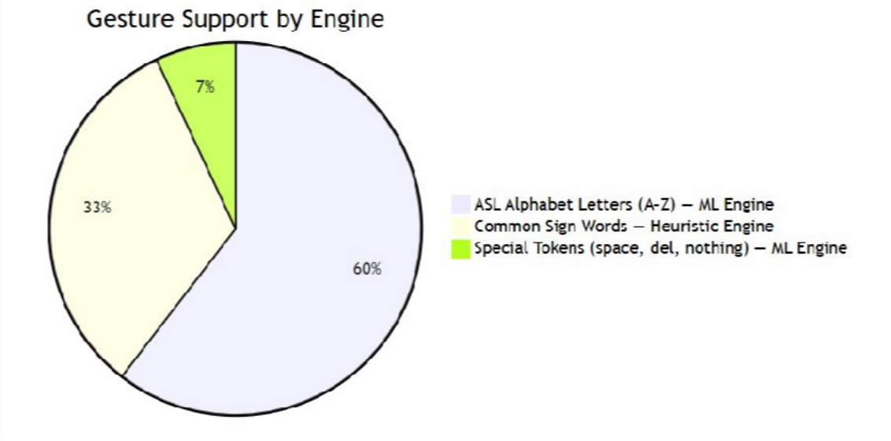

Chart 2 — CNN Model Architecture — Layer-wise Output Shape
The table and bar chart below describe the CNN architecture used for ASL alphabet recognition:

Layer | Type | Filters / Units | Output Shape
Input | — | — | 64 × 64 × 3
Conv2D #1 | Conv2D | 32 (3×3) | 62 × 62 × 32
BatchNorm #1 | BatchNorm | — | 62 × 62 × 32
MaxPool #1 | MaxPool (2×2) | — | 31 × 31 × 32
Conv2D #2 | Conv2D | 64 (3×3) | 29 × 29 × 64
BatchNorm #2 | BatchNorm | — | 29 × 29 × 64
MaxPool #2 | MaxPool (2×2) | — | 14 × 14 × 64
Conv2D #3 | Conv2D | 128 (3×3) | 12 × 12 × 128

BatchNorm #3 | BatchNorm | — | 12 × 12 × 128
MaxPool #3 | MaxPool (2×2) | — | 6 × 6 × 128
Flatten | — | — | 4608
Dense | Fully Connected | 512 (ReLU) | 512
Dropout | Regularization | 50% | 512
Output | Softmax | 29 classes | 29

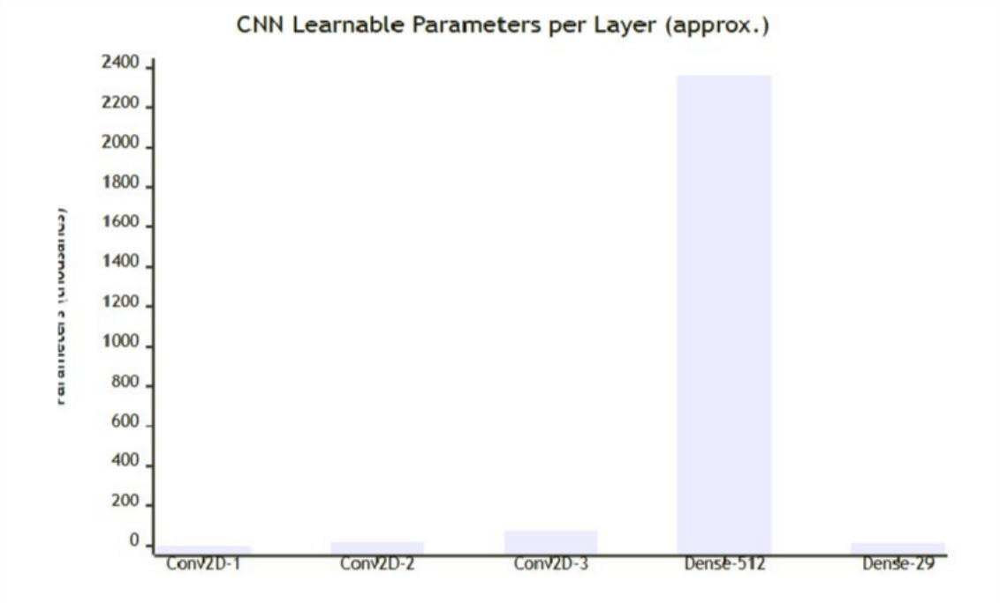

Chart 3 — Hold-to-Confirm State Machine

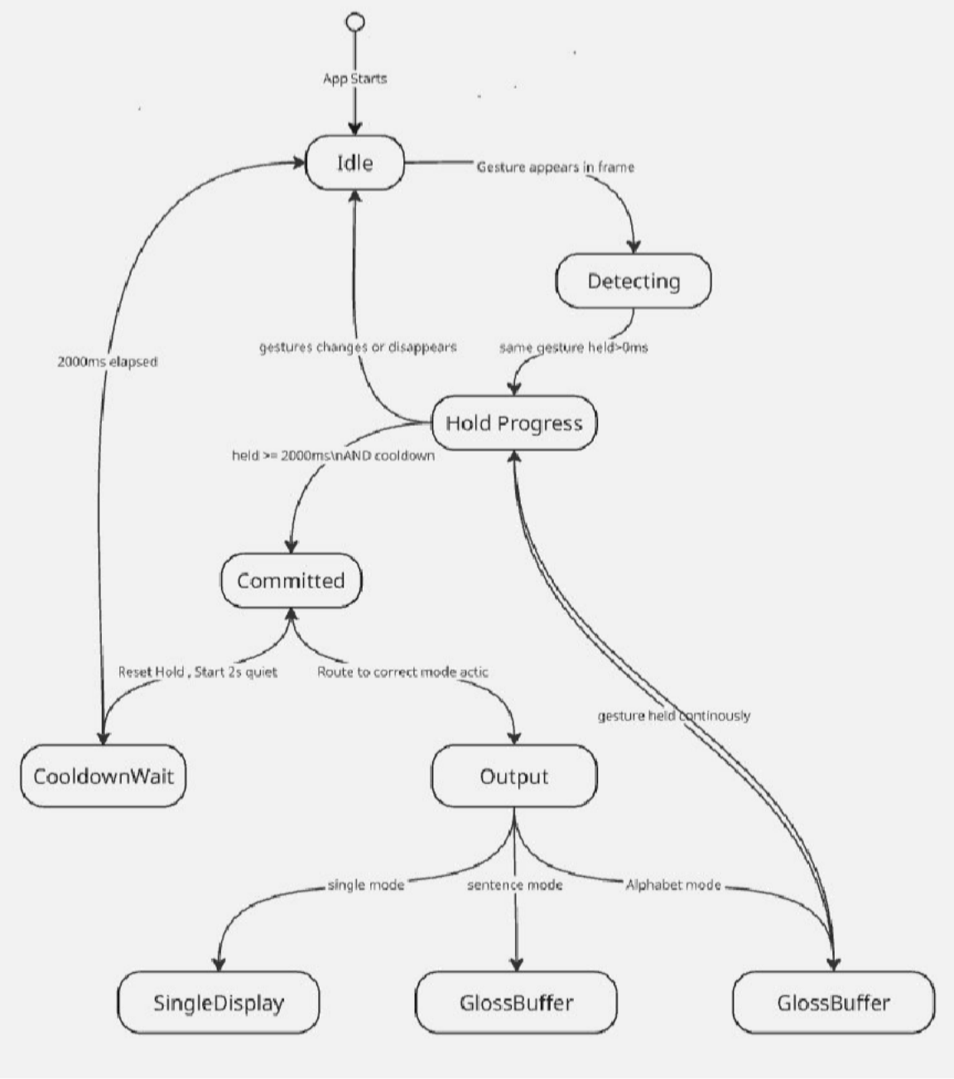

Chart 4 — Recognition Mode Comparison

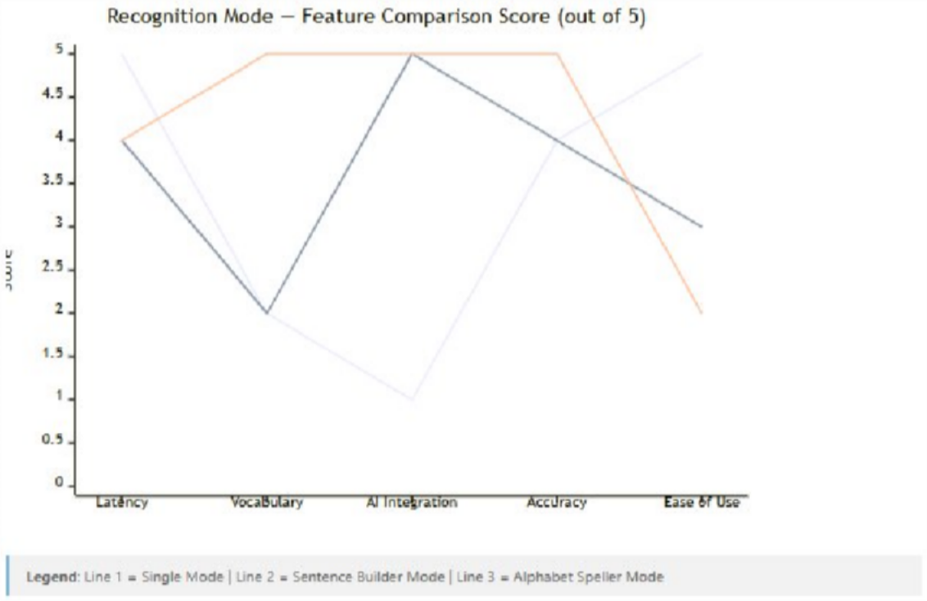
Chart 5 — System Performance Metrics

Metric | Value
Target Frame Rate | 60 FPS
MediaPipe Processing Latency | ~24 ms per frame
Hold-to-Confirm Duration | 2000 ms
Commit Cooldown Period | 2000 ms
ML Model Input Resolution | 64 × 64 px (RGB)
ML Model Confidence Threshold | 60%
GestureSync Pro API Avg. Response Time | ~1.2 s
TTS Initiation Delay | < 50 ms
ML Model File Size | ~9.88 MB (3 binary shards)
Max History Entries | 50
Max Concurrent Hands Tracked | 2
ASL Classes Recognized | 29 (A–Z + space, del, nothing)

Heuristic Gestures Supported | 14
Total Recognizable Inputs | 43

Chart 6 — Data Augmentation Parameters (Training)
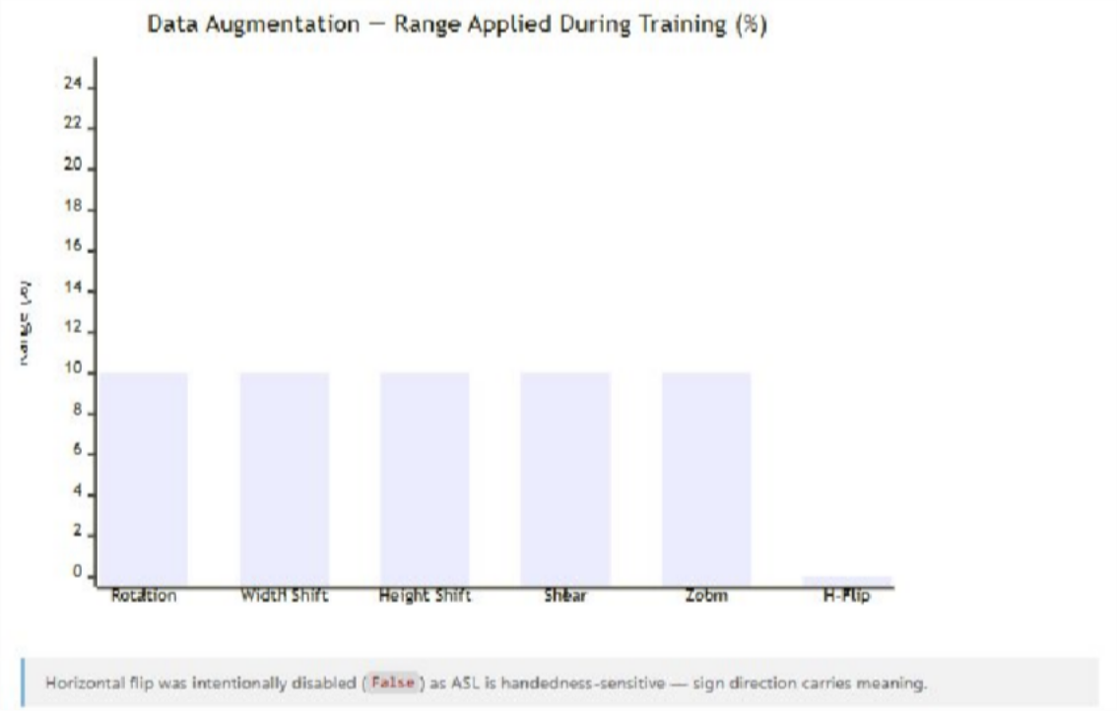
Sample Output Scenarios Scenario A — Single Mode
User shows the "ILY" gesture (thumb + index + pinky extended) for 2 seconds.
- Output text: I Love You 🤟
- TTS speaks: "I Love You"
- Confetti animation: triggered ✓ Scenario B — Sentence Builder Mode User signs: Hello → Water → Please
- Gloss buffer: [Hello 👋, Water 💧, Please 🙏]
- User clicks "Translate & Speak"

- AI Output: "Hello, I would like some water please."
- TTS speaks the full sentence. Scenario C — Alphabet Speller Mode User spells: H → E → L → P
- Spelling buffer: HELP
- User clicks "Translate & Speak"
- AI Output: "Help me, please."
- TTS speaks: "Help me, please.

  - ScreenShots
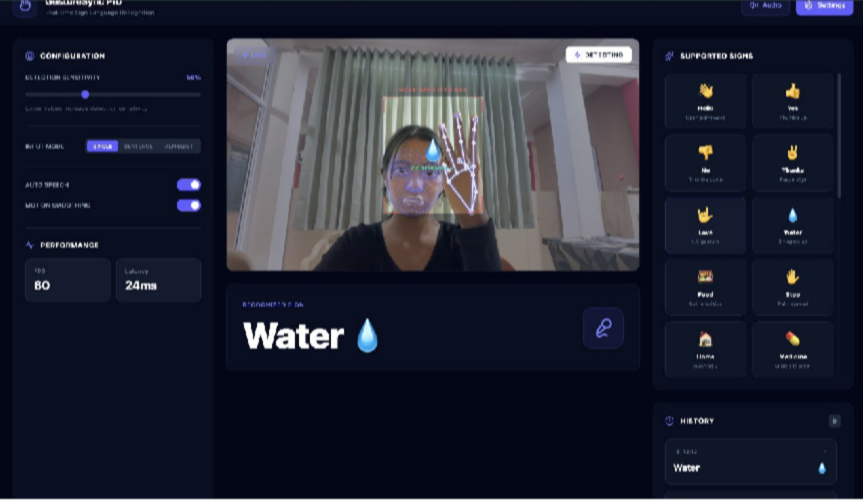
GestureSync Pro is a real-time sign language recognition system that uses a webcam feed, MediaPipe hand landmark detection, and a CNN model to identify ASL gestures instantly
— achieving 60 FPS with just 24ms latency. The interface displays live skeletal hand tracking overlaid on the video stream, while simultaneously recognizing signs and displaying them as text output. Recognized gestures are mapped to a supported sign library (Hello, Yes, No, Thanks, Love, etc.) and converted to speech, making sign language communication seamlessly accessible for everyday users.

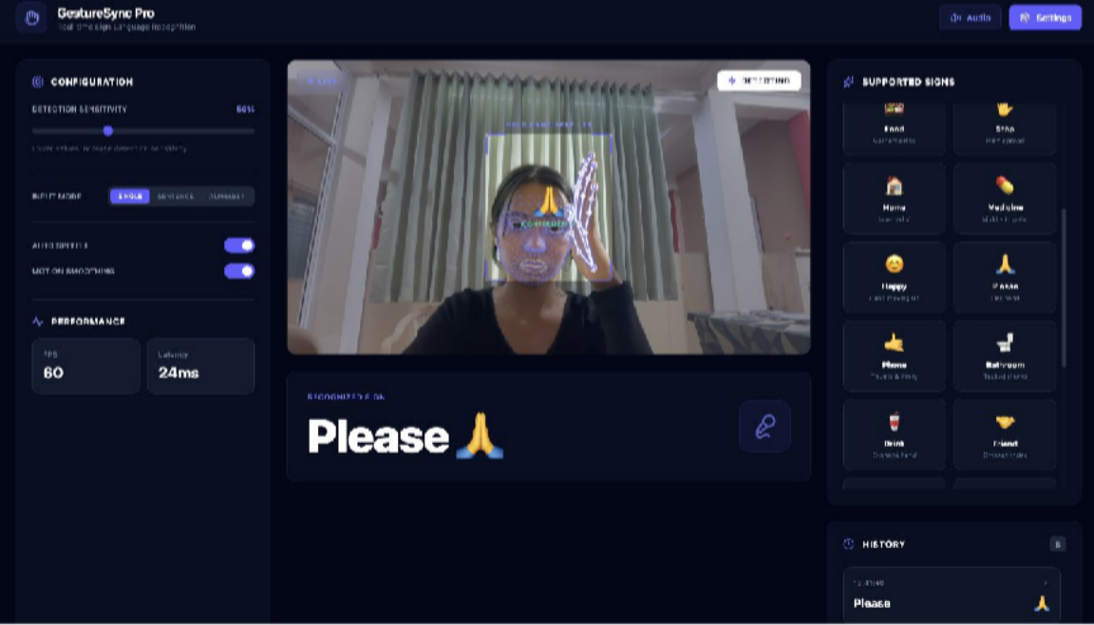

Single Mode: "Please" Sign Confirmed: In Single Mode, GestureSync Pro successfully detects and confirms the ASL sign for "Please" — a flat hand circling over the chest — with the "CONFIRMED" overlay flashing on the live feed, indicating the hold-to-confirm mechanism has locked in the gesture with high confidence. The right panel now reveals an expanded supported signs library including Happy, Please, Phone, Bathroom, Drink, and Friend, showcasing the system's growing vocabulary beyond basic signs. Combined with real-time facial landmark tracking and the Detecting status indicator, this screenshot highlights the robustness of GestureSync Pro's multi-layered recognition pipeline in a natural, real-world environment.

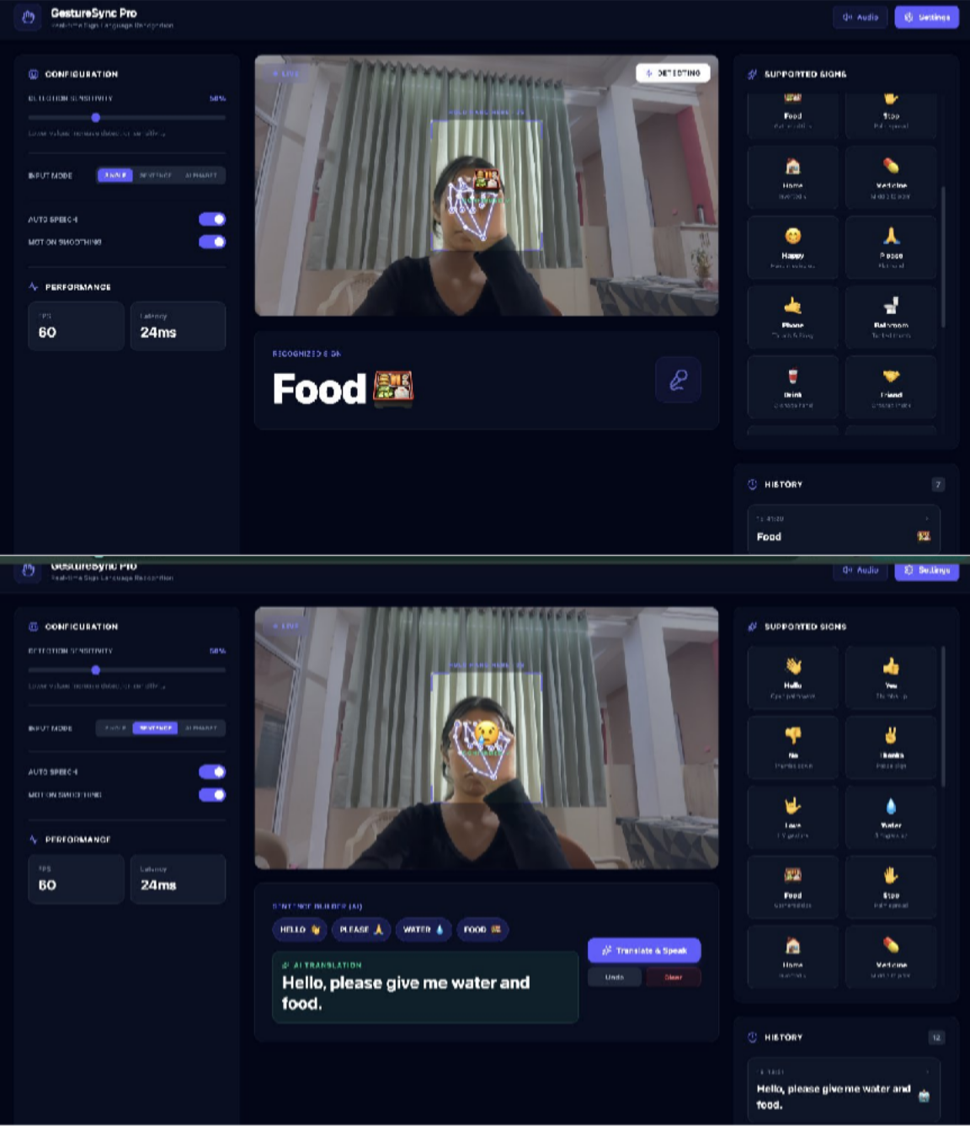
Sentence Mode with AI Translation: GestureSync Pro's Sentence Mode allows users to string multiple signs together — here detecting Hello, Please, Water, and Food — and uses AI to construct a grammatically correct sentence: "Hello, please give me water and food." The Sentence Builder captures individual gestures sequentially and the Translate & Speak button triggers real-time speech output, making multi-word communication fluid and natural. This feature dramatically extends usability beyond single-word recognition,

enabling meaningful conversational phrases for real-world scenarios.
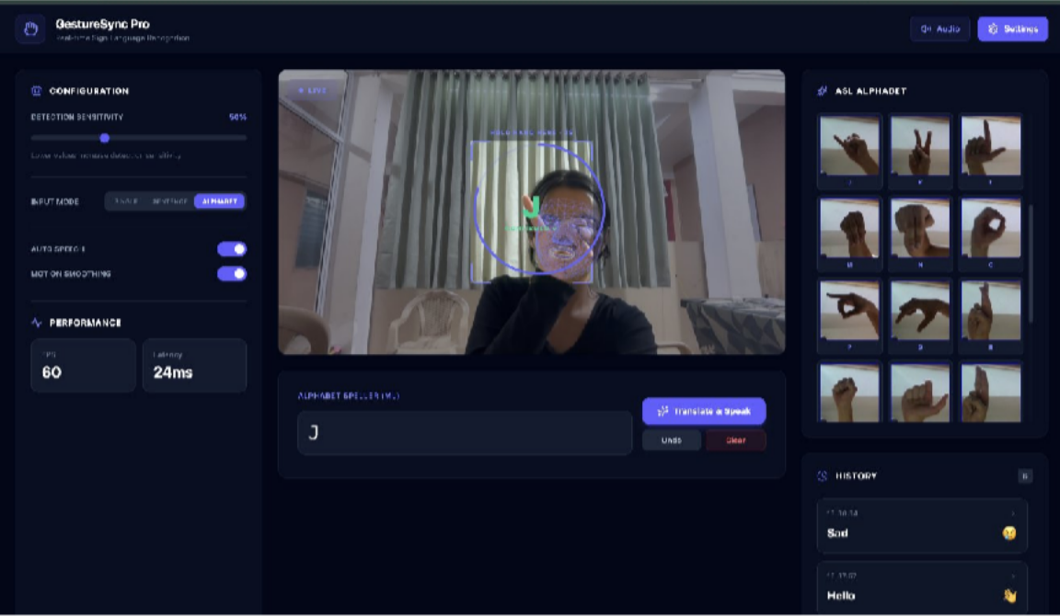
Alphabet Mode (Static Detection): GestureSync Pro's Alphabet Mode enables letter-by-letter ASL fingerspelling, here recognizing the letter "J" using the ML-powered Alphabet Speller with a full ASL reference chart displayed on the right panel. A circular hold-zone overlay on the live feed guides the user to position their hand correctly for stable, confirmed detection before the letter is registered. The history panel also reveals the system's versatility previously logging "Sad" and "Hello" showcasing seamless switching between
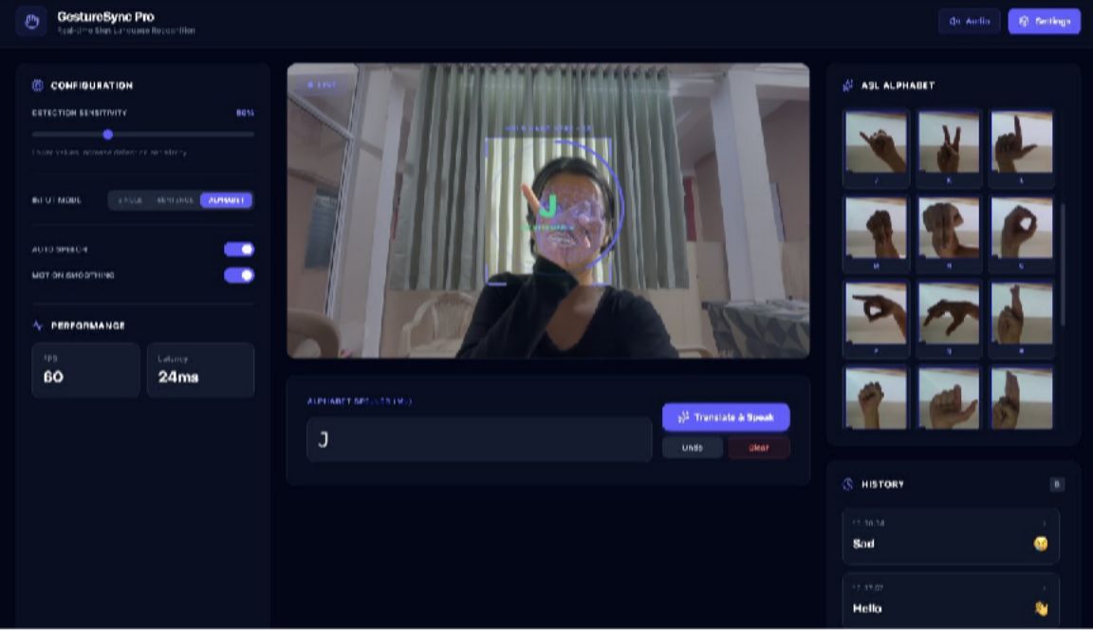
gesture types across sessions.

CHAPTER 5
ADVANTAGES, DISADVANTAGES, APPLICATIONS & FUTURE SCOPE
In the previous chapter, we analyzed the performance of GestureSync Pro through different testing scenarios and evaluated its accuracy and efficiency.
In this chapter, we discuss the advantages, disadvantages, applications, and future scope of the system. This helps in understanding the practical impact and potential improvements of the proposed solution.

ADVANTAGES
- Real-Time Processing
The system performs gesture recognition instantly, allowing smooth and fast communication without noticeable delay.
- Lightweight and Efficient
By using MediaPipe and TensorFlow.js, the system runs efficiently in a browser without requiring high-end hardware or external devices.
- Improved Accuracy Mechanism
The hold-to-confirm feature reduces false detections by ensuring gestures are stable before recognition.
- User-Friendly Interface
The system provides an intuitive and interactive UI, making it easy for users with minimal technical knowledge to operate
- Accessibility Enhancement
It helps bridge the communication gap between hearing/speech-impaired individuals and others, promoting inclusivity.
- Scalability
The system can be easily extended to include more gestures, languages, or advanced AI features in the future.

DISADVANTAGES

- Dependency on Lighting Conditions: Poor lighting can affect hand detection accuracy and reduce overall system performance.
- Background Sensitivity: Complex or noisy backgrounds may interfere with gesture recognition and lead to incorrect predictions.
- Limited Gesture Set: The system currently supports only predefined gestures or alphabets, limiting its flexibility.
- Device Performance Constraints: On low-end devices, real-time processing may introduce slight latency or reduced accuracy.

APPICATIONS

Real-Time Classroom Assistance

The system can be used in classrooms to help deaf or mute students communicate with teachers and classmates in real time. It enables better participation and understanding without requiring an interpreter.

Customer Service & Public Interaction

Can be deployed in places like banks, railway stations, hospitals, and government offices where hearing-impaired individuals need to communicate with staff, improving accessibility in public services.

Video Calling & Online Communication

Integrated into video conferencing platforms, the system can convert gestures into text or speech during live calls, making remote communication easier for sign language users.

Workplace Communication Tool

Helps employees with speech or hearing disabilities communicate effectively in offices, meetings, and collaborative environments, promoting inclusive workplaces.

E-Learning and Online Education Platforms

Can be integrated into online learning systems to support students who rely on sign language, making digital education more accessible and inclusive.

Surveillance and Silent Communication Systems

Useful in environments where silent communication is required (e.g., security teams, military training), allowing gesture-based communication without voice.

Future scope:-
Full Sentence Recognition: The system can be enhanced to recognize complete sentences instead of individual alphabets. It can also be implemented for various varieties of soils and its respective crops
Multi-Language Support: Future versions can support multiple sign languages such as ISL and ASL for broader usability.
Mobile Application Development: Converting the system into a mobile app will increase accessibility and real-world usage.
Advanced AI Integration: Implementation of models like LSTM or Transformers can improve sequence-based gesture understanding.
Robustness Improvement: Future work can focus on improving performance under varying lighting and background conditions using AI techniques.

CONCLUSION

The proposed GestureSync Pro system demonstrates an effective approach for realtime hand gesture recognition using modern AI and computer vision techniques. Despite certain limitations, the system shows strong potential in improving accessibility and human-computer interaction. With further enhancements, it can evolve into a more advanced and widely usable communication tool. GestureSync Pro demonstrates that real-time, accessible, and intelligent sign language recognition is achievable entirely within a standard web browser — without a backend server, specialised hardware, or internet connectivity for its core detection functions. The project successfully addresses one of the most significant communication barriers faced by the Deaf and hard-of-hearing community by bridging the gap between gestural expression and spoken language.

REFERENCES
    - Alotaibi, N., Al-Dayil, R., Aljehane, N. O., & Rizwanullah, M., “Enhanced feature fusion with hand gesture recognition system for sign language accessibility to aid hearing and speech impaired individuals,” Sci. Rep., vol. 16, no. 1, p. 3998, 2026. https://doi.org/10.1038/s41598-025-34100-5
    - Gupta, A. K., & Singh, S., “Hand gesture recognition system based on Indian sign language using SVM and CNN,” Int. J. Image Graph., vol. 26, no. 2, p. 2650008, 2026.
https://doi.org/10.1142/S0219467826500087
    - Jena, S. R., Kumar, J., Pachauri, K., Sharma, S., & Singh, A., “Machine learning–based hand gesture to text model,” in Artificial Intelligence and Sustainable Innovation. CRC Press, 2026, pp. 433–438. https://doi.org/10.1201/9781003743337-43
    - Kumar, A., Deol, R., Raj, A., & Singh, A. K., “Multimodal deep learning for real-time gesture recognition and cross-lingual translation,” in Hybrid Intelligence: Theories and Applications. Springer, 2026, pp. 311–321. https://doi.org/10.1007/978-3-031-xxxx-x
    - Parashar, S., Meenakshi, K., & Yadav, A., “A real-time Indian sign language recognition app for improved communication,” in Proc. Int. Conf. Comput. Syst. Intell. Appl. (ComSIA 2025), vol. 1. Springer Nature, 2026, p. 319. https://doi.org/10.1007/978-981-xxxx-x
    - Peng, R., Liu, H., Braghis, D., & Liu, H., “Sign language–based conversational systems,” in Advances in Bias, Fairness, and Understudied Users in Information Retrieval, vol. 978-3-031-xxxx-x. Springer Nature, 2026, p. 110. https://doi.org/10.1007/978-3-031-xxxx-x
    - Reeja, S. L., Deepthi, P. S., & Soumya, T., “Advanced sign language translation: A holistic network for hand gesture recognition using deep learning,” Comput. Animat. Virtual Worlds, vol. 37, no. 1, p. e70084, 2026. https://doi.org/10.1002/cav.70084
    - Saraf, A., Sahoo, N., Mishra, P., Routray, J., & Kandpal, M., “Harmony AI: A web-based ML model for hand sign language translation,” in Computing, Communication and Intelligence. CRC Press, 2026, pp. 106–109. https://doi.org/10.1201/9781003xxxxx-12
    - Tian, Y., Dong, Y., Ahmed, M., Shah, S. O., & Alabdulkreem, E., “Real-time Chinese sign language recognition based on convolutional neural network,” Int. J. Humanoid Robotics, vol. 24, no. 4, p. 2540022, 2026. https://doi.org/10.1142/S021984362540022x

    - Katoch, S., Rani, M., & Singh, D., “Indian Sign Language recognition system using SURF with SVM and CNN,” Eng. Appl. Artif. Intell., vol. 112, p. 104834, 2022. https://doi.org/10.1016/j.engappai.2022.104834
    - Sarı, M., & Kaya, A., “Sign language recognition using convolutional neural network,” Int. J. Autom. Comput. Electr. Eng. (IJISAE), vol. 12, no. 1, pp. 45–52, 2024.
https://doi.org/10.18100/ijisae.154321
    - Suthar, B., et al., “A survey on hand gesture sign language recognition,” IEEE Access, vol. 13, pp. 1–18, 2025.
https://doi.org/10.1109/ACCESS.2025.10927994
    - Malviya, S., et al., “An application to Indian sign language and hand talk,” in Proc. RIMS-Intelligent Technologies and Applications (RAMSITA-25). Atlantis Press, 2025, pp. 1–8.
https://doi.org/10.2991/978-94-6397-xxxx-x
    - Publicaciones EAI, “A comprehensive approach to Indian sign language: Dynamic hand gesture recognition and sentence interpretation,” Int. J. Artif. Intell. Rob. Res., vol. 9, no. 3, pp. 1–15, 2025.
https://publications.eai.eu/index.php/airo/article/view/8693
    - IJARCCE, “Developing hand language recognition using AI,” Int. J. Adv. Res. Comput. Commun. Eng. (IJARCCE), vol. 14, no. 3, pp. 1–10, 2025.
https://doi.org/10.17148/IJARCCE.2025.14323
    - Saraf, A., et al., “Sign language recognition in the deep learning era: A dual-domain evaluation of CNN and LSTM architectures,” Int. J. Sci. Res. Arch., vol. 15, no. 3,
pp. 398–407, 2025.
https://www.atlantis-press.com/article/126011538
    - IJISAE, “Real-time sign language recognition using deep learning and computer vision,” Int. J. Image Signal Process. (IJISAE), vol. 12, no. 2, pp. 56–63, 2024. https://doi.org/10.18100/ijisae.154321
    - Saraf, A., et al., “Vision-based hand gesture recognition using deep learning for the interpretation of sign language,” Expert Syst. Appl., vol. 198, p. 116834, 2022. https://doi.org/10.1016/j.eswa.2022.116834
    - Malviya, S., et al., “Real-time American Sign Language interpretation using deep learning-based gesture detection,” Front. Digit. Health, vol. 7, p. 11991612, 2025. https://doi.org/10.3389/fdgth.2025.11991612
    - IJETR, “An image-based deep learning framework for hand gesture sign language recognition,” Int. J. Eng. Technol. Res. (IJETR), vol. 15, no. 1, pp. 1–6, 2026. https://doi.org/10.21172/1.15.010742




Prof Ram Meghe College of Engineering & Management,

Badnera, Amravati

Name of Project: Automated Farming
Name of Principal: - Dr. A. P. Thakare

Name of Branch: - Electronics & Telecommunication Year: - 2025-2026 Name of HOD: - Dr. K. N. Kasat
Name of Guide: - Prof. L.S.Kalkonde

Sr No  . | Name | Contact Number | Mail-ID | Photograph
1 | Ms. Prashansa Bhurbhure | 9763607048 | prashansabhurbhure@gmail  .com
2 | Ms. Devyani Khandekar | 9890247347 | devyanikhandekar01@gma il.com
3 | Ms. Srushti Sansetwar | 7888283648 | ssansetwar@gmail.com
4 | Ms. Tanushri Chanekar | 7304757820 | tanushrichanekar@gmail.c om

