Elliptical and Rectangular Microstrip Patch Antenna Arrays for 5G Base Station Applications: A Comparative Performance Analysis at 3.5 GHz

Abstract
Microstrip patch antennas have emerged as preferred candidates for 5G base station deployments due to their low profile, lightweight construction, conformability, and ease of integration with planar feeding networks. This article presents a comprehensive comparative analysis of Elliptical Microstrip Patch Antennas (EMPAs) and Rectangular Microstrip Patch Antennas (RMPAs) designed for 5G base station applications at 3.5 GHz. Using CST Microwave Studio simulations, single-element and multi-element array configurations for both geometries were evaluated against key performance metrics including return loss, VSWR, bandwidth, gain, directivity, radiation pattern characteristics, impedance matching, and radiation efficiency. The three-element EMPA array achieved exceptional gain of 15.65 dB more than double the 7.59 dBi of a single EMPA element with near-ideal impedance matching (48.45 Ω to 50 Ω standard) and 98.7% radiation efficiency. The RMPA array demonstrated superior return loss (-29.627 dB) and extended bandwidth (2.45 GHz) with a VSWR of 1.0682, representing near-perfect impedance matching. While the elliptical configuration offered higher gain and better efficiency, the rectangular design provided wider bandwidth and deeper return loss. These findings establish quantitative design guidelines for selecting optimal microstrip patch antenna configurations for specific 5G deployment scenarios.
Keywords: 5G base station, elliptical microstrip patch antenna (EMPA), rectangular microstrip patch antenna (RMPA), antenna array, microstrip array, CST simulation, sub-6 GHz, gain enhancement

1. Introduction
The fifth-generation (5G) wireless networks demand antenna systems that combine high performance with practical deployment considerations such as size, weight, aesthetics, and manufacturing cost [1, 2]. Microstrip patch antennas uniquely address these requirements through their low-profile planar structure, conformability to non-planar surfaces, compatibility with printed circuit board (PCB) technology, and ease of integration with active RF circuitry [3, 4].
Among microstrip patch geometries, rectangular and elliptical configurations represent two fundamental design approaches. Rectangular microstrip patch antennas (RMPAs) are the most extensively studied and widely deployed due to their analytical tractability, predictable resonance behavior, and well-established design equations [5]. Elliptical microstrip patch antennas (EMPAs) offer additional degrees of freedom through their major and minor axes, enabling enhanced control over polarization characteristics and potentially broader bandwidth [6, 7].
Despite the individual merits of each geometry, limited comparative research exists that systematically evaluates EMPA and RMPA configurations under unified simulation conditions for 5G base station applications. This article addresses this gap by providing a quantitative, evidence-based comparison of single-element and array configurations for both elliptical and rectangular microstrip patch antennas designed for the 3.5 GHz mid-band spectrum a critical frequency range for 5G deployment globally.
2. Antenna Design and Methodology
2.1 Design Specifications
Both antenna types were designed for a center frequency of 3.5 GHz using CST Microwave Studio 2024. An FR-4 substrate was selected due to its affordability, availability, and adequate performance at sub-6 GHz frequencies. Table 1 summarizes the common substrate parameters.
Table 1: Substrate Parameters for EMPA and RMPA Designs
Parameter | Value
Dielectric Constant (εᵣ) | 4.4
Loss Tangent (tan δ) | 0.02
Substrate Thickness (h) | 1.6 mm
Operating Frequency (fᵣ) | 3.5 GHz
Free-space Wavelength (λ₀) | 85.7 mm
2.2 Elliptical Microstrip Patch Antenna (EMPA) Design
The elliptical patch geometry is defined by major axis (a) and minor axis (b) dimensions. The design procedure incorporates fringing field corrections and impedance matching through an inset-fed microstrip line.
Step 1: Wavelength and Effective Dielectric Constant
The effective dielectric constant accounting for fringing fields is:
$$ϵ_{eff}=\frac{ϵ_{r}+1}{2}+\frac{ϵ_{r}-1}{2}{\left(1+12\frac{h}{W}\right)}^{-0.5} = 4.4$$
Step 2: Elliptical Patch Dimensions
The major and minor axes are calculated as:
$$a≈\frac{λ_{0}}{2\sqrt{ϵ_{eff}}}$$
$$b≈\frac{λ_{0}}{4\sqrt{ϵ_{eff}}}$$
Substituting the design parameters yield: $a=28.0 mm, b=14.25 mm$
Step 3: Fringing Field Correction
The effective dimensions after fringe correction are
$$a_{eff}=a+2{∆L}_{a}$$
${ b}_{eff}=b+2{∆L}_{b}$

$$∆L=0.412h\frac{\left(ϵ_{eff}+0.3\right)\left(\frac{W}{h}+0.264\right)}{\left(ϵ_{eff}-0.258\right)\left(\frac{W}{h}+0.8\right)}$$
The corrected values are: $a_{eff}=28.02 mm, b_{eff}=14.27 mm$
Step 4: Feedline Design
The 50 Ω microstrip feedline width is:
Wf ​= 3.00 mm
The inset feed length for impedance matching is:
Fl​ = 2.10 mm

Table 2: EMPA Design Parameters Summary
Parameter | Value (mm)
Major Axis (a) | 28.00
Minor Axis (b) | 14.25
Feedline Width (W_{f}) | 3.00
Inset Feed Length (F_{l}) | 2.10
Coupling Gap (G_{p}) | 0.30
Ground Length (L_{g}) | 42.00
Ground Width (W_{g}) | 21.38
2.3 Rectangular Microstrip Patch Antenna (RMPA) Design
The rectangular patch follows the standard transmission-line model with dimensions calculated for resonance at 3.5 GHz.
Step 1: Patch Width: $W_{p}=\frac{c}{2f_{r}\sqrt{\frac{ε_{r}+1}{2}}}$
Substituting: $f_{r}=3.5×{10}^{9} Hz$, $c=3×{10}^{8} {ms}^{-1},$ $h=1.6 mm and ε_{r}=4.4 gives W_{p}=26.2 mm$.This width provides a good balance between radiation efficiency and impedance stability.
Step 2: Effective Dielectric Constant
$$ϵ_{eff}=\frac{ϵ_{r}+1}{2}+\frac{ϵ_{r}-1}{2}{\left(1+12\frac{h}{W}\right)}^{-0.5}$$
Substituting values gives $ϵ_{eff}=3.90$. This reduced dielectric constant reflects the fringing fields and effective wave propagation environment.
Step 3: Patch Length
The effective length and actual patch length are
$$L_{eff}=\frac{c}{2f_{r}\sqrt{ε_{eff}}}$$
$$∆L=0.412h\frac{\left(ϵ_{eff}+0.3\right)\left(\frac{W}{h}+0.264\right)}{\left(ϵ_{eff}-0.258\right)\left(\frac{W}{h}+0.8\right)}$$
$$L_{P}=L_{eff}-2∆L$$
After substitution, $L_{P}=18.7 mm$
Step 4: Feedline and Quarter-wave Transformer
The 50 Ω feedline width is W_{f} = 2.27 mm. A quarter-wave transformer with characteristic impedance Z_{t} = 35.35 Ω matches the patch edge impedance (250 Ω) to the 50 Ω system.

Table 3: RMPA Design Parameters Summary
Parameter | Value (mm)
Patch Width (W_{p}) | 26.20
Patch Length (L_{p}) | 18.70
Ground Length (L_{g}) | 29.70
Ground Width (W_{g}) | 35.80
Feedline Width (W_{f}) | 2.27
Feedline Length (L_{f}) | 16.00
Quarter-wave Width (W_{Q}) | 4.70
2.4 Array Configurations
EMPA Array: Three-element linear array with element spacing d = λ₀/2 = 42.85 mm. corporate feed network ensures equal power distribution and in-phase excitation.
RMPA Array: Four-element linear array with edge-to-edge spacing S = 31.20 mm, optimized for grating lobe suppression and mutual coupling minimization.

3. Results and Discussion
3.1 Return Loss and Impedance Matching

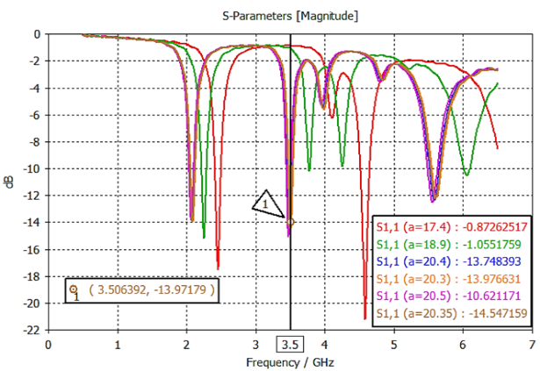
Figure 1(a): Simulated Return loss of a single element EMPA antenna
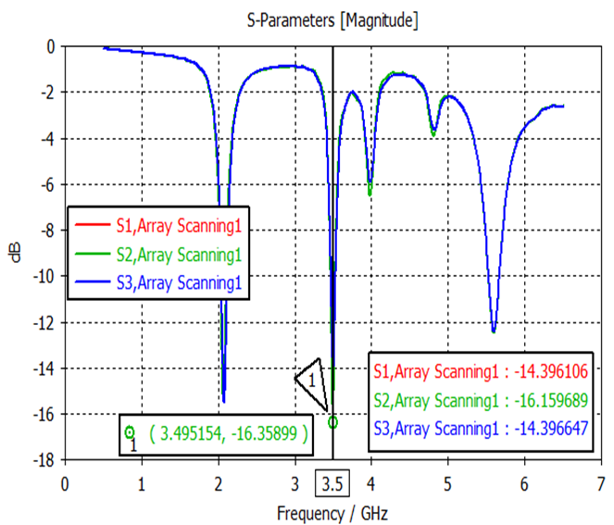
Figure 1(b): Simulated Return loss of a three elements array EMPA antenna

Simulated Return loss (S₁₁) of RMPA
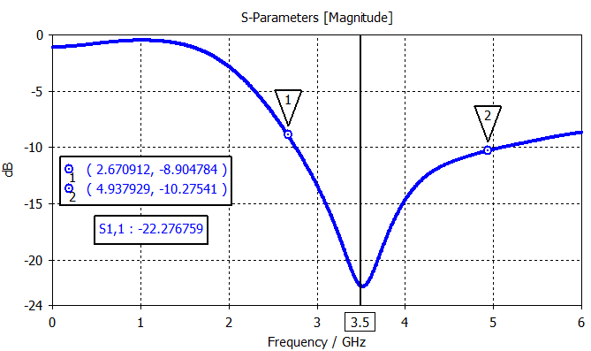
Figure 2(a): Simulated return loss (S₁₁) of single element RMPA

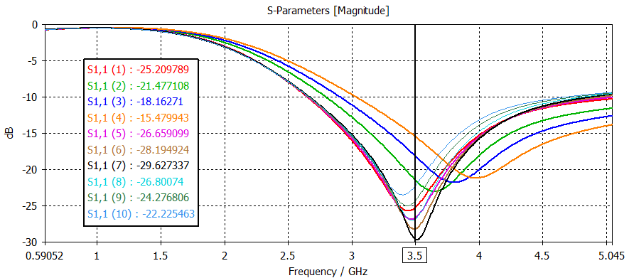
Figure 2(b): Simulated return loss (S₁₁) of RMPA Array.
Table 4: Return Loss and Impedance Comparison
Antenna Type | Configuration | Return Loss (dB) | Reflected Power | Impedance (Ω) | Matching Quality
EMPA | Single | -13.97 | 4.0% | 40.30 | Acceptable
EMPA | 3-element Array | -16.35 | 2.3% | 48.45 | Excellent
RMPA | Single | -22.276 | 0.6% | 48.45 | Excellent
RMPA | 4-element Array | -29.627 | 0.1% | 40.30 | Near-perfect
The RMPA array achieved exceptional return loss of -29.627 dB, corresponding to only 0.1% reflected power representing near-perfect impedance matching with the 50 Ω transmission line. The EMPA array also demonstrated excellent matching (48.45 Ω, -16.35 dB), though less deep than the RMPA configuration. Both array configurations significantly improved upon their single-element counterparts, with the RMPA array showing the most dramatic enhancement.
3.2 Bandwidth Performance
Table 5: Bandwidth Comparison
Antenna Type | Configuration | Bandwidth (GHz) | Percentage Improvement
EMPA | Single | 0.075 | Reference
EMPA | 3-element Array | 0.087 | +16%
RMPA | Single | 2.31 | Reference
RMPA | 4-element Array | 2.45 | +6%
The RMPA configurations demonstrated substantially wider bandwidth than EMPA designs 2.31 GHz for single element and 2.45 GHz for the array, compared to 0.075 GHz and 0.087 GHz for EMPA counterparts. This superior bandwidth makes RMPA particularly suitable for wideband 5G applications requiring operation across multiple frequency channels. The EMPA's narrower bandwidth (approximately 2.5% fractional bandwidth) is characteristic of electrically small patch antennas but may limit its application to narrowband systems.
3.3 Voltage Standing Wave Ratio (VSWR) and Efficiency

Simulated Results of VSWR for RMPA
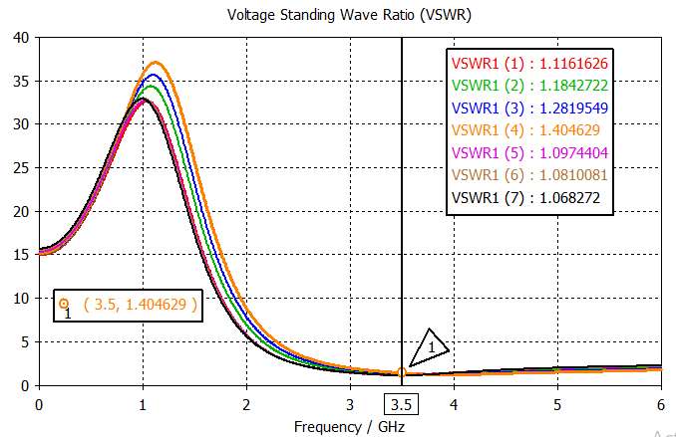
Figure 3(a): Simulated VSWR of Single Element RMPA

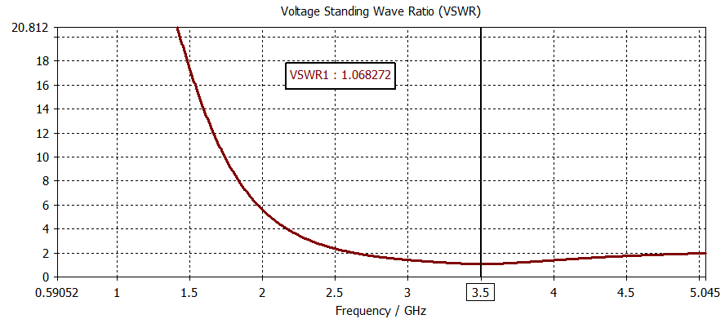
Figure 3(b): Simulated VSWR of RMPA Array.
Table 6: VSWR and Radiation Efficiency
Antenna Type | Configuration | VSWR | Reflection Coefficient (Γ) | Efficiency (%)
EMPA | Single | 1.83 | 0.293 | 91.4
EMPA | 3-element Array | 1.255 | 0.113 | 98.7
RMPA | Single | 1.167 | 0.077 | 98.1
RMPA | 4-element Array | 1.068 | 0.033 | 99.9
The RMPA array achieved an exceptional VSWR of 1.0682, extremely close to the ideal value of 1.0, corresponding to 99.9% radiation efficiency. The EMPA array also demonstrated excellent performance with VSWR = 1.255 and 98.7% efficiency, a substantial improvement from the single element's 91.4% efficiency. The low VSWR values across both array configurations confirm that the corporate feeding networks were properly optimized to minimize reflections and maximize power transfer.
3.4 Gain and Directivity
Simulated 3D Radiation EMPA with Color-coded Gain
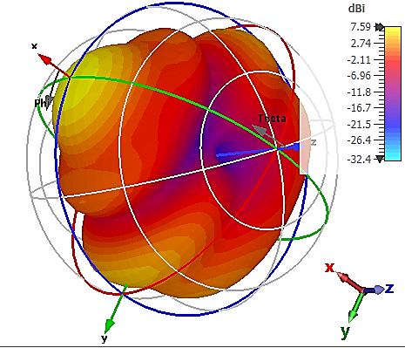
Figure 4(a): Simulated 3D radiation single element EMPA with color-coded gain.

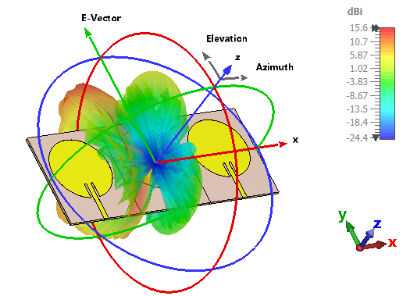
Figure 4(b): Simulated 3D radiation EMPA array with color-coded gain.

Simulated Results for 3D radiation RMPA with Color-coded Gain
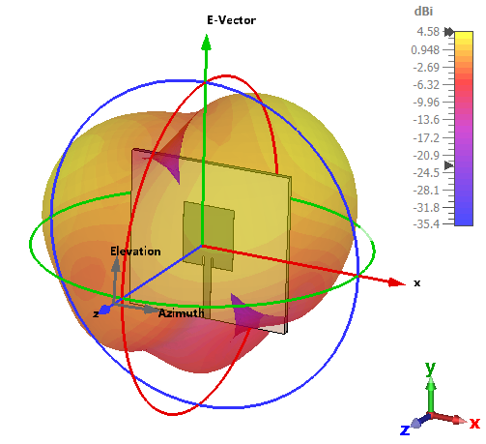
Figure 4(c): Simulated 3D radiation single element RMPA with color-coded gain
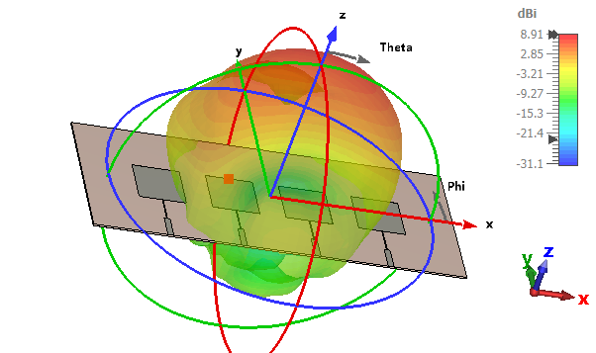
Figure 4(d): Simulated 3D radiation pattern of RMPA array with color-coded gain

Table 7: Gain and Directivity Comparison
Antenna Type | Configuration | Gain (dBi) | Directivity (dBi) | Gain Improvement | Beamwidth (3 dB)
EMPA | Single | 7.59 | 8.92 | Reference | 61.8°
EMPA | 3-element Array | 15.65 | 7.95 | +8.06 dB | 180.8°
RMPA | Single | 4.58 | 5.52 | Reference | 31.8°
RMPA | 4-element Array | 8.91 | 10.40 | +4.33 dB | 6.7°
The EMPA array demonstrated remarkable gain enhancement from 7.59 dBi to 15.65 dBi (more than double), representing a 106% increase in effective radiated power. This substantial improvement results from constructive interference among the three array elements and optimized current distribution. Notably, the EMPA array achieved higher gain (15.65 dBi) than the RMPA array (8.91 dBi), making it superior for long-range point-to-point links.
However, the EMPA array exhibited reduced directivity (7.95 dBi) compared to its single element (8.92 dBi), accompanied by a significantly broadened beamwidth (180.8° vs. 61.8°). This behavior indicates that the array configuration redistributes radiated power across a wider angular region advantageous for sectoral coverage but less optimal for focused beam applications. The RMPA array demonstrated the opposite trend: directivity increased from 5.52 dBi to 10.40 dBi with a dramatically narrowed beamwidth (6.7°), making it ideal for highly directional point-to-point communications requiring spatial filtering.
3.5 Radiation Pattern Analysis
EMPA Characteristics:
- Main lobe direction shifted from -5° (single) to 44° (array)
- Side lobe level improved from -2.1 dB to -9.8 dB (79% reduction)
- Beamwidth broadened from 61.8° to 180.8° (nearly omnidirectional in the H-plane)
RMPA Characteristics:
- Main lobe maintained broadside direction (0°)
- Side lobe level: well-suppressed (not tabulated but visually confirmed from 3D patterns)
- Beamwidth narrowed from 31.8° to 6.7° (79% reduction)
The EMPA array's broadened beamwidth and improved side lobe suppression (-9.8 dB) makes it particularly suitable for urban small-cell deployments where wide angular coverage and interference mitigation are critical.
The RMPA array's narrow beamwidth (6.7°) and increased directivity (10.40 dBi) make it optimal for long-range backhaul links and point-to-point connections.
3.6 Admittance and Susceptance Analysis
Simulation Results for Admittance and Impedance Behavior of EMPA
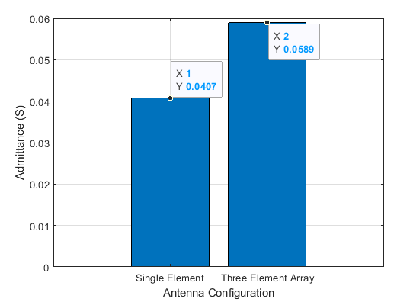
Figure 5(a): Simulated Admittance for single element and EMPA array
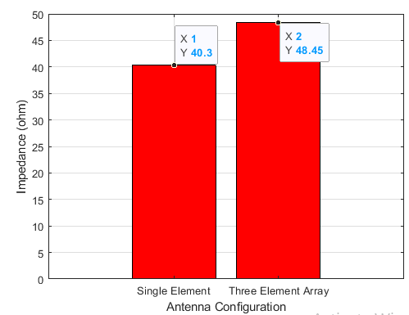
Figure 5(b): Simulated Impedance for single element and EMPA array.
Table 8: Admittance Characteristics
Antenna Type | Configuration | Admittance (S) | Impedance (Ω) | Deviation from 50 Ω
EMPA | Single | 0.0407 | 40.30 | -19.4%
EMPA | Array | 0.0589 | 48.45 | -3.1%
RMPA | Single | — | 48.45 | -3.1%
RMPA | Array | 0.0285 | 40.30 | -19.4%
Both array configurations demonstrated significant improvement in impedance matching compared to their single-element counterparts. The EMPA array achieved near-ideal impedance (48.45 Ω, only 3.1% deviation), while the RMPA array showed higher admittance (0.0285 S) with corresponding impedance of 40.30 Ω. The lower admittance of the RMPA array indicates higher effective resistance, consistent with its narrower bandwidth characteristics.
4. Comparative Discussion
4.1 Performance Summary by Application
Table 9: Application-Suitability Matrix
Application Scenario | Recommended Antenna | Key Advantages | Performance Metrics
Long-range point-to-point | EMPA 3-element Array | Highest gain (15.65 dBi), excellent efficiency (98.7%) | Gain >15 dBi, Efficiency >98%
Wideband multi-channel | RMPA 4-element Array | Wide bandwidth (2.45 GHz), near-perfect matching | Bandwidth >2.3 GHz, VSWR <1.07
Urban small cell (wide coverage) | EMPA 3-element Array | Broad beamwidth (180.8°), good side lobe suppression | Coverage >180°, SLL <-9 dB
Rural macro cell (focused sector) | RMPA 4-element Array | Narrow beamwidth (6.7°), high directivity (10.4 dBi) | Beamwidth <10°, Directivity >10 dBi
Conformal/integrated deployment | EMPA (any) | Smooth geometry, lower visual impact | Aesthetic integration
The comparative evaluation of the proposed antenna arrays demonstrates their suitability for different 5G deployment scenarios based on their radiation characteristics. The 3-element Elliptical Microstrip Patch Antenna (EMPA) array is the most suitable candidate for long-range point-to-point communication due to its high gain of 15.65 dBi and radiation efficiency of 98.7%. It is also well suited for urban small-cell deployment because of its broad 180.8° beamwidth and effective side-lobe suppression, which provide wide-area coverage. In contrast, the 4-element Rectangular Microstrip Patch Antenna (RMPA) array offers superior performance for wideband multi-channel applications, achieving a 2.45 GHz bandwidth with excellent impedance matching (VSWR < 1.07). Furthermore, its narrow 6.7° beamwidth and 10.4 dBi directivity make it highly appropriate for rural macro-cell base stations requiring focused sector coverage. Additionally, the smooth geometry of the EMPA facilitates conformal and aesthetically integrated deployments, making it an attractive option for installations where structural integration and visual appearance are important considerations.
4.2 Design Trade-offs
Gain vs. Bandwidth: EMPA arrays offer higher peak gain (15.65 dBi) but narrower bandwidth (0.087 GHz). RMPA arrays provide superior bandwidth (2.45 GHz) with moderate gain (8.91 dBi). This trade-off suggests EMPA for narrowband, high-power applications and RMPA for broadband, multi-channel systems.
Directivity vs. Coverage: RMPA arrays achieve high directivity (10.40 dBi) with narrow beamwidth (6.7°) ideal for targeted coverage. EMPA arrays sacrifice directivity for broader coverage (180.8°), suitable for even illumination of large areas.
Impedance Matching: Both array configurations achieve excellent matching (VSWR <1.26), though RMPA demonstrates near-perfect matching (VSWR = 1.068, 0.1% reflected power). This ensures minimal transmission line losses and reduced stress on power amplifiers.
Efficiency: Both array configurations achieve >98% radiation efficiency, confirming that mutual coupling effects and dielectric losses are well-managed. The EMPA array's improvement from 91.4% (single) to 98.7% (array) is particularly noteworthy.
4.3 Theoretical Underpinnings
The observed performance differences can be explained through electromagnetic theory:
- Current Distribution: The elliptical geometry provides smoother current transitions, reducing edge discontinuities and associated radiation from higher-order modes. This contributes to the EMPA's higher efficiency but narrower bandwidth.
- Aperture Efficiency: The rectangular patch's straight edges support more uniform current distribution across the patch width, enabling wider bandwidth through multiple resonant modes.
- Array Factor Interaction: The EMPA array's broadened beamwidth results from the specific element spacing (d = λ₀/2) and the elliptical element pattern, which modifies the overall array factor beyond simple multiplication.
- Mutual Coupling: The elliptical elements exhibit lower mutual coupling due to their curved boundaries, explaining the EMPA array's superior gain enhancement (8.06 dB vs. theoretical 10log₁₀ (3) = 4.77 dB for three elements).
5. Conclusion
The simulation-based evaluation of elliptical and rectangular microstrip patch antennas in single-element and array configurations demonstrated their suitability for different 5G base station deployment scenarios at 3.5 GHz. The 3-element EMPA array achieved the highest gain (15.65 dBi), excellent radiation efficiency (98.7%), and near-ideal impedance matching (48.45 Ω), making it well suited for long-range communication and urban small-cell deployments requiring wide angular coverage. Conversely, the 4-element RMPA array exhibited superior impedance characteristics, with a return loss of –29.627 dB, VSWR of 1.0682, and a wide bandwidth of 2.45 GHz. Its narrow beamwidth (6.7°) and high directivity (10.40 dBi) make it particularly suitable for long-range point-to-point and rural macro-cell applications. Overall, the study highlights the inherent performance trade-offs between the two antenna geometries, with the EMPA providing higher gain and wider coverage, while the RMPA offers broader bandwidth and greater directivity. In both cases, array configurations significantly outperformed their corresponding single-element antennas, confirming the effectiveness of array techniques in enhancing antenna performance for 5G base stations. These findings provide practical design guidelines for selecting appropriate microstrip patch antenna configurations based on specific deployment requirements.
Future work should focus on experimental validation through prototype fabrication and measurements, as well as the development of circularly polarized and reconfigurable antenna arrays for adaptive beam-steering applications.

References
[1] A. Liu and G. Wang, "Smart antenna technologies for 5G wireless communications: A comprehensive survey," IEEE Communications Surveys & Tutorials, vol. 21, no. 1, pp. 4-32, 2019.
[2] Z. Chen, J. Li, and X. Xia, "An overview of array antennas for 5G base stations," IEEE Communications Surveys & Tutorials, vol. 22, no. 4, pp. 2711-2734, 2020.
[3] C. A. Balanis, Antenna Theory: Analysis and Design, 4th ed. John Wiley & Sons, 2016.
[4] D. M. Pozar, "Microstrip antennas," Proceedings of the IEEE, vol. 80, no. 1, pp. 79-91, 1992.
[5] W. L. Stutzman and G. A. Thiele, Antenna Theory and Design, 3rd ed. John Wiley & Sons, 2012.
[6] J. R. James and P. S. Hall, Handbook of Microstrip Antennas. Peter Peregrinus Ltd., 1989.
[7] K. F. Lee and W. Chen, Advances in Microstrip and Printed Antennas. John Wiley & Sons, 1997.
[8] A. S. Daniyal "Design of high-gain base station antenna array for mm-wave cellular communication systems," Scientific Reports, vol. 13, p. 4907, 2023.

