Development of Smart Water IoT System to Assess and

1. INTRODUCTION

The escalating pressures of population growth, industrial activity, and climate change have exacerbated concerns about the quality of our freshwater resources. Rivers, playing a vital role in supporting ecosystems and human well-being, are particularly vulnerable to pollution. To proactively manage and protect these critical waterways, real-time and efficient monitoring of river water quality is paramount. This paper presents the development and implementation of an Internet of Things (IoT)-based river water quality monitoring system. This system leverages the power of sensor technology, wireless communication, and cloud computing to provide continuous, cost-effective, and geographically distributed data collection, enabling timely assessments of potential pollution threats and informed decision-making for sustainable river management.

Water is one of the most important natural resources in the world. Although 71% of the world is filled with unusable salt water, only less than 1% of water is available in a freshwater form (Wikipedia, Water distribution on Earth). The freshwater sources include rivers, lakes, ponds, and underground aquifers. India is a country that mainly depends on rivers for its daily water needs. In recent years, Indian rivers have been subjected to overload. The main reason is the mineral-rich basins themselves, which cause the over exploitation and thus results in the pollution of river water. The toxic wastes, such as sewage, industry, and agricultural waste, are dumped into the river, causing pollution, and rendering the water unusable for daily use. In India, water quality monitoring (WQM) is carried out according to an old traditional technique, which is to collect the samples from the site, bring them to the laboratory and perform the analysis of the samples[ ]. This technique is time consuming and takes a day or two to get the results, so the available data are not real time. Consumption of such water can lead to waterborne diseases in people around the basins. The advent of the Internet of Things (IoT) has been a blessing to overcome the situation described above. IoT can help obtain real-time data, especially in the river basin region. This idea can be accomplished with the help of the IoT system called the WQM system. WQM generally consists of different water quality sensors, such as Temperature, pH, turbidity and total dissolved solids (TDSs) to monitor water quality in the deployed region. Water quality sensors assess the physicochemical parameters that are essential for overall water quality. WQM system collects data from the designated site in real time and immediately analyzes the quality of the sample and informs the data center about the wellbeing of the water. If the data received is in the normal range, then no action is taken, but if the data are above or below the normal range, people around the river basins are informed about the water abnormality along with the precautions to be taken, thus avoiding any endemic related to water.

In our paper, the primary focus is the development of a sophisticated model. This is designed to gather comprehensive data from the river water by utilizing advanced sensors that are strategically placed throughout the river. The crucial sensor data obtained is then seamlessly transmitted and stored in a secure cloud-based platform for further processing and analysis. Harnessing the power of cutting-edge machine learning algorithms, the gathered data is meticulously scrutinized and thoroughly evaluated to compute the Water Quality Index (WQI) of the sampled river water. This pivotal information is seamlessly made available to authorized users and regulatory bodies through a user-friendly website interface, ensuring easy access and transparency. Moreover, an intelligent alert system is intricately integrated into the model so that immediate notifications are dispatched to users in the event of any detected anomalies or deviations in the water quality parameters, enabling swift and proactive responses to safeguard the river ecosystem. Through this comprehensive and innovative approach, our proposed system aims to revolutionize the monitoring and management of river water quality, ultimately contributing to the preservation and sustainability of our precious water resources.

The organization of the rest of the paper is as follows: Section 2 presents literature survey, Section 3 provides the proposed system and its architecture, followed by experimental results in Section 4. Finally, conclusion is presented in Section 5.

2. LITERATURE SURVEY

In their innovative approach, Olasupo O. Ajayi et al [2] have put forth a sophisticated network framework designed to continuously gather real-time data on various water parameters. The crux of their proposal involves the utilization of advanced Machine Learning (ML) tools to autonomously assess the suitability of water samples for both drinking and irrigation purposes. On a parallel front, Harish H. Kenchannavar et al [3] have introduced a method aimed at evaluating and scrutinizing water quality utilizing an Internet of Things (IoT) based system dedicated to monitoring water quality. This methodology entails the extraction of water samples from the river using the Water Quality Monitoring (WQM) system specifically from predetermined sampling sites. These samples are then subjected to linear regression analysis to determine the correlations and level of accuracy between the different parameters being measured. Furthermore, Quentin Quevy et al [4] have engineered an accessible sensing system tailored for long-term and cost-effective monitoring of water quality. Their device aims to provide a sustainable solution for ongoing assessment and surveillance of water quality parameters. In this technique, an advanced buoy is placed in operation and overseen by a central unit equipped with sophisticated sensors to assess environmental variables. The customized electronic circuit board facilitates sustainable integration of electronics, focusing on power management and network connectivity. Fowzia Akhter et al [5] have pioneered a water quality monitoring system featuring a Multifunctional sensor made of MWCNT/PDMS tailored for agricultural use. They have innovatively designed an interdigital sensor and conducted thorough assessments for detecting temperature, nitrate, phosphate, and pH levels in water. The results are meticulously compared against established benchmarks for validation purposes. Yuhao Wang et al [6] have introduced a novel approach for real-time monitoring and evaluation of water quality utilizing Artificial Intelligence and IoT applications to preserve Freshwater Biodiversity. In the realm of Internet of Things (IoT), both measurable and unmeasurable parameters are gauged utilizing a general regression neural network (GRNN) model in conjunction with a multivariate polynomial regression (MPR) model, drawing insights from historical water quality monitoring data. Manish Kumar et al [7] have pioneered the creation of a cutting-edge Smart Water IoT kit designed specifically for the evaluation and continuous monitoring of river water utilizing IoT infrastructure. This innovative approach involves outfitting the smart water IoT (SWIoT) kit with advanced sensors capable of assessing crucial parameters such as pH levels, dissolved oxygen content, temperature, conductivity, and oxidation-reduction potential in real-time. Furthermore, an algorithm has been developed to facilitate feature selection and assign weights for a comprehensive assessment of river water quality. This method not only ensures efficient data collection but also contributes significantly to the enhancement of water quality management practices through technology-driven solutions. Most of the works here have used complex algorithms and some of the models takes much time to calculate the results and some costs more to develop their proposed model. So, we have proposed a method to overcome the limitations that are mentioned above.

The contributions of our proposed work are as follows: We have successfully designed a cutting-edge, cost-effective, self-sufficient, and wireless water-quality monitoring system to address challenges related to scaling, energy consumption, affordability, and other crucial aspects. This innovative model is programmed to gather data at intervals of every 10 minutes, ensuring continuous monitoring. Moreover, the collected data can be conveniently accessed remotely, enabling prompt detection of any potential issues as they arise. This expeditious access to real-time information plays a pivotal role in quickly identifying and resolving any water-quality-related concerns that may arise, thereby contributing to more efficient and effective monitoring of water resources.

3. PROPOSED SYSTEM AND ARCHITECTURE

3.1. Proposed Block Diagram

The proposed block diagram is depicted in Figure 1. The water quality sensors are placed in the water sources. These specialized sensors are responsible for gathering data related to a variety of parameters, including pH levels, temperature variations, turbidity measurements, and the presence of dissolved solids. Subsequently, the sensor-generated data is wirelessly transmitted to a centralized server or cloud-based service through the utilization of a communication protocol such as Wi-Fi. Upon reaching the central server or cloud environment, the sensor data is stored for further analysis. This stored information is processed and comprehensive analysis is done using sophisticated algorithms or software tools, aiming to discern significant trends and patterns within the water quality data. When the sensor data indicates any anomalies related to water quality, a notification is promptly dispatched to the designated authorities. These authorities possess the capability to intervene by taking necessary measures, such as adjusting the pH levels within the water treatment facility. Moreover, the sensor data can be effectively presented through user-friendly dashboards or similar visualization tools, enabling stakeholders to monitor the current state of water quality along with its historical trends. Furthermore, the data acquired and analyzed from Internet of Things (IoT) sensors can be shared with the general public, relevant governmental bodies, non-governmental organizations, or other responsible individuals.

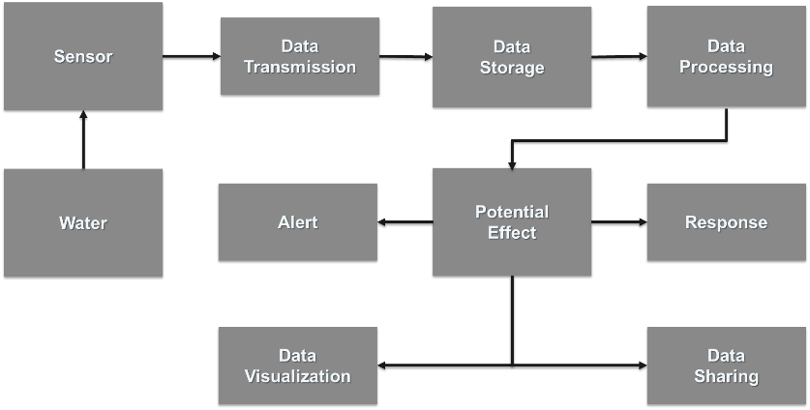

Figure 1. Conceptual Framework for proposed Water Quality Monitoring System
3.2. Hardware Block Diagram
Figure 2 illustrates the hardware block diagram employed to implement the proposed methodology. The approach entails the utilization of four distinct sensors to acquire essential water quality metrics, including temperature, Total Dissolved Solids (TDS), turbidity, and pH levels. This system relies on the integration of these sensors to precisely monitor and assess the water quality parameters mentioned. In the process, the initial sensor data undergoes amplification through specialized amplifiers to enhance its signal strength. Subsequently, the amplified data is transmitted to an Arduino Uno microcontroller for further processing. From the Arduino Uno, the data is then routed to a Wi-Fi module, specifically the ESP8266 module, for wireless communication. This module is pivotal in transmitting the data to the Adafruit cloud platform for centralized storage and accessibility. The retrieval of the data from the cloud to the software is facilitated through the utilization of the MQTT (Message Queuing Telemetry Transport) protocol.
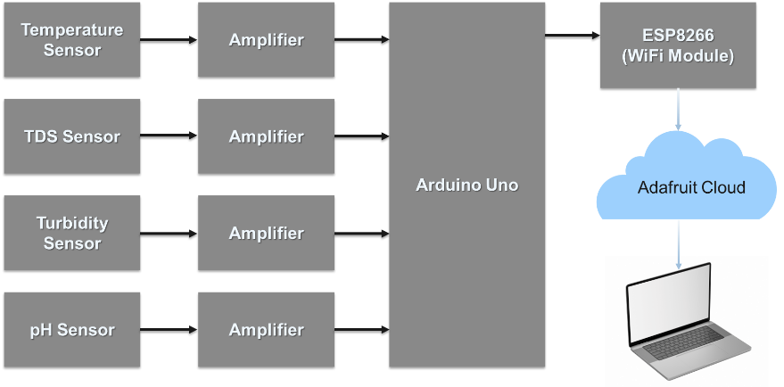
Figure 2. Proposed Hardware for Water Quality Management
A visual representation of the project's circuit configuration is illustrated in Figure 3. Notably, the incorporation of a step-down transformer enables the direct connection of the system to a standard 230V power supply, ensuring efficient power distribution. The sensors that are used in this project are Turbidity sensor, TDS sensor, LM35 and pH sensor. Turbidity sensor is a device that measures the cloudiness or haziness of a liquid, typically to assess water quality. They work by shining a light through a sample of the liquid and measuring how much light is scattered by suspended particles. The more light that is scattered, the more turbid the liquid is. LM35 is a popular integrated circuit (IC) for measuring temperature. It is a linear temperature sensor, meaning the output voltage is directly proportional to the Celsius temperature it's measuring. Every degree Celsius increase in temperature results in a 10mV increase in output voltage. (10mV/°C). This linear relationship makes it straightforward to convert the voltage reading to temperature. TDS sensor, also known as Total Dissolved Solids sensor, is a device used to estimate the amount of dissolved solids present in a water sample. It is a handy tool for various applications where water quality is a concern. TDS sensors do not directly measure the total dissolved solids themselves. Instead, they indirectly estimate the TDS level by measuring the electrical conductivity (EC) of the water. The sensor produces an electrical signal proportional to the EC. This signal is often converted to a TDS value in parts per million (ppm) by a meter or a microcontroller it is connected to. And finally, pH sensor, which is a crucial tool for measuring the acidity or alkalinity of a liquid solution. It plays a vital role in various fields by ensuring optimal conditions in processes and applications. A typical pH sensor consists of two main electrodes. Measuring electrode and Reference electrode. Measuring electrode is usually made of glass with a special membrane sensitive to hydrogen ions. As the H+ concentration in the solution changes, the voltage across this membrane changes as well. Reference electrode provides a stable reference voltage and completes the electrical circuit. It does not interact directly with the solution being measured. The difference in voltage between the measuring electrode and the reference electrode creates an output signal that corresponds to the H+ concentration and, consequently, the pH level of the solution. We have used an LCD display in the hardware to display the current values of the water quality parameters. In terms of software utilization, our team implemented Visual Studio Code as the primary tool for conducting our data analysis efficiently. Furthermore, our data gathering and analysis processes heavily relied on Python and Jupyter Python, allowing us to seamlessly extract information from the cloud and derive valuable insights from our datasets. In addition, the development of a real-time river water quality monitoring website was facilitated through the integration of PHP. This website serves as a crucial platform to track and oversee the condition of the river water continually. Moreover, to ensure prompt action in cases of irregular sensor data readings, an automated alert system embedded within the Adafruit io website has been established. This system is designed to instantly notify users via email upon the detection of any anomalies in the sensor data, enabling swift responses and interventions as needed.
Figure 3. Proposed Circuit Diagram

3.3 Water Quality Index

The Water Quality Index, or WQI, is a handy way to communicate the overall health of water at a specific location and time. It takes multiple measurements of water quality, like temperature, oxygen levels, and presence of contaminants, and combines them into a single score, often on a scale of 0 to 100. This easy-to-understand value helps people quickly grasp how suitable the water is for drinking, recreation, or aquatic life. By simplifying complex data, the WQI is a valuable tool for public awareness, pollution monitoring, and prioritizing water treatment efforts. This is the formula that is used to calculate the Water Quality Index.

$WQI= \frac{\sum_{n=1}^{m}{w_{n}q_{n}}}{\sum_{n=1}^{m}{w_{n}}}$

The figure 4 displays graphs that aid in determining the Q value necessary for the calculation of the Water Quality Index (WQI) utilizing data sourced from the cloud. The Q value for sensor data falls within the range of 0 to 100, and this information will be extracted from the graphs. Furthermore, a fixed value of ‘1’ will be assigned to the parameter W across all four data parameters.

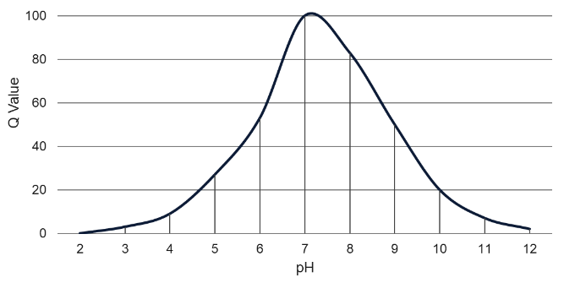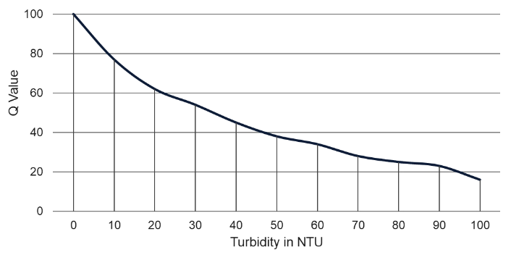

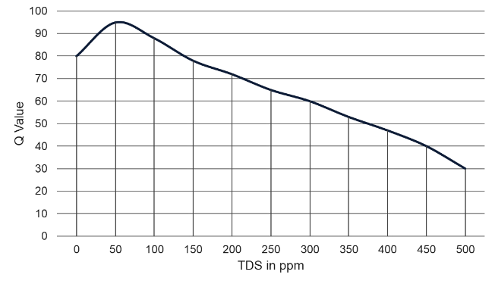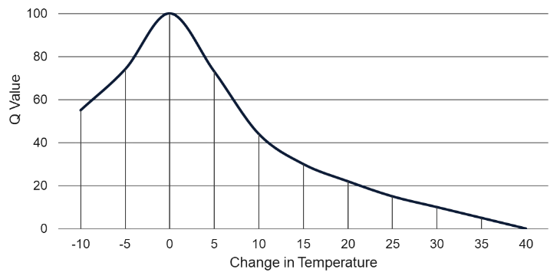

Figure 4. Graph to calculate the Q value

Table 1 provides a comprehensive overview of the water quality rating based on the WQI derived through the implementation of a machine learning algorithm.

Table 1. WQI Interpretation

WQI Range | Water Quality Rating | Possible Usage
90 - 100 | Excellent | Drinking, Irrigation & Industrialization
70 - 89 | Good | Domestic, Irrigation & Industrialization
50 - 69 | Moderate | Irrigation & Industrialization
25 - 49 | Bad | Irrigation & Hydroelectric Power
0 - 24 | Very Bad | Hydroelectric Power

4. EXPERIMENTAL SETUP AND RESULTS

4.1 Data Processing

In our project, the dataset utilized for training the algorithm comprises four distinct features, namely pH level, Temperature, Total Dissolved Solids (TDS), and Turbidity, with the target variable being the potability status of water samples. The dataset is substantial, consisting of a total of 3277 rows of data entries. From this dataset, the training and testing data will be automatically taken by the module used in python. To effectively process and analyze this data set, a comprehensive evaluation was conducted by testing six different machine learning algorithms. These algorithms include Logistic Regression, K-Nearest Neighbors (KNN), Support Vector Machine (SVM), Random Forest, Decision Tree, AdaBoost, and XGBoost. Following rigorous testing, the algorithm that demonstrated the most promising performance amongst the others was identified as XGBoost. This selection was based on thorough evaluation and analysis of the algorithms' results, ultimately highlighting XGBoost as the most effective choice for our predictive modeling application. XGBoost, short for Extreme Gradient Boosting, is a machine learning powerhouse known for its speed, accuracy, and versatility. This algorithm excels at supervised learning tasks, particularly regression and classification problems. It builds a robust model by combining multiple weak decision trees, sequentially improving upon each one to enhance overall accuracy. XGBoost's strength lies in its ability to handle complex data and efficiently leverage resources, making it a favorite tool for data scientists across various domains.

Before training the machine learning model, data in the dataset is usually normalized to ensure consistent scaling across different features. Normalizing involves applying the specified formula to adjust the range of values so that the model can more effectively learn patterns and relationships within the data. By normalizing the dataset before training, the model can converge faster and provide more accurate predictions or classifications based on the input data. This preprocessing step is essential in enhancing the performance and stability of the machine learning model, as it helps prevent certain features from dominating others due to differing scales or units. Overall, proper data normalization plays a crucial role in producing reliable results and improving the overall efficiency of the machine learning process.. Normalizing is done by using the following formula.

Normalized Value $=\frac{(Value in dataset -Smallest Value in that Feature)}{(Biggest Value in that Feature -Smallest Value in that Feature)}$

Figure 5 illustrates the accuracy outcomes attained by executing machine learning algorithms via the Jupyter Python code. This visual representation showcases the results obtained from the application of these algorithms and emphasizes the importance of leveraging technological tools to enhance data analysis practices. The accuracy figures serve as a vital indicator of the efficacy and reliability of the machine learning models deployed in this study.

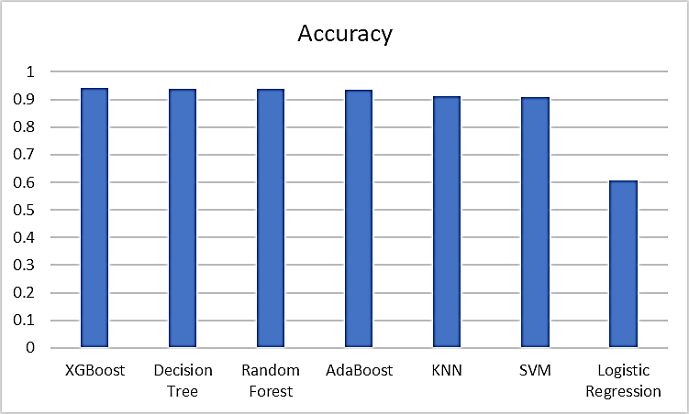

Figure 5. Accuracy Score

In summary, the figures and tables presented offer a holistic view of the data analysis process, ranging from the initial calculation of the WQI to the evaluation of water quality ratings and the assessment of algorithmic accuracy. This detailed examination highlights the significance of adopting advanced computational techniques for optimizing data interpretation and decision-making processes.

The Figures 6.a and 6.b provide a visual representation of a website that has been meticulously designed using PHP. This platform aims to keep users informed about the real-time status of river water. It effectively showcases the 12 most recent data points related to various parameters such as water quality, potability, and the Water Quality Index (WQI). The inclusion of these extensive data points allows users to gain a comprehensive understanding of the current river water conditions.

Figure 7 exhibits the mechanisms in place to trigger email alerts whenever an irregular or abnormal value is detected within the system. This proactive approach ensures that any deviations from expected data are immediately flagged and communicated to the relevant stakeholders. Such timely alerts serve as a crucial component in maintaining the integrity and accuracy of the provided information.

Lastly, Figure 8 captures the practical outcome of the alert system as it showcases an email notification generated through the Adafruit io website. This alert was prompted by the identification of an abnormal value within one of the water quality parameters. The prompt detection and communication of such anomalies play a pivotal role in mitigating potential risks and ensuring the overall reliability of the system.

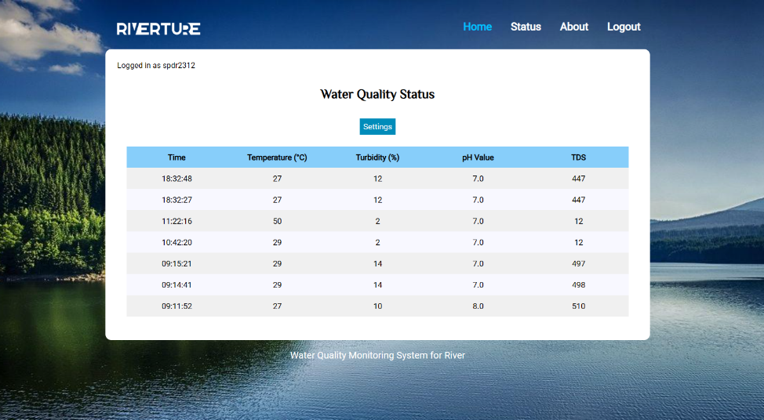

Figure 6.a. Screenshot of Developed Website

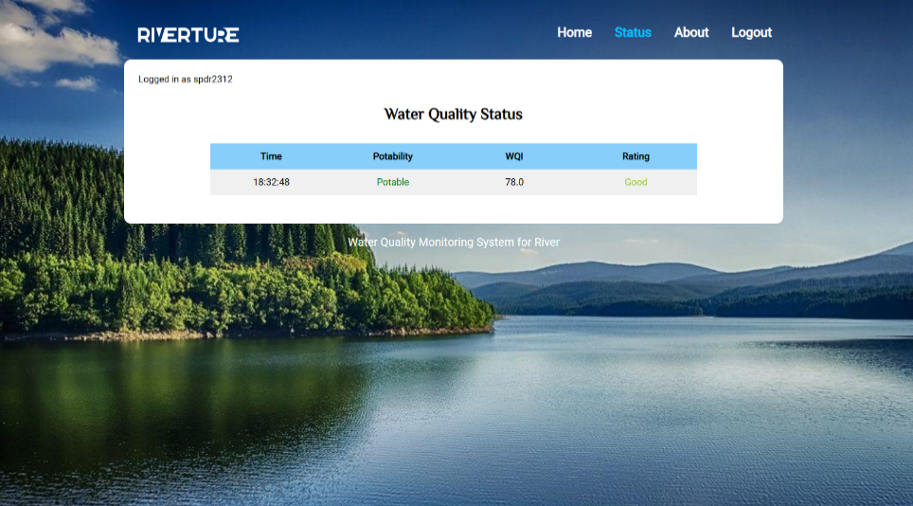

Figure 6.b. Screeshot of Developed Website
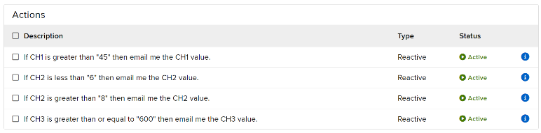

Figure 7. Triggers set in Adafruit io

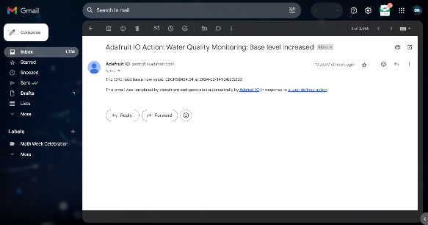

Figure 8. Screenshot of Mail Alert

5. CONCLUSION

The overarching objective of this paper is centered around the evaluation of water samples. This evaluation is achieved through the development of a cutting-edge smart water quality monitoring device, intricately integrated within an IoT platform. This device is specifically engineered to detect and analyse four fundamental physical parameters crucial for water quality assessment; these parameters consist of temperature, pH levels, turbidity, and dissolved solids. Employing a variety of Arduino-based sensors, the project team diligently conducts tests on diverse water samples to accumulate precise metric values. To derive actionable insights from these gathered values, a suitable machine learning approach is meticulously applied. Notably, the XGBoost algorithm emerges as the optimal choice for scrutinizing and enhancing system performance, thereby underlining its efficacy in predicting water quality accurately. The system's proficiency in detecting water quality based on physical parameters underscores its critical significance. Leveraging the capabilities of IoT technology, this system is primed to revolutionize real-time water monitoring solutions, promising enhanced efficiency and precision in environmental data analysis.

Funding information
No funds were used for the research work.

Acknowledgment
The authors wish to thank the management of Mepco Schlenk Engineering College for providing all the necessary facilities to carry out the research.

Consent for publication
The authors give their full consent for publication.

Author contribution
All the authors contributed equally to the paper

Data availability statement
Data used for research will be made available after the paper is accepted for publication

Ethical approval statement and Competing interest

No ethical conflicts. The authors declare no competing interest

REFERENCES:

- S. ¸Sener, E. ¸Sener, and A. Davraz, “Evaluation of water quality using water quality index (WQI) method and GIS in Aksu River (SW-Turkey),” Sci. Total Environ., vols. 584–585, pp. 131–144, Apr. 2017.
- O. O. Ajayi, A. B. Bagula, H. C. Maluleke, Z. Gaffoor, N. Jovanovic and K. C. Pietersen, "WaterNet: A Network for Monitoring and Assessing Water Quality for Drinking and Irrigation Purposes," in IEEE Access, vol. 10, pp. 48318-48337, 2022.
- H. H. Kenchannavar, P. M. Pujar, R. M. Kulkarni and U. P. Kulkarni, "Evaluation and Analysis of Goodness of Fit for Water Quality Parameters Using Linear Regression Through the Internet-of-Things-Based Water Quality Monitoring System," in IEEE Internet of Things Journal, vol. 9, no. 16, pp. 14400-14407, 15 Aug.15, 2022.
- Q. Quevy, M. Lamrini, M. Chkouri, G. Cornetta, A. Touhafi and A. Campo, "Open Sensing System for Long Term, Low Cost Water Quality Monitoring," in IEEE Open Journal of the Industrial Electronics Society, vol. 4, pp. 27-41, 2023.
- F. Akhter, H. R. Siddiquei, M. E. E. Alahi, K. P. Jayasundera and S. C. Mukhopadhyay, "An IoT-Enabled Portable Water Quality Monitoring System With MWCNT/PDMS Multifunctional Sensor for Agricultural Applications," in IEEE Internet of Things Journal, vol. 9, no. 16, pp. 14307-14316, 15 Aug.15, 2022.
- Y. Wang, I. W. -H. Ho, Y. Chen, Y. Wang and Y. Lin, "Real-Time Water Quality Monitoring and Estimation in AIoT for Freshwater Biodiversity Conservation," in IEEE Internet of Things Journal, vol. 9, no. 16, pp. 14366-14374, 15 Aug.15, 2022.
- M. Kumar, T. Singh, M. K. Maurya, A. Shivhare, A. Raut and P. K. Singh, "Quality Assessment and Monitoring of River Water Using IoT Infrastructure," in IEEE Internet of Things Journal, vol. 10, no. 12, pp. 10280-10290, 15 June15, 2023.
- S. Nihalani and A. Meeruty, “Water quality index evaluation for major rivers in Gujarat,” Environ. Sci. Pollut. Res., vol. 28, pp. 63523–63531, Dec. 2021.
- Z. Wu, X. Wang, Y. Chen, Y. Cai, and J. Deng, “Assessing River water quality using water quality index in Lake Taihu Basin, China,” Sci. Total Environ., vol. 612, pp. 914–922, Jan. 2018.
- S. Bi et al., “A comprehensive method for water environment assessment considering trends of water quality,” Adv. Civil Eng., vol. 2021, Sep. 2021, Art. no. 5548113.
- M. Bora and D. C. Goswami, “Water quality assessment in terms of water quality index (WQI): Case study of the Kolong River, Assam, India,” Appl. Water Sci., vol. 7, no. 6, pp. 3125–3135, 2017.
- S. Geetha and S. Gouthami, “Internet of Things enabled real time water quality monitoring system,” Smart Water, vol. 2, no. 1, pp. 1–19, 2016.
- T. Srour, A. Haggag, M. A. M. El-Bendary, M. Eltokhy, and A. E. Abouelazm, “Efficient approach for monitoring and controlling water parameters utilizing integrated treatment based on WSNs,” Wireless Sens. Netw., vol. 11, no. 4, pp. 47–66, 2019.
- D. Jalal and T. Ezzedine, “Towards a water quality monitoring system based on wireless sensor networks,” in Proc. Int. Conf. Internet Things Embedded Syst. Commun. (IINTEC), vol. 2018. Gafsa, Tunisia, Jan. 2018, pp. 38–41.
- U. Ahmed, R. Mumtaz, H. Anwar, A. A. Shah, R. Irfan, and J. García-Nieto, “Efficient water quality prediction using supervised,” Water, vol. 11, no. 11, pp. 1–14, 2019.
- K. R. S. R. Raju and G. H. K. Varma, “Knowledge based real time monitoring system for aquaculture Using IoT,” in Proc. 7th IEEE Int. Adv. Comput. Conf. (IACC), Hyderabad, India, 2017, pp. 318–321.
- N. Kafli and K. Isa, “Internet of Things (IoT) for measuring and monitoring sensors data of water surface platform,” in Proc. IEEE 7th Int. Conf. Underwater Syst. Technol. Theory Appl. (USYS), vol. 2018. Kuala Lumpur, Malaysia, Jan. 2018, pp. 1–6.
- B. Das and P. C. Jain, “Real-time water quality monitoring system using Internet of Things,” in Proc. Int. Conf. Comput. Commun.Electron. (COMPTELIX), Jaipur, India, 2017, pp. 78–82, 2017.

