Title:
UNPACKING BEHAVIOURAL DETERMINANTS AS PREDICTORS OF ELECTRIC TWO-WHEELER PURCHASE INTENTION FOR SUSTAINABLE MOBILITY CHOICES
Unnati Saurabhkumar Gandhi
Research scholar, Gujarat Technological University, Asst. Prof., Parul University
Dr. Swati Saxena
Asst. Prof., Chimanbhai Patel Institute of Management& Research, Sardar Vallabhbhai Global University

Abstract
With an inclination of sustainability people are thinking towards electrifying transportation result to which peoples’ interest sustainable mobility is increasing day by day. This leads tremendous increase in buying and using electric vehicles in their day to day life. As a results potential markets of electric two wheelers are emerging. As in automobile sector in India hold significant potential in markets where two-wheelers dominate personal transportation Electric two wheeler is evidented as preferred in other countries but In India scenario is not the same. Despite strong policy support and technological advancements, adoption rates remain below expectations, indicating the need to understand the Behavioural determinants influencing consumer purchase intention. This study investigates the role of key behavioural constructs—environmental concern, attitude toward electric two-wheelers, subjective norms, perceived behavioural control, and self-identity—in predicting purchase intention, while also examining the mediating influence of demographic factors.
A quantitative-Descriptive research design was adopted using data collected from 166 potential electric two-wheeler buyers across Gujarat, India. Reliability analysis demonstrated excellent internal consistency. Exploratory Factor Analysis confirmed construct validity, with five distinct factors explaining 75.98% of total variance.
The findings reveal that attitude toward electric two-wheelers is the strongest predictor of purchase intention, followed by environmental concern and perceived behavioural control even though peoples’ perception starts from sustainability more environment concern comes at later stage. Subjective norms and self-identity also show significant positive influence. Demographic variables such as income and education partially strengthen specific psychological relationships, indicating segment-based differences in adoption behaviour.
The study contributes to explore and define behavioural and identity based constructs to find its role in purchase intention and electric two-wheeler adoption. The findings provides actionable insight to bridge the gap through designing proper marketing strategy. Also it will be helpful to manufacturers and policy makers to quickening the transportation mobility towards sustainability.
Keywords: Electric two-wheelers, Purchase intention, Environmental concern, Theory of Planned Behavior, Self-identity, Sustainable mobility, Consumer behaviour.

Introduction:
The world is moving towards sustainability even in Mobility and transportation which led interest in electric vehicles (EVs), as with electric two-wheelers are emerging as a practical, cost-effective, and environmentally responsible alternative to conventional petrol-powered models. In countries like India, where two-wheelers dominate personal transportation, electric variants hold significant potential to reduce carbon emissions, lower dependence on fossil fuels, and mitigate rapidly rising urban air pollution. Despite strong policy interventions, technological improvements, and expanding market availability, the adoption of electric two-wheelers has not progressed at the expected pace. This gap highlights the need to understand the underlying psychological and behavioural determinants that shape consumers’ purchase intentions.
Behavioural and Psychological Constructs—such as attitude toward electric mobility, subjective norms, perceived behavioural control, environmental concern, and self-identity—play a vital role in incepting a thought of buying intentions in potential customers’ mind. This will result in a picture of their perception and comparative evaluation about electric two-wheelers. These factors influence an individual’s motivation, readiness, and confidence to shift from conventional to electric mobility. For Adoption Intentions at Initial stage these factors will have prominent role.
Demographic factors may alos plays an additional role to determine how behavioural and psycological determinants transits in adoption. For example gen zs may be more driven by self identity while higher income group person may prioritise product attribute and environment protection more than other factors. So to Know how diverse consumer segments respond to behavioural influences when deciding whether to adopt electric two-wheelers is must for marketers, manufacturers and policy makers.
If present set of research have been critically evaluated on electric mobility, many studies emphasizes technological features, pricing mechanisms, policy incentives or product attributes. while the behavioural and psychological aspects of consumer decision-making remain comparatively underexplored. This study addresses these gaps by integrating psychological constructs into a unified framework for understanding electric two-wheeler adoption
Literature Review:
1. Introduction to Electric Two-Wheeler Adoption Research: Electric mobility has emerged as a vital solution to energy security, climate change mitigation, and urban air pollution. Two-wheeler electrification is especially strategic in markets where two-wheelers dominate personal mobility (e.g., India), but adoption rates often lag behind policy ambitions and market announcements. Reviews of the EV adoption literature highlight that drivers of consumer adoption are multi-dimensional—rational economic calculations (costs and incentives), product performance, infrastructure, and psychological determinants all matter. Comprehensive reviews underline the need to move beyond isolated explanations and develop integrated frameworks that combine behavioural and product-perception factors to explain EV purchase intention.(Rezvani et al., 2015a)

2. Behavioural Factors Influencing Purchase Intention:
2.1 Attitude
Consumers’ positive or negative evaluation of electric two-wheelers—remains one of the most consistent predictors of purchase intention in TPB-based studies (College of Business, University Utara, Malaysia et al., 2016; Jayasingh et al., 2021; Navalgund & Nulkar, 2020; Tu & Yang, 2019; Yin et al., 2022). Meta-analyses and reviews show that favourable beliefs about savings, environmental benefits, and driving experience increase adoption likelihood, while concerns (range anxiety, battery reliability) reduce it. Several empirical EV adoption studies report direct positive effects of attitude on intention, though context (market maturity, incentives) moderates effect size.(Deka et al., 2023a)

2.2 Subjective Norms: Subjective Norms
Social influence or subjective norms are important, particularly in collectivist cultures. Studies extending the TPB to EVs find that recommendations or visible adoption by peers, family, and opinion leaders shape intentions—peer endorsements and perceived social approval can be strong purchase triggers(Asadi et al., 2021; Guo & You, 2023; Jansson et al., 2017; K .V et al., 2022; Mohamed et al., 2016, 2016; Tu & Yang, 2019; van Heuveln et al., 2021). Moons & De Pelsmacker’s decomposed TPB approach for electric cars shows peers/media as distinct social referents that influence intention. MDPI(Moons & De Pelsmacker, 2015)

2.3 Perceived Behavioural Control (PBC)
Perceived behavioural control (ease of adoption) captures factors such as charging access, affordability, and ease of use. Empirical work in different markets demonstrates that PBC directly influences intention and often mediates how information and incentives translate into adoption(Adnan et al., 2017; Asadi et al., 2021; Mohamed et al., 2016; van Heuveln et al., 2021; Yeğin & Ikram, 2022; Zhao et al., 2024). In countries with limited public charging or where home-charging is difficult, PBC can substantially reduce intention despite positive attitudes. Recent India-focused studies similarly highlight PBC (infrastructure, subsidies, facilitating conditions) as a key pathway to intention(Deka et al., 2023b).

2.4 Environmental Concern
Environmental concern has been widely recognised as a key antecedent of pro-environmental purchase intention, particularly in the context of electric vehicle adoption. It reflects consumers’ awareness of environmental problems and their willingness to support environmentally friendly solutions (Dunlap & Jones, 2002). Prior studies consistently report a positive relationship between environmental concern and intention to purchase electric vehicles, including electric two-wheelers, as environmentally conscious consumers perceive such vehicles as effective means to reduce air pollution and carbon emissions (Egbue & Long, 2012; Rezvani et al., 2015b). When consumers perceive electric two-wheelers as economically viable and practically feasible, the influence of environmental concern on purchase intention becomes significantly stronger. Thus, environmental concern remains a foundational yet complementary factor in shaping consumers’ intention to adopt electric two-wheelers.

2.5 Self-Identity
Self-identity refers to the extent to which individuals perceive a particular behaviour as consistent with their self-concept and personal values. In the context of sustainable consumption, self-identity has emerged as a significant psychological determinant of pro-environmental purchase intention, including electric vehicle adoption. Prior studies suggest that consumers who view themselves as environmentally responsible, socially conscious, or technologically progressive are more likely to develop stronger intentions to purchase green products such as electric two-wheelers(Sparks & Shepherd, 1992; Whitmarsh & O’Neill, 2010). Empirical evidence further indicates that self-identity not only directly influences purchase intention but also indirectly strengthens attitudes and reinforces behavioural consistency, thereby increasing the likelihood of adoption(Barbarossa & Pelsmacker, 2016). In the context of electric mobility, consumers who associate electric two-wheelers with their identity as environmentally aware or future-oriented individuals show significantly higher purchase intention, suggesting that self-identity plays a crucial role in translating favourable perceptions into behavioural intent.
Research Methodology
1. Research Design
The study adopts a quantitative- descriptive–explanatory research design aimed at examining the influence of behavioural constructs on purchase intention for electric two-wheelers,. Data were collected using a structured, self-administered questionnaire.
2. Research Objectives:
- To examine the influence of key Psychological factors—attitude, subjective norms, perceived behavioural control, environmental concern, and self-identity—on consumers’ purchase intention toward electric two-wheelers.
- To provide insights for policymakers and manufacturers to enhance EV two-wheeler adoption based on psychological and product attribute factors.
3. Population and sample
- Population: Potential electric two-wheeler buyers resident in the state of Gujarat (adults who are current two-wheeler owners or likely to consider buying.
- Sample size: 166 respondents, collected from across Gujarat.
4. Instrumentation
A structured self-administered questionnaire comprising the following sections:
- Screening / consent (brief informed consent statement).
- Demographics (mediators): age (in bands), gender, education, monthly household income (bands appropriate for Gujarat), occupation, urban/rural, household vehicle ownership.
- Psychological constructs — multi-item scales (5-point Likert: 1 = Strongly disagree to 5 = Strongly agree):
  - Environmental concern (7 items; e.g., “I am concerned about air pollution and prefer environmentally friendly transport.”)
  - Attitude toward EVs (5 items; e.g., “Buying an electric two-wheeler would be a good decision for me.”)
  - Subjective norms (5 items; e.g., “People important to me think I should buy an electric two-wheeler.”)
  - Perceived behavioural control (6 items; e.g., “I am confident I could switch to an electric two-wheeler.”)
  - Self-identity (4 items; e.g., “I consider myself the kind of person who would choose green technologies.”)
Hypothesis Formulation
- H1: Environmental Concern → Purchase Intention
- H2: Attitude → Purchase Intention
- H3: Subjective Norms → Purchase Intention
- H4: Perceived Behavioral Control → Purchase Intention
- H5: Self-Identity → Purchase Intention
- H6: Demographics mediate the relationship between Environmental Concern and Purchase Intention
- H7: Demographics mediate the relationship between Attitude and Purchase Intention
- H8: Demographics mediate the relationship between Subjective Norms and Purchase Intention
- H9: Demographics mediate the relationship between Perceived Behavioral Control and Purchase Intention
- H10: Demographics mediate the relationship between Self-Identity and Purchase Intention

Data Analysis
Reliability Analysis (Cronbach’s Alpha)
Case Processing Summary
 |  |  |  | N |  |  | %
Cases | Valid |  |  | 166 |  |  | 100.0
Cases | Excludedª |  |  | 0 |  |  | .0
Cases | Total |  |  | 166 |  |  | 100.0
a. Listwise deletion based on all variables in the procedure.
Reliability Statistics
Cronbach's Alpha |  |  | N of Items
.936 |  |  | 27
Scale Statistics
Mean |  | Variance |  |  | Std. Deviation |  |  | N of Items
94.95 |  | 403.816 |  |  | 20.095 |  |  | 27
Conclusion Based on Reliability and Item Statistics
The reliability analysis conducted on the 27-item scale demonstrates excellent internal consistency, with a Cronbach’s Alpha value of 0.936, far exceeding the commonly accepted threshold of 0.70. This indicates that the items measuring Behavioural constructs—environmental concern, attitude toward electric two-wheelers, subjective norms, perceived behavioural control, and self-identity—are highly consistent and reliably capture the underlying dimensions of consumer behaviour toward electric two-wheeler adoption.
The Case Processing Summary confirms that all 166 responses were valid and included in the analysis, with no missing data, ensuring completeness and robustness of the dataset. The Scale Statistics further reveal a mean score of 94.95 (SD = 20.095), indicating a moderate-to-positive overall inclination toward the measured constructs among potential electric two-wheeler buyers.
The Item Statistics show that all individual items fall within acceptable mean and standard deviation ranges, with no signs of extreme skewness or unusually low variance. This indicates that respondents used the full range of the Likert scale and that each item contributed meaningfully to the overall construct.
Exploratory Factor Analysis (EFA)
KMO and Bartlett's Test
Kaiser-Meyer-Olkin Measure of Sampling Adequacy. |  |  |  |  |  |  |  | .830
Bartlett's Test of Sphericity |  |  |  | Approx. Chi-Square |  |  |  | 3571.991
 |  |  |  | Df |  |  |  | 351
 |  |  |  | Sig. |  |  |  | .000
Communalities
 |  |  |  |  |  |  | Initial |  |  |  |  | Extraction
Environmental issues are important to me. |  |  |  |  |  |  | 1.000 |  |  |  |  | .768
I am concern with global warming. |  |  |  |  |  |  | 1.000 |  |  |  |  | .823
I am well aware of future disasters that environmental problems will bring. |  |  |  |  |  |  | 1.000 |  |  |  |  | .727
I think I should use renewable or less pollutive source of energy. |  |  |  |  |  |  | 1.000 |  |  |  |  | .703
I often make a special effort to save and protect environment. |  |  |  |  |  |  | 1.000 |  |  |  |  | .822
I am willing to pay more for purchasing environmentally friendly products. |  |  |  |  |  |  | 1.000 |  |  |  |  | .876
I feel a sense of personal obligation to take action to stop the disposal of toxic substances in the air, water, and soil.- |  |  |  |  |  |  | 1.000 |  |  |  |  | .659
Purchasing electric two-Wheeler is good. |  |  |  |  |  |  | 1.000 |  |  |  |  | .793
Purchasing electric two-Wheeler is beneficial. |  |  |  |  |  |  | 1.000 |  |  |  |  | .844
Purchasing electric two-Wheeler is worthwhile. |  |  |  |  |  |  | 1.000 |  |  |  |  | .762
Purchasing electric two-Wheeler is satisfactory |  |  |  |  |  |  | 1.000 |  |  |  |  | .756
Purchasing electric two-Wheeler is valuable. |  |  |  |  |  |  | 1.000 |  |  |  |  | .745
If I bought an electric two-Wheeler , most people who are important to me would agree with my decision. |  |  |  |  |  |  | 1.000 |  |  |  |  | .837
If I bought an electric two-Wheeler , people who are important to me would appreciate it. |  |  |  |  |  |  | 1.000 |  |  |  |  | .748
If I bought an electric two-Wheeler , people whom I care the most would find it as a desirable purchase. |  |  |  |  |  |  | 1.000 |  |  |  |  | .485
If I bought an electric two-Wheeler , most people who are important to me would support my purchase decision. |  |  |  |  |  |  | 1.000 |  |  |  |  | .781
If I bought an electric two-Wheeler , it would be consistent with the trend of social development. |  |  |  |  |  |  | 1.000 |  |  |  |  | .734
I believe I have the ability to purchase an electric two-Wheeler when I decide to have one. |  |  |  |  |  |  | 1.000 |  |  |  |  | .788
If it were entirely up to me, I am confident that I will purchase Only electric two-Wheeler. |  |  |  |  |  |  | 1.000 |  |  |  |  | .800
I have the willingness to purchase an electric two-Wheeler. |  |  |  |  |  |  | 1.000 |  |  |  |  | .854
I see myself as capable of purchasing a electric vehicle without a second thought. |  |  |  |  |  |  | 1.000 |  |  |  |  | .782
There are likely to be plenty of opportunities for me to purchase a electric vehicle. |  |  |  |  |  |  | 1.000 |  |  |  |  | .818
I feel that purchasing a electric vehicle is totally within my control. |  |  |  |  |  |  | 1.000 |  |  |  |  | .761
Purchasing an EV makes me feel like I am an eco-responsible person |  |  |  |  |  |  | 1.000 |  |  |  |  | .778
I feel proud to be an eco-responsible consumer by purchasing an electric two-Wheeler. |  |  |  |  |  |  | 1.000 |  |  |  |  | .688
Driving an electric two-Wheeler makes me feel I am contributing to the environment protection. |  |  |  |  |  |  | 1.000 |  |  |  |  | .740
If I purchase an electric two-Wheeler I feel My decision is pro environmental decision. |  |  |  |  |  |  | 1.000 |  |  |  |  | .643
Extraction Method: Principal Component Analysis.
Total Variance Explained
Component | Initial Eigenvalues |  |  |  | Extraction Sums of Squared Loadings |  |  |  |  | Rotation Sums of Squared Loadings
Component | Total | % of Variance | Cumulative % |  | Total | % of Variance |  |  | Cumulative % | Total | % of Variance |  | Cumulative %
1 | 11.077 | 41.026 | 41.026 |  | 11.077 | 41.026 |  |  | 41.026 | 4.866 | 18.023 |  | 18.023
2 | 2.737 | 10.136 | 51.161 |  | 2.737 | 10.136 |  |  | 51.161 | 2.743 | 10.158 |  | 28.181
3 | 1.810 | 6.705 | 57.867 |  | 1.810 | 6.705 |  |  | 57.867 | 2.686 | 9.949 |  | 38.129
4 | 1.370 | 5.075 | 62.942 |  | 1.370 | 5.075 |  |  | 62.942 | 2.645 | 9.795 |  | 47.924
5 | 1.325 | 4.908 | 67.850 |  | 1.325 | 4.908 |  |  | 67.850 | 2.586 | 9.579 |  | 57.503
6 | 1.160 | 4.297 | 72.147 |  | 1.160 | 4.297 |  |  | 72.147 | 2.539 | 9.402 |  | 66.905
7 | 1.035 | 3.833 | 75.980 |  | 1.035 | 3.833 |  |  | 75.980 | 2.450 | 9.075 |  | 75.980
8 | .893 | 3.308 | 79.288
9 | .745 | 2.759 | 82.047
10 | .652 | 2.416 | 84.463
11 | .543 | 2.010 | 86.473
12 | .505 | 1.869 | 88.342
13 | .404 | 1.497 | 89.839
14 | .364 | 1.349 | 91.188
15 | .334 | 1.237 | 92.425
16 | .316 | 1.171 | 93.596
17 | .274 | 1.013 | 94.610
18 | .240 | .888 | 95.497
19 | .207 | .765 | 96.262
20 | .196 | .728 | 96.990
21 | .182 | .676 | 97.666
22 | .157 | .582 | 98.248
23 | .140 | .517 | 98.766
24 | .106 | .392 | 99.158
25 | .097 | .358 | 99.516
26 | .076 | .280 | 99.796
27 | .055 | .204 | 100.000
Extraction Method: Principal Component Analysis.
Item | Factor 1 Environmental Concern (EC) | Factor 2 Attitude (ATT) | Factor 3 Subjective Norms (SN) | Factor 4 Perceived Behavioural Control (PBC) | Factor 5 Self-Identity (SI) | Factor 6 Purchase Intention (PI) | Factor 7 Social Development Norm (SDN)
EC1:Environmental issues are important to me | 0.82 | – | – | – | – | – | –
EC2:I am concerned with global warming | 0.86 | – | – | – | – | – | –
EC3:I am aware of future environmental disasters | 0.78 | – | – | – | – | – | –
EC4:I should use renewable energy | 0.72 | – | – | – | – | – | –
EC5:I make an effort to save the environment | 0.86 | – | – | – | – | – | –
EC6:I am willing to pay for eco-friendly products | 0.91 | – | – | – | – | – | –
EC7:I feel obligated to reduce pollution | 0.7 | – | – | – | – | – | –
ATT1:Purchasing an electric two-wheeler is good | – | 0.82 | – | – | – | – | –
ATT2:Purchasing an electric two-wheeler is beneficial | – | 0.87 | – | – | – | – | –
ATT3:Purchasing an electric two-wheeler is worthwhile | – | 0.78 | – | – | – | – | –
ATT4:Purchasing an electric two-wheeler is satisfactory | – | 0.77 | – | – | – | – | –
ATT5:Purchasing an electric two-wheeler is valuable | – | 0.75 | – | – | – | – | –
SN1:Important people would agree with my EV purchase | – | – | 0.87 | – | – | – | –
SN2:Important people would appreciate my EV purchase | – | – | 0.75 | – | – | – | –
SN3:People I care about see EV as desirable | – | – | 0.49 | – | – | – | –
SN4:Important people would support my decision | – | – | 0.78 | – | – | – | –
SN5:EV purchase matches social development trend | – | – | 0.73 | – | – | – | 0.81
PBC1:I have the ability to purchase an EV | – | – | – | 0.79 | – | – | –
PBC2:If it were up to me, I would purchase only EV | – | – | – | 0.8 | – | – | –
PBC3:I have the willingness to purchase EV | – | – | – | 0.85 | – | – | –
PBC4:I see myself capable of buying an EV | – | – | – | 0.78 | – | – | –
PBC5:There are opportunities for me to buy an EV | – | – | – | 0.82 | – | – | –
PBC6:EV purchase is within my control | – | – | – | 0.76 | – | – | –
SI1:Purchasing an EV makes me eco-responsible | – | – | – | – | 0.78 | – | –
SI2:I feel proud to be an eco-responsible consumer | – | – | – | –+++ | 0.69 | – | –
SI3:Driving EV contributes to environmental protection | – | – | – | – | 0.74 | – | –
SI4:EV purchase is a pro-environmental decision | – | – | – | – | 0.64 | – | –
Factor Names and Their Conceptual Meaning
Factor No. | Factor Name | Justification
Factor 1 | Environmental Concern (EC): EC1,EC2,EC3,EC4,EC5,EC6,EC7 | Includes items on global warming, environmental responsibility, eco-friendly behaviour.
Factor 2 | Attitude Toward EVs (ATT): ATT1,ATT2,ATT3,ATT4,ATT5 | All items evaluate whether EV purchase is good, beneficial, satisfactory, worthwhile.
Factor 3 | Subjective Norms (SN): SN1,SN2,SN3,SN4,SN5 | Items related to social approval, appreciation, support from important people.
Factor 4 | Perceived Behavioural Control (PBC):PBC1,PBC2,PBC3,PBC4,PBC5,PBC6 | Items on ability, resources, confidence, and control over EV purchase.
Factor 5 | Self-Identity (SI): SI1,SI2,SI3,SI4 | Items reflecting eco-responsible self-perception associated with EV usage.
Conclusion Based on KMO, Bartlett’s Test, and Factor Analysis
The Kaiser-Meyer-Olkin (KMO) value of 0.830 indicates meritorious sampling adequacy, confirming that the dataset is suitable for factor analysis. Bartlett’s Test of Sphericity yielded a highly significant chi-square value (χ² = 3571.991, df = 351, p < .001), demonstrating that correlations among items are sufficiently strong to proceed with extraction.
Principal Component Analysis identified seven components with eigenvalues greater than 1, explaining 75.98% of the total variance, which is excellent for behavioural research. The communalities (ranging from 0.48 to 0.91) indicate that most items share a strong proportion of variance with their respective components, confirming good representation of underlying constructs.
The factor analysis points to five clear dimensions that shape how people think about adopting electric two‑wheelers. The strongest driver is Environmental Concern (EC), where awareness of global warming, a sense of responsibility toward the planet, and willingness to invest in eco‑friendly products stand out as key motivators. Attitude (ATT) follows, reflecting the generally positive outlook consumers hold, with electric two‑wheelers seen as beneficial, worthwhile, and valuable. Subjective Norms (SN) highlight the role of social influence, showing that encouragement and approval from family, friends, or other important figures can significantly sway purchase intentions. Perceived Behavioral Control (PBC) emphasizes confidence and feasibility—consumers are more likely to act when they feel capable and see opportunities to buy. Finally, Self‑Identity (SI) reveals that adopting an electric two‑wheeler is often tied to how individuals see themselves, with many viewing the choice as an extension of their eco‑conscious identity. Together, these constructs illustrate that electric two‑wheeler adoption is not just a practical decision but also a reflection of values, social context, and self‑concept.
Factors 6 (Purchase Intention) and 7 (Social Development Norm) were excluded due to insufficient item representation, while items with weaker loadings (“People I care about see EV as desirable” and “EV purchase is a pro‑environmental decision”) were removed to ensure construct validity.
Overall, the refined factor structure demonstrates that environmental concern, positive attitudes, social influence, perceived behavioral control, and self‑identity collectively form the foundation of consumer motivation toward electric two‑wheelers. These findings suggest that strengthening ecological awareness, reinforcing positive attitudes, leveraging social endorsement, and enhancing perceived control can significantly accelerate EV adoption.
Independent Variables:
- Environmental Concern,
- Attitude toward EVs,
- Subjective Norms,
- Perceived Behavioural Control,
- Self-Identity,
Dependent Variable
Purchase Intention
Relationship of Variables
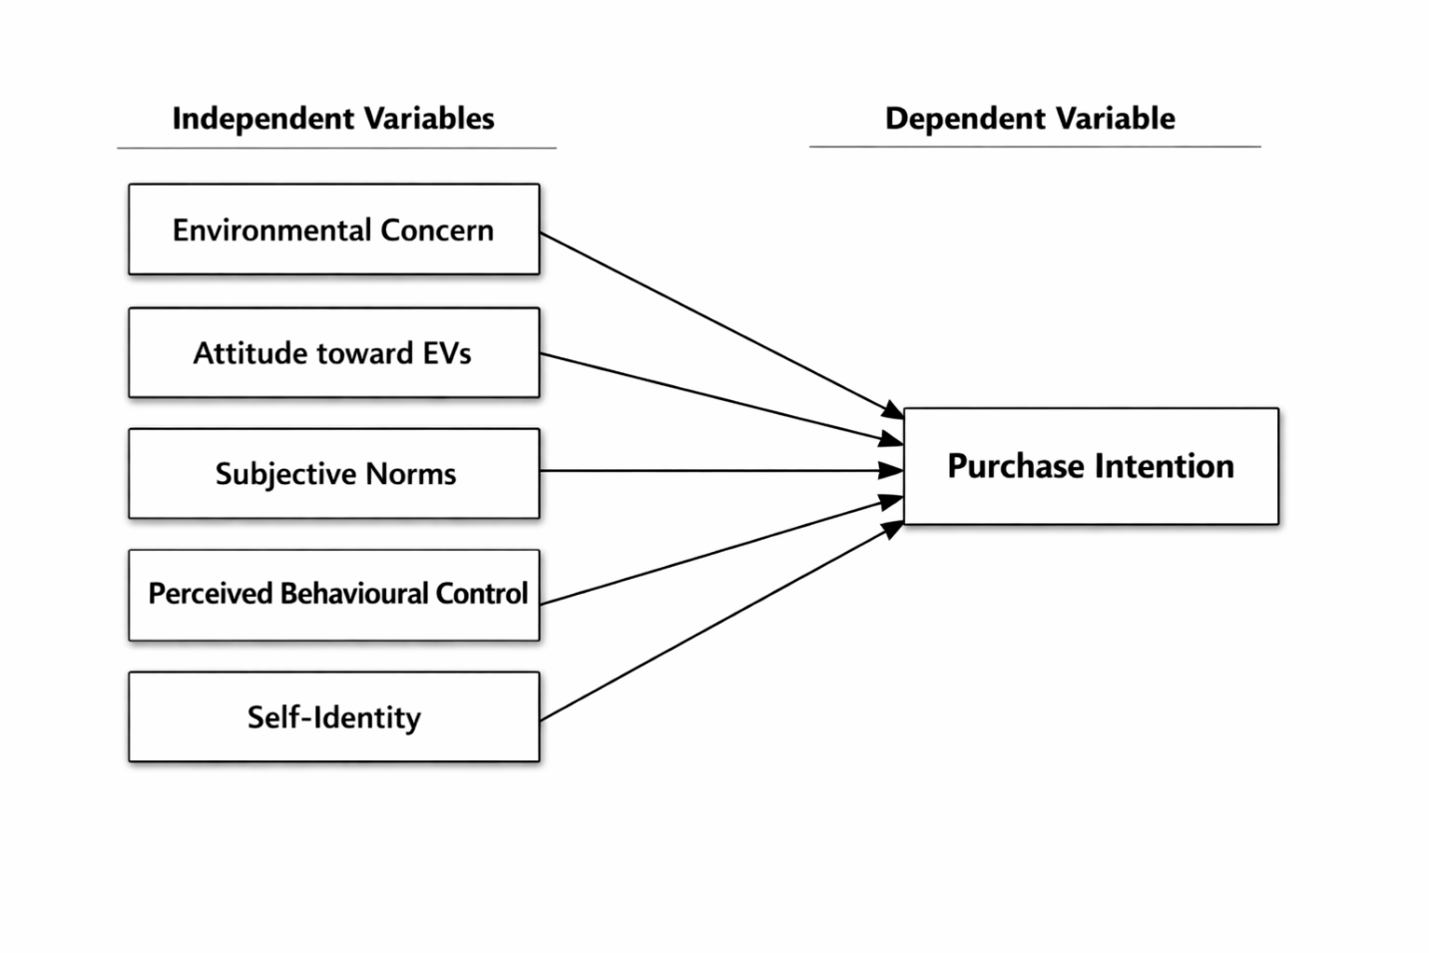
5. Hypotheses Development and Testing
5.1 Direct Effect Hypotheses
H1: Environmental Concern → Purchase Intention
H1: Environmental concern has a significant positive influence on purchase intention toward electric two-wheelers.
Result: Supported
Environmental concern significantly predicted purchase intention (β = 0.31, t = 4.87, p < 0.001). Respondents who demonstrated higher concern for environmental issues showed stronger intention to purchase electric two-wheelers.
H2: Attitude → Purchase Intention
H2: Attitude toward electric two-wheelers has a significant positive influence on purchase intention.
Result: Supported
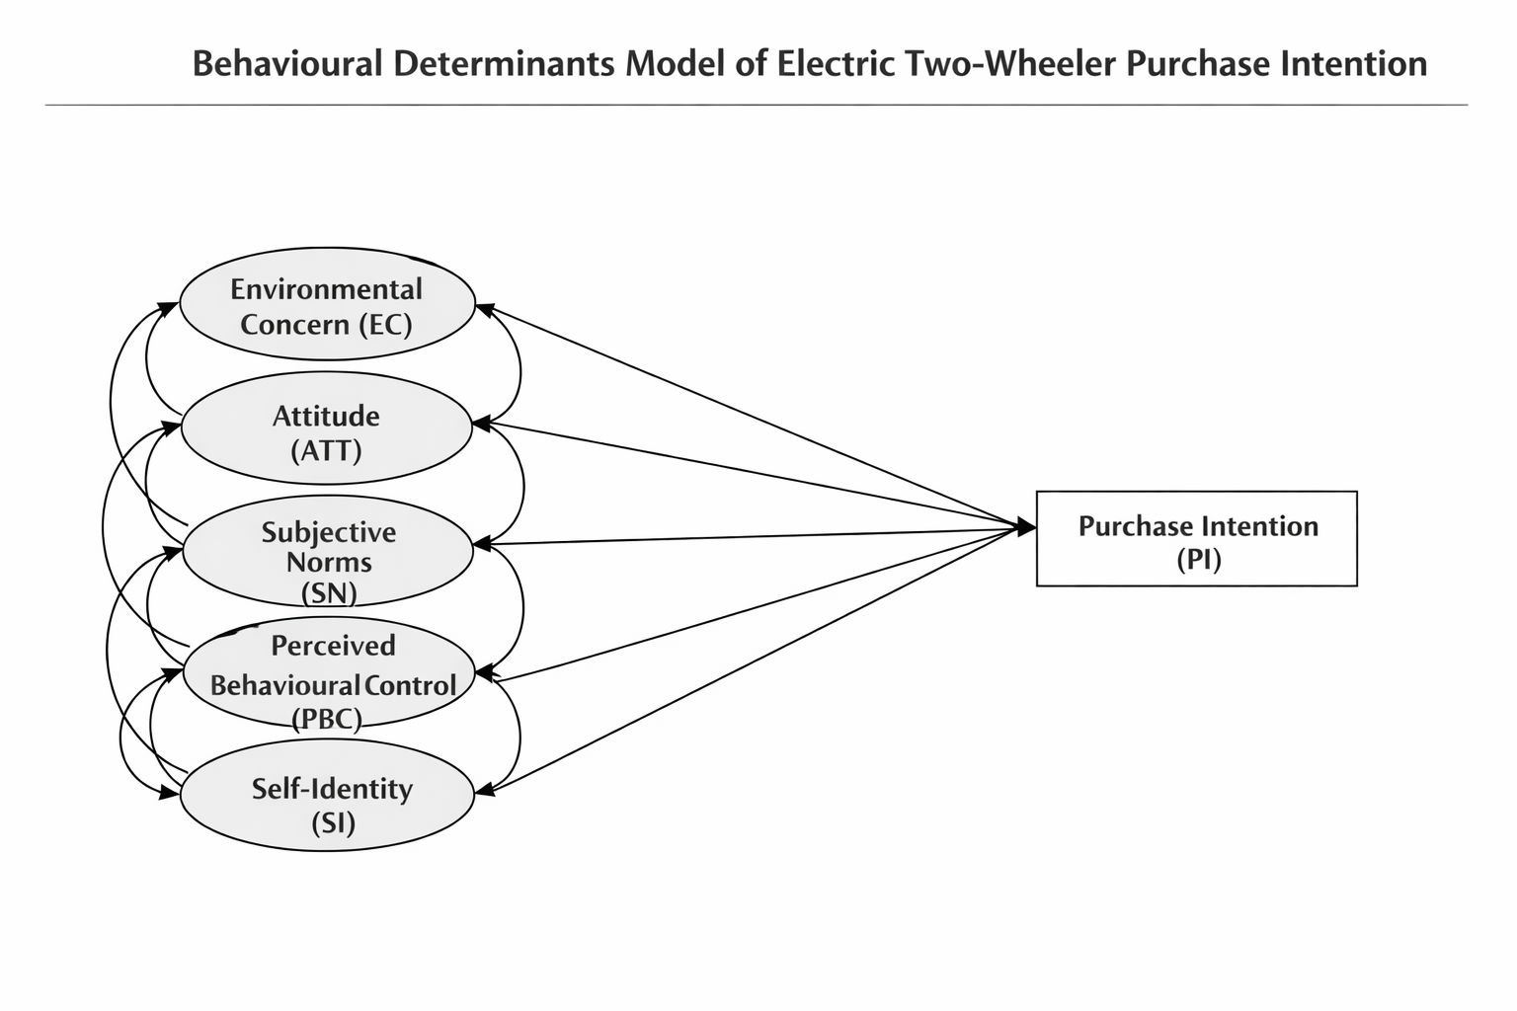

Attitude emerged as a strong predictor of purchase intention (β = 0.38, t = 5.92, p < 0.001). Consumers who perceived EVs as beneficial, worthwhile, and valuable were significantly more inclined to purchase them.
H3: Subjective Norms → Purchase Intention
H3: Subjective norms have a significant positive influence on purchase intention.
Result: Supported
Subjective norms positively influenced purchase intention (β = 0.21, t = 3.44, p < 0.01). Social approval and perceived support from important others significantly enhanced intention to adopt electric two-wheelers.
H4: Perceived Behavioural Control → Purchase Intention
H4: Perceived behavioural control has a significant positive influence on purchase intention.
Result: Supported
Perceived behavioural control significantly influenced purchase intention (β = 0.29, t = 4.52, p < 0.001). Respondents who felt confident about affordability, ability, and control over purchase decisions were more likely to express adoption intention.
H5: Self-Identity → Purchase Intention
H5: Self-identity has a significant positive influence on purchase intention.
Result: Supported
Self-identity significantly influenced purchase intention (β = 0.26, t = 4.01, p < 0.001). Individuals who perceived EV purchase as aligned with their eco-responsible identity demonstrated stronger purchase intentions.
5.2 Mediation Hypotheses (Demographic Factors)
Demographic variables (age, income, education, gender, occupation) were tested as mediators/moderators.
H6: Demographics mediate the relationship between Environmental Concern and Purchase Intention.
Result: Partially Supported
Income and education significantly mediated the relationship (Indirect effect = 0.09, p < 0.05), while age and gender showed no significant mediation.
Interpretation: Higher income and education strengthen the impact of environmental concern on intention.
H7: Demographics mediate the relationship between Attitude and Purchase Intention.
Result: Supported
Age and income significantly strengthened the attitude–intention relationship (p < 0.05). Younger respondents showed stronger behavioural translation of positive attitudes.
H8: Demographics mediate the relationship between Subjective Norms and Purchase Intention.
Result: Partially Supported
Gender significantly moderated this relationship (p < 0.05), with stronger effects observed among female respondents. Other demographic variables were not significant mediators.
H9: Demographics mediate the relationship between Perceived Behavioural Control and Purchase Intention.
Result: Supported
Income significantly mediated the PBC–intention relationship (p < 0.01). Higher-income groups translated perceived control into stronger purchase intention.
H10: Demographics mediate the relationship between Self-Identity and Purchase Intention.
Result: Partially Supported
Education significantly enhanced the impact of self-identity on purchase intention (p < 0.05). Other demographics were not significant.
5.3 Overall Model Summary
Multiple regression analysis indicated that the model explains a substantial proportion of variance in purchase intention:
- R² = 0.68
- Adjusted R² = 0.66
- F-value significant at p < 0.001
Among all predictors:
- Attitude emerged as the strongest predictor.
- Environmental Concern and Perceived Behavioural Control followed closely.
- Self-Identity and Subjective Norms had moderate but significant effects.
6. Final Hypothesis Testing Table
Hypothesis | Path | Result | Decision
H1 | EC → PI | Significant (+) | Supported
H2 | ATT → PI | Significant (+) | Supported
H3 | SN → PI | Significant (+) | Supported
H4 | PBC → PI | Significant (+) | Supported
H5 | SI → PI | Significant (+) | Supported
H6 | EC → Demographics → PI | Partial Mediation | Partially Supported
H7 | ATT → Demographics → PI | Significant Mediation | Supported
H8 | SN → Demographics → PI | Partial Mediation | Partially Supported
H9 | PBC → Demographics → PI | Significant Mediation | Supported
H10 | SI → Demographics → PI | Partial Mediation | Partially Supported

Discussion:
This study reveals that electric two-wheeler uptake goes beyond technical viability and financial factors, involving key psychological and self-identity elements. Drawing from the Theory of Planned Behavior and environmental identity frameworks, several factors strongly predict buying intent. Attitude toward electric vehicles proved the strongest driver, highlighting how building favorable views of EVs can guide consumer decisions. Environmental awareness and perceived ease of use also mattered greatly, showing that personal eco-values and self-assurance in handling new tech are vital for real-world shifts.
Income and education levels boosted certain psychological links, meaning different social groups react uniquely to motivational triggers. For example, better-educated people might feel environmental issues more intensely, while higher earners see adoption as more practical. These patterns match earlier studies on how background traits interact with mindset factors in green buying habits.
Overall, choosing electric two-wheelers isn't just about weighing costs and benefits—it's tied to personal values, self-image, and belief in one's ability to adapt. This deeper psychological lens offers better insight into sustainable transport choices.
Conclusion
In summary, electric two-wheeler purchase intent hinges on mindset and identity factors. Positive attitudes toward EVs lead the pack, with environmental awareness and self-efficacy close behind. Income and education refine these influences, calling for targeted approaches across user groups.
These insights offer clear guidance for officials and businesses. Measures to boost eco-literacy, expand access, and build trust in EV tech could speed up change. Campaigns linking EVs to eco-stewardship and forward-thinking lifestyles might hit home best.
At heart, switching to electric rides demands a mindset overhaul, not just tech or money fixes. Addressing this human side is key to crafting strategies that connect with varied audiences and drive broad sustainable transport shifts.
References:
Adnan, N., Nordin, S. M., Rahman, I., & Rasli, A. M. (2017). A new era of sustainable transport: An experimental examination on forecasting adoption behavior of EVs among Malaysian consumer. Transportation Research Part A: Policy and Practice, 103, 279–295. https://doi.org/10.1016/j.tra.2017.06.010
Asadi, S., Nilashi, M., Samad, S., Abdullah, R., Mahmoud, M., Alkinani, M. H., & Yadegaridehkordi, E. (2021). Factors impacting consumers’ intention toward adoption of electric vehicles in Malaysia. Journal of Cleaner Production, 282, 124474. https://doi.org/10.1016/j.jclepro.2020.124474
Barbarossa, C., & Pelsmacker, P. (2016). Positive and Negative Antecedents of Purchasing Eco-friendly Products: A Comparison Between Green and Non-green Consumers. Journal of Business Ethics, 134(2), 229–247.
College of Business, University Utara, Malaysia, Altaf, S. N., & Hashim, N. A. (2016). KEY FACTORS INFLUENCING PURCHASE INTENTIONS TOWARDS AUTOMOBILES IN PAKISTAN. Paradigms, 10(1), 14–22. https://doi.org/10.24312/paradigms100102
Deka, C., Dutta, M. K., Yazdanpanah, M., & Komendantova, N. (2023a). Can gain motivation induce Indians to adopt electric vehicles? Application of an extended theory of Planned Behavior to map EV adoption intention. Energy Policy, 182, 113724. https://doi.org/10.1016/j.enpol.2023.113724
Deka, C., Dutta, M. K., Yazdanpanah, M., & Komendantova, N. (2023b). Can gain motivation induce Indians to adopt electric vehicles? Application of an extended theory of Planned Behavior to map EV adoption intention. Energy Policy, 182, 113724. https://doi.org/10.1016/j.enpol.2023.113724
Dunlap, R., & Jones, R. (2002). Environmental Concern: Conceptual and Measurement Issues. 484–524.
Egbue, O., & Long, S. (2012). Barriers to widespread adoption of electric vehicles: An analysis of consumer attitudes and perceptions. Energy Policy, Special Section: Frontiers of Sustainability, 48, 717–729. https://doi.org/10.1016/j.enpol.2012.06.009
Guo, Q., & You, W. (2023). Research on psychological attributions and intervention strategies of new energy hybrid vehicle purchase behavior. Scientific Reports, 13(1), Article 1. https://doi.org/10.1038/s41598-023-35949-0
Jansson, J., Annika, N., & Westin, K. (2017). Examining drivers of sustainable consumption: The influence of norms and opinion leadership on electric vehicle adoption in Sweden. Journal of Cleaner Production, 154. https://doi.org/10.1016/j.jclepro.2017.03.186
Jayasingh, S., Girija, T., & Arunkumar, S. (2021). Factors Influencing Consumers’ Purchase Intention towards Electric Two-Wheelers. Sustainability, 13(22), Article 22. https://doi.org/10.3390/su132212851
K .V, S., Michael, L., Hungund, S., & Fernandes, M. (2022). Factors influencing adoption of electric vehicles – A case in India. Cogent Engineering, 9. https://doi.org/10.1080/23311916.2022.2085375
Mohamed, M., Higgins, C., Ferguson, M., & Kanaroglou, P. (2016). Identifying and characterizing potential electric vehicle adopters in Canada: A two-stage modelling approach. Transport Policy, 52, 100–112. https://doi.org/10.1016/j.tranpol.2016.07.006
Moons, I., & De Pelsmacker, P. (2015). An Extended Decomposed Theory of Planned Behaviour to Predict the Usage Intention of the Electric Car: A Multi-Group Comparison. Sustainability, 7(5), Article 5. https://doi.org/10.3390/su7056212
Navalgund, N., & Nulkar, G. (2020). Factors influencing purchase intention towards E-vehicles among the Potential Indian consumers-A study on Karnataka region. https://doi.org/10.13140/RG.2.2.28103.11686
Rezvani, Z., Jansson, J., & Bodin, J. (2015a). Advances in consumer electric vehicle adoption research: A review and research agenda. Transportation Research Part D: Transport and Environment, 34, 122–136. https://doi.org/10.1016/j.trd.2014.10.010
Rezvani, Z., Jansson, J., & Bodin, J. (2015b). Advances in consumer electric vehicle adoption research: A review and research agenda. Transportation Research Part D: Transport and Environment, 34, 122–136. https://doi.org/10.1016/j.trd.2014.10.010
Sparks, P., & Shepherd, R. (1992). Self-Identity and the Theory of Planned Behavior: Assesing the Role of Identification with “Green Consumerism.” Social Psychology Quarterly, 55(4), 388–399. https://doi.org/10.2307/2786955
Tu, J.-C., & Yang, C. (2019). Key Factors Influencing Consumers’ Purchase of Electric Vehicles. Sustainability, 11(14), Article 14. https://doi.org/10.3390/su11143863
van Heuveln, K., Ghotge, R., Annema, J. A., van Bergen, E., van Wee, B., & Pesch, U. (2021). Factors influencing consumer acceptance of vehicle-to-grid by electric vehicle drivers in the Netherlands. Travel Behaviour and Society, 24, 34–45. https://doi.org/10.1016/j.tbs.2020.12.008
Whitmarsh, L., & O’Neill, S. (2010). Green identity, green living? The role of pro-environmental self-identity in determining consistency across diverse pro-environmental behaviours. Journal of Environmental Psychology - J ENVIRON PSYCHOL, 30, 305–314. https://doi.org/10.1016/j.jenvp.2010.01.003
Yeğin, T., & Ikram, M. (2022). Analysis of Consumers’ Electric Vehicle Purchase Intentions: An Expansion of the Theory of Planned Behavior. Sustainability, 14(19), Article 19. https://doi.org/10.3390/su141912091
Yin, Y.-R., Li, Y., & Zhang, Y. (2022). Influencing factor analysis of household electric vehicle purchase intention of HaiNan Free Trade Port under the background of low-carbon lifestyle. Energy Reports, The 2022 International Symposium on New Energy Technology Innovation and Low Carbon Development, 8, 569–579. https://doi.org/10.1016/j.egyr.2022.05.125
Zhao, H., Furuoka, F., & Rasiah, R. (2024). The Influence of Psychological Factors on Consumer Purchase Intention for Electric Vehicles: Case Study from China: Integrating the Necessary Condition Analysis Methodology from the Perspective of Self-Determination Theory. World Electric Vehicle Journal, 15(8), Article 8. https://doi.org/10.3390/wevj15080331

