THE FATTY LIVER CRISIS IN INDIA
Mohammed Akber, Dr.Rahila Tarannum

Abstract
Fatty liver disease, now commonly known as Metabolic Dysfunction–Associated Steatotic Liver Disease (MASLD), has become an increasingly important health concern in India over the past few years. The rapid growth of urbanization, changes in lifestyle, reduced physical activity, and unhealthy eating habits have played a major role in the rising number of people affected by this condition. Factors such as obesity, type 2 diabetes, insulin resistance, and metabolic syndrome are closely linked to the development of fatty liver disease, making it a serious issue in both urban and semiurban populations. MASLD occurs due to excessive fat accumulation in liver cells, which can gradually progress to more severe liver conditions if not identified and managed early. In many cases, the disease remains asymptomatic in the initial stages, leading to delayed diagnosis. With the increasing prevalence of metabolic disorders in India, the burden of fatty liver disease is expected to grow further, creating challenges for the healthcare system. This project report aims to provide a detailed overview of fatty liver disease in the Indian context. It discusses the epidemiology and pathophysiology of MASLD, along with its major risk factors and common clinical features. The report also highlights the various diagnostic methods, management approaches, and preventive strategies that can help reduce disease progression. In addition, special emphasis is given to the role of pharmacists in patient education, medication management, lifestyle modification counseling, and early detection. Through this study, the importance of awareness, timely intervention, and a multidisciplinary approach in managing fatty liver disease in India is emphasized.

INTRODUCTION
In recent years, lifestyle-related health problems have increased rapidly, especially in developing countries like India. One such condition that is gaining attention is fatty liver disease, which is now referred to as Metabolic Dysfunction–Associated Steatotic Liver Disease (MASLD). This condition develops when fat starts accumulating in the liver due to metabolic imbalances rather than alcohol intake. Although it may seem harmless in the early stages, fatty liver disease can gradually affect normal liver function if proper care is not taken.

The increasing use of technology, desk-based jobs, lack of regular exercise, and unhealthy food choices have significantly changed the way people live today. As a result, problems such as obesity, diabetes, high cholesterol, and insulin resistance have become common, even among young adults. These conditions are closely related to the development of MASLD. In India, the problem is further aggravated by lack of awareness, late diagnosis, and limited routine health screenings.
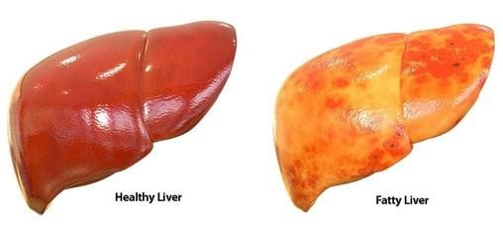
One of the major concerns associated with fatty liver disease is that it often does not show clear symptoms in the beginning. Many individuals come to know about the condition only during routine medical checkups or when they
develop complications. If left untreated, MASLD can progress to more serious conditions such as liver inflammation, fibrosis, cirrhosis, and in some cases, liver failure. Therefore, early identification and proper management are very important.

Understanding fatty liver disease is essential not only for patients but also for healthcare professionals and students in the medical and allied health fields. This project aims to study the causes, risk factors, clinical features, diagnosis, and management of MASLD with special reference to India. By increasing knowledge and awareness, the burden of fatty liver disease can be reduced and better health outcomes can be achieved.
In addition to lifestyle factors, genetic predisposition also plays an important role in the development of fatty liver disease. Environmental factors, dietary patterns, and family history together contribute to the overall risk. In India, where traditional diets are rapidly being replaced by processed and fast foods, this genetic vulnerability may further increase disease prevalence.
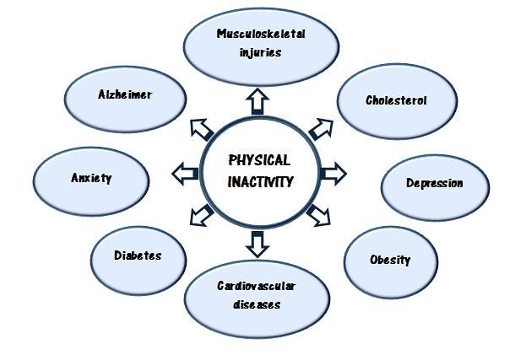
Dietary habits in the Indian population have undergone a significant shift over the past few decades. Increased consumption of refined carbohydrates, sugary beverages, deep-fried foods, and foods high in saturated fats has negatively affected metabolic health. At the same time, intake of fiber-rich foods, fruits, vegetables, and whole grains has reduced. These dietary changes contribute to weight gain and fat deposition in organs such as the liver. Irregular meal timings, overeating, and dependence on packaged foods further worsen metabolic balance and promote liver fat accumulation.
Physical inactivity is another major contributor to fatty liver disease. Modern lifestyles involving long hours of sitting, reduced physical labor, and minimal exercise have decreased overall energy expenditure. Regular physical activity plays a key role in maintaining insulin sensitivity and lipid metabolism. Lack of exercise leads to insulin resistance, which causes excess glucose to be converted into fat and stored in the liver. Even among individuals with normal body weight, sedentary behavior can increase the risk of MASLD, highlighting that the disease is not limited only to obese individuals.

Urbanization and economic growth have also influenced stress levels among individuals. Chronic stress, irregular sleep patterns, and mental health issues such as anxiety and depression can indirectly affect metabolic health.
One of the challenges in addressing MASLD is the lack of awareness among the general population. Many people consider liver diseases to be associated mainly with alcohol consumption and are unaware that fatty liver disease can develop in non-alcoholic individuals as well.
Early diagnosis of fatty liver disease is crucial to prevent disease progression. Simple investigations such as liver function tests, ultrasound imaging, and metabolic screening can help detect the condition at an early stage. However, routine health checkups are not commonly practiced by many individuals in India, especially among younger age

groups. As a result, MASLD is frequently diagnosed incidentally or at an advanced stage when complications have already developed.
Over time, this may result in fibrosis, where scar tissue replaces healthy liver tissue. If fibrosis continues to worsen, it can progress to cirrhosis, a condition characterized by irreversible liver damage and impaired liver function. In severe cases, patients may develop liver failure or hepatocellular carcinoma, which significantly affects quality of life and survival.
Management of MASLD primarily focuses on lifestyle modification, as there is no specific drug therapy approved exclusively for this condition. Weight reduction through a balanced diet and regular physical activity has been shown to improve liver fat content and metabolic parameters. Even a modest weight loss can have a positive impact on liver health. Dietary counseling and individualized exercise plans are essential components of disease management.
Pharmacological treatment may be required to manage associated conditions such as diabetes, hypertension, and dyslipidemia. Proper control of blood sugar levels and lipid profiles helps reduce further liver damage.
In conclusion, fatty liver disease has emerged as a significant public health concern due to rapid lifestyle changes and increasing metabolic disorders. Although the condition is often silent in its early stages, its long-term consequences can be severe if left untreated. A comprehensive approach involving early detection, lifestyle modification,
patient education, and multidisciplinary healthcare support is necessary to manage and prevent MASLD.

ANATOMY AND PHYSIOLOGY OF THE LIVER

Anatomy of the Liver
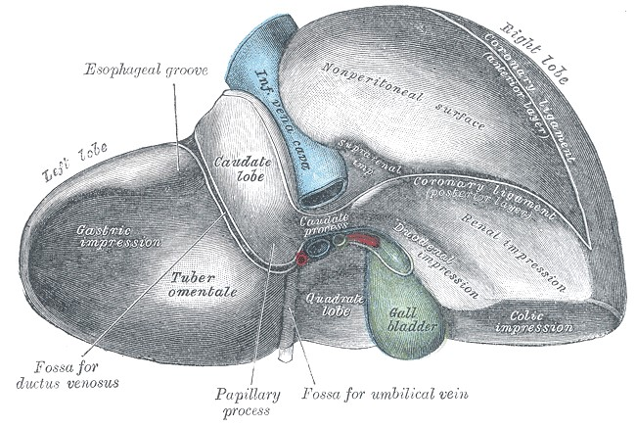

The liver is the largest gland and one of the most vital organs of the human body. It plays a central role in metabolism, digestion, detoxification, and storage of essential nutrients. In an adult human, the liver weighs approximately 1.2 to 1.5 kilograms and is reddish-brown in color due to its rich blood supply. It is located in the upper right quadrant of the abdominal cavity, just below the diaphragm and above the stomach, right kidney, and intestines.
The liver is divided anatomically into two main lobes: the right lobe and the left lobe. The right lobe is much larger than the left and occupies most of the upper right abdomen. Apart from these, the liver also has two smaller lobes known as the caudate lobe and the quadrate lobe, which are visible on the inferior surface. Functionally, the liver is divided into right and left functional lobes based on blood supply and bile drainage rather than anatomical appearance.
The surface of the liver is covered by a thin fibrous capsule called Glisson’s capsule, which helps protect the organ and maintain its shape. The liver has two main surfaces: the diaphragmatic surface, which is smooth and convex and lies in contact with the diaphragm, and the visceral surface, which is irregular and faces the abdominal organs.
The liver receives blood from two major sources. The hepatic artery supplies oxygenated blood from the heart, while the portal vein brings nutrient-rich but oxygen-poor blood from the digestive tract. This dual blood supply is essential for the liver’s metabolic and detoxifying functions. Blood from the liver drains through the hepatic veins into the inferior vena cava.
The structural and functional unit of the liver is the hepatic lobule. Each lobule is hexagonal in shape and consists of rows of liver cells known as hepatocytes. At the center of each lobule lies the central vein, while the corners contain portal triads. A portal triad consists of three structures: a branch of the hepatic artery, a branch of the portal vein, and a bile duct. Blood flows from the portal triads toward the central vein, while bile flows in the opposite direction toward the bile ducts.
The bile ducts of the liver collect bile produced by hepatocytes and transport it to the gallbladder for storage or directly to the small intestine. Bile plays a crucial role in digestion, especially in the digestion and absorption of fats.

Physiology of the Liver
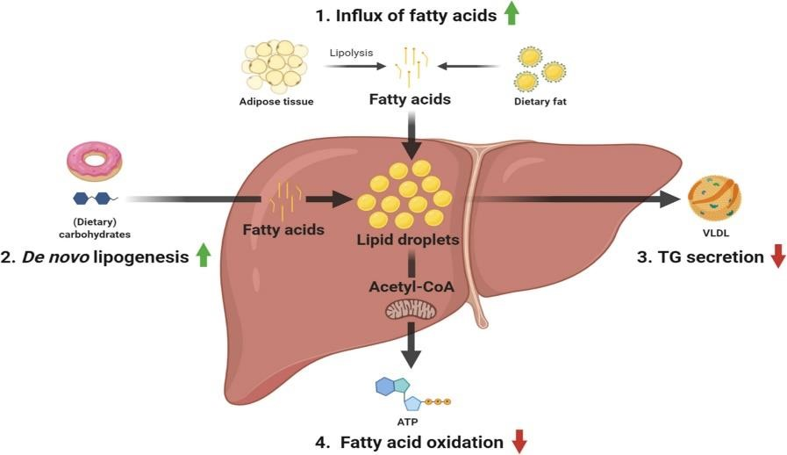

The liver performs a wide range of physiological functions that are essential for maintaining homeostasis in the body. One of its primary functions is metabolism. The liver regulates carbohydrate, protein, and fat metabolism. In carbohydrate metabolism, the liver helps maintain normal blood glucose levels by storing excess glucose in the form of glycogen and releasing glucose when needed through glycogenolysis and gluconeogenesis.
In protein metabolism, the liver is responsible for the synthesis of plasma proteins such as albumin, clotting factors, and enzymes. It also plays a role in the breakdown of amino acids and the conversion of toxic ammonia into urea, which is later excreted by the kidneys. This urea cycle is essential for preventing the accumulation of toxic substances in the blood.
Fat metabolism is another important function of the liver. The liver synthesizes cholesterol, phospholipids, and lipoproteins and helps in the oxidation of fatty acids. It also converts excess carbohydrates and proteins into fats for storage. The liver plays a key role in regulating lipid levels in the blood, thereby influencing overall metabolic health.
The liver is the primary organ responsible for detoxification. It converts harmful substances such as drugs, alcohol, toxins, and metabolic waste products into less toxic or water-soluble forms that can be easily excreted through urine or bile. This detoxification process occurs in two phases involving various enzymes, particularly those of the cytochrome P450 system.
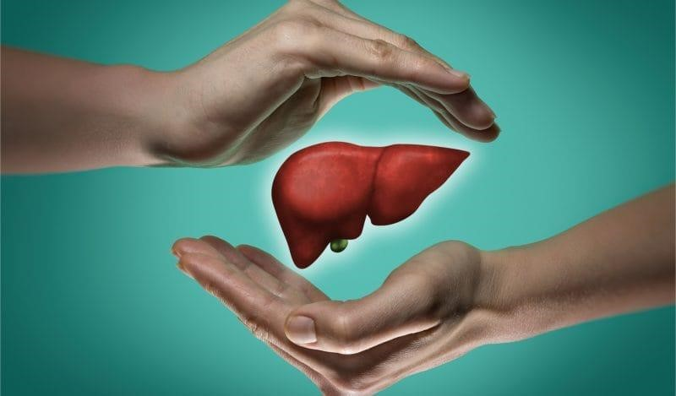
Another vital function of the liver is bile production and secretion. Bile contains bile

salts, bilirubin, cholesterol, and electrolytes. Bile salts are essential for emulsification and absorption of dietary fats and fat-soluble vitamins such as vitamins A, D, E, and K. Bilirubin, a breakdown product of hemoglobin, is excreted through bile, preventing its accumulation in the blood.
The liver also acts as a storage organ. It stores glycogen, vitamins such as A, D, E, K, and B12, and minerals including iron and copper. These stored substances are released into the bloodstream when required by the body, helping to maintain nutritional balance.
In addition, the liver plays a role in immune function. Specialized cells called Kupffer cells line the liver sinusoids and act as macrophages. They help remove bacteria, dead cells, and foreign particles from the blood, thereby protecting the body from infections.
In summary, the liver is a multifunctional organ that is essential for survival. Its complex
anatomy supports its diverse physiological functions, including metabolism, detoxification, digestion, storage, and immune defense. Any impairment in liver structure or function can significantly affect overall health, emphasizing the importance of maintaining liver health through proper lifestyle and medical care.

Definition and Classification of Fatty Liver Disease

Definition of Fatty Liver Disease
Fatty liver disease is a metabolic liver disorder characterized by the excessive accumulation of fat, mainly triglycerides, within liver cells known as hepatocytes. Under normal conditions, a small amount of fat is present in the liver; however, when fat content exceeds normal limits, it interferes with liver function and leads to liver damage over time. Fatty liver disease is not a single condition but a spectrum of liver abnormalities that range from simple fat accumulation to more severe inflammatory and fibrotic stages.
In recent medical terminology, fatty liver disease not related to alcohol consumption is now referred to as). This condition develops due to metabolic disturbances such as obesity, insulin resistance, type 2 diabetes mellitus, dyslipidemia, and hypertension.
Fatty liver disease often develops silently and may not present noticeable symptoms during its early stages. Despite the absence of symptoms, fat accumulation within the liver can gradually impair liver functions such as metabolism, detoxification, and bile production. Therefore, early recognition and proper classification of fatty liver disease are essential for effective management and prevention of complications. Classification of Fatty Liver Disease
Fatty liver disease can be classified based on its underlying cause, pathological changes, and disease progression. The major classifications are described below.
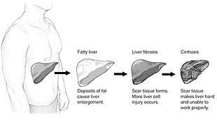

1. Alcoholic Fatty Liver Disease (AFLD)
Alcoholic fatty liver disease develops due to excessive and prolonged consumption of alcohol. Alcohol interferes with normal fat metabolism in the liver, leading to increased fat synthesis and reduced fat breakdown. In this condition, fat accumulation occurs as an early response to alcohol-induced liver injury. Although alcoholic fatty liver disease is reversible in its initial stage with alcohol abstinence, continued alcohol intake can lead to alcoholic hepatitis, fibrosis, and cirrhosis.

2. Metabolic Dysfunction–Associated Steatotic Liver Disease (MASLD)
MASLD is the most common form of fatty liver disease and is associated with metabolic risk factors rather than alcohol use. It occurs in individuals with obesity, insulin resistance, type 2 diabetes, hypertension, and abnormal lipid levels.. This condition has gained significant importance due to its increasing prevalence, particularly in developing countries.
MASLD represents a wide spectrum of liver involvement, ranging from simple fat accumulation to advanced liver damage. The progression of MASLD is influenced by the severity of metabolic dysfunction and lifestyle factors.

3. Simple Hepatic Steatosis
Simple hepatic steatosis is the earliest and mildest stage of fatty liver disease. In this stage, fat accumulates in liver cells without significant inflammation or liver cell injury.. This stage is considered reversible with lifestyle modification such as weight loss, healthy diet, and regular physical activity.

4. Steatohepatitis
Steatohepatitis is a more severe form of fatty liver disease characterized by fat accumulation along with liver inflammation and hepatocellular injury. In MASLD, this stage was previously referred to as non-alcoholic steatohepatitis (NASH). Inflammation causes progressive liver damage and increases the risk of fibrosis. Patients at this stage may experience fatigue, abdominal discomfort, or abnormal liver enzyme levels.

5. Liver Fibrosis
Liver fibrosis occurs when persistent inflammation leads to the formation of scar tissue in the liver. Fibrosis represents an intermediate stage between steatohepatitis and cirrhosis. At this stage, liver structure begins to change, but the damage may still be partially reversible if appropriate interventions are taken. Early detection of fibrosis is important to prevent further disease progression.

6. Liver Cirrhosis
Cirrhosis is the advanced stage of fatty liver disease and is characterized by extensive scarring and permanent damage to liver tissue. Normal liver architecture is replaced by fibrotic tissue, leading to impaired liver function. Patients with cirrhosis may develop complications such as portal hypertension, ascites, jaundice, and increased risk of liver cancer. At this stage, liver damage is usually irreversible, and management focuses on preventing complications and improving quality of life.

Epidemiology of Fatty Liver Disease
Fatty liver disease has emerged as one of the most common chronic liver disorders worldwide and is increasingly recognized as a major public health concern. Its prevalence has risen significantly over the past few decades due to rapid changes in lifestyle, dietary habits, and physical activity patterns. The disease affects individuals across different age groups, genders, and socioeconomic backgrounds, making it a global health challenge. Global Prevalence
Globally, fatty liver disease affects a substantial proportion of the adult population. The prevalence varies between regions, with higher rates observed in countries experiencing rapid urbanization and economic development. Industrialized nations and developing countries alike are witnessing a steady increase in cases. This rise closely parallels the growing prevalence of obesity, type 2 diabetes mellitus, metabolic syndrome, and sedentary lifestyles. Fatty liver disease is now considered a leading cause of chronic liver disease and a major contributor to liver-related morbidity and mortality worldwide. Epidemiology in India
In India, fatty liver disease has become increasingly common over recent years. Studies indicate that a significant percentage of the Indian population, particularly in urban areas, is affected by the condition. Urban residents show higher prevalence due to greater exposure to risk factors such as high-calorie diets, reduced physical activity, stress, and irregular eating habits. However, the disease is no longer limited to urban settings, as changing lifestyles in rural areas have also contributed to rising prevalence.
India’s unique genetic makeup, combined with dietary patterns rich in carbohydrates and fats, increases susceptibility to metabolic disorders and fatty liver disease.

Age and Gender Distribution

Fatty liver disease is more commonly observed in middle-aged adults; however, its occurrence among younger individuals is increasing. The disease often develops silently over several years, making it more prevalent in individuals above 30 years of age. In recent times, childhood and adolescent fatty liver disease has also gained attention, largely due to childhood obesity and poor dietary habits.
Gender differences in prevalence have been observed, with males generally showing higher rates than females. However, postmenopausal women are at increased risk due to hormonal changes that affect fat distribution and metabolism. Lifestyle factors, physical activity levels, and metabolic health contribute to these gender-based differences.

Association with Metabolic Disorders
Fatty liver disease shows a strong association with metabolic conditions such as obesity, insulin resistance, type 2 diabetes mellitus, and abnormal lipid profiles. Individuals with diabetes are at a significantly higher risk of developing fatty liver disease, and the presence of both conditions increases the likelihood of disease progression. Metabolic syndrome is considered one of the strongest predictors of fatty liver disease prevalence and severity.

Socioeconomic and Lifestyle Factors
Socioeconomic status plays an important role in the epidemiology of fatty liver disease. Increased income levels often lead to lifestyle changes such as consumption of processed foods, decreased physical activity, and increased screen time. Occupational factors, especially desk-based jobs, further contribute to sedentary behavior. Stressful lifestyles and inadequate sleep patterns also indirectly influence disease prevalence.
Lack of awareness and limited access to preventive healthcare services contribute to underdiagnosis, particularly in low-resource settings. Many individuals remain undiagnosed until the disease is detected incidentally during routine health examinations or when complications arise.

Disease Burden and Public Health Impact
The growing prevalence of fatty liver disease has placed a significant burden on healthcare systems. As the disease progresses, it increases the risk of advanced liver conditions, cardiovascular diseases, and overall mortality. Fatty liver disease is now recognized as a major risk factor for liver cirrhosis and liver cancer, contributing to increased healthcare costs and reduced quality of life.

Conclusion
In conclusion, the epidemiology of fatty liver disease reflects a rapidly growing health problem influenced by lifestyle changes, metabolic disorders, and urbanization. Both globally and in India, the disease affects a wide segment of the population and continues to rise. Understanding its epidemiological patterns is essential for developing effective prevention strategies, early detection programs, and public health interventions aimed at reducing disease burden and improving long-term health outcomes.

Etiology and Risk Factors of Fatty Liver Disease

Etiology of Fatty Liver Disease
Etiology refers to the causes and underlying mechanisms responsible for the development of a disease. Fatty liver disease develops when the balance between fat intake, fat synthesis, fat breakdown, and fat removal in the liver is disturbed. When excess fat accumulates in liver cells and the liver is unable to process or eliminate it effectively, fatty liver disease occurs. The etiology of this condition is multifactorial and involves a combination of metabolic, lifestyle, genetic, and environmental factors.
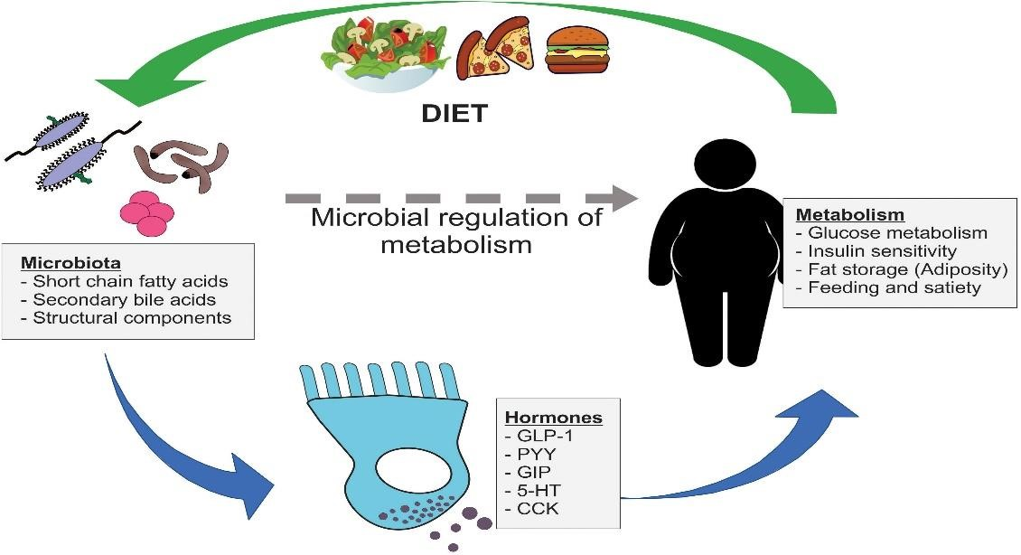
One of the primary causes of fatty liver disease is metabolic dysfunction. Insulin resistance plays a central role in the accumulation of fat within hepatocytes. When insulin resistance occurs, the body’s ability to regulate blood glucose levels is impaired, leading to increased fat synthesis in the liver and reduced breakdown of fatty acids. This metabolic imbalance promotes excessive fat deposition in the liver.
Dietary factors also contribute significantly to the etiology of fatty liver disease. High consumption of calorie-dense foods, refined carbohydrates, sugary beverages, and foods rich in saturated and trans fats increases fat production in the liver. Excess intake of fructose, commonly found in sweetened drinks and processed foods, has been shown to enhance fat accumulation and oxidative stress in liver cells.
Physical inactivity further aggravates the condition by reducing energy expenditure and impairing lipid metabolism. A sedentary lifestyle promotes weight gain, insulin resistance, and abnormal fat storage. In individuals with limited physical activity, even moderate caloric intake may lead to fat accumulation in the liver.
Genetic and epigenetic factors also play a role in the development of fatty liver disease. Certain genetic variations affect lipid metabolism, insulin sensitivity, and inflammatory responses, making some individuals more susceptible to liver fat accumulation even with minimal risk factors.

Risk Factors of Fatty Liver Disease
Risk factors are conditions or behaviors that increase the likelihood of developing a disease. Fatty liver disease is associated with several modifiable and non-modifiable risk factors.

1. Obesity and Overweight

Obesity is one of the strongest risk factors for fatty liver disease. Excess body fat, particularly abdominal or visceral fat, is closely linked to insulin resistance and increased free fatty acid delivery to the liver. Individuals who are overweight or obese have a significantly higher risk of developing fatty liver disease.

2. Type 2 Diabetes Mellitus
People with type 2 diabetes are at a high risk of developing fatty liver disease due to persistent insulin resistance and abnormal glucose metabolism. The coexistence of diabetes and fatty liver disease increases the risk of disease progression and liverrelated complications.

3. Dyslipidemia
Abnormal lipid levels, including elevated triglycerides and low levels of high-density lipoprotein (HDL) cholesterol, contribute to fat accumulation in the liver. Dyslipidemia is commonly observed in individuals with fatty liver disease and is an important metabolic risk factor.

4. Unhealthy Dietary Habits
Frequent consumption of processed foods, fast foods, sugary snacks, and sugar sweetened beverages increases the risk of fatty liver disease. Diets low in fiber, fruits, and vegetables further contribute to metabolic imbalance and liver fat accumulation.

5. Genetic Predisposition
Family history of fatty liver disease, diabetes, or metabolic syndrome increases susceptibility. Genetic factors influence how the body processes fats and sugars, thereby affecting liver health.

Pathophysiology
The pathophysiology of fatty liver disease involves a complex sequence of metabolic disturbances that lead to excessive fat accumulation within liver cells, followed by inflammation and progressive liver damage. The condition primarily develops due to an imbalance between fat acquisition and fat removal in the liver, resulting in the deposition of triglycerides in hepatocytes.
The initial step in the development of fatty liver disease is insulin resistance. When insulin resistance occurs, the body’s ability to utilize glucose effectively is reduced, leading to increased breakdown of fat from adipose tissue. This process releases large
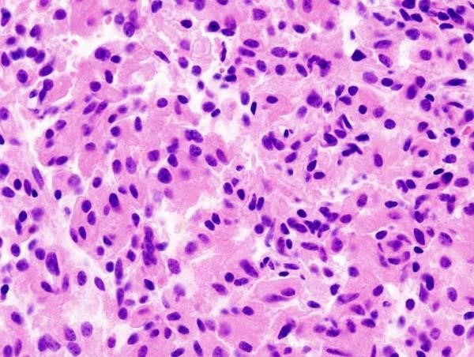

amounts of free fatty acids into the bloodstream, which are transported to the liver. The liver, overwhelmed by this increased fat load, begins to store excess fatty acids as triglycerides within hepatocytes, causing hepatic steatosis.
In addition to increased fat delivery, insulin resistance also stimulates de novo lipogenesis, a process by which the liver synthesizes new fatty acids from carbohydrates. At the same time, the oxidation of fatty acids is reduced, further contributing to fat accumulation. Impaired export of triglycerides in the form of very lowdensity lipoproteins (VLDL) also plays a role in worsening liver fat content.
As fat continues to accumulate, hepatocytes become vulnerable to injury. Excess fat leads to oxidative stress due to the increased production of reactive oxygen species. Oxidative stress damages cellular structures, including cell membranes and mitochondria, impairing normal liver function. This cellular injury triggers the release of inflammatory mediators, leading to liver inflammation.
Persistent inflammation activates immune cells such as Kupffer cells, which further amplify inflammatory responses. These inflammatory processes contribute to hepatocellular injury and cell death. Over time, chronic inflammation stimulates hepatic stellate cells, leading to increased production of collagen and extracellular matrix components. This results in fibrosis, characterized by the formation of scar tissue within the liver.
If the underlying metabolic disturbances persist, fibrosis progresses and disrupts normal liver architecture. Advanced fibrosis may eventually lead to cirrhosis, where extensive scarring causes irreversible liver damage and impaired liver function. Cirrhosis increases the risk of complications such as portal hypertension, liver failure, and hepatocellular carcinoma.
In summary, the pathophysiology of fatty liver disease involves a progressive cascade starting with insulin resistance and fat accumulation, followed by oxidative stress,
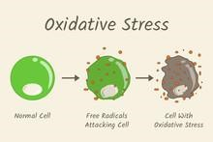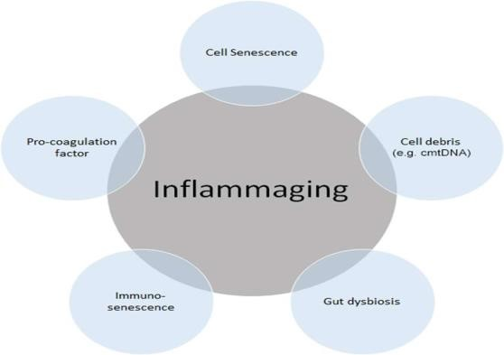
inflammation, fibrosis, and potential progression to cirrhosis. Understanding these mechanisms is essential for early intervention and prevention of disease progression.

Clinical Manifestations of Fatty Liver Disease
Fatty liver disease often presents with minimal or no symptoms, especially during the early stages. Many individuals remain asymptomatic for long periods, and the condition is frequently detected incidentally during routine medical examinations or imaging studies performed for other reasons. The absence of early symptoms makes clinical recognition challenging and contributes to delayed diagnosis.
In the initial stage of simple hepatic steatosis, most patients do not experience noticeable discomfort. Some individuals may report nonspecific symptoms such as mild fatigue or a general feeling of weakness. These symptoms are often overlooked or attributed to stress, poor sleep, or lifestyle factors rather than liver disease. Liver function tests may show mild elevation of liver enzymes, although results can also remain within normal limits.
As the disease progresses to steatohepatitis, clinical manifestations become more evident. Patients may experience persistent tiredness, reduced appetite, and vague discomfort or pain in the upper right side of the abdomen due to liver enlargement. Hepatomegaly, or enlargement of the liver, may be detected during physical examination. Nausea, bloating, and a sense of fullness may also be present in some individuals.
In advanced stages, when fibrosis and cirrhosis develop, symptoms become more pronounced and severe. Patients may develop jaundice, characterized by yellowing of the skin and eyes due to impaired bilirubin metabolism. Fluid accumulation in the abdomen, known as ascites, and swelling of the legs and ankles may occur as a result of reduced liver function and altered fluid balance. Muscle wasting, weight loss, and weakness are also common in advanced disease.

Diagnostic Evaluation
The diagnostic evaluation of fatty liver disease aims to identify the presence of excess fat in the liver, assess the severity of liver involvement, and rule out other causes of liver disease. Since fatty liver disease often remains asymptomatic in its early stages, diagnosis is commonly made during routine health examinations or investigations done for unrelated conditions. A combination of clinical assessment, laboratory tests, imaging studies, and, in selected cases, liver biopsy is used for accurate evaluation.

Clinical Assessment
The initial step in diagnosis involves a detailed medical history and physical examination. Information regarding lifestyle habits, dietary patterns, physical activity, alcohol consumption, and presence of metabolic disorders such as diabetes or obesity is obtained. Physical examination may reveal hepatomegaly in some patients, although findings are often normal in early disease. Assessment of risk factors plays a crucial role in guiding further investigations.

Laboratory Investigations


Blood tests are commonly used to evaluate liver function and metabolic status. Liver function tests may show mild to moderate elevation of liver enzymes such as alanine aminotransferase (ALT) and aspartate aminotransferase (AST). In fatty liver disease, ALT levels are often higher than AST levels, particularly in non-alcoholic cases. However, normal enzyme levels do not exclude the presence of fatty liver disease.
Additional laboratory tests include lipid profile, fasting blood glucose, and glycated hemoglobin to assess associated metabolic abnormalities. Tests for viral hepatitis, autoimmune liver diseases, and other liver disorders are performed to exclude alternative causes of liver damage. Imaging Studies
Imaging plays an important role in the diagnosis of fatty liver disease. Ultrasonography is the most commonly used and widely available imaging technique. It can detect increased liver echogenicity, which suggests fat accumulation. Ultrasound is noninvasive, cost-effective, and suitable for screening, although it cannot accurately assess disease severity.

Non-Invasive Assessment of Fibrosis
Non-invasive methods are increasingly used to evaluate liver fibrosis. These include serum-based scoring systems and imaging techniques such as elastography, which measures liver stiffness. These methods help identify patients at risk of advanced liver disease and reduce the need for invasive procedures.

Liver Biopsy
Liver biopsy is considered the gold standard for diagnosing and staging fatty liver disease. It provides detailed information about fat accumulation, inflammation, fibrosis, and liver cell injury. However, due to its invasive nature, cost, and risk of complications, biopsy is reserved for selected cases where diagnosis is uncertain or advanced disease is suspected.

Complications
Fatty liver disease, although often asymptomatic in its early stages, can lead to several serious complications if not properly managed. The progression of the disease occurs gradually and may result in both liver-related and systemic complications. The severity of complications depends on the duration of the disease, presence of metabolic disorders, and effectiveness of treatment and lifestyle modification.
One of the earliest complications of fatty liver disease is the progression from simple steatosis to steatohepatitis. In this stage, fat accumulation is accompanied by inflammation and liver cell injury. Persistent inflammation increases the risk of further liver damage and accelerates disease progression. Steatohepatitis significantly raises the likelihood of developing fibrosis and other advanced liver conditions.
Liver fibrosis is a major complication resulting from long-term inflammation. Fibrosis involves the formation of scar tissue within the liver, which gradually replaces healthy liver tissue. As fibrosis advances, normal liver structure and blood flow are disrupted. Although early fibrosis may be partially reversible, continued liver injury can lead to permanent damage.
Cirrhosis is one of the most serious complications of fatty liver disease. It is characterized by extensive scarring and irreversible destruction of liver architecture. Cirrhosis leads to impaired liver function and increases the risk of life-threatening complications such as portal hypertension, ascites, variceal bleeding, and hepatic encephalopathy. Patients with cirrhosis often require long-term medical management and monitoring.
Another significant complication is liver failure, which occurs when the liver can no longer perform its essential functions. Symptoms of liver failure include jaundice, severe fatigue, confusion, bleeding disorders, and fluid accumulation. In advanced cases, liver transplantation may be the only treatment option.
Fatty liver disease also increases the risk of hepatocellular carcinoma, a primary cancer of the liver. Chronic inflammation and cirrhosis create an environment conducive to cancer development. Patients with advanced fatty liver disease require regular screening to detect liver cancer at an early stage.

Conclusion
In conclusion, fatty liver disease can lead to serious hepatic and extra-hepatic complications if left untreated. Early detection, lifestyle modification, and proper management are essential to prevent disease progression and reduce the risk of longterm complications. Awareness and timely intervention play a key role in improving patient outcomes.

Management Strategies

The management of fatty liver disease focuses on preventing disease progression, improving liver function, and reducing associated metabolic risk factors. Since fatty liver disease is closely linked to lifestyle and metabolic disturbances, the cornerstone of management involves non-pharmacological measures along with appropriate medical treatment when necessary. Early intervention
plays a crucial role in reversing liver fat accumulation and preventing long-term complications.

Lifestyle Modification
Lifestyle modification is the most effective and primary management strategy for fatty liver disease. Gradual and sustained weight loss through a balanced diet and regular physical activity has been shown to significantly reduce liver fat content. A healthy diet rich in fruits, vegetables, whole grains, lean proteins, and healthy fats is recommended. Reduction in the intake of refined carbohydrates, sugary beverages, saturated fats, and processed foods is essential for improving metabolic health.
Regular physical activity improves insulin sensitivity and lipid metabolism. Moderateintensity exercises such as brisk walking, cycling, or swimming for at least 30 minutes on most days of the week are beneficial. Combining aerobic exercise with strength training provides additional metabolic benefits. Control of Metabolic Risk Factors
Effective management of associated metabolic conditions is essential in fatty liver disease. Proper control of blood glucose levels in diabetic patients helps reduce liver inflammation and disease progression. Management of dyslipidemia through dietary measures and medications, when required, helps regulate lipid levels and reduce liver fat accumulation. Blood pressure control is also important to minimize cardiovascular risk.

Alcohol Abstinence
In individuals with alcoholic fatty liver disease, complete abstinence from alcohol is necessary to prevent further liver damage. Even in metabolic-associated fatty liver disease, alcohol intake should be minimized or avoided, as it can worsen liver injury and accelerate disease progression.

Role of Healthcare Professionals
A multidisciplinary approach involving physicians, dietitians, and pharmacists is important for effective disease management. Pharmacists play an essential role in patient education, medication counseling, and promoting adherence to treatment and lifestyle modifications.

Conclusion
In conclusion, the management of fatty liver disease primarily relies on lifestyle modification, control of metabolic risk factors, and regular monitoring. Early diagnosis and a comprehensive, patient-centered approach can effectively prevent disease progression and improve long-term health outcomes.

Pharmacological Treatment
Pharmacological treatment of fatty liver disease is mainly aimed at managing associated metabolic disorders and preventing disease progression, as there is currently no single drug approved specifically for the complete cure of fatty liver disease. Medications are used as supportive therapy in patients who do not respond adequately to lifestyle modification or who have advanced disease and associated risk factors.

Drugs Improving Insulin Sensitivity
Insulin resistance plays a central role in the development of fatty liver disease; therefore, drugs that improve insulin sensitivity are commonly used. Antidiabetic medications help in controlling blood glucose levels and reducing liver fat accumulation. Improved glycemic control reduces inflammation and slows disease progression, particularly in patients with type 2 diabetes mellitus.

Lipid-Lowering Agents
Dyslipidemia is commonly associated with fatty liver disease. Lipid-lowering drugs are used to reduce elevated triglycerides and cholesterol levels. These medications help improve lipid metabolism and reduce cardiovascular risk, which is a major concern in patients with fatty liver disease. Careful monitoring is required to ensure liver safety during therapy.

Antioxidants
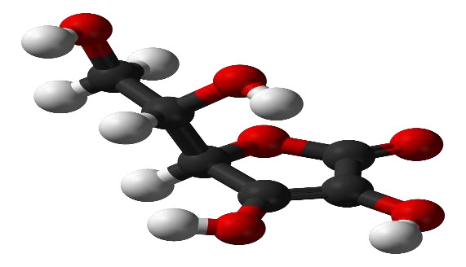
Oxidative stress contributes to liver cell injury in fatty liver disease.
and

Antioxidant therapy may help reduce oxidative damage and inflammation in the liver. Certain vitamins and antioxidant agents are used to protect liver cells
improve liver enzyme levels in selected patients. Their use should be guided by medical supervision to avoid excessive intake.

Hepatoprotective Agents
Hepatoprotective drugs are commonly prescribed to support liver function and promote liver cell regeneration. These agents help stabilize liver cell membranes, improve detoxification processes, and reduce inflammation. Although they do not cure the disease, they may provide symptomatic relief and support liver health.

Conclusion
In conclusion, pharmacological treatment of fatty liver disease focuses on managing metabolic abnormalities, reducing inflammation, and protecting liver function. While medications play a supportive role, lifestyle modification remains the cornerstone of therapy. A comprehensive and individualized treatment approach is essential for achieving better clinical outcomes.

Non-Pharmacological Management
Non-pharmacological management forms the foundation of treatment for fatty liver disease and is considered the most effective approach, especially in the early stages. Since the condition is strongly associated with lifestyle and metabolic factors, longterm improvement depends largely on behavioral changes rather than medication alone. These measures aim to reduce liver fat, improve metabolic health, and prevent disease progression.

Weight Reduction
Gradual and sustained weight loss is one of the most important strategies in managing fatty liver disease. Even a modest reduction in body weight can significantly decrease liver fat and improve liver enzyme levels. Weight loss should be achieved through healthy methods rather than extreme dieting, as rapid weight loss may worsen liver injury.

Dietary Modification


Adopting a balanced and nutritious diet plays a crucial role in non-pharmacological management. Diets rich in fruits, vegetables, whole grains, lean proteins, and healthy fats are recommended. Reduction in the intake of refined carbohydrates, sugary foods, sweetened beverages, fried items, and processed foods helps improve insulin sensitivity and reduces fat accumulation in the liver. Adequate fiber intake supports better digestion and metabolic balance. Physical Activity
Regular physical activity improves insulin sensitivity, promotes fat oxidation, and aids in weight management. Moderate-intensity exercises such as brisk walking, cycling, swimming, or yoga are beneficial when practiced consistently. Both aerobic exercise and resistance training contribute to improved liver health. Maintaining an active lifestyle helps prevent disease progression even in individuals without significant weight loss.

Alcohol Avoidance
Avoidance of alcohol is strongly recommended, as alcohol can worsen liver injury and accelerate disease progression. Even small amounts of alcohol may aggravate liver damage in individuals with fatty liver disease. Complete abstinence is especially important in patients with advanced liver involvement.

Conclusion
In conclusion, non-pharmacological management is the cornerstone of fatty liver disease treatment. Lifestyle modification through healthy diet, regular physical activity, weight management, and alcohol avoidance plays a vital role in reversing liver fat accumulation and preventing complications. Early adoption of these measures leads to improved liver health and better long-term outcomes.

Role of Diet and Nutrition
Diet and nutrition play a crucial role in the development, management, and prevention of fatty liver disease. Since the condition is closely linked to metabolic imbalance and lifestyle habits, appropriate dietary modification is one of the most effective strategies to reduce liver fat accumulation and improve liver function. A well-planned nutritional approach helps control body weight, improve insulin sensitivity, and reduce inflammation.
Excess calorie intake, particularly from refined carbohydrates, saturated fats, and sugary foods, contributes significantly to fat accumulation in the liver. Diets high in sugar and fructose promote increased fat synthesis within hepatocytes and worsen insulin resistance. Therefore, reducing the intake of sugar-sweetened beverages, sweets, and processed foods is essential in managing fatty liver disease.
A balanced diet rich in whole grains, fruits, vegetables, and lean protein sources is highly beneficial. Whole grains and fiber-rich foods help regulate blood glucose levels and improve lipid metabolism. Dietary fiber also promotes satiety, which helps prevent overeating and supports weight management. Increased consumption of vegetables and fruits provides essential vitamins, minerals, and antioxidants that protect liver cells from oxidative stress.
Protein intake is important for maintaining muscle mass and supporting liver regeneration. Lean protein sources such as legumes, pulses, low-fat dairy products, fish, and poultry are recommended. Excessive intake of red meat and processed meats should be avoided, as they are associated with increased inflammation and metabolic risk.
The type of dietary fat consumed also influences liver health. Saturated and trans fats found in fried foods and processed snacks should be limited, while healthy fats such as those found in nuts, seeds, olive oil, and fish should be included in moderation. Omega3 fatty acids have been shown to improve lipid profiles and reduce liver fat content.

Lifestyle Modification
Lifestyle modification is the cornerstone of prevention and management of fatty liver disease. Since the condition is strongly associated with unhealthy lifestyle habits and metabolic disturbances, long-term improvement in liver health largely depends on sustained changes in daily routine, physical activity, diet, and behavioral practices. Early adoption of healthy lifestyle measures can reverse liver fat accumulation and prevent disease progression.
Regular physical activity plays a vital role in improving liver function and reducing fat accumulation. Exercise enhances insulin sensitivity, promotes fat metabolism, and supports weight management. Moderate-intensity activities such as brisk walking, jogging, cycling, swimming, or yoga performed regularly are effective in reducing liver fat. Both aerobic exercises and resistance training contribute to improved metabolic health and should be included in daily routines whenever possible.
Weight management is another key component of lifestyle modification. Excess body weight, particularly central obesity, increases the risk of fatty liver disease. Gradual and sustained weight loss helps reduce liver fat content and inflammation. Crash dieting and rapid weight loss should be avoided, as they may worsen liver injury. Maintaining a healthy body weight through balanced nutrition and regular exercise is essential for long-term disease control.
Avoidance of alcohol is strongly recommended for individuals with fatty liver disease. Alcohol intake increases liver stress and accelerates disease progression. Even small amounts of alcohol can aggravate liver damage in affected individuals. Complete abstinence or strict limitation of alcohol consumption supports liver recovery and prevents further injury.
Sleep and stress management are increasingly recognized as important lifestyle factors influencing metabolic health. Poor sleep quality and chronic stress contribute to hormonal imbalance, insulin resistance, and weight gain. Maintaining regular sleep patterns, practicing relaxation techniques, and managing stress through physical activity or mindfulness practices help improve overall health and liver function.

Prevention strategies
Prevention of fatty liver disease focuses on addressing modifiable lifestyle and metabolic risk factors before significant liver damage occurs. Since the disease often develops silently and progresses gradually, preventive measures play a crucial role in reducing its incidence and long-term complications. Early adoption of healthy habits and awareness are essential for effective prevention Maintaining a healthy body weight is one of the most important preventive strategies. Excess body fat, especially abdominal obesity, increases the risk of fat accumulation in the liver. Regular monitoring of body weight and body mass index helps identify early weight gain and encourages timely corrective measures. Gradual weight control through healthy practices is more effective than rapid weight loss.

Adopting a balanced and nutritious diet helps prevent metabolic disturbances associated with fatty liver disease. Limiting the intake of refined carbohydrates, sugary foods, sweetened beverages, and high-fat processed foods reduces liver fat formation. A diet rich in fruits, vegetables, whole grains, lean proteins, and healthy fats supports normal liver metabolism and overall health.
Regular physical activity is essential in preventing fatty liver disease. Exercise improves insulin sensitivity, enhances fat oxidation, and helps maintain a healthy weight. Engaging in moderate physical activity such as walking, cycling, swimming, or yoga on a regular basis significantly lowers the risk of developing metabolic disorders and liver fat accumulation.
Avoidance or strict limitation of alcohol intake is an important preventive measure. Alcohol interferes with normal liver metabolism and can worsen liver injury. Even moderate alcohol consumption may increase the risk of fatty liver disease in individuals with metabolic risk factors. Abstaining from alcohol helps protect liver health and prevents disease progression.

Public Health Impact


Fatty liver disease has emerged as a significant public health challenge due to its rapidly increasing prevalence and long-term health consequences. The condition affects a large proportion of the population and is closely linked to lifestyle-related metabolic disorders such as obesity, diabetes, and cardiovascular disease. Its silent nature in the early stages makes it difficult to detect and contributes to delayed diagnosis, increasing the overall disease burden.
One of the major public health concerns associated with fatty liver disease is its contribution to chronic liver-related morbidity and mortality. As the disease progresses, it can lead to advanced liver conditions such as fibrosis, cirrhosis, liver failure, and hepatocellular carcinoma

Fatty liver disease is also strongly associated with cardiovascular disease, which is a leading cause of death worldwide. Individuals with fatty liver disease have an increased risk of developing hypertension, coronary artery disease, and stroke.
The economic impact of fatty liver disease is significant. Direct healthcare costs include diagnostic tests, medications, hospital admissions, and long-term management of complications. Indirect costs arise from loss of productivity, absenteeism from work, disability, and reduced quality of life. In developing countries like India, the financial burden is further intensified due to limited healthcare resources and out-of-pocket medical expenses.
From a public health perspective, addressing fatty liver disease requires a multidisciplinary and preventive approach. Population-based interventions promoting healthy diet, regular physical activity, weight management, and reduction of alcohol consumption are essential. Integration of liver health education into existing public health programs can help reduce disease prevalence and long-term complications.
In conclusion, fatty liver disease poses a substantial public health challenge due to its high prevalence, association with metabolic and cardiovascular disorders, and significant economic burden. Strengthening prevention strategies, improving awareness, and promoting early detection are crucial steps toward reducing its impact and improving population health outcomes

CONCLUSION
Fatty liver disease has emerged as a significant health concern due to rapid lifestyle changes, increasing metabolic disorders, and reduced physical activity in modern society. Once considered a relatively harmless condition, it is now recognized as a progressive disease that can lead to serious liver-related and systemic complications if not identified and managed at an early stage. The rising prevalence of metabolic dysfunction–associated Steatotic liver disease highlights the need for greater awareness and preventive strategies.
This project has provided a comprehensive overview of fatty liver disease, including its definition, classification, epidemiology, etiology, pathophysiology, clinical manifestations, diagnostic evaluation, complications, and management strategies. Understanding the anatomy and physiology of the liver helps in appreciating how metabolic imbalances disrupt normal liver function and lead to fat accumulation. The disease process involves complex metabolic and inflammatory mechanisms that gradually impair liver structure and function.
Early stages of fatty liver disease are often asymptomatic, making early diagnosis challenging. However, timely detection through routine health screenings and appropriate diagnostic methods can prevent disease progression. Lifestyle modification remains the cornerstone of management, with emphasis on healthy diet, regular physical activity, weight management, and avoidance of alcohol. Pharmacological treatment plays a supportive role, particularly in managing associated metabolic conditions such as diabetes and dyslipidemia.
Non-pharmacological measures, including dietary control, physical activity, stress management, and patient education, are essential for long-term disease control. Preventive strategies focusing on awareness, early intervention, and healthy lifestyle practices can significantly reduce the burden of fatty liver disease at both individual and community levels. From a public health perspective, addressing this condition is important to reduce healthcare costs and improve overall population health.
In conclusion, fatty liver disease is a preventable and manageable condition when identified early and addressed through a comprehensive and multidisciplinary approach. Increasing awareness among the general population and healthcare professionals, along with sustained lifestyle changes, can help reduce disease prevalence and improve long-term health outcomes. Effective prevention and management strategies are key to minimizing the impact of fatty liver disease on individuals and society.

REFERENCES
- World Health Organization (WHO).
Non-communicable Diseases and Liver Health Reports. Available from: www.who.int
- Indian Council of Medical Research (ICMR).
Publications on Metabolic Disorders and Liver Diseases.
Available from: www.icmr.gov.in
- BrainKart – B.Pharm pharmacy lecture notes and online study material related to medical and pharmaceutical subjects.
Available from: https://www.brainkart.com
- PACE Hospitals – Educational articles and clinical information on liver diseases and metabolic disorders.
Available from: https://www.pacehospitals.com
- PubMed Central (PMC) – “Non-Alcoholic Fatty Liver Disease: An Update on
Diagnosis” – review article providing scientific information on diagnosis and evaluation.
Available from: https://pmc.ncbi.nlm.nih.gov
- SlideShare – Educational presentations and student reference materials on fatty liver disease.
Available from: https://www.slideshare.net
- MedlinePlus – Information on fatty liver disease and related health conditions. Available from: https://medlineplus.gov
- ScienceDirect – Non-alcoholic fatty liver disease development: A multifactorial pathogenesis.
Available from: https://www.sciencedirect.com
- Wikipedia – Overview of fatty liver disease. Available from: https://en.wikipedia.org
- ResearchGate – Research articles from the International Journal of Clinical studies related to fatty liver disease.
Available from: https://www.researchgate.net
- National Medical Journal of India (NMJI) – Prevalence of non-alcoholic fatty liver disease among adults. Available from: https://www.nmji.in

