Shading Applications for Effective Control of Daylighting

ABSTRACT
Shading devices are an important but underutilised architectural design tool for commercial bank buildings in tropical climates. Regional bank buildings in Port Harcourt, Rivers State, Nigeria, operate in a tropical humid climate with high, near-overhead sun radiation throughout the year but have almost no purpose-designed external shading. The struggle between solar heat gain and thermal comfort has resulted in a built culture of opaque facades and interior window coverings that exclude sunshine while negating energy conservation. This study investigates shading applications for effective daylight control in regional bank buildings in Port Harcourt, Rivers State, with the purpose of identifying architectural principles for resolving the heat-daylighting conflict via exterior shade. Using a qualitative multi-case research design, the study uses direct and participant observation of two Port Harcourt bank buildings (Parallex Bank, Trans-Amadi Road; Providus Bank, Olu Obasanjo Road), structured key-informant interviews with facility managers at four regional banks, and secondary case study analysis of two internationally recognised daylighting-responsive banking buildings: the BMCE Bank Branches in Casablanca, Morocco (Foster + Partners, 2011), and the Lombard Odier 1Roof Headquarters, Bellevue. The findings show that both local bank buildings lack efficient external shading, necessitating the management of solar heat intake either with internal blinds that cancel available daylighting or with minimum fenestration that eliminates heat and light. The international case studies demonstrate that climate-calibrated external shading systems, specifically 200mm-deep perforated stainless steel mashrabiya screens at BMCE Bank and cantilevered concrete floor slab overhangs at Lombard Odier, successfully decouple solar heat gain from daylight admission in their respective climatic contexts, allowing naturally illuminated, thermally comfortable banking interiors without recourse to interior blinds or artificial lighting. The paper contextualises these findings within the current literature on shading device performance in Nigerian and tropical climates, and it ends with six climate-calibrated design recommendations for incorporating external shading into the envelope design of regional bank buildings in Port Harcourt.
Keywords: Daylighting Control; Mashrabiya; Solar Heat Gain; External Shading; Energy Conservation.
BACKGROUND TO THE STUDY
Controlling solar radiation at the building envelope is one of the most important architectural issues in tropical climates. Sunlight, the source of both natural illumination and unwanted heat gain, presents a fundamental design problem in hot, humid regions: it is both the most abundant, freely available source of visual illumination in the environment and, if not managed, a powerful thermal load that increases cooling energy consumption and degrades interior comfort. The shading device is an architectural element designed to intercept direct solar beam radiation before it reaches or penetrates the building's glazed envelope, allowing diffuse skylight while excluding the direct solar beam, which carries the majority of the thermal load (Bakr & Fikry, 2019; Garba, 2023).
Port Harcourt, the capital of Rivers State and the economic core of Nigeria's Niger Delta, is located at around 4.84° North latitude, which places it in the wet tropics near the equator. The city's solar geometry is defined by high solar altitude angles throughout the year, with the sun becoming near-vertical at solar noon during the equinoxes (solar altitude greater than 85°) and remaining high even at the solstices. Adeyemi et al. (2018) reported a peak solar irradiation of 508 W/m² at noon, with an average annual solar radiation of 3.8-4.5 kWh/m²/day (Uko & Tamunobereton-ari, 2013). This high and sustained sun exposure makes Port Harcourt one of Nigeria's most difficult sites for daylighting design: the same solar resource that provides ample natural light for building interiors also poses a significant thermal challenge.
Shading devices work by selectively intercepting direct beam solar radiation, which contains both visible light and concentrated infrared thermal energy, while allowing diffuse skylight to pass through, which contains more visible wavelengths but carries less heat per unit of luminous flux (Reinhart & Weissman, 2012). This selective behaviour is the technical foundation of effective daylighting control in tropical climates: properly designed shading reduces the Solar Heat Gain Coefficient (SHGC) of the effective opening while not proportionally reducing its Visible Light Transmittance (VLT), thus decoupling the heat and light components of solar radiation at the envelope. The end result is a building that is well-daylit without being thermally compromised, exactly the condition that Port Harcourt's present bank buildings fail to attain.
The literature on shading devices in Nigerian climates is expanding, but it remains narrow in scope. Ochedi and Taki (2019) identified shading as one of the most important passive design elements for commercial buildings in Nigerian hot climates, stating that well-planned overhangs can minimise solar heat gain through glass surfaces by 30-70%, depending on geometry and orientation. Garba (2023) used daylight autonomy (DA) simulation to assess the daylighting performance of six shading device typologies in a Nigerian single-banked building prototype, discovering statistically significant differences in performance across device types and recommending horizontal overhangs and egg-crate devices for northern and southern facades and vertical fins for eastern and western facades. Kalu et al. (2025) discovered, through a systematic review of 30 studies, that passive design strategies such as shading can improve thermal conditions and reduce energy consumption by up to 50% in Nigerian buildings, but adoption remains low, with less than 29% of examined commercial buildings incorporating adequate passive cooling measures.
The commercial banking industry in Port Harcourt is a critical example of passive design underutilisation. A study specific to the Port Harcourt commercial context, a design thesis on daylighting in a regional shopping mall, identified external shading devices as one of the key passive daylighting strategies applicable to commercial buildings in the city, along with clerestory windows, light shelves, atria, and reflective interior surfaces. The current study focuses specifically on shading applications, acknowledging that shading is the foundational strategy on which all other daylighting interventions in the tropical context rely: without appropriate solar control, all other daylighting measures like large windows, glazed atria, and reflective surfaces become thermal liabilities rather than assets.
The Floating Architecture paper by Victor and Daminabo (2025), published in the same journal, observes that climate-adaptive design responses in Nigeria necessitate a shift from traditional, reactive building strategies to proactive, integrated design approaches that anticipate and work with environmental forces rather than against them, a design philosophy that is equally applicable to the challenge of daylighting and shading in banking architecture, where Victor and Daminabo (2025) argue that water should be embraced as a design partner rather than treated as a threat. This study contends that solar radiation should be designed with rather than against it: harnessed for its light value through selective filtering rather than blindly excluding.
STATEMENT OF THE PROBLEM
The regional bank buildings in Port Harcourt have a shading arrangement that makes effective daylighting control structurally difficult. Observed buildings in the study area have either opaque or minimally fenestrated facades, which are a brute-force approach to solar control that eliminates both heat gain and daylight at the same time, or fenestrated facades without external shading, where the thermal consequences of unmoderated solar admission are managed through interior window blinds that cancel the daylighting benefit of available glazing. In neither case is the energy-saving promise of daylighting achieved.
The results are measurable: regardless of available natural light, all four banks surveyed in the structured interview phase of this study maintain artificial lighting throughout the entire working day, with monthly diesel expenditure for generator-powered artificial lighting ranging from N2,170,000 to N2,500,000 per branch at the current diesel price of N2,100 per litre (field interviews, 2026). According to interview data, the primary driver of this condition is an unresolved conflict between solar heat gain and interior thermal comfort (Question 8 responses, Table 1), which external shading would resolve at the source but is instead managed through interior blinds that address the symptom (glare and discomfort at the window) but not the cause (uncontrolled direct solar penetration).
This pattern reflects what Ochedi and Taki (2019) refer to as Nigerian commercial building design's broader failure to systematically apply climate-responsive passive strategies, which they attribute to weak regulatory enforcement, low professional awareness, and a lack of locally calibrated design guidance. For shade, the difference between international practice (as evidenced by the two international case studies in this research) and Port Harcourt practice creates an actionable design intervention opportunity, which this study aims to describe and solve.
AIM
The purpose of this study is to investigate shading applications for effective daylight control in regional bank buildings in Port Harcourt, Rivers State, Nigeria, and to develop evidence-based, climate-calibrated design recommendations for their incorporation into banking building envelope design.
LITERATURE REVIEW
Shading Devices: Types, Mechanisms, and Performance
The architectural literature divides shading devices into three types: external, mid-pane, and internal, based on their position relative to the glazing, with performance decreasing with nearer proximity to the interior (Stevanovic & Stevanovic, 2018). External shading devices intercept direct solar radiation before it contacts the glass surface, preventing heat conversion within the building envelope; mid-pane devices (such as blinds within double-glazed units) intercept radiation after partial penetration; and internal devices (roller blinds, Venetian blinds, and curtains) intercept radiation after it has fully penetrated the glass and entered the room, allowing the bulk of its thermal energy to remain within the interior. Bakr and Fikry (2019) discovered that external louvre shading systems reduced solar heat gain by 31% while increasing the proportion of banking hall floor area achieving the recommended illuminance range (300-500 lux) from 23% to 67%, resulting in a simultaneous improvement in thermal performance and daylighting quality that internal blinds are physically incapable of providing.
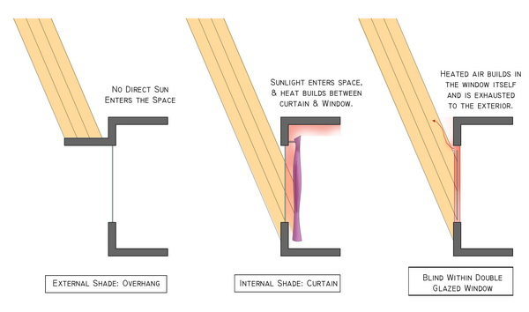
Figure 1. External, internal, and mid-pane shading devices
Source: https://www.tboake.com/carbon-aia/strategies1b.html

The primary external shading typologies documented in the literature applicable to commercial buildings include horizontal overhangs and brise-soleils, most effective for high-altitude solar radiation on northerly and southerly facades in tropical latitudes; vertical fins, most effective for low-altitude east and west solar radiation; egg-crate systems (combinations of horizontal and vertical elements), effective across a broader range of solar angles; louvres (fixed or adjustable horizontal or angled slats), which provide calibrated interception over a specific altitude range; and screen systems (perforated or lattice panels), which provide fine-grained, distributed solar interception while admitting diffuse skylight through apertures (Garba, 2023; Ochedi & Taki, 2019). Each typology follows a distinct geometric logic: the effectiveness of a horizontal overhang is determined by the ratio of its projection to the window head height (the overhang projection factor), which must be calibrated to the solar altitude angles at the specific latitude and orientation of the shaded facade.
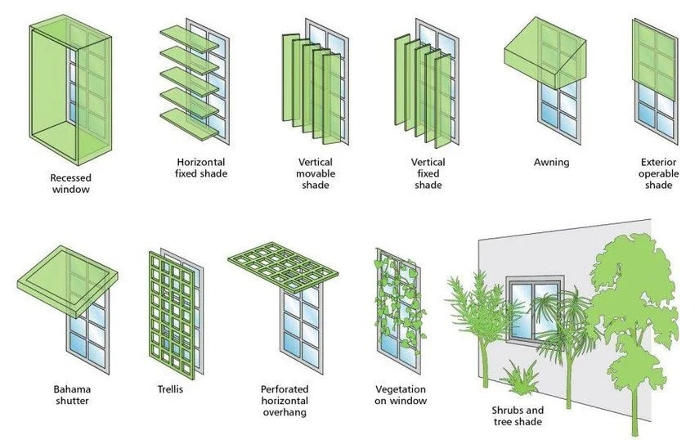
Figure 2. External shading strategies
Source: https://www.researchgate.net/figure/Types-of-external-shading-devices-20_fig2_357050721

Garba (2023) conducted the most directly relevant Nigerian study, evaluating six shading device types for daylighting performance in a prototype single-banked building in Zaria, Nigeria, a temperate dry climate with solar characteristics that differ from Port Harcourt's humid tropics but at a similar latitude (11°N). Using OpenStudio simulation with daylight autonomy (DA) as the performance metric, the study discovered that horizontal overhangs and egg-crate devices provided the best balance of daylighting and shading on north- and south-facing facades, while vertical fins performed best on eastern and western exposures. The study found statistically significant differences in DA values and percentage reduction under shading across device types (F(5, 18) = 217.64, p < .000), indicating that choosing a shading device type is a quantitative engineering decision rather than an aesthetic one.
The performance of shading devices is also environment-dependent. Iwuanyanwu et al. (2022) observed that passive design tactics such as shading work differently across Nigeria's many climate zones and that strategies designed for the temperate dry environment of the north may be unsuitable for the humid tropics of the south. Kalu et al. (2025) confirm this, stating in their systematic review that climate-specificity is a necessity for the efficient use of passive design solutions in Nigerian structures. Port Harcourt's tropical humid climate, which is distinguished by high ambient humidity, near-vertical solar angles at the equinoxes, and consistently high solar radiation throughout the year, necessitates shading geometries calibrated specifically to these conditions rather than those derived from temperate-climate design guides.
The Conflict Between Daylighting and Solar Heat Gain in Tropical Climates
The struggle between natural light and solar heat uptake is a common issue in research on daylighting design for hot areas. Boubekri et al. (2020), in a study of office workers' cognitive performance in daylit environments, note that despite strong evidence for the benefits of daylighting, including improved sleep duration, enhanced alertness, and measurable gains in cognitive task performance, most commercial buildings built in the last two decades continue to underutilise daylighting solutions, partly because designers and developers have not systematically addressed the thermal implications. This underutilisation is especially noticeable in sub-Saharan African commercial buildings, where the thermal challenge of daylighting is greatest and professional resources to handle it are scarce (Kalu et al., 2025; Ochedi & Taki, 2019).
The literature clearly states that this problem is technically resolvable through external shading. The fundamental physical basis is the spectral separation of solar radiation: the visible spectrum (400-700nm wavelength), which is daylight, accounts for approximately 45% of total solar irradiance; the near-infrared spectrum (700-2500nm), which is the primary heat component, accounts for approximately 50%; and ultraviolet radiation accounts for approximately 5% (Reinhart & Weissman, 2012). Opaque shading elements, whether horizontal or vertical, exclude all wavelengths of direct beam radiation in equal measure, lowering heat and light in proportion to the shading factor. Perforated or translucent shading elements, on the other hand, can be designed to block the direct beam (all wavelengths) while allowing diffuse sky radiation to pass through the perforations or translucent material after being scattered by atmospheric particles and shifted spectrally toward the visible range. This is how the BMCE Bank's perforated mashrabiya screens achieve both sun control and daylighting performance.
Stevanovic and Stevanovic (2018) show, using mathematical optimisation, that the geometry of external shading devices has a significant impact on both the cooling load and daylighting performance of the spaces they serve and that curvilinear geometries calibrated to the annual solar path can outperform rectilinear alternatives, a finding that supports the geometric sophistication of both international case study shading systems. According to Ochedi and Taki (2019), properly designed overhangs can reduce solar heat gain through glazed openings by 30-70% in Nigerian commercial buildings. They also recommend external shading as the single most effective passive intervention for commercial building envelopes in hot Nigerian climates.

Shading in Banking and Commercial Architecture: International Evidence
Despite the rich literature on shading devices in residential and office buildings, there are few studies exclusively focused on commercial banking design. Bakr and Fikry (2019) conducted the most directly applicable published study, offering a parametric analysis of shading device types for banking halls in hot, arid Cairo. Their findings show that the banking typology, with its large, open-plan customer halls, continuous daytime occupancy, and high demands for both visual comfort and security, benefits particularly from external louvre and screen systems that provide shading while avoiding the visual and physical opacity of solid overhangs or opaque facades. The study proposes an overhang projection factor of 0.4-0.6 for horizontal shading on north-facing building facades in hot climes, with external shading combined with high-performance low-e glazing being the best integrated method.
The use of traditional Islamic architectural shading typologies, particularly the mashrabiya lattice screen, in contemporary commercial banking buildings has been documented and analysed in a number of Middle Eastern and North African projects (Foster + Partners, 2011; Bakr & Fikry, 2019). The mashrabiya is especially relevant in the commercial banking context because it addresses shading, privacy, and security all in one architectural element: its fine-grained lattice structure prevents direct visual access from the exterior while admitting diffuse daylight, thereby resolving the two most frequently cited objections to fenestration in Port Harcourt bank buildings (heat gain and security vulnerability). The BMCE Bank project is the most completely documented current use of this approach in a banking building context.
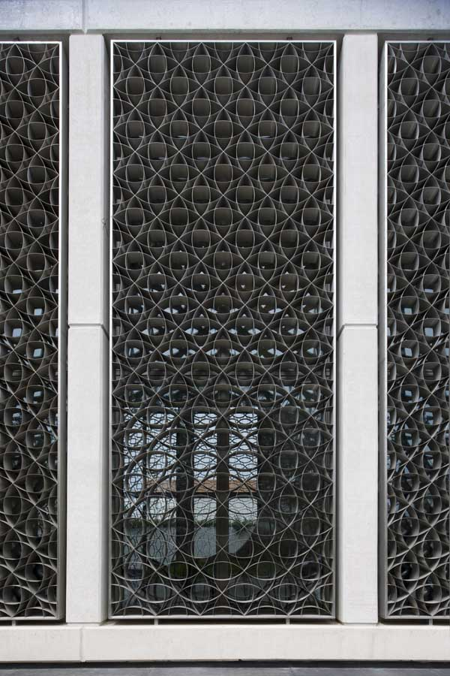
Figure 3. Mashrabiya
Source: https://www.e-architect.com/images/jpgs/morocco/bmce_morocco_f250311_ny3.jpg

METHODS OF DATA COLLECTION
Three complementary methods of data collection were employed, consistent with the qualitative multiple case study research design adopted for this study (Yin, 2018):
Direct and Participant Observation
Two regional bank buildings in Port Harcourt were visited and systematically examined utilising a shading-focused observation protocol: Parallex Bank on Trans-Amadi Road and Providus Bank on Olu Obasanjo Road. The procedure documented the presence, kind, position, geometry, material, and apparent effectiveness of shading devices on all accessible elevations, as well as the correlation between observed shade provision and the quality of natural light in accessible interior spaces. Participant observation, which involved engaging with the banking hall as a client, offered experiential data on the quality of the interior illumination environment that supplemented external observations. Field notes and dimensional estimates were taken during each site visit.
Structured Key-Informant Interview
Structured face-to-face interviews were conducted with senior facility management personnel at four Port Harcourt bank branches: the Facility Manager of Access Bank Plc (Olu Obasanjo Road), the Property Manager of Zenith Bank Plc (GRA Junction), the Admin Officer of Alpha-Morgan Bank (Olu Obasanjo Road), and the Facility Manager of Providus Bank. The interviews included fifteen standardised questions. Of the fifteen interview questions, two are directly related to shading: Question 7 (measures made to allow natural light) and Question 8 (the conflict between natural light and air conditioning and how it is managed). The interview evidence base for this study consists of responses to these questions, as well as additional comments on energy expenses, lighting management, and climate-responsive design knowledge.
Secondary Case Study Analysis
Two internationally recognised commercial banking buildings were examined for their shading design approach and performance using published secondary documentation: the BMCE Bank Branches in Casablanca, Morocco (Foster + Partners, 2011) and the Lombard Odier 1Roof Headquarters in Bellevue, Geneva, Switzerland (Herzog & de Meuron, 2025). Sources studied include official project material from both design companies, architectural media articles (ArchDaily, Dezeen, Wallpaper*, METALOCUS), and client institution publications (Lombard Odier, 2025). Both buildings were chosen for their documented use of purpose-designed external shading as a main daylighting management approach, serving as exemplars against which Port Harcourt's building stock is measured.
METHODS OF DATA ANALYSIS
A qualitative descriptive and comparative analysis methodology was used. Each case study building's shading characteristics were documented using a five-parameter analytical framework: (i) shading device type (external/internal, fixed/adjustable, opaque/perforated); (ii) shading geometry (depth, angle, overhang projection factor, perforation density); (iii) elevations addressed and solar exposures controlled; (iv) integration with the glazing and fenestration system; and (v) documented or observed effect on interior daylighting quality. Interview data were thematically examined, with responses to shading-related questions extracted and compared across all four respondents to uncover similar patterns of shading practice and managerial attitude. The five-parameter framework was employed in a comparative examination of all four case study buildings to discover different approaches, assess relative efficacy, and extract design principles applicable to Port Harcourt.

SAMPLE SIZE AND SAMPLE SELECTION CRITERIA
Purposive sampling was used to select four case study buildings based on typological relevance (all are commercial bank buildings); geographic range (two local Port Harcourt buildings providing primary observational data; two internationally recognised buildings providing secondary comparative data); representativeness of contrasting shading conditions across a spectrum from no shading (Parallex Bank) to inadequate internal shading (Providus Bank) to exemplary calibrated external shading (BMCE Bank; Lombard Odier 1Roof); and the availability of sufficient documentary evidence for meaningful analysis (for secondary cases). Four interviewees were chosen specifically for their seniority and direct operational expertise of building energy and lighting systems. The sample size is suitable and consistent with the qualitative multiple case study technique used, which prioritises analytical depth and transferability of findings over statistical representativeness (Yin, 2018; Groat & Wang, 2013).
DEDUCTIONS
The combined interview and observational data yield three principal deductions prior to the detailed case study findings:
First, the shading strategy of regional bank buildings in Port Harcourt does not include any external shading devices. None of the four interview respondents highlighted external shading devices as a design component of their building or as a method for controlling the conflict between heat and daylighting. Table 1 summarises the responses to Questions 7 (measures to admit natural light) and 8 (management of the heat-light conflict), and the pattern is clear: the options available to Port Harcourt bank buildings are limited to interior blinds (Access Bank, Providus Bank), minimal fenestration (Zenith Bank, Alpha-Morgan Bank), or tinted glass (Parallex Bank), all internal or material-level responses to a problem that is most effectively addressed.
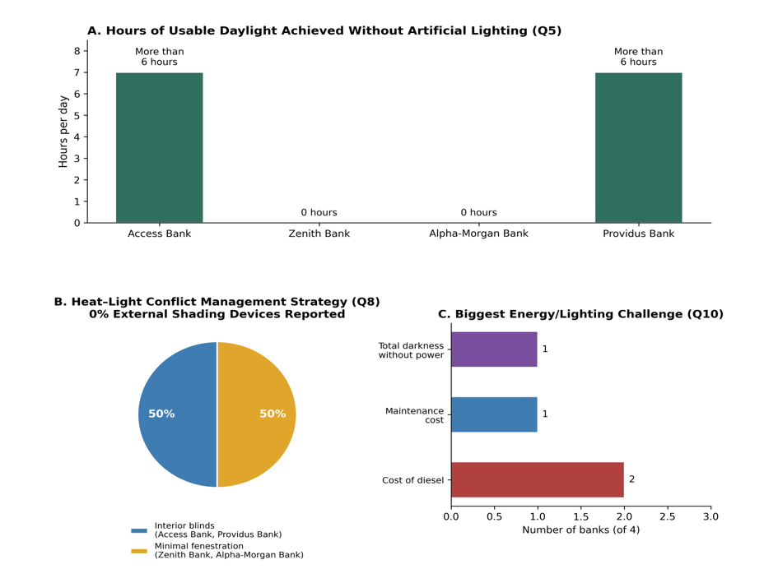
Figure 3. Interview response charts for shading-related questions
Source: Author’s field interview
Second, the interview data show that the conflict between solar heat gain and thermal comfort, which is the primary driver of the all-day artificial lighting pattern, is being resolved through operational means (interior blinds) or design defaults (opaque facades), rather than architectural design means (external shading). This is supported by the responses to Question 8, in which every responder who identifies a heat-light conflict resolves it using interior shades or minimum fenestration rather than any sort of external solar control. This pattern is consistent with the broader result of Ochedi and Taki (2019) and Kalu et al. (2025), which found that passive design methods, such as shading, are consistently underutilised in Nigerian commercial buildings.
Third, the heat-daylighting issue is clearly a design flaw rather than a climatic need. According to interview data from Access Bank and Providus Bank, banking halls in these buildings can operate for more than six hours per day without artificial light (Question 5), which directly contradicts the all-day artificial lighting practice indicated in Question 4. This disparity between potential and practice reveals that the resource is present; what is missing is a design strategy for admitting it without incurring thermal penalties. External shading is the strategy.
FINDINGS OF THE STUDY
Finding 1 — Parallex Bank, Trans-Amadi Road, Port Harcourt
The external view of Parallex Bank's south-east-facing major facade (26 meters in span) exposes a minimalist, smooth surface interrupted only by a small strip of fixed, dark blue-colored glass. There are no external shading mechanisms on any of the building's elevations, including overhangs, fins, louvres, screens, or canopies. The dark blue colouring of the glass symbolises the building's only solar control measure: a material-level response that reduces the Visible Light Transmittance (VLT) of the glazed aperture by an estimated 20-35%, attenuating both the solar heat and the daylighting value of the opening. This approach to solar control, using absorptive or reflective glazing tint as a substitute for shading, is identified in the literature as among the least effective strategies for tropical commercial buildings because it proportionally reduces daylight transmission in exactly the same degree as heat, providing no spectral selectivity (Reinhart & Weissman, 2012; Bakr & Fikry, 2019).
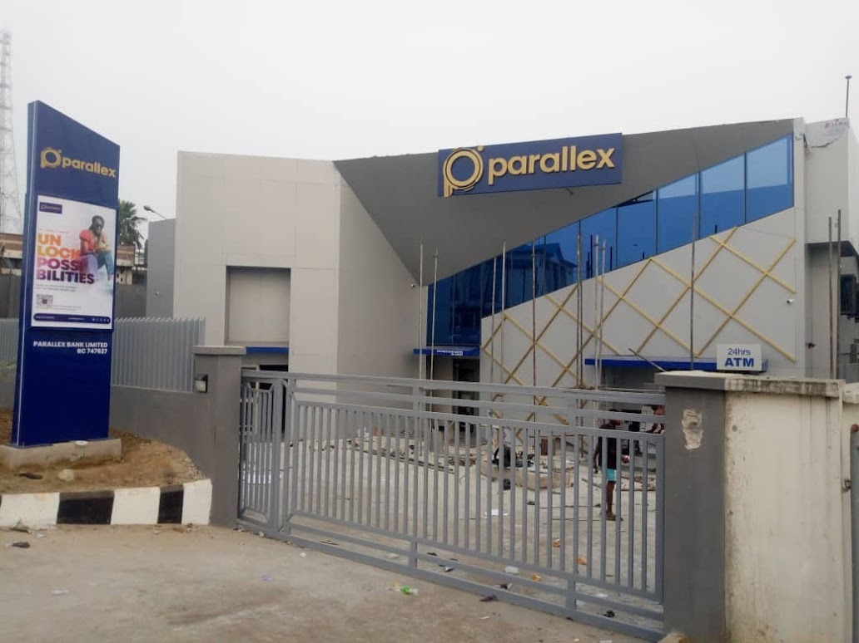
Figure 4. Parallex bank front elevation
Source: https://www.dormaisignsltd.com/
During a participant observation visit, a front desk staff member confirmed that the building's interior is fully dependent on artificial lighting and that any failure or insufficiency of the grid, generator, or solar energy systems would render the banking hall visually inoperable. This indicates the absence of any useful natural light in the main banking area. The building's first-floor east and west elevations include openable windows with no external shading, exposing these openings to unmoderated morning (east) and afternoon (west) solar radiation at low angles that are difficult to control with horizontal elements, confirming that the building's limited fenestration is not accompanied by any consideration of shading device typology appropriate to the relevant solar exposures.
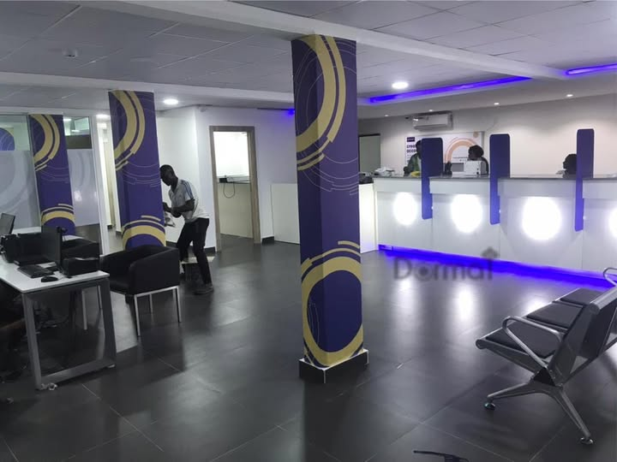
Figure 5. Parallex bank interior space
Source: https://web.facebook.com/DormaiSigns/posts/dormai-parallex-portharcourt-interiorbranding/957203836407562/?_rdc=1&_rdr#

Finding 2 — Providus Bank, Olu Obasanjo Road, Port Harcourt
Providus Bank has the only distinct exterior shading element shown in either local case study: a row of closely spaced vertical, angled fins fitted along the balcony opening of the open stairwell on the north-east elevation. These fins, as parallel blades pointed toward the morning sun to intercept the east solar arc, are a typologically proper response to the particular solar exposure they address. Vertical fins are a suitable shading mechanism for east and west facades in Nigerian climates, according to Garba (2023), since they intercept low-angle solar radiation that is below the effective range of horizontal overhangs. The fins' close spacing decreases the solid angle of sky seen through the stairwell opening, decreasing both direct sun penetration and the resulting glare.
However, the area of this shading option is extremely limited: the fins only cover the stairwell side elevation. The principal banking hall facade, which faces north-west and spans 20.5 metres, features a long fixed-light curtain wall and glazed entrance panels. It is completely unshaded. The north-west orientation exposes this facade to direct solar radiation from approximately midday to sunset, at altitude angles that range from moderate to low through the afternoon, requiring a combination of horizontal overhangs (for the mid-altitude afternoon sun) and vertical fins (for the low-angle late-afternoon sun), neither of which is present. The result is exactly as documented by Bakr and Fikry (2019) for unshaded banking facades in hot climates: the facility manager confirmed that the stairwell curtain wall generates direct solar heat gain, which is managed by a translucent interior window blind that also cancels the daylighting potential of the building's most generously glazed surface. Providus Bank demonstrates that fenestration without external shade is not a partial daylighting solution but rather a problem that manifests itself in the shape of the internal blind that it requires.
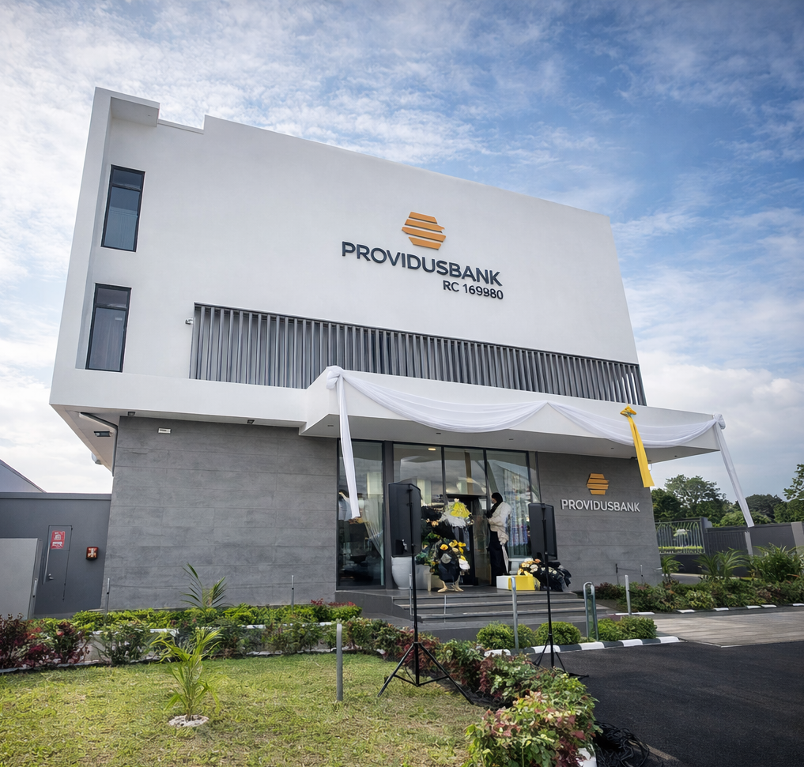
Figure 6. Providus Bank front elevation
Source: https://web.facebook.com/Davshotz/videos/so-i-was-contacted-to-document-providus-bank-port-harcourt-branch-opening-enjoy-/762953472472968/?_rdc=1&_rdr#

Finding 3 — BMCE Bank Branches, Casablanca, Morocco (Foster + Partners, 2011)
The BMCE Bank branches in Casablanca are the study's major international example of climate-calibrated external shade for daylighting management. The primary shading device is a continuous external screen system of 200mm deep perforated panels fabricated from low-iron stainless steel alloy, a material chosen by the design team specifically because it does not heat up under direct North African solar radiation, remaining cool to the touch and thus not re-radiating absorbed thermal energy as secondary heat into the interior environment (Foster + Partners, 2011). This material choice addresses a common failure mode in external shading design: the use of dark or high-thermal-mass materials that absorb incident solar radiation and then re-radiate a significant portion of it as longwave (infrared) thermal energy into the adjacent air and glass, reducing the shading's net thermal benefit.
The screens' 200mm depth is tuned to match the solar geometry of Morocco's Atlantic coast cities. At Casablanca's latitude (about 33.5°N), the solar altitude angle at solar noon varies from 33° in winter to 80° in summer. A 200mm-deep panel flush with the glazing line provides an effective horizontal shade projection relative to the panel-to-glass depth, intercepting high-altitude summer sunlight but admitting lower-angle winter skylight through the perforations. The screens are perforated panels rather than solid overhangs; their geometric aperture pattern is calibrated in density and scale to the specific solar angles of each branch location, ensuring that the direct solar beam is intercepted across the critical altitude range while diffuse skylight, arriving from the full sky dome rather than the sun's disc alone, passes through the perforations into the banking hall interior. The result is the signature quality of the BMCE interiors documented in published descriptions: dynamic, dappled light patterns that shift with the sun's position, animating the banking hall with a quality of natural illumination that is architecturally expressive, visually comfortable, and thermally manageable simultaneously.
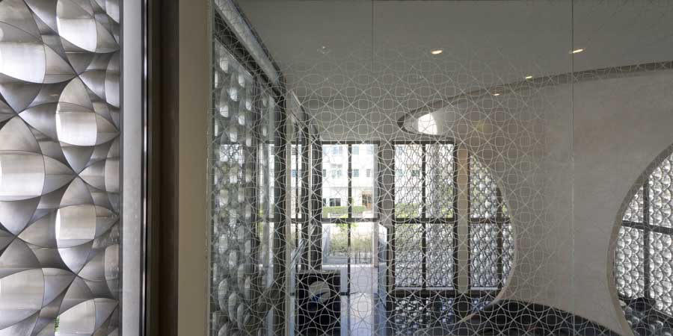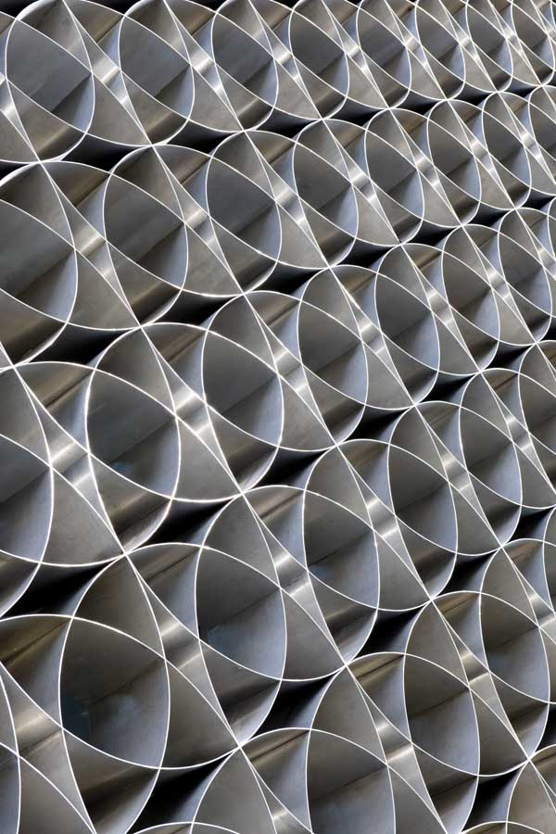
Figure 7. BCME Mashrabiya screen panel strategy
Source: https://www.e-architect.com/images/jpgs/morocco/bmce_morocco_f250311_ny3.jpg

The BMCE design's secondary shading element, the entrance colonnade, serves as a complementary daylighting control function by creating a transitional luminous zone between the intense exterior (potentially exceeding 50,000 lux in direct Moroccan sun) and the controlled interior illuminance (targeting 300-500 lux for the banking hall). This transitional shading is especially important given the human visual system's adaptation bandwidth, which can take several minutes to fully adapt between extreme luminance conditions, during which contrast glare, or the experience of intense bright areas against a dark background, impairs visual performance. The colonnade provides an intermediate luminance level (estimated 5,000-10,000 lux) at which this adaptation can occur without discomfort. This shading strategy has direct applicability to banking environments in Port Harcourt, where the transition from direct tropical sun to an artificially lit interior occurs abruptly at the building threshold.
Finding 4 — Lombard Odier 1Roof Headquarters, Bellevue, Geneva, Switzerland (Herzog & de Meuron, 2025)
The Lombard Odier 1Roof Headquarters uses a shading strategy that is fundamentally different in scale and typology than the BMCE screens but achieves the same essential goal: control of direct solar radiation at the building envelope while allowing diffuse daylight to pass through a fully glazed facade. The principal shading technique is the system of cantilevered, curved concrete floor slab extensions that project beyond the facade line at each of the building's eight floors, providing continuous horizontal overhangs of significant depth around the whole building perimeter. These structural cantilevers provide as both usable outdoor terrace space and climate-calibrated horizontal brise-soleils, the most popular and architecturally integrated external shade typology in the literature (Bakr & Fikry, 2019; Garba, 2023).
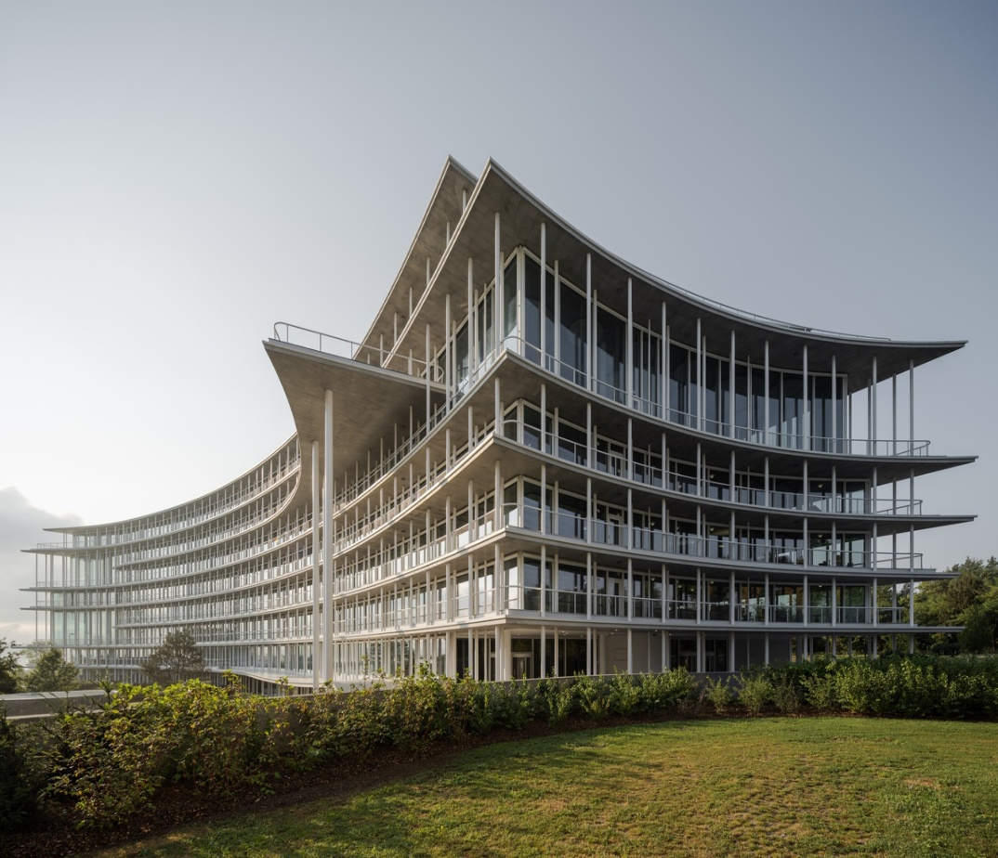
Figure 7. BCME Mashrabiya screen panel strategy
Source: https://www.archdaily.com/1034364/lombard-odier-new-headquarters-herzog-and-de-meuron/68d1cdc767a7a410dde6d1f7-lombard-odier-new-headquarters-herzog-and-de-meuron-image?next_project=no

The depth and geometry of the cantilevers are calibrated to the sun altitude at Geneva latitude (46.2°N). At this latitude, the summer solstice solar altitude at noon is around 67°, high enough to be intercepted by the cantilever overhang extended from the floor plate above. The winter solstice midday altitude of around 20° is below the effective shading angle of the cantilever, allowing solar radiation to flow beneath the overhang and penetrate deep into the glazed facade and interior during the cold months, when solar gain is advantageous. This seasonal differentiation, being the summer shading and winter solar admission through the same structural element, is a sophisticated passive thermal performance that can only be achieved with an external horizontal shading device of the correct geometry for the specific latitude, and is completely impossible with any type of internal shading (Stevanovic and Stevanovic, 2018; Reinhart and Weissman, 2012).
Jacques Herzog expresses the shading objective clearly: "Deep cantilevers protect windows from excessive direct sunlight, reducing cooling requirements" (Lombard Odier, 2025). The combination of cantilever shading and Minergie-P-standard high-performance glazing, which achieves very low Solar Heat Gain Coefficients while maintaining high Visible Light Transmittance, makes the fully glazed four-facade envelope thermally viable, allowing a floor-to-ceiling transparent enclosure on all sides without reliance on interior blinds. According to Wallpaper* (2025), the interior is "flooded with natural daylight" throughout all eight stories. The central atrium and surrounding facades provide multilateral daylighting to the full 60,000 m² floor area. For a building of this size, this is an outstanding daylighting achievement, one that is structurally and architecturally inseparable from the shading technique that enables it.

Table 2: Comparative Shading Analysis — Four Case Study Buildings
Parameter | Parallex Bank (Trans-Amadi, PH) | Providus Bank (Olu Obasanjo, PH) | BMCE Bank (Casablanca, Morocco) | Lombard Odier 1Roof (Geneva, Switzerland)
External shading type | None | Vertical fins on stairwell balcony (north-east only) | 200mm perforated stainless steel mashrabiya screens (all bays, all elevations) | Cantilevered concrete floor slabs at each of the 8 levels, full perimeter
Internal shading | None observed | Translucent blind on curtain wall | None required | None required
Solar control mechanism | Tinted glass (absorptive) — reduces VLT and SHGC equally | Interior blind (post-penetration) — heat already inside envelope | Pre-penetration: screen blocks direct beam, perforations admit diffuse sky | Pre-penetration: cantilever blocks high-altitude summer beam; low-altitude winter sun admitted
Daylighting outcome | None — total artificial dependence | Potential negated by blinds despite >6hrs daylight available | Diffuse dappled daylight throughout the hall; no artificial supplementation during daylight | All floors ‘flooded with natural daylight’; atrium and facades provide multilateral daylighting
Thermal outcome | Controlled by the opacity of the facade | Heat gain unresolved; blinds treat the symptom, not the cause | Heat gain is controlled at the envelope; earth tube supplements passive cooling | Controlled by cantilever depth and Minergie-P glazing, the GeniLac system supplements
Latitude-calibrated geometry | Not applicable (no shading) | Not applicable (fins address stairwell only) | Screen depth and perforation calibrated to ~33°N solar angles per branch | Cantilever depth calibrated to ~46°N: shades summer sun, admits winter sun
Material rationale | Blue-tinted glass only | No documented material rationale for fins | Low-iron stainless steel: cool to the touch, no secondary heat radiation | Concrete: structural integration, thermal mass, permanent durability

CONCLUSION
This study demonstrates that external shading devices are an important missing design element in the daylighting strategy of regional bank buildings in Port Harcourt, Rivers State. The lack of purpose-designed external shade has created a building type marked by a false choice, heat or darkness, that is perpetuated through inside blinds and opaque facades rather than resolved by climate-responsive envelope design. The economic and environmental repercussions of this failure are measurable: banks in Port Harcourt spend between N2,170,000 and N2,500,000 per month on diesel fuel for generators that power artificial lighting in places that can get more than six hours of natural light per working day.
The two worldwide case studies show, in differing climatic and architectural contexts, that this issue is the result of architectural design failure rather than environmental inevitability. The BMCE Bank's 200mm perforated stainless steel mashrabiya screens are calibrated to the solar geometry of North Africa's Atlantic coast cities, achieving the simultaneous exclusion of direct solar beam radiation and transmission of diffuse daylight through a single external architectural element of cultural resonance and technical precision. The Lombard Odier 1Roof's cantilevered concrete floor slabs, calibrated to Geneva's temperate latitude, provide structural-scale perimeter shading, making a fully glazed eight-story banking headquarters thermally viable without interior blinds. Published accounts describe natural daylight flooding all floors of a 60,000 m² building.
The principles underlying both solutions are transferable to Port Harcourt with climatic recalibration: external interception of direct solar radiation before glass penetration, geometric calibration to local solar altitude angles, maintenance of diffuse skylight transmission, and integration of shading design with building structure and architectural concept from the initial design stage. These ideas are backed by the larger Nigerian literature on passive design (Ochedi & Taki, 2019; Garba, 2023; Kalu et al., 2025) and the building science literature on shading device performance (Bakr & Fikry, 2019; Stevanovic & Stevanovic, 2018; Reinhart & Weissman, 2012). Their implementation in Port Harcourt's regional banking sector is an effective, evidence-based design solution with measurable energy conservation potential, directly connected with the imperatives of SDG Goal 13 on Climate Action.

RECOMMENDATIONS
- Prioritise exterior shade over interior shading in all new and refurbished bank buildings in Port Harcourt. Interior window blinds, the existing de facto shading standard, should be replaced as the major sun control tool with purpose-built external shading devices. External shade stops heat gain at the source before solar radiation penetrates the glass, whereas interior blinds allow heat to enter but cannot evacuate it. The energy cost of maintaining air conditioning against heat gain that has already entered the building much outweighs the expense of preventing its entry via external shading (Bakr & Fikry, 2019; Ochedi & Taki, 2019).
- Calculate shading geometry unique to Port Harcourt's sun angles. At 4.84°N, the solar altitude at equinoctial noon exceeds 85°. To provide efficient shading at near-vertical solar altitudes, horizontal overhangs on north and south-facing facades should have an overhang projection factor of at least 0.4-0.6 (overhang depth ÷ window head height). East and west-facing facades require vertical fins or angled louvre systems calibrated to block solar radiation at altitudes below 45° (the range of the morning and afternoon sun at this latitude), according to the guidance of Garba (2023), adapted from temperate dry to tropical humid circumstances.
- Create perforated screen systems as the ideal shading method for bank facades. Following in the footsteps of the BMCE Bank mashrabiya screens, perforated or lattice-type external screens provide the most architecturally complex method of shading for Port Harcourt's banking industry. By fragmenting direct solar radiation into diffuse light patterns rather than simply eliminating it, screens provide an interior daylighting quality, dappled, dynamic, and spatially rich, that is superior to that achievable with solid overhangs. Screens also provide some visual privacy and security without reducing light transmission, thus addressing the security concern most typically claimed by Port Harcourt bank managers as a reason for opaque façades. Powder-coated aluminium, stainless steel, or fibre-reinforced polymer composites are suitable materials for durability in Port Harcourt's humid, salty coastal environment.
- Integrate structural shading (cantilevers, deep overhangs) into the building shape from the start of the design process. The most effective shading systems, the BMCE screens and the Lombard Odier cantilevers, are not aftermarket additions, but rather integral components of the building's structural and architectural design. Shading design should be determined during the schematic design phase, with decisions on orientation, massing, and fenestration, to ensure geometric compatibility, structural economy, and climatic efficacy. The advice is compatible with Kalu et al.'s (2025) approach to passive design solutions in Nigerian commercial structures.
- Combine exterior shading with high-performance glazing to maximise thermal and daylighting benefits. External shading minimises direct sun beam penetration but does not eliminate the amount of diffuse sky radiation that passes through unshaded sections of the opening. High-performance glass with low SHGC (0.25 or lower) and high VLT (50% or above) should be selected for all glazed surfaces to reduce residual thermal gain while preserving daylighting performance. External shading and high-performance glass, as established by both international case studies, are the technically comprehensive response to the heat-daylighting problem and should be the design standard for commercial bank buildings in Port Harcourt.
- Examine Nigerian vernacular shade typologies as culturally relevant design predecessors. Nigeria's built legacy includes a variety of climate-responsive shading methods, such as deep verandas, compound courtyard overhangs, louvred screen walls, and ornate screen blocks, whose underlying geometric and material logic is immediately suited to the Port Harcourt climate. The reinterpretation of these vernacular strategies in contemporary banking architecture, as Foster + Partners did with the Islamic mashrabiya for the BMCE Bank, paves the way for daylighting-responsive design that is technically effective, economically viable, and culturally grounded in Nigerian architectural identity. Rivers State University's Department of Architecture is well-positioned to lead research in this domain, drawing on the recorded regional climate and building tradition.

REFERENCES
Adeyemi, R. A., Okonkwo, C. N., & Eze, G. O. (2018). Diurnal weather patterns in Nigeria: A climate domain analysis. Atmospheric and Climate Sciences, 8(3), 341–356. https://doi.org/10.4236/acs.2018.83023
Bakr, N., & Fikry, A. (2019). Improving daylighting performance in commercial banks: Parametric study of shading devices in hot arid climate. Energy and Buildings, 197, 128–143. https://doi.org/10.1016/j.enbuild.2019.05.035
Boubekri, M., Lee, J., MacNaughton, P., Woo, M., Schuyler, L., Tinianov, B., & Satish, U. (2020). The impact of optimized daylight and views on the sleep duration and cognitive performance of office workers. International Journal of Environmental Research and Public Health, 17(9), 3219. https://doi.org/10.3390/ijerph17093219
Foster + Partners. (2011). BMCE branches: Project documentation. Foster + Partners. Retrieved from https://www.fosterandpartners.com/projects/bmce-branches/
Garba, A. I. (2023). Evaluating the impact of different shading devices on daylighting and visual comfort in Nigeria’s temperate dry climate. FUTY Journal of the Environment, 17(2), 19–26. https://www.ajol.info/index.php/fje/article/view/292830
Groat, L. N., & Wang, D. (2013). Architectural research methods (2nd ed.). Wiley.
Herzog & de Meuron. (2025). Lombard Odier new headquarters. Herzog & de Meuron. Retrieved from https://www.herzogdemeuron.com/projects/480-lombard-odier-new-headquarters/
IIARDJOURNALS. (2025). Enhancing daylighting using passive daylighting strategies in a proposed design of regional shopping mall, Port Harcourt, Rivers State. International Journal of Engineering and Modern Technology. Retrieved from https://www.iiardjournals.org/abstract.php?j=IJEMT&id=62311
Iwuanyanwu, O., Okwandu, A. C., & Ike, C. S. (2022). The role of passive design strategies in enhancing energy efficiency in green buildings. Engineering Science & Technology Journal, 3(2). https://doi.org/10.51594/estj.v3i2.1519
Kalu, G., Ogunnaike, A. O., & Eze, W. O. (2025). Integrating biophilic and passive design strategies in Nigerian architecture: A systematic review of current practices and impacts. African Journal of Environmental Sciences and Renewable Energy. https://afropolitanjournals.com/index.php/ajesre/article/view/913
Lombard Odier. (2025). 1Roof: Our headquarters. Lombard Odier Group. Retrieved from https://www.lombardodier.com/home/about-us/our-headquarters.html
Ochedi, E. T., & Taki, A. (2019). A framework for developing energy efficient residential buildings in Nigeria. Energy and Built Environment, 1(3), 241–253. https://doi.org/10.1016/j.enbenv.2019.11.001
Reinhart, C. F., & Weissman, D. A. (2012). The daylit area — Correlating architectural student assessments with current and emerging daylight availability metrics. Building and Environment, 50, 155–164. https://doi.org/10.1016/j.buildenv.2011.10.024
Stevanovic, S., & Stevanovic, D. (2018). Optimisation of curvilinear external shading of windows in cellular offices. PLOS ONE, 13(9), e0203575. https://doi.org/10.1371/journal.pone.0203575
Uko, E. D., & Tamunobereton-ari, I. (2013). Variability of climatic parameters in Port Harcourt, Nigeria. Journal of Emerging Trends in Engineering and Applied Sciences, 4(5), 727–730.
Victor, A. C., & Daminabo, F. F. O. (2025). Exploring the potential of floating structures in enhancing flood resilient design. International Journal of Engineering and Modern Technology, 11(9), 298–308. https://doi.org/10.56201/ijemt.vol.11.no9.2025.pg298.308
Wallpaper*. (2025, September 5). We tour Herzog & de Meuron’s ‘One Roof’ for Lombard Odier. Wallpaper* Magazine. Retrieved from https://www.wallpaper.com/architecture/herzog-de-meuron-one-roof-lombard-odier-switzerland
Yin, R. K. (2018). Case study research and applications: Design and methods (6th ed.). SAGE Publications.

