A Multi-Criteria Spatial Analysis Of Habitat Quality And Threat Dynamics In The Mangrove Ecosystems Of Puttalam Lagoon
Wijesinghe W M U S¹, Jayakody J A S²
¹² Department of Remote Sensing and GIS, Faculty of Geomatics, Sabaragamuwa University of Sri Lanka
ABSTRACT

Puttalam Lagoon, a significant coastal ecosystem in Sri Lanka, faces multiple threats destroying its biodiversity and the crucial ecosystem services it provides to local communities. This research focuses on identifying critical Key Biodiversity Areas (KBAs) within Puttalam Lagoon, considering both threats and ecosystem services. Through a comprehensive literature review and Geographic Information System (GIS) analysis, this study examines the interplay between biodiversity, threats, and habitat quality to prioritize conservation efforts effectively. The research reveals that Puttalam Lagoon's rich biodiversity is crucial for supporting local livelihoods and maintaining ecosystem health. However, anthropogenic pressures such as pollution from agricultural runoff, sewage, and industrial waste, coupled with climate change impacts, pose significant risks to the lagoon's biodiversity and ecosystem services.
By employing methodologies like the InVEST model and the Analytic Hierarchy Process (AHP), this study identifies areas within Puttalam Lagoon that require immediate conservation attention. Regions such as Manalthivu, Mudalappaliya, Musalpitiya, Kurinjipitiya, Wannimundalama, Anawasala, and Deuch Bay are highlighted as particularly vulnerable to threats, emphasizing the need for targeted conservation interventions. Conversely, areas with higher habitat quality, offer opportunities for proactive conservation measures to safeguard their ecological integrity and maximize ecosystem service provision. The findings show that Manalthivu, Musalpitiya, Kurinjipitiya, Wannimundalama, Anawasala, and Deuch Bay need a conservation process.
In conclusion, this research provides valuable insights into the critical KBAs of Puttalam Lagoon, offering the first steps to identify the areas that require priority to be conserved and actionable policy recommendations for local governments and conservation practitioners. By prioritizing conservation efforts in vulnerable areas and enhancing ecosystem resilience, biodiversity and ecosystem services can be protected, promoting sustainable development and the well-being of people and the planet.
Key words: Puttalam lagoon, Threat mapping, InVEST, Mangrove biodiversity, Conservation.

INTRODUCTION

Puttalam Lagoon is a valuable environmental and economic asset and a significant study area with a surface area of 327 km² which is bordered by the Puttalam District, North-Western province of Sri Lanka. The Lagoon is fed by two rivers, namely the Kala Oya and Mi Oya, and is connected to the Indian Ocean through a narrow channel (Pathirana et al., 2008). Puttalam Lagoon supports a wide range of habitats, including mangroves, seagrass beds, salt marshes, and coral reefs. It is a paradise not only for plants but also for animals. The area is rich in biodiversity - wetland birds and fish are easily observed in lagoon ecosystem (Ekanayake, 2016). It serves as an important breeding and feeding ground for several migratory bird species, including flamingos, terns, and herons (Bandara, 2019). Mangrove ecosystems of Puttalam Lagoon are proportionately the largest extent of mangrove ecosystems in Puttalam Lagoon is located in Kala oya and Mee oya estuaries as well as in the uninhabited islands (Amarasinghe and Balasubramaniam, 1992). Not only mangroves by themselves, animals in mangroves play an important role in ecological dynamics of Mangroves. Ecosystem services derived from mangrove forests, woodlands and wetlands provide immense benefit to people by supporting clean drinking water, reducing the risk of natural hazards, and maintaining the functions of infrastructure investments (Shrestha et al., 2021).
Key Biodiversity Areas are promoted by the International Union for Conservation of Nature (IUCN) to identify sites of importance for the global persistence of biodiversity (IUCN, 2016). KBAs are specific geographic locations that are the most important places in the world for species and their habitats and are critical for the conservation of global biodiversity and management by identifying priority sites for protection. Mangroves and other coastal vegetation support biodiversity conservation and enable improvements in livelihoods and human well-being (Zhou et al., 2023). In the context of Puttalam Lagoon, KBAs would likely encompass a variety of habitats, including mangrove forests, seagrass beds, coral reefs, and adjacent terrestrial ecosystems. These areas not only provide habitat for wildlife but also provide various ecosystem services such as water filtration, nutrient cycling, and shoreline stabilization. Ecosystem services are benefits to humans provided by natural ecosystems (Shrestha et al., 2021). Assessments of habitat quality and ecological risk are required as part of sustainable ecosystem management to reduce the negative effects of anthropogenic disturbances (Admasu et al., 2023).
The Puttalam Lagoon, despite its ecological significance, faces a multitude of threats that harm its biodiversity and the vital ecosystem services it provides. Increasing population and development pressures are causing significant damage to mangroves, leading to the loss of mangrove diversity. This degradation of the ecosystem not only threatens the rich biodiversity sustained by the lagoon, but also harms the livelihoods of local communities who depend on the lagoon for fishing, aquaculture, and tourism. Even though there is an urgent need to take actions to alleviate the pressure on the lagoon, these actions are hindered by the limitations like lack of expertise and resources. So the identification of critical KBAs is important for prioritizing areas for the conservation of lagoons and to local communities Biodiversity conservation has attracted more and more attention in recent decades due to its ecosystem services and the rapid and intense development in highly urbanized regions.
Main goal to solve this problem is to prepare a map for identifying mangrove biodiversity areas in Puttalam Lagoon which require immediate attention for conservation considering threats and habitat quality. Many research studies show different kind of prioritizing factors. Traditionally, the selection of priority areas for conservation is primarily based on species richness and levels of endemism (Shrestha et al., 2021).
Adding ecosystem services to this set of criteria increases popular support for protection, provides for greater biodiversity protection and attracts an average of more than four times the funds compared to the traditional approach (Goldman et al., 2008). For this study, critical KBAs in the Puttalam Lagoon were prioritized using a two-pronged approach. Firstly, GIS-based MCDM was used to identify vulnerable areas from development activities and climatic impacts. Secondly, the habitat quality module in InVEST model was used to estimate the areas providing the highest level of habitat quality as an ecosystem service considered in this study.

METHODOLOGY

Materials

For preparing maps, data such as monthly rainfall, temperature, population density, railroad and road network data were collected from relevant departments of Sri Lanka. Sentinel-2A Satellite images with 10m resolution were used to obtain Normalized Difference Vegetation Index (NDVI) and Land Use Land Cover (LULC). Sentinel-5 Level-2 processed O₃ data were used to get the air quality for the threat map while the shrimp farms distribution was obtained from research paper, published by IUCN. All these data were analyzed using the Arcmap software and calculations were done using Excel. Figure 1 shows the methodology of the research to prepare a map of critical mangrove biodiversity areas of Puttalam Lagoon considering threats and habitat quality for conservation priorities.
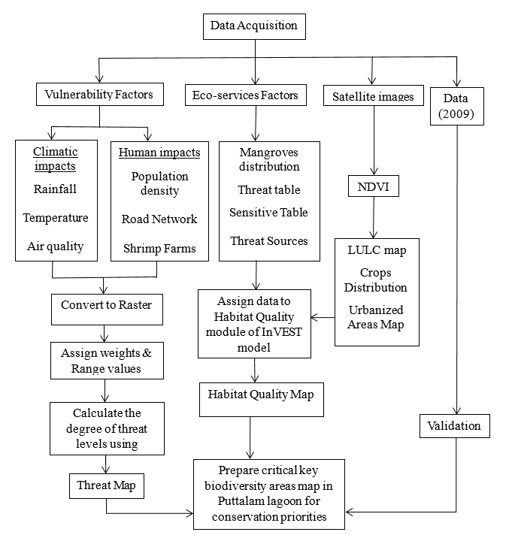
Figure 1. Methodology

Land Cover Classification

The Supervised classification method of Maximum Likelihood was chosen for classifying land cover types. The method involves several crucial steps to ensure the accuracy and reliability of the classification results. Firstly, representative areas of different land cover classes, such as water, builtup area, and vegetation types, are visually identified on the satellite imagery. A systematic sampling strategy is then employed to select random sample points within each land cover class, ensuring sufficient coverage of the study area. Using Arcmap software, training samples are delineated by digitizing polygons corresponding to each land cover class. When spectral signatures of known categories were provided, the software assigns each pixel in the image to the cover type to which its signature is most comparable. Then, signature files are created by computing. Finally, the classification results are validated using independent reference data and improve classification accuracy.

Accuracy Assessment

The overall accuracy of the classified image compares how each of the pixels is classified versus the definite land cover conditions obtained from their corresponding ground truth data. Producer’s accuracy measures errors of omission, which is a measure of how well real-world land cover types can be classified. User’s accuracy measures errors of commission, which represents the likelihood of a classified pixel matching the land cover type of its corresponding real-world location. The error matrix and kappa coefficient have become a standard means of assessment of image classification accuracy.

Threat Map

For preparing a threat map for the study area, the data were projected and transformed into CGS_WGS_1984 coordinate system and converted to raster format using the Euclidean distance tool in ArcGIS. All the input data were clipped or masked according to the study area. GIS-based MCDM is a process that combines and transforms spatial data into a resultant decision (Shrestha et al., 2021). A Weighted Overlay method was used in this study to combine various decision criteria and prepare the final threat map. It is assigned weight value by stakeholders through ArcGIS software. Reclassification of data is a preprocessing step commonly performed before applying the Weighted Overlay method in GIS analysis. It reassigns the values of raster cells in a dataset to new values based on predefined criteria and makes them into a common scale with five classes. Reclassification can help simplify data, standardize values, and prepare them for integration into a weighted overlay analysis. Mostly threatened areas will be highlighted on the map.

Habitat Quality Map

To compute habitat quality, the model incorporates information on land use and threats. The spatial extent of habitat quality within the landscape was determined by the habitat’s proximity to human-dominated land use and the intensity of disturbance caused by the LULC (Admasu et al., 2023). Habitat quality refers to the ability of the ecosystem to provide conditions appropriate for individual and population persistence. It is considered a continuous variable in the model, ranging from low to medium to high, based on resources available for survival, reproduction, and population persistence, respectively (Hall et al 1997). The model runs using raster data, where each cell in the raster is assigned an LULC class, which can be a natural class or a managed class, the model also requires data on habitat threat density and its effects on habitat quality. Current land cover map, threat raster maps, sensitivity information table, threat information table, and half saturation constant are the compulsory inputs for the module to run and produce quality map. High quality areas support higher biodiversity accordingly.

RESULTS ANALYSIS AND DISCUSSION

Threat Mapping

The AHP is an effective multi-criteria decision making tool that can be used to set a systematic approach for evaluating and integrating the impacts of different factors, which include some levels for qualitative and quantitative information (Saaty, 1990). For obtaining the weights Pair-wise Comparison Method is used. Table 1 shows the weights used for the threat map. Here, A represents land use type, B represents rainfall, C represents temperature, D represents roads, E represents population density, F represents air quality, and G represents shrimp farms.

Table 1. Normalized Matrix
 | A | B | C | D | E | F | G | SUM | Weights
A | 0.1195 | 0.1711 | 0.2459 | 0.0857 | 0.1304 | 0.1852 | 0.0958 | 1.0336 | 14.83%
B | 0.0398 | 0.0570 | 0.0273 | 0.0285 | 0.1957 | 0.1852 | 0.0684 | 0.6019 | 8.63%
C | 0.0398 | 0.1711 | 0.0820 | 0.2571 | 0.1957 | 0.1852 | 0.0684 | 0.9992 | 14.33%
D | 0.1195 | 0.1711 | 0.0273 | 0.0857 | 0.0652 | 0.1111 | 0.0958 | 0.6756 | 9.26%
E | 0.0598 | 0.0190 | 0.0273 | 0.0857 | 0.0652 | 0.1111 | 0.0958 | 0.4638 | 6.56%
F | 0.0239 | 0.0114 | 0.0164 | 0.0285 | 0.0217 | 0.0370 | 0.0958 | 0.2347 | 3.37%
G | 0.5976 | 0.3993 | 0.5737 | 0.4285 | 0.3261 | 0.1852 | 0.4795 | 2.9899 | 42.90%

Collected data which were in CSV files and shape files transformed in to the raster format and clipped so that inputs can be used in weighted overlay tool. Finally the KBA focused threat map in Figure 2 was extracted from the threat map on biodiversity of Puttalam district.
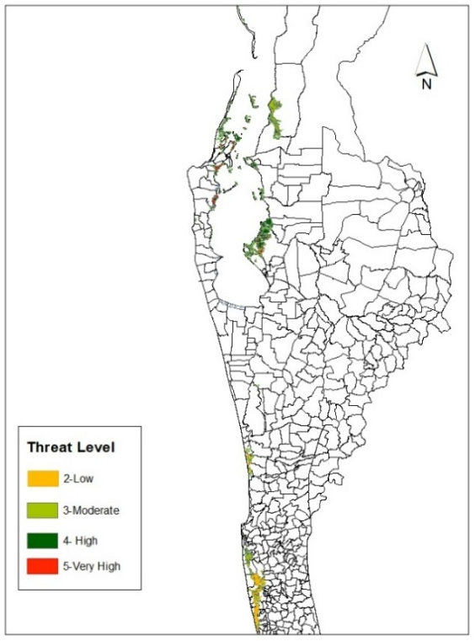
Figure 2. Key Biodiversity Area focused Threat map
Habitat Quality Mapping

The current Landuse map shown in Figure 3 and the other threat sources which are crop distribution, urban areas, shrimp farms, railroads, and roads were used as the module inputs.
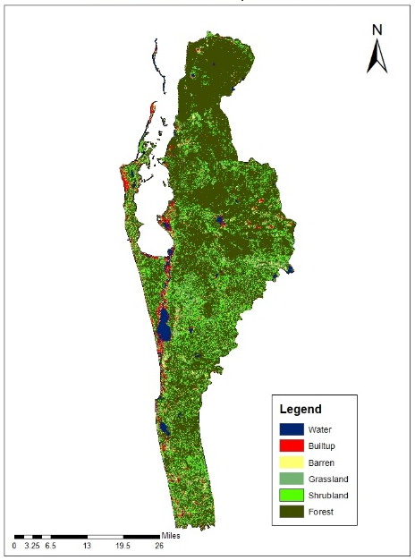
Figure 3. Current Landuse map
All the input maps must be in the format of GeoTIFF. The threat table and sensitive table were input as CSV files. Then the habitat quality map, shown in Figure 4 representing mangrove biodiversity was generated using the Habitat Quality module of the InVEST model.
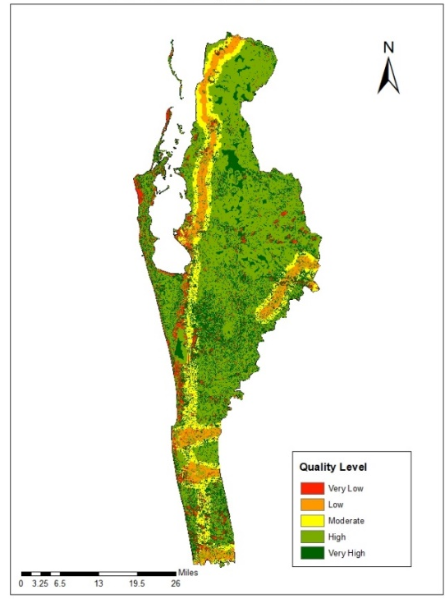
Figure 4. Habitat Quality Map of Puttalam

Figure 5 shows the mangrove biodiversity focused habitat quality map that was used to prepare the final map.
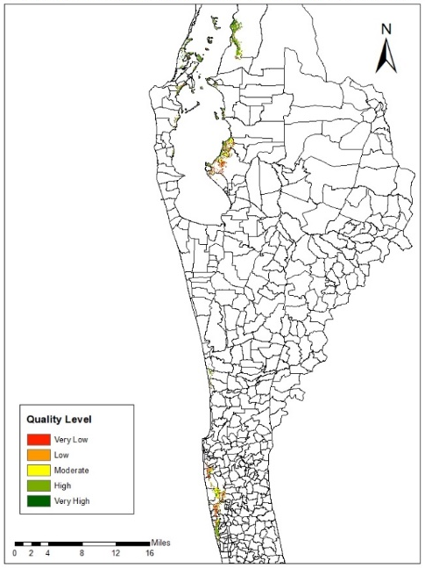
Figure 5. Mangrove Biodiversity focused Habitat Quality map of Puttalam
By intersecting high threat level areas and higher habitat quality provided mangrove biodiversity, areas that require immediate attention for conservation were obtained as shown in Figure 6.
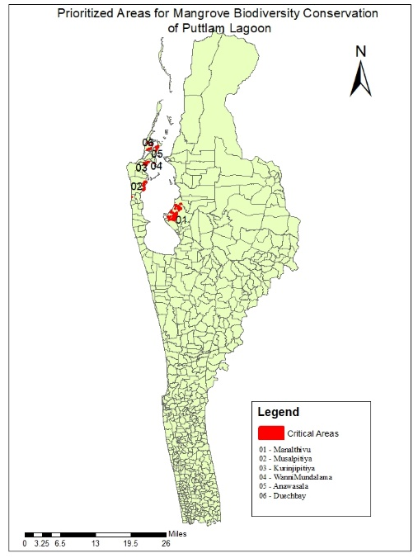
Figure 6. Areas need to be prioritized for Mangrove Biodiversity Conservation

According to the map Manalthivu, Mudalappaliya, Musalpitiya, Kurinjipitiya, Wannimundalama, Anawasala and Deuch Bay GND require conservation priorities according to the threat level and habitat quality ecosystem service.

Validation of Final Map

For the validation, threats were assessed to mangrove biodiversity by integrating same environmental and anthropogenic factors using 2009 data. Data on rainfall, temperature, population density, shrimp farm distribution, distance from roads, air quality, and land use were collected and processed using GIS tools in Arcmap. Then using the provided information on habitat quality according to the year 2009, the module produced the habitat quality map.
The accuracy assessment was performed by comparing the resulting final map with an independently sourced ground truth dataset that is shown in Figure 7. For this purpose, a map published by the International Union for Conservation of Nature which shows sensitive areas proposed to give priority for conservation around the Puttalam was chosen as the reference data for validation. Various statistical measures, such as accuracy, precision, and kappa coefficient, were calculated to assess the agreement between the two datasets. This validation step ensured the reliability and credibility of the final map, enhancing confidence in its utility for informing conservation strategies and management decisions.
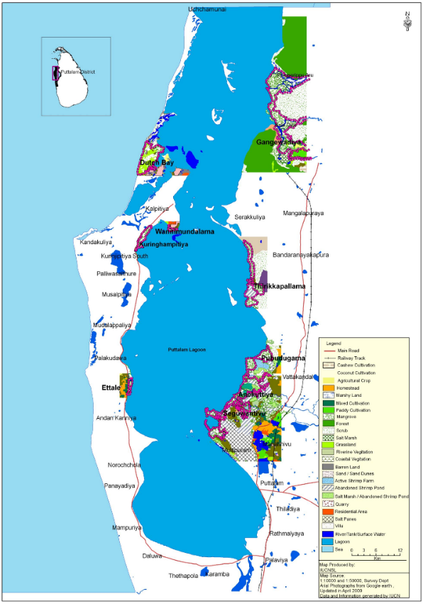
Figure 7. Sensitive areas for conservation around the Puttalam Lagoon (Weragodathenna, 2022)

Confusion Matrix that is shown in Figure 8 relevant to the final map accuracy assessment shows 0.83 total accuracy and 0.667 Kappa value. According to assessment final output has substantial accuracy.

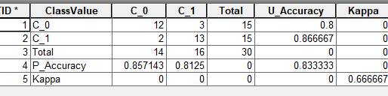
Figure 8. Confusion matrix

Discussion

Even though there are numerous methods to conserve areas, especially regarding biodiversity, there's no shortage of clever ways to figure out which areas need our help the most. In this research, the selection of critical KBAs considered the results of both, ecosystem services and the level of threat to mangrove biodiversity. The study evaluates the impacts of key threats, including rainfall, temperature, population density, land use changes, shrimp farms, and air pollution, on mangrove biodiversity within the Puttalam Lagoon. By integrating spatial data and GIS analysis, areas where these threats overlap and intersect with critical mangrove habitats could be identified, highlighting potential areas of vulnerability and risk for biodiversity loss. The research also assesses the role of ecosystem services and the levels of habitat quality of mangrove biodiversity within the Puttalam Lagoon. Using the InVEST model, the study quantifies habitat suitability and identifies areas of high quality based on key indicators. Both threat levels and habitat quality enable the identification of areas with the most pressing conservation needs. The findings of this study offer actionable policy recommendations for local governments in highly urbanized regions, aiding in the development of effective conservation strategies and action plans. By highlighting the critical KBAs and their associated threats and ecosystem service values, this research serves as a valuable resource for decision-makers and conservation practitioners aiming to safeguard biodiversity and ecosystem services in the Puttalam Lagoon area.
However, it is important to consider the limitations of the study. Firstly, some parameters were derived from provincial or regional scales, which may lead to relatively approximate results. Secondly, the mismatch of resolution for input data, with resolutions ranging from 10m to 30m, could introduce uncertainties in the evaluation of anthropogenic threats and ecosystem service habitat quality. Despite these limitations, the study retains significant applicability.
By integrating diverse datasets and employing sophisticated modeling techniques, the study provides a comprehensive assessment of the factors influencing mangrove ecosystems. Moreover, the validation process, despite its challenges, contributes to enhancing the credibility of the generated habitat quality map. Recognizing the complexities inherent in biodiversity conservation and habitat management, this research serves as a foundation for further investigations and interventions. Future studies could focus on refining methodologies to mitigate scale disparities and improve the accuracy of assessments. Additionally, incorporating real-time or higher-resolution data sources could enhance the precision of the analysis, thereby strengthening the efficacy of conservation strategies. Overall, while acknowledging its limitations, this study represents a crucial step toward informed decision-making and sustainable management of mangrove ecosystems.

CONCLUSION

Puttalam Lagoon and its surrounding ecosystems play a vital role in supporting biodiversity and sustaining the livelihoods of vulnerable communities, including refugees residing in the area. However, these ecosystems face significant degradation due to various threats. Urgent action is needed to alleviate the pressure on lagoon ecosystems and address the challenges they face. This requires collaborative efforts between responsible agencies, local communities, and other stakeholders. However, local communities are hindered by limitations such as a lack of expertise, resources, and infrastructure. Additionally, communities depending on lagoon resources are often marginalized, with limited capacity for sustainable resource management. Therefore, addressing these issues requires an approach that prioritizes areas that require immediate conservation.
Through the research on identifying critical KBAs, an assessment of conservation priorities for key biodiversity areas in Puttalam Lagoon was conducted by integrating anthropogenic and climate threats with ecosystem conditions. It has allowed for the prioritization of critical biodiversity areas, highlighting regions such as Manalthivu, Musalpitiya, and Kurinjipitiya North as particularly vulnerable and in need of immediate conservation attention. Conversely, areas with higher habitat quality, such as Mullipuram and Serakkuliya, present opportunities for proactive conservation efforts to preserve their ecological integrity and maximize the provision of ecosystem services. By mapping critical habitats for ecosystem conservation, habitat quality modeling helps in protecting key biodiversity and sustainable land management initiatives.
In addition to considering biophysical indicators, it is crucial for ecosystem studies to integrate economic and socio-economic factors into their analyses to effectively support environmental management policies. By quantifying other ecosystem services rather than just one, researchers can gain valuable insights into the tangible benefits provided by natural ecosystems, beyond their ecological value. These insights are essential for informing policy decisions and designing management strategies that account for the full range of ecosystem contributions to human well-being. By incorporating ecosystem quality indices, economic and socio-economic considerations into ecosystem studies, policymakers can develop more holistic and sustainable approaches to environmental management, balancing conservation objectives with socio-economic priorities. In conclusion, by integrating biophysical, economic, and socio-economic factors into ecosystem studies, complex relationships between human societies and natural ecosystems can be understood, leading to a more effective and equitable environmental conservation plan for the long-term benefit of both people and the planet.

REFERENCES

- Admasu, S., Yeshitela, K. & Argaw, M. 2023. Assessing habitat quality using the InVEST model in the Dire and Legedadi watersheds, central highland of Ethiopia: Implication for watershed management. Sustainable Environment, 9, 2242137.
- Amarasinghe, M. & Balasubramaniam, S. 1992. Net primary productivity of two mangrove forest stands on the northwestern coast of Sri Lanka. Hydrobiologia, 247, 37-47.
- Bandara, K., et al. (2019). 2019. Avifauna of Puttalam Lagoon, Sri Lanka: distribution, abundance and threats. Journal of Threatened Taxa, 11(10), 14334-14342.
- Ekanayake, L. 2016. Environmental status and issues of Puttalam Lagoon–A case study in six coastal villages. Sri Lanka Turtle Conservation Project.
- Hall, L.S., Krausman, P.R. And Morrison, M.L., 1997. The habitat concept and a plea for standard terminology. Wildlife society bulletin, pp.173-182.
- IUCN 2016. A Global Standard for the Identification of Key Biodiversity Areas, Version 1.0. First edition. Gland, Switzerland.
- Pathirana, K., Kamal, A., Riyas, M. & Safeek, A. 2008. Management of coastal resources in Puttalam lagoon, Sri Lanka. Paper No: P-06 COPEDEC VII.
- Saaty, T. L. 1990. How to make a decision: the analytic hierarchy process. European journal of operational research, 48, 9-26.
- Shrestha, M., Piman, T. & Grünbühel, C. 2021. Prioritizing key biodiversity areas for conservation based on threats and ecosystem services using participatory and GIS-based modeling in Chindwin River Basin, Myanmar. Ecosystem Services, 48, 101244.
- Weragodathenna, D. 2022. GIS Atlas for Puttalam Lagoon (Eng.Version) - As an Assistance for Natural Resource Management.
- Zhou, G., Huan, Y., Wang, L., Zhang, R., Liang, T., Dunn, M. E., Yao, F. & Tong, Y. 2023. Identifying ecological priority areas for synergistic conservation across scales in the Asian Water Tower region. Ecosystem Health and Sustainability, 9, 0036.

