Proposed Architecture and User Acceptability Framework for TriGo: An Online Tricycle Booking System

ABSTRACT
This study investigates the digital transformation of tricycle transportation in Bolinao, Pangasinan, emphasizing a tricycle dispatch system designed to enhance operational efficiency and community mobility. Bolinao's 30 barangays rely on the traditional "torno" queuing method, managed through physical blackboards at terminals. This results in prolonged driver idle times and unnecessary travel without passengers, compels commuters to wait for extended periods, and necessitates physical presence at terminals to secure rides. The lack of centralized trip records limits the Bolinao Tricycle Operators and Drivers Federation (BTODF) in effectively overseeing operations or addressing conflicts. Given the growing preference among commuters for digital services, mobile technology presents a promising avenue for improving coordination. The study developed a digital booking and dispatch system that facilitates online ride requests and operational management. Utilizing a descriptive developmental methodology guided by the Agile Software Development Life Cycle, the project delivered a functional mobile application tailored to the federation's requirements, evaluated by 115 purposively sampled respondents, comprising commuters, tricycle drivers, TODA officers, and an IT expert validator, using the ISO/IEC 25010 software quality standard across functional suitability, performance efficiency, usability, reliability, and portability. Core elements include internet connectivity and mobile GPS, connecting commuters and drivers through a three-tier architecture spanning the Presentation, Application, and Data tiers. TriGo incorporates a nearby-driver algorithm, real-time GPS tracking, in-app messaging, incident and operational reporting, SOS alerts, and driver ratings following rides, modernizing tricycle operations while maintaining the established TODA community framework. This architecture directly addresses the operational gaps identified in the manual torno system, offering a scalable, community-responsive alternative without displacing existing organizational structures. Digital transformation initiatives in local transport sectors are most effective when designed to complement, rather than replace, established community governance, positioning TriGo as a viable model for future deployment and evaluation of user acceptability and operational impact in Bolinao.
Keywords: Tricycle dispatch system, torno, TODA operations, mobile application, Bolinao Pangasinan
INTRODUCTION
Transportation constitutes a critical component of contemporary society, facilitating economic activities, social interactions, and the routine movement of individuals and goods. In developing countries, the accessibility and efficiency of transportation systems have been closely associated with community development and overall quality of life [9]. Within the Philippine context, the transportation sector has transitioned from traditional horse-drawn vehicles known as kalesa to modern Public Utility Vehicles (PUVs), including jeepneys, buses, and taxis. Notably, tricycles have become the predominant mode of short-distance local transport, especially in municipalities and rural areas where larger vehicles face operational constraints [8]. The emergence of digital transportation platforms worldwide has further reshaped access to these services, with ride-hailing and mobile transit applications exhibiting observable enhancements in accessibility, operational efficiency, and user satisfaction [2].
This study contributes to the municipality of Bolinao, Pangasinan, by addressing the persistent operational inefficiencies of its manual tricycle dispatch system and providing a technology-based solution tailored to its community context. Bolinao comprises 30 geographically dispersed barangays, each served by its own Tricycle Operators and Drivers Association (TODA), a regulatory body that coordinates drivers, assigns terminals, and implements guidelines under local government supervision [3]. The primary objective of this study is to design and develop TriGo: A Digital Tricycle Booking and Dispatch System for Efficient Community Transportation, which specifically aims to: (1) identify existing tricycle transportation operations under TODA organizations in Bolinao; (2) determine the common transportation challenges experienced by drivers and commuters; (3) develop a digital tricycle dispatch system based on the identified needs and requirements; and (4) evaluate the user acceptability of the developed system using the ISO/IEC 25010 software quality standard [6].
Even with national and regional progress in digital transport, Bolinao continues to struggle with key operational issues. Riders continue to visit terminals or 'todahan' physically, or stand by the roadside waiting for available drivers which relies entirely on physical presence and informal coordination. Drivers still strictly use 'torno system' which is a traditional sequential queueing system run using only physical blackboards 'pisara' at each terminal. This manual blackboard does not have any backup and there is often queue order and monitoring inaccuracies which is difficult to detect and verify. Drivers have idle times, thus leading to dead mileage and lower income at the terminals, and text messaging and social networking informal coordination often leads to poor coordination and missed dispatching. Lack of central records of trips prevent TODA organizations and local government to monitor the operations and demand and to solve disputes.
The scope of this study is the development of the mobile booking and dispatch system for tricycle commuters and tricycle drivers in Bolinao, Pangasinan. For the evaluation of the system, the study involved only 115 respondents selected through purposive sampling (commuters, tricycle drivers, TODA officers, and an IT expert validator). Tricycle services in Bolinao are confined only to those recognized by the local TODA of tricycle operators and drivers; tricycle systems in other municipalities are outside the boundaries of the study, and features such as payroll, tax, and accounting are not within its scope. The system may not function perfectly, and features such as real-time GPS tracking and automatic dispatch may take time to update when signal is low, due to the system's dependence on internet connectivity. Offline operations are also excluded from the scope of the study.
METHODOLOGY
This study employed a descriptive developmental research design. The descriptive component was used to characterize the existing tricycle transportation operations under TODA organizations in Bolinao and to identify the common challenges experienced by both drivers and commuters through structured interviews and direct observation. The developmental component guided the systematic design, construction, and evaluation of the TriGo mobile application. This dual-method approach is appropriate for studies that seek to both understand an existing problem and produce a working technological solution as a direct response [4]. The Agile Software Development Life Cycle (SDLC) was adopted as the project development methodology. Unlike the rigid sequential structure of the Waterfall Model, Agile allows for iterative development and continuous testing, enabling the research team to respond to evolving requirements and incorporate stakeholder feedback throughout the development process [1]. Development proceeded through structured sprints: registration and booking modules, the nearby available driver algorithm and SOS emergency alerts, the commuter incident and operational reporting module, and finally the post-ride driver rating module.
Figure 1: Agile Method
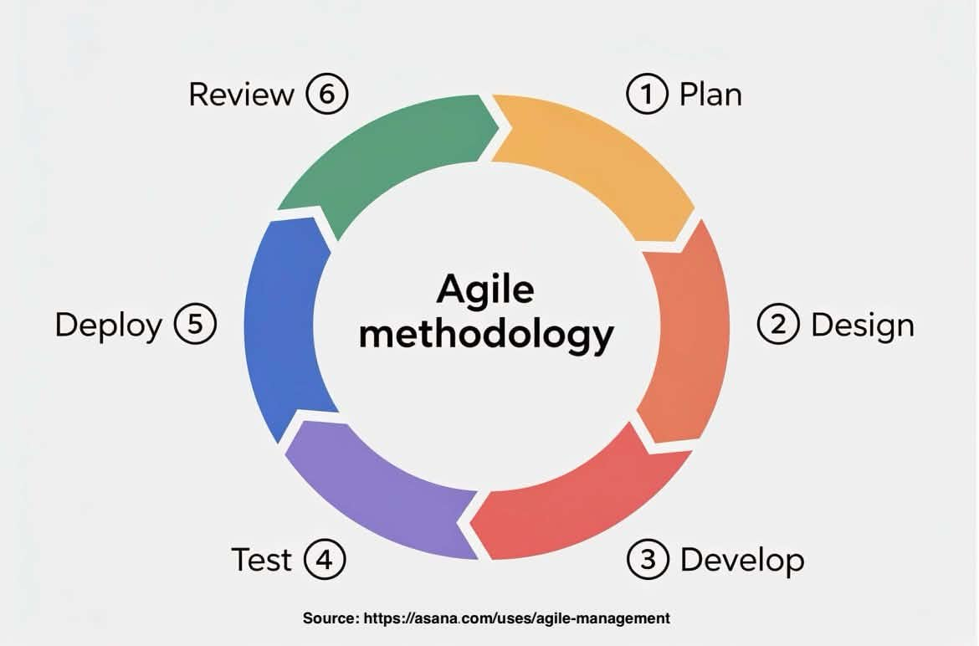
The study was conducted in the municipality of Bolinao, Pangasinan, which comprises 30 barangays, each with its own designated TODA. Purposive sampling was used to select respondents who have direct and relevant experience with the local tricycle transportation system, as this technique ensures that the most informed and contextually appropriate participants contribute to the evaluation of the system [7]. A total of 115 respondents participated in the study. Commuter respondents were identified based on observed foot traffic at primary tricycle terminals across the municipality, with two commuters selected per barangay to ensure geographic representation. Driver and federation officer respondents were coordinated through the Bolinao Tricycle Operators and Drivers Federation (BTODF), prioritizing those with significant experience in the manual torno system. IT expert validators were drawn from qualified professionals and faculty members to provide a rigorous technical assessment of the system's functionality and reliability. Data collection instruments included structured observation at tricycle terminals, in-depth interviews with the BTODF President and selected officers, and a structured survey questionnaire evaluated using the ISO/IEC 25010 software quality standard [5]. The system was evaluated across key quality characteristics including functional suitability, performance efficiency, usability, reliability, and portability [10]. A four-point Likert scale was used for all survey items, with responses interpreted as: 3.26–4.00 (Strongly Agree / Highly Accepted), 2.51–3.25 (Agree / Accepted), 1.76–2.50 (Disagree / Not Accepted), and 1.00–1.75 (Strongly Disagree / Highly Not Accepted).
Table 1. Respondents of the Study
Respondents | Number of Respondents
Commuters | 60
Tricycle Drivers | 40
TODA Officers | 10
IT Validators | 5
Total Respondents | 115
RESULTS AND DISCUSSION
The operational issues identified among commuters and drivers in the manual torno system were used as the basis for selecting the features built into TriGo. Table 2 maps each identified problem to its corresponding proposed feature in the system.
Table 2. Mapping of Identified Problems to Proposed TriGo Features
Persona | Identified Problem | Proposed TriGo Feature
Commuter | Must wait at the terminal or roadside with no way to know when a tricycle will arrive. | Online booking with nearby-driver algorithm.
Commuter | No way to verify a driver’s identity or track the ride for safety. | Real-time GPS tracking and SOS alert
Commuter | No structured channel to communicate with the driver before or during the ride. | In-app messaging
Driver | Idle time and dead mileage while waiting for a torno turn at the terminal. | Nearby-driver dispatch algorithm
Driver | No centralized trip records to monitor operations or resolve disputes. | Admin dashboard with centralized trip records
Driver | No formal mechanism to report incidents or assess driver conduct. | Incident reporting and post-ride driver rating
The architecture description that follows builds on these mapped features by detailing how each is structured across the system’s presentation, application, and data tiers.
The Presentation Tier (Mobile UI) serves as the front-facing layer through which all users interact with the system. It consists of three modules: the Commuter Module, which handles booking, tracking, SOS, reports, and ratings; the Driver Module, which manages dispatch alerts, GPS, trip status, and ratings; and the Admin Dashboard, which oversees operations, user management, reports, and system monitoring. This tier ensures that each user type, commuter, driver, and administrator, has a tailored and role-appropriate interface.

The Application Tier (Business Logic) acts as the processing core of the system, handling all functional operations behind the scenes. It encompasses five key components: a Nearby Driver Algorithm that uses real-time GPS proximity to match commuters with available drivers; a Booking Engine that implements a 3-step booking flow with fare calculation; a Safety & SOS module that manages emergency alerts and location broadcasting; a Reports & Ratings engine that tracks incident logs and driver performance scores; and a Notifications module powered by Firebase Cloud Messaging to deliver real-time alerts across the platform.

The Data Tier (Cloud Storage, Firebase Firestore) forms the persistence layer of the system, storing all critical data in four structured collections: User Profiles for commuter, driver, and admin accounts; Trip Records containing booking history and GPS logs; Incident Reports covering violations and SOS history; and Driver Ratings including scores and commuter reviews. By leveraging Firebase Firestore as a cloud-based NoSQL database, the TriGo system ensures real-time data synchronization, scalability, and reliable data access across all tiers.

Figure 2: Three-Tier Architecture
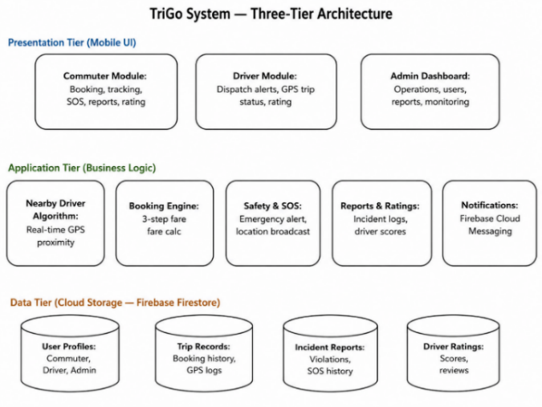
To further clarify how each proposed feature is structured across the system’s layers, Table 3 maps the key TriGo features to their corresponding components in the Presentation, Application, and Data Tiers.

Table 3. Mapping of TriGo Features to Three-Tier Architecture
Feature | Presentation Tier | Application Tier | Data Tier
Nearby-driver dispatch | Driver search screen | Nearby Driver Algorithm | Trip Records
Real-time GPS tracking | Live map view | Booking Engine | Trip Records
In-app messaging | Chat interface | Notifications module | Trip Records
SOS emergency alert | SOS button | Safety & SOS module | Incident Reports
Incident reporting & rating | Report & rating forms | Reports & Ratings engine | Incident Reports, Driver Ratings
Admin monitoring | Admin Dashboard | All business logic modules | User Profiles, all collections

Figure 3 presents the authentication and Role selection TriGo application. Upon launching the app, users are greeted with a role selection screen prompting them to identify whether they are a Commuter or a Driver. Commuters are directed toward the ride booking workflow, while drivers are guided to register under a TODA Federation. This role-based entry point ensures that the system delivers a contextually appropriate experience for each user type from the very first interaction, eliminating confusion and streamlining onboarding. The clean, minimal design of the welcome screen reflects the need for accessibility among users in Bolinao who may have varying levels of digital literacy.
Figure 3: User Authentication and Role Selection
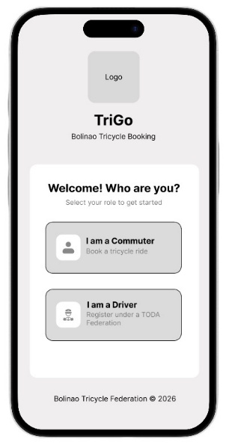

Figure 4 shows the driver-matching screen that is triggered immediately after a booking is confirmed. The interface displays a "Searching for nearest driver" status message accompanied by a loading progress bar and a "Connecting to nearby driver" indicator, with skeleton-loaded driver cards beneath it. This screen reflects the operation of the Nearby Driver Algorithm in the application tier, which uses real-time GPS proximity data to identify and connect the commuter with the closest available tricycle driver. The inclusion of a Cancel Search button further empowers commuters with control over the booking process, a feature absent in the current manual torno queue system.

Figure 4: Search for nearest driver
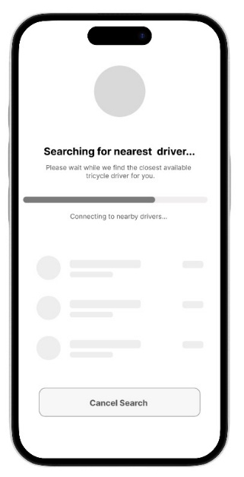
Figure 5 illustrates the Booking Summary screen, which represents the core transactional interface of the TriGo system. The screen displays the commuter's pickup point (Bolinao Public Market) and destination (Bolinao Municipal Hall), along with key trip details including a distance of 1.1 km, an estimated travel time of approximately 5 minutes, and a computed fare of ₱35.00. The fare breakdown is transparently presented, showing a base fare of ₱15.00, a distance charge of ₱18.00 for 1.2 km, and a ₱2.00 booking fee. Passengers can also adjust the number of riders, with a maximum of four per tricycle. Payment options include Cash and GCash, giving commuters flexible payment methods suited to local conditions. This screen directly addresses the lack of standardized fare computation in the existing manual dispatch system by providing an automated, transparent, and consistent pricing mechanism.

Figure 5: Booking and Ride Summary
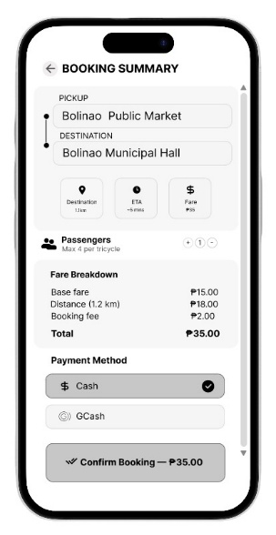
Figure 6 demonstrates the live tracking interface activated once a driver has been assigned. The screen prominently displays a LIVE indicator alongside a status message confirming that the driver is on the way, with an estimated arrival time of approximately 3 minutes. The assigned driver's profile is shown, including the driver's name (Juan Dela Cruz), star rating (4.8 from 321 trips), license number, plate number, franchise number, and TODA association (Patar). Commuters are also provided with direct communication options via Call Driver and Message buttons, as well as the trip route from Bolinao Public Market to Bolinao Municipal Hall. An SOS button is prominently accessible on the map view for emergency situations. This screen directly addresses critical safety and transparency gaps in the manual dispatch system, as commuters previously had no means to track their driver, verify credentials, or signal emergencies during a trip.
Figure 6: GPS tracking
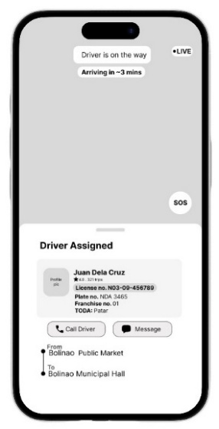
Figure 7 presents the in-app messaging interface of the TriGo system, accessible during an active ride session. The screen displays a conversation thread between the commuter and the assigned driver, identified here as Alliah Coronel, with a status indicator showing "Commuter Active ride." At the top of the chat window, a prominent red-dot notification reminds users that the SOS emergency alert is available during active rides, ensuring that safety features remain visible and accessible throughout the trip. A system-generated message confirms the ride acceptance, noting the route from Tara to Poblacion booked on the current day at 9:10 AM. A trip summary card is also embedded within the chat, displaying the current trip route from Poblacion to Tara, the fare of ₱70.00, and the selected payment method of Cash. A text input field at the bottom of the screen allows both parties to exchange messages in real time. This feature directly addresses one of the key gaps identified in the manual dispatch system, the lack of structured, documented communication between commuters and drivers. By integrating messaging within the booking context, TriGo eliminates reliance on informal text messages or social media group chats, while simultaneously providing a traceable and accountable communication channel embedded within each trip transaction.
Figure 7: In-app messaging
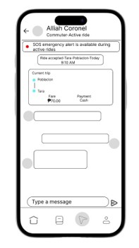
Figure 8 shows Commuter Incident and Operational Reporting. Commuters may submit formal reports through the application to document service-related concerns or violations committed during a trip. Reportable incident categories include reckless driving, overcharging, discourteous or inappropriate behavior, refusal of service, and other safety or operational concerns. All submitted reports are forwarded to the administrator and TODA for review and appropriate action [7]. SOS Emergency Alert. A critical-response mechanism that enables commuters or drivers to immediately notify the administrator and emergency services when facing situations that threaten personal safety or require urgent assistance during a trip. The SOS function transmits the user's real-time GPS location to facilitate prompt response [10].

Figure 8: Commuter Incident and SOS Alert
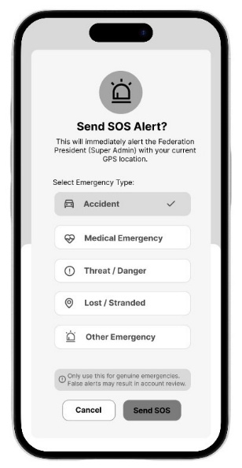

Figure 9 displays the Post-Ride Driver Rating. After trip completion, the commuter evaluates the driver using a star-based rating scale. The rating reflects the commuter's assessment of the driver's professionalism, punctuality, driving behavior, and overall service quality. Accumulated ratings serve as a performance indicator accessible to the administrator and TODA officers for monitoring, commendation, or disciplinary action [1].

Figure 9: Post-Ride Driver Rating
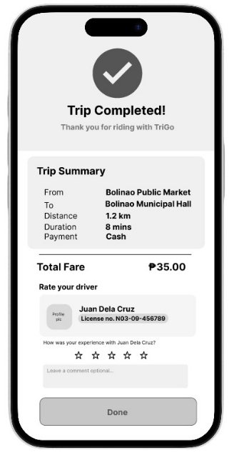

Figure 10 shows the Super Admin Dashboard. The super admin is provided with a centralized dashboard to monitor trips, manage user accounts, review driver applications, process incident reports, view driver rating records, and generate operational reports. The dashboard ensures that TODA officers have full visibility and control over the operations of the TriGo platform without needing to go through multiple screens to find basic information.

Figure 10: Super Admin Dashboard
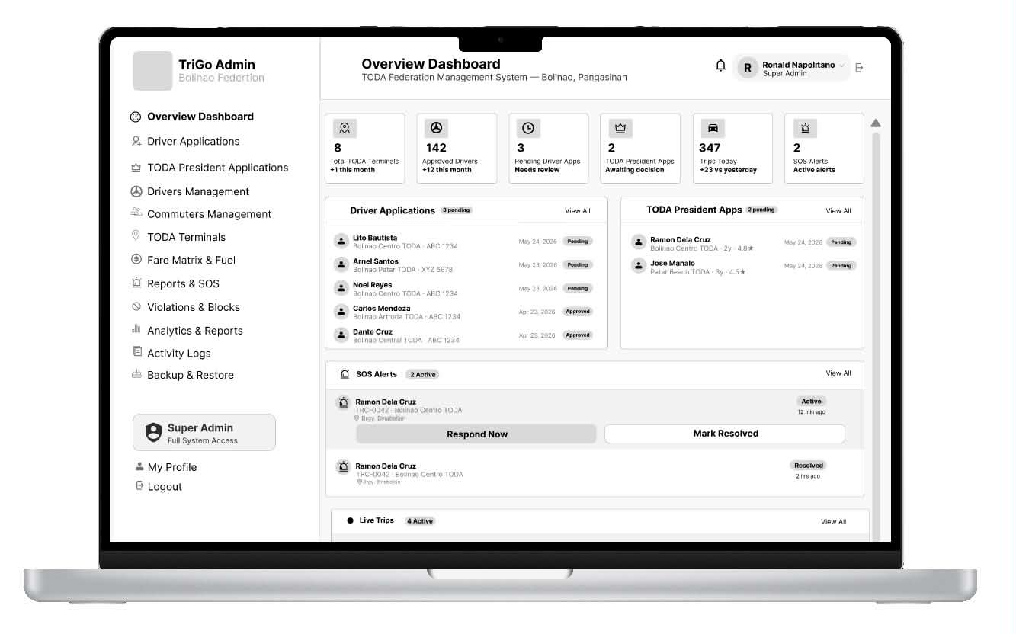
CONCLUSION
TriGo demonstrates that digital transformation, when properly designed, does not need to abolish an existing community framework, but can instead enhance it. Because the nearby-driver algorithm of TriGo is designed to operate within the same operational logic as the old torno system, TriGo is intended to revamp the operational workflow without removing the TODA structure that drivers and officers rely upon. Each proposed system feature was designed to address a specific gap identified in the current manual process, giving every component a clear, community-grounded rationale. Built on Agile SDLC and a three-tier architecture, the TriGo system is designed to be scalable and community-responsive, reflecting the principle that technology delivers the most value when it is built around the needs of its users. As this study covers the design and development stages of the system, future research is recommended to deploy TriGo and empirically evaluate its user acceptability, performance, and overall impact on tricycle operations in Bolinao.
REFERENCES
- Aniag, J. J. R., Cruz, A. R., Festijo, I. C. N., Garcia, L. S. A., & Munez, R. M. (2023). Tricycle operators and drivers' association automated sequencing using a Raspberry Pi. Academia.edu.
- Chalermpong, S., Kato, H., Thaithatkul, P., Ratanawaraha, A., Fillone, A., Hoang-Tung, N., & Jittrapirom, P. (2023). Ride-hailing applications in Southeast Asia: A literature review. International Journal of Sustainable Transportation, 17(3), 298–318. https://doi.org/10.1080/15568318.2022.2032885
- Department of Transportation. (2020). Guidelines on tricycle operations and TODA regulation. https://dotr.gov.ph/
- Galang, N. A. A., Villeno, A. M. M., Camaro, P. J., & Cabauatan, R. R. (2025). Impact of digital platform economy and ride-hailing services on urban mobility in Pampanga. Journal of Technology and Systems, 7(1), 28–57. https://doi.org/10.47941/jts.2506
- Gumasing, M. J. J., Deinla, E. C. C., Espaldon, A. K. P., Jarin, D. R. I., & Mercado, N. C. (2023). The usability of transport network vehicle service apps in the Philippines: A comparison of Grab, Angkas, and Joyride. In Proceedings of the 2023 5th International Conference on Management Science and Industrial Engineering (pp. 310–318). https://doi.org/10.1145/3603955.3603974
- Moumane, K., & Idri, A. (2023). ISO/IEC 25010-based quality evaluation of mobile applications for health services in Morocco. Research Square. https://doi.org/10.21203/rs.3.rs-2720323/v1
- Ong, A. K. S., Prasetyo, Y. T., Lagura, F. C., Ramos, R. N., Sigua, K. M., Villas, J. A., & Diaz, J. F. T. (2023). Determining tricycle service quality and satisfaction in the Philippine urban areas: A SERVQUAL approach. Cities, 137, 104339. https://doi.org/10.1016/j.cities.2023.104339
- Philippine Statistics Authority. (2021). Transport statistics in the Philippines. https://psa.gov.ph/statistics/survey/transport
- Smart and sustainable public transportation: A need of developing countries. (2024). International Journal of Networked and Distributed Computing. https://doi.org/10.1007/s44227-024-00023-2
- Verma, R., Singh, B. K., & Zahidi, F. (2024). Management of GPS tracking systems in transportation. In Intelligent Transportation System and Advanced Technology (pp. 251–263). Springer Nature Singapore.

