CUTBACK CANE POINT PRODUCTION OF SUGARCANE
VARIETIES APPLIED WITH VERMICOMPOST

Myrna P. Prudente,
Myrnaprudente72@gmail.com

ABSTRACT

The study was conducted to determine the cutback cane point production of sugarcane varieties applied with vermicompost in terms of the number of days to germinate, germination rate, plant height, number of tillers, number of internodes, number of nodes and number of cane points harvested. The results revealed that application of vermicompost significantly influenced the number of days to germinate, plant height, number of tillers, number of nodes, number of internodes and number of cane point harvested. VMC 67-252 germinated early significantly differ from Phil- 99-1793 using 15t/ha but insignificant from other levels of same variety. Application of 20t/ha (V₁ & V₂) resulted to highest plant 15 days after planting, same result after 30 and 45 days (V2) for V1, 15t/ha after 30 and 180 days after planting. The result also revealed that the tallest plants (281.03 cm) noted from Phil 99-1793 variety and application of 10t/ha (V₂) were the tallest plants but it was almost the same due to insignificant result. For the number of tillers, 20t/ha (V₁) and 15t/ha (V₂) obtained the most number of tillers significant from 10t and 15t/ha (V1) and 10t and 20t/ha (V₂) but both lower from the control group (inorganic fertilizer). Number of nodes and internodes no significant results from the amount of vermicompost but significant noted between varieties. The most number of nodes produced by V₂ and the most number of internodes noted from V₁. For the cane point harvested the most was harvested from VMC 67-252 variety (21.55 pc) higher from Phil 99-1793 but leaser from plants applied with inorganic fertilizer. Significant difference noted from the amount of vermicompost but insignificant between varietis.

Keywords

Sugarcane, Cutback Cane point, Vermicompost, Organic Fertilizer

I. Rationale

Sugarcane (Saccharum officinarum L.) is one of the most important industrial crops and principal drivers of Philippine economy. According to Sugar Regulatory Administration, sugar is a mainstay of the country’s export products and has a significant contribution to the country’s foreign earnings and gross value added to agriculture sector from the sale of sugar and molasses.
Sugarcane production is very popular, but continuous planting has a negative impact on sugarcane plant growth and reduces global sugarcane crop production and it was hypothesized that sugarcane monoculture would affect physiochemical soil properties and microbial communities (Pang, et al 2008). The continuous application of inorganic fertilizer in sugarcane production can disrupt the natural balance of nutrients on the soil and decrease soil fertility which helps farmers and organic practitioners to use organic fertilizer, specifically the vermicompost. The use of vermicompost has long been recognized as an effective means of increasing crop yields through improved soil physical, chemical and biological properties (Gopinath, et al 2010). It was added by the same authors that vermicompost is a nutritive organic fertilizer rich in NPK, micronutrients, beneficial microbes like nitrogen fixing bacteria and mycorrhizal fungi and plant growth hormones. Singh, et al cited by Gopinath, et al (2010) that application of organic amendments produced yield parameters and cane yields in both planted and ratoon crop statistically similar to those with recommended NPK.
Vermicomposts are products derived from the accelerated biological degradation of organic wastes by earthworms and microorganisms. This contains many outstanding biological properties in which it is rich in bacteria, actinomycetes, fungi and cellulose-degrading bacteria (Werner and Cuevas, cited by Arancon 2006). In addition, Tomati et al. (1983) reported that earthworm castings, obtained after sludge digestion, were rich in microorganisms, especially bacteria. The outstanding physicochemical and biological properties of vermicomposts makes them excellent materials as additives to greenhouse container media, organic fertilizers or soil amendments for various field horticultural crops, Arancon, et al (2020).
Organic fertilizer is an organic agricultural practices that can improve the quality of soil or water and can save soil from degradation through the use of excessive chemicals and synthetic fetilizers. The continuous use of inorganic fertilizer which causes waterway pollution, chemical burn to crops, increased air pollution, acidification of the soil and mineral depletion of the soil which has been observed in many years. According to Dominy, et al 2020) the amount of organic matter has detrimental effects on soil physical, chemical and biological properties and need to develop strategies in the maintenance and improvement of soil organic matter content, according to the same authors. According to them, sugarcane monoculture decreases the organic matter content of the soil.
Hence; the researchers came up to conduct study on the use of vermicompost on cutback cane point production of sugarcane varieties as organic fertilizer in response to RA 10068 known as Organic Agriculture Act of 2010 and to support R.A. 9003 or Ecological Solid Waste Management and R.A. 9729 or Climate Change Act of 2009.

II. Objectives of the Study
The study was conducted to determine the cutback cane point
production of sugarcane varieties applied with vermicompost.
Specifically, it sought to:
- Determine the growth performance of sugarcane varieties applied
with vermicompost in terms of the number of days to germinate, germination rate, plant height, number of tillers, number of internodes, and number of nodes.
- Determine the yield performance of sugarcane varieties
applied with vermicompost in terms of the
number of cutback cane point harvested.
- Determine if there is significant differences on the cutback cane
point production of sugarcane varieties applied with vermicompost in terms of the number of canepoint harvested.
- Determine if there is an interaction effect on the amount of
vermicompost on the cutback cane point production of Phili 99-1793 and VMC 67-252 sugarcane varieties.

III. Methodology
The study was laid-out in a Two-Factor experiment using the Randomized Complete Block Design (RCBD) . Factor A was the sugarcane varieties (V₁) using the Phil 99-1793, and variety 2 (V₂) was VMC 67-252 ; while factor B levels of the vermicompost as fertilizer: F₁₋ 10 t/ha, F₂ ₋15 t/ha), F₃ (20 t/ha), F4 (control 1)-no fertilizer application, and F₅ (control 2)-inorganic fertilizer. The treatment combinations were: V₁F₁; V₁F₁; V₁F₂; V₁F₃; V₁F₄; V₁F₅ V₂F₁; V₂F₂; V₂F₃; V₂F₄; V₂F_{5.} Experimental lay-out is shown in Figure 1

In this study two varieties following the treatment descriptions were used. The cane points were procured from reliable source with the help of Sugar Regulatory Administration (SRA) using two (2) cane buds as planting materials. All data gathered were analyzed statistically using the Analysis of Variance (ANOVA) in a Two-factor experiment using the Randomized Complete Block Design and data with significant results were subjected to Duncan’s Multiple Range Test (DMRT). The study was conducted at ISCOF (ISUFST)-San Enrique Campus experimental area San Enrique, Iloilo, in the fourth district of the province of Iloilo, Region VI-Western Visayas.
Five Hundred Forty (540) pieces Phil-99-1793 V₁) canepoints; 540 pc VMC 67-252 (V₂) canepoints were used as planting materials applied with different levels of vermicompost. And other materis used were the digital weighing scale, meterstick, sacks, cane knive, sprinkler, vermicompost, inorganic fertilizer (Urea, T₁₄, Muriate of potash), plow, and black v-net.
The study was conducted to determine the canepoint production performance sugarcane varieties applied with vermicompost in terms of the number of days to germinate, germination rate, plant height, number of tillers, number of nodes, number of internodes and the number of canepoint harvested.
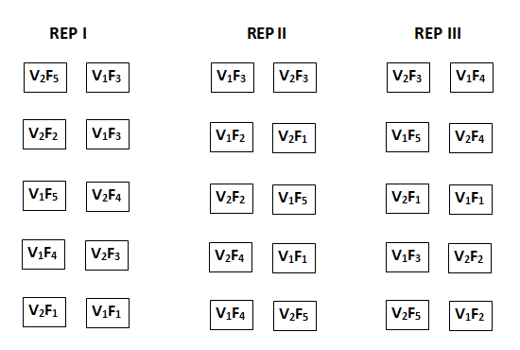

Figure 1. Experimental lay-out of the study in a Two-Factor
Experiment using Randomized Complete Block Design

Legend:
Varieties: V₁ ₋ Phil 99-1793
V₂-VMC 67-252
F₁ -10 t/ha
F₂ -15t/ha
F₃ -20t/ha
F₄ (control 1)-no fertilizer application
F₅ (control 2)-inorganic fertilizer

IV. Results and Discussion

Number of Days to Germinate. The number of days to germinate of sugarcane varieties applied with different levels of vermicompost is shown in Table 1. The result revealed that application of different levels of vermicompost on the different varieties significantly influenced the number of days to germinate. Application of 20t/ha (Phil 99-1793) was the earliest
(4.70 days) and the last was noted from those applied with inorganic fertilizer. The result also shows that V₁ (VMC 67-252 significantly germinated early compared from the V1 or Phil 99-1793 variety. There was an interaction effect on the levels and the variety of sugarcane and the levels of vermicompost. The application of 15t/ha vermicompost (V₂) significantly germinated early from those variety without fertilizer application but insignificant from those with other levels including with inorganic fertilizer. Based on statistical analysis the result revealed that application of 15t/ha of vermicompost for VMC 67-252 (V₂ germinated earlier which was significantly early from those plants without fertilizer application but insignificant from other treatments including those applied with inorganic fertilizer. For V₁ the application of 20t/ha resulted to a significant result over from those without fertilizer but comparable from those applied with other levels including plants applied with inorganic fertilizer. Interaction effect was noted on the levels of vermicompost and on the varieties of sugarcane applied with vermicompost that V₂ applied with 15t significantly differ from plants in other treatments. The result supports the findings of Gopinath, et al 2010 that the use of vermicompost has long been recognized as an effective means of increasing crop yield through improved soil physical, chemical and biological properties and it was explained that application of vermicompost significantly improves overall health of soil.

Germination Rate. For the germination rate of different sugarcane varieties, it was noted that the highest for V₁ (Phil 99-1793) was from plants applied with 15t/ha (V1) same result for V₂ (VMC 67-252) with an average of 87.98% and 88.89%, respectively. Based on the statistical analysis, the application of vermicompost both for variety 1 and 2 did not significantly differ from those plants in the control group groups both without fertilizer and with inorganic fertilizer application. This shows that application of vermicompost can be an alternative to inorganic fertilizer due to insignificant results.

Plant Height. The result revealed that application of vermicompost significantly influenced the height of Phil 99-1793 and VMC 67-252 sugarcane varieties. It was noted that the highest amount of vermicompost using 20t/ha resulted to the tallest plants after 15, 120 and 135 days after planting (V₁); while application of 15t/ha were tall after 30 and 150 days after planting and the rest was noted from those plants in the control group or applied with inorganic fertilizer. For V2, it was noted that after 15, 30 and 45 days, the highest amount of vermicompost application resulted to the tallest plants but after 60, 75, 90 and 105 days it was obtained by plants applied with 15t/ha of vermicompost. The result also revealed that application of vermicompost significantly differs from those plants without fertilizer application but comparable from those plants applied with inorganic fertilizer. It was recorded that after 180 days or during the termination of the study, the tallest plants was noted from those applied with 15t/ha (V₁) and for V₂, the tallest were those applied with 10t/ha.

Based on statistical analysis, the application of vermicompost significantly influenced the height of V₁ and V₂ at the earlier stages but during the termination of the study the result showed insignificant results. This means that application of vermicompost is an alternative to inorganic fertilizer due to comparable result in terms of height. Generally, during the termination of the study or after 180 days, the tallest plant was noted from Phil 99-1793 variety but the height was comparable from those plants (V2) due to insignificant results. This findings conformed to the statement of Arora, et al (2018) that vermicompost stimulates the microbial activity in the soil and increases the availability of oxygen and maintains normal soil temperature, increases soil porosity and infiltration of water, improves nutrient content and increases growth, yield and quality of the plants.

Number of Tillers. The number of tillers of sugarcane verities applied with vermicompost is shown in Table 1. The result revealed that application of vermicompost (V₁) showed significant result. The most number of tillers from plants applied with vermicompost was noted from those applied with 20t/ha (V₁) with an average of 5.3 pc; while for variety 2 it was obtained by plants applied with 15t/ha (5.38 pc) but the findings was few compared from those applied with inorganic fertilizer, 5.6 pc and 5.98, respectively. The result also revealed that application of vermicompost to the sugarcane varieties resulted to a significant result both for V₁ and V₂. The number of tillers applied with inorganic fertilizer was significantly differ from plants applied with 10t/ha and plants without fertilizer application (V₁) but insignificant from those applied with15 and 20t/ha; and for V₂, the control group was significant from the tillers of plants applied with10t/ha and those without fertilizer application but insignificant to those applied with 15 and 20t/ha.

Number of Nodes. The result revealed that the most number of nodes for V1 was noted from those plants applied with 10t/ha and 20t/ha, higher from those plants in the control groups both without application and those with inorganic fertilizer. For V₂, the most number of nodes was obtained from those plants applied with 10t/ha (15.64 pc) higher from other treatments in the same variety. The result also signifies that there were more nodes were recorded for V2 compared from those with that of V1, both V₁ and V₂ applied with different levels of vermicompost showed insignificant results. It was noted that application of 10t/ha (V₂) obtained the most number of nodes but almost the same results with other treatments because there were no significant results noted. For the effect of vermicompost on the varieties of sugarcane, the application of 10t/ha enhanced the number of node of V₂ which was significantly higher from those node produced by V1 or Phil 99-1793.

Number of Internodes. For the number of internodes, the application of different levels of vermicompost did not significantly influence the internodes of two sugarcane varieties but significant result noted from the number from the two varieties Phil 99-1793 and VMC 67-252, the result revealed that application of the highest amount (20t/ha) resulted to the most number of internodes (V₂), 23.52 pc compared to V1 (12.65 pc). The result was significantly higher from all plants in other treatments both V1 and V₂.

Number of Canepoint Harvested. The number of cane point harvested from sugarcane varieties is shown in Table 1. The result revealed that application of different levels of vermicompost significantly influenced the cane points produced by Phil 99-1793 (V₁). The application of 20t/ha vermicompost resulted to the most canepoint harvested among plants applied with vermicompost higher from those with 10t and 15t/ha 21.2 pc but fewer than plants applied with inorganic fertilizer. For VMC 67-252 (V₂), the results revealed that application of 15t/ha result to the most number of canepoint harvested higher from that of 10t and 20t/ha including those without fertilizer application but lower from plants applied with inorganic fertilizer. In terms of the effects of vermicompost on the varieties of sugarcane, the result revealed that the highest amount of vermicompost application produced the most number of canepoints (V₁) but for variety 2, it was noted that the application of 10t/ha and without fertilization was significantly shorter from those applied with 15 and 20t/ha together with those plants without fertilizer application. It was also recorded that application of vermicompost to the varieties of sugarcane had insignificant result both V₁ and V₂. It was also noted that the cane points produced by plants applied with the highest amount of vermicompost was lower from those plants applied with inorganic fertilizer, but the statistical analysis shows no significant results among treatment means.
This findings supports to the claims of Rehman, et al (n.d.) that vermicompost amendment offers a sustainable approach to plant nutrition, improving soil and plant health. According to them, that vermicompost regulate plant growth and its role in mitigating abiotic stresses such as soil salinity and drought, as well as biotic stresses such as diseases and insect pest attack and the hormones and humic substances present in vermicompost can be a good substitute for chemical fertilizers and pesticides that can contribute in producing healthy, contaminated-free food for growing population without negatively affecting the environment.

V. Conclusions
The researchers concluded that vermicompost influenced the cutback cane point production of Phil 99-1793 and VMC 77-652 sugarcane varieties.. The application of 15t/ha and 20t/ha of vermicompost resulted to early germination, high germination rate, more number of tillers and more number of cane point harvested for VMC 67-252 variety; and early germination, more number of tillers, more number of nodes, more number of internodes and cane point harvested for Phil 99-1793 variety, respectively.

VI. Recommendations
Based on the result and findings of the study, the following recommendations are forwarded:
- Use 10 to 20t/ha vermicompost for sugarcane production.
- For economic reasons, the use of 15t/ha vermicompost is recommended for sugarcane cutback cane point production.
- More studies be conducted using different levels of vermicompost with different sugarcane varieties to validate result.

References

Djajadi, S. D., Syaputra, R. Hidayati, S. N and Khairiyah, Y. (2020). Effect of Vermicompost and Nitrogen on N, K, Na Uptakes and Growth of Sugarcane in Saline Soil. GRIVITA Journal of Agricultural Science. 42(1): 110–119.

Erşahin, Y.S., Ece, A. and Karnez, E (2017). Differential Effects of a Vermicompost Fertilizer on Emergence and Seedling Growth of Tomato Plants. Turkish Journal of Agriculture - Food Science and Technology, 5(11): 1360-1364.

Food and Agriculture Organization (FAO) (2019). The agricultural production indices. FAOSTAT, Food and Agricultural Organization of the United Nations (FAO). Available Online: http://faostat.fao.org/ (Accessed on April 2020).

Gopinath, K.A.,Venkateswarlu, B.,Mina, B.L., Nataraja, K.C., Devi, K.G. (2010). Utilization of vermicompost as a soil amendment in organic crop production. Dynamic Soil, Dynamic Plant. Global Science Books. India.

Hunt, Janet (2021). Harmful effects of chemical fertilizers.
https://www.sra.gov.ph/the-philippine-sugarcane-industry-challenges-and-opportunities/. Retrieved 11/21/2022

Pang, Z., Tayyab, M.,Kong,C.,Liu, Q., et al (2008). Continuous sugarcane planting negatively impacts soil microbial community structure, soil fertility and sugarcane agronomic parameters. PMCID: PMC8537732

Rehma, U.R.,Castro, F., Aprile, A., Benedetti, and Fanizzi, F.P., (n.d). Vermicompost: Enhancing plant growth and combating abiotic and biotic stress. Department of Biological and Environmental Sciences and Technologies (DiSTeBA), University of Salento, Via Monteroni, Italy.

Appendices
Table 1. Summary on the cutback cane point production of sugarcane varieties applied with vermicompost
Performance | Treatment |  |  |  |  |  |  |  |  |  | Level of | cv  (%)
 | V1F1 | V1F2 | V1F3 | V1F4 | V1F5 | V2F1 | V2F2 | V2F3 | V2F4 | V2F5 | Sig.
No. of days to Germinate (day) | 5.17^{ab} | 4.77^{b} | 4.70^{b} | 5.70ª | 5.90ª | 3.60ª | 3.53ª | 3.70ª | 4.17^{b} | 3.63^{b} |  | 2.67
Variety (A) |  |  |  |  |  |  |  |  |  |  | **
Fertilizer (B) |  |  |  |  |  |  |  |  |  |  | **
A x B |  |  |  |  |  |  |  |  |  |  | ns
Germinataion rate | 86.49 | 87.96 | 87.03 | 85.92 | 87.28 | 88.42 | 88.89 | 87.03 | 88.42 | 83.11 | ns | 53.24
Variety (A) |  |  |  |  |  |  |  |  |  |  | ns
Fertilizer (B) |  |  |  |  |  |  |  |  |  |  | ns
A x B |  |  |  |  |  |  |  |  |  |  | ns
Height of sugarcane
15 days | 15.45^{b} | 17.11^{ab} | 18.51ª | 16.07^{b} | 16.45^{b} | 28.05ª | 27.65ª | 30.36a | 24.86^{b} | 28.7ª |  | 11.57
Variety (A) |  |  |  |  |  |  |  |  |  |  | **
Fertilizer (B) |  |  |  |  |  |  |  |  |  |  | **
A x B |  |  |  |  |  |  |  |  |  |  | ns
30 days | 39.18b | 51.04a | 41.44a | 38.85b | 39.29b | 68.95ab | 71.27a | 73.67b | 61.1b | 61.94 | ** | 90.57
Variety (A) |  |  |  |  |  |  |  |  |  |  | **
Fertilizer (B) |  |  |  |  |  |  |  |  |  |  | ns
A x B |  |  |  |  |  |  |  |  |  |  | ns
45 days | 59.65ab | 62.01a | 62.73a | 57.44b | 63.04a | 92.00a | 96.57a | 99.98a | 81.87b | 87.95b | ** | 31.55
Variety (A) |  |  |  |  |  |  |  |  |  |  | **
Fertilizer (B) |  |  |  |  |  |  |  |  |  |  | **
A x B |  |  |  |  |  |  |  |  |  |  | ns
60 days | 90.92ª | 94.32ª | 95.05ª | 80.91^{b} | 97.26ª | 120.57a | 124.75a | 124.58a | 100.98b | 122.01a | ** | 25.35
Variety (A) |  |  |  |  |  |  |  |  |  |  | **
Fertilizer (B) |  |  |  |  |  |  |  |  |  |  | **
A x B |  |  |  |  |  |  |  |  |  |  | ns
75 days | 125.83^{b} | 131.94^{b} | 142.19ª | 122.61^{b} | 144.15ª | 132.76^{b} | 147.01ª | 143.6ª | 116.82^{b} | 145.09a |  | 33.81
Variety (A) |  |  |  |  |  |  |  |  |  |  | ns
Fertilizer (B) |  |  |  |  |  |  |  |  |  |  | **
A x B |  |  |  |  |  |  |  |  |  |  | ns
90 days | 153.41b | 161.7ab | 167.91a | 138.86b | 171.05a | 146.92b | 164.98a | 160.93a | 132.24b | 163.78a | ** | 31.9
Variety (A) |  |  |  |  |  |  |  |  |  |  | ns
Fertilizer (B) |  |  |  |  |  |  |  |  |  |  | **
A x B |  |  |  |  |  |  |  |  |  |  | ns
180 days | 270.87 | 281.03 | 275.12 | 259.52 | 276.92 | 275.54 | 269.05 | 273.35 | 268.22 | 270.89 |  | 258.24
Variety (A) |  |  |  |  |  |  |  |  |  |  | ns
Fertilizer (B) |  |  |  |  |  |  |  |  |  |  | ns
A x B |  |  |  |  |  |  |  |  |  |  | ns

No. of Tillers | 4.8 | 5.06 | 5.3 | 4.5 | 5.56 | 4.45 | 5.38 | 5.14 | 3.72 | 5.98 |  | 3.76
Variety (A) |  |  |  |  |  |  |  |  |  |  | ns
Fertilizer (B) |  |  |  |  |  |  |  |  |  |  | **
A x B |  |  |  |  |  |  |  |  |  |  | ns
No. of nodes | 12.57 | 23.5 | 12.58 | 12.07 | 12.45 | 13.64 | 13.07 | 12.06 | 13.35 | 13.07 |  | 3.45
Variety (A) |  |  |  |  |  |  |  |  |  |  | *
Fertilizer (B) |  |  |  |  |  |  |  |  |  |  | ns
A x B |  |  |  |  |  |  |  |  |  |  | ns
No. of internodes | 10.58 | 10.38 | 10.66 | 10.77 | 9.92 | 9.74 | 10.23 | 10.52 | 9.76 | 9.46 | ns | 3.66
Variety (A) |  |  |  |  |  |  |  |  |  |  | *
Fertilizer (B) |  |  |  |  |  |  |  |  |  |  | ns
A x B |  |  |  |  |  |  |  |  |  |  | ns
No. of Canepoints | 16.87 | 17.31 | 18.78 | 16.32 | 18.38 | 16.98 | 18.17 | 18.74 | 15.97 | 22.35 | * | 14.82
Variety (A) |  |  |  |  |  |  |  |  |  |  | ns
Fertilizer (B) |  |  |  |  |  |  |  |  |  |  | **
A x B |  |  |  |  |  |  |  |  |  |  | ns

DOCUMENTATIONS

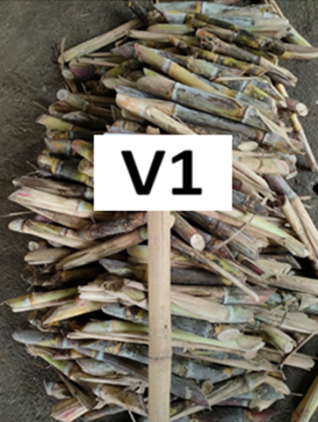
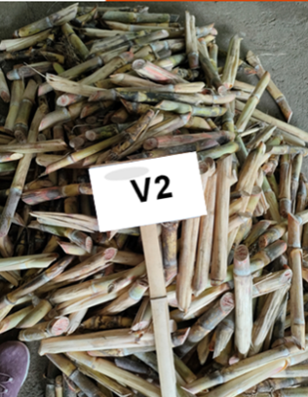
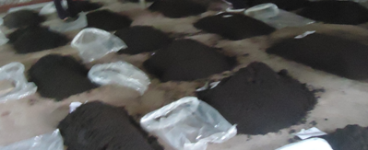
Phil 99-1793 Variety

VMC 67-252 Variety

Vermicompost used in the study

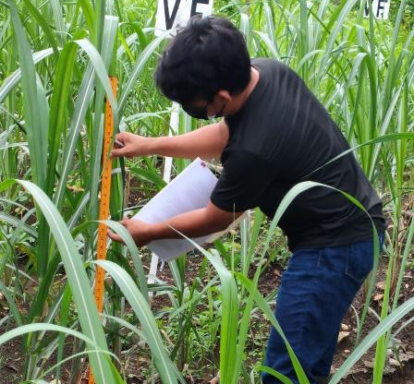
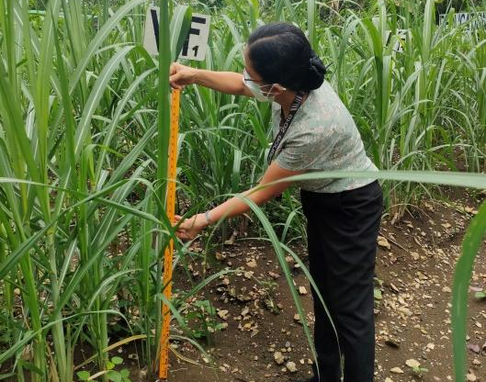

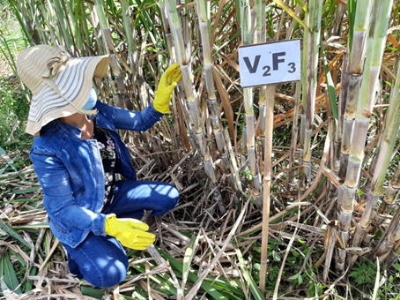
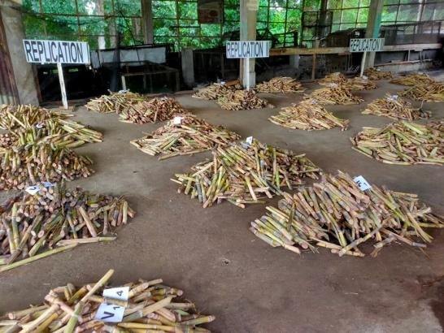
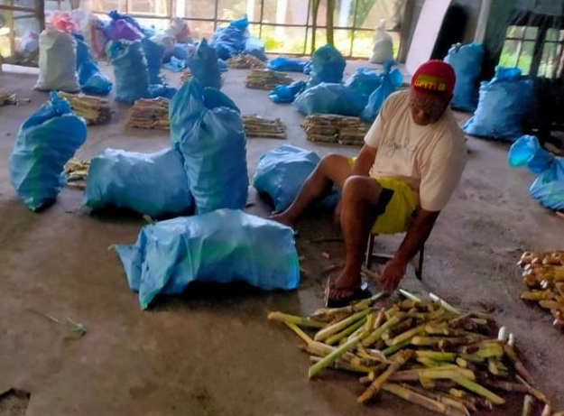
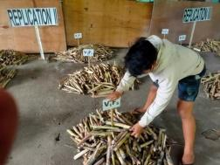
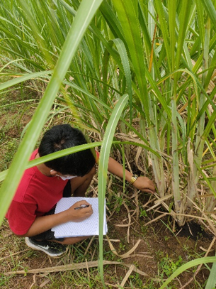
Gathering the height of the plants
Counting the number of tillers of experimental plants
Counting the cane points harvested

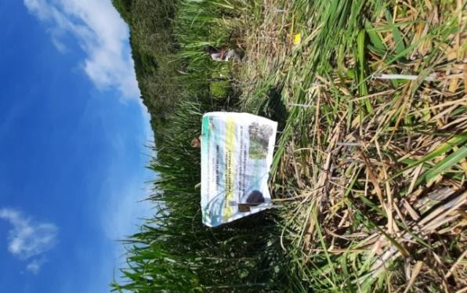
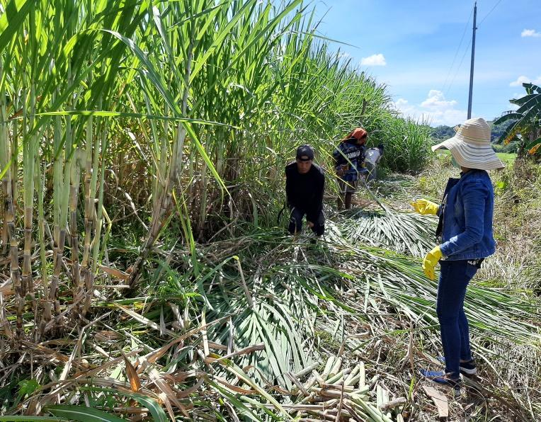
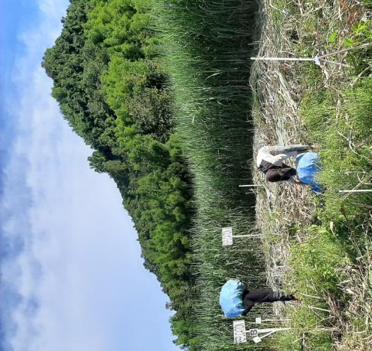
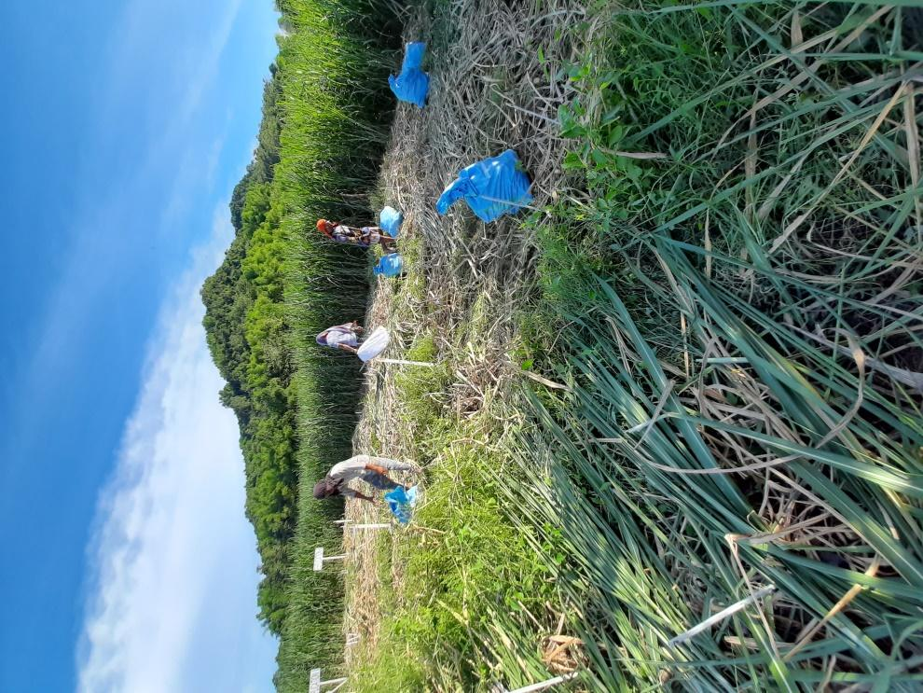
Experimental area during the termination of the study

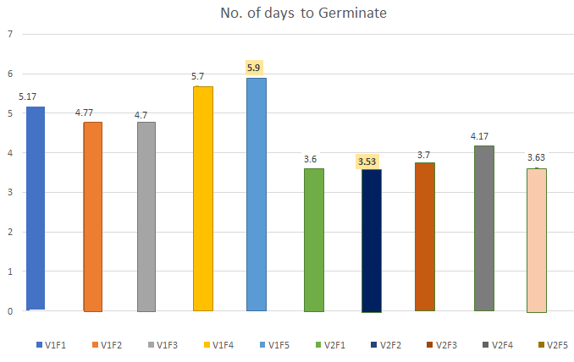

No. of
days
(day)

Treatment combinations

Figure 2. Graphical presentation on the number of days to germinate (day)

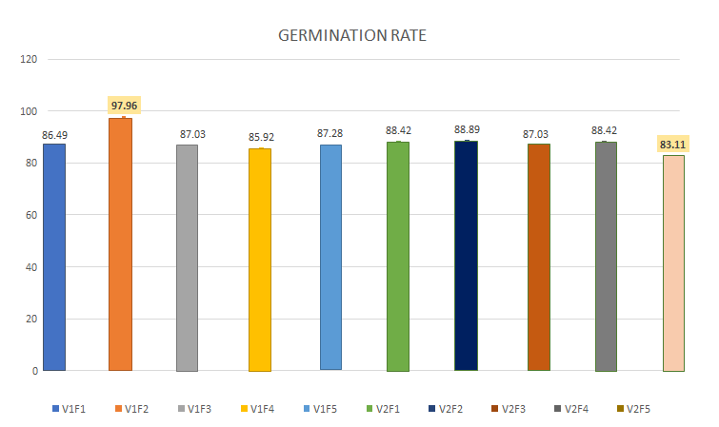

Germination
Rate
(%)

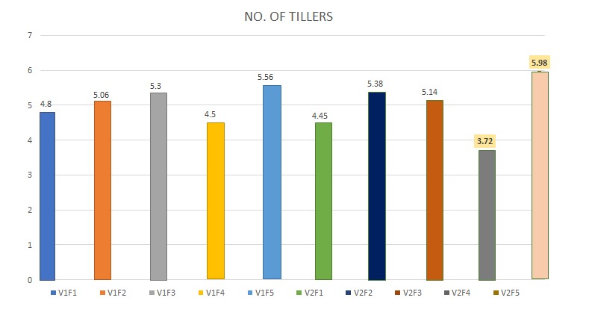
Figure 3. Graphical presentation on the germination rate (%)
Figure 4. Graphical presentation on the no. of tillers (pc)
Treatment combinations
Treatment combinations
No. of
tillers
(pc)

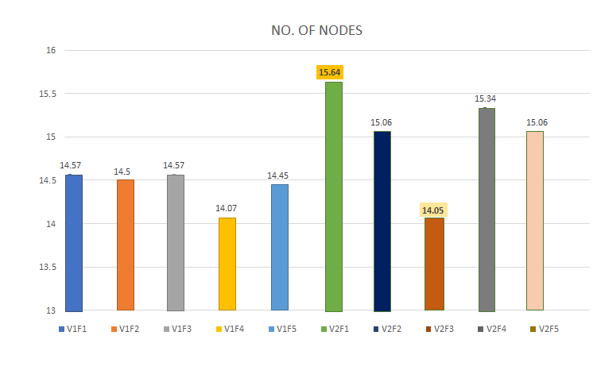
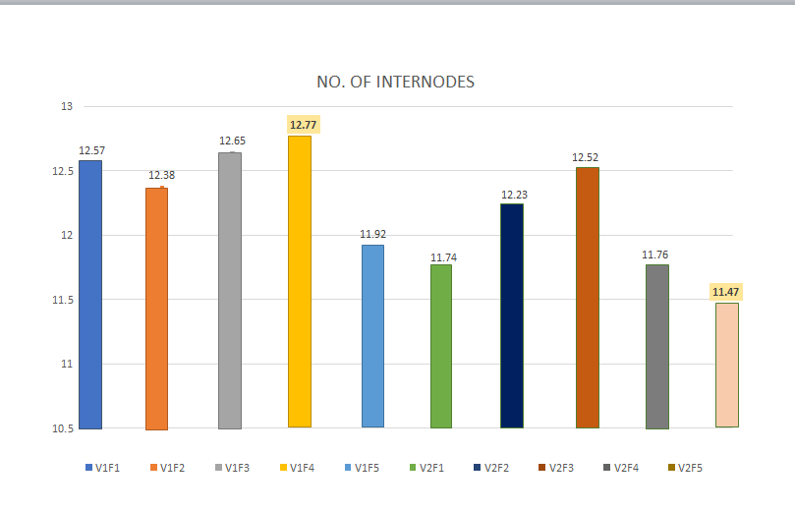
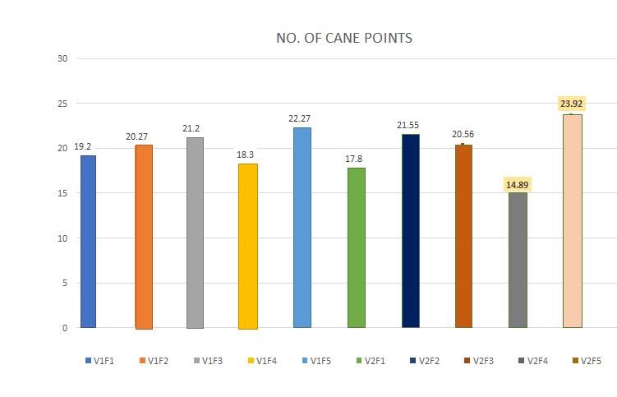
Figure 5. Graphical presentation on the no. of nodes (pc)
Figure 6. Graphical presentation on the no. of internodes
Figure 7. Graphical presentation on the no. of cane point harvested (pc)
Treatment combinations
Cane point harvested
(pc)
No. of
internodes
(pc)
No. of
nodes
(pc)
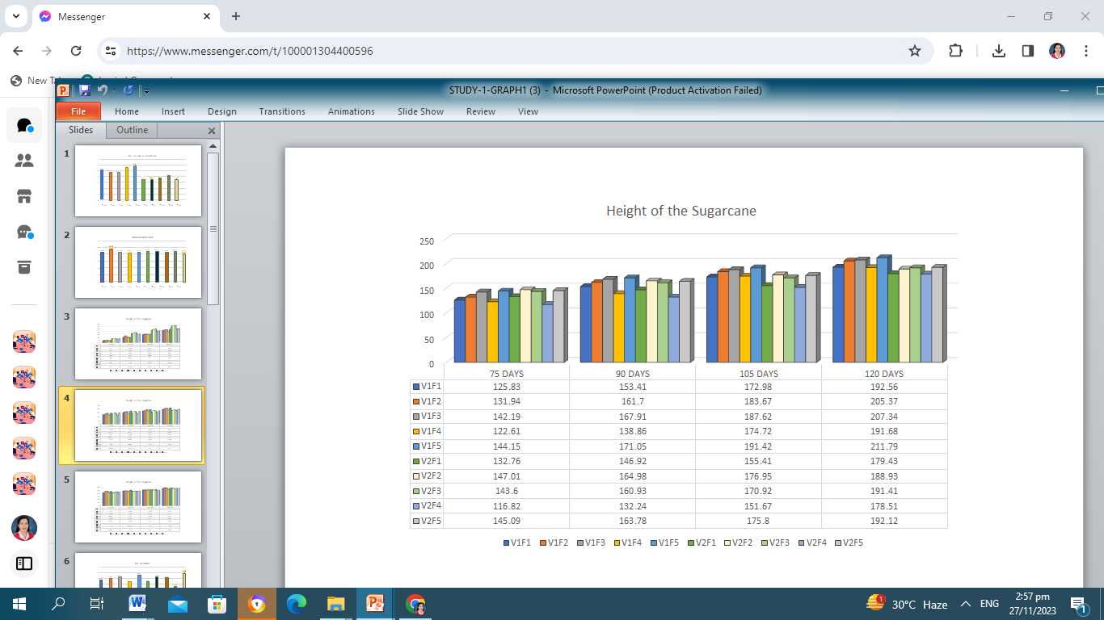
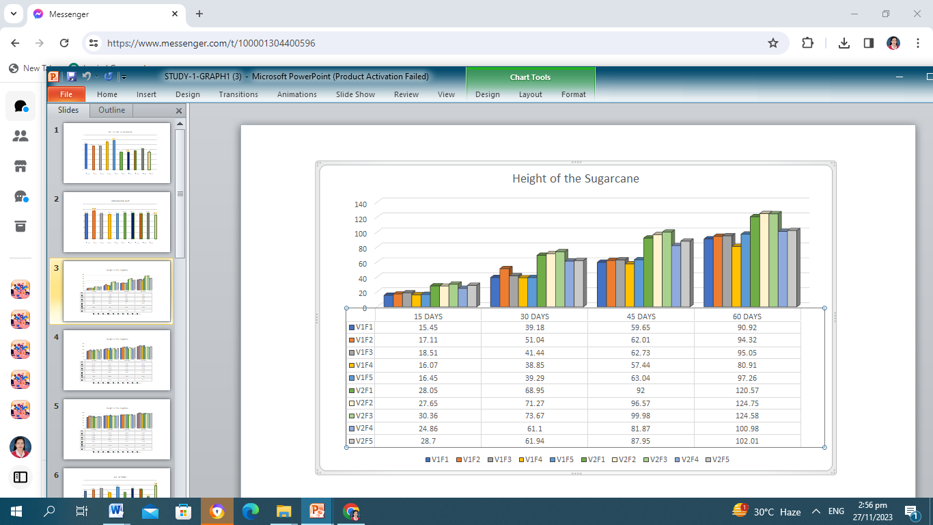
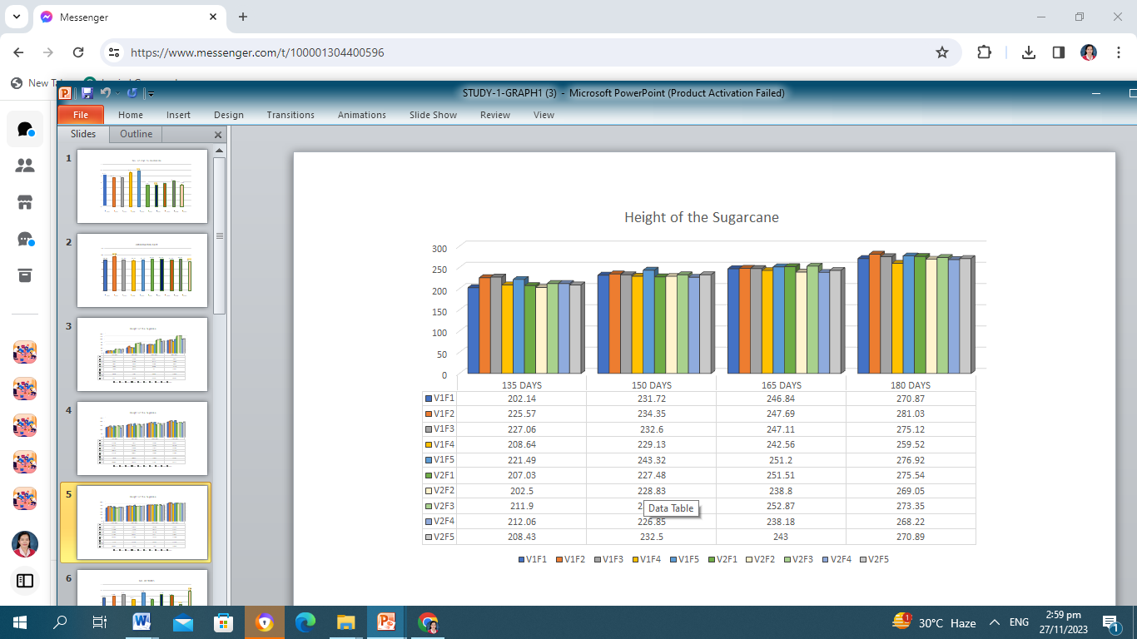
Figure 8. Graphical presentation on the height of plants
Treatment combinations
Treatment combinations
Treatment combinations
Height
(cm)

