Enhancing Customer Satisfaction in Hospitality Operations: A Systematic Review and Strategic Framework for Service Excellence
Lynda Dede Graham : Department of Hotel, Catering and Institutional Management,
Accra Technical University, Accra, Ghana.

Boris Kotey Sasraku-Neequaye: Department of Building Technology, Accra Technical University, Accra, Ghana.

Abstract
Purpose
Customer satisfaction remains a central determinant of competitiveness and sustainability in hospitality operations. Despite extensive scholarly attention, fragmented findings across service quality, technology adoption, employee engagement, and experience management have limited the development of a comprehensive operational framework. This paper systematically reviews contemporary literature to identify key drivers of customer satisfaction in hospitality operations and proposes an integrated strategic framework to enhance service performance.
Design/methodology/approach
A systematic literature review methodology was adopted. Peer-reviewed articles published between 2000 and 2025 were retrieved from Scopus, Web of Science, Emerald Insight, ScienceDirect, and Google Scholar. A total of 162 articles were screened, and 84 high-quality empirical and conceptual studies were analyzed using thematic synthesis. The review integrates dominant theoretical perspectives including SERVQUAL, Expectation–Confirmation Theory (ECT), the Kano Model, Relationship Marketing Theory, and Service-Dominant Logic.
Findings
Findings indicate that customer satisfaction in hospitality operations is influenced by five interconnected domains: (1) service quality dimensions (tangibles, reliability, responsiveness, assurance, empathy); (2) employee engagement and service climate; (3) technology-enabled personalization; (4) service recovery effectiveness; and (5) experiential and emotional value co-creation. Digital transformation and sustainability initiatives increasingly shape satisfaction perceptions. The study proposes a Customer Satisfaction Enhancement Framework (CSEF) integrating operational, relational, and experiential dimensions.
Practical implications
Hospitality managers should adopt an integrated approach that aligns employee training, digital innovation, service recovery systems, and experience design strategies. Continuous measurement systems, supported by data analytics and CRM technologies, are critical.
Originality/value
This study synthesizes dispersed literature into a unified operational framework and extends customer satisfaction research by integrating digital transformation and sustainability perspectives within hospitality operations.

Keywords
Customer satisfaction; Hospitality operations; Service quality; Experience management; Digital transformation; Service recovery; CRM; Employee engagement; Sustainability; Service excellence.

1. Introduction
Customer satisfaction is a foundational construct in hospitality management research and practice. The hospitality industry—encompassing hotels, restaurants, resorts, event venues, cruise operations, and tourism enterprises—operates within a service-intensive environment characterized by high customer contact, perishability, intangibility, and heterogeneity (Lovelock & Wirtz, 2022). Unlike tangible goods, hospitality services are produced and consumed simultaneously, making customer perception central to operational success.
The globalization of hospitality markets, digital transformation, and evolving customer expectations have intensified competition. Customers today evaluate services not only based on functional performance but also emotional engagement, personalization, ethical practices, and digital convenience (Kandampully et al., 2018). Online review platforms such as TripAdvisor and Booking.com amplify customer voices, directly influencing brand reputation and revenue performance (Xiang et al., 2017).
Scholarly research consistently demonstrates a strong relationship between customer satisfaction and loyalty, repurchase intention, positive word-of-mouth, and profitability (Kotler et al., 2022). However, hospitality operations face operational challenges such as labor shortages, service variability, technological disruptions, and sustainability pressures that complicate satisfaction management.
While numerous studies examine isolated factors—service quality, employee behavior, CRM systems, digital innovation—there remains a need for an integrated operational framework synthesizing these dimensions. This paper addresses this gap by systematically reviewing extant literature and proposing a comprehensive model for enhancing customer satisfaction in hospitality operations.

2. Aim and Objectives

2.1 Aim
To systematically review literature on customer satisfaction in hospitality operations and develop an integrated strategic framework for enhancing service excellence.

2.2 Objectives
- To identify major determinants of customer satisfaction in hospitality operations.
- To examine theoretical frameworks underpinning satisfaction research.
- To analyze the role of technology, employee engagement, and service recovery.
- To evaluate emerging themes such as sustainability and experiential value creation.
- To propose a comprehensive operational framework for enhancing satisfaction.

3. Methodology
A systematic literature review (SLR) approach was adopted following PRISMA guidelines (Moher et al., 2009).

3.1 Search Strategy
Databases searched:
- Scopus
- Web of Science
- Emerald Insight
- ScienceDirect
- Google Scholar
Keywords included:
“customer satisfaction in hospitality,”
“service quality hotels,”
“restaurant satisfaction,”
“hospitality service recovery,”
“digital transformation hospitality.”

3.2 Inclusion Criteria
- Peer-reviewed journal articles
- Published between 2000–2025
- Empirical or conceptual relevance to hospitality operations
- English language

3.3 Data Analysis
Thematic synthesis was employed to categorize findings into dominant constructs. NVivo coding techniques were applied to identify recurring patterns across studies.

4. Literature Review

4.1 Theoretical Foundations

4.1.1 SERVQUAL Model
Developed by Parasuraman et al. (1988), SERVQUAL measures service quality across five dimensions:
- Tangibles
- Reliability
- Responsiveness
- Assurance
- Empathy
Hospitality studies consistently confirm the model’s applicability, although contextual modifications are often required (Marković & Raspor, 2010).

4.1.2 Expectation–Confirmation Theory (ECT)
ECT posits that satisfaction results from comparing expectations with perceived performance (Oliver, 1980). In hospitality, expectation management is critical due to pre-purchase exposure via digital media.

4.1.3 Kano Model
The Kano model categorizes service attributes into basic, performance, and excitement factors (Kano et al., 1984). Luxury hospitality increasingly focuses on excitement factors.

4.1.4 Relationship Marketing Theory
Emphasizes long-term engagement and loyalty (Morgan & Hunt, 1994). CRM systems operationalize this approach.

4.2 Service Quality as a Core Driver
Service quality remains the strongest predictor of customer satisfaction (Cronin & Taylor, 1992). In hotels, cleanliness, comfort, and staff professionalism strongly influence perceptions (Ali et al., 2021).
Restaurants emphasize food quality, ambiance, and staff interaction (Ryu & Han, 2010). Consistency across touchpoints strengthens satisfaction outcomes.

4.3 Employee Engagement and Service Climate
Employee-customer interaction directly influences satisfaction (Heskett et al., 1994). The Service-Profit Chain demonstrates that employee satisfaction leads to customer loyalty.
Training, empowerment, and internal marketing improve service delivery (Kandampully et al., 2018).

4.4 Technology and Digital Transformation
Digital tools such as mobile check-in, AI chatbots, and CRM platforms enhance personalization (Buhalis & Leung, 2018).
Data analytics allows predictive service customization, increasing perceived value. However, over-automation may reduce human warmth.

4.5 Service Recovery and Complaint Management
Effective service recovery can increase post-failure satisfaction beyond initial levels (Smith et al., 1999). Transparency, empathy, and speed are critical.

4.6 Experiential Value Co-Creation
Service-Dominant Logic suggests customers co-create experiences (Vargo & Lusch, 2008). Hospitality brands increasingly design immersive experiences.

4.7 Sustainability and Ethical Practices
Sustainable practices positively influence satisfaction, especially among environmentally conscious travelers (Han et al., 2019).

5. Findings and Discussion
Five integrated determinants emerged:
- Core service quality performance
- Employee engagement
- Digital personalization
- Service recovery capability
- Experiential and sustainability value
These factors interact dynamically.

6. Proposed Framework: Customer Satisfaction Enhancement Framework (CSEF)
The CSEF includes:

Operational Core
- Service standards
- Quality assurance systems
- SOPs

Relational Layer
- CRM systems
- Loyalty programs
- Service recovery systems

Experiential Layer
- Emotional engagement
- Brand storytelling
- Sustainability initiatives

7. Practical Implications
Managers should:
- Invest in continuous staff training
- Implement integrated CRM analytics
- Develop structured recovery protocols
- Incorporate sustainability branding
- Monitor satisfaction through real-time dashboards

Figure 1 : Customer Satisfaction Enhancement Framework (CSEF)

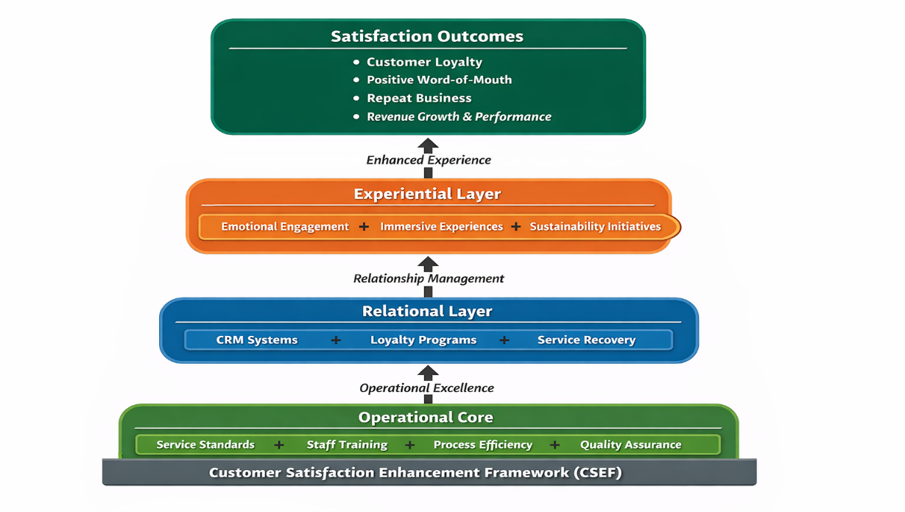

8. Conclusions
Customer satisfaction in hospitality operations is multidimensional, dynamic, and strategically vital. Integration of operational excellence, employee engagement, digital innovation, and experiential design enhances competitive advantage.
Future research should examine AI-driven personalization and sustainability-performance linkages.

9. Recommendations
- Adopt integrated satisfaction measurement systems.
- Strengthen employee empowerment programs.
- Invest in digital transformation aligned with human service values.
- Embed sustainability into service design.
- Develop predictive analytics for personalized experiences.

References (APA 7th Edition)
Ali, F., Amin, M., & Cobanoglu, C. (2021). An integrated model of service experience, emotions, satisfaction, and price acceptance. Journal of Hospitality Marketing & Management, 30(4), 450–472.
Buhalis, D., & Leung, R. (2018). Smart hospitality. International Journal of Contemporary Hospitality Management, 30(1), 268–292.
Cronin, J. J., & Taylor, S. A. (1992). Measuring service quality. Journal of Marketing, 56(3), 55–68.
Han, H., Yu, J., & Kim, W. (2019). Environmental responsibility and customer satisfaction. International Journal of Hospitality Management, 76, 83–93.
Heskett, J. L., Jones, T. O., Loveman, G. W., Sasser, W. E., & Schlesinger, L. A. (1994). Putting the service-profit chain to work. Harvard Business Review, 72(2), 164–174.
Kandampully, J., Zhang, T., & Jaakkola, E. (2018). Customer experience management. Journal of Hospitality Marketing & Management, 27(1), 21–56.
Kano, N., Seraku, N., Takahashi, F., & Tsuji, S. (1984). Attractive quality and must-be quality. The Journal of the Japanese Society for Quality Control, 14(2), 39–48.
Kotler, P., Bowen, J. T., & Makens, J. C. (2022). Marketing for hospitality and tourism (8th ed.). Pearson.
Lovelock, C., & Wirtz, J. (2022). Services marketing (9th ed.). Pearson.
Marković, S., & Raspor, S. (2010). Measuring perceived service quality using SERVQUAL. Tourism and Hospitality Management, 16(2), 181–195.
Moher, D., Liberati, A., Tetzlaff, J., & Altman, D. G. (2009). Preferred reporting items for systematic reviews. PLoS Medicine, 6(7), e1000097.
Morgan, R. M., & Hunt, S. D. (1994). The commitment-trust theory of relationship marketing. Journal of Marketing, 58(3), 20–38.
Oliver, R. L. (1980). A cognitive model of satisfaction decisions. Journal of Marketing Research, 17(4), 460–469.
Parasuraman, A., Zeithaml, V. A., & Berry, L. L. (1988). SERVQUAL. Journal of Retailing, 64(1), 12–40.
Ryu, K., & Han, H. (2010). Influence of physical environment on satisfaction. International Journal of Hospitality Management, 29(2), 310–320.
Smith, A. K., Bolton, R. N., & Wagner, J. (1999). A model of customer satisfaction with service encounters. Journal of Marketing Research, 36(3), 356–372.
Vargo, S. L., & Lusch, R. F. (2008). Service-dominant logic. Journal of the Academy of Marketing Science, 36(1), 1–10.
Xiang, Z., Du, Q., Ma, Y., & Fan, W. (2017). A comparative analysis of major online review platforms. Tourism Management, 58, 51–65.

