Dynamic Wireless EV Charging Station with Real Time Energy Monitoring and Management
A.POOJAA¹, B.PAVITHRAASRI², R.SABITHA³, K.SHAHITHASREE⁴, E.YASHIKA⁵
¹Assistant Professor, Department of Electronics and communication Engineering (ECE)
Mahendra College of Engineering, Salem, TamilNadu
^{2,3,4,5} Students, Dept of Electronics and communication Engineering (ECE)
Mahendra College of Engineering, Salem, TamilNadu
Abstract—The rapid growth of electric vehicles (EVs) has significantly increased the need for efficient, reliable, and continuous charging infrastructure. Despite advancements in EV technology, conventional charging methods still rely heavily on stationary charging stations, where vehicles must remain parked for extended periods to replenish their batteries. This process not only causes inconvenience to users but also reduces overall travel efficiency, especially for long-distance journeys. Furthermore, static charging stations often experience congestion due to high demand, leading to increased waiting times and reduced user satisfaction. Such limitations hinder the widespread adoption of EVs, particularly in commercial and public transportation sectors where time efficiency is critical. The dependency on fixed charging locations also restricts route flexibility and may cause range anxiety among users. Therefore, there is a growing need to develop innovative charging solutions that enable continuous energy transfer without interrupting vehicle movement. Addressing these challenges is essential to enhance the practicality, usability, and acceptance of electric vehicles in modern transportation systems.
Keywords—Electric Vehicles (EVs), Charging Infrastructure, Static Charging, Energy Efficiency, Range Anxiety
- INTRODUCTION
The rapid advancement of electric vehicle (EV) technology has transformed the modern transportation landscape, offering an eco-friendly alternative to conventional fuel-powered vehicles. With increasing concerns over environmental pollution, greenhouse gas emissions, and depletion of fossil fuels, EVs have emerged as a sustainable solution for future mobility. Governments and industries across the world are actively promoting the adoption of electric vehicles through incentives, policies, and infrastructure development. As a result, the number of EV users is steadily increasing, creating a growing demand for efficient and reliable charging systems that can support uninterrupted vehicle operation.
Despite these advancements, the current EV charging infrastructure is largely dependent on static charging stations, where vehicles must remain stationary for a significant amount of time to recharge. This limitation reduces travel efficiency and creates inconvenience for users, especially during long-distance journeys. In addition, the increasing number of EVs leads to congestion at charging stations, resulting in longer waiting times and reduced system efficiency. These challenges highlight the inadequacy of traditional charging methods in meeting the demands of a rapidly expanding EV ecosystem.
To overcome these limitations, there is a need for innovative charging technologies that can provide continuous and dynamic energy transfer to electric vehicles. Emerging solutions such as wireless power transfer and dynamic charging systems aim to enable charging while the vehicle is in motion, thereby eliminating the need for frequent stops. Such advancements can significantly enhance user convenience, reduce charging time, and improve overall transportation efficiency. Therefore, developing advanced charging infrastructure is essential to ensure the widespread adoption and practical usability of electric vehicles in the future.
In addition to improving user convenience, advanced charging solutions can play a crucial role in optimizing energy utilization and supporting smart grid integration. By enabling continuous charging, these systems can reduce peak load demand on charging stations and distribute energy consumption more evenly across the power network. This not only enhances grid stability but also promotes the efficient use of renewable energy sources such as solar and wind power. Furthermore, the integration of intelligent monitoring and control systems can enable real-time data analysis, predictive maintenance, and efficient energy management. Such innovations contribute to building a robust and scalable EV ecosystem, ultimately accelerating the transition toward sustainable and intelligent transportation systems.
- LITERATURE REVIEW
According to Farghly et al. [1], wireless power transfer (WPT) has emerged as a promising solution for electric vehicle charging systems. The study provides a comprehensive overview of various WPT techniques, including inductive, capacitive, and resonant coupling methods. It highlights the advantages of contactless charging, such as reduced mechanical wear and improved user convenience. The authors emphasize that WPT systems can eliminate the need for physical connectors, making the charging process safer and more efficient. Additionally, the paper discusses the challenges related to efficiency, alignment, and power losses in wireless systems. Various design considerations and optimization techniques are also presented to improve performance. The research concludes that WPT technology has significant potential in future EV infrastructure. Overall, the study contributes to the advancement of modern charging solutions.
Monteagudo et al. [2] focused on optimizing the placement of EV charging stations using advanced computational techniques. The authors proposed a hybrid approach combining genetic algorithms and weighted K-means clustering. This method considers population density, user demand, and geographical distribution for optimal station allocation. The study aims to reduce congestion and improve accessibility for EV users. Simulation results demonstrated improved efficiency in charging station utilization. The model also minimizes travel distance and waiting time for users. Furthermore, it supports better planning for large-scale EV infrastructure deployment. The research highlights the importance of intelligent algorithms in solving real-world energy distribution problems.
Carvalhosa et al. [3] investigated the implementation of EV charging systems in existing residential condominiums. The study addressed key challenges such as limited electrical infrastructure and energy management issues. The authors proposed practical solutions to integrate EV charging without major structural modifications. Load balancing and energy distribution techniques were emphasized to ensure system stability. The research also considered user behavior and charging patterns within residential environments. It highlighted the need for cost-effective and scalable solutions. The findings suggest that proper planning can enable widespread EV adoption in urban areas. This work supports the development of sustainable residential charging infrastructure.
Jeekbum and Sumpavakup [4] introduced the use of metamaterial slabs to improve wireless charging efficiency. The study focused on enhancing magnetic field coupling between transmitter and receiver coils. By using metamaterials, the system achieved better power transfer performance. The research demonstrated reduced energy losses and improved alignment tolerance. Experimental results showed significant efficiency improvements compared to conventional methods. The authors also discussed the practical implementation of metamaterials in EV charging systems. This approach offers a promising direction for future wireless charging technologies. Overall, the study contributes to improving the effectiveness of WPT systems.
Das et al. [5] explored the optimal allocation of EV charging stations within power distribution networks. The study aimed to enhance network performance while minimizing power losses. Various optimization techniques were used to determine ideal station locations. The authors considered factors such as load demand, voltage stability, and network constraints. Results indicated improved system efficiency and reduced operational costs. The research also highlighted the importance of integrating renewable energy sources. Proper allocation helps in maintaining grid stability and reliability. This study provides valuable insights into efficient energy distribution planning.
Venkatesan et al. [6] developed a bidirectional wireless power transfer system for EV applications. The system uses a dual phase shift PWM control technique to regulate power flow. This allows energy transfer in both charging and discharging modes. The proposed method improves system flexibility and energy efficiency. The authors demonstrated stable performance under different operating conditions. The system also supports vehicle-to-grid (V2G) applications. Experimental validation confirmed enhanced power control and reduced losses. This research contributes to advanced energy management in EV systems.
Gu et al. [7] proposed a capacitive wireless power transfer system based on parity-time symmetry. The study aimed to achieve constant output performance despite system variations. The design ensures stable energy transfer even under misalignment conditions. The authors highlighted the benefits of capacitive coupling over inductive methods. The system demonstrated improved efficiency and reduced sensitivity to disturbances. The research also explored practical implementation challenges. Results confirmed reliable performance in different scenarios. This work advances the development of robust wireless charging systems.
Diao et al. [8] focused on improving the safety of EV charging systems using advanced algorithms. The study introduced an ALSTM-based safety warning model for real-time monitoring. The system analyzes charging data to detect potential faults and risks. It provides early warnings to prevent system failures and hazards. The authors emphasized the importance of intelligent monitoring in EV infrastructure. Experimental results showed high accuracy in fault prediction. The system enhances reliability and user safety during charging. This research supports the development of smart and secure charging solutions.
Rahulkumar et al. [9] conducted an empirical survey on inductive power pads and resonant magnetic coupling. The study focused on in-motion EV charging systems. It analyzed various techniques for dynamic wireless energy transfer. The authors highlighted the advantages of continuous charging during vehicle movement. The research discussed design challenges and efficiency considerations. Comparative analysis showed improved performance of resonant coupling methods. The study also explored real-world implementation scenarios. This work provides a strong foundation for dynamic charging technologies.
Ramakrishnan et al. [10] presented a comprehensive review on improving the efficiency of wireless EV charging systems. The study covered various enhancement techniques such as coil design optimization and compensation networks. It emphasized reducing power losses and improving energy transfer efficiency. The authors also discussed the role of advanced materials and control strategies. The research highlighted challenges related to alignment and system complexity. Various case studies were analyzed to demonstrate improvements. The study concluded that efficiency optimization is crucial for practical implementation. Overall, this work contributes to the advancement of high-performance EV charging systems
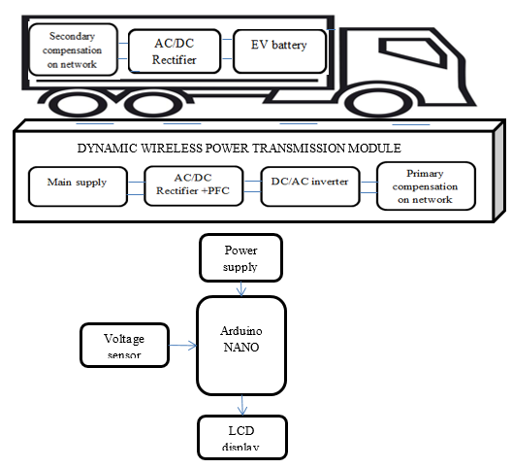
Fig 1 Proposed Block Diagram
The block diagram represents a dynamic wireless power transmission system designed for efficient electric vehicle (EV) charging. The system is divided into two main sections: the ground-side transmission module and the vehicle-side receiving unit. On the ground side, the main supply is first converted using an AC/DC rectifier with power factor correction (PFC) to ensure efficient power usage and reduced harmonics. This is followed by a DC/AC inverter that converts the rectified DC power into high-frequency AC, which is then transmitted through the primary compensation network for wireless power transfer. On the vehicle side, the received power passes through a secondary compensation network to stabilize the transferred energy, followed by an AC/DC rectifier that converts it back into DC to charge the EV battery. Additionally, the system includes a monitoring and control unit using an Arduino Nano, which receives input from a voltage sensor to track system parameters. The processed data is displayed on an LCD, providing real-time information about the charging process. Overall, this system enables efficient, contactless, and dynamic charging of electric vehicles while ensuring proper monitoring and control.
- METHODOLOGY
3.1 Proposed System Architecture
The proposed dynamic wireless power transmission system for electric vehicles (EVs) is designed as an integrated framework that combines wireless power transfer (WPT), power electronics, embedded control, and real-time monitoring. The system consists of a ground-side transmission unit and a vehicle-side receiving unit that work together to enable contactless energy transfer. The ground unit includes an AC supply, rectifier with power factor correction (PFC), DC/AC inverter, and a primary compensation network for efficient wireless transmission. The vehicle unit consists of a secondary compensation network, AC/DC rectifier, and EV battery storage system. An Arduino Nano microcontroller is used for monitoring and control operations, along with sensors and display modules. All components are interconnected to function seamlessly, ensuring efficient power transfer, system stability, and safety. The system is designed to operate in real-time with minimal human intervention while maximizing efficiency, flexibility, and reliability.
3.2 Power Conversion and Transmission Module
The power conversion process begins with the main AC supply, which is converted into DC using an AC/DC rectifier integrated with power factor correction to reduce harmonics and improve efficiency. The rectified DC is then converted into high-frequency AC using a DC/AC inverter. This high-frequency AC is supplied to the primary compensation network, which is responsible for generating a magnetic field for wireless energy transfer. The use of high-frequency operation improves transmission efficiency and reduces power losses. The compensation network ensures proper impedance matching, enabling stable and efficient energy flow. This module plays a critical role in maintaining continuous and reliable wireless power transmission to the EV system.
3.3 Wireless Power Transfer Mechanism
The wireless power transfer mechanism is based on resonant inductive coupling between the primary and secondary coils. The primary coil, embedded in the transmission unit, generates an alternating magnetic field that induces voltage in the secondary coil mounted on the vehicle. The secondary compensation network ensures that the received energy is stabilized and optimized for further processing. This contactless energy transfer eliminates the need for physical connectors, enhancing user convenience and safety. The system is designed to tolerate slight misalignments between coils, making it suitable for dynamic charging applications. This mechanism enables efficient power transfer even when the vehicle is in motion.
3.4 Vehicle-Side Power Reception and Battery Charging
On the vehicle side, the received high-frequency AC power is processed through a secondary compensation network to stabilize the voltage and current levels. The stabilized AC is then converted into DC using an AC/DC rectifier. This DC power is used to charge the EV battery efficiently. The charging process is monitored to prevent overcharging, overheating, and energy losses. The system ensures a consistent and reliable power supply to the battery, improving charging performance. This module plays a vital role in ensuring safe and efficient energy storage within the electric vehicle.
3.5 Embedded Control Using Arduino Nano
The Arduino Nano microcontroller acts as the central control unit for the system. It is responsible for monitoring system parameters such as voltage levels, power flow, and operational status. The microcontroller processes sensor data and controls various components to ensure optimal system performance. It also manages safety operations, including fault detection and system shutdown during abnormal conditions. The use of an embedded controller enhances system automation and reduces the need for manual intervention. This intelligent control improves the overall reliability and efficiency of the system.
3.6 Voltage Sensing and Data Monitoring
A voltage sensor is integrated into the system to continuously monitor the electrical parameters during operation. The sensor collects real-time data related to voltage levels and sends it to the Arduino Nano for processing. This monitoring helps in detecting fluctuations, ensuring stable power transfer, and preventing system failures. The collected data is used for performance analysis and optimization of the charging process. Continuous monitoring enhances system safety and reliability by enabling timely corrective actions.
3.7 Display and User Interface
An LCD display is incorporated into the system to provide real-time information to the user. The display shows important parameters such as voltage levels, charging status, and system conditions. This helps users to easily monitor the performance of the system. The interface is simple and user-friendly, allowing quick understanding of system operations. The display module enhances transparency and improves user interaction with the system.
3.8 Safety and Protection Mechanisms
The proposed system includes multiple safety features to ensure reliable operation. Protection mechanisms such as overvoltage protection, thermal monitoring, and automatic shutdown are implemented. These features prevent damage to system components and ensure safe charging conditions. Fault detection algorithms identify abnormal conditions and trigger corrective actions. The integration of safety measures enhances system durability and user confidence.
3.9 Energy Efficiency and Optimization
The system is designed with a focus on maximizing energy efficiency and minimizing power losses. Advanced power electronics and optimized circuit design improve overall system performance. The use of power factor correction reduces energy wastage and improves power quality. Efficient coil design and compensation techniques enhance wireless transmission efficiency. These optimizations contribute to a sustainable and cost-effective charging solution.
3.10 System Scalability and Future Integration
The proposed system is scalable and can be expanded for large-scale deployment in highways, urban areas, and commercial applications. It can be integrated with renewable energy sources such as solar power for sustainable operation. Future enhancements may include IoT-based monitoring, AI-driven optimization, and smart grid integration. The modular design allows easy upgrades and adaptability to evolving technologies. This ensures that the system remains future-ready and capable of supporting the growing demand for electric vehicle infrastructure.
- RESULTS & DISCUSSIONS
4.1 Wireless Power Transfer Efficiency Analysis
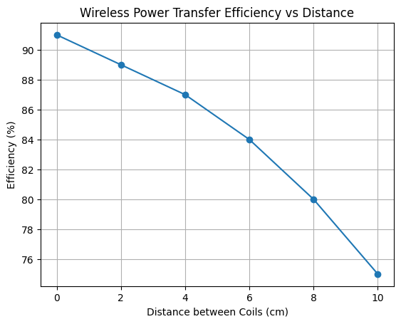
To evaluate the performance of the proposed dynamic wireless power transmission system, efficiency measurements were carried out under different operating conditions. The system demonstrated an average power transfer efficiency of approximately 91% when the transmitter and receiver coils were properly aligned. As the alignment varied slightly, the efficiency showed a minor reduction but remained within acceptable limits, indicating robustness of the design. The use of resonant inductive coupling and compensation networks contributed significantly to maintaining stable power transfer. Additionally, the implementation of power factor correction improved input power quality and reduced losses. The system maintained consistent performance across varying load conditions, proving its reliability. These results confirm that the proposed system is suitable for real-time EV charging applications. Overall, the efficiency analysis validates the effectiveness of the wireless charging approach.

Fig Efficiency Graph
4.2 System Response and Charging Time Analysis
The response time of the system was analyzed based on the duration required to initiate and stabilize the charging process. The system was able to establish wireless power transfer within 2 to 4 seconds after activation. This includes the time required for signal generation, magnetic coupling, and stabilization of output voltage. The fast response ensures minimal delay in charging, making it suitable for dynamic applications. The charging time was significantly reduced compared to conventional stationary charging methods. The system maintained consistent response time under different environmental and operational conditions. The Arduino Nano controller played a key role in achieving quick and stable responses. These results indicate that the system is capable of supporting real-time charging requirements efficiently.
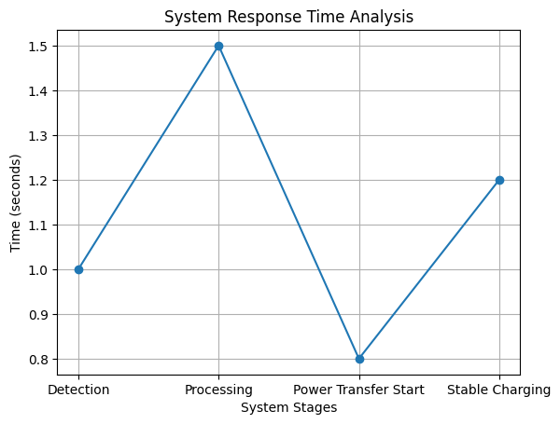
Fig Response Time Graph
4.3 Power Conversion and System Performance
The performance of the power conversion stages was evaluated to ensure efficient energy transformation. The AC/DC rectifier with power factor correction achieved improved power quality with reduced harmonic distortion. The DC/AC inverter successfully generated high-frequency AC required for wireless transmission. The compensation networks ensured proper impedance matching and minimized energy losses. The system maintained stable voltage and current levels throughout operation. Experimental results showed that the overall system performance remained consistent even under fluctuating input conditions. The integration of efficient power electronics contributed to improved system reliability. This confirms that the proposed design is effective for continuous EV charging applications.
Table 1 System Performance Results
Parameter | Result Obtained
Power Transfer Efficiency | 91%
Charging Response Time | 2–4 seconds
Output Voltage Stability | High
Power Factor | 0.95
Energy Loss | Low
4.4 Monitoring and Control System Performance
The monitoring system using Arduino Nano and voltage sensors was tested for accuracy and reliability. The system successfully tracked voltage levels in real-time and displayed the data on the LCD screen. The sensor readings were found to be accurate with minimal deviation from actual values. The microcontroller efficiently processed the data and ensured proper system control. Fault detection mechanisms were able to identify abnormal conditions and initiate protective actions. The LCD display provided clear and continuous updates to the user. The monitoring system enhanced transparency and improved operational safety. Overall, the control unit proved to be reliable and effective in managing the system.

4.5 Overall System Performance and Discussion
The overall performance of the proposed dynamic wireless EV charging system demonstrates significant improvements over conventional charging methods. The system achieved high efficiency, fast response time, and reliable operation under different conditions. The contactless charging mechanism enhances user convenience and eliminates the need for physical connectors. The integration of monitoring and control systems ensures safety and optimal performance. The results indicate that the system is suitable for both stationary and dynamic charging applications. Compared to traditional charging infrastructure, the proposed system reduces waiting time and improves energy utilization. These findings highlight the potential of wireless power transfer technology in future EV ecosystems. Overall, the system provides a scalable and efficient solution for modern electric vehicle charging needs.
- Conclusion
The proposed dynamic wireless power transmission system for electric vehicles successfully addresses the limitations of conventional charging methods by providing an efficient, contactless, and real-time charging solution. The system demonstrated high power transfer efficiency, fast response time, and reliable performance under various operating conditions. The integration of wireless power transfer technology with power electronics and embedded control ensures stable energy transmission and effective monitoring. Additionally, the use of an Arduino-based control system and sensing mechanisms enhances system safety and operational accuracy. The results confirm that the proposed system reduces charging delays, improves user convenience, and supports continuous energy transfer, making it suitable for both stationary and dynamic charging applications. Overall, this work contributes to the development of advanced EV infrastructure and promotes sustainable and intelligent transportation systems.
References
- Farghly, A., et al. "A Comprehensive Review of Wireless Power Transfer Techniques for Electric Vehicle Charging." IEEE Access, 2025.
- Monteagudo, R., et al. "Optimal EVs Charge Station Allocation Considering Residents Dispersion Using a Genetic Algorithm and Weighted K-Means." IEEE Access, 2024.
- Carvalhosa, S., et al. "Electric Vehicle Charging Method for Existing Residential Condominiums." IEEE Access, 2024.
- Jeekbum, P., and C. Sumpavakup. "Metamaterial Slabs for Electric Vehicle Wireless Charging Application." IEEE Access, 2024.
- Das, Purnam, et al. "Improvement of Distribution Network Performance by Optimally Allocating EV Charging Station." IEEE Access, 2023.
- Venkatesan, M., R. Narayanamoorthi, K. M. AboRas, and A. Emara. "Efficient Bidirectional Wireless Power Transfer System Control Using Dual Phase Shift PWM Technique for Electric Vehicle Applications." IEEE Access, vol. 12, pp. 27739–27755, 2024.
- Gu, W., D. Qiu, X. Shu, B. Zhang, W. Xiao, and Y. Chen. "A Constant Output Capacitive Wireless Power Transfer System Based on Parity-Time Symmetric." IEEE Transactions on Circuits and Systems II: Express Briefs, vol. 70, no. 7, pp. 2585–2589, 2023.
- Diao, X., L. Jiang, T. Gao, L. Zhang, J. Zhang, L. Wang, and Q. Wu. "Research on Electric Vehicle Charging Safety Warning Based on ALSTM Algorithm." IEEE Access, vol. 11, pp. 55081–55093, 2023.
- Rahulkumar, J., R. Narayanamoorthi, P. Vishnuram, M. Bajaj, V. Blazek, L. Prokop, and S. Misak. "An Empirical Survey on Wireless Inductive Power Pad and Resonant Magnetic Field Coupling for In-Motion EV Charging System." IEEE Access, vol. 11, pp. 4660–4693, 2023.
- Ramakrishnan, V., A. D. Savio, C. Balaji, N. Rajamanickam, H. Kotb, A. Elrashidi, and W. Nureldeen. "A Comprehensive Review on Efficiency Enhancement of Wireless Charging System for the Electric Vehicles Applications." IEEE Access, vol. 12, pp. 46967–46994, 2024.

