FROM GREEN PRACTICES TO STRATEGIC HR:

INTRODUCTION
The consequences of industrial operations, including pollution and the accumulation of waste and residues, are becoming increasingly apparent. The world is currently surrounded by environmental issues caused by carbon emissions, global warming, and climate change. Organizations face a new set of challenges to combat climate change by adjusting competitive and regulatory scopes, by showing commitment to curb carbon emissions, which finally leads to extreme weather events. The increasing regulatory and societal pressure drives organizations to proactively implement green practices in the transition to environmental sustainability. Organizations are battling to introduce green innovation to lessen the effects of environmental deterioration by creating products that are less detrimental to the ecosystem, in addition to investing in renewable energy and low-carbon technologies.
As businesses have grown, they are becoming more concerned with environmental issues and actively looking for sustainable resources, which not only give them a competitive advantage but are also linked to the welfare of society. Organizations have started to adapt their practices with environmental sustainability by adopting GHRM. As discussed by Kim et al. (2019), GHRM contributes positively to the green behavioural outcomes of employees that subsequently lead to their performance in terms of innovation, finances, social issues, and the environment. To reduce environmental harm, GHRM allows senior management to focus on policies that encourage people to participate in green activities and represent environmental preservation as the organization's focus (Oh et al., 2016).
Most prior scholarship has predominantly emphasized structural interventions, particularly within the domain of GHRM, which encompasses practices such as green recruitment, green training and development, green performance appraisal, and green reward systems (Fawehinmi et al., 2020; Shabban & Edgar, 2025). This stream of research is grounded in the assumption that formalized organizational systems and policies serve as primary mechanisms for shaping green among employees. For instance, green recruitment ensures the attraction and selection of individuals whose values align with environmental sustainability, while green training enhances employees’ knowledge and competencies required to perform environmentally responsible tasks.
Not only highlighting the organization's commitment to environmental issues, implementing GHRM is known as an evolving concept that integrates environmental sustainability into human resource practices (Kramar, 2014). It emerged from the wide-ranging discussions on sustainable development and corporate responsibility, emphasizing the role of employees in fostering an environmentally conscious workplace. It can be regarded as the organizational instrument that unifies individuals with environmental sustainability through a series of activities centered on human resources, adaptable across various organizational roles (Renwick et al., 2013). This is suggested throughout an employee's entire life cycle, beginning with recruitment and ending with exit policy. (Benn et al., 2015; Jabbour et al., 2010; Zibarras & Coan, 2015). Benevene and Buonomo (2020) assert that green practices typically encompass training and development, performance management and evaluation, reward systems, and recruiting and selection. Green hiring refers to the process through which companies seek to employ individuals who are environmentally conscious and possess the necessary skills and expertise to address issues related to the environment (Song et al. 2021). Similarly, green training equips employees with the skills, information, and competencies required for green innovation. Employing green talent will enable businesses to develop eco-friendly products and procedures (Chowhan, 2016).
At its core, GHRM refers to the efforts made by organizations to align their human resource strategies with the broader environmental goals of sustainability. This can be achieved by involving the development of Human Resource (HR) practices that not only support the organization's operational goals but also contribute to reducing its ecological footprint (Jabbour, 2013). Active engagements in GHRM are often perceived as socially responsible and environmentally conscious, which can attract eco-conscious consumers and strengthen relationships with stakeholders. Such green activities will help the organization obtain an attractive green image with enhanced environmental performance (Tang et al., 2018). The attention organizations wish to give to green issues is reflected in the extent of the integration of a company's corporate GHRM strategy into its performance management system (Marcus & Fremeth, 2009).
Therefore, this study aims to assess Scopus publications in GHRM using bibliometric analysis to determine the extent of research that has been done. This paper's method section, which discusses the procedures needed to gather and analyse the data, comes next. The results are then separated into two categories: conceptual structure and descriptive analysis. Finally, knowledge discoveries will be discussed in the discussion and conclusion sections together with the suggestions to be used by future research on GHRM.

LITERATURE REVIEW
This study is to map the literature using a bibliometric analysis on the development of GHRM from 2010 to 2025, considering the growing significance and attention given to GHRM. According to Ellegaard and Wallin (2015), the application of statistical methods in bibliometric analysis can enable a quantitative evaluation of scientific output. The quality of the article reviews could be raised by implementing a methodical, open, and repeatable review process using these bibliometric techniques. By directing the researcher to the most significant publications and outlining the research field, they serve as a helpful tool in literature reviews by mitigating subjective bias. The bibliometric analysis also enables researchers to ground their findings in aggregated bibliographic data generated by other scholars, whether through citation, collaboration, or authorship (Zupic & Čater, 2015).

This study introduces an open-source bibliometric tool developed in R, following a standardised and reproducible bibliometric workflow. The analysis and visualisation of research patterns on GHRM were carried out through the Biblioshiny interface, an extension of the bibliometrix package. Generating an interactive bibliometric dashboard with the program's user-friendly interface requires very few lines of code, making it easy to use for researchers who do not know how to program. According to Aria and Cuccurullo (2017), this program benefits from being an open-source product that is improved and expanded on by a large, active global community of contributors, including data scientists and statisticians from all over the world. Because the framework is based on biblioshiny, it can be easily updated and works well with other analytical packages available in R. This combined functionality supports continued work on an ever-changing field of bibliometric analysis.

Methodology
This study aims to map the intellectual structure, research evolution, and conceptual foundations of the GHRM domain. The research process was conducted in five systematic phases: Phase 1: Development of the study design, Phase 2: Collecting the data, Phase 3: Screening the data, Phase 4: Conducting the bibliometric analysis, and Phase 5: Conducting knowledge discovery. Considering its extensive bibliographic coverage and reliable metadata, including titles, abstract in English, author name, author affiliation, document type, journal title, and citation metrics (Mika et al., 2016). The Scopus core collection was selected as the primary database.

Data were extracted using the term "Green Human Resource Management," and all records were exported in CSV format on 15 January 2025. Subsequently, the Biblioshiny package in R was employed to perform bibliometric mapping and conceptual structure analysis of GHRM literature. The overall workflow and methodological stages are illustrated in Figure 1.

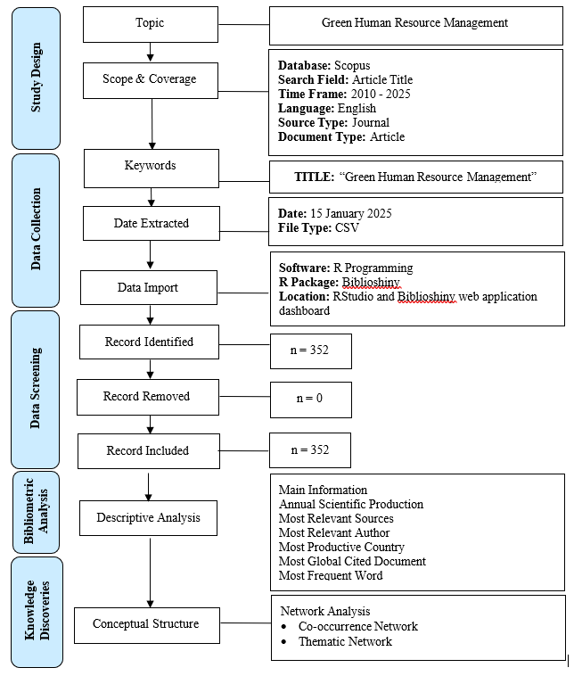

Figure 1: Methodologies Phases of Bibliometric Research (Source: Aria & Cuccurullo, 2017; Firdaus et al., 2019).

Results and Discussion
In this part, the analysis will be divided into two parts: descriptive and network analysis.

Descriptive Analysis
Main Information
MAIN INFORMATION
Timespan | 2010:2025
Sources (Journals) | 233
Documents | 352
Document Average Age | 3.1
Average citations per doc | 34.52
DOCUMENT CONTENTS
Keywords Plus (ID) | 649
Author's Keywords (DE) | 1040
AUTHORS
Authors | 1215
Authors of single-authored docs | 43
AUTHORS COLLABORATION
Single-authored docs | 51
Co-Authors per Doc | 3.3
International co-authorships % | 37.88
DOCUMENT TYPES
Article | 352
Table 1 summarises the key bibliometric characteristics of the documents imported into Biblioshiny from the Scopus database. The search produced 352 publications drawn from 233 distinct sources, covering the period 2010 to 2025. On average, each article received 34.52 citations, indicating a moderate level of scholarly impact within the GHRM research domain.

Table 1: Main Information of Retrieved Articles

A total of 1,215 authors participated in the writing of 352 documents, showing the intense contribution of researchers in this field. Additionally, 43 documents were single-authored. On author collaboration, the data showed that 51 articles were written by a single
author, and 37.88% were international co-authorships. The table indicates that research on GHRM is still in its early stages and needs further investigation globally.

Annual Scientific Production
As indicated in Figure 2, the annual scientific production of GHRM began in 2010 and continued until 2014 with one article. Production only began to continue in 2015 with three (3) articles and increased to 11 in 2016 before declining to six (6) articles the following year. The publication only began to increase consistently in 2018 with fifteen articles (15), 2019 (20), and 2020 (48). Most articles ever published were witnessed in 2024 (140). However, the one (1) publication of 2025 is yet to be the total because the data were captured on 15 January 2025.
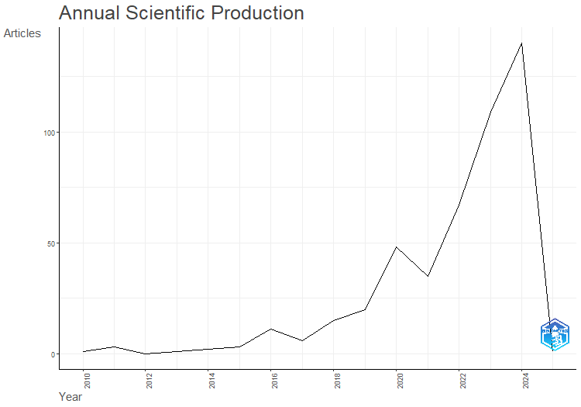
Figure 2: Annual Scientific Production on Green Human Resource Management

Most Relevant Sources

As shown in Figure 3, the analysis conducted using Biblioshiny identified the ten most prolific journals contributing to the GHRM literature, ranked according to the total volume of publications retrieved from the Scopus dataset. During the period 2010 to January 15, 2025, the Journal of Sustainability (Switzerland), with 25 articles, was ranked first for publishing GHRM studies. Later sources were the International Journal of Manpower with a count of 14, Environmental Science and Pollution Research and International Journal of Human Resource Management with a tie of 12 articles, and Green Human Resource Management: A View from Global South Countries and Journal of Cleaner Production with the identical figure of ten (10) articles. Having nine (9) articles each were sourced from Corporate Social Responsibility and Environmental Management and International Journal of Sustainability Development and Planning. And as for Business Strategy, The Environment and Frontiers in Psychology journals, they produce seven (7) articles. The top ten journals identified as leading contributors to GHRM research represent the principal publication outlets where scholars can access significantly updated research results, conceptual discussions, and evidence-based findings related to GHRM.
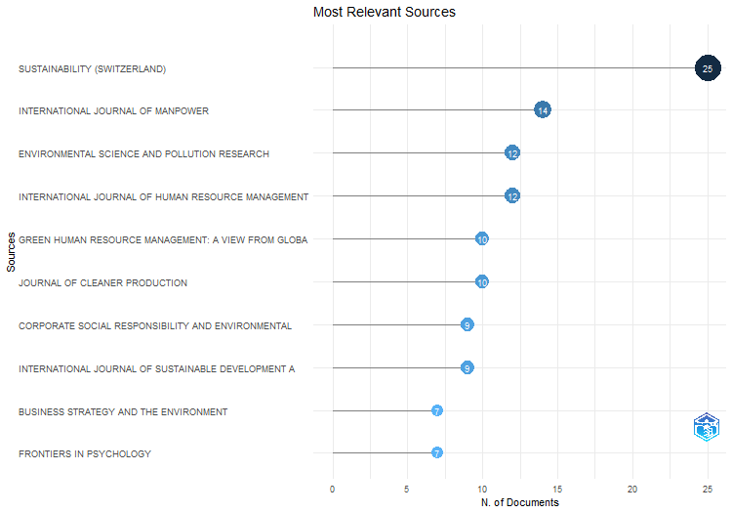

Figure 3: Most Relevant Sources on Green Human Resource Management Sources

Most Relevant Author
As shown in Figure 4, Biblioshiny showed that authors with the most published articles were also the most prominent authors in HRM. This ranking was determined by the total of published articles for all authors on all records included in the review process. In total, 1,215 unique authors were involved in producing 352 publications related to GHRM. This supports an increased interest in the research community, as well as the collaborative aspect of the research. Figure 4 shows the top ten authors based on the number of authored articles. Yusliza MY was the highest author with 16 articles, followed by Ramayah T (10). Yong YJ, with 9 articles, and Nisar QA authored 8 articles. Fawehimni O and Tanveer MI contributed 7 articles, and Renwick DWS and Singh S contributed 6 articles each. Finally, with 5 articles, Ahmed U and Ho TH. They are the most prolific authors to contribute to GHRM knowledge.

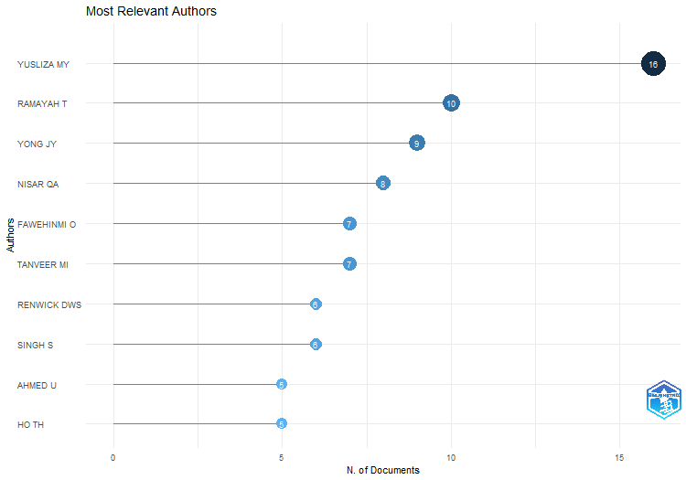

Figure 4: The Most Relevant Author in GHRM Research in Terms of the Number of Articles Published
Most Productive Country
Based on Biblioshiny's research and filtering, Figure 5 shows the nations that published the most papers on GHRM. The most productive countries were determined by the "Country Scientific Production" measure, which counts the number of "author appearances by country affiliation" rather than the research location. The 61 blue-coloured nations that made contributions to the GHRM study's scholarly output between 2010 and January 15, 2025, are highlighted in Figure 5. The map's blue gets darker as more articles are produced. The Indian authors received the highest rating for the subject contribution with a total of 228 frequencies. The United Kingdom (59), Australia (49), Saudi Arabia (46), Malaysia (202), China (178), Indonesia (88), Pakistan (209), Spain (25), and the United States of America (23) come next. This suggests that the home countries of the authors are significantly advancing the field of GHRM research.

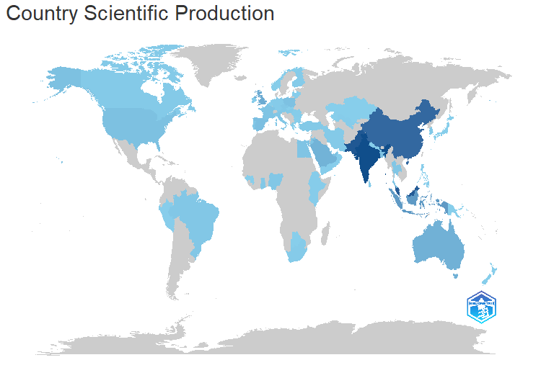

Figure 5: Countries' Scientific Production on Green Human Resource Management

Most Global Cited Document
Out of the 352 papers on GHRM in the Scopus database, Table 2 lists the top 10 most referenced articles worldwide together with the total number of citations received annually.

Table 2: Most Global Cited Document

Paper | Total Citations | TC per Year
Singh SK, 2020,  Technol. Forecast. Soc. Chang. | 1100 | 183.333333
Dumont J, 2017,  Human Resource Management | 805 | 89.4444444
Saeed BB, 2019,  Corporate Social Responsible Environmental Management | 554 | 79.1428571
Jackson SE, 2011,  Z. Fur Pers. | 487 | 32.4666667
Yong JY, 2020,  Business Strategy Environment | 392 | 65.3333333
Guerci M, 2016,  International Journal Human Resource Management -a-b | 341 | 34.1
Anwar N, 2020,  Journal Cleaner Production | 322 | 53.6666667
Chams N, 2019,  Resource Conservation Recycle | 307 | 43.8571429
Jackson SE, 2010,  Organizational Management Journal | 301 | 18.8125
Pinzone M, 2016,  Journal Cleaner Production | 277 | 27.7

Based on Table 2, Singh SK (2020) was the most widely cited article in GHRM, with 1100 total citations and 183.33 total citations per year. Dumont J (2017) 's Human Resource Management has 805 total citations with an average of 89.44 total citations per year, while Saeed BB (2019)'s Corporate Social Responsible Environment Management has 554 total citations with an estimated 79.14 total citations per year. Jackson SE (2011) was the next most cited author in the Z. Fur Pers., with 487 citations and 32.46 citations each year. Next is Yong JY (2020) 's Business Strategy Environment, with 392 total citations and 65.33 total citations per year. From the International Journal Resource Management -a-b, Guerci M (2016) has 341 citations with 34.1 total citations per year, followed by Anwar N (2020) 's Journal Cleaner Production with 322 citations and an average of 53.66 total citations per year. Chams N (2019) 's Resource Conservation Recycling has 307 citations with 43.85 per year. With 301 total citations and an average of 18.81 citations annually, Jackson SE (2020) is once more included in the top 10 most referenced papers, although it is published in a different publication. Lastly, there are at least 277 citations for Pinzone M. (2016).

Most Frequent Word
Figure 6 presents a word cloud comprising the 50 most frequently occurring terms extracted from the abstracts of publications related to GHRM.
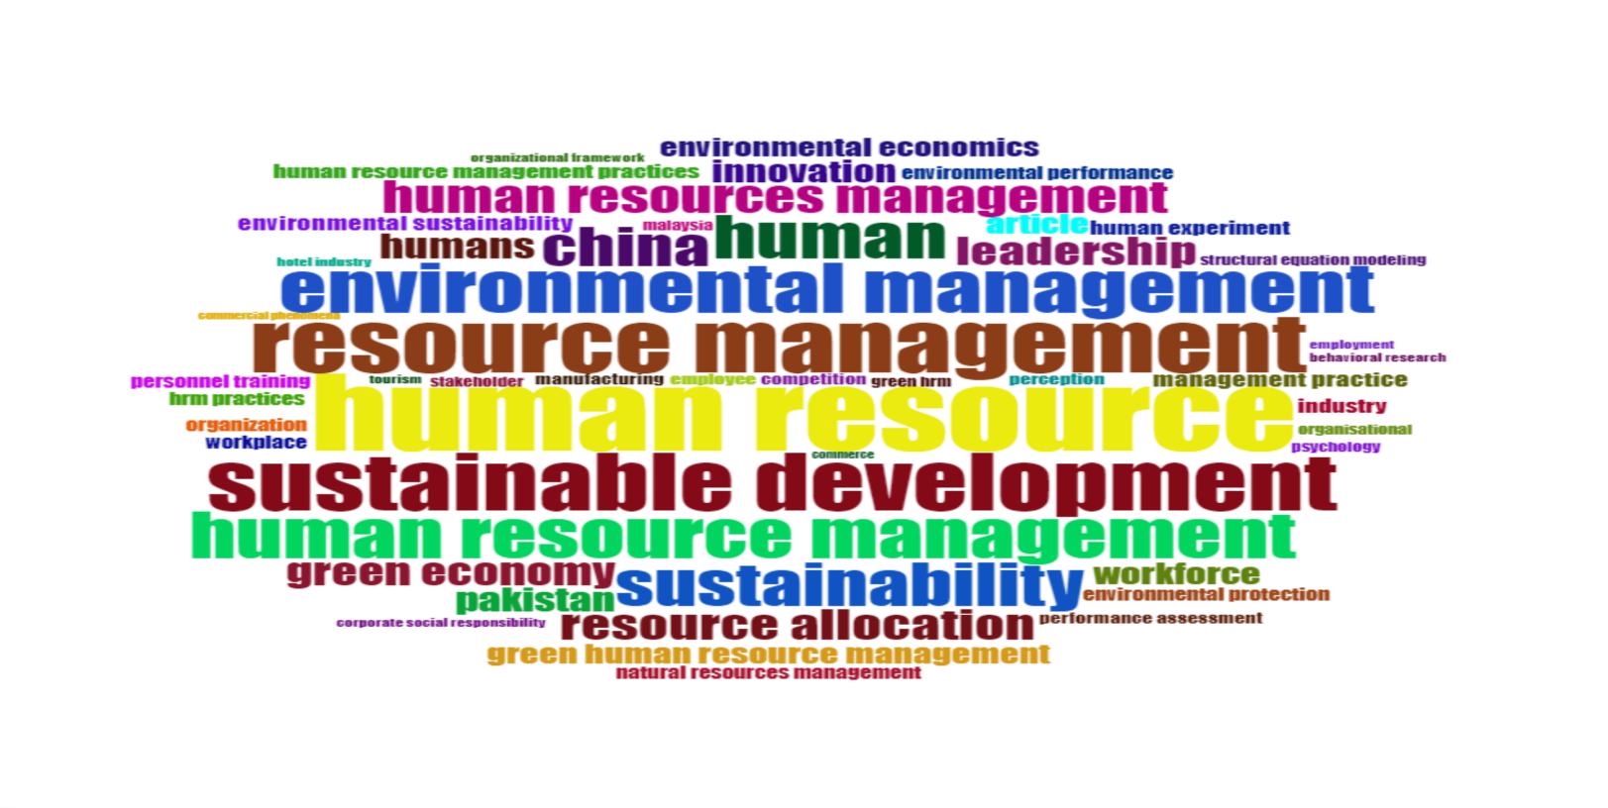

Figure 6: Most Frequent Word
In the abstracts of all 352 publications, the term “human resource” was used 62 times, or almost 13% of the time, as shown in Figure 6. With relative total frequencies of 48, 46, and 40, the terms “resource management,” “sustainable development,” and “environmental management” follow. On the other hand, the terms “human” and “sustainability” appeared at the same rate of 7.5% of the time, while having different frequencies.

Network Analysis
Co-occurrence Network
Figure 7 illustrates the co-occurrence network, which maps the pairwise relationships among keywords appearing in the abstracts of 352 GHRM-related articles.
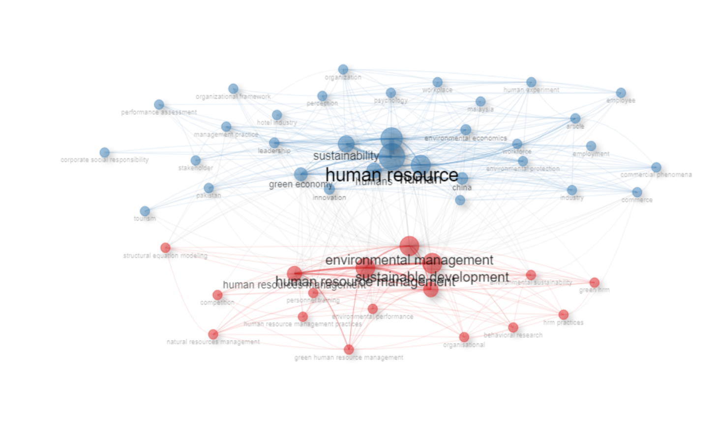

Figure 7: Co-occurrence Network of Abstract Term

In this bibliometric analysis, data from abstracts were utilized to explore the knowledge structure that underlies GHRM research. The co-occurrence network was developed from the co-occurrence of words/terms using the Walktrap clustering algorithm, available through Biblioshiny (Lancichinetti et al., 2009), which identifies groups of similar terms, resulting in the identification of conceptual clusters defining both the main thematic areas and the interconnections defining this area of research.
Based on the abstract analysis, two clusters were created in Figure 7 and were distinguished by their various colors. Each cluster is represented by a distinct colour, indicating the group of terms that share a strong association with the central keyword in the co-occurrence network. The red cluster had the highest vertex centrality of the term "sustainable development," while "human resource" was the highest vertex centrality term for the blue cluster. Cluster two had a strong connection to the first cluster for their term relationships; that is, the terms "environmental management," "human resource management," "resource allocation," and "personnel training" that are connected to the first cluster of "sustainable development" by much stronger edge connections. Similarly, the terms "green economy," "innovation," and "industry" that are related to the second cluster of "human resource" provide a relationship between the ongoing GHRM research and GHRM results at a future stage.

THEMATIC MAP
The results of the co-occurrence network were further visualized using a bivariate thematic map. This map provides a comprehensive overview of the thematic clusters and their relationships to one another in the GHRM research landscape. Figure 8 illustrates different themes present in this field based on their relevance and their development over time. The network cluster shown in Figure 8 has been categorized into four categories representing the different quadrants or themes comprising Motor Themes, Niche Themes, Emerging or Declining Themes, and Basic Themes (Cobo et al., 2011). There is also a thematic map showing an aspect of keywords or terms in an abstract way, with the three major abstracts identified as being positioned in the Motor Theme quadrant, including "Human," "Humans," and "Leadership." These keywords collectively represent a key component of the overall development and advancement of the GHRM research area because they have both high centrality and high density values, indicating significant internal cohesion among themselves and a broad ecological footprint across other associated keywords/themes.
There is a blob containing "human resources management, resource allocation" in the area between the Motor and Niche Themes. There do not appear to be any fully defined clusters in Niche Theme's second quadrant, as the area containing the blob of "environmental values, industrial performance cognition" is located somewhere between Niche and Emerging or Declining Themes. These clusters contain a moderately specialised thematic area, positioned on the fringes of the research field but with evidence of extensive growth, consolidation, and theoretical development potential for the future in the domain.
In the third quadrant of the thematic map, the cluster encompassing the terms "human resource," "resource management," and "sustainability" was positioned within the Emerging or Declining Theme category. This cluster has low centrality and low density and reflects a research area that is either developing and gaining attention by researchers or an area with declining relevance. This reflects that the topics included in this cluster are conceptually aged, but not well integrated into the overall research landscape. The basic theme in the fourth quadrant includes fundamental themes of the research area; however, they are not well developed phenomenologically or theoretically.
The bubbles of the following terms: green economy, environmental management, and sustainable development were present throughout the research area and situated directly in the center of the border between adjacent theme areas. Therefore, this theme is relevant within this research field and continues to evolve and structurally consolidate throughout the research field.
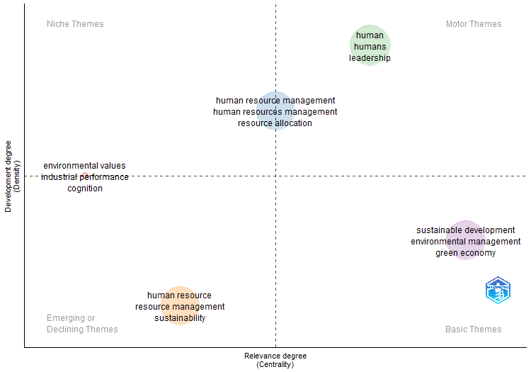

Figure 8: Thematic Map on Abstract's Term
conclusion
The bibliometric analysis presented here uses Biblioshiny to conduct a bibliometric study of GHRM since the beginning of its use in 2010 till now. It uses bibliometric methods and techniques to provide an analysis and an overview of the development of GHRM research themes, such as using green practices within established HRM functions, as well as key concepts that are present in the GHRM literature. This analysis has created an overall framework or model that can inform future areas of research around GHRM in terms of what meets the expectations of a global academic community. The bibliometric dataset was retrieved from Scopus and consisted of 352 publications written in English by a total of 1215 researchers from all around the world; in total, there were 703 author affiliations representing all the countries that provided scholarly work relative to GHRM. Collectively, researchers from 61 different countries have worked together and developed research cooperation, resulting in promoting GHRM research internationally. In addition, there was an abundance of researchers affiliated, representing many diverse institutional and organizational networks, producing research output in the GHRM field.
The analysis revealed a strong upward trend in the publication of GHRM from 2018 to date, signalling a dramatic escalation in interest and the prominence of GHRM in research themes and methods. This indicates that the private sector, not-for-profit sector, and government policymakers are positively impacting research toward GHRM. Additionally, creating a green economy through the sustainability of resources is now becoming a major focus of all companies. Besides, future researchers who are interested in this field of study can have a thorough introduction to the research domain by observing the overview of the most significant author or article provided by the bibliometric analysis. The most influential author was determined by measuring their individual contributions to a collection of published articles. This process enabled the researcher to identify the leading experts in the GHRM field, with their works serving as key references for further exploration of GHRM. Regarding potential collaboration and knowledge sharing, the researcher can leverage the results from the most significant affiliations. In total, the contribution of 703 affiliations in this knowledge is able to provide a substantial pool for identifying new expertise or opportunities for knowledge exchange through various collaborative efforts.
Findings on the Co-occurrence Network help future researchers to identify gaps and research extensions in GHRM. The cluster found in this paper shows the related areas that should be focused on for the next research. To name a few, future research can select the tourism sector as the study scope, and the location of the research for the next study can be expanded beyond China, Pakistan, and Malaysia.
This study also presents a thematic map illustrating the positional distribution of clusters across the four quadrants: Motor, Niche, Emerging or Declining, and Basic Themes. The analysis shows that there is considerable opportunity for future growth and theoretical development within the GHRM area based on research related to human leadership and the green economy.
However, because all the data used in this study came from the Scopus database, there are some limitations associated with this research study, as it does not combine information from the Cochrane Library, Web of Science (WoS/Wok), Dimensions, PubMed, or another database, which may be added as alternative sources for the study. Additionally, the bibliometric research may have provided a greater benefit by incorporating an analysis of Lotka's Law, Bradford's Law, Author and/or Source Impact, or other bibliometric elements for purposes of performing descriptive analysis; this study looked at only the conceptual structure of knowledge to discover hidden patterns in knowledge, and could benefit from exploring the two other knowledge which are intellectual and social structures.

Acknowledgements

The authors would like to extend their gratitude to Universiti Teknologi MARA, Cawangan Melaka, for funding this research through the international matching research grant GST2025/1-5.

references
Aria, M., & Cuccurullo, C. (2017). Bibliometrix: An R-tool for comprehensive science mapping analysis. Journal of Informetrics, 11(4), 959–975. https://doi.org/10.1016/j.joi.2017.08.007
Benevene, P., & Buonomo, I. (2020). Green human resource management: An evidence-based systematic literature review. Sustainability, 12, 5974. https://doi.org/10.3390/su12155974
Benn, S., Teo, S. T. T., & Martin, A. (2015). Employee participation and engagement in working for the environment. Personnel Review, 44, 492–510.
Chowhan, J. (2016). Unpacking the black box: Understanding the relationship between strategy, HRM practices, innovation and organizational performance. Human Resource Management Journal, 26, 112–133.
Cobo, M.-J., López-Herrera, A.-G., Herrera-Viedma, E., & Herrera, F. (2011). An approach for detecting, quantifying, and visualizing the evolution of a research field: A practical application to the fuzzy sets theory field. Journal of Informetrics, 5(1), 146–166. https://doi.org/10.1016/j.joi.2010.10.002
Fachada, J., Rebelo, T., Lourenço, P., Dimas, I., & Martins, H. (2022). Green human resource management: A bibliometric analysis. Administrative Sciences, 12(3), 95. https://doi.org/10.3390/admsci12030095
Faheem, A., Nawaz, Z., Ahmed, M., Haddad, H., & Al-Ramahi, N. M. (2024). Past trends and future directions in green human resource management and green innovation: A bibliometric analysis. Sustainability, 16, 133. https://doi.org/10.3390/su16010133
Fawehinmi, O., Yusliza, M. Y., Mohamad, Z., Noor Faezah, J., & Muhammad, Z. (2020). Assessing the green behaviour of academics: The role of green human resource management and environmental knowledge. International Journal of 178 Manpower, 41(7), 879–900. https://doi.org/10.1108/IJM-07-2019-0347
González-Benito, J., & González-Benito, Ó. (2006). A review of determinant factors of environmental proactivity. Business Strategy and the Environment, 15, 87–102.
Guerci, M., & Carollo, L. (2016). A paradox view on green human resource management: Insights from the Italian context. The International Journal of Human Resource Management, 27, 212–238.
Guerci, M., Longoni, A., & Luzzini, D. (2016). Translating stakeholder pressures into environmental performance: The mediating role of green HRM practices. The International Journal of Human Resource Management, 27, 262–289.
Jabbour, C. J. C. (2013). Environmental training in organisations: From a literature review to a framework for future research. Resources, Conservation and Recycling, 74, 144–155. https://doi.org/10.1016/j.resconrec.2012.12.017
Jackson, S. E., Renwick, D. W. S., Jabbour, C. J. C., & Muller-Camen, M. (2011). State-of-the-art and future directions for green human resource management: Introduction to the special issue. German Journal of Human Resource Management, 25, 99–116.
Kim, Y. J., Kim, W. G., Choi, H.-M., & Phetvaroon, K. (2019). The effect of green human resource management on hotel employees' eco-friendly behavior and environmental performance. International Journal of Hospitality Management, 76, 83–93.
Kramar, R. (2014). Beyond strategic human resource management: Is sustainable human resource management the next approach? The International Journal of Human Resource Management, 25(8), 1069–1089.
Lancichinetti, A., Fortunato, S., & Kertész, J. (2009). Detecting the overlapping and hierarchical community structure in complex networks. New Journal of Physics, 11(3), 033015.
Marcus, A. A., & Fremeth, A. R. (2009). Green management matters regardless. Academy of Management Perspectives, 23, 17–26.
Oh, D.-S., Phillips, F., Park, S., & Lee, E. (2016). Innovation ecosystems: A critical examination. Technovation, 54, 1–6.
Pinzone, M., Guerci, M., Lettieri, E., & Redman, T. (2016). Progressing in the change journey towards sustainability in healthcare: The role of "green" HRM. Journal of Cleaner Production, 122, 201–211.
Renwick, D. W. S., Jabbour, C. J. C., Muller-Camen, M., Redman, T., & Wilkinson, A. (2016). Contemporary developments in green (environmental) HRM scholarship. The International Journal of Human Resource Management, 27, 114–128.
Shabban, S., & Edgar, D. (2025). Nurturing green behaviour : Exploring managerial competencies for effective green human resource management in hotels. Cleaner Production Letters Journal, 9, 1–12.
Song, W., Yu, H., & Xu, H. (2021). Effects of green human resource management and managerial environmental concern on green innovation. European Journal of Innovation Management, 24, 951–967.
Tang, G., Chen, Y., Jiang, Y., Paillé, P., & Jia, J. (2018). Green human resource management practices: Scale development and validity. Asia Pacific Journal of Human Resources, 56, 31–55.
Yusliza, M.-Y., Othman, N. Z., & Jabbour, C. J. C. (2017). Deciphering the implementation of green human resource management in an emerging economy. Journal of Management Development, 36, 1230–1246.
Yusliza, M.-Y., Norazmi, N. A., Jabbour, C. J. C., Fernando, Y., Fawehinmi, O., & Seles, B. M. R. P. (2019). Top management commitment, corporate social responsibility and green human resource management: A Malaysian study. Benchmarking: An International Journal, 26, 2051–2078.
Zibarras, L. D., & Coan, P. (2015). HRM practices used to promote pro-environmental behavior: A UK survey. The International Journal of Human Resource Management, 26, 2121–2142.
Zupic, I., & Čater, T. (2015). Bibliometric methods in management and organization. Organizational Research Methods, 18, 429–472.

