Original article

“ Modified Chevrel technique : An alternative to component separation technique in large ventral hernias or difficult to close abdomen ”

Abstract
Ventral hernias (VH) pose significant challenges for surgeons due to the risk of recurrence, complexities in aligning abdominal muscles, and selecting the most suitable layer for mesh augmentation. This study aims to evaluate the effectiveness of utilizing the anterior rectus fascia as a turnover flap in conjunction with onlay mesh reinforcement, a procedure known as the modified Chevrel technique (MCT). Here two cases discussed where modified chevrel technique were used.

Keywords :
Modified Chevrel technique, Anterior fascia turnover technique , Ventral hernia repair, Incisional hernia repair, Onlay mesh hernioplasty

Introduction
Ventral hernia repairs are some of the commonest surgeries performed by general surgeons worldwide. These commonly comprises of incisional hernias, umbilical & paraumbilical hernias & epigastric hernias and rare hernias like spigelian hernias. Midline incisional hernias remain a significant challenge in general surgery, with high incidence rates following emergency laparotomies. While laparoscopic and robotic approaches have gained popularity, open repair remains a cornerstone for complex cases. According to the placement of mesh hernia repairs can be onlay or sublay repairs. One of the onlay techniques included in these studies is the original Chevrel technique. First described by french surgeon J.P. Chevrel in 1979, this technique consists of an anterior fascia ‘turnover’ closed in the midline with an overlapping midline plasty, combined with a large onlay mesh augmentation sutured with overlap to the lateral part of the anterior rectus fascia, or even to the fascia of the oblique external muscle [4, 7]. To facilitate mesh placement, subcutaneous dissection beyond the lateral border of the anterior rectus fascia is often necessary with the original Chevrel technique.
Fig 1- Schematic approach of Chevrel technique
Modified Chevrel technique does not require such large subcutaneous dissection since the mesh is sutured to the remnant of the anterior rectus fascia with only one-and-a-half centimetres overlap [8]. This results in a dual-layer repair where both the sutured anterior
fascia turnover and the onlay mesh provide support to the ventral abdominal wall. Therefore, the modified Chevrel technique offers the advantages of onlay mesh placement, potentially without the alleged disadvantage of increased wound complications caused by extensive
subcutaneous dissection.
Here, two cases are discussed where modified chevrel technique were used.

CASE – 1
50 year old male patient presented with a midline incisional hernia of approximately 8 cm in size. He underwent laparotomy for peptic perforation repair 5 years ago. We decided to go for modified chevrel technique instead of component separation repairs. An incision is made in the anterior rectus fascia 5 cm from the medial edge of the rectus muscle. The medial part of the anterior rectus fascia is separated from the muscle fibres and tendinous intersections, and turned over towards the midline. This procedure is repeated at the contralateral side. Any residue of the hernia sac is left alone or excised. Both the left and right ‘turned over’ anterior fascia can now be sutured in the midline with a continuous 2/0 polypropylene suture using small bites. Then onlay mesh repair done by placing a large polypropelene mesh with adequate overlap of the incisions laterally.
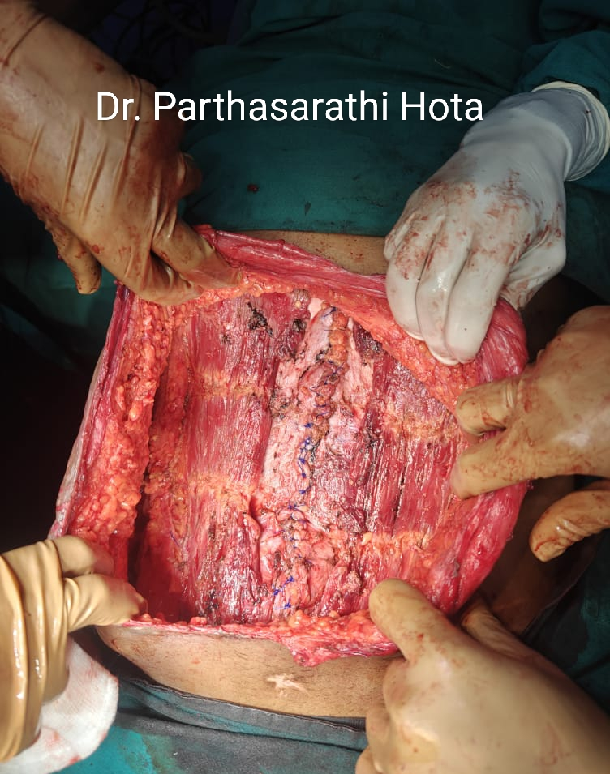
Fig 2 : Both anterior rectus sheath flaps created, turned over medially & sutured with polypropelene suture. Bilateral bare rectus abdominis are seen.
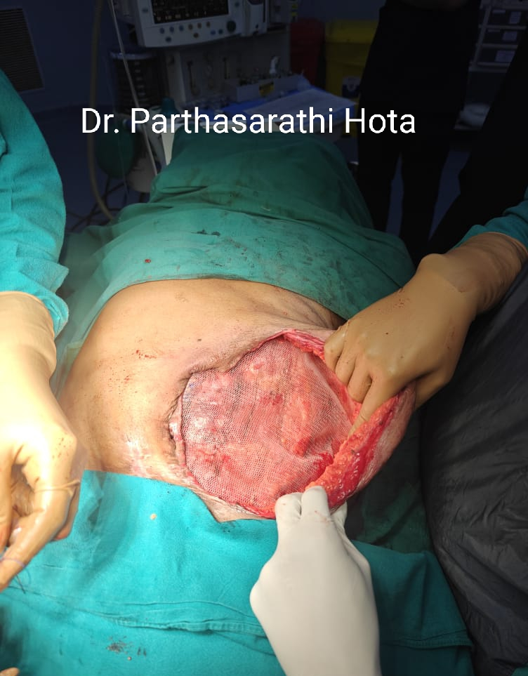
Fig 3 – Onlay mesh placement done with wide overlapping.
CASE 2
A 67 year old male patient came to the emergency with pain , vomiting & distention of abdomen. Abdominal radiograph showed grossly dilated stomach. CT scan suggested gastric volvulus. After resuscitation , patient posted for laparotomy. On laparotomy, hugely distended, atonic stomach seen twisted upon . Untwisting done & then we noticed gangrenous changes along the greater curvature. The devitalized segment excised, gastric content suctioned out, & repaired. Afterwards gastropexy done with anterior abdominal wall to prevent future volvulus formation.
Pt was in sepsis, nutritionally deficient & developed large full thickness wound dehiscence with midline gap approximately 7 cm.
To close the abdomen, we decided to go for modified chevrel technique.Bilateral longituidinal incisions given 4 cm lateral to the medial edge of rectus abdominis muscle. Both flaps raised, turned over medially & sutured with 2-0 polypropelene suture. After midline closure, we decided to go for darning with 2-0 polypropelene suture instead of placing mesh because it was an infected case.

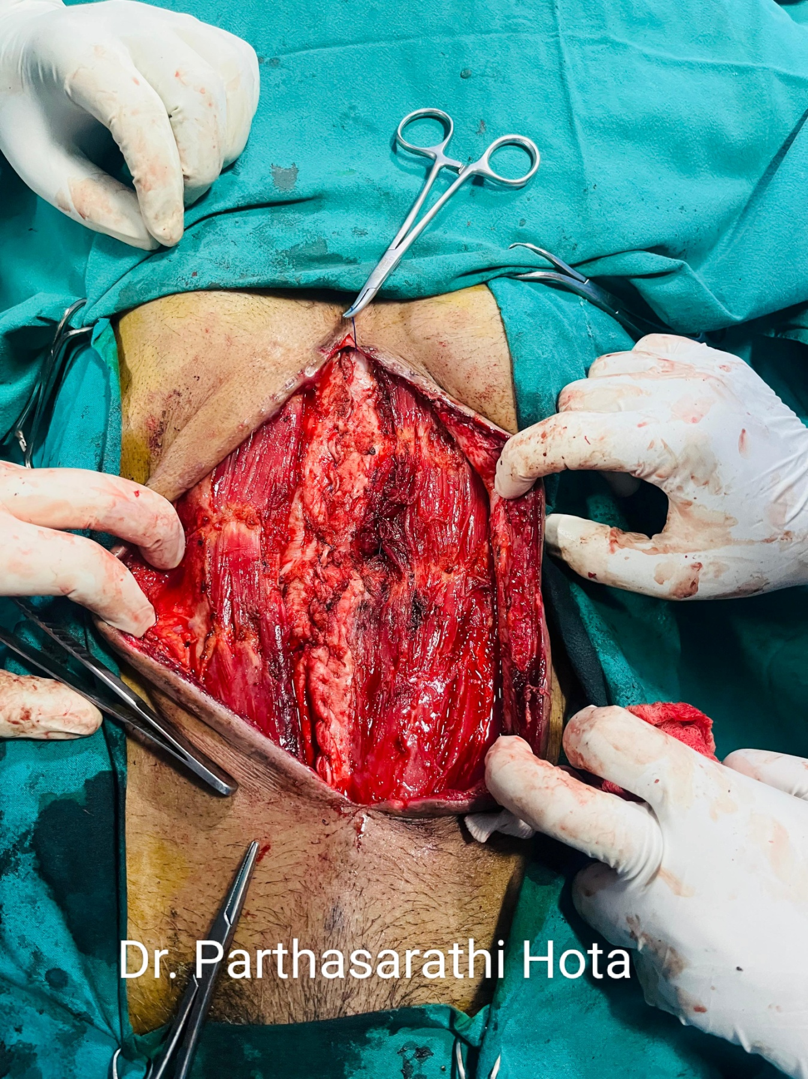
Fig 4- Anterior rectus sheath flaps raised and sutured with polypropelene suture to close the defect. Bare rectus muscle seen.
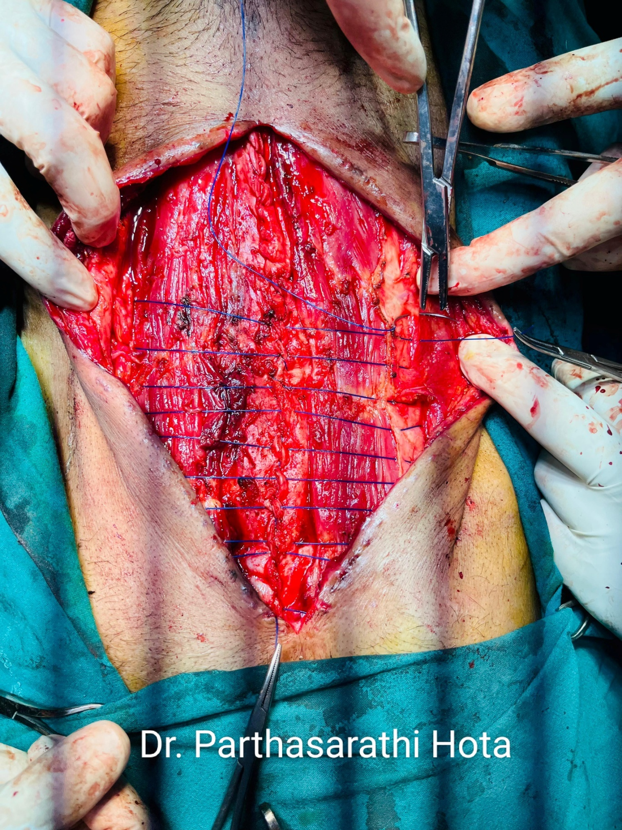
Fig 5 – Darning with 2-0 polypropelene suture done instead of onlay mesh placement.
Both the patients recovered well and in one year follow-up, neither of them showed any signs of recurrence.

Discussion
Large ventral hernias , particularly large incisional hernias can be a surgical challenge. Nowdays the most widely employed techniques in these cases are anterior component separation & posterior component separation. Posterior component separation by doing unilateral/ bilateral TAR [ Transverse abdominis release ] is gaining popularity because it bypasses the complications of wide dissection in subcutaneous plane for onlay mesh placement required in anterior component separation. But in the long term, both these techniques weakens the strength & integrity of the anterior abdominal wall by deliberately separating the layers. Another risk factor is injury of the neurovascular bundles during TAR which is technically more difficult. Patients have reported with lateral bulges after component separation repairs.

Previous studies have demonstrated that onlay mesh placement could lead to fewer recurrences when compared to sublay placement, though the evidence is not conclusive.
A prospective 5-year trial of We´ber et al. showed recurrence rates after onlay mesh placement to be half of the recurrence rates after sublay mesh placement (12% onlay vs. 22% sublay, p\0.05) [11]. A 2008 Cochrane metaanalysis pre-dates the above-mentioned trial, though did
show a clear trend towards lower recurrence rates in onlay mesh placement compared to sublay placement (RR0.66, 95% CI [0.35–1.25]) [12]. On the other hand, Timmermans et al. showed a trend towards lower recurrence rates in sublay repair (OR 2.41 95% CI [0.99–5.88]) in their 2014 meta-analysis [1].

Moreover, both these component separation techniques requires mesh placement after midline closure, onlay mesh for anterior component separation & sublay mesh for TAR. Therefore , these techniques are not suitable in the infected cases like the second case scenario described above.

So, Chevrel technique is a viable option in these situations. It doesnot damage the integrity of the abdominal wall and there is no question of injury to the neurovascular bundles. It can be employed in infected cases as we have done in the second case where the usual alternative is employing costly absorbable vicryl mesh which is outside the purview of many patients in our country because of high cost & availability. Technically less demanding than TAR. So Chevrel technique is a viable option both in large ventral hernia repairs and also in difficult abdominal closures.
The modified Chevrel technique offers a comprehensive approach to all types of midline ventral hernias, if there is sufficient healthy skin to cover the mesh. If this technique alone is not sufficient to close the defect, it can easily be combined with a minimally invasive or endoscopically assisted component separation technique [5].

Conclusion

Modified chevrel technique for ventral hernia is a durable repair with acceptable adverse effects. Main advantages are maintaining of the integrity of the anterior abdominal wall and usefulness in the infected setting where mesh is substituted by suture repair or darning. This technique is a nice addition in the armamentarium of a hernia surgeon.

Conflict of interest – None

References
1. Timmermans L, de Goede B, van Dijk SM, Kleinrensink GJ, Jeekel J, Lange JF (2014) Meta-analysis of sublay versus onlaymesh repair in incisional hernia surgery. Am J Surg 207:980–988

2. Luijendijk RW, Hop WC, van den Tol MP et al (2000) A comparison of suture repair with mesh repair for incisional hernia. N Engl J Med 343:392–398

3. Deerenberg EB, Timmermans L, Hogerzeil DP et al (2015) A systematic review of the surgical treatment of large incisional hernia. Hernia 19:89–101. doi:10.1007/s10029-014-1321-x (Epub 2014 Nov 8)

4. de Vries Reilingh TS, van Goor H, Rosman C et al (2003) ‘‘Components separation technique’’ for the repair of large abdominal wall hernias. J Am Coll Surg 196:32–37

5. Mommers EH, Wegdam JA, Nienhuijs SW, de Vries Reilingh TS (2016) How to perform the endoscopically assisted components separation technique (ECST) for large ventral hernia repair.
Hernia 20(3):441–447

6. De Vries Reilingh TS, van Geldere D, Langenhorst B et al (2004) Repair of large midline incisional hernias with polypropylene mesh: comparison of three operative techniques. Hernia J Hernias Abdom Wall Surg 8:56–59

7. Chevrel JP, Dilin C, Morquette H. (1986) Traitement des e´ventrations abdominales me´dianes par autoplastie musculaire et prothe`se pre´-musculo-apone´vrotique. Chirurgie. 112(9):616–622

8. Chevrel JP (1979) Traitement des grandes e´ventrations me´dianes par plastie en paletot et prothe`se. Nouv Presse Me´d 8:695–696

9. Heniford BT, Walters AL, Lincourt AE, Novitsky YW, HopeWW, KercherKW(2008) Comparison of generic versus specific qualityof- life scales for mesh hernia repairs. JAmColl Surg 206:638–644. doi:10.1016/j.jamcollsurg.2007.11.025 (Epub 8 Feb 1)

10. Hope WW, Lincourt AE, Newcomb WL, Schmelzer TM, Kercher KW, Heniford BT (2008) Comparing quality-of-life outcomes in symptomatic patients undergoing laparoscopic or open ventral hernia repair. J Laparoendosc Adv Surg Tech A 18:567–571

11. Weber G, Baracs J, Horvath OP (2010) [‘‘Onlay’’ mesh provides significantly better results than ‘‘sublay’’ reconstruction. Prospective randomizedmulticenter study of abdominalwall reconstructionwith sutures only, or with surgical mesh—results of a 5-years follow-up].
Magy Seb 63:302–311. doi:10.1556/MaSeb.63.2010.5.3

12. Hartog D, Dur AH, Tuinebreijer WE, Kreis RW (2008). Open surgical procedures for incisional hernias.CochraneDatabase Syst Rev. 16(3):CD006438. doi:10.1002/14651858.CD006438.pub2

13. Mommers E.H.H., Leenders B.J.M., Leclercq W.K.G., Reilingh T.S.D.V., Charbon J.A. A modified Chevrel technique for ventral hernia repair: Long-term results of a single centre cohort. Hernia. 2017;21:591–600. doi: 10.1007/s10029-017-1602-2.

