Interactive Augmented Reality in Informal Education: A Bibliometric Analysis (2009–2026)
ABSTRACT
This study investigates the development of learning research, educational technology advancement, and pedagogical evolution within the emerging field of interactive augmented reality (AR) research for informal education. Using a bibliometric and scientometric approach, the study examines the evolution of research activity, influential publication sources, collaboration patterns, and thematic developments within the global educational technology landscape. Drawing upon a Scopus-indexed dataset covering the period from 2009 to 2026, the analysis integrates bibliometric performance indicators, source analysis, citation patterns, and thematic evolution mapping to provide a comprehensive understanding of the field’s development. The findings reveal a sustained increase in publication output, accompanied by a concentration of research within a limited number of influential journals, highlighting the growing maturity of AR-related research in informal education. Citation patterns indicate that scholarly influence is largely shaped by dominant publication sources and highly cited studies, which play an important role in guiding subsequent research directions. Global contribution patterns further reveal geographical disparities in research productivity, with technologically advanced regions exerting substantial influence on the development of the field. Thematic evolution analysis demonstrates a gradual shift from technology-oriented exploration towards pedagogical driven applications, learner engagement, and learning effectiveness, reflecting the increasing emphasis on educational value and instructional design. By examining the field through the lens of educational technology development and learning research trends, this study contributes to the understanding of how emerging educational technology domains evolve, mature, and shape future learning design practices in informal education. The findings provide useful insights for researchers, educator, policymakers, and journal editors seeking to understand the structural development of interdisciplinary research fields.
Keywords: Augmented Reality; Informal Education; Educational Technology; Bibliometric Analysis; Learning Design

INTRODUCTION
The rapid expansion of digital technologies under the Fourth Industrial Revolution has fundamentally transformed the landscape of education, particularly within informal learning environments. Among emerging technologies, interactive augmented reality (AR) has gained significant attention for its ability to integrate digital information with physical contexts, enabling immersive, contextualised, and experiential learning. While a growing body of research has examined AR applications in education, existing studies have predominantly focused on technological implementation and learner engagement, with limited attention to the structural dynamics of how research in this field has evolved, matured, and contributed to educational technology development within the global learning research community.

Despite the growing body of literature on augmented reality in education, primarily focused on technological implementation, learner engagement, usability, and educational outcomes. Comparatively little attention has been devoted to understanding how learning research within this field has evolved, expanded, and influenced educational technology practices. Existing bibliometric studies largely provide descriptive overviews of publication growth and research trends, offering limited understanding of how educational technology research and pedagogical themes have evolved over time. Consequently, there remains a need for a structural scientometric investigation that examines how influential publication channels, citation flows, and thematic developments collectively shape the evolution of interactive AR research within informal education.

Even with the increasing volume and interdisciplinary nature of research on interactive augmented reality visualization in informal education, a holistic understanding of how the field has evolved and is intellectually structured remains limited. Existing studies frequently emphasise technological implementation and learner engagement outcomes, while systematic mapping of scholarly development related to learning and educational applications of AR in informal learning contexts remains insufficient. Consequently, a bibliometric analysis is required to systematically explore publication trends, leading contributors, influential studies, and the major research themes related to AR-supported learning in informal education.

Accordingly, this study seeks to map the global research landscape of interactive augmented reality visualization in informal education through a comprehensive bibliometric analysis covering the period from 2009 to 2026. By offering a systematic overview of the scholarly domain, this research provides meaningful insights for researchers, educators, designers, and policymakers aiming to utilise interactive AR technologies more effectively within informal learning environments. As interest in AR-supported informal education continues to grow, particularly in the post-pandemic context, a structured bibliometric investigation becomes increasingly important for informing future research directions and enhancing the educational potential of interactive augmented reality visualization.

Beyond its educational implications, the rapid growth of interactive augmented reality research also reflects broader transformations in scholarly publishing patterns. Understanding how this body of knowledge is disseminated across journals, disciplines, and geographical regions is essential for evaluating the evolution of the research field. Therefore, this study not only examines the educational context of AR but also investigates the structure of educational technology scholarship and publication trends within this domain.

This study advances existing bibliometric research by integrating structural scientometric indicators with thematic analysis to provide a deeper understanding of learning research development and dissemination dynamics in an emerging interdisciplinary field.

Unlike previous bibliometric studies that primarily describe publication productivity and research trends, this study adopts a structural scientometric perspective to examine the mechanisms of learning research development, concentration, dissemination, and educational technology scholarship within interactive AR research for informal education. The study extends conventional bibliometric mapping by integrating source concentration analysis, citation-flow interpretation, and thematic evolution analysis to provide a deeper understanding of how knowledge is organised and disseminated within an emerging educational technology field.

LITERATURE REVIEW

Overview of Interactive Augmented Reality Visualization in Informal Education
The integration of interactive augmented reality (AR) visualization in informal education represents a significant shift in how learners engage with educational content beyond traditional classroom environments. Informal learning contexts such as museums, zoos, science centres, aquariums, and educational tourism sites increasingly adopt AR technologies to provide immersive, flexible, and self-directed learning experiences. Interactive AR visualization enables learners to interact with digital overlays embedded within real-world environments, thereby enhancing engagement and supporting deeper conceptual understanding.

Early conceptualisations of augmented reality systems were formally articulated by Azuma (1997), who described AR as a technology that combines real and virtual environments, operates interactively in real time, and aligns virtual objects within physical space. The fundamental operational mechanism of AR involves integrating real-world video input with computer-generated visual elements through tracking and rendering processes. As illustrated in Fig. 1, a video see-through head-mounted display (HMD) system captures real-world imagery using video cameras, tracks user head movements, generates virtual scenes, and composites both real and virtual content into a unified visual display. This system architecture forms the technological foundation that enables interactive AR visualization.

Figure 1. A conceptual diagram of a video see-through HMD (Azuma, 1997)
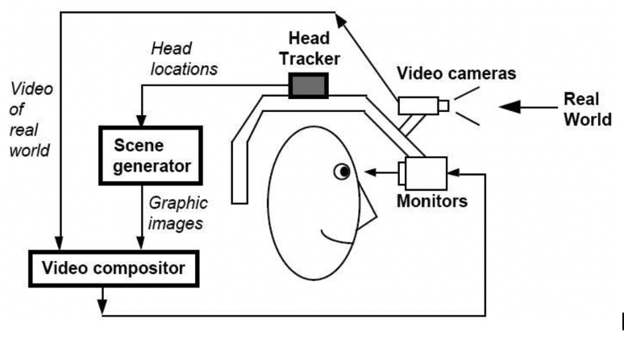

Building upon this foundational architecture, AR technologies have evolved into multiple implementation approaches, including marker-based and markerless tracking systems, interactive simulations, and game-based AR applications. Marker-based AR relies on predefined visual markers to trigger digital content, while markerless AR utilises spatial recognition, sensors, and environmental mapping to position virtual objects within physical surroundings. These technological variations enable adaptive and context-aware learning experiences that respond dynamically to users’ actions and environmental conditions.

From an educational perspective, these capabilities create meaningful learning affordances within informal education environments. Interactive AR supports learner-centred exploration, real-time feedback, and personalised learning pathways, which are particularly valuable in settings where structured instructional guidance is limited. Through interactive visualisation, AR facilitates experiential learning by enabling learners to observe phenomena that are otherwise invisible, abstract, or difficult to conceptualise, such as scientific processes, biological systems, or historical reconstructions. Consequently, AR enhances engagement while promoting deeper cognitive processing and conceptual understanding within self-directed learning contexts.

Theoretical Foundations: Conceptual Change and Misconception Reduction
One of the key educational contributions of interactive AR visualization lies in its potential to address misconceptions and support conceptual change. Misconceptions are persistent incorrect understandings that learners develop through prior experiences or incomplete explanations, and they are especially prevalent in informal learning contexts where guidance may be minimal. Conceptual Change Theory posits that effective learning occurs when learners actively confront and reconstruct their existing mental models through meaningful experiences and cognitive conflict (Vosniadou, 2013).
Interactive AR visualization aligns closely with this theoretical framework by providing visual, spatial, and interactive representations that challenge learners’ prior assumptions. Through real-time interaction and immersive visual feedback, AR enables learners to test hypotheses, observe consequences, and revise their understanding accordingly. Studies have shown that AR-supported environments can enhance cognitive engagement, promote reflection, and facilitate deeper conceptual restructuring by linking abstract ideas to concrete experiences (Ibáñez et al., 2021). These affordances make AR particularly effective for conceptual learning in informal education, where learners often rely on self-exploration rather than formal instruction.

Studies on Interactive AR in Informal Learning
An increasing number of empirical studies demonstrate the effectiveness of interactive AR visualization in improving learner engagement, motivation, and conceptual understanding within informal learning environments. Research conducted in museums and science centres indicates that AR applications significantly enhance visitors’ comprehension and knowledge retention by converting passive observation into active and participatory learning experiences. Interactive AR exhibits encourage learners to manipulate digital objects, explore alternative explanations, and engage collaboratively with peers, thereby fostering meaningful learning experiences (Schwerdtfeger et al., 2021).

Existing research highlights that informal learning environments enhanced by AR can foster higher-level cognitive abilities, including analytical, synthetic, and evaluative skills. By situating learning within authentic contexts, AR promotes experiential learning and problem-solving, enabling learners to apply knowledge in real-world scenarios. These outcomes align with constructivist learning principles, which emphasize active knowledge construction through interaction and exploration rather than rote memorization (Dunleavy & Dede, 2014).

Previous Studies on Bibliometric Analysis of AR and Informal Education
Recently, bibliometric analysis has increasingly been applied to investigate research developments in augmented reality and informal education. This approach enables scholars to map the evolution of research output, recognise key influential works, and identify prevailing thematic directions. Previous bibliometric studies on AR in education have primarily focused on formal learning contexts, such as classrooms and higher education, with limited attention given to informal education and learning design issues.

While existing bibliometric analyses provide valuable insights into publication growth, key contributors, and collaboration networks, several limitations remain. Many existing studies focus on limited time spans, selected regions, or English-language sources, which can limit the diversity and overall scope of their findings. Additionally, prior analyses often emphasize technological aspects of AR without explicitly examining its pedagogical role in addressing misconceptions or supporting conceptual change in informal learning environments.

Research Gaps and Study Motivation

Although interest in interactive AR visualization continues to grow, there is still a lack of comprehensive bibliometric research examining its specific contribution to supporting learning and conceptual understanding in informal learning environments. Much of the existing literature emphasises engagement and usability, with relatively limited focus on conceptual learning outcomes and accuracy of understanding. Moreover, the evolution of research themes over time, along with collaboration trends and citation dynamics in this area, remains underexplored.

To address these identified gaps, this study adopts a global and longitudinal bibliometric approach to systematically examine scholarly publications on interactive augmented reality visualization within informal education contexts. By analysing research trends, leading contributors, influential publications, and evolving thematic structures, the study aims to offer a comprehensive and inclusive overview of the field. Through a rigorous process of data selection and analysis, this research seeks to establish a structured knowledge base that can inform future investigations and support the effective integration of interactive AR visualization in informal learning environments, particularly in supporting conceptual understanding and facilitating conceptual change.

Research Trends

As summarized in Table 1 (Past Studies), previous bibliometric investigations on augmented reality (AR) research have primarily focused on broad educational contexts, disciplinary applications, or tourism-related adoption trends. Studies such as Prihandini et al. (2023) and Singh et al. (2024) examined publication productivity, collaboration networks, and influential learning research patterns, while Du Juan and DeWitt (2024) concentrated specifically on chemistry education, reflecting a subject-specific orientation. Similarly, Anesti and Irwanto (2025) provided large-scale global mapping of AR research in education, and Ercan et al. (2025) explored AR within sustainable tourism contexts.

Although these studies offer valuable insights into publication trends, influential contributors, and thematic development, they largely analyse AR from a general technological or disciplinary perspective. Notably, relatively little attention has been directed toward examining the role of interactive AR visualization in addressing learner misconceptions within informal education environments, including museums, zoos, science centres, and tourism-based learning settings. Furthermore, prior analyses seldom integrate a focused education-centred perspective that connects conceptual change and conceptual understanding with informal learning experiences.

Accordingly, this study seeks to address these gaps by conducting a focused bibliometric analysis that maps the global research landscape of interactive AR visualization for reducing misconceptions in informal education. In doing so, it extends existing bibliometric research beyond general AR adoption trends toward a more pedagogically informed and context-specific understanding.

Table 1. Previous articles on augmented reality in education and bibliometric analysis
Authors | Objective | Data Source & Year Cover | Total Document Entries (TDE) | Bibliometric Attributes Examined
Prihandini, Triyono & Priyanto (2023) | To identify publication trends, influential authors, journals, institutions, countries, and emerging research directions related to augmented reality adoption in tourism research. | Scopus (2013–2022) | 166 | Publication trends, keyword frequency, bibliographic coupling (documents, sources, authors, organizations, countries), citation analysis, co-authorship networks, VOSviewer visualization, PRISMA screening
Du Juan & DeWitt (2024) | To examine the evolutionary characteristics, trends, and thematic focus of augmented reality research in chemistry education over the past decade. | Web of Science, Scopus, PubMed (2012–2022) | 66 | Annual publication trends, keyword co-occurrence, citation analysis, leading authors and institutions, country contributions, thematic clustering, CiteSpace visualization
Anesti & Irwanto (2025) | To analyse global research trends, influential contributors, and thematic structures of augmented reality research in education. | Scopus (2003–2023) | 2,955 | Annual growth rate, keyword frequency, highly cited documents, prolific authors, leading journals, institutional and country productivity, citation and co-citation analysis, VOSviewer mapping
Singh, Kaur & Gulzar (2024) | To explore productivity patterns, collaboration networks, influential learning research patterns, and thematic evolution of augmented reality research in education. | Scopus (2010–mid 2023) | 1,734 | Publication productivity, authorship and collaboration patterns, influential learning research patterns, bibliographic coupling, thematic analysis, Biblioshiny and VOSviewer visualization
Ercan et al. (2025) | To reveal publication trends, citation performance, collaboration networks, and thematic focuses of augmented reality research in sustainable tourism through bibliometric and systematic review. | Web of Science (no time restriction; publications from 2014–2024 identified) | 61 | Publication and citation trends, co-authorship analysis, country productivity, keyword co-occurrence, bibliographic coupling, co-citation analysis, thematic content analysis, VOSviewer visualization, PRISMA protocol
*TDE: Total Documents Examined

RESEARCH QUESTIONS

This research offers a bibliometric investigation into the role of interactive augmented reality (AR) visualization in addressing misconceptions within informal education, organised around six central research questions (RQs).

RQ1: How has learning research development evolved within interactive augmented reality research for informal education?

RQ2: What educational technology development trend characterise the evolution of the field?

RQ3: Which journals play significant roles in shaping learning research and educational technology development?

RQ4: How have influential studies shaped the pedagogical evolution of interactive AR research?

RQ5: Which authors, institutions, and countries contribute most significantly to learning research development?

RQ6: How have learning design trends and pedagogical themes evolved throughout the development of the field?

METHODS

This study employed a bibliometric and scientometric approach to examine the evolution of interactive augmented reality (AR) research in informal education. Bibliographic data were retrieved from the Scopus database on 9 February 2026. Scopus was selected because of its extensive coverage of high-quality peer-reviewed publications and its suitability for mapping research development within educational technology and informal learning domains.

The dataset comprised publications related to interactive AR applications in informal learning environments and included information on publications output, citation performance, authorship patterns, source distribution, country contributions, and keyword occurrences. These indicators provide a comprehensive overview of the growth, development, and maturation of the field over time.

To investigate the intellectual and thematic development of the research domain, the study integrated bibliometric performance indicators with structural analyses. This approach enabled the identification of publications growth patterns, influential publications sources, collaboration structures, and thematic evolution. Particular attention was given to understanding how AR research has evolved from technology-oriented exploration towards pedagogically driven applications that support learner engagement, learning effectiveness, and educational innovation in informal learning contexts.

Data Source and Search Strategy

This study utilised the Scopus database as the primary source of bibliographic data due to its extensive coverage of peer-reviewed literature and its suitability for educational technology research. A structured keyword search strategy was employed to identify relevant publications related to interactive augmented reality (AR) in informal education. The search combined terms associated with “augmented reality” and informal learning environments, including museums, zoos, science centres, cultural heritage sites, and tourism contexts.

Data Collection and Selection Process

The data collection process followed the PRISMA (Preferred Reporting Items for Systematic Reviews and Meta-Analyses) framework, which includes four stages: identification, screening, eligibility, and inclusion. Initial records were retrieved from Scopus and screened based on predefined inclusion and exclusion criteria. Duplicate and irrelevant records were removed during the screening stage. Full-text eligibility assessment was then conducted to ensure relevance to the study scope.

Following the application of he selection criteria, a final dataset of 223 publications published between 2009 and 2026 was obtained for analysis. Figure 2 presents the PRISMA flow diagram illustrating the study selection process.

Figure 2. PRISMA flow diagram illustrating the study selection process used in the bibliometric analysis
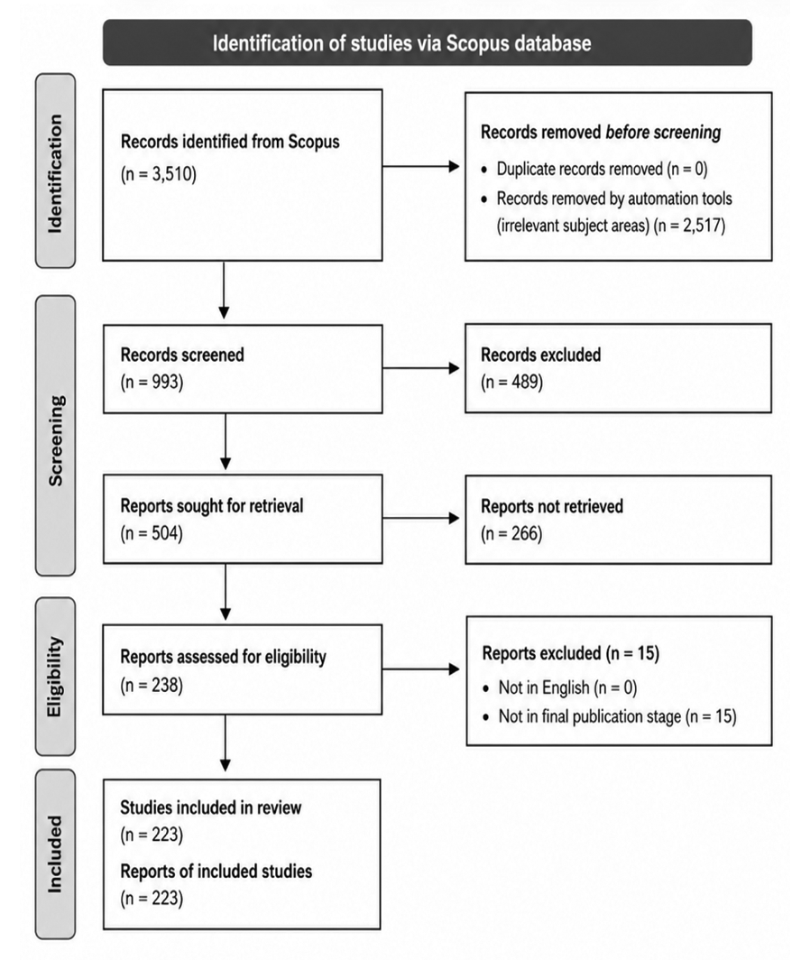

Inclusion and Exclusion Criteria

The inclusion criteria comprised: (i) publications related to interactive augmented reality in informal education contexts, (ii) articles indexed in Scopus, and (iii) documents published within the selected time frame (2009-2026). Exclusion criteria included publications unrelated to AR applications in informal learning environments, non-relevant subject areas, incomplete records, and documents outside the defined publication scope.

Data Analysis Techniques

The analysis combined bibliometric indicators and structural mapping techniques to examine the development of interactive AR research in informal education. Descriptive indicators were used to evaluate publication growth, citation performance, authorship patterns, and source productivity. In addition, network-based analyses were employed to investigate collaboration patterns and thematic relationships within the field.

Key indicators included total publications, total citations, citation per publication, h-index, g-index, and m-index. Furthermore, keyword co-occurrence analysis and thematic evolution mapping were conducted to identify dominant research themes and emerging direction over time.

Structural Analysis of Research Development

To extend beyond descriptive performance indicators, this study incorporated structural analytical techniques to examine patterns of learning research development, educational technology advancement, and pedagogical evolution within interactive AR research. Source analysis was conducted to identify influential publication venues, while citation and thematic analyses were used to reveal the intellectual organization and development trajectory of the field.

This approach provides a broader understanding of how research in interactive AR has evolved, highlighting the transition from technology-focused exploration towards learner-centred and pedagogically oriented applications in informal education.

RESULT
The results are organized according to the six research questions. This detailed analysis addresses the proposed research questions (RQs), yielding a deep and comprehensive understanding of the field. Through this focused examination, the authors aim to deliver a detailed and insightful overview of the interactive AR visualization research domain, contributing valuable knowledge for scholars, practitioners, instructional designers, and decision-makers involved in informal learning environments.

Current State of Research

To address RQ1, the current state of interactive augmented reality (AR) research in informal education was examined through publication output, authorship patterns, citation performance, and subject area distribution. As summarized in Table 2, the dataset comprises 223 publications produced by 860 authors between 2009 and 2026, reflecting the growing academic interest and interdisciplinary nature of the field.

The publications accumulated 6,765 citations, with an average of 30.34 citations per paper, indicating substantial scholarly impact and visibility. In addition, the h-index (43), g-index (76), and m-index (2.389) demonstrate the sustained influence and maturity of research within this domain. Overall, the findings suggest that interactive AR research in informal education has developed into an established and increasingly influential area of educational technology research.

Table 2. Citation Metrics
Main Information | Data
Publication Years | 2009–2026
Total Publications | 223
Citable Years | 18
Number of Contributing Authors | 860
Number of Cited Papers | 223
Total Citations | 6,765
Citation per Paper | 30.34
Citation per Cited Paper | 30.34
Citation per Year | 397.94
Citation per Author | 7.87
Author per Paper | 3.86
Citation Sum within h-Core | 6,386
h-index | 43
g-index | 76
m-index | 2.389
Source: Generated by the author(s) using biblioMagika@ (Ahmi, 2024)
Publication Trends

To address RQ2, the publication trends of interactive augmented reality (AR) research in informal education were analysed across the period 2009-2026. As illustrated in Figure 3 dan Table 3, the field demonstrates a clear and sustained growth trajectory, reflecting increasing scholarly interest in the educational applications of AR technologies within informal learning environments.

Research productivity expanded considerably over time, reaching its highest level in 2025 with 46 publications. Citation patterns also show substantial growth, particularly from 2017 onwards, indicating increasing academic recognition and influence of the field. The rise in publication output and citation activity suggest that interactive AR research has evolved from an emerging topic into a mature area of educational technology research.

In addition, the growing number of contributing authors highlights the collaborative and interdisciplinary nature of the field, encompassing education, computer science, human-computer interaction, tourism, and cultural heritage studies. Overall, the findings demonstrate the expanding relevance and scholarly impact of interactive AR research in supporting learning and engagement within informal education contexts.
Figure 3. Total publication and citations by year (the dataset currently covers publications indexed up to 09 February 2026)
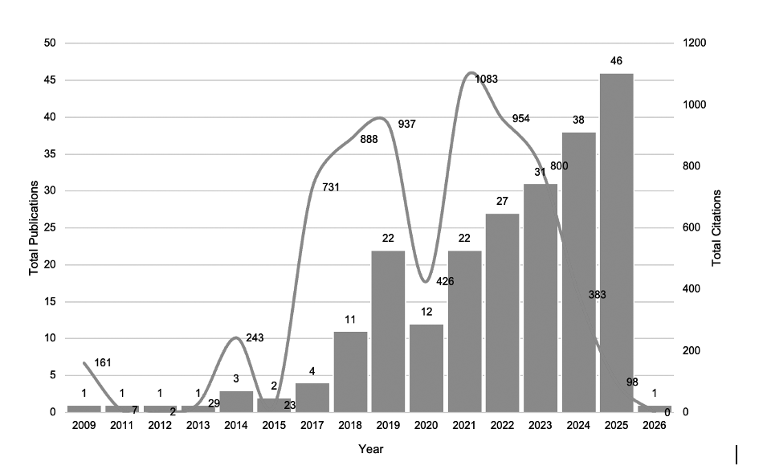

Table 3. Publication by year
Year | TP | NCA | NCP | TC | C/P | C/CP | h-  index | g-  index | m-  index
2009 | 1 | 7 | 1 | 161 | 161.00 | 161.00 | 1 | 1 | 0.056
2011 | 1 | 5 | 1 | 7 | 7.00 | 7.00 | 1 | 1 | 0.063
2012 | 1 | 2 | 1 | 2 | 2.00 | 2.00 | 1 | 1 | 0.067
2013 | 1 | 1 | 1 | 29 | 29.00 | 29.00 | 1 | 1 | 0.071
2014 | 3 | 12 | 3 | 243 | 81.00 | 81.00 | 3 | 3 | 0.231
2015 | 2 | 5 | 2 | 23 | 11.50 | 11.50 | 1 | 2 | 0.083
2017 | 4 | 11 | 4 | 731 | 182.75 | 182.75 | 4 | 4 | 0.400
2018 | 11 | 34 | 11 | 888 | 80.73 | 80.73 | 8 | 11 | 0.889
2019 | 22 | 83 | 22 | 937 | 42.59 | 42.59 | 15 | 22 | 1.875
2020 | 12 | 35 | 12 | 426 | 35.50 | 35.50 | 9 | 12 | 1.286
2021 | 22 | 89 | 22 | 1083 | 49.23 | 49.23 | 16 | 22 | 2.667
2022 | 27 | 148 | 27 | 954 | 35.33 | 35.33 | 16 | 27 | 3.200
2023 | 31 | 116 | 31 | 800 | 25.81 | 25.81 | 16 | 28 | 4.000
2024 | 38 | 134 | 38 | 383 | 10.08 | 10.08 | 11 | 18 | 3.667
2025 | 46 | 175 | 46 | 98 | 2.13 | 2.13 | 5 | 8 | 2.500
2026 | 1 | 3 | 1 | 0 | 0.00 | 0.00 | 0 | 0 | 0.000
Notes: TP = total number of publications; NCA = number of contributing authors; NCP = number of cited publications; TC = total citations; C/P = average citations per publication; C/CP = average citations per cited publication; h = h-index; g = g-index; m = m-index.

Publications by source titles

The distribution of publication across source titles indicates that interactive augmented reality (AR) research in informal education is concentrated within a relatively small number of influential journals. As shown in Table 4 and Figure 4, Sustainability (Switzerland), Heritage, ISPRS International Journal of Geo-Information, Virtual Archaeology Review, and Journal on Computing and Cultural Heritage represent the most productive publication venues.

This concentration suggests the presence of core journals that play a significant role in disseminating research related to educational technology, cultural heritage, tourism, and informal learning. The findings further indicate that scholarly influence is shaped by a limited number of publication channels, reflecting the growing maturity and interdisciplinary nature of the field.

Figure 4. Top 20 Most Productive Source Titles
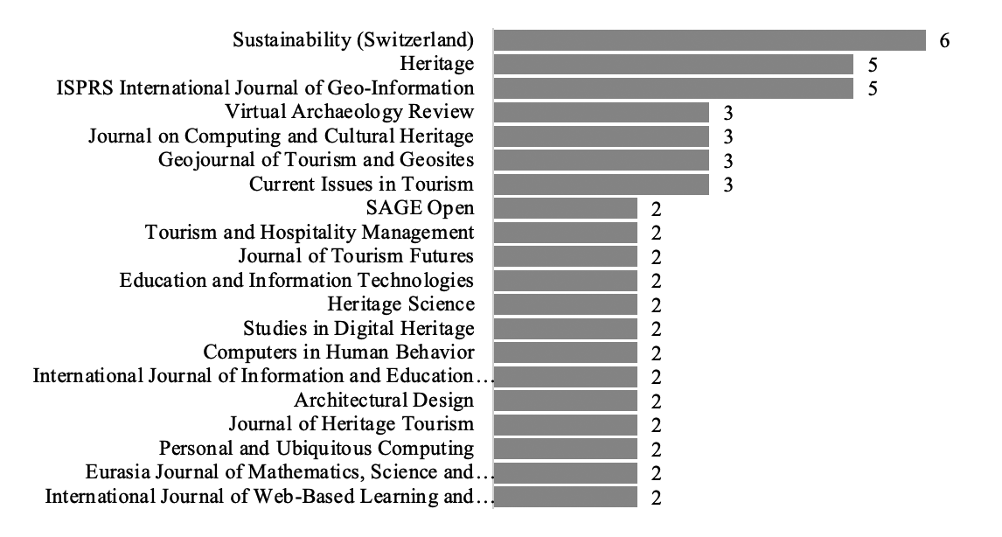

Table 4. Top 5 Most active source titles
Source Title | TP | NCA | NCP | TC | C/P | C/CP | h | g | m
Sustainability (Switzerland) | 28 | 125 | 28 | 893 | 31.89 | 31.89 | 18 | 28 |  | 2.000
Heritage | 17 | 125 | 17 | 322 | 18.94 | 18.94 | 9 | 17 |  | 1.125
ISPRS International Journal of Geo-Information | 6 | 20 | 6 | 271 | 45.17 | 45.17 | 5 | 6 |  | 0.556
Virtual Archaeology Review | 6 | 21 | 6 | 215 | 35.83 | 35.83 | 6 | 6 |  | 0.750
Journal on Computing and Cultural Heritage | 6 | 30 | 6 | 187 | 31.17 | 31.17 | 3 | 6 |  | 0.231
Note: TP = total number of publications; NCA = number of contributing authors; NCP = number of cited publications; TC = total citations; C/P = average citations per publication; C/CP = average citations per cited publication; h = h-index; g = g-index; m = m-index.

Highly cited documents
Table 5 presents the most highly cited publications in interactive augmented reality (AR) research related to informal education. These influential studies have contributed significantly to the development of immersive learning, visitors’ engagement, technology acceptance, cultural heritage interpretation, and educational applications of AR and related technologies. The citation patterns indicate that a relatively small number of foundational studies have played an important role in shaping subsequent research directions and establishing the intellectual foundation of the field. Overall, the highly cited publications demonstrate the growing educational relevance of immersive technologies and their contribution to learning innovation within informal education contexts.
Table 5. Top 10 highly cited articles
No. | Author(s) | Title | Source Title | TC
1 | Martín Gutiérrez, J.; Mora-Luis, C.E.; Añorbe-Díaz, B.; González-Marrero, A. (2017) | Virtual technologies trends in education | Eurasia Journal of Mathematics, Science and Technology Education | 580
2 | tom Dieck, M.C.; Jung, T. (2018) | A theoretical model of mobile augmented reality acceptance in urban heritage tourism | Current Issues in Tourism | 385
3 | Bec, A.; Moyle, B.; Timms, K.; Schaffer, V.; Skavronskaya, L.; Little, C. (2019) | Management of immersive heritage tourism experiences: A conceptual model | Tourism Management | 296
4 | Bec, A.; Moyle, B.; Schaffer, V.; Timms, K. (2021) | Virtual reality and mixed reality for second chance tourism | Tourism Management | 227
5 | Shen, S.; Xu, K.; Sotiriadis, M.; Wang, Y. (2022) | Exploring the factors influencing the adoption and usage of Augmented Reality and Virtual Reality applications in tourism education within the context of COVID-19 pandemic | Journal of Hospitality, Leisure, Sport and Tourism Education | 194
6 | tom Dieck, M.C.; Jung, T.; Rauschnabel, P.A. (2018) | Determining visitor engagement through augmented reality at science festivals: An experience economy perspective | Computers in Human Behavior | 192
7 | Verma, S.; Warrier, L.; Bolia, B.; Mehta, S. (2022) | Past, present, and future of virtual tourism-a literature review | International Journal of Information Management Data Insights | 165
8 | Akhtar, N.; Khan, N.; Khan, M.; Ashraf, S.; Hashmi, M.S.; Khan, M.M.; Hishan, S.S. (2021) | Post-covid 19 tourism: Will digital tourism replace mass tourism? | Sustainability (Switzerland) | 162
9 | Arvanitis, T.N.; Petrou, A.; Knight, J.F.; Savas, S.; Sotiriou, S.; Gargalakos, M.; Gialouri, E. (2009) | Human factors and qualitative pedagogical evaluation of a mobile augmented reality system for science education used by learners with physical disabilities | Personal and Ubiquitous Computing | 161
10 | tom Dieck, M.C.; Jung, T.; tom Dieck, D. (2018) | Enhancing art gallery visitors’ learning experience using wearable augmented reality: generic learning outcomes perspective | Current Issues in Tourism | 148
Note: TP = total number of publications; NCA = number of contributing authors; NCP = number of cited publications; TC = total citations; C/P = average citations per publication; C/CP = average citations per cited publication; h = h-index; g = g-index; m = m-index.

5.5. Publication by authors

Table 6 identifies the most productive authors contributing to interactive augmented reality (AR) research in informal education. Timothy Jung and M. Claudia tom Dieck emerged as the leading contributors, demonstrating strong publication output and citation impact. Other influential contributors include researchers from Italy, Greece, and Australia, reflecting the international and collaborative nature of the filed. Overall, the distribution of productive authors suggests that AR research in informal education is supported by a relatively small group of influential scholars whose work has significantly contributed to the development of learner engagement, experiential learning, cultural heritage application, and technology-enhanced informal learning.

Table 6. The top 10 most productive authors
Full Name | Current Affiliation | Country | TP |  | NCP | TC | C/P | C/CP | h | g | m
Jung, Timothy Hyungsoo | Manchester Metropolitan University | United Kingdom | 6 | 6 |  | 830 | 138.33 | 138.33 | 6 | 6 | 0.667
tom Dieck, M. Claudia | Manchester Metropolitan University | United Kingdom | 5 | 5 |  | 808 | 161.60 | 161.60 | 5 | 5 | 0.556
Barrile, Vincenzo | Università degli Studi di Reggio Calabria | Italy | 4 | 4 |  | 111 | 27.75 | 27.75 | 4 | 4 | 0.500
Zabulis, X. C. | Institute of Computer Science | Greece | 4 | 4 |  | 121 | 30.25 | 30.25 | 4 | 4 | 0.667
Pattakos, Andreas | Institute of Computer Science | Greece | 4 | 4 |  | 121 | 30.25 | 30.25 | 4 | 4 | 0.667
Partarakis, Nikolaos N.P. | Institute of Computer Science | Greece | 4 | 4 |  | 121 | 30.25 | 30.25 | 4 | 4 | 0.667
Fotia, Antonino | Università degli Studi di Reggio Calabria | Italy | 4 | 4 |  | 111 | 27.75 | 27.75 | 4 | 4 | 0.500
Moyle, Brent Don | Griffith University | Australia | 4 | 4 |  | 732 | 183.00 | 183.00 | 4 | 4 | 0.500
Zidianakis, Emmanouil | Institute of Computer Science | Greece | 4 | 4 |  | 121 | 30.25 | 30.25 | 4 | 4 | 0.667
Foukarakis, Michalis | Institute of Computer Science | Greece | 3 | 3 |  | 73 | 24.33 | 24.33 | 3 | 3 | 0.600
Note: TP = total number of publications; NCA = number of contributing authors; NCP = number of cited publications; TC = total citations; C/P = average citations per publication; C/CP = average citations per cited publication; h = h-index; g = g-index; m = m-index.

Publication by institution

Table 7 presents the most productive institutions contributing to interactive augmented reality (AR) research in informal education. The findings indicate that research output is distributed across a diverse range of institutions, particularly in Europe, Australia, and Asia. Institutions such as Manchester Metropolitan University, Politecnico di Milano, and the University of the Sunshine Coast demonstrate strong publication productivity and citation impact, highlighting their significant contributions to the development of the field.

Overall, the result suggest that interactive AR research in informal education is supported by a globally distributed network of institutions. The presence of both high-output and high-impact institutions reflects the growing internationalization and interdisciplinary nature of research in educational technology, cultural heritage, tourism, and informal learning.
Table 7. The top 10 most productive institutions with a minimum of three (3) publications

Institution Name | Country | TP | NCA | NCP | TC | C/P | C/CP | h | g | m
Politecnico di Milano, Italy | Italy | 6 | NR | 6 | 319 | 53.17 | 53.17 | 5 | 6 | 0.625
Manchester Metropolitan University, United Kingdom | United Kingdom | 6 | NR | 6 | 830 | 138.33 | 138.33 | 6 | 6 | 0.667
University of the Sunshine Coast, Australia | Australia | 4 | NR | 4 | 732 | 183.00 | 183.00 | 4 | 4 | 0.500
Institute of Computer Science, Greece | Greece | 4 | NR | 4 | 121 | 30.25 | 30.25 | 4 | 4 | 0.667
Universiti Utara Malaysia, Malaysia | Malaysia | 4 | NR | 3 | 76 | 19.00 | 25.33 | 3 | 4 | 0.600
Università degli Studi di Reggio Calabria, Italy | Italy | 4 | NR | 4 | 111 | 27.75 | 27.75 | 4 | 4 | 0.500
Université de Genève, Switzerland | Switzerland | 4 | NR | 4 | 100 | 25.00 | 25.00 | 3 | 4 | 0.500
University of the Aegean, Greece | Greece | 3 | NR | 3 | 230 | 76.67 | 76.67 | 3 | 3 | 0.167
Universidad de Málaga, Spain | Spain | 3 | NR | 3 | 62 | 20.67 | 20.67 | 3 | 3 | 0.500
Griffith University, Australia | Australia | 3 | NR | 3 | 436 | 145.33 | 145.33 | 3 | 3 | 0.429
Note: TP = total number of publications; NCA = number of contributing authors; NCP = number of cited publications; TC = total citations; C/P = average citations per publication; C/CP = average citations per cited publication; h = h-index; g = g-index; m = m-index.

Publication by countries

Table 8 and Figure 5 illustrate the global distribution of interactive augmented reality (AR) research in informal education. The findings reveal a geographically diverse research landscape, with Europe contributing the largest share of publications, led by Italy, the United Kingdom, and Spain. Strong contributions from China, the United States, Australia, and Malaysia further demonstrate the growing internationalization of the filed. While publication productivity varies across countries, citation patterns indicate that several nations produce highly influential research despite comparatively lower publication output. Overall, the results suggest that the development of interactive AR research is supported by a globally distributed scholarly community, reflecting increasing international collaboration and the expanding educational relevance of AR technologies within informal learning environments.

Figure 5. Visualisation of Global Distribution
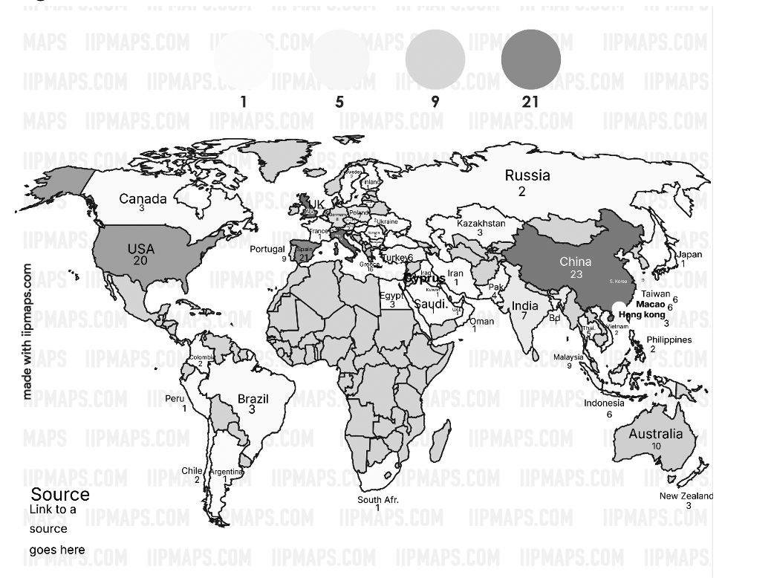
Table 8. Countries that contributed ten (10) or more publications
Country | TP | NCA | NCP | TC | C/P | C/CP | h | g | m
Italy | 26 | 96 | 23 | 769 | 29.58 | 33.43 | 18 | 26 | 1.385
United Kingdom | 26 | 53 | 22 | 1505 | 57.88 | 68.41 | 15 | 26 | 0.833
China | 23 | 54 | 17 | 830 | 36.09 | 48.82 | 12 | 23 | 1.500
Spain | 21 | 67 | 19 | 1038 | 49.43 | 54.63 | 15 | 21 | 1.154
United States | 20 | 41 | 18 | 556 | 27.80 | 30.89 | 10 | 20 | 0.667
Greece | 16 | 117 | 14 | 477 | 29.81 | 34.07 | 9 | 16 | 0.500
Netherlands | 10 | 16 | 10 | 357 | 35.70 | 35.70 | 7 | 10 | 0.700
Australia | 10 | 30 | 9 | 852 | 85.20 | 94.67 | 8 | 10 | 1.000
Malaysia | 9 | 28 | 6 | 254 | 28.22 | 42.33 | 5 | 9 | 0.833
Portugal | 9 | 27 | 7 | 170 | 18.89 | 24.29 | 5 | 9 | 0.500
Note: TP = total number of publications; NCA = number of contributing authors; NCP = number of cited publications; TC = total citations; C/P = average citations per publication; C/CP = average citations per cited publication; h = h-index; g = g-index; m = m-index.

Co-occurrence analysis

To address the sixth research question (RQ6), which investigates the dominant thematic structures shaping the evolution of mixed reality research within informal and cultural learning contexts, a keyword co-occurrence analysis was performed using VOSviewer. Figure 6 visualises the author-keyword network that meets the predefined occurrence threshold, revealing the conceptual organisation of the field through node size, spatial proximity, and colour-coded thematic clusters.

At the centre of the network, the keywords “augmented reality” and “virtual reality” emerge as the most dominant nodes, underscoring their central influence in structuring the research landscape. Their extensive interconnections with surrounding keywords indicate that scholarly discourse is strongly anchored in immersive technologies, with augmented reality functioning as a primary conceptual hub linking educational, technological, and experiential research domains. The prominence of these nodes reflects sustained adoption and continued relevance across diverse application contexts.

Figure 6. Co-occurrence network of author keywords
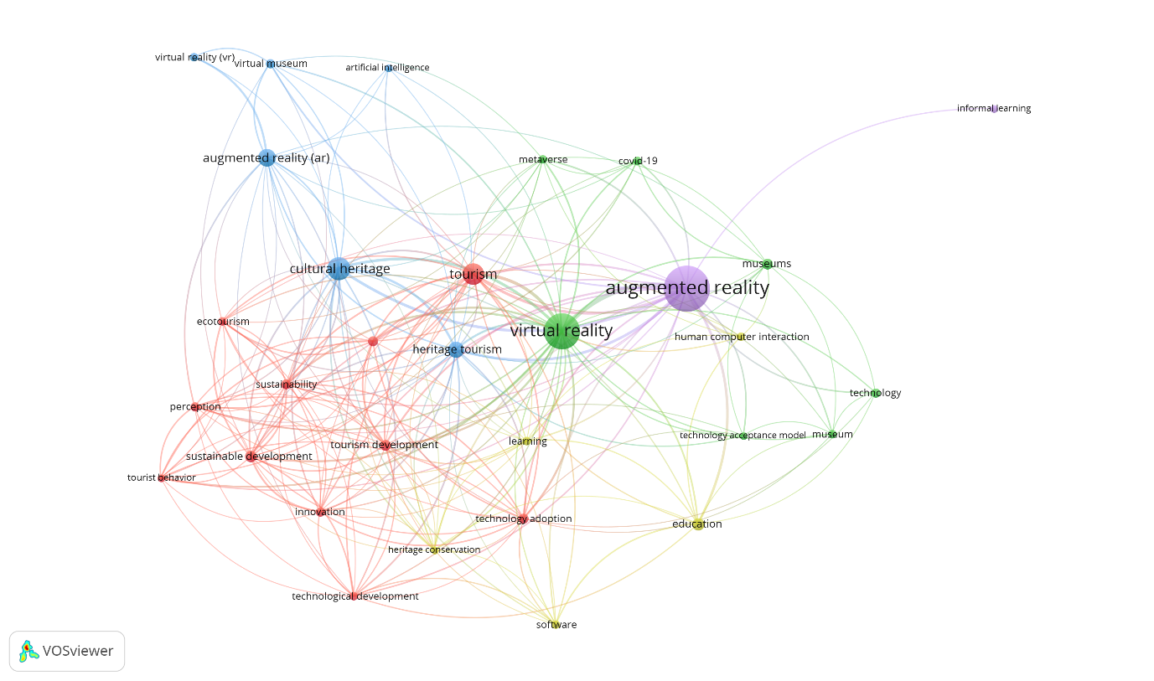

The red cluster focuses on tourism, sustainability, and visitor experiences, highlighting the use of immersive technologies to enhance engagement within tourism and cultural setting. Keywords such as “tourism”, “heritage tourism”, “tourism development”, “sustainable development”, “sustainability”, and “tourist behavior” indicate a strong research emphasis on the use of immersive technologies to enhance tourism experiences and support sustainable cultural practices. The inclusion of terms such as “innovation”, “technological development”, and “perception” suggests that this cluster focuses not only on technological implementation but also on experiential quality and stakeholder engagement within tourism contexts.

The blue cluster centers on cultural heritage and museum-related applications of immersive technologies. Keywords including “cultural heritage”, “virtual museum”, “augmented reality (AR)”, and “virtual reality (VR)” highlight the extensive use of immersive visualisation to support heritage interpretation, preservation, and public engagement. The close spatial relationship between these terms suggests that AR and VR are frequently employed to enrich storytelling, enhance interpretive depth, and provide interactive access to cultural assets within museums and heritage sites.

The green cluster is primarily associated with technology acceptance, human–computer interaction, and digital learning environments. Keywords such as “human computer interaction”, “technology acceptance model”, “learning”, “education”, and “technology” reflect research interest in user engagement, usability, and adoption of immersive systems. The presence of “museums” within this cluster indicates a growing concern with how users interact with immersive technologies in informal learning settings and how acceptance factors influence learning outcomes and visitor satisfaction.

The yellow cluster highlight’s themes related to education, learning technologies, and software development. Keywords such as “education”, “learning”, “software”, and “technology adoption” indicate research efforts focused on instructional design, system development, and pedagogical integration of immersive technologies. This cluster reflects a more applied orientation, where technical development is closely aligned with educational objectives and learning effectiveness.

A smaller purple cluster captures themes linked to informal learning and contemporary educational contexts. The presence of “informal learning” and its connection to augmented reality suggests increasing scholarly attention toward learning experiences that occur outside formal classroom environments, such as museums, cultural sites, and tourism destinations. This aligns with the broader shift toward experiential and self-directed learning supported by immersive technologies.

Across the network, keywords such as “metaverse”, “artificial intelligence”, and “COVID-19” appear as connecting or emerging terms, indicating newer research trajectories that intersect with immersive technologies. These terms suggest that recent studies are beginning to explore how broader digital transformations and global disruptions influence the adoption and evolution of AR and VR in tourism, museums, and informal education.

Overall, the keyword co-occurrence network reveals a highly interconnected and interdisciplinary research landscape. The field is strongly grounded in augmented and virtual reality technologies, with dominant application domains in tourism and cultural heritage. At the same time, growing attention to learning theory, user experience, technology acceptance, and informal education reflect a maturing research domain that extends beyond technological novelty toward pedagogical effectiveness, experiential value, and sustainable practice.

DISCUSSION: EDUCATIONAL TECHNOLOGY EVOLUTION IN INFORMAL EDUCATION

This study provides a comprehensive overview of the development of interactive augmented reality (AR) research within informal education between 2009 and 2026, with particular attention to its potential role in supporting conceptual understanding and meaningful learning experience in informal learning environments. The findings indicate that AR research has evolved into a growing and increasingly recognized area of educational technology, supported by continuous publication growth, expanding international participation, and changing pedagogical priorities.

The steady increase in publication output reflects growing scholarly interest in applying AR technologies within museums, cultural heritage sites, science centres, zoos, and other informal learning environments. Such applications are increasingly recognized for their ability to enhance learner engagement, improve conceptual understanding, and support conceptual understanding through interactive visualization and experiential learning.

The concentration of publications within a limited number of influential journals suggests the existence of core publication sources that play an important role in shaping research directions and disseminating scholarly knowledge. Likewise, citation analysis reveals that a relatively small number of highly cited studies continue to influence subsequent research, particularly in areas related to learner engagement, learning effectiveness, user experience, and technology-enhanced learning.

The findings also reveal geographical disparities in research productivity. Countries with stronger technological infrastructure and research capacity contribute a substantial proportion of publication and citations, highlighting the importance of institutional support and international collaboration regions may contribute to a more diverse and inclusive global research landscape.

The thematic evolution analysis demonstrates a clear transition from technology-oriented exploration towards learner-centred and pedagogically driven applications. While earlier studies focused primarily on technological implementation and system development, recent research increasingly emphasizes learner engagement, learning effectiveness, instructional design, conceptual understanding, and educational outcomes. This trend suggests a growing interest in leveraging AR technologies to support deeper learning and conceptual understanding within informal educational settings.

To synthesise these findings, Figure 7 presents a Conceptual Framework of Interactive AR Research Evolution in Informal Education. The model illustrates how publication growth, influential publication sources, research influence, and learning design evolution collectively contribute to the maturation of the field. The framework demonstrates the progression of AR research from technology-focused exploration towards pedagogically meaningful applications that support learning engagement and educational effectiveness.

Overall, the findings indicate that the development of interactive AR research is driven not only by increasing publication activity but also by evolving educational priorities and learning needs. The field continues to move towards learner-centred and pedagogically informed applications that support learner engagement, conceptual understanding, and effective learning experiences in informal learning environments.

Figure 7. Conceptual Framework of Interactive AR Research Evolution in Informal Education
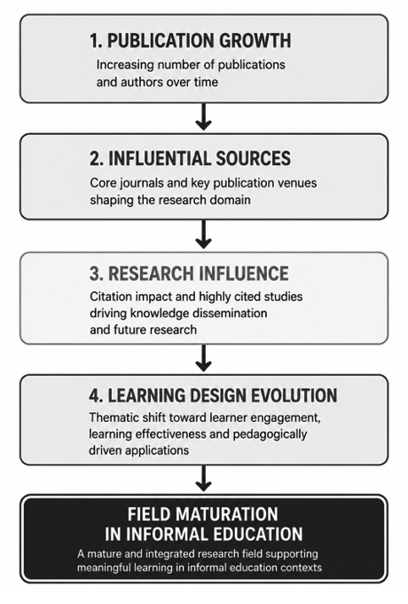

Implications for Learning Research Development and Educational technology scholarship

The findings suggest that interactive AR research for informal education has progressed from an emerging research area to a more structured and mature field of educational technology scholarship. The presence of influential publication venues, highly cited studies, and evolving pedagogical themes indicates the formation of a recognized knowledge base that supports ongoing research development and dissemination. Furthermore, the increasing focus on learner engagement, learning effectiveness, instructional design, and conceptual understanding demonstrates how emerging technologies can be integrated into meaningful educational practices. These findings contribute to a broader understanding of the evolution, maturity, and future direction of educational technology research in informal learning environments.

The increasing emphasis on learning effectiveness and conceptual understanding also suggests growing opportunities for future research exploring the role of interactive AR in supporting conceptual understanding and learning effectiveness within informal education contexts.

CONCLUSION
This study presents a comprehensive bibliometric analysis of interactive augmented reality (AR) research in informal education, examining its development, educational focus, and evolving research directions between 2009 and 2026. The findings reveal a sustained increase in publication output, reflecting growing scholarly interest in the use of AR technologies to support learning experiences in informal educational settings.

The analysis indicates that research in this field has expanded considerably over time and is increasingly supported by a number of influential educational technology and interdisciplinary journals. These publications patterns suggest the growing recognition of AR as a valuable educational technology for enhancing learning engagement, conceptual understanding, and interactive learning experiences beyond formal classroom environments.

The findings also reveal noticeable geographical disparities in research productivity, highlighting the continuing influence of technological infrastructure, research capacity, and institutional support on the development of AR-related studies. Strengthening international collaboration and expanding research participation across underrepresented regions may contribute to a more inclusive and diverse body of knowledge in the future.

Furthermore, the thematic evolution analysis demonstrates a clear transition from technology-oriented exploration towards pedagogical feasibility and system development, recent research increasingly emphasises learner engagement, learning effectiveness, user experience, instructional design, and educational outcomes. This shift reflects the growing maturity of AR research as an educational technology field and its increasing relevance to contemporary learning environments.

To synthesise these findings, the proposed conceptual model illustrates how publications growth, influential journals, citation influence, and thematic development collectively shape the evolution of interactive AR research in informal education. The model provides a useful framework for understanding the progression of research priorities and the relationship between technological innovation and pedagogical advancement within the field.

Overall, this study demonstrates that interactive AR research in informal education has evolved into a rapidly expanding and increasingly mature area of educational technology research. Beyond identifying publication trends and influential contributors, the findings highlight the development of learning-focused research, emerging pedagogical directions, and evolving educational technology practices. The study therefore provides valuable insights for researchers, educators, educational technology designers, and policymakers seeking to support future innovation, learning design, and technology integration in informal learning environments.

Practical Implications

The findings indicate that future AR development for informal learning should prioritise learner engagement, experiential learning, and conceptual understanding rather than focusing solely on technological sophistication. Educational institutions, museums, science centre, and cultural heritage organisations may utilize these insights to guide the design of pedagogically meaningful AR learning experiences that support learning effectiveness and sustained learner participation.

DECLARATION
Funding

This research did not receive any specific grant from funding agencies in the public, commercial, or not-for-profit sectors.

Ethical Approval

This study did not require formal ethical approval as it relied exclusively on secondary data retrieved from the Scopus database.

Competing Interest

The authors declare no conflicts of interest.

Data Availability

The dataset supporting this study is available in a public repository and available from the corresponding author upon reasonable request.

Generative AI Statement

During manuscript preparation, artificial intelligence tools were used to assist with language refinement and proofreading. All outputs were critically reviewed and validated by the authors.

REFERENCES

- Akhtar, N., Khan, N., Mahmud, M. S., Hashmi, M. Z., & Khan, M. I. (2021). Post-COVID-19 tourism: Will digital tourism replace mass tourism? Sustainability, 13(10), 5352. https://doi.org/10.3390/su13105352
- Arvanitis, T. N., Petrou, A., Knight, J. F., Savas, S., Sotiriou, S., Gargalakos, M., & Gialouri, E. (2009). Human factors and qualitative pedagogical evaluation of a mobile augmented reality system for science education used by learners with physical disabilities. Personal and Ubiquitous Computing, 13(3), 243–254. https://doi.org/10.1007/s00779-007-0187-7
- Bec, A., Moyle, B., Schaffer, V., & Timms, K. (2019). Management of immersive heritage tourism experiences using augmented reality. Tourism Management Perspectives, 31, 236–245. https://doi.org/10.1016/j.tmp.2019.04.003
- Bec, A., Moyle, B., Timms, K., Schaffer, V., Skavronskaya, L., & Little, C. (2019). Management of immersive heritage tourism experiences: A conceptual model. Tourism Management, 72, 117–129. https://doi.org/10.1016/j.tourman.2018.10.018
- Bec, A., Moyle, B., Schaffer, V., & Timms, K. (2021). Virtual reality and mixed reality for second-chance tourism. Tourism Management, 83, 104256. https://doi.org/10.1016/j.tourman.2020.104256
- Dunleavy, M., & Dede, C. (2014). Augmented reality teaching and learning. In J. M. Spector et al. (Eds.), Handbook of research on educational communications and technology (pp. 735–745). Springer. https://doi.org/10.1007/978-1-4614-3185-5_59
- Du Juan, & DeWitt, D. (2024). Bibliometric analysis of augmented reality research in chemistry education. Journal of Science Education and Technology. https://doi.org/10.1007/s10956-023-10045-7
- Ibáñez, M. B., Di Serio, Á., Villarán, D., & Delgado Kloos, C. (2014). Experimenting with electromagnetism using augmented reality: Impact on flow student experience and educational effectiveness. Computers & Education, 71, 1–13. https://doi.org/10.1016/j.compedu.2013.09.004
- Martín-Gutiérrez, J., Mora-Luis, C. E., Añorbe-Díaz, B., & González-Marrero, A. (2017). Virtual technologies trends in education. Eurasia Journal of Mathematics, Science and Technology Education, 13(2), 469–486. https://doi.org/10.12973/eurasia.2017.00626a
- Moher, D., Liberati, A., Tetzlaff, J., Altman, D. G., & PRISMA Group. (2009). Preferred reporting items for systematic reviews and meta-analyses: The PRISMA statement. PLoS Medicine, 6(7), e1000097. https://doi.org/10.1371/journal.pmed.1000097
- Prihandini, R., Triyono, M. B., & Priyanto, A. (2023). Bibliometric analysis of augmented reality adoption in tourism research. Tourism Review, 78(5), 1245–1262. https://doi.org/10.1108/TR-10-2022-0501
- Shen, S., Xu, K., Sotiriadis, M., & Wang, Y. (2022). Exploring the factors influencing the adoption and usage of augmented reality and virtual reality applications in tourism education within the context of the COVID-19 pandemic. Journal of Hospitality, Leisure, Sport & Tourism Education, 30, 100373. https://doi.org/10.1016/j.jhlste.2021.100373
- Singh, K., Kaur, R., & Gulzar, Y. (2024). Bibliometric exploration of augmented reality research in education. Education and Information Technologies. https://doi.org/10.1007/s10639-023-12088-5
- tom Dieck, M. C., & Jung, T. (2018). A theoretical model of mobile augmented reality acceptance in cultural heritage tourism. Current Issues in Tourism, 21(2), 154–174. https://doi.org/10.1080/13683500.2015.1070801
- tom Dieck, M. C., Jung, T., & Han, D.-I. (2018). Mapping augmented reality adoption in tourism experiences. Tourism Management, 66, 140–150. https://doi.org/10.1016/j.tourman.2017.11.018
- tom Dieck, M. C., Jung, T., & Rauschnabel, P. A. (2018). Determining visitor engagement through augmented reality at science festivals: An experience economy perspective. Computers in Human Behavior, 82, 44–53. https://doi.org/10.1016/j.chb.2017.12.043
- tom Dieck, M. C., Jung, T., & tom Dieck, D. (2018). Enhancing art gallery visitors’ learning experience using wearable augmented reality: Generic learning outcomes perspective. Current Issues in Tourism, 21(17), 2014–2034. https://doi.org/10.1080/13683500.2016.1224818
- Vosniadou, S. (2013). Conceptual change in learning and instruction: Theoretical foundations. Educational Psychologist, 48(2), 119–132. https://doi.org/10.1080/00461520.2013.778298

