Food Composition and Feeding Intensity of Channa Striata from Selected Stations of Lake Kolleru,
Andhra Pradesh

Dr M. Naveen Kumar
MIG 14, APHB Colony, YSR Statue, Above Pujitha Super Bajar, Satrampadu, Eluru, A.P.

Authors’ contributions
Original Research Article

ABSTRACT
Aim of the current piece of work was to study the food composition and feeding intensity of Channa striata from Lake Kolleru, Andhra Pradesh from June, 2024 to July 2025. The gut contents were analysed from the three stations to undertaken the food composition of the fish. The major components of food items in the gut of fish was: fishes and their larvae, crustaceans, insect larvae, annelids with semi digested material and unidentified items. Fishes are identified as of teleost, particularly carps and cat fish larvae but most of the fishes leftovers could not be recognized since they are found in advanced phases of digestion with only scales & skeleton remains. Gastropods are identified as polycheate larvae, and Crustaceans are prawn and crab larvae. The percentage occurrence of fishes and their larvae in gut contents and also feeding intensity were indicated that
C. striata preferential food was fishes followed by crustaceans.

Keywords: Channa striata; food composition and feeding intensity.

INTRODUCTION
Kolleru is a largest fresh water lake in Indian sub-continent and as well as Asian continent which located in between Krishna and Godavari rivers near Eluru (16.6500° N, 81.2167° E). The present study is on Murrels feeding intensity. Murrels belonging to family channidae are predatory air-breathing fishes well distributed in Asian continent and African countries [1]. This family was the most economic food fish among the local market with traditionally identified pharmacological benefits with wound healing and in boosting energy of the disease persons particularly Channa striata. The Channa has highest species diversity with 46 valid species[2]. Nearly 22 species of Channa have been described from India, out of which 19 sps are found in the Eastern Himalayan region [2]. Foodand feeding habits of fishes from various environments has shown that the requirements at different stages in lifecycle required different type of food organisms [3]. It is very important in fishery biology as it relates to various activities ofthe fish like shoaling behaviors and even entire fishery [4]. Feeding biology is a significant feature of the life history phases of fish species [5]. Food quality and occurrence is the majorfactor controlling fish production [6]. The foodand their quality of fishes may influence number of factors such as region, zones species, size and behavior) and thus information on food of fishes is an important to understand the basic functioning of fish assemblages [7,8]. The concept of critical feeding season has been found to be valuable in information of recruitment of wild fish population [9] and also anunderstanding of how the various fish species utilize available food resources [10,11].

Fishes are directly depend upon their surrounding aquatic environment for food and also proper utilization of the readily available food organisms [12]. Kolleru et al., [13], reported food spectrum and analysis of Indian shad Rastrelliger kanagurta from Kakinada coast and the fish omnivores feeder. The omnivore fishes which fed on one or more assemblies of animals, i.e., plankton, benthos [11]. The knowledge of the food quality and feeding intensity of fish helps in distribution fish through survey for successful management of a fishery and such studies are undoubtedly important in any fisher’s research program [13]. The food composition and feeding intensity of Channa striata in Lake Kolleru is really scanty. Therefore, the results of current study provides valuable information for the forthcoming studies in the Lake Kolleru region fishery management. In the present study murrel Channa striata was selected for the observation of diet composition and feeding habits in the selected area of lake Kolleru, Andhra Pradesh.

MATERIALS AND METHODS
Fish sampling are collected from 3 stations of the Lake Kolleru, Eluru district of Andhra Pradesh and they are Station-ST1: Kolletikota - Its located 16.6471° N Latitude and 81.3069° E Longitude. Station-ST2: Atapaka - Its located 16.5605°N Latitude and 81.2285°E Longitude. Station-ST3: Gudivakalanka, Its located 16.6365° N Latitude and 81.2126° E Longitude with the help of fisherman during June, 2024 to May, 2025. The collected fishes were brought to the laboratory and total length, and weight were measured of fishes and also the dissected and also preserved 5% formalin. The content each stomach was examined using binocular microscope. The weight of the stomach of the individual fish was recorded, based on the weight of the stomach and body weight of the fish C.sriata. Gastro somatic index of each and every fish was calculated using the following formula.

Gastro Somatic Index (GSI) = (Weight of the stomach )/(Weight of the fish ) X 100

18 fishes are sacrificed in each month for quantitative analysis by using both occurrence and point’s volumetric method [14]. The matters of food were smallest size and their volume could be estimated only by allotment of points. The volume index was evaluated from the total points of the entire item recorded over the period of study. In order to get a clear picture of frequency of occurrence as well as volume of various food items in the stomach was recorded [15].

Feeding intensity during various months was observed from the data on the grade of fullness of the stomach. The condition of feed was determined by the observations of the degree of distension of the stomach as described by [16]. Fishes with stomach with gorged, full, ¾ full, ½ full were considered to be feeding actively, while, stomach with ¼ full and empty were considered to poor feeding activity The percentage occurrence of stomach under different circumstances of feeding was also calculated for the whole period of study.

Point’s Method
The degree of apparent, the fullness of the fish stomach the points were allocated. Gorged (1.25);
Full (1.00), ¾ Full (0.75), ½ full (0.50), ¼
full (0.25) and empty was (0.00).

RESULTS AND DISCUSSION
During study period a total 260 (130 males and 130 females) guts of C. striata were examined. The food composition of male fishes were represented in Figs. (1-4) and the female fishes were represented in Figs. (5-8). The feeding intensity of C. striata males were presented in Table 1 and the females were presented in Table 2. The stomach content composed the fishes and their larvae, crustaceans, insect larvae, annelids with semi digested items and unidentified materials. Fishes are identified as of teleost particularly major carps and minor carp’s larvae, but most of the fish remains

could not be identified since they are found in advanced stages of digestion with only scales and bones are remains. Gastropods identified as polycheate larvae, and crustaceans goes to prawn, shrimp and crab larvae.

Murrels are air breathing fishes and they have unique capacity to utilize atmospheric oxygen for respiration by certain morphological adaptations.They are capable for surviving even minute quantity of water [4]. This fish an important freshwater fishery in various states of India and in great market demand because of their pleasant tasty flesh and presence of less number of bones/ spines and also they have medicinal value. Although they popular in fishery, butproved a curse in other species for having an aggressive carnivorous nature. Murrels are commended all over the country for their flavor, medicinal and recuperative attributes high qualitymineral and low fat contents. They are also considered as pest fish since they destroy other species in water body [4].
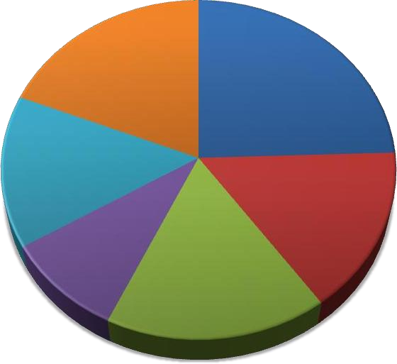
The investigation revealed that C. striata wasomnivore species feeding mainly on fishes followed by crustaceans, insects and annelidsand gastropods. Murrels pray on fishes, crustaceans, worms, molluscs and insect larvae [17,18]. Braga et al., [19] explained that thefeeding intensity of a species linked its population dynamics. Shamsan and Ansari [20], reported that fishes and crustaceans are the most favorable food items of carnivore fishes. In the present study preferential food C. striata arefishes & crustaceans. Gastro somatic index recorded highest in the months of September(5.53) and October (6.4) in case of males and females goes to September (5.69) and October (6.8).
19%
14%
9%

 | 25%
 |  | Fish and their Larvae
Crustaceans
Insects Larvae
 | 16% | Annelids
 |  | Miscellaneous Items
17% |  | Unidentified

Fig. 1. Percentage of food composition of male Channa striata in the south west monsoon, 2024-2025
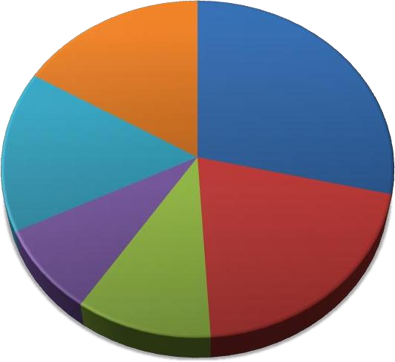
Miscellaneous Items
Unidentified
12%
19%
9%
Crustaceans
Insects Larvae Annelids
15%
Fish and their Larvae
29%
16%

Fig. 2. Percentage of food composition of male Channa striata in the post monsoon, 2024-2025

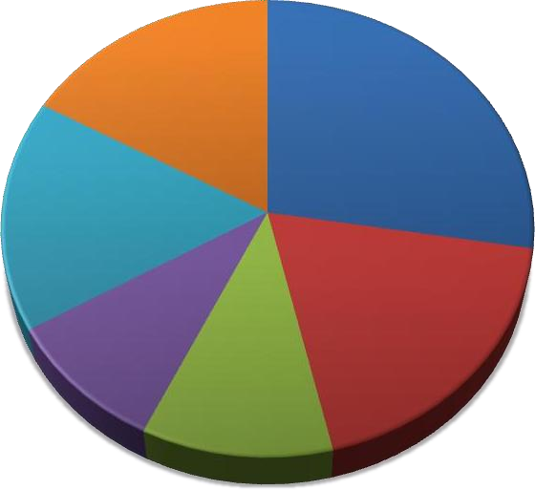
Fish and its Larvae
16%
28%
16%
10%
19%
11%
Crustaceans
Insects Larvae
Annelids
Miscellaneous Items
Unidentified

Fig 3. Percentage of food composition of male Channa striata in the north east monsoon, 2024-2025

Abundance and diversity of food organisms was play an important role in survival, growth and maturity in fishes and they can be achieved through selection of quality food or better nutrition. The seasonal effect on the structure of the food web and consequence on fish food [21]. Gastro somatic index values as an indication of fullness of stomach and find out the feeding rhythm. During the course of the investigation, maximum numbers of fishes were found with empty stomach. The frequent occurrence of empty stomach or stomach with little content might be dependent on the ratio between the size of the fish and size of the prey as cited on the caloric values of the diet as explained by [22].

The occurrence of empty stomachs of fishes does not show any relationship either to seasonal month or to the size of the fish. Feeding intensity of the fish and feeding behavior and also food intake by fish can encounters their energy requirements time to time [23]. Food has low energy, fish will compensate by fed more food and stomach capacity [24].
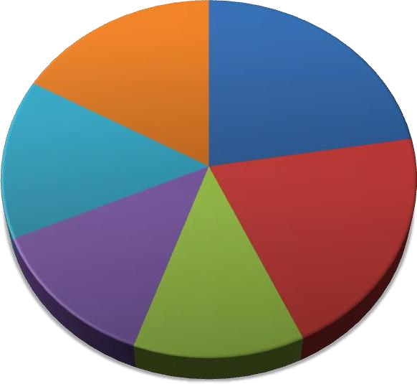
Unidentified Items
13%
Insects
Annelid Miscellaneous Items
13%
20%
Fish and their
Crustaceans
15%
23%
16%

Fig. 4. Percentage of food composition of male Channa striata in the summer, 2024-2025

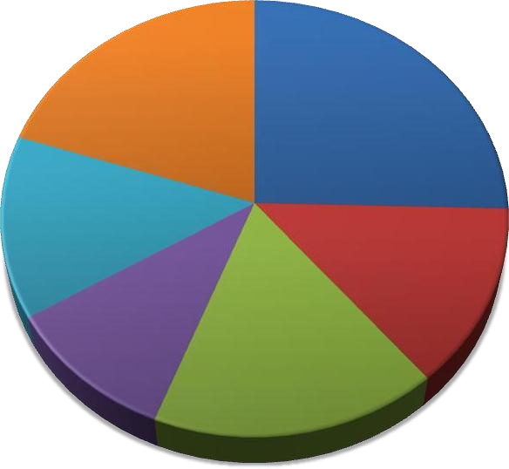
19%
26%
14%
14%
11%
Fish and their Larvae
Crustaceans Insects Larvae Annelids
Miscellaneous Items
Unidentified Items
16%

Fig. 5. Percentage of food composition of female Channa striata in the south west monsoon, 2024-2025

The ranking of various food composition with ranked first by fishes dominated during the entire study period followed by crustaceans, insect larva, annelids, worms and Gastropods. This observations similar thewith diet composition of carnivorous fishes from coral reef lagoons [25]. Kulbicki et al., [26] reported that the fishes are opportunistic feeders and changes in number of prey types reflect on the particular ecosystem where the fish is feeding. The length of the alimentary canal is indicate the food preferences of the fishes [27,28]. Wilson [29] stated that an increase in protein levels of food during summer period. Madhupratap et al., [30], reported that adverse environmental conditions resulting in less than optimum plankton food production.

The present study was confined that the food items available in the guts which revealed that there are seasonal variations in diet and may influencing feeding patterns in all seasons. Manojkumar.et al., [31] says that Nemipterus japonicus is a demorsal carnivorous fish and the food items consisted of fish larvae, crustaceans, molluscs, polychaetes and miscellaneous food items. In our results also shows that the C. striata is an carnivorous and diet containing fish and their larvae, crustaceans, insects and annelids are the major food items. Jambo and Maduako, [32], reported that the food and feeding habit of Mugil cephalus from Niger delta and it was fish larvae, crustaceans, insect parts annelids and other plant material along with sand particles. Kolleru et al., [33], reported that the Lates calcarifer is an top predator and gut contains crustaceans, fishes, and polychaete worms some extent.

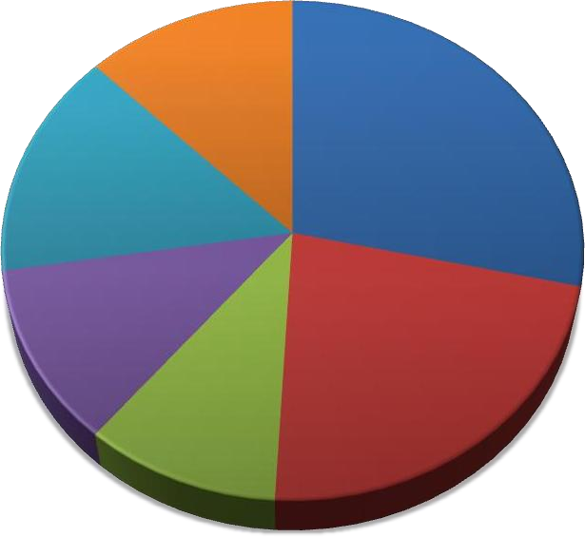
13%
28%
15%
Fish and their Larvae
Crustaceans
Insects Larvae
11%
23%
10%
Annelids
Miscellaneous Unidentified

Fig. 6. Percentage of food composition of female Channa striata in the Post Monsoon, 2024-2025
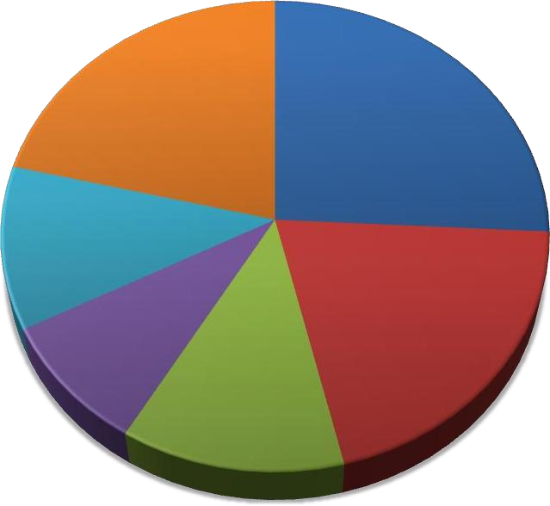
13%
Miscellaneous Items
Unidentified Items
20%
9%
Insects Larvae
Annelids
11%
Fish and their Larvae
Crustaceans
26%
21%

Fig. 7. Percentage of food composition of female Channa striata in the North East Monsoon, 2024-2025

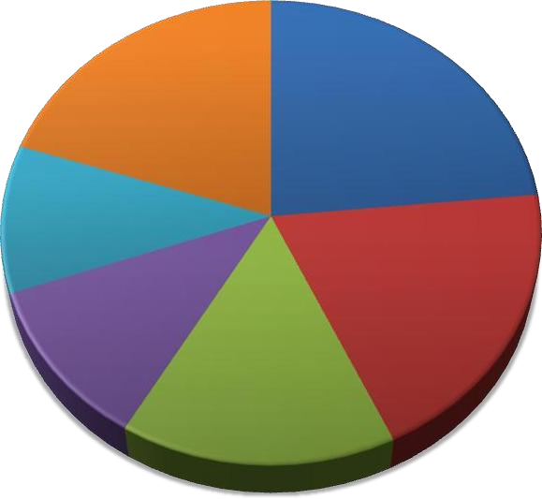
16%
Miscellaneous
Items Unidentified Items
11%
20%
Insects Larvae
Annelids
10%
Fish and its
Larvae Crustaceans
23%
20%

Fig. 8. Percentage of food composition of female Channa striata in the summer, 2024-2025 Table 1. Seasonal variations and feeding intensity in C.striata males

Seasons Months Status
Gorged Full ¾ Full ½ Full ¼ Full Empty

South west monsoon
Post monsoon North
east monsoon
June 0 0 5 10.5 25.5 59
July 0 0 6 12.5 29.5 52
August 0 5 9 14.2 30.5 41.3
September 3 6 12 16.5 26.8 35.7
October 4 8 13 15 22.5 37.5
November 6 10 15.4 18 12.5 38.1
December 5 12 16.5 10 15.5 41
January 7 13 8 16 18.8 37.2
February 9 14 10.5 19.5 14.9 32.1

Summer March 8 12 6.5 15.5 19.3 38.7
April 4 15 19 14.8 10.6 36.6
May 0 12 16 15.5 16.8 39.7

Table 2. Seasonal variations and feeding intensity in C. striata females

Seasons Months | Gorged | Full | St  ¾ Full | atus  ½ Full | ¼ Full | Empty
South June | 0 | 0 | 6 | 11.5 | 20.5 | 62
west July | 0 | 0 | 8 | 15.4 | 20.8 | 55.8
monsoon August | 0 | 7 | 12 | 15.6 | 22.5 | 42.9
September | 5 | 12.5 | 16.8 | 22.3 | 13.4 | 30
Post October | 8 | 14.4 | 18.5 | 10.5 | 15.8 | 32.8
monsoon November | 5 | 13 | 18.4 | 18.5 | 15.4 | 30.7
North December | 4 | 14.5 | 10.4 | 10.6 | 19.6 | 40.9
east January | 5 | 11.5 | 16.4 | 18.5 | 11.4 | 37.2
monsoon February | 6 | 13.5 | 14.2 | 15.5 | 15.6 | 35.2
Summer March | 6 | 9.5 | 17.2 | 14.3 | 22.2 | 30.8
April | 3 | 12.5 | 13.5 | 13.4 | 19.5 | 38.1
May | 0 | 6 | 12 | 11.5 | 24.5 | 46

CONCLUSION
Based on the research result, it was concluded that the diet composition and feeding intensity of Channa striata from Lake Kolleru were Fishes and their larvae (22- 28%), followed by crustaceans (19- 23%), insect larvae, annelids with semi digested items and unidentified materials. The percentage occurrence of feeding intensity indicated their preference for fish’s food. There were empty stomach 63% in the month of May was observed in and the remaining was filled with food in different levels.

REFERENCES
- Ruber L, Tan HH, Britz R. Snakehead (Teleost: Channidae) diversity and theEastern Himalaya biodiversity hotspot. Journal of Zoological Systematics and Evolutionary Research. 2020;58(1):356–386.
- Praveenraj J, Uma A, Moulitharan N,Kannan R. Channa brunnea, a new species of snakehead (Tele-ostei:Channidae) from West Bengal, India. Zootaxa. 2019;4624(1):59–70.
- Krishna PV, Aradhya Sarma BVL, Gurramma M. Food and feeding habits of Indian shad Tenualosa ilisha from Godavari estuary, Andhra Pradesh.International Journal of Recent ScientificResearch. 2022;13(03):680-684.
- Krishna PV. Food spectrum of spotted murrel Channa punctatus from Repalle area Guntur District Andhra Pradesh. J.Aquacult. 2008;19(1):83-88.
- Blaber SJM. Fish and fisheries of tropical estuaries London: Chapman and Hall.1997;367.
- Walters C, Christensen V, Pauly D. Structuring dynamic models of exploited ecosystems from trophic mass-balance assessments. Rev. Fish. Biol. Fish. 1997; 7(2):139–172. Hanson JM, Chouinard GA. Diet of atlantic cod in the southern gulf of st. lawrence as an index of ecosystem change, 1959 – 2000. J. Fish Biol. 2002;60:902–922.
- Kulbicki M, Bozec YM, Labrosse P, Letourneur Y, Moutham G, Wantiez L. Dietcomposition of carnivorous fishes from coral reef lagoons of New Caledonia. Aqua. Living Resour., 2005;18:231–250.
- Keast A, Eadie JMA. Growth depensation in the year 0 largemouth Bass- Theinfluence of diet. Trans. Am. Fish Soc. 1985;114:204–213.
- Ellis JK, Musick JA. Ontogenetic changes in the diet of the sandbar shark, Carcharhinus plumbeus, in lower Chesapeake Bay and Virginia (USA) coastal waters. Environ. Biol. Fish. 2007;80:51–67.
- Krishna PV, Panchakshari V, Prabhavathi
K. “Food and feeding habits of goat fish Upeneus sulphureus from Nizampatnam Coast, Andhra Pradesh, India”. International Journal of AdvancedResearch, 2015;3(11):1066–1070.
- Krishna PV, Aradhya Sarma BVL, Gurramma M. Food and feeding habits of Indian shad Tenualosa ilisha from Godavari estuary, Andhra Pradesh. International Journal of Recent ScientificResearch. 2022;13(03):680-684.
- Krishna PV, Saroja J, Aradhya Sarma BVL, Gurramma M. Food spectrum and analysis of Indian shad Rastrelliger kanagurta from Visakhapatnam coast, Andhra Pradesh. Int. Jour. of Fisheries and Aquatic Studies 2022;10(5):107-110.
- Hynes HBN. The food of fresh-water sticklebacks (Gasterosteus aculeatus and Pygosteus pungitius), with a review of methods used in the studies of the food of fishes. J. Anim. Ecol. 1950;19:36–58.
- Natarajan AV, Jhingran VG. Index ofpreponderance: A method of grading the food elements in the stomach analyses of fishes. Indian Journal of Fisheries. 1961;8:54–59.
- Pillay TVR. A critique of the method of study of food fishes. J. Zool. Soc. India, 1952;19(6):777-827.
- Vassilopoulou V, Papaconstantinou C. Aspects of the biology of the red mullet(Mullus barbatus) in the Aegean Sea. FAO Fisheries Report. 1992;477:115-126.
Labropoluo M, Machias A, Tsimendes N, Eleftheriou A. Feeding habits and ontogenic diet shift of the striped red mullet, Mulls surmuletus Linnaeus, 1758. Fish. Res. 1997;31:257–267.
- Braga RR, Bornatowski H, Vitule JRS. Feeding ecology of fishes: An overview of word wide publications. Reviews in FishBiology and Fisheries. 2012;22:915-929.
- Shamsan EF, Ansari ZA. Study of age and growth of Indian sand whiting, Sillago sihama (Forsskal)

from Zuari estuary, Goa.Indian Journal of Marine Sciences. 2010;39:68-73.
- Kariman A Sh Shalloof, Nehad Khalifa. 2009. Stomach Contents and Feeding Habits of Oreochromis niloticus (L.) From Abu Zabal Lakes, Egypt; World Applied Sciences Journal; 6 (1) : 01- 05.
- Longhurst AR. The food of the domersal fish of a West African estuary. J. Anim. Ecol. 1957;26:369-387.
- Bowen SH, Lutz EV, Ahlgren MO. Dietary protein and energy as determinants of foodquality: Trophic strategies compared. Ecology. 1995;76(3):899–907.
- Mittelbach GJ. Fish foraging and habitatchoice: A theoretical perspective. In: Hart PJB, Reynolds JD. (Eds.) Handbook onFish Biology and Fisheries. Blackwell Publishing. 2002;249–266.
- Schaefer LN, Platell ME, Valesinni FJ, Potter IC. Comparison between theinfluence of habitat type, season and body sizeon the dietary compositions of fish species in near-shore marine waters. J. Exp. Mar. Biol. Ecol. 2002;278:67–92.
- Kulbicki M, Bozec YM, Labrosse P, Letourneur Y, Mou Tham G, Wantiez L.Diet composition of carnivorous fishes fromcoral reef lagoons of New Caledonia. Aquat. Living Resour. 2005;18:231–250.
- Kapoor BG, Smith H, Verighina IA. Thealimentary canal and digestion in teleosts. Advances in Marine Biology. 1975;13:109–239.
- Rao, Narayana KV, Rao KP. Differences inthe food of the young and the adult Indian mackerel, Rastrelliger kanagurta (Cuv.). Nature. 1957;180:711–712.
- Wilson S. Nutritional value of detritus and algae in blenny territories on the Great Barrier Reef. J. Exp. Mar. Biol. Ecol. 2002;271:155–169.
- Madhupratap M, Shetye SR, Nair KN, Nair RS. Oil sardine and Indian mackerel: Their fishery problems and coastal oceanography. Curr. Sci. 1994;66(5):340- 348.
- Manojkumar PP, Pavithran PP, Ramachandran NP. Food and feeding habits of
Nemipterus japonicus (Bloch) from Malabar Coast, Kerala Indian J. Fish.,2015;62(1):64-69.
- Jambo NA, Maduako NC. Food and feeding habits of Mugil cephalus [Linnaeus,1758] in Elechi Creek, Niger Delta. Nigeria. Inter. Jour. of Fish and Aqua., 2015;7(3):25-29.
- Krishna PV, Panchakshari V, Prabhavathi

K. Feeding habits and stomach contents of asian seabass lates calcarifer from Nizampatnam Coast, Andhra Pradesh, India. International Journal of Advanced Research. 2016;4(4):168-172

