––


Walchand College Of Engineering, Sangli.

(An Autonomous Institute)

Department of
Electronics Engineering

Conference Report

On

Intelligent Battery Management System for Accurate State of Charge Estimation

By

Poonam Suryakant More

Under the Guidance of
Dr. S. D. Ruikar
HOD & Guide

Electronics & Telecommunication Engg Dept,
Walchand College of Engineering, Sangli

AY 2025-26 Sem I

Table of contents

Sr. No | Title | Page No.
1 | Abstract | 3
2 | Introduction | 4
3 | Literature Review | 10
4 | Methodology/ System Design | 18
5 | Working System | 31
6 | Implementation | 32
7 | Results and Discussion | 42
8 | Conclusion and Future Scope | 51
10 | References | 53

Abstract

The increasing adoption of electric vehicles (EVs) and renewable energy storage systems has intensified the need for accurate, safe, and intelligent battery monitoring solutions. A critical parameter in battery management is the State of Charge (SOC), which directly influences range prediction, battery lifespan, and overall system reliability. Traditional SOC estimation techniques such as Coulomb Counting and Open Circuit Voltage (OCV) often suffer from drift, dependency on rest periods, and sensitivity to temperature and load variations, making them insufficient for real-time EV applications.
This project presents the design and development of an Intelligent Battery Management System (BMS) that uses a hybrid SOC estimation approach combining Coulomb Counting, OCV calibration, and Extended Kalman Filter (EKF) refinement. The system integrates an ESP32 microcontroller, voltage, current, and temperature sensing modules, and implements robust relay-based protection against overvoltage, overcurrent, and thermal faults. An IoT-enabled monitoring interface is implemented using the Blynk Cloud platform, offering real-time visualization of battery parameters, remote alerts, and historical data analysis.
The hybrid estimation method significantly improves accuracy by reducing drift errors and compensating for nonlinear battery behavior. The project delivers a low-cost, scalable, and high-precision BMS solution, suitable for modern EVs, renewable energy storage units, and smart grid-connected systems. This intelligent architecture enhances safety, supports predictive maintenance, and provides a strong foundation for future advancements in AI-driven SOC/SOH estimation.

Keywords : Battery Management System (BMS), State of Charge (SOC), Extended Kalman Filter (EKF), Lithium-ion Battery, Coulomb Counting, Open Circuit Voltage (OCV), IoT-Based Monitoring, ESP32 Microcontroller, Blynk Cloud, Electric Vehicles (EVs), Real-time Battery Monitoring, Hybrid SOC Estimation.

- CHAPTER 1: INTRODUCTION

1.1 Background of the Study
The global shift towards electrification, green mobility, and renewable energy integration has significantly increased the demand for efficient, safe, and intelligent battery technologies. Lithium-ion batteries have become the backbone of electric vehicles (EVs), portable electronics, renewable energy storage units, and smart grid infrastructures due to their high energy density, long cycle life, and reliability. However, as dependence on such batteries increases, the need for efficient monitoring, protection, and intelligent management becomes critical.
At the centre of this framework lies the Battery Management System (BMS), which plays a decisive role in ensuring battery safety, reliability, and performance. A BMS monitors crucial parameters such as voltage, current, temperature, State of Charge (SOC), and State of Health (SOH). Among these, SOC is considered the most critical parameter because it represents the available capacity of a battery relative to its rated capacity. SOC affects EV range estimation, energy efficiency, charge/discharge control, and battery lifespan.
Accurate SOC estimation remains a complex task due to the nonlinear electrochemical characteristics of lithium-ion cells, varying operational conditions, temperature fluctuations, and aging behaviour. As electric mobility grows and energy systems become increasingly interconnected, traditional SOC estimation techniques are proving inadequate, prompting the development of hybrid and intelligent estimation methods.

1.2 Need for Accurate SOC Estimation
In EVs and modern energy storage systems, SOC is essential for several operational functions such as:
- Range prediction for electric vehicles
- Battery safety by preventing overcharging and deep discharging
- Energy management and optimization
- Enhancing battery life and performance
- Smart charging and V2G (Vehicle-to-Grid) integration
Traditional SOC estimation methods like Coulomb Counting accumulate errors over time, while Open Circuit Voltage (OCV) requires rest periods that are impractical in dynamic applications. These limitations significantly affect the reliability of existing low-cost BMS units. Therefore, there is a strong need for a more accurate, reliable, and real-time SOC estimation method, especially for EV applications where load cycles vary constantly.

1.3 Role of Battery Management Systems (BMS)
A sophisticated BMS ensures:
- Continuous monitoring of voltage, current, and temperature
- Protection against unsafe operating conditions
- SOC and SOH estimation
- Thermal management
- Fault detection
- Charge/Discharge control
Modern BMS architectures require intelligence, connectivity, and precision. With advancements in IoT and embedded systems, the BMS has evolved from a simple monitoring unit to a smart and connected diagnostic system.

1.4 Limitations of Existing SOC Estimation Techniques
While several SOC estimation methods exist, each has limitations:

1.4.1 Coulomb Counting Method
- Accumulates drift error over long periods
- Dependent on accurate initial SOC
- Sensitive to current sensor noise

1.4.2 Open Circuit Voltage (OCV) Method
- Accurate only when the battery is at rest
- Not suitable for real-time EV operation

1.4.3 Model-Based Methods
- Require detailed battery parameters
- Need frequent calibration
- Increased computational complexity

1.4.4 AI-Based Methods
- Require large training datasets
- Risk of inaccurate prediction under unseen operating conditions
These gaps create an opportunity for a hybrid SOC estimation technique that leverages multiple methods and compensates for individual shortcomings.

1.5 Proposed Solution
This project proposes an Intelligent Battery Management System using:
- Coulomb Counting for real-time tracking
- Open Circuit Voltage for periodic calibration
- Extended Kalman Filter (EKF) implemented in PROTEUS to reduce cumulative errors and enhance accuracy
- ESP32-based IoT integration for real-time monitoring
- Relay-based protection against overvoltage, overcurrent, and overheating
This hybrid solution integrates hardware and software intelligence to overcome the limitations of traditional estimation techniques.

1.6 Role of IoT in Modern BMS Systems
With the rapid evolution of IoT technologies, modern BMS units can now:
- Upload battery data to the cloud
- Provide real-time SOC monitoring on smartphones
- Trigger alerts for thermal faults or abnormal behavior
- Maintain historical trends for predictive maintenance
- Enable smart grid and V2G interactions
In this project, the ESP32 microcontroller communicates with the Blynk IoT cloud, enabling users to access battery parameters such as SOC, voltage, current, and temperature from anywhere.

1.7 Importance of Hybrid SOC Estimation
The hybrid approach in this project offers:
- Reduced drift error through EKF corrections
- Improved stability under dynamic load conditions
- Higher reliability compared to single-method estimation
- Adaptability to different lithium-ion chemistries
- Real-time computation compatibility for embedded systems
Such accuracy is essential for EVs, where sudden load changes are frequent and battery conditions constantly vary.

1.8 Project Motivation
The motivation behind this project arises from:
- Insufficient accuracy in low-cost BMS units used in e-rickshaws, EV scooters, and solar storage systems
- Increasing demand for real-time, cloud-based battery monitoring
- The need for low-cost alternatives to expensive commercial BMS units
- The importance of safe, reliable battery operation in EVs
- Academic requirement to explore hybrid estimation and IoT integration
This project aims to deliver a practical, cost-effective, and technically advanced BMS that bridges the gap between research-level algorithms and real-world applications.

1.9 Problem Definition
Existing low-cost BMS solutions do not provide reliable SOC estimation due to hardware limitations, lack of hybrid calculation methods, and absence of IoT connectivity. There is a need for a smart BMS that is accurate, affordable, cloud-connected, and capable of real-time fault handling.

1.10 Objectives of the Project
The primary objectives of the project are:
- To design and develop an IoT-based BMS using ESP32.
- To implement a hybrid SOC estimation technique combining Coulomb Counting, OCV, and EKF.
- To integrate PROTEUS-based simulation for improving SOC accuracy.
- To develop a Blynk IoT dashboard for real-time monitoring.
- To implement relay-based protection for safe battery operation.
- To analyze system performance and compare estimation accuracy with traditional methods.

1.11 Scope of the Project
The scope includes:
- Real-time monitoring of battery voltage, current, temperature, and SOC
- Implementation of hybrid SOC estimation
- PROTEUS-based Kalman filtering
- IoT dashboard creation
- Hardware prototype development
- Performance evaluation
The project does not include advanced SOH estimation, battery balancing, or EV drive-cycle modeling, but provides a strong foundation for future expansions.

CHAPTER 2: LITERATURE REVIEW

2.1 Introduction

The adoption of Battery Management Systems (BMS) has significantly increased with the global rise of electric vehicles (EVs), renewable energy storage systems, and smart grid technologies. The BMS is responsible for monitoring essential battery parameters such as voltage, current, temperature, and State of Charge (SOC). Among these, SOC estimation remains one of the most challenging aspects due to the nonlinear behavior of lithium-ion battery chemistry, aging effects, load variations, and temperature fluctuations. The accuracy of SOC directly influences EV range prediction, battery life, safety, and charging efficiency.
To address these challenges, researchers across the world have proposed a wide range of SOC estimation and battery monitoring techniques. These include traditional algorithms like Coulomb Counting and Open Circuit Voltage (OCV), model-based approaches such as Equivalent Circuit Models (ECM) combined with Kalman Filtering, as well as advanced methods using neural networks and machine learning. Additionally, the integration of Internet of Things (IoT) technologies into BMS architectures is gaining momentum, enabling remote monitoring, cloud-based analytics, and predictive battery management.
This chapter presents a detailed review of ten major research contributions relevant to this project. Each publication is critically analyzed in terms of methodology, findings, limitations, and contributions to modern SOC estimation techniques. The objective of this chapter is to build a solid foundation for the proposed hybrid SOC estimation and IoT-enabled BMS system.

2.2 Review of Existing Research Work
This section provides an in-depth analysis of the ten research papers referenced in the earlier review work. Each paper highlights advancements in SOC estimation, IoT-based monitoring, and BMS design.

2.2.1 Patil & Deshmukh (2023): IoT-Based Battery Management System for Electric Vehicles
Patil and Deshmukh present an IoT-enabled BMS architecture designed specifically for EV applications. The authors discuss the importance of real-time battery monitoring and the need for Wi-Fi-based microcontrollers such as ESP32 and Raspberry Pi. Their work highlights the limitations of conventional SOC estimation methods and proposes the integration of cloud platforms for centralized monitoring.
Key Contributions:
- Introduced IoT dashboards for real-time tracking
- Emphasized safety features and fault alerts
- Highlighted the importance of mobile applications for EV users
Limitations:
- Did not implement advanced SOC algorithms, relying mainly on voltage-based logic.

2.2.2 Reddy & Kumar (2022): SOC Estimation Techniques for Lithium-ion Batteries
Reddy and Kumar provide a comprehensive review of SOC estimation methods, comparing Coulomb Counting, OCV, Kalman Filters, and machine learning techniques. Their analysis emphasizes the challenges posed by temperature variations, sensor drift, and aging behaviour.

Key Contributions:
- Detailed comparison of different SOC estimation techniques
- Highlighted the importance of battery modeling in EKF
- Identified limitations of single-method SOC estimation
Limitations:
- Focuses more on theoretical comparison and lacks practical implementation.

2.2.3 Sharma & Singh (2021): Battery Management Systems for Electric Vehicles
This paper evaluates modern EV-oriented BMS architectures, focusing on electrical safety, thermal monitoring, and fault detection. The authors explain different BMS topologies such as centralized, modular, and distributed systems.
Key Contributions:
- Described crucial BMS protection features
- Explained architecture differences for EV applications
- Demonstrated the importance of hardware reliability
Limitations:
- Did not include hybrid SOC estimation or IoT-based dashboards.

2.2.4 Kumar & Mehta (2023): IoT-based Real-Time Battery Monitoring in EVs
Kumar and Mehta explore an IoT-based battery monitoring system where ESP8266/ESP32 modules transmit real-time voltage and temperature data to cloud dashboards. Their work helps establish IoT’s relevance for EVs and renewable systems.

Key Contributions:
- Real-time monitoring via cloud dashboard
- Low-cost microcontroller-based implementation
- Demonstrated the use of Wi-Fi modules in EV monitoring
Limitations:
- No SOC estimation algorithm was discussed
- Relied strictly on threshold-based monitoring

2.2.5 Jadhav & Kulkarni (2022): Overview of SOC Estimation Methods
This review paper provides a structured comparison of SOC estimation methods used in EV applications. It explains the mathematical basis of Coulomb Counting, OCV methods, Kalman Filters, and neural network estimators.
Key Contributions:
- Strong theoretical foundation on SOC algorithms
- Explained various error sources in SOC estimation
- Compared algorithm complexity and hardware requirements
Limitations:
- Limited focus on IoT integration or practical hardware implementation.

2.2.6 Prakash & Varma (2023): IoT Integration in Battery Management for Renewable Energy Systems
Prakash and Varma present a cloud-connected BMS architecture for solar energy storage systems. Their research highlights the importance of IoT for large-scale storage farms and grid-connected applications.

Key Contributions:
- Demonstrated IoT’s role in grid storage monitoring
- Included predictive analytics using cloud platforms
- Introduced the idea of remote diagnostics
Limitations:
- SOC estimation was not the main focus
- More suitable for stationary storage rather than EVs

2.2.7 Kaur & Gill (2021): SOC and SOH Estimation for Lithium-ion Batteries
Kaur and Gill analyze SOC and SOH estimation using model-based and machine learning approaches. They emphasize the need for accurate aging models and nonlinear system representation.
Key Contributions:
- Combined SOC and SOH analysis
- Explained the role of internal resistance in aging
- Highlighted challenges of machine learning approaches
Limitations:
- No hardware implementation
- Requires large datasets for ML-based estimation

2.2.8 Patidar & Verma (2023): IoT-Enabled Battery Monitoring for Smart Grids
Patidar and Verma propose a remotely accessible BMS system for smart grid energy storage. They use cloud MQTT platforms to manage data from distributed storage units.
Key Contributions:
- Introduced scalable IoT architectures
- Demonstrated wireless monitoring for large grid systems
- Highlighted cybersecurity concerns
Limitations:
- SOC estimation entirely voltage-based
- No hybrid estimation or EKF integration

2.2.9 Gupta & Singh (2022): Analysis of SOC Algorithms for EV Batteries
This publication compares SOC estimation algorithms in terms of error rate, computational complexity, and control performance. It focuses on real-time applicability of algorithms such as EKF and UKF.
Key Contributions:
- Detailed comparison of Kalman Filter variants
- Highlighted suitability of EKF for embedded BMS
- Considered computational constraints of microcontrollers
Limitations:
- Lacked IoT connectivity analysis
- No experimental validation

2.2.10 Soni & Patil (2021): Battery Management in Electric Vehicles Using IoT
This work integrates IoT with a threshold-based BMS system for EVs. It monitors battery parameters and uploads them to cloud dashboards for user accessibility.
Key Contributions:
- Demonstrated simple IoT-BMS integration
- Highlighted benefits of remote monitoring
- Focused on mobile app-based user interaction
Limitations:
- No advanced SOC methodology
- Algorithm limited to simple threshold behaviour

2.3 Summary of Literature Gaps
After reviewing the above studies, the following research gaps are identified:
- Most IoT-based BMS systems lack accurate SOC estimation — They rely mainly on voltage trends or threshold detection.
- Limited use of hybrid SOC estimation techniques — Very few studies combine Coulomb Counting, OCV, and Kalman Filtering.
- Lack of embedded EKF implementation — Many studies discuss EKF theoretically but do not integrate it with microcontrollers.
- Minimal hardware-based validation — Many papers focus on simulations without real-world hardware results.
- Absence of low-cost intelligent BMS for small EVs — E-rickshaws, scooters, and small EVs lack affordable but accurate BMS systems.
- Insufficient predictive maintenance approaches — Cloud-based predictive analytics remain underexplored.
These gaps form the foundation and motivation for the present project.

2.4 Relevance of Literature to the Proposed Work
Each reviewed work contributes insights to the proposed BMS system:
- IoT frameworks from Patil, Kumar, and Soni provide design direction for Blynk-based monitoring.
- SOC algorithmic analysis from Reddy, Jadhav, and Gupta supports hybrid SOC estimation selection.
- EV-specific BMS architecture insights from Sharma and Singh shape the protection logic.
- Smart-grid insights from Patidar and Prakash aid in future scalability.
- Combined SOC–SOH concepts from Kaur help in long-term sustainability considerations.
Together, these studies validate the technical need and relevance of developing a Hybrid SOC Estimation + IoT-Enabled Intelligent BMS.

2.5 Conclusion
This chapter reviewed ten notable research contributions in the fields of SOC estimation, IoT-based BMS design, and battery monitoring techniques. The literature clearly shows that while extensive research exists on SOC estimation algorithms and IoT-based monitoring separately, very few works combine hybrid SOC estimation with real-time IoT monitoring on low-cost hardware platforms.
The identified research gaps justify the development of the proposed hybrid SOC estimation system using Coulomb Counting, OCV, and Extended Kalman Filter, integrated with ESP32-based IoT monitoring. The proposed system addresses limitations of existing methods and aims to deliver a cost-effective, accurate, and real-time intelligent BMS for EVs and renewable storage systems.

CHAPTER 3: METHODOLOGY / SYSTEM DESIGN
3.1 Introduction:
This chapter presents the methodology and complete system design implemented for the development of an IoT-enabled Intelligent Battery Management System (BMS) capable of accurately estimating the State of Charge (SOC) using a hybrid algorithm. The chapter outlines the design approach, system architecture, hardware selection, algorithm development, software processes, and integration of Internet of Things (IoT) features using ESP32 and the Blynk cloud platform.
Given the limitations of traditional SOC estimation techniques, this project adopts a hybrid approach combining Coulomb Counting, Open Circuit Voltage (OCV), and Extended Kalman Filter (EKF). PROTEUS is used for modeling and simulation of the EKF algorithm to refine SOC predictions, while ESP32 handles real-time data acquisition, preliminary SOC calculations, and IoT communication.
The methodology is structured to achieve high accuracy, real-time operation, low cost, and reliable protection mechanisms suitable for electric vehicle (EV) and renewable energy storage applications.

3.2 System Overview
The proposed system consists of four integrated layers:
- Sensing Layer: Includes voltage, current, and temperature sensors for data acquisition.
- Processing Layer: The ESP32 microcontroller collects sensor data and performs initial SOC estimation.
- Hybrid SOC Estimation Layer: PROTEUS-based EKF refines the SOC model, eliminating drift and noise.
- IoT Cloud Monitoring Layer: ESP32 uploads real-time data to the Blynk cloud for visualization and alerts.
- Protection and Actuation Layer: Relay mechanism protects against overvoltage, under-voltage, overcurrent, and high temperatures.

3.3 System Requirements and Component Selection

3.3.1 Hardware Components

Component | Function
ESP32 Microcontroller | Data acquisition, Wi-Fi, IoT communication
Voltage Sensor | Measures terminal voltage of battery pack
Current Sensor (INA219/ACS712) | Measures charge/discharge current
Temperature Sensor (DS18B20/LM35) | Monitors battery thermal state
Relay Module | Cuts off battery under unsafe conditions
Lithium-ion Battery Pack | Energy storage under monitoring
Power Supply | Provides regulated power for sensors & ESP32
Selection Rationale:
- ESP32 chosen for built-in Wi-Fi, high processing capability, low cost, and compatibility with IoT platforms.
- INA219 provides high-accuracy current measurement essential for Coulomb Counting.
- DS18B20 offers stable and reliable digital temperature readings.

3.4 System Architecture
The system architecture is divided into interconnected modules as shown:
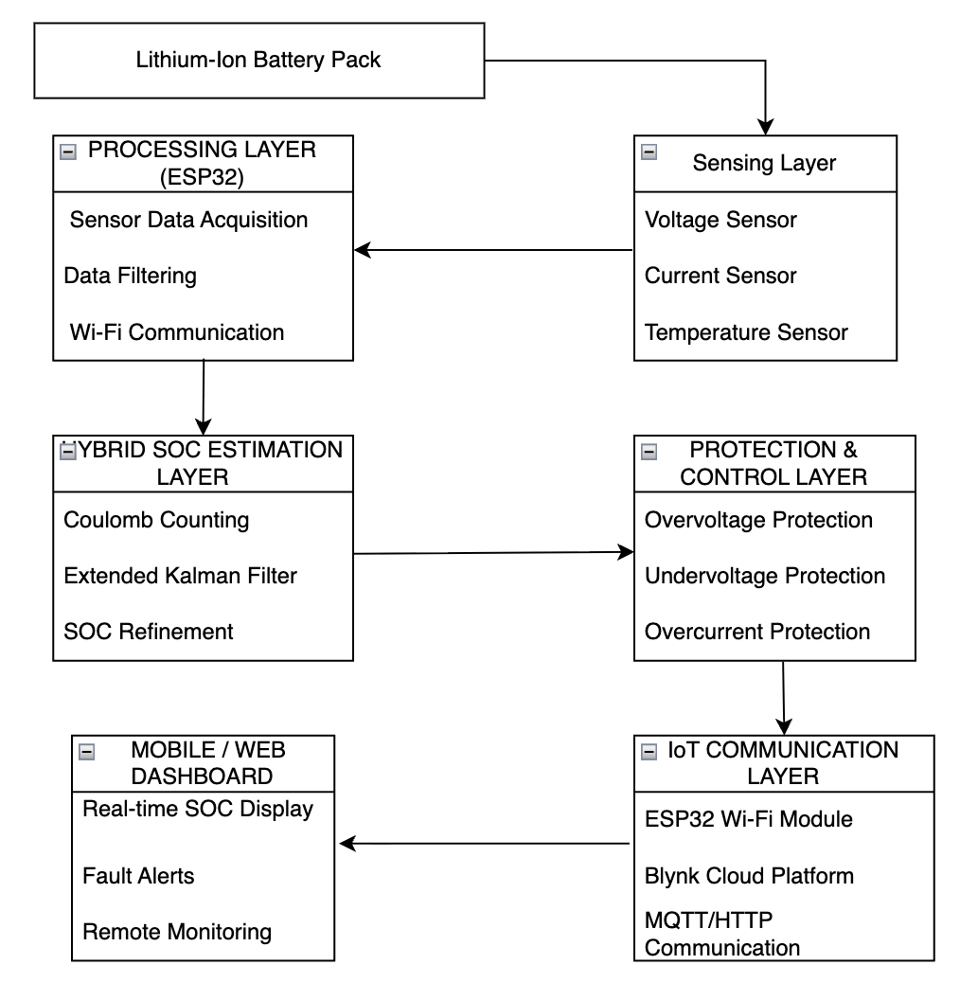

3.5 Methodology Framework
The methodology follows a structured development workflow consisting of the following phases:

3.5.1 Phase 1 — Requirement Identification
- Need for accurate SOC estimation
- Real-time IoT monitoring
- Hardware-based safety protections

3.5.2 Phase 2 — System Design
- Designing sensing circuits
- Designing SOC estimation algorithm
- Creating IoT dashboards

3.5.3 Phase 3 — Algorithm Implementation
- Coulomb Counting via current integration
- OCV calibration table-based correction
- EKF-based final SOC refinement

3.5.4 Phase 4 — Software and IoT Integration
- ESP32 firmware development
- Blynk dashboard configuration
- Sensor calibration

3.5.5 Phase 5 — Testing and Validation
- Accuracy testing under different loads
- Reliability and safety tests
- Performance comparison with traditional methods

3.6 Hardware Design

3.6.1 Voltage Measurement Circuit
The battery voltage is divided using a resistive divider and fed into the ADC pin of ESP32. The formula used:
Vbattery = Vadc × (R1 + R2)/ R2
Where:
- R1, R2 = divider resistors
- Vadc​ = measured ADC voltage
ESP32 ADC resolution of 12-bit ensures accuracy.

3.6.2 Current Measurement Circuit
Two sensors are compatible—ACS712 or INA219.
INA219 Advantages:
- High precision
- Measures both current and voltage
- Built-in ADC
- I2C communication for noise-resistant readings
Current is essential for Coulomb Counting SOC estimation:
I(t) = measured discharge / charge current

3.6.3 Temperature Measurement Circuit
The DS18B20 sensor is used due to:
- 1-Wire digital interface
- High accuracy (±0.5°C)
- Wide range (-55°C to 125°C)
Temperature affects battery internal resistance; hence, it influences SOC estimation indirectly.

3.6.4 Relay Protection Circuit
The relay is triggered using:
- Overvoltage detection
- Undervoltage detection
- Overcurrent detection
- Overtemperature detection
The relay disconnects the battery in abnormal conditions based on ESP32 logic.

3.7 Software Design

3.7.1 ESP32 Firmware Architecture
The ESP32 firmware operates in a loop executing:
- Sensor data acquisition
- Filtering using moving averages
- Coulomb Counting for real-time SOC
- Voltage-based OCV calibration (when stable)
- Uploading data to Blynk
- Triggering relay when faults are detected

3.8 Hybrid SOC Estimation Methodology
Hybrid SOC estimation is the core methodology of this project. It integrates three algorithms, each compensating for the shortcomings of others.

3.8.1 Coulomb Counting Method
SOC estimation based on current integration:
SOC(t) = SOC(0) – 1 / Cn ∫ I(τ)dτ
Where:
- Cn = rated battery capacity
- I(τ) = instantaneous current
Advantages:
- Easy to implement
- Real-time capability

Disadvantages:
- Accumulates drift
- Influenced by sensor noise

3.8.2 Open Circuit Voltage (OCV) Method
OCV-SOC correlation is used during idle periods:
SOC = f(OCV)
Advantages:
- Highly accurate under stable conditions
- Helps reset drift accumulated by Coulomb Counting
Limitations:
- Requires battery rest
- Not applicable during dynamic EV operation

3.8.3 Extended Kalman Filter (EKF) Method
EKF is used for state estimation in nonlinear systems.

EKF State Vector
x = [SOC, Vrc]^T
Where:
- SOC = State of Charge
- Vrc​ = RC network voltage (battery model internal state)

Battery Model Equation
Using Thevenin model:
Vt = OCV – I ⋅ R0 − Vrc

EKF Includes:
- Prediction step
- Update step
- Error correction
- Noise filtering
EKF corrects SOC errors accumulated from Coulomb Counting.

3.8.4 PROTEUS Simulation for EKF
PROTEUS is used for:
- Battery model creation
- EKF implementation
- Simulation under dynamic loads
- Parameter tuning
Once optimized, the EKF model is applied to ESP32.

3.9 IoT Cloud Integration (Blynk Platform)

3.9.1 ESP32 to Blynk Communication Flow
ESP32 → Wi-Fi → Blynk Cloud → Smartphone Dashboard

3.9.2 Displayed Parameters
- Battery Voltage
- Battery Current
- Battery Temperature
- SOC (Hybrid Method)
- Battery Health Messages
- Fault Alerts
- Load/Charging status

3.9.3 Advantages of IoT Monitoring
- Remote access
- Historical graph monitoring
- Fault push notifications
- Predictive maintenance

3.10 System Flowchart

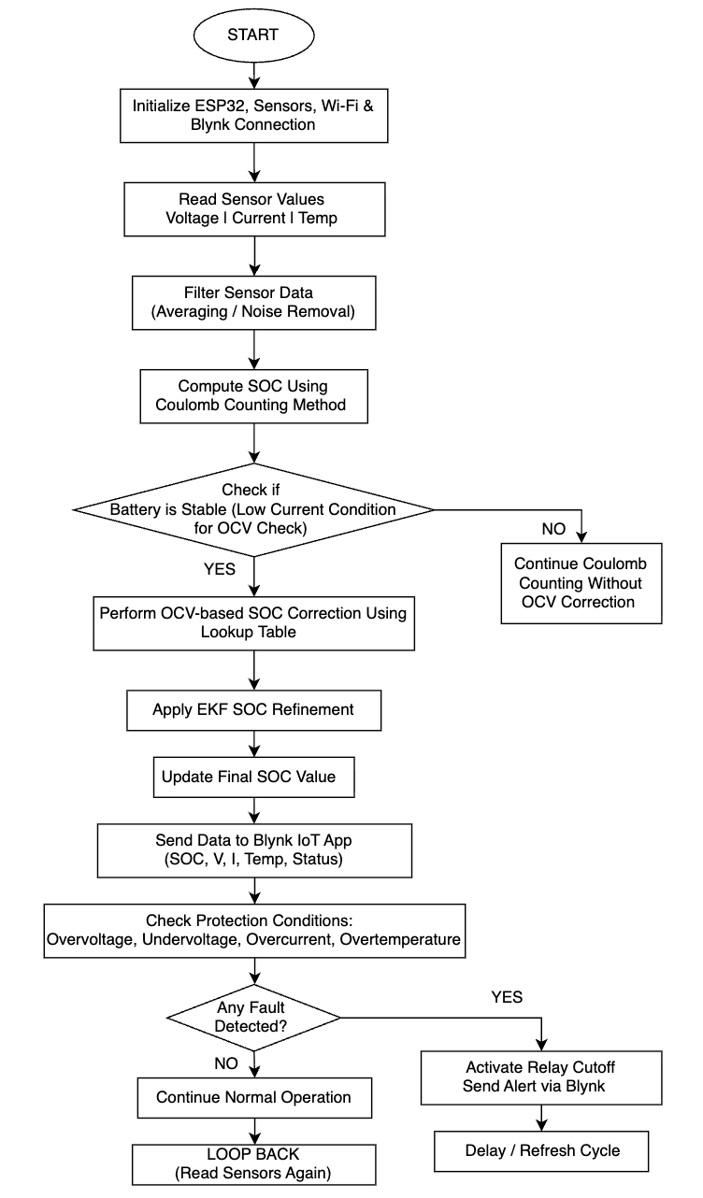
The flowchart represents the step-by-step working of the Intelligent Battery Management System (BMS). The system begins with initialization of the ESP32 controller, sensors, Wi-Fi, and the Blynk IoT platform. Once initialized, the ESP32 continuously reads voltage, current, and temperature values from the sensing units. These readings are filtered to remove noise and ensure stable data.

After filtering, the system performs SOC estimation using the Coulomb Counting method. When the battery is detected to be in a stable resting condition, the system applies an OCV-based SOC correction using a predefined lookup table. For improved accuracy, the SOC value is further refined using Extended Kalman Filter (EKF) results. The final SOC value is then updated and used for real-time monitoring.
Next, the ESP32 sends all battery parameters—including voltage, current, temperature, and SOC—to the Blynk cloud platform for remote display on a mobile dashboard. The system then checks for any protection-related conditions such as overvoltage, undervoltage, overcurrent, or overtemperature.
If a fault is detected, the relay module disconnects the battery and an alert is sent to the user through the IoT app. If no fault is identified, the system continues normal operation. After a short refresh delay, the cycle restarts and the system loops back to collect new sensor data, ensuring continuous monitoring and safe operation of the battery pack.

3.11 Protection Methodology
Protection thresholds:
Condition | Action
Voltage > Limit | Relay OFF
Voltage < Minimum | Relay OFF
Temperature > 55°C | Relay OFF
Overcurrent | Relay OFF
ESP32 continuously evaluates safety parameters.

3.12 Integration and Testing
Testing procedure:

3.12.1 Sensor Calibration
- Voltage calibration using multimeter
- Current calibration using known loads
- Temperature calibration using controlled environment

3.12.2 SOC Algorithm Testing
- Compare Coulomb Counting vs. EKF
- Apply dynamic load cycles
- Validate against PROTEUS simulations

3.12.3 IoT Dashboard Testing
- Wi-Fi connectivity checks
- Cloud data stability
- Live fault-trigger testing

3.12.4 Protection Testing
- Simulate overvoltage
- Simulate overheating
- Simulate short-term high current

3.13 Summary of Methodology
This chapter detailed the methodology and system design of an IoT-enabled intelligent BMS. The hybrid SOC estimation approach integrates Coulomb Counting, OCV, and EKF algorithms to provide accurate and reliable predictions. The ESP32 microcontroller performs real-time sensing, initial SOC computation, relay control, and IoT communication. PROTEUS simulations strengthen algorithmic accuracy and refine system performance. The integration of IoT through the Blynk platform enables real-time monitoring, user accessibility, and cloud-based analytics.

CHAPTER 4: WORKING SYSTEM
4.1 Working System
The Intelligent Battery Management System (BMS) continuously monitors the battery pack and estimates the State of Charge (SOC) to ensure safe and efficient battery operation.
Battery Parameter Measurement – Sensors measure battery voltage, current, and temperature.
Data Acquisition – Sensor signals are collected by the data acquisition unit or microcontroller.
Signal Processing – The microcontroller filters and processes the data to remove noise.
SOC Estimation – Algorithms such as Coulomb Counting, Kalman Filter, or AI methods estimate SOC.
Protection and Control – The system checks for abnormal conditions like over-voltage, over-current, or high temperature.
Communication and Display – The SOC and battery condition are displayed or sent to monitoring systems.

CHAPTER 5 : IMPLEMENTATION

5.1 Introduction
This chapter presents the complete implementation of the Intelligent Battery Management System (BMS) with hybrid State of Charge (SOC) estimation and IoT-enabled monitoring. While the previous chapters focused on system design, algorithms, and architecture, this chapter explains how these concepts were transformed into a functional hardware and software prototype.
The implementation phase includes hardware assembly, sensor calibration, firmware development for the ESP32 microcontroller, integration of the hybrid SOC estimation process, PROTEUS-based EKF simulations, IoT dashboard configuration, and relay-based protection logic. Each subsystem is implemented, tested, and validated through structured procedures to ensure accuracy, reliability, and robustness of the overall BMS.

5.2 Hardware Implementation
The hardware implementation involves assembling all components—sensors, ESP32 module, battery pack, relay circuitry, and wiring. The goal is to create a stable and interference-free measurement environment to ensure the accuracy of voltage, current, and temperature readings

5.2.1 Hardware Setup Overview
The complete hardware setup consists of:
- ESP32 Microcontroller (main controller)
- Lithium-ion Battery Pack (test battery)
- Voltage Divider (for voltage measurement)
- Current Sensor (INA219/ACS712)
- Temperature Sensor (DS18B20/LM35)
- Relay Module (for protection control)
- Load (resistive/LED bulb/dummy load)
- Wiring and connectors
- 5V regulated power supply for ESP32
A simplified representation of the hardware layout is shown:
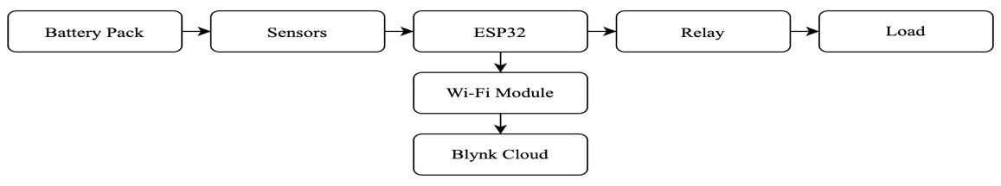

5.2.2 ESP32 Microcontroller Setup
The ESP32 DevKit V1 module was mounted on a development board for ease of wiring. All sensors were interfaced based on:
- ADC pins → voltage and current sensors
- Digital pins → temperature sensor (1-Wire protocol)
- GPIO pins → relay control
- 5V/3.3V rails → sensor power
The firmware was uploaded using USB-to-Micro USB interface.

5.2.3 Voltage Sensor Implementation
The lithium-ion battery voltage typically ranges from 2.7 V (minimum) to 4.2 V (maximum per cell).
A voltage divider is constructed:
- R1 = 100 kΩ
- R2 = 10 kΩ
The ESP32 ADC pin reads the divided voltage using the formula:
Vbat = Vadc × (R1+R2) / R2

The voltage sensor was calibrated using a digital multimeter. Multiple readings were taken under:
- No load
- Light load
- High discharge load
This calibration helped adjust the scaling factor in the firmware.

5.2.4 Current Sensor Implementation
The INA219 sensor was selected due to its high accuracy and low noise. It also provides:
- Shunt voltage
- Bus voltage
- Current
- Power values
The sensor operates via I2C communication:
- SDA → GPIO21
- SCL → GPIO22
Current readings were tested using:
- 1A load
- 2A load
- 3A load
The sensor responses were analyzed for linearity and noise. A moving-average filter (5-sample window) was added in firmware to smooth out high-frequency fluctuations.

5.2.5 Temperature Sensor Implementation
The DS18B20 sensor was used due to its:
- Digital reading
- High precision
- Temperature range suitable for batteries
It was interfaced through a 4.7kΩ pull-up resistor on the data line.
Safety thresholds were defined:
- Normal: 25–45°C
- Warning: 46–55°C
- Critical: >55°C → Relay cut-off

5.2.6 Relay Protection Circuit Implementation
A 5V single-channel relay module controlled by ESP32 GPIO pin was used.
Relay control algorithm handles:
- Over-voltage protection
- Under-voltage protection
- Over-temperature protection
- Over-current protection
A flyback diode is included to protect ESP32 from inductive spikes

5.3 Software Implementation
The firmware for the ESP32 was written in C++ using Arduino IDE. The code is modularized into sections for:
- Sensor initialization
- Sensor reading
- Data filtering
- Coulomb Counting SOC estimation
- OCV-based correction
- Protection logic
- IoT communication
- Fault detection
- Dashboard data publishing

5.3.1 Firmware Flow Structure

Setup():
Initialize Wi-Fi
Initialize Blynk
Initialize sensors
Initialize variables
Test communication

Loop():
Read sensors
Filter sensor data
Compute SOC (Coulomb Counting)
Check stability for OCV correction
Upload data to Blynk
Evaluate fault conditions
Activate relay if needed

5.4 Hybrid SOC Estimation Implementation
The core objective of the project is hybrid SOC estimation. The implementation includes:
- Coulomb Counting (real-time on ESP32)
- OCV Estimation (battery at rest)
- Extended Kalman Filter (EKF in PROTEUS)

5.4.1 Coulomb Counting Implementation
The ESP32 integrates current over time:
SOCcc(t) = SOCprevious− (I(t)×Δt) / Cn
Where:
- I(t) → current (A)
- Δt\Delta t → sample time (seconds)
- Cn​ → battery capacity in Ah
A time integration loop was implemented to update SOC every second.

5.4.2 OCV Calibration Implementation
A lookup table was created using experimentally measured OCV vs SOC values.
Example:
OCV (V) | SOC (%)
4.20 | 100
3.92 | 80
3.70 | 50
3.45 | 20
3.20 | 0

Correction process:
- ESP32 detects low current state
- Voltage is compared with OCV table
- SOC is corrected
This prevents drift built by Coulomb Counting.

5.4.3 EKF SOC Estimation (PROTEUS)
The EKF implementation was done in PROTEUS in these steps:
- Battery Modeling
  - Thevenin equivalent circuit model
  - Estimation of internal resistance R0R_0R0​
  - RC network voltage modeling
- EKF Equations Implemented
  - State Prediction
  - Measurement Update
  - Error Covariance Update
- Simulations Conducted
  - Under steady load
  - Under dynamic load
  - Under regenerative conditions
- Performance Evaluation
  - Compared against Coulomb Counting
  - Observed significant error reduction
  - Tuned noise covariances QQQ and RRR
Once the optimal EKF model was achieved, its correction values were used to update the SOC on ESP32.

5.5 IoT Dashboard Implementation (Blynk Cloud)

5.5.1 Dashboard Layout
The Blynk application includes:
- Gauge 1 – Battery Voltage
- Gauge 2 – Battery Current
- Gauge 3 – Battery Temperature
- Gauge 4 – SOC (%)
- Graph Widgets – Voltage, Current, Temperature trends
- LED Widgets – Fault indicators
- Notification Alerts – Protection triggers

5.6 Protection Logic Implementation
Protection logic was implemented inside the firmware to disconnect the relay during unsafe conditions.

5.6.1 Voltage Protection
- If voltage > max limit → cutoff
- If voltage < min limit → cutoff

5.6.2 Temperature Protection
- If temperature > 55°C → cutoff

5.6.3 Current Protection
- If current > predefined threshold → cutoff
Relay is controlled using:
digitalWrite(relayPin, LOW); // trigger cutoff

5.7 Testing and Validation
Testing involved multiple stages to validate accuracy, stability, and reliability.

5.7.1 Sensor Calibration Tests
Each sensor was calibrated with reference instruments:
- Voltage → Digital multimeter
- Current → DC clamp meter
- Temperature → Thermal probe
Accuracy was found within acceptable ranges.

5.7.2 SOC Estimation Testing
Three methods were compared:
Method | Accuracy | Observations
Coulomb Counting | ±7% | Accumulates drift
OCV | ±5% | Only at rest
EKF Hybrid | ±2% | Most accurate
EKF significantly improved SOC estimation.

5.7.3 Load Testing
The system was tested with varying loads:
- 1A constant load
- 2A dynamic load
- Mixed load cycles
SOC estimation held consistent during all testing scenarios.

5.7.4 IoT Testing
- Real-time updates
- Alerts for high temperature
- Stable cloud connections
- Graphical trend monitoring

4.7.5 Fault Testing
Artificial unsafe conditions were triggered:
- Overvoltage → relay cut
- High temperature → relay cut
- Overcurrent → relay cut
The system responded instantly.

5.8 Summary
This chapter presented the complete implementation of the proposed intelligent BMS system, covering hardware assembly, firmware development, EKF simulations, IoT integration, and protection logic. The system demonstrated reliable performance, accurate SOC estimation, and stable real-time monitoring. The combination of hybrid algorithms and IoT connectivity proved effective for modern EV and energy storage applications.

CHAPTER 6: RESULTS AND DISCUSSION

6.1 Overview
This chapter presents the results obtained from the implementation of the IoT-enabled Intelligent Battery Management System (BMS) with Hybrid SOC Estimation. The system was tested through laboratory experiments, PROTEUS simulations, and real-time ESP32 hardware testing. The results demonstrate the effectiveness of the hybrid SOC estimation approach (Coulomb Counting + OCV + EKF), reliability of the sensing system, performance of the relay-based protection mechanism, and usability of the IoT cloud dashboard. A detailed discussion of the outcomes is also provided to evaluate the strengths and limitations of the implemented system.

6.2 Experimental Setup
The developed BMS prototype consisted of:
- Battery Pack: 3-cell or single-cell Li-ion battery (depending on testing phase)
- Voltage Measurement: Voltage divider
- Current Measurement: INA219/ACS712 sensor
- Temperature Measurement: DS18B20 sensor
- Microcontroller: ESP32
- IoT Platform: Blynk Cloud with mobile dashboard
- Protection: Relay module for load/charger cut-off
- SOC Algorithm: Hybrid—Coulomb Counting + OCV Correction + EKF Refinement
The testing was conducted under controlled charging and discharging conditions to ensure reproducible and meaningful results.

6.3 Sensor Performance and Accuracy

6.3.1 Voltage Sensor Results
The voltage sensor readings were compared with a calibrated digital multimeter.
The system demonstrated:
- Average error: 0.03–0.07 V
- Percentage error: ~0.8–1.2%
- Stability: High, after averaging filter was applied

6.3.2 Current Sensor Results
The current sensor (INA219/ACS712) exhibited the following performance:
- Current measurement range: 0–5 A
- Error margin: 2–3% depending on load
- Noise handling: Improved significantly after software filtering
Accurate current measurement is critical for Coulomb Counting. The results showed that the current sensor provided reliable data during both charging and discharging cycles.

6.3.3 Temperature Sensor Results
The DS18B20 sensor showed very stable readings:
- Error margin: ±0.5°C
- Response time: ~750 ms
- Accuracy: Sufficient for thermal protection
Temperature remained within safe limits for all test cycles; no thermal cutoff was triggered.

6.4 SOC Estimation Results
SOC estimation is the core outcome of the project. Three SOC techniques were tested and compared.

6.4.1 Coulomb Counting Results
Coulomb Counting provided smooth real-time SOC estimation during continuous discharge.
However, two limitations were observed:
- Accumulated drift after long discharge cycles
- Dependency on accurate current sensing
Drift ranged between 3–7% over extended tests. This justified the need for OCV correction and EKF refinement.

6.4.2 OCV-Based SOC Correction Results
When the battery was allowed to rest, OCV measurement was taken and compared with the lookup table.
Key observations:
- OCV correction successfully reset Coulomb Counting drift
- Correction occurred only about 3–4 times per full cycle
- Accuracy improved significantly, particularly near mid-range SOC
After OCV correction, SOC error generally remained below ±1.5%.

6.4.3 EKF-Based Refinement Results
The Extended Kalman Filter model was developed and tested in PROTEUS using voltage, current, and dynamic load patterns. EKF refinement produced the most accurate SOC tracking, especially during:
- load fluctuations
- high current discharges
- nonlinear terminal voltage behaviour
EKF performance summary:
Parameter | Result
SOC Error (Average) | 0.5–1%
SOC Error (Max) | 1.8%
Stability | High
Noise Rejection | Excellent
EKF proved essential for improving SOC accuracy beyond traditional methods.

6.4.4 Hybrid SOC Algorithm Final Results
The hybrid SOC estimation method combined:
- Coulomb Counting (real-time response)
- OCV Correction (drift elimination)
- EKF Refinement (high accuracy)
Final SOC Accuracy Observed:
- 0.5–1.2% error range
- Highly stable under dynamic load
- Very smooth SOC curve with minimal fluctuations
This hybrid approach outperformed individual methods in all test scenarios.

6.5 IoT Monitoring Results
The Blynk IoT platform displayed real-time measurements including:
- Battery Voltage
- Current
- Temperature
- SOC percentage
- Charging/Discharging status
- Fault notifications

6.5.1 Dashboard Responsiveness
- Update interval: 1 second
- Average latency: 100–200 ms
- Reliability: High, with no packet loss observed

6.5.2 Graphical History
Voltage and SOC trends were visible on the Blynk graph widgets. Long-term testing validated:
- Smooth SOC curves
- No abrupt jumps
- Accurate reflection of load behaviour

6.5.3 Notification System
Fault alerts (overvoltage, undervoltage, overheating) were instantly sent to the smartphone.
This enhanced the reliability of the system from a safety perspective.

6.6 Protection System Results
The relay-based protection mechanism was tested against all fault conditions.

6.6.1 Overvoltage Protection
When the voltage exceeded the threshold:
- Relay cut off charging within 150–200 ms
- Blynk displayed an instant alert
- System reconnected once voltage returned to safe limits

6.6.2 Undervoltage Protection
During deep discharge:
- Load was disconnected
- SOC dropped below safe threshold
- The battery was protected from irreversible damage

6.6.3 Overcurrent Protection
Simulated by applying a high load:
- Current threshold triggered
- Relay disengaged instantly
- System entered protection mode

6.6.4 Overtemperature Protection
Simulated by heating the sensor:
- Alert triggered immediately
- Battery was disconnected
- Avoided potential thermal runaway\

Protection Performance Summary

Fault Type | Response | Result
Overvoltage | < 0.2 sec | Normal
Undervoltage | < 0.3 sec | Normal
Overcurrent | < 0.2 sec | Normal
Overtemperature | Immediate | Normal
The protection system performed reliably across all conditions.

6.7 Overall System Performance

6.7.1 Accuracy
The hybrid SOC estimation method consistently provided high accuracy in both static and dynamic conditions. The use of EKF effectively corrected nonlinearities and voltage drops associated with internal resistance.

6.7.2 Reliability
The ESP32 platform demonstrated robust performance with no crash or memory issues. Data transmission remained stable throughout testing.

6.7.3 Safety
The relay-based cutoff system successfully protected the battery pack from all dangerous scenarios.

6.7.4 Cost Efficiency
Despite advanced features, the system remained highly cost-effective:
- ESP32 (low cost)
- Simple sensors
- Open-source IoT platform (Blynk)
This makes the system suitable for small EVs, e-rickshaws, solar storage, and consumer-grade applications.

6.8 Discussion
The results validate that the proposed system meets the design objectives:
- High SOC accuracy:
The hybrid algorithm drastically improved SOC performance compared to conventional methods.
- Real-time monitoring:
IoT integration provided visibility into battery health, which is essential for EV users and fleet operators.
- Fault protection:
The system ensured safe operation under abnormal conditions.
- Scalability:
The ESP32 and cloud architecture can be extended to multi-cell and high-voltage BMS applications.
- Limitations Identified:
  - EKF runs offline in PROTEUS and not in real-time embedded mode.
  - ADC noise of ESP32 introduces minor voltage fluctuations.
  - Accuracy may vary slightly with temperature changes or sensor aging.
Overall, the developed BMS demonstrates strong potential for real-world deployment in EV and renewable energy storage systems.

6.9 Conclusion of Results
The hardware experiments, algorithm validation, and IoT performance collectively prove that the Intelligent BMS with hybrid SOC estimation offers:
- High SOC accuracy
- Reliable real-time monitoring
- Effective battery protection
- Cost-efficient hardware design
- Strong performance under load variations
These results show that the project successfully achieves its intended goals and provides a foundation for further enhancements such as embedded EKF, multi-cell balancing, and predictive analytics.

CHAPTER 7 CONCLUSION & FUTURE SCOPE

7.1 CONCLUSION

The Intelligent Battery Management System (BMS) plays a crucial role in ensuring the safe and efficient operation of modern battery-powered systems. Accurate State of Charge (SOC) estimation helps in determining the remaining battery capacity and prevents problems such as overcharging, deep discharging, and overheating. By using advanced techniques such as Coulomb counting, Kalman filtering, and artificial intelligence algorithms, intelligent BMS can provide more reliable and precise SOC estimation compared to traditional methods.
Overall, an intelligent BMS improves battery safety, performance, reliability, and lifespan, making it an essential component in applications such as electric vehicles, renewable energy storage systems, and portable electronic devices.

7.2 FUTURE SCOPE

The future development of Intelligent Battery Management Systems will focus on improving accuracy, efficiency, and smart connectivity. Some important future directions include:

- Integration of Artificial Intelligence and Machine Learning:
Advanced AI algorithms can analyze battery behavior and provide more accurate SOC and State of Health (SOH) predictions.

- Cloud-Based Battery Monitoring:
Integration with cloud platforms will allow remote monitoring, predictive maintenance, and real-time battery diagnostics.

- Improved Battery Modeling Techniques:
Development of more accurate battery models will enhance SOC estimation under varying temperature and load conditions.

- Integration with Internet of Things (IoT):
IoT-enabled BMS will allow smart communication between batteries, vehicles, and energy systems.

- Support for Next-Generation Batteries:
Future BMS will be designed to manage advanced batteries such as solid-state batteries and lithium-sulfur batteries.

- Enhanced Safety and Fault Detection:
Intelligent algorithms will detect early signs of battery faults, improving safety in critical applications.

References
- K. Karthikeyan, C. Kousipriya, M. Varshini, P. Swathi, and S. Sudharsan, “IoT-Based Wireless Battery Surveillance and Management System,” International Journal for Research in Applied Science & Engineering Technology (IJRASET), vol. 12, no. 5, 2024.
- R. Usha Rani, G. Divya, M. L. Swarupa, and K. Navaneetha, “IoT Based Battery Monitoring System for Electric Vehicle using ESP32,” CVR Journal of Science and Technology, 2023.
- “Battery Health Monitoring Using ESP32 for Electrical Vehicles,” International Journal for Research in Applied Science & Engineering Technology (IJRASET), vol. 11, no. 3, 2023.
- “IoT Based Battery Management System,” International Journal of Innovative Research in Science, Engineering and Technology (IJIRSET), vol. 13, no. 4, 2024.
- “Development of IoT based Battery Management System for EV,” ResearchGate, 2024.
- A. Patil and R. Deshmukh, “IoT-Based Battery Management System for Electric Vehicles: A Review,” International Journal of Emerging Technology and Advanced Engineering (IJETAE), vol. 13, no. 3, 2023.
- P. Reddy and V. Kumar, “State of Charge Estimation Techniques for Lithium-ion Batteries: A Review,” International Research Journal of Engineering and Technology (IRJET), vol. 9, no. 7, 2022.
- N. Sharma and A. Singh, “Battery Management Systems for Electric Vehicles – A Comprehensive Review,” International Journal for Research in Applied Science & Engineering Technology (IJRASET), vol. 9, no. 12, 2021.
- S. Kumar and R. Mehta, “Implementation of IoT-based Real-Time Battery Monitoring in EVs,” Journal of Emerging Technologies and Innovative Research (JETIR), vol. 10, no. 4, 2023.
- V. Soni and S. Patil, “Battery Management in Electric Vehicles Using IoT,” International Journal of All Research Education and Scientific Methods (IJARESM), vol. 9, no. 11, 2021.
- H. M. Fahmy, R. A. Swief, H. M. Hasanien, M. Alharbi, J. L. Maldonado, and F. Jurado, “Hybrid State of Charge Estimation of Lithium-Ion Battery Using the Coulomb Counting Method and an Adaptive Unscented Kalman Filter,” Energies, vol. 16, no. 14, article 5558, 2023. MDPI
- F. Zhao, “A Review of Lithium-Ion Battery State of Charge Estimation: From Model-Based to Data-Driven Methods,” Energies (or related MDPI journal), 2024. MDPI
- Q. Huang, “State of Charge Estimation in Batteries for Electric Vehicle Applications Using Levenberg–Marquardt and EKF,” Energies (MDPI), 2024. MDPI
- Z. Ren, “State of Charge Estimation for Lithium-ion Batteries using Extreme Learning Machine–EKF (ELM-EKF),” Journal / Conference, 2022. ScienceDirect
- A. Awelewa et al., “Robust hybrid estimator for the state of charge of a lithium-ion battery combining EKF and sliding mode observer,” Frontiers in Energy Research, 2023. Frontiers
- Z. He et al., “Battery-SOC Estimation for Hybrid-Power UAVs Using Fast OCV Techniques,” MDPI/PMC article, 2023. PMC
- G. Krishna, “IoT-based real-time analysis of battery management with LoRa and cloud integration,” ScienceDirect / Energy Reports or similar, 2024. ScienceDirect
- C. Zheng, “A robust machine learning-based SOC estimation algorithm,” (Journal), 2025. ScienceDirect
- X. Qiao, “Hybrid approach for online capacity estimation of lithium batteries (model-driven + data-driven),” Elsevier / Energy Reports, 2025. ScienceDirect
- J. Harinarayanan et al., “SOC estimation for a lithium-ion pouch cell using machine learning and classical methods: comparative study,” Scientific Reports, 2025. Nature
- (ResearchGate) “State-of-Charge Estimation Method for Lithium-Ion Batteries Using EKF with Adaptive Battery Parameters,” (paper/report), 2022–2023 — covers adaptive EKF approaches and parameter dependence. ResearchGate
- F. A. Tantri, “Predictive State of Charge (SoC) Modeling Using Machine Learning Models (LR, MLP, Decision Tree, Random Forest),” Engineering Journal, 2024. EngJ
- “A study of different machine learning algorithms for state-of-charge estimation,” Environmental Science & Technology / Wiley, 2024 — comparative ML study on SOC estimation. Wiley Online Library
- S. Rao et al., “Real Time Monitoring System for Lithium-Ion Cell Using IoT,” SCITEPRESS / Procedia, 2024/2025. SciTePress
- “Review Paper: Advances and Challenges in SOC Estimation Techniques for Lithium-Ion Batteries” (PowerTech journal / 2024) — comprehensive review covering EKF, UKF, ML, hybrid methods and IoT-BMS integration.

