Advanced Driver Assistance System for Irregular Roads

Dr.S.Anbumalar, Dean Academics
Sri Manakula Vinayagar Engineering College Madagadipet, Puducherry, India

Arokia Anandu Prasanthu A Electrical and Electronics Engineering
Sri Manakula Vinayagar Engineering College Madagadipet, Puducherry, India btecheee221666@smvec.ac.in

Pavinthran U
Electrical and Electronics Engineering
Sri Manakula Vinayagar Engineering College Madagadipet, Puducherry, India btecheee221627@smvec.ac.in
Mukeshkumar R
Electrical and Electronics Engineering
Sri Manakula Vinayagar Engineering College Madagadipet, Puducherry, India btecheee@220962smvec.ac.in

Herwin W
Electrical and Electronics Engineering
Sri Manakula Vinayagar Engineering College Madagadipet, Puducherry, India btecheee221455@smvec.ac.in

Abstract—Modern transportation systems demand Advanced Driver Assistance Systems (ADAS) capable of operating reliably on irregular and unstructured roads where lane markings are faded, broken, or entirely absent. This work presents an ADAS- integrated lane detection and surroundings awareness system implemented on a low-cost ride-on car platform, specifically targeting challenging Indian road conditions. The proposed architecture integrates a Raspberry Pi 5 coordination unit, multiple STM32 and ESP32 controllers, and a laptop GPU/CPU tier with deep learning models such as DeeplabV3 and PIDNet-S for robust lane and drivable-region segmentation. Multi-sensor fusion incorporating a Pi camera, radars, ultrasonic sensors, GPS NEO-6M, and MPU-9250 IMU enables 360-degree surroundings awareness and real-time obstacle detection. This work focuses on system design, hardware selection, circuit-level integration, and initial model training and benchmarking, achieving a lane detection accuracy of approximately 98.49% under irregular road conditions with an end-to-end latency of approximately 28.7ms per frame. These results demonstrate that reliable ADAS functionality is achievable on non-standard roads using low-cost hardware and distributed processing architectures.
Index Terms—Advanced Driver Assistance Systems, Lane Detection, Semantic Segmentation, Multi-Sensor Fusion, Embedded Systems.

- Introduction
ADAS technologies are becoming essential for improving road safety, reducing human error, and enabling higher levels of driving automation [1]. Conventional systems perform well on structured highways but degrade sharply on irregular roads with poor or missing lane markings, which are common in developing regions [2]. In such environments, lane geometry, surface quality, and lighting conditions vary significantly, creating failure modes for classical computer vision algorithms [3]. Irregular roads often exhibit sharp curves, variable lane widths, patch repairs, debris, and occlusions from parked vehicles and vegetation. Many road segments lack standard lane markings, and environmental
factors such as shadows, fog, rain, and low illumination further complicate perception [4]. At the same time, safe navigation requires surroundings awareness beyond lane boundaries, including detection of pedestrians, vehicles, and static obstacles [5].
This paper reports our work on an ADAS-integrated lane detection and surroundings awareness system designed for irregular roads. The main contributions of this work are:
- A distributed three-tier architecture separating edge control, coordination, and AI inference.
- A complete hardware design with block diagram and detailed circuits for sensor-control and motor-control subsystems.
- Integration plan for DeeplabV3 and PIDNet-S based lane and drivable-region segmentation on custom unstructured- road datasets.

- Related Work

Classical lane detection approaches based on edge detection and Hough transform demonstrate acceptable performance on well-marked highways but fail when markings are degraded or absent [6], [7]. Recent deep learning methods, including encoder-decoder CNNs, attention-based models, and GAN- based lane detectors, significantly improve robustness but often assume structured roads and high-end hardware [8]–[10]. Multi-sensor ADAS architectures combining cameras, radar, and LiDAR have been widely studied for highway scenarios [11], [12], yet comparatively fewer works address low-cost platforms and highly irregular, unmarked roads typical of Indian and rural traffic networks. Existing studies also highlight challenges in real-time deployment on embedded hardware due to computational and power constraints [13].

The proposed system aims to bridge this gap by utilizing semantic segmentation models (DeeplabV3, PIDNet-S) in conjunction with radar, ultrasonic, GPS, and IMU sensors on a distributed embedded platform, specifically targeting unstructured and low-cost deployment scenarios.

- System Architecture and Block Diagram
  - Overall Architecture
The system adopts a three-tier distributed processing architecture:
    - Edge tier: STM32F103C8T6 and ESP32 controllers perform sensor data acquisition, PWM motor control, and low-latency actuation tasks.
    - Coordination tier: A Raspberry Pi 5 (8 GB RAM) handles sensor fusion, inter-node communication, and medium-complexity processing operations.
    - AI inference tier: A laptop-class GPU/CPU executes deep learning models (DeeplabV3, PIDNet-S) for semantic segmentation of lanes and drivable regions.
Communication between nodes is implemented using CAN (MCP2515 + TJA1050), SPI, I²C, UART, and Ethernet
protocols to ensure robust, scalable system integration.

  - Block Diagram
Fig. 1 illustrates the complete system architecture, including camera and radar inputs, the Raspberry Pi 5 coordination unit, STM32/ESP32 controllers, motor drivers, sensors, and the power subsystem.

- Hardware Design and Circuit Diagrams
- Chassis and Mechanical Platform
A 12 V battery-powered kids’ ride-on car serves as the experimental platform, featuring dual 15 W DC motors for rear- wheel drive and a separate motor for steering. The vehicle operates at speeds of approximately 3–5 km/h and includes automatic braking and suspension systems, making it suitable for safe on-campus testing.
  - Sensor Suite
The sensor configuration includes a Pi Camera Night Vision (8 MP, 1080p) as the primary vision sensor with NoIR capability for low-light operation, four HLK-LD2450 24 GHz trajectory radars for object tracking up to approximately 8 m, four HLK-LD2410C-P presence radars for pedestrian and static human detection, twelve HC-SR04 ultrasonic sensors for close- range blind-spot detection and parking assistance, a GPS NEO- 6M module for positioning with approximately 2.5 m accuracy and update rates up to 10 Hz, and an MPU-9250 IMU for 9-axis motion and orientation measurement.
Motor control is implemented using TB6612FNG dual H- bridge drivers, which provide efficient, low-heat drive capability for both the propulsion and steering motors.
  - Power and Regulation
A 12 V main battery supplies power to the motors and higher-power electronics, while DC-DC converters generate 6 V, 5 V, and 3.3 V rails for logic circuits and low-power sensors. A 6 V, 1.5 Ah secondary battery provides backup power to critical electronics during transients, enhancing overall system reliability. Smart charging with multi-stage profiles improves battery life and ensures safe operation.
  - Power Budget and Battery Design
- System Components: The complete system comprises a 45 W drive motor (12 V), a Raspberry Pi 5 (8 GB) with Pi Camera, four STM32F103 microcontrollers, four MCP2515 CAN controllers, four trajectory radars, four presence radars, a Neo-6M GPS module, an MPU-9250 IMU, and an MG995 servo motor.
- Design Assumptions: The design assumes a battery nominal voltage of 12 V with DC-DC converter efficiency of 90%. The motor operates at 45 W continuous power with 135 W peak power (approximately 3× surge). The servo draws
1.0 A at 6 V nominal and 2.5 A at stall. The 5 V rail load is
22.3 W (4.455 A).
- Current Calculations: For the electronics operating on the 5 V rail, the current draw from the 12 V battery is calculated as:

Ielectronics = P5V =
22.3
≈ 2.06 A (1)

- Processing and Communication Units Vbattery × η 12 × 0.9

The Raspberry Pi 5 utilizes a Broadcom BCM2712 SoC with a 2.4 GHz quad-core ARM Cortex-A76 CPU, Video Core VII GPU, and 8 GB LPDDR4X memory, providing adequate resources for multi-sensor fusion and moderate AI workloads. Multiple STM32F103C8T6 MCUs (72 MHz, 64 kB Flash, 20 kB RAM) implement deterministic motor control, ADC-based feedback, and low-level protocol handling. ESP32 modules provide local sensor preprocessing and wireless connectivity where required.
MCP2515 CAN controllers paired with TJA1050 transceivers form an automotive-grade CAN network, enabling reliable message passing between distributed nodes with built- in error detection and retransmission capabilities.
The MG995 servo motor draws 6 W nominal power (0.56 A at 12 V) and 15 W at stall conditions (1.39 A at 12 V). The drive motor requires 45 W continuous power (3.75 A at 12 V) and 135 W during peak operation (11.25 A at 12 V).
- Total Current Requirement: The total continuous load is approximately 6.37 A, while the peak load reaches approximately 14.7 A during maximum power operation.
- Battery Sizing: For practical deployment, LiFePO₄ batteries are recommended due to their superior safety
characteristics, extended cycle life, and stable discharge profiles. A 10–12 Ah LiFePO₄ (12.8 V) battery provides runtime of 1–1.5 hours, while a 20 Ah LiFePO₄ (12.8 V) battery enables runtime of 2.5–3 hours continuous operation.

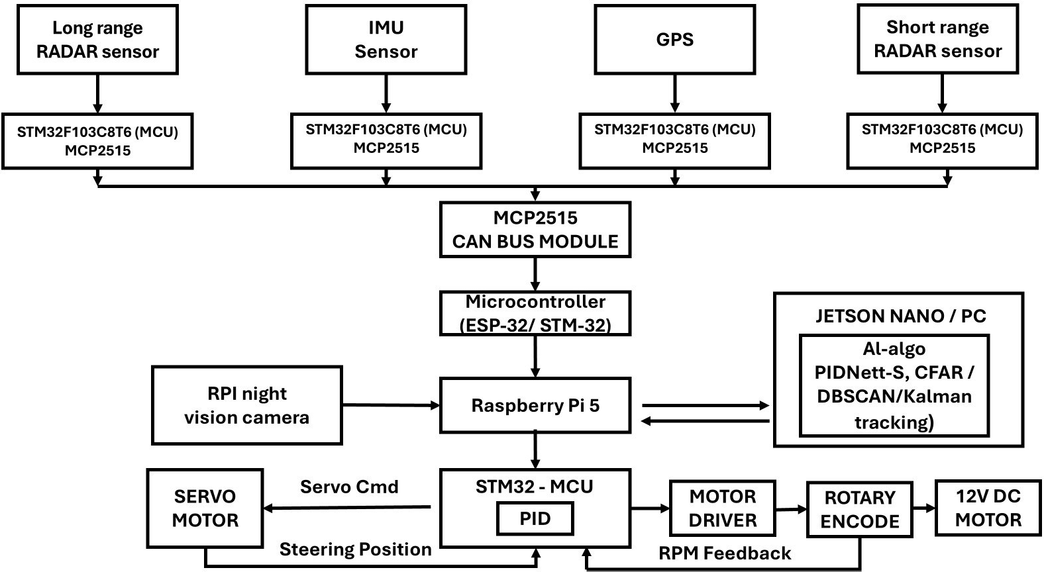

Fig. 1. ADAS System Block Diagram showing camera and radar inputs, Raspberry Pi 5 unit, STM32/ESP32 controllers, motor drivers, sensors, and power subsystem.

TABLE I
Battery Runtime vs Capacity

Runtime | Capacity (Ah) | Energy (Wh)
1 hour | ≈6.4 Ah | ≈76 Wh
2 hours | ≈12.7 Ah | ≈153 Wh

The battery must support a continuous discharge rate of at least 20 A and surge capability of at least 50 A to accommodate peak power demands.
- Recommended Hardware: The battery system should consist of a 12.8 V LiFePO₄ battery with capacity of 10– 20 Ah, depending on runtime requirements. A 4S LiFePO₄ Battery Management System (BMS) rated for at least 30 A
continuous current (with 100 A rating preferred) is essential for safe operation. The main fuse should be a 20–30 A automotive or ANL type (slow-blow) to protect against overcurrent conditions. Buck converters are required: one for converting 12 V to 5 V with at least 6–8 A output rating,
communicate with the Raspberry Pi through CAN or GPIO. The 3.3 V and 5 V regulated rails provide power to the MCUs and sensors.
2) Motor-Control Circuit: The ESP32 or STM32 controllers drive the TB6612FNG or L298N input pins and enable lines using PWM for speed and direction control. Separate outputs are routed to the left and right drive motors as well as the steering motor, enabling differential drive and independent steering control.
A 10 kΩ steering potentiometer provides analog feedback to the MCU ADC pins, enabling closed-loop steering angle control with fine resolution. The potentiometer is used to determine the steering angle of the vehicle using the following calculation:
Angle = ADC × 90 − 45 (2)
4024
Range: −45◦ to +45◦
Resolution:

and a Battery Eliminator Circuit (BEC) or buck converter for 12 V to 6 V conversion with at least 5 A output rating for the servo motor. The motor branch wiring should be 12–14 AWG gauge wire to handle up to 12 A peak current, while the electronics branch can utilize 14–16 AWG gauge wiring. Anderson Powerpole or XT60 connectors are recommended for enhanced reliability and safety.
90
4024
Counts per degree:

Code snippet:
≈ 0.0224◦/count (3)

4024 ≈ 44.7 (4)
90

  - Circuit Diagrams and Design Aspects
1) Sensor-Control Circuit: The ultrasonic sensors, MPU- 9250, GPS module, and radars connect to the ESP32 via GPIO, I²C, and UART interfaces. The ESP32 interfaces with MCP2515 CAN controllers over SPI, which then
int adc = analogRead(34);
float angle = (adc * 90.0 / 4024.0) - 45.0;
Key design features include the isolation of power paths for logic circuits and motors to reduce electrical noise, use of watchdog timers and an emergency kill switch for

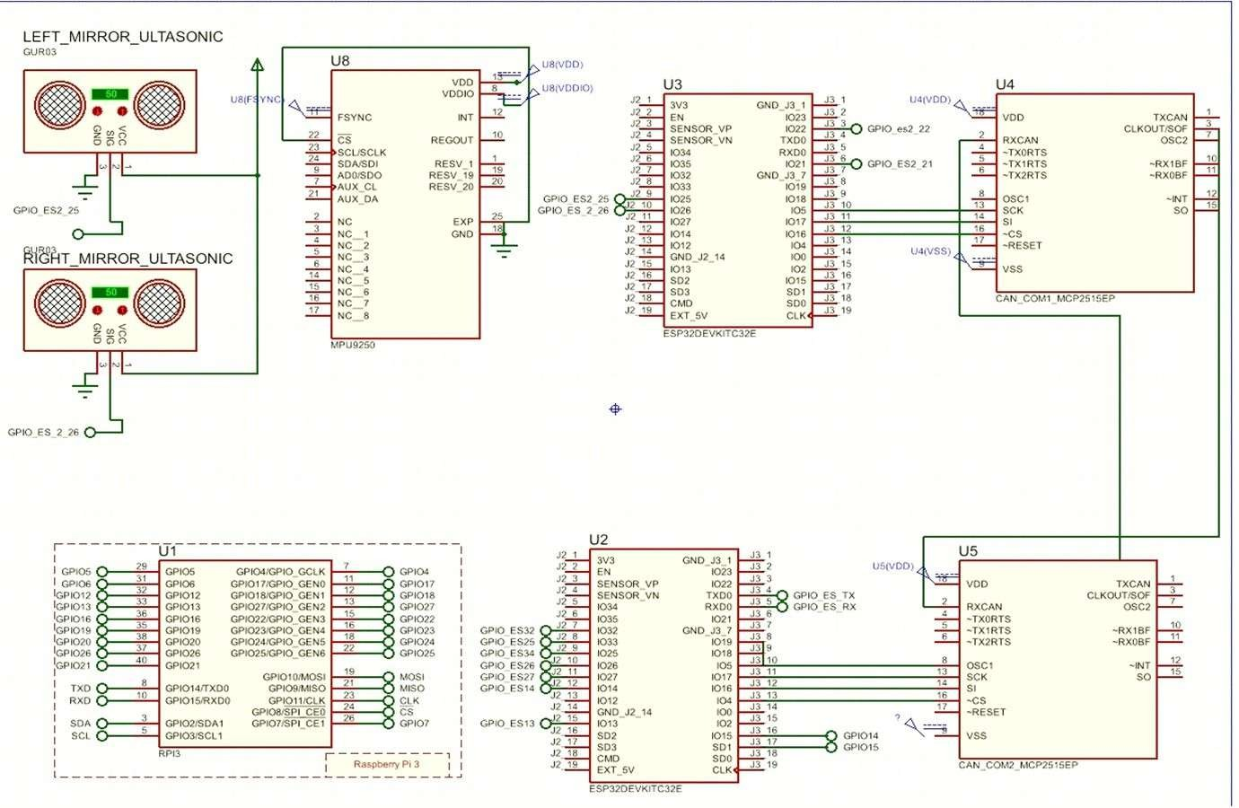

Fig. 2. Sensor-Control Circuit Subsystem.
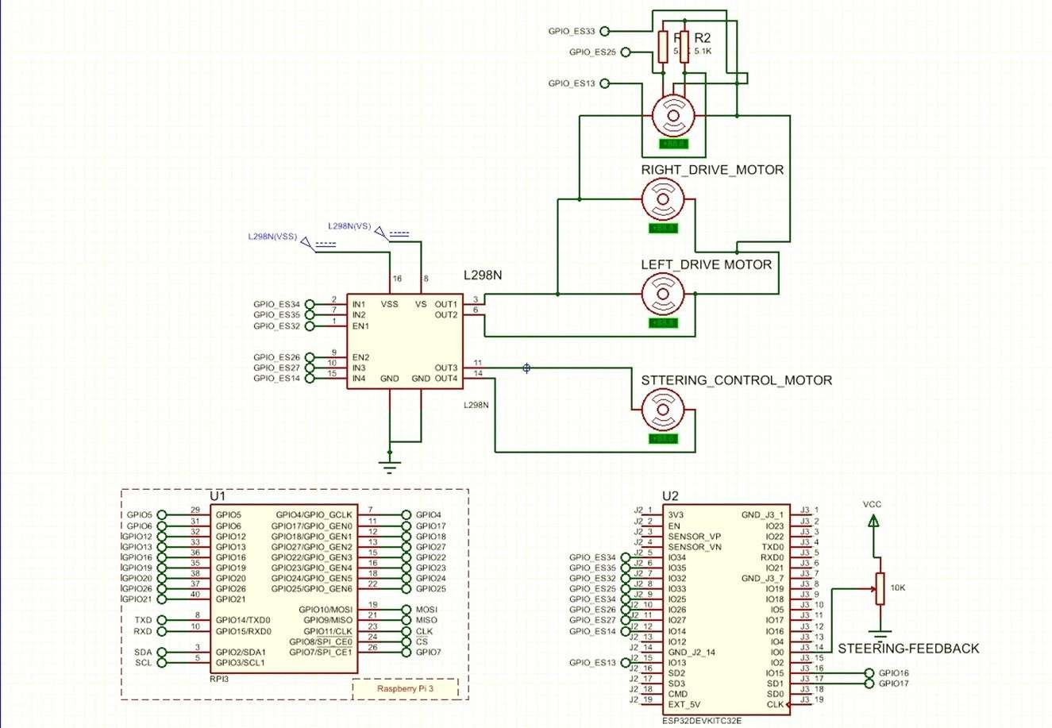

Fig. 3. Motor-Control Circuit Subsystem.

enhanced safety, and CAN-based modularity enabling sensors and actuators to be easily reconfigured or extended.
- Software and Algorithmic Design
- Lane Detection with DeeplabV3
DeeplabV3 was selected as the main semantic segmentation model for lane and drivable-region detection. It leverages atrous spatial pyramid pooling and multi-scale context to segment irregular lanes where markings are faded, broken, or partially occluded. Training was carried out in Python using PyTorch and Keras with OpenCV-based preprocessing and augmentation on Google Colab.
A custom dataset of approximately 160 images was collected along a veranda path in the college to emulate unstructured roads under varying lighting and environmental conditions. The trained model achieves approximately 98.49% detection accuracy with Intersection over Union (IoU) and accuracy curves converging within roughly 10 epochs.
- Real-Time PIDNet-S Segmentation
PIDNet-S was adopted as a lightweight, real-time semantic segmentation network for embedded deployment. It employs depthwise separable convolutions, feature pyramids, and attention mechanisms to achieve a favorable trade-off between segmentation quality and inference latency on resource- constrained devices. PIDNet-S is intended to run on the Raspberry Pi 5 or edge accelerators, while DeeplabV3 remains deployed on the laptop GPU for development and benchmarking purposes.
- Multi-Sensor Fusion and Control
The Raspberry Pi 5 fuses camera segmentation outputs with radar ranges, ultrasonic distances, GPS position, and IMU orientation data to construct a consistent surroundings model. Obstacle positions and drivable regions are then mapped into control commands for speed and steering, which are transmitted to the STM32 controllers via the CAN bus.
Closed-loop steering control utilizes potentiometer feedback and PID or similar controllers to translate desired heading into PWM duty cycles for the steering motor. The end-to-end latency from sensor acquisition through AI inference to actuator command is approximately 28.7 ms, meeting the real- time requirements for this low-speed platform.
- Results and Discussion
Initial experiments demonstrate that the DeeplabV3-based lane detection achieves approximately 98.49% accuracy on the collected irregular-road data, with training IoU stabilizing near 0.965 and validation IoU around 0.947. Both training and validation losses decrease rapidly over the first few epochs, indicating good convergence behavior, and the overall system latency supports frame rates exceeding 30 FPS.
Comparisons with traditional Hough-transform-based methods indicate accuracy improvements from approximately 40–70% in challenging conditions to more than 95% using the proposed approach. The custom veranda dataset

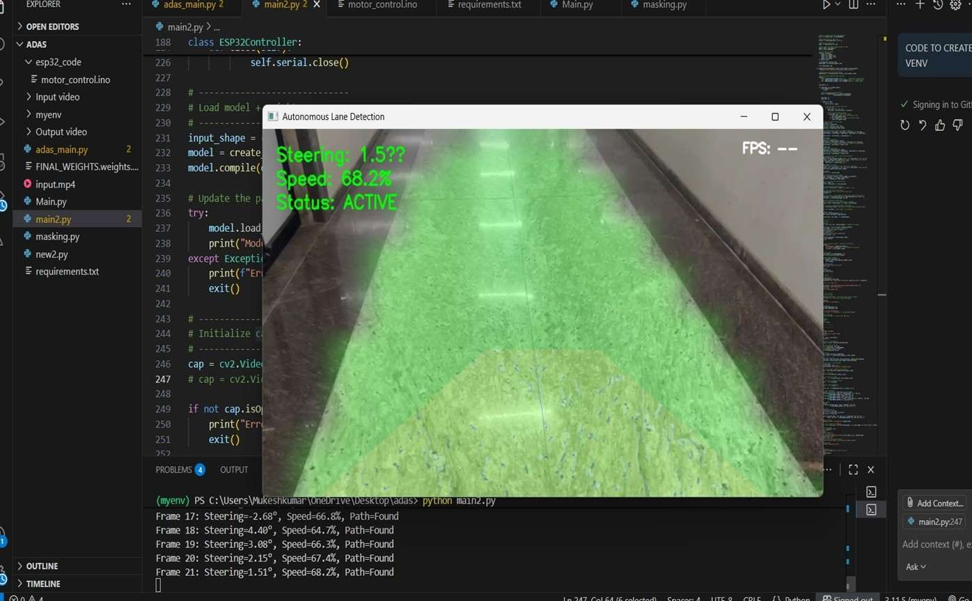

Fig. 4. Lane detection results on irregular road dataset.
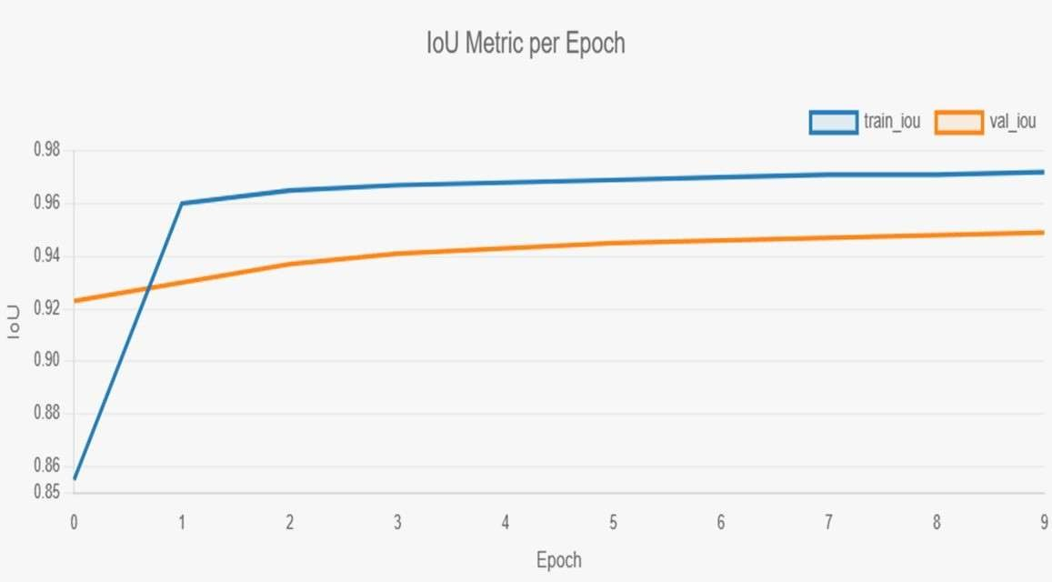

Fig. 5. IoU (Intersection over Union) Metric per Epoch.
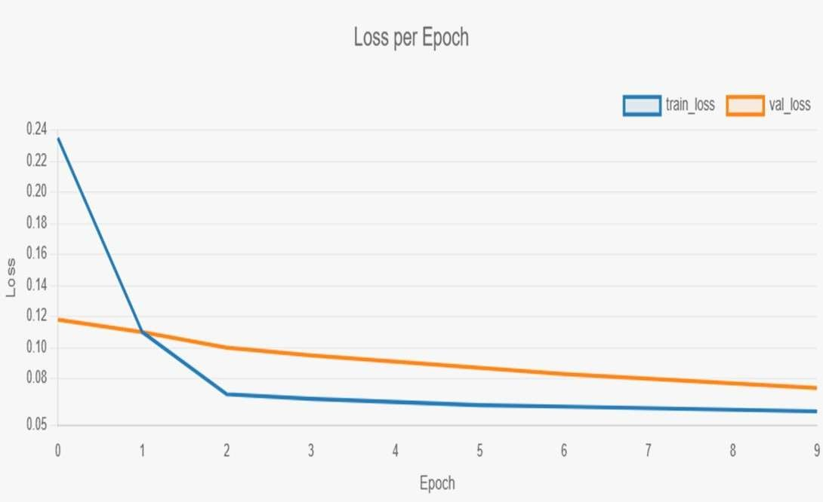

Fig. 6. Loss per Epoch.

demonstrates that the system can distinguish between drivable and non-drivable regions even in the absence of explicit lane markings, which is essential for deployment on unstructured roads.
- Conclusion and Future Work
This work has delivered a complete system architecture, comprehensive hardware design with circuits and block diagram, and an initial deep-learning pipeline for lane detection and surroundings awareness on irregular roads.

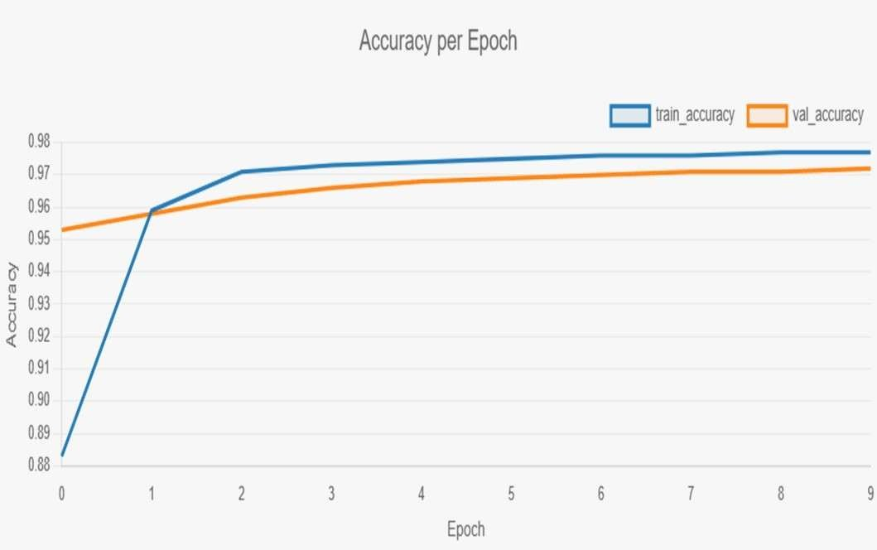

Fig. 7. Accuracy per Epoch.

The distributed architecture incorporating Raspberry Pi 5, STM32, ESP32, and laptop GPU enables both real-time control and accurate AI inference on a low-cost platform. Future work will focus on the full deployment of PIDNet-S on embedded hardware, extension of datasets to encompass more diverse road types and weather conditions, integration of V2X communication capabilities, and exploration of transformer- based models and reinforcement learning techniques for predictive and driver-adaptive assistance.
References
- S. Yenikaya, G. Yenikaya, and E. Düven, “Keeping the vehicle on the road: A survey on on-road lane detection systems,” ACM Computing Surveys, vol. 46, no. 1, pp. 1–43, 2013.
- M. Aly, “Real time detection of lane markers in urban streets,” in Proc. IEEE Intelligent Vehicles Symposium, 2008, pp. 7–12.
- J. C. McCall and M. M. Trivedi, “Video-based lane estimation and tracking for driver assistance: Survey, system, and evaluation,” IEEE Trans. Intelligent Transportation Systems, vol. 7, no. 1, pp. 20–37, 2006.
- A. B. Hillel, R. Lerner, D. Levi, and G. Raz, “Recent progress in road and lane detection: A survey,” Machine Vision and Applications, vol. 25, no. 3, pp. 727–745, 2014.
- S. Sivaraman and M. M. Trivedi, “Looking at vehicles on the road: A survey of vision-based vehicle detection, tracking, and behavior analysis,” IEEE Trans. Intelligent Transportation Systems, vol. 14, no. 4,
pp. 1773–1795, 2013.
- Y. Wang, E. K. Teoh, and D. Shen, “Lane detection and tracking using B-Snake,” Image and Vision Computing, vol. 22, no. 4, pp. 269–280, 2004.
- Z. Kim, “Robust lane detection and tracking in challenging scenarios,” IEEE Trans. Intelligent Transportation Systems, vol. 9, no. 1, pp. 16–26, 2008.
- D. Neven, B. De Brabandere, S. Georgoulis, M. Proesmans, and L. Van Gool, “Towards end-to-end lane detection: An instance segmentation approach,” in Proc. IEEE Intelligent Vehicles Symposium, 2018,
pp. 286–291.
- X. Pan et al., “Spatial as deep: Spatial CNN for traffic scene understanding,” in Proc. AAAI Conference on Artificial Intelligence, 2018, pp. 7276–7283.
- Z. Qin, H. Wang, and X. Li, “Ultra fast structure-aware deep lane detection,” in Proc. European Conference on Computer Vision, 2020,
pp. 276–291.
- C. Urmson et al., “Autonomous driving in urban environments: Boss and the urban challenge,” Journal of Field Robotics, vol. 25, no. 8,
pp. 425–466, 2008.
- J. Levinson et al., “Towards fully autonomous driving: Systems and algorithms,” in Proc. IEEE Intelligent Vehicles Symposium, 2011,
pp. 163–168.
- M. Bojarski et al., “End to end learning for self-driving cars,” arXiv preprint arXiv:1604.07316, 2016.

