Social, Economic, Cultural, and Composite Consumer Archetypes in Sri Lanka: A Social Cognitive Theory-Based Approach to Strategic Marketing Design

ABSTRACT
This paper explores the evolving nature of the modern Sri Lankan consumer through four archetypes: the Cultural Man, Composite Man, Economic Man, and Social Man. In addition to these perspectives, the review examines the emergence of new social class segments, including Traditional Middle Class 1 (TMC1), Traditional Middle Class 2 (TMC2), the New Urban Middle Class (NUMC), and the Traditional Working Class (TWC). By integrating these archetypes with the dynamics of shifting social classes, the study provides a nuanced understanding of consumer decision-making in Sri Lanka. The findings are grounded in Social Cognitive Theory, which emphasizes the interplay between personal, behavioral, and environmental factors. The analysis demonstrates how composite, social, cultural, and economic dimensions shape consumer choices across different socio-economic strata. The study further reveals how shifting social class boundaries — particularly the decline of the Traditional Working Class and the rise of the New Urban Middle Class — are redefining consumption patterns, aspirations, and lifestyle choices in the Sri Lankan marketplace. Implications for marketers are discussed, highlighting the need for dynamic, psychologically grounded, and culturally sensitive marketing strategies that address the diverse motivations, cultural influences, and socio-economic transitions shaping contemporary Sri Lankan consumer behavior. The paper underscores the importance of moving beyond income-based segmentation toward identity-driven, aspirational, and inclusive marketing frameworks suited to Sri Lanka's rapidly evolving consumer landscape.
Keywords: Social Archetypes, Cultural Consumer, Economic Consumer, Composite Consumer, Social Classes, Sri Lankan Consumer Behavior, Social Cognitive Theory, Marketing Strategy
I. INTRODUCTION
Modern marketers must focus more on the customer than on products or sales alone. It is not about finding people to buy what is already being sold, but about creating the right products to meet customers' needs. Since the late 1970s, when Sri Lanka opened its economy, the market has undergone significant transformation. More recently, digital growth — including increased smartphone use, internet access, and the influence of artificial intelligence — has accelerated this change. Shifting demographics and cultural evolution have given rise to a new type of consumer, compelling marketers to quickly recognize and adapt their strategies to prioritize customer needs, a critical factor for business success.
Significant changes are taking place in the Sri Lankan consumer market, where social, economic, cultural, and composite factors increasingly shape consumers' behavior and decision-making processes. Accordingly, four types of consumers can be identified to better understand different customer perspectives: the Composite Man, Economic Man, Social Man, and Cultural Man.
The Social Man archetype reflects the influence of social factors — particularly social class — on consumer behavior. This paper explores the paradigm shift across different social classes in Sri Lanka and highlights how understanding these transformations can help marketers gain deeper insights into consumers' problems, preferences, and behaviors in today's complex marketplace. Social class influences consumers' judgments and decisions, while these choices simultaneously reflect and reinforce class identity. Understanding the role of social class in consumption is increasingly critical due to growing economic stratification [1]. Extant literature has identified the utility of social class constructs in various marketing strategies, including segmentation [2]. Socioeconomic status has been explained through multiple dimensions, including income [3], occupation [4], and education [5], with wealth, social capital, and professional opportunities collectively shaping what has been recognized as a multifaceted concept [6].
Sri Lanka's socio-economic classification can broadly be divided into five categories (A–E), determined by economic, social, and educational factors. Category A represents the upper class, while Category E represents the lowest in terms of social status and educational attainment. Over time, Category E has been shrinking as individuals gradually move upward into higher categories. Industry groups such as Agriculture, Forestry and Fishing primarily correspond to socio-economic groups ranging from E (low-income laborers, small-scale farmers, and manual workers) to C (skilled laborers) and possibly B (supervisory roles and technicians). Professional, Scientific and Technical Activities and Public Administration typically map to higher groups like A1, A2, or B1, where occupations require higher education and professional qualifications (see Figure 1).

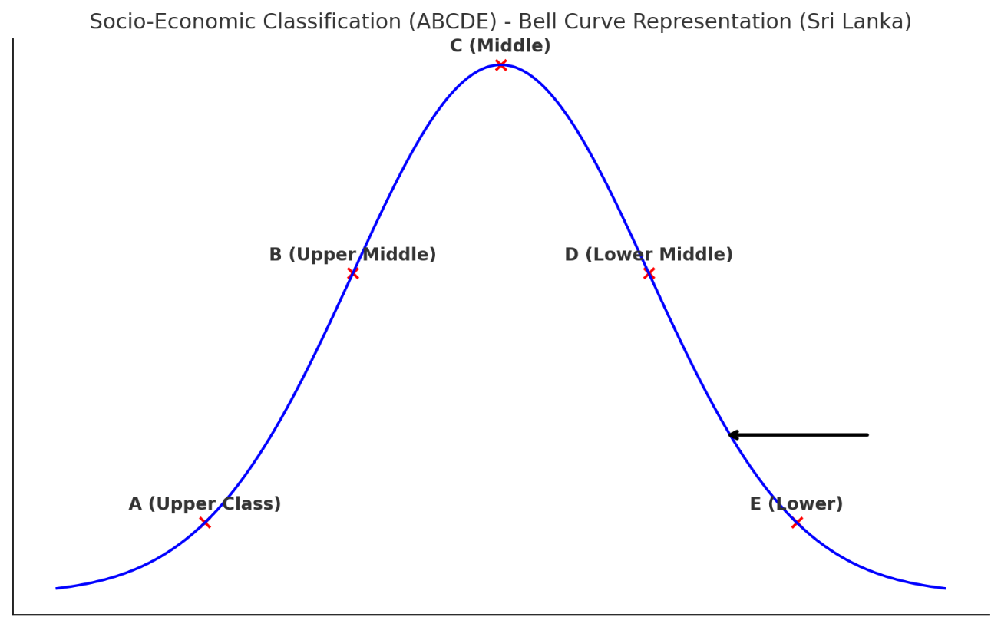

Figure 1. Social Class Classification in Sri Lanka.
With the shifting of social classes, various paradigm movements can be identified among Sri Lankan consumers. Historically, Sri Lanka's Traditional Middle Class (TMC) was divided into two segments: TMC1, consisting of western-oriented, bilingual individuals working mainly in the corporate sector; and TMC2, more eastern-oriented, primarily native-language speakers employed in government jobs. Although culturally and linguistically distinct, both groups shared similar levels of education, spending power, and social standing, with recognition based on personal identity. However, today, recognition is based less on identity and more on profession, status, and achievements.
The Traditional Working Class has also evolved, giving rise to the New Working Class and Alienated Rural Youth, who have embraced the gig economy and self-employment as new avenues for upward mobility. Many of these groups have subsequently merged into what is known as the New Urban Middle Class (NUMC), in which an individual's exact social or cultural origins have become increasingly difficult to trace due to blurring boundaries shaped by changing economic roles and lifestyles.
This paper highlights the significance of social class in offering fresh perspectives, drawing on four key personas — the composite, social, economic, and cultural consumer — grounded in Social Cognitive Theory. The discussion identifies how these dimensions influence consumer decision-making and demonstrates how marketers can leverage insights from these archetypes to formulate more effective strategic decisions.
II. THEORETICAL FRAMEWORK: SOCIAL COGNITIVE PERSPECTIVE
Social Cognitive Theory (SCT), as a psychological framework, illustrates that consumer behavior is shaped by observational learning from others' behavior and outcomes. The theory explains the dynamic relationship between personal factors, behavioral actions, and environmental influences. SCT is particularly valuable for understanding consumer behavior by emphasizing the impact of social interactions, mental processes, and environmental factors on decision-making [7]. The theory also highlights the role of environmental influences — including observational learning and social support — alongside individual elements such as outcome expectations and self-efficacy in explaining why certain behaviors occur [8].
In SCT, an individual's behavior is influenced by a combination of personal, environmental, and behavioral factors [9]. Environmental factors exist outside the individual, either in social or physical form. The social environment encompasses interactions with friends, family, and colleagues, while the physical environment includes factors such as weather conditions or spatial lighting. Personal factors encompass fundamental cognitive and emotional abilities, including self-efficacy, individual traits, expectations, self-regulation, and reinforcement. An individual anticipates specific outcomes resulting from their actions, and these expectations influence their decision to carry out those actions.
The concept of triadic reciprocal causation, central to SCT, refers to the functional interdependence between events, whereby cognitive, affective, and biological factors, behavioral patterns, and environmental influences interact dynamically and shape one another in a bidirectional manner [8]. Each activity depends on situational circumstances and socio-structural constraints and opportunities. Bandura [8] further identifies the environment as comprising three elements: the imposed environment, the selected environment, and the constructed environment.
Applied to the Sri Lankan consumer context, SCT provides the theoretical lens through which four main consumer archetypes are identified as key factors influencing the decision-making of different and evolving social classes.
III. CONSUMER ARCHETYPES
A. Composite Man
The Composite Man framework examines the evolving family life cycle and its implications for consumer behavior, as influenced by various demographic and societal trends. This concept provides a structured approach to understanding how shifts in household dynamics shape purchasing patterns and market demand. By examining these trends, the Composite Man framework aids in identifying gaps in consumer needs and informing marketing strategies that align with changing family structures.
In the twenty-first century, gender equality and equity have become critical issues as societies work to correct historical imbalances between men and women, focusing on ensuring fair access to resources and bridging gaps in opportunity [10]. Sri Lanka, a South Asian nation with a population of approximately 21 million, falls under the lower-middle-income country category. The Global Gender Gap Report 2020 positioned Sri Lanka 102nd out of 153 nations, highlighting gender disparities across health, education, economic participation, and political representation, with women accounting for only 31.8% of the total labor force [11].
Human behavior has often been interpreted through the lens of one-sided determinism, where actions are seen as either dictated by external environmental factors or driven solely by internal dispositions. SCT identifies psychosocial functioning through triadic reciprocal causation [8], in which cognitive, affective, and biological factors, behavioral patterns, and environmental influences interact dynamically. The concept of future time perspective is reflected in various ways: individuals develop beliefs about their capabilities, anticipate potential outcomes of their actions, set personal goals, and strategize plans to achieve desired results. By exercising forethought, they can self-motivate and direct their behavior toward meaningful objectives [8].
The two main variables identified in SCT — outcome expectancy and self-efficacy beliefs — are central to the Composite Man archetype. Outcome expectancies refer to individuals' beliefs regarding the potential results of performing certain behaviors [8]. People tend to engage in actions that they believe will enhance positive outcomes and reduce negative consequences [12]. Individual drivers of decision-making further encompass affective, conative, and cognitive dimensions [13][14][15]. A considerable body of research has examined the roles of husbands, wives, and adolescents in various aspects of household decision-making [16]. While women traditionally held primary decision-making authority in domestic matters, the modern era has seen a notable shift as more women engage in external employment [17].
B. Cultural Man
Culture can be viewed as a cognitive framework that offers knowledge and direction regarding individual behavior, shaped by personal values, social norms, and long-standing traditions [18]. Consumers' preferences, behaviors, and purchasing patterns are shaped by culture across diverse markets, and with the globalized economy, the cultural relevance of products and services is increasingly significant from a marketing perspective.
Different beliefs and value systems developed within families shape culture and exert a high impact on decision-making. Religion is a key area in this regard. From a Sri Lankan youth community perspective, while religion holds personal significance for many young people, their openness in expressing it publicly — through worship or social media — varies widely. A significant number choose to keep their religious beliefs and practices private, possibly due to concerns about judgment or lack of strong motivation [19].
The weakening of close family connections has also had significant impacts, with many young people increasingly relying on external social networks to guide their life choices and career paths. Social media has intensified this reliance, often bringing more challenges than benefits. Many youth express frustrations about limited personal freedom in Sri Lanka, with numerous individuals aspiring to move away from their hometowns or the country in pursuit of more independent lifestyles. In this setting, some view higher education as a stepping stone toward achieving such aspirations.
Given this cultural climate of growing distrust and individualism, marketers must prioritize authenticity, transparency, and emotional intelligence in their strategies. Understanding these deep-rooted societal sentiments is essential for crafting messages that resonate with consumers who are increasingly skeptical and driven by personal aspirations rather than collective values. Cultural migration among youth further reflects a shift away from traditional family structures.
Food represents another dimension of culture exhibiting notable consumer trends. There is an increasing trend toward convenient food options, including ready-to-eat items such as rolls, cutlets, frozen baked goods, instant pizzas, and pre-cooked curries, all easily available in supermarkets. Ready-to-drink beverages such as tea and coffee have also gained popularity, with local brands adopting strategies from international counterparts to appeal to a wider customer base.
Consistent with SCT, which emphasizes that consumer decision-making is influenced by a combination of personal, environmental, and behavioral factors [9], culture constitutes a part of both the internal and external environmental influences on decision-making. Marketing decision-makers must therefore consider diverse cultural values, beliefs, purchasing patterns, and lifestyles when formulating strategies.
C. Economic Man
Economic factors influencing consumer behavior can be categorized as macroeconomic and microeconomic. Micro factors encompass individual demand and supply-related considerations, while macroeconomic factors include wider economic indicators such as inflation, interest rates, and overall economic growth, which have the potential to impact entire industries and national economies.
Economic indicators released by the Central Bank of Sri Lanka (CBSL) highlight several macroeconomic dynamics that marketers must consider when crafting strategies in an expanding yet volatile economy. In 2022, the Sri Lankan economy experienced nominal growth. Despite this, GDP per capita declined, reflecting reduced individual purchasing power. Private consumption remained comparatively strong through Personal Consumption Expenditure (PCE), indicating that while inflation and currency depreciation pressured consumers, spending behavior adapted. This represents a key consideration for marketers who must balance value-driven offerings with rising cost sensitivity.
Several sectors present emerging opportunities and challenges for marketers. The insurance industry has seen significant growth, particularly in life insurance adoption, suggesting increased consumer interest in financial security. The banking sector has similarly recorded a notable rise in savings and deposits, signaling cautious financial behavior. Marketers in financial services and fintech should leverage this cautious optimism by promoting savings products, insurance plans, and secure investment options. The food expenditure ratio — representing the share of household income spent on food — remains high, with estate sector households allocating a disproportionate amount to alcohol, tobacco, and related products. These spending patterns highlight both ethical considerations and segmentation opportunities for marketers targeting underserved communities.
The telecommunications sector has witnessed extraordinary growth, particularly in internet and broadband usage. However, digital access remains uneven, with approximately 40% of Sri Lankans reportedly never having used the internet, according to 2023 survey data. This digital divide presents both a challenge and a strategic opportunity for marketers, who can expand digital engagement through inclusive platforms while maintaining hybrid or offline strategies to reach less connected audiences. Furthermore, increasing income inequality — reflected in a rising Gini Coefficient and growing poverty indices such as the Headcount Index (HCI) and Multidimensional Poverty Index (MPI) — underlines the importance of inclusive, socially responsible marketing.
D. Social Man
Social factors significantly influence consumer behavior, shaping individuals' purchasing decisions. Elements such as family, reference groups, social status, and cultural norms all play a role in determining how consumers view and choose products and brands. Consumers' choices are strongly shaped by the decision-making context, and the growing influence of social networks is shifting consumer behavior, as choices are increasingly driven by the desire to engage in identity play, accumulate social capital, and cultivate a personal brand [20].
Within the SCT framework, social learning, peer recognition, and the size of the user base are key factors affecting the quality and quantity of knowledge contributions [21]. Societal factors such as embedded community norms and personal incentives work together to shape user behavior, with peer recognition playing a key role in influencing individual engagement. Social structures are established to shape, direct, and oversee human activities through recognized rules and regulations.
By observing the social environment — such as witnessing others' successes or learning through vicarious experiences — people can adopt behaviors as if they had personally experienced those events [9]. Behavior is formed within a social environment, encompassing beliefs and choices aimed at benefiting both the individual and the surrounding community [22]. Affective components operate at two levels of social context: a broader social context (neighborhood, society) and a narrower social circle (family, friends). Both environments shape personal norms, which subsequently affect behavior directly and indirectly through attitudes [23].
Social motives — including group identity and status-seeking — have been shown to significantly impact behavior. Status-seeking refers to the drive to obtain products or brands that symbolize prestige and social standing, aimed at boosting one's self-image and position within social groups [24]. Peer groups, defined as close-knit circles of individuals of similar age engaged in comparable activities, also exert a strong influence on behavior and decision-making [25].
IV. EMERGING SOCIAL CLASSES IN SRI LANKA
A. TMC1: Traditional Middle Class 1
One of the most significant effects of colonization in Sri Lanka was the strong influence of Western ideas, values, and systems, which remain embedded in Sri Lankan society today. Sri Lankan society continues to reflect signs of its colonial past through class stratification, which is a key sociological concept for explaining how society is divided into different levels — typically measured by income, wealth, occupation, power, and social standing. A major outcome of colonization was the formation of a native elite group known as the Traditional Middle Class (TMC), which adopted Western lifestyles and thinking, effectively facilitating a societal transition from traditional to more modern orientations.
B. TMC2: Traditional Middle Class 2
Over time, a new group within the Traditional Middle Class — referred to as TMC2 — began to replace TMC1 as the dominant force. TMC2 emerged from the free education system and is predominantly monolingual, working primarily in government employment with a strong orientation toward national issues. Key members include school principals, teachers, university lecturers, and other professionals working mainly in the public sector. While TMC1 blends Western ideas with traditional values, TMC2 largely adheres to traditional orientations, emphasizing family background and job status. Although familiar with Western lifestyles, TMC2 does not fully adopt them.
C. New Urban Middle Class (NUMC)
As the private sector became the main engine of economic and social change in Sri Lanka and government roles began to decline, the country's social structure shifted, leading to the emergence of the New Urban Middle Class (NUMC). Though relatively small, this group plays a pivotal role in shaping the country's economy and culture. The NUMC includes individuals who either inherited wealth — such as property and land — or built it through business and investments. Those who inherit wealth often live modestly and focus on sustainability, while those who earn it tend to seek social status through material goods and social network building. This behavior reflects Mead's [26] concept of Symbolic Interactionism, which suggests that societal values often influence people more profoundly than personal desires. As noted by Bamunusinghe [27], in contemporary society, what one owns has become more significant than who one is. Members of the NUMC are typically business-minded, skilled in trade, and possess strong purchasing power.
The rise of digital and information communication technologies has brought major changes globally, improving quality of life while also reflecting the NUMC's capacity to adapt to and leverage technology. In the banking and finance sector, for example, one clear trend among the NUMC is the growing demand for exclusive services such as Premier, Private, or Prestige Banking — personalized offerings that match the lifestyle expectations of this group.
A key feature of Sri Lanka's NUMC is the rise of 'Mod-Tradi' consumers — modern consumers who combine elements of both tradition and modernity, even when these influences appear contradictory. Consumer behavior in Sri Lanka is shaped by three main forces: traditionalization, modernization, and a mix of both, known as post-modernization. These influences have created unique and recognizable patterns in consumption that are visible across many real-life examples.
D. Traditional Working Class (TWC)
In addition to the TMC and NUMC, the Traditional Working Class (TWC) represents another key group. This segment includes unskilled and semi-skilled laborers along with lower-level clerical workers, and makes up a substantial portion of the wage-earning population. The TWC often faces social and economic challenges that limit their ability to fully participate in consumer culture and enjoy the advantages of modernization [28]. However, the traditional working class is gradually shrinking with the evolution of the New Working Class.
E. New Working Class (NWC)
The New Working Class refers predominantly to young people working in industries such as free trade zones, construction, or the unorganized sector — often because they were unable to secure white-collar employment. This definition has evolved to encompass a broader group of workers engaged in digital mobility, including those in app-based services such as food delivery, ride-hailing, e-commerce, and rapid commerce logistics, frequently utilizing personal vehicles. While this group may lack the English language proficiency required for white-collar positions, they demonstrate rapid adoption of technology to participate in the unorganized economy. In the construction industry, meanwhile, the hiring of international labor has become increasingly common for large-scale development projects due to project deadlines and a shortage of dedicated local labor.
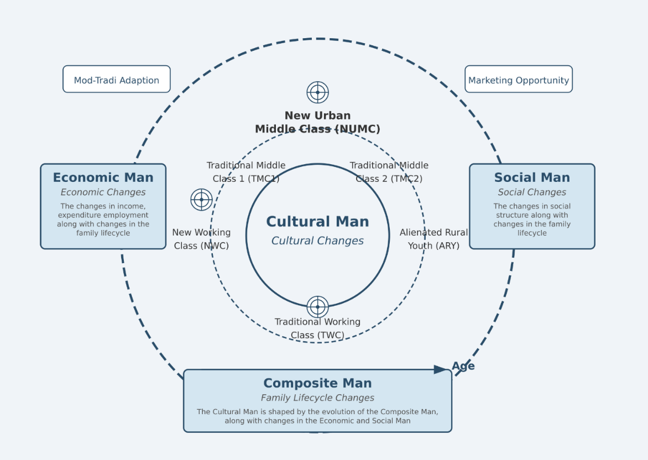

Figure 2. Social Classes Emerged with Different Consumer Archetypes in Sri Lanka.
Source: Authors
Figure 2 illustrates the different social classes that have emerged, shaped by economic, social, cultural, and composite archetypes. The trends indicate that the Traditional Working Class is shrinking — corresponding to Category E of the Socio-Economic Classification — while the New Working Class and Alienated Rural Youth are transitioning toward the New Urban Middle Class.
V. CONSUMER DECISION-MAKING
Understanding these different social classes is important for analyzing the diverse decision-making contexts of consumers in the Sri Lankan market, providing marketers with valuable insights for developing effective strategies. Frequent and unpredictable changes in the market environment further impact consumer decision-making. The traditional framework for understanding this process is the five-stage model of the consumer buying process [29]. Belch and Belch [30] expanded on this model by examining the internal psychological processes associated with each stage.
Decision-making comprises various stages influenced by both internal and external drivers. As identified in this review, social, cultural, and economic factors significantly impact consumer decision-making. In addition, composite aspects and internal drivers demonstrate notable influence. Internal information search involves drawing on personal memory, including past experiences with a product or service. In contrast, external information search involves seeking input from others — asking friends and family about their experiences when considering a new purchase [31].
According to Belch and Belch [30], consumer decision-making is significantly influenced by external factors such as culture, social class, reference groups, and situational variables. Culture remains one of the most complex factors to study in consumer behavior. As the global market continues to evolve, there is ongoing debate about whether consumption patterns are becoming more uniform, with lifestyles increasingly reflecting those of the industrialized world, influenced by similar demographic changes [31]. This review has thus identified various factors — alongside the composite, social, cultural, and economic archetypes — that shape different social classes and impact consumer decision-making in Sri Lanka.
VI. IMPLICATIONS FOR SRI LANKAN MARKETERS
The evolving landscape of the Sri Lankan consumer, examined through the lenses of the Composite Man, Economic Man, Social Man, and Cultural Man, urges marketers to move beyond traditional rational models of behavior. By incorporating the Social Cognitive perspective, the study highlights how personal beliefs, social dynamics, and environmental contexts collectively shape consumer decisions. For marketers, this implies the need to adopt a more holistic, psychologically grounded approach — one that acknowledges emotional, social, and cognitive influences rather than relying solely on functional or price-based appeals.
Changing social trends and shifting ideas of social status offer valuable opportunities for marketers. Status and personal identity remain critically important today, with people increasingly defining themselves by what they own rather than by their values, character, or personality. This is especially evident on social media platforms such as LinkedIn, YouTube, and TikTok, where young people share content to demonstrate their presence, skills, and talents — opportunities that may not have previously been accessible due to social barriers. The aspirational nature of such content illustrates the degree to which today's consumers seek recognition and social status, exemplified by users posting about the shopping malls they visit, the food they eat, the clothes they wear, or images with luxury goods to project a successful lifestyle.
The segmentation of emerging social classes — TMC1, TMC2, NUMC, TWC, and NWC — further underscores the necessity for tailored marketing strategies. Each group reflects distinct cultural values, economic priorities, and lifestyle aspirations, requiring marketers to create nuanced campaigns that resonate with their unique characteristics. NUMC consumers may seek aspirational and technology-driven messaging, while TWC audiences may prioritize value, trust, and community connection. Understanding these differences enables brands to engage consumers more meaningfully and foster long-term loyalty.
The evolving socio-economic classifications and shifting social classes also highlight the need for more dynamic and segmented marketing strategies. As Category E continues to shrink and more consumers transition into higher socio-economic groups such as the NUMC, purchasing power, aspirations, and lifestyle choices are becoming more diverse and sophisticated. Traditional segmentation based solely on income is no longer sufficient; marketers must also consider cultural orientation, professional identity, and status-driven aspirations when positioning products and services. The rise of the gig economy and self-employed consumers suggests opportunities for affordable, flexible, and technology-enabled offerings that align with upward mobility. Moreover, the blurring of traditional class boundaries requires brands to build inclusive marketing approaches that emphasize lifestyle, value creation, and aspirational identity rather than rigid class markers. By aligning marketing strategies with these shifting paradigms, businesses can strengthen consumer engagement and build long-term loyalty in Sri Lanka's transforming market.
VII. CONCLUSIONS
This paper has examined the evolving Sri Lankan consumer landscape through four distinct archetypes — the Composite Man, Cultural Man, Economic Man, and Social Man — grounded in Social Cognitive Theory. The analysis demonstrates that consumer decision-making in Sri Lanka is a multidimensional process shaped by the interplay of personal, behavioral, and environmental factors. The emergence of new social class formations, particularly the New Urban Middle Class (NUMC) and the New Working Class (NWC), alongside the decline of the Traditional Working Class, represents a fundamental shift in the structure of Sri Lankan consumer society.
For marketers, these findings underscore the imperative of adopting psychologically informed, culturally sensitive, and socio-economically nuanced strategies. The movement toward identity-driven consumption, the growing influence of digital platforms, and the blurring of traditional class boundaries collectively demand that marketing practice transcend conventional segmentation approaches. Future research should examine these dynamics empirically through primary data collection across different social class segments, enabling validation and further refinement of the archetypes presented in this paper.
VIII. DECLARATION OF GENERATIVE AI AND AI-ASSISTED TECHNOLOGIES IN THE WRITING PROCESS
During the preparation of this manuscript, the authors used Claude (Anthropic) to assist with language editing, manuscript formatting, and structural refinement of the text. All intellectual content, arguments, analysis, theoretical frameworks, and conclusions presented in this paper are entirely the work of the authors. The authors have reviewed, edited, and take full responsibility for all content published in this paper. Generative AI tools were not used to generate original research ideas, data, or academic claims.

REFERENCES
[1] Shavitt, S., Jiang, D., & Cho, H. (2016). Stratification and segmentation: Social class in consumer behavior. Journal of Consumer Psychology, 26(4), 583–593. https://doi.org/10.1016/j.jcps.2016.08.005
[2] Wedel, M., & Kamakura, W. A. (2000). Market Segmentation: Conceptual and Methodological Foundations. Springer Science & Business Media.
[3] Drentea, P. (2000). Age, debt and anxiety. Journal of Health and Social Behavior, 41(4), 437–450. https://doi.org/10.2307/2676296
[4] Oakes, J. M., & Rossi, P. H. (2003). The measurement of SES in health research: Current practice and steps toward a new approach. Social Science & Medicine, 56(4), 769–784. https://doi.org/10.1016/S0277-9536(02)00073-4
[5] Stephens, N., Markus, H., & Townsend, S. (2007). Choice as an act of meaning: The case of social class. Journal of Personality and Social Psychology, 93, 814–830. https://doi.org/10.1037/0022-3514.93.5.814
[6] Carey, R. M., & Markus, H. R. (2016). Understanding consumer psychology in working-class contexts. Journal of Consumer Psychology, 26(4), 568–582. https://doi.org/10.1016/j.jcps.2016.08.004
[7] Bandura, A. (1986). Social Foundations of Thought and Action: A Social Cognitive Theory. Prentice-Hall.
[8] Bandura, A. (1991). Social cognitive theory of self-regulation. Organizational Behavior and Human Decision Processes, 50(2), 248–287. https://doi.org/10.1016/0749-5978(91)90022-L
[9] Nursanti, I., Murti, B., & Mulyani, S. (2025). Modeling of maternal behavior to improve the development of children under five based on social cognitive theory (SCT) and the information-motivation-behavioral skills model (IMB). Social Sciences & Humanities Open, 11, 101283. https://doi.org/10.1016/j.ssaho.2025.101283
[10] Marufu, H., & Matanga, S. Y. (2025). Continuity and change: Depictions of gender roles and relations from the Stone Age period to the present. In M. Manyonganise et al. (Eds.), Bible in Africa Studies (Vol. 44, pp. 71–90). University of Bamberg Press. https://doi.org/10.20378/irb-106037
[11] Labour Force Survey. (2021). Annual Report. Department of Census and Statistics, Sri Lanka.
[12] Young, H. N., Lipowski, E. E., & Cline, R. J. W. (2005). Using social cognitive theory to explain consumers' behavioral intentions in response to direct-to-consumer prescription drug advertising. Research in Social and Administrative Pharmacy, 1(2), 270–288. https://doi.org/10.1016/j.sapharm.2005.03.011
[13] Lavidge, R. J. (1961). A model for predictive measurements of advertising effectiveness. Journal of Marketing, 25(6), 59–62.
[14] Rajagopal. (2021). Consumer behavior and cognitive theories. In Rajagopal (Ed.), Crowd-Based Business Models (pp. 197–225). Springer. https://doi.org/10.1007/978-3-030-77083-9_7
[15] Sofi, S. A., Mir, F. A., & Baba, M. M. (2020). Cognition and affect in consumer decision making. Future Business Journal, 6(1), 31. https://doi.org/10.1186/s43093-020-00036-7
[16] Lee, C. K. C., & Beatty, S. E. (2002). Family structure and influence in family decision making. Journal of Consumer Marketing, 19(1), 24–41. https://doi.org/10.1108/07363760210414934
[17] Singh, R., & Nayak, J. K. (2014). Peer interaction and its influence on family purchase decision: A study among Indian teenagers. Vision: The Journal of Business Perspective, 18(2), 81–90. https://doi.org/10.1177/0972262914527873
[18] Khan, O., Varaksina, N., & Hinterhuber, A. (2024). The influence of cultural differences on consumers' willingness to pay more for sustainable fashion. Journal of Cleaner Production, 442, 141024. https://doi.org/10.1016/j.jclepro.2024.141024
[19] Subasinghe, D. et al. (2021). Religious beliefs and practices among Sri Lankan youth. [Journal details as per original source].
[20] Willman-Iivarinen, H. (2017). The future of consumer decision making. European Journal of Futures Research, 5(1), 14. https://doi.org/10.1007/s40309-017-0125-5
[21] Mustafa, S., Zhang, W., Mateen Naveed, M., & Adan, D. e. (2024). Using social cognitive theory to reengage dormant users in question and answer communities. Electronic Commerce Research and Applications, 68, 101450. https://doi.org/10.1016/j.elerap.2024.101450
[22] Jordi, L.-S., Lamberti, G., & Abedini, N. (2025). One size does not fit all consumers: How social context shapes the behavioral drivers behind organic food purchases. Cleaner and Responsible Consumption, 17, 100273. https://doi.org/10.1016/j.clrc.2025.100273
[23] Bamberg, S., & Möser, G. (2007). Twenty years after Hines, Hungerford, and Tomera: A new meta-analysis of psycho-social determinants of pro-environmental behaviour. Journal of Environmental Psychology, 27(1), 14–25. https://doi.org/10.1016/j.jenvp.2006.12.002
[24] Simonetti, A., Bigne, E., & Rico Navas, L. F. (2025). Consumer brand choice in the metaverse: Exploring personal and social factors. Technological Forecasting and Social Change, 213, 124033. https://doi.org/10.1016/j.techfore.2025.124033
[25] Prinstein, M. J., & Dodge, K. A. (2008). Understanding Peer Influence in Children and Adolescents. Guilford Press.
[26] Mead, G. H. (1934). Mind, Self, and Society. University of Chicago Press.
[27] Bamunusinghe, R. (2013). Social class and consumption patterns in Sri Lanka. [Journal details as per original source].
[28] Liyanage, S. (2009). The traditional working class in Sri Lanka: Challenges and transformations. [Journal details as per original source].
[29] Kotler, P., & Keller, K. L. (2012). Marketing Management (14th ed.). Pearson Education.
[30] Belch, G. E., & Belch, M. A. (2009). Advertising and Promotion: An Integrated Marketing Communications Perspective (8th ed.). McGraw-Hill.
[31] Stankevich, A. (2017). Explaining the consumer decision-making process: Critical literature review. Journal of International Business Research and Marketing, 2(6), 7–14. https://doi.org/10.18775/jibrm.1849-8558.2015.26.3001

