Mediating Intrinsic Goal Orientation for Motivation and Social Support in Online Learning: A PLS-SEM Analysis

ABSTRACT
This study investigates the mediating role of intrinsic goal orientation in the relationship between motivation and social support in online learning using Partial Least Squares Structural Equation Modeling (PLS-SEM). Grounded in Expectancy-Value Theory, Self-Determination Theory, and Social Presence Theory, the study examines how expectancy and value influence instructor support and social engagement through intrinsic goal orientation. Data were collected using an adapted questionnaire consisting of 32 items measuring expectancy, value, intrinsic goal orientation, social engagement, and instructor support. The respondents comprised students from science, technology, social sciences, humanities, and business disciplines. Data analysis was conducted using SmartPLS 4 through the assessment of measurement and structural models. The findings revealed that expectancy and value significantly influenced intrinsic goal orientation and instructor support. Expectancy demonstrated a strong positive relationship with intrinsic goal orientation, while value significantly predicted instructor support and social engagement. The study also found that intrinsic goal orientation significantly mediated the relationship between motivation and social engagement, although no mediating effect was found between intrinsic goal orientation and instructor support. The measurement and structural models achieved acceptable levels of reliability, validity, predictive relevance, and effect sizes, confirming the robustness of the proposed framework. The study contributes to the understanding of online learning motivation by integrating motivational and social support factors within a single PLS-SEM framework. The findings provide practical implications for educators and institutions in designing online learning environments that foster intrinsic motivation, meaningful social interaction, and sustained student engagement.
KEYWORDS: online motivation, intrinsic gal orientation, social support, social engagement, instructor support

- INTRODUCTION
  - Background of Study
Online learning has become an essential mode of education, especially following the rapid expansion of digital learning environments during and after the COVID-19 pandemic. In these environments, students’ motivation plays a critical role in determining their engagement, persistence, and academic performance. Research grounded in Self-Determination Theory emphasizes that intrinsic goal orientation and intrinsic motivation are strengthened when learners experience autonomy, competence, relatedness, and meaningful support in online learning contexts. (Mendoza et al., 2023) found that need-supportive online task instructions significantly increased students’ intrinsic motivation and indirectly improved task performance through self-assessment practices. Similarly, (Qiu, 2025) highlighted that autonomy support and social connectedness are important strategies for enhancing learner motivation and engagement in remote learning. Studies have also shown that both intrinsic and extrinsic motivational factors influence students’ willingness to participate in online courses and continue learning online in the future (Teo & Ho, 2024). Moreover, (Jing et al., 2026) demonstrated that autonomy, competence, and relatedness significantly contribute to intrinsic motivation and student engagement in Malaysian online learning settings using PLS-SEM analysis.
1.2 Statement of Problem
Despite the growing body of literature on online learning motivation, several issues remain unresolved. Existing studies have mainly focused on the direct effects of intrinsic and extrinsic motivation on engagement, learning performance, or effort regulation, with limited attention given to the mediating role of intrinsic goal orientation in explaining how motivational and social support factors influence online learning outcomes. For instance, Zhou & Zhang, 2024) argued that online learning activities do not necessarily improve students’ motivation unless they are carefully designed, while (Alshammari & Alrashidi, 2026) revealed that intrinsic motivation significantly affected online learning effort regulation but showed insignificant effects on actual English achievement. Furthermore, while social connectedness and relatedness were identified as important motivational elements in remote learning (Jing et al., 2026; Qiu, 2025) prior studies have not sufficiently examined how social support mechanisms interact with students’ intrinsic goal orientation to shape motivation in online learning contexts.
1.3 Research Gap
A significant research gap therefore exists in understanding the mediating mechanism of intrinsic goal orientation between motivation and social support in online learning environments. Although recent studies have adopted advanced analytical approaches such as PLS-SEM to examine relationships among motivation, engagement, and self-regulation (Jing et al., 2026), limited empirical research has specifically investigated intrinsic goal orientation as a mediator within an integrated motivational framework. Additionally, previous studies predominantly examined either motivational factors or learning environments independently, rather than exploring their combined effects on students’ online learning experiences. Therefore, this study seeks to address this gap by examining the mediating role of intrinsic goal orientation in the relationship between motivation and social support in online learning using Partial Least Squares Structural Equation Modeling (PLS-SEM). The findings are expected to contribute to the theoretical understanding of online learning motivation and provide practical implications for educators and institutions in designing supportive and motivating digital learning environments.

  - Research Objective, Research Questions, and Hypothesis
The research questions will be answered using SmartPLS analysis using both measurement and structural models.

Table 1- Distribution of Research Objectives, Questions, and Hypotheses

RO | RQ | RESEARCH  HYPOTHESIS
To investigate if there is a significant relationship between Expectancy and Instructor Support | Is there a significant relationship between Expectancy and Instructor Support? | Ho1; There is no significant relationship between Expectancy and Instructor Support
To investigate if there is a significant relationship between Expectancy and Intrinsic Goal Orientation | Is there a significant relationship between Expectancy and Intrinsic Goal Orientation? | Ho2; There is no significant relationship between Expectancy and Intrinsic Goal Orientation
To investigate if there is a significant relationship between Expectancy and Social Engagement | Is there a significant relationship between Expectancy and Social Engagement? | Ho3: There is no significant relationship between Expectancy and Social Engagement
To investigate if there is a mediating effect of Intrinsic Goal Orientation on Instructor Support | Is there a mediating effect of Intrinsic Goal Orientation on Instructor Support? | Ho4: There is no mediating effect of Intrinsic Goal Orientation on Instructor Support
To investigate if there is a mediating effect of Intrinsic Goal Orientation on Social Engagement | Is there a mediating effect of Intrinsic Goal Orientation on Social Engagement? | H_{o}5: There is no mediating effect of Intrinsic Goal Orientation on Social Engagement
To investigate if there is a significant relationship between Value and Instructor Support | Is there a significant relationship between Value and Instructor Support? | Ho6: There is no significant relationship between Value and Instructor Support
To investigate if there is a significant relationship between Value and Intrinsic Goal Orientation | Is there a significant relationship between Value and Intrinsic Goal Orientation? | Ho7: There is no significant relationship between Value and Intrinsic Goal Orientation
To investigate if there is a significant relationship between Value and Social Engagement | Is there a significant relationship between Value and Social Engagement? | Ho8: There is no significant relationship between Value and Social Engagement

- LITERATURE REVIEW
  - Theoretical Framework
    - Expectancy-Value Theory

Expectancy-Value Theory (Wigfield & Eccles, 2000) explains that students’ motivation to engage in learning activities is influenced by their expectations for success and the value they place on the task. In the context of online learning, this theory suggests that students are more motivated when they believe they can complete online tasks and perceive online learning as useful, interesting, or important to their personal and academic goals. Expectancy refers to learners’ confidence in their ability to perform well in online courses, which may be influenced by factors such as digital skills, prior experience, and self-efficacy. Task value, on the other hand, includes the enjoyment, usefulness, and relevance students associate with online learning activities. When learners view online learning as meaningful and beneficial, they are more likely to participate actively, persist through challenges, and maintain engagement. Therefore, the Expectancy-Value Theory provides a strong framework for understanding how students’ beliefs and values shape their motivation in online learning environments.

    - Self-Determination Theory and Intrinsic Goal Orientation

According to Ryan and Deci (2000), Self-Determination Theory explains that individuals are more motivated when their psychological needs for autonomy, competence, and relatedness are fulfilled. The theory emphasizes intrinsic motivation, in which learners engage in activities because they find them enjoyable, meaningful, or personally rewarding, rather than for external rewards such as grades or recognition. In the context of online learning, Self-Determination Theory is highly relevant because online environments often require students to learn independently and regulate their own learning behaviors. Students with strong intrinsic goal orientation are more likely to participate actively in online discussions, complete learning tasks, and persist despite challenges because they value learning for personal growth and knowledge acquisition. Online learning platforms that provide flexibility, interactive activities, and opportunities for self-paced learning can enhance learners’ sense of autonomy and competence, which further strengthens motivation. Additionally, when students feel connected to instructors and peers through online communication and collaboration, their sense of relatedness improves. Therefore, Self-Determination Theory supports the idea that intrinsic goal orientation positively influences students’ motivation, engagement, and persistence in online learning environments.
- Social Presence Theory
Social Presence Theory (Short, et.al, 1976) explains that the effectiveness of communication depends on the degree to which individuals perceive others as “real” and present during interactions. In online learning environments, social presence is important because students often learn through digital platforms where face-to-face interaction is limited. The theory suggests that higher levels of social presence can increase students’ motivation, satisfaction, and engagement in online learning. Social engagement occurs when students actively participate in discussions, collaborate with peers, and communicate openly in virtual classrooms. These interactions help reduce feelings of isolation and create a sense of belonging within the online learning community. Instructor support also plays a significant role in enhancing social presence. When instructors provide timely feedback, encouragement, guidance, and active communication, students feel more connected and supported in their learning process. This supportive environment increases learners’ confidence and willingness to participate in online activities. Therefore, Social Presence Theory supports the idea that both social engagement and instructor support are essential factors that positively influence students’ motivation and participation in online learning environments.

  - Past Studies on Online Learning Motivation

Past studies on online learning motivation consistently highlight the role of expectancy and value in shaping students’ engagement, particularly within contexts of social engagement and instructor support. Grounded in Expectancy-Value theory, learners’ motivation is influenced by their belief in success and the perceived importance of the task. In online environments, these components are closely tied to how learners interact with peers and instructors. (Mendoza et al., 2023) demonstrate that need-supportive teaching, which addresses students’ needs for autonomy, competence, and relatedness, significantly enhances intrinsic motivation. This suggests that instructor support contributes to learners’ expectancy of success, while meaningful task design increases perceived value, both of which are critical for sustained online engagement.
Furthermore, social engagement and instructor support are essential in cultivating intrinsic goal orientation, which mediates the relationship between motivation and performance. (Qiu, 2025) emphasizes that fostering social connectedness and autonomy support in remote learning environments enhances intrinsic motivation and deeper engagement. Similarly, Zhou & Zhang (2023) argue that poorly designed online activities fail to sustain motivation, indicating that the value component of learning tasks must be strengthened through interaction and relevance. These findings reinforce the notion that motivation is not only shaped by task design but also by the quality of social and instructional support embedded within the learning environment.
In addition, the mediating role of intrinsic goal orientation becomes evident in how motivation translates into learning behaviors and outcomes. (Mendoza et al., 2023) found that intrinsic motivation indirectly improved task performance through self-assessment practices, suggesting that internally driven goals enhance learners’ active engagement.Alshammari & Alrashidi 2026) further support this by showing that intrinsic motivation significantly improves effort regulation in online learning, even when its direct effect on achievement is limited. This indicates that intrinsic goal orientation strengthens learners’ persistence and engagement, bridging the gap between motivational beliefs and actual learning practices.
Finally, both intrinsic and extrinsic motivational factors contribute to online learning engagement, though their impacts differ. (Teo & Ho, 2024)found that extrinsic factors such as performance improvement strongly motivate students, while intrinsic factors sustain long-term engagement. Together, these studies suggest that expectancy and value influence online motivation through social engagement and instructor support, with intrinsic goal orientation acting as a key mediator that enhances learners’ commitment, effort, and overall learning experience.

  - Conceptual Framework and Proposed Model of the Study

The conceptual framework (figure 1 below) of this study is grounded in Expectancy-Value Theory, developed by Wigfield & Eccles (2000). The theory explains that students’ motivation and learning behaviors are influenced by two major components: expectancy and value. Expectancy refers to learners’ beliefs about their ability to successfully perform learning tasks, while value refers to the importance, usefulness, and enjoyment students attach to the learning activity. In the context of online learning, students who believe they can succeed in online courses and who perceive online learning as beneficial and meaningful are more likely to participate actively and remain engaged. Therefore, expectancy and value are proposed as key motivational factors that influence students’ online learning experiences and behaviors.
The framework further incorporates Self-Determination Theory by Ryan and Deci (2000) to explain the mediating role of intrinsic goal orientation in online learning motivation. Self-Determination Theory emphasizes that learners are more motivated when they engage in learning for intrinsic reasons such as personal growth, enjoyment, and mastery of knowledge. In this framework, expectancy and value factors are expected to strengthen students’ intrinsic goal orientation, which subsequently enhances their motivation and participation in online learning. Students who are intrinsically motivated are more likely to regulate their learning, persist through challenges, and actively engage in online educational activities.
Additionally, the framework is supported by Social Presence Theory, developed by Short et al. (1976), which explains the importance of social interaction and perceived presence in online communication environments. The theory suggests that students are more motivated when they feel socially connected to instructors and peers in virtual learning settings. In this study, social engagement and instructor support are viewed as important outcomes influenced by expectancy, value, and intrinsic goal orientation. Students who feel encouraged and supported by instructors and who actively interact with peers are more likely to experience meaningful online learning. Thus, Social Presence Theory provides a foundation for understanding how social engagement and instructor support contribute to students’ motivation and participation in online learning environments.

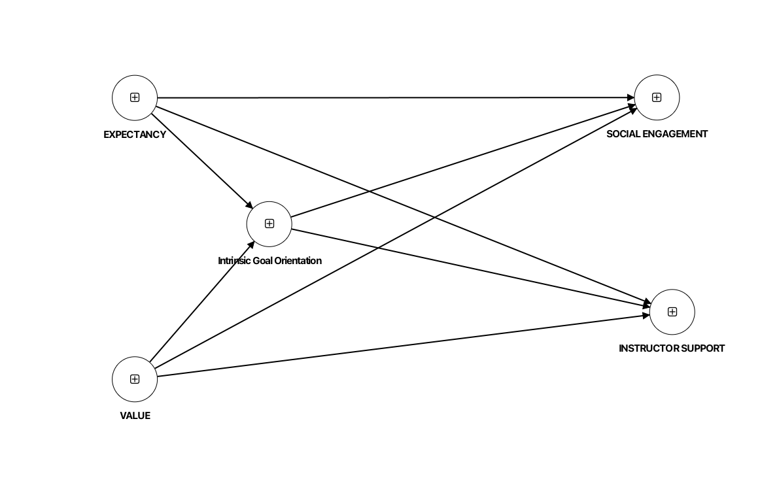
Figure 1- The Conceptual Framework –
Mediating Role of Intrinsic Goal Orientation on Motivation and Social Support in Online Learning

- METHODOLOGY
  - Research Design

This study (Figure 2) employs a quantitative design. The research goal is to explore an extension of an existing theory which combines the theories of (i) Expectancy-Value Theory, developed by Wigfield & Eccles (2000), (ii) Self-Determination Theory by Ryan and Deci (2000), and (iii) Social Presence Theory by Short et al. (1976).
The diagram illustrates a Partial Least Squares Structural Equation Modeling (PLS-SEM) framework consisting of both the measurement model and the structural model. In the measurement model, the latent constructs are represented by oval shapes, while the observed indicators or questionnaire items are represented by rectangular boxes. The constructs on the left side of the model represent the independent variables, namely expectancy beliefs and value-related factors, which are measured using multiple indicators such as ESEQ1–ESEQ7, VEQ1–VEQ4, and VTQ1–VTQ6. These indicators are used to assess the reliability and validity of the latent variables. The central construct, measured by VIQ1–VIQ4, represents intrinsic goal orientation, which functions as the mediating variable in the model. On the right side, the dependent variables include social engagement and instructor support, measured by indicators such as SSEQ2–SSEQ5 and SISQ1–SISQ7, respectively.
In terms of the structural model, the diagram shows the hypothesized relationships among the latent constructs. The arrows connecting the constructs indicate the direction of influence between variables. Expectancy beliefs and value-related factors are proposed to influence intrinsic goal orientation, which subsequently affects social engagement and instructor support in online learning. This suggests a mediation effect where intrinsic goal orientation explains how expectancy and value factors contribute to students’ motivation and interaction in online learning environments. In PLS-SEM analysis, the model would be evaluated by examining the measurement model through factor loadings, composite reliability, convergent validity, and discriminant validity, while the structural model would be assessed using path coefficients, coefficient of determination (R²), effect size (f²), and predictive relevance (Q²) to determine the strength and significance of the hypothesized relationships.

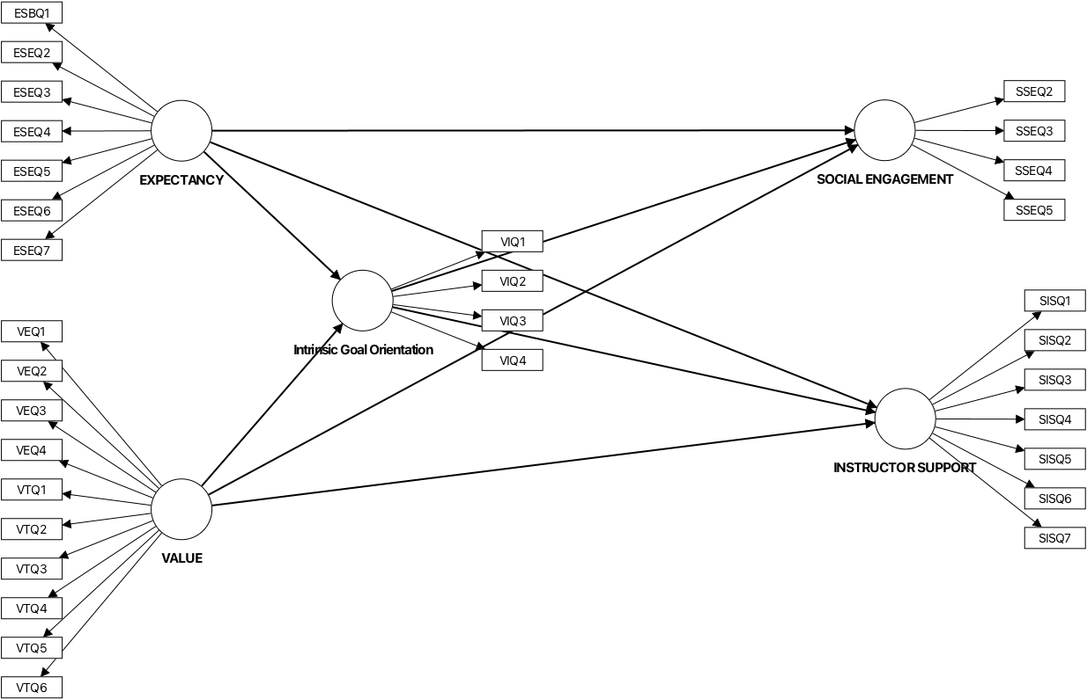
Figure 2-PLS-SEM Model for the Study

  - Population and Sample
The demographic analysis of 305 participants is presented in percentages. According to Ziegenfuss (2021), researchers report demographic data in percentages to establish sample representatives and allow for generalizability to a larger population. Presenting in percentages also provides an overview of participants’ characteristics and offers a clear and understandable picture of the sample makeup

Table 2- Percentage for Demographic Profile
Table 2- Percentage for Demographic Profile
Question | Demographic Profile | Categories | Percentage (%)
1 | Gender | Male | 51%
 |  | Female | 49%
2 | Cluster | Science & Technology | 28%
 |  | Social Sciences, Humanities & Business | 72%

Table 2 above presents the demographic profile of the respondents based on gender and academic cluster. In terms of gender, the respondents were almost equally distributed, with males representing 51% of the sample and females accounting for 49%. This indicates a balanced participation between male and female students in the study. For the academic cluster, most of the respondents belonged to the Social Sciences, Humanities, and Business cluster, which comprised 72% of the participants, while only 28% were from the Science and Technology cluster. The findings suggest that the study involved a more diverse representation from non-science-related disciplines compared to science and technology fields. This distribution may reflect the actual enrollment patterns of students in the institution or the higher willingness of students from the Social Sciences, Humanities, and Business cluster to participate in the study.

  - Instrument

The instrument (Table 3) used is a questionnaire adapted from Fowler (2018) with 32 items. It is comprised of three main sections. Section B has 7 items on Expectancy. Section C has 4 items on Intrinsic Goal orientation. Section D has 10 items on value, while Section D has 4 items on Social Engagement and 7 items on Instructor support.

Table 3- Distribution for Item in Instrument

SECTION | VARIABLE  MOTIVATION | CONSTRUCT | NO OF ITEMS
B | EXPECTANCY | Self-Efficacy | 7 | 7
C |  | Intrinsic Goal Orientation | 4 | 4
D | VALUE | Extrinsic Goal Orientation | 4 | 10
 |  | Task Value | 6
D | SOCIAL SUPPORT | Social Engagement | 4 | 11
 |  | Instructor Support | 7
 |  |  |  | 32

  - Data Collection and Data Analysis
Data is collected via a Google Form. The data is then analyzed using SmartPLS 4 through two main stages. As suggested by (Hair et.al. 2017), data analysis is done at two levels: the measurement and structural model. The first stage is the measurement model, which measures the outer model. The second stage is the structural model, which measures the inner model. The analyzed data is used to answer the research questions and also to confirm the model chosen.

- FINDINGS
The findings are presented in two stages. The first stage presents the measurement model, and the third stage reveals the structural model as well as answers research questions.

  - Measurement Model
In SmartPLS, the measurement model assesses the reliability and validity of the constructs. This is done by examining the relationships between them and their observable behavior. The measurement model measures the outer model. Figure 3 below shows the measurement model for this study. Further detailed explanation of this model is elaborated in tables below.

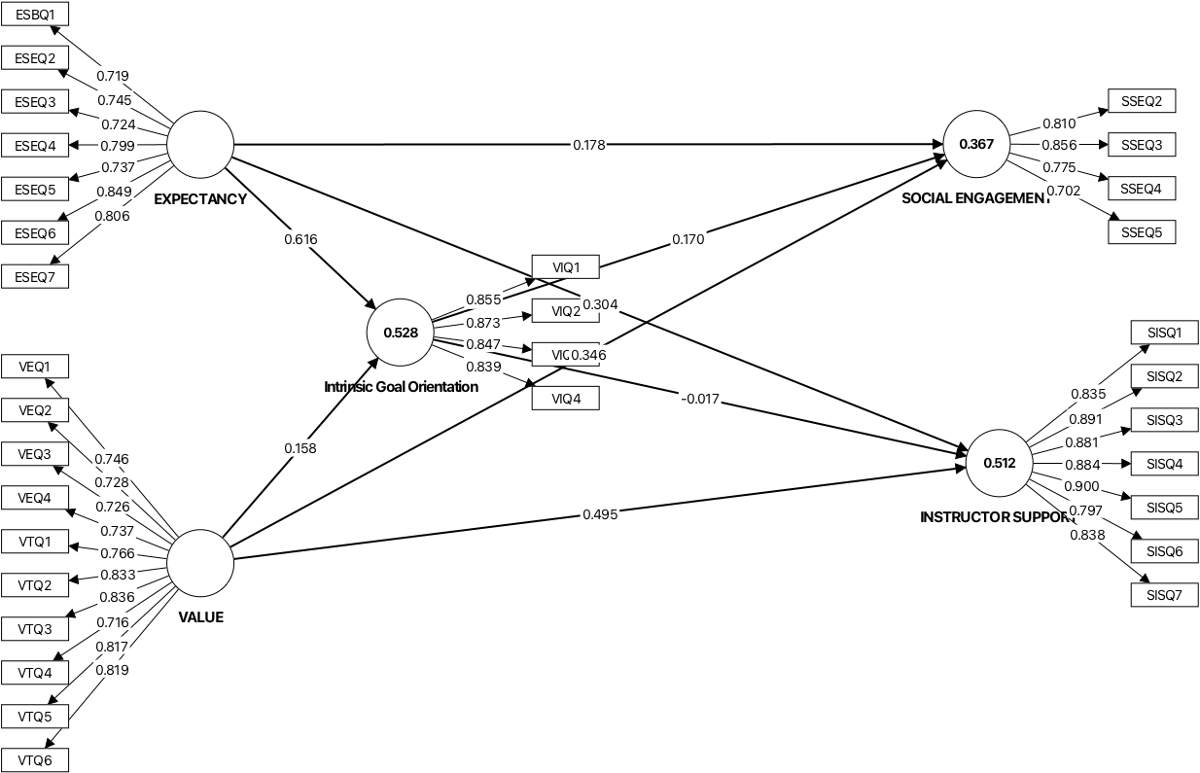

Figure 3- Measurement Model

    - Reliability

According to Ringle & Sarstedt (2016), reliability is assessed by checking indicator reliability and internal consistency reliability. Internal consistency is done using Composite reliability (rho_c) and Cronbach’s Alpha. The cut-off value for Cronbach’s Alpha is 0.70 to 0.90. The cut-off values for composite reliability (rho_c) are 0.70-0.90. For indicator reliability, the factor loadings cut-off values are >0.70 and squared loadings ≥0.50. Finally, the cut-off values for Average Variance Extracted (AVE) ≥0.50.

Table 4 -Results for Reliability- Expectancy

CONSTRUCT/  ITEM | FACTOR LOADING | CRONBACH’S ALPHA | COMPOSITE RELIABILITY (rho_c) | AVERAGE VARIANCE EXTRACTED (AVE)
 |  | 0.884 | 0.91 | 0.592
ESBQ1 | 0.719
ESEQ2 | 0.745
ESEQ3 | 0.724
ESEQ4 | 0.799
ESEQ5 | 0.737
ESEQ6 | 0.849
ESEQ7 | 0.806

Table 4 presents the reliability results for Expectancy. Factor loading of all items was found to be between 0.719 and 0.849. The loadings comply with the indicator reliability of more than 0.7. Next, the Cronbach’s Alpha for Expectancy is 0.884, the composite reliability is 0.91, and the AVE is 0.592.

Table 5 -Results for Reliability- Value

CONSTRUCT/  ITEM | FACTOR LOADING | CRONBACH’S ALPHA | COMPOSITE RELIABILITY (rho_c) | AVERAGE VARIANCE EXTRACTED (AVE)
 |  | 0.925 | 0.937 | 0.599
VEQ1 | 0.746
VEQ2 | 0.728
VEQ3 | 0.726
VEQ4 | 0.737

Table 4 presents the reliability results for the Value. Factor loading of all items were found to be between 0.726 and 0.746. The loadings comply with the indicator reliability of more than 0.7. Next, the Cronbach’s Alpha for Value is 0.925, composite reliability is 0.937 and AVE is 0.599.

Table 6 -Results for Reliability- Social Engagement

CONSTRUCT/  ITEM | FACTOR LOADING | CRONBACH’S ALPHA | COMPOSITE RELIABILITY (rho_c) | AVERAGE VARIANCE EXTRACTED (AVE)
 |  | 0.796 | 0.867 | 0.62
SSEQ2 | 0.81
SSEQ3 | 0.856
SSEQ4 | 0.775
SSEQ5 | 0.702

Table 5 presents the reliability results for Social Engagement. Factor loading of all items was found to be between 0.702 and 0.856. The loadings comply with the indicator reliability of more than 0.7. Next, The Cronbach’s Alpha for Social Engagement is 0.796, composite reliability is 0867 and AVE is 0.62.

Table 7 -Results for Reliability- Instructor Support

CONSTRUCT/  ITEM | FACTOR LOADING | CRONBACH’S ALPHA | COMPOSITE RELIABILITY (rho_c) | AVERAGE VARIANCE EXTRACTED (AVE)
 |  | 0.942 | 0.953 | 0.742
SISQ1 | 0.835
SISQ2 | 0.891
SISQ3 | 0.881
SISQ4 | 0.884
SISQ5 | 0.9
SISQ6 | 0.797
SISQ7 | 0.838

Table 6 presents the reliability results for the Instructor Support. Factor loading of all items was found to be between 0.797 and 0.891. The loadings comply with the indicator reliability of more than 0.7. Next, the Cronbach’s Alpha for Instructor Support is 0.942, the composite reliability is 0.953, and AVE is 0.742.

Table 8 -Results for Reliability- Intrinsic Goal Orientation
CONSTRUCT/  ITEM | FACTOR LOADING | CRONBACH’S ALPHA | COMPOSITE RELIABILITY (rho_c) | AVERAGE VARIANCE EXTRACTED (AVE
 |  | 0.876 | 0.915 | 0.729
EGQ1 | 0.865
EGQ2 | 0.857
EGQ3 | 0.864
EGQ4 | 0.859
EGQ5 | 0.782

Table 7 presents the reliability results for the Intrinsic Goal Orientation. Factor loading of all items was found to be between 0.782 to 0.865. The loadings comply with the indicator reliability of more than 0.7. Next, the Cronbach’s Alpha for Intrinsic Goal Orientation is 0.876, the composite reliability is 0.915, and the AVE is 0.729.

    - Validity

According to (Ramayah et al., 2018) for validity, the Discriminant validity (HTMT) needs to be <0.85 or <0.90.

Table 9- Discriminant Validity (HTMT)
 | EXPECTANCY | INSTRUCTOR SUPPORT | Intrinsic Goal Orientation | SOCIAL ENGAGEMENT
INSTRUCTOR SUPPORT | 0.665
Intrinsic Goal Orientation | 0.81 | 0.518
SOCIAL ENGAGEMENT | 0.613 | 0.839 | 0.566
VALUE | 0.697 | 0.718 | 0.6 | 0.633

Table 9 presents the discriminant validity of the model. The HTMT for all combinations met the threshold and is therefore valid.

  - Structural Model

In SmartPLS, the structural model visualizes the hypothesized causal relationships between constructs. The structural model is thus formed after the researcher has established the reliability and validity in the measurement model. For the analysis of the structural model, the researcher runs bootstrapping and examines the collinearity, path coefficients of determination, effect size, PLS predict, and IPMA. In addition to that, the analysis in the structural model allows the researcher to answer research questions and hypotheses 1-8). Figure 4 below shows the structural model for this study. Detailed explanation is elaborated in Tables below.

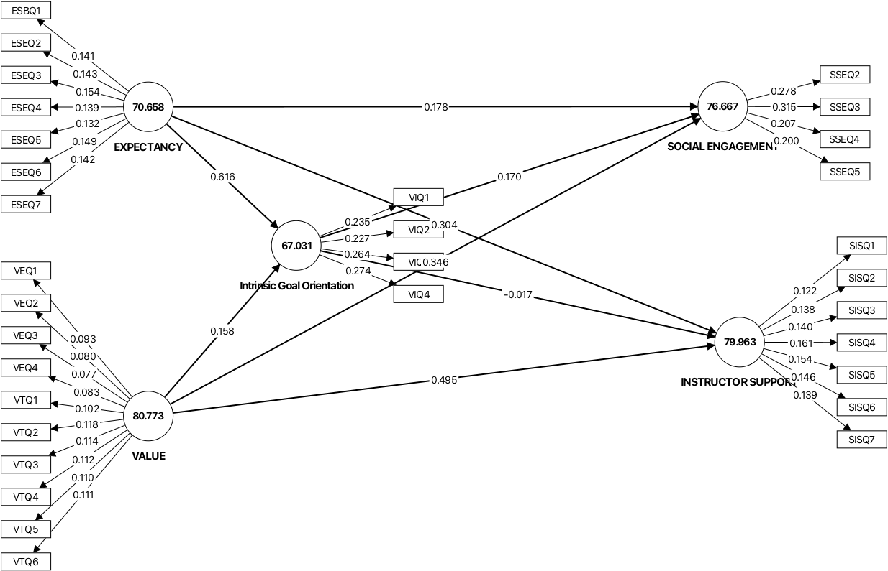

Figure 4- Structural Model

    - Collinearity

According to Ringle & Sarstedt (2016), the cut-off value for collinearity inner model VIF is ≤ 5.0.

Table 10- Collinearity
 | Original sample (O)
EXPECTANCY -> INSTRUCTOR SUPPORT | 2.479
EXPECTANCY -> Intrinsic Goal Orientation | 1.676
EXPECTANCY -> SOCIAL ENGAGEMENT | 2.479
Intrinsic Goal Orientation -> INSTRUCTOR SUPPORT | 2.117
Intrinsic Goal Orientation -> SOCIAL ENGAGEMENT | 2.117
VALUE -> INSTRUCTOR SUPPORT | 1.729
VALUE -> Intrinsic Goal Orientation | 1.676
VALUE -> SOCIAL ENGAGEMENT | 1.729

Table 10 above presents the collinearity results for this study. According to (C. M. Ringle & Sarstedt, 2016) the inner model VIF must be less than or equal to 5.0. All interactions met the threshold for Collinearity.

    - Coefficients of determination (R²)

According to (Ramayah et al., 2018), the coefficients of determination (R²) 0.2 to 0;7, depending on the field of study. Social Sciences & Economics follows the range above.

Table 11-R²

 | Original sample (O)
INSTRUCTOR SUPPORT | 0.512
Intrinsic Goal Orientation | 0.528
SOCIAL ENGAGEMENT | 0.367

Table 11 shows the results for coefficients of determination (R²). Results indicate that the R² for Autonomy Instructor Support is 0.512, for Intrinsic Goal Orientation is 0.528, and for Social Engagement is 0.367. All results met the threshold.

    - P-Value

Table 12- Interpretation for p-value
Thresholds | Interpretation | Decision
p ≤ 0.05 | Often considered statistically significant | Reject H₀
p ≤ 0.01 | Indicates very strong evidence against H₀ | Reject H₀
p> 0.05 | Weak or no evidence against H₀ | Fai to reject H₀

According to Goodman (1999) ,a threshold of p-value is the cut-off for determining statistical significance, most set at 0.05. Below is the table that interprets the threshold.
Table 12 shows the interpretation for p=value. According to (Goodman, 1999) ,if the p-value is p ≤ 0.05, the data is often considered statistically significant, and the hull hypothesis is rejected. If it is p ≤ 0.01, then it indicates very strong evidence to reject the null hypothesis (H₀₎. However, a p> 0.05 is considered weak, and there is no evidence to reject the null hypothesis.

Table 13- Interpretation for p-value
Thresholds | Interpretation | Decision
p ≤ 0.05 | Often considered statistically significant | Reject H₀
p ≤ 0.01 | Indicates very strong evidence against H₀ | Reject H₀
p> 0.05 | Weak or no evidence against H₀ | Fai to reject H₀

Table 14-Path Coefficient for the current study

 | T statistics (|O/STDEV|) | P values
EXPECTANCY -> INSTRUCTOR SUPPORT | 2.988 | 0.003
EXPECTANCY -> Intrinsic Goal Orientation | 9.697 | 0
*EXPECTANCY -> SOCIAL ENGAGEMENT | 1.704 | 0.088
*Intrinsic Goal Orientation -> INSTRUCTOR SUPPORT | 0.275 | 0.783
Intrinsic Goal Orientation -> SOCIAL ENGAGEMENT | 2.757 | 0.006
VALUE -> INSTRUCTOR SUPPORT | 4.937 | 0
VALUE -> Intrinsic Goal Orientation | 2.882 | 0.004
VALUE -> SOCIAL ENGAGEMENT | 3.548 | 0

Table 14 presents data to answer research questions and hypotheses. Path coefficients are presented in beta and t-value. The significant value (t-statistic) must be more than 1.65, and p-values must be less than 0.05 to show significant relationships. The paths for EXPECTANCY -> SOCIAL ENGAGEMENT (p=0.088; t=1.704) and Intrinsic Goal Orientation -> INSTRUCTOR SUPPORT (p=0.783; t=0.275) did not indicate significant relationships.

    - Effect Size (f²)

According to Ramayah et al., 2018), the cutoff values for effect sizes (f²) are 0.02 (small), 0.15 (medium), and 0.35 (large). In addition to that,

Table 15- Effect Size
 | Original sample (O) | Interpretation
EXPECTANCY -> INSTRUCTOR SUPPORT | 0.077 | small
EXPECTANCY -> Intrinsic Goal Orientation | 0.479 | large
Intrinsic Goal Orientation -> SOCIAL ENGAGEMENT | 0.022 | small
VALUE -> INSTRUCTOR SUPPORT | 0.291 | medium
VALUE -> Intrinsic Goal Orientation | 0.031 | small
VALUE -> SOCIAL ENGAGEMENT | 0.11 | small

With reference to Table 15 above, results indicate that there is a large effect size for EXPECTANCY -> Intrinsic Goal Orientation. Next, there is a medium effect size for VALUE -> INSTRUCTOR SUPPORT. Lastly, the interactions for EXPECTANCY -> INSTRUCTOR SUPPORT, Intrinsic Goal Orientation -> SOCIAL ENGAGEMENT, VALUE -> Intrinsic Goal Orientation, and VALUE -> SOCIAL ENGAGEMENT were small.

    - PLS Predict (Q²)

In PLS-SEM, it is stated that Q² ≥ 0 ( (C. M. Ringle & Sarstedt, 2016) Table 18 below reveals the PLS Predict (Q²) for the dependent variable. The analysis reveals the Q² for all items in the dependent variable -connectedness.

Table 16- PLS Predict (Q²)
 | Q² predict | RMSE | MAE
INSTRUCTOR SUPPORT | 0.485 | 0.729 | 0.5
Intrinsic Goal Orientation | 0.519 | 0.701 | 0.525
SOCIAL ENGAGEMENT | 0.325 | 0.834 | 0.616

Table 16 above shows the results for Q² Predict in the study. According to Cohen (1988) , Q² Predict is used to interpret the magnitude of the predictive relevance. For Q² > 0 indicates the model has predictive relevance. Secondly, 0.02 indicates small predictive relevance. Next, 0.15 indicates medium predictive relevance. Finally, 0.35 indicates large predictive relevance. Results for table 16 that all variables indicate predictive relevance. Specifically, INSTRUCTOR SUPPORT has high predictive relevance. Intrinsic Goal Orientation also has high predictive relevance. SOCIAL ENGAGEMENT has medium predictive relevance.

    - IPMA

IPMA or Importance-Performance Matrix Analysis. According to R(C. M. Ringle & Sarstedt, 2016), IPMA is used to evaluate performance and importance of the chosen constructs or indicators within a model. In the context of this study, individual IPMA analysis was done on each construct and reported in Table 17.

Table 17- Latent Variables Average Performance (Performance)
 | LV performance value, average
Intrinsic Goal Orientation | 67.031
SOCIAL ENGAGEMENT | 76.667
INSTRUCTOR SUPPORT | 79.963
EXPECTANCY | 70.658
VALUE | 80.773

Table 18-Constructs Total Effects showing Importance
 | Total effects
Intrinsic Goal Orientation -> SOCIAL ENGAGEMENT | 0.17
EXPECTANCY -> INSTRUCTOR SUPPORT | 0.294
EXPECTANCY -> Intrinsic Goal Orientation | 0.616
VALUE -> INSTRUCTOR SUPPORT | 0.492
VALUE -> Intrinsic Goal Orientation | 0.158
VALUE -> SOCIAL ENGAGEMENT | 0.373
EXPECTANCY -> SOCIAL ENGAGEMENT | 0.283
Intrinsic Goal Orientation -> INSTRUCTOR SUPPORT | -0.017

According to S. Hauf et al., (2024), for PLS-SEM IPMA (Importance-Performance Map Analysis), there isn’t a single "good score," but rather constructs with high importance (total effects) but low performance scores (rescaled 0-100) are key areas for improvement, indicating high potential for managerial action, while high importance/high performance is good, and low importance/low performance means less priority. Performance scores range 0 to 100, with higher values showing better attainment, but you interpret them relative to their importance.

Figure 5- IPMA for Intrinsic Goal Orientation
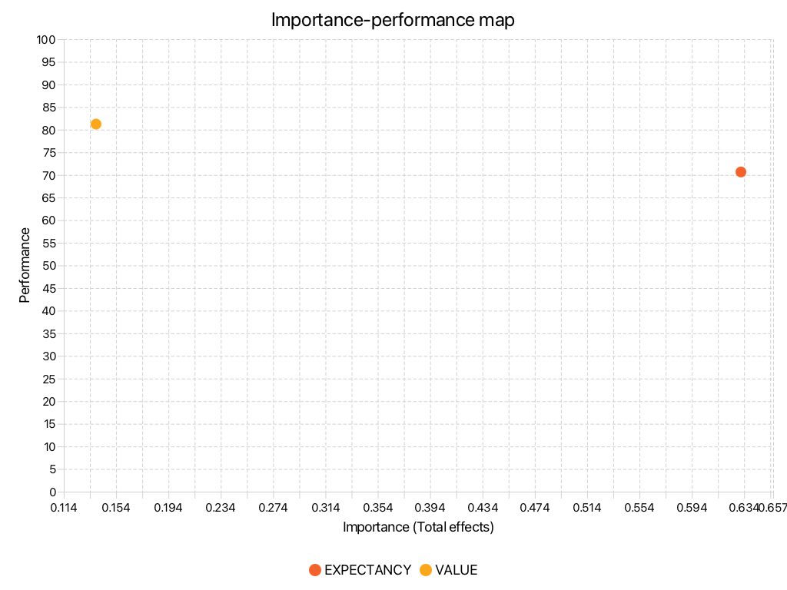

Figure 5 above shows the importance and performance analysis for Intrinsic Goal Orientation. When paired with Expectancy, there is High Importance/High Performance (Importance = 0.616; Performance = 70.658). When Intrinsic Goal Orientation is paired with Value, there is Low Importance/High Performance (Importance = 0.158; Performance = 80.773).

Figure 6- IPMA for Social Engagement

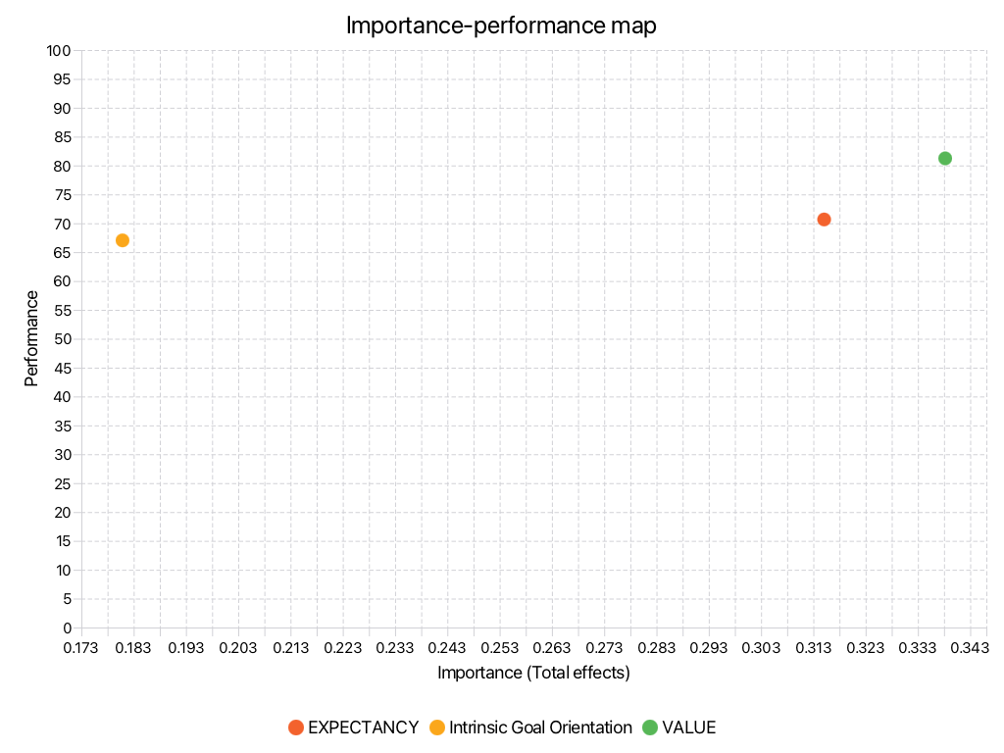

Figure 6 above shows the importance and performance analysis for Social Engagement. When paired with Expectancy, there is Moderate Importance/High Performance (Importance = 0.373; Performance = 70.658).
When Social Engagement is paired with Intrinsic Goal Orientation, there is Low Importance/High Performance (Importance = 0.17; Performance = 67.031).
When Social Engagement is paired with Value, there is Low Importance/High Performance (Importance = 0.158; Performance = 80.773).
Figure 7- IPMA for Instructor Support
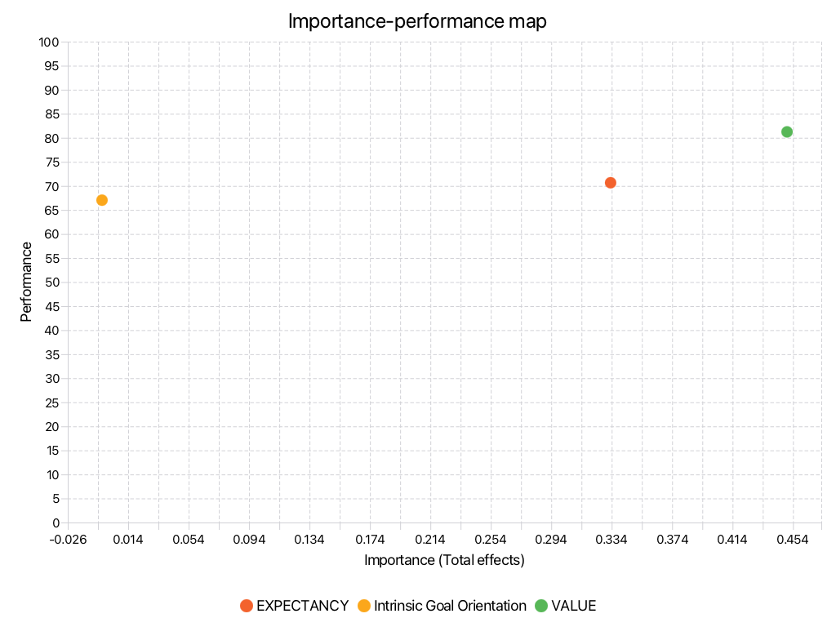

Figure 6 above shows the importance and performance analysis for Instructor Support. When paired with Expectancy, there is Low Importance/High Performance (Importance = 0.294; Performance = 70.658).
When Instructor Support is paired with Intrinsic Goal Orientation, there is Low Importance/Moderate Performance (Importance = -0.017; Performance = 67.031).
When Instructor Support is paired with Value, there is Moderate Importance/High Performance (Importance = 0.492; Performance = 80.773).

5.0 CONCLUSION
5.1 Summary of Findings and Discussions

Table 19- Outcome of Research Hypothesis
NO | Research Question | Research Hypothesis | Outcome
1 | Is there a significant relationship between Expectancy and Instructor Support? | Ho1; There is no significant relationship between Expectancy and Instructor Support | Reject null hypothesis  There is a relationship between Expectancy and Instructor Support.  Small effect
2 | Is there a significant relationship between Expectancy and Intrinsic Goal Orientation? | Ho2; There is no significant relationship between Expectancy and Intrinsic Goal Orientation | Reject null hypothesis  There is a relationship between Expectancy and Intrinsic Goal Orientation.  Large effect
3 | Is there a significant relationship between Expectancy and Social Engagement? | Ho3: There is no significant relationship between Expectancy and Social Engagement | Accept null hypothesis  There is a relationship between Expectancy and Social Engagement
4 | Is there a mediating effect of Intrinsic Goal Orientation on Instructor Support? | Ho4: There is no mediating effect of Intrinsic Goal Orientation on Instructor Support | Accept null hypothesis. There is no mediating effect of Intrinsic Goal Orientation on Instructor Support
5 | Is there a mediating effect of Intrinsic Goal Orientation on Social Engagement? | H_{o}5: There is no mediating effect of Intrinsic Goal Orientation on Social Engagement | Reject null hypothesis. There is a mediating effect of Intrinsic Goal Orientation on Social Engagement  Small effect
6 | Is there a significant relationship between Value and Instructor Support? | Ho6: There is no significant relationship between Value and Instructor Support | Reject null hypothesis. There is a significant relationship between Value and Instructor Support  Medium effect
7 | Is there a significant relationship between Value and Intrinsic Goal Orientation? | Ho7: There is no significant relationship between Value and Intrinsic Goal Orientation | Reject null hypothesis. There is a significant relationship between Value and Intrinsic Goal Orientation  Small effect
8 | Is there a significant relationship between Value and Social Engagement? | Ho8: There is no significant relationship between Value and Social Engagement | Reject null hypothesis. There is a significant relationship between Value and Social Engagement Value and Intrinsic Goal Orientation t  Small Effect

Table 19 above shows the presentation of the outcome of the research questions and hypotheses. The null hypothesis is accepted for the research hypotheses 3, and 4. There was no significant relationship between Expectancy and Social Engagement. There was no mediating effect of Intrinsic Goal Orientation on Instructor Support.
Nevertheless, there were significant relationships between Expectancy and Instructor Support, Expectancy and Intrinsic Goal Orientation, Value and Instructor Support, and Value and Intrinsic Goal Orientation. There was a small mediating effect of Intrinsic Goal Orientation on Social Engagement

5.2 Implications and Suggestions for Future Research
Figure 5 below presents the proposed model for fear of oral presentation from the perspectives of social cognitive theory. This study has shown that Intrinsic Goal Orientation only has a mediating effect on Social Engagement, but no mediating effect on Instructor Support.
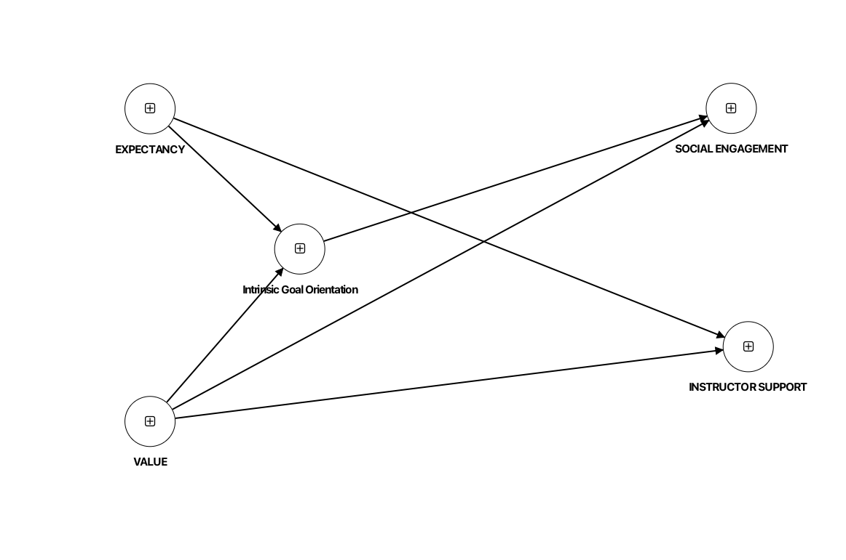
Figure 5- The Proposed Model- The Mediating Effect of Intrinsic Goal Orientation on Social Engagement
In conclusion, this study examined the mediating role of intrinsic goal orientation in the relationship between motivation and social support in online learning using PLS-SEM analysis. The findings revealed that expectancy and value significantly influenced intrinsic goal orientation, instructor support, and social engagement among online learners. Specifically, expectancy showed a strong relationship with intrinsic goal orientation, while value demonstrated significant relationships with instructor support and social engagement. The study also found that intrinsic goal orientation significantly mediated the relationship between motivation and social engagement, although it did not mediate the relationship between motivation and instructor support. These findings support the principles of Expectancy-Value Theory, Self-Determination Theory, and Social Presence Theory, highlighting that students who perceive online learning as meaningful and achievable are more likely to develop intrinsic motivation and actively engage in online learning activities. Furthermore, the study confirmed that social interaction and meaningful engagement are important outcomes of motivational processes in digital learning environments.
The implications of this study suggest that educators and institutions should design online learning environments that strengthen students’ expectancy beliefs, task value, and intrinsic goal orientation through supportive instructional practices and interactive learning activities. Instructors should provide timely feedback, meaningful tasks, and opportunities for collaboration to enhance students’ social engagement and motivation in online learning. The findings also contribute theoretically by extending previous motivational studies through the integration of expectancy-value, self-determination, and social presence perspectives within a single PLS-SEM framework. For future research, researchers may explore additional mediating or moderating variables such as self-regulation, digital literacy, or emotional engagement to gain deeper insights into online learning motivation. Future studies could also involve larger and more diverse samples across different educational settings and cultures to improve the generalizability of the findings and further validate the proposed model.

REFERENCES

Alshammari, S. H., & Alrashidi, O. (2026). The effects of informal digital learning, intrinsic motivation, and grit on online learning effort regulation and English achievement. Scientific Reports, 16(1), 13828. https://doi.org/10.1038/s41598-026-44548-8
Cohen, J. (1988). Statistical Power Analysis for the Behavioral Sciences (2nd ed). Lawrence Erlbaum Associates.
Fowler, S. (2018). The Motivation to learn online Questionnaire. Doctor of Philosophy Dissertation, University of Georgia.
Goodman, S. N. (1999). Toward evidence-based medical statistics:2 The Baye factor. Clinical Trials, 6(3), 229–240.
Hair, J. F. , Mathews, L. , M., Mathews, R. L., & Sarstedt, M. (2017). PLS-SEM or CB-SEM: updated guidelines on which method to use. International Journal of Multivariate Data Analysis, 1(2), 107–123.
Hauf, S. , R. N. F. , S. M. , R. C. M. (2024). The Importance and Performance in PLS-SEM. Journal of Retailing and Consumer Services, 78(2024)(100723).
Hauf, S., Rickter, N. F., & Ringle, C. M. (2024). The Importance of Performance in PLS-SEM. Journal of Retailing and Consumer Services, 78(2024).
Jing, Q. I., Mohammed, D., & Mai, Y. M. (2026). Motivation and Self-Regulation as Mediators between Learning Environment and Engagement in Online Learning among Chinese University Students. II(X), 4476–4485. https://doi.org/10.47772/IJRISS
Mendoza, N. B., Yan, Z., & King, R. B. (2023). Supporting students’ intrinsic motivation for online learning tasks: The effect of need-supportive task instructions on motivation, self-assessment, and task performance. Computers & Education, 193, 104663. https://doi.org/10.1016/j.compedu.2022.104663
Qiu, Y. (2025). Intrinsic and Extrinsic Motivation in Remote Learning. SHS Web of Conferences, 222, 04006. https://doi.org/10.1051/shsconf/202522204006
Ramayah, T., Cheah, F., Ting, H., & Memon, M. A. (2018). Partial Least Equation Structural Equation Modeling (PLS-SEM) using SEM 3.0: AN Updated Guide and Practical Guide to Statistical Analysis. Pearson.
Ringle, C. M. , S. M. (2016). Gain more insights from your PLS-SEM results: The Importance-performance map analysis. . Industrial Management & Data System, 116(9), 1865–1886.
Ringle, C. M., & Sarstedt, M. (2016). Using importance-performance matrix analysis (IPMA) in PLS-SEM: Using SmartPLS 3. . Journal of Business Research, 69(8), 3169–3177.
Teo, K. M., & Ho, S. T. (2024). Undergraduate students’ motivation toward online learning and intention to enrol in future online courses. Issues and Perspectives in Business and Social Sciences, 4(2), 143–153. https://doi.org/10.33093/ipbss.2024.4.2.3
Zhou, Z., & Zhang, Y. (2023). Intrinsic and Extrinsic Motivation in Distance Education: A Self-Determination Perspectives. American Journal of Distance Education, 38(1), 51–64.
Zhou, Z., & Zhang, Y. (2024). Intrinsic and Extrinsic Motivation in Distance Education: A Self-Determination Perspective. American Journal of Distance Education, 38(1), 51–64. https://doi.org/10.1080/08923647.2023.2177032
Ziegenfuss, J. Y. , C. A. E. , J. M. D. M. M. J. T. E. K. , M. C. (2021). Impact of Demographic Surevy Questions on Response Rate and Measurement: A Randomized Experiment:A Randomized Experiment. Survey Practice, 14(1).

.

APPENDIX
MOTIVATION TO LEARN ONLINE QUESTIONNAIRE
The instrument is adapted from Fowler (2018)
SECTION | VARIABLE  MOTIVATION | CONSTRUCT | NO OF ITEMS
B | EXPECTANCY | Self-Efficacy | 7 | 7
C |  | Intrinsic Goal Orientation | 4 | 4
D | VALUE | Extrinsic Goal Orientation | 4 | 10
 |  | Task Value | 6
D | SOCIAL SUPPORT | Social Engagement | 4 | 11
 |  | Instructor Support | 7
 |  |  |  | 32

SECTION B – EXPECTANCY(E)

- SELF- EFFICACY (ESE)

No | Statement | 1 | 2 | 3 | 4 | 5
1 | ESEQ 1 I believe I'll receive excellent grades in my classes.
2 | ESEQ2I'm certain I can understand the most difficult material presented in the readings.
3 | ESEQ3I'm confident I can learn the basic concepts that are being taught.
4 | ESEQ4I'm confident I can understand the most complex material presented by the instructor online.
5 | ESEQ5I'm confident I can do an excellent job on assessments online
6 | ESEQ6 I'm certain I can master the skills being taught online.
7 | ESEQ7 Although online classes can be challenging, I think I can do well.

SECTION C – VALUE (V)

- Intrinsic Goal Orientation (VI)
No | Statement | 1 | 2 | 3 | 4 | 5
1 | VIQ1I prefer online material that really challenges me, so I can learn new things.
2 | VIQ2I prefer online material that arouses my curiosity, even if it's difficult to learn.
3 | VIQ3The most satisfying thing for me is trying to understand the online content as thoroughly as possible.
4 | VIQ4I choose assignments that I can learn from even if they don't guarantee a good grade.

- Extrinsic Goal Orientation(VE)

No | Statement | 1 | 2 | 3 | 4 | 5
1 | VEQ1Getting a good grade is the most satisfying thing for me.
2 | VEQ2 I want to do well in my classes so that I can get awards and recognition.
3 | VEQ3I want to get better grades than most of the other students in my classes.
4 | VEQ4I want to do well in my classes because it's important to show my ability to my family, friends, employer, or others.

- Task Value (VT)

No | Statement | 1 | 2 | 3 | 4 | 5
1 | VTQ1I think I will be able to use what I learn in this course in other courses.
2 | VTQ2It is important for me to learn the course material in this class.
3 | VTQ3I am very interested in the content area of this course.
4 | VTQ4I think the course material in this class is useful for me to learn.
5 | VTQ5I like the subject matter of this course.
6 | VTQ6Understanding the subject matter of this course is very important to me.

SECTION D – SOCIAL SUPPORT (S)
- Social Engagemnt (SSE)

No | Statement | 1 | 2 | 3 | 4 | 5
2 | SSEQ2I pay attention in classes.
3 | SSEQ3I enjoy class discussions.
4 | SSEQ4I feel like I can freely communicate with other students in classes.
5 | SSEQ5I have strong relationships with fellow students in this course.

- Instructor Support (SIS)

No | Statement | 1 | 2 | 3 | 4 | 5
1 | SISQ1I feel like I can freely communicate with the instructor in this class.
2 | SISQ2The instructor responds to questions, clearly, completely, and in a timely manner.
3 | SISQ3The instructor’s expectations for me in this class are clear.
4 | SISQ4The instructor provides the guidance I need to be successful in this class.
5 | SISQ5The instructor presents the material in a way that makes it relevant to me.
6 | SISQ6In this course, I have the freedom to guide my own learning
7 | SISQ7The instructor provides regular feedback that helps me gauge my performance in this class.

