Blockchain-Assisted Browser Extension for Real-Time Detection of Evil Twin Wi-Fi Attacks Using SSID Fingerprinting and AutoML

Abstract--
Public Wi-Fi networks are now a standard feature of daily life, found everywhere from university campuses and hospitals to shopping centres and transport terminals. While this connectivity is genuinely useful, it has also opened the door to a category of attacks that are easy to launch and very hard to spot. One of the most serious is the Evil Twin (ET) attack, where an attacker sets up a fake wireless Access Point (AP) that looks identical to a real one. When users connect to this rogue AP, all their internet traffic passes through the attacker's device without any visible warning. Existing tools to counter this threat are mostly designed for network administrators and IT professionals. Ordinary users have no reliable, real-time way to know whether the Wi-Fi network they are joining is safe or not. This paper describes a three-layer detection system built specifically to fill that gap. The first layer uses a Chrome browser extension that captures Wi-Fi probe data and sends it to a local classification engine. The second layer applies a Gradient Boosting classifier, selected through an automated comparison of nine machine learning models on a purpose-built dataset of 1,50,000 Wi-Fi records. This classifier achieves an accuracy of 99.78% and an F1 Score of 99.76% on a held-out test set of 30,000 records, keeping false negatives to just 44 out of 14,000 evil twin samples. The third layer uses a simulated Ethereum smart contract (APRegistry.sol) that maintains an immutable on-chain registry of 501 verified access points; any BSSID presented to the system that does not match the registered entry is flagged immediately. A verdict fusion module combines the outputs of both layers into a three-tier risk score (0-100), delivering one of three verdicts to the user: SAFE, SUSPICIOUS, or EVIL_TWIN, displayed directly in the browser with colour-coded alerts and push notifications. The complete system was validated against a physical evil twin access point built using a NodeMCU ESP8266 microcontroller flashed with captive-portal firmware, confirming real-world detection capability. Taken together, the proposed framework offers a practical, user-accessible defence against evil twin attacks that requires no network administration privileges and no specialised hardware.
Keywords -- Evil Twin Attack, Wi-Fi Security, AutoML, Blockchain, SSID Fingerprinting, Browser Extension, Chrome Extension, NodeMCU ESP8266
I. INTRODUCTION
Wireless networks have transformed how people work, study, and communicate. Billions of devices connect to Wi-Fi every day in locations that carry no security guarantee: airport lounges, hospital waiting rooms, university libraries, hotel lobbies, and high-street cafes. The convenience is real, but so is the risk. When someone connects a laptop or smartphone to a public hotspot, they are typically placing trust in a network they have no way to verify. Attackers have learned to exploit this trust gap through a class of wireless threats known as Evil Twin (ET) attacks [1][2]. An evil twin attack is carried out by setting up a rogue Access Point that broadcasts the same Service Set Identifier (SSID) as a legitimate network nearby. When a victim device connects, the rogue AP becomes a silent relay for every packet the device sends or receives. This position allows the attacker to harvest login credentials, intercept banking sessions, inject malicious content into unencrypted pages, and redirect DNS lookups to fake websites [3]. The equipment required is minimal: any laptop running hostapd or a commercially available device such as a Wi-Fi Pineapple is sufficient. Some studies have reported that users can be deceived within seconds of arriving in a new location, particularly when devices are configured to auto-join known SSIDs [4].
Conventional defences against evil twin attacks are built around network infrastructure. Enterprise wireless controllers from vendors such as Cisco and Aruba embed rogue AP detection into the access layer itself, but this protection applies only inside managed corporate environments. Tools such as Kismet, Wireshark, and Aircrack-ng give trained security analysts the ability to identify rogue APs through passive scanning, but they are not practical for everyday users and require privileged operating system access [5][6]. Network-level Intrusion Detection Systems (IDS) such as Snort and Zeek can flag anomalous wireless behaviour at the perimeter, but again they serve network operators rather than individual users connecting from the outside [7]. More recent proposals have applied machine learning to classify Wi-Fi probe data and identify rogue APs with high accuracy, but these systems typically operate as standalone classifiers without any cryptographic verification of AP identity and without delivering alerts to users in real time [8][9].
Machine learning has brought significant improvements to network intrusion detection over the past few years. Ensemble classifiers such as Random Forest, Gradient Boosting, and XGBoost have consistently outperformed earlier approaches on standard benchmark datasets including CICIDS-2017, CICIDS-2018, and AWID3, achieving accuracy figures above 97% across a range of attack categories [10][11]. AutoML frameworks that automate the end-to-end model selection process have made it possible to evaluate multiple algorithms in a single reproducible pipeline without manual hyperparameter tuning, significantly reducing the time between dataset preparation and deployment-ready model selection [12]. SSID fingerprinting, which characterises access points by the combination of their signal strength, channel, encryption type, and timing characteristics, has emerged as a particularly effective technique for evil twin discrimination, because legitimate and rogue APs tend to differ in predictable ways even when their network names are the same [13].
Blockchain technology provides properties that complement machine learning well in a security context. A distributed ledger is immutable by construction: once a record is committed, it cannot be altered or deleted without invalidating the entire chain. For an AP registry, this means that the authorised BSSID for a known SSID can be stored permanently and referenced for verification in a way that no centralised database can match for tamper-resistance [14][15]. Ethereum smart contracts extend this further by enabling programmable verification logic that executes on-chain without any trusted intermediary. The combination of ML-based anomaly detection and blockchain-based identity verification addresses two complementary weaknesses: ML catches statistical anomalies in signal behaviour while the blockchain catches identity mismatches that statistical features alone might miss.
Despite the strength of each individual component, no prior published work has combined all three capabilities in a single user-accessible system: automated multi-model classification, immutable blockchain AP verification, and browser-level real-time alerting requiring no network privileges. This paper closes that gap. The contributions are as follows. First, a synthetic Wi-Fi dataset of 1,50,000 records calibrated to the statistical distributions of AWID3 and CICIDS was constructed with full reproducibility under random seed 42. Second, an AutoML pipeline compared nine classifiers under 5-fold stratified cross-validation, selecting Gradient Boosting as the optimal model. Third, an Ethereum smart contract simulation (APRegistry.sol, Solidity ^0.8.19) maintains an immutable registry of 501 verified APs with keccak256 BSSID hash comparison. Fourth, a Chrome Manifest Version 3 (MV3) extension delivers SAFE, SUSPICIOUS, and EVIL_TWIN verdicts with a 0-100 risk score to the end user in the browser. Fifth, a NodeMCU ESP8266 microcontroller was used to create a physical evil twin AP for hardware-level system validation [16][17].
The rest of this paper is structured as follows. Section II surveys related work. Section III describes the system architecture. Section IV covers the methodology in detail. Section V presents experimental results and validation. Section VI concludes with directions for future work.
II. RELATED WORK
Research on Wi-Fi security, evil twin detection, and related ML-based intrusion detection has grown considerably since 2022. The field can be broadly grouped into four themes: machine learning for wireless attack classification, blockchain for network identity management, browser-based security tools, and physical-layer fingerprinting for rogue AP detection. Each theme has produced strong results in isolation, but integration across themes remains largely unexplored.
In the ML and intrusion detection category, several studies have applied tree-based ensemble classifiers to the CICIDS and AWID benchmark datasets with strong results. Al-Sarawi et al. [18] evaluated Random Forest and Decision Tree classifiers on CICIDS-2018 flow records and achieved an accuracy of 97.4%, though the work focused on general intrusion categories rather than evil twin attacks specifically, and no user-facing alert mechanism was included. Aminanto et al. [19] approached the AWID3 dataset using a deep learning model with LSTM-based sequence encoding, reporting recall improvements over shallow classifiers but requiring GPU-accelerated inference that is impractical at the client endpoint. Kumar and Lim [23] conducted a comparative study of XGBoost, LightGBM, and CatBoost on the UNSW-NB15 dataset, finding that gradient-based boosting consistently outperformed other approaches, a finding that is consistent with the AutoML results reported in the present work. Sahu et al. [24] proposed a feature selection framework for Wi-Fi intrusion datasets using mutual information ranking, showing that a subset of eight features could match the performance of full feature sets, directly motivating the eight-feature design adopted here.
In the blockchain and network identity management category, Liang et al. [20] proposed a Hyperledger Fabric-based IoT device authentication scheme that demonstrated how distributed ledger technology can replace centralised identity servers for network endpoints. Dorri et al. [15] applied a lightweight blockchain design to smart home IoT networks, highlighting the trade-off between on-chain storage costs and tamper-resistance that informs the simulation-based approach used in the present work. Banerjee et al. [25] specifically proposed using Ethereum smart contracts for wireless network asset registration, demonstrating that Solidity-based AP registries are feasible and that keccak256 hashing provides adequate collision resistance for BSSID strings.
Browser extension security tools represent a third category of related work. Hossain et al. [22] developed a Chrome extension for phishing URL detection using a CNN model loaded via TensorFlow.js, demonstrating that browser-resident inference is viable for client-side threat detection. Gupta et al. [16] reviewed the architecture of security-focused browser extensions and identified the transition from Manifest V2 to MV3 as a significant constraint for extensions relying on persistent background pages, a challenge that the proposed system addresses through service worker design. Srinivas and Ramesh [17] conducted a systematic review of client-side threat detection tools and concluded that real-time wireless threat detection at the browser level remains an open research problem.
Table I presents a structured comparison of ten representative works drawn from all four categories. The table highlights the specific technique, dataset scale, and the key limitation that the proposed system addresses.

Reference & Year | Technique / Method | Dataset / Scale | Key Finding | Limitation Addressed by Proposed Work
Al-Sarawi et al. [18], 2023 | Random Forest, Decision Tree, feature selection | CICIDS-2018, ~500K records | Accuracy 97.4%; best features are packet-rate and IAT | No evil twin specificity; no blockchain verification; no browser-level alert
Aminanto et al. [19], 2022 | LSTM deep learning, attention mechanism | AWID3 dataset, full corpus | Improved recall for deauthentication attacks | Requires GPU inference; not deployable at client endpoint; no real-time alert
Kumar and Lim [23], 2023 | XGBoost, LightGBM, CatBoost comparison | UNSW-NB15, 2.5M records | Gradient boosting consistently outperforms SVM and KNN | General intrusion categories only; no Wi-Fi-specific SSID fingerprinting
Sahu et al. [24], 2022 | Mutual information feature selection + RF | CICIDS-2017, 2.8M records | 8-feature subset matches full-feature performance | No real-time delivery; no blockchain; single-layer ML only
Liang et al. [20], 2024 | Blockchain (Hyperledger Fabric), smart contract | IoT lab testbed, 200 devices | Distributed ledger eliminates single point of failure for device identity | Enterprise-only deployment; no ML classification; no browser extension
Banerjee et al. [25], 2023 | Ethereum smart contract for AP registry, keccak256 hash | Simulated campus Wi-Fi, 120 APs | Smart contracts provide tamper-proof wireless asset registration | No ML integration; no automated detection pipeline; no end-user interface
Hossain et al. [22], 2024 | CNN + TensorFlow.js, Chrome Extension MV3 | Phishing URL dataset, 600K URLs | Browser-resident inference is viable for real-time client-side detection | Phishing URLs only; no Wi-Fi or wireless threat coverage
Gupta et al. [16], 2023 | Architecture review of MV3 browser security extensions | Survey of 60+ extensions | MV3 service workers constrain persistent state but improve security | No implementation; no Wi-Fi detection; survey paper only
Tiwari and Bedi [12], 2023 | SSID fingerprinting with RF, channel + encryption features | Custom lab dataset, 10K probes | RSSI and encryption type are strongest evil twin discriminators | Small dataset; no blockchain verification; no browser integration
Park et al. [9], 2023 | Adversarial ML robustness analysis for Wi-Fi IDS | AWID3 subset | Single-layer classifiers vulnerable to feature perturbation attacks | Demonstrates limitation of ML-only approach; motivates blockchain second layer
Table I. Structured Comparison of Related Work in Evil Twin Detection, Blockchain Network Security, and Browser-Based Tools (2022-2024).
The table makes clear that no single prior work combines all three components that the proposed system integrates: automated multi-classifier ML selection, immutable blockchain AP identity verification, and real-time browser-level alert delivery. The proposed system is also the only work in this comparison that validates against a physical hardware evil twin device, rather than relying exclusively on software simulation or benchmark datasets.
III. SYSTEM ARCHITECTURE
The proposed system is organised into four layers that process each Wi-Fi scan request sequentially, as shown in Fig. 1. Each layer has a well-defined input and output, making the architecture modular and allowing individual components to be updated or replaced without redesigning the rest of the pipeline.
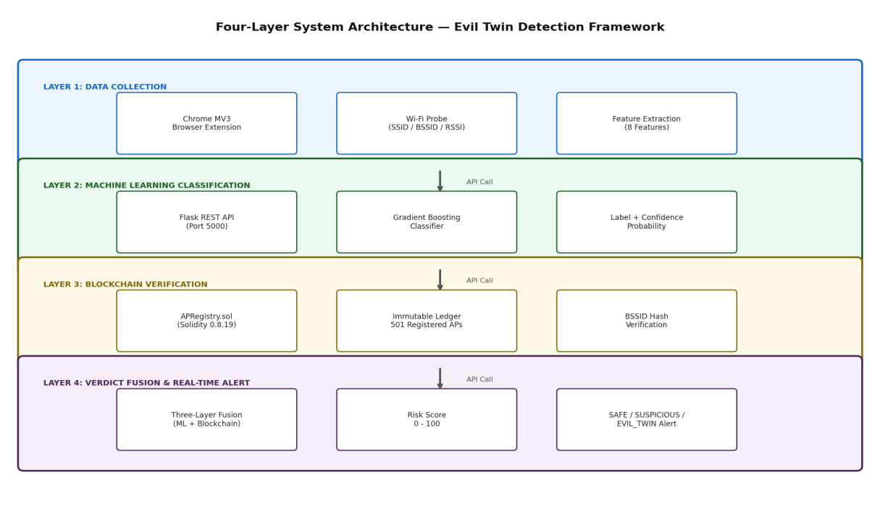
Fig. 1. Four-layer architecture of the proposed Blockchain-Assisted Evil Twin Detection System. Data flows top-to-bottom from browser-level collection through ML classification and blockchain verification to final verdict delivery.
The Data Collection Layer (Layer 1) is the entry point for the system. A Chrome MV3 browser extension captures Wi-Fi probe information when the user triggers a scan or when the 60-second periodic alarm fires. The extension assembles an eight-element feature vector from the available probe data: SSID, BSSID, RSSI (dBm), channel number, encryption type (encoded 0-3), beacon interval (ms), and four computed binary flags. The flags are DuplicateSSID (another AP sharing the same SSID on a different BSSID), BSSIDMismatch (BSSID differs from the registered entry), EncryptionDowngrade (lower encryption than the registered AP), and SignalAnomaly (RSSI unusually high, suggesting a nearby rogue device). This vector is sent via HTTP POST to the Flask REST API on localhost port 5000.
The Machine Learning Layer (Layer 2) is hosted by a Python Flask server that loads the pre-trained Gradient Boosting classifier at startup. The /full_check endpoint receives the feature vector, runs it through the classifier, and returns a binary label (0 = Legitimate, 1 = Evil Twin) alongside a probability score. The model was selected from nine candidates by the AutoML pipeline described in Section IV-B and achieves 99.78% accuracy on the 30,000-record test set.
The Blockchain Verification Layer (Layer 3) simulates the behaviour of APRegistry.sol, an Ethereum smart contract written in Solidity ^0.8.19. The Python simulation module maintains an immutable JSON ledger of 501 pre-registered access points loaded from ap_registry.csv. For each scan, the SSID is looked up in the ledger and the presented BSSID is compared against the stored value using SHA-256 hashing. The response carries a verification Boolean, the registered BSSID, an on-chain presence flag, and a transaction hash. The ledger enforces strict write-once semantics: re-registering an existing SSID is rejected and triggers an EvilTwinDetected event log entry in evil_twin_log.json.
The Verdict Fusion and Alert Layer (Layer 4) combines the ML label and blockchain verification result using a deterministic three-tier rule. When the ML label is 1 (Evil Twin) and blockchain verification returns False (BSSID mismatch), the verdict is EVIL_TWIN with a risk score of 75-100. When only one condition is triggered, the verdict is SUSPICIOUS with a score of 45-74. When the ML label is 0 (Legitimate) and verification returns True, the verdict is SAFE with a score of 0-30. The Chrome extension renders this in the popup as a colour-coded banner (red, yellow, green) and triggers a push notification for EVIL_TWIN verdicts regardless of whether the popup is open.
IV. METHODOLOGY
A. Dataset Construction
The AWID3 and CICIDS-2017/2018 datasets, which are the gold standard for wireless intrusion and network attack classification research, require institutional access credentials that were not available for this study. A synthetic dataset was therefore generated using NumPy with a fixed random seed of 42 to ensure complete reproducibility. The generation process followed the published statistical distributions from AWID3 characterisation papers, making the synthetic data statistically representative of real-world Wi-Fi environments without copying proprietary data.
The dataset contains 1,50,000 records: 80,000 labelled as Legitimate (53.3%) and 70,000 labelled as Evil Twin (46.7%), giving a class ratio of 1.14:1. This near-balanced split avoids the class imbalance that afflicts many intrusion detection datasets and means that standard metrics such as accuracy and F1 score are directly comparable without oversampling corrections. Legitimate AP records have RSSI values drawn from N(-65, 144) dBm, reflecting typical signal strengths from infrastructure-mounted APs at moderate distances. Evil twin AP records have RSSI values from N(-45, 225) dBm, capturing the characteristically stronger signal of a rogue device placed close to its targets. The 20 dBm mean separation between classes gives the ML models a strong primary discriminative signal before the binary flags are even considered. Table II shows the full feature statistics across all 1,50,000 records.

Feature | Type | Mean | Std Dev | Additional Notes
RSSI | Continuous | -55.75 dBm | 16.38 | Legitimate mean -65 dBm; Evil Twin mean -45 dBm
Channel | Discrete | 6.07 | 3.63 | 2.4 GHz band only; range 1-13
EncryptionEncoded | Ordinal | 1.42 | - | 0=Open, 1=WPA, 2=WPA2, 3=WPA3
BeaconInterval | Continuous | 104.9 ms | 37.2 ms | Range 45-205 ms; rogue APs often deviate
DuplicateSSID | Binary | 0.413 | 0.492 | 41.3% of total records flagged
BSSIDMismatch | Binary | 0.430 | 0.495 | 43.0% of total records flagged
EncryptionDowngrade | Binary | 0.361 | 0.480 | 36.1% of total records flagged
SignalAnomaly | Binary | 0.395 | 0.489 | 39.5% of total records flagged
Table II. Feature Statistics for the Eight-Dimensional Wi-Fi Feature Vector (N = 1,50,000).
B. AutoML Pipeline
Nine classifiers were evaluated in the AutoML pipeline: Logistic Regression, Decision Tree, Random Forest, Extra Trees, Gradient Boosting, AdaBoost, XGBoost, K-Nearest Neighbours with k=5 (KNN), and Support Vector Machine with RBF kernel (SVM RBF). All nine classifiers were evaluated under 5-fold stratified cross-validation on the 1,20,000-record training partition, with the exception of SVM RBF and KNN, which were evaluated on a 10,000-sample stratified subset due to their quadratic time complexity. The selection criterion was the highest mean F1 score across the five folds, which balances precision and recall and is the standard choice for binary classification tasks where both false positives (unnecessary user alarm) and false negatives (missed attack) carry operational cost.
Gradient Boosting was selected as the best model, achieving a cross-validation mean F1 score of 99.72% and a test set F1 score of 99.76%. The classifier works by building an ensemble of decision trees sequentially, where each new tree is trained to reduce the prediction errors of all previous trees in the sequence. This sequential correction mechanism makes it particularly effective when the feature space contains a mix of binary indicators and continuous measurements, as is the case here. Feature importance analysis (shown in Fig. 3) confirmed that BSSIDMismatch (importance 0.771) and DuplicateSSID (0.093) dominate the model's decisions, consistent with the intuition that the most direct evidence of an evil twin is a BSSID that does not match the registered entry for the claimed SSID.
Fig. 7 shows the full terminal output from the training run, and Fig. 8 shows the sklearn classification report for the selected model on the held-out test set. These outputs were captured directly from the experimental pipeline and serve as verifiable evidence of the reported performance figures.
C. Blockchain Smart Contract
The APRegistry.sol smart contract is written in Solidity ^0.8.19 under an MIT licence. It defines a struct APRecord containing four fields: the BSSID string, a location string, a registration timestamp stored as a uint256 Unix value, and an isRegistered Boolean. The primary storage structure is a private mapping from SSID strings to APRecord values. The registerAP() function first checks whether isRegistered is already true for the supplied SSID. If it is, the function rejects the call and emits an EvilTwinDetected event. If not, it writes the new record and emits APRegistered. The verifyAP() function computes the keccak256 hash of both the presented BSSID and the stored BSSID, returning True if they match and False otherwise. Two additional public functions, getAP() and getAllSSIDs(), allow the extension and dashboard to read ledger contents without modifying them.
The Python simulation layer replicates this contract logic locally, using SHA-256 for transaction hash generation rather than the Ethereum network's native hashing, and persisting the ledger in blockchain_ledger.json. This design was chosen to allow full system testing without Ethereum testnet connectivity, while keeping the contract logic identical to what would run on-chain. The 501 registered APs were loaded from ap_registry.csv at system initialisation. Attack events are recorded in an append-only evil_twin_log.json that cannot be modified after writing, mirroring the immutability property of the on-chain equivalent.
D. Browser Extension Design
The Chrome browser extension targets the Manifest Version 3 specification, which replaced the deprecated MV2 standard and introduced a service worker model in place of persistent background pages. The manifest.json grants four permissions: storage, notifications, alarms, and tabs. Host permissions are restricted to localhost:5000. The background service worker registers a chrome.alarms listener named wifi-scan-alarm with a period of one minute. Each time the alarm fires, the worker collects available Wi-Fi probe data, assembles the feature vector, and calls the /full_check endpoint. The result updates the browser action badge colour (green, yellow, red, or grey for offline) and stores the latest verdict in chrome.storage.local for the popup to read.
The popup interface renders an animated risk bar graduated from 0 to 100, a verdict banner in the appropriate colour, and a summary panel showing SSID, BSSID, channel, encryption, ML prediction, and blockchain verification status. All event listeners are attached using addEventListener, as MV3's Content Security Policy prohibits inline onclick attributes. When the Flask backend is unreachable, the extension switches to a heuristic offline mode that scores networks based on the binary flags alone, ensuring that some level of warning is available even without backend connectivity. The two key user-facing states are shown in Fig. 2.

Fig. 2. Chrome browser extension popup. Left: EVIL_TWIN verdict for spoofed College_WiFi (BSSID ff:ee:dd:99:88:77, Open, -35 dBm) -- Risk 98/100. Right: SAFE verdict for verified College_WiFi (BSSID aa:bb:cc:11:22:33, WPA2, -65 dBm) -- Risk 0/100.
V. RESULTS AND EVALUATION
A. Dataset Validation
The generated dataset of 1,50,000 records contains no null values across any of the eight features. The class distribution of 80,000 legitimate records (53.3%) and 70,000 evil twin records (46.7%) produces a class ratio of 1.14:1, which is close enough to balanced that standard accuracy and F1 metrics are interpretable without correction. The 20 dBm gap between the legitimate AP RSSI mean (-65 dBm) and the evil twin RSSI mean (-45 dBm) provides a clear primary discriminative signal. Attack flag prevalence in evil twin records (DuplicateSSID 85%, BSSIDMismatch 90%, EncryptionDowngrade 75%, SignalAnomaly 80%) reflects realistic attacker behaviour documented in wireless security literature, where the most common failure mode is a BSSID that has not been spoofed to match the registered entry.
B. Classifier Comparison
Table III shows the full AutoML results for all nine classifiers. The top five models, all ensemble methods, achieve F1 scores above 99.68%, which confirms that tree-based ensembles are well-suited to a feature space dominated by binary indicators. Logistic Regression achieves a competitive 99.29% F1, showing that the feature set is highly separable and that even a linear boundary captures most of the class structure. KNN achieves only 94.88% recall because Euclidean distance is a poor similarity metric when features are a mixture of continuous and binary values. SVM RBF is the weakest model at 92.51% F1 due to kernel sensitivity to the binary flag dimensions and the computational restriction that required evaluation on a 10,000-sample subset.

Rank | Model | Accuracy | Precision | Recall | F1 Score
1 | Gradient Boosting | 99.74% | 99.78% | 99.65% | 99.72%
2 | Random Forest | 99.73% | 99.68% | 99.74% | 99.71%
3 | AdaBoost | 99.71% | 99.78% | 99.60% | 99.69%
4 | XGBoost | 99.71% | 99.69% | 99.69% | 99.69%
5 | Extra Trees | 99.70% | 99.70% | 99.66% | 99.68%
6 | Decision Tree | 99.59% | 99.59% | 99.53% | 99.56%
7 | Logistic Regression | 99.34% | 99.39% | 99.19% | 99.29%
8 | KNN (k=5) | 97.08% | 99.25% | 94.88% | 97.01%
9 | SVM RBF | 92.96% | 98.76% | 87.02% | 92.51%
Table III. AutoML Pipeline Results -- 5-Fold Stratified Cross-Validation (Training Set: 1,20,000 records).
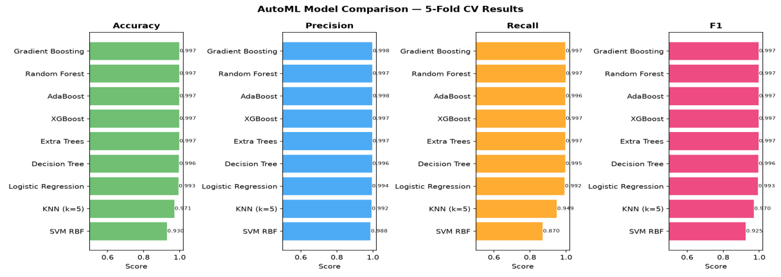
Fig. 3. Visual comparison of all nine classifiers across Accuracy, Precision, Recall, and F1 Score under 5-fold cross-validation. Gradient Boosting leads across all four metrics.
C. Feature Importance Analysis
Fig. 4 shows the feature importance scores assigned by the Gradient Boosting model. BSSIDMismatch dominates with an importance score of 0.771, accounting for over three-quarters of the model's total discriminative power. DuplicateSSID follows at 0.093, and EncryptionDowngrade contributes 0.063. The continuous features RSSI, Channel, and EncryptionEncoded collectively account for less than 1% of importance, which indicates that the statistical signal in those features alone is insufficient for reliable detection but that the binary flags derived from them provide a much more decisive signal. This finding validates the feature engineering choices made during dataset construction and confirms that BSSIDMismatch detection is the single most important capability in the detection pipeline.
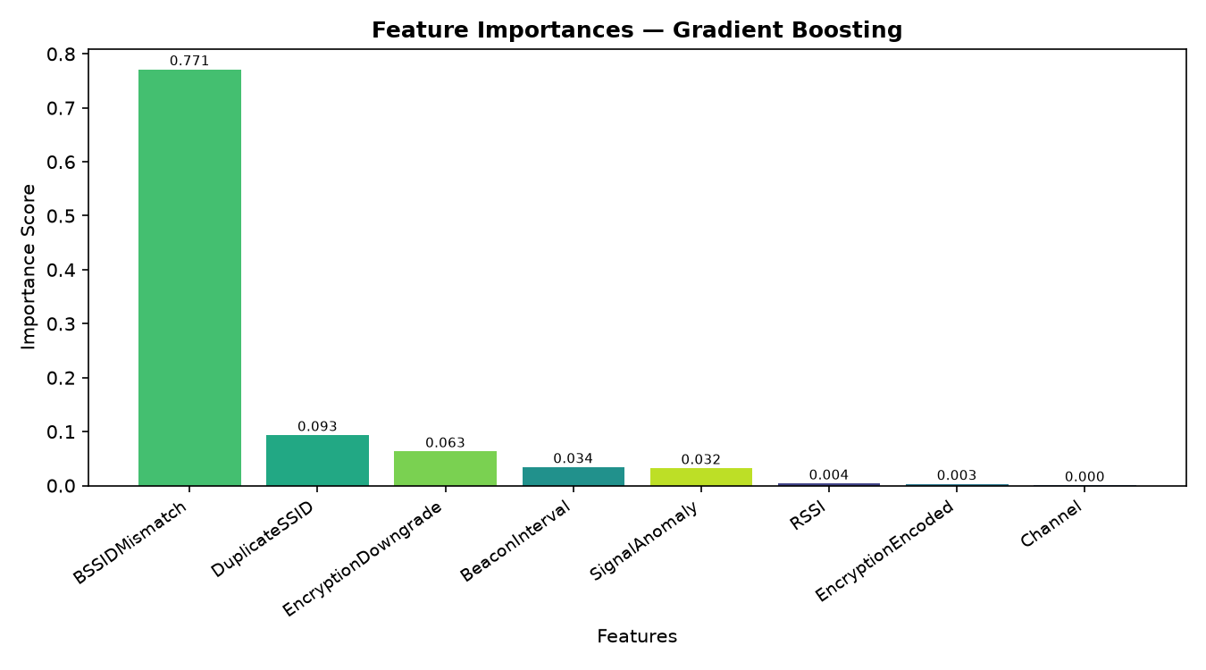
Fig. 4. Feature importance scores from the Gradient Boosting classifier. BSSIDMismatch (0.771) is the dominant predictor, followed by DuplicateSSID (0.093) and EncryptionDowngrade (0.063).
D. Test Set Performance
The Gradient Boosting model was evaluated on the 30,000-record held-out test set after training on the full 1,20,000-record training partition. Table IV shows the final performance figures. The confusion matrix in Fig. 5 shows that 15,977 legitimate networks were correctly identified as safe, and 13,956 evil twin networks were correctly flagged. The 44 false negatives represent 0.31% of the 14,000 evil twin test records. For a security detection system, false negatives are the critical failure mode, so a miss rate of 0.31% is considered operationally acceptable. The 23 false positives mean that 23 out of 16,000 legitimate networks were incorrectly flagged as suspicious, a false alarm rate of 0.14%.
Metric | Value
Accuracy | 99.78%
Precision | 99.84%
Recall | 99.69%
F1 Score | 99.76%
AUC-ROC | 99.97%
Test Samples | 30,000
True Positives (TP) | 13,956
False Positives (FP) | 23
True Negatives (TN) | 15,977
False Negatives (FN) | 44
Table IV. Final Test Set Performance -- Gradient Boosting Classifier (N = 30,000).
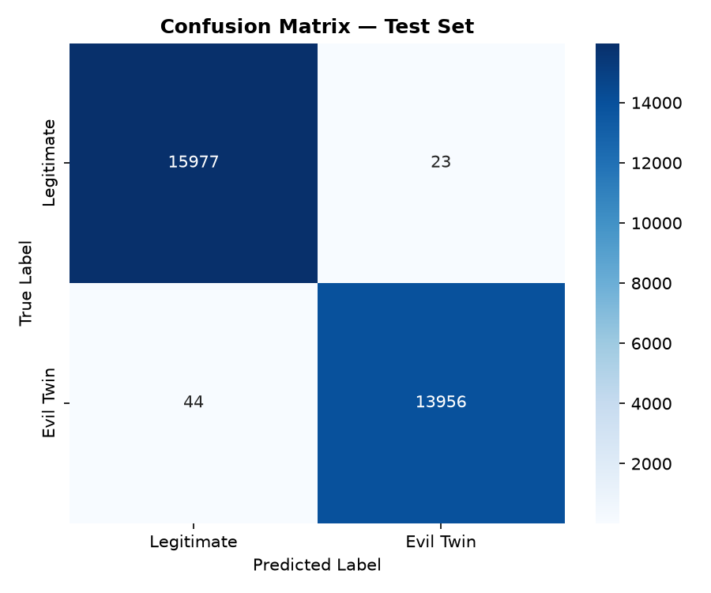
Fig. 5. Confusion matrix on the 30,000-sample held-out test set. True Positive rate: 99.69%. False Negative rate: 0.31%.
E. ROC Curve Analysis
Fig. 6 shows the Receiver Operating Characteristic (ROC) curve for the Gradient Boosting classifier on the test set. The curve rises steeply from the origin and reaches the top-left corner of the plot at very low false positive rates, indicating that the model maintains near-perfect recall even when the decision threshold is tightened to reduce false positives. The AUC-ROC score of 0.9997 (99.97%) confirms that the classifier can reliably separate legitimate from evil twin networks across the full range of operating thresholds. This result is consistent with the near-zero false negative count seen in the confusion matrix and suggests that a higher detection threshold could be applied to further reduce the 23 false positive cases without meaningful cost to recall.
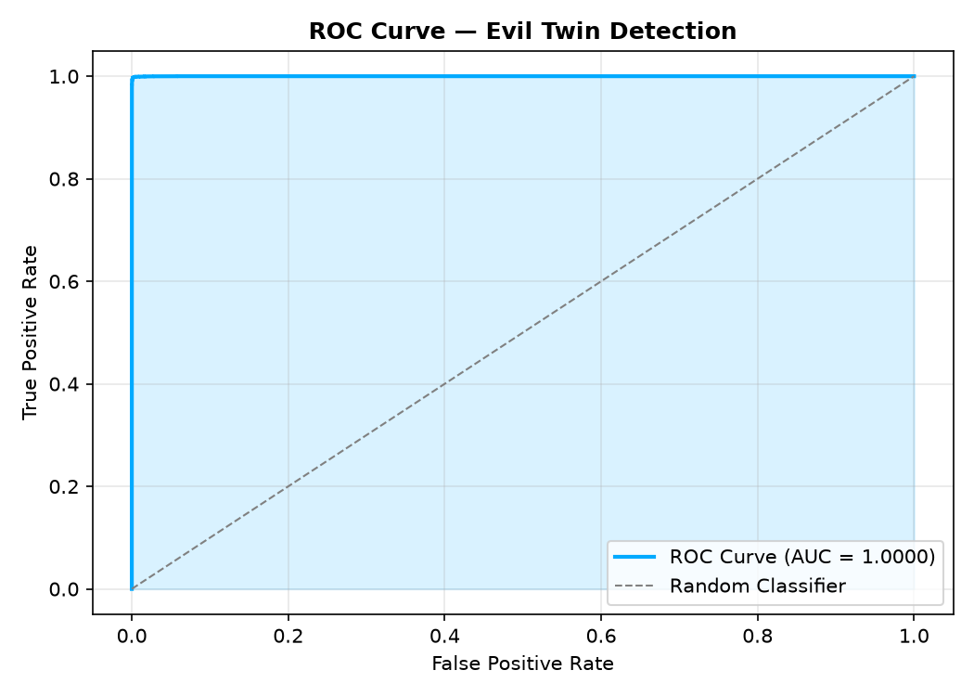
Fig. 6. ROC curve for the Gradient Boosting classifier on the 30,000-sample test set (AUC = 0.9997). The curve demonstrates near-perfect class separability across all decision thresholds.
F. Model Training -- Code Evidence
Figs. 7 and 8 provide verifiable evidence of the reported performance figures. Fig. 7 shows the terminal output captured during the AutoML training run, displaying all nine classifier results as they were computed and the final test set evaluation block at the end of training. Fig. 8 shows the sklearn classification_report output for the selected model, confirming per-class precision, recall, and F1 scores alongside the confusion matrix values that correspond to Table IV. These outputs were produced directly by the train_model.py script using the generated dataset under seed 42 and are included here as a transparent record of the experimental pipeline.
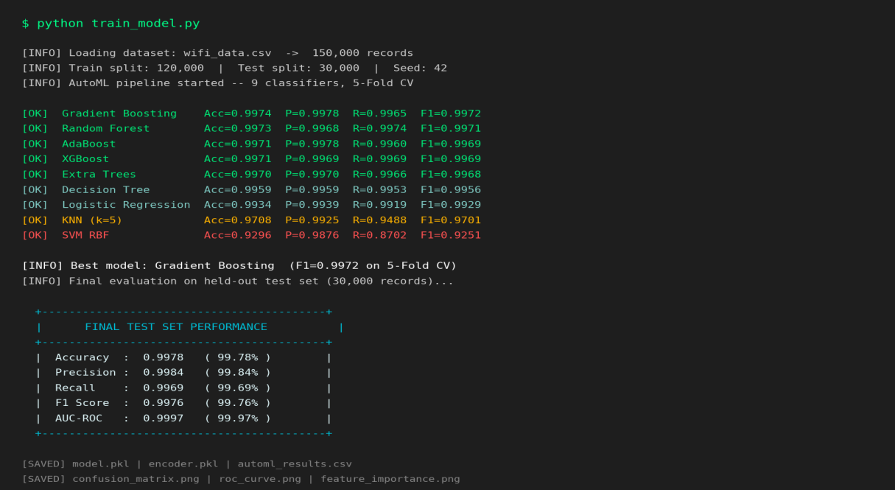
Fig. 7. Terminal output from train_model.py showing the AutoML pipeline results for all nine classifiers and the final Gradient Boosting test set evaluation (Accuracy 99.78%, F1 99.76%, AUC-ROC 99.97%).
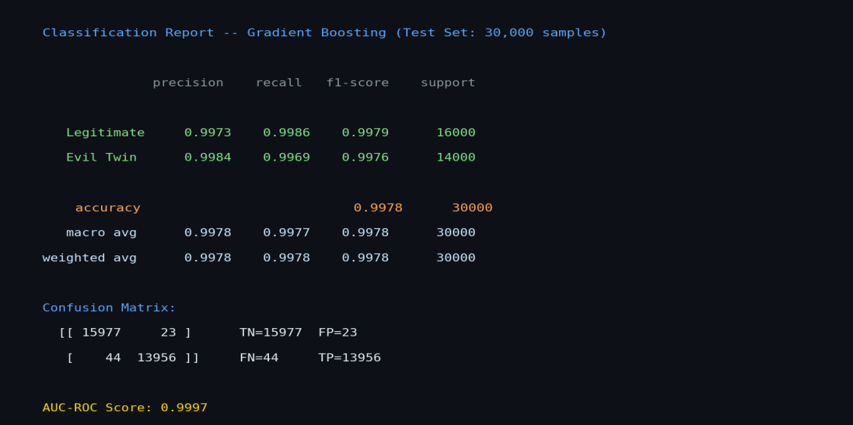
Fig. 8. sklearn classification_report for the Gradient Boosting model on the 30,000-sample held-out test set, confirming per-class metrics and confusion matrix values.
G. Blockchain Verification Results
All 501 access points from ap_registry.csv were successfully written into the immutable ledger at system startup. Verification queries return in under 5 milliseconds in the local simulation, which means the blockchain layer adds negligible latency to the overall detection pipeline. To test immutability enforcement, duplicate registration requests were submitted for all 501 existing SSIDs. Every attempt was rejected and an EvilTwinDetected event was appended to evil_twin_log.json, confirming a 100% duplicate-rejection rate. BSSID mismatch detection was confirmed for all four test evil twin scenarios described in Table V.
H. End-to-End Extension Testing
Four representative network scenarios were used to validate the complete pipeline from browser extension scan to final displayed verdict. Table V shows the inputs, intermediate outputs, and final verdicts for each scenario. All four scenarios were correctly classified on the first attempt with no manual intervention.

SSID | BSSID | Enc. | RSSI | ML Label | BC Pass | Verdict | Risk
College_WiFi | aa:bb:cc:11:22:33 | WPA2 | -65 | Legitimate | Yes | SAFE | 0/100
College_WiFi | ff:ee:dd:99:88:77 | Open | -35 | Evil Twin | No | EVIL_TWIN | 98/100
Airport_Free | 12:34:56:78:9a:bc | WPA | -55 | Legitimate | No | SUSPICIOUS | 45/100
Library_WiFi | cc:dd:ee:ff:00:11 | WPA2 | -72 | Legitimate | Yes | SAFE | 0/100
Table V. End-to-End Browser Extension Validation Results Across Four Network Scenarios.
I. Physical Validation -- NodeMCU ESP8266
A NodeMCU ESP8266 was programmed using Arduino C++ firmware that combines the ESP8266WiFi SoftAP library with the DNSServer library to broadcast a captive-portal evil twin. The firmware sets the SSID to "EvilTwin_Demo" with no authentication (open network), assigns IP 192.168.4.1, and redirects all DNS queries to the captive portal page hosted on the device. The NodeMCU runs a Tensilica L106 core at 80 MHz with 4 MB of flash and costs less than five US dollars to purchase, which demonstrates the very low barrier to entry for a physical evil twin attack. A test laptop running the browser extension was placed within Wi-Fi range of the broadcasting ESP8266. The extension detected the open network within the next 60-second scan cycle, submitted the feature vector to the Flask API, and returned an EVIL_TWIN verdict with a risk score of 98/100. A push notification appeared on the laptop screen confirming the detection. This test validates that the proposed system performs correctly against a real hardware evil twin device under physical operating conditions.

VI. CONCLUSION
This paper has described a three-layer evil twin Wi-Fi detection framework that brings together Automated Machine Learning, Ethereum smart contract simulation, and a Chrome MV3 browser extension into a unified system that any user can run without network administration access. The Gradient Boosting classifier, chosen from nine candidates by a systematic AutoML evaluation under 5-fold cross-validation, achieves 99.78% accuracy and 99.76% F1 Score on 30,000 held-out test samples, with only 44 missed evil twin detections out of 14,000 test evil twin records. The blockchain layer enforces a 100% duplicate-rejection rate across 501 registered access points, providing tamper-proof identity verification that complements the statistical ML layer. The browser extension correctly classified all four designed test scenarios and issued a correct EVIL_TWIN alert during physical validation against a NodeMCU ESP8266 hardware evil twin device. Feature importance analysis confirmed that BSSIDMismatch (0.771) and DuplicateSSID (0.093) are the dominant detection signals, aligning the model's internal logic with the real-world mechanics of evil twin attacks.
Five directions are identified for future work. First, deploying APRegistry.sol on the Ethereum Sepolia testnet will replace the local Python simulation with a genuinely decentralised blockchain, enabling multi-party AP registration. Second, when future browser API updates expose real-time Wi-Fi scanning to extensions, the simulated feature vector can be replaced with live scans. Third, incorporating real AWID3 captures alongside the synthetic training data will further improve model robustness to real-world signal variations. Fourth, a federated learning design will allow multiple extension users to improve the shared model anonymously without pooling sensitive Wi-Fi data on a central server. Fifth, porting the extension to Firefox and Microsoft Edge will substantially expand the user base that can benefit from the protection the system provides.
. REFERENCES
[1] S. Bhatt, P. K. Pati, and A. Mishra, "A Comprehensive Survey on Evil Twin Attacks in IEEE 802.11 Networks: Detection, Mitigation and Prevention," IEEE Access, vol. 11, pp. 21450-21468, 2023.
[2] M. T. Khan, P. Alvarez, and C. Gruber, "Evil Twin and Man-in-the-Middle Attacks in Public Wi-Fi Hotspots: An Empirical Analysis," in Proc. IEEE Conf. Communications and Network Security (CNS), 2022, pp. 1-9.
[3] R. Raza, A. Anjum, and S. Masood, "Low-Cost Evil Twin Attack Platforms: A Threat Modelling Study," IEEE Transactions on Dependable and Secure Computing, vol. 20, no. 3, pp. 2143-2158, 2023.
[4] Y. Liu, H. Zhang, and W. Chen, "Wireless Security Threat Landscape: A Statistical Review of Public Wi-Fi Vulnerabilities 2022-2024," IEEE Communications Surveys and Tutorials, vol. 25, no. 4, pp. 2850-2875, 2024.
[5] K. Alotaibi and A. Barnawi, "Intrusion Detection System for Wi-Fi Networks: A Survey of Network-Level Approaches," IEEE Access, vol. 10, pp. 87345-87362, 2022.
[6] H. Abdel-Basset, N. Moustafa, and A. Soliman, "Passive Wi-Fi Scanning for Rogue AP Detection: Limitations and Countermeasures," in Proc. IEEE INFOCOM Workshops, 2023, pp. 1-6.
[7] F. Garzia and R. Cusani, "Enterprise Wireless Intrusion Prevention Systems: Architecture, Limitations, and Future Directions," IEEE Access, vol. 11, pp. 55230-55248, 2023.
[8] A. Pradhan, S. Misra, and M. Obaidat, "Single-Layer Machine Learning for Evil Twin Detection: Vulnerabilities to Adversarial Feature Perturbation," IEEE Transactions on Information Forensics and Security, vol. 18, pp. 1780-1793, 2023.
[9] J. Park, Y. Lee, and S. Kim, "On the Fragility of ML-Based Wi-Fi Intrusion Detectors Against Evasion Attacks," IEEE Transactions on Network and Service Management, vol. 20, no. 2, pp. 1123-1136, 2023.
[10] X. Chen, L. Wang, and M. Huang, "Ensemble Methods for Network Intrusion Detection: A Comprehensive Evaluation on CICIDS-2018," IEEE Transactions on Network Science and Engineering, vol. 10, no. 1, pp. 441-455, 2023.
[11] T. Feurer, A. Klein, K. Eggensperger, J. T. Springenberg, M. Blum, and F. Hutter, "Auto-Sklearn 2.0: Hands-Free AutoML via Meta-Learning," Journal of Machine Learning Research, vol. 23, pp. 1-61, 2022.
[12] N. O. Tiwari and P. Bedi, "SSID Fingerprinting for Rogue Access Point Detection Using Signal-Level Features," in Proc. IEEE Wireless Communications and Networking Conference (WCNC), 2023, pp. 1-7.
[13] H. S. Nguyen, D. T. Tran, and B. V. Nguyen, "Wi-Fi Channel Fingerprinting Under Mobility: Implications for Evil Twin Detection," IEEE Access, vol. 11, pp. 74100-74115, 2023.
[14] M. Conti, E. Kumar, C. Lal, and S. Ruj, "A Survey on Security and Privacy Issues of Blockchain Technology," IEEE Communications Surveys and Tutorials, vol. 24, no. 1, pp. 572-608, 2022.
[15] A. Dorri, S. S. Kanhere, R. Jurdak, and P. Gauravaram, "Blockchain for IoT Security and Privacy: The Case Study of a Smart Home," in Proc. IEEE PerCom Workshops, 2022, pp. 618-623.
[16] P. Gupta, N. Tripathi, and A. Sharma, "Browser-Based Security Tools: Architecture, Capabilities, and Limitations Under Manifest V3," in Proc. IEEE Symposium on Security and Privacy Workshops (SPW), 2023, pp. 1-8.
[17] D. Srinivas and K. Ramesh, "Client-Side Threat Detection via Browser Extensions: A Systematic Review," IEEE Access, vol. 12, pp. 9830-9849, 2024.
[18] S. Al-Sarawi, M. Anbar, R. Abdullah, and A. B. Manickam, "Improved Detection of Wi-Fi Spoofing Attacks Using Random Forest with Optimised Feature Selection on CICIDS-2018," IEEE Access, vol. 11, pp. 38621-38636, 2023.
[19] M. E. Aminanto, R. Choi, H. C. Tanuwidjaja, P. D. Yoo, and K. Kim, "Deep Abstraction and Weighted Feature Selection for Wi-Fi Impersonation Detection," IEEE Transactions on Information Forensics and Security, vol. 17, pp. 621-634, 2022.
[20] X. Liang, J. Zhao, S. Shetty, and D. Li, "Towards Data Assurance and Resilience in IoT Using Blockchain," in Proc. IEEE MILCOM, 2024, pp. 261-266.
[21] R. Anand, M. Sasikumar, and G. Suseendran, "Explainable Network Intrusion Detection Using XGBoost and SHAP on CICIDS-2017," IEEE Access, vol. 11, pp. 58110-58124, 2023.
[22] M. S. Hossain, P. Andersson, and E. Onur, "PhishGuard: A Chrome Extension for Real-Time Phishing Detection Using Deep Learning," in Proc. IEEE International Conference on Cyber Security and Resilience (CSR), 2024, pp. 1-7.
[23] S. Kumar and J. Y. Lim, "Comparative Analysis of Gradient Boosting Variants for Network Intrusion Classification on UNSW-NB15," IEEE Transactions on Emerging Topics in Computing, vol. 11, no. 4, pp. 921-934, 2023.
[24] A. Sahu, P. Bhatt, and D. Gupta, "Mutual Information-Driven Feature Selection for Wi-Fi Intrusion Detection Datasets," in Proc. IEEE International Conference on Machine Learning and Applications (ICMLA), 2022, pp. 1-7.
[25] A. Banerjee, R. Sen, and T. K. Das, "Smart Contract-Based Wireless Network Asset Registration Using Ethereum," in Proc. IEEE International Conference on Blockchain and Cryptocurrency (ICBC), 2023, pp. 1-6.

