BEYOND TRADITIONAL POLICING: COMMUNITY RESIDENTS’ PERSPECTIVES ON THE SMART POLICING STRATEGIES OF THE PHILIPPINE NATIONAL POLICE

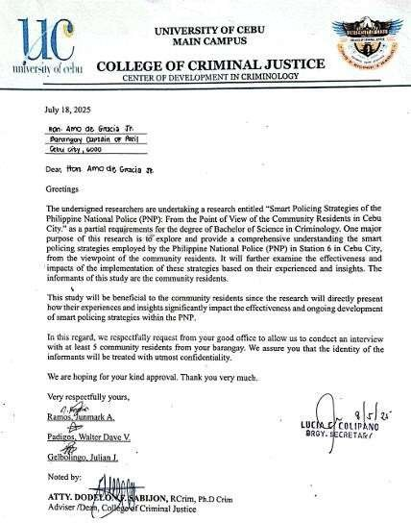

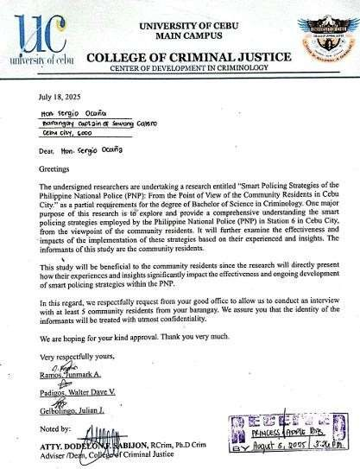

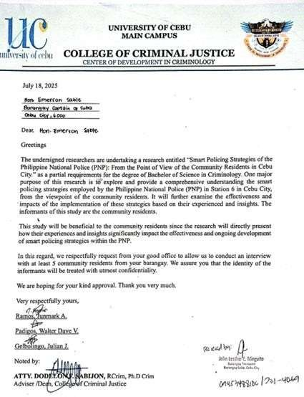

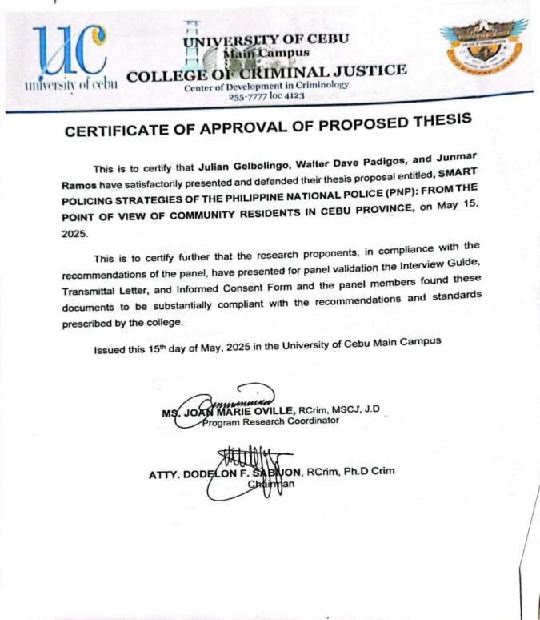



Introduction

The researchers are from the University of Cebu –Main Campus presently enrolled in Bachelor of Science in Criminology and conducting qualitative research entitled

SMART POLICING STRATEGIES OF THE PHILIPPINE NATIONAL POLICE (PNP): FROM THE POINT OF VIEW OF THE

COMMUNITY RESIDENTS IN CEBU CITY. The researcher is asking for your permission and invites you to be part of this research. You do not have to decide today whether or not you will participate in this research. Before you decide, you can talk to anyone you feel comfortable with about the research. This consent form may contain words that you do not understand. Please ask me to stop as we go through the information, and I will take the time to explain. If you have questions later, you can ask contact and ask me.

Purpose of the research

One key goal of research concerning smart policing is to assess and enhance the efficiency of police methods. Recently, the PNP has integrated various innovations, including data analysis and crime mapping, to foresee and avert criminal activities. Research focused on these methods facilitates an evaluation of their influence on crime statistics and the level of trust within the community.

Type of Research Intervention

Smart policing in the Philippines, especially within the Philippine National Police (PNP), aims to utilize data and technology to enhance crime prevention and ensure community safety. Research activities are vital in developing effective smart policing methods. Community-based participatory research (CBPR) represents an essential type of research engagement from the viewpoint of residents in Cebu City.

Community-based participatory research focuses on engaging community members throughout the entire research process, including problem identification, solution implementation, and evaluation. This method guarantees that policing tactics are informed by data while also being tailored to meet the particular needs of the community. In Cebu City, these interventions might include surveys, focus group discussions, and public gatherings to capture feedback from residents regarding crime trends, feelings of safety, and their experiences with local policing. For instance, a Community-based participatory research initiative could examine the effects of heightened police presence in specific areas. Researchers might collaborate with community members to gather information on crime statistics, residents’

sense of safety, and their views on police effectiveness both before and after the implementation of increased patrols. This information could help adjust patrol strategies, ensuring they are efficient and aligned with what the community requires. Another possible focus for research initiatives is the creation of community-oriented policing programs. Using Community-based participatory research, it could be possible to pinpoint particular challenges that affect the relationship between law enforcement and the community, including distrust or poor communication. Joint projects could then be designed based on these insights to promote understanding and collaboration, such as community discussions, youth mentoring programs, or collaborative problem-solving meetings.

Participant selection

The researchers are inviting community residents of Barangay Pasil, Barangay Suba and some portions of Barangay Sawang Calero from Cebu City to participate this study.

Voluntary Participation

Your participation in this research is entirely voluntary. You also have the right and the freedom to change your decision later and to stop participating even if you agreed earlier and this will not be taken against you. And if you agree to participate that will be my gratitude.

Procedures and Protocol

In this investigation, you will be asked to answer the questions during the individual in-depth interview to be conducted by the field interviewers during your free and convenient time. The questions in the interview guide will be read aloud by the interviewer and you can answer those items that you like to answer. Furthermore, there will be follow-up questions to be asked if necessary. If you wish not to answer some of the questions, you can tell the interviewer to skip them and move on to the next question. The information recorded is confidential and no one else except the field interviewers and researchers will have access to a copy of the transcript and audio recording, which will be destroyed after 6 months.

To ensure that you will be able to have a full understanding of the purpose of the study, the proponent will first explain the objectives of the study and the intended benefits of participating in this investigation.

Duration

The duration of the research is three (3) months. During the data collection phase, the field interviewers will request fifteen (15) informants for an appointment for an individual in-depth interview at your convenient time and place. The interview will last for forty (40) minutes to one (1) hour. Your engagement as a participant will only take place once.

Risks

During the individual in-depth interview, the field interviewers will ask you about Smart Policing Strategies Of The Philippine National Police (PNP): From The Point Of View Of The Community Residents In Cebu City. You will not be forced nor required to answer all questions that will be asked. If you do not want to answer some of the items because you are not comfortable with them your decision will be respected and you do not have to give reasons for not responding, or for refusing to take part in the interview. Furthermore, be assured that the responses that you will provide will not be shared.

Benefits

There will be no immediate and direct benefits to you for participating in this research However, your response to this research will greatly help the researcher, to contribution to public safety and community empowerment of the Smart Policing Strategies Of The Philippine National Police (PNP): From The Point Of View Of The Community Residents In Cebu City. This could provide enhanced public safety with technology integration in the Philippines.

Reimbursements

You will not be provided with any payment or monetary remuneration if you take part in this research.

Confidentiality

All the data and responses that you will provide in this investigation will not be shared with other people and will be kept confidential. Your information and other information collected from this research will be put away and no one, except the field interviewers and the researchers will be able to have access to it. Any information about you will have a number/code on it instead of your name. Only the field interviewers/researchers will know your number/code. All the documents related to this investigation will be placed in the cabinet with a lock and key and will not be shared with or given to anyone except the research proponents. All related documents regarding the research will be kept in UC main research office and only the research director has the key or access to all of the files. After the research is completed/published, it will be destroyed after six (6) months.

Sharing the Results

At the end of the study, I will be sharing the results with the academic community. Be assured that your answers during the individual in-depth interview will be shared with anybody.
The results will also be presented in a research conference/colloquium and will be published so that other interested people may learn from this research.

All records will be kept confidential. All the names of the informants will not be divulged. Furthermore, as an informant, you may also share the results and a copy of the report will be provided by the researcher. If you have a plan to do so, please include the timeline and reason for sharing the information, including the details.

Right to Refuse or Withdraw

You may choose not to participate in this study. It is also of primordial importance that you must know that you may stop participating in the individual in-depth interview at any time.

Who to Contact

If you have any questions, you can ask them now. You can also ask questions even after the study has started. If you wish to ask questions later, you may contact any of the following:

Junmark A. Ramos – 09222144533 junmarkramos1129@gmail.com
Walter Dave V. Padigos - 09701725988 walterdavepadigos88@gmail.com Julian J. Gelbolngo – 09701222559 gelbolingojulian2003@gmail.com
Atty. Dodelon Sabijon Ph.D. Crim – email add: delonucgs@gmail.com Dr. Renato Sagayno – 09212297427 – UC Main Research Director Dr. Juanito N. Zuasula Jr., MD – 233-5503 (UC CAREC)

This research project has been reviewed and scrutinized by the technical panel of the University of Cebu-Main Campus and the UC research office. If you have any questions, please contact the University of Cebu at 032-255-7777.

PART II: Certificate of Consent
I have read the foregoing information, or it has been read to me. I've had the opportunity to ask questions about it, and any inquiries I've asked have been addressed satisfactorily. I consent voluntarily to participate in this research.
Print Name of Participant Signature of Participant Date
Day/Month/Year If Illiterate
A literate witness must sign (if possible, this person should be selected by the participant and should have no connection to the research team). Illiterate participants should include their thumbprints as well.

I have witnessed the accurate reading of the consent form to the potential participant, and the individual has had the opportunity to ask questions. I confirm that the individual has given consent freely.


Print Name of Witness AND Thumb Print of the Participant Signature of Witness
Date Day/Month/Year

Statement by the researcher/person taking consent.

I have accurately read out the information sheet to the potential participant, and to the best of my ability made sure that the participant understands that the following will be done:
- individual in-depth interview
- record the proceeding of the interview
- manually record other responses/ answers during the interview

I confirm that the participant was allowed to ask questions about the study, and all the questions asked by the participant have been answered correctly and to the best of my ability. I confirm that the individual has not been coerced into giving consent, and the consent has been given freely and voluntarily.

A copy of this ICF has been provided to the participant. Print Name of Researcher/Person Taking the Consent: Signature of Researcher /Person Taking the Consent: Date
Day/Month/Year

APPENDIX C INFORMED CONSENT FORM

University of Cebu Research Office
(032) 255 – 7777 local 183

Informed Consent for the Study on SMART POLICING STRATEGIES OF THE PHILIPPINE NATIONAL POLICE (PNP): FROM THE POINT OF VIEW OF THE COMMUNITY RESIDENTS IN CEBU CITY.

Name of Principal Investigator: Junmark A. Ramos, Walter Dave V.

Padigos, Julian J. Gelbolingo
Name of Organization : University of Cebu – MAIN

Name of Proposal : SMART POLICING STRATEGIES OF THE PHILIPPINE NATIONAL POLICE (PNP): FROM THE POINT OF VIEW OF THE COMMUNITY RESIDENTS IN CEBU CITY.

This Informed Consent Form has two parts:

- Information Sheet (to share information about the research with you)

Certificate of Consent (for signatures if you agree to take part) You will be given a copy of the full Informed Consent Form PART 1: Information Sheet
Introduction
Ang mga nagtuon gikan sa University of Cebu – Main Campus og kasamtangang naenroll sa Bachelor of Science in Criminology and conducting qualitative research entitle SMART POLICING STRATEGIES OF THE PHILIPPINE NATIONAL POLICE (PNP): FROM THE POINT OF VIEW OF THE COMMUNITY RESIDENTS
IN CEBU CITY. Ang nagtuon nangayo sa imong pagtugot og giimbitar ka

nga mahimong parte ani nga pagtuon. Dili ka kinahanglan mudesidir karon kung ganahan ba ka or dili nga muapil aning pagtuon. Usa ka mudesidir, pwede ka makaistorya sa bisan kinsa nga paminaw nimo komportable ka kabahin sa pagtuon.
Kini nga consent form adunay mga pulong nga wala nimo nasabtan. Palihog pangotana nako aron muhunong ta samtang atong tarongon ang impormasyon, og gamiton nako ang takna aron sa pagpasabot. Og naa kay pangotana unya, pwede ko nimo kontakon og mangotana.

Purpose of the research

Kining pagtuon nagtinguha sa pagsusi ug paghatag og lawom nga pagsabot sa mga pamaagi sa “smart policing” nga gigamit sa Philippine National Police (PNP) Station 6 sa Cebu City, gikan sa panan-aw sa mga munulupyo sa barangay pasil, barangay suba og ubang bahin sa barangay sawang calero. Dugang pa, susihon niini ang kaepektibo ug mga epekto sa pagpatuman niining mga pamaagi base sa ilang mga kasinatian ug mga panabot.

Type of Research Intervention
Kini nga pagtuon naglakip sa kinse ka mga informante, lima kanila mahiubos sa barangay officials samtang ang laing lima mo paubos sa gitawag nga negosyante og ang nahibiling lima mupaubos sa gi tawag nga professional. Pagahimoon pinaagi sa face- to-face apan depende sa protocol nga itakna sa gobyerno, ang nagtuon naay opsyon nga mugamit og online nga plataporma sama sa Zoom, Google Meet, or Video Call nga mulungtad sa kwarenta minutos hantod usa ka oras. Aron matago ang identity sa mga informante, ang nagtuon mugamit og voice recording, og kung ang gigamit kay online nga plataporma, pwede nila palongon ang ilang bidyo usa magsugod ang interbyu.

Participant selection
Ako nag imbitar og kinse ka munulupyo gikan sa barangay pasil, suba og gamay nga dapit sa sawang calero, para mo participate ani nga pagtuon.

Voluntary Participation

Ang imong partisipasyon ani nga pagtuon kay entaryong boluntaryo. Naa sad kay katungod og kagawasan nga usbon ang imong desisyon unya og muhunong bisan pa og niuyon ka nga muapil kaganiha og dili kini gamiton kontra nimo. Og kung ikaw muoyon sa paagi niining maong pagtuon kana akong dakong pasalamatan.

Procedures and Protocol
Sa kini nga imbestigasyon, ikaw agdahon sa pagtubag sa mga pangotana inig binagsa na interbyu nga pagabuhaton sa field interviewers sa imong bakante og komportable nga oras. Ang mga pangotana sa interbyu guide kay basahon og kusog sa interbyuwer og pwede nimo matubag ang mga items nga ganahan nimo tubagon. Kung dili nimo gusto nga tubagon ang bisan unsang mga pangutana sa panahon sa interbyu, mahimo nimong isulti ug ang tig-interbyu nga mopadayon sa sunod nga pangutana. Ang impormasyon nga narekord kay konfidensyal, ug walay lain nga maka-access sa impormasyon kundi ang mga field interbyuwers og ang nagtuon lamang. Ang kopya sa transcript og audio recording gub-on human sa unom ka bulan.
Aron masiguro nga makakuha og puno nga pagsabot sa hinungdan ani nga pagtuon, ang nagtuon magpasabot usa sa mga tumong sa pagtuon og ang intended nga benepisyo apil ani nga imbestigasyon.

Duration

Kini nga pagtuon mukabat og tulo ka bulan. Diha sa bahin sa pagkuha sa mga datos, ang mga field interbyuwers murequest og kinse ka informante para sa ipaagi sa individual in dept-interview sa inyong takna og lugar nga gusto. Ang interbyu mulungtad og kwarenta minutos hantod sa usa ka oras. Ang imong pag apil isip partisipante mahitabo lang sa usa ka higayon.

Risks
Ang mga tig interview mangutana sila bahin sa smart policing
strategies sa Philippine National Police didto sa munulupyo sa barangay pasil, barangay suba og ubang bahin sa barangay sawang calero, sa ilang mga pag tan-aw ani. Dili ka pugson ug dili pod ka agdahon nga tubagon ang tanang ipangutana. Kon dili ka ganahan motubag sa uban nga mga pangutana tungod kay dili ka komportable, ang imong desisyon pagasabton ug dili ka kinahanglan maghatag og rason sa imong pagdumili o pagtanggi nga moapil sa interbyu. Labaw pa, makasalig ka nga ang imong mga tubag nga ihatag dili ipanghatag sa uban.

Benefits

Ang mga interbyu mangutana bahin sa mga estratehiya nga Smart Policing sa Philippine National Police (PNP): Gikan sa punto sa mga Personahe sa kini nga butang. Dili ka mapugos sa pagtubag sa bisan unsang mga pangutana nga dili ka komportable, ug ang imong desisyon nga dili motubag sa pipila ka mga pangutana nga tahuron.

Reimbursements

Dili ka matagaan og bisan unsa nga bayad o ganti nga kwarta kung ikaw mahimong parte ani nga pagtuon.

Confidentiality
Ang tanang datos og mga tubag nga imong ipagawas ani nga imbestigasyon dili ihatag sa laing tawo og magpabilin nga konfidensyal. Ang imong impormasyon og lain pang impormasyon nga makuha ani nga pagtuon kay tagoan og walay bisan usa kundi ang filed interbyuwers og ang nagtuon lamang ang makalantaw niini. Ang mga impormasyon kabahin nimo anaay numero o code og dili ang imong ngalan. Ang reseracher lamang ang makabalo sa imong number o code. Ang tanang dokumento

subay ani nga imbestigasyon ibutang sa kabinet nga naay lock og yawi og dili kini ihatag o ipakatap kundi sa nagtuon laman. Ang mga dokumento nga susama sa gitun- an kay tagoan sa UC main research office og ang research director lamang ang naay yawi og access sa tanang files. Inig human sa pagtuon, kini gub-on human sa unom ka bulan.

Sharing the Results

Inig human sa pagtuon, ako ipakita ang resulta sa academic community.
Makasalig ka nga ang imong mga tubag sa interbyu ipakita sa uban.

Ang mga resulta ipresentar usab sa usa ka research conference o colloquium og ipublish aron ang mga tawo nga naay interest makat-on kabahin ani nga pagtuon.

Ang tanang record konfidensyal. Ang tanang mga ngalan dili ipagawas. Labaw pa, isip informante, pwede pod nimo iapod apod ang resulta og kopya sa report nga ihatag sa nagtuon. Kung naa kay plano nga buhaton kini, palihog og apil sa timeline og rason sa pag apod apod sa impormasyon, lakip na ang mga detalye.

Right to Refuse or Withdraw

Mamahimo ka nga muapil o dili ani nga pagtuon. Kini pod usa ka nag unang importansya nga ikaw dapat makabalo nga mamahimo kang dili muapil sa interbyu sa bisan unsang taknaa.

Who to Contact

Kung ikaw naay mga pangotana, pwede naka mangotana karon dayun. Pwede pod ka mangotana misig nahuman na pagsugod sa pagtuon. Kung ikaw gusto mangotana taod taod, pwede nimo kontakon ang mga musunod:

Junmark A. Ramos – 09222144533 junmarkramos@gmail.com Walter Dave V. Padigos - 09701725988 walterdavepadigos88@gmail.com Julian J. Gelbolngo – 09701222559 gelbolingojulian2003@gmail.com
Atty. Dodelon Sabijon Ph.D. Crim – email add: delonucgs@gmail.com Dr. Renato Sagayno – 09212297427 – UC

Main Research Director
Dr. Juanito N. Zuasula Jr., MD – 233-5503 (UC CAREC)

Kini nga proyekto sa pagtuon girebyu og gituki sa teknikal panel sa University of Cebu-Main Campus og sa UC research office. Kung naa kay mga pangotana, palihog kontaka ang University of Cebu sa ilang landline, 032-255-7777.

PART II: Certificate of Consent
I have read the foregoing information, or it has been read to me. I've had the opportunity to ask questions about it, and any inquiries I've asked have been addressed satisfactorily. I consent voluntarily to participate in this research.
Print Name of Participant Signature of Participant Date
Day/Month/Year If Illiterate
A literate witness must sign (if possible, this person should be selected by the participant and should have no connection to the research team). Illiterate participants should include their thumbprints as well.

I have witnessed the accurate reading of the consent form to the potential participant, and the individual has had the opportunity to ask questions. I confirm that the individual has given consent freely.

Print Name of Witness AND Thumb Print of the Participant Signature of Witness
Date Day/Month/Year

Statement by the researcher/person taking consent.

I have accurately read out the information sheet to the potential participant, and to the best of my ability made sure that the participant understands that the following will be done:
- individual in-depth interview
- record the proceeding of the interview
- manually record other responses/ answers during the interview

I confirm that the participant was allowed to ask questions about the study, and all the questions asked by the participant have been answered correctly and to the best of my ability. I confirm that the individual has not been coerced into giving consent, and the consent has been given freely and voluntarily.

A copy of this ICF has been provided to the participant. Print Name of Researcher/Person Taking the Consent: Signature of Researcher /Person Taking the Consent: Date
Day/Month/Year

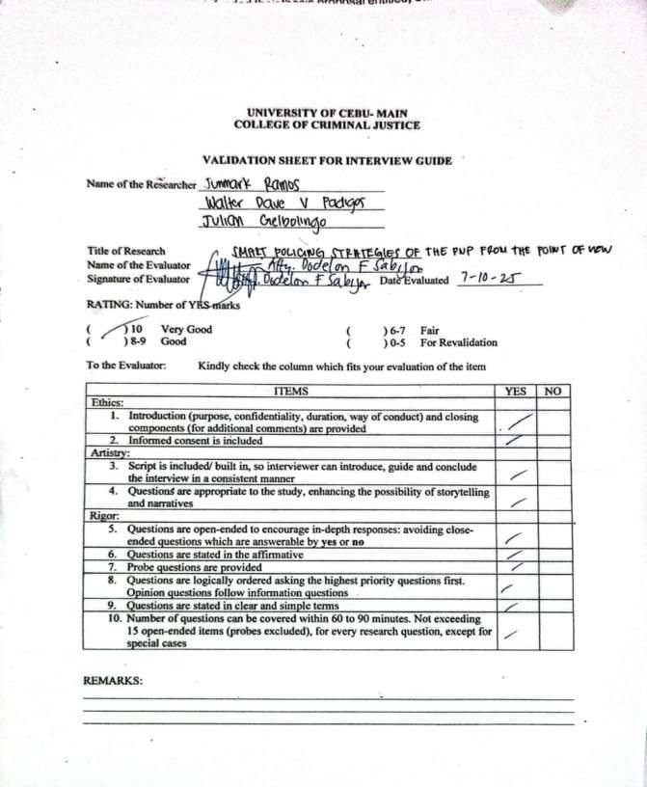
APPENDIX D VALIDATION OF INTERVIEW GUIDE

APPENDIX E
SAMPLE VERIFICATION FORM OF TRANSCRIPTION INDIVIDUAL IN-DEPTH INTERVIEW

Informants : Informants 1
Age : 45 years old
Session No. : 1
Date/ s : September 11, 2025
Time Started : 1:09 PM
Time Ended : 1:28 PM
Duration : 19 minutes and 3 seconds
Location : Cebu City

Interviewed by : Junmark A. Ramos, Julian J. Gelbolingo, Walter Dave
V. Padigos

Transcribed by : Junmark A. Ramos
Reviewed by : Atty. Dodelon F. Sabijon
Adviser : Mr. Vanz Rover Nillama
Line number | Responses | Code
Q1 | Hmm let me think about that. So I have said earlier I haven’t been out lately but I am aware of that how I see what about program about the PNP program to help us stop those crimes especially here in our area. I think it would be effective, basically it would help the residents feel safer if ever they would be able to see that a lot of police officers in the area roaming around doing some checks and it helps a lot although I haven’t personally experience it since I have been staying  inside our house most of the time.
Q2 | Hmm so let me just cite 1 example. It happened like 2 days ago so it was like early in the morning around 2 or 3 am so I was still awake doing my job since I have been working from home. So I heard a lot of noises and when I checked I saw someone got caught. It was a thief actually so because of the policy of the program of the PNP they were able to catch the thief. Basically that would help us residents hmm we would be able to feel much safer because the police officers are just around the corner. They will be able to assist and help us in case there will be like something like there will be criminals around. I think it is really good improvement.
Q3 | Hmm well point of view for us residents ahmm we will be safer because they will be around, a lot of policemen are always visible at the area. Now for the police, it would help them because if they hmm I mean once they implement this policy or they have been doing this for maybe a few months already. Ahm crime rate will be lower so their job will be easier so it is beneficial for both the policemen and the  residents.
Q4 | Hmm first I noticed that ahmm it is not consistent. I am saying that sometimes I see them sometimes I don’t so it is a challenge maybe because they don’t have enough staff to do the work this kind of policing our area and considering that cebu city is quite big. They might have staffing shortage. That’s the reason why ahmm you don’t see them as much as  they wanted to be visible in our area.

Q5 | Yeah just I mentioned in the previous question it is not really consistent that’s a drawback. To implement this, PNP has to  have a lot of police officers.
Q6 | I think there are 2 things to be considered, staffing that’s the first thing so people I mean the police has to have enough officers to work or implement this policy. One other thing is the familiarity on the area. Most of the residents are not comfortable seeing the police officers around although I have seen that this has improved this past few months since the residents here seeing the police around. Ahm first they would think that something must have happened because before when we saw the police ahmm we are expecting that a crime has happened but now since this ahm policing smart policing policy program of the police or PNP has been implemented. People are getting acquainted that once the police are visible  that the crimes there has been a crime. It is to prevent the crime from happening.
Q7 | In general, it is quite helpful to the community and one success is that it has lowered the crime rate especially in our area. I noticed less thieves going around loitering during night time or early in the morning. One other thing is that since our place is considered to be one of the hotspot for drug dealings. It has been less and less compared to what I have seen on the  previous 2 to 3 years before.
Q8 | Hmm police visibility really helps lower crimes, that’s a known fact. Now with the implementation of the smart policing program of the PNP it has been improved. Ahmm as long as there are enough staff, enough officers to check on the community on designated areas. It would really help lower the  crime rate.
Q9 | Ahmm I think it is almost similar to the previous questions we had earlier so yeah it happened just 2 days ago. A thief has got caught so it really helped lower the crime, now to improve, Hmm I think consistency the key because yeah as I have said earlier, sometimes I see them sometimes I don’t so that would really help if the police will be very consistent with the smart  policing program.
Q10 | Hmm base on my observation, before when you see a police, we are thinking that a crime was happened but now we are aware they are all visible just to know the area checking if something has gone wrong. It has lowered the crime rate that’s first. Second is the police are getting friendlier, they were like, especially in our are there are a lot of people ahmm just staying inside the community not really doing anything. They are just talking, when they see the police at times they will be speaking with them, sharing some secrets something like that so being  friendly. It also helps in this past scenario for police for the smart policing program.
Q11 | Yeah, considering the fact that they will be around here, the residents are getting familiar with them especially if they will be seeing the same faces, same officers doing their routines everyday so they become friendlier to general public and that’s the public will be ah getting more trustful to the officers to the  PNP in general.
Q12 | None of that I have seen of ah maybe because I haven’t been really out lately. Thinking about the policy itself, I think it is

 | pretty much useful to help the community well in the positive and not just negative.
Q13 | I think, it helps so PNP is now getting a lot of positive feedbacks from the community. Seeing that police visibility is somewhat improved. I would say again, they have to be very consistent again about this. It is not just a just a few couple days that they will be here and the next 2 to 3 days they will not be around so they should be getting like a regular schedule it could be a regular routine could change or assigned at least 1 or 2 police officers to check the internal community from time to time. In that way it will be improve the overall positive impact of the PNP to the public.
Q14 | Hmm, the greatest impact I have seen here is that if ever police are arrived so if there is criminal or none they are going to do anything on the base will be staying away from the area where police is not very much visible. That really helps on lowering  the crime rate.
Q15 | Ahh yeah just 2 days ago as I have said, a thief got caught because there were like 3 officers doing their job doing the routine check. That was really 2 in the morning, people are almost asleep during that time especially here in our area so it really helps if they will be able to caught those thief. Ahm in fact in my house that I left something before so I have learned I never my doors open especially at night. Since that the police  was being very vigilant already they are doing policing program. It helps in lowering the crime rate here in our area.
Q16 | Hmm in the earlier stage maybe in the first 2, 3 months before ahmm the people in our community is not familiar with this policy and thing he has ahmm hurdled that the police are implementing this policy before I guess. The people were thinking they are here to catch someone and not really to  prevent crime.
Q17 | Yes, it has improved of our safety in the community.
Q18 | Ahmm in our area in particular, we don’t see any challenges at  all. It is just that they have to be very consistent in implementing these policies.
Q19 | Being able to identify the exact same police officer doing their job ahmm taking in our community daily or could be regularly so people here are getting familiar with the officers. In that way they are like getting more trust on the police officers in  the PNP overall.
Q20 | Yeah if the resident itself is not going to trust the police officers being assigned into our area so in a way it could hinder  the police in implementing the smart policing program.
Q21 | Hmm not that I think of. I have seen this before, I have seen a lot of improvements so I would say nothing.
Q22 | I actually reiterated this for the entire time I am not sure how many times I have said. They have to be very consistent so yeah it is a positive thing in implementing this smart policing program but if they are not being consistent it is useless so I  think consistency, consistency and consistency that’s all.

APPENDIX F LOCATION MAP
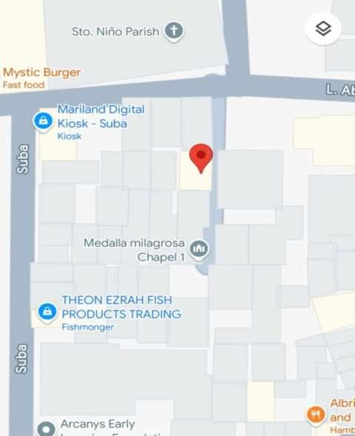

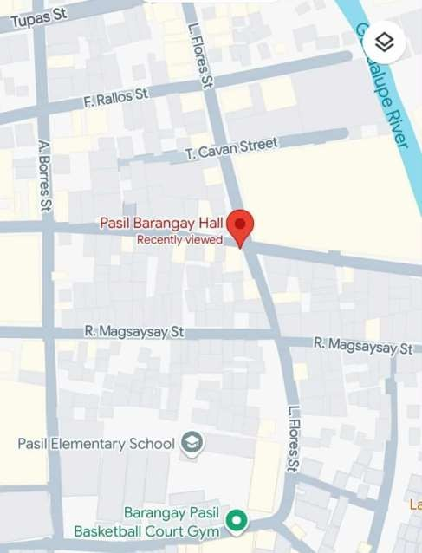

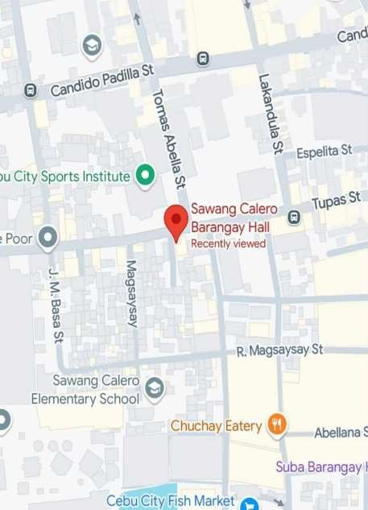

APPENDIX G
SAMPLE CODED SIGNIFICANT STATEMENTS

Significant  Statement Number | Significant Statements | Line Number | Informant Number
1 | Basically, it would help the residents feel safer if ever they would be  able to see that a lot of police officers in the area roaming around doing some checks... I  think it is a really good improvement.. I1:SS1 | 1 | I1
2 | It is not really consistent, that’s a drawback. To implement this, PNP has to have a lot of police officers...  considering that Cebu City is quite big, they might have staffing  shortage.I1:SS5 | 5 | I1
3 | It’s beneficial because it makes it much easier to reach them, as long as you have access to the necessary  technology. I2:SS3 | 3 | I2
4 | Even if smart policing is implemented, if the public isn’t given  access to the required technology, it becomes ineffective. I2:SS4 | 4 | I2
5 | For instance, when police officers are out conducting mobile patrols, it tends to discourage criminal  activity. A potential offender would likely think twice before committing a crime.  I3:SS1 | 1 | I3
6 | We can also see that it's effective, especially when compared to previous  years when police officers would mostly just stay stationed at outposts.  Now, things have changed; they’re more | 3 | I3

 | visible, actively patrolling on foot. I3:SS3
7 | Actual videos of crime scenes can now be easily viewed, even without the need for witnesses,  through CCTV footage. In terms of the community, people nowadays can also record or go live on social media, and those live videos can be accessed by the police. This benefits law enforcement because they can clearly see the crime scenes or the actual incidents that took place, eliminating the need for multiple witnesses. These are the kinds of advantages that both the community and law enforcement can gain.  I4:SS3 | 3 | I4
8 | It’s extremely useful. Modern technology is genuinely valuable. With tools like drones, police no longer have to take as many risks. Through drones they can see who’s fighting or causing  trouble and observe what’s happening from above. Even if the drone is damaged or shot down, no lives are lost, so it’s a very practical and  effective too. I5:SS1 | 1 | I5
9 | Yes, it has made a huge difference, this so-called smart policing strategy. The police can now respond much faster whenever incidents happen in the area. That’s why this smart policing strategy is really a good and effective approach.  I6:SS2 | 2 | I6
10 | I can say, sir, that this initiative is very helpful for us citizens, especially in cases where crimes are committed. For example, the use of body cameras or dashcams by PNP officers is a great way to ensure transparency and accountability during  operations. I7:SS1 | 1 | I7

11 | In my view, the PNP's Smart Policing initiative  is a strategic and commendable move. Why do I consider it a good move? Because it  enhances the efficiency of our police force and keeps them aligned with modern technological  advancements. They’re no longer just reactive; they now focus more on prevention, which is a  critical improvement.  I8:SS1 | 1 | I8
12 | From my perspective, the implementation of smart policing strategies within the PNP is a progressive step, especially in today's modern era. These approaches utilize technology, data, and intelligence to enhance criminal investigations,  crime prevention, and law enforcement. This has significantly transformed  the overall approach to policing. I9:SS1 | 1 | I
13 | From my perspective, the new smart policing strategies that use technology are a very positive change. They reduce opportunities for crime and also lower the risks for police officers because of the tools they now have. For example, drones can be deployed to conduct aerial patrols in dangerous areas that both deters crime and helps prevent incidents before  they happen. I10:SS1 | 1 | I10
14 | For me, the smart policing strategies implemented by the PNP are a good development. They have helped make their services more modern and effective. For example, they can now respond more quickly to where  crimes occur because they are using data and technology.  I11:SS1 | 1 | I11

15 | I think the smart  policing strategies are a good change. The use of mobile patrol  tracking and text  hotlines really helps. Before, it was hard to contact police, but now we can easily send a report through text or  online.I12:SS1 | 1 | I12
16 | For me, the implementation of  smart policing is good because the PNP’s system is now more organized. They don’t just take action after a complaint, they now have data and  coordination starting from the barangay  level. They also have an e-blotter system that allows easy access to records, so when there’s a case or  complaint, they can  quickly trace it. Before, it took a long time before cases were  recorded, but now it’s automatic. The police also use body cameras during operations,  which shows transparency in their  work. I13:SS1 | 1 | I13
17 | For me, the implementation of smart policing  strategies by the PNP is a big help to our  community. Before, the police were mostly focused on responding after a crime happened, but now, they are more active in preventing crimes. I noticed that they are using  technologies like CCTV, social media monitoring, and even coordination through online reports. It feels  like they are more | 1 | I14

visible and alert now. This approach helps lessen fear among residents and makes
people feel more secure walking around the area, even at night.
I14:SS1

APPENDIX H
SAMPLE OF FORMULATION OF CORE MEANING

SIGNIFICANT STATEMENT | FORMULATED MEANINGS
Basically, it would help the residents feel safer if ever they would be able to see that a lot of police officers in the area roaming around doing some checks... I think it is a really good improvement. I1:SS1 | Routine police checks boost residents’ sense of safety.  FM1
It is not really consistent, that’s a drawback. To implement this, PNP has to have a lot of police officers... considering that Cebu City is quite big, they might have staffing shortage  I1:SS5 | Inconsistent police visibility weakens smart policing in Cebu City’s wide coverage.  FM2
It’s beneficial because it makes it much easier to reach them, as long as you have access to the necessary technology. I2:SS3 | Smart policing improves access, but depends on residents having the right technology.  FM3
Even if smart policing is implemented, if the public isn’t given access to the required technology, it becomes ineffective. I2:SS4 | Smart policing only works if the public has access to needed technology.  FM4
For instance, when police officers are out conducting mobile patrols, it tends to discourage criminal activity. A potential offender would likely think twice before committing a crime. I3:SS1 | Visible mobile patrols deter crime by making offenders think twice.  FM5
We can also see that it's effective, especially when compared to previous years when police officers would mostly just stay stationed at outposts. Now, things have changed; they’re more visible, actively patrolling on foot.  I3:SS3 | Smart policing boosts visibility and effectiveness over old outpost methods.  FM6
Actual videos of crime scenes can now be easily viewed, even without the need for witnesses, through CCTV footage. In terms of the community, people nowadays can also record or go live on social media, and those live videos can be accessed by the police. This benefits law enforcement because they can clearly see the crime scenes or the actual incidents that took place, eliminating the need for multiple witnesses. These are the kinds of advantages that both the community and law enforcement can gain.  I4:SS3 | CCTV and social media offer instant evidence, reducing reliance on witnesses and improving police response.  FM7
It’s extremely useful. Modern technology is genuinely valuable. With tools like drones, police no longer have to take as many risks. Through drones they can see who’s fighting or causing trouble and observe what’s happening from above. Even if the drone is damaged or shot down, no lives are lost, so it’s a very practical and effective too.  I5:SS1 | Drones enhance police safety and situational awareness through aerial monitoring of disturbances.  FM8
Yes, it has made a huge difference, this so-called smart policing strategy. The police can now respond much faster whenever incidents happen in the area. That’s why this  smart policing strategy is really a good and effective approach. I6:SS2 | Smart policing enhances response efficiency and contributes to community safety.  FM9
I can say, sir, that this initiative is very helpful for us citizens, especially in cases where crimes are committed. For example, the use of body cameras or dashcams by  PNP officers is a great way to ensure transparency and | Body cams and dashcams promote transparency and accountability in crime-related encounters.  FM10

accountability during operations. I7:SS1
In my view, the PNP's Smart Policing initiative is a strategic and commendable move. Why do I consider it a good move? Because it enhances the efficiency of our police force and keeps them aligned with modern technological advancements. They’re no longer just reactive; they now focus more on prevention, which is a  critical improvement. I8:SS1 | Smart policing represents a strategic shift toward efficiency and technology-driven crime prevention.  FM11
From my perspective, the implementation of smart policing strategies within the PNP is a progressive step, especially in today's modern era. These approaches utilize technology, data, and intelligence to enhance criminal investigations, crime prevention, and law enforcement.  This has significantly transformed the overall approach to policing. I9:SS1 | Smart policing leverages technology to strengthen investigations, prevention, and law enforcement efforts.  FM12
From my perspective, the new smart policing strategies that use technology are a very positive change. They reduce opportunities for crime and also lower the risks for police officers because of the tools they now have. For example, drones can be deployed to conduct aerial patrols  in dangerous areas that both deters crime and helps prevent incidents before they happen. I10:SS1 | Drones are perceived as effective tools for crime deterrence and officer safety.  FM13
For me, the smart policing strategies implemented by the PNP are a good development. They have helped make their services more modern and effective. For example, they can now respond more quickly to where crimes occur because they are using data and technology.  I11:SS1 | Smart policing utilizes data and technology to enhance police services and accelerate crime response.  FM14
I think the smart policing strategies are a good change. The use of mobile patrol tracking and text hotlines really helps. Before, it was hard to contact  police, but now we can easily send a report through text or online.I12:SS1 | Smart policing improves reporting through mobile patrols and text hotlines.  FM15
For me, the implementation of smart policing is good because the PNP’s system is now more organized.  They don’t just take action after a complaint, they now have data and coordination starting from the barangay level. They also have an e-blotter system that allows easy access to records, so when there’s a case or complaint, they can quickly trace it. Before, it took a long time before cases were recorded, but now it’s automatic. The police also use body cameras  during operations, which shows transparency in their work. I13:SS1 | Smart policing improves coordination, speeds up case tracking, and promotes transparency.  FM16
For me, the implementation of smart policing strategies by the PNP is a big help to our community. Before, the police were mostly focused on responding after a crime happened, but now, they are more active in preventing crimes. I noticed that they are using technologies like CCTV, social media monitoring, and even coordination through online reports. It feels like they are more visible and alert now. This approach helps lessen fear among residents and makes people feel more secure walking  around the area, even at night. I14:SS1 | Smart policing shifts from reactive to preventive, using tech to boost safety.  FM17

APPENDIX I
SAMPLE OF DEVELOPMENT OF CLUSTER THEMES AND EMERGENT THEMES
DEVELOPMENT OF CLUSTER THEMES

Formulated Core Meanings | Cluster Themes
Routine police checks boost residents’ sense of safety.  FM1 | - Perceived Safety and Crime Deteremce  - Technology-Enabled Access and Responsiveness  - Transparency and Evidence-Based Policing  - Strategic and Preventive Orientation  - Operational Gaps and Coverage Challenges
Inconsistent police visibility weakens smart policing in Cebu City’s wide coverage.
FM2
Smart policing improves access, but depends on residents having the right technology.
FM3
Smart policing only works if the public has access to needed technology.
FM4
Visible mobile patrols deter crime by making offenders think twice.
FM5
Smart policing boosts visibility and effectiveness over old outpost methods.
FM6
CCTV and social media offer instant evidence, reducing reliance on witnesses and improving police response.
FM7
Drones enhance police safety and situational awareness through aerial monitoring of disturbances.
FM8
Smart policing enhances response efficiency and contributes to community safety.
FM9
Body cams and dashcams promote transparency and accountability in crime-related encounters.
FM10
Smart policing represents a strategic shift toward efficiency and technology-driven crime prevention.
FM11
Smart policing leverages technology to strengthen investigations, prevention, and law enforcement efforts.
FM12
Drones are perceived as effective tools for crime deterrence and officer safety.
FM13
Smart policing utilizes data and technology to enhance police services and accelerate crime response.
FM14
Smart policing improves reporting through mobile patrols and text hotlines.
FM15
Smart policing improves coordination, speeds up case tracking, and promotes transparency.
FM16
Smart policing shifts from reactive to preventive, using tech to boost safety.

FM17


CURRICULUM VITAE

PERSONAL BACKGROUND

Name : Walter Dave V. Padigos
Date of Birth : July 4, 2003 Place of Birth : Cebu City Contact Number : 09701725988
Email Address : walterdavepadigos88@gmail.com

EDUCATIONAL BACKGROUND

College : University of Cebu Sanciangko Street, Cebu City

Secondary Education : OPRRA NATIONAL HIGHSCHOOL

OPRRA KALUNASAN CEBU CITY July 06, 2022

Secondary Education : OPRRA NATIONAL HIGHSCHOOL

OPRRA KALUNASAN CEBU CITY

April 2019

Elementary : OPRRA ELEMENTARY SCHOOL OPRRA KALUNASAN CEBU CITY

March 2016

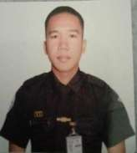
CURRICULUM VITAE

PERSONAL BACKGROUND

Name : Julian J. Gelbolingo Date of Birth : August 20, 2003 Place of Birth : Dalaguete, Cebu Contact Number : 09701222559
Email Address : gelbolingojulian2003gmail.com

EDUCATIONAL BACKGROUND

College : University of Cebu Sanciangko Street, Cebu City

Secondary Education : Sisters of Mary School - Boystown Inc.

Tungkop,Minglanilla,Cebu July 06, 2022

Secondary Education : Sisters of Mary School - Boystown Inc

Tungkop, Minglanilla, Cebu April 2019

Elementary : Bulak Elementary School Bulak, Dalaguete, Cebu March 2016

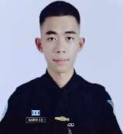
CURRICULUM VITAE

PERSONAL BACKGROUND

Name : Junmark A. Ramos Date of Birth : November 29, 2002 Place of Birth : Labangon, Cebu City Contact Number : 09222144533
Email Address : junmarkramos1129@gmail.com

EDUCATIONAL BACKGROUND

College : University of Cebu-main campus Sanciangko Street, Cebu City

Secondary Education : University of cebu main campus

J. Alcantara Sreet, Cebu July 2022

Secondary Education : University of Cebu Main Campus
Sanciangko Street, Cebu City March 2020

Elementary : Labangon BLISS Elementary School Balaga Drive, Labangon, Cebu City March 2016

