LOOSE CHANGE AND LOST PAPERS

Abstract
This field study investigated the bystander effect within a high-traffic commercial environment, examining whether helping behavior in everyday public situations is influenced by situational context. Using a between-subjects experimental field design with a descriptive approach, the study observed a convenience sample of 47 naturally occurring bystanders (estimated age range of 18–24 years) across four public locations in Quezon City. Helping behavior was operationalized as active (directly intervening to assist) or passive (observing without intervening) following a staged accident. The independent variable was manipulated across two conditions: a "Lost Papers" condition (n = 31), where an actor dropped 40–50 unclipped sheets of paper, and a "Loose Change" condition (n = 16), where an actor dropped a coin purse containing 15–20 coins. A Chi-square test of independence revealed a statistically significant association between the type of dropped item and the bystander response, X²(1, N = 47) = 7.00 p < .05, with a moderate effect size, Φ = .39. Active helping occurred more frequently in the paper condition (51.6%) than in the coin condition (50.0%). The study concludes that situational cues and the perceived nature of dropped objects significantly alter bystander intervention, suggesting that everyday prosocial behavior remains contextual even within environments embedded with cultural values like malasakit and kapwa.

Introduction
A human’s behavior does not only happen when a person is alone, but also in how they act and respond socially in different situations and environments. In social psychology experiments, it examines how thoughts, emotions, and behaviors are influenced by the presence of other individuals particularly in public places, emergency areas, or everyday social interactions. One social phenomenon that is still commonly observed today is the Bystander effect. This phenomenon shows that people may be less likely to help others in social scenarios because of an increased number of people who are nearby to help (Ganti & Baek, 2021). This became widely known through the studies of John Darley and Bibb Latane, who later expound by research studies the concept of diffusion of responsibility. This is where when more people are present in a situation, individuals may feel less personal responsibility to help, because people assume that someone else will take action, which causes hesitation or no response at all. Based on this theoretical basis, there are key factors of people becoming bystander, when the five stages of decision making situations are being ignored. These include identifying the situation if assistance is needed, is a person responsible to act, choosing between helping or not, how they will help, and execution of their help.
However, within the context of Filipino’s culture it is embedded the malasakit, or being concern, shared compassion to others, because of the concept of Virgilio Enriquez’s “kapwa” or shared identity, that Filipinos are connected to other people even those who are not blood-related, more of helping others in times of need, which a different lens from bystander effect. Supporting this idea, Libiran et al. (2024) found that Filipino university students showed less bystander effect as many participants were still willing to help in bullying situations. However, research suggests that being a bystander effect differs internally and externally, when individuals are alone and exposed to situations needing help, it has an impact of responsibility because no one else is around. Meanwhile, people felt less responsibility when others are present to assist, making that bystander effect may not be eligible because of its inclined responsibility regarding whether to be surrounded with other people or not (Ai, Yueyue et al., 2026). Given these perspectives, the present study examines whether helping behavior in everyday public situations is influenced by the type of dropped item and the number of bystanders present.
This gap is important because helping opportunities are not limited to emergencies but also occur through simple interactions, such as assisting a person who accidentally drops papers or loose change. Philpot et al. (2020) found that bystander intervention frequently occurs in real-world public settings, highlighting the importance of understanding helping behavior in natural environments. By examining helping responses in non-emergency situations, this study seeks to contribute to the existing literature on the bystander effect and provide a deeper understanding of how situational factors influence prosocial behavior in everyday life. Furthermore, the findings may offer insight into whether Filipino values such as “malasakit” and “kapwa” continue to encourage helping behavior despite the presence of other bystanders.
Main Research Question:
To what extent do the number of bystanders and the type of dropped item (lost papers vs. loose change) affect helping behavior in a high-traffic commercial environment?
Specific Question 1: Is there a significant difference in helping behavior toward a person who drops loose change?
Specific Question 2: How does the number of bystanders present influence the likelihood of helping behavior
Hypothesis
Ho: There is no significant difference in helping behavior based on the type of dropped item or the number of bystanders present.
H1: There is a significant difference in helping behavior based on the type of dropped item or the number of bystanders present.

Method

Design
The study employed a field study design using a between-subjects approach to examine the Bystander Effect in a public setting. A field study design was deemed appropriate because the study was conducted in an open environment where participants were unaware that they were being observed as part of a research investigation. This approach allowed helping behavior to be examined in a more natural context, minimizing the influence of artificial laboratory conditions and reducing the likelihood of response bias.
The descriptive approach was used to systematically observe and describe the helping behaviors exhibited by bystanders when exposed to a staged accident. This allowed the researchers to record the frequency and nature of bystander responses as they occurred in a real-world environment.
The Independent Variable (IV) was the type of dropped item presented during the staged incident.. This variable was operationalized through two experimental conditions: (a) Lost Papers Condition and (b) Loose Change Condition. The study examined whether the type of dropped item influenced helping behavior among bystanders.
The Dependent Variable (DV) was the helping behavior, operationalized as the behavioral response displayed by bystanders after witnessing the staged incident. Helping behavior was categorized as either active bystander or passive bystander.
Active Bystander – Individuals who directly intervened by assisting the actor/actress, such as picking up and returning the dropped items or otherwise providing immediate help.
Passive Bystander – Individuals who witnessed the incident but did not actively intervene. This category includes those who merely observed the situation, hesitated without taking action, or continued on their way without offering assistance.
To ensure consistency across conditions, several factors were controlled, including the location of the staged accident, which was conducted in both an enclosed space and an open space, the behavior and appearance of the actor and actress, the timing of the incident, and the observational procedures used by the researchers. The same procedures were followed across all locations to ensure that any differences in helping behavior could be attributed to the experimental conditions rather than environmental variations.

Participants
Participants consisted of naturally occurring bystanders who were present in the locations where the staged incidents were conducted. A total of 47 bystander responses were observed across both experimental conditions. As the study was conducted in public settings using unobtrusive observation, participants were not directly recruited and were selected through convenience sampling based on their presence at the time of data collection.
To ensure the data accurately reflected behavioral responses to the staged events, specific inclusion and exclusion criteria were applied during observation. The final sample included only those individuals who qualified as either active bystanders (those who directly intervened or offered assistance) or passive bystanders (those who visibly noticed the event but did not directly intervene). Conversely, individuals who demonstrated no reaction or awareness of the situation whatsoever were excluded from the final count.
Consequently, precise demographic data could not be collected; however, based on visual estimation, the participants fell within the 18–24 age bracket. Finally, because the study occurred in an open, public domain, individuals retained complete freedom to engage with, remain near, or leave the scene at any point.

Materials
Experimental Stimuli (Props)
To manipulate the types of dropped items across experimental conditions, two distinct sets of physical props were used:
- Object Set A (Lost Papers): Consisted of approximately 40 - 50 loose sheets of unclipped white paper.
- Object Set B (Loose Change): Consisted of a coin purse holding an assortment of 15 to 20 pieces of Philippine peso coins in varying denominations.
Observational Tracking and Data Recording
- Video Recording Equipment: Distantly positioned smartphone and digital camera were utilized to record high-definition video footage of each experimental trial. This allowed the researchers to capture the naturalistic responses of the bystanders without causing reactivity or awareness that an experiment was taking place.
Ethical Documentation
- Informed Consent Forms: Printed consent sheets outlining the study’s true purpose, data privacy disclosures, and a signature line indicating voluntary permission to utilize the observed behavioral data.
- Debriefing Script: A standardized verbal script read aloud by researchers during the post-experimental disclosure to systematically explain the staged incident and alleviate any participant discomfort.
Statistical Software
All collected categorical frequency data (a total of 47 bystander responses) were compiled and analyzed using the Chi-square Test of Independence in Google Sheets.

Procedure
The experiment used a field study design to observe helping behavior in natural public settings. The experiment was conducted on different days in and locations including Circle Memorial Park, NU Fairview Learning Resource Center (LRC), NU Fairview Canteen, and SM Fairview Annex. Participants were not directly recruited; instead, naturally occurring bystanders in the environment became the participants of the study.
Then, two experimental conditions were implemented to examine how the type of dropped item and the number of bystanders affected helping responses in public settings.
Condition 1:
In the first condition, the actor, dressed in casual civilian clothing, walked through crowded areas while carrying several papers and personal items. The actor then intentionally stumbled, causing numerous papers to scatter on the ground. This condition was conducted in Quezon City Circle Memorial Park and NU Fairview Learning Resource Center (LRC), with large groups of people or crowded environments to observe helping behavior under high social density.
Condition 2:
In the second condition, the actor, however dressed in NU-Fairview’s BS Psychology uniform, walked while carrying a lot and heavy coin purse. The actor then intentionally dropped the coins to see if the bystanders would help her. This condition was conducted inside the NU Fairview Cafeteria and SM Fairview Annex.
To minimize bias, the experiment was conducted across different days and locations. The independent variables were the type of dropped item (papers and loose change) and the number of bystanders present, while the dependent variables were the frequency of helping behavior as well as the type of help offered (passive or active help). No verbal request for help was made in either condition to ensure that helping behavior remained spontaneous and natural.

Results
A Chi-square Test of Independence was performed to examine whether the type of dropped item (paper or coins) was significantly associated with helping behavior among bystanders in a high-traffic commercial environment. Helping behavior was operationally defined into two categories: Active Bystander, referring to individuals who directly assisted after observing the dropped item, and Passive Bystander, referring to individuals who observed the situation but did not provide assistance.
Descriptive Statistics
A total of 47 bystanders were observed across the two experimental conditions. Of the total sample, 24 participants (51.1%) demonstrated active helping behavior, while 23 participants (48.9%) remained passive observers.
Within the paper condition, 16 participants (51.6%) exhibited active bystander behavior, whereas 15 participants (48.4%) displayed passive behavior, yielding a total of 31 observations.
Within the coin's condition, 8 participants (50.0%) engaged in active helping behavior, while 8 participants (50.0%) remained passive, for a total of 16 observations.
These descriptive findings indicate a slight tendency for helping behavior to occur more frequently when papers were dropped than when coins were dropped.
TABLE 1: Observed Frequencies of Helping Behavior by Type of Dropped Item
Item Dropped | Active Bystander | Passive Bystander | Row Total
Paper | 16 | 15 | 31
Coins | 8 | 8 | 16
Column Total | 24 | 23 | 47
TABLE 1: Expected Frequencies of Helping Behavior by Type of Dropped Item
Item Dropped | Active Bystander | Passive Bystander | Row Total
Paper | 15.8 | 7.8 | 23.7
Coins | 8.2 | 7.8 | 16
Column Total | 24 | 16 | 40
Inferential Statistics
To determine whether the observed differences in helping behavior across item conditions were statistically significant, a Chi-square Test of Independence was conducted.
The analysis revealed a statistically significant association between the type of dropped item and helping behavior, χ²(1, N = 47) = 7.00, p < .05. The obtained Chi-square statistic exceeded the critical value of 3.841 at the α = .05 significance level. Accordingly, the null hypothesis was rejected.
The magnitude of association was further assessed using the Phi coefficient (φ), which is appropriate for a 2 × 2 contingency table.
Φ = √ χ2 / N​​
Φ = √ 7.00​​ / 47
Φ = 0.39
The resulting φ = .39 indicates a moderate effect size, suggesting that the association between type of dropped item and helping behavior was not only statistically significant but also meaningful in magnitude.
Tables and Figures:
Figure 1. Helping Behavior by Type of Dropped Item.
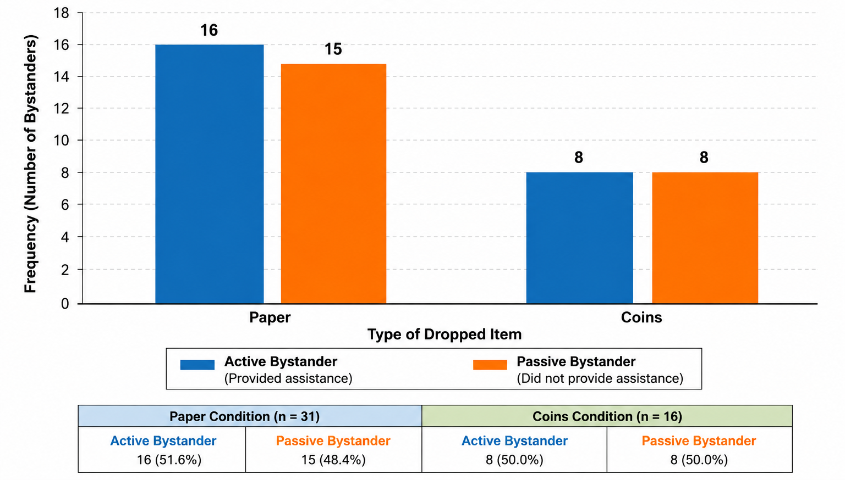
The figure illustrates the frequency of active and passive bystander responses under paper and coin conditions. Active helping behavior was slightly higher in the paper condition compared with the coins condition.
Figure 2. Percentage of Helping Behavior by Condition
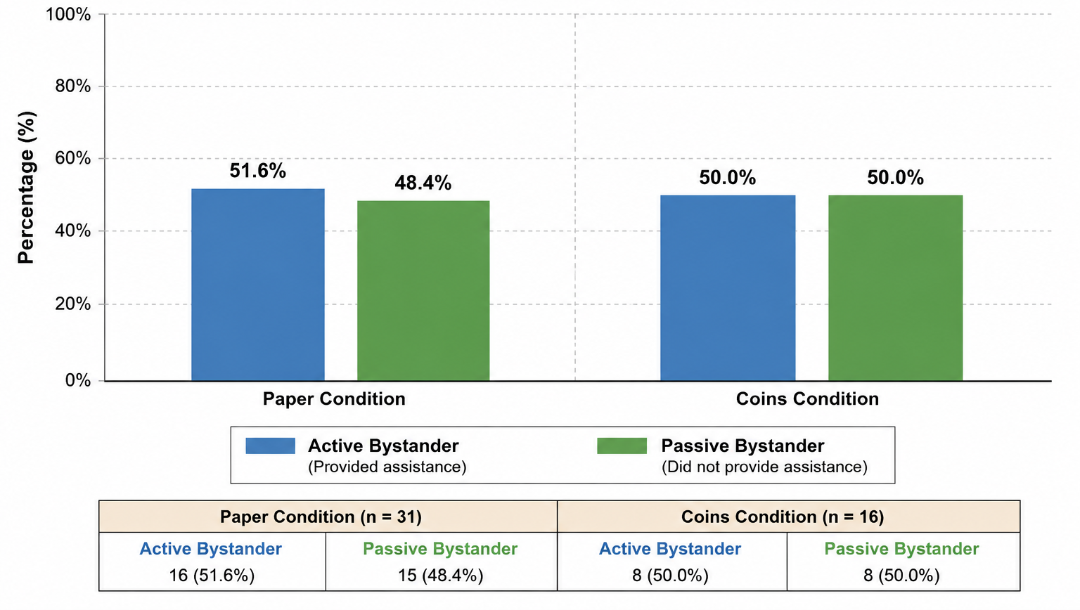
Percentage distribution of active and passive bystander behavior under paper and coin conditions. Helping behavior was slightly more frequent in the paper condition than in the coin condition.
Interpretation of Findings
The findings indicate that helping behavior varied as a function of the type of dropped item.
Specifically, participants demonstrated a greater likelihood of engaging in helping behavior when papers were dropped compared with when coins were dropped. This pattern supports the alternative hypothesis, indicating that situational context significantly influenced bystander response.
The results further suggest that environmental characteristics, such as the perceived nature or urgency of the dropped item, may influence whether individuals choose to intervene or remain passive observers. This supports broader theoretical perspectives on helping behavior, which propose that contextual cues contribute to decision-making in bystander intervention.

Discussion
This study aimed to determine whether the type of dropped item (paper versus coins) significantly influences helping behavior among bystanders in a public, non-emergency setting. Specifically, it examined whether individuals are more likely to become active bystanders (providing assistance after observation) or remain passive bystanders (no intervention after observation) depending on the item being dropped. This study’s results showed statistically significant association between type of dropped item and helping behavior, leading to rejection of null hypothesis. This means that there is sufficient evidence that helping behavior was influenced by the situational context, particularly by the type of object involved.
These findings can be explained using the bystander decision-making framework (Latane & Darley, 1968), which suggests that people first interpret a situation before deciding to help. In this study, the paper items showed slightly higher active helping, suggesting that may have been seen as important personal belongings such as documents, receipts, or records. This aligns with Abbate et al. (2022), which emphasizes that helping behavior is influenced by cognitive interpretation, perceived responsibility, and situational clarity. When an item appears more important, individuals are more likely to feel a moral obligation to assist. On the other hand, the coin condition may have been perceived as low value or less urgent, and the situation may be more ambiguous in terms of whether helping is necessary or appropriate. This is explained by risk-based models of helping behavior. According to Liu et al. (2023), helping decisions is weighted between the benefits of helping and possible personal or social risks, individuals may be unlikely to help or avoid helping when they think that there is a chance of negative consequences. In this study, coin-related situations bystanders may hesitate due to fear of being misjudged as taking money, increasing the social cost of helping. Likewise, Lockwood et al. (2017), describe “prosocial apathy”, where individuals are less likely to help when involving cognitive or high effort. In this case, coins may require additional psychological effort like risks, uncertainty, making helping behavior less likely to happen. With that, helping behavior appears to depend not only on effort but also on how safe and clear the situation feels.
In comparison with previous studies, the findings are consistent with research showing that people are more likely to help in situations that are clear, low-risk, and easy to interpret, while ambiguity and perceived. risk reducing helping behavior. However, unlike many studies that focus on emergency situations, this extends to everyday scenarios such as dropping items in public spaces. This helps show that even small, non-emergency situations can still influence whether people choose to help or not, depending on how they interpret the situation.
Other than the influence of dropped items to help behavior of bystanders, one of its important factors is the number of people present in the situation whether individuals feel responsible enough to help or choose to remain passive.
Building upon this discussion, the amount of individuals present in a situation influences the likelihood of helping behavior by altering their assessment of the situation. There could be a misinterpretation on what individuals think deems worthy of assistance, or what the majority thinks worthy of assistance. Another concept called pluralistic ignorance coined by Katz & Allport (1931) refers to widespread public adherence to a norm, where individuals observe each other’s behavior, and upon noticing what the majority is acting on, this becomes the norm where individuals conform to. The core principle of this concept hinges on the distinction between private thought and public action, where belief and interpretation could be easily distorted, and the general population adheres to what is perceived as the norm. Other influencers of helping behavior underlying the amount of people present in a situation also include psychological mechanisms. One such mechanism is referred to as the “responsibility effect” (Darley and Latané, 1968), where responsibility is assumed based on how many people are present during a situation. Responsibility is diffused when people witness someone needing help, and those individuals would intervene if they assume the responsibility to do so but only if they have established that assisting is their responsibility and not someone else’s. As the amount of people present in a situation increases, the diffusion of responsibility expands in turn, making individuals assume responsibility upon others more than themselves.
However, there are also those that influence the likelihood of helping behavior in the form of a more collectivist approach. A study by Rovira et al. (2023), has yielded results concluding that the more individuals are present, as long as they are grouped together, it is more likely that they will help a person in need. Even with the diffusion of responsibility, individuals would all assume responsibility to help a person in need, so long as said individuals are grouped together by some relationship. There is also another contributing factor called prosocial modelling, where an individual who acts prosocially can further inspire other individuals to help, because being in the presence of a helping model can stimulate others’ own prosocial behavior (Greitemeyer, 2021). Albert Bandura's initial work on observational learning has influenced research into the effects of prosocial modeling, and according to his social learning theory, human behavior is guided by observing, modeling, and imitating the behaviors of others. In turn, when people witness an individual or a group of individuals act in a prosocial way towards a person, after having assessed that they will not be judged negatively for helping, and that individuals are indeed in need of help, these individuals may be encouraged to also help those in need, propagating a more prosocial behavior aimed towards volunteerism, empathy, and altruism.
Despite the data and the findings accumulated from this study, several limitations should be acknowledged when interpreting the results. First, the research was conducted across different geographic areas. While the targeted locations were somewhat similar in terms of both being accessible to the general public and an enclosed, limited space, the locations where the experiment was conducted were different, which may have introduced variations in environmental, cultural, and social factors that were not controlled for in the study. Second, the study employed convenience sampling, wherein participants of the research consisted of naturally occurring bystanders who were present in the locations during the conduction of the experiment. As a result, the sample may not be fully representative of the broader population, limiting the generalizability of the findings. Future research may address these limitations by utilizing more representative sampling methods, consistency in geographical conditions and locations, and incorporating additional variables to provide a more comprehensive understanding of the topic.
Nonetheless, even with these limitations, the study offers meaningful insights into how the presence of bystanders may influence the likelihood of helping behavior. The findings contribute to the growing research on prosocial behavior by offering evidence on how situational factors may influence an individual's willingness to provide assistance. These findings may serve as a useful reference for future researchers interested in examining the bystander effect, prosocial behavior, and other contributing factors that shape helping behavior.

Ethical Considerations
The experiment was guided by the following Ethical Considerations:
Informed Consent & Voluntariness: The study aimed to observe spontaneous behavior in natural public settings, obtaining informed consent before the experiment was not possible, as it could have influenced the responses and compromised the validity of the results. Therefore, participants were not informed in advance but were given informed consent form immediately after debriefing and assured that their involvement was entirely voluntary. They were informed that they had the right to refuse inclusion of their observed data and could withdraw consent without any consequences.
Confidentiality: All information and footage obtained from the deceived participants was kept confidential as it must be protected, respected, and treated fairly. No information, and footage was disclosed or used in any manner that could potentially harm or exploit the participants.
Debriefing: After the experiment, the deceived participants were given a debriefing on the true purpose of the experiment. They were informed that the situation they witnessed was staged and were only intended to investigate a social phenomena—bystander effect hence the “accidental” public situation. Although, there is a minimal use of deception as the participants were not aware about the staged experiment, this was explained during debriefing immediately after the act, ensuring that participants who are involved left aware of what experiment they had been part in.

References
Abbate, C. S., Misuraca, R., Vaccaro, C., Roccella, M., Vetri, L., & Miceli, S. (2022). Prosocial priming and bystander effect in an online context. Frontiers in Psychology, 13, Article 945630. https://doi.org/10.3389/fpsyg.2022.945630
Ai, Y., Ismail, R. B., & Chong, S. T. (2024). A study of the bystander effect in different helping situations. Social Psychology and Society, 15(1), 127–136. https://doi.org/10.17759/sps.2024150108
Ganti, N., & Baek, S. (2021). Why people stand by: A comprehensive study about the bystander effect. Journal of Student Research, 10(1). https://doi.org/10.47611/jsrhs.v10i1.1390
Greitemeyer, T. (2021). Prosocial modeling: person role models and the media. Current Opinion in Psychology, 44(7), 135-139. https://www.sciencedirect.com/science/article/pii/S2352250X21001573#bbib4
Latané, B., & Darley, J. M. (1968). Group inhibition of bystander intervention in emergencies. Journal of Personality and Social Psychology, 10(3), 215–221. https://doi.org/10.1037/h0026570
Libiran, T. J. D. C., Lacanlale, J. E., Tallara, A. P., Del Rosario, P. M., & Dela Cruz, A. (2024). Analyzing the bystander effect in bullying: Unraveling factors that influence action and inaction among selected university students. International Journal of Academic Multidisciplinary Research, 8(3), 97-110. https://www.researchgate.net/publication/379671667_Analyzing_the_Bystander_Effect_in_Bullying_Unraveling_Factors_that_Influence_Action_and_Inaction_among_Selected_University_Students
Liu, C., Xiao, X., Pi, Q., Tan, Q., & Zhan, Y. (2023). Are you more risk-seeking when helping others? Effects of situational urgency and peer presence on prosocial risky behavior. Frontiers in Psychology, 14, Article 1036624. https://doi.org/10.3389/fpsyg.2023.1036624
Lockwood, P. L., Hamonet, M., Zhang, S. H., Ratnavel, A., Salmony, F. U., Husain, M., & Apps, M. B. J. (2017). Prosocial apathy for helping others when effort is required. Nature Human Behaviour, 1(7), Article 0131. https://doi.org/10.1038/s41562-017-0131
Miller, D. (2023). A century of pluralistic ignorance: what we have learned about its origins, forms, and consequences. Frontiers in Social Psychology. https://www.frontiersin.org/journals/social-psychology/articles/10.3389/frsps.2023.1260896/full#B3
Philpot, R., Liebst, L. S., Levine, M., Bernasco, W., & Lindegaard, M. R. (2020). Would I be helped? Cross-national CCTV footage shows that intervention is the norm in public conflicts. American Psychologist, 75(1), 66–75. https://doi.org/10.1037/amp0000469
Rosenberg, M. J. (1965). When dissonance fails: On eliminating evaluation apprehension from attitude measurement. Journal of Personality and Social Psychology, 1(1), 28–42. https://doi.org/10.1037/h0021647
Rovira, A., Southern, R., Swapp, D., Campbell, C., Zhang, J. J., Levine, M., & Slater, M. (2021). Bystander affiliation influences intervention behavior: A virtual reality study. SAGE Open, 11(3), 1–13. https://journals.sagepub.com/doi/10.1177/21582440211040076

