VaultFi:A Blockchain-Based Decentralized Lending Platform
Harsha Deore1, Dhanashri Mankar2, Kirti Rajbhar3, Sujata Kullur4
¹²³Student, Dept. of Information Technology, Usha Mittal Institute of Technology, SNDT Women’s University
⁴Professor, Dept. of Information Technology, Usha Mittal Institute of Technology, SNDT Women’s University

Abstract—Decentralized Finance (DeFi) is reshaping tradi- tional financial systems by enabling trustless lending and borrow- ing through blockchain technology. Despite rapid growth, existing DeFi platforms face challenges such as smart contract vulner- abilities, oracle manipulation, liquidity instability, governance inefficiencies, and security risks including flash loan attacks. This paper presents VaultFi, a secure and governance-driven decentralized lending and borrowing platform designed to en- hance transparency, capital efficiency, and user participation. The system leverages Ethereum-based smart contracts to automate lending, borrowing, and liquidation processes while integrating decentralized price oracles for real-time asset valuation. DAO- based on-chain governance enables community-driven decision- making, and dynamic interest rate models optimize liquidity management. VaultFi also incorporates security mechanisms to mitigate reentrancy and oracle-related attacks. Performance metrics including Total Value Locked (TVL), borrowing activity, and user adoption are evaluated to assess platform effectiveness. The results demonstrate that VaultFi provides a scalable, trans- parent, and resilient framework for decentralized lending while promoting financial inclusion and sustainable DeFi growth.
Index Terms—decentralized finance (DeFi), blockchain technol- ogy, smart contracts, blockchain-based lending, liquidity pools, de- centralized autonomous organization (DAO), on-chain governance, oracle manipulation prevention, DeFi risk management, cross- chain interoperability, financial inclusion, secure decentralized systems.

- Introduction
The global financial ecosystem is undergoing a major transformation driven by blockchain technology and the rapid emergence of decentralized finance (DeFi). Traditional finan- cial systems rely heavily on centralized intermediaries such as banks and financial institutions, which often introduce inefficiencies, high transaction costs, restricted accessibility, and operational opacity. These limitations have motivated the development of decentralized alternatives that aim to provide open, transparent, and trustless financial services.
Decentralized finance (DeFi) refers to a collection of blockchain-based financial applications that eliminate inter- mediaries by leveraging smart contracts deployed on public blockchains. DeFi lending platforms enable users to lend and borrow digital assets directly through decentralized protocols, ensuring transparency, immutability, and automated execution. Unlike traditional lending systems that require extensive credit checks and documentation, DeFi lending primarily relies on collateralization mechanisms, allowing global participation with minimal entry barriers.
In recent years, DeFi lending has witnessed rapid growth due to its ability to offer permissionless access, real-time settlement, and algorithmically determined interest rates. Plat- forms such as Aave, Compound, and MakerDAO have demon- strated the feasibility of decentralized money markets, where liquidity pools are governed by smart contracts and interest rates dynamically adjust based on supply and demand. How- ever, despite their success, existing DeFi platforms continue to face challenges related to risk management, governance centralization, liquidation inefficiencies, and user experience complexity.
One of the critical concerns in DeFi lending systems is effective collateral monitoring and liquidation management. Extreme market volatility can lead to rapid collateral devalua- tion, increasing the risk of under-collateralized loans and bad debt accumulation. Additionally, many platforms lack robust governance participation, where protocol decisions are often influenced by a limited subset of token holders. These chal- lenges highlight the need for a more transparent, community- driven, and resilient lending architecture.
This paper presents VaultFi, a decentralized lending and borrowing platform designed to address these limitations through a modular architecture, real-time oracle integra- tion, automated risk monitoring, and DAO-based governance. VaultFi enables users to deposit digital assets as collateral, borrow against them, and manage loans through a secure and intuitive interface. By integrating decentralized price oracles, the system ensures accurate collateral valuation and dynamic loan-to-value (LTV) enforcement.
Furthermore, VaultFi introduces a governance and reputation-based framework that incentivizes responsible user behavior and community participation. Governance tokens allow users to propose and vote on protocol-level decisions, while reputation metrics encourage timely repayments and long-term engagement. This approach enhances transparency, decentralization, and sustainability within the lending ecosystem.
The remainder of this paper is organized as follows: Section II reviews related work and existing DeFi lending platforms. Section III discusses the limitations of current systems. Section IV presents the proposed VaultFi architecture and modules. Section V describes the implementation methodology and ex- perimental setup. Section VI analyzes results and performance metrics. Finally, Section VII concludes the paper and outlines

future research directions.
- Literature Review
In this literature survey on decentralized finance (DeFi) lending, a comprehensive review of research articles and technical reports was conducted to understand the evolution, architecture, and challenges of blockchain-based lending sys- tems. One of the foundational works examined was “A Next- Generation Smart Contract and Decentralized Application Platform” (2014), which introduced Ethereum’s programmable smart contract infrastructure. This framework significantly enhanced the scalability and flexibility of decentralized finan- cial applications and contributed to the emergence of yield- generating mechanisms within DeFi ecosystems.
Another seminal contribution, “Bitcoin: A Peer-to-Peer Electronic Cash System” (2008), established the conceptual foundation for decentralized financial transactions. The study demonstrated how peer-to-peer blockchain networks can elim- inate intermediaries while promoting transparency, accessi- bility, and reduced entry barriers. These principles directly influence the operational structure of DeFi lending platforms. Beyond foundational blockchain research, studies analyzing decentralized lending protocols provide insights into architec- tural design and interest rate mechanisms. Comparative anal- yses of lending and borrowing platforms highlight the use of both fixed and variable interest rate models, each influencing liquidity dynamics and borrower behavior differently. Such mechanisms play a critical role in maintaining equilibrium
between supply and demand within liquidity pools.
Token economics also forms a central theme in DeFi research. Studies such as “Token-Based Platform Finance” examine how governance tokens are used to incentivize partic- ipation and decentralize platform control. Research into plat- forms like Aave and Compound further illustrates how token issuance supports liquidity mining, governance participation, and ecosystem growth. However, token-based governance in- troduces challenges including token concentration risks and regulatory uncertainty.
Security and privacy considerations are extensively discussed in blockchain literature. Research addressing blockchain security highlights vulnerabilities such as smart contract exploits, liquidity shocks, and governance manip- ulation. The importance of conducting security audits and implementing mechanisms such as multisignature wallets has been emphasized to mitigate systemic risks. Additionally, scalability solutions including second-layer protocols and state channels have been proposed to reduce transaction costs and improve throughput in high-demand environments.
Liquidity management remains a critical factor in decentral- ized lending systems. Effective liquidity provisioning ensures that borrowers can access funds while lenders maintain earning opportunities. Leading platforms implement dynamic interest rate adjustments and collateralization strategies to manage utilization rates and reduce insolvency risk.
The literature also recognizes the transformative potential of DeFi lending in promoting financial inclusion. By removing
centralized intermediaries and enabling automated smart con- tract execution, DeFi platforms offer accessible financial ser- vices to underbanked and unbanked populations. Automated loan execution reduces operational inefficiencies and enhances transparency compared to traditional lending systems.
Overall, the reviewed studies indicate substantial growth in the DeFi lending sector, driven by smart contract innovation, liquidity pool models, and token-based governance. Neverthe- less, challenges related to scalability, security vulnerabilities, regulatory compliance, and liquidity risk remain significant. Addressing these limitations is essential to ensure sustainable expansion and long-term resilience of decentralized lending ecosystems.
- Analysis of Contemporary DeFi Lending
Platforms
Decentralized Finance (DeFi) lending platforms have emerged as a fundamental component of blockchain-based financial ecosystems. These platforms enable permissionless borrowing and lending of digital assets through smart con- tracts, eliminating traditional intermediaries. To examine their operational mechanisms and governance structures, a compar- ative study of leading platforms was conducted. The analysis focuses on collateral requirements, interest rate models, gov- ernance architecture, and market capitalization.
- Aave
Aave is a decentralized liquidity protocol that enables users to deposit crypto assets into liquidity pools and earn interest, or borrow assets against collateral. A notable feature of Aave is the flash loan mechanism, which allows users to borrow funds without collateral, provided that the borrowed amount is repaid within the same blockchain transaction.
Interest rates are dynamically determined based on asset utilization within liquidity pools. As borrowing demand in- creases, interest rates rise accordingly. This automated adjust- ment enhances capital efficiency while maintaining liquidity equilibrium within the system.
- Compound
Compound operates as an algorithmic money market proto- col where interest rates are automatically calculated based on supply and demand conditions. Users deposit assets into smart contract–based liquidity pools and receive interest-bearing tokens (cTokens), which represent their proportional share in the pool.
The protocol ensures transparency and automation in in- terest accrual, reducing manual governance intervention. Its tokenized interest model simplifies participation for lenders while promoting efficient market-driven rate discovery.
- MakerDAO
MakerDAO is a decentralized credit platform built on the Ethereum blockchain that facilitates the issuance of the DAI stablecoin. Users lock digital assets as collateral to generate DAI, typically at over-collateralized ratios to mitigate price volatility risks.

Borrowers are required to pay a stability fee, which is periodically adjusted through decentralized governance mech- anisms. The primary objective of MakerDAO is to maintain the price stability of DAI while ensuring the long-term solvency of the protocol.
- NEXO
NEXO functions as a centralized cryptocurrency lending platform offering loans against digital asset holdings. Unlike decentralized protocols, NEXO operates under a centralized governance and custodial framework.
Interest rates are generally fixed or administratively con- trolled rather than algorithmically determined. While this structure enhances user accessibility and simplifies onboard- ing, it introduces counterparty and custodial risks not present in decentralized systems.
- dYdX
dYdX is a decentralized protocol supporting margin trading, perpetual contracts, and crypto lending services. The platform enables non-custodial trading with variable interest rates in- fluenced by market liquidity conditions.
Its integration of lending with leveraged trading instruments makes it particularly suitable for advanced users seeking sophisticated decentralized financial tools.
- Comparative Discussion
The comparative evaluation reveals that decentralized plat- forms such as Aave, Compound, MakerDAO, and dYdX emphasize transparency, algorithmic interest rate mechanisms, and community-driven governance. These systems enhance trust minimization and censorship resistance but remain ex- posed to risks such as smart contract vulnerabilities and collateral volatility.
Conversely, centralized platforms like NEXO offer simpli- fied user experiences and structured risk management but rely on custodial control, thereby introducing counterparty risk.
Overall, DeFi lending platforms differ significantly in gov- ernance models, collateral structures, and interest rate strate- gies. These structural differences influence capital efficiency, systemic risk, and user accessibility within the broader decen- tralized financial ecosystem.
- Proposed System
The proposed system, VaultFi, is a blockchain-based de- centralized lending platform designed to provide a secure, transparent, and governance-driven financial ecosystem. The platform integrates smart contracts, decentralized price feeds, a DAO-based governance framework, and a reputation-driven incentive mechanism to ensure trustless and automated lending operations. Unlike traditional financial systems, VaultFi elim- inates intermediaries by executing all financial transactions through Ethereum smart contracts, thereby ensuring trans- parency, immutability, and decentralized control.
The system begins with secure user onboarding through wallet integration. Users connect their Ethereum wallets, such
as MetaMask, which enables cryptographically signed trans- actions and non-custodial interaction with deployed smart contracts. This wallet connection acts as the identity layer of the platform, ensuring secure authentication without relying on centralized credential storage.
VaultFi enables users to deposit Wrapped Bitcoin (WBTC) into the LendingPool smart contract. Once deposited, the assets are securely stored on-chain and the user’s balance is updated automatically. The system calculates a safety ratio based on deposited collateral to ensure financial stability and prevent under-collateralization. This collateral-backed mech- anism forms the foundation of secure borrowing within the protocol.
Borrowing functionality allows users to obtain WBTC by locking approved collateral assets. The maximum borrowable amount is calculated dynamically using real-time price feeds integrated through Chainlink oracles. The system evaluates the Loan-to-Value (LTV) ratio and ensures that borrowing remains within governance-defined risk thresholds. If the requested amount exceeds the permissible borrowing limit, the trans- action is rejected automatically. Otherwise, the smart contract transfers the approved funds to the borrower’s wallet while locking the corresponding collateral.
Loan repayment can be executed at any time, enabling flexibility for borrowers. Upon successful repayment, the smart contract updates the outstanding balance and releases the locked collateral back to the user. Depositors are also permitted to withdraw their WBTC provided that the assets are not locked against active loans. All these processes are handled autonomously through smart contracts, ensuring transparency and eliminating manual intervention.
A distinctive feature of VaultFi is its DAO-based gover- nance model. Users can propose modifications to protocol parameters such as interest rates, collateral requirements, and loan-to-value ratios. Voting is conducted on-chain through the governance smart contract, and approved proposals are executed automatically. This governance structure ensures that the protocol evolves through community participation rather than centralized control.
To further enhance ecosystem stability, VaultFi incorpo- rates a reputation-based incentive system. The ReputationSys- tem smart contract tracks user activities including deposits, borrowing, repayments, and governance participation. Users accumulate reputation scores based on responsible behavior, and high-reputation participants may gain access to collateral- reduced micro-loans. This mechanism encourages long-term engagement while rewarding trustworthy users.
The platform also includes a continuous monitoring mecha- nism that evaluates active loans using updated price feeds. Col- lateral ratios are recalculated periodically to assess loan health. If a loan becomes under-collateralized, the system triggers alerts and initiates liquidation procedures to protect overall protocol liquidity. This automated monitoring ensures risk mitigation and capital efficiency within the lending ecosystem. The overall architecture of VaultFi consists of a React-based frontend interface integrated with ethers.js for blockchain

communication, a Node.js backend layer for secure API inter- action, Solidity-based smart contracts for core protocol logic, and Chainlink oracles for decentralized price validation. This modular architecture ensures scalability, security, and adapt- ability, positioning VaultFi as a next-generation decentralized lending solution.
- System Architecture
The VaultFi decentralized lending platform follows a lay- ered, modular architecture designed to ensure security, trans- parency, and scalability. The system is composed of four primary layers: the user-facing frontend, a backend API layer, a smart contract layer, and external infrastructure components including blockchain deployment and oracle integration.
- Frontend Layer
The user interface is built using React.js and ethers.js, providing a responsive dashboard through which users can per- form core operations — depositing and withdrawing WBTC, initiating borrowing, creating DAO governance proposals, and monitoring their reputation scores. Users connect to the plat- form either via MetaMask or a custom wallet generated by the platform itself.
- Backend API Layer
A Node.js-based backend serves as an intermediary between the frontend and the blockchain. It manages user sessions, pro- vides REST API endpoints for frontend consumption, handles optional private key custody for custom wallets, and routes contract interactions securely. This layer abstracts blockchain complexity from the user interface while maintaining secure and efficient communication with deployed smart contracts.
- Smart Contract Layer
The core protocol logic is implemented in Solidity and consists of four primary contracts. The LendingPool.sol con- tract governs deposit, withdrawal, over-collateralized borrow- ing, and loan repayment operations. The DAOGovernance.sol contract enables community-driven decision-making, allowing users to create and vote on proposals that modify protocol parameters such as interest rates and collateral ratios, with approved proposals executed automatically on-chain. The Rep- utationSystem.sol contract tracks user activity — including depositing and voting — and awards high-reputation users ac- cess to collateral-free micro-loans as an incentive mechanism. An optional fourth contract, YieldFarming.sol, is planned for future integration to enable auto-compounding yield strategies through external protocols and distribute farming rewards to participants.
- Oracle Integration
Chainlink Price Feeds are integrated directly into the smart contracts to supply real-time BTC/ETH/USD price data. This ensures accurate collateral valuation during borrowing oper- ations, preventing under-collateralization and protecting the protocol against price manipulation attacks — a known vul- nerability in first-generation DeFi systems.
- Blockchain Deployment
All smart contracts are deployed on the Ethereum Go- erli Testnet, ensuring that transaction records — including deposits, governance votes, and loan data — are stored immutably on-chain. This guarantees full transparency and auditability of all platform operations. The overall architecture follows a clear data flow: external users interact through the frontend dashboard, which communicates with the backend API, which in turn calls the appropriate smart contracts on-chain. The contracts rely on Chainlink oracles for price data and the Ethereum testnet for immutable state storage. This separation of concerns across layers ensures that each component remains independently testable and upgradeable, while the system as a whole delivers trustless, community- governed, and reputation-incentivized financial services.
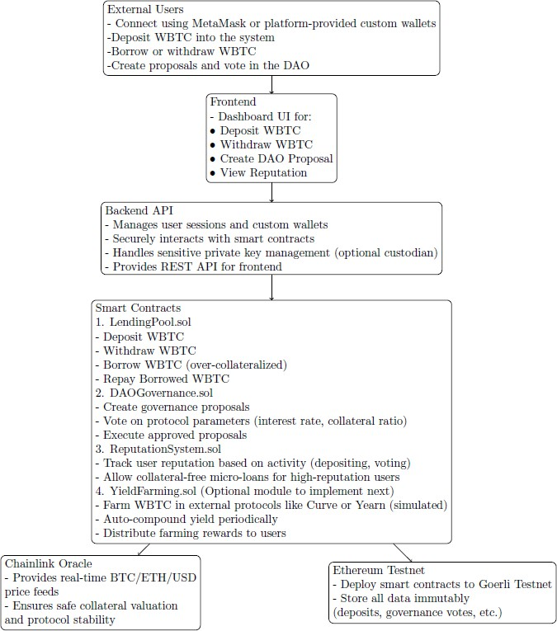

Figure 1 Overall System Architechture of VaultFi

The data relationships between users, loans, assets, and gov- ernance entities are represented using the entity relationship model shown in Fig. 2.
- Implementation Modules
The implementation of VaultFi translates the proposed sys- tem architecture into a fully functional decentralized lending platform. The system was developed as a full-stack web application wherein the frontend, built using React.js and ethers.js, communicates with Solidity-based smart contracts deployed on the Ethereum Sepolia Testnet via a Node.js backend API. Smart contracts were compiled and deployed using the Hardhat framework, with OpenZeppelin Contracts

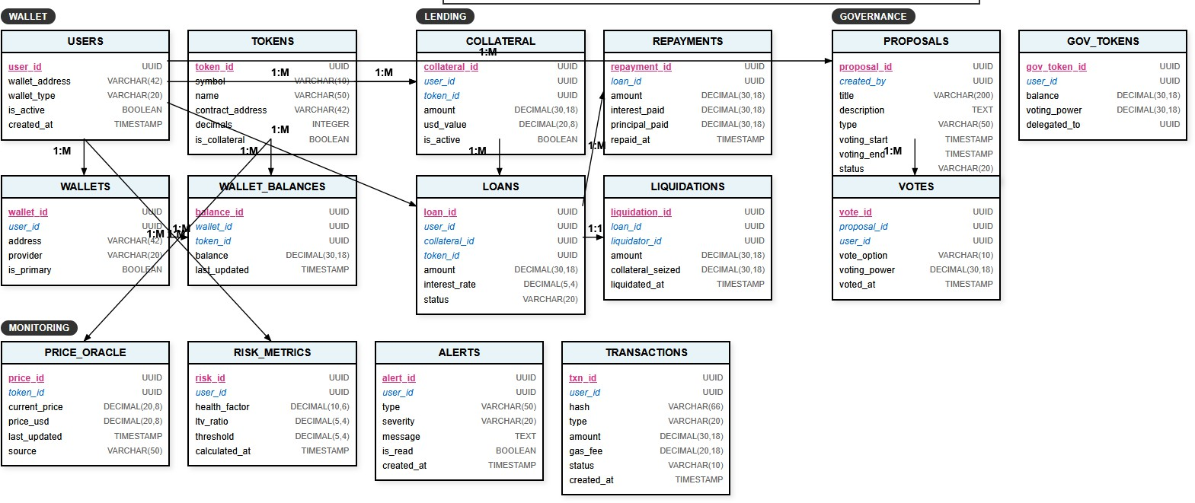
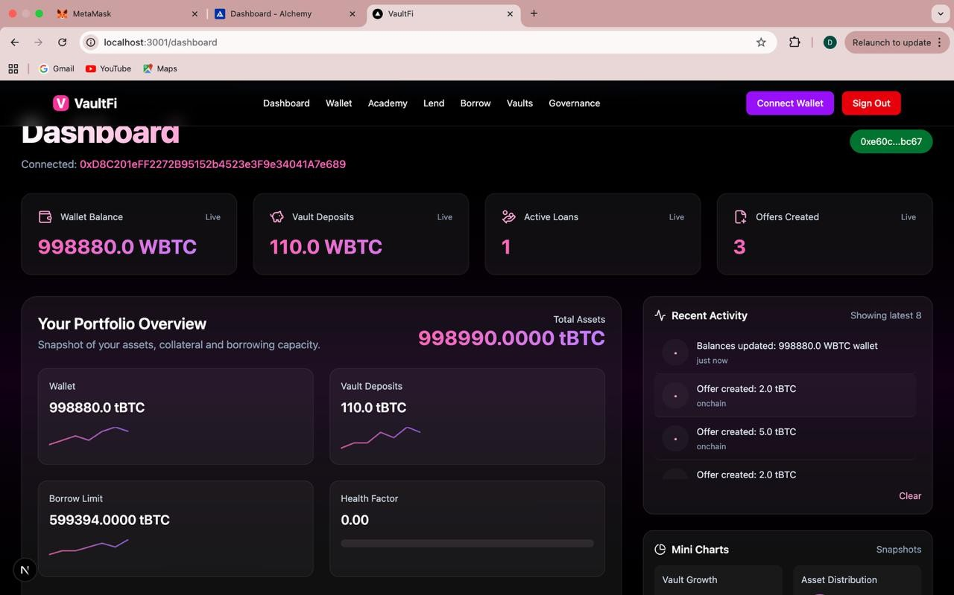
panel presents the user’s total assets, current borrow limit, and Health Factor, which is dynamically computed based on governance-defined risk parameters such as the loan-to-value ratio and liquidation threshold. A Recent Activity feed records on-chain events as they occur, while embedded Mini Charts visualize vault growth and asset distribution trends, giving users actionable insight into their financial position. Fig. 4 illustrates the dashboard interface.

Figure 2 Entity Relationship Diagram of VaultFi

ensuring standardized, audited security practices. The follow- ing subsections describe each implemented module, supported by interface previews of the working prototype.
A. Landing Page and Authentication
The platform entry point presents users with a navigation bar providing access to all core modules — Dashboard, Wallet, Academy, Lend, Borrow, Vaults, and Governance — along with wallet connectivity and account management options. The authentication layer implements a hybrid access model, supporting both traditional email-password registration and MetaMask-based wallet connection. This dual approach ac- commodates users across varying levels of blockchain famil- iarity. Upon successful authentication, users are redirected to the main dashboard where their on-chain data is fetched and rendered in real time via ethers.js calls to the deployed smart contracts. Fig 3 illustrates wallet connection and authentication interface
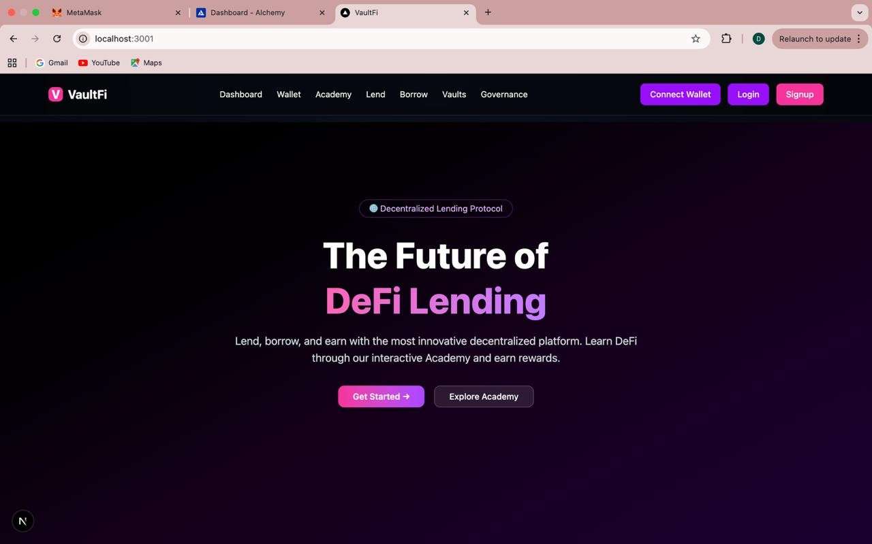
Figure 3 Wallet Connection and Authentication Interface

Figure 4 Dashboard Interface

C. Wallet Module
The Wallet Module interfaces directly with the user’s con- nected MetaMask wallet via ethers.js, retrieving and displaying token balances for Sepolia ETH and the platform’s TST token in real time. The module continuously monitors wallet connectivity status and reflects the active wallet address in the navigation bar throughout the session. This module is fundamental to user identity management and serves as the signing authority for all on-chain transactions executed within the platform. Fig. 5 shows the wallet interface.

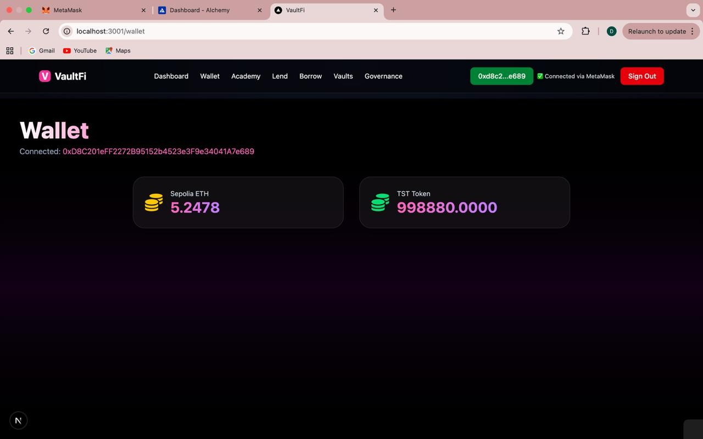
B. Dashboard
The dashboard serves as the central control panel of the platform, aggregating live blockchain data into a unified portfolio view. It displays key financial metrics including wallet balance, vault deposits, active loan count, and offers

D. Lend Module

Figure 5 Wallet Interface

created — all fetched directly from the LendingPool smart contract with live status indicators. A Portfolio Overview
The Lend Module enables liquidity providers to create lending offers by specifying loan parameters — amount in

TST tokens, interest rate, and duration — which are submit- ted on-chain via the LendingPool smart contract. An Active Lending Offers table renders all current offers fetched from the contract state, displaying lender address, amount, interest rate, duration, and action controls. This peer-to-peer lending model eliminates intermediaries, with all offer logic enforced transparently through smart contract code. (Fig 6)
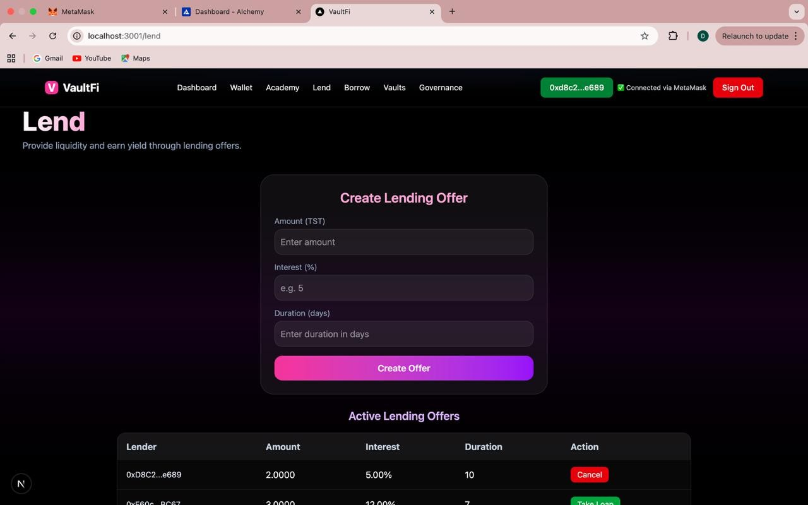
Figure 6 Loan Lending Interface

E. Borrow Module
The Borrow Module allows users to select from available lending offers and take loans against provided collateral. The interface enforces a minimum collateralize requirement of 150 percent, with the smart contract automatically validating collateral sufficiency before approving any loan. Upon loan creation, the contract generates an on-chain loan record and transfers the borrowed tokens to the user’s wallet. An active loans panel displays outstanding loan details including amount, interest, due date, and a repayment trigger, enabling borrowers to manage their debt positions directly from the interface. Chainlink Price Feeds supply real-time asset pricing to ensure accurate collateral valuation throughout the borrowing lifecy- cle.(Fig. 7).
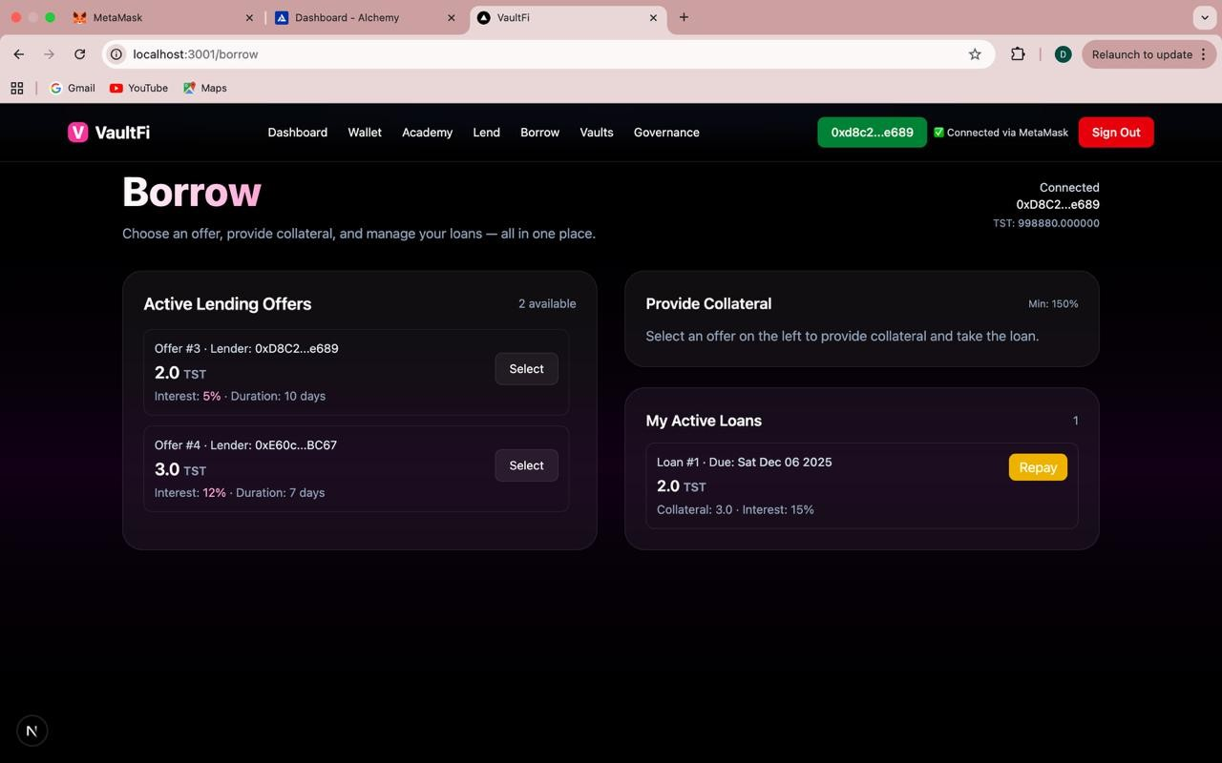
Figure 7 Borrow and Vaults Interface
F. Governance Module
The Governance Module implements decentralized protocol management through the DAOGovernance.sol smart contract. Any connected user may submit a governance proposal by providing a title and description, which is recorded on-chain. All active proposals are rendered with their current vote tallies and execution status. Voting transactions — For, Against, or Abstain — are signed via MetaMask and recorded on-chain in real time. Once a proposal achieves majority approval, an Execute button triggers automatic on-chain enforcement of the proposed change, such as adjusting vault withdrawal fees or mandating transparency reporting. This mechanism ensures that protocol evolution remains fully community- driven without reliance on any centralized authority.(Fig. 8).
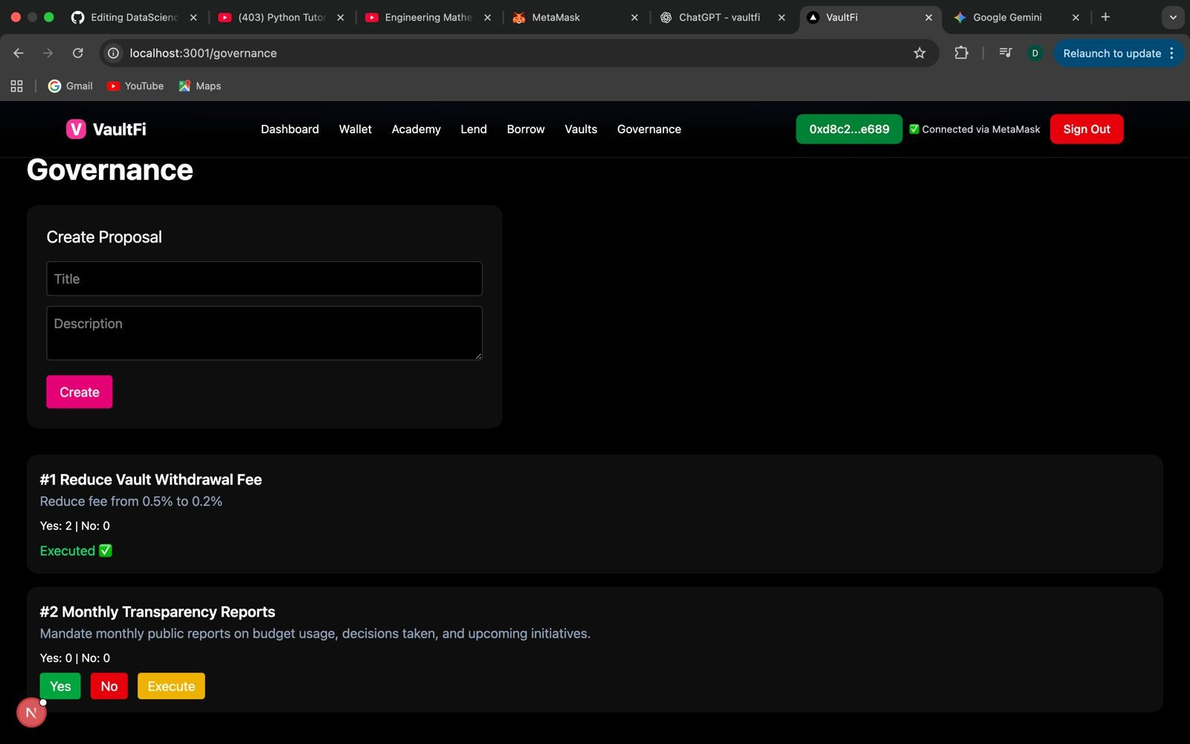
Figure 8 Governance Interface

- Results and Discussion
The implementation of VaultFi resulted in a functional governance-aware decentralized lending prototype deployed on the Ethereum test network, successfully integrating wallet authentication, collateral management, borrowing logic, on- chain governance, reputation tracking, and real-time moni- toring within a modular smart contract architecture. Wallet authentication via MetaMask enabled secure non-custodial access through cryptographically signed transactions. The col- lateral module handled asset deposits and calculated safety ratios using Chainlink price feeds, while the borrowing mech- anism accurately enforced Loan-to-Value (LTV) constraints — automatically rejecting transactions that exceeded permissible thresholds. Repayment cycles were validated successfully, with the system correctly updating balances and releasing collateral upon debt settlement. Governance-controlled param- eters, including LTV ratios and risk thresholds, responded correctly to on-chain proposals. Voting mechanisms updated proposal statuses dynamically, demonstrating transparent and tamper-resistant decision-making. The Health Factor module continuously recalculated collateral ratios using live oracle data and generated alerts when values approached liquidation thresholds, strengthening protocol resilience against under- collateralization. The ReputationSystem contract tracked user

activity across deposits, borrowing, repayments, and gover- nance participation, dynamically updating scores to incentivize responsible engagement. The React.js and ethers.js frontend delivered a responsive interface displaying portfolio balances, active loans, governance proposals, and reputation metrics in real time. Overall, the results validate VaultFi as a se- cure, governance-aware, and risk-managed lending prototype that achieves transparency, capital efficiency, and community- driven control while addressing key limitations of existing DeFi platforms.
- Conclusion
This paper presented VaultFi, a blockchain-based decen- tralized lending platform designed to address key limitations in existing DeFi systems. A literature survey of protocols such as Aave, Compound, and MakerDAO revealed persistent challenges including oracle manipulation, governance vul- nerabilities, liquidity instability, and capital inefficiency — issues that motivated VaultFi’s design. VaultFi integrates smart contract–driven lending logic, decentralized price feeds, DAO- based governance, and a reputation-based incentive system within a unified architecture. Experimental validation con- firms that Health Factor–based risk evaluation, governance- controlled parameters, and real-time oracle integration collec- tively enhance protocol stability, enforce Loan-to-Value con- straints, prevent over-borrowing, and enable dynamic response to market fluctuations. In conclusion, VaultFi demonstrates the feasibility of a governance-aware, risk-managed decentralized lending ecosystem that advances beyond current DeFi im- plementations. Future work may explore multi-asset support, cross-chain interoperability, advanced governance automation, and improved analytics to further strengthen protocol re- silience and accessibility.
- Future Scope
Future enhancements of VaultFi may focus on extending support to multiple digital assets to improve liquidity diver- sification and capital efficiency. The integration of AI-driven risk modeling can further optimize collateral thresholds and dynamic interest rate adjustments based on market conditions. Cross-chain interoperability may also be explored to enable seamless lending operations across different blockchain net- works.
In addition, advanced governance mechanisms such as reputation-weighted or delegated voting can strengthen decen- tralization and community participation. Formal verification of smart contracts and enhanced monitoring tools can further improve protocol security. These improvements would position VaultFi as a scalable, adaptive, and resilient decentralized lending framework within the evolving DeFi ecosystem.
Acknowledgment
We would like to express our sincere gratitude to our mentor and project supervisor for their guidance, support, and constructive feedback throughout this research. Their expertise and dedication were instrumental in bringing this work to
completion. We also thank the scholars whose published works informed and shaped our study. Any errors or shortcomings that remain are entirely our own.
References
- A. U. Sable, A. Patil, P. Nimbalkar, K. Pathare, and T. Rane, “Decentralized borrow and lending of crypto assets,” International Journal of Research Publication and Reviews, vol. 4, no. 5, pp. 4289–4295, 2023.
- B. Kaplan, V. F. Benli, and E. A. Alp, “Decentralized finance and new lending protocols,” PressAcademia Procedia, vol. 16, no. 1, pp. 192–195, 2023.
- A. Paliwal, “Analysis between different decentralized lending and borrowing protocols,” Journal of Business Ana- lytics and Data Visualization, pp. 15–23, 2022.
- K. Kosˇta´l, M. N. Bahar, R. Gazd´ık, and M. Ries, “Ad- vancing decentralized finance: A comprehensive pool-based liquidity protocol,” 2023.
- P. Bhadade, S. Chandak, R. Mohare, P. Dahake, and
K. Tolani, “Blockchain-driven decentralized finance (DeFi): Trends, contributions, and future research directions,” 2024.
- S. K. Hegde and R. Hegde, “An efficient and transparent financial transaction system using decentralized finance (DeFi) based on blockchain technology,” 2023.
- B. Khanchandani, M. Bhutada, V. Sachdev, B. Watwani, and D. Mane, “Decentralized finance lending with EZfinance: An implementation and analysis approach,” 2023.
- S. Naikwadi, A. Pandey, C. Patil, H. Parab, P. Patil, and D. Khachane, “DeFinance: Decentralised lending and borrowing of digital assets,” 2023.
- Finematics, “DeFi: Past, present and future,” [Online]. Available: https://finematics.com/defi-past-present-and-future/
- P. K. Ozili, “Decentralized finance research and devel- opments around the world,” Journal of Banking and Financial Technology, vol. 6, no. 2, pp. 117–133, 2022.

