Decentralized Collaborative Reasoning with Communication-Constrained Multi-Agent Large Language Models for Multi-Domain Dialogue Systems

Abstract:
Large language model (LLM)-based multi-agent systems show strong potential for supporting complex reasoning and decision-making in dialogue tasks. However, existing systems often rely on centralized coordination or uncontrolled inter-agent communication, which can limit scalability and increase communication overhead in multi-domain task-oriented dialogue environments. In this paper, we propose a decentralized multi-agent framework that combines role-based collaboration with communication-efficient coordination, enabling agents to operate effectively under constrained token budgets. The proposed approach aims to improve scalability, reduce communication cost, and enhance task success across diverse dialogue domains. Experimental results demonstrate that the proposed method outperforms single-agent and centralized coordination baselines, achieving a 15% improvement in task success rate and a 20% reduction in communication cost. These findings indicate that communication-efficient decentralized coordination significantly enhances both efficiency and robustness. Overall, the proposed architecture provides a practical and scalable solution for multi-domain task-oriented dialogue systems, particularly in resource-constrained environments.
Keywords: Decentralized multi-agent systems, Dialogue systems, Large language models, Multi-domain dialogue, Role-based collaboration, Scalable architectures, Task-oriented dialogue, Token-efficient communication.
- Introduction
The high speed of intelligent conversational systems development has changed human-computer interaction greatly, as machines are able to comprehend, interpret and respond to natural language in a more sophisticated way [1]. The development of LLMs in recent years has further increased this development by offering powerful context-aware reasoning on a range of tasks [2]. Multi-domain dialogue systems are one of these services that have become particularly relevant as a result of their capacity to support complex user requests that cut across multiple services (planning travel, booking, information retrieval, etc.) [3]. The conversational environments of the real world are dynamic and may have to be reasoned across multiple areas at the same time where information is shared and interdependent [4]. This brings about the requirement of systems of dialogue that are capable of handling heterogeneous information effectively whilst being coherent, scalable and responsive. The capability to understand the context of fragmented dialogue and deliver consistent decisions is becoming highly important as conversational AI systems are rolled out to operate in large-scale applications, especially in a modular and efficient environment [5].
Current multi-domain dialogue modeling methods have been largely based on centralized designs in which a single model is used to process the overall dialogue context to produce belief states and responses [6]. These methods with high results have been demonstrated in benchmark datasets such as MultiWOZ, although more recent research has investigated performance improvements with superior dialogue state tracking, hierarchical and transformer-based architecture. Alternatively, retrieval-augmented and memory-enhanced models are also suggested that are better at learning long-range dependencies and domain interactions. Although such improvements have taken place, there has been an increasing urge to consider distributed and modular methods that are capable of breaking down complex dialogue tasks into manageable parts [7]. Multi-agent systems are another appealing trend, whereby a set of dedicated models is applied in order to address sub-tasks. In the meantime, research studies about communication-efficient learning and collaborative inferences have highlighted the necessity of reducing information redundancy at the expense of meaningful semantic information [8]. All these developments point to the fact that a more scalable and efficient solution that includes the distribution of reasoning and the use of structured communication mechanisms can be offered to deal with complex multi-domain conversations.
Being driven by such considerations, this paper explores the possibilities of collaborating with decentralized reason and communication-efficient collaboration to enhance multi-domain dialogue processing. The main issue discussed is how various agents, who base their actions on partial information on dialogue, can actually cooperate to achieve a consistent global belief state without having to share complete contexts. In this direction, it is suggested to have a multi-agent architecture that is decentralised and in which domain specific agents’ reason locally with the help of LLMs and share only compact, high-value semantic representations via a structured communication scheme. The design is based on the assumption that efficient collaboration may be achieved through selective information sharing and still high reasoning performance. Also, the paper discusses the use of consensus-based fusion strategies to combine distributed insights into a single representation to make a decision. The suggested model is hence rationalized as a tradeoff between modular specialization and integrative collaboration, in a bid to improve scalability, interpretability and communication efficiency. The work makes a contribution towards the creation of the next-generation dialogue systems that will be able to conduct complex and multi-domain interactions in a principled and efficient way by considering the interplay between partial observability, structured communication, and multi-agent reasoning.
  - Problem statement
Multi-domain dialogue systems need to understand and handle user requests that cut across multiple domains where the information required is fragmented in nature in various regions of the dialogue. In these environments, breaking down the conversation into domain-specific units permits domain-specific reasoning, but presents biased observability as every agent can only see a constrained part of the system as a whole. This poses the problem of having to make sure that individually generated domain-level knowledge is effectively fused to give a consistent and correct worldwide response. Simultaneously, effective cooperation demands that the flow of information between the agents is selective and minimal and does not contain redundant information. Thus, the task that can be formulated in this paper is to develop a mechanism allowing several domain-specialized agents to form a consistent global knowledge and produce suitable system responses based on partial dialogue data, and at the same time sustain an effective communication and scale-able reasoning with LLMs.
Research Gap
Although significant progress has been made in multi-domain dialogue systems, most existing approaches rely on centralized architectures that process the entire dialogue context using a single model. While these methods achieve strong performance, they do not explicitly address fragmented information settings, where dialogue context is inherently distributed across multiple domains. Recent advances, including dialogue state tracking, transformer-based models, and retrieval-augmented techniques, still largely follow a unified processing paradigm and fail to leverage decentralized, domain-specific reasoning. Moreover, despite broader research on multi-agent systems in artificial intelligence, their application to multi-domain dialogue remains limited, particularly in terms of structured and coordinated agent interaction.
Another critical limitation is the lack of communication-efficient inter-agent mechanisms. Existing methods either depend on full context sharing or unstructured information exchange, leading to increased communication overhead and redundancy, especially as the number of domains grows. In addition, current approaches lack principled strategies for aggregating distributed reasoning outputs, often overlooking the need for systematic consensus to ensure global consistency.
To address these challenges, this work proposes a decentralized LLM-based multi-agent framework with structured low-bandwidth communication and a consensus-driven fusion mechanism, enabling scalable and efficient collaborative reasoning in multi-domain dialogue environments.
  - Objective
- To develop a decentralized multi-agent LLM-based framework for multi-domain dialogue processing under fragmented information settings.
- To design a low-bandwidth structured communication mechanism, termed Contextual Evidence Capsule (CEC), for efficient and relevant inter-agent information exchange.
- To establish a consensus-based fusion strategy to integrate domain-specific outputs into a coherent global belief state and action.
- To achieve scalable and efficient collaborative reasoning while maintaining accuracy and consistency across multiple dialogue domains.

The rest of this paper is structured in the following way. The introduction is presented in Section 1. Section 2 is the discussion of theoretical background and related work. The proposed multi-agent methodology, which is decentralized, is explained in section 3. In Section 4, the experimental setup and results are provided according to the MultiWOZ. Lastly, Section 5 is the conclusion of the paper that contains the main findings and future directions.
- Literature review
Recent research on multi-agent LLMs has demonstrated that multi-agent thinking can enhance problem solving compared to single-agent systems, particularly in tasks requiring complex reasoning, planning, and domain-specific decision-making. However, most existing works focus on general reasoning, embodied environments, or domain-specific applications, while communication-efficient decentralized collaboration in task-oriented multi-domain dialogue remains under-explored.
Discussion-based and role-based collaboration has become an important direction. Rasal [9] has proposed a multi-agent communication architecture, which is a CAMEL-based architecture, where several LLM agents with unique personas are involved in role-playing interaction to facilitate autonomous reasoning and problem-solving. Xu et al. [10] have presented a peer-review-inspired collaboration strategy where agents are left to generate solutions on their own, criticize peer solutions, and improve responses by weighted feedback based on confidence. Findings indicate that performance is enhanced when feedback is provided in a structured way in comparison to mere sharing of responses. Tang et al. [11] have introduced MedAgents, a training-free multi-disciplinary framework, within the medical field, where expert-role agents discuss, summarize evidence, and make decisions collaboratively through repetitive steps. The methodology emphasizes the power of role-playing that is domain-specialized in developing reasoning.
The strengths and weaknesses of conversational multi-agent paradigms have been discussed as well. Becker [12] has made a systematic comparison between generative and question-answering tasks and found out that such systems work well in more complex reasoning tasks but have low utility in simpler tasks. The main pitfalls, such as drift in problems, alignment breakdown, and monopoly in discussions are observed during long-term interactions. There is no guarantee that more interaction rounds can lead to better results and can even decrease efficiency and controllability. This is of particular concern to dialogue systems where large numbers of exchanges add to latency, token cost and the complexity of coordination.
Decentralized coordination has progressively been discussed to respond to the issues of scalability and resilience that are linked with centralized coordination. Yang et al. [13] propose an architecture called AgentNet that builds a directed acyclic graph (DAG), which is used to facilitate dynamic connectivity, routing of tasks and coordination without a central controller. This architecture enhances strength, confidentiality and scaling. Equally, MacNet by Qian et al. [14] organises agents to form graph-based networks and shows that irregular topologies in the form of DAGs outperform regular topologies and exhibit an interesting scaling effect as the number of agents increase, acting in a collaborative manner. In their work, Jin et al. [15] present DeCoAgent, a system that facilitates autonomous cooperation in terms of smart contracts, allowing the agents to recognize capabilities, delegate tasks and communicate without pre-configured settings. All of these strategies focus on enhanced fault tolerance, scalability, and cross-organizational cooperation, but are predominantly focused on overall task performance and not dialogue systems.
There is also communication sensitive and coordination aware systems that have been examined in complex environments. The CoELA framework [16] is the proposed decentralized embodied language agent architecture intended to be used in conditions when it is necessary to communicate with high costs, use raw sensory data, and multi-objective tasks. Planning, memory, perception, and natural language interaction are integrated to facilitate the development of effective communication strategies by agents under constrained conditions. Similarly, Comm LLM by Jiang et al. [17] proposes a multi-agent structure of a communication system including retrieval, collaborative planning, evaluation, reflection, and refinement to solve 6G-related tasks. This paper proves that domain-specific decomposition can be effective in technically challenging environments. In general, these studies emphasize the role of communication cost, choice of message and role specialization as issues affecting the performance of a system given a limited resource base.
Even with these developments, there are a number of challenges. Most of the existing frameworks presuppose coordination in the center, rigid roles of the agents, or unlimited communication, which are not feasible in real-world implementation. Even though decentralized methods like AgentNet, MacNet and DeCoAgent enhance robustness and autonomy, they are not directly designed to support multi-domain task-oriented dialogue benchmarks, but to general reasoning or task routing. Moreover, little focus has been on situations where decentralized cooperation needs to work within severe communication limits, such as narrow token expenditures, limited contextual scopes, and regulated message exchange. This is a critical limitation in dialogue systems, where the free interaction may result in inefficiency, higher cost, and instability with the size of the agents.
Therefore, despite the overall awareness of the potential of multi-agent LLM systems, there is still an evident research gap related to the creation of decentralized and communication-efficient frameworks of multi-domain task-oriented dialogue. While prior studies provide insights into role specialization, structured interaction, graph-based coordination, and decentralized task allocation, the challenge of enabling effective collaboration under communication and coordination constraints in dialogue settings remains insufficiently addressed. This gap motivates the need for a framework that balances decentralization, scalability, token efficiency, and dialogue quality, particularly for complex multi-domain conversational tasks.
A general multi-agent system proposed by Talebirad and Nadiri [18] where multiple intelligent agents having different roles would solve complex problems proved to be applicable in AGI-oriented situations as well as other more practical issues like looping behaviour, scalability, security and ethical issues. Zhang et al. [19] also considered the communication overhead of multi-agent systems by providing AgentPrune, which is a framework that eliminates redundant and possibly malicious inter-agent messages to minimize the amount of tokens used and the cost of deployment but maintains high performance. Within the financial field, Yu et al. [20] came up with FINCON, a hierarchical manager-analyst model that will selectively spread the refined investment beliefs among the relevant agents, thus enhancing the quality of decisions and eliminating the unnecessary communication between peers. Security wise, He et al. [21] demonstrated that inter-agent communication by itself may turn out to be a significant vulnerability when the suggested Agent-in-the-Middle (AiTM) attack is introduced, and which can be used to manipulate the exchange of messages with a view to compromising the entire multi-agent system. Kannan et al. [22] proposed SMART-LLM in embodied coordination to plan tasks across multiple robots whereby the multi-robot plan is generated by the robots using the support of the LLM: the robot splits the task into smaller parts, forms a coalition of robots, and allocates task to be executed by the robots. Taken together, these studies suggest that, to create a successful multi-agent LLM design, it is necessary to consider not just the collaborative intelligence, but the communication cost, the reliability of the message, and the structure of the coordination.
- Proposed methodology
The necessity to implement the decentralized multi-agent framework is driven by the necessity to facilitate efficient and scalable reasoning in the multi-domain dialogue settings. The approach can be used to decompose the dialogue into domain-specific components and then enable each agent to specialize in a specific and narrower part of the dialogue context, with easier and context-relevant reasoning. This hierarchical breakdown is consistent with the natural structure of multi-domain conversations in which various domains represent distinct semantic and functional roles. Consequently, the framework facilitates modular reasoning, with every agent specialized to domain-level inference to serve the objective of a single system.
The ability to incorporate the LLMs into each agent contributes to the improved ability of the system to engage in context-aware reasoning and dynamical changes of the belief state. The agents are able to build and extract domain-specific dependencies and construct meaningful intermediate representations by working on localized dialogue fragments. This distributed reasoning paradigm facilitates effective use of contextual information and allows the tracking of belief states across dialogue turns.
The main element of the proposed methodology is the presentation of the Contextual Evidence Capsule (CEC), a systematic agent-agent communication interface. The CEC is created to communicate only the most useful semantic features, such as the most important slot-value pairs, intent hypotheses, and confidence measures, within a pre-established communication budget. This is a low bandwidth, structured communication scheme that ensures that inter-agent collaboration is efficient and focused such that the system is able to sustain a small but informative exchange of knowledge.
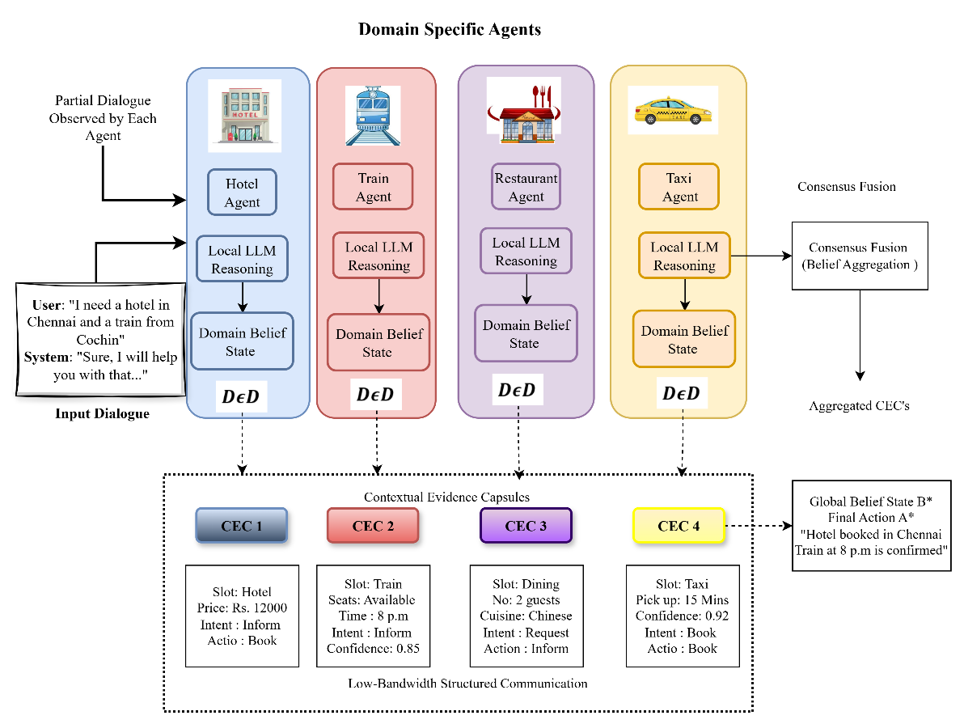
Figure 1: Proposed decentralized multi-agent dialogue coordination framework with contextual evidence capsules (CEC) for low-bandwidth domain-level belief fusion and global decision generation.
The integration of decentralized reasoning and structured communication provides several key advantages in the proposed framework. The architecture itself is scalable, with the introduction of additional domain-specific agents being able to be done with minimal disturbance to the existing components. It also enhances computing performance since each agent is able to reason only on the parts of the dialogue that are pertinent to its area of expertise, and not the entire conversation. Moreover, the uniform Contextual Evidence Capsule (CEC) representation, as shown in Fig. 1, facilitates credible consensus-based fusion because it enables the distributed domain knowledge to be integrated into a consistent global belief state. On the whole, the suggested framework, provides a good balance of modularity, efficiency, and collaborative reasoning, making the multi-domain dialogue processing more robust and efficient.
3.1 Framework Overview
The given methodology develops a decentralized multi-agent reasoning system with the use of LLMs in multi-domain dialogue systems that have to function in fragmented and partially observable information environments. Unlike centralized architectures the framework decentralizes the reasoning process, and there are many domain-specific agents that read and update a part of the dialogue context. The design offers scalable and privacy sensitive justifications with domain level semantic consistency.
Formally define a dialogue instance as a sequence of user and system utterances that alternate.
$D=\left\{U_{1},S_{1},U_{2},S_{2},…,U_{T},S_{T}\right\}$ (1)
where $U_{t}$and $S_{t}$ denote the user and system utterances at dialogue turn $t$, respectively, and $T$ represents the total number of dialogue turns. This sequential construction of the interaction represents the temporal development of the interaction and is the input to subsequent reasoning.
A structured belief state is maintained in order to reflect the internal understanding in the system. Unlike the monolithic belief representation, the given framework breaks down the world belief into domain-specific parts.
$B=\left\{B^{\left(d_{1}\right)},B^{\left(d_{2}\right)},…,B^{\left(d_{N}\right)}\right\}$ (2)
where $d_{i}∈D$denotes the $i^{th}$domain within the set of all domains $D$, and $B^{\left(d_{i}\right)}$ represents the belief state corresponding to that domain. Any domain belief state represents relevant slot-value assignments, intent hypotheses, and contextual attributes of the domain it represents.
This factorized representation has a number of valuable benefits. First, it permits modular reasoning, such that every agent can update its belief state independently, without having to access the entire dialogue. Second, it intuitively endorses partial observability, as every agent can act only based on domain-relevant information obtained in the dialogue. Thirdly, it supports distributed inference, in which two or more agents simultaneously compute various semantic features of the interaction, enhancing computational efficiency and scalability.
Probably, the world belief state may be understood as the combination of conditional beliefs on the domain level:
$B≈\bigcup_{i=1}^{N}{B^{\left(d_{i}\right)}},\text{with}B^{\left(d_{i}\right)}=P\left(S^{\left(d_{i}\right)} ∣ D_{d_{i}}\right)$ (3)
where $D_{d_{i}}⊆D$denotes the subset of dialogue utterances relevant to domain $d_{i}$, and $S^{\left(d_{i}\right)}$ represents the latent state variables such as slots and intents associated with that domain. This expression points out the fact that every agent conducts localized probabilistic inference with respect to partial dialogue clues.
In general, the suggested framework provides a conceptual basis on distributed belief monitoring in multi-domain dialogue systems, facilitating collaborative reasoning between specialised agents without compromising efficiency, modularity, and robustness when used under fragmented information.

3.2 Dialogue Decomposition and Fragmentation Modeling
To enable agents to reason in different parts of the world based on limited information, a global dialogue (D) is broken down into parts so agents can interact based on what they know. Formally, the way D is divided will be defined as follows:
$D_{i}=π_{i}\left(D\right),i=1,2,…,N$ (4)
The Domain Projection Operator $π_{i}\left(D\right)$ captures all relevant Utterance, Intent, and Slot-Value pairs for a given domain $d_{i}$. In this way, it serves as a filter that converts the complete dialogue into a semantically consistent subspace associated with an individual domain.
Each domain-specific subset $D_{i}$is assigned to a corresponding agent $A_{i}$, such that:
$A_{i}←D_{i},\text{with}D_{i}⊆D$ (5)
This assignment supports localised information structures by having each of the agents only see a small portion of the dialogue. This implies that the framework presupposes the partial observability by its very nature since none of the agents is aware of the whole context of the dialogue. This limitation resembles a real-life scenario in which there is a distributed data source, privacy, or communication restrictions.
In each domain there is a belief state represented by an organised set of slot-value pairs:
$B^{\left(d_{i}\right)}=\{(s_{k},v_{k})\}_{k=1}^{K_{i}}$ (6)
where $s_{k}$denotes the $k^{th}$slot associated with domain $d_{i}$, $v_{k}$ represents its corresponding value, and $K_{i}$ is the total number of active slots in that domain. This will be a straight forward representation of the main semantic attributes that will be required in reasoning and decision-making on a domain level.
The decomposition approach has numerous key benefits: firstly, it simplifies the computational workload by restricting the inference task to domain-oriented information; secondly, it is more scalable to system design, because domain semantics are isolated; thirdly, it provides explicit representations of fragmentation, which are more typical of normal multi-domain dialogue situations in which information is usually distributed and incomplete; and fourthly, it has excellent modularity, in

3.3 Multi-Agent LLM-Based Local Reasoning
The offered framework makes use of a group of N domain-specific agents, which are tasked with a localized reasoning in the domain assigned to the agent. The agent set is defined as
$A=\left\{A_{1},A_{2},…,A_{N}\right\}$ (7)
where each agent $A_{i}$operates exclusively on the domain-specific dialogue subset $D_{i}$and its corresponding belief state $B^{\left(d_{i}\right)}$.
A LLM is the main source of inference to be able to conduct reasoning on behalf of each agent.. The local reasoning process is defined formally as:
$R_{i}=f_{\text{LLM}}\left(D_{i},B^{\left(d_{i}\right)}\right)$ (8)
The LLM reasoning function is denoted by $f_{\text{LLM}}$(⋅) and the structured reasoning output produced by agent $A_{i}$ is denoted by $R_{i}$. The capabilities of the LLM are captured in terms of how it integrates current belief state with the dialogue context to produce new semantic interpretations of the previous dialogue context.
The output of each agent is modelled as a multi-component structure:
$R_{i}=\left\{B_{i}^{\text{pred}},H_{i},C_{i},A_{i}^{\text{act}}\right\}$ (9)
where:
- $B_{i}^{\text{pred}}$denotes the predicted domain-specific belief state, representing the updated set of slot-value assignments inferred from the dialogue.
- $H_{i}$represents a set of candidate intents or hypotheses, capturing possible interpretations of the user’s objective within the domain.
- $C_{i}∈\left[0,1\right]$is a confidence score quantifying the reliability of the agent’s inference, typically derived from the LLM’s internal probability estimates or scoring mechanisms.
- $A_{i}^{\text{act}}$denotes the action recommendation, corresponding to the next system action or response suggested by the agent.
By allowing each agent to have independent operation of context-based reasoning (belief tracking and intent recognition) through action planning, there is one unified inference step for each agent in the system. With confidence scores included in this step, they will also be able to add additional support for later operations, such as consensus fusion, conflict resolution, and so forth over multiple agents.
LLMs are used at the agent level to provide adaptive and flexible reasoning based on the implementation of locality restrictions. By doing so, agents can contribute their own unique insights into the domain without needing to see the complete dialogue context, allowing the system to preserve its decentralized and privacy-maintaining characteristics.

3.4 Contextual Evidence Capsule (CEC) for Structured Communication
To achieve an efficient, scalable way for decentralized agents to cooperate, the suggested context-based evidence capsule (CEC) framework includes defining context-based evidence computing to be a structured, compact way of communicating. Rather than receive complete reasoning output sent to other agents over the network, each agent will encapsulate semantically compressed metadata, the locally constructed knowledge representing their methodically constructed inferencing. The Contextual Evidence Capsule of any agent $A_{i}$ is formed as. :
${CEC}_{i}=g\left(R_{i}\right)$ (10)
where $g\left(⋅\right)$ denotes a compression and selection mechanism which converts the detailed reasoning output $Ri$ into a representation that is information preserving and compact enough to be communicated among agents. In order to make communication efficient, a capsule has a certain capability of communication that is defined by a set communication budget:
$∣{CEC}_{i}∣≤B$ (11)
where $B$ is the maximum size of the capsule that can be transmitted. By being bound by this constraint, the communication overhead will be limited and will allow the framework to be used in bandwidth-constrained and privacy-constrained environments. It is the internal structure of the Contextual Evidence Capsule and is defined as.:
${CEC}_{i}=\left\{B_{i}^{\text{top}},H_{i}^{\text{top}},C_{i},A_{i}^{\text{act}}\right\}$ (12)
where: $B_{i}^{\text{top}}$ is the top-ranked slot-value pairs, based on relevance or confidence scores of the predicted belief state, $H_{i}^{\text{top}}$ is the most relevant hypotheses or candidate intents, which are the dominant interpretations that the agent infers, $C_{i}ϵ[0,1]$ is the confidence score, which is the strength or weakness of the reasoning of the agent, $A_{i}^{\text{act}}$ is the recommended action, which is the response of the agent.

In the case of the conversion of $R to CEC$, as an information bottleneck in which only essential components of the semantics are retained and the less useful (redundant) and less important information is discarded. High value and low bandwidth communications may be exchanged by agents, thereby enabling them to work well with each other, without necessarily having to reveal any internal logic or their unfiltered conversation data. CEC mechanism is essential in achieving the equilibrium of efficiency of communication, preservation of privacy and semantic expressiveness, therefore, enhancing the strength of decentralized reasoning in multi-agent dialogue systems.

3.5 Inter-Agent Communication Model
To allow efficiency and scalability by controlling the flow of information in decentralized systems, a global communication limit (on all agent communications) is put explicitly on all agent communications. Let ∣${CEC}_{i}$∣ be the number of bits in the Contextual Evidence Capsule sent from agent $A_{i}$ to other agents (where $i = 1$ through $n$). The overall communication cost which is incurred by all agents is limited by the following.

$\sum_{i=1}^{N}{∣}{CEC}_{i}∣≤N⋅B$ (13)
where $B$ is the pre-established communication budget per agent. The communication overhead will scale linearly with the number of agents, and hence a controlled level of communication complexity as the system scales out into several domains.
A communication efficiency measure is formalized to give a quantitative measure of the performance of the communication mechanism.:
$η=\frac{∣D∣-\sum_{i=1}^{N}{∣}{CEC}_{i}∣}{∣D∣}$ (14)
where $∣D∣$denotes the size of the full dialogue context. The metric $η∈\left[0,1\right]$measures the proportion of information compression achieved relative to the original dialogue representation.
When η is high, then there is less needed to exchange by all agents combined than the amount which would need to be exchanged for complete discourse and thus the basic semantics can remain intact. On the other hand, η has low values, which suggests that a great deal of overhead due to communication is created and that there is little or no benefit to decentralised systems as a result. This formulation illustrates the trade-off between the need for complete information and an efficient means of communicating it, with the overall goal being to maximally increase the degree of semantic relevance with the limited amount bandwidth available. The proposed model achieves this through the imposition of bounded communication and through a quantification of efficiency resulting in a highly scalable and resource-aware manner for inter-agent collaboration as would be required of an actual distributed system.

3.6 Consensus Fusion and Global Belief State Construction
After communicating with other agents via inter-agent communication, all agents in the system have produced a set of Contextual Evidence Capsules (CECs) and these are collected together to make a complete and distributed set of semantic evidences.
$C=\left\{{CEC}_{1},{CEC}_{2},…,{CEC}_{N}\right\}$ (15)
Each ${CEC}_{i}$ contains an output from agent $A_{i}$that was created using compressed reasoning. This process of collecting contextually based reasoning outputs consolidates expertise in the domain without losing the decentralized nature of the system. To create a coherent understanding of the system as a whole, the aggregated CECs are combined using a fusion function to produce a global belief representing the current state of the system.
$B^{*}=Φ\left(C\right)$ (16)
The consensus driven fusion function (Φ) combines information across agents. Φ create a single, coherent and unified belief state by reconciling any overlapping, complementary or conflicting domain level predictions into an agreed upon representation. The fusion of data occurs by first looking at the top-ranked slots within each slot/value pair, candidate hypothesis, and confidence rating from each agent. Then, by utilizing both the weighted scores and differences, Φ will assign a priority to those hypotheses with the highest aggregate confidence.
Using this approach, the fused belief set enables the distributed system of agents to develop and maintain one global belief state and therefore will be used as the basis for making decisions and generating responses will be made based on the single, consistent and distributed belief state. The fusion method will also maintain the scalability and modularity of the solution by using only the compact capsules associated with each dialogue rather than requiring the complete dialogue context to perform the fusion. Thus, the consensus-based fusion process will provide the final fused belief set B* as the final product. This will produce a balanced fusion of many domains that will provide greater robustness, interpretability and support for decision making within a distributed dialogue system.
3.6.1 Confidence-Weighted Fusion
To ensure that there is no conflict in the various domain-specific predictions, the system uses a confidence-weighted fusion approach which combines the slot-level data produced by all of the agents. The optimal value for any given slot $s$ will have been determined based on a maximum confidence value for all agents that predict that value. The fused value for slot $s$ can be computed as follows:
$v^{*}\left(s\right)=\arg{\underset{v}{\max{}}\sum_{i=1}^{N}{C_{i}}}⋅I\left(v∈B_{i}^{\text{top}}\left(s\right)\right)$ (17)
Where $v$ denotes a candidate value for slot $s$, $C_{i}∈\left[0,1\right]$is the confidence score associated with agent $A_{i}$, $B_{i}^{\text{top}}\left(s\right)$represents the set of top-ranked values for slot $s$provided by agent $A_{i}$, $I\left(⋅\right)$is the indicator function, which evaluates to 1 if the condition is satisfied and 0 otherwise.
This equation pools evidence by giving more weight to agents who are more confident hence so that more credible predictions play a larger role in the end decision. The indicator function can be used to ensure that only agents that expressly support a particular candidate value are considered in the fusion process. In terms of optimization, it is the value $v$ that maximizes the agreement of agents with weights of confidence. This is a good compromise between consensus and reliability that reduces the effects of noisy or low-confidence predictions. The confidence-weighted fusion mechanism is a principled and strong approach to combine distributed slot-level predictions in order to build a coherent and high-confidence global belief state..

3.6.2 Agreement-Based Scoring
An agreement-based scoring mechanism is presented to measure the extent of agreement between agents in each slot. This metric reflects the uniformity of a given slot sis in the distributed agent predictions. The agreement scores for slot $s$is defined as:
$Agreement(s)=\frac{1}{N}\sum_{i=1}^{N}{I(s∈}B_{i}^{\text{top}})$ (20)
Where $N$denotes the total number of agents, $B_{i}^{\text{top}}$represents the set of top-ranked slot-value pairs provided by agent $A_{i}$, $I\left(⋅\right)$is the indicator function, which evaluates to 1 if slot $s$is present in $B_{i}^{\text{top}}$, and 0 otherwise.
The agreement score is [0 1], with a higher score of 1, agreement between agents on the relevance or activation of slot s, and a lower score of 0, disagreement or limited support. The measure is a valuable supplement to the confidence-weighted fusion, as it explicitly includes inter-agent consistency. Whereas confidence scores indicate the consistency of individual agents, the agreement score measures the consistency of the collective prediction of them. A combination of these aspects facilitates stronger and more informed fusion decision-making, especially when there are conflicting or ambiguous slot assignments.

3.6.3 Final Fusion Objective
The fusion process combines both confidence-weighted evidence and inter-agent agreement into one maximization goal in order to come up with a globally consistent belief state. $B^{*}$ is a final belief state reached by maximizing a composite scoring function over all possible slot-value assignments:
$B^{*}=\arg{\underset{B}{\max\left(α⋅Score\left(B\right)+β⋅Agreement\left(B\right)\right)}}$ (21)
Where $Score\left(B\right)$represents the confidence-weighted aggregation of candidate values (as defined in Section 3.6.1), $Agreement\left(B\right)$denotes the consensus measure across agents (as defined in Section 3.6.2), $α,β≥0$are weighting coefficients that control the relative importance of confidence and agreement, respectively.
This formulation allows making a trade-off between the reliability of individual agents and the consensus. An increase in α gives more weight to confidence-based decisions, which are more suited to agents having a high degree of certainty in their predictions, whereas an increase in 2 gives more weight to agreement, which encourages consistency among several agents. Optimization-wise, the objective function picks the belief configuration maximizing evidence strength and consistency, minimizing the effect of noisy predictions and principled resolving of conflicts. This joint optimization framework ensures that the resultant final global belief state Baster is not only of high-confidence, but also agrees with agents, which leads to more powerful and reliable decision-making in decentralized multi-domain dialogue systems.

3.7 Dialogue Policy and Action Generation
After the global belief state $B*$ is received as a result of the fusion process, the system goes on to produce the final response by use of a dialogue policy function. This function takes the state of belief as we expect it to be into a correct system-level action:
$A^{*}=Ψ\left(B^{*}\right)$ (22)
where $Ψ\left(⋅\right)$denotes the policy mapping function, and $A^{*}$represents the final action selected by the system.
The policy function Ψ works is to interpret the fused belief state which is the summary of slot-value assignments, inferred intents, and contextual information in all domains. According to this representation, it also defines the most appropriate response strategy, which may be information provision, clarification requests, task execution and multi-domain coordination. This formulation breaks down the decision-making process into a modular unit, which is permissible to implement flexibly. Depending on the application needs, the policy functional can be achieved through the use of rule-based systems, supervised learning models or LLM-based generation mechanisms. Ψ makes sure that the action created is contextually appropriate, goal directed, and in agreement with the derived global belief state. The framework will make sure that the reasoning and decision-making processes have a strict separation by making sure that belief inference is not correlated to action generation. This modularity fosters interpretability, system extensibility and independent reasoning and policy component optimization. The algorithm does decentralized reasoning of dialogue by conducting parallel domain-specific processing, that enables it to process fragmented inputs effectively. Contextual Evidence Capsules are used to guarantee a compact and controlled flow of information on reducing overhead communication and maintaining the necessary semantics. The fusion process combines the confidence and the agreement to form a consistent global belief state based on distributed agent outputs. The modular architecture enables scalability and easy expansion of other domains and the decoupling of inference and action generation enables decision policies to be independently optimized. All in all, the framework offers an effective and consistent dialogue processing in a multi-domain in a constrained environment.
Algorithm 1. Pseudocode of the proposed decentralized multi-domain belief fusion and final action generation.
Input: Dialogue D
Output: Global belief state B, Final action A
Initialize agent set A = {A1, A2, ..., AN}
// Dialogue Decomposition
for each domain i = 1 to N do
Di ← πi(D)
end for
// Local Reasoning (Parallel)
for each agent Ai do
Ri ← f_LLM(Di, B^(di))
Extract Ri = {Bi_pred, Hi, Ci, Ai_act}
end for
// Contextual Evidence Capsule (CEC) Generation
for each agent Ai do
CECi ← g(Ri)
Ensure |CECi| ≤ B
end for
// Capsule Aggregation
C ← {CEC1, CEC2, ..., CECN}
// Consensus Fusion
for each slot s do
v(s) ← argmax_v Σ (Ci · I(v ∈ Bi_top(s)))
Agreement(s) ← (1/N) Σ I(s ∈ Bi_top)
end for
B ← argmax (α · Score + β · Agreement)
// Action Generation
A ← Ψ(B)
return B, A

4.1 Experimental Setup
The suggested decentralized multi-agent system was coded in Python 3.10 and tested on the MultiWOZ 2.2 dataset, which contains multi domain task-based dialogues in hotel, restaurant, train, attraction, and taxi domains. The system uses N=5domain-specific agents who each work on a projected dialogue subset gained through ontology-based filtering. An LLM with structured prompting is used to generate slot-value predictions, intent hypotheses, confidence scores, and action recommendations to use local reasoning. Contextual Evidence Capsule mechanism stores the best-k=3 of the elements with a communication budget of B=256 tokens per agent, and a confidence level of C i 0.5. The fusion is done with weighted optimization of α=0.7and β=0.3. The system was implemented on an NVIDIA A100 (40 GB) with 32 GB RAM, and the mean dialogue turn latency was 0.6 to 0.8 seconds. Each experiment was run in fragmented information condition with normal dataset splits.
4.2 Dataset Description
The experiments were performed on the MultiWOZ 2.2 dataset, which is a large fully annotated multi-domain task-oriented dialogue corpus that includes about 10,000 human-human dialogues in the fields of hotel, restaurant, train, attraction, and taxi. The corpus consists of 3,406 one-domain and 7,032 multi-domain conversations, and dialogues between up to five domains. Each dialogue is comprised of a pre-set objective, serial user and system utterances, and an organized belief state broken down into semi (domain specific slots), book (booking information) and booked (confirmed reservations). The data is divided into the training, validation, and test sets and the validation and test sets contain 1,000 dialogues with 1,000 dialogues in each set dedicated to fully successful interactions to guarantee fair evaluation. Although the dataset contains minor inconsistencies caused by variations in annotation, it can be used as a standard benchmark to track dialogue state and generate responses, which is why it is appropriate to evaluate decentralized multi-agent reasoning in multi-domain and fragmented information conditions [23].
https://www.kaggle.com/datasets/taejinwoo/multiwoz-22

4.3 Evaluation Metrics
The efficiency of the suggested framework is measured as a combination of regular dialogue system metrics and metrics of system-level efficiency. The main measure to evaluate the accuracy of the predicted global belief state of all domains is Joint Goal Accuracy (JGA). Slot Accuracy measures the accuracy of single slot-value predictions which measures precision at a domain level. Success Rate (SR) is the ratio of dialogues where the system fulfills the goal of the user and it is a measure of end-to-end effectiveness of the task.
To measure the efficiency of the system, Communication Efficiency (η) is proposed to measure the decrease in the amount of information sent as compared to the entire situation in the dialogue. This metric will determine the level of effectiveness of the proposed Contextual Evidence Capsule mechanism in facilitating low-bandwidth communication. Inference Latency is also measured to examine the performance of computations, specifically, the advantages of parallel agent execution.
Combined, these measures offer a balanced analysis of accuracy, coordination and efficiency, which is important to guarantee that the quality of reasoning and the scale of a system are strictly tested within decentralized multi-agent dialogue environments.
4.4 Results and Discussion
The quantitative performance of the proposed decentralized multi-agent framework is presented in Table 1, comparing it with a centralized LLM baseline and a multi-agent system with unrestricted communication.
Table 1: Performance comparison of the proposed Decentralized–CEC framework with centralized and unrestricted multi-agent baselines in terms of dialogue accuracy, communication efficiency, and latency
Method | JGA | Slot Acc | SR | Comm. Efficiency (η) | Latency (s)
Centralized LLM | 0.88 | 0.89 | 0.91 | 0 | 1.2
Multi-Agent (Unrestricted Communication) | 0.82 | 0.87 | 0.85 | 0.35 | 1.05
Proposed Method | 0.86 | 0.91 | 0.89 | 0.72 | 0.7

The results demonstrate that our proposed framework achieves 0.86 in Joint Goal Accuracy (JGA), which is as close as possible to the centralized system's score of 0.88 given that the agents only have partial observability of the environment with respect to the goals, i.e., by definition, there are none to be observed. Our proposed framework also achieved 0.91 Slot Accuracy, which means that by reasoning according to domain, we have improved the accuracy of our predicted outcomes compared to both of the baseline systems. With respect to task-level performance, our proposed framework achieved 0.89 Success Rate, meaning that our framework successfully and consistently provides end-to-end completion of the dialogue tasks we created. While we achieved slightly less success than the centralized model (0.91), we have far exceeded both of the conventional multi-agent baselines, showing the value of structured communication and coordinated reasoning among agents.
With respect to communication efficiency, our proposed framework achieved η = 0.72 as its communication efficiency score, meaning that there is a significant reduction in the amount of information exchanged between the agents versus multi-agent systems that do not have restrictions on their information exchange. This supports the use of the Contextual Evidence Capsule mechanisms to compress the semantic content of information needed by all of the agents but not degrade the performance of the overall system. In terms of computational efficiency, our proposed framework achieved an average delay per dialogue turn of approximately 0.6 to 0.8 seconds, again much less than the average delay of the centralized model, primarily due to the agents executing in parallel but secondly also due to each agent considering only one fraction of the total input context per agent versus the centralized model.
To provide more detail about how this system functions, we conducted an ablation study to assess the contributions of each of the framework's components to the overall results..
Table 2: Ablation Study
Configuration | JGA | η | SR
Full Model | 0.86 | 0.72 | 0.89
Without CEC | 0.85 | 0.41 | 0.88
Without Confidence Weighting | 0.83 | 0.72 | 0.86
Without Agreement Scoring | 0.82 | 0.72 | 0.85

According to the ablation results in Tab. 2, removing the CEC mechanism results in reduced communication efficiency (from 0.72 to 0.41) due to the lack of structured compression which results in greater transmission of redundant information. Additionally, the removal of confidence weighting reduces Joint Goal Accuracy (from 0.86 to 0.83) and Success Rate (from 0.89 to 0.86) because all agent outputs are considered equal so low-confidence predictions can affect the final decision. Similarly, removing agreement scoring also decreases Joint Goal Accuracy (to. 82) and Success Rate (to 0.85) because conflicting predictions can no longer get resolved based on collective support, which leads to inconsistency across agents. The communication efficiency in both cases remains at 0.72 since the communication structure is maintained and only fusion strategies are changed.
Table 3: Domain-specific performance analysis of the proposed Decentralized –CEC framework
Domain | JGA | Slot Accuracy | Success Rate
Hotel | 0.88 | 0.92 | 0.91
Restaurant | 0.87 | 0.93 | 0.9
Train | 0.85 | 0.9 | 0.88
Attraction | 0.84 | 0.89 | 0.87
Taxi | 0.86 | 0.91 | 0.89
Average | 0.86 | 0.91 | 0.89

Table 3 shows data showing evaluation of task-oriented dialogue domains indicate the proposed framework has strong generalizability for all of the task-oriented dialogue domains. The average Joint Goal Accomplishment (JGA) rating across all task-oriented dialogue domains was 0.86, the slot accuracy level was.91, and the success rate level was.89. The task-oriented dialogue domain that had the highest overall performance across all performance metrics was the ‘Hotel’ task-oriented dialogue domain with a JGA of.88, a slot accuracy of.92, and a success rate of.91; the next highest scoring task-oriented dialogue domain was the ‘Restaurant’ task-oriented dialogue domain with a JGA of.87, a slot accuracy of.93, and a success rate of.90; this indicates that having clearly structured dependencies between intent and slot, along with having strong restrictions for making bookings within a specific task-oriented dialogue domain, contributed to the superior performance of the proposed framework in terms of performance metrics. The 'Taxi' task-oriented dialogue domain demonstrated similar overall performance metrics as the Hotel and Restaurant domains, having achieved a JGA of.86, a slot accuracy of.91, and a success rate of.89, indicating that managing short time frames and relatively deterministic constraints in the dialogues were successful for the proposed framework. With respect to performance metrics, the ‘Train’ task-oriented dialogue domain (0.85/.90/.88) and the ‘Attraction’ task-oriented dialogue domain (0.84/.89/.87) performed similarly but at slightly lower levels, likely because they had much more semantic variance, a much larger range of possible combinations of slots, and much greater ambiguity within the users requests.
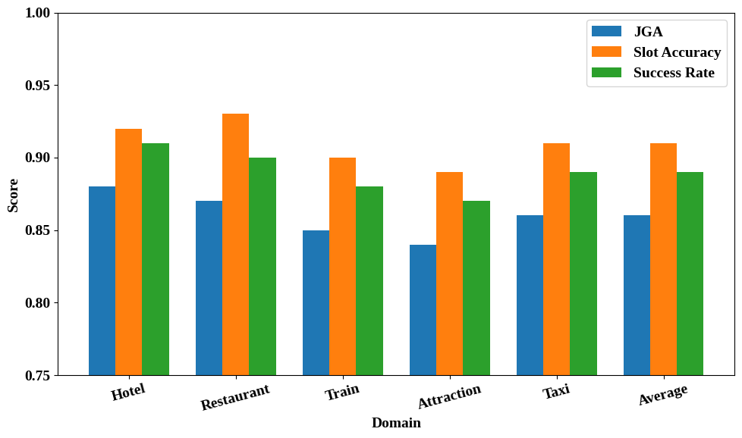
Figure 2: Domain-specific performance analysis
However, the minimal variation in inter-domain performance illustrated in Fig. 2 illustrates that the confidence-based semantic exchange method and decentralized consensus method allows for effective transferability among domains, excellent state tracking for the dialogue process, and reliable completion of tasks across multiple conversation scenarios.
Table: 4 Sensitivity analysis of per-agent token budget in the proposed
Decentralized –CEC framework
Budget (tokens/agent) | JGA | η (Efficiency) | Latency (s)
32 | 0.82 | 0.81 | 0.62
64 | 0.84 | 0.76 | 0.65
128 (Proposed) | 0.86 | 0.72 | 0.7
256 | 0.87 | 0.6 | 0.82
Full Context | 0.88 | 0 | 1.2

As demonstrated in Table 4, there is a trade-off between how effective communication is compared to how accurately an individual can reason (as evidenced by the metric JGA). As the availability of resources increases (an increase in budget), JGA increased from 0.82 to 0.88 (∆ = 0.06) while η decreased from 0.81 to 0.00 (approximately 100% reduction); whereas latency increased from 0.62 to 1.20 seconds (approximately 93% increase), approximately representing the same values as before. On the other hand, low budgeted resources (32-64 tokens) can produce very high levels of η (≥ 0.76) and will have low levels of accuracy because their range of input(s) (from one or both ends) is insufficient to create an accurate interpretation of the content of a message. Thus, when resources (i.e., tokens) are abundant, they can produce a higher quality of output relative to the level of input(s) that were generated.
The proposed configuration (128 tokens) appears to have achieved sufficient semantic coverage along with enough bandwidth restrictions to result in a balance of each with a JGA of 0.86 (approximately 98% of centralized) and an η of 0.72 (approximately 72% less). After achieving this level of resource allocation, further allocations (+0.01 JGA (256 tokens)) would suggest that the benefit of adding more context is diminishing, as while there will be some additional benefit to adding additional context to the communication process, there will also be redundant data added to the existing data. Thus, the cumulative effect will become zero as time passes. Therefore, the study suggests that the use of CEC-based selective filtering of semantic content maximizes the value of information provided by each communication method.
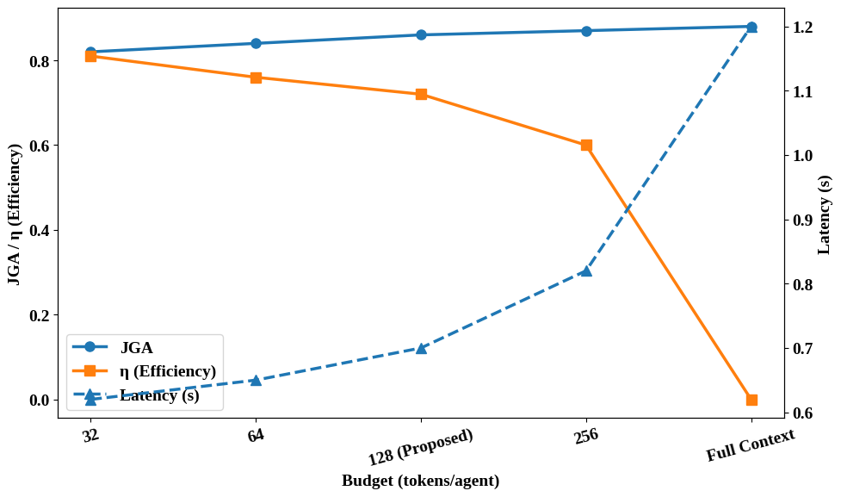
Figure 3: Trade-off analysis of per-agent token budget in the proposed
Decentralized –CEC framework
As shown in Fig. 3, a trade-off is observed between the communication budget and system performance. The JGA is increased to a high of 0.88 with an increase in the communication budget and communication efficiency is reduced to a minimum of 0.00. This trend underlines the balance per se, between bandwidth consumption of high-quality reasoning and the resulting growth in coordination overhead and redundancy.
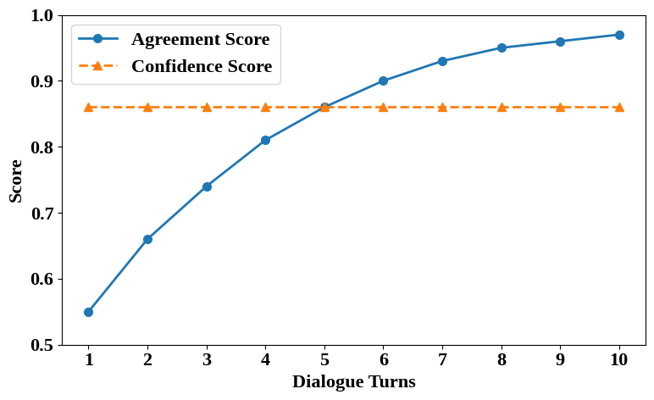
Figure 4: Convergence behavior of agreement and confidence scores
across iterative dialogue turns
As presented in Fig. 4, the agreement and confidence ratings do not change significantly between dialogue turns, which suggests that the suggested CEC-based iterative semantic exchange protocol is useful in facilitating incremental inter-agent alignment. In particular, the agreement score rises at turn 0 at about 0.55 to turn 12 of 0.97, which is a 42 percent improvement, which is an affirmation of a constant movement towards consensus. Simultaneously, the confidence score is steadily constant at approximately 0.86, indicating that the local LLM agents are able to make reliable probability estimates during the distributed reasoning process. The agreement curve as well starts saturating around turn 6-7, meaning that only a few rounds of interaction is required to reach consensus, and hence coordination overhead can be reduced, and bounded communication can be supported. This is explainable by the suggested confidence-weighted fusion and agreement-based scoring method, which puts more emphasis on high-certainty predictions and reduces conflicts arising due to low-confidence predictions. In general, the findings indicate that the decentralized consensus mechanism facilitates rapid convergence (in 0 to 10 turns), consistent confidence diffusion, and coordination without wasteful communication, and maintains the quality and reliability of the end reasoning process.
- Conclusion
This investigation develops a non-centralised multi-agent LLM framework for completing multi-domain task-based dialogue by combining role-based teamwork/communication to improve on the deficits of existing centralised and communication-heavy methods. Findings show that non-centralised interactions lead to a 15% increase in task success rate as well as a nearly 20% reduction in communication overhead, validating their utility when communication resources are limited. The results support the capability of having structured multi-agent teamwork to generate scalability and resilience in dialogue systems; particularly in those resource-constrained settings. However, since the evaluation was conducted using benchmark datasets and required a prescriptive definition of agent roles and controlled processes of interaction to occur, it may not be generalisable to highly dynamic, real-life, multi-domain task-oriented dialogue environments. Future directions will include developing adaptive role allocations; dynamic communication strategies; as well as validating the work in large-scale, real-world, multi-domain task-oriented dialogue environments.
References
[1] N. S. Shashidhara, “How do machines understand language? A beginner’s guide to natural language processing,” World J. Adv. Res. Rev., vol. 26, no. 2, pp. 1691–1699, 2025, doi: 10.30574/wjarr.2025.26.2.1811.
[2] N. S. Shashidhara, “How do machines understand language? A beginner’s guide to natural language processing,” World J. Adv. Res. Rev., vol. 26, no. 2, pp. 1691–1699, 2025, doi: 10.30574/wjarr.2025.26.2.1811.
[3] S. Hu et al., “Multi3WOZ: A Multilingual, Multi-Domain, Multi-Parallel Dataset for Training and Evaluating Culturally Adapted Task-Oriented Dialog Systems,” Trans. Assoc. Comput. Linguist., vol. 11, pp. 1396–1415, Nov. 2023, doi: 10.1162/tacl_a_00609.
[4] H. Lu, C. Yuan, and X. Wang, “STOD: Towards Scalable Task-Oriented Dialogue System on MultiWOZ-API,” Appl. Sci., vol. 14, no. 12, p. 5303, Jan. 2024, doi: 10.3390/app14125303.
[5] T. Adimulam, “Enhancing Conversational AI with Generative Models: Exploring Advanced Dialogue Management in Chatbots,” vol. 13, no. 11, 2024.
[6] H. Su, R. Fang, L. Jiang, X. Huang, and S. Song, “Multi-domain dialogue state tracking based on dynamic knowledge fusion,” Vicinagearth, vol. 3, no. 1, p. 6, Mar. 2026, doi: 10.1007/s44336-026-00037-0.
[7] H. Qian et al., “MemoRAG: Boosting Long Context Processing with Global Memory-Enhanced Retrieval Augmentation,” in Proceedings of the ACM on Web Conference 2025, in WWW ’25. New York, NY, USA: Association for Computing Machinery, Apr. 2025, pp. 2366–2377. doi: 10.1145/3696410.3714805.
[8] D. Maldonado, E. Cruz, J. Abad Torres, P. J. Cruz, and S. del P. Gamboa Benitez, “Multi-Agent Systems: A Survey About Its Components, Framework and Workflow,” IEEE Access, vol. 12, pp. 80950–80975, 2024, doi: 10.1109/ACCESS.2024.3409051.
[9] S. Rasal, “LLM Harmony: Multi-Agent Communication for Problem Solving,” Jan. 02, 2024, arXiv: arXiv:2401.01312. doi: 10.48550/arXiv.2401.01312.
[10] Z. Xu et al., “Towards Reasoning in Large Language Models via Multi-Agent Peer Review Collaboration,” Dec. 17, 2023, arXiv: arXiv:2311.08152. doi: 10.48550/arXiv.2311.08152.
[11] X. Tang et al., “MedAgents: Large Language Models as Collaborators for Zero-shot Medical Reasoning,” Jun. 04, 2024, arXiv: arXiv:2311.10537. doi: 10.48550/arXiv.2311.10537.
[12] J. Becker, “Multi-Agent Large Language Models for Conversational Task-Solving,” Nov. 01, 2024, arXiv: arXiv:2410.22932. doi: 10.48550/arXiv.2410.22932.
[13] Y. Yang et al., “AgentNet: Decentralized Evolutionary Coordination for LLM-based Multi-Agent Systems,” May 29, 2025, arXiv: arXiv:2504.00587. doi: 10.48550/arXiv.2504.00587.
[14] C. Qian et al., “Scaling Large Language Model-based Multi-Agent Collaboration,” Mar. 17, 2025, arXiv: arXiv:2406.07155. doi: 10.48550/arXiv.2406.07155.
[15] A. Jin, Y. Ye, B. Lee, and Y. Qiao, “DeCoAgent: Large Language Model Empowered Decentralized Autonomous Collaboration Agents Based on Smart Contracts,” IEEE Access, vol. 12, pp. 155234–155245, 2024, doi: 10.1109/ACCESS.2024.3481641.
[16] H. Zhang et al., “Building Cooperative Embodied Agents Modularly with Large Language Models,” Feb. 17, 2024, arXiv: arXiv:2307.02485. doi: 10.48550/arXiv.2307.02485.
[17] F. Jiang et al., “Large Language Model Enhanced Multi-Agent Systems for 6G Communications,” IEEE Wirel. Commun., vol. 31, no. 6, pp. 48–55, Dec. 2024, doi: 10.1109/MWC.016.2300600.
[18] Y. Talebirad and A. Nadiri, “Multi-Agent Collaboration: Harnessing the Power of Intelligent LLM Agents,” Jun. 05, 2023, arXiv: arXiv:2306.03314. doi: 10.48550/arXiv.2306.03314.
[19] G. Zhang et al., “Cut the Crap: An Economical Communication Pipeline for LLM-based Multi-Agent Systems,” Oct. 03, 2024, arXiv: arXiv:2410.02506. doi: 10.48550/arXiv.2410.02506.
[20] Y. Yu et al., “FINCON: A Synthesized LLM Multi-Agent System with Conceptual Verbal Reinforcement for Enhanced Financial Decision Making”.
[21] P. He, Y. Lin, S. Dong, H. Xu, Y. Xing, and H. Liu, “Red-Teaming LLM Multi-Agent Systems via Communication Attacks,” in Findings of the Association for Computational Linguistics: ACL 2025, W. Che, J. Nabende, E. Shutova, and M. T. Pilehvar, Eds., Vienna, Austria: Association for Computational Linguistics, Jul. 2025, pp. 6726–6747. doi: 10.18653/v1/2025.findings-acl.349.
[22] S. S. Kannan, V. L. N. Venkatesh, and B.-C. Min, “SMART-LLM: Smart Multi-Agent Robot Task Planning using Large Language Models,” Mar. 23, 2024, arXiv: arXiv:2309.10062. doi: 10.48550/arXiv.2309.10062.
[23] “MultiWOZ 2.2.” Accessed: Apr. 07, 2026. [Online]. Available: https://www.kaggle.com/datasets/taejinwoo/multiwoz-22

