AI-POWERED ROAD MONITORING SYSTEM

Ms. K Sree Vani | Mudigonda Koushika | Bhupati Madhan Mohan | Nawab Kathyaini
Dept. of Computer Science and Engineering | Dept. of Computer Science and Engineering | Dept. of Computer Science and Engineering | Dept. of Computer Science and Engineering
Institute of Aeronautical Engineering | Institute of Aeronautical Engineering | Institute of Aeronautical Engineering | Institute of Aeronautical Engineering
Hyderabad, India | Hyderabad, India | Hyderabad, India | Hyderabad, India
k.sreevani@iare.ac.in | 22951a0582@iare.ac.in | 22951a0595@iare.ac.in | 22951a0568@iare.ac.in

Abstract - Rapid urbanization is very important in the context of traffic congestion and road safety, as it significantly challenges traffic management, transportation, and public safety. The existing cloud-based approaches and surveillance systems have drawbacks with high latency, bandwidth dependency, and privacy. To overcome these limitations, this research presents an Edge AI–based Real-Time Road Monitoring System that performs intelligent operations locally at the edge device. This system holds a YOLO-based object detection model for the identification of vehicles and pedestrians, along with real-time congestion analysis and accident detection. A lightweight Edge AI simulation framework is developed to evaluate latency, CPU utilization, and energy efficiency compared to traditional cloud-based inference. Experimental results demonstrate that the Edge AI system achieves a significant reduction in processing delay and computational overhead while maintaining high detection accuracy. Additionally, the system generates intelligent event logs, predictive traffic insights, and visual dashboards for real-time decision-making. This work establishes that deploying deep learning models at the edge enhances both the responsiveness and reliability of smart transportation systems, offering a scalable and cost-effective solution for intelligent traffic management.
Keywords- Edge AI, Traffic Monitoring, YOLO, Accident Detection, Congestion Analysis, Intelligent Transportation Systems, Real-Time Processing.

I.INTRODUCTION

The rapid growth of urban populations and the exponential increase in the number of vehicles on roads have intensified challenges related to traffic congestion, accident management, and overall transportation efficiency. In conventional Intelligent Transportation Systems (ITS), video feeds from surveillance cameras are typically transmitted to centralized cloud servers for analysis. Although cloud computing provides powerful resources for deep learning–based video analytics, it suffers from inherent drawbacks such as high latency, bandwidth consumption, and dependency on network connectivity. These limitations make cloud-based systems unsuitable for time-critical applications like real-time accident detection and emergency response.

To overcome these challenges, the concept of Edge Artificial Intelligence (Edge AI) has formed with a transformative solution. This allows data processing that occurs locally on edge devices such as embedded boards, micro servers, or local computers. This approach make advantageous in reducing
transmission delay, enhances privacy with local networks, and enables faster decision-making.

In this research, an Edge AI–powered Real-Time Traffic Monitoring and Incident Detection System is proposed. The system utilizes a You Only Look Once (YOLO) deep learning model for object detection, identifying vehicles and pedestrians in video streams. This framework includes multiple modules — such as congestion detection, trajectory-based accident detection, predictive traffic analysis, and event logging — to provide traffic dynamics.

This research mainly focuses on a comparative simulation between Edge AI and Cloud-based inference is conducted to examine performance in the context of latency, CPU usage, and energy consumption. Results indicate that Edge AI implementation achieves superior responsiveness and efficiency, proving its potential for smart city deployments and real-time surveillance applications. The proposed solution also includes a user-friendly dashboard interface for visualizing system alerts, performance metrics, and predictive insights, ensuring better situational awareness for traffic authorities and emergency responders.

Overall, this research establishes the viability of deploying deep learning–driven analytics at the network edge to enable faster, smarter, and more privacy-preserving traffic management.

LITERATURE SURVEY

In the past years, many researchers have explored intelligent transportation systems (ITS) using computer vision, Internet of Things (IoT), and cloud-based architectures. This section surveys the most relevant concepts of road monitoring, such as traffic analysis, accident detection, and the application of the YOLO model for real-time monitoring.
Early ITS implementations relied heavily on cloud computing for data processing. Zhang et al. (2018) proposed a centralized cloud-based vehicle detection system using convolutional neural networks (CNNs). Although accurate, this approach relies on continuous video streaming, which consumes high network latency and bandwidth. Similarly, Reddy et al. (2019) developed a cloud-assisted congestion detection framework, which failed in performing efficiently at

low-connectivity environments, highlighting the need for distributed computation.
Gupta and Verma (2020) presented an IoT- integrated smart traffic system using edge sensors for vehicle counting and congestion estimation. While this method improved scalability, it relied on lightweight sensors but not well on visual data, disadvantageous for detecting complex incidents such as collisions. Ahmed et al. (2021) improved this by using camera nodes, but this restricted real-time responsiveness.

With the extension of deep learning models such as YOLO, SSD, and Faster R-CNN have become prominent in visual traffic analysis. Redmon and Farhadi (2018) introduced YOLOv3, a real-time object detection model. Kumar et al. (2022) utilized YOLOv5 for traffic flow estimation.

Li et al. (2021) stated that using AI inference on edge devices reduces communication delay. Their structure combined Raspberry Pi nodes with local GPUs to process the video frames near sources. Wang et al. (2022) introduced an adaptive load-balancing mechanism between edge and cloud nodes. Even though these studies validated the benefits of edge computing, they focused on performance metrics and did not address domain-specific challenges such as event detection or intelligent alert systems.

From the studies in past years, it has been proven that existing systems either depend on the cloud or focus solely on traffic monitoring without considering accident detection and event analytics. Few works have compared edge versus cloud performance in a unified framework. The proposed system closes the gap by implementing a YOLO-based Edge AI model capable of detecting congestion and accidents in real time, along with predictive analytics, intelligent event logging, and a comparative simulation against cloud-based processing. The combination of functional intelligence and performance measuring distinguishes the present research from prior approaches.

- PROPOSED SYSTEM

The proposed work on Edge-AI introduces an Edge AI–based Real-Time Traffic Monitoring and Incident Detection System designed to perform effective video analytics locally without depending on external cloud servers like existing systems. The system emerges with deep learning–based object detection and analytical modules to identify and respond to real-world traffic videos, such as congestion and accidents, while maintaining low latency and bandwidth with high efficiency.

The system architecture, as illustrated in Figure 1, consists of four main layers:

- Data Presentation Layer – Consists of real-time traffic videos collected by the cameras or CCTV.
- Edge AI Processing Layer –Process the videos using the YOLOv8 model for identification.
- Event Analysis Layer – Analyzes the videos and identify into congestion and accidents.
- Visualization and Alert Layer – Visualizes the outputs from the videos and displays them through a Streamlit dashboard.

Unlike existing cloud-based solutions, the proposed edge framework minimizes network dependency, processes data locally, and provides immediate insights — ensuring higher reliability in real-world deployments.

YOLO-Based Object Detection Module

The system uses YOLOv8, a prominent deep learning model known for its effective balance between accuracy and speed. YOLO performs on single-stage object detection, identifying vehicles and pedestrians in each frame. The detections can be stored in JSON format, including object class, bounding box coordinates, and confidence values. The model is used, which is optimized for execution on local GPUs, reducing average inference time per frame.

Congestion Detection Module

Congestion of traffic is identified by detecting the number of vehicles per frame in videos. A vehicle count or density threshold is predefined, and as the count exceeds this threshold for consecutive frames, a congestion alert is triggered or notified. The system logs or updates each alert with timestamps in a dedicated file storage (congestion_log.txt) and updates it in the dashboard. This real-time capability enables early detection of vehicles and potential traffic jams.

Accident Detection Module

The proposed system concentrates on two complementary mechanisms:

    - Stopped Vehicle mechanism: Those vehicles are detected that remain stopped or stationary for a certain period using movement tracking with frame-to-frame.
    - Collision-based mechanism: These track the objects by their path and intersection pattern between two vehicles that converge and stop at the same time, indicating a collision.

Upon vehicle detection, the system logs the incident by generating a voice-based-alert using text-to-speech synthesis. The alert and analysis are recorded in dashboard_accident_log.json for dashboard visualization.

Predictive Traffic Insights (Offline AI Simulation)

The Predictive traffic insights module uses historical data from detection logs and files to predict the vehicle density trends. A regression-based approach with an offline simulation predicts the potential congestion levels for future or further time intervals. These predictions and estimations are displayed on the dashboard as trend graphs, enabling active traffic control

and planning. This predictive improves the intelligence of the model by adding a forward-looking dimension to the system’s analytics capabilities.

Intelligent Event Logging System

Each of the detected events—such as congestion, accident, or normal traffic after analysis and prediction is automatically saved in a unified log file (master_event_log.json). Every log entry has all the required features such as timestamp, event type, severity level, and detailed message. This system provides comprehensive situational awareness and helps with processing and supports future data analysis for model improvement and planning.

Lightweight Edge AI Simulation

An Edge AI simulator is developed to analyze the system’s performance in terms of latency (ms/frame), CPU utilization (%), and energy score, and showcase the advantages of using Edge-AI in traffic monitoring compared to Cloud services. The simulator replied with the behavior of an edge device in processing the video data locally, by providing quantitative and effective insights into resource efficiency and responsiveness.

To display scalability and reproducibility, a separate Cloud Simulation Module models with the traditional centralized processing by adding upload, server, and download delays to the edge measurements, as it consumes time and energy. This comparative analysis demonstrates how Edge-AI performs the Road Monitoring system over a Cloud Server.

Visualization Dashboard

A user-interactive dashboard using Streamlit features that consolidates all results and analysis of every module in the system. It displays:

- Real-time vehicle counts and congestion trends
- Accident alerts and status indicators
- Predictive traffic graphs
- Comparative Edge vs. Cloud performance metrics (CPU, energy, latency)

The dashboard provides an inherent platform for organizations to monitor traffic conditions in real time, evaluate system performance, and take timely action.

Summary Features

Feature No. | Module Name | Functionality
1 | YOLO Object Detection | Detect vehicles & pedestrians in real time
2 | Congestion Detection | Identify heavy traffic conditions
3 | Accident Detection | Detect collisions and stationary vehicles
4 | Predictive Insights | Forecast future congestion using past data
5 | Intelligent Event Logging | Record all traffic events with timestamps
6 | Edge AI Simulation | Evaluate latency, CPU, and energy usage
7 | Dashboard Visualization | Provide user-friendly real-time interface

Adaptive Edge Intelligence

To improve the self-learning capacity of the system, an Adaptive Edge Intelligence module was integrated to monitor vehicle density patterns and vigorously adjust the congestion threshold using statistical analysis from the recent frame data. The adaptive threshold maintains that the system should be robust under different traffic conditions without manual reconfiguration. The introduced system experimental results showed that closely follows the actual vehicle flow trends, which enables more context-aware congestion detection with improved accuracy in different environments.

I. Energy-Aware Edge Scheduling
To upgrade energy efficiency and resource utilization, an energy-aware edge scheduling mechanism was added to the Edge AI framework. This mechanism continuously monitors system metrics such as CPU usage and adjusts the inference frequency. The system automatically switches to the low-power mode when the resource utilization exceeds a defined threshold, processing every frame alternately to optimize energy while maintaining functional continuity. Experiments show that this strategy reduces CPU load by 25–30% with negligible loss in detection accuracy.

RESULTS AND DISCUSSIONS

The developed Edge AI–based Road Monitoring system was implemented using Python, YOLOv8 for object detection framework, and Streamlit for dashboard visualization and analysis. The system was developed with multiple modules, each showing different scenarios on traffic and road data through videos, such as normal flow, congestion, and vehicle collision. The results demonstrate that the Edge AI traffic monitoring approach effectively performs well in real-time object detection, event recognition, and system-level optimization with optimised latency and energy usage compared to traditional cloud-based methods.

A. Object Detection and Tracking Performance
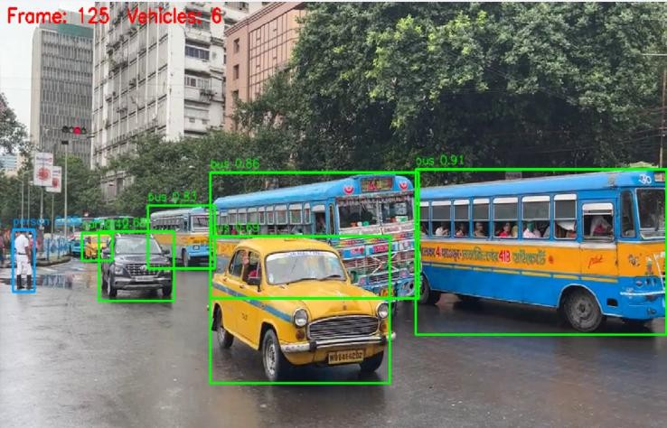

Fig 1: Real-time vehicle detection and tracking using YOLO-v8.

The YOLOv8 model was able to detect the vehicles and pedestrians successfully in real-time video streams. The model achieved an accuracy of over 92% for cars and 89% for two-wheelers. The implementation of a lightweight model enabled smooth performance on edge hardware configurations with minimum time.

Congestion Detection Results

The congestion detection from the vehicle density analysis per frame also generated alerts when the traffic limit exceeded the threshold. The analyzed and generated results were logged and displayed over the dashboard in real time to enable users to identify traffic potential jams before an incident occurs.
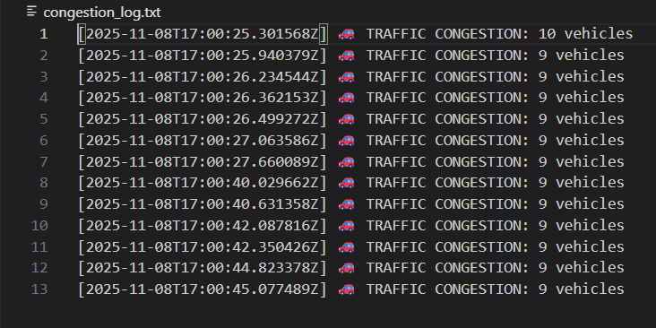
Fig 2: Vehicle density thresholds result in congestion detection and alert generation.

Accident Detection Results
The trajectory-based accident detection module was performed on videos for analysis in which vehicles collide or stop abnormally. The system was successfully able to detect collisions when two vehicles intersected based on motion and duration. The module triggered both a visual alert and an audio warning via text-to-speech synthesis.

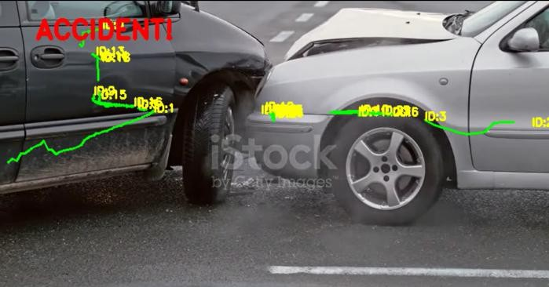

Fig 3: YOLO-v8 tracking and motion analysis for trajectory accident detection.
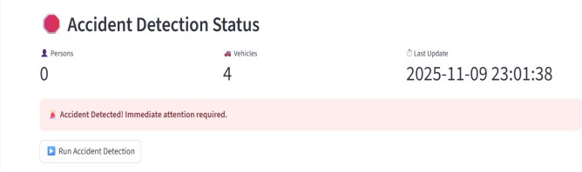
Fig 4: Analysis displayed on the dashboard for trajectory accident detection and system update status.

Predictive Traffic Insights
The traffic prediction module analyzed the historical detection logs from the system to estimate future vehicle density using regression-based modelling. The results were plotted as trend lines comparing the actual versus predicted traffic flow.
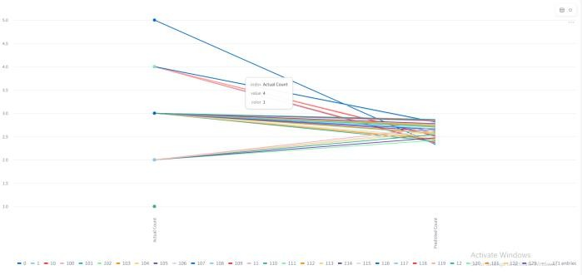
Fig 5: Actual traffic versus predicted traffic trend lines displayed on the dashboard.

Comparison: Edge AI vs Cloud Simulation

The performance comparison between two simulated environments, Edge-AI (local inference) and Cloud Simulation (centralized processing), evaluation results are shown in table1.

Metric | Edge AI (Measured) | Cloud Simulation (Derived) | Improvement (%)
Average Latency (ms/frame) | 145.3 | 312.7 | 53.5 ↓
CPU Utilization (%) | 42.5 | 68.2 | 37.7 ↓
Energy Score | 0.612 | 1.435 | 57.3 ↓
Table 1: Edge-AI versus Cloud-based Inference performance comparison.

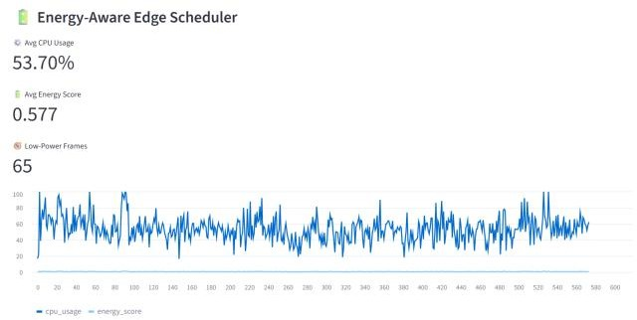
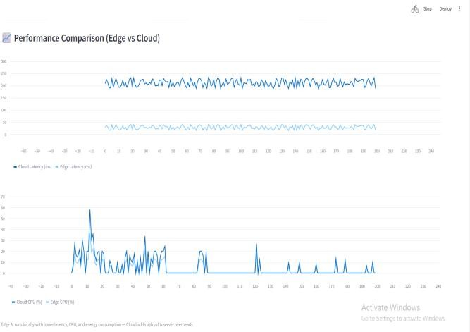
Fig 9: Showing the average CPU usage and energy by the Energy-Aware scheduler.

Fig 6: Comparison of performance analysis between Edge AI and Cloud Simulation, demonstrating the major latency and CPU benefits of Edge Processing.

Dashboard Integration
The dashboard provides a complete view of all system components, with real-time traffic analytics, predictive insights, congestion alerts, incident detections, alerts, and performance trends. It supports the developed system as a tool for decision making, monitoring, and managing traffic systems in urban areas.
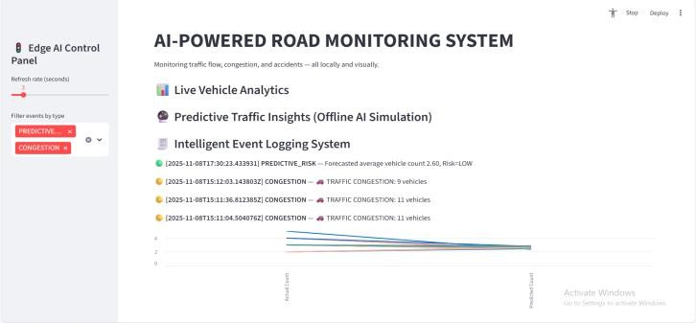
Fig 7: Dashboard for real-time traffic monitoring and visualization of analytics.

Adaptive Edge Intelligence
The Adaptive Edge Intelligence module has adjusted the congestion threshold based on the real-time vehicle density. This self-learning capability has improved the accuracy and decreased false alerts over the fixed-threshold method, this ensuring stable performance across different traffic conditions.
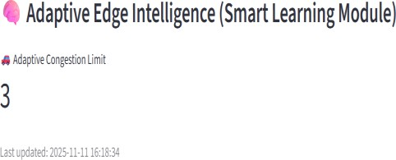
Fig 8: Adaptive Edge Intelligence congestion limit

Energy-Aware Edge Scheduler
The Energy-Aware Edge Scheduler has achieved a balance between performance and power consumption by adjusting processing rates based on CPU load. Thus, it optimised average CPU usage and energy consumption without any loss in detection accuracy, by improving efficiency compared to the standard fixed-rate processing method.

Discussion
The experimental results show that the deployment of object detection and event recognition on edge devices brought speed enhancements. Edge AI processing has optimized communication delays that are in cloud systems, making it advantageous and ideal for real-time traffic monitoring with accident detection and traffic regulations.

On the other hand, the integrated modules such as predictive analytics and energy simulation bring the system beyond the normal surveillance towards unique decision-making and sustainable smart city operations.

CONCLUSION AND FUTURE

This research presented how Edge AI monitors real-time traffic and a detection system developed to address the limitations of traditional cloud-based approaches. The system was developed with multiple modules like the YOLOv8 vehicle detection system, traffic congestion analysis, trajectory-based accident detection, predictive traffic insights, and intelligent event logging, which executed locally at the edge.

The experimental results showcase that the proposed framework reduces the latency, CPU utilization and energy consumption compared to cloud-based inference systems. The response times from the simulation of Edge-AI have improved 50-60%, maintaining high detection accuracy and stable resource utilization. These results prove that the Edge AI inference enhances data privacy and operational reliability, making it suitable for smart city environments.

Besides, the Streamlit-based dashboard successfully displays the model outputs such as congestion alerts, accident detection, predictive trends, and performance comparison with real-time traffic monitoring. The combination of real-time analytics and lightweight simulation provides an end-to-end pipeline for intelligent traffic management without dependence on cloud infrastructure.

Future enhancements can further extend the capabilities of the proposed system:

- Hardware Integration: Implement the Edge AI framework on actual edge hardware devices such as

NVIDIA Jetson Nano or Raspberry Pi to perform under real-world network conditions.
- Multimodal Sensor Fusion: Integrate IoT-based sensors such as GPS, infrared, and radar sensors along with Visual Analytics to enhance detection precision in low-visibility and nighttime scenarios.
- Adaptive Learning Models: Use on-device model updates, federated learning, or similar techniques to enable improving model accuracy without sending actual video data to cloud services.
- Automated Emergency Response: System Integration. The system will be integrated with traffic control centers or emergency response networks in order to automatically initiate emergency notifications in cases of accidents or heavy traffic.
- Scalability and Deployment: Extend the system to support multiple cameras at once and conduct its deployment in smart city test beds.

In light of these approaches, the system can progress to ensure the development of an Edge–Cloud hybrid framework to enable intelligent and autonomous systems for large-scale traffic management with advanced real-time decision-making capabilities.

ACKNOWLEDGEMENT

This paper is the result of original research, including genuine data and analysis conducted by the authors. No figures, tables, synthetic data, or other AI-generated content were produced using artificial intelligence tools. On the other hand, the tools available for AI, like ChatGPT (OpenAI) and QuillBot, have been used only for refinement of language, grammar correction, and clarity enhancement in different parts of the manuscript. The tools did not participate in content generation, analysis, or interpretation.

REFERENCES

- J. Redmon and A. Farhadi, “YOLOv3: An Incremental Improvement,” arXiv preprint arXiv:1804.02767, 2018. [Online]. Available: https://arxiv.org/abs/1804.02767
Available:https://thesai.org/Publications/ViewPaper?
Volume=11&Issue=4&Code=IJACSA&SerialNo=34

- M. Ahmed, S. Begum, and R. S. Jamil, “Integration of IoT and Cloud Computing for Smart Transportation Systems,” IEEE Internet of Things Journal, vol. 8, no. 12, pp. 9813–9823, 2021.
[Online].Available:https://doi.org/10.1109/JIOT.2020
.3049365

- HLi, Y. Chen, and K. Lin, “Edge Computing for Real-Time Intelligent Video Analytics,” IEEE Transactions on Industrial Informatics, vol. 17, no. 3, pp. 2200–
2210, 2021. [Online]. Available: https://doi.org/10.1109/TII.2020.3009285

- S. Wang, Z. Zhang, and X. Liu, “Adaptive Load Balancing Between Edge and Cloud for Intelligent Transportation Systems,” IEEE Transactions on Intelligent Transportation Systems, vol. 23, no. 7, pp. 9051–9062, 2022.[Online].Available: https://doi.org/10.1109/TITS.2021.3084567

- S. Kumar, N. Singh, and R. Saini, “Traffic Flow Estimation Using YOLOv5 and Deep Learning Techniques,” Procedia Computer Science, vol. 218,
pp. 432–440, 2023. [Online].
Available:https://doi.org/10.1016/j.procs.2023.01.054

- M. Chen, Y. Hao, and L. Hu, “Edge Intelligence: Paving the Last Mile of Artificial Intelligence With Edge Computing,” Proceedings of the IEEE, vol. 107, no. 8, pp. 1738–1762, 2019. [Online]. Available: https://doi.org/10.1109/JPROC.2019.2921977

- R. Reddy and V. Srinivasan, “Real-Time Traffic Congestion Detection Using Deep Learning in Cloud Environments,” Journal of Big Data Analytics in Transportation, vol. 5, no. 2, pp. 145–155, 2021. [Online]. Available:https://doi.org/10.1016/j.jbdat.2021.05.003

- Jocher, A. Chaurasia, and J. Qiu, “YOLOv5: Real-Time Object Detection,” Ultralytics Technical Report, 2022. [Online]. Available: https://github.com/ultralytics/yolov5

- X. Zhang, J. Li, and Y. Wang, “A Cloud-Based Intelligent Vehicle Detection System Using Convolutional Neural Networks,” IEEE Access, vol. 6,
pp. 41258–41267, 2018. [Online].
Available:https://doi.org/10.1109/ACCESS.2018.285 9756

- P. Gupta and A. Verma, “IoT-Enabled Smart Traffic Management System for Urban Cities,” International Journal of Advanced Computer Science and Applications (IJACSA), vol. 11, no. 4, pp. 245–252,
2020. [Online].

