Gender-Responsiveness: The Triple Burden Perspective of ‘Mama Fua’ (Laundry Women) in Theta Ward, Kiambu, Kenya

ABSTRACT
Despite the global efforts to promote gender responsive development, women continue to face certain social and structural barriers. Women’s labour is multi-dimensional, often undervalued, and yet crucial for societal functioning. Legitimizing the status quo propagates socially constructed expectations that limit human capital and social development among women. The study targeted low-income women who offer laundry and other menial cleaning services, popularly known as Mama Fua, in Theta Ward, a peri-urban area in Juja Subcounty, Kiambu, Kenya. The study was conducted through a focus discussion group (FDG) where participants were recruited through the snowball method. The data collection technique involved audio recording of the group discussions. Caroline Moser’s Gender Analysis Framework (1993) was applied in analyzing the roles of the participants. The analysis of their activity profiles revealed the burden of the triple role that imposed overlapping duties on women. This included multifaceted roles such as manual labour, invisible, unpaid reproductive chores, and community responsibilities. Findings also indicate that, while the laundry activities provide some income, they remain largely informal and insecure, thus restricting the advancement of human capital and social development among this population. Structural factors such as informal labour systems and societal norms further hampered their empowerment. The study makes the following conclusions: there is need to address both the practical and strategic needs of Mama Fua to improve both their survival and basic social welfare; the practical needs include the use of technology-assisted labour, such as cleaning machines, fair wages, safer working conditions, and peer support groups; strategic needs, such as rights protection, skills training, and gender-responsive policies, are necessary for the realization of sustainable empowerment and social development of the Mama Fua. The study recommends gender-responsive interventions to address the apparent gender role gaps.
Keywords: Triple burden, Mama Fua, gender-responsive, gender role gaps.

INTRODUCTION
Women are often faced with multiple responsibilities that demand juggling income-generating activities besides unpaid domestic and caregiving roles, as well as community activities. This paper analyzes the nature of this triple role and examines how the overlapping demands placed on Mama Fua in Theta Ward in Kiambu, Kenya. In this paper, Mama Fua is used to refer to a low-income population of women in urban and peri-urban areas who are hired on a casual basis to offer laundry and other menial cleaning services, particularly in residential estates. This term originates from the Swahili language, a language commonly spoken in Kenya and some parts of Eastern Africa and the neighbouring countries. Mama Fua in Kiswahili literally means "laundry woman". It is a common Kenyan Swahili term for women engaged in laundry work in the informal sector: "laundry woman" or "washerwoman, "A woman who launders clothes (Kinyanjui, 2020). Swahili is the most used indigenous lingua franca in Africa by millions of speakers across East, Central, and parts of Southern Africa. It is spoken among diverse linguistic communities, strengthening regional integration. Kiswahili could play an even broader role as a pan-African language (Batibo, 2016; Chrysostome et al., 2025).

Study Background
Unemployment among women in peri-urban areas, like many other regions, presents significant socio-economic challenges. Beyond the inadequate and unreliable income, unemployment leads to increased vulnerability. In the global south, this would reflect the assertion by Maria Mies in Patriarchy and Accumulation on a World Scale (1986), which explains how women’s unpaid domestic labor sustains households and economies in developing regions. Women participate in certain roles in society, for instance, in "productive" roles- entrepreneurial efforts. However, this often overlooks the significant time and energy women invest in their "reproductive" roles (childcare, household management, caregiving) and "community" roles such as volunteering, participating in community activities, and social support networks. The triple role is a universal phenomenon experienced by women not only in Kenya but globally.
Across many societies worldwide, research consistently shows that women carry multiple and overlapping roles, including productive (income-generating work), reproductive (care and household work), and community roles. Women’s multiple roles in productive, reproductive, and community work create a disproportionate workload that affects their time, resources, and empowerment within the community (Moser, 1993; Chant, 2003; Kabeer, 2001). This pattern appears in both developing and developed countries, though the balance varies due to certain factors like welfare systems, gender norms, labour markets, and cultural expectations. This phenomenon is more pronounced in low- and middle-income contexts, where the invisible work, such as unpaid care infrastructure (childcare, eldercare), is limited, women are more likely to work in informal or subsistence economies, and community social norms strongly assign domestic work to women.
In Sub-Saharan Africa, the scenario is the same. In Nigeria, for instance, women's gender roles include contributing to productive activities through subsistence farming, food processing, and small-scale trading in local markets. Women also carry out reproductive roles, including household care and participate in community responsibilities such as religious groups and rotating labour associations (FAO, 2011; International Labour Organization [ILO], 2018). In Tanzania, women are actively engaged in productive roles such as farming and informal employment to support the survival of their households. Besides, they are involved in reproductive work like caregiving and domestic chores and community development activities, including village meetings and collective action groups (FAO, 2011; World Bank, 2014).
Women in Kenya often perform the triple role. As Obachi (2001) notes, the roles include reproductive responsibilities such as childcare and household tasks, productive roles like farming and income-generating activities, and community responsibilities involving social and local development activities. These multiple roles limit women’s time and opportunities, as they continuously assume both unpaid domestic work and economic activities, besides participating in community life.

Statement of the Problem
Women’s gender roles are complex and multifaceted, frequently underestimated, yet essential to the functioning of society. Despite global efforts to promote gender responsive development, women continue to face certain social and structural barriers. Women's triple role is a growing concern because balancing these multiple roles often leads to role overload and limited opportunities for self-actualization. In the global south and Sub-Saharan Africa, in particular, socially entrenched norms often assign women the responsibility for unpaid reproductive and community work while simultaneously contributing to household production and community responsibilities. This creates immense workloads and limits their economic empowerment (Maviza & Thebe, 2023; Balgah et al., 2019). Legitimizing the status quo propagates socially constructed expectations that limit their opportunities to improve their livelihoods. There is scant documented information about the experiences of the low-earning women who offer paid manual hand-washing services in Theta ward in Kiambu, Kenya. This concern triggers the need for context-specific research on possible interventions. Therefore, this paper analyzes the triple burden and provides possible interventions for the challenges faced by the population under study.
Objectives
The following objectives guided the study:
- To analyze the triple role of Mama Fua in Theta Ward, Kiambu County, Kenya.
- To assess the extent of control over family resources by Mama Fua in Theta Ward, Kiambu County, Kenya
- To establish gender-responsive interventions for the situations facing the Mama Fua in Theta Ward, Kiambu County, Kenya
Research Questions
- What are the gender roles of Mama Fua in Theta Ward, Kiambu County, Kenya?
- What is the level of control over family resources by Mama Fua in Theta Ward, Kiambu County, Kenya?
- What are the gender- responsive interventions for the challenges facing Mama Fua in Theta Ward, Kiambu County, Kenya?

Scope of the Study
This study was limited to Mama Fua in Theta Ward to provide an in-depth understanding of the context of the laundry women in relation to gender roles and resource management. The study focused on the Triple Role Analysis Framework to examine their reproductive, productive, and community roles. Focus Group Discussions (FGDs) were used to explore gender roles, access to, control, and decision-making on resources by the selected respondents. The study participants were recruited through the snowball sampling technique and excluded men because the primary objective was to understand Mama Fua’s perspectives and lived experiences in the triple gender roles. Additionally, women who were not residents of the study area and those who were not involved in laundry services did not meet the inclusion criteria and were excluded from the study.

Limitations of the Study
The findings are specific to Mama Fua's experiences in the Theta ward, Kiambu County, Kenya. The study employed the snowball approach, where the researcher depended on the accessible population. It was impossible to locate this category of population among the male population. The study excludes men and other gender groups and may not fully account for how these roles are created, maintained, or challenged within society in Theta Ward, Kiambu County, Kenya. There is reduced generalizability since the findings may not fully represent the experiences or attitudes of the broader population. The study is limited to and reflects only women’s viewpoints and experiences of the phenomenon under study.

LITERATURE REVIEW
This tool helps analyze women’s triple burden of work. Gender Roles Identification.
Productive role (Paid work) which involves the production of goods and services for consumption and trade (in employment and in self-employment as well as in formal and informal sectors). Reproductive roles(Unpaid-Unrecognized) involve caring and maintenance of the household and its members, including caring for children, preparing food, collecting water and fuel, cleaning and washing clothes, shopping and housekeeping, and family healthcare. Community work (Unpaid Voluntary), which includes the collective organization of social events and services, ceremonies and celebrations, activities to improve the community, participation in groups and organizations, local community activities, and others.

Moser’s Triple Burden Framework: A reflection.
Caroline Moser’s Gender Analysis Framework explains roles through the concept of the triple role, which refers to the productive, reproductive, and community roles. These responsibilities s are uncommonly performed simultaneously by women but are often invisible, undervalued and unpaid (Moser, 1993; Nabaggala, 2024). The framework has been mostly used in gender and development to highlight how women experience and are involved in income-generating activities while being responsible for household care and community roles. This accumulation of responsibilities restricts women’s time, mobility, and opportunities for empowerment (Nabaggala, 2024; Moser, 1993).
Literature shows that the triple burden becomes more pronounced during crises such as pandemics and economic crises, where women’s unpaid tasks, such as care work, increase while they continue to participate in low-income or informal and entrepreneurial activities. This reinforces structural gender disparity by maintaining women’s workload in the community (Chopra & Krishnan, 2022; Moser, 1993). The framework supports policy interventions aimed at redistributing gender roles and promoting equity. As Nabaggala (2024) observes, it aligns with empowerment approaches that focus on transformation rather than simply accommodating gender roles in the community (Nabaggala, 2024).

Application of the Moser Gender Analysis Framework
Generally, gender responsibilities are determined by ideological, ethno-religious, economic and socio-cultural factors, which are major determinants of the distribution of roles and access and control (Food and Agriculture Organization [FAO, 2011). According to Ludgate (2016), the Moser framework can be applied to analyze gender roles by examining: the productive role, which includes income-generating activities; the reproductive role: household roles, childcare, cooking, and caregiving; and the community role, which encompasses participation in community activities and decision-making processes. Moser's framework addresses the access and control of resources to try to understand who has access to and control over resources and decision-making within households and communities.
Moser also seeks to identify the practical gender needs, which are immediate needs that help women perform existing roles more effectively, such as access to water, healthcare, training, or agricultural inputs, as well as the strategic gender needs that aim at transforming unequal gender relations related to equal decision-making power, property rights, education, and leadership opportunities. Akinola (2018) explored the impact of traditional African practices and cultural beliefs on women’s land ownership and use, and also reconciled women’s land rights (access and control) with the realities of land reform in the African post-colonial epoch. The study found that certain belief systems run through most African communities, such as the denial of women’s land ownership rights and the patriarchal nature of African societies. The article further found that, despite the development of legal frameworks that advocated for women’s property rights, cases of cultural impediments to the exercise of land rights are still present in Africa.
Across Sub-Saharan Africa, the framework has been widely used to analyze how gendered divisions of responsibilities, women's access to, and control in the household. The model also highlights that women's multiple responsibilities often increase their workload and limit their opportunities for economic empowerment, underscoring the need for gender-responsive development interventions (Moser, 1993; Quisumbing et al., 2015). Caroline Moser's Triple Role Analysis Model particularly advances that women simultaneously perform productive, reproductive, and community roles.

Reproductive Roles
Reproductive roles involve unpaid domestic and care work such as childcare, cooking, cleaning, and household maintenance (Ludgate, 2016). These roles involve motherhood and caregiving as well as domestic tasks that support the household’s well-being, such as domestic chores cooking, cleaning, laundry, fetching water, and caregiving the to sick and elderly members. These responsibilities, which are rarely considered ‘real work’, are rarely paid and are performed primarily by women.
Productive Roles
These roles are related to activities that produce goods and services for consumption or trade (growing crops for sale or household consumption). Productive roles refer to work done by women and men for an income or subsistence. It includes a variety of roles such as trading, farming, and wage employment (Balgah, Amungwa, & Egwu, 2019). Both men and women can be involved in these activities. However, women often carry out these roles alongside their reproductive roles in a household farm or home garden, which makes their contributions less visible and less valued than men’s productive work. These roles are commonly not paid.

Community Roles
These roles involve community work, such as holding meetings, cooking at social events, and activities to improve or care for community resources, such as participating in communal work. These activities are often voluntary and are normally not paid. According to Maviza & Thebe (2024), community role refers to voluntary, unpaid activities undertaken at the community level, such as managing shared resources, attending community meetings, and supporting collective services such as water, health, and social organisation. Generally, men tend to participate more often in public spheres- e.g. political affairs of the community and paid office roles; whereas women in public spheres contribute their time for free, serving for social good (cleaning community halls and church backyards, serving food in community meetings while men control family resources. According to Coffe & Bolzendahl ( 2010). Across sub-Saharan Africa, men are more likely to dominate participation in public and political spheres such as governance and political organizations. They are likely to contribute more to formal decision-making processes, reflecting persistent gendered divisions between public and private roles.

METHODOLOGY
This study adopted a qualitative research methodology using Focus Group Discussions (FGDs). This approach facilitated interaction among participants and enabled the researcher to obtain rich and detailed data on the phenomenon under study. According to Kitzinger (1995), FGDs are valuable in qualitative research because they generate rich data emerging from participants' interaction and discussion.

Research Design
The study adopted the phenomenological research design. This research design is a qualitative approach that seeks to describe and understand the essence of lived experiences of a phenomenon as they are consciously perceived (Giorgi, 2009; Moustakas, 1994; van Manen, 2016). This design is one of the commonly used methodologies in qualitative research to describe how human beings experience a certain context.

Target population
The study targeted the low-income women who offer laundry and other menial cleaning services, popularly known as Mama Fua, in Theta Ward, a peri-urban area in Kiambu County, Kenya.

The Study Site
Theta Ward is a vibrant peri-urban zone in Kiambu County, Kenya. Peri-urban areas are zones that transition from rural to urban land located between the outer limits of urban and regional centres and the rural environment. The Theta ward area touches the Nairobi–Thika Super Highway in Kenya. It is located in a porous and transitory rural-urban development in the sprawling and fast-growing Nairobi-Ruiru-Thika residential, commercial, and industrial zone.

Sampling and Data Collection
The study was conducted through a focus discussion group (FDG) of 14 women. The study participants were recruited through the snowball method. Snowball sampling is commonly used for the recruitment of participants in qualitative studies involving hard-to-reach study populations. The technique is a strategy that involves initial participants identifying other individuals who meet the inclusion criteria. This method is particularly useful when studying marginalized or specialized populations. As Naderifar et al. (2017) note, the snowball sampling technique helps the researcher to access participants through existing social connections, thereby increasing the likelihood of obtaining resourceful respondents with rich and relevant data from firsthand experience of the phenomenon being investigated. The data collection technique involved audio recording of the face-to-face discussions. In qualitative research, audio recording ensures that participants' responses are captured accurately.

Ethical considerations
The purpose of the study was well communicated before engaging the respondents in the study. Participation was purely voluntary and the participants understood that they were free to withdraw from the study at any point without consequences. Anonymity, confidentiality, and safe handling of the respondents' data were ensured. Participants were advised not to disclose personal information such as names. Written consent was obtained before audio-recording the FDG discussion session.
DATA ANALYSIS AND FINDINGS
Demographic Analysis
The demographic information of the respondents has been alnalysed. This includes the marital status, age, and education profiles.

About the marital status, seven of the participants lived with their married partners, five were single, one was separated, and one was widowed. As indicated in the figure below, in terms of age, the highest number was between 35 and 46 years.

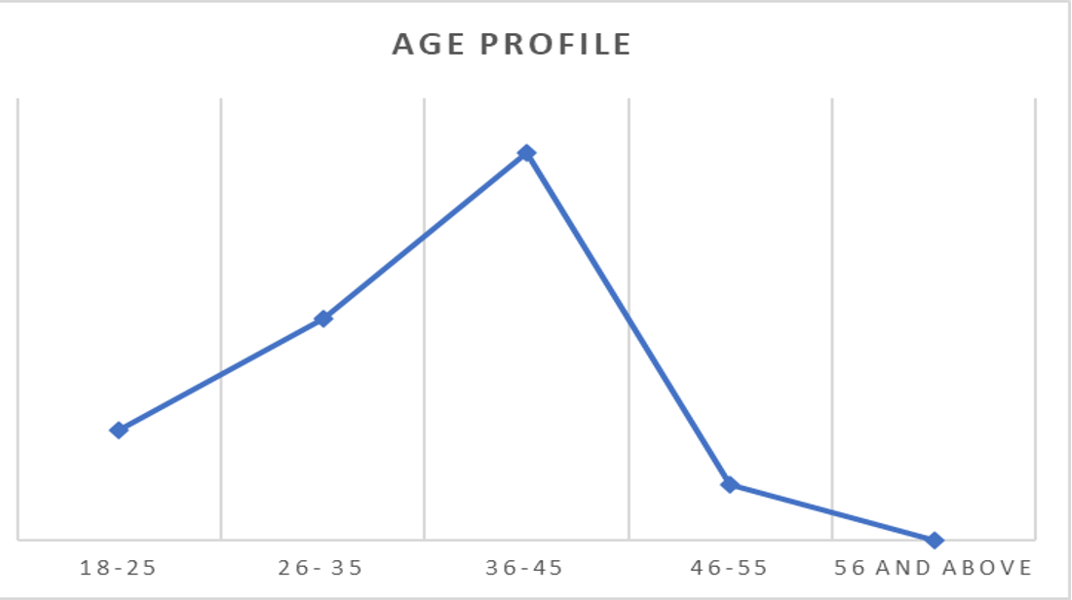

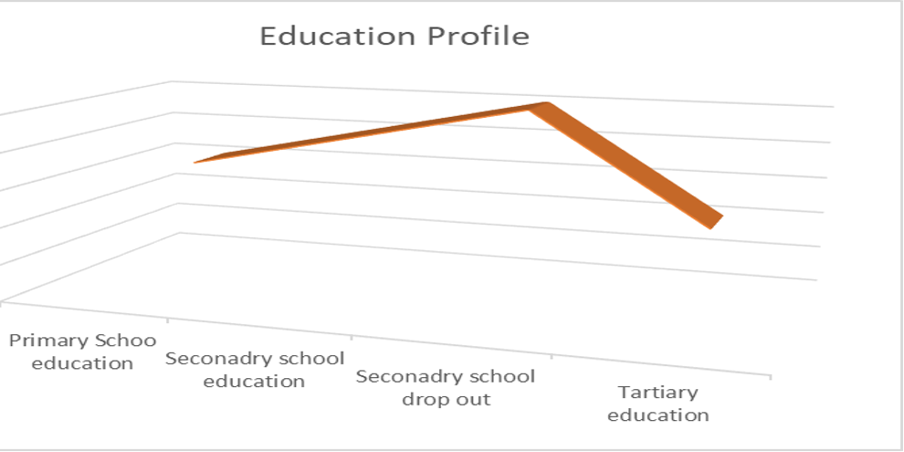
The analysis of the education profile of the participants shows that most of them had a form of basic schooling, such as secondary school and tertiary education

Data Analysis
The data were analyzed using Caroline Moser’s Triple Burden Framework (1993). The analysis of their activity profiles revealed the burden of the triple role that imposed overlapping duties on women. While the laundry activities provide some income, they remain largely informal and insecure, thus constraining the advancement of human capital and social development among this population. Structural factors such as informal labour systems and societal norms further hampered their empowerment. The laundry service is dominated by low-earning women.

Analysis of the Triple Role
The table below presents the common tasks assigned to Mama Fua in Theta in Theta Ward.
Productive Roles  (Hired/Paid work) | Reproductive Roles  ( Unpaid/ invisible Work) | Community Roles  ( Unpaid Work)
- Laundry work  - Cooking  - Cleaning dishes  - Baby sitting  - Ironing clothes  - Shopkeeping & kiosk  - Selling  groceries  - Selling fast  food  - Hawking  - Hairdressing.  - Hotel waiter/  Cleaning  - Decluttering  - Cleaning furniture  - House carpets  - Cleaning Car mats  - Brushing shoes  - Cleaning Toys  - Washing Pets  - Trash containers | - Family laundry and cleaning  - Children caregiving  - Cooking for the family  - Cleaning dishes  - Helping/ supervising with school assignments  - Paying school fees  - Buying foodstuffs  - Buying clothing/  Uniform  - Ironing clothes  - Folding clothes  - Baby seating  - Darning damaged clothes  - Decluttering  - Cleaning furniture  - Paying house rent | - Leading religious activities such as visiting the sick at home and hospitals and bereaved families  - Attending weddings and giftings  - Leading women's groups  - Local Community meetings/ leadership  - Security meetings  - Attend political meetings and voting  - Offerings and other alms/ Fundraising

The above roles analysis reveals Mama Fua women in Theta ward continue to shoulder overlapping triple duties, ranging from productive, reproductive, to community roles. This simultaneous role expectation that women engage in paid roles while remaining primarily responsible for unpaid domestic chores and community service reflects the persistent gender role gaps and inequalities embedded in social and household structures. This is consistent with Bunning et al. (2022), who observe that gendered distributions of unpaid duties and housework affect women's participation in the labour market. Seedat and Rondon (2021) argue that the disproportionate assignment of unpaid work negatively impacts women's mental health and overall well-being.
From the FGD discussions, Mama Fua's work is largely menial, repetitive, physically demanding, without assistive infrastructure or technology, such as laundry machines. The participants noted that they were mostly provided with, among others, water sources, washing tabs, washing basins, brushes, washing powder, bar soaps, linen softeners, and gloves.
The cumulative effect of these overlapping duties contributes to general physical fatigue and limited opportunities for personal advancement. According to Carneiro et al. (2023), the persistence of the gendered responsibilities continues to assign women the bulk of routine household roles, exposing them to greater physical and psychological strain from the intensified overall workload.
Control of and Use of Family Resources
Most scholars argue that access to and control over resources significantly influence how households make decisions on the use of resources. Quisumbing et al. (2015) found that gender norms influence control over productive assets and decision-making regarding the use of household resources. Similarly, Johnson et al. (2016) argue that gender roles determine ownership and control of assets, which affect not only household decision-making but also the distribution of resources.

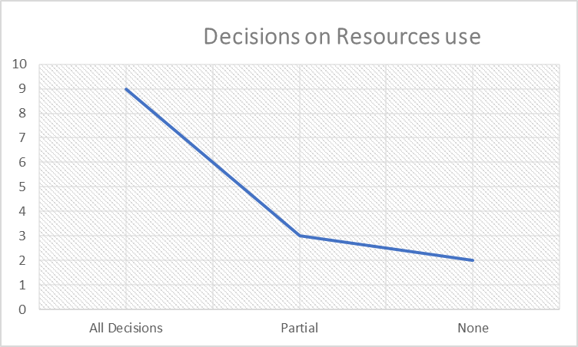
Most respondents indicated that they supported paying school fees and school items, and also made decisions on buying foodstuffs, buying clothing/ uniform, and paying rent. Nine said they were fully involved, three indicated that they were partially involved. Findings show that most of them were involved in decision-making and the control of family resources. This may have been influenced by the fact that half of the participants did not have marriage partners. It was easy for the women to decide how to save, spend, or invest their money without needing to negotiate with someone. Two married respondents never got involved, as the partners never asked what they did with their earnings, though they indicated that they often bought domestic items and were engaged in women’s savings groups as well as community service.

CONCLUSIONS
The study makes the following conclusions:
- The role of Mama Fua includes multifaceted roles such as poorly paid manual labour, invisible, unpaid reproductive chores, and community responsibilities.
- Women continue to repetitively perform most domestic tasks despite participating in paid productive roles.
- Women’s labour is strenuous, often undervalued, and yet crucial for societal functioning.
- The Mama Fua have inadequate skills training, entrepreneurship support, flexible work opportunities, and supportive infrastructure.
- Based on their educational profile, the women can be trained for semi-skilled jobs.
- There is a need to address both the practical and strategic needs of Mama Fua to improve both their survival and basic social welfare as they continue to sustain their households.
Recommended Interventions
The study recommends the following interventions to address gendered gaps:
- The study recommends the promotion of gender-responsive interventions to address the apparent structural inequalities towards an inclusive human capital and social development.
- The need to address the gendered gaps for gender mainstreaming is crucial in human capital and social development, among the Mama Fua in Theta Ward.
- Tap into the resilience of the women by advancing finances for small businesses, such as a laundry shop where clients can drop off and pick up their items.
- There is a need to develop a framework that advocates for the practical needs of Mama Fua, such as assistive infrastructure, technology-supported labour, such as cleaning machines, fair wages, safer working conditions, and peer support groups.
- There is a need to support the strategic needs of Mama Fua, such as rights protection, skills training, access to financing support, and gender-responsive policies, which are necessary for the realization of sustainable empowerment and social development of Mama Fua women.

REFERENCES
- Akinola, A. O. (2018). Women, culture, and Africa's land reform agenda. Frontiers in Psychology, 9, Article 2234. https://doi.org/10.3389/fpsyg.2018.02234
- Balgah, R. A., Amungwa, F. A., & Egwu, B. M. J. (2019). A gender analysis of intra-household division of labor in Cameroon using Moser’s triple roles framework [PDF]. Asian Journal of Agricultural Extension, Economics & Sociology. https://ageconsearch.umn.edu/record/357567/files/Balgah2942019AJAEES47195.pdf
- Balgah, R. A., Amungwa, F. A., & Egwu, B. M. J. (2019). A gender analysis of intra-household division of labor in Cameroon using Moser's Triple Roles Framework. Asian Journal of Agricultural Extension, Economics & Sociology, 29(4), 1–12. https://doi.org/10.9734/AJAEES/2019/v29i430095.
- Batibo, H. M. (2016). The position of Kiswahili among the lingua francas of Africa: A typological survey. Journal of Linguistics and Language in Education. https://journals.udsm.ac.tz/index.php/jlle/article/view/2366?utm_source

- Bunning, M., Hipp, L., & Munnes, S. (2022). Care and careers: Gender (in)equality in unpaid care, housework and employment. Research in Social Stratification and Mobility, 77, 100659. https://doi.org/10.1016/j.rssm.2021.100659
- Carneiro, C. M. M., Pinho, P. S., Teixeira, J. R. B., & Araújo, T. M. (2023). Unpaid domestic work: Persistence of gender-based labor division and mental disorders. Revista de Saúde Pública, 57, 31. https://doi.org/10.11606/S1518-8787.2023057004502
- Chant, S. (2003). Female household headship and the feminisation of poverty: Facts, fictions and forward strategies (IDS Working Paper 27). Institute of Development Studies. https://www.ids.ac.uk/download.php?file=files/Wp27.pdf
- Chopra, D., & Krishnan, M. (2022). “Care is not a burden”: A 7-4-7 framework of action for operationalising the Triple R. Gender & Development, 30(1–2), 35–57. https://doi.org/10.1080/13552074.2022.2066265
- Chrysostome, E. V., Adegbile, A., Boafo, C., & Ogunsanya, F. (2025). From thousands of African languages to a pan-African language for the African Continental Free Trade Area: A framework promoting Kiswahili as a common language for intra-African trade. AIB Insights.DOI: https://doi.org/10.46697/001c.136476
- Coffé, H., & Bolzendahl, C. (2010). Gender gaps in political participation across sub-Saharan African nations. Social Indicators Research, 102, 245–264. https://doi.org/10.1007/s11205-010-9676-6
- Food and Agriculture Organization of the United Nations (2011). The state of food and agriculture 2010–11: Women in agriculture—Closing the gender gap for development. FAO. https://www.fao.org/3/i2050e/i2050e.pdf
- Food and Agriculture Organization. (2011). The state of food and agriculture 2010–11: Women in agriculture—Closing the gender gap for development. FAO. https://www.fao.org/3/i2050e/i2050e.pdf
- Giorgi, A. (2009). The descriptive phenomenological method in psychology: A modified Husserlian approach. Duquesne University Press.
- International Labour Organization(ILO) (2018). Care work and care jobs for the future of decent work. ILO. https://www.ilo.org/wcmsp5/groups/public/---dgreports/---dcomm/documents/publication/wcms_633135.pdf
- Johnson, N. L., Kovarik, C., Meinzen-Dick, R., Njuki, J., & Quisumbing, A. (2016). Gender, assets, and agricultural development: Lessons from eight projects. World Development, 83, 295–311. https://doi.org/10.1016/j.worlddev.2016.01.009
- Kabeer, N. (2001). Resources, agency, achievements: Reflections on the measurement of women’s empowerment (IDS Working Paper 179). Institute of Development Studies. https://www.ids.ac.uk/download.php?file=files/Wp179.pdf
- Kinyanjui, M. N. (2020). Mama Jua Kali: Female resistance and resilience to the coloniality of modernism and neoliberalism in Nairobi, Kenya. Journal of Language, Technology & Entrepreneurship in Africa, 11(1).
- Kitzinger, J. (1995). Qualitative research: Introducing focus groups. BMJ, 311(7000), 299–302. https://doi.org/10.1136/bmj.311.7000.299
- Ludgate, N. (2016). Moser gender analysis framework. Integrating Gender and Nutrition within Agricultural Extension Services (INGENAES), University of Florida. https://ingenaes.illinois.edu/wp-content/uploads/ING-Info-Sheet-2016_09-3-Moser-Triple-Role-Framework-Ludgate.pdf
- Maviza, G., & Thebe, P. (2023). Working from home and the triple role of women in the context of COVID-19-induced lockdowns in Zimbabwe. Journal of Asian and African Studies, 59(8), 1880–1896. https://doi.org/10.1177/00219096231154240.
- Maviza, G., & Thebe, P. (2024). Working from home and the triple role of women in the context of COVID-19-induced lockdowns in Zimbabwe. Journal of International Women’s Studies. https://journals.sagepub.com/doi/pdf/10.1177/00219096231154240
- Moser, C. O. N. (1993). Gender planning and development: Theory, practice and training. Routledge. https://api.pageplace.de › preview › preview-9781...
- Moustakas, C. (1994). Phenomenological research methods. Sage Publications.
- Nabaggala, R. (2024). A review of the Moser Gender Analysis Framework: A tool for development practitioners, scholars and gender equality advocates. University repository (Open Access PDF). https://www.researchgate.net/publication/379507328
- Naderifar, M., Goli, H., & Ghaljaie, F. (2017). Snowball sampling: A purposeful method of sampling in qualitative research. https://brieflands.com/articles/sdme-67670.pdf
- Obachi, A. (2001). A gender perspective of the reading habits of Jomo Kenyatta Memorial Library users [PDF]. University of Nairobi Repository. https://erepository.uonbi.ac.ke/bitstream/handle/11295/42675
- Quisumbing, A. R., Rubin, D., Manfre, C., Waithanji, E., van den Bold, M., Olney, D., Johnson, N., & Meinzen-Dick, R. (2015). Gender, assets, and market-oriented agriculture: Learning from high-value crop and livestock projects in Africa and Asia. Agriculture and Human Values, 32(4), 705–725. https://doi.org/10.1007/s10460-015-9587-
- Seedat, S., & Rondon, M. (2021). Women's wellbeing and the burden of unpaid work. BMJ, 374, n1972. vhttps://doi.org/10.1136/bmj.n1972
- Van Manen, M. (2016). Researching lived experience: Human science for an action sensitive pedagogy (2nd ed.). Routledge.
- World Bank. (2014). Levelling the field: Improving opportunities for women farmers in Africa. World Bank Group.https://openknowledge.worldbank.org/handle/10986/17636

