MENTAL HEALTH STATUS OF FILIPINO ACTIVE-DUTY SOLDIERS DEPLOYED TO COMBAT OPERATIONS: A RESEARCH REFERENCE FOR POLICYMAKERS IN INSTITUTIONALIZING A RESPONSIVE MENTAL HEALTH SUPPORT PROGRAM

Abstract

This study assessed the mental health status and identified the psychological problems encountered by Filipino active-duty soldiers deployed to combat operations. Using a descriptive and predictive cross-correlational research design, the study gathered data from 384 soldiers through standardized tools such as the Mental Status Examination, PTSD Checklist (PCL-5), PHQ-9, GAD-7, AUDIT, and CAGE. The findings revealed that while the majority exhibited normal mental health functioning (62.24%) and moderate psychological hardiness (62.24%), a substantial proportion showed signs of mild to moderate psychological distress. Specifically, 35.68% screened positive for provisional PTSD, 33.59% exhibited symptoms of depression, 27.86% reported varying levels of anxiety, and 35.68% were flagged for possible alcohol abuse based on CAGE. Furthermore, 42.71% of the respondents fell under hazardous to dependent alcohol use categories in the AUDIT screening. The study also found that certain demographic variables were significantly associated with mental health outcomes, and that psychological hardiness played a moderate role in these relationships. These findings emphasize the need for sustained and culturally sensitive mental health programs, routine screenings, and targeted interventions within the Philippine Army. The study recommends the creation of a comprehensive mental health support program through legislative action to institutionalize responsive mental health support for active-duty soldiers.
Keywords: psychological hardiness, mental health, filipino soldiers, combat deployment, PTSD, alcohol use

ACKNOWLEDGMENTS

I would like to express my deepest gratitude to Almighty God for granting me strength, wisdom, and perseverance throughout this academic journey.
My heartfelt appreciation goes to my family—Mama Ruth, Dadii Love, Pagpag, Cocomelon Ding, Beautiful, Darna, Jeti, and Weaky—for their unconditional love, sacrifices, and unwavering support, which have been my constant source of inspiration and motivation.
I am sincerely grateful to my thesis adviser, Dr. Dorothea C Dela Cruz, for her invaluable guidance, patience, and encouragement in completing this study. I also extend my profound appreciation to my panel of evaluators for their insightful comments, constructive suggestions, and encouragement, which greatly enriched the quality of this study.
Special thanks to my friends—Charmagne, Monica, Dawnita and Anthonette—and my peers who have been with me through challenges and triumphs, reminding me that this accomplishment is not mine alone, but shared with all who supported me along the way.
Foremost among those I am grateful to are the respondents from the Philippine Army units, whose invaluable participation and cooperation made this research possible.

DEDICATION

I dedicate this work as a symbol of my love and deep respect to all Filipino soldiers whose sacrifices in the line of duty inspired this study, especially those who silently endure their mental health struggles and hesitate to seek help. True to the spirit of “ang mamatay ng dahil sa’yo,” may this humble contribution serve as a step toward giving them the voice and support they truly deserve.

LIST OF TABLES

Table Page

Table 1. Filipino Active-duty soldiers Demographic Profiles….……… 62

Table 2. Psychological Hardiness of Filipino Active-Duty Soldiers…. 71

Table 3. Mental Status Examination Results……………………………. 75

Table 4. PTSD Screening Results based on PCL-5……………………... 79

Table 5. Results of the AUDIT – Self-Report Version……………………82

Table 6. Results of the AUDIT – Interview Version…………………….. 85

Table 7. Results of the CAGE Screening Tool…………………………… 87

Table 8. Results of the Generalized Anxiety Disorder Test…………… 90

Table 9. Results of the Depression Screening using PHQ-9…………..91

Table 10. Results of the DASS-21 Depression Scale Test…………….. 93

Table 11. Results of the DASS-21 Anxiety Scale Test…………………. 95

Table 12. Results of the DASS-21 Stress Scale Test…………………… 97

Table 13. Profiles and Hardiness profile of active-duty soldiers…….. 99

Table 14. Profiles and Mental Health Status…………………………….. 101

Table 15. Age and Psychological Measures………………………………. 103

Table 16. Gender and Psychological Measures…………………………..105

Table 17. Civil Status and Psychological Measures……………………. 107

Table 18. Rank and Psychological Measures……………………………..109

Table 19. Number of Households and Psychological Measures…… 111

Table 20. Educational Qualifications and Psychological Measures…113

Table 21. Years in service and Psychological Measures………………..115

Table 22. Physical injuries and Psychological Measures……………… 117

Table 23. Religion and Psychological Measures………………………….119

Table 24. War Encounters and Psychological Measures……………….120

Table 25. Combat Deployment and Psychological Measures………….122

Table 26. Summary table of significant findings
on Mental Health Problems………………………….………. 125

Table 27. Summary table of significant findings
on Profiles with Psychological Measures…………….…….128

LIST OF FIGURES

Page

Figure 1. The Military Resilience Model……………………………………11

Figure 2. The Conceptual Framework...……………………………………12

CHAPTER 1

Introduction
This chapter presents the rationale for the conduct of the study. The objectives of the study are enumerated based on the statement of the problem. Also, this chapter presents several theoretical frameworks that served as the basis for formulating the conceptual framework. The hypotheses of the study are also developed based on the literature and studies that have been reviewed. The scope and delimitation of this study are likewise presented, including the significance of this study to various stakeholders. The definition of terms is also included at the end of the chapter to guide the readers on some words and/or phrases not familiar to them.
Background of the Study
Military service, especially combat deployment, puts soldiers at risk of extreme levels of physical danger, mental pressure, and long durations of uncertainty. Soldiers are usually exposed to life-threatening situations that put their strength, coping skills, and mental toughness to the test. The stressful conditions of combat missions not only influence their effectiveness in actions but also lead to serious threats to their overall psychological well-being. Although it is often said that mental health is as important as physical health, many Philippine Army soldiers face the fear of losing their jobs if diagnosed with a mental health condition, which discourages them from seeking the help they need.
The demands of military service, especially during combat operations, are much deeper than physical endurance. Behind every mission are soldiers who carry not only the weight of their duty but also the psychological burdens that often remain unseen. In most of the cases, there are reports of soldiers who come back after a deployment without any apparent injuries but are emotionally troubled as they grapple with the effects of stress, anxiety, and emotional distress. These are realities that are not observable as much as the physical injuries, but are also important and ought to be looked at closely.
Moreover, mental illness stigma is rather widespread in the military culture and stops many soldiers from seeking help because they fear their administrative governmental reprisal or being seen as weak (Maglalang, 2020). Often in combat cultures, admitting to mental health problems can be perceived as risking one's career or being seen as a liability. These concerns are consistently cited as among the primary reasons why many service members avoid mental health services. Such institutional and cultural apathy explains why these special-purpose interventions are required, beyond the usual global public health action plans.
The cases of active-duty soldiers serving in combat units within the Bangsamoro Autonomous Region in Muslim Mindanao (BARMM) present unique challenges in the context of the Philippines as a result of the long-term exposure to conflict, recurring combat operations, and the physical and mental strains of military operations. Although the Philippine military pays significant attention to training and physical readiness, less focus has been given to the mental health condition and psychological resilience of soldiers, although it is critical in maintaining performance and keeping both soldiers and citizens safe.
Recent discussions on the welfare of wounded soldiers in the Philippines have highlighted concerns regarding the existing policy on Complete Disability Discharge (CDD). In response to the case of a Philippine Army officer who lost his eyesight during combat operations, Ferdinand R. Marcos Jr. emphasized the need to review policies affecting soldiers who sustain injuries in the line of duty. The President questioned the fairness of discharging personnel who were wounded while defending the country, stating that it is unjust for a soldier who sacrificed and performed his duty for the nation to simply be released from service after being injured. He stressed that such situations should not occur and directed the Department of National Defense to review and reform the disability discharge policy to ensure that wounded soldiers are given opportunities to continue serving in capacities suited to their condition (Philippine News Agency, 2025).
This statement underscores a significant policy concern regarding the treatment and recognition of soldiers who suffer service-related injuries. The uncertainty surrounding disability discharge and career termination may contribute to psychological distress among military personnel, particularly those deployed in high-risk combat environments. For many soldiers, the fear of losing their profession, identity, and employment after sustaining injuries may discourage them from seeking medical or psychological assistance. Consequently, strengthening institutional policies that protect injured service members and provide continued roles within the military may not only recognize their sacrifice but also promote psychological security and overall mental well-being among active-duty personnel.
This study was conceptualized from the recognition that mental health concerns among Filipino active-duty soldiers are often underexplored, despite their critical role in operational readiness and overall well-being. Observations from military settings and existing narratives reveal that while soldiers are trained to be resilient, they are not immune to psychological challenges brought about by prolonged exposure to high-risk and high-stress environments.
Furthermore, psychological hardiness—a combination of commitment, control, and challenge—has been identified as a key factor in helping military personnel withstand stress, adapt to high-risk environments, and recover from adverse experiences. Similarly, understanding the prevalence and nature of mental health problems among soldiers, as well as the demographic and personal factors associated with these issues, is essential for developing effective interventions and support mechanisms. This study aimed to address several critical questions regarding Filipino active-duty soldiers deployed to combat operations. Specifically, it sought to examine their demographic profiles, levels of psychological hardiness, mental health status, and the types of mental health problems they encounter. It also investigated how these problems relate to individual characteristics, including age, educational attainment, marital status, family size, number of deployments, combat encounters, physical injuries, place of birth, rank, religion, sex, and years of service. Finally, the study aimed to provide evidence-based recommendations for mental health support programs tailored to the unique needs of combat-deployed personnel.
By exploring these issues, the study intended to provide a research-based reference for policymakers to guide the development of holistic mental health support programs. Such initiatives, ideally institutionalized through legislation or constitutional support, would help ensure that Filipino soldiers receive the psychological care and resilience-building resources necessary to perform effectively while safeguarding their well-being. Ultimately, this research bridges the gap between understanding the mental health challenges faced by soldiers and implementing actionable policies and programs. It lays the foundation for evidence-informed interventions that enhance psychological hardiness, address mental health problems, and promote the long-term welfare of combat-deployed personnel.

Statement of the Problem
The study was conducted to assess the mental health status and problems encountered by Filipino active-duty soldiers who are deployed to combat operations with the end in view that amendments to the existing policy can be recommended.
Specifically, it sought to answer the following problems:
1. What were the demographics and profiles of Filipino active-duty soldiers deployed to combat operations?
  - Age
  - educational qualification
  - marital status
  - number of children/family members
  - number of combat deployments
  - number of war encounters
  - number of physical injuries resulting from combat/encounter
  - place of birth
  - rank
  - religion
  - sex
  - years of service
- What was the psychological hardiness of Filipino active-duty soldiers deployed to combat operations?
- What was the mental health status of Filipino active-duty soldiers deployed to combat operations?
- What mental health problems were encountered by Filipino active-duty soldiers deployed to combat operations?
- What profiles were associated with the mental health problems of Filipino active-duty soldiers deployed to combat operations?
- To what extent was the relationship of demographic profiles between mental health status and mental health problems among Filipino active-duty soldiers deployed to combat operations?
- Based on the findings, what amendments to the existing policy could be recommended that can responsively support the mental health programs for Filipino active-duty soldiers in combat deployments?

Objectives of the Study
Mental health among active-duty soldiers is a crucial yet often overlooked aspect of military readiness and effectiveness. Filipino active-duty soldiers, like their counterparts globally, face unique stressors and challenges, especially during combat operations. Understanding their mental health status is vital for ensuring their well-being and maintaining their operational readiness. The study was conducted mainly to assess the mental health status of Filipino active-duty soldiers, aiming to generate and contribute a comprehensive research reference that can inform policymakers by providing them with detailed data and insights into the current mental health conditions of Filipino soldiers that will equip policymakers with the evidence needed to develop informed and effective policies and regulations. Specifically, the study aims to: (1) determine the demographics and socio-economic profiles of Filipino active-duty soldiers deployed to combat operations in terms of their age, place of birth, sex, religion, marital status, number of kids/family members, educational qualification, rank, years of service, number of war encounters, length of recent combat deployment, number of combat deployments, and physical injuries resulting from combat encounters; (2) determine the Psychological Hardiness of Filipino active-duty soldiers deployed to combat operations; (3) assess the mental health status of Filipino active-duty soldiers deployed to combat operations; (4) assess the mental health problems of Filipino active-duty soldiers deployed to combat operations; and (5) explore the profiles associated with the mental health problems of Filipino active-duty soldiers deployed to combat operations.

Theoretical and Conceptual Framework
The military is high-risk because soldiers must carry out their duties in perilous and stressful circumstances (Baumann, Gohm, & Bonner, 2011). The pressures they experience might come from a variety of causes, such as being apart from family, the risk posed by carrying weapons and other firearms, or the potential danger to their lives posed by combat situations (Bartone, Adler, & Vaitkus, 1998; Boermans, Kamphuis, Delahaij, Korteling, & Euwema, 2013). Selection and training are the two approaches that military organizations rely on in order to enhance resilience in soldiers, or the ability to adjust to stressful conditions, and to lessen the physical and mental hazards linked with these professional strains (Zautra, Arewasikporn, & Davis, 2010).
The study is anchored on the military resilience model of Kamphuis, van Hemert, van Wouwe, van den Berg, and van Boxmeer (2012) (please see Fig.1). The military resilience model does not elaborate a definite number of phases and or stages unlike other theory on resilience; instead, it focuses on the cyclic process of the military career in which the significance of five levels of resources, such as individual, team, leader, home-front, and organizational, changes with time. The model was developed for the Netherlands Armed Forces based on a literature review and interviews with military experts. It highlights that resilience depends on different resources during the various phases of a military career, such as training, deployment, and post-deployment. As an example, individual and organizational resources are especially visible in the in-garrison phase, and team cohesion is identified as the most pertinent measure of resilience in the case of the intensive deployment phase. The particular emphasis is put on the post-deployment stage, which is an important phase of transition characterized by the presence of specific stressors, threats to mental health, and reintegration challenges. At this stage, the resiliency of a service member relies heavily on personal coping capabilities, good home-front support, and enduring ties with the team in order to overcome readjustments and deliver positive results. Thus, the study only focused on the post-deployment phase.
Figure 1
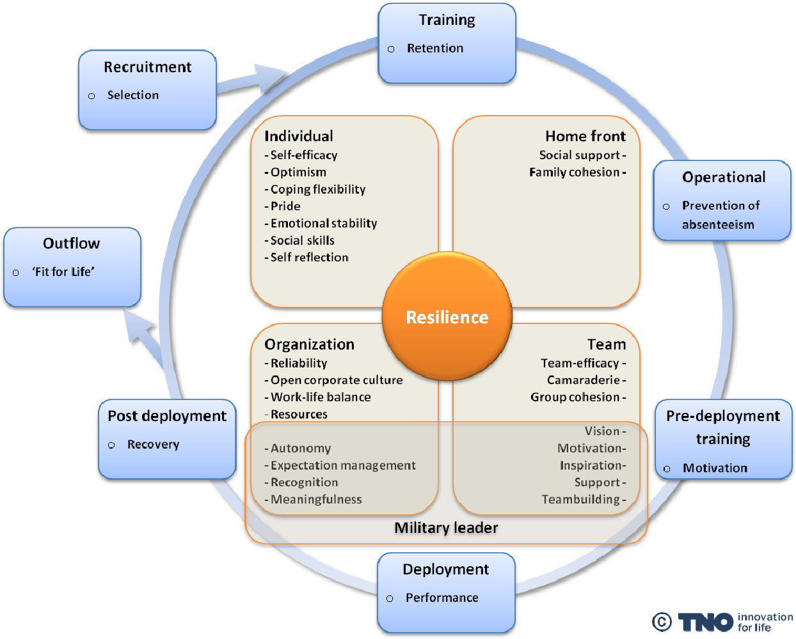
The military resilience model (Kamphuis et al., 2012)

The Big-Five model provides an integrative framework for researchers and other professionals to understand personality better in the field of personality psychology (Sheldon, Ryan, Rawsthorne, & Ilardi, 1997). The key behavioral characteristics of Extraversion, Neuroticism, Agreeableness, Conscientiousness, and Openness to Experience are the emphasis of the Five Factor Model (Sheldon et al., 1997). Researchers have used the Five Factor Model to comprehend how each factor affects various outcomes, such as the quality of relationships, career choices, health, and clinical disorders (Maples, Guan, Carter, & Miller, 2014). Conscientiousness (Hurtz & Donovan, 2000) and emotional stability (Ohlsson, Hedlund, & Larsson, 2016), which have been proven to be constant across most occupations, have been related by several studies to job performance. Instead of focusing on performance in general, some contend that personality and performance should be studied in distinct job domains (Hurtz & Donovan, 2000). For instance, Bartone et al. (2009) discovered that extraversion could predict military leadership effectiveness in training camps.
However, Bartone et al. (2009) pointed out that the Big Five do not address psychological toughness and social judgment, two crucial aspects of personality. It is essential to consider psychological hardiness and personality qualities since they are critical components in assessing how people cope with stressful conditions (Kobasa, 1979).
The hardiness construct is a framework that examines why many people can deal with problems even in stressful situations and why many people find it challenging to deal with issues in non-stressful cases (Abdollahi et al., 2014). Understanding why some Filipino soldiers can cope with mental health problems during their deployment in combat operations may depend on one's level of hardiness.
Considering the demographic profiles and the psychological hardiness of Filipino soldiers deployed in combat operations, this study would like to contribute to the literature on how these factors could be linked to the mental health status and problems they encountered after they were deployed from combat operations. Figure 2 presents the conceptual framework of the study.
Figure 2
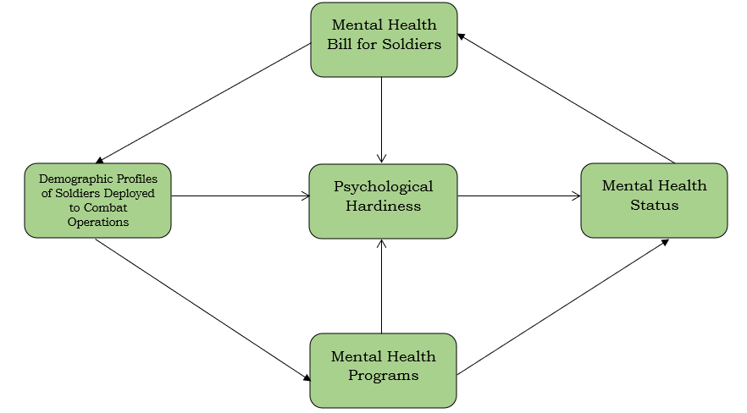
The Conceptual Framework

Hypotheses of the Study
The present study examined mental health status and problems of Filipino active-duty soldiers deployed to combat operations and psychological hardiness as a potential resilience factor for active-duty soldiers that can influence both performance and mental well-being when one is exposed to combat operations. Based on the foregoing discussion, the study hypothesizes the following:
Hypotheses 1: There is a significant relationship between the age, place of birth, sex, religion, marital status, number of kids/family members, educational qualification, rank, years of service, number of war encounters, length of recent combat deployment, number of combat deployments, physical injuries resulting from combat/encounter with the mental health status and problems among Filipino active-duty soldiers deployed to combat operations.
Hypothesis 2: Psychological hardiness moderates the relationship between mental health problems among Filipino soldiers deployed to combat operations.
Hypothesis 3: There is no significant relationship between the demographic and socio-economic profiles and mental health status and problems among Filipino soldiers deployed to combat operations.

Scope and Delimitations of the Study
The study focused on assessing the mental health status and mental health problems of active Filipino soldiers deployed for combat operations. Only Filipino soldiers within the Philippine Army who were deployed for combat operations within the year were the target participants of the study. The researcher excluded soldiers who are not currently in active service in the Philippine Army and who have not been deployed in combat operations within the current year. Their profiles were gathered regarding their age, sex, marital status, number of kids/family members, educational qualification, number of combat deployments, and personality factors.
The study focused on capturing the range of mental health status and mental health problems encountered by Filipino soldiers when deployed for combat operations. For this, various psychological tests were employed, such as the Mental Status Examination (MSE), the Brief Trauma Questionnaire (BTQ) of Schnurr et al. (1999), the Post-traumatic Stress Disorder Checklist of Weathers et al. (2013), the Alcohol Use Disorders Identification Test (AUDIT) of Babor et al. (1992), the Patient Health Questionnaire of Kroenke et al. (2001), and the Depression, Anxiety, and Stress Scale – 21 Items (DASS-21) of Lovibond et al. (1995). The Mental Health Status of Filipino Active-Duty Soldiers was defined based on the results of these tests. Likewise, the study also explored the factors associated with their current mental health status and issues.
Lastly, this study is not designed to create an intervention program nor craft a policy in completing this research; the possibility of creating a more concrete policy that would enable the Philippine Army to establish reliable mental health care services for its personnel is left in the hands of its leaders. Thus, the study was focused on the post-deployment phase.

Significance of the Study
The present study sought to provide information focusing on the mental well-being of active Filipino soldiers deployed for combat operations. The results of the study may be beneficial to the following:
For the Filipino soldiers. Filipino soldiers have adapted and adjusted to some problems, but others have had problems going home, reuniting with family, seeking a job, and returning to school. This research may enlighten them on dealing with difficulties associated with their deployment to combat operations. The study findings may give them insights into what factors could be associated with mental health, so they can strengthen/avoid those that directly or indirectly affect their health.
For the Families of Filipino soldiers. Families of the service members play an important part in the preparedness and well-being of the regular/active force. They must handle impairments in their mental and physical well-being, issues in their relationships, duties as parents of their children or wounded members, and a mountain of domestic responsibilities. Hence, the findings of the study may enlighten them on the techniques and proper approaches that they may apply in rearing their wounded service members. In this way, the study may provide them with insights that they may consider in fostering positive environments to eliminate some causes of mental distress upon return from combat operations.
For the Legislators and Policymakers. This study may be a basis for revisiting the existing policies on military services and their deployment schedules. Likewise, in drafting a constitutional bill in support of the well-being and mental health of our Filipino active-duty soldiers.
For the Armed Forces of the Philippines. This study is essential for improving policies on the deployment of Filipino soldiers to combat operations and identifying mental health support that needs to be addressed. The result from the study may serve as a basis for designing deployment plans and strategies that will promote optimum health status among Filipino soldiers.
For Mental Health Practitioners. This study may aid as a basis for Mental Health practitioners in designing intervention programs and/or recovery plans that could alleviate mental health problems among Filipino soldiers after their deployment from combat operations.
For Future Researcher/s. Researchers and individuals interested in the study would be able to gain insights and inputs from the findings of this study as a valuable reference for further research about assessing mental health status and alleviating mental problems among Filipino soldiers and/or any profession with a high risk of stress and highly demanding employment environments.

Definition of Terms
Active-duty Soldiers. This refers to military personnel who are currently serving in the Philippine Army with full-time active service in the regular force. They are regularly engaged in military duties and responsibilities, as opposed to reserve or retired soldiers. Active-duty means they are on continuous duty status and can be deployed for operations, training, or other official missions at any time.
Anxiety. This refers to a state of fear, fear and nervousness, which is usually accompanied by physical symptoms of fear and sweating, nervousness, and an accelerated heart rate. It is common as a reaction to stress. It may be a typical reaction to stress. (National Institute of Mental Health [NIMH], 2023).
Armed Forces of the Philippines. This is mandated with the responsibility of upholding the sovereignty of the nation, safeguarding the country's Constitution, and ensuring the security of the land against any enemy of the state. It consists of the Philippine Army, the Philippine Navy, and the Philippine Air Force (Armed Forces of the Philippines, n.d.).
Combat Operations. This refers to the conduct of warfighting activities usually in mountainous terrain that lasts a maximum of forty-five (45) days to prevent terrorist activities and continue its mandate in securing the land.
Deployment. This refers to the assignment of troops/military personnel to combat or any other military units within the Philippine Army, AFP.
Major Depressive Disorder. A mental condition that causes an individual to constantly feel extreme sadness and apathy. Often referred to as clinical depression, it affects the way one feels, thinks, and acts and may lead to both emotional and physiological problems (Mayo Clinic, 2023).
Mental Health Status. This is determined based on the results from several tests that were given upon conducting the study.
Philippine Army or PA. The Army is the largest, oldest, and most significant component of the Armed Forces of the Philippines (AFP) personnel, which is responsible for conducting ground combat (Filipino: Hukbong Katihan ng Pilipinas) (Philippine Army, n.d.).
Policymakers. Refers to any person in authority in the Philippine Army or agency that can craft rules and regulations within an office or organization.
Post-traumatic Stress Disorder (PTSD). This is a mental disorder that follows after the experience or witnessing of a traumatic event. It can cause symptoms like flashbacks, nightmares, intense anxiety, and intrusive thoughts about the event (American Psychiatric Association, 2013).
Psychological hardiness. This refers to a person’s ability to handle and react to tough life situations by using coping strategies that turn challenges into chances to grow. It shows how involved they are, their need to stay in control, and their willingness to learn from what life throws at them, no matter the result (Kobasa & Maddi, 2018).
Somatization disorders. This happens when a person becomes deeply focused on physical symptoms like pain or fatigue, which can lead to emotional distress and make it hard to go about daily life (Mayo Clinic, 2022).
Substance Use Disorders. This occurs when regular alcohol or drug use causes significant problems, like health issues, disability, and an inability to meet important responsibilities at home, work, or school (CDC, 2023).

CHAPTER 2

Review of Related Literature
This chapter discusses the Filipino soldiers and the challenging environments they were in. The leading health implications of deployment are discussed, including Post-traumatic Stress Disorder, Major Depressive Disorder (MDD), Substance Use Disorder, Suicide, and Anxiety Disorders.

Filipino Soldiers
Since military personnel are frequently deployed in challenging environments for extended periods, they are inevitably exposed to traumatic events and combat stress (US Marine Corps, 2010). They endure difficulties, including the physical demands of their duties, being away from their families, and choosing between protecting their country and their survival (Kennedy, 2013), which adds to their stress (Reyes et al., 2020).
In particular, the recently concluded Marawi Siege has been described as the Philippines' most prolonged war after World War II (Fonbuena, 2018). The AFP claimed that for more than five months, they were engaged in their most complex and demanding assignment to date because of the enemy of the state, the Maute rebels, who employed fresh tactics for which they were unprepared (Neuhof, 2017). Despite these unanticipated events, the military forces defeated the Maute rebels and other terrorist elements from outside the country and finally liberated Marawi City. The AFP consequently felt contented and fulfilled concerning their involvement in the Marawi situation. Along with liberating the city, they were adaptable and flexible during the entire Siege (Fonbuena, 2017).
However, still following the soldier’s triumph, their lives have been profoundly impacted by the physical and mental consequences of their combat involvement (Sabia, Tekin, & Cesur, 2013). Armed service & combat-related events like assignment in combat zones, unforeseen mobilization, and exposure to high casualty rates have been linked to psychological anguish (Sonnek & Pflanz, 2002). Clearly, even the most courageous soldiers can suffer from mental health problems, including extreme sadness, anxiety, PTSD, and even psychotic symptoms. It is crucial to realize that some people, in contrast to others, can bounce back quickly from adversity, while others do not.
Mental Health
According to the American Psychological Association, Mental Health is a state of the mind that is indicative of being emotionally stable, having an adaptive and reasonable amount of freedom that is devoid of anxiety and disabling symptoms, and the capacity to develop healthy relationships and manage all stress and demands that are typical of life. Good Mental Health is described as the ability of a person to respond to the routine challenges of life. This adaptive ability encourages good labor performance and allows for significant socioeconomic impacts. Yet, some circumstances may make dealing with life's unexpected twists and turns more difficult. These situations may also interfere with day-to-day activities and the capacity to adapt to these changes. (Plumptre, 2023).
Mental Health Status among Filipino Soldiers
Mental health issues are equally, or even more, complicated when it comes to Filipino soldiers. They are continuously involved in armed combat, internal security responses, and operations in response to natural disasters. As Hontiveros (2019) asserts, cases of PTSD, depression, and even schizophrenia among soldiers have also been reported in the military hospitals and field units.
In October 2018, the Philippine Mental Health Act (Republic Act No. 11036) became a law in the country as the first and largest mental health law. It also requires reintegration of mental health services throughout all the levels of the public health system and acknowledges the right of every Filipino citizen to mental health care (DOH, 2019). Still, it has no specific provisions on the mental health care of soldiers. Military personnel are not covered explicitly in the act as citizens, even though they receive implicit coverage; the act cannot be effective in dealing with combat-related trauma and stress disorders because it does not include policies to address the issue of soldiers.
In a contrasting manner, Republic Act No. 12080, enacted in December 2024, unified a national mental health program, which was a teacher and school personnel program that institutionalized school-based dedicated support systems (Gatchalian, 2024). This case precedent shows that the government has realized that some of these professions need special mental health structures. Soldiers in high-risk, life and emotion-draining situations, in comparison to teachers who represent other servants to the nation, be they teachers or otherwise, deserve at least as much, and perhaps more, of legislative protection.
The development of a particular law would facilitate more effective management of mental health problems related to the service by formalizing financing, personnel, and facilities at the Department of National Defense and Armed Forces. Such laws would help not only decrease stigma but also resilience, operational effectiveness, and integration of a person upon leaving service.
Combat Deployment
Combat deployment refers to the assignment of military personnel to active operational environments where exposure to hostile threats, life-threatening situations, and prolonged stress is highly probable. These environments often involve direct engagement with enemy forces, counterinsurgency operations, and high-risk security missions. According to the American Psychological Association, exposure to adverse conditions like combat operations is one of the most significant predictors of psychological strain among military personnel, often leading to increased vulnerability to mental health disorders such as anxiety, depression, and post-traumatic stress disorder (PTSD) (American Psychological Association, 2017).
The nature of combat deployment exposes soldiers to a wide range of stressors, including constant danger, sleep deprivation, separation from family, and witnessing injury or death. These experiences can have both immediate and long-term psychological effects. Research by Charles W. Hoge found that soldiers returning from combat deployments reported significantly higher rates of PTSD and depression compared to non-deployed personnel (Hoge et al., 2004). This highlights the profound psychological impact of sustained exposure to combat environments.
In addition, repeated or prolonged deployments further increase the risk of mental health problems. Studies have shown that cumulative exposure to combat stressors may lead to emotional exhaustion, reduced coping capacity, and impaired functioning (Adler et al., 2011). The intensity and frequency of deployment cycles are therefore critical factors influencing the psychological well-being of military personnel.
Combat deployment also affects social and family dynamics, as soldiers often experience difficulties reintegrating into civilian life after returning from missions. This reintegration process can be complicated by unresolved psychological distress, which may manifest as irritability, withdrawal, or difficulty maintaining relationships (Milliken et al., 2007). Such challenges underscore the importance of post-deployment support systems and mental health interventions.
Despite these risks, not all soldiers experience negative outcomes. Protective factors such as strong leadership, unit cohesion, and psychological resilience—including constructs like hardiness—play a crucial role in mitigating the adverse effects of combat deployment (Bartone, 2006). Soldiers with higher resilience levels are better able to adapt to stress and maintain operational effectiveness even in high-risk environments.
In the Philippine military context, combat deployment often involves internal security operations, counterterrorism efforts, and disaster response missions. These deployments place Filipino soldiers in physically and psychologically demanding situations, making them vulnerable to stress-related conditions. However, mental health support systems remain limited, and stigma surrounding psychological help-seeking persists. This creates a gap between the mental health needs of deployed soldiers and the services available to them.
Given these conditions, there is a strong need to institutionalize responsive mental health programs tailored to combat-deployed personnel. Policies that ensure timely psychological assessment and accessible treatment are essential. Addressing these gaps is particularly relevant to the development of a mental health bill for soldiers, as it provides a structural framework to safeguard their well-being throughout and after deployment.

Post-traumatic Stress Disorder (PTSD)
PTSD is a psychological disorder that may progress when an individual directly exposes or observes an incident that they feel threatens their life or poses serious harm. Accordingly, PTSD symptoms might appear in one of 4 categories: unfavorable changes in mood and thought processes, changes in stimulation and reactivity, avoidance of cues related to a distressing incident, and the intrusion of trauma-related stimuli (APA, 2013). Examples of intrusion symptoms are recurrences or flashbacks, night terrors, and reactions to external cues that trigger the trauma. Trauma-related thoughts, emotions, or external trauma reminders are some forms of avoidance. Self-blame and constricted affect belong to adverse cognitive and emotional change. Finally, difficulty concentrating, hypervigilance, impatience, startle response, and disturbed sleep are found in the arousal and reactivity group.
Furthermore, when the above-mentioned symptoms persist for three to four weeks, the patient is suffering from acute stress syndrome. However, if it persists for more than a month, the patient is diagnosed with PTSD. PTSD often develops three months after being exposed to a traumatic experience. However, it can sometimes happen at a later time. War exposure, actual or threatened physical assault and sexual assaults, being detained, persecuted, being enslaved as a “prisoner of war”, and car incidents are some combat-related distressing incidents that may cause the disorder (APA, 2013).
People with PTSD frequently exhibit an increased startle response to unexpected situations (for instance, a loud noise or sudden movements). A lot of PTSD patients also struggle to remember daily occurrences and struggle to concentrate or focus on responsibilities (APA, 2013). This can be long-lasting, with no remission or recurrent, with remission and recurrence (Friedman, 2003).
Despite efforts to mitigate and lessen the psychological harm caused by combat operations, a large number of service men still experience combat-related symptoms (Fajarito & De Guzman, 2017). Therefore, it is advised that additional research be done on factors that might prevent soldiers from developing PTSD (Riggs & Sermanian, 2012). More research is required, such as determining the critical risk factors that increase soldiers' vulnerability to acquiring PTSD from combat (Xue et al., 2015). Determining & considering all of these risks will lead clinicians to create methods for alleviating PTSD among soldiers. This can prevent potential PTSD symptoms from developing into full-blown PTSD after a soldier has combat experience in a war zone.
Combat-Related PTSD. Xenaxis (2014) concluded that PTSD is most commonly observed in the military population. More than 18,000 US soldiers claimed that they experienced severe PTSD between three and one year of deployment in military assignments in Iraq and in the years after the conflict (Nolen, 2014).
Ilagan (2010) discovered in the Philippines that one among four soldiers in the 10th Infantry Division (10ID exhibited elevated levels of stress due to combat exposure. According to her, 10ID is the most heavily engaged unit in operations in the Philippine Army with a high-stress environment. Two battalions (66IB and 28IB) of the 10ID also registered the highest means of stress, which remained the highest in the country.
In addition, PTSD is less commonly caused by natural calamities than human-made traumatic situations like war (Nolen, 2014). Military service has always been related to PTSD, with multiple military operations, even decades after the conflict ended. (Moore, Bliese, Britt & Adler, 2013). Xue et al. (2016) discovered that symptoms of PTSD are more common in military personnel who had deployed in Vietnam, the Persian Gulf, Afghanistan, and Iraq on repeated occasions for more extended periods.
Soldiers may experience the same symptoms after experiencing extreme stress, including unwanted recollections of the events, nocturnal flashbacks, stress-inducing events or cues, a faster heartbeat, increased tensed muscles, a loss of focus, being on guard, feeling unusually irritable, sleeping less than usual, avoiding discussions of wartime experiences, having fewer positive feelings, finding it difficult to trust others, not engaging in regular pastimes, and experiencing feelings of undeserved survival (Vega, Decarvalho & Whealin, 2008). Such are considered natural reactions following military situations. Just when their symptoms fully satisfy the clinical criteria for this disorder (APA, 2013), including having persisted for more than a month or longer, a diagnosis of PTSD can be confirmed.
Risk Factors for PTSD. PTSD can be associated with many factors. For instance, the IOM (2013) identified several potential causes for PTSD within military personnel and veterans, encompassing those below the age of twenty-five, unmarried, and of junior ranks (Phillips et al., 2010). Additionally, IOM (2013) highlighted various factors related to deployment that elevate the risk of PTSD, including challenges at home, limited personal privacy, leadership problems, close contact to combat or exposure, past traumatic incidents, experiences with sexual trauma while in the service, previous mental illness, and the occurrence of serious physical injuries. Genetic and environmental factors raise the possibility that PTSD can be inherited and comorbid with other disorders (Bandelow et al., 2012).
Combat Exposure. As expected, PTSD can be linked to combat exposure and its surrogates (Ramchand et al., 2010). The combat-related PTSD can range from murder or suicide (Maguen et al., 2011), risk of self-injury (Peterson et al., 2010; Phillips et al., 2010), and seeing a colleague or a member of a similar unit die or having serious injury (Pietrzak et al., 2011).
Combat-Associated Stressors. The likelihood of developing PTSD has been associated with combat-related stressors, including worries about loved ones away from them or at home, problems with management, and privacy loss (Booth-Kewley et al., 2010; Seal et al., 2009). Vasterling et al. (2010) used the Deployment Risk and Resilience Inventory Scale and found that soldiers with high combat exposure exhibited the largest increase in PTSD symptoms.
Environmental factors. Surrounding influences that contribute to a higher chance of post-traumatic stress symptoms include dysfunctional families and physical and sexual abuse. An additional risk factor for developing PTSD includes a weak support system (Bandelow et al., 2012), severity of traumatic events, pre-existing adjustment difficulties, and earlier trauma experiences (Rademaker, van Zuiden, Vermetten, & Geuze, 2011).
Military sexual trauma. Kimerling et al. (2007) define military sexual trauma (MST) as aggressive sexual violence and intimidation experienced during a service member’s deployment and is considered a significant contributor to the progression of trauma-related psychological conditions (Maguen et al., 2012). Additionally, he discovered that MST victims had a significantly higher chance of being diagnosed with conditions like depression, substance use disorders, other anxiety disorders, and other combat-related mental health issues than non-victims.
Alcoholism
Alcoholism is excessive and repeated alcohol consumption, which often results in harm to the drinker or others. This harm may take various forms, including physical, mental, social, legal, or economic damage. Many medical professionals classify alcoholism as a disease and addiction due to its compulsive nature and the impaired voluntary control it causes (Keller & Vaillant, 2023).
Alcohol, on the other hand, Alcohol has had a major influence on military life, where it was employed on a global scale as a method of managing tension during performances and in the days following the battle. Used to foster comradeship and social bonds, Drinking has become a widely practiced and accepted activity (Osborne et. al., 2022). In military culture, the general population has a high level of alcohol consumption. Norms of what is considered appropriate drinking are susceptible to being impacted and reinforced by the military milieu society. These causes of alcohol abuse have also been proven in populations among military personnel. Still, despite possible social benefits of alcohol usage, particularly in terms of fostering positive relationships, when alcohol is used inappropriately, emotional experiences and issues arise (Osborne et. al., 2022).
Keller & Vaillant (2023) also define Alcoholism complex and layered condition, with its definition varying based on the perspective of the person or field offering it. One basic view describes alcoholism as a disorder driven by continuous and uncontrollable alcohol use. From a physiological or pharmacological standpoint, it is considered a form of drug addiction—marked by the need for increasing quantities to achieve the same effect and by the onset of withdrawal symptoms when drinking stops. Still, this interpretation isn't without problems. Unlike many substance dependencies, alcohol use doesn’t always escalate endlessly in dosage. In fact, alcoholics typically do not exceed doses near the fatal limit. This contrasts sharply with addictions like opium, where users may become so tolerant that they can withstand many times the normal lethal amount.
Major Depressive Disorder
Mood disorders are a cluster of psychological issues marked by significant disturbances in emotional states. These conditions often involve extreme shifts, including prolonged sadness or low mood, episodes of elevated or manic energy, and heightened irritability. Depression stands as the most frequently diagnosed mood disorder, with major depressive disorder being its most prominent type. This condition typically involves a persistently low mood and noticeable decrease in interest in daily routines, which are present most of the time. It is often accompanied by a range of symptoms, including significant changes in weight without trying, difficulty sleeping, slowed or restless physical movement, constant tiredness, trouble focusing, and recurring thoughts of death or suicide (APA, 2013). Seal et al. (2009) found that major depression ranks as the second most frequently diagnosed mental health condition among veterans, with post-traumatic stress disorder coming in first.
Risk Factors. Men in the US military, Gadermann et al. (2012) that certain factors—such as being female, between the ages of 17 and 25, unmarried, and having an education level below college—may contribute to a higher likelihood of experiencing depression. Several other risk factors, such as experiences of sexual trauma during military service, physical abuse in childhood, and various difficult or traumatic events faced early in life (Fritch et al., 2010; Kimerling et al., 2010).
A diagnosis of depression is also associated with deployment (Gadermann et al., 2012; IOM, 2013). In addition, soldiers who experienced combat during deployment showed a greater incidence of developing depression compared to those who were deployed but did not encounter combat situations (Wells et al., 2010).
Researchers also have indicated that major depression mainly contributes to dissatisfaction in health (Rauch et al., 2010) and physical & mental well-being (Pittman et al., 2012). In 2010, 17.7 percent of military personnel who made suicide attempts had previously been diagnosed with major depressive disorder (DCOE, 2011).

Substance Use Disorders
According to the APA (2013), substance use disorder is mainly characterized by improper use of substances that cause intoxication, including illegal drugs, prescribed medications, alcohol, and similar substances. Underlying changes in brain functions may last after detoxification, especially in people with severe cases. Alterations in the brain become evident through recurring relapses and powerful urges to use drugs, especially when individuals encounter cues linked to substance use. Diagnosis relies on identifying consistent patterns in a person’s behavior and drug consumption, often marked by a combination of mental, physical, and physiological signs.
Some symptoms enumerated by APA (2013) include the inability to meet responsibilities at work, in school, or within the family setting, recurrent social and interpersonal problems, withdrawal from social activities, and using substances in larger doses or for an extended period than was originally planned. APA (2013) also categorizes the disorder by its severity based on the number of symptoms manifested. A diagnosis of mild substance use disorder is made when a person shows two to three symptoms; a moderate case is represented by four to five symptoms; and six symptoms or more are a sign of severe cases of the disorder.
Risk factors. Using illicit drugs among military active members included age (45 years and above), smoking, sex (male), experiencing sexual abuse at a young age (especially women), having a serious mental health condition, a record of legal troubles, past involvement in vehicle accidents, and lacking strong family support (Department of the Army, 2012).
According to IOM (2013), people deployed to any operational zone had a greater rate of heavy alcohol usage than those who were not deployed in combat. Several causes for high intake of alcohol among soldiers include intense job-related stress, age (younger age), sex (as male), feeling threatened with death or injury, more frequent deployments, more time spent deployed cumulatively, and a PTSD diagnosis.

Suicide and Suicidal Ideation
Suicidal ideations involve having thoughts or considerations to end a person’s own life, such as a desire to die or even plans of committing suicide. It is a fatal self-imposed act, while suicide attempts are non-lethal actions. Among US service members, suicide is a primary cause of mortality and is on the rise (Trofimovich et al., 2012).
It is difficult to determine how many individuals who experience suicidal thoughts eventually attempt or complete suicide. However, Snarr et al. (2010) found that in their study involving a large sample of 52,780 members of the Air Force on active duty, 8.7% of those who reported having suicidal thoughts also indicated they had recently attempted suicide.
Risk factors. Aspects of risk for suicidal thoughts in male Air Force active-duty personnel are linked to suicidal ideation. These include being single, non-Christian, holding a junior enlisted rank, working in the medical field, struggling with alcohol use, working extended hours, lacking strong social support, feeling unhappy in their relationships, having ineffective coping mechanisms, experiencing relational aggression, as well as feeling discontented with life in the service. On the other hand, women in the Air Force, risk factors for suicidal ideation include holding a lower rank, experiencing financial difficulties, struggling with alcohol problems, being unhappy in their marriage, facing interpersonal violence, lacking sufficient emotional help, and identifying as unchristian. Either men or women, depression emerged as the most common cue to suicidal thoughts. Reservists assigned to combat operations were found to have a higher likelihood of experiencing serious psychological health challenges, such as suicidal thoughts and attempts, compared to those who were either not deployed or stationed in non-combat zones (IOM, 2013).

Anxiety
Anxiety is marked by persistent tension-related sensations, recurring disturbing thoughts, and physical manifestations such as elevated blood pressure. Anxiety Disorders in individuals often deal with consistent worry or disturbing ideas and may refrain from specific circumstances due to fear and can also manifest tactile sensations such as sweating, shaking, light-headedness, or palpitations that measurably affect functioning on a day-to-day basis (APA, 2023).
Although often used interchangeably, anxiety is not the same as fear. Anxiety is a longer-lasting, future-focused reaction to a more vague or uncertain threat, while Fear is a brief or temporary, present-focused reaction to a clear and certain danger. After experiencing a traumatic or life-threatening event, some Veterans may suffer from intense anxiety. Some individuals may develop anxiety disorders due to stressful life events, such as leaving the military and entering the civilian world or facing challenging situations in the workplace (Inoue et al., 2022)
Anxiety is a natural reaction to stress, and in some situations, mild levels of anxiety can actually be helpful. It can alert us to potential dangers, aid in preparation, and improve concentration. The anxiety disorders are described by excessive fear or anxiety that goes beyond the normal feelings of worry or nervousness experienced in everyday situations. Nearly 30% of adults have experienced anxiety disorders sometime during their life, and it is, therefore, the most common mental health problem (American Psychiatric Association, 2023).
Protective Factors
The American Psychological Association (2023) describes that protective factors are clearly identified behaviors, genetic traits, psychological characteristics, environmental conditions, or other attributes that reduce an individual’s likelihood of having a particular disorder or illness, decrease in severity of the actual disorder, and help lessen its overall effect on mental health. For instance, regular exercise helps as a protective factor in lowering any risk or reducing the severity of conditions such as congestive heart-related illnesses, high blood pressure, and depression. Similarly, protective factors help decrease the impact of life’s challenges and contribute to better overall well-being, which includes having strong social support and using healthy coping strategies.
Research has identified several protective factors that may help soldiers prevent or mitigate psychological conditions, including post-traumatic stress disorder (PTSD). Psychological hardiness or resilience has been found to be inversely associated with the likelihood of developing PTSD, particularly following exposure to distressing or traumatic events (Institute of Medicine [IOM], 2008). Consistent findings also indicate that strong social support serves as a significant buffer against the development of PTSD, with support from one’s military unit and continued support after deployment being associated with lower levels of PTSD and depression (MacGregor et al., 2012; Phillips et al., 2010). Additional protective factors include maintaining a positive perception of military duty, having at least five close and trusted individuals for emotional support, and ensuring sufficient intervals or extended breaks between deployments, all of which contribute to improved psychological well-being among soldiers (MacGregor et al., 2012; Skopp et al., 2011).
Psychological Hardiness
Psychological hardiness is a personality construct that explains an individual’s resilience in the face of stress and adversity. It was first introduced by Suzanne C. Kobasa, who defined hardiness as a combination of three interrelated attitudes: commitment, control, and challenge (Kobasa, 1979). Individuals high in hardiness tend to perceive stressful situations as meaningful (commitment), believe they can influence outcomes (control), and view change as an opportunity for growth rather than a threat (challenge) (Kobasa, 1979).
Further expanding this concept, Salvatore R. Maddi emphasized that psychological hardiness functions as a resistance resource that mitigates the negative effects of stress on mental and physical health (Maddi, 2002). According to Maddi (2002), hardy individuals are more likely to engage in active coping strategies, thereby reducing the likelihood of psychological distress under high-pressure conditions.
In military settings, psychological hardiness has been identified as a critical factor in maintaining mental health and operational effectiveness. Soldiers exposed to combat-related stressors often experience anxiety, depression, and post-traumatic stress symptoms; however, those with high levels of hardiness demonstrate better psychological adjustment and lower levels of distress (Bartone, 2006). Research by Paul T. Bartone found that hardiness serves as a buffer against combat stress, enhancing resilience and performance among military personnel (Bartone, 2006).
Moreover, psychological hardiness is closely linked to resilience, a broader construct that refers to the ability to recover from adversity. While resilience focuses on outcomes, hardiness emphasizes the personality traits that enable individuals to withstand stress (Fletcher & Sarkar, 2013). In this regard, hardiness can be considered a foundational component of resilience, particularly in high-risk professions such as the military.
Studies have also shown that psychological hardiness can be developed through training and interventions. Programs focusing on stress management, cognitive restructuring, and leadership development have been found to enhance hardiness among soldiers, thereby improving their coping mechanisms and overall well-being (Maddi, 2007). This is particularly relevant in the context of ongoing efforts to strengthen mental health support systems within the armed forces.
In the Philippine context, where soldiers are frequently deployed in combat and disaster-response operations, fostering psychological hardiness is essential. It not only contributes to individual well-being but also supports mission readiness and unit cohesion. Integrating hardiness training into military programs may serve as a proactive approach to addressing mental health challenges among Filipino active-duty soldiers.

Synthesis
The principles, concepts, and other important information that were reviewed and gathered by the researcher based on the reviewed local and foreign research and publications, and which were determined to directly and indirectly impact this study, were presented and discussed by the researcher. In the study by Fajarito and De Guzman (2017), military soldiers have frequently encountered unfavorable, potentially traumatic events that have the potential to be traumatic and increase the likelihood of developing mental health issues. The notion that mental health problems should be supported was reiterated by Britt (2013) which are prevalent among the soldiers who were deployed for combat operations, regardless of the length of deployment and after a long time has passed after combat exposure which makes them prone suicide, substance use disorders and major depressive disorder are also among the mental health problems observed by the service members. Bergman (2017), Elnitsky (2017), Johnson (2018), and Williams & Berenbaum (2019) confirmed that depression, anxiety, and stress are likewise prevalent among soldiers. On this note, Payumo (2021) indicated that one significant milestone towards the process of institutionalizing mental health services in the organization is the approval of the Philippine Army Mental Health Program (PACMHP) in June 2020, which can be regarded as a wake-up call for all psychiatrists, psychologists, and other mental health pioneers in the Philippine Army. However, despite the several mental health initiatives implemented by the Philippine Army over the years, its continuation cannot be determined due to the lack of constitutional mandates or support. In contrast with other branches of the government, including education, where teachers are entitled to mental health under legislative mandates, some mental health programs offered to military personnel tend to be ad-hoc initiatives, often tied to political leadership that is not likely to be replicated under the rule of a different administration. In addition, the socioeconomic and demographic characteristics of Filipino Soldiers serving in combat in terms of age, place of birth, sex, religion, marital status, number of kids/family members, educational qualification, rank, years of service, number of war encounter, length of recent combat deployment, number of combat deployments, physical injuries resulting from combat/encounter predicts on how these factors could be linked to the mental health status and problems they met following their deployment from combat missions. On the other hand, Abdollahi (2014) cited that having a high level of psychological hardiness is more likely to overcome these problems even in stressful life events. In contrast, a person with low psychological hardiness is most likely to incur mental health problems. Understanding why some Filipino soldiers can cope with mental health problems during their deployment in combat operations may depend on one's level of hardiness. Similarly, Protective Factors decreases the influence of adverse life events and improves mental health as mentioned by APA (2023) which they define as a prespecified behavior, constitutional (i.e., genetic), psychological, environmental, or other trait that is associated with reduced risk of an individual developing a specific disease or disorder, that lessens established pathology, or that lessens the effects of stress in general.

CHAPTER 3
Methods
This chapter includes the following components of a research methodology as discussed in detail within this part, namely: research design, setting, who took part in the research, sample size and sampling technique, institutional review of ethics, data collection, and data analysis. These standard methods and approaches allow you to have a better picture of the research and even search further on what the result of the investigation may be.
Research Design
The study used a quantitative, descriptive, and predictive cross-sectional research design. The cross-sectional research design enabled the investigator to describe the mental health status of Filipino active-duty personnel assigned to combat operations and assess the prevalence of psychological issues among them due to their assignment and exposure to combat-related events (Setia, 2016). The predictive approach was valuable for the researcher to assess relationships between variables and make predictions about future outcomes based on data collected simultaneously. In the context of this study, the predictive approach enabled the researcher to determine if mental health problems can be anticipated based on the soldiers' profiles, which include variables such as age, place of birth, sex, religion, marital status, number of kids/family members, educational qualification, rank, years in service, number of war encounters, length of recent combat deployment, number of combat deployments, physical injuries resulting from combat encounters, and psychological hardiness. By using this approach, the study identified predictors of mental health issues, providing valuable data for policymakers to develop intended support mechanisms. It helped in pinpointing which specific factors are most strongly associated with mental health challenges, thereby guiding the creation of more effective mental health programs and policies tailored to the needs of active-duty soldiers.

Setting
The study was carried out in the Philippine Army. Specifically, military units in the 6th Infantry Division in the province of BARMM. The Armed Forces of the Philippines has its main, oldest, and largest branch, the Philippine Army, which specializes in land engagements and by 2024, was expected to have a strength of 100,000 troops. The Philippine Army was chosen since they are both involved in numerous conflicts, such as the still ongoing Communist rebellion in the Philippines, the Moro struggle, as well as in international conflicts with other world military forces (DBpedia, 2025).
The specific infantry division or battalion units from which most of the participants have come were based on the recommendations of commanders or officers of the Philippine Army. The infantry battalion units’ primary function is to conduct combat operations where soldiers are deployed. These military units are equipped with conducive rooms that are used for several activities/conferences where they usually plan their operations, which were used for assessment/testing of the study.
Participants of the Study
To objectively determine the mental health status and the prevalence of mental health problems among the selected soldiers, 383 active-duty soldiers from the Philippine Army assigned for combat operations within the year were chosen randomly and enjoined to participate in the study voluntarily. This sample size is significant given that the Philippine Army comprises over 100,000 active-duty military personnel. The study participants were selected using selection criteria that they are in the active service of the Philippine Army and have been in combat operations at least once within the current year. The researcher excluded soldiers who are not currently in active service in the Philippine Army and who have not been deployed in combat operations within the current year. On the other hand, the withdrawal criteria by the researcher are performed when it is found that the soldier-participant no longer meets the inclusion criteria, or if they feel discomfort and decide to discontinue from the study, at that moment, they were free to do so without any obligations to provide a reason and without any penalty. Once a respondent confirms their withdrawal, their data is automatically disposed of, and no duplication of any sort has been made. Also, participants did not receive any direct material or monetary compensation, reimbursements, or entitlements for their participation, and no expenses or fees were asked for from the participants throughout the study.

The selected participants were drawn from the recommended infantry divisions or battalions as identified by commanders or officers of the Philippine Army, ensuring that the sample accurately reflects the diverse experiences and backgrounds within the Philippine Army. The participation of the soldiers lasted approximately 6 months to 1 year, or after the paper has been defended to panelists and published or presented in conventions/programs/competitions.

Sample Size and Sampling Techniques
There are more than a hundred thousand soldiers in the Philippine Army. Raosoft calculator was used in order to calculate the sample size. This tool computed the size of the minimum sample requirement in terms of confidence levels and margins of error in statistical sampling, which indicated that 383 soldiers were needed. By selecting 383 soldiers, the study ensured a robust and representative sample that can provide reliable and generalized insights into the mental health status of the broader soldier population. A simple random sampling technique was used in selecting the 383 participants. The simple random sampling comprised probability sampling, where a researcher would randomly choose a sample of soldiers out of the entire population. The opportunity to be selected was equally distributed among the members of the population.

Instruments Used
The study focused on capturing the range of mental health status and problems encountered by Filipino soldiers when deployed for combat operations. For this, various psychological tests were employed, such as the Mental Status Examination (MSE), the Brief Trauma Questionnaire (BTQ) of Schnurr et al. (1999), the Post-traumatic Stress Disorder Checklist of Weathers et al. (2013), the Alcohol Use Disorders Identification Test (AUDIT) of Babor et al. (1992), the Patient Health Questionnaire of Kroenke et al. (2001), and the Depression, Anxiety, and Stress Scale – 21 Items (DASS-21) of Lovibond et al. (1995). The Mental Health Status of Filipino Active-Duty Soldiers was defined based on the results of these tests. Likewise, the study also explored the factors associated with their current mental health status and issues.
- Profiling Inventory. This is a researcher-made questionnaire wherein the demographic and socio-economic profiles of the Filipino soldiers in terms of age, place of birth, sex, religion, marital status, number of kids/family members, educational qualification, rank, years of service, number of war encounters, length of recent combat deployment, number of combat deployments, and physical injuries resulting from combat/encounter.
- Mental Status Examination (MSE). This was used to initially assess the mental health status of Filipino soldiers. It consists of observed and/or inquired data ranging from behavior, appearance, attitude, the level of consciousness, speech and language, mood, affect, process/form of thought, content of thought, suicidality, homicidal, insight, and judgment, among others.
- The Brief Trauma Questionnaire (BTQ) is a self-reported scale based on the Brief Trauma Interview (Tanahashi, Schnurr, & Cuffe, 1999). It also offers a holistic evaluation of Criterion A of PTSD in the Diagnostic and Statistical Manual of Mental Disorders, 5th Edition (DSM-5). Respondents were asked about their experience of Criterion A events with dichotomous responses of "Yes/No." The Brief Trauma Questionnaire (BTQ) demonstrates acceptable psychometric properties, with test-retest reliability ranging from moderate to perfect agreement (kappa values between 0.69 and 1.00) (Schnurr et al., 2002). It shows strong face and content validity by covering a wide range of traumatic events aligned with DSM criteria. Additionally, it has good construct and convergent validity, as BTQ responses are significantly associated with PTSD symptoms and other comprehensive trauma assessments (Schnurr et al., 2002).
The Brief Trauma Questionnaire (BTQ) is a widely used screening tool designed to assess exposure to potentially traumatic events (Schnurr et al., 1999). It has been utilized in various international studies involving trauma-exposed populations, including military personnel and individuals in high-risk environments. Its brevity and ease of administration make it appropriate for large-scale assessments. Although limited studies have documented its use in the Philippine setting, its established validity in diverse populations supports its applicability in assessing trauma exposure among Filipino soldiers.
- The Posttraumatic Stress Disorder Checklist for DSM-5 (PCL-5; Weathers et al., 2013) was utilized to measure PTS. It is a 20-question self-report assessment corresponding to DSM-5 criteria of PTSD by a 5-point Likert Scale from "Not at all" to "Extremely." Scores above 31 suggest a "probable" PTSD diagnosis, which is recommended for screening due to higher sensitivity at this cut point (Wortmann et al., 2016). The PCL-5 previously demonstrated excellent internal consistency (α = .96) (Bovin et al., 2016).
The Posttraumatic Stress Disorder Checklist (PCL) is a standardized self-report measure widely used to assess symptoms of PTSD (Weathers et al., 2013). It has demonstrated strong reliability and validity across different populations, including military personnel and combat-exposed individuals (Blevins et al., 2015). The PCL has also been utilized in studies involving trauma-exposed groups across different cultural contexts, supporting its cross-cultural applicability. While limited published studies specifically focus on Filipino soldiers, the PCL has strong cross-cultural validity and is widely used in diverse trauma-exposed populations. Given its extensive use in both clinical and research settings, the instrument is appropriate for assessing PTSD symptoms among Filipino active-duty soldiers.
- Alcohol Use Disorders Identification Test (AUDIT; Babor et al., 2001) is made up of 10 questions that deal with current alcohol consumption, having symptoms of alcohol dependence, and alcohol problems. Questions one to eight form a scale consisting of five items (0-4 scored), and questions nine and ten form a three-item scale (0, 2, or 4 scored). Scores above 8 indicate hazardous drinking, while scores above 20 indicate a "possible dependence" on alcohol. The AUDIT has already been shown to have a positive internal consistency of Cronbach's Alpha = .80 (Fleming et al., 2009).
The Alcohol Use Disorders Identification Test (AUDIT) is a screening tool developed by the World Health Organization to assess alcohol consumption, drinking behaviors, and alcohol-related problems (Babor et al., 2001). It has been widely used in international research and remains a standard screening instrument for alcohol-related problems in both clinical and non-clinical populations (World Health Organization, 2019). In the Philippines, the AUDIT has been used in selected research studies involving community and student populations, demonstrating its applicability in local contexts (Tuliao et al., 2016), supporting its applicability in assessing alcohol use among Filipino respondents, including those exposed to occupational stress such as military personnel.
- The Patient Health Questionnaire (PHQ-9; Kroenke et al., 2001) is a multifunctional tool used in screening and determining the severity of depression. PHQ-9 is a questionnaire that comprises nine items, and they are matched with the DSM-IV criteria of depression. Depending on a 5-point Likert Scale of rating on the preferences of the items, two ends, namely, “Not at all” and “Nearly every day”, are provided. Scores of 5, 10, 15, and 20 represent the cut-points of mild, moderate, moderately severe, and severe depression, respectively. The PHQ-9 had a Cronbach Alpha coefficient of 0.86 to 0.89, representing internal consistency (Kroenke et al., 2001).
The Patient Health Questionnaire (PHQ) is a widely used self-report instrument for screening, diagnosing, and measuring the severity of mental health conditions, particularly depression (Kroenke et al., 2001). It has demonstrated strong psychometric properties across various populations and has been widely validated in international clinical and research settings. The PHQ has been applied in multiple cross-cultural studies, supporting its reliability and validity as a screening tool for depressive symptoms. Also, it has been applied in studies involving Filipino populations, including migrant and clinical samples, demonstrating its applicability in this study (Hall et al., 2021; Kroenke et al., 2001; Garabiles et al., 2017).
- Depression, Anxiety, and Stress Scale – 21 Items (DASS-21). Depression, Anxiety, and Stress Scale- 21 Items (DASS-21) is a set of three self-report scales used to measure the emotional state of three conditions (depression, anxiety, and stress). The DASS-21 consists of three scales, each of which contains seven items that are divided into sub-scales of similar content. The depression scale assesses the extent of dysphoria, loss of hope, depreciation of life, loss of activity, loss of anhedonia, and moribundity. The anxiety scale measures autonomic excitation, skeletal muscle activity, anxiety in a situation, and feelings of anxious affect. The stress scale responds to a level of chronic nonspecific arousal. It measures the ease of relaxation, the nervousness, the ease of frightening or agitating, the irritability/over-reactivity, and impatience levels. The scores of depression, anxiety, and stress are obtained by adding the scores of the respective items. DASS-21 has demonstrated excellent psychometric properties across various populations. It shows high internal consistency, with Cronbach’s alpha coefficients typically reported as 0.88 for depression, 0.82 for anxiety, and 0.90 for stress subscales (Lovibond & Lovibond, 1995). It has also exhibited strong construct and convergent validity, correlating well with other established measures of psychological distress.
The Depression Anxiety Stress Scale – 21 Items (DASS-21) is a widely used instrument that measures the emotional states of depression, anxiety, and stress (Lovibond & Lovibond, 1995). It has demonstrated strong reliability and validity across different cultural contexts and continues to be widely used in both clinical and non-clinical populations (Oei et al., 2013). Recent studies have further confirmed its psychometric soundness and applicability in diverse populations, including Filipino samples. In addition, recent Philippine research has applied the DASS-21 in assessing psychological distress among Filipino adults exposed to traumatic and high-stress events such as typhoon survivors, further supporting its contextual relevance (Aruta, 2023). Its established cross-cultural validity and use in Filipino populations make it appropriate for assessing psychological distress among active-duty military personnel.
- Hardy Personality Profile. The psychological hardiness was assessed using the Hardy Personality Questionnaire. It is a self-report scale, which aims at assessing three significant components of hardiness (control, commitment, challenge). It is a 12-item questionnaire in which all the responses to the items are based on a four-point Likert scale with values of 0 (strongly disagree) to 3 (strongly agree). The Hardy Personality Profile, often measured using the Personal Views Survey (PVS) developed by Kobasa and colleagues, has shown acceptable reliability and validity in assessing the three core dimensions of hardiness: commitment, control, and challenge. Studies report internal consistency (Cronbach’s alpha) typically ranging from 0.70 to 0.85 across subscales, indicating adequate reliability (Kobasa et al., 1982; Maddi, 2004). Validity is supported by its significant negative correlations with stress-related symptoms and positive associations with resilience and adaptive coping, confirming its construct and predictive validity in both occupational and military settings.
The construct of psychological hardiness refers to a personality disposition characterized by commitment, control, and challenge, which is associated with resilience and effective coping under stress (Kobasa, 1979; Maddi, 2004). It has been widely studied in military and high-stress populations and is considered a protective factor against stress-related mental health problems (Maddi, 2004; Bartone, 2006). While Philippine-specific validation studies are limited, their theoretical and empirical strength in similar populations supports their use in this study.
Institutional Ethics Review
Ethics forms a significant part of any research study in that it assures the safety, dignity, and health of all the people who are involved in the research. Developing a productive relationship with the research participants is one of the key objectives of the researcher, starting on the first day of the research. Establishing rapport with participants is vital not just for the seamless conduct of the research but also to guarantee that the participants feel valued and understood. This relationship is particularly crucial when investigating sensitive issues such as mental health status and prevalence of mental health problems among soldiers, as it can lead to more honest and reliable data collection.
Before proceeding with data gathering, the investigator sought the approval of the Institutional Ethical Review Board (IERB) of Centro Escolar University. This step is fundamental to ensure that the study adheres to ethical standards and that the welfare and rights, privacy, and confidentiality of the respondents are safe. The researcher presented all necessary instruments and documentation to the committee for review. This includes informed consent forms, the study protocol, the tools that were used for data collection, and detailed procedures for how the data was gathered.
The Informed Consent Form provided the respondents with a complete overview of the research, including its objectives and purpose. It informed them of their rights as participants, the benefits of their participation, the expected duration of the study, and the procedures involved. Additionally, although there aren’t any known risks tied to the study, the form explained and reassured the participants that their involvement was optional. Their right to withdraw was granted to the participants; they were not negatively affected when they withdrew their consent to take part in the study. This made sure that they were able to make a knowledgeable decision on whether to join in on it, maintaining their autonomy and protecting their well-being.
In the context of this study, maintaining ethical standards is particularly important because of the sensitivity of the topic and the potential impact on national security. The mental health of soldiers is not only a personal issue but also one that affects operational readiness and overall effectiveness of the country's military forces. By adhering to ethical guidelines, the researcher ensures that the study contributes positively to the understanding and support of soldiers' mental health without compromising their rights or well-being. This approach also helps in fostering trust between the participants and the researcher, which is crucial for obtaining accurate and meaningful data.

Data Collection
The researcher initiated data collection by requesting permission to carry out the study through the administration of the Philippine Army. Letters of request were issued to the commanders of military camps prior to acquiring active soldiers as respondents of the study. It sought the approval of the respective Ethics Review Board (ERB) of the camps and decided on the schedule of the testing or assessment.
Upon requesting permission, the researcher discussed the purpose and background of the research as well. The study incorporated the use of ethical considerations while conducting the study with the aim of safeguarding the privacy and confidentiality of the participants. Respondents agreed to provide information that was used in research with the knowledge that the information was not used in any other way other than the research purposes and that the data was not accessed by any unauthorized person. The responses of the participants were handled with the highest degree of confidentiality and were confined to research purposes only. The participants were anonymous throughout the analysis and discussion, as no identifiable aspect of the respondents was disclosed or published. It's also critical to remember that only the primary investigator of this research has access to the data collection materials. The personal information of the respondents was assigned a code number, and the list connecting their names to this number was kept in an encrypted file on a computer that is password-protected. Only the primary investigator has access to the files, and no publications or reports arising from the study were used in any respondent's identity. The participant’s information or data will be discarded after the paper has been defended by the panelists and published or presented at conventions/programs/conferences. Once the research instruments had been fully reviewed and analyzed, they were permanently deleted, and no copy, online or hardcopy, was made. Data collection began once the Certificate of Approval from the camps' ERB was given, or any necessary approval was acquired.
Once approval was acquired, the primary investigator asked the respondents for consent by personally providing them with the Informed Consent Form personally and one by one. The background and the objectives of the study were also discussed by the researcher. Additionally, the researcher conducted a mental status examination among the participants while allowing them to answer the Profiling Inventory. Next, the researcher distributed the other questionnaires one at a time, which ensured that the researcher captured the range of mental health status and problems they have experienced. Lastly, the researcher reiterated to the soldiers the anonymity and confidentiality of the data collected from them. Each of the participants was coded by the researcher in order not to give out any details concerning them. To make a valid comparison, all the test questionnaires were screened by the researcher to make sure that only answered questionnaires were retained and considered in this study.
Data and Statistical Analysis Plan
This research utilized a quantitative, descriptive, and predictive cross-sectional research design, and the data were examined with the help of suitable statistical treatments to respond to the research questions or Statement of the Problem (SOP). After data collection, all the responses were coded and scored to facilitate systematic analysis. Preliminary analyses entailed the computation of the descriptive statistics to give a summary of the fundamental characteristics of the data.
SOP Number 1 was answered using frequency counts and percentages because these values give a clear view of the distribution and proportion of respondents within various categories, and therefore, demographic and categorical data are easier to interpret.
In the case of SOP Numbers 2, 3, and 4, the weighted mean has been used. This measure computes the mean of responses and takes into account the weight or importance of every item, enabling the study to measure the perception, level, or experiences of the respondents.
Pearson Correlation Coefficient and Stepwise Linear Regression Analysis were used to investigate relationships and make predictions about the results of SOP Number 5. Pearson Correlation Coefficient is used to determine the direction and intensity of the linear association between two continuous variables, indicating whether increases or decreases in one variable are associated with changes in another. Stepwise Linear Regression Analysis, on the other hand, identifies which independent variables significantly predict the dependent variable, providing a clear picture for understanding contributing factors. In the case of SOP Number 6, Correlational Analysis was done to establish the magnitude and direction of the relationships between the variables, and to understand the way the measured constructs relate to each other.
Statistical analyses were done through Statistical Package for the Social Sciences (SPSS) and Microsoft Excel, which offered credible tools for organizing, analyzing, and presenting data in an explanatory manner. These approaches also made the findings of the study valid and interpretable to support evidence-based conclusions and recommendations.

CHAPTER 4
Results and Discussion
The Results and Discussion section presents the findings of the study based on the gathered data and provides corresponding analysis and interpretation. This section discusses the significant results in relation to the objectives of the study and existing related literature. Through tables, figures, and narrative explanations, the researcher aimed to highlight the implications of the findings regarding the mental health and problems experienced by Filipino active-duty soldiers deployed to combat operations.
Demographic Profiles
Table 1 shows the aggregate demographic and socio-economic profile of active-duty Filipino military personnel. Analysis of these variables offers valuable information about the composition and life circumstances of military personnel and is valuable for program planning, psychological support services, and welfare and military service readiness policy-making.
Table 1

Distribution of Filipino active-duty soldiers based on their Demographic and Socio-Economic Profiles

PROFILES | FREQUENCY  (N = 384) | PERCENTAGE
Age
21 - 25 years old | 45 | 11.72
26 - 30 years old | 180 | 46.88
31 - 35 years old | 81 | 21.09
36 - 40 years old | 41 | 10.68
41 - 45 years old | 19 | 4.95
46 - 50 years old | 16 | 4.17
51 - 55 years old | 2 | 0.52
Place of Birth
Cordillera Administrative Region | 13 | 3.38
National Capital Region | 13 | 3.38
Region I - Ilocos Region | 16 | 4.16
Region II - Cagayan Valley | 21 | 0.26
Region III - Central Luzon | 41 | 10.66
Region IV-A - CALABARZON | 17 | 4.42
Region IV-B - MIMAROPA | 5 | 1.3
Region V - Bicol Region | 14 | 3.64
Region VI - Western Visayas | 17 | 4.42
Region VII - Central Visayas | 5 | 1.3
Region VIII - Eastern Visayas | 11 | 2.86
Region IX - Zamboanga Peninsula | 16 | 4.16
Region X - Northern Mindanao | 27 | 7.02
Region XI - Davao Region | 16 | 4.16
Region XII - SOCCSKSARGEN | 65 | 16.9
Region XIII - Caraga | 10 | 2.6
BARMM | 23 | 5.98
Undetermined | 54 | 14.04
Sex
Female | 15 | 3.91
Male | 369 | 96.09
Religion
Roman Catholic | 288 | 75.00%
Protestant / Evangelical | 55 | 14.32%
Iglesia ni Cristo | 23 | 5.99%
Islam | 12 | 3.13%
Others | 6 | 1.56%
Marital Status
Married | 193 | 50.26
Separated/Annulled | 2 | 0.52
Single | 188 | 48.96
Widow/Widower | 1 | 0.26
Family Members
Small Family (0–3 members) | 131 | 34.11
Medium Family (4–6 members) | 173 | 45.05
Large Family (7–9 members) | 66 | 17.19
Very Large Family (10 or more members) | 14 | 3.65
Educational Qualification
High School | 176 | 45.83
College Level | 118 | 30.73
College Graduate | 86 | 22.40
Post Graduate | 4 | 1.04
Rank
1st Lieutenant | 2 | 0.52
2nd Lieutenant | 1 | 0.26
Captain | 3 | 0.78
corporal | 1 | 0.26
Corporal | 71 | 18.49
Lieutenant | 1 | 0.26
Lieutenant Colonel | 1 | 0.26
Master Sergeant | 1 | 0.26
private | 4 | 1.04
Private | 91 | 23.70
Private First Class | 1 | 0.26
Private First Class | 105 | 27.34
Second Lieutenant | 5 | 1.30
Sergeant | 43 | 11.20
Staff Sergeant | 38 | 9.90
Technical Sergeant | 16 | 4.17
Years in Service
1-5 years | 161 | 42.04
6-10 years | 106 | 27.60
11-15 years | 58 | 15.14
16-20 years | 29 | 7.57
21-25 years | 24 | 6.27
26-30 years | 5 | 1.30
Number of War Encounters
No Encounter | 102 | 26.56
Low War Experience (1-10 wars) | 248 | 64.58
Moderate War Experience (11-20 wars) | 24 | 6.25
High War Experience (21-30 wars) | 6 | 1.56
Very High War Experience | 4 | 1.04
Length of recent combat deployments/ operations
1-2 months | 201 | 71.28
3-4 months | 35 | 12.41
5-6 months | 17 | 6.03
7-8 months | 2 | 0.71
9-10 months | 3 | 1.06
11-12 months | 2 | 0.71
more than 1 year | 2 | 0.71
Number of Combat Deployments
0 deployments | 16 | 4.17
1–20 deployments | 265 | 69.01
21–40 deployments | 62 | 16.15
41–60 deployments | 29 | 7.55
61–80 deployments | 7 | 1.82
81 and above deployments | 5 | 1.30
Number of physical injuries resulting from a combat encounter
0 | 351 | 91.41%
1–2 injuries | 26 | 6.77%
3–4 injuries | 2 | 0.52%
5–6 injuries | 4 | 1.04%
7–8 injuries | 0 | 0.00%
9–10 injuries | 1 | 0.26%
Living With
Own Family | 218 | 56.77%
Parents or Relatives | 158 | 41.15%
Others | 8 | 2.08%

Age. The largest proportion n of active-duty soldiers is in the 26–30 years old category (46.88%), indicating a comparatively young and inexperienced force. It is followed by the 31–35 years old category (21.09%) and 21–25 (11.72%). The low percentages in the older age groups (e.g., only 0.52% in 51–55 years old) indicate the early retiring age and strenuous lifestyle of soldiers, as it is in conformity with world trends where armed forces recruit and retain members mainly during early adulthood. In the United States, for example, more than 60% of active service members of the defense force are below the age of 30, and thus it can be inferred that the Armed Forces of the Philippines (AFP) also adheres to the same demographic profile (U.S. Department of Defense, 2021; MFAN, 2022).
Place of Birth. The over-representation of respondents coming from Mindanao areas (particularly Northern Mindanao and Davao Region) is a testament to the AFP's strategic recruitment and deployment practices. These regions have had long-standing histories of armed conflict and security concerns, resulting in localized recruitment and extended deployment of units in the hotspots of conflict (Espina, 2019; Valerio, 2021). This local concentration also has implications for the provision of mental health services, since Mindanao-based troops might have increased risk factors from being exposed to extended periods of armed conflict (Santos, 2020).
Sex. As far as sex-disaggregation is concerned, 96.09% of the respondents are male. This is not unexpected since military entities around the world are still predominantly male, especially in combat positions. In the Philippines, women formally entered combat duty in 1993, yet they continue to represent only about 4–5% of active-duty troops in combat positions (Flores, 2020; Wikipedia, 2022). This continued gender disparity highlights the necessity for gender-sensitive policy and inclusive welfare programs.
Religion. The Roman Catholic religion dominates (75%), followed by Protestant/Evangelical (14.32%), followed by Iglesia ni Cristo (5.99%), which mirrors the religious landscape of the nation. Islam is at 3.13%, which is pertinent to cultural requirements and diversity within the force.
Marital Status. The research further indicates that 50.26% of the soldiers are married, and the majority of them are from small to medium-sized families (0–6 members). Family structure and marital status are strong predictors of mental health. Married soldiers can be cushioned by support from their spouses, but at the same time, they experience heightened anxiety from separation and family duties. Single soldiers, on the other hand, can suffer from loneliness and lack of emotional support while deployed (Gewirtz et al., 2010).
Family Size. Most of the soldiers have small (0–3 members; 34.11%) or medium (4–6 members; 45.05%) families, possibly reflecting the fertility rate trend of the country. Yet 17.19% have large families, which may have an impact on economic burdens and welfare.
Educational Qualification. With regards to educational attainment, 45.83% are high school graduates, 30.73% made it through college level, only 22.40% are college graduates, and a small proportion of the respondents, comprising four (4) individuals or 1.04%, have attained postgraduate education. Although this group represents a minimal percentage of the total sample, it indicates that within the population, there are personnel who possess advanced academic qualifications. This suggests that the respondents are largely composed of individuals with secondary to undergraduate educational attainment, with only limited representation of higher-level academic training. This is similar to the U.S. military, where the majority of enlisted men come in with a high school diploma or some college schooling (Booth-Kewley et al., 2010). Education has been linked with higher health literacy and better mental health outcomes, in that individuals with higher educational attainment tend to identify symptoms of mental health and access professional treatment (Gulliver et al., 2010).
The presence of postgraduate-educated respondents may reflect occupational differentiation within structured organizations, where higher educational attainment is often associated with specialized roles, technical expertise, or leadership responsibilities. In general, education is recognized as an important determinant of cognitive capacity and information processing, which can influence how individuals understand and respond to psychological and occupational stressors (Koutra et al., 2024).
Rank. The prevalence of junior enlisted ranks like Private First Class (27.34%), Private (23.70%), and Corporal (18.49%) also testifies to the young nature and frontline orientation of the force. This allocation is consistent with research by Britt, Adler, and Castro (2006), who identified that the mental health hazards and physical demands overwhelm the soldiers of lower ranks because they are directly exposed to combat operations. Additionally, these ranks may lack full access to support resources, hence their vulnerability to stress-related disorders (Hoge et al., 2004).
Years of Service. The majority of the troops (42.04%) have been in service for 1–5 years, with a few having service of over 20 years (1.3%), to be expected from the early retirement policy and physically strenuous nature of the job. This indicates a comparatively young and possibly inexperienced force.
War Experience. Most of them had limited war exposure (1–10 contacts; 64.58%), and 26.56% never fought. Most of them had only a few combat exposures, but some had moderate to high combat exposure, which is relevant to know in order to treat trauma and for psychological resilience interventions. Such relatively short-term exposure to sustained combat could reflect lower cumulative trauma. Yet, troops who have had over 10 contacts—and particularly those with more than 30 deployments—risk PTSD, depression, and moral injury since repeat combat exposure has been found to compound psychological distress (Maguen et al., 2010; Litz et al., 2009).
Current Length of Combat Deployments. The research also identified that deployment durations are normally brief, ranging from 71.28%, which last 1–2 months. These brief but recurrent combat deployments may still be a source of considerable stress because of anticipation, high operational tempo, and poor recovery opportunities (Bliese et al., 2005). In addition, long and repeated deployments without adequate psychological intervention have been associated with stress accumulation and burnout (Adler et al., 2011).
Number of Combat Deployments. Most of the troops (69.01%) have been deployed 1–20 times, and a few have been deployed over 40 times, indicating differential exposure to the open environment. The incidence of extreme cases (81+ deployments at 1.3%) requires special attention to mental and physical fatigue.
Battle Injuries. Surprisingly, 91.41% of the respondents sustained no physical wounds from combat. This may imply low-level operational environments or proper training and safety procedures (Cureg, 2019). Injury underreporting is still a possibility, and even minor injuries result in long-term psychological effects (Hoge et al., 2008).
Living Arrangements. The majority of soldiers (56.77%) are living in their own homes, but there is a significant number who live with relatives or parents (41.15%), perhaps because of financial motives or individual beliefs in very extended family arrangements. The individuals living with others (2.08%) may need institutional care or homeless services.

Psychological Hardiness of Filipino active-duty soldiers deployed to combat operations
Table 2 provides the distribution of Filipino active-duty personnel by level of psychological hardiness. Psychological hardiness is the characteristic that reflects resilience to stress, particularly in stressful environments such as combat. Psychological hardiness encompasses aspects of commitment, control, and challenge—and it is these that are required in order to remain psychologically stable while deployed.
Table 2

Psychological Hardiness of Filipino active-duty soldiers deployed to combat operations

LEVEL OF PSYCHOLOGICAL HARDINESS | FREQUENCY | PERCENT
Low hardiness. | 106 | 27.60
Moderate Hardiness. | 239 | 62.24
Hardy Personality. | 39 | 10.16
Total | 384 | 100.00

The study results indicated that the majority of Filipino active-duty troops deployed to combat engagements have moderate psychological hardiness (62.24%). This means that there is an overall reasonable level of resilience in terms of coping with the pressure and demands of combat duty. This finding is in accordance with Falguera and Valencia (2023), who reported that Filipino troops generally have average to moderate personal resilience, and positive factors such as sleep quality and perceived health contribute to resilience, while stress and loneliness exert a negative influence on resilience. Medium hardiness indicates that the majority of staff can sustain psychological equilibrium under deployment, but still have something to gain from formalized psychological support and preventive interventions. Such support systems are essential in increasing the soldiers' capacity to cope with future stressors and reduce the risks accompanying prolonged exposure to high-stress environments.
Most notably, 27.60% of the respondents fell in the category of low psychological hardiness, which is of concern as it puts them at risk of stress-associated disorders like burnout, anxiety, and depression. This is echoed by Jurgita et al. (2023) in their study on Lithuanian reservists, where low levels of hardiness significantly correlated with increased stress perception and lowered performance. Equally, Maddi (2006) contended that low hardiness individuals do experience greater psychological distress when under pressure because they do not perceive much control, commitment, and challenge in difficult situations. Thus, the fact that a substantial number of soldiers with low hardiness exist necessitates the incorporation of resilience training, peer support systems, and psychological counseling into the military's operational readiness process. Targeted interventions for this subgroup can minimize long-term psychological effects and foster sustainable mental well-being during and after deployment.
On the other hand, just 10.16% of the soldiers were found to possess a highly hardy personality, indicating high psychological hardness and stress tolerance. It is also worth noting that a small proportion of the respondents, comprising four (4) individuals or 1.04%, have attained postgraduate education and were observed to demonstrate a moderate to high level of psychological hardiness. In this context, the presence of postgraduate-educated respondents, although limited, may reflect a subgroup within the population that demonstrates enhanced psychological resilience and adaptive coping mechanisms. This minority shares similarity with research by Bartone, Roland, Picano, and Williams (2008), who reported that high psychological hardiness is a major predictor of success for U.S. Army Special Forces applicants, as a marker that higher hardiness individuals have better coping mechanisms and are more apt to do well in high-risk environments. They are likely to be potential mental health champions and natural leaders within their unit, offering peer-based emotional support to fellow troops. Their ability to withstand stress and psychological stability makes them also able to maintain support of morale and cohesion for long or repeated deployments.
Generally, the prevalence of psychological hardiness in Filipino soldiers presents both strengths and weaknesses in the force. Although most have moderate hardiness, the high number of low-hardiness soldiers indicates that there is a growing need for organized mental health interventions. It has been demonstrated that psychological hardiness not only protects against the impact of combat stress but also decreases the risk of post-traumatic stress disorder (PTSD), alcohol abuse, and other behavioral health disorders (Bartone, 1999; Hoopsick et al., 2021). Thus, integrating psychological fitness courses patterned after U.S. military programs—e.g., the Comprehensive Soldier and Family Fitness (CSF2) program—can be crucial in enhancing the psychological readiness of Filipino soldiers (Cornum, Matthews, & Seligman, 2011). Such programs must encompass resilience training exercises, routine psychological screening, and leadership development that enables hardy individuals to become peer mentors. Ultimately, such measures will not only enhance personal coping but also enhance the general psychological texture of the Armed Forces.
Mental Health Status of Filipino active-duty soldiers deployed to combat operations
The mental well-being of Filipino active-duty personnel was screened via the Mental Status Examination to assess their global cognitive and psychological functioning. This instrument is used to identify whether personnel are ready mentally to meet the challenges of military life. The outcome tells the researcher about the frequency of normal functioning and mild to moderate psychological impairment among the respondents.
Table 3

Mental Status Examination Results

Category | Description | Frequency | Percent
Normal | Intact psychological functioning; no noted abnormalities. | 239 | 62.24%
Mild | Minor impairment; does not significantly affect daily life. | 119 | 30.99%
Moderate | Moderate distress impacting daily life and decision-making. | 26 | 6.77%
Total |  | 384 | 100.00

Table 3 illustrates the findings of the Mental Status Examination, which provides an overall picture of the cognitive and psychological functioning of the respondents. The information reveals that 239 out of 384 soldiers (62.24%) exhibited normal psychological functioning, which reflects steady cognitive, emotional, and behavioral responses appropriate for military life. Within this group, it is noteworthy that the four (4) respondents, or 1.04% of the total sample, who have attained postgraduate education were also classified under normal psychological functioning. Although this subgroup represents a very small proportion, their inclusion indicates that individuals with advanced academic qualifications likewise demonstrate stable psychological functioning within the study population. This result implies that most of these individuals are psychologically fit to deal with the routine and operational stressors of deployment. This is supported by research among deployed troops in Germany, where it was discovered that a high percentage of soldiers were psychologically stable, especially when evaluated shortly after returning from combat operations (Zimmermann et al., 2024). Likewise, a study by Rona et al. (2006) with British soldiers found that the majority of troops had no significant psychological issues shortly after deployment, especially when mental health screening was incorporated in post-operation procedures. The findings add substance to routine mental health assessment as a prophylactic measure in ensuring operational capability and force readiness.
Yet the research also established that 30.99% of the soldiers had mild psychological impairment, such as mood changes, mild anxiety, or difficulty concentrating that do not severely interfere with daily functioning. While non-severe, the symptoms can eventually become worse if not treated, particularly in stress-filled settings like war zones. Abraham (2025) also experienced the same results in the case of Philippine Army personnel, with a significant number of respondents indicating mild symptoms of depression, anxiety, and stress that were primarily affected by perceived stigma and lack of exposure to mental health services. In addition, Gulliver, Griffiths, and Christensen (2010) observed stigma as still a significant help-seeking barrier among military personnel that may introduce a lag even in the case of mild symptoms. Such evidence indicates that low-level symptoms are just as serious and must be handled with preventive mental health measures like resilience training and peer-to-peer psychological first aid.
The research also indicated that 6.77% of the respondents were in the category of moderate psychological impairment, indicating symptoms that are intrusive in decision making, interpersonal relationships, and occupational functioning. This rate is consistent with large-scale studies in other military settings. For instance, Hoge et al. (2004) discovered that 11–17% of War veterans in the American army who had undertaken combat missions in the region of Iraq and Afghanistan have reported moderate to severe mental health symptoms such as post-traumatic stress disorder (PTSD), depression, and anxiety. A similar study among German service members revealed that 8.5% of them demonstrated signs of moderate distress after deployment, especially among those who had been exposed to combat or traumatic incidents (Zimmermann et al., 2024). In the Philippine setting, Cruz-Fajarito and De Guzman (2017) also reported combat-related PTSD as well as other psychological effects among troops stationed in high-conflict zones, further confirming the presence of mental health problems in this population group. The existence of moderate impairment highlights the value of having accessible and non-stigmatizing mental health care, particularly for those who could be at risk of developing chronic psychological conditions.
Aggregated, the incidence of psychological impairment among 37.76% of the respondents—mild or moderate—indicates a pressing need for organized psychological support services in the Philippines Armed Forces. Various studies stress that earlier detection and prompt intervention in mental health are needed to avert the escalation of minor symptoms into major disorders (Cornum, Matthews, & Seligman, 2011; Seal et al., 2009). The adoption of regular mental health screenings, post-deployment debriefings, and ordered peer-support programs, as applied by some mature military systems, can potentially be an exemplary model for the AFP. Furthermore, challenging mental health stigma and improving help-seeking behavior are essential elements to prevent those with early indicators of distress from not being supported (Gulliver et al., 2010). By acknowledging the psychological needs of the soldiers and institutionalizing the practices of mental health, the AFP can sustain both the health of its personnel and the efficacy of its operational missions.

Mental Health Problems of Filipino active-duty soldiers deployed to combat operations
The subsequent tables provide the prevalence and type of mental health issues suffered by Filipino active-duty soldiers serving in combat operations. These are keyed on the measures of trauma, depression, anxiety, stress, and alcohol use disorders derived from standardized screening instruments. The results seek to determine the psychological issues confronted by soldiers, with these data points serving as a basis for focused mental health intervention and care services.
Table 4

PTSD Screening Results based on PCL-5 with Criterion A

SCORE | PTSD CLASSIFICATION | FREQUENCY | PERCENTAGE
Below 31 | Subthreshold symptoms or does not meet criteria for PTSD | 247 | 64.32
31–33 or higher | Provisional diagnosis of PTSD | 137 | 35.68
Total |  | 384 | 100.00
The findings of the PTSD screening utilizing the PTSD Checklist DSM 5 (PCL-5) with Criterion A were that 35.68% of the Filipino active-duty troops deployed for combat operations had scored 31 to 33 or more, qualifying them for a provisional diagnosis of post-traumatic stress disorder (PTSD). In contrast, 64.32% of the respondents had scores below the threshold, indicating subthreshold PTSD symptoms or absence of significant trauma-related distress. The ratio of troops who are likely to have PTSD is in agreement with global results for military troops who have been exposed to combat. For instance, research conducted by Forbes et al. (2011) indicated that the prevalence of PTSD among troops deployed differed broadly, ranging from 3.8% to 42.4%, based on combat exposure intensity, deployment time, and availability of psychological services. The 35.68% rate seen in the present study lies within this bracket and highlights the psychological load borne by a high proportion of the military forces.
The application of the 31–33 cut-off points on the PCL-5 as a provisional PTSD threshold has the support of available validation studies. Wortmann et al. (2016) observed that a PCL-5 score of 31 or greater provided excellent sensitivity and specificity against the Clinician-Administered PTSD scale for the DSM-5 (CAPS-5), which is the PTSD diagnostic gold standard. This renders the screening strategy utilized in this study both clinically meaningful and methodologically valid. Further, the high rate of soldiers qualifying on this provisional basis for PTSD calls for thorough clinical evaluation and follow-up to validate diagnoses and initiate proper interventions.
Within the Philippine context, previous research has likewise reported high levels of PTSD symptoms in combat-exposed military personnel. Villalobos and Mendoza (2020) conducted a study of Filipino soldiers and reported that 36.7% of them qualified for PTSD, a finding that closely resembles the 35.68% described in the present study. They also reported that PTSD was more frequent than C-PTSD, suggesting that acute reactions to trauma might be more typical than chronic or cumulative expressions of trauma in this group. Moreover, instances of subthreshold PTSD symptoms, as indicated by the 64.32% of participants under the cut-off, cannot be ignored. Tay et al. (2020) focused their research on pointing out that cognitive functioning, emotional regulation, and occupational functioning can be affected by subthreshold PTSD, especially in a high-stress occupation such as the military.
Moreover, findings are in line with research indicating that combat exposure, extended operational stress, and lack of adequate psychological support are all factors contributing to the development of PTSD. Seal et al. (2009) noted rising rates of PTSD diagnosis in US military veterans exposed to high frequencies of deployments and combat. The deployment tactics of the AFP and access to mental health services must thus be evaluated to determine modifiable risk factors. In the absence of organized post-deployment mental health assessment and early intervention for psychological problems, the risk for chronic PTSD and related functional impairment may rise among soldiers.
In conclusion, the findings of the study's PTSD screening validate a serious mental health issue within the Filipino military. The results are consistent with local and international evidence on PTSD prevalence among combat veterans. In order to protect military readiness and individual welfare, institutionalizing trauma-informed models of care, regular PTSD screenings, and integrated mental health services specific to combat veterans is suggested. Such interventions should prioritize early identification, destigmatized access to care, and evidence-based treatment strategies, including trauma-focused cognitive behavioral therapy (TF-CBT) and eye movement desensitization and reprocessing (EMDR), which are supported by the World Health Organization and the U.S. Department of Veterans Affairs.

Table 5

Results of the Alcohol Use Disorders Identification Test (AUDIT) – Self-Report Version

RISK LEVEL | DESCRIPTION | FREQUENCY | PERCENTAGE
Zone I | Low-risk drinking or abstinence (0–7) | 220 | 57.29
Zone II | Hazardous drinking: advice needed (8–15) | 120 | 31.25
Zone III | Harmful drinking: brief counseling advised (16–19) | 36 | 9.38
Zone IV | Likely alcohol dependence: diagnostic evaluation needed (20+) | 8 | 2.08
Total |  | 384 | 100.00

Table 5 shows the outcome of the Alcohol Use Disorders Identification Test (AUDIT) in its self-report form. The results revealed that 57.29% of respondents fell within Zone I, indicating low-risk alcohol consumption or abstinence. This suggests that the majority of the soldiers either abstain from alcohol use or consume it in moderation, which does not pose health risks. Nonetheless, a considerable 42.71% of the sample also indicated risky use of alcohol and fell under Zone II (31.25%), Zone III (9.38%), and Zone IV (2.08%), the indicators of hazardous drinking, harmful drinking, and likely alcohol dependence, respectively. These results are of concern, given the increasing use of alcohol as one possible mechanism of coping with combat stress among service members.
Similar results have been shown in other cross-cultural studies. In Wickramasinghe et al.'s (2011) research among Sri Lankan naval personnel, 16.7% of exposed combat soldiers were hazardous drinkers (AUDIT score ≥ 8), and 0.75% were signs of potential alcohol dependence (AUDIT score ≥ 20). Slightly elevated rates among Filipino troops could be due to cultural influences, disparity in operational stress, or differences in availability of mental health and coping resources. Contrastingly, findings from the U.S. military present even greater levels of alcohol abuse, with as much as 52.7% of the military screening positive for at-risk drinking according to the AUDIT-C, the abbreviated version of the AUDIT (Mattiko, Olmstead, Brown, & Bray, 2011). The differences illustrate the role that military culture, deployment, and drinking beliefs play in alcohol consumption patterns.
These studies have all proven a high correlation between combat exposure, psychological distress, and enhanced alcohol consumption in troops. Seal et al. (2009) found that veterans with post-traumatic stress disorder (PTSD) were more likely to experience a higher risk of alcohol misuse, suggesting that undiagnosed psychological disorders may cause binge drinking. Likewise, Stevelink et al. (2022) highlighted that alcohol abuse among military personnel tends to be associated with deployment rate, combat exposure, and comorbid psychiatric disorders, highlighting the necessity for combined screening and intervention protocols. The implications of these findings are that troops in Zones II through IV are not only at risk for physical injury as a result of alcohol but are likely underpinned by underlying psychological distress.
In the Philippine setting, drinking is socially embedded, and heavy alcohol use is normalized in communal and social environments. Amul (2023) explained that drinking in the Philippines is acceptable culturally, and alcohol misuse interventions need to take cognizance of these social norms in order to be effective. The finding that 2.08% of the sample might already have the criteria for alcohol dependence is most distressing, since they may experience functional impairment, withdrawal symptoms, and clinical detoxification and rehabilitation needs.
Overall, most Filipino soldiers reveal low-risk alcohol use, but a significant percentage commit hazardous or harmful alcohol use. The findings require the institutionalization of annual alcohol screening, brief intervention procedures, and referral systems among those at risk. Programs need to be culturally competent and integrated into established military health services so that alcohol misuse is treated in conjunction with mental health issues. Implementing early detection and specialized intervention can strongly diminish the health consequences of alcohol abuse and promote the general health and operational capability of service members.

Table 6

Results of the Alcohol Use Disorders Identification Test (AUDIT) – Interview Version

RISK LEVEL | DESCRIPTION | FREQUENCY | PERCENTAGE
Zone I | Low-risk drinking or abstinence (0–7) | 225 | 58.59
Zone II | Hazardous drinking: advice needed (8–15) | 114 | 29.69
Zone III | Harmful drinking: brief counseling advised (16–19) | 36 | 9.38
Zone IV | Likely alcohol dependence: diagnostic evaluation needed (20+) | 9 | 2.34
Total |  | 384 | 100.00

Table 6 presents results from the same AUDIT instrument but taken in an interview mode. The results revealed that 58.59% of Filipino active-duty personnel were categorized in Zone I, indicating low-risk drinking or abstention. Yet, 41.41% of the sample fell into Zones II to IV, indicating some level of hazardous, harmful, or dependent alcohol use. These results closely parallel those that come from the self-report form of the AUDIT, validating the reliability of the findings. The concurrent results in modes of administration indicate that soldiers answered as expected, no matter what format was applied.
This agreement is also corroborated by the work of Kriston et al. (2018), who carried out a meta-analysis and established that the AUDIT has high internal consistency and diagnostic validation both when self-administered and interviewer-administered. Their results emphasize the validity of the tool in measuring alcohol use disorders in diverse populations, including high-risk groups such as military personnel. Likewise, Crawford et al. (2013) cross-validation of the AUDIT found similar results using interview-based versus computerized administration and concluded that mode of administration has minimal effect on reliability among military populations.
The findings of the current study are also in line with worldwide evidence on alcohol consumption among military groups. Stevelink et al. (2022) identified in a systematic review of the narrative that prevalence levels of hazardous alcohol use among military personnel were generally between 30% and 40%, especially among those who had been exposed to combat and had multiple deployments. This prevalence is echoed in the 41.41% of Filipino military personnel in this study who exhibited at-risk drinking behaviors, thus highlighting the endemicity of alcohol abuse within high-stress military settings. Additionally, alcohol consumption has often been regarded as a maladaptive coping mechanism for traumatic stressors like combat experience, interpersonal loss, and psychological harm (Seal et al., 2009).
While the results support AUDIT as a sound instrument, institutional issues tend to thwart the transition from screening to treatment. A United States Department of Defense audit showed large discontinuities in the process of care after positive alcohol abuse screenings, where referral delay and failure to follow through were frequently reported (LaBerge et al., 2022). These systemic concerns underscore the need not just to perform frequent screenings but also to have well-defined, evidence-based channels for brief intervention, counseling, and treatment in the Philippines Armed Forces (AFP).
Overall, the concordance of the self-report and interviewer-based AUDIT results attests to the study's strength. Nevertheless, the high prevalence of four in ten risky alcohol use among soldiers creates a pressing necessity for a coherent institutional action comprising alcohol education, regular screening, and incorporation of brief counseling and referral systems within the AFP standard health services. This way, the military can maintain a culture of well-being, enhance operational readiness, and decrease the long-term effects of alcohol abuse.

Table 7

Results of the CAGE screening tool (Cut, Annoyed, Guilty, Eye-opener)

CATEGORY | FREQUENCY | PERCENTAGE
Normal alcohol drinking | 247 | 64.32%
Two or more positive responses (indicative of substance abuse) | 137 | 35.68%
Total | 384 | 100.00

Table 7 gives the results of the CAGE screening tool to identify possible alcohol-related issues. This indicates that 64.32% of Filipino active-duty soldiers indicate normal drinking habits, and 35.68% answered affirmatively to two or more questions—indicative of potential alcohol abuse or dependence. This percentage of positive CAGE also parallels the 35.68% of soldiers who had higher-risk scores on the AUDIT, further indicating concern that more than one-third of the troops are using risky alcohol behavior.
Empirical research supports the application of the CAGE screening questionnaire in military settings. Fertig, Allen, and Cross (1993) tested its screening characteristics on active-duty U.S. soldiers and determined that two or more positive responses were highly correlated with problem drinking, with high predictive validity across demographic groups. Their findings confirmed that the CAGE instrument effectively screens for alcohol abuse in military populations, highlighting its value in this study (Fertig et al., 1993).
The prevalence of CAGE-positive cases reported (35.68%) is in line with more general substance abuse research from the military. A Jones and Fear (2011) narrative review reported that alcohol-related problem rates in military forces tend to be between 20% and 40%, with cultural standards, combat stress, and peer pressure accounting for risky behaviors. These results place current rates among Filipino troopers in the context of the world's military trends.
Persuasively, CAGE positivity has been shown to have strong correlations with mental health disorders. There have been many studies that have associated positive CAGE responses with PTSD, depression, and anxiety in veterans. For example, Seal et al. (2009) found that veterans who have co-occurring PTSD scored higher on measures of alcohol use, hinting that alcohol use may frequently be a method of self-medication for trauma. Likewise, Stevelink et al. (2022) reported that alcohol misuse and co-occurring PTSD symptoms are prevalent among deployed military groups.
Given these results, the present CAGE findings again support the need for an institutional screening policy. The U.S. military uses brief interventions in response to positive alcohol screening on a routine basis, including command referral to substance abuse treatment programs and clinical follow-up (Army Substance Abuse Program, 2020). Likewise, the Veterans Administration indicates that veterans with positive alcohol screens are more likely to be counseled if they are also screened for mental health disorders, though treatment rates are still less than optimal (HSRD, 2018).
In short, the CAGE statistics indicate that over a third of Filipino troops may have alcohol problems, presumably combined with psychological stressors of combat duty. The repeatability of the findings from military research worldwide validates the screening findings and points to the necessity for integrated intervention models. Implementing yearly CAGE screening in addition to mental health assessment, brief counseling, and medical referral routes should be prioritized as the core elements of the AFP's behavioral health system.
Table 8

Results of the Generalized Anxiety Disorder (GAD-7) Test

SCORE | DESCRIPTION | FREQUENCY | PERCENTAGE
0 – 4 | None to minimal | 277 | 72.14
5 – 9 | Mild Anxiety | 70 | 18.23
10 – 14 | Moderate Anxiety | 25 | 6.51
15+ | Severe Anxiety | 7 | 1.82
 | Composite/Mixed Scores (e.g., overlapping range responses) | 5 | 1.30
Total |  | 384 | 100.00

Table 8 outlines the levels of anxiety among soldiers based on the Generalized Anxiety Disorder Assessment (GAD-7). A significant proportion, 72.14%, reported none to minimal anxiety, reflecting a generally stable emotional state for the majority. However, 18.23% exhibited mild anxiety, 6.51% moderate anxiety, and 1.82% severe anxiety. An additional 1.30% had mixed or composite scores, which further reflect uncertainty or overlap in symptoms. These findings indicate that over one-quarter of the troops are experiencing some degree of anxiety, which, although not necessarily alarming at a cursory glance, is problematic within the context of readiness for operations. Mild symptoms alone can disrupt decision-making, attention, and interpersonal relationships in high-pressure settings.
Table 9

Results of the Depression Screening using PHQ-9

SCORE | DESCRIPTION | FREQUENCY | PERCENTAGE
0 – 4 | None to minimal | 255 | 66.41
5 – 9 | Mild Depression | 86 | 22.40
10 – 14 | Moderate Depression | 34 | 8.85
15 – 19 | Moderately Severe Depression | 9 | 2.34
Total |  | 384 | 100.00
Table 9 gives the findings on the PHQ-9 depression assessment. On this measure, 66.41% of the sample reported no to mild depressive symptoms. Nevertheless, 22.40% were classified as suffering from mild depression, and 8.85% and 2.34% were classified under moderate and moderately severe depression, respectively. These percentages suggest that almost a third of the respondents (33.59%) are exhibiting depressive symptoms. Although mild cases will not necessarily affect performance directly, having moderate to moderately severe cases is cause for concern in relation to long-term psychological distress. These individuals can be at greater risk of lower motivation, compromised judgment, and lower psychological resilience if their symptoms are left untreated.
This is consistent with international findings indicating a high burden of depression in military populations. For instance, a meta-analysis by Rytwinski et al. (2013) showed that the prevalence of depression among soldiers and veterans varies from 20% to 30%, based on deployment status, trauma exposure, and the method of assessment used. Also, Milliken, Auchterlonie, and Hoge (2007) reported that around 8% of U.S. troops had new-onset depression six months after they were back from deployment in Iraq, a prevalence very similar to the 8.85% with moderate depression here.
Moreover, Kroenke, Spitzer, and Williams (2001) established that PHQ-9 is a sensitive screening instrument to detect different levels of depression severity among general populations and clinical settings. The authors utilized the PHQ-9 in their study, and in it, they were able to accurately categorize mild, moderate, and severe depression, which enhances the validity of this study's classification. The percentage of troops with moderately severe to moderate depression (11.19%) in this sample lends credibility to the belief that mental health issues among combat-exposed soldiers can continue and worsen if not addressed. Mild depressive symptoms, although not at first debilitating, may yet compromise concentration, motivation, and social functioning—concerns that are particularly unhelpful in high-risk military missions (Spitzer, Kroenke, & Williams, 1999).
This is in contrast to findings, though, of a recently NHANES-linked analysis, which identified U.S. military veterans as having lower PHQ-9 depression prevalence (7.5%) than civilians (9.5%) (Xiao et al., 2022). This difference may be due to protective factors such as institutional support, fraternity, and organized environments in certain military settings that can act as buffers against depression. Yet, the comparatively higher prevalence of depressive symptoms among this Filipino group may indicate variability in operational environments, availability of mental health care, and post-deployment support systems.
Overall, although the majority of the Filipino troops in the sample had few symptoms of depression, one-third with mildly to moderately severe symptoms underscore a key target for intervention. Incorporating routine depression screening, evidence-based treatments like cognitive-behavioral therapy, and systematic referral systems into the Armed Forces of the Philippines' mental health policy would be essential steps toward ensuring psychological resilience and combat readiness.

Table 10

Results of the DASS-21 Depression Scale Test

SCORE | DESCRIPTION | FREQUENCY | PERCENTAGE
0 - 9 | Normal | 247 | 64.32
10 - 13 | Mild | 82 | 21.35
14 - 20 | Moderate | 41 | 10.68
21 - 27 | Severe | 13 | 3.39
Above 28 | Extremely Severe | 1 | 0.26
Total |  | 384 | 100.00

Results from the DASS-21 Depression Scale (Table 10) indicate that most (64.32%) of the Filipino active-duty soldiers had normal depression levels (scores 0–9), while 21.35% had mild (scores 10–13), 10.68% moderate (14–20), 3.39% severe (21–27), and 0.26% extremely severe depression (score >28). These findings closely parallel those for the PHQ-9 in this study and indicate consistent depressive symptom patterns, and they serve to provide strong internal validation of mental health risks to a substantial minority of soldiers.
The DASS-21 has been validated in studies as a sound depression screening instrument in military and high-stress occupational environments. For example, a pilot investigation of Greek military personnel with the DASS-21 found similar distributions of low to moderate depression symptoms, which further supports the validity of this instrument for use in measuring emotional distress within disciplined high-stress settings (Kotoulas et al., 2023). Additionally, Thiyagarajan, James, and Marzo (2022) highlighted the psychometric quality of DASS-21 across diverse groups, specifically how it can discriminate normal, subclinical, and clinical depressive states.
International standards confirm these results. A Malaysian study of the 8th Battalion of the Royal Ranger Regiment (Para) reported that 34.5% of troops had scores on the mild to severe scale of depression with DASS-21, also very close to the 35.68% of the current study (Shanmugam et al., 2023). Correspondingly, a study among Australian Defence Force personnel has also reported that around 10% of them had moderate to severe depressive symptoms (Kaur et al., 2018), which is consistent with this Filipino sample's 14.33% moderate to extremely severe.
The cross-consistency with other military studies highlights the importance of continued mental health monitoring and stratified interventions. As suggested by Lovibond and Lovibond (1995), the initial creators of the DASS scales, depression ratings using this measure can guide evidence-based conclusions regarding whether or not psychoeducation, brief interventions, or complete clinical referrals are indicated. Thus, a tiered response—mild symptoms handled by education, moderate to extreme symptoms managed by counseling or psychiatric services—is necessary to guarantee the psychological preparedness and resilience of soldiers.

Table 11

Results of the DASS-21 Anxiety Scale Test

SCORE | DESCRIPTION | FREQUENCY | PERCENTAGE
0 - 7 | Normal | 228 | 59.38%
8 - 9 | Mild | 105 | 27.34%
10 - 14 | Moderate | 33 | 8.59%
15 - 19 | Severe | 16 | 4.17%
Above 20 | Extremely Severe | 2 | 0.52%
Total |  | 384 | 100.00

The DASS-21 Anxiety Scale results (Table 11) show 59.38% of the respondents having normal levels (0–7), 27.34% with mild anxiety, 8.59% with moderate anxiety, 4.17% with severe anxiety, and 0.52% with extremely severe anxiety. This indicates that 40.62% of the Filipino active-duty soldiers exhibited different levels of anxiety, corroborating previous findings from the GAD-7 screening. Although mild anxiety seems to be controllable, it can develop into more severe types if left unchecked, especially during high-pressure situations like combat missions.
The results are aligned with foreign research. In a Greek investigation amongst soldiers at the height of the COVID-19 outbreak, Kotoulas et al. (2021) reported that a significant percentage of soldiers had symptoms of anxiety as measured by the DASS-21, and age and service stress came out as major predictors. Likewise, in Malaysian battalion research, 30.2% of the soldiers were found to have mild to very severe anxiety symptoms, very close to the 40.62% prevalence that was identified in this study (Shanmugam, Karupannan, & Zahari, 2023). A larger study by Kaur et al. (2018) of Australian Defence Force personnel similarly found that DASS-21 successfully identified subclinical symptoms of anxiety, commonly overlooked by brief screeners, that can jeopardize operational performance even in the absence of a formal diagnosis.
Furthermore, research has found that chronic low to moderate levels of anxiety in soldiers have long-term psychological effects, such as compromised decision-making and decreased readiness (Hosie et al., 2020). Routine psychological screening with standardized instruments such as DASS-21 is thus advocated in military environments, not just for early detection but also for the stratification of intervention levels (Lovibond & Lovibond, 1995). Mild cases of anxiety can be treated with stress reduction programs and peer counseling, whereas moderate to severe cases require counseling or psychiatric examination.
Overall, the level of anxiety expressed in this study aligns satisfactorily with available international evidence. This supports calls for early mental health surveillance and interventions at multiple levels, particularly in light of operational pressures put on service personnel.
Table 12

Results of the DASS-21 Stress Scale Test

SCORE | DESCRIPTION | FREQUENCY | PERCENTAGE
0 - 14 | Normal | 253 | 65.89%
15 - 18 | Mild | 85 | 22.14%
19 - 25 | Moderate | 31 | 8.07%
26 - 33 | Severe | 15 | 3.91%
Total |  | 384 | 100.00

The DASS-21 Stress Scale scores show that 65.89% of Filipino active-duty military personnel indicated normal levels of stress (0–14), followed by 22.14% of mild, 8.07% of moderate, and 3.91% of severe. Almost a third (34.11%) of respondents thus experience high stress levels known to hamper important functions like concentration, memory, and decision-making under field conditions.
These findings are consistent with military research worldwide. A pilot study of DASS-21 conducted among Greek air force personnel yielded comparable low to moderate stress levels (65% normal), and monitoring them at regular intervals was suggested to inform psychological prevention policy more effectively (Kotoulas et al., 2021). Their psychometric assessments determined the construct validity and the test-retest reliability of the instrument among operational troops.
Military-specific statistics also replicate this trend: an Iranian study on deployed troops reported that about 35% of soldiers had moderate to severe stress, with percentages positively related to the intensity of deployment and shift-work soldiers received during active duty. These comparisons reaffirm that the 34.11% high stress rate of your study is in alignment with military contexts internationally.
Critically, moderate to severe stress—a finding in 11.98% of your sample (scores ≥ 19)—is recognized to compromise operational performance and fatigue and error rates (Hosie, Varker, & Phelps, 2020). The DASS-21 stratifies effectively by severity, allowing stepped-care management strategies in which minor stress is responded to with psychoeducation and resilience training, while elevated stress results in organized interventions or psychological first aid (Lovibond & Lovibond, 1995).
In conclusion, the stress data in your cohort is according to international military standards and emphasizes that over three in every ten soldiers deserve proactive stress reduction measures. These need to involve building resilience, continuous monitoring, and clear referral pathways to protect mental readiness.

Relationship of demographic profiles with mental health status among Filipino active-duty soldiers deployed to combat operations
Chi-square test of association was done between several demographic characteristics and the psychological hardiness of Filipino active-duty troops deployed to combat zones. Psychological hardiness, as a principal character in stress and adversity coping, is considered in terms of age, gender, rank, educational attainment, and deployment history. Analysis determines the profiles that significantly affect a soldier's level of resilience within combat environments.
Table 13

Results of the test of the association between profiles and hardiness profiles of active-duty soldiers

PROFILES | χ² | CRAMER'S V | EFFECT SIZE INTERPRETATION | P-VALUE | REMARKS
Age | 17.583 | 0.151 | Negligible Correlation | 0.129 | NS
Gender | 3.425 | 0.094 | Negligible Correlation | 0.180 | NS
Civil Status | 11.096 | 0.12 | Negligible Correlation | 0.085 | NS
Rank | 87.192 | 0.337 | Low Correlation | 0.000 | S
Total Household | 57.327 | 0.273 | Low Correlation | 0.004 | S
Educational Qualifications | 17.406 | 0.151 | Negligible Correlation | 0.008 | S
Years of Service | 61.191 | 0.282 | Low Correlation | 0.362 | NS
No. of Physical Injuries | 13.742 | 0.469 | Moderate Correlation | 0.469 | NS
Religion | 6.082 | 0.089 | Negligible Correlation | 0.808 | NS
No. of War Encounter | 10.490 | 0.117 | Negligible Correlation | 0.915 | NS
No. of Combat Deployment | 46.458 | 0.246 | Low Correlation | 0.075 | NS
S – significant at 5% NS – not significant at 5%
Of the profiles that were tested, rank (χ² = 87.192, Cramer's V = 0.337, p < 0.001), household size altogether (χ² = 57.327, Cramer's V = 0.273, p = 0.004), and qualification at a higher level of education (χ² = 17.406, Cramer's V = 0.151, p = 0.008) were statistically significant with psychological hardiness. They imply that more senior individuals and those with higher levels of education might be more psychologically resilient because of their increased responsibility, exposure, or learned coping mechanisms. In particular, it is noteworthy that the 1.04% of the total sample, who have attained postgraduate education, are included within the category of higher educational qualifications, household size, and senior in terms of rank, which demonstrated a significant relationship with psychological hardiness. This may be attributed to enhanced cognitive skills, problem-solving abilities, and greater exposure to complex decision-making situations, which are often developed through advanced academic training. Higher levels of education are associated with improved cognitive proficiency, adaptive problem-solving, and critical thinking skills, which enable individuals to respond more effectively to complex and dynamic situations (OECD, 2024; Ramírez-Montoya et al., 2025). Strong problem-solving skills can enhance a person’s resilience and self-confidence, which are important components of psychological hardiness (Şenocak & Demirkıran, 2023). Likewise, those from larger families might have more robust support systems based on the family connections that help to make them psychologically stronger. Other factors like age, gender, civil status, years of service, physical injuries, religion, and combat exposure did not have significant correlations, suggesting that these alone cannot be used to predict the hardiness of a soldier. The results shed light on the significance of encouraging education and leadership development in order to enhance active-duty resilience.

Table 14

Results of the test of the association between profiles and the mental health status of active-duty soldiers

PROFILES | χ² | CRAMER'S V | EFFECT SIZE INTERPRETATION | P-VALUE | REMARKS
Age | 7.893 | 0.101 | Negligible Correlation | 0.793 | NS
Gender | 7.327 | 0.138 | Negligible Correlation | 0.026 | S
Civil Status | 7.902 | 0.101 | Negligible Correlation | 0.245 | NS
Rank | 14.120 | 0.136 | Negligible Correlation | 0.994 | NS
Total Household | 35.632 | 0.215 | Low Correlation | 0.301 | NS
Educational Qualifications | 9.679 | 0.112 | Negligible Correlation | 0.139 | NS
Years of Service | 51.788 | 0.26 | Low Correlation | 0.704 | NS
No. of Physical Injuries | 20.229 | 0.123 | 0.162 | 0.123 | NS
Religion | 7.627 | 0.1 | Negligible Correlation | 0.665 | NS
No. of War Encounter | 11.216 | 0.121 | Negligible Correlation | 0.885 | NS
No. of Combat Deployment | 41.353 | 0.232 | Low Correlation | 0.180 | NS
S – significant at 5% NS – not significant at 5%

Table 14 summarizes the association test between demographic and socio-economic characteristics of Filipino active-duty military personnel and mental health status according to findings from the Mental Status Examination. This study seeks to identify personal and service-related factors that have significant associations with mental health function during combat deployment. It is important to know such an association in order to identify targeted interventions and support strategies in the context of the military.
Of the different profiles analyzed, gender alone was found to have a statistically significant correlation with mental health status (χ² = 7.327, Cramer's V = 0.138, p = 0.026), but with an insignificant effect size. This indicates that although gender is involved, its practical impact is weak. Other factors like age, civil status, rank, household size, years of service, physical wounds, religion, and combat exposure, like the number of deployments and war contacts, did not result in significant correlations with mental health status. What these findings suggest is that mental health status among active-duty soldiers is not significantly affected by socio-demographic or combat exposure profiles. Instead, personalized psychological considerations and coping strategies might be more prominently at issue, calling for targeted mental health evaluation and treatment in spite of background or combat experience.

Profiles Associated with Mental Health Problems of Filipino active-duty soldiers deployed to combat operations
Table 15 demonstrates the result of the chi-square test examining the relationship between age and several measures of mental health issues among Filipino active-duty soldiers deployed for combat operations. Measures covered include PTSD screening, alcohol consumption, anxiety, depression, and stress to identify if age is a causative factor in psychological susceptibility. Identifying age patterns is essential for developing interventions on mental health that cater to particular age groups within the military.
Table 15

Results of the test of the association between age and psychological measures of active-duty soldiers

PSYCHOLOGICAL MEASURE | χ² | CRAMER'S V | EFFECT SIZE INTERPRETATION | P-VALUE | REMARKS
PCL-5 with Criterion A | 8.749 | .151 | Negligible | .188 | Not significant
AUDIT – Self-Report Version | 11.605 | .100 | Negligible | .867 | Not significant
AUDIT – Interview Version | 11.322 | .099 | Negligible | .880 | Not significant
CAGE (Alcohol Abuse Screening) | 5.717 | .122 | Negligible | .456 | Not significant
Hardy Personality Profile | 17.583 | .151 | Negligible | .129 | Not significant
GAD-7 (Anxiety) | 25.168 | .105 | Negligible | .912 | Not significant
PHQ-9 (Depression) | 11.650 | .101 | Negligible | .865 | Not significant
DASS-21 Depression | 24.710 | .127 | Negligible | .422 | Not significant
DASS-21 Anxiety | 19.435 | .112 | Negligible | .728 | Not significant
DASS-21 Stress | 12.827 | .106 | Negligible | .802 | Not significant
PCL-5 = PTSD Checklist for DSM-5;
AUDIT = Alcohol Use Disorders Identification Test;
CAGE = Cut down, Annoyed, Guilty, Eye-opener;
GAD-7 = Generalized Anxiety Disorder;
PHQ-9 = Patient Health Questionnaire;
DASS-21 = Depression, Anxiety, Stress Scale.

The results indicate that there is no significant relationship between age and any of the psychological assessments considered. For all the instruments—PCL-5 for PTSD, AUDIT (self-report and interview), CAGE, GAD-7, PHQ-9, and DASS-21 subscales—the chi-square obtained gave p-values > 0.05 and Cramer's V, which were read as negligible effect sizes. This implies that combat-deployed soldiers' mental health issues are not significantly affected by age and that psychological issues are widely distributed across all ages. It follows then that military mental health programs would not be dependent on age as the only screening factor for vulnerability, but should include multifactorial tools to determine at-risk cases.
Table 16

Results of the test of the association between gender and psychological measures of active-duty soldiers

PSYCHOLOGICAL MEASURE | χ² | CRAMER'S V | EFFECT SIZE INTERPRETATION | P-VALUE | REMARKS
PCL-5 with Criterion A | 0.552 | 0.038 | Negligible Correlation | 0.457 | NS
AUDIT – Self-Report Version | 1.458 | 0.062 | Negligible Correlation | 0.692 | NS
AUDIT – Interview Version | 1.294 | 0.058 | Negligible Correlation | 0.731 | NS
CAGE (Alcohol Abuse Screening) | 0.127 | 0.018 | Negligible Correlation | 0.721 | NS
Hardy Personality Profile | 3.492 | 0.095 | Negligible Correlation | 0.745 | NS
GAD-7 (Anxiety) | 9.965 | 0.161 | Negligible Correlation | 0.019 | S
PHQ-9 (Depression) | 10.815 | 0.168 | Negligible Correlation | 0.029 | S
DASS-21 Depression | 10.797 | 0.168 | Negligible Correlation | 0.029 | S
DASS-21 Anxiety | 2.583 | 0.082 | Negligible Correlation | 0.460 | NS
DASS-21 Stress | 0.552 | 0.038 | Negligible Correlation | 0.457 | NS
PCL-5 = PTSD Checklist for DSM-5;
AUDIT = Alcohol Use Disorders Identification Test;
CAGE = Cut down, Annoyed, Guilty, Eye-opener;
GAD-7 = Generalized Anxiety Disorder;
PHQ-9 = Patient Health Questionnaire;
DASS-21 = Depression, Anxiety, Stress Scale.

Table 16 shows the correlation of gender with all the psychological measures in active-duty Filipino soldiers. The majority of the psychological measures, such as PTSD (PCL-5), alcohol consumption (AUDIT Self-Report and Interview), CAGE screening, GAD-7 for anxiety, and the DASS-21 Stress Scale, have no significant correlation with gender (p > 0.05), and all have negligible effect sizes as presented through their Cramer's V values. This implies that both men and women soldiers have comparable extents of PTSD symptoms, alcohol use behavior, overall anxiety, and stress, which indicates equal exposure and psychological reaction to combat challenges across genders.
Three psychological assessments had statistically significant correlations with gender: PHQ-9 (Depression) (p = 0.019), DASS-21 Depression (p = 0.029), and DASS-21 Anxiety (p = 0.029). Even with the importance, all three remain to represent negligible effect sizes (Cramer's V = 0.161 to 0.168), showing only a very weak association. Such results suggest that gender perhaps has some modest but conspicuous impact on the experience or presentation of depressive and anxiety symptoms in soldiers, in that one gender might be more susceptible, albeit the effect is weak.
The implications are two-fold. First, mental health interventions need to continue being inclusive and equitable, since gender per se is not a strong predictor of psychological vulnerability. Second, gender-sensitive mental health programs can still prove useful, particularly in detecting and responding to subtle gender differences in how depression and anxiety occur among male and female troops. Regular screenings and support systems need to pay attention to gender subtleties, despite their seemingly marginal influence, in order to provide thorough and specific psychological care in military environments.
Table 17

Results of the test of the association between civil status and psychological measures of active-duty soldiers
PSYCHOLOGICAL MEASURE | χ² | CRAMER'S V | EFFECT SIZE INTERPRETATION | P-VALUE | REMARKS
PCL-5 with Criterion A | 4.182 | 0.104 | Negligible Correlation | 0.242 | NS
AUDIT – Self-Report Version | 7.196 | 0.079 | Negligible Correlation | 0.617 | NS
AUDIT – Interview Version | 9.559 | 0.091 | Negligible Correlation | 0.387 | NS
CAGE (Alcohol Abuse Screening) | 3.319 | 0.093 | Negligible Correlation | 0.345 | NS
Hardy Personality Profile | 7.012 | 0.078 | Negligible Correlation | 0.990 | NS
GAD-7 (Anxiety) | 5.208 | 0.067 | Negligible Correlation | 0.816 | NS
PHQ-9 (Depression) | 10.709 | 0.096 | Negligible Correlation | 0.554 | NS
DASS-21 Depression | 8.886 | 0.088 | Negligible Correlation | 0.714 | NS
DASS-21 Anxiety | 7.891 | 0.083 | Negligible Correlation | 0.545 | NS
DASS-21 Stress | 4.182 | 0.104 | Negligible Correlation | 0.242 | NS
PCL-5 = PTSD Checklist for DSM-5;
AUDIT = Alcohol Use Disorders Identification Test;
CAGE = Cut down, Annoyed, Guilty, Eye-opener;
GAD-7 = Generalized Anxiety Disorder;
PHQ-9 = Patient Health Questionnaire;
DASS-21 = Depression, Anxiety, Stress Scale.

Table 17 shows the findings of association tests between civil status and different psychological measures among Filipino active-duty soldiers. For all ten measures of psychology—PTSD (PCL-5), alcohol consumption (AUDIT self-report and interview versions), drug abuse (CAGE), resilience (Hardy Personality Profile), anxiety (GAD-7, DASS-21), depression (PHQ-9, DASS-21), and stress (DASS-21)—statistically significant associations were not seen (p > 0.05). Also, all Cramer's V-based effect sizes were zero, which means that civil status did not have any very weak or non-existent relation with mental health outcomes.
The results suggest that being single, married, or otherwise does not make much difference in the mental health of a soldier or his susceptibility to psychological issues in this sample. This might be due to the consistency of stressors encountered during deployment in combat, which might eliminate any risk or protective factors related to marital status. It also implies that married or partnered social support, though positive under other circumstances, might have little influence on mental health outcomes during or post-deployment, perhaps because of the severity and type of combat-related stressors.
The implication for mental health treatment is that no program should make civil status a primary risk factor for psychological problems among soldiers. Rather, universal mental health care and resilience training programs should be given priority to all personnel, based on their military status rather than their civil status, in order to promote equal access to psychological treatment and to mitigate stigma associated with seeking help.
Table 18

Results of the test of the association between rank and psychological measures of active-duty soldiers

PSYCHOLOGICAL MEASURE | χ² | CRAMER'S V | EFFECT SIZE INTERPRETATION | P-VALUE | REMARKS
PCL-5 with Criterion A | 15.086 | 0.198 | Negligible Correlation | 0.445 | NS
AUDIT – Self-Report Version | 25.651 | 0.149 | Negligible Correlation | 0.991 | NS
AUDIT – Interview Version | 24.347 | 0.145 | Negligible Correlation | 0.995 | NS
CAGE (Alcohol Abuse Screening) | 16.862 | 0.21 | Negligible Correlation | 0.327 | NS
Hardy Personality Profile | 153.385 | 0.258 | Low Correlation | 0.000 | S
GAD-7 (Anxiety) | 27.129 | 0.153 | Negligible Correlation | 0.984 | NS
PHQ-9 (Depression) | 34.880 | 0.151 | Negligible Correlation | 0.996 | NS
DASS-21 Depression | 33.947 | 0.149 | Negligible Correlation | 0.997 | NS
DASS-21 Anxiety | 28.600 | 0.158 | Negligible Correlation | 0.973 | NS
DASS-21 Stress | 15.086 | 0.198 | Negligible Correlation | 0.445 | NS
PCL-5 = PTSD Checklist for DSM-5;
AUDIT = Alcohol Use Disorders Identification Test;
CAGE = Cut down, Annoyed, Guilty, Eye-opener;
GAD-7 = Generalized Anxiety Disorder;
PHQ-9 = Patient Health Questionnaire;
DASS-21 = Depression, Anxiety, Stress Scale.

Table 18 shows the outcomes of the association of rank with several psychological measures among active-duty Filipino soldiers. The results indicate that rank is significantly related solely to the Hardy Personality Profile (χ² = 153.385, p < 0.001) with a weak effect size correlation (Cramer's V = 0.258). This indicates that psychological hardiness differences—being able to endure stress and stay resilient—could be different depending on military ranks, with more senior or higher ranks perhaps being psychologically tougher due to experience, training, and leadership.
For all other psychological assessments—PTSD (PCL-5), alcohol consumption (AUDIT self-report and interview), drug abuse (CAGE), anxiety (GAD-7 and DASS-21), depression (PHQ-9 and DASS-21), and stress (DASS-21)—there are no associations with rank in the results, and all of Cramer's V values are negligible correlations. This would mean that mental health issues are not predominantly impacted by one's rank in the military, which indicates that the psychological effects of combat operations have an equal impact on soldiers irrespective of their hierarchical status.
The implication of these results is two-fold. First, leadership development and resilience training programs may be strategically designed by rank, leveraging higher ranks' increased hardiness and propagating such psychological strengths downward. Second, because mental illness issues such as anxiety, depression, and drug abuse do not vary much by rank, mental health care needs to be universally available and accessible to all levels of military personnel, with a focus on preventive care and early intervention for all soldiers, whether or not in a position of authority.
Table 19

Results of the test of the association between the total number of households and psychological measures of active-duty soldiers

PSYCHOLOGICAL MEASURE | χ² | CRAMER'S V | EFFECT SIZE INTERPRETATION | P-VALUE | REMARKS
PCL-5 with Criterion A | 15.963 | 0.204 | Negligible Correlation | 0.456 | NS
AUDIT – Self-Report Version | 49.981 | 0.208 | Low Correlation | 0.395 | NS
AUDIT – Interview Version | 46.104 | 0.2 | Negligible Correlation | 0.551 | NS
CAGE (Alcohol Abuse Screening) | 26.436 | 0.262 | Low Correlation | 0.048 | S
Hardy Personality Profile | 148.914 | 0.254 | Low Correlation | 0.000 | S
GAD-7 (Anxiety) | 82.795 | 0.268 | Low Correlation | 0.001 | S
PHQ-9 (Depression) | 91.323 | 0.244 | Low Correlation | 0.014 | S
DASS-21 Depression | 94.474 | 0.248 | Low Correlation | 0.008 | S
DASS-21 Anxiety | 85.143 | 0.272 | Low Correlation | 0.001 | S
DASS-21 Stress | 15.963 | 0.204 | Negligible Correlation | 0.456 | NS
PCL-5 = PTSD Checklist for DSM-5;
AUDIT = Alcohol Use Disorders Identification Test;
CAGE = Cut down, Annoyed, Guilty, Eye-opener;
GAD-7 = Generalized Anxiety Disorder;
PHQ-9 = Patient Health Questionnaire;
DASS-21 = Depression, Anxiety, Stress Scale.

Table 19 shows the correlation of the total household number (i.e., size of the household or dependents) and different psychological measures among Filipino active-duty soldiers. The results show statistically significant correlations between total household size and several indicators of mental health, namely substance abuse (CAGE), psychological hardiness, anxiety (GAD-7 and DASS-21), depression (PHQ-9 and DASS-21), and stress (DASS-21). These correlations are buttressed by small effect size correlations (Cramer's V = 0.244 to 0.272), implying that while the associations are statistically significant, the association strength is modest.
Interestingly, larger household size is associated with higher symptoms of depression and anxiety, demonstrated by significant p-values in GAD-7 (p = 0.001), PHQ-9 (p = 0.014), DASS-21 Depression (p = 0.008), and DASS-21 Anxiety (p = 0.001). Likewise, risk for substance use likewise demonstrates an association with family size (CAGE, p = 0.048), perhaps suggesting soldiers with larger families might be more stressed or resort to less adaptive coping strategies like alcohol consumption. Surprisingly, hardy personality also has a significant correlation (p < 0.001), perhaps suggesting that a few of these soldiers in larger families have simply become more resilient, though the overall trend is toward greater vulnerability.
Implications are vital to military mental health policy. Increased family obligations can impose more emotional, financial, and psychological demands upon soldiers, particularly during extended deployment. These findings support the necessity for psychosocial interventions that are specifically aimed at soldiers with larger family sizes, including family-based mental health interventions, stress management training, and financial planning assistance. A family-oriented method for addressing soldier well-being could serve to mitigate the effect of domestic stressors and lower the risk of developing mental illness during and after deployment.

Table 20

Results of the test of the association between educational qualification and psychological measures of active-duty soldiers

PSYCHOLOGICAL MEASURE | χ² | CRAMER'S V | EFFECT SIZE INTERPRETATION | P-VALUE | REMARKS
PCL-5 with Criterion A | 4.858 | 0.112 | Negligible Correlation | 0.183 | NS
AUDIT – Self-Report Version | 8.920 | 0.088 | Negligible Correlation | 0.445 | NS
AUDIT – Interview Version | 8.340 | 0.085 | Negligible Correlation | 0.500 | NS
CAGE (Alcohol Abuse Screening) | 0.885 | 0.048 | Negligible Correlation | 0.829 | NS
Hardy Personality Profile | 29.729 | 0.161 | Negligible Correlation | 0.040 | S
GAD-7 (Anxiety) | 11.650 | 0.101 | Negligible Correlation | 0.234 | NS
PHQ-9 (Depression) | 9.490 | 0.091 | Negligible Correlation | 0.661 | NS
DASS-21 Depression | 10.156 | 0.094 | Negligible Correlation | 0.602 | NS
DASS-21 Anxiety | 14.132 | 0.111 | Negligible Correlation | 0.118 | NS
DASS-21 Stress | 4.858 | 0.112 | Negligible Correlation | 0.183 | NS
PCL-5 = PTSD Checklist for DSM-5;
AUDIT = Alcohol Use Disorders Identification Test;
CAGE = Cut down, Annoyed, Guilty, Eye-opener;
GAD-7 = Generalized Anxiety Disorder;
PHQ-9 = Patient Health Questionnaire;
DASS-21 = Depression, Anxiety, Stress Scale.

Table 20 shows the correlation between the educational level of active-duty Filipino military personnel and several personality tests. Of all the mental health measures that were tested, only the Hardy Personality Profile gave a statistically significant correlation with educational level (χ² = 29.729, p = 0.040), although the effect size remains trivial (Cramer's V = 0.161). This would imply that the educational level of soldiers could have some circumscribed effect on their psychological robustness, perhaps to mean that greater educational attainment is associated with somewhat greater psychological hardiness or stress-resistance.
All the other psychological markers, such as PTSD (PCL-5), alcohol consumption (AUDIT Self-Report and Interview, CAGE), anxiety (GAD-7 and DASS-21), depression (PHQ-9 and DASS-21), and stress (DASS-21), were not statistically significantly related to education level, and the magnitudes of all correlations were negligible. These findings suggest that education level by itself does not predict the existence or severity of mental disorder in these soldiers.
The meaning of this result has two implications. First, education is not a robust protective factor for psychological hardiness against prevalent mental health issues in battlefield settings, although it might play a marginal role in hardiness, for example, through improved cognitive coping or resource availability. Second, support programs for mental health need to be made equally available and focused regardless of levels of education, so interventions neither disproportionately benefit nor exclude groups as a function of academic achievement. Since correlations are so low, an integrative approach based on such factors as social support, training, family burden, and combat exposure is necessary to provide thorough psychological care to active-duty troops.

Table 21

Results of the test of the association between years in service and psychological measures of active-duty soldiers

PSYCHOLOGICAL MEASURE | χ² | CRAMER'S V | EFFECT SIZE INTERPRETATION | P-VALUE | REMARKS
PCL-5 with Criterion A | 43.812 | 0.338 | Low Correlation | 0.038 | S
AUDIT – Self-Report Version | 95.827 | 0.288 | Low Correlation | 0.243 | NS
AUDIT – Interview Version | 87.800 | 0.276 | Low Correlation | 0.456 | NS
CAGE (Alcohol Abuse Screening) | 36.486 | 0.308 | Low Correlation | 0.160 | NS
Hardy Personality Profile | 171.222 | 0.273 | Low Correlation | 0.545 | NS
GAD-7 (Anxiety) | 72.047 | 0.25 | Low Correlation | 0.876 | NS
PHQ-9 (Depression) | 92.116 | 0.245 | Low Correlation | 0.950 | NS
DASS-21 Depression | 97.318 | 0.252 | Low Correlation | 0.895 | NS
DASS-21 Anxiety | 107.929 | 0.306 | Low Correlation | 0.065 | NS
DASS-21 Stress | 43.812 | 0.338 | Low Correlation | 0.038 | S
PCL-5 = PTSD Checklist for DSM-5;
AUDIT = Alcohol Use Disorders Identification Test;
CAGE = Cut down, Annoyed, Guilty, Eye-opener;
GAD-7 = Generalized Anxiety Disorder;
PHQ-9 = Patient Health Questionnaire;
DASS-21 = Depression, Anxiety, Stress Scale.

Table 21 reports the results of the tests on the correlation of years in service with the different psychological measures of Filipino active-duty military personnel. Interestingly, two psychological measures—PTSD (PCL-5) and DASS-21 Stress—were statistically correlated with years in service, both with p-values = 0.038 and low correlation effect size (Cramer's V = 0.338). This suggests that with an increase in years of service, there is also a related tendency for shifts in PTSD symptomatology and for stress levels to indicate the additive psychological effect of extended military service and deployment-related stressors.
Though other psychological measures like alcohol consumption (AUDIT and CAGE), anxiety (GAD-7 and DASS-21), depression (PHQ-9 and DASS-21), and psychological hardiness had low correlation values, none of them achieved statistical significance (p > 0.05). These insignificant findings imply that, excluding PTSD and stress, years of service might not be a robust independent predictor of other psychological disorders.
The implications are critical. First, the positive correlation between service length and PTSD and stress symptoms emphasizes that long-term mental health follow-up and intervention methods need to be implemented among veteran military personnel. Second, the military would do well to devise specific resilience programs and periodic psychological assessments, particularly among those with longer years of service. These results bolster the imperative to make policy and programmatic changes aimed at psychological wellness throughout the course of military service, especially as cumulative stress and trauma can result in enduring mental health issues if not adequately addressed.

Table 22

Results of the test of the association between the number of physical injuries and psychological measures of active-duty soldiers

PSYCHOLOGICAL MEASURE | χ² | CRAMER'S V | EFFECT SIZE INTERPRETATION | P-VALUE | REMARKS
PCL-5 with Criterion A | 7.700 | .142 | Low Correlation | 0.360 | NS
AUDIT – Self-Report Version | 15.835 | .117 | Low Correlation | 0.779 | NS
AUDIT – Interview Version | 16.578 | .120 | Low Correlation | 0.736 | NS
CAGE (Alcohol Abuse Screening) | 9.712 | .159 | Low Correlation | 0.206 | NS
Hardy Personality Profile | 13.742 | .134 | Low Correlation | 0.469 | NS
GAD-7 (Anxiety) | 20.992 | .095 | Negligible Correlation | 0.997 | NS
PHQ-9 (Depression) | 13.932 | .110 | Low Correlation | 0.873 | NS
DASS-21 Depression | 38.877 | .159 | Low Correlation | 0.083 | NS
DASS-21 Anxiety | 35.622 | .152 | Low Correlation | 0.152 | NS
DASS-21 Stress | 44.250 | .196 | Low Correlation | 0.002 | S
PCL-5 = PTSD Checklist for DSM-5;
AUDIT = Alcohol Use Disorders Identification Test;
CAGE = Cut down, Annoyed, Guilty, Eye-opener;
GAD-7 = Generalized Anxiety Disorder;
PHQ-9 = Patient Health Questionnaire;
DASS-21 = Depression, Anxiety, Stress Scale.

Table 22 displays the relationship between the number of physical injuries and different psychological indicators. Out of the ten tested psychological indicators, the sole statistically significant result (p = 0.002) was obtained for DASS-21 Stress, although the effect size (Cramer's V = 0.196) falls within the range of negligible-to-low correlation. This important result suggests that those soldiers who experience greater physical injuries are more likely to have higher levels of stress, as indicated by the DASS-21 measure. This is consistent with the literature that suggests physical trauma is associated with chronic stress reactions and psychological distress.
All other psychological assessments—such as PTSD symptoms (PCL-5), alcohol consumption (AUDIT and CAGE), anxiety (GAD-7 and DASS-21), depression (PHQ-9 and DASS-21), and psychological hardiness—also failed to produce statistically significant correlations (p > 0.05), even though some had high chi-square scores. Their respective Cramer's V values, though seemingly large in some (e.g., AUDIT Self-Report and Interview), indicate zero to non-significant correlation because of the absence of sample variability or distribution into categories.
The implication of these findings is that physical trauma in and of itself may not be a first-order cause of more general mental health problems, but it certainly plays a significant role in elevated stress levels, which can damage recovery and operational readiness if left unaddressed. Post-injury care practices within the military, thus, ought to incorporate mental health screening and stress management interventions in addition to physical rehabilitation. Such initiatives are crucial in guaranteeing the comprehensive soldier recovery and reintegration, especially in experienced combat units.
Table 23

Results of the test of the association between religion and psychological measures of active-duty soldiers

PSYCHOLOGICAL MEASURE | χ² | CRAMER'S V | EFFECT SIZE INTERPRETATION | P-VALUE | REMARKS
PCL-5 with Criterion A | 2.869 | 0.086 | Negligible Correlation | P = 0.720 > 0.05 | NS
AUDIT – Self-Report Version | 12.793 | 0.105 | Negligible Correlation | 0.618 | NS
AUDIT – Interview Version | 11.739 | 0.101 | Negligible Correlation | 0.699 | NS
CAGE (Alcohol Abuse Screening) | 1.547 | 0.063 | Negligible Correlation | 0.908 | NS
Hardy Personality Profile | 15.002 | 0.088 | Negligible Correlation | 0.990 | NS
GAD-7 (Anxiety) | 17.974 | 0.125 | Negligible Correlation | 0.264 | NS
PHQ-9 (Depression) | 12.109 | 0.089 | Negligible Correlation | 0.912 | NS
DASS-21 Depression | 21.570 | 0.119 | Negligible Correlation | 0.364 | NS
DASS-21 Anxiety | 9.738 | 0.092 | Negligible Correlation | 0.836 | NS
DASS-21 Stress | 2.869 | 0.086 | Negligible Correlation | 0.720 | NS
PCL-5 = PTSD Checklist for DSM-5;
AUDIT = Alcohol Use Disorders Identification Test;
CAGE = Cut down, Annoyed, Guilty, Eye-opener;
GAD-7 = Generalized Anxiety Disorder;
PHQ-9 = Patient Health Questionnaire;
DASS-21 = Depression, Anxiety, Stress Scale.

Table 23 shows the findings of the relationship of religion with other psychological indicators among Filipino active-duty personnel. For all psychological indices—PTSD (PCL-5), alcohol consumption (AUDIT self-report and interview forms, and CAGE), anxiety (GAD-7 and DASS-21), depression (PHQ-9 and DASS-21), stress (DASS-21), and psychological hardiness—none of the p-values were significant (p > 0.05), and all the Cramer's V values reveal very small correlations.
This indicates that religious affiliation has no significant impact on the mental health status or prevalence of mental health issues among the respondents. Although religion is usually seen as a protective mechanism against psychological morbidity, these results indicate that, for this population, other factors like service experiences, combat exposure, and individual coping styles might have a more central role in dictating mental health outcomes. The findings highlight the value of moving beyond religious affiliation in developing and implementing psychological support programs for soldiers.
Table 24

Results of the test of the association between the number of war encounters and psychological measures of active-duty soldiers

PSYCHOLOGICAL MEASURE | χ² | CRAMER'S V | EFFECT SIZE INTERPRETATION | P-VALUE | REMARKS
PCL-5 with Criterion A | 8.633 | 0.15 | Negligible Correlation | 0.472 | NS
AUDIT – Self-Report Version | 43.848 | 0.195 | Negligible Correlation | 0.021 | S
AUDIT – Interview Version | 43.353 | 0.194 | Negligible Correlation | 0.024 | S
CAGE (Alcohol Abuse Screening) | 14.420 | 0.194 | Negligible Correlation | 0.108 | NS
Hardy Personality Profile | 48.748 | 0.145 | Negligible Correlation | 0.677 | NS
GAD-7 (Anxiety) | 28.524 | 0.157 | Negligible Correlation | 0.384 | NS
PHQ-9 (Depression) | 13.801 | 0.095 | Negligible Correlation | 1.000 | NS
DASS-21 Depression | 20.210 | 0.115 | Negligible Correlation | 0.984 | NS
DASS-21 Anxiety | 15.224 | 0.115 | Negligible Correlation | 0.966 | NS
DASS-21 Stress | 11.216 | 0.121 | Negligible Correlation | 0.885 | NS
PCL-5 = PTSD Checklist for DSM-5;
AUDIT = Alcohol Use Disorders Identification Test;
CAGE = Cut down, Annoyed, Guilty, Eye-opener;
GAD-7 = Generalized Anxiety Disorder;
PHQ-9 = Patient Health Questionnaire;
DASS-21 = Depression, Anxiety, Stress Scale.

Table 24 presents the outcome of the association of the frequency of war contacts and other psychological tests among active-duty Filipino soldiers. Out of all the tests, the AUDIT Self-Report Version (p = 0.021) and AUDIT Interview Version (p = 0.024) produced statistically significant outcomes. Nonetheless, both had small effect sizes (Cramer's V = 0.195 and 0.194, respectively), meaning that even though the relationship is significant at the statistical level, the association strength is small. What this implies is that with rising war encounters, there tends to be a marginal increase in alcohol consumption, perhaps evidence of the consumption of alcohol as a coping strategy.
For all the other psychological measures—PTSD (PCL-5), anxiety (GAD-7 and DASS-21), depression (PHQ-9 and DASS-21), stress (DASS-21), CAGE screen, and psychological hardiness—no associations were significant (p > 0.05), and all correlations were negligible. These results suggest that, despite the anticipated psychological cost of repeated combat exposure, the number of combat encounters does not seem to be an intense independent variable linked with most mental health outcomes in this research.
The implication is double: first, alcohol use might need to be targeted in post-deployment care, especially among individuals with high combat exposure frequency. Second, the lack of significant associations for other measures indicates that psychological resilience, military training, or external support networks might insulate against the mental health effects of war encounters, or that other variables (like personal coping ability or social support) might mediate the relationship. However, repeated screening for alcohol problems is still necessary in preventing possible long-term outcomes among troops who have repeated combat exposure.
Table 25

Results of the test of the association between the number of combat deployments and psychological measures of active-duty soldiers

PSYCHOLOGICAL MEASURE | χ² | CRAMER'S V | EFFECT SIZE INTERPRETATION | P-VALUE | REMARKS
PCL-5 with Criterion A | 14.026 | 0.191 | Negligible Correlation | P = 0.665 > 0.05 | NS
AUDIT – Self-Report Version | 56.823 | 0.222 | Low Correlation | P = 0.267 > 0.05 | NS
AUDIT – Interview Version | 56.438 | 0.221 | Low Correlation | P = 0.279 > 0.05 | NS
CAGE (Alcohol Abuse Screening) | 13.786 | 0.189 | Negligible Correlation | P = 0.682 > 0.05 | NS
Hardy Personality Profile | 94.149 | 0.202 | Negligible Correlation | P = 0.698 > 0.05 | NS
GAD-7 (Anxiety) | 50.083 | 0.209 | Low Correlation | P = 0.510 > 0.05 | NS
PHQ-9 (Depression) | 67.867 | 0.21 | Low Correlation | P = 0.482 > 0.05 | NS
DASS-21 Depression | 60.681 | 0.199 | Negligible Correlation | P = 0.724 > 0.05 | NS
DASS-21 Anxiety | 48.746 | 0.206 | Low Correlation | P = 0.564 > 0.05 | NS
DASS-21 Stress | 14.026 | 0.191 | Negligible Correlation | P = 0.665 > 0.05 | NS
PCL-5 = PTSD Checklist for DSM-5;
AUDIT = Alcohol Use Disorders Identification Test;
CAGE = Cut down, Annoyed, Guilty, Eye-opener;
GAD-7 = Generalized Anxiety Disorder;
PHQ-9 = Patient Health Questionnaire;
DASS-21 = Depression, Anxiety, Stress Scale.

Table 25 shows the findings of the correlation between the number of combat deployments and the different psychological measures among Filipino active-duty military personnel. For all psychological measures—such as PTSD (PCL-5), alcohol consumption (AUDIT and CAGE), anxiety (GAD-7 and DASS-21), depression (PHQ-9 and DASS-21), stress (DASS-21), and psychological hardiness—none provided statistically significant findings (p > 0.05). Even though certain tests like the AUDIT (self-report and interview), GAD-7, PHQ-9, and DASS-21 anxiety have low correlation according to Cramer's V (values 0.206 to 0.222), the lack of statistical significance indicates that the findings may be by chance.
These results suggest that the number of combat deployments does not have a statistically significant impact on the psychological well-being of the soldiers in this sample. This could be because pre-deployment training, post-deployment care, and psychological resilience established from repeated deployments are effective in mitigating the effects of increasing numbers of deployments. Alternatively, it is possible that psychological stress is more determined by qualitative rather than quantitative experiences during combat.
As far as implications are concerned, though frequency of deployment per se does not seem to be a good determinant of outcomes in mental health, military mental health programs should still focus on monitoring and support across deployment cycles since even low-level, chronic stress can be overlooked without regular assessment. Additional research might find it worthwhile to examine the character and intensity of combat exposure and how these interact with persons' coping strategies and support systems present.
Recommended Amendments to the existing policy
To clearly present the key outcomes of the study, a summary table of the significant findings is provided below. This table consolidates the major results derived from the data analysis regarding the mental health conditions and challenges experienced by Filipino active-duty soldiers deployed to combat operations. The summarized findings serve as a reference point in identifying critical gaps in existing policies and support systems. Furthermore, these results provide an empirical basis for the proposed recommendations and possible amendments aimed at strengthening mental health support mechanisms for soldiers in the Philippine Army.
Table 26

Summary table of significant findings on Mental Health Problems encountered by Filipino active-duty soldiers deployed to combat operations

PSYCHOLOGICAL MEASURE | % | INTERPRETATION
Mental Status Exam | 30.99 | Mild Impairment
PTSD Checklist | 35.68 | Provisional diagnosis of PTSD
AUDIT Self-Report Version | 42.71 | Hazardous Drinking
AUDIT Interview Version | 41.41 | Hazardous Drinking
CAGE Screening Tool | 35.68 | Indicative of Substance Abuse
Patient Health Questionnaire | 33.59 | Exhibiting depressive symptoms
DASS-21 Depression Scale | 35.68 | Mild to Severe depressive symptoms
DASS-21Anxiety Scale | 40.62 | Mild to Severe anxiety symptoms
DASS-21 Stress Scale | 34.12 | Mild to Severe stress symptoms
This section provides a discussion of the significant results presented in Table 26, focusing on the mental health problems encountered by Filipino active-duty soldiers.
In light of the study on the Filipino active-duty soldiers’ mental health status and issues deployed to combat operations, some policy reforms are suggested to maximize the responsiveness of mental health programs in the Philippine military environment.
One crucial suggestion is to institutionalize regular mandatory mental health screening within the Armed Forces of the Philippines (AFP). This may be addressed through the development of a mental health bill specifically designed to support the psychological well-being of military personnel, or by revising the current AFP Comprehensive Mental Health Program. This specific support and revision would ensure psychological assessments are conducted, especially at the post-deployment phase. Standardized instruments like the PCL-5, PHQ-9, and GAD-7 can be used to provide early detection, intervention, and referral.
Dedicated mental health teams, including psychologists, psychiatrists, and trained personnel, should be formed to work at the battalion or equivalent military unit level to enhance mental health service delivery. Mobile psychological response units that can be employed during combat as well as post-combat missions would further increase access to such care. With the prevalence of PTSD symptom-related indications, depression, anxiety, and alcohol consumption among soldiers, mental health professionals should be available to support, counsel, and treat them.
The research further points to the necessity of dealing with alcohol consumption as a widespread coping strategy. Changes to military healthcare policy must incorporate detailed alcohol consumption risk education and encourage the application of self-assessment instruments such as the AUDIT and CAGE, in conjunction with confidential counseling referral systems. The findings presented that a high percentage of troops practiced hazardous or harmful drinking, supporting the necessity for active prevention and intervention.
Family-based support programs also need to be enhanced. Welfare and psychosocial programs should be amended with the inclusion of psychoeducation, support groups, and counseling services for the families of active soldiers. The research revealed that soldiers taking care of larger households exhibited increased anxiety, depression, and alcohol-related issues, indicating the impact of family dynamics on the mental well-being of a soldier.
Further, a data-driven monitoring and research national framework for military mental health must be established. This involves the creation of a mental health surveillance system and data depository in the AFP, in collaboration with the health department or DOH and the National Defense. It will allow continuous data generation and analysis to facilitate evidence-based assessment of existing programs and inform more focused mental health interventions. Taken together, these policy changes seek to enhance the military combat readiness of troops as well as the protection of their psychological health and a culture of care and resilience in the armed forces.

Table 27

Summary table of significant findings on Profiles of Filipino active-duty soldiers deployed to combat operations associated with Psychological Measures

Profiles | Psychological Measures | P-VALUE | REMARKS
Rank | Psychological Hardiness | 0.000 | S
Total Household Nr | CAGE (Alcohol Abuse Screening) | 0.048 | S
Total Household Nr | Psychological Hardiness | 0.004 | S
Total Household Nr | GAD-7 (Anxiety) | 0.001 | S
Total Household Nr | PHQ-9 (Depression) | 0.014 | S
Total Household Nr | DASS-21 Depression Scale | 0.008 | S
Total Household Nr | DASS-21 Anxiety Scale | 0.001 | S
Educational Qualifications | Psychological Hardiness | 0.008 | S
Years in Service | PCL-5 | 0.038 | S
Years in Service | DASS-21 Stress Scale | 0.038 | S
Physical Injuries | DASS-21 Stress Scale | 0.002 | S
War Encounters | AUDIT – Self-Report Version | 0.021 | S
War Encounters | AUDIT – Interview Version | 0.024 | S
S – significant at 5% NS – not significant at 5%
This section provides a discussion of the significant results presented in Table 46 with emphasis on the relationship between the profiles of Filipino active-duty soldiers deployed to combat operations and psychological measures.
The research discovered that the majority of soldiers had low to moderate psychological hardiness levels, with significant correlations found for rank, household size, and educational attainment. It is advised that the AFP training procedures should be modified to incorporate modules on developing psychological hardiness and resilience. These are to be incorporated into leadership development, stress management, and pre-deployment courses. Accordingly, individually targeted programs that promote enhanced coping skills are vital to enhancing psychological resilience.
In light of the concerns regarding the Compulsory Disability Discharge (CDD) of soldiers who sustain injuries in the line of duty, it is recommended that policymakers and military leadership review and strengthen this policy to ensure that wounded personnel, whether mentally or physically, are not prematurely separated from service. Instead, appropriate mechanisms should be established to allow injured soldiers in availing long term treatment and to continue serving in roles compatible with their physical condition, such as administrative, training, or advisory positions. Such policy reforms would not only recognize the sacrifice and dedication of these service members but also contribute to their psychological well-being by preserving their sense of purpose, identity, and professional security. Furthermore, ensuring continued institutional support may encourage soldiers to seek medical and mental health assistance without fear of losing their careers, thereby promoting a more responsive and comprehensive mental health support system within the Armed Forces of the Philippines.

CHAPTER 5
Summary, Conclusion, and Recommendation
This chapter presents the summary of findings, conclusions drawn from the results of the study, and the corresponding recommendations of the researcher. It highlights the significant data gathered, the implications of the study on the mental health and challenges of Filipino active-duty soldiers deployed in combat operations, and the proposed actions and interventions that may serve as reference for policymakers and future researchers.
Summary of Findings
The present research examined the demographic profiles, psychological hardiness, mental health status, PTSD symptoms, alcohol use patterns, and symptoms of anxiety, depression, and stress among 384 Filipino active-duty soldiers. The sample was demographically skewed, young, male, and mostly Catholic, with the majority of the soldiers in lower ranks and in their initial periods of military service.
Psychologically, most were moderately psychologically hardy, with a worrying 27.60% having low hardiness. Mental health screening via the Mental Status Examination revealed that 62.24% of the participants were in normal functioning, while more than a third indicated mild to moderate psychological impairment.
PTSD symptoms according to the PCL-5 indicated that 35.68% of them met the cut-off score for a provisional diagnosis of PTSD. Self-report and interview AUDIT outcomes identified that approximately 42% of respondents were in hazardous to dependent levels of alcohol consumption, which was also supported by the CAGE screening, indicating 35.68% had substance use problem markers.
Evaluation with GAD-7 and DASS-21 instruments identified that despite the fact that the majority of the respondents experienced minimal depression and anxiety, about one-third reported symptoms ranging from mild to severe on the anxiety, depression, and stress scales, highlighting the need for multi-level psychological interventions.
Conclusions
This research sought to investigate the psychological and mental health status of Filipino active-duty soldiers deployed to combat operations by focusing on some of the key areas. From the findings, the following conclusions are thus derived in relation to each respective research aim:
- The demographic profiles revealed that most soldiers are young, male, and from modest socio-economic backgrounds, with many still in the early stages of their military careers. In addition to fulfilling military responsibilities, many are also managing family and personal obligations, which may increase their vulnerability to stress, anxiety, and other mental health concerns. These findings emphasize the importance of providing comprehensive support systems that address both operational demands and personal well-being.
- The majority of participants demonstrated moderate psychological hardiness, reflecting a generally adequate capacity to cope with stress and adversity. However, the presence of a considerable number of soldiers with low hardiness and only a few with high resilience indicates that many remain susceptible to psychological difficulties. This highlights the need for strengthened mental health programs and interventions aimed at enhancing resilience and adaptive coping strategies among military personnel.
- Mental status screenings showed that while most respondents maintained intact psychological functioning, a significant proportion exhibited mild to moderate impairment. Furthermore, a substantial number exceeded the threshold for PTSD, while many also reported symptoms of anxiety, depression, and elevated stress levels. These findings confirm the presence of considerable mental health challenges among deployed soldiers and underscore the necessity for continuous psychological monitoring, timely intervention, and accessible mental health services within the military.
- Although most soldiers were classified within the low-risk drinking range, a notable proportion engaged in hazardous or potentially dependent alcohol use, with screening results suggesting possible alcohol abuse among many respondents. These findings indicate that alcohol-related concerns remain prevalent within the military population and reinforce the need for routine screening, early intervention, and targeted alcohol awareness and prevention programs to promote healthier coping mechanisms and overall well-being.

Recommendations
Based on the findings and conclusions of this study, several recommendations are proposed to address the identified issues and to strengthen the mental health care for Filipino active-duty soldiers deployed to combat operations. These recommendations aim to serve as practical and actionable measures for policymakers, military leaders, and relevant stakeholders in ensuring the overall well-being, resilience, and operational readiness of our Filipino active-duty soldiers:
- Institutionalized Tiered Mental Health Program. The tiered intervention model must be employed: stress management and psychoeducation for mild conditions, psychotherapy and counseling for moderate, and psychiatric referral for serious conditions.
The following services/programs/activities are part of:
  - Mental Health Screening and Integration of Mental Health Screening in the Mental Wellness Break. Routine psychological evaluation using standardized measures like the PCL-5, GAD-7, PHQ-9, and DASS-21 must be institutionalized, particularly prior to and subsequent to deployment, to identify developing mental health issues. Active-duty soldiers are granted a Mental Wellness Break as a form of rest and recovery, typically lasting fifteen (15) days. In this regard, the study recommends extending the duration by an additional three (3) days to facilitate the conduct of comprehensive mental health screening prior to their return home or going on leave. Additionally, these screenings will be formally integrated into the Mental Wellness Break program, with clearly defined schedules reflected in the annual action plan of mental health activities to ensure systematic implementation, monitoring, and continuity of care.
  - Psychological Hardiness and Resilience Training. Intervention programs to build psychological hardiness—such as cognitive behavioral techniques, resilience training, and mindfulness-based stress reduction—must be incorporated into military training programs.
  - After Combat Care and PTSD Care. PTSD treatment services and trauma-informed care need to be made easily available to troops with combat experience, particularly immediately after combat operations, and especially those who hit the provisional PTSD threshold.
  - Alcohol Use Intervention Programs. Comprehensive prevention programs for substance use, such as education, brief interventions, and formal rehabilitation pathways, should be accessible, particularly for individuals in AUDIT Zones II–IV and with positive CAGE scores.
  - Peer Support and Leadership Involvement. Talented soldiers with high psychological hardiness can be recruited to lead peer support groups, furthering the mental health consciousness and care culture in units.
  - Family and Social Support Services. Improving access to family-based counseling and community reintegration services can minimize loneliness and enhance psychological outcomes for soldiers who live apart from their families.
  - Crisis/Suicide Protocol. Crisis/Suicide Protocol should be included to provide clear guidance on what actions to take and who to contact in situations involving suicidal behavior or mental health crises among soldiers. While this study may not have directly documented suicide cases during data collection, the inclusion of such a protocol remains important. It can help reduce uncertainty and fear among personnel by outlining immediate steps for response and support, even in situations where the individual may initially refuse help. This ensures that timely and appropriate interventions are initiated to provide and establish referral pathways to professionals.
- Constitutional support and Funding. Policy integration at the national and Armed Forces leadership level to secure proper funding to maintain and sustain human resources, training, and support infrastructure will support these mental health programs.
- Integration of Mental Health Screening in the Mental Wellness Break. The integration of psychological assessment during this period will help identify early signs of stress, burnout, or other mental health concerns that may affect performance and well-being. Through timely assessment and appropriate referrals, personnel who may require further psychological support can be guided toward the proper interventions.
- Research and Institutional Ethics Review Board (IERB). It is recommended that the Philippine Army establish an Institutional Ethics Review Board (IERB) to serve as a central body for monitoring and recording all research conducted within the organization. The creation of an IERB will ensure that research activities are properly documented, ethically reviewed, and systematically referenced, providing a reliable database for future studies and supporting evidence-based policy-making within the Army.
- Immediate Mental Health Intervention. Considering that the study has identified active-duty soldiers who are already at risk, particularly those with low levels of psychological hardiness, increased stress, and those exhibiting hazardous or potentially dependent drinking behaviors based on CAGE screening, it is strongly recommended that immediate and proactive interventions be undertaken. These soldiers should not wait for the full implementation of long-term programs. Instead, unit commanders and concerned offices must initiate prompt actions, such as referral to mental health professionals for initial psychological support or counseling, and close monitoring within their respective units. Early intervention is critical to prevent the further progression of mental health concerns and reduce the risk of more serious outcomes.
- Mental Health Leave Policy for At-Risk Soldiers. Considering that some active-duty soldiers may be identified as at-risk, such as those experiencing high stress, low psychological hardiness, or hazardous alcohol use, it is recommended that a policy be established to allow temporary relief or replacement of such personnel from combat operations. This would enable them to undergo proper mental health treatment or recovery without the added stress of operational duties. Integrating this policy into the human resources framework ensures that soldiers’ mental health is prioritized while maintaining operational readiness. Such a provision would promote sustainable positive mental health outcomes, reduce the risk of burnout or crisis, and reinforce the organizational culture of care and support for service members.
- For Future Researchers. It is recommended to replicate this study with a larger and more diverse sample of Filipino active-duty soldiers across different branches and regions. Expanding the sample size and including varied deployment experiences may provide a more comprehensive understanding of the relationship between combat deployment, psychological hardiness, and mental health outcomes. Additionally, employing longitudinal designs could offer insights into how soldiers’ mental health and hardiness evolve over time, particularly before, during, and after combat deployments. Such replication studies will strengthen the generalizability of findings and provide valuable evidence to support the development of policies and interventions aimed at enhancing the mental well-being of military personnel.

REFERENCES

Abdollahi, A. (2014). Problem-solving skills and hardiness as protective factors against stress in Iranian nurses. Issues in Mental Health Nursing, 35(2), 100–107. https://doi.org/10.3109/01612840.2013.843621

Abraham, M. P. (2025). Mental health stigma and mental health help- seeking intention in the Philippine Army. ResearchGate. https://www.researchgate.net/publication/389505982

Adler, A. B., Bliese, P. D., McGurk, D., Hoge, C. W., & Castro, C. A. (2011). Battlemind debriefing and Battlemind training as early interventions with soldiers returning from Iraq: Randomization by platoon. Journal of Consulting and Clinical Psychology, 77(5), 928–940. https://doi.org/10.1037/a0016877

Amul, G. G. H. (2023). The Philippines’ blind spot: Alcohol. Think Global Health. https://www.thinkglobalhealth.org/article/philippines- blind-spot-alcohol

Army Substance Abuse Program. (2020). Army Regulation 600–85: The Army Substance Abuse Program. Headquarters. Department of the Army.

Armed Forces of the Philippines. (n.d.). Mission. https://www.afp.mil.ph

Armed Forces of the Philippines. (2023). AFP Annual Report 2023. https://www.afp.mil.ph

Aruta, J. J. B. R. (2023). Validation of the Depression Anxiety Stress Scale (DASS-21) among typhoon survivors in the Philippines. Environmental Health Perspectives, 2023. https://doi.org/10.1289/isee.2023.SA-085

Asis, M. M. B. (2006). The Philippines’ culture of migration. Migration Information Source. https://www.migrationpolicy.org

Awan, M., Boyce, M. A., & Lindsay, B. L. (2025). Mental health literacy and help-seeking: The mediating role of self-stigma and emotional intelligence. Frontiers in Psychology, 16, Article 1589093. https://doi.org/10.3389/fpsyg.2025.1589093

Babor, T. F., Higgins-Biddle, J. C., Saunders, J. B., & Monteiro, M. G. (2001). AUDIT: The alcohol use disorders identification test. World Health Organization.

Bartone, P. T. (1999). Hardiness protects against war-related stress in Army reserve forces. Consulting Psychology Journal, 51(2), 72–82.

Bartone, P. T. (2006). Resilience under military operational stress: Can leaders influence hardiness? Military Psychology, 18(Suppl), S131– S148. https://doi.org/10.1207/s15327876mp1803s_10

Bartone, P. T., Roland, R. R., Picano, J. J., & Williams, T. J. (2008). Psychological hardiness predicts success in U.S. Army Special Forces candidates. International Journal of Selection and Assessment, 16(1), 78–81.

Baklola, M., et al. (2024). Mental health literacy and help-seeking behaviour among university students. BMC Psychiatry, 24, Article 120. https://doi.org/10.1186/s12888-024-05620-7

Bautista, L. A. (2020). Operational tempo and morale of soldiers in the Philippine Army. Philippine Journal of Military and Veterans Affairs, 45(2), 112–124.

Blevins, C. A., Weathers, F. W., Davis, M. T., Witte, T. K., & Domino, J. L. (2015). The PTSD Checklist for DSM-5 (PCL-5): Development and initial psychometric evaluation. Journal of Traumatic Stress, 28(6), 489–498. https://doi.org/10.1002/jts.22059

Bliese, P. D., Wright, K. M., Adler, A. B., Thomas, J. L., & Hoge, C. W. (2005). Timing of postcombat mental health assessments. Psychological Services, 2(3), 134–141. https://doi.org/10.1037/1541-1559.2.3.134

Booth-Kewley, S., Larson, G. E., Highfill-McRoy, R. M., Garland, C. F., & Gaskin, T. A. (2010). Correlates of post-traumatic stress disorder symptoms in Marines back from war. Journal of Traumatic Stress, 23(1), 69–77.

Britt, T. W., Adler, A. B., & Castro, C. A. (2006). Military life: The psychology of serving in peace and combat. Praeger Security International.

Castro, C. A., & McGurk, D. (2007). The intensity of combat and behavioral health status. Traumatology, 13(4), 6–23. https://doi.org/10.1177/1534765607309950

Centers for Disease Control and Prevention. (2023). Substance use disorder (SUD). https://www.cdc.gov

Creswell, J. W., & Creswell, J. D. (2018). Research design: Qualitative, quantitative, and mixed methods approaches (5th ed.). SAGE.

Cruz-Fajarito, M. D., & De Guzman, A. B. (2017). Risk factors for combat- related PTSD. Philippine Journal of Psychology, 50(1), 1–25.

Cureg, E. (2019). Combat readiness and stress among soldiers. Philippine Army Journal of Psychology.

Cureg, J. A. (2019). Deployment cycles in counterinsurgency operations. Journal of Philippine Military Studies, 12(1), 45–60.

Department of National Defense. (2022). Philippine defense strategic review. https://www.dnd.gov.ph

Defense Intelligence Agency. (2020). Military ranks and responsibilities. Government Publishing Office.

DCOE. (2011). DoD Suicide Event Report CY2010.

DCOE. (2012a). DoD Suicide Event Report CY2011.

DCOE. (2012b). RESPECT-Mil program report.

Endicott, J., & Spitzer, R. L. (1978). Diagnostic interview schedule. Archives of General Psychiatry, 35, 837–844.

Espina, A. L. (2019). Military recruitment trends in conflict zones. Armed Forces Review, 12(1), 34–45.

Espina, M. (2019). Regional representation in the Philippine military. Philippine Center for Strategic Studies.

Falguera, J. G., & Valencia, M. (2023). Filipino soldiers’ resilience and stress. ResearchGate.

Fertig, J. B., Allen, J. P., & Cross, G. M. (1993). CAGE alcohol screening in Army personnel. Alcoholism: Clinical and Experimental Research, 17(6), 1184–1187.

Flores, M. J. (2020). Gender roles in the Philippine military. Philippine Journal of Development Studies.

Flores, M. J. (2020). Military recruitment trends in Mindanao. Journal of Southeast Asian Security Studies, 18(2), 45–59.

Forbes, D., et al. (2011). PTSD treatment guidelines. Australian & New Zealand Journal of Psychiatry, 45(10), 905–917.

Garabiles, M. R., Ofreneo, M. A. P., & Hall, B. J. (2017). Resilience model for Filipino workers. PLOS ONE, 12(8), e0183225. https://doi.org/10.1371/journal.pone.0183225

Garcia, L. M., Santos, R. B., & Mendoza, A. C. (2020). Mental health in the Philippines. Philippine Journal of Psychology, 53(1), 15–30.

Gulliver, A., Griffiths, K. M., & Christensen, H. (2010). Barriers to mental health help-seeking. BMC Psychiatry, 10, 113. https://doi.org/10.1186/1471-244X-10-113

Hall, B. J., Garabiles, M. R., & Latkin, C. A. (2019). Health determinants among Filipino domestic workers. International Journal of Environmental Research and Public Health, 16(22), 4369.

Hoge, C. W., Castro, C. A., Messer, S. C., McGurk, D., & Koffman, R. L. (2004). Combat duty and mental health problems. New England Journal of Medicine, 351(1), 13–22.

Hoge, C. W., Auchterlonie, J. L., & Milliken, C. S. (2006). Mental health after deployment. JAMA, 295(9), 1023–1032.

Hosie, J., Varker, T., & Phelps, A. (2020). Military resilience training. Military Psychology, 32(3), 162–176.

HSRD. (2018). Veterans alcohol screening report. VA HSR&D.

Jones, E., & Fear, N. T. (2011). Alcohol use in the military. International Review of Psychiatry, 23(2), 166–172.

Jurgita, G., Eimantas, M., & Jonas, M. (2023). Military resilience in reservists. Healthcare, 11(9), 1224.

Kaur, M., Poyser, C., & Page, A. (2018). Mental health screening in Australian Defence Force. BMJ Military Health, 164(2), 122–128.

Kobasa, S. C. (1979). Hardiness and stress. Journal of Personality and Social Psychology, 37(1), 1–11.

Koutra, K., Pantelaiou, V., & Mavroeides, G. (2024). Mental health literacy and stigma in university students. Psychology International, 6(1), 45–60. https://doi.org/10.3390/psycholint6010004

Kroenke, K., Spitzer, R. L., & Williams, J. B. W. (2001). PHQ-9 validation. Journal of General Internal Medicine, 16(9), 606–613.

Litz, B. T., Stein, N., Delaney, E., Lebowitz, L., Nash, W. P., Silva, C., & Maguen, S. (2009). Moral injury. Clinical Psychology Review, 29(8), 695–706.

Lovibond, S. H., & Lovibond, P. F. (1995). Manual for the Depression Anxiety Stress Scales. Psychology Foundation of Australia.

Maddi, S. R. (2004). Hardiness: An operationalization of existential courage. Journal of Humanistic Psychology, 44(3), 279–298.

Maddi, S. R. (2006). Hardiness: The courage to grow from stresses. Journal of Positive Psychology, 1(3), 160–168.

Mattiko, M. J., Olmstead, K. L. R., Brown, J. M., & Bray, R. M. (2011). Alcohol use and negative consequences among military personnel. Addictive Behaviors, 36(6), 608–614.

Mayo Clinic. (2022–2023). Mental health conditions. Mayo Clinic. https://www.mayoclinic.org

Milliken, C. S., Auchterlonie, J. L., & Hoge, C. W. (2007). Post-deployment mental health problems. JAMA, 298(18), 2141–2148.

National Institute of Mental Health. (2023). Anxiety disorders. National Institute of Mental Health. https://www.nimh.nih.gov

Oei, T. P. S., Sawang, S., Goh, Y. W., & Mukhtar, F. (2013). DASS-21 cross- cultural validity. International Journal of Psychology, 48(6), 1018– 1029.

Orbeta, A. C., & Abrigo, M. R. M. (2019). Education and migration in the Philippines. Philippine Institute for Development Studies.

Pargament, K. I. (1997). The psychology of religion and coping. Guilford Press.

Peterson, C., & Seligman, M. E. P. (1987). Explanatory style. Journal of Personality, 55(2), 237–265.

Philippine Army. (n.d.). About. https://www.army.mil.ph

Philippine Statistics Authority. (2023). Statistical tables. https://psa.gov.ph

Richardson, G. E. (2002). Resilience theory. Journal of Clinical Psychology, 58(3), 307–321.

Rona, R. J., et al. (2006). Military mental health screening. British Journal of Psychiatry, 190(6), 503–509.

Santos, E. M. (2020). Mental health in Mindanao conflict. Peace Review, 32(2), 201–210.

Saunders, J. B., et al. (1993). AUDIT development. Addiction, 88(6), 791– 804.

Schnurr, P. P., Vielhauer, M. J., Weathers, F. W., & Findler, M. N. (1999). Brief Trauma Questionnaire.

Seal, K. H., Metzler, T. J., Gima, K. S., Bertenthal, D., Maguen, S., & Marmar, C. R. (2009). Trends in mental health diagnoses. American Journal of Public Health, 99(9), 1651–1658.

Setia, M. S. (2016). Cross-sectional study methods. Indian Journal of Dermatology, 61(3), 261–264.

Simon, P. D., & Bernardo, A. B. I. (2022). DASS-21 validation in Filipino adolescents.

Stevelink, S. A. M., Greenberg, N., Jones, N., & Fear, N. T. (2022). Alcohol misuse and mental health. BMJ Military Health, 168(3), 238–245.

Tay, A. K., et al. (2020). PTSD in Filipino populations. European Journal of Psychotraumatology, 11, 1765544.

Weathers, F. W., Litz, B. T., Keane, T. M., Palmieri, P. A., Marx, B. P., & Schnurr, P. P. (2013). PCL-5 manual.

Wickramasinghe, N. D., et al. (2011). Alcohol disorders in military. Substance Abuse Treatment, Prevention, and Policy, 7(1), 24.

Wilk, J. E., et al. (2012). PTSD, TBI, depression. Psychosomatic Medicine, 74(3), 249–257.

World Health Organization. (2019). Global status report on alcohol and health. https://www.who.int

Wortmann, J. H., Jordan, A. H., Weathers, F. W., Resick, P. A., Dondanville, K. A., Hall-Clark, B., et al. (2016). PCL-5 psychometrics. Psychological Assessment, 28(11), 1392–1403.

Wikipedia. (2022). Women in the Philippine military. https://en.wikipedia.org

Zimmermann, P., Müller, J., & Koch, U. (2024). German soldiers’ mental health. Frontiers in Psychiatry, 15, 1419022.

APPENDIX A
Profiling Inventory
Directions: Please indicate your answer by ticking the box (☐).
- Age:
☐ 21 – 25 years old ☐ 26 – 30 years
☐ 31 – 35 years old ☐ 36 – 40 years
☐ 41 – 45 years old ☐ 46 – 50 years
☐ 51 – 55 years old ☐ 56 – 60 years

- Gender: ☐ Male ☐ Female

- Civil Status
☐ Single ☐ Married
☐ Widow/Widower ☐ Separated/Annulled

- Rank: ___________________________________________________________

- Place of Birth (Town, Province): ___________________________________

- Religion: _________________________________________________________

- Living with:
☐ Own Family ☐ Parents/Relatives ☐ Others

- Total Household Number (kids/family members): __________________

- Educational Qualifications:
☐ High School ☐ College Level
☐ College Graduate ☐ Master’s Level
☐ Master’s Degree ☐ Post Graduate

- Years of Service: ___________________________________________

- Number of war encounters: _________________________________

- Length of recent combat deployment (in months): ___________

- Number of combat deployments within the last three years:_
- Number of physical injuries resulting from combat encounter: ___

APPENDIX B

Mental Status Examination (MSE)
- Appearance (observed)
- Behavior (observed)
- Attitude (observed)
- Level of Consciousness (observed)
- Orientation (inquired)
- Speech and Language (observed)
- Mood (inquired)
- Affect (observed)
- Thought Process/Form (observed/inquired)
- Thought Content (observed/inquired)
- Suicidality and Homicidal (inquired)
- Insight and Judgment (observed/inquired)
- Attention Span (observed/inquired)
- Memory (observed/inquired)
- Intellectual Functioning (observed/inquired)

Components of the Mental Status Examination

- Appearance (Observed) - Possible descriptors:
- Gait, posture, clothes, grooming.

- Behavior (Observed) - Possible descriptors
- Mannerisms, gestures, psychomotor activity, expression, eye contact, ability to follow commands/requests, compulsions.

- Attitude (Observed) - Possible descriptors
- Cooperative, hostile, open, secretive, evasive, suspicious, apathetic, easily distracted, focused, defensive.

- Level of Consciousness (Observed) - Possible descriptors:
- Vigilant, alert, drowsy, lethargic, stuporous, asleep, comatose, confused, fluctuating.

- Orientation (Inquired) – Possible questions for patient:
  - "What is your full name?"
  - "Where are we at (floor, building, city, county, and state)?"
  - "What is the full date today (date, month, year, day of the week, and season of the year)?" • "How would you describe the situation we are in?"

- Speech and Language (Observed)
    - Quantity - Possible descriptors:
- Talkative, spontaneous, expansive, paucity, poverty.

    - Rate - Possible descriptors:
- Fast, slow, normal, pressured.

    - Volume (Tone) - Possible descriptors:
- Loud, soft, monotone, weak, strong.
    - Fluency and Rhythm - Possible descriptors:
- Slurred, clear, with appropriately placed inflections, hesitant, with good articulation, aphasic.

- Mood (Inquired): A sustained state of inner feeling – Possible questions for patient:
- "How are your spirits?"
- "How are you feeling?"
- "Have you been discouraged/depressed/low/blue lately?"
- "Have you been energized/elated/high/out of control lately?"
- "Have you been angry/irritable/edgy lately?"

- Affect (Observed): An observed expression of inner feeling. - Possible descriptors:
- Appropriateness to situation, consistency with mood, congruency with thought content.
- Fluctuations: Labile, even.
- Range: Broad, restricted.
- Intensity: Blunted, flat, normal intensity.
- Quality: Sad, angry, hostile, indifferent, euthymic, dysphoric, detached, elated, euphoric, anxious, animated, irritable.

- Thought Processes or Thought Form (Inquired/Observed): logic, relevance, organization, flow and coherence of thought in response to general questioning during the interview. - Possible descriptors:
- Linear, goal-directed, circumstantial, tangential, loose associations, incoherent, evasive, racing, blocking, perseveration, neologisms.

- Thought Content (Inquired/Observed) – Possible questions for patient:
- "What do you think about when you are sad/angry?"
- "What’s been on your mind lately?”
- “Do you find yourself ruminating about things?”
- “Are there thoughts or images that you have a really difficult time getting out of your head?” • “Are you worried/scared/frightened about something or other?”
- “Do you have personal beliefs that are not shared by others?” (Delusions are fixed, false, unshared beliefs.) • “Do you ever feel detached/removed/changed/different from others around you?”
- “Do things seem unnatural/unreal to you?”
- “What do you think about the reports in papers such as The National Enquirer?”
- “Do you think someone or some group intend to harm you in some way?”
- [In response to something the patient says] “What do you think they meant by that?”
- “Does it ever seem like people are stealing your thoughts, or perhaps inserting thoughts into your head? Does it ever seem like your own thoughts are broadcast out loud?”
- “Do you ever see (visual), hear (auditory), smell (olfactory), taste (gustatory), and feel (tactile) things that are not really there, such as voices or visions?” (Hallucinations are false perceptions)
- “Do you sometimes misinterpret real things that are around you, such as muffled noises or shadows?” (Illusions are misinterpreted perceptions)

- Suicidality and Homicidal
- Suicidality – Possible questions for patient:
- “Do you ever feel that life isn’t worth living? Or that you would just as soon be dead?”
- “Have you ever thought of doing away with yourself? If so, how?”
- “What would happen after you were dead?”

- Homicidality – Possible questions for patient:
- “Do you think about hurting others or getting even with people who have wronged you?”
- “Have you had desires to hurt others? If so, how?”

- Insight and Judgment (Inquired/Observed) – Possible questions for patient:
- “What brings you here today?”
- “What seems to be the problem?”
- “What do you think is causing your problems?”
- “How do you understand your problems?”
- “How would you describe your role in this situation?”
- “Do you think that these thoughts, moods, perceptions, are abnormal?”
- “How do you plan to get help for this problem?”
- “What will you do when _____________ occurs?”
- “How will you manage if ____________ happens?”
- “If you found a stamped, addressed envelope on the street, what would you do with it?”
- “If you were in a movie theater and smelled smoke, what would you do?”

- Attention (Inquired/Observed) - Possible descriptors:
- Attend, concentration, distractibility.
- Digit Span (forward and reverse) - Suggested patient instructions:
- “I will recite a series of numbers to you, and then I will ask you to repeat them to me, first forwards and then backwards.” [Begin with 3 numbers – not consecutive numbers, and advance to 7-8 numbered sequence.]

- Spelling Backwards - Suggested patient instructions:
- “Spell the word ‘world.’ Now spell the word ‘world’ backwards.”

- Calculations - Suggested patient instructions:
- (Serial 7’s) “Starting with 100, subtract 7 from 100, and then keep subtracting 7 from that number as far as you can go.”
- (Serial 3’s) “Starting with 20, subtract 3 from 20, and then keep subtracting 3 from that number as far as you can go.” [Monitor for speed, accuracy, effort required, and monitor patient reactions to the request]
- “Add these numbers: (15 + 12 + 7)”
- “Multiply these numbers: (25 x 6)”
- “If something costs 78 cents and you give the cashier one dollar, how much change should you get back?”

- Memory (Inquired)
- Recent Memory – Possible questions for patient:
- “What is my name?”
- “What medications did you take today?”
- “What time was your appointment with me for today?”

- Remote Memory – Possible questions for patient:
- “Where were you when President Kennedy was shot?” (For patients over 40)
- “What is your Social Security number?”
- “What were the dates of your graduation from high school, college, graduate school?”
- “When and where did you get married?”

- Immediate Memory (also see XIII.-A. above) and New Learning - Suggested patient instructions:
- “I am going to ask you to remember three words (color, object, animal – e.g., blue, table, and horse) and I will ask you to repeat them to me in 5 minutes. Please repeat them now after me: blue, table, and horse.” – 5 minutes elapse – “What were those three words I asked you to remember?” [Monitor accuracy of response, awareness of whether responses are correct, tendency to confabulate or substitute other words, ability to correct themselves with category clue and multiple choice].

- Intellectual (Inquired/Observed)
- Information and Vocabulary - Suggested patient instructions:
- “Name the last 5 presidents.” (Clinton, Bush, Reagan, Carter, Ford, Nixon, …)
- “Name 5 of the largest cities in the country.” (New York City, Los Angeles, Chicago, Houston, Philadelphia)
- “Name the current president, vice president, governor, and mayor.” (Bill Clinton, Al Gore, George Ryan, Richard M. Daley)

- Vocabulary - Possible descriptors:
- Grade school level, high school level, fluent, consistent with education.

- Abstraction - Possible questions for patient:
        - Similarities – “How are the following items similar?”
        - “an apple and an orange” (round ~concrete, fruit ~abstract)
        - “a chair and a table” (made of wood ~concrete, furniture ~abstract)
        - “a watch and a ruler” (measurement instruments ~abstract)

        - Proverbs – “How would you describe the meaning of the following sayings?”
- “People living in glass houses should not throw stones.”
- “A bird in the hand is worth two in the bush.”
- “You shouldn’t cry over spilt milk.”
- “Two heads are better than one.”

References:
Tomb DA. Psychiatry for the House Officer. Williams & Wilkins. (1995).
American Psychiatric Association. Diagnostic and Statistical Manual of Mental Disorders, Fourth Edition (DSM-IV). American Psychiatric Association Press. (1994).
Kaplan HI, Saddock BJ. Synopsis of Psychiatry, Eighth Edition, Williams & Wilkins. (1998). Scully JH. NMS Psychiatry, Third Edition, Williams & Wilkins. (1996).
Endicott J, Spitzer RL. A diagnostic interview: the schedule for affective disorders and schizophrenia. Arch Gen Psychiatry 35:837-844 (1978).
Nurnberger JI Jr, Blehar MC, Kaufmann CA, York-Cooler C, Simpson SG, Harkavy-Friedman J, Severe JB, Malaspina D, Reich T. Diagnostic interview for genetic studies. Rationale, unique features, and training. NIMH Genetics Initiative. Arch Gen Psychiatry 51:849-59 (1994).

THE CAGE SCREENING TOOL

- “Have you ever felt that you should Cut down on your drinking?”
- “Have people Annoyed you by criticizing your drinking?”
- “Have you ever felt bad or Guilty about your drinking?”
- “Have you ever had a drink first thing in the morning to steady your nerves or get rid of a hangover (Eye-opener)?

Scoring: Two or more positive responses correlate with substance abuse.

Ewing JA. Detecting alcoholism: The CAGE questionnaire. JAMA 252:1905-1907 (1995)

APPENDIX C

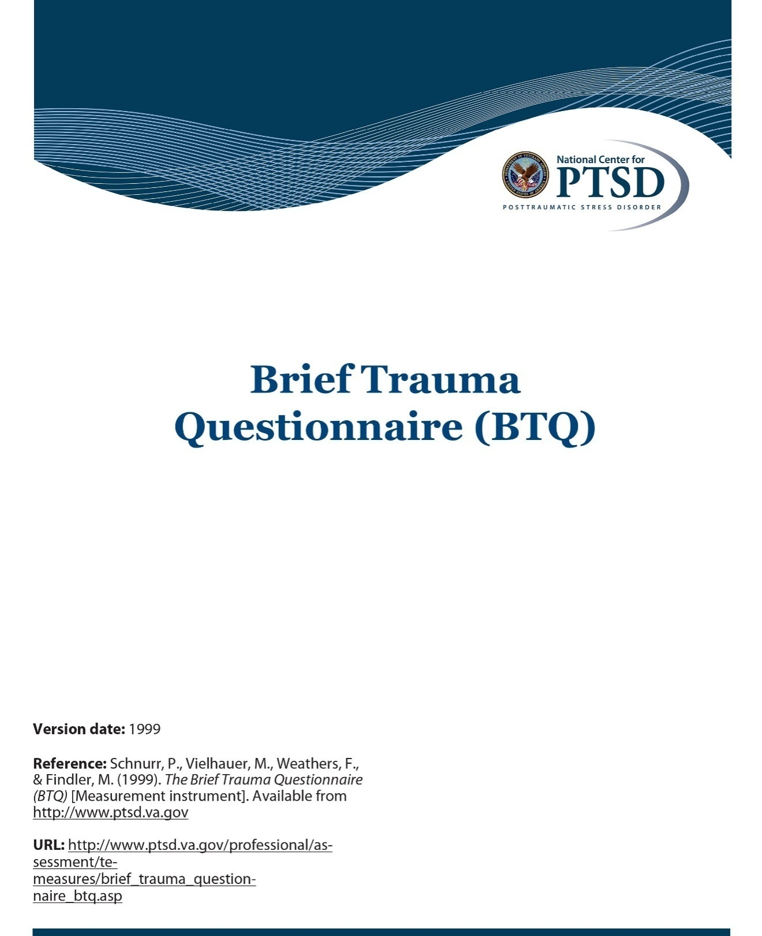
The Brief Trauma Questionnaire (BTQ)

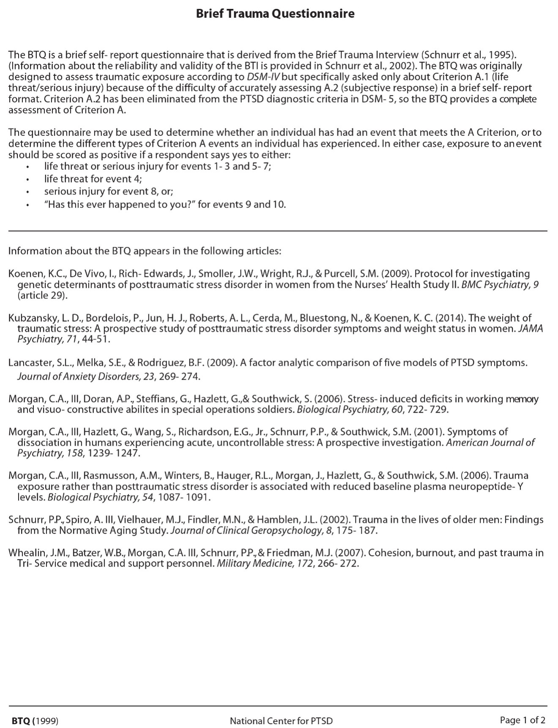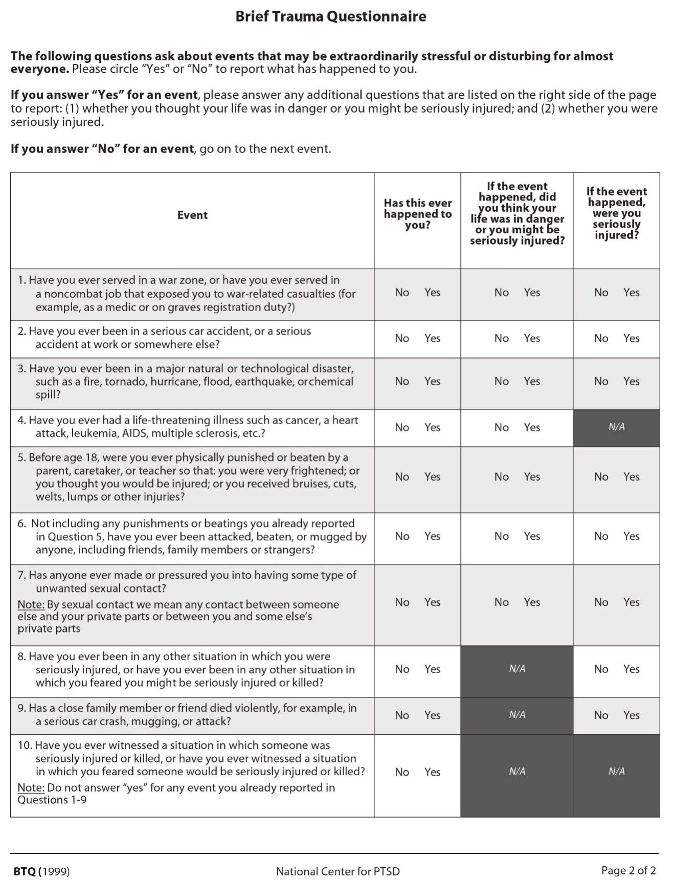

APPENDIX D

The Posttraumatic Stress Disorder Checklist
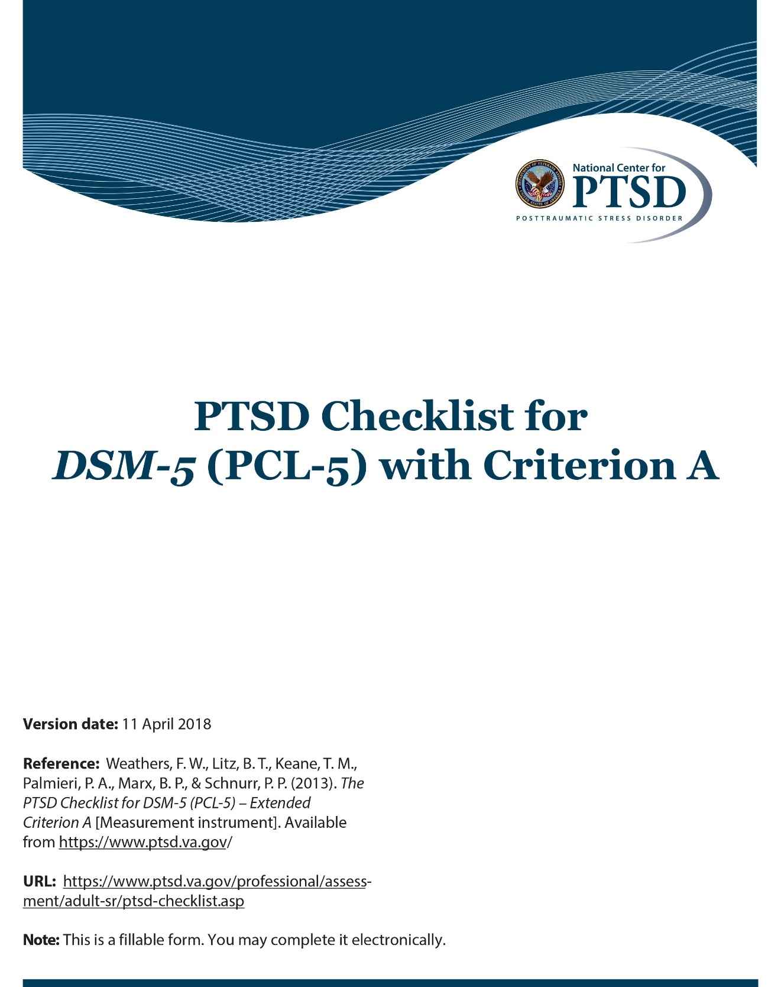
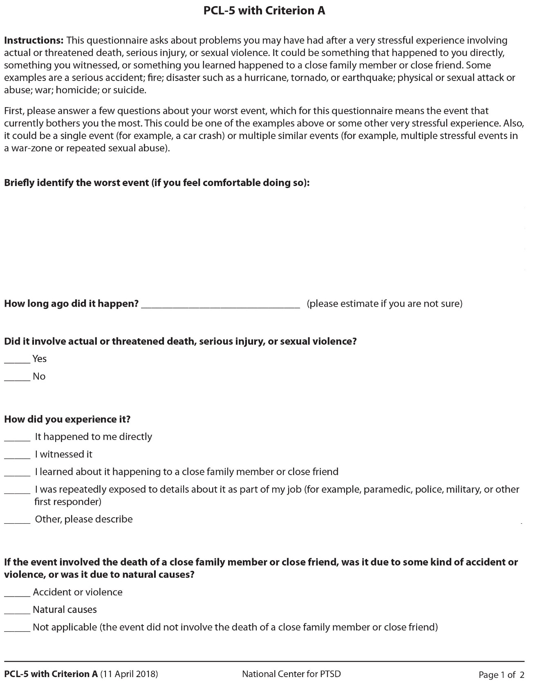
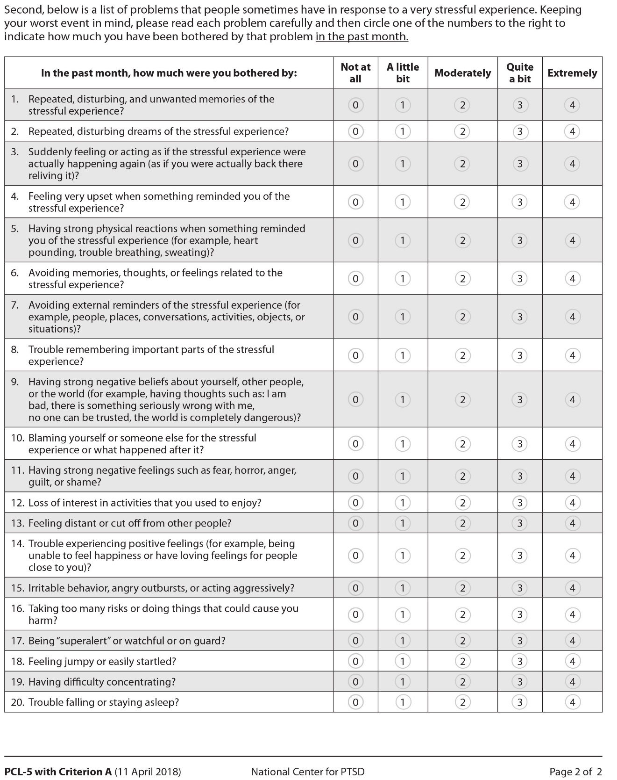

APPENDIX E

Alcohol Use Disorders Identification Test (AUDIT)
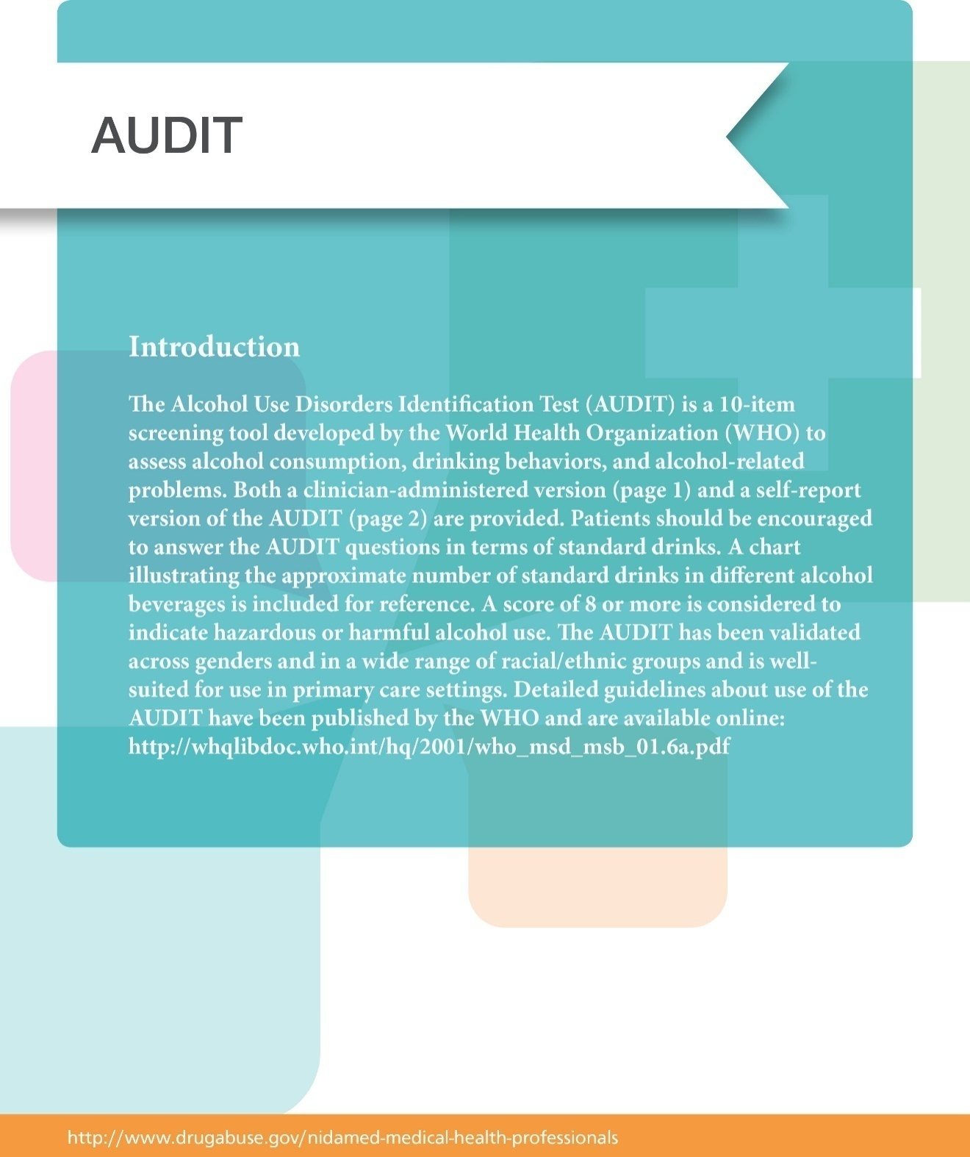
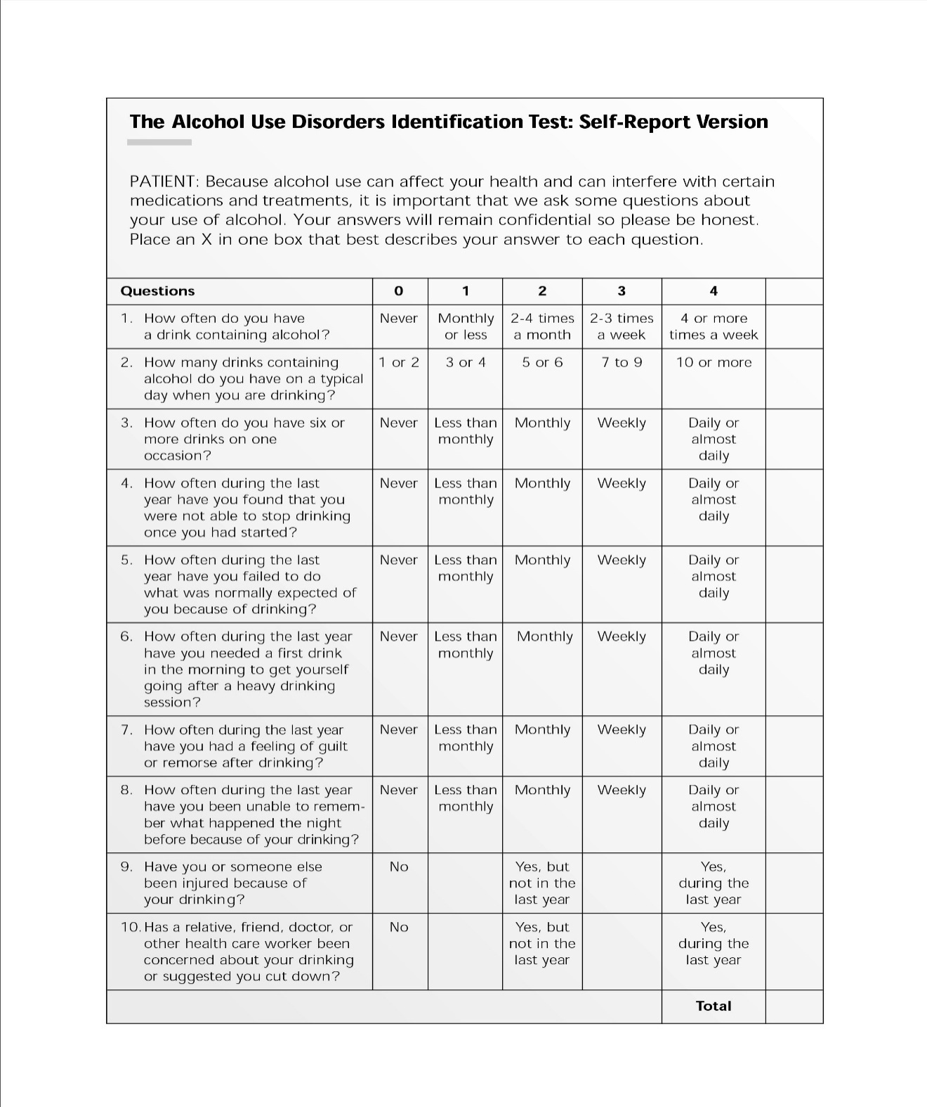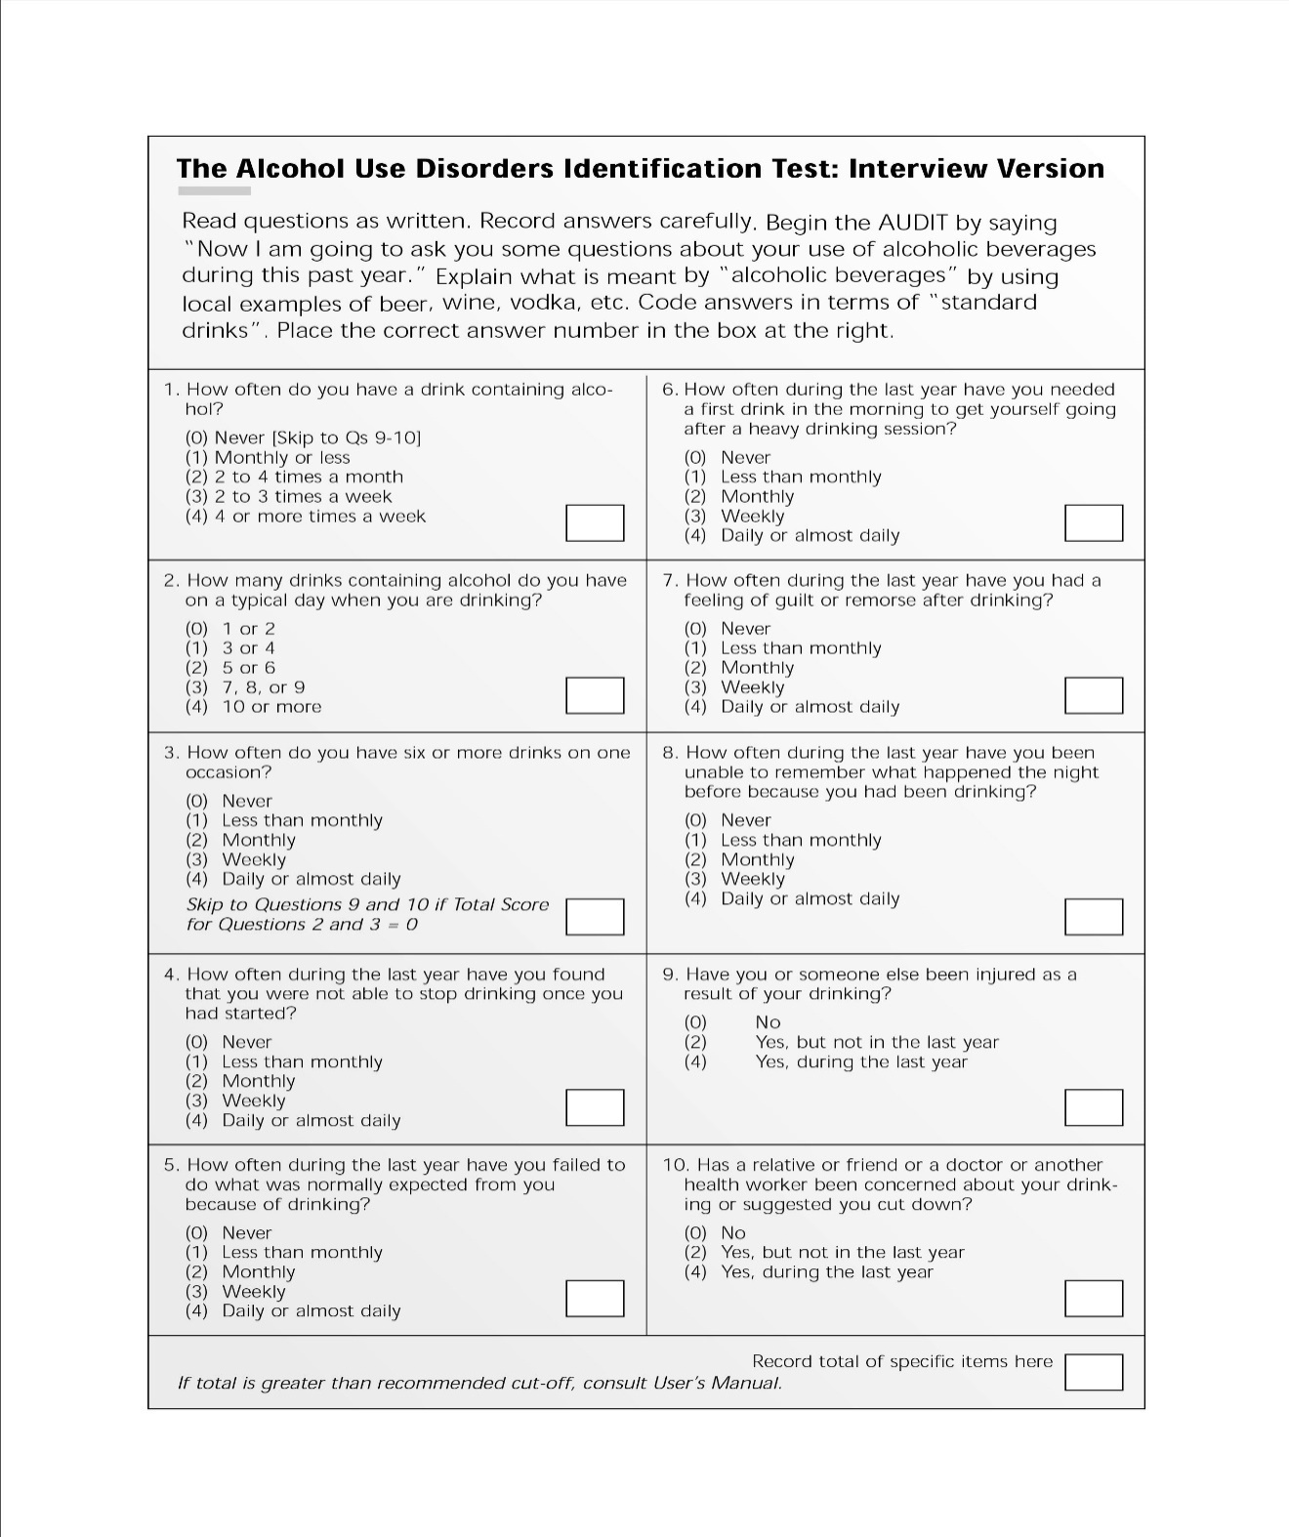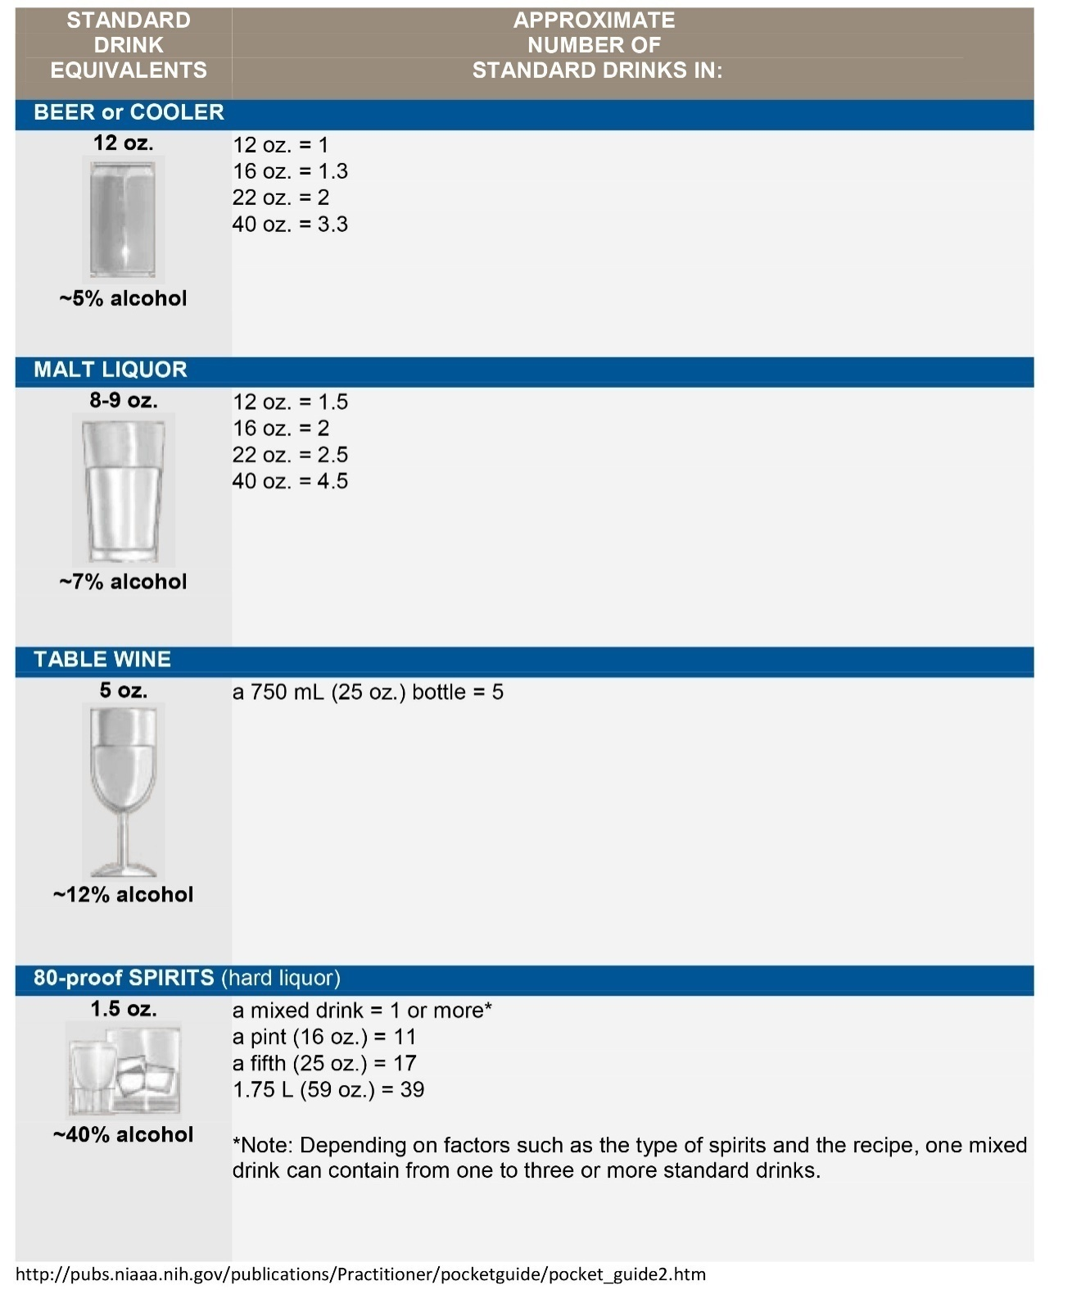

APPENDIX F

The Patient Health Questionnaire (PHQ-9)
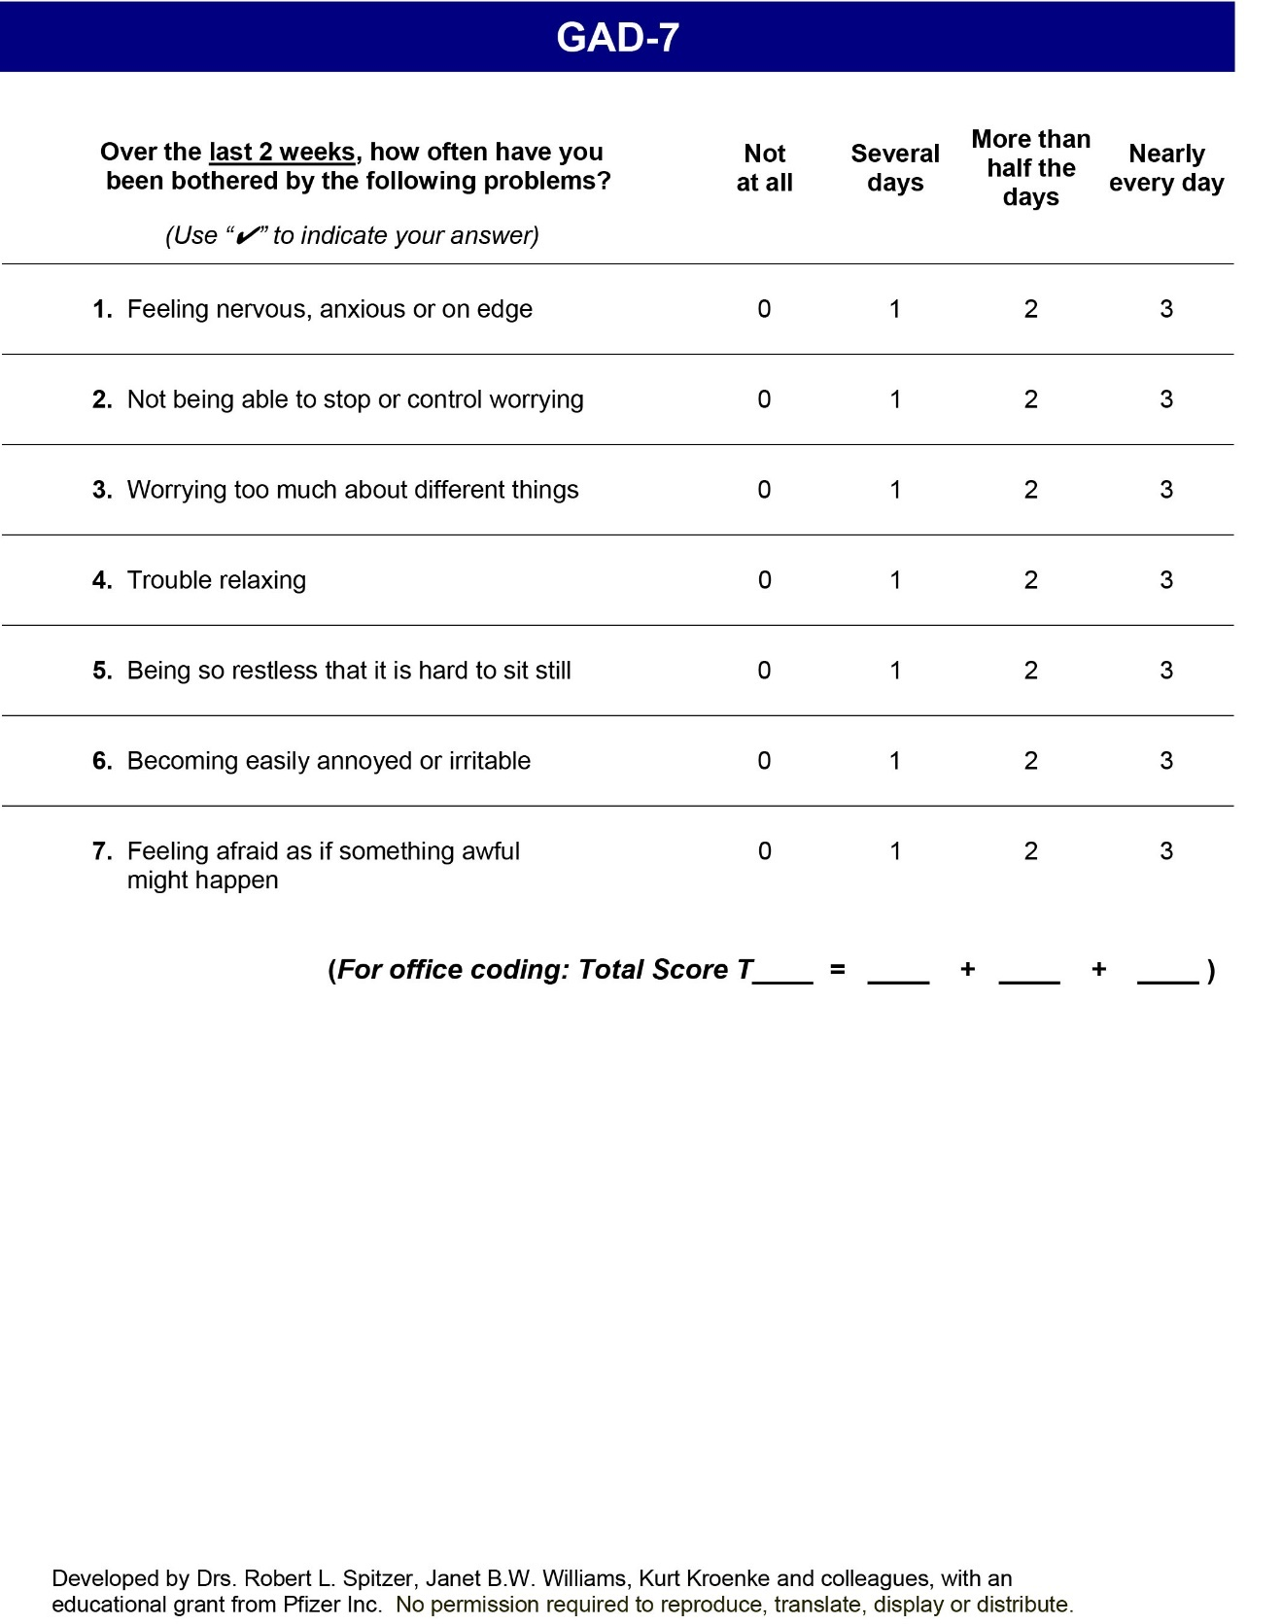
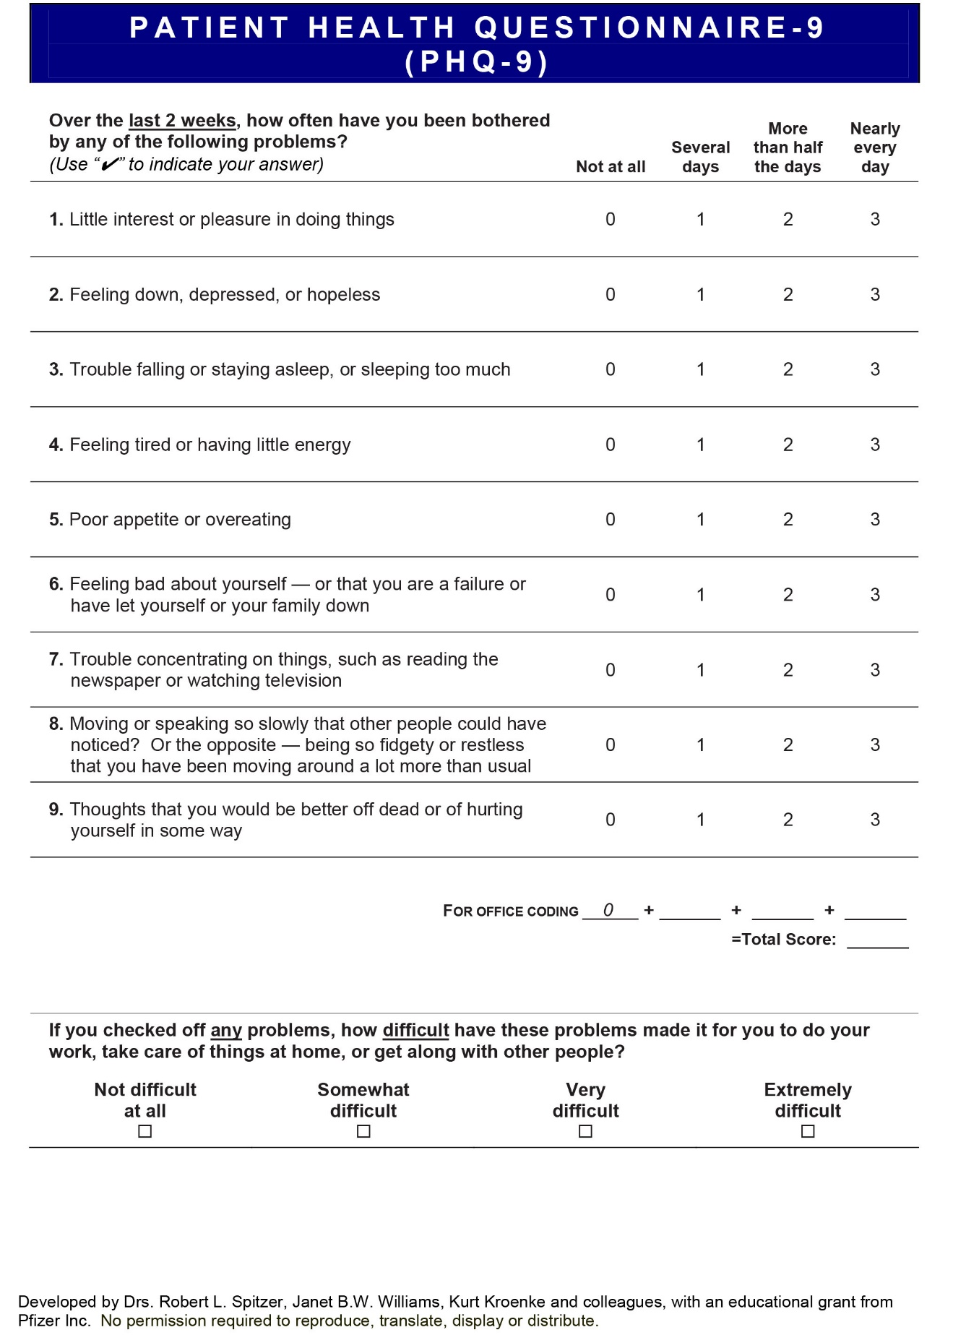

APPENDIX G

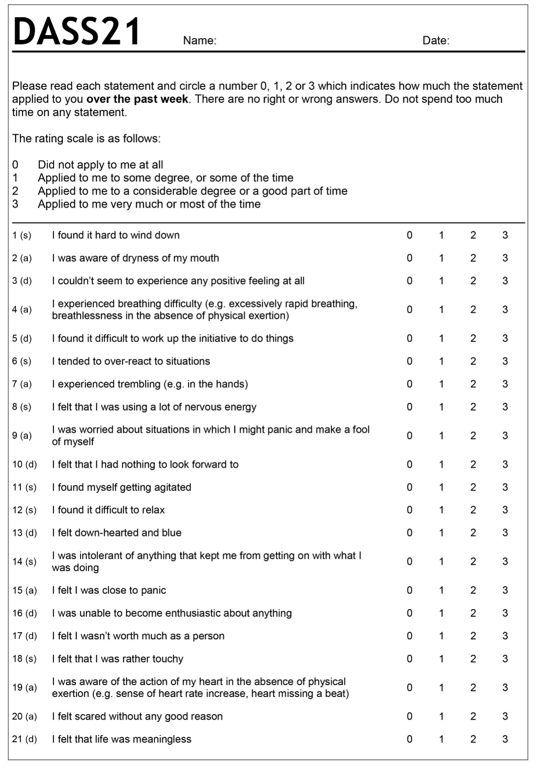
Depression, Anxiety and Stress Scale – 21 Items (DASS-21)

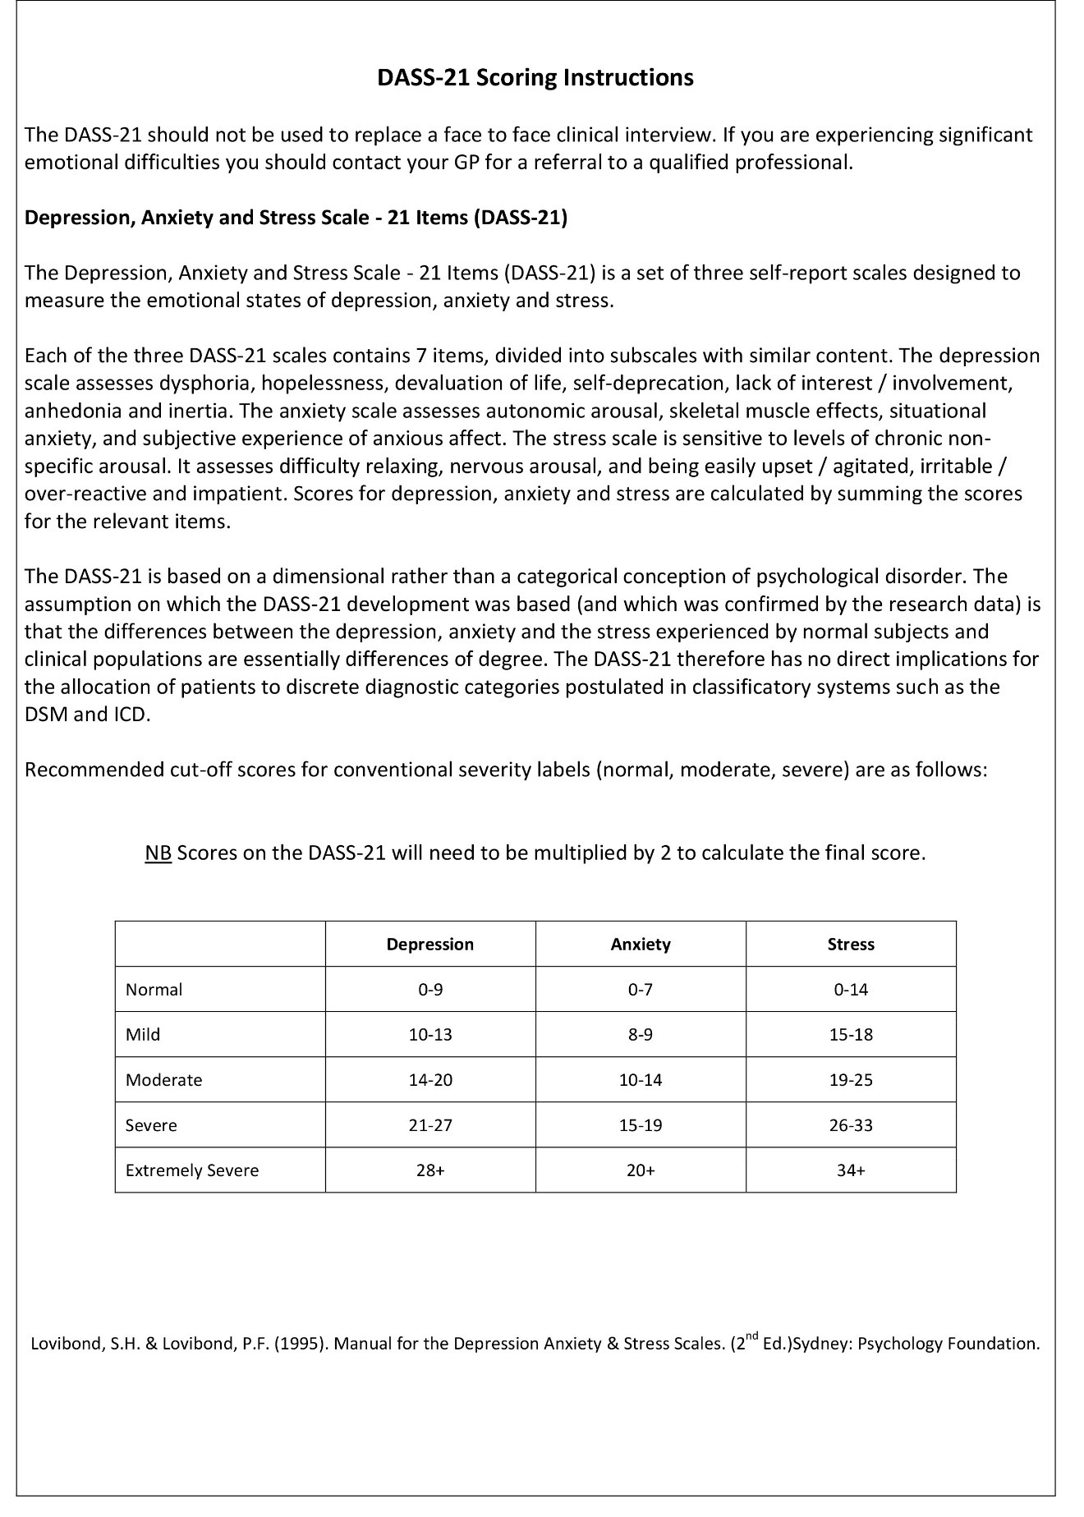

APPENDIX H
Hardy Personality Profile
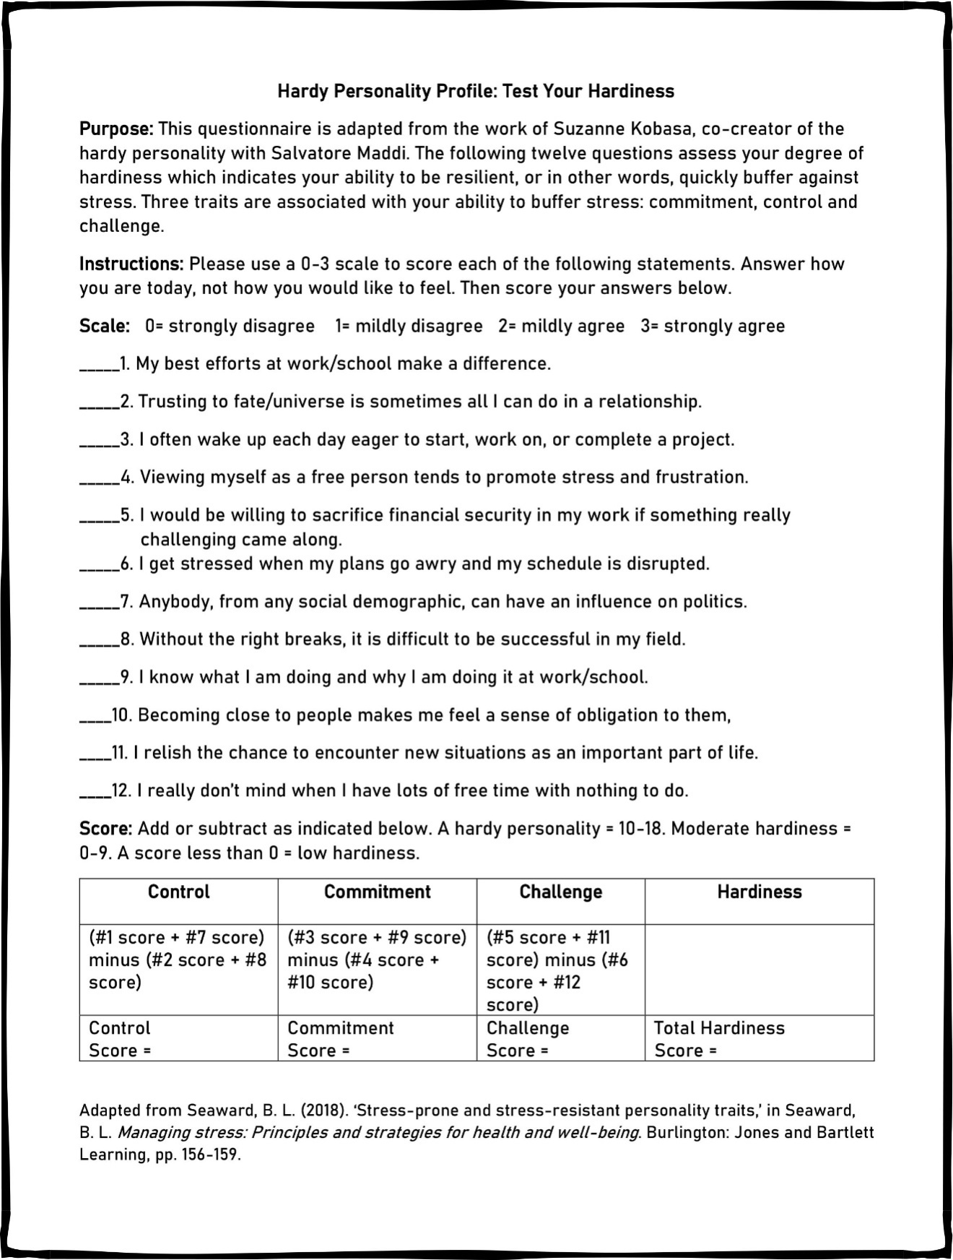

APPENDIX I
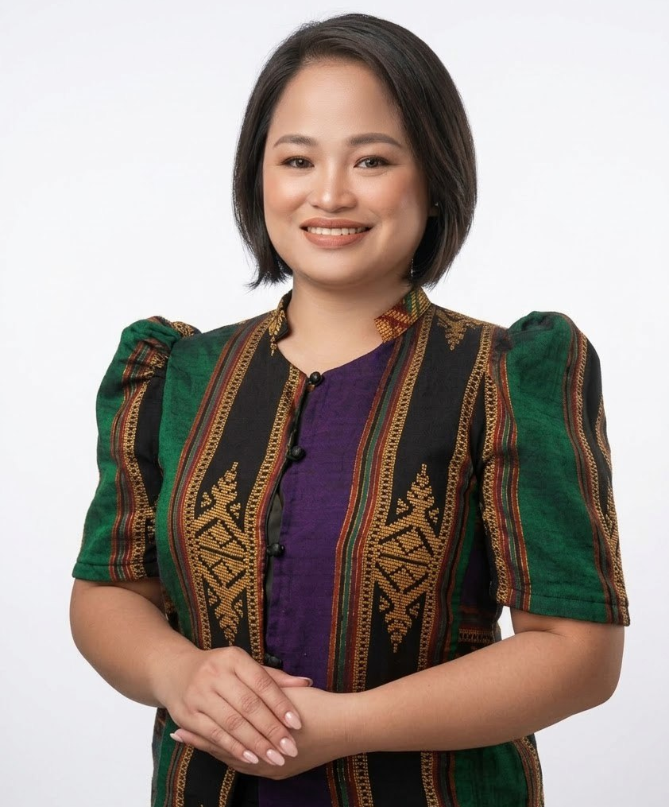
Curriculum Vitae

Jessieca Nitafan Fuentes
5th Road Purok Ilang-Ilang, RH-12, Cotabato City
E-mail address: jessieca.fuentes@gmail.com
Contact number: +639171202663

Objectives:
To practice what I learned in Psychology and learn more about it.

Personal Statement:
- I consider myself an open-minded individual.
- A self-reliant with the ability to pick up new ideas and concepts quickly.
- Enjoy learning new skills and methods of working in producing excellent works.
- I am fun and cheerful and love to work with people.

Personal Details Age : 33
Birth date : December 6, 1992
Birthplace : Cotabato City
Sex : Female
Height : 5’2”
Weight : 78
Religion : Born-again Christian
Civil Status : Single

Education: Master of Science in Psychology
Centro Escolar University, Mendiola
(2016 - Present)

Bachelor of Science in Psychology
Cotabato City State Polytechnic College
(2009-2013)

Cotabato City National High School Rojas-site
(2005-2009)

Kimpo Elementary School
(2005)

Work Experience: Administrative Assistant II (Permanent)
NCRRCDG, Philippine Army, Fort Bonifacio, Taguig City
September 14, 2020 – Present

Active Military Officer (Called to Active Duty Training)
NCRRCDG, Philippine Army, Fort Bonifacio, Taguig City
June 01, 2017 – June 1, 2019

Line Guard
Teleperformance, MAAX, Pasay City
October 20, 2015 – December 31, 2016
Acting Guidance Counsellor
Antonio R. Pacheco College, Inc.
June 3, 2013 – March 31, 2014

Student Assistant
College of Arts and Sciences, CCSPC
June 2009 – March 2012
Major Training Course, Conferences, and Seminars Attended (from the last 3years)
- Instructor Duty Training – RESCOM, PA (July 16, 2025)
- Basic Civilian Human Resource Training – Philippine Army (March 28, 2025)
- Basic Strategy Management Training - Philippine Army (September 06 – 08, 2023)
- 15th Post-Graduate Course – University of the Philippines PGH (November 21 - 24, 2022)
- Psychological First Aid - John Hopkins University thru Coursera (December 12 – 16, 2020)
- Internship – Centro Escolar University Guidance Counselling Center (December 01 – March 31, 2021)
Achievements:
- Awarded as Philippine Army Model Employee CY 2025 on March 19, 2026.
- Passed the Board Licensure Examination for Psychologist and Psychometrician (BLEPP) given by the PRC last August 30 – 31, 2016
- Probationary Officers Training Course Class-40, Tanza, Cavite, October 7, 2014
- Reserved Officer Training Course Advanced graduate, March 2012
- Completed JEEP-Accelerate (Job Enabling English Proficiency), March 21,2013
Awards Received:
- Plaque of Recognition (September 6, 2024)
- Certificate of Commendation (December 17, 2023)
- Military Commendation Medal (May 25, 2019)
- Military Civic Action Medal (December 07, 2023)
- Letter of Commendation (April 20, 2023)
- Plaque of Appreciation – Philippine Army (May 16, 2019)
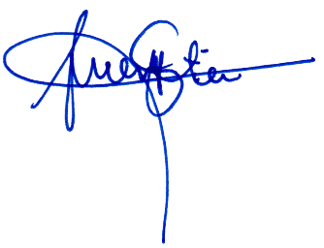

Jessieca N. Fuentes, RPm
Primary Investigator

