Embedding Learning for Unsupervised Breast Cancer Images Clustering
Andriamasinoro Rahajaniaina¹, Adolphe Andriamanga Ratiarison²
¹Department of Mathematics, Computer Science and Applications, University of Toamasina,
Toamasina, Madagascar.

²Department of Physics and Applications, University of Antananarivo, Antananarivo,
Madagascar.
*Corresponding author: Andriamasinoro Rahajaniaina
ABSTRACT
Early detection of breast cancer significantly reduces the number of deaths caused by this disease. In Africa where the number of new cases and deaths is constantly increasing. For Madagascar, very little information is available regarding the number of people affected by this disease. Advances in the application of artificial intelligence in medicine are improving the techniques for detecting this disease. Unfortunately, most of these techniques are cumbersome, complex, and very expensive. In this work, we propose a lightweight, hybrid approach to clustering breast cancer images. Our approach combines deep learning, ArcFace and unsupervised clustering. The architecture relies on the MobileNetV3Small convolutional network as a feature extractor. At the output of the backbone, a projection head is added to transform the feature maps into a compact embedding vector. The goal is to project the data into a low-dimensional (64-dimensional) latent space, where the discriminating properties between classes are strengthened. The use of ArcFace ameliorate intra-class compactness and inter-class separability, enhancing the quality of the learned representations. Two phases of training were adopted: firstly, only the projection layers and the ArcFace layer are trained, with the backbone remaining frozen to stabilize the learning process. Then, partial fine-tuning is performed by unfreezing the final layers of the convolutional neural network. Principal Component Analysis algorithm is used to facilitate the structuring of the embedding in a lower-dimensional space while preserving most of the discriminating information. A comparative study was conducted to evaluate the clustering capabilities of K-Means and HDBSCAN. The overall metrics results show that K-Means provides the best results for all metrics used. Despite the lightweight of our model (3,6 GFLOPs), it achieved a performance comparable to other state-of-the-art approach.
Key Words: Embedding learning, Unsupervised Clustering, Breast Cancer images, ArcFace loss, lightweight clustering method

INTRODUCTION
Several types of cancer can affect humans. Breast cancer is one of them, affecting women in the majority of cases. Currently, this disease represents a major public health challenge worldwide, particularly in Africa where the number of new cases and deaths is constantly increasing. According to the GLOBOCAN 2020 program, breast cancer is the most common cancer among women in Africa, with approximately 186,598 new cases and 85,787 deaths recorded in 2020 [12]; [3]. This high mortality rate is generally due to late diagnosis, limited access to screening and treatment facilities, and significant inequalities in healthcare systems [4]; [13]. For Madagascar data is very limited, which is a significant constraint for monitoring the progression of this disease. However, according to estimates from the World Health Organization, breast cancer was responsible for approximately 629 deaths in 2020, representing 0.38% of all deaths in the country, with an adjusted mortality rate of 8.32 per 100,000 inhabitants [15]; [3]. Very few people with this disease survive long, especially those already in the final stages. Early detection of this disease could reduce the number of deaths.
Today, artificial intelligence is constantly providing innovative solutions in several fields, including healthcare, to enable the early detection of diseases. Indeed, [1] proposed comparative study for breast cancer classification. They used transfer learning and meta-learning and ensemble learning to achieve their goal. The Breast Ultrasound Imaging (BUSI) dataset was employed to evaluate the performance of the proposed technique. the experiment result show that meta-learning achieved higher performance. [6] suggested a method based on wavelet and curvelet coefficients, to obtain a multi-resolution representation of the original image at each resolution, a set of features is extracted, which serves as input to a binary tree classifier. In [10], Clustering Ensemble was proposed, combining multiple algorithms to ameliorate the performance. The work presented in [5] made a Hybrid Clustering mixing clustering with other machine learning techniques like classification or regression. An example includes Deep Clustering Ensemble (DCE) [8], which combines deep learning and ensemble methods. In [14], Graph Convolutional Clustering (GCC) is proposed. It combines graph convolutional networks with clustering for efficient and accurate clustering of graph structured data. For clustering big data, Distributed Deep Clustering (DDC) framework [16], which leverages distributed computing frameworks like Apache Spark to distribute the training of deep clustering models across multiple machines, enabling efficient processing of large-scale datasets. Most of these works achieved higher performance but they are more complex and heavier. In this work, we suggested a lightweight clustering method using the combination of MobilenetV3Small, ArcFace and clustering method like K-Means and HDBSCAN. The remain of the paper is organized as follows: section II describes related work about breast cancer classification, section III explores our approach, results and discussion are presented in section IV and section V conclude this work.
RELATED WORK
The present work focuses on the breast cancer images clustering using images dataset. Several works have already been carried out in this direction. Various approaches were existed to cluster these ones. The authors proposed in [11] a comparative study of three unsupervised algorithms for the task of breast Magnetic Resonance (MRI) lesion segmentation, namely, Gaussian Mixture Model clustering, K-Means clustering and a marker-controlled Water shed transformation-based method. They used a dataset MR image acquired from 1.5 T scanners Magnetom Avanto. and 3.0 T Magnetom Verio, Siemens Healthineers, Erlangen, Germany, with dedicated breast array coils and the patient in a prone position. they applied to the all methods on breast MRI slices following selection of regions of interest (ROIs) by an expert radiologist. They used the Dice similarity coefficient (DSC), Jaccard index (JI), Hausdorff distance and precision recall metrics to evaluated the segmentation accuracy. The result shows that the marker-controlled Watershed transformation achieved higher segmentation accuracy compared to the other algorithm.
In [2], the authors proposed an automatic approach to segment masses in mammograms. Their method used hierarchical clustering to isolate the salient area, and then features are extracted to reject false detection. They used two datasets (mini-MIAS and DDSM) to evaluate their approach. Support Vector Machine (SVM) is used as classifier. The total accuracy of the system is 83,43%. The result shows that their method is efficient compared with other techniques.
The Work presented in [9] made comparative studies of two clustering methods: K-means and K-medoids clustering or Partitioning Around Medoids (PAM). In their approach, no pretrained model and label were need. The dataset consisted of 458 benign which is 65.5% of the dataset and 241 malignant which is also 34.5% of the dataset. They used Weka software to pre-process the data. Hopkins Statistic is used to evaluate the clustering quality of the dataset and silhouette width is used to measure the performance of the clustering methods. The experiment results show that k-Means achieved slightly higher silhouette width (0.58) compared with PAM (0.57).
In [7], authors conducted a comprehensive comparison of three clustering methods: K-Means, Agglomerative, and Gaussian Mixture Models applied to breast cancer dataset downloaded from Kaggle. They evaluate the performance of these clustering techniques using the Silhouette Score, Calinski-Harabasz Score, and Davies Bouldin Score. The results show: Silhouette Score k-Means 0.4711, Agglomerative 0.4631 and GMM 0.4703; Calinski-Harabasz Score: k-Means 523.4070, Agglomerative 494.1320 and GMM 429.3527; Davies-Bouldin Score kmeans 0.9263, Agglomerative 0.9750 and GMM 1.0203. After analysis, K-Means performs the best in terms of creating distinct, well-separated, and compact clusters for the breast dataset.
MATERIALS AND METHODS
Our Approach
In this section, we describe our approach to cluster breast cancer ultrasound images. Dataset publicly available in Kaggle web site was used to evaluate the model. The data is injected to the backbone for extracting the features map. This one is fed to several pool layer to product features vector. This vector is then projected into a low-dimensional latent space to form an embedding. To improve data separability in this space, an ArcFace-type loss function is applied, imposing an angular constraint between classes and promoting the formation of discriminating embeddings. Finally, these embedding are exploited by unsupervised clustering algorithms, after having applicated normalization and reduction of dimensionality, such as K-Means or HDBSCAN, in order to automatically clustering images according to their morphological similarities, in particular for the distinction between benign and malignant lesions. Figure 1 illustrate our approach.
Input images

Futures extraction
(MobileNetV3Small)
Transformation
(GAP + ArcFace)
Pre-process
(resizing)
224x224x3
Features map
Discriminating Embedding
Normalization
Dimensionality reduction (PCA)

Clustering
(K-Means/HDBSCAN)

GAP: Global Average Pooling
Figure 1: Our approach
Dataset Description
For this study, we used publicly available dataset from Kaggle web site. Our dataset contains 9015 breast ultrasound images. Down sampling technic was applied to balance the number of images for each class. Outcome this operation, each class contains 3000 images. Then, this data fed to the model to be clustering into benign or malignant case.
Proposed Method
The proposed model employs a hybrid approach combining supervised deep learning and metric learning to produce discriminating vector representations suitable for classification and clustering tasks. The architecture relies on the MobileNetV3Small convolutional network as a feature extractor. This model, known for its computational efficiency and lightweight nature, is used without its final classification layer to retain only its ability to generate relevant visual descriptors. The input images are resized and then fed into the network. The pre-trained weights are initially frozen, thus leveraging generic representations learned from large datasets.
At the output of the convolutional backbone, a projection head is added to transform the feature maps into a compact embedding vector. This model head consists of a global pooling layer followed by several fully connected layers, incorporating nonlinear activation functions and Batch Normalization. The goal of this structure is to project the data into a low-dimensional (64-dimensional) latent space, where the discriminating properties between classes are strengthened. Furthermore, data augmentation techniques, including random geometric transformations such as horizontal flips, rotations, and zooms, are applied during training to improve the model's generalization ability to different data.
The originality of this approach lies in the integration of an ArcFace layer, based on the Additive Angular Margin Loss principle, which replaces the classic softmax loss function. This method involves normalizing the embeddings and the weights of the classification layer, then introducing an additive angular margin into the logit calculation for the target class. In practice, this means forcing examples of the same class to move closer together in angular space, while simultaneously increasing the separation between distinct classes. This geometric constraint promotes the learning of more discriminating and better-structured representations, which is particularly beneficial in contexts where the embeddings are used for subsequent clustering tasks. The use of ArcFace thus significantly improves intra-class compactness and inter-class separability, enhancing the quality of the learned representations.
The training strategy adopted unfolds in two phases. Initially, only the projection layers and the ArcFace layer are trained, with the backbone remaining frozen to stabilize the learning process. Subsequently, partial fine-tuning is performed by unfreezing the final layers of the convolutional neural network, allowing for a more precise adaptation of the representations to the specific characteristics of the dataset being studied. This progressive approach ensures an effective compromise between training stability and model specialization.
Once trained, the model is used to extract embeddings via a derived architecture that retains only the projection portion. This embedding vector contains 384,000 elements. These outputs contain a significant amount of noise and zero-elements resulting from filters that did not activate. These vector representations are then normalized and subjected to dimensionality reduction using the Principal Component Analysis (PCA) algorithm to facilitate their structuring in a lower-dimensional space while preserving most of the discriminating information.
The map was computed using PCA components. The map reveals the natural clustering of the data. The resulting embeddings are then used in unsupervised clustering methods, notably K-Means and HDBSCAN. The optimal number of clusters for K-Means is automatically determined from the silhouette coefficient (see figure 2), while HDBSCAN detects structures of varying density while identifying points considered noise.
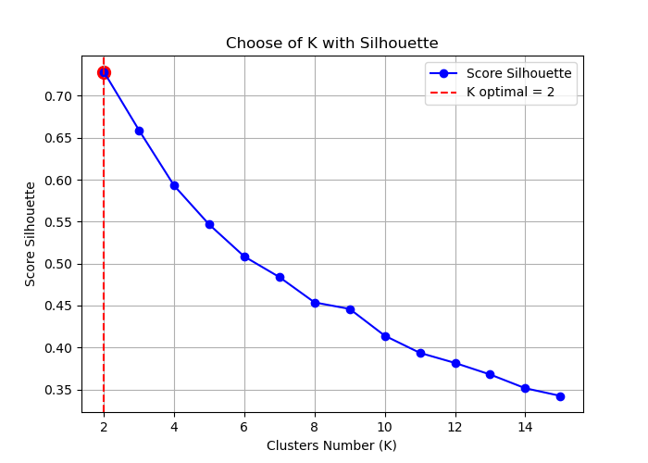

Figure 2: search k values using Score silhouette
A sample t-SNE map for the embedding is shown in Figure 3.
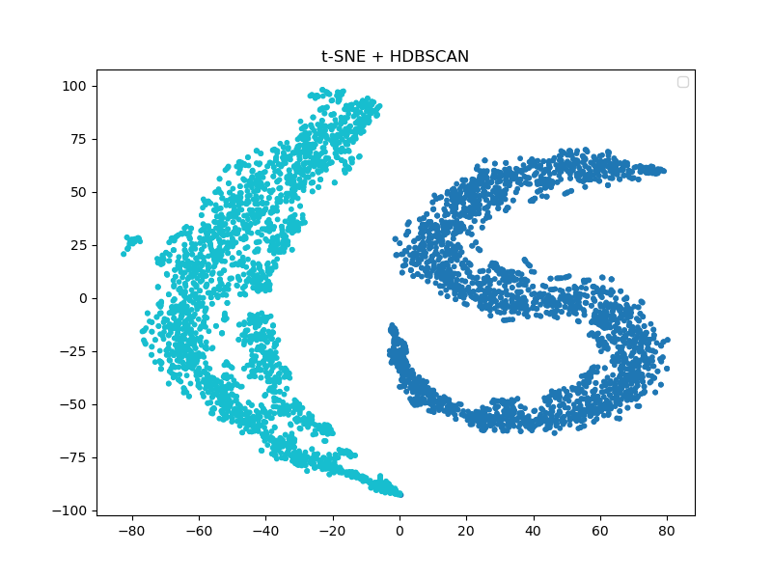
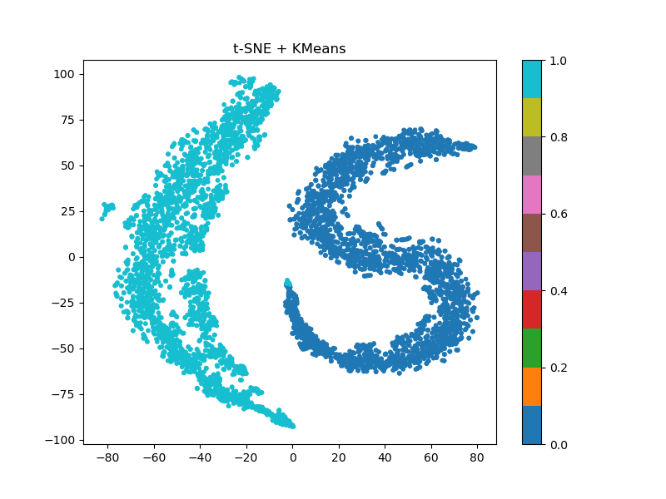

Figure 3.a : K-means t-sne map for PCA components Figure 3.b : HDBSCAN t-sne map for PCA components
Finally, performance evaluation is performed using standard classification and clustering metrics, including accuracy, the F1 score, and specific indicators such as the Adjusted Rand Index and Normalized Mutual Information, which measure the agreement between the obtained partitions and the reference annotations. K-Fold cross-validation is implemented to ensure the robustness and stability of the experimental results.
RESULTS AND DISCUSSION
The proposed model was evaluated on a dataset of histopathological images of breast cancer, composed of two balanced classes: benign and malignant cases. The images, initially stored without class organization.
The model's performance was evaluated in a K-Fold cross-validation framework (k = 10), using learned embeddings for unsupervised clustering tasks. The results obtained with the K-Means algorithm show high overall performance, with a mean accuracy of 0.945 and a similar mean F1 score. Table I.a and Table I.b show the predictive results of K-Means and HDBSCAN. The low variability observed between the different folds demonstrates the robustness of the model and its ability to produce stable representations. In addition, the clustering metrics indicate good agreement between the predicted clusters and the actual classes, with a mean Adjusted Rand Index of 0.792 (± 0.035) and a Normalized Mutual Information of 0.695 (± 0.040). These results suggest that the learned embedding space exhibits a coherent structure, enabling efficient separation of the two classes.
Evaluation using the HDBSCAN algorithm reveals slightly lower performance, with an average accuracy of 0.9255 and an F1 score of 0.9258. The ARI (0.702 ± 0.032) and NMI (0.618 ± 0.028) values confirm this trend. This difference can be explained by the very nature of HDBSCAN, which relies on a density-based approach and is particularly sensitive to the distribution of data in the latent space. In this case, the embeddings appear to form relatively compact and well-separated groups, a configuration more favourable to partitioning methods like K-Means than to density-based clustering approaches.
These results highlight the effectiveness of the adopted strategy, particularly the use of ArcFace loss to structure the embedding space. By imposing an angular constraint between classes, this approach promotes strong intra-class compactness and marked inter-class separation, which directly translates into better clustering performance. The relatively small difference between accuracy and F1 score also indicates a good balance in the classification of the two classes, which is consistent with the balanced distribution of the dataset.
Finally, it is worth noting that the proposed approach transforms an initially supervised problem into an unsupervised representation space structuring task. The results demonstrate that the learned embeddings are sufficiently discriminating to allow for efficient class separation without direct recourse to a supervised classifier during the inference phase. This property opens up interesting possibilities, particularly for applications where annotations are limited or partially available, as is often the case in medical imaging.
Table I.a: K-Means predictive results Table I.b: HDBSCAN predictive results
Validation Accuracy | F1 Score |  | Validation Accuracy | F1 Score
0.9350 | 0.9350 |  | 0.9217 | 0.9220
0.9450 | 0.9450 |  | 0.9317 | 0.9320
0.9567 | 0.9567 |  | 0.9250 | 0.9253
0.9467 | 0.9467 |  | 0.9250 | 0.9254
0.9517 | 0.9517 |  | 0.9317 | 0.9320
0.9350 | 0.9350 |  | 0.9217 | 0.9219
0.9617 | 0.9617 |  | 0.9267 | 0.9268
0.9500 | 0.9500 |  | 0.9383 | 0.9384
0.9283 | 0.9283 |  | 0.9233 | 0.9234
0.9400 | 0.9400 |  | 0.9100 | 0.9108

In summary, the performance obtained confirms the relevance of the proposed architecture and the adopted learning strategy, while highlighting the interest of metric-based learning approaches for classification and clustering tasks in a biomedical context.
CONCLUSION AND PERSPECTIVES
The present work was focused on breast cancer images clustering using hybrid approach combining transfer learning, ArcFace and unsupervised clustering. Our approach was tested with ultrasound breast cancer images. Despite the encouraging performance achieved, several limitations must be highlighted to accurately assess the scope of the results and identify areas for improvement. First, although the dataset is balanced between benign and malignant classes, it remains limited to a relatively simple binary configuration. This constraint reduces the inherent complexity of the problem and prevents a full evaluation of the model's ability to generalize to more realistic scenarios, particularly those involving a greater number of histopathological subtypes or unbalanced class distributions, which are common in clinical practice.
The evaluation based primarily on clustering methods applied to embeddings. While metrics such as the Adjusted Rand Index and Normalized Mutual Information provide a relevant indication of the quality of latent space structuring, they do not replace a comprehensive evaluation within a strictly supervised framework. In particular, the lack of direct comparison with standard classifiers (e.g., a classic softmax layer) makes it difficult to estimate the actual gain from using ArcFace loss in this specific context.
Furthermore, the choice of hyperparameters, especially those related to the ArcFace layer (angular margin and scaling factor), has not been systematically studied. However, these parameters play a crucial role in structuring the embedding space and can significantly influence performance.
In terms of future directions, several avenues for improvement can be explored. First, extending the study to more diverse datasets, including multiple classes and from different sources, would allow for a better assessment of the model's robustness and generalizability. Integrating domain adaptation techniques or pre-training specific to the medical domain could also improve the quality of the learned representations.
Furthermore, a more in-depth exploration of metric learning approaches is a promising avenue. Variants of ArcFace loss or other distance-based loss functions (such as Triplet Loss or Contrastive Loss) could be investigated to compare their impact on the structuring of the latent space. Similarly, the introduction of attention mechanisms or more recent models could enable the capture of finer and more discriminating features.
Finally, a particularly interesting prospect lies in integrating the model into a semi-supervised or weakly supervised framework, where only a portion of the data is annotated. In this context, the model's ability to produce discriminating embeddings could be leveraged to improve overall performance while reducing the annotation cost, a major challenge in medical imaging. The combined use of clustering and active learning techniques could also be a promising way to progressively refine annotations and improve system performance.
In conclusion, although the results obtained are encouraging, they constitute an intermediate step towards the development of more robust, generalizable systems adapted to the real constraints of biomedical applications.
REFERENCES
- Breast Cancer Classification through Meta-Learning Ensemble Technique Using Convolution Neural Networks. Diagnostics 2023, volume 13. 19 pages, 2023. https://doi.org/10.3390/diagnostics13132242
- Bilal Ahmed Lodhi (2021). Unsupervised Method to Localize Masses in Mammograms. arXiv: 1904.06044v1[cs.CV] 12 Apr 2019.IEEE Access, vol. 9, pp. 99327-99338, 2021.
- Ferlay, J., Ervik, M., Lam, F., et al. (2021). Global Cancer Observatory: Cancer Today. International Agency for Research on Cancer (IARC), 2021.
- Jedy-Agba, E., McCormack, V., Adebamowo, C., & dos-Santos-Silva, I. (2016). Stage at diagnosis of breast cancer in sub-Saharan Africa: A systematic review. The Lancet Global Health, 4(12), e923–e935, 2016.
- Kashef, R., & Kamel, M. S. (2009). Cooperative clustering. Pattern Recognition, 42(10), pp. 2324-2349, 2009.
- M. M. Eltoukhy and I. Faye (2014). An optimized feature selection method for breast cancer diagnosis in digital mammogram using multiresolution representation. Appl. Math, 8(6), pp. 2921–2928, 2014.
- Nikhil Sanjay Suryawanshi (2023). Enhancing Breast Cancer Diagnosis Through Clustering: A Study of KMeans, Agglomerative, and Gaussian Mixture Models. International Journal of Innovative Science and Research Technology, Volume 8, Issue 7, pp 3497-3504, July 2023.
- Peng, X., et al. (2017). Deep clustering via integrating sparse subspace clustering analysis and deep
- representation. Pattern Recognition Letters, 98, pp. 74-83, 2017.
- Somenath Chakraborty (2021). Beddhu Murali.Investigate the Correlation of Breast Cancer Dataset using Different Clustering Technique. arXiv:2109.01538v1[cs.CV], 2021.
https://doi.org/10.48550/arXiv.2109.01538
- Strehl, A., & Ghosh, J. (2002). Cluster ensembles a knowledge reuse framework for combining multiple partitions. Journal of Machine Learning Research,3(Dec), 583-617, 2002.
- Sulaiman Vesal, Nishant Ravikumar, Stephan Ellman, Andreas Maier (2018). Comparative Analysis of Unsupervised Algorithms for Breast MRI Lesion Segmentation. arXiv: 1802.08655v1[cs.CV] 23 feb 2018. 6 pages, 2018. https://doi.org/10.48550/arXiv.1802.08655.
- Sung, H., Ferlay, J., Siegel, R. L., et al. (2021). Global cancer statistics 2020. CA: A Cancer Journal for Clinicians, 71(3), pp. 209–249, 2021.
- Vanderpuye, V., Grover, S., Hammad, N., et al. (2017). An update on the management of breast cancer in Africa. Infectious Agents and Cancer, 12(13), 2017.
- Wang, Y., et al. (2023). Graph Convolutional Clustering: A Deep Learning Approach to Graph Clustering. In Proceedings of the 13th ACM International Conference on Web Search and Data Mining, pp. 861-869, 2023.
- World Health Organization (WHO). (2020). Global Health Observatory data repository. 2020.
- Zaheer, M., Reddi, S., Sachan, D., Kale, S., & Kumar, S. (2019). Distributed Deep Clustering. In Proceedings of the IEEE/CVF Conference on Computer Vision and Pattern Recognition, pp. 9489-9498, 2019.

