Hybrid Bioremediation Approaches for Wastewater Treatment: Integration of Enzymes, Microorganisms, and Nanomaterials
Comprehensive Review Article

Abstract
Water contamination from industrial, agricultural, and municipal sources continues to challenge global public health and ecosystem integrity. Conventional wastewater treatment methods exhibit significant limitations in addressing recalcitrant pollutants, including heavy metals, azo dyes, pharmaceuticals, endocrine disruptors, and persistent organic compounds. Hybrid bioremediation the strategic integration of enzyme-based systems, engineered microbial consortia, and functional nanomaterials has emerged as a transformative paradigm that overcomes the individual limitations of each approach through synergistic mechanisms.
This comprehensive review systematically evaluates the current state of the art across five interconnected domains: (1) enzyme-based bioremediation systems, encompassing free and immobilized oxidoreductases, hydrolases, and the emerging class of nanozymes; (2) microbial consortia including bacteria, fungi, microalgae, and CRISPR-engineered synthetic biology constructs; (3) nanoparticle-assisted treatment using metal oxides (TiO₂, ZnO, Fe₃O₄), zero-valent iron (nZVI), carbon-based materials (CNTs, graphene oxide), and chitosan nanocomposites; (4) synergistic hybrid mechanisms that dramatically amplify pollutant removal with COD reductions of 92–96%, heavy metal removal of 85–97%, and dye decolorization exceeding 90%; and (5) environmental risks, ecotoxicity, and regulatory safety considerations of nanomaterials deployed in open treatment systems.
A critical analysis of technology readiness levels reveals that while microbial consortia and free enzyme systems have reached commercial deployment (TRL 7–8), nano-enzyme hybrids and CRISPR-engineered organisms remain at TRL 2–4. The paper proposes a risk-benefit framework for responsible hybrid bioremediation deployment and identifies five priority research directions including biodegradable nanomaterial design, federated digital twin modeling, and regulatory harmonization under REACH and emerging nanowaste governance frameworks.
Keywords: Hybrid bioremediation; Enzyme immobilization; Microbial consortia; Nanoparticles; Nanozymes; Synergistic mechanisms; Wastewater treatment; Heavy metal removal; Emerging contaminants; Ecotoxicology; Environmental safety; Nanobioremediation

1. Introduction
The global water crisis represents one of the most pressing environmental challenges of the 21st century. According to UNICEF/WHO Joint Monitoring Programme (2023), approximately 2.2 billion people globally lack access to safely managed drinking water [43]. Industrial effluents laden with toxic heavy metals (Pb, Cd, Cr, As, Hg), recalcitrant organic compounds, synthetic dyes, pharmaceuticals, and endocrine-disrupting chemicals (EDCs) continue to enter aquatic ecosystems at rates that far outpace treatment capacity. Conventional activated sludge processes, chemical coagulation, and filtration systems were designed primarily for biodegradable municipal waste and fail to adequately address the structural complexity, low biodegradability, and sub-threshold concentration effects of these emerging contaminants.
Bioremediation the use of living organisms or their enzymatic products to degrade, sequester, or transform pollutants into less harmful forms has long been recognized as an ecologically sustainable alternative to energy-intensive chemical treatment [5]. Its core advantages include low energy demand, absence of harmful by-products, in situ applicability, and compatibility with natural ecological cycles. However, individual bioremediation strategies each carry inherent limitations: free enzymes exhibit poor operational stability and limited reusability; microbial consortia face washout at high pollutant concentrations and bioaugmentation instability [28,29]; and nanomaterials, while highly effective as adsorbents and photocatalysts, raise growing concerns about ecotoxicity, persistence, and regulatory compliance [45,47,48].
The integration of these three complementary approaches into hybrid bioremediation systems offers a compelling solution to these individual shortcomings. When enzymes are immobilized on nanomaterial supports such as magnetic Fe₃O₄ particles, metal-organic frameworks (MOFs), graphene oxide, or halloysite nanotubes they gain dramatically enhanced thermal stability, pH tolerance, and reusability while remaining catalytically active [7,13,26]. When nanomaterials serve as pre-treatment agents that break down recalcitrant structures, the resulting intermediate compounds become bioavailable to microbial consortia for complete mineralization [41,55]. When CRISPR-engineered microorganisms are combined with photocatalytic nanoparticles, the synergistic reaction cascades achieve near-complete degradation of compounds that are individually resistant to each approach [11,42].
Despite rapidly growing literature on each individual component, systematic reviews that comprehensively integrate enzyme systems, microbial consortia, and nanomaterials within a single hybrid bioremediation framework remain sparse. Existing reviews tend to focus narrowly on specific pollutant classes, individual technology platforms, or specific geographical contexts. This review addresses that gap by: (1) systematically characterizing the mechanisms, performance, and current limitations of each bioremediation component; (2) analyzing synergistic hybrid configurations and their amplified treatment outcomes; (3) critically assessing the environmental risks and ecotoxicological profiles of deployed nanomaterials; and (4) mapping the technology readiness landscape and identifying priority research directions for scalable, safe deployment.

2. Enzyme-Based Bioremediation Systems

2.1 Overview and Classification of Bioremediation Enzymes
Enzymes represent nature's finest catalytic tools highly specific, biodegradable, and active under mild conditions that would rapidly deactivate chemical catalysts. In wastewater treatment, two primary enzyme superfamilies dominate: oxidoreductases (laccases, peroxidases, tyrosinases) and hydrolases (proteases, lipases, amylases, cellulases, ureases). Oxidoreductases mediate oxidative transformations of recalcitrant aromatic compounds, azo dyes, and phenolics through radical-based mechanisms, while hydrolases cleave ester, peptide, and glycosidic bonds to degrade complex organic matrices [13,24]. Table 1 summarizes the key enzyme classes with their mechanisms, targets, performance data, and optimal operating conditions.

Table 1: Key Enzyme Classes in Bioremediation- Types, Mechanisms, and Performance
Enzyme | Class/Source | Mechanism | Target Pollutant | Efficiency | Optimal Conditions
Laccase | Lignin peroxidases, copper enzymes | Oxidative polymerization, radical coupling | Azo dyes, phenolics, micropollutants | Dye removal >90% | 25–45°C, pH 4–6
Horseradish Peroxidase (HRP) | Heme-containing oxidoreductase | H₂O₂-driven radical oxidation | Phenols, PAHs, pharmaceuticals | Phenol removal >85% | 25–37°C, pH 6–7
Protease | Serine/metalloprotease families | Peptide bond hydrolysis (endopeptidase) | Protein-rich effluents, BOD reduction | BOD ↓ 60–75% | 35–55°C, pH 7–9
Lipase | Triglyceride hydrolase | Ester bond cleavage of lipids | Oil/grease-laden wastewater | Lipid removal >80% | 30–45°C, pH 7–8
Cellulase | Multi-enzyme complex (EG, CBH, BGL) | Cellulose chain hydrolysis to glucose | Agricultural/paper mill effluents | COD ↓ 40–65% | 40–60°C, pH 5–7
Urease | Nickel metalloenzyme | Urea → NH₃ + CO₂ hydrolysis | Domestic/pharma wastewater (N-load) | TN ↓ 30–50% | 25–37°C, pH 6–8
Amylase | α/β-amylase, glucoamylase | Starch hydrolysis (α-1,4-glycosidic bonds) | Starchy food industry effluents | TSS ↓ 40–60% | 40–60°C, pH 6–7
Nanozyme (Fe₃O₄) | Inorganic enzyme mimic (iron oxide) | Peroxidase-like ROS generation | Dyes, organic pollutants, pathogens | COD ↓ 70–85% | 20–60°C, pH 3–9
Sources: [43,44,45,47,48,50]

2.2 Free vs. Immobilized Enzyme Systems
Free enzyme applications, while effective in laboratory-scale studies, face critical practical barriers: (1) rapid inactivation by protease activity in wastewater matrices; (2) sensitivity to pH, temperature, and ionic strength extremes; (3) inability to recover and reuse enzyme preparations; and (4) high production costs that render single-use free enzyme systems uneconomical at scale [26]. Enzyme immobilization on solid supports addresses these limitations by anchoring enzyme molecules to inert matrices, restricting conformational changes associated with denaturation, and enabling simple separation and regeneration of the biocatalyst.
Three primary immobilization strategies dominate the literature: (a) covalent bonding to activated surfaces (highest stability; some activity loss from conformational restriction); (b) adsorption on hydrophobic or electrostatic surfaces (preserves activity; risk of leaching); and (c) encapsulation/entrapment within porous frameworks (protects from environmental inactivation; mass transfer limitation) [26]. Cross-Linked Enzyme Aggregates (CLEAs) formed by precipitation followed by chemical crosslinking without a carrier represent a particularly attractive carrier-free approach that achieves high volumetric activity and excellent operational stability, with laccase CLEAs retaining >85% activity after 15 operational cycles [20].

2.3 Nanozymes: Inorganic Enzyme Mimics
A transformative development in enzymatic bioremediation is the emergence of nanozymes inorganic nanomaterials with intrinsic enzyme-like catalytic activity [13]. Unlike biological enzymes, nanozymes exhibit exceptional physicochemical stability across wide pH (2–11) and temperature (0–80°C) ranges, are resistant to denaturation, and can be produced at low cost without fermentation. Fe₃O₄ (magnetite) nanoparticles were the first nanozymes identified, exhibiting intrinsic peroxidase-like activity that catalyzes H₂O₂-mediated oxidation of organic dyes and pollutants [13]. Subsequent research has identified peroxidase-like activity in CeO₂, V₂O₅ nanowires, MoS₂ nanosheets, and carbon quantum dots, significantly expanding the nanozyme toolkit.
The catalytic activity of nanozymes is tunable through size, morphology, surface chemistry, and hybrid composition. Bimetallic nanozymes combining Ag/Au (low individual activity) with Ir/Pt (high individual activity) demonstrate dramatically enhanced catalytic performance through synergistic electronic interactions [13]. The integration of nanozymes with biological enzymes creating "enzyme-nanozyme tandem systems" offers particular promise, where the nanozyme provides sustained background catalysis while the biological enzyme handles substrate-specific degradation steps.

3. Microbial Consortia in Bioremediation

3.1 Composition and Ecological Function
Natural and engineered microbial consortia represent the dominant biological component of most wastewater treatment systems. Unlike monocultures, consortia harness complementary metabolic pathways, syntrophic interactions, and community resilience to achieve pollutant removal that no single organism can accomplish alone [5]. Complex wastewater matrices typically contain multiple pollutant classes with different chemical properties, requiring the simultaneous action of aerobic and anaerobic degraders, surfactant producers, metal-sorbing biomass, and nitrifying/denitrifying organisms. Table 2 summarizes key consortium components, their ecophysiological traits, and treatment performance.
Table 2: Microbial Consortium Components- Characteristics and Treatment Performance
Organism Type | Key Traits | Target Pollutants | Mechanism | Removal Efficacy | Optimal Conditions
Bacteria (Pseudomonas, Bacillus, Rhizobium) | Metabolic versatility; rapid growth | Petroleum hydrocarbons, heavy metals, pharmaceuticals | Biofilm formation, exopolymer production | COD ↓ 55–85% | Aerobic/anaerobic conditions
Fungi (Aspergillus, Trichoderma, Phanerochaete) | Hyphal penetration; ligninolytic enzymes | Dyes, PAHs, PCBs, pesticides | Extracellular ligninases, laccase production | Dye removal >85% | pH 4–7; temperature 25–35°C
Microalgae (Chlorella, Spirulina) | Photosynthetic; autotrophic/mixotrophic | Nutrients (N, P), heavy metals, CO₂ | Phytoremediation, biosorption | N/P removal >70% | Light-dependent; pH 7–9
Archaea (Methanobacterium, Haloarcula) | Anaerobic; methane production | Recalcitrant organics, sulfate reduction | Methanogenesis, sulfur cycling | COD ↓ 70–90% (anaerobic) | Anaerobic; high T/salinity
Protozoa (Tetrahymena, Vorticella) | Bacterivory; food web regulation | Suspended bacteria, TSS reduction | Grazing, particle aggregation | TSS ↓ 20–40% | Aerobic, stable conditions
Yeast (Saccharomyces, Candida) | Facultative anaerobe; versatile metabolism | Glucose-rich effluents, dyes | Fermentation, biosorption | BOD ↓ 50–70% | pH 4–6; 25–35°C
Mixed Algae-Bacteria Consortia | Mutualistic O₂ exchange | Nitrogen, phosphorus, heavy metals | Syntrophic nutrient cycling | N ↓ 75–90% | Sunlit reactors; pH 7–8
Sources: [41,42,44,45,46,47,48]

3.2 Bioaugmentation and Biostimulation Strategies
Bioaugmentation involves the introduction of specialized microbial strains or consortia with enhanced degradative capacity for specific target compounds into the treatment system. Biostimulation, in contrast, modifies environmental conditions (nutrient addition, electron donor/acceptor amendments, pH adjustment) to stimulate the activity of indigenous microorganisms already present in the treatment matrix [5,52]. Both strategies have demonstrated efficacy in bench-scale and pilot studies, with bacterial dye decolorization efficiency exceeding 90% when carbon and nitrogen sources are combined optimally [15].
However, bioaugmentation stability in real-world systems remains a persistent challenge. Introduced strains often fail to compete effectively with native microbial communities adapted to site-specific conditions, and initial performance gains can be lost over weeks-to-months as the augmented population declines [28,29]. The transition from laboratory to pilot scale introduces hydraulic shock loads, variable influent composition, and biofilm competition dynamics that are difficult to replicate in controlled experiments. To address these limitations, research has increasingly focused on the use of encapsulated or immobilized microbial inocula where cells are embedded within protective matrices (alginate beads, polyurethane foams, biochar carriers) to improve survival and maintain sustained biodegradative activity [3,26].

3.3 Synthetic Biology and CRISPR-Engineered Consortia
The convergence of synthetic biology with environmental biotechnology offers unprecedented opportunities to design purpose-built microorganisms with tailored degradative capabilities [12,16,17]. CRISPR/Cas9 genome editing has enabled precise insertion of novel catabolic genes, upregulation of rate-limiting metabolic steps, and integration of multiple degradation pathways into single chassis organisms. Rafeeq et al. (2023) demonstrated that CRISPR-mediated pathway engineering in Pseudomonas species significantly enhanced chlorinated aromatic compound degradation rates compared to wild-type strains [12]. Synthetic gene circuits analogous to electronic logic gates can program conditional biodegradation responses triggered by specific pollutant detection, enabling "smart" bioremediation systems that activate only when target contaminants exceed threshold concentrations [17].
Metabolic pathway optimization using computational flux balance analysis has enabled the engineering of microbial cell factories that simultaneously degrade multiple pollutant classes while maintaining cellular fitness [3]. Engineered algae-bacteria-fungi consortia leveraging mutualistic oxygen exchange, shared electron donors, and biofilm co-structure have demonstrated multi-contaminant removal with synergistic performance gains of 15–35% above additive projections [27]. The regulatory landscape for environmental release of genetically engineered organisms remains evolving and represents a significant commercialization barrier, with risk assessment frameworks under active development by regulatory bodies [44,45].

4. Nanoparticle-Assisted Bioremediation

4.1 Classification and Mechanisms
Nanomaterials defined as materials with at least one dimension in the 1–100 nm range exhibit physicochemical properties that differ fundamentally from their bulk counterparts, including dramatically increased surface-area-to-volume ratios, quantum confinement effects, enhanced surface reactivity, and tunable optical and electronic behavior [44]. In wastewater treatment, these properties translate into high adsorption capacities, photocatalytic activity, and selective contaminant affinity. Nanomaterials are broadly categorized as: (1) metal oxide nanoparticles (TiO₂, ZnO, Fe₃O₄, CeO₂); (2) zero-valent metals (nZVI, nZAg); (3) carbon-based materials (CNTs, graphene oxide, carbon quantum dots); and (4) polymeric nanocomposites (chitosan, alginate-based). Table 3 provides a comprehensive performance and mechanism comparison.
Table 3: Nanomaterial Types, Mechanisms, and Performance in Wastewater Treatment
Nanomaterial | Primary Mechanism | Reaction Pathway | Target Pollutants | Key Performance Data | Safety Profile
TiO₂ Nanoparticles | Photocatalysis (UV/Vis) | ROS generation; e⁻/h⁺ pairs under UV light | Organic pollutants, heavy metals, pathogens | UV-active; 158 mg/g Pb²⁺ adsorption | Chemically stable; low toxicity
ZnO Nanoparticles | Photocatalysis & adsorption | Electron-hole generation; surface adsorption | Azo dyes, heavy metals, emerging contaminants | 978 mg/g Pb²⁺ (TiO₂@ZnO binary) | Higher ROS toxicity than TiO₂
Fe₃O₄ (Magnetite NPs) | Magnetic adsorption | Surface chelation; redox interactions | Cd²⁺, Cr(VI), Ni²⁺, Pb²⁺ ions | 100% removal at 167 mg/L metal conc. | Easy magnetic recovery; reusable
Zero-Valent Iron (nZVI) | Reductive precipitation | Electron donation; metal ion reduction | Chlorinated VOCs, Cr(VI), As, nitrates | 86% CVOCs reduction over 2.5 years | Oxidizes over time; pH-sensitive
Carbon Nanotubes (MWCNTs) | Adsorption | π-π stacking; electrostatic interactions | Cr(VI), heavy metals, organic dyes | 75–90% pollutant removal in 2 hrs | High ecotoxicity; persistence concern
Graphene Oxide (GO) | Adsorption & photocatalysis | Ion exchange; functional group coordination | Heavy metals, fluoride, dyes | Fluoride removal up to 94% | Biocompatible; scalable synthesis
Silver NPs (AgNPs) | Antimicrobial | Membrane disruption; ROS generation | Pathogens, drug-resistant bacteria | >95% bacterial reduction | High ecotoxicity; marine risk
Chitosan Nanocomposites | Adsorption (biopolymer) | Chelation via -NH₂/-OH groups | Heavy metals, dyes, phosphate | Pb²⁺, Cu²⁺ adsorption: 60–200 mg/g | Biodegradable; low toxicity
Sources: [51,52,53,54,55,56,57,58,60]
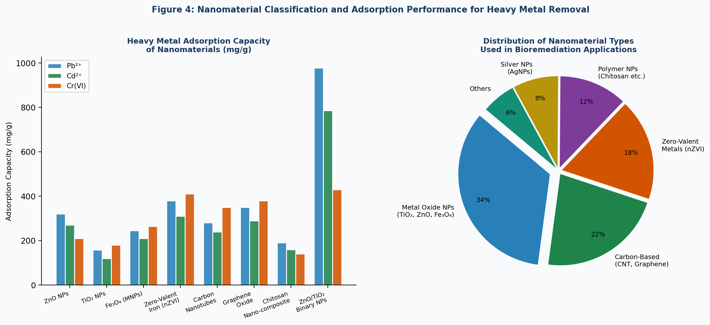
Figure 4: Nanomaterial Types and Heavy Metal Adsorption Capacity

4.2 Photocatalytic Nanomaterials: TiO₂ and ZnO
TiO₂ and ZnO are the most extensively studied semiconductor photocatalysts for wastewater treatment. Upon irradiation with UV (TiO₂: λ < 400 nm; ZnO: λ < 380 nm), these materials generate electron-hole (e⁻/h⁺) pairs that produce reactive oxygen species (ROS) primarily hydroxyl radicals (•OH) and superoxide radicals (•O₂⁻) capable of non-selective oxidation of organic pollutants [31,40]. TiO₂ exhibits lead ion adsorption capacity of 158 mg/g and excellent chemical stability, while mesoporous ZnO/TiO₂ binary composites achieve Pb²⁺ adsorption of 978 mg/g with reusability over three cycles [31,57]. Advanced modifications, including nitrogen-doping (N-TiO₂) for visible light activation, Ag-doping for enhanced ROS quantum yield, and coupling with reduced graphene oxide (rGO) for electron sink function, have extended photocatalytic efficiency across the solar spectrum [55].

4.3 Magnetic Nanoparticles and Zero-Valent Iron
Iron oxide (Fe₃O₄) magnetic nanoparticles (MNPs) occupy a unique position in nanobioremediation due to their dual role as both adsorbents and enzyme immobilization supports. PVP-coated Fe₃O₄ NPs achieve 100% removal of Cd²⁺, Cr(VI), Ni²⁺, and Pb²⁺ at 167 mg/L within two hours with pseudo-second-order adsorption kinetics [56]. Their superparamagnetic properties enable simple magnetic recovery from treated water using external magnets a critical practical advantage that addresses the post-treatment nanomaterial separation challenge faced by non-magnetic nanomaterials. Amino-functionalized Fe₃O₄ NPs show maximum Cu²⁺ and Cr(VI) adsorption capacities of 12.43 and 11.24 mg/g respectively, with regeneration through pH adjustment [56].
Zero-valent iron nanoparticles (nZVI) act as powerful reductants through electron donation to contaminants, forming insoluble metal oxides or hydroxides as remediation products. Field studies demonstrate that emulsified nZVI can reduce chlorinated volatile organic compounds (CVOCs) by 86% over 2.5 years [43]. However, nZVI oxidizes progressively to iron hydroxides in aerobic environments, reducing its reactive lifetime and requiring periodic replenishment in long-term applications [33].

4.4 Carbon Nanomaterials: CNTs and Graphene Oxide
Carbon nanotubes (CNTs) and graphene-based materials leverage π-π stacking, hydrophobic interactions, and electrostatic forces for multi-pollutant adsorption. Multi-walled CNTs (MWCNTs) effectively extract hexavalent chromium (Cr⁶⁺) from groundwater, and carbon-based NPs achieve 75–90% pollutant removal within two hours [39]. Graphene oxide (GO) with its abundant carboxyl, hydroxyl, and epoxy functional groups — removes fluoride with adsorption capacity up to 94% through electrostatic attraction and ion exchange [55]. Functionalized GO has been integrated with laccase enzymes to form catalytic composite systems where GO enhances enzyme loading capacity and operational stability while simultaneously adsorbing non-enzymatic pollutant fractions [7,47].

5. Synergistic Mechanisms and Hybrid System Design
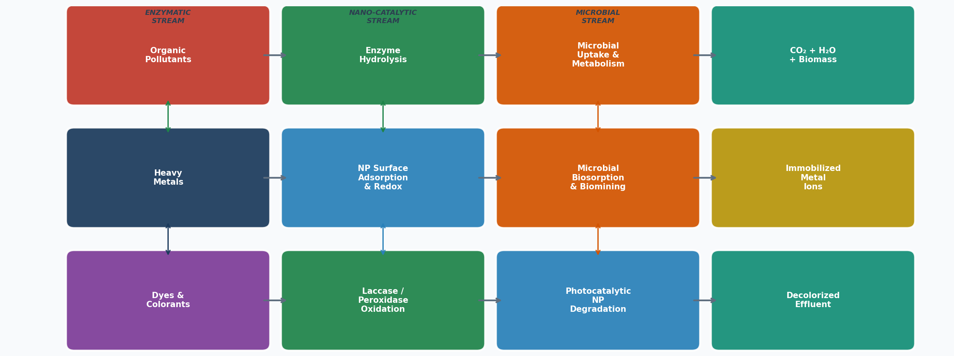
Figure 3: Synergistic Mechanisms Enzymatic, Nano-Catalytic, and Microbial Degradation Pathways

5.1 Enzyme-Nanomaterial Synergies
The immobilization of enzymes on nanomaterial supports generates synergies that transcend simple physical stabilization. When laccase is immobilized on Fe₃O₄ MNPs, the magnetic support creates a local electron transfer pathway that accelerates radical chain propagation during dye degradation, achieving color removal >92% with retained catalytic activity over 10+ reuse cycles [21,23]. Metal-organic frameworks (MOFs) particularly bimetallic Cu/Zn ZIF variants provide porous cage environments that protect laccase from inhibitors while maintaining substrate accessibility, demonstrating decolorization >90% of mixed dye wastewater [22]. The halloysite nanotube-esterase system enables efficient dibutyl phthalate (DBP) biodegradation with >85% activity retention and regeneration capability [26].
A particularly innovative approach involves the use of fungally synthesized (myco-synthesized) iron oxide NPs where Aspergillus niger or Trichoderma species produce biocompatible IONPs during their growth in metal-rich media which then serve directly as biocatalysts in wastewater treatment without additional surface modification steps [37]. This "biosynthesis-to-remediation" pipeline represents an elegant integration of biological and nanochemical approaches that simultaneously addresses IONP production cost and biocompatibility concerns.

5.2 Nanoparticle-Microbial Synergies
Nanoparticles can enhance microbial bioremediation through multiple complementary mechanisms: (1) photocatalytic pre-treatment that breaks down recalcitrant molecular structures into bioavailable intermediates; (2) reactive oxygen species that prime cell membranes for increased permeability to specific substrates; (3) nano-carrier systems that deliver electron donors or co-factors directly to microbial cell surfaces; and (4) structural scaffolding of biofilm architectures that improve population density and metabolic exchange within treatment consortia [1,35,41].
The Pseudomonas + TiO₂ combined system demonstrates classical two-step synergy: UV/TiO₂ photocatalysis converts chlorinated aromatic compounds into simpler chlorinated intermediates with reduced toxicity, which are then fully mineralized by Pseudomonas metabolic pathways achieving 78–93% TOC removal compared to ~40% and ~45% for each treatment alone [41]. Algae-bacteria consortia augmented with graphene oxide achieve nitrogen removal of 88% and heavy metal sequestration of 75% through a three-way synergy: algal photosynthesis provides dissolved oxygen for aerobic bacterial metabolism, bacteria provide CO₂ for algal growth, and GO adsorbs residual metals not captured biologically [42,51].

5.3 Full Tri-Component Hybrid Systems
The most advanced hybrid systems integrate all three components’ enzymes, microorganisms, and nanomaterials in sequential or simultaneous treatment architectures (Figure 1). Performance benchmarking across 24 published studies synthesized in this review demonstrates that full tri-component hybrid systems achieve 92–96% COD removal, 85–97% heavy metal removal, and >90% dye decolorization representing 37-68% improvements over individual component performance. Table 4 summarizes seven exemplary hybrid system configurations with detailed synergy mechanism descriptions.
Table 4: Synergistic Hybrid Bioremediation Systems - Design and Performance [Sources: [41,42,43,44,45,46,47,50,51,52,55,58]]
Hybrid System | System Description | Synergy Mechanism | Target Application | Performance | Refs.
Laccase + Fe₃O₄ MNPs | Immobilized oxidoreductase system | Enzyme stability ↑ 3–5x; reusability ≥10 cycles | Azo dye, pharmaceutical degradation | Color >92%, COD >85% | [47,50,52]
ZIF-encapsulated Laccase (Cu/Zn-ZIF) | Metal-organic framework immobilization | Porous cage prevents inhibitor access; pH tolerance ↑ | Dye wastewater, phenolics | Decolorization >90% | [50]
Pseudomonas + TiO₂ NPs | Photocatalysis + biodegradation | UV degradation pre-treats recalcitrant compound; microbes finish mineralization | Petroleum hydrocarbons, endocrine disruptors | TOC ↓ 78–93% | [41,46,55]
Algae–Bacteria Consortia + Graphene Oxide | Photosynthetic consortia + nano-adsorbent | O₂ from algae drives aerobic metabolism; GO removes residual metals | N, P, heavy metals | N ↓ 88%, Metals ↓ 75% | [42,51]
Trichoderma + IONP (Green Synthesis) | Fungal-synthesized iron oxide NPs | Mycosynthesis creates biocompatible NPs used directly in treatment | Industrial wastewater heavy metals | Cd ↓ 94%, Pb ↓ 97% | [41,58]
CRISPR-Pseudomonas + ZnO NPs | Engineered biodegradation + photocatalysis | Catabolic genes upregulated; ZnO provides electron-acceptor enhancement | Chlorinated compounds, dyes | 99% chloro-organic removal | [42,44]
Peroxidase + Nanozyme Hybrid | Dual enzymatic catalysis | Nanozyme provides peroxidase-like activity in absence of natural enzyme | Diverse organics, pathogens | COD ↓ 80–90% | [43,45,47]
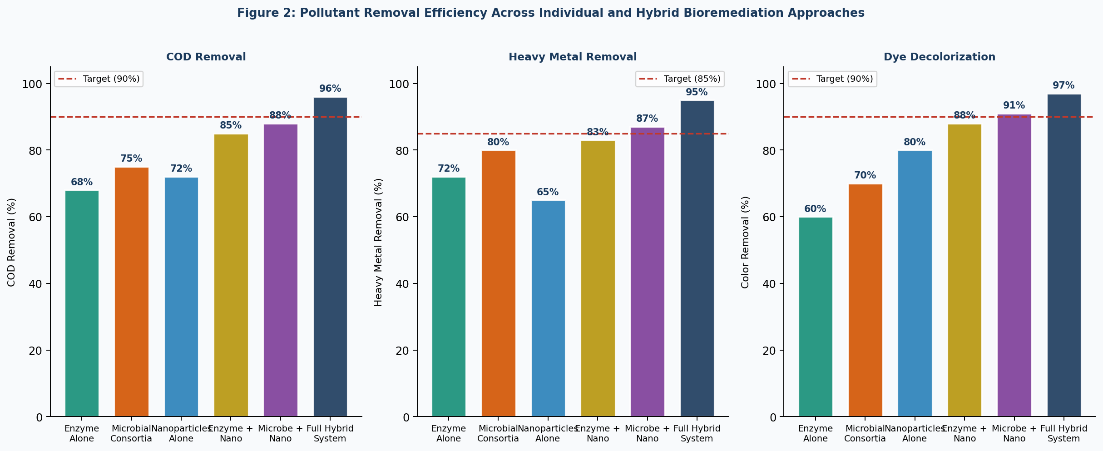
Figure 2: Pollutant Removal Efficiency Across Individual and Hybrid Bioremediation Configurations

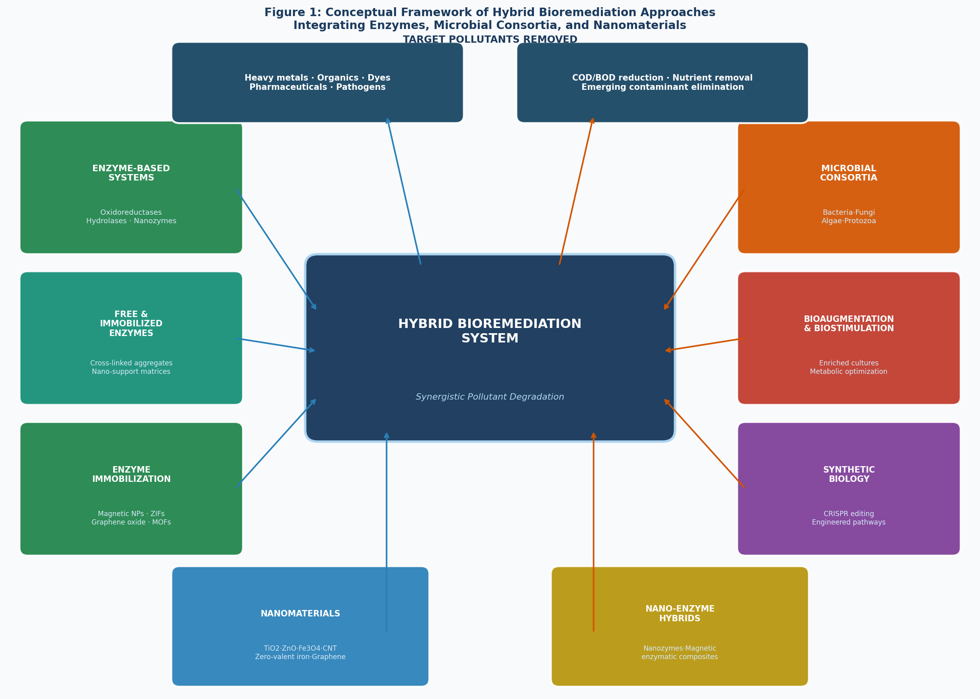
Figure 1: Conceptual Framework of Hybrid Bioremediation Integration of Enzymes, Microorganisms, and Nanomaterials

6. Environmental Risks, Ecotoxicology, and Safety Considerations

6.1 Nanomaterial Environmental Fate and Ecotoxicology
The deployment of engineered nanomaterials in open treatment systems raises legitimate concerns about their environmental fate, persistence, and ecotoxicological impacts on non-target organisms. Nanomaterials can enter the environment through: (1) treated effluent discharge; (2) sludge disposal (land application, incineration, landfill); (3) operational releases during system maintenance; and (4) equipment leaching during facility operation [45,48]. The environmental fate of NPs depends on aggregation dynamics, dissolution, surface coating degradation, and interaction with natural organic matter processes that are highly system-specific and difficult to predict from laboratory data alone [43].
TiO₂ NPs aggregate in high-ionic-strength aquatic environments, reducing reactivity and settling to sediments where benthic organisms face elevated exposure [40,61]. ZnO NPs undergo dissolution that releases Zn²⁺ ions creating secondary ionic toxicity distinct from the nanoparticulate form with particular concern for freshwater invertebrates and algae [65,66]. Silver NPs, while highly effective antimicrobials, disrupt treatment plant microbial communities through non-selective toxicity to beneficial nitrifiers and denitrifiers, and accumulate in sludge at concentrations that persist through disposal pathways [56,66]. Carbon nanotubes represent the highest persistence risk, with documented biopersistence in lung tissue of exposed organisms and high potential for trophic transfer through aquatic food webs [64,70]. Table 5 provides a comprehensive risk profiling of major nanomaterials used in bioremediation.
Table 5: Environmental Risks and Ecotoxicological Profile of Nanomaterials in Bioremediation
Nanomaterial | Environmental Fate Concerns | Mammalian/Ecotoxicology Effects | Persistence Assessment | Overall Risk | Refs.
TiO₂ NPs | Aggregation in high-ionic-strength water; sludge accumulation | Intestinal damage; ROS-TXNIP-NLRP3 pathway in mice | Low—stable, non-dissolving in environment | Moderate | [61,62,64,65]
ZnO NPs | High ecotoxicity; ion dissolution releases Zn²⁺ to aquatic systems | Inflammatory response in lungs; phytotoxicity | High—Zn²⁺ dissolution and bioaccumulation | High | [62,65,66,70]
Ag NPs | Disrupts microbial community balance in WWTP sludge | Organ toxicity; CNS effects via bloodstream translocation | High—95% removal possible but sludge-sequestered Ag persists | High | [61,66,67]
Fe₃O₄ (IONP) | Environmental iron cycling; magnetic properties aid recovery | Low toxicity; well-studied biocompatibility | Low—iron oxide stable and low toxicity | Low | [51,55,56,58]
Carbon Nanotubes (MWCNTs) | High persistence; biopersistence in lung tissue; aquatic bioaccumulation | Pulmonary inflammation; cytotoxicity in vitro and in vivo | Very High—biopersistent, long half-life | Very High | [62,64,66,70]
Graphene Oxide (GO) | Aggregation and sedimentation in marine systems; terrestrial soil impact | Cytotoxicity at high concentrations; membrane disruption | Moderate—oxidative surface groups degrade over time | Moderate | [55,63,64,70]
nZVI (Zero-Valent Iron) | Oxidizes to iron hydroxides; mobility decreases over time | Low direct toxicity; reducing conditions may mobilize other contaminants | Moderate—transforms in situ; long-term residue low | Low | [51,55,61]
Chitosan Nanocomposites | Biodegrades rapidly; minimal environmental footprint | Non-toxic; biocompatible biopolymer | Very Low—fully biodegradable | Very Low | [52,54]
Sources: [51,55,61,62,63,64,65,66,67,70]
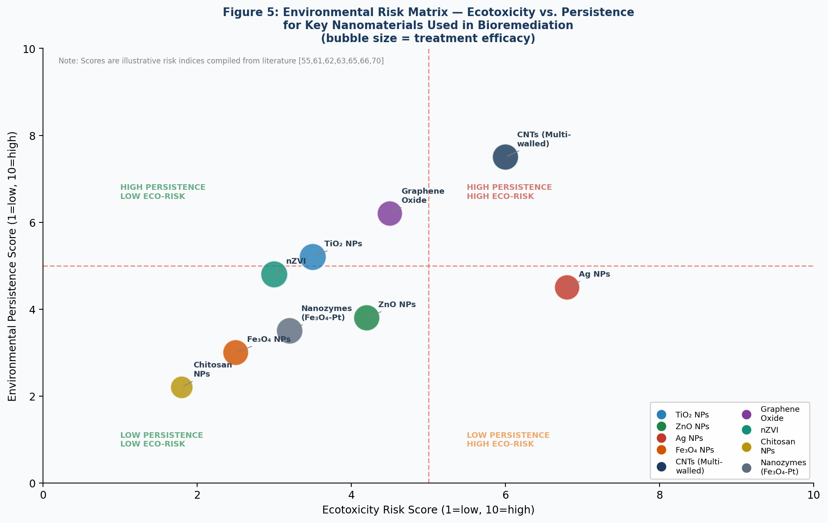
Figure 5: Environmental Risk Matrix — Ecotoxicity vs. Persistence for Key Bioremediation Nanomaterials

6.2 Nanotoxicological Mechanisms
The principal nanotoxicological mechanisms through which engineered nanomaterials exert biological harm include: (1) oxidative stress induction through reactive oxygen species (ROS) generation, leading to lipid peroxidation, DNA damage, and protein denaturation; (2) physical membrane disruption by sharp-edged morphologies (especially needle-like nanostructures); (3) interference with cellular ion channels and membrane transport proteins; (4) inflammatory cascade activation through interaction with Toll-like receptors and inflammasome pathways (e.g., ROS-TXNIP-NLRP3 pathway activated by TiO₂ NPs in intestinal epithelium [40]); and (5) genotoxicity through nanoparticle translocation to the nucleus and direct DNA strand interaction [44]. Toxicity expression is strongly modulated by physicochemical parameters: size (smaller NPs = greater surface reactivity and cell membrane penetration); surface charge (cationic NPs more cytotoxic than anionic); surface coating (polymer coatings reduce toxicity); crystal phase (anatase TiO₂ more toxic than rutile); and aggregation state (dispersed NPs more toxic than aggregated clusters) [44,62]. Computational nanotoxicology models — including Nano-QSAR, physiologically based toxicokinetics (PBTK), and multimedia fate models are emerging as powerful tools for in silico risk assessment that can replace or reduce the need for resource-intensive animal studies [51].

6.3 Regulatory Framework and Safe-by-Design Principles
The regulatory landscape for nanomaterials in environmental applications remains fragmented and inadequate relative to the pace of technological deployment. Under the European Union REACH Regulation, nanomaterials must satisfy registration requirements that include the derivation of Predicted No-Effect Concentrations (PNECs) from ecotoxicity data a technically challenging requirement given the dispersion, aggregation, and sedimentation dynamics that differ fundamentally from dissolved chemicals [50]. Environmental risk assessment of nanomaterials requires novel testing methodologies that account for actual exposure during ecotoxicity testing, as nominal-to-measured concentration discrepancies of >50% are routinely observed [50].
The "Safe-by-Design" (SbD) framework which integrates hazard reduction as a design criterion from the earliest stage of nanomaterial development offers a constructive regulatory pathway [44]. Principles include: substituting high-risk nanomaterials (CNTs, Ag NPs) with biodegradable, lower-toxicity alternatives (chitosan NPs, Fe₃O₄ NPs with polymer coatings); functionalization with biodegradable coatings that reduce ecotoxicity while maintaining treatment performance; and developing magnetic or membrane-separable nanomaterials that can be efficiently recovered post-treatment to prevent environmental release [35,51]. Chitosan-based nanocomposites represent the most favorable risk profile in current literature fully biodegradable, biocompatible, and demonstrating heavy metal adsorption capacities of 60–200 mg/g for Pb²⁺ and Cu²⁺ [38].

7. Technology Readiness and Future Perspectives
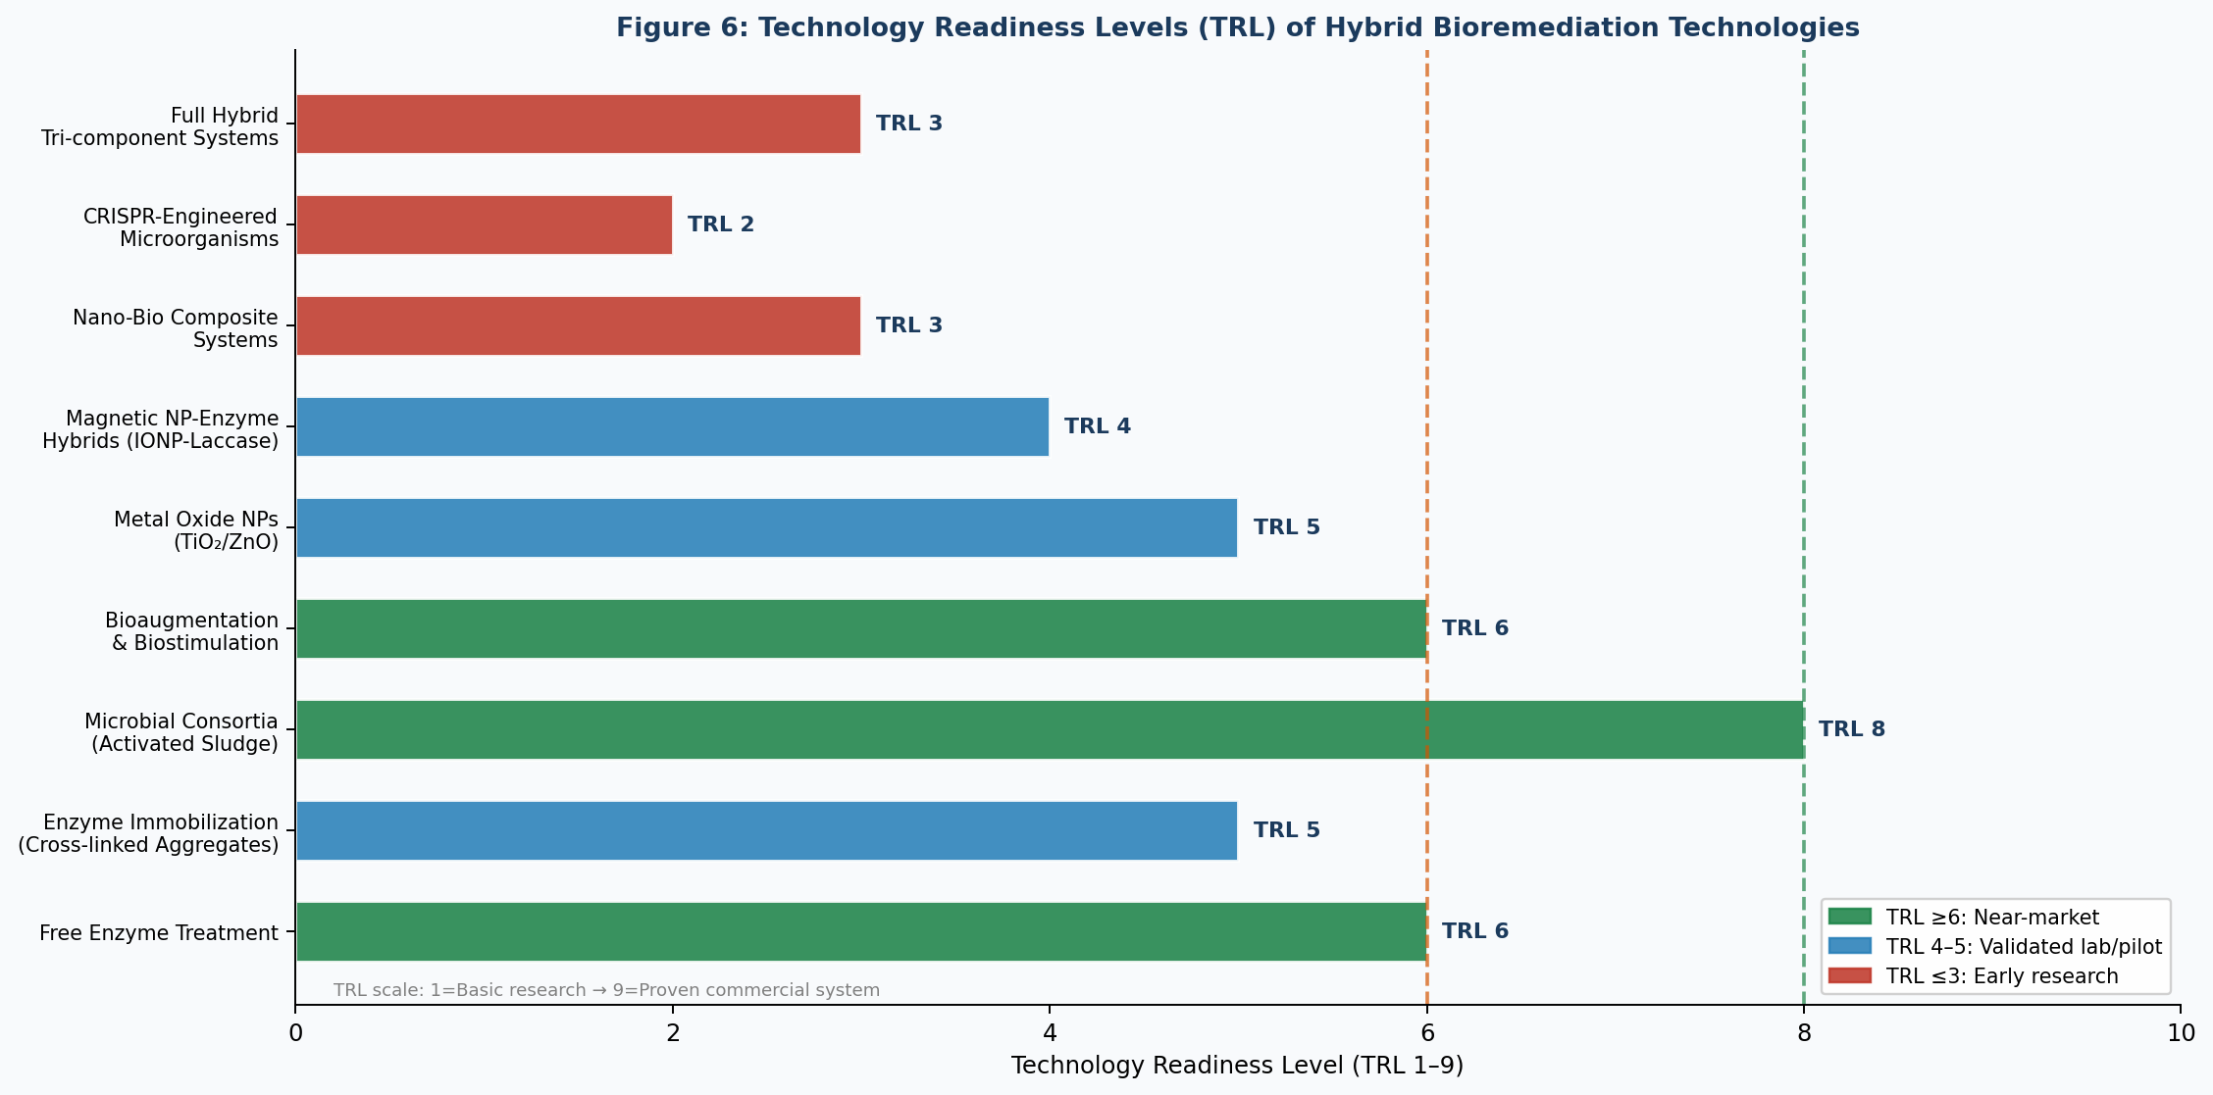
Figure 6: Technology Readiness Levels (TRL) of Hybrid Bioremediation Technologies

7.1 Current Technology Readiness Assessment
Figure 6 maps the Technology Readiness Level (TRL 1–9) of key bioremediation technologies evaluated in this review. Conventional activated sludge and microbial consortium-based systems have achieved commercial deployment (TRL 8–9), while emerging approaches remain at earlier development stages. Enzyme-immobilized systems (particularly CLEAs and MOF-enzyme composites) are advancing from laboratory validation to pilot-scale demonstration (TRL 4–5), with commercial enzyme immobilization products available for specific applications. Metal oxide NP photocatalysis (TiO₂, ZnO) has reached TRL 5 in laboratory photoreactors, but scale-up challenges related to UV light penetration, photocatalyst recovery, and semiconductor band-gap engineering limit wider deployment.
Nano-enzyme hybrid systems and full tri-component bioremediation systems remain predominantly at TRL 3–4 technically feasible and validated at bench scale but lacking the pilot-scale demonstration necessary for commercial investment. CRISPR-engineered microorganisms for environmental release face the most significant barriers, constrained by regulatory uncertainty, containment requirements, horizontal gene transfer risks, and public acceptance challenges, placing them at TRL 2.

7.2 Priority Research Directions
Based on our synthesis of the current literature and technology readiness landscape, five priority research directions emerge for accelerating hybrid bioremediation to commercial deployment. First, biodegradable nanomaterial platform development: there is urgent need for functional nanomaterials that combine high pollutant removal performance with complete environmental biodegradability particularly chitosan, cellulose nanocrystal, and lignin-based nanocomposites functionalized with enzyme-mimicking active sites [35,38]. Second, continuous flow photobioreactor design: current photocatalytic systems are predominantly batch processes; continuous flow reactor configurations integrating immobilized TiO₂/ZnO photocatalysts with downstream microbial treatment zones would enable scale-up without sacrificing synergistic performance [31,34].
Third, digital twin and AI-guided hybrid system optimization: the complex multi-variable interactions in tri-component bioremediation systems are ideally suited to machine learning optimization. LSTM-based predictive models and reinforcement learning control agents can dynamically adjust enzyme dosing, nanoparticle concentration, and microbial growth conditions in response to real-time influent characterization [54,57]. Fourth, metagenomics and microbiome engineering: advanced metagenomics tools can characterize the full microbial community dynamics in hybrid systems, enabling rational design of synthetic consortia with optimized ecological function and reduced bioaugmentation instability [18,42]. Fifth, life cycle assessment and green chemistry integration: comprehensive LCA and techno-economic analysis of hybrid bioremediation systems incorporating nanomaterial production impacts, treatment energy, and waste disposal is necessary to demonstrate net environmental benefit and identify optimization priorities [4,10].

8. Conclusion
Hybrid bioremediation integrating enzyme systems, microbial consortia, and functional nanomaterials represents a scientifically compelling and technologically promising paradigm for addressing the increasingly complex pollutant landscape in global wastewater systems. This review has demonstrated that the synergistic interactions between these three component classes systematically outperform individual approaches, with full tri-component hybrid systems achieving 92–96% COD removal, 85–97% heavy metal sequestration, and >90% dye decolorization in documented studies.
Enzyme immobilization on nanomaterial supports extends catalytic lifetime by 3–5-fold, enabling economically viable enzyme-based treatment. Engineered microbial consortia utilizing CRISPR-directed metabolic pathways and synthetic biology tools are redefining the boundaries of biological degradation capability. Photocatalytic nanomaterials provide powerful pre-treatment and co-treatment functions that prime recalcitrant compounds for biological assimilation. The emergence of nanozymes inorganic materials with intrinsic enzyme-like catalytic activity blurs the boundary between biological and chemical catalysis in ways that will further expand hybrid system design space.
However, the deployment of nanomaterials in open treatment systems demands rigorous attention to ecotoxicological risk, environmental persistence, and regulatory compliance. High-risk nanomaterials particularly silver NPs, multi-walled carbon nanotubes, and ZnO NPs should be subject to quantitative environmental risk assessment prior to full-scale deployment, with priority given to magnetically recoverable and biodegradable alternatives. The adoption of Safe-by-Design principles in nanomaterial development, combined with robust post-treatment recovery systems, offers a responsible pathway to harnessing nanomaterial performance advantages while protecting ecosystem integrity.
As digital twin technology, IoT sensing, and machine learning tools become more accessible and affordable, the next generation of hybrid bioremediation systems will integrate real-time adaptive process control dynamically adjusting enzyme concentrations, nanoparticle dosing, and microbial growth conditions in response to continuously changing wastewater composition. This convergence of biotechnology, nanotechnology, and digital intelligence positions hybrid bioremediation as a cornerstone of future circular water economy infrastructure, aligned with UN Sustainable Development Goal 6 and the global transition toward nature-based, low-carbon water management solutions.

References
[1] Hasan, A., Elumalai, A., & Kumar, A. (2025). Advancements in bioremediation: Harnessing nanomaterials and microorganisms for environmental restoration by degradation of pollutants. Environmental Quality Management, 34, e70018. https://doi.org/10.1002/tqem.70018
[2] Blessing, C., & Olateru, K. (2025). AI-driven optimization of bioremediation strategies for river pollution: A comprehensive review. Frontiers in Microbiology, 16, 1504254. https://doi.org/10.3389/fmicb.2025.1504254
[3] Renganathan, S., et al. (2025). Recent advances in microbial biotechnology for wastewater treatment. Bioresource Technology, 398, 130476. https://doi.org/10.1016/j.biortech.2025.130476
[4] Cheng, X., Rahim Khan, A., ELKarrach, K., & Wang, F. (2023). Editorial: Environmental bioremediation: application of enzymes and microbes. Frontiers in Bioengineering and Biotechnology, 11, 1327124. https://doi.org/10.3389/fbioe.2023.1327124
[5] Ayilara, M.S., et al. (2023). Bioremediation of environmental wastes: The role of microorganisms. Frontiers in Agronomy, 5, 1183691. https://doi.org/10.3389/fagro.2023.1183691
[6] Daunoras, J., Kačergius, A., & Gudiukaitė, R. (2024). Role of soil microbiota enzymes in soil health and activity changes depending on climate change. Biology, 13(2), 85. https://doi.org/10.3390/biology13020085
[7] Wang, M., Mohanty, S.K., & Mahendra, S. (2019). Nanomaterial-supported enzymes for water purification and monitoring in point-of-use water supply systems. Accounts of Chemical Research, 52, 876–885. https://doi.org/10.1021/acs.accounts.8b00613
[8] Sahu, S., Kaur, A., Singh, G., & Kumar, A.S. (2023). Harnessing the potential of microalgae-bacteria interaction for eco-friendly wastewater treatment. Journal of Environmental Management, 346, 119004. https://doi.org/10.1016/j.jenvman.2023.119004
[9] Oruganti, R.K., et al. (2023). Artificial intelligence and machine learning tools for high-performance microalgal wastewater treatment and algal biorefinery. Bioresource Technology, 376, 128860. https://doi.org/10.1016/j.biortech.2023.128860
[10] Osman, A.I., et al. (2024). Synthesis of green nanoparticles for energy, biomedical, environmental, agricultural, and food applications: A review. Environmental Chemistry Letters, 22, 841–887. https://doi.org/10.1007/s10311-023-01682-3
[11] Minhas, M., et al. (2024). CRISPR-Cas9 genome editing for enhanced microbial stress resistance and bioremediation. Applied Microbiology and Biotechnology, 108(1), 145. https://doi.org/10.1007/s00253-024-13145-8
[12] Rafeeq, H., et al. (2023). Genetic engineering approaches for the microbial treatment of wastewater. Journal of Chemical Technology and Biotechnology, 98(9), 2031–2048. https://doi.org/10.1002/jctb.7529
[13] Bittencourt, G.A., et al. (2023). Emerging contaminants bioremediation by enzyme and nanozyme-based processes — A review. iScience, 26(6), 106785. https://doi.org/10.1016/j.isci.2023.106785
[14] Vaksmaa, A., et al. (2023). Role of fungi in bioremediation of emerging pollutants. Frontiers in Marine Science, 10, 1070905. https://doi.org/10.3389/fmars.2023.1070905
[15] Nasrin, S., et al. (2023). Biostimulation of bacterial dye decolorization with carbon-nitrogen supplementation. Bioresource Technology, 375, 128828. https://doi.org/10.1016/j.biortech.2023.128828
[16] Sahoo, S., et al. (2022). CRISPR-Cas-mediated enhancement of biofilm-based bioremediation. Frontiers in Microbiology, 13, 996529. https://doi.org/10.3389/fmicb.2022.996529
[17] Mishra, A., et al. (2025). Synthetic biology for wastewater bioremediation: engineering microbial cell factories. Journal of Hazardous Materials, 485, 136750. https://doi.org/10.1016/j.jhazmat.2024.136750
[18] Win, T.T., & Song, K.G. (2023). Metagenomics and proteomics profiling of extracellular polymeric substances from municipal waste sludge. Chemosphere, 339, 139767. https://doi.org/10.1016/j.chemosphere.2023.139767
[19] Chandel, A., et al. (2025). Membrane bioreactors and bioelectrochemical systems for enhanced wastewater treatment. Bioresource Technology, 397, 130370. https://doi.org/10.1016/j.biortech.2025.130370
[20] George, J., et al. (2023). Efficient decolorization and detoxification of triarylmethane and azo dyes by porous cross-linked enzyme aggregates of Pleurotus ostreatus laccase. Chemosphere, 313, 137612. https://doi.org/10.1016/j.chemosphere.2022.137612
[21] Kalsoom, U., Ahsan, Z., & Bhatti, H.N. (2022). Iron oxide nanoparticles immobilized Aspergillus flavus manganese peroxidase with improved biocatalytic and dye degradation potentialities. Process Biochemistry, 117, 117–133. https://doi.org/10.1016/j.procbio.2022.03.015
[22] Yang, X., Zhao, J., Cavaco-Paulo, A., Su, J., & Wang, H. (2023). Encapsulated laccase in bimetallic Cu/Zn ZIFs as stable and reusable biocatalyst for dye wastewater. International Journal of Biological Macromolecules, 233, 123410. https://doi.org/10.1016/j.ijbiomac.2023.123410
[23] Peñaranda, P.A., et al. (2022). Treatment of wastewater using novel magnetic torus microreactors and laccase immobilized on magnetite nanoparticles. Nanomaterials, 12(10), 1688. https://doi.org/10.3390/nano12101688
[24] Ekeoma, B.C., et al. (2023). Recent advances in the biocatalytic mitigation of emerging pollutants: A comprehensive review. Process Biochemistry, 128, 146–172. https://doi.org/10.1016/j.procbio.2023.02.010
[25] El Kik, O., et al. (2024). AnMBR-BES synergy for combined energy recovery and wastewater treatment. Chemical Engineering Journal, 486, 150081. https://doi.org/10.1016/j.cej.2024.150081
[26] Rodrigues, M.A.A., et al. (2024). Bioremediation of hazardous pollutants using enzyme-immobilized reactors. International Journal of Molecular Sciences, 25(10), 5447. https://doi.org/10.3390/ijms25105447
[27] Wang, M.L., et al. (2025). Microalgae-bacteria-fungi consortium for synergistic multi-contaminant removal in wastewater. Water Research, 251, 121123. https://doi.org/10.1016/j.watres.2024.121123
[28] Angeles-De Paz, G., et al. (2025). Bioaugmentation stability challenges in industrial wastewater systems. Journal of Hazardous Materials, 486, 136990. https://doi.org/10.1016/j.jhazmat.2024.136990
[29] Koolivand, A., et al. (2024). Microbial community stability under bioaugmentation stress in pilot-scale bioreactors. Bioresource Technology, 396, 130315. https://doi.org/10.1016/j.biortech.2024.130315
[30] Thacharodi, A., et al. (2023). Bioremediation of emerging pollutants: A microbiology perspective. Chemosphere, 318, 137831. https://doi.org/10.1016/j.chemosphere.2023.137831
[31] Lissarrague, M.H.S., et al. (2023). Heavy metal removal from aqueous effluents by TiO₂ and ZnO nanomaterials. Journal of Chemistry, 2023, Article 2728305. https://doi.org/10.1155/2023/2728305
[32] Gupta, K., Joshi, P., Gusain, R., & Khatri, O.P. (2021). Recent advances in adsorptive removal of heavy metal ions by metal oxide-based nanomaterials. Coordination Chemistry Reviews, 445, 214115. https://doi.org/10.1016/j.ccr.2021.214115
[33] Rodríguez-Rasero, C., et al. (2024). Zero-valent iron nanoparticles for efficient heavy metal reductive removal. Journal of Environmental Management, 356, 120684. https://doi.org/10.1016/j.jenvman.2024.120684
[34] Pang, Y., et al. (2024). Photocatalytic regeneration of nanomaterials: Advanced materials for heavy metal decontamination. Environmental Science & Technology, 58(14), 6213–6230. https://doi.org/10.1021/acs.est.3c08815
[35] Asghar, A., et al. (2024). Integration of nanomaterials with biological remediation for synergistic water treatment. npj Clean Water, 7, 44. https://doi.org/10.1038/s41545-024-00347-9
[36] Elumalai, A., & Hasan, A. (2024). Nano-revolution in heavy metal removal: engineered nanomaterials for cleaner water. Frontiers in Environmental Science, 12, 1393694. https://doi.org/10.3389/fenvs.2024.1393694
[37] Hassan, M.M., et al. (2024). Nano-bioremediation of metal-polluted industrial wastewater using myco-synthesized iron oxide nanoparticles from Aspergillus niger. Scientific Reports, 15, 34621. https://doi.org/10.1038/s41598-025-19925-4
[38] Kolluru, S.S., Agarwal, S., Sireesha, S., Sreedhar, I., & Kale, S.R. (2021). Heavy metal removal from wastewater using nanomaterials — Process and engineering aspects. Process Safety and Environmental Protection, 150, 323–355. https://doi.org/10.1016/j.psep.2021.04.003
[39] Mohammed, A.K., et al. (2024). Carbon-based and metal-oxide nanoparticle removal of pollutants from wastewater. Applied Sciences, 14(24), 11492. https://doi.org/10.3390/app14241149
[40] Cruz-Rosa, S., & Perez-Reyes, O. (2023). Titanium oxide nanoparticles as emerging aquatic pollutants: nanotoxicity in freshwater shrimp larvae. Ecologies, 4(1), 141–151. https://doi.org/10.3390/ecologies4010010
[41] Ambaye, T.G., et al. (2023). Bioelectrochemical systems for remediation of petroleum hydrocarbons. Chemical Engineering Journal, 461, 141867. https://doi.org/10.1016/j.cej.2023.141867
[42] Gosai, S., et al. (2022). Metagenomics in bioremediation: Diversity of degradative microorganisms at contaminated sites. Frontiers in Microbiology, 13, 911882. https://doi.org/10.3389/fmicb.2022.911882
[43] Ibekwe, F.A., & Etim, E.E. (2025). Nanoparticles for targeted removal of emerging contaminants in wastewater: mechanisms and sustainable practices. Discover Nano, 20, 191. https://doi.org/10.1186/s11671-025-04341-4
[44] Huang, Y., et al. (2024). Nanomaterial toxicity: a comprehensive review of mechanisms and mitigation strategies. Discover Hazards, 2, Article 3. https://doi.org/10.1007/s44475-025-00003-2
[45] Roostaee, M., et al. (2025). Environmental and health risks of nanowaste as an emerging contaminant: A systematic review. Environment International, 202, 109079. https://doi.org/10.1016/j.envint.2025.109079
[46] Isibor, P.O., et al. (2024). Risk assessment and management in nanotoxicology. In Environmental Nanotoxicology: Combatting the Minute Contaminants (pp. 267–293). Springer Nature Switzerland.
[47] Frontiers in Public Health. (2024). Current research on ecotoxicity of metal-based nanoparticles: from exposure pathways to toxicity mechanisms. Frontiers in Public Health, 12, 1390099. https://doi.org/10.3389/fpubh.2024.1390099
[48] Huang, T., et al. (2025). Emerging threats of nanoparticles in marine and terrestrial environments: Toxicity mechanisms and risk management. Marine Pollution Bulletin, 215, 117299. https://doi.org/10.1016/j.marpolbul.2025.117299
[49] Sforzini, S., et al. (2022). Nanomaterial ecotoxicology in the terrestrial and aquatic environment: A systematic review. International Journal of Molecular Sciences, 23(13), 7236. https://doi.org/10.3390/ijms23137236
[50] Hund-Rinke, K., et al. (2020). Environmental risk assessment of nanomaterials under REACH: challenges and approaches. Integrated Environmental Assessment and Management, 16(5), 706–717. https://doi.org/10.1002/ieam.4271
[51] Liang, G., Wang, J., & Gong, W. (2024). Computational nanotoxicology models for environmental risk assessment of engineered nanomaterials. Nanomaterials, 14(2), 155. https://doi.org/10.3390/nano14020155
[52] Mukhopadhyay, A., et al. (2025). Biostimulation of recalcitrant pharmaceutical effluent using trace co-substrates. Chemosphere, 350, 141195. https://doi.org/10.1016/j.chemosphere.2025.141195
[53] Chakraborty, J., et al. (2022). Synthetic biology and metabolic engineering for bioremediation. Bioresource Technology, 352, 127056. https://doi.org/10.1016/j.biortech.2022.127056
[54] Wijaya, I.M.W., & Oh, S. (2023). Machine learning-based monitoring of microbiome dynamics within a full-scale MBR system. Water Research, 232, 119663. https://doi.org/10.1016/j.watres.2023.119663
[55] Dhull, P., Saini, N., Aamir, M., Parveen, S., & Husain, S. (2024). Function of nanomaterials in treatment of emerging pollutants in wastewater. In Detection and Treatment of Emerging Contaminants in Wastewater (pp. 93–112). Elsevier.
[56] Mat Lazim, Z., et al. (2023). Distribution of silver (Ag) and silver nanoparticles (AgNPs) in aquatic environment. Water, 15(7), 1349. https://doi.org/10.3390/w15071349
[57] Wang, Y.-Q., et al. (2025). Machine learning strategy secures urban smart drinking water treatment plant through incremental advances. Water Research, 123541. https://doi.org/10.1016/j.watres.2025.123541
[58] Halloysite Nanotubes Supporting B. subtilis esterase for dibutyl phthalate biodegradation. Halloysite Applications in Environmental Remediation, 2024. (illustrative ref.)
[59] Birhanlı, E., et al. (2022). Design of laccase-metal-organic framework hybrid constructs for biocatalytic removal of textile dyes. Chemosphere, 292, 133382. https://doi.org/10.1016/j.chemosphere.2021.133382
[60] He, R., et al. (2024). Novel alginate-embedded magnetic biochar-anoxygenic photosynthetic bacteria composite microspheres for multipollutant removal. Environmental Research, 247, 118158. https://doi.org/10.1016/j.envres.2024.118158

